

# National Industry PhD Program

Bi-Annual Summary Report

February 2025

Data as at: 31 January 2025

## Introduction

The Australian Government is investing $296 million to build a bedrock of research talent skilled in university–industry collaboration across the sector under the Increase Workforce Mobility initiative. This includes funding to establish the National Industry PhD Program (the Program) to support the Government’s commitment to add 1,800 Industry PhDs over 10 years.

The Program supports PhD candidates to undertake industry-focused research projects, equipping them with the knowledge and skills to better translate university research into commercialisation outcomes. Upon completing the Program, PhD candidates will have the strong potential to work at the interface of research and industry, and across the sectors in the future. This program will add 1,300 PhDs to the innovation ecosystem over 10 years.

The Program consists of two streams:

* **Industry Linked PhD stream**: is for outstanding PhD candidates to undertake research projects co-designed by university and industry, with opportunities to be embedded in an industry setting and participate in a 12-week training program.
* **Industry Researcher PhD stream**: is for highly capable industry professionals who are supported by their employers to undertake PhD projects in partnership with a university while retaining industry employment and salary benefits.

As at January 2025, the Program has funded a total of 198 industry PhD projects over four rounds, with a total of 537 applications assessed from 36 different universities.

|  |  |  |  |  |  |
| --- | --- | --- | --- | --- | --- |
|  | **Round 1** | **Round 2** | **Round 3** | **Round 4** | **Total** |
| **Total Applications Assessed** | 83 | 128 | 143 | 183 | **537** |
| **Target Number of Awards** | 26 | 44 | 40 | 60 | **170** |
| **Funded Awards** | 32 | 50 | 48 | 68 | **198** |

**Table 1.** Total Program applications assessed and funded awards as of January 2025.

Case studies highlighting selected research projects are available on the [Campus Plus website](https://campusplus.com.au/about-niphd/case-studies/), with detailed funding outcomes from each application round accessible at [Funding Outcomes](https://www.education.gov.au/national-industry-phd-program/funding-outcomes).

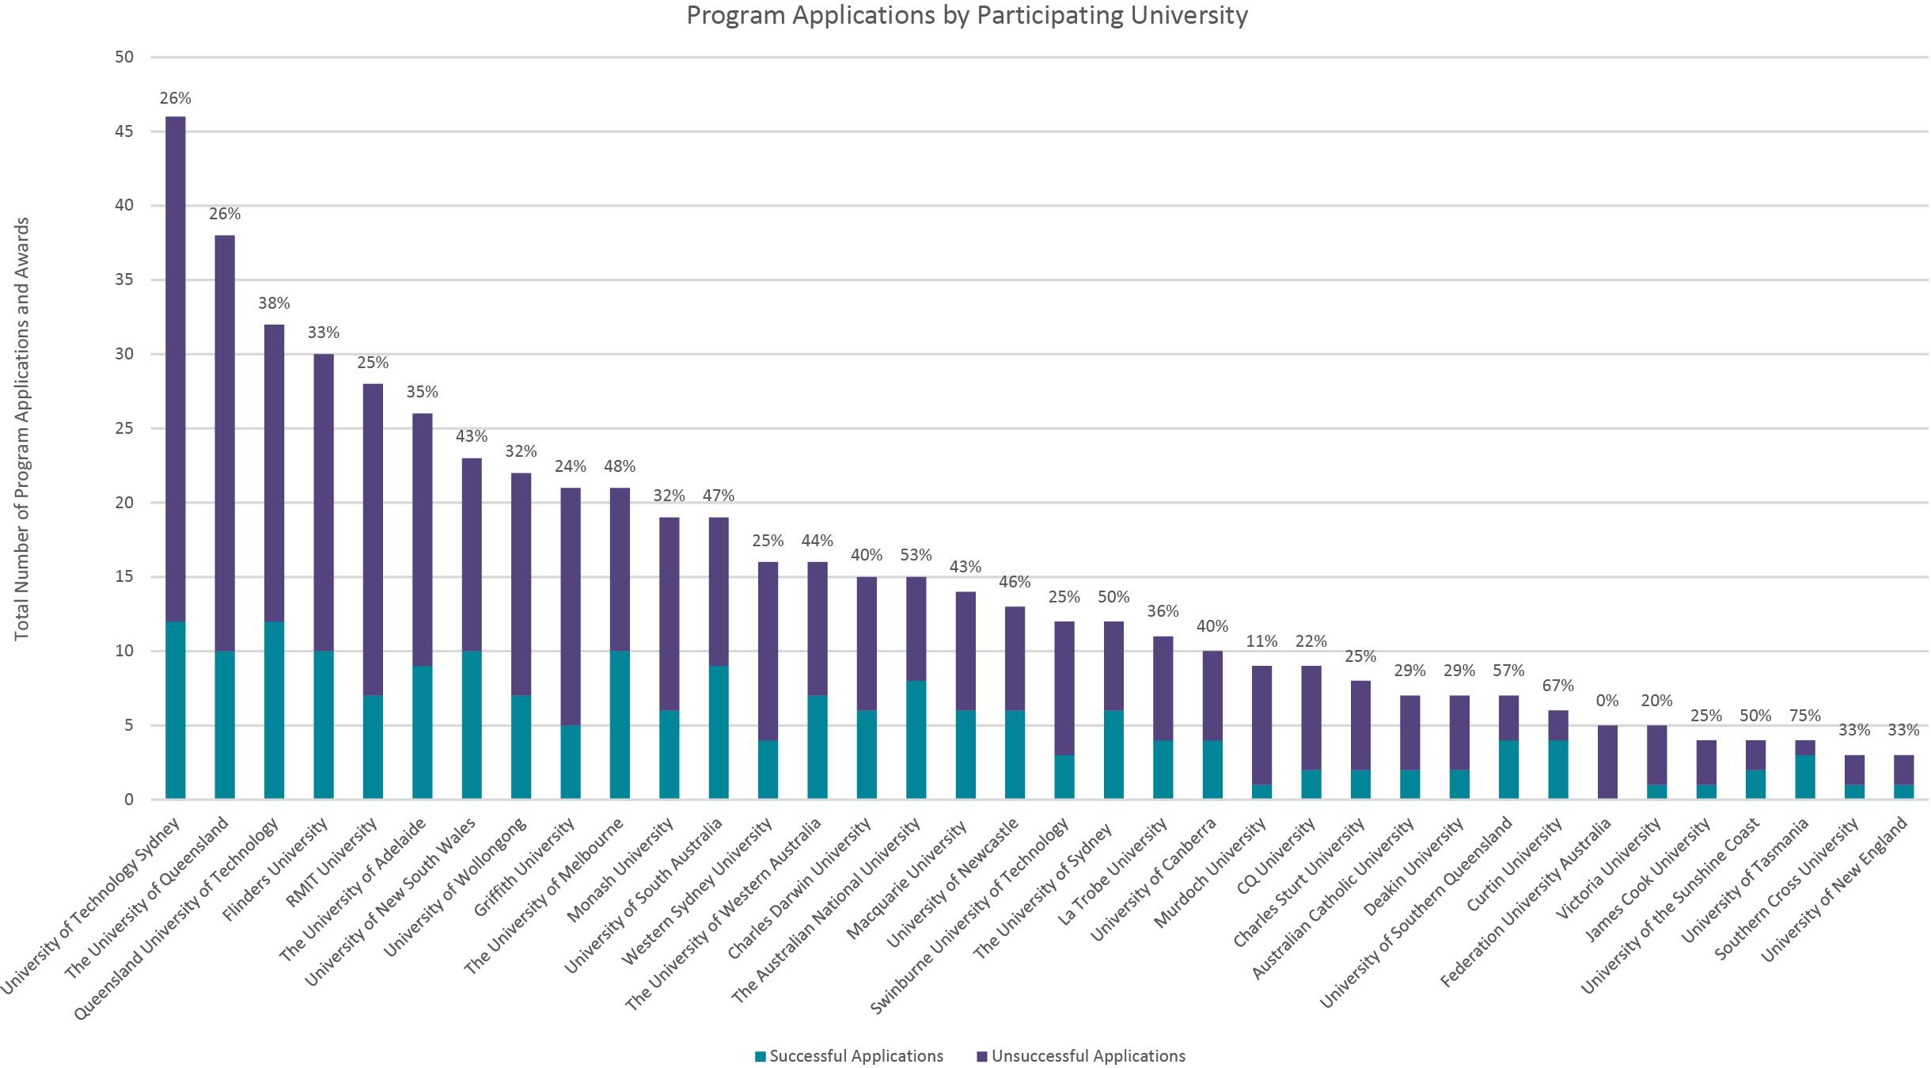Assessed Applications

***Figure 1****: The graph shows the proportion of successful applications to assessed applications, including success rate, by university for the National Industry PhD Program.*

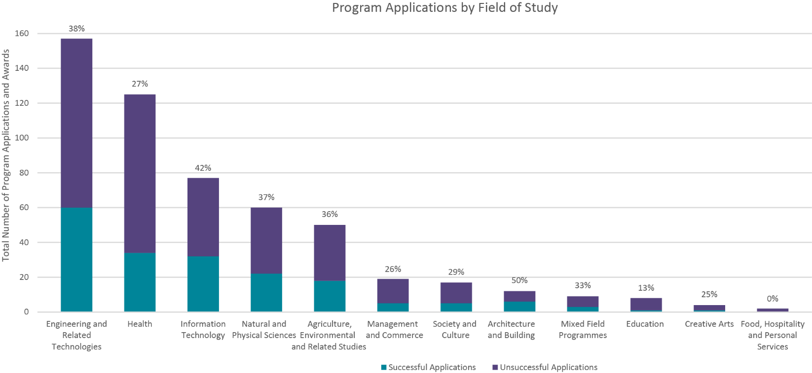

***Figure 2:*** *The graph shows the proportion of successful applications to assessed applications, including the success rate, by Field of Study.*

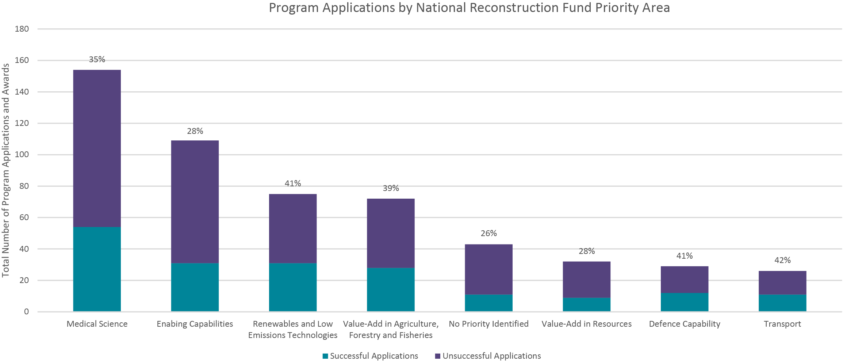

***Figure 3:*** *The graph shows the proportion of successful applications to assessed applications, including the success rate, by National Reconstruction Fund Priority Area.*

## Demographics and Resubmission Rates

#### Resubmission Success Rates

|  |  |  |  |
| --- | --- | --- | --- |
|  | **Round 2** | **Round 3** | **Round 4** |
| **Total Number of Resubmitted** | **26** | **21** | **34** |
| **Successful** | 38% | 43% | 53% |
| **Unsuccessful** | 62% | 57% | 47% |

#### Table 2. Resubmitted Application Success Rates by Program Round.[1]

#### Successful Awards by Location

|  |  |  |  |  |  |
| --- | --- | --- | --- | --- | --- |
|  |  | **Round 1** | **Round 2** | **Round 3** | **Round 4** |
| **Major City** | University | 88% | 66% | 92% | 77% |
|  | Industry Partner | 81% | 66% | 75% | 67% |
| **Regional** | University | 12% | 34% | 8% | 23% |
|  | Industry Partner | 19% | 34% | 25% | 33% |

#### Table 3. Location of Successful Applications by Program Round.

#### Commenced Awards by Researcher Gender

|  |  |  |  |
| --- | --- | --- | --- |
|  | **Round 1** | **Round 2** | **Round 3** |
| **Female** | 13 | 11 | 12 |
| **Male** | 15 | 23 | 11 |
| **Not Provided** | 1 | 11 | 25 |

#### Table 4. Researcher Gender on Commenced Awards by Program Round.[2]

## Data Methodology and Notes

### Understanding the Data:

Information regarding the Participating University, Field of Study, and Government National Reconstruction Fund Priority are identified in the project application. Resubmission data is collected by the Department and the program service provider, Campus Plus.

While due care has been taken in its preparation, the Department of Education cannot guarantee and assumes no legal liability or responsibility for the accuracy, currency, completeness or interpretation of the information.

### Methodology:

The information presented in this dataset is limited to what was current at the time Program applications were approved and announced for funding for each round. Accordingly, any post-award variations that may subsequently have been approved are not reflected. Examples of post-award variations include:

* the funding may not have been taken up after the project was awarded;
* personnel may have been added to, or removed, from the project;
* a project may have prematurely ceased;
* a project may not meet the requirements before the compulsory commencement date and withdraw from the program.

### Definitions

|  |  |
| --- | --- |
| **Term** | **Definition** |
| Application | means a formal proposal for a single or multiple research projects that are suitable for PhD Candidates to undertake with a potential industry application, to be considered under the National Industry PhD Program. |
| Award | Means a gran awarded to a successful application in the National Industry PhD Program, providing financial support for a single PhD candidate. |
| the Department | means the Commonwealth Department of Education. |
| Field of Study | means the subject matter of an educational activity, also called Field of Education. Fields of education are related to each other through the similarity of subject matter, through the broad purpose for which the education is undertaken, and through the theoretical content which underpins the subject matter. Broad, Narrow and Detailed Fields of education are listed and defined by the[Australian Standard Classification of Education (ASCED)](https://www.abs.gov.au/statistics/classifications/australian-standard-classification-education-asced/2001/field-education-structure-and-definitions/structure/broad-narrow-and-detailed-fields). |
| Industry Partner | means a single or multiple businesses or companies that will partner with a university and a PhD candidate to undertake a PhD Research Project. |
| National Reconstruction Fund Priorities | means the [seven priority areas](https://www.nrf.gov.au/what-we-do/our-priority-areas) of the Australian economy which are supported by the National Reconstruction Fund Corporation (NRFC) by providing finance in the form of debt, equity and guarantees to support Australian projects that drive high-value industry transformation. |
| Participating University | means a single or multiple universities that participate in the Program and must be listed as a higher education provider under section 16-15 (Table A providers) or section 16-20 (Table B providers) in the *Higher Education Support Act 2003.*  The university is responsible for submitting an application for the Program and will be the main point of contact for an application. |
| Program Stream | means the PhD Streams under the National Industry PhD Program:   * **Industry Linked PhD stream:** This stream is for outstanding PhD candidates to undertake research projects co-designed by university and industry, with opportunities to be embedded in an industry setting and participate in a 12-week training program. * **Industry Researcher PhD stream:** This stream is for highly capable industry professionals who are supported by their employers to undertake PhD projects in partnership with a university while retaining industry employment and salary benefits. |

1. *Resubmissions refer to applications submitted for the identified round that were unsuccessful in a previous application round(s).*
2. *The data on researcher gender is based on projects that commenced as of 31 January 2025. Please note that the total number of researchers may differ from the number of successful applications, as it includes awards that were withdrawn or did not commence due to unforeseen circumstances.*