

# Trailblazers quarterly newsletter

January 2025 update

Welcome to the inaugural edition of our quarterly newsletter, dedicated to celebrating the remarkable achievements of the Trailblazer Universities Program. We are excited to share the latest news from the program and our university partners, and keep you informed about upcoming events and announcements.  
  
The Trailblazer Universities Program is helping to build world-leading capabilities in national priority areas, foster collaborative partnerships and create career pathways that bridge academia and industry. The program is a shining example of how collaborative efforts between universities, industry and government can drive innovation and create lasting impacts.  
  
In 2024, the program continued to go from strength to strength. So far it has attracted more than $300 million in funding from industry partners, building on the Australian Government’s investment of $370.3 million. We’re looking forward to a bigger and better 2025. Stay tuned for more updates and inspiring stories in the upcoming editions.  
  
All the best,  
  
Anthony Millgate  
Assistant Secretary  
Australian Government Department of Education

## Recycling and Clean Energy Commercialisation Hub (REACH)

Reach start-up recognised for global innovation

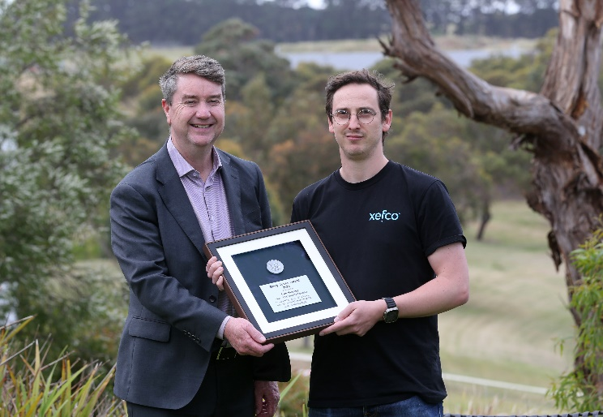Tom Hussey, CEO and co-founder of innovative textiles company Xefco, has been awarded the prestigious Geelong Innovation Award – The Barry Jones Medal.  
  
A founding industry partner of REACH and the Australian Research Council Research Hub for Future Fibres, Tom was honoured for Xefco’s Ausora technology, a breakthrough water-free dyeing and finishing solution that enables textile processing without the use of water. [Read the full story](https://reach.deakin.edu.au/2024/11/reach-start-up-recognised-for-global-innovation/) on the [REACH website](https://reach.deakin.edu.au/).

REACH is led by Deakin University. Follow [REACH on LinkedIn](https://www.linkedin.com/school/deakin-university).

Deakin Distinguished Professor Matthew Clarke and CEO and co-founder of Xefco Tom Hussey.

[More about REACH](https://www.deakin.edu.au/research/research-partnerships/geelong-future-economy-precinct/reach)

## The Innovative Launch, Automation, Novel Materials, Communications, and Hypersonics Hub (iLAuNCH)

Unravelling the mysteries of the cosmos

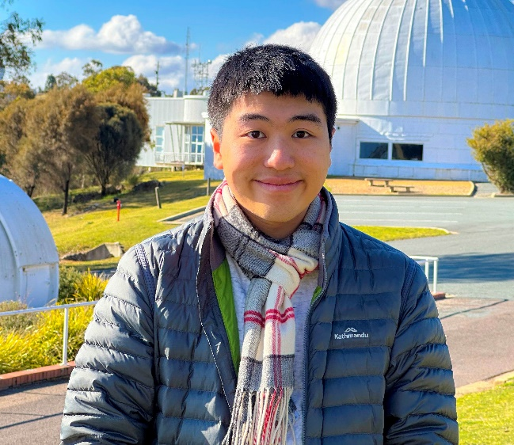From exploring active galactic nuclei and supernovae cosmology to testing quantum gravity and tracking fast-moving satellites, Alan Chan is unravelling the mysteries of the cosmos one small step at a time. [Read the full story](https://ilaunch.space/article/exploring-the-final-frontier-in-law/) on the [iLAuNCH website](https://ilaunch.space/).

Dr Alan Chan at the Mt Stromlo Observatory.

iLAuNCH is led by the University of Southern Queensland. Follow [iLAuNCH on LinkedIn](https://www.linkedin.com/authwall?trk=bf&trkInfo=AQHCJoaSHT6O9AAAAYhQVcPQrle_TN0Hr1S2Fx1eNTQKQQRHMgAyTrPJXaJaIbx4dz8PdwobsjH8iZbqtu_w-VZI5Ur73FmP0VRf-FBKFUi-9fE_oQs_bbvLzV4fBbKQ6TBTxYU=&original_referer=&sessionRedirect=https%3A%2F%2Fwww.linkedin.com%2Fcompany%2Filaunchspace%2Fposts%2F%3FfeedView%3Dall).

[More about iLAuNCH](https://ilaunch.space/)

## Australia’s Food and Beverage Accelerator (FaBA)

Digging deep with data

FaBA researchers have invested in a vast range of databases to give industry participants a distinct advantage both before and after they enter the marketplace. The FaBA Innovation Pathways Program's subscription with Mintel, widely recognised as a leader in market intelligence, is assisting FaBA industry participants to grow their businesses. [Read the full story](https://faba.au/news/digging-deep-with-data/) on the [FaBA website](https://faba.au/).  
  
FaBA is led by the University of Queensland in partnership with the University of Southern Queensland and Queensland University of Technology. Follow [FaBA on LinkedIn](https://msg.dese.gov.au/link/id/zzzz6792be3f636b8724Pzzzz678d971d81d2c710/page.html).

Investing in databases is giving industry partners a distinct advantage.

[More about FaBA](https://faba.au/)

## Resources Technology and Critical Minerals Trailblazer

Transforming Manganese Resources into   
Battery Grade Chemicals and Energy Materials

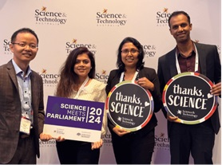Developing a more economical and sustainable method to produce manganese is essential, with the critical mineral forming a key component of most lithium ion and conventional alkaline batteries needed in devices like smartphones and laptops, electric vehicles, and energy storage systems.  
  
The challenge is to develop sustainable waste management practices and production solutions that increase efficiency and reduce the demand for land needed for waste management. [Read the full story](https://rtcm-trailblazer.au/transforming-manganese-resources-into-battery-grade-chemicals-and-energy-materials/) on the [Resources Technology and Critical Minerals Trailblazer website](https://rtcm-trailblazer.au/).

Dr Nirmala Ilankoon attended last year's Science & Technology Australia’s Science Meets Parliament event at the invitation of the Australian Government Department of Education.

The RTCM Trailblazer is led by Curtin University. Follow the [Resources Technology and Critical Minerals Trailblazer on LinkedIn](https://www.linkedin.com/company/resources-technology-and-critical-minerals-trailblazer/).

[More about RTCM Trailblazer](https://rtcm-trailblazer.au/)

## Defence Trailblazer for Concept to Sovereign Capability

GuardWare Australia and UNSW Sydney   
partner to strengthen Australia’s defence   
supply chain resilience

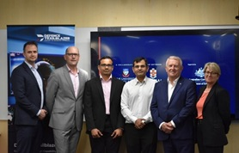GuardWare Australia and UNSW Sydney, under the Defence Trailblazer, have signed a $7 million collaboration agreement to develop technologies to improve Australia’s defence supply chain resilience by encrypting and controlling unstructured data shared in defence supply chains. [Read the full story](https://dtb.solutions/media-release/guardware-australia-and-unsw-sydney-partner-to-strengthen-australias-defence-supply-chain-resilience/) on the [Defence Trailblazer website](https://dtb.solutions/).  
  
The Defence Trailblazer is led by the University of Adelaide. Follow [Defence Trailblazer on LinkedIn](https://www.linkedin.com/company/defence-trailblazer/).

Richard Williamson (Defence Trailblazer), Professor Stephen Rodda (UNSW Sydney), Professor Salil Kanhere (UNSW Sydney), Rizwan Mahmood (GuardWare Australia), Alan Rankins OAM (GuardWare Australia) and Dr Margaret Law (Defence Trailblazer).

[More about Defence Trailblazer](https://dtb.solutions/)

## Trailblazer for Recycling and Clean Energy (TRaCE)

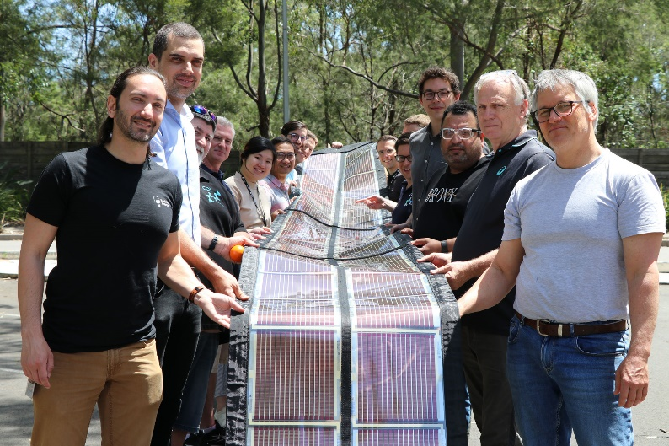University-made Printed Solar powers Coldplay concerts

Printed Solar, a 100% recyclable solar material developed by researchers at the University of Newcastle, is helping power Coldplay’s Music of the Spheres world tour thanks to a collaboration between the iconic band, Kardinia Energy (the technology’s commercialisation partner), and the University of Newcastle’s Centre for Organic Electronics (COE).  
  
Coldplay has made significant commitments to sustainability, continuously exploring and applying new technologies to reduce their environmental impact. This partnership is another step towards achieving their ambitious sustainability goals to reduce their tour’s carbon emissions by 50%. [Read the full story](https://trace.org.au/university-made-printed-solar-powers-coldplay-concerts/) on the [TRACE website](https://trace.org.au/).

The COE team at the University of Newcastle’s Newcastle Institute for Energy and Resources holding up a roll of Printed Solar designed for the Coldplay concert.

TRaCE is delivered in partnership between the University of New South Wales and the University of Newcastle. Follow [TRaCE on LinkedIn](https://www.linkedin.com/company/trace/).

[More about TRaCE](https://trace.org.au/)

## Stay informed

Subscribe to the Department of Education’s Trailblazer newsletter – delivered every quarter to your mailbox and on the department's [Trailblazer website](https://www.education.gov.au/trailblazer-universities-program).

[](https://msg.dese.gov.au/link/id/zzzz6786f72ae5ffb618/page.html)Find out more about the great work happening in the Australian Government's Trailblazer Universities Program through our social media channels and websites.

[Department of Education](http://www.education.gov.au/trailblazer-universities-program) | [Australia's Economic Accelerator](http://www.aea.gov.au/) | [AEA LinkedIn](http://au.linkedin.com/company/australias-economic-accelerator?trk=public_post_feed-actor-name)

## Acknowledgement of Country

**The Department of Education acknowledges the Traditional Owners and Custodians of Country throughout Australia and their continuing connection to land, waters and community. We pay our respects to the people, the cultures and the Elders past and present.**

[Privacy](http://www.education.gov.au/using-site/privacy) | [Disclaimer](http://www.education.gov.au/using-site/disclaimer) | [Unsubscribe](https://msg.dese.gov.au/trailblazer-unsubscribe)

