**Non-Government Reform Support Annual Report**

**2023**

**Victorian Catholic Education Authority**

**Executive Summary**

Victorian Catholic Education Authority (VCEA) was established to provide Catholic education and ensure proper governance and leadership in Catholic education across Victoria. As part of governance services to Victorian schools and their governing entities, VCEA:

* is the approved system authority for Victorian Catholic schools, receiving and distributing government grants, including NCCD grants, to schools and reporting to the government(s) on Catholic schools' use of public funds in accordance with legislation.
* provides sponsorship for the Digital Re-imagination program. The program will replace the existing Integrated Catholic Online Network (ICON). Digital Re-imagination is a collaborative technology platform across 12 school operational taxonomies: strategy management, curriculum, assessment and teaching management, student support services management, operations management, student and stakeholder management, human capital management, ICT and data management, finance and payroll management, facility management, risk management, external relationship management, and capabilities management.

VCEA’s 2023 school reform priorities focus on two of the three Non-Government Schools Reform Support (NGSRF) national priorities:

1. **Improve governance and financial management practices in Victorian Catholic schools.**

The Digital Reimagination program will strengthen financial viability, improve business decision making, and build resilience to mitigate unforeseen risk. User experiences, modern technology and simple efficient business processes will form the foundation of technology functionality. The current ICON technology was conceived in 2008 for the legacy diocesan structure where individual Parish Priests were school governors for most schools. By 2021, Victorian Catholic schools governed by Parish Priests moved to a new governance structure under four independent governing entities, with the remaining schools governed by Public Juridic Persons.

The ICON configuration is approaching the ‘end of support’ life with vendor services ceasing in October 2024. VCEA has the option to move to the vendor’s latest fully digitalised online solution. In preparation for this move, VCEA has reviewed business and functionality across twelve business capability areas /operational taxonomies to capture current business requirements, understand and remove current inefficiencies, improve future functionality, and ensure that reporting capabilities align with the new governance structure, compliance and operating requirements.

The Digital Re-imagination program in 2023 was to conduct the specification analysis phase and prepare for the launch of a request for proposal (RFP). This was completed and the RFP was launched in 2024 and remains underway. The Program is expected to continue in the RFP and negotiation phase through to end of 2024.

The delivery program will then commence in 2025 with the first wave of rollouts anticipated to commence in the second half of 2026. The program will be delivered in at least 3 waves over the next 3 years and benefits will start to accrue by mid 2026 and continue for at least 3 years post.

We have put contingencies in place whilst we develop and commence replacement technology implementation, these include:

* Additional support with non-product vendor support and maintenance organisations
* Reduced volume of changes to stabilise the environments
* Any delays with implementation with continue to be managed with extension of existing contracts

If we are delayed in implementing the program we are prepared to extend use of the current systems and maintain existing contingencies as per above.

The key benefits for schools and Governing bodies, agreed in collaboration with schools and central offices, include the delivery of an enterprise solution built for current day incorporated bodies, that supports effective business management, best practice and provides a holistic solution to all functional requirements; is user friendly, data driven, secure and supports compliance; aligned as a system, enabling school stakeholders to focus time supporting student learning and wellbeing outcomes; with Principals and key stakeholders valuing the system and able to realise benefits in real-time.

The following image represents these opportunities and benefits to school Governing bodies and schools that were developed for the initial business case; a further iteration of this business case will be developed by the end of 2024 to expand on these benefits: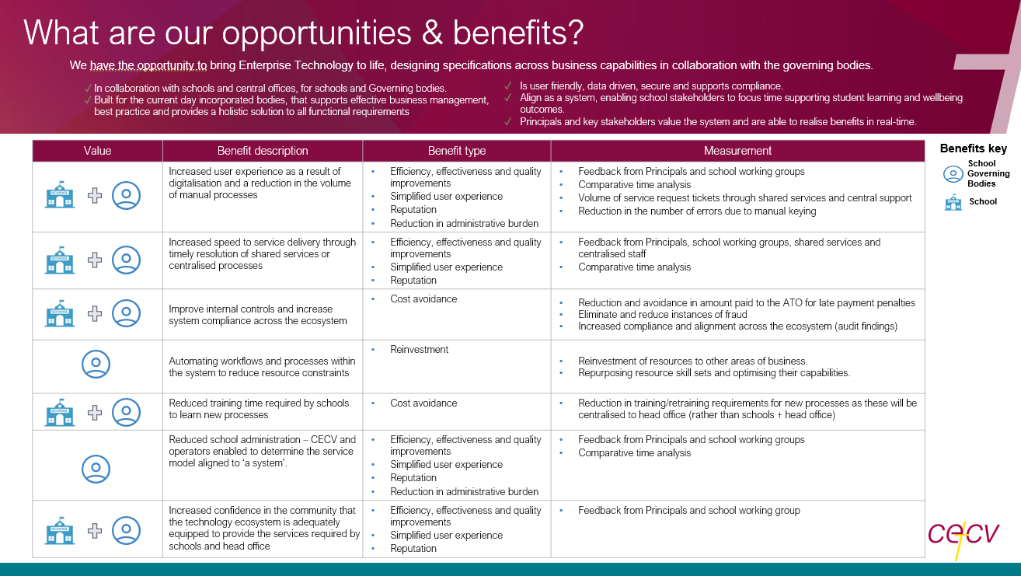

1. **Improve the quality of information** on the Nationally Consistent Collection of Data (NCCD) on School Students with Disability. VCEA will support schools to improve the efficiency and integrity of the data collection through NCCD Training and Support and Quality Assurance for Victorian Catholic schools.

**Progress against strategic plan**

Both the Digital Reimagination Program and NCCD Training and Support projects within the 2023 VCEA Workplan align with VCEA’s broader strategic plan objectives within its aims of delivering ‘governance practices and stewardship’ (reimagining ICON as an effective means of streamlining workflows for schools and facilitating ease of compliance and management reporting: Digital Reimagination) and ‘equity and fairness’ (distributing resources according to need: NDDC Training and Support.

**Relationship with state and territory government**

VCEA has an ongoing positive working relationship with both the Victorian Department of Education and Training (DET) and Independent Schools Victoria (ISV).

The VCEA continues to be a participant of the School Policy and Funding Advisory Council (SPFAC), which comprises of five members, including the Secretary of the Victorian Department of Education and Training, the Chief Executive Officer of the VCEA, Chief Executive of Independent Schools Victoria, a second Department of Education and Training representative and an independent member.

The group provides advice to the Minister for Education on regulatory, policy and funding issues that affect government and non-government schools. The Council is also responsible for establishing all the State based reform initiatives in the bilateral agreement between the Commonwealth and Victorian governments.

**Project Report**

**Include here a general statement that provides a response to the following:**

The summary below outlines the specific projects undertaken in 2023, to realise the strategic objectives outlined above. The comprehensive NCCD training and guidance provided by the VCEA has supported schools to apply the NCCD processes in an informed and consistent way. This promotes the equitable distribution of resources according to need.

Digital Re-imagination during 2022-2023, focussed on VCEA and school governing entity alignment as well as planning and several high level deliverables required to inform the RFP as per the Procurement Strategy.

**Summary of 2023 achievements**

| 1. **Project title** | 1. **Project description and activities** | 1. **Expected outcomes, benefits or impacts** | 1. **Indicators of success** | 1. **List any additional or variations of Activities undertaken/Achieved outcomes.** |
| --- | --- | --- | --- | --- |
| **NCCD Training and Support** | **Improve the quality of information on the Nationally Consistent Collection of Data on School Students with Disability (NCCD) and improve the efficiency and integrity of the data collection.**  Learning Consultants will build the capacity of Principals and school Leaders to understand, implement and accurately complete NCCD processes within the VCEA Intervention Framework and Multi-Tiered Systems of Support (MTSS).  Provide training to Principals and school Leaders to improve accuracy in determining disability categories and levels of adjustment through moderation and quality assurance processes within and across schools.  Learning Consultants will continue to support and refine NCCD school processes to identify, collect, analyse and moderate the data.  Implement targeted VCEA quality assurance and moderation processes to ensure the consistency, accuracy and integrity of submitted NCCD data. | * Build the capacity of school Leaders to utilise the VCEA Intervention Framework to accurately identify and make required adjustments, including participation in sponsored study * Deliver professional learning that outlines the key principles of NCCD at central/regional workshops. * Support schools to accurately determine the disability category and level of adjustment for individual students supported by evidence in the four areas. * Build the capacity of school Leaders to identify, collect, analyse and moderate their NCCD | * For 90% of schools to directly engage with the VCEA   **Achieved – All systemic Catholic schools engaged with VCEA at various points throughout the 4 phases of NCCD**   * For 90% of schools to attend workshops / NCCD briefings (moderation component of agenda)   **Achieved – All systemic Catholic schools engaged with either their NCCD Diocesan representative or accessed resources through live online webinars or recorded versions.**   * For 90% of schools to work with their Learning Consultant to review their application of the NCCD model including the processes documented in their "key timeframes and activities" document or similar school-based document.   **Achieved- All systemic schools engaged with their learning consultant to ensure implementation of the NCCD model, particularly during the quality assurance process, which is conducted annually for every systemic Catholic school.**   * For 100% of new coordinators to receive targeted support (onsite).   **Achieved – All new coordinators received targeted support. Due to the number of schools/locations, some of this support occurred online.**   * For 100% of schools to upload data to the VCEA NCCD portal allowing year-on year analysis of data at category/ adjustment level to identify variances/ anomalies and raise these with schools as part of the QA process.   **Achieved – 100% of systemic Catholic schools uploaded data to the VCEA NCCD portal.**   * For a 5% increase in the number of staff that have completed the DSE online modules for 2023 compared to 2022.   **Not Achieved – 8009 staff completed the DSE Modules in 2023 (8193 in 2022)**   * For 500 staff to have completed one of the online training modules (OLT) (dyslexia, oral language, hearing impairment, ASD behaviour) training in disability specific areas and development of SMART goals in 2023.   **Not Achieved – 288 staff enrolled in OLT.**  40 school staff completing the User B training, attending all training sessions and completing associated tasks.  **Not Achieved – 35 staff completed training**  40 schools receiving individual school visits to assist in applying assessment to NCCD processes.  **Achieved – 45 Diocesan schools were visited in 2023 to assist in applying NCCD processes.** | **Schools have open access to guidance materials, presentations and recorded webinars. Schools continue to report that open access allows them to access materials independently, as required. The resources have been especially valued by new diocesan staff and school coordinators.**  **In 2023 95% of schools also completed an online survey to provide high level data on the use of NCCD funds. The 5% of schools that did not complete the survey reported technical or access issues with the portal.**  **The number of staff who completed the DSE Modules decreased in 2023. Whilst 8009 staff completed the training an additional 1147 staff commenced the training but did not complete it. The reduction in numbers is attributed to chronic staff shortages and increased work demands of teachers across the sector in 2023.**  **The decrease in the number of teachers completing the OLT modules is attributed to chronic teacher shortages and increased demands on teachers (leaving less time for professional development opportunities). Whilst the OLT numbers decreased, 43 Teachers commenced a Master of Education – Intervention at the University of Melbourne in 2023.**  **35 staff completed this training. While this number is less than anticipated, over 100 staff completed User B accreditation over the last 5 years. Staff shortages and increased teacher workload impacted the number of teachers undertaking professional learning out-of-hours.** |

| 1. **Project title** | 1. **Project description and activities** | 1. **Expected outcomes, benefits or impacts** | 1. **Indicators of success** | 1. **List any additional or variations of Activities undertaken/Achieved outcomes.** |
| --- | --- | --- | --- | --- |
| **ICON Decommission and Digital Re-imagination** (State based initiative)  ***(Program Governance)*** | **Program Governance:**   * Define and establish governance structure * Establish program tracking and monitoring tools * Develop a detailed program plan * Develop a stakeholder engagement plan * Develop a program management plan | * VCEA stakeholder representation and requirements identified * Clear and transparent plans as defined. | * Program governance defined and established with VCEA sponsored DRI Steering Committee and Program Control Board (PCB); with these groups providing governance over the business requirements and endorsement of the procurement phase, procurement approach and contract sign off. * Governance structures established including VCEA and Diocesan representation * Plan components are developed with high-level business requirements. |  |
| **ICON Decommission and Digital Re-imagination**  (State based initiative)  ***(Change Management and Communications)*** | **Change Management and Communications**:   * Stakeholder communication and engagement plan * Change impact assessment * Business readiness assessment * Draft communication and engagement materials * Detailed handover documentation and support   High level change strategy | * VCEA stakeholder representation and requirements identified * Clear and transparent plan * Clear and timely communications | * Stakeholder and communications engagement plan as well as other plans listed are established and executed for high level business requirements phase. * Position description and recruitment for a Digital Change and Transformation Lead (appointed in Q1, 2024). |  |
| **ICON Decommission and Digital Re-imagination**  (State based initiative)  ***(Operating Model)*** | **Operating Model:**   * Operating model design principles * Strategic service/channel mode * Target operating model options |  | * High level operating model design and principles completed. |  |
| **ICON Decommission and Digital Re-imagination**  (State based initiative)  ***(High Level Business Requirements)*** | **High Level Business Requirements:**   * Define and prioritise user stories * Develop user stories across the full enterprise   functions to support the specification of requirements for the technology platform   * Develop variance impact register to capture change in requirements from current to future state | * VCEA stakeholder representation and requirements captured and agreed | * User stories and workshops for all 12 business capabilities developed   + User stories – 1,675   + Workshops – 72   + Critical Vic Catholic Education differentiating user stories – 235 * Scope of capability areas (12 business capabilities) developed to specifications for the business case for the Digital Re-Imagination of Catholic Schools in Victoria; including each school operating entity’s position on specifications. Scope includes:   + Curriculum, Assessment & Teaching Management   + Student Support Services Management   + Operations Management (School)   + Student and Stakeholder Management   + Human Capital Management   + ICT and Data Management   + Finance   + Payroll Management   + Facilities Management   + Risk Management   + Procurement   + Capabilities Management   + Business case approved by VCEA Board in March 2023. |  |
| **ICON Decommission and Digital Re-imagination**  (State based initiative)  ***(Conceptual System Architecture)*** | **Conceptual System Architecture:**   * Current state conceptual architecture views * Future state conceptual architecture view |  | **Achieved**: Conceptual system architecture, current and future state view achieved |  |
| **ICON Decommission and Digital Re-imagination**  (State based initiative)  (Generate Procurement Strategy and Approach) | **Generate Procurement Strategy and Approach:**   * Develop procurement strategy * Establish Evaluation Teams and Evaluation Steering Committee * Develop Tender Documents | Successful vendor selection | * Achieved: Development of procurement strategy, approach, tender documents, and establishment of evaluation teams and committees (Legal and Compliance; ICT/Technical; and Business evaluation panels). * RFP released and initial short-listing process conducted * The RFP is now in the evaluation phase with the remaining participating entities. |  |
| **ICON Decommission and Digital Re-imagination**  (State based initiative)  **End Benefits** | **Deliverable end user benefits that are expected to be achieved with the implementation of solutions. Noting that at the end of 2024 a further iteration of the business case will be developed and will expand on these benefits** | * Increased user experience as a result of a reduction in the volume of manual processes * Increased speed of service delivery * Improved internal controls and increased system compliance * Automated workflows and processes to reduce resource constraints * Reduced training time for schools to learn new processes   Reduction in administrative burden through a simplified user experience, efficiency, effectiveness and quality improvements | * school working groups * Reduced volume of help desk requests * Reduction of manual keying errors * Positive feedback from Principals, school working groups, Shared Services and centralised staff * Positive comparative time analysis * Reduction in ATO late payment penalties * Reduction in instances of fraud * Increased compliance and reduced audit observations of control failures and weaknesses * Reinvestment of resources to other areas of business * Repurposing staff skill sets and optimising their capabilities * Reduction in training/retraining requirements * Positive feedback from Principals and school working groups * Positive comparative time analysis | * These deliverables and user benefits are expected to be achieved with the implementation of solutions.   The procurement phase is in progress with evaluations of implementation vendors and partners currently underway.   * It is anticipated that implementation of solutions and outcomes of these benefits will be assessed post implementation. |

**2023 Budget Expenditure**

| **Project Activities** | **Reform Support Funding** |
| --- | --- |
| **NCCD** |  |
| NCCD Training and Support Project | $1,550,107 |
| **NAPLAN Online** | $0 |
| **Governance** |  |
| ICON Digital Reimagination Project | $4,782,893 |
| **Administration of projects** | $0 |
| **TOTAL** | **$6,333,000** |