**11-12 November 2024**

**Early Childhood Care and Development Policy Partnership**

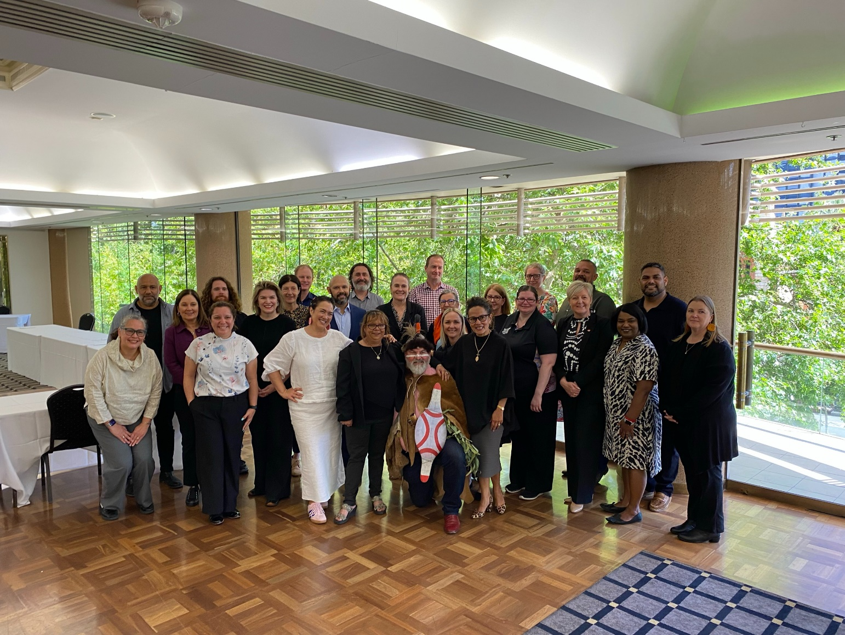

Members of the Early Childhood Care and Development Policy Partnership on Kaurna Country, with Uncle Mickey O’Brien

**Meeting Eight Outcomes**

The Early Childhood Care and Development Policy Partnership (the Partnership) held its eighth meeting in Tarntanya/Adelaide. The meeting was on Kaurna land, the lands of the Red Kangaroo Dreaming.

The meeting opened with a Welcome to Country by Uncle Michael (Mickey) Kumatpi O'Brien, a senior Kaurna and Narrunga man. Uncle Mickey reflected on his father Uncle Lewis Yarlupurka O'Brien and his history as a member of the Stolen Generations sharing an excerpt from his autobiography. Uncle Mickey also reflected on his father's role as a respected Elder and his legacy as an educator with a passion for caring for children. He shared the Dreaming story of Kauwirlta (the platypus), which teaches about the connections between people.

The meeting was co-chaired by Kylie Crane, Deputy Secretary, Early Childhood and Youth Group, Commonwealth Department of Education, and Catherine Liddle, CEO, SNAICC – National Voice for our Children (SNAICC). The meeting was attended by Aboriginal and Torres Strait Islander independent and peak body representatives and representatives from all Australian governments. A full list of attendees is located on page 4.

**Presentation on Early Childhood Care and Development policy landscape in South Australia**

South Australian (SA) representatives provided an overview of the local early childhood care and development (ECCD) operating context. Members noted key achievements, including the establishment of Wakwakurna Kanyini (the peak body for Aboriginal children and families in SA established July 2024) and the First Nation’s Voice to the SA Parliament.

The SA Government, together with the South Australian Aboriginal Community Controlled Organisation Network (SAACCON) provided an overview of their work to implement the Priority Reforms of the National Agreement on Closing the Gap (National Agreement). This includes establishment of the Aboriginal Co-design Governance Group overseeing Aboriginal early years reforms and initiatives and a Place-Based Partnership in the Western Suburbs of Adelaide. The SA Government is working closely with SAACCON and members to implement Priority Reform Two of the National Agreement, which includes working towards a partnership-based commissioning model. The Children and Young People (Safety and Support) Bill 2024 is part of the SA Government’s work to transform government organisations. Representatives also provided examples of how government was working with Aboriginal community-controlled Organisations (ACCO) to support data sovereignty. The draft Office for Early Childhood Development Bill 2024 was the first piece of legislation to utilise the SA First Nations Voice to Parliament mechanism and is currently being considered by the Upper House after being passed by the Lower House this week.

April Lawrie, Commissioner for SA Aboriginal Children and Young People, spoke about the need for an ACCO in the Northern suburbs of Adelaide to embed a strong Aboriginal voice and self-determination in that area. Ashum Owen, CEO of Wakwakurna Kanyini spoke to Wakwakurna Kanyini’s strategic planning and planned community engagement.

**Progressing the Partnership’s Priorities**

The Partnership’s priorities are the agreed policy reform areas the Partnership will focus on in its work and shared decision-making activities. The priorities aim to drive concrete action to advance the safety, development and wellbeing of children and to meet Closing the Gap targets 2, 3, 4, 12 and 13 and the cross-cutting area of disability.

Members were provided with and discussed an update on how the priorities had been progressed to date by the Commonwealth and each state and territory government in partnership with Aboriginal and Torres Strait Islander communities and organisations, as well as an update on the priorities being taken forward by the co-chairs and co-secretariat. Members agreed to the plans for how each priority would be taken forward over the next year and beyond.

Discussion focussed on the need for planning to consider children’s needs and rights in a holistic way, the need for and benefits of close engagement with communities when delivering the priorities, and opportunities for briefing within and across governments to support a shared approach to delivering the priorities. Aboriginal and Torres Strait Islander members raised the need to expedite government processes to implement agreed priorities in order to make progress towards meeting Closing the Gap targets for children. Members agreed to the proposed approach to taking forward the priorities which are being led by co-chairs and the co-secretariat on behalf of the Partnership.

Members agreed to pursue a targeted priority (Priority 4D) to support Aboriginal and Torres Strait Islander families who experience violence and are at risk of child protection intervention. Members agreed that the priority should link to the National Aboriginal and Torres Strait Islander Family Safety Plan (the Plan) that is currently being developed. There was also agreement that the Partnership should identify and focus on early opportunities to address this issue while the Plan was being finalised.

As part of the priorities discussion, members discussed the importance of developing a further set of key messages to complement the existing communications strategy for Aboriginal and Torres Strait Islander community audiences. The key messages will communicate the purpose, focus policy reform areas and achievements of the Partnership to other government and non-government audiences.

**The Partnership’s 2024 Annual Report**

As part of its requirement to produce an Annual Report for consideration by Joint Council on Closing the Gap, members agreed on the process and high-level content for the 2024 Annual Report.

**Productivity Commission Review into the National Agreement on Closing the Gap**

Government members presented on work underway in their jurisdictions to implement the recommendations of the Productivity Commission Review into the National Agreement on Closing the Gap.

Members discussed and provided feedback on the approaches taken by governments and noted that each government was at a different stage in its response to the review and had taken different approaches to engaging with Aboriginal and Torres Strait Islander people. During the discussion, Aboriginal and Torres Strait Islander members noted the important role community-led peak bodies have in advocating for the needs of children and the ACCO sector more broadly. It was identified that where successful outcomes have been achieved for Aboriginal and Torres Strait Islander communities, this was largely driven by strong, well-resourced community-controlled sectors, demonstrating the importance of strengthening the ACCO sector, in accordance with Priority Reform Two of the National Agreement.

Aboriginal and Torres Strait Islander members emphasised the importance of peak bodies in advocating for the needs of children and the sector, and the need to establish strong, community-led peaks in jurisdictions and sectors where they did not exist. Members also reflected on the benefits of working in partnership on policy development and responding to the Review. Members also reiterated the strengths and expertise of Aboriginal and Torres Strait Islander communities, and how local community engagement needs to continue to be a focus of work to Close the Gap.

Aboriginal and Torres Strait Islander members reiterated that the Review found that ‘business as usual’ is insufficient, and transformational change is needed to deliver on the intent of the Priority Reforms, and that governments need to be reflecting this transformational change in their response to the Review. A common theme was the difficulty in delivering the broad structural change required to implement the National Agreement. Members also reflected on the need to join up responses to the Review across departments and governments, and strategies to do this.

**Planning for the formal evaluation of the Partnership**

Members discussed the evaluation of the Partnership. Members discussed the broad approach to the evaluation and agreed that the evaluation should be conducted by an Aboriginal and Torres Strait Islander-owned organisation.

**Partnership artwork**

Members noted the new artwork that has been selected to communicate the work of the Partnership, which is at Attachment A.

**Next meeting**

The Partnership will meet again in March 2025 to continue progressing the Partnership’s priorities.

**Attendees**

|  |  |
| --- | --- |
| **Name** | **Representing** |
| **Coalition of Peaks representatives** | |
| **Catherine Liddle** | SNAICC – National Voice for our Children (SNAICC) |
| **Donnella Mills** | National Aboriginal Community Controlled Health Organisation (NACCHO) |
| **Neville Atkinson** | Victorian Aboriginal Education Association Incorporated |
| **Lisa Coulson** | Tasmanian Aboriginal Centre |
| **Damian Griffis** (online, Day 1) | First Peoples Disability Network |
| **Nikki Clinch** (representing **Sharron Williams**) | South Australian Aboriginal Community Controlled Organisation (SAACCON) |
| **Independent Aboriginal and Torres Strait Islander representatives** | |
| **Darcy Cavanagh** | Independent representative |
| **Paul Gray** | Independent representative |
| **Garth Morgan** | Independent representative |
| **Joanne Della Bona** | Independent representative |
| **Government representatives** | |
| **Kylie Crane** | Commonwealth Government, Department of Education |
| **Mark Barraket** (online) | New South Wales Government |
| **Mathew Lundgren** | Victorian Government |
| **Tania Porter** | Queensland Government |
| **Caron Irwin** | Western Australia Government |
| **Kim Little** | South Australia Government |
| *Apology from* **Jodee Wilson** | Tasmania Government |
| **Emma Sculthorpe** (representing **Nicole Moore**) | Australian Capital Territory Government |
| **Gabrielle Brown** | Northern Territory Government |
| **Partners** | |
| *Apology from***Muriel Bamblett** | SNAICC – National Voice for our Children (SNAICC) |
| **John Leha** (Day 1) | CEO of AbSec – NSW Child, Family and Community Peak Aboriginal Corporation |
| **Emily Devine** and **Tasma Vyver** (online, representing **Letitia Hope**) | Commonwealth Government, Department of Social Services |
| **Julie-Ann Guivarra**  **Andy Johnston** (online as a proxy for parts of Day 2) | Commonwealth Government, National Indigenous Australians Agency |
| **Stuart Malcher** | New South Wales Government |
| **Nathan Chapman** (online) | Victorian Government |
| **Fiona Ward** | Queensland Government |
| **Lisa Criddle** (online Day 1) | Western Australia Government |
| **Shirley Smith** (online)  **Jackie Bracy** (in person as proxy) | South Australian Government |
| **Vidhya Chelliah** | Tasmania Government |
| **Brooke Rigney** (representing **Chris Simpson**) | Australian Capital Territory Government |
| **Andrea McNair** (representing **Agnes McGrath**) | Northern Territory Government |

**Attachment A – ECCDPP Artwork ‘Guiding Stars’**

**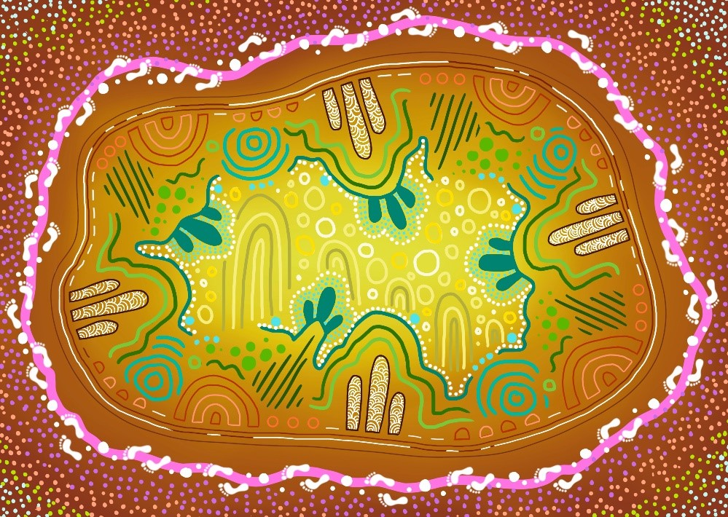  
Artwork Description: Guiding Stars**

This vibrant artwork, titled ‘Guiding Stars’, symbolizes the unity and shared decision-making embodied by the Early Childhood Care and Development Policy Partnership (ECCDPP).

The central motif of interconnected patterns and shapes represents the coming together of Aboriginal and Torres Strait Islander leaders, families, and government representatives, all working harmoniously to ensure the well-being and cultural richness of the youngest children. The bright, swirling elements signify the Guiding Stars, an ancestral reminder of the wisdom and strength that guide the community in making decisions for a brighter future. Surrounding footprints depict the journey of collaboration and continuous support from the community, creating a nurturing environment where every child can thrive and remain connected to their heritage. This piece is a celebration of the ECCDPP's commitment to fostering early childhood development and closing the gap for Aboriginal and Torres Strait Islander children.

**Artist Biography**

Tovani Cox is a proud Bunuba, Gija and Karajarri woman from the Kimberley region of Western Australia.

Born in Broome, Tovani is passionate about art and design and often her inspiration is from her long-standing commitment to self-determination and rights of first nations people and communities.

She was predominantly raised in Noongar country in Perth, and since early 2017 has been living in Melbourne on Wurundjeri country, and travels home to the Kimberley as often as she can to connect with kin and country.

Tovani has qualifications in Digital Graphic Design from RMIT University,and wants to pursue further skills and training using art as therapy and healing.