

**Suburban University Study Hubs**

2024 Targeted Round Application Guide

The purpose of this document is to assist applicants for the targeted round of the Suburban University Study Hubs Program (the Program) to prepare their application. It contains detailed advice on how to respond to each question.

**Applications must be submitted using the** [**online form**](https://submit.dese.gov.au/jfe/form/SV_e9WjAIOzJIcDuho).

Contents

Purpose 4

The Targeted Round 4

Overview: Application process 6

Application Stage 1 9

Expression of Interest (EOI) 9

Getting help 9

Privacy statement 9

Expression of Interest: Sections 9

Guide instructions 9

Part A: Hub details and eligibility 10

1. Applicant organisation 10

2. Hub Name 10

Contact details 10

3. Authorised person 10

4. Primary contact officer 11

Proposed site (or sites) 11

5. Details of proposed site (or sites) 11

Program eligibility and targeted round requirements 12

6. Eligible location 12

7. Identified SA2 (or SA2s) 12

8. New Hub locations 13

9. Body corporate 14

10. Fit and proper person 14

Part B: Budget Proposal 16

Budget proposal 16

Operational budget 16

Capital works budget 17

Part C: Hub Proposal Summary 18

Key Assessment Consideration 1: Community need 18

Key Assessment Consideration 2: Community involvement 19

Key Assessment Consideration 3: Readiness to operate 20

Part D: Presentation 21

Key Assessment Consideration 1: Community need 22

Key Assessment Consideration 2: Community involvement 22

Key Assessment Consideration 3: Readiness to operate 22

Key Assessment Consideration 4: Appropriate and sustainable budget 22

Part E: Supporting documents and materials 24

Part F: Declarations 24

Application Stage 2 25

Part A: Presentation 25

Part B: Financial risk management 25

Assessment 26

Key assessment considerations and scoring 26

Assessment Process 27

Assessment Stage 1: Preconditions Eligibility 27

Assessment Stage 2: Assessment of Weighted Considerations 27

Assessment Stage 3: Moderation and Final Assessment 27

Assessment Process Map 28

Appendix A: Identified Statistical Areas Level 2 29

Queensland – Clusters 29

New South Wales – Clusters 31

Victoria – Clusters 33

## Purpose

This Application Guide is intended to serve as a guide for potential applicants to the Suburban University Study Hubs Program Targeted Round.

It will explain the Targeted Round and how to apply, covering eligibility criteria and information about the assessment process.

Further information about the Program, including the online application form is available on the [Suburban University Study Hubs](https://www.education.gov.au/node/16756) webpage.

Applicants should read this 2024 Targeted Round Application Guide in conjunction with the [Suburban University Study Hubs – Program Guidelines](https://www.education.gov.au/preview-link/node/18756/ddd902b2-5eb4-40f3-8540-6ed6e1027dd4) (the Program Guidelines) **before** applying.

The Program Guidelines contain further information on the program including:

* background and objectives
* eligibility criteria
* application and assessment process
* funding available, including estimated operating costs and GST
* managing funds, including use and payment of grant funds
* administration and reporting.

**Applications for funding will be accepted until 12:00pm, noon, (AEDT), 17 January 2025.**

## The Targeted Round

**Overview**

Following the initial round of Suburban University Study Hubs (SUSHs), the Department of Education (the department) identified 7 key clusters of Statistical Areas Level 2 (SA2s) that remained underrepresented based on the outcomes of the initial round (Round 1):

* Southern Brisbane and Western Brisbane
* Western Sydney and South-western Sydney
* Southeast Melbourne, Western Melbourne and Southwest of Melbourne (including Geelong)

This targeted application round aims to establish up to 4 new hubs within these SA2s identified for their population density, community need, geographic spread and their potential to improve access to higher education.

Appendix 1 provides a breakdown of eligible SA2 areas in the 7 key clusters.

##### Queensland

The two clusters of 40 identified SA2s in Queensland are the Brisbane South corridor from Logan to Beenleigh and the Brisbane West corridor from Acacia Ridge to Ipswich. These areas have diverse and rapidly growing populations, including many with low income and culturally diverse families.

##### New South Wales

In New South Wales, the two clusters of 45 identified SA2s are the Sydney West corridor from Blacktown to Penrith and the Sydney Southwest corridor from Campsie to Bankstown and from Auburn to Ashcroft. Western and southwestern Sydney are densely populated and culturally diverse areas with many first-in-family university students.

##### Victoria

Victoria has 3 clusters of identified SA2s: the Melbourne Southeast corridor from Dandenong to Frankston; some underserved areas of Melbourne West around Sunshine and St Albans; and the Melbourne Southwest cluster which includes parts of Werribee, and parts of Geelong. These areas have growing populations with diverse demographic profiles, including many from lower socio-economic backgrounds and culturally diverse communities.

The targeted round will maintain the same 5 key assessment considerations used in the initial round (Round 1) of community need, community involvement, readiness to operate, appropriate and sustainable budget and geographic spread.

Successful applicants are expected to finalise Conditions of Grant with the Department in early 2025 and be operational during the second half of 2025.

**Available funding**

The Government approved $32.5 million to support the establishment of up to 14 Suburban University Study Hubs, with some funding already allocated through a previous competitive application process. For the targeted round, the Commonwealth will use the remaining funds (estimated to be about $9 million) from this commitment to support up to 4 additional hubs.

**Timeframes**

**Important: Applicants invited to progress their application to the presentation stage will need to be available the week beginning 27 January 2025.**

## Overview: Application process

The application process consists of two stages:

1. **Expression of Interest (EOI):** Submit an online EOI form which includes responses to eligibility criteria and a Hub proposal ’pitch’, and detailed budget proposal.
2. **Presentation + Q&A:** Eligible applicants will be invited to provide a short presentation to the Panel, where clarification may be sought, and final assessments would be undertaken.

**Stage 1. Submit online Expression of Interest form by 12:00pm AEDT, Friday 17 January 2025.**

|  |  |
| --- | --- |
| Details | Mode |
| 1. Hub details and eligibility   Applicants will need to meet all of the below criteria (i.-iv.) to be considered for funding:   1. Eligible Location in an Identified Area:   Hubs will only be established in a location that will serve one or more locations classified by the ABS as Quintiles 1 (Q1) and 2 (Q2) in Statistical Area Level 2 (SA2), according to the Index of Relative Socio-Economic Advantage and Disadvantage (IRSAD) which is one of the Socio-Economic Indexes for Areas (SEIFA).   * A location must be categorised as a Major City of Australia under the ABS Remoteness Structure; and * A SA2 classified as either Quintile 1 or 2 according to the ABS SEIFA Index of IRSAD and * A SA2 which is in an Identified Area as per Tables 1-3 in Appendix A.  1. New Hub only; 2. Body corporate; and 3. Fit and proper person. | EOI Online Form Questions |
| 1. Budget proposal (3 years – 2024-25 to 2026-27)   The budget proposal must demonstrate value for money, with clear justifications provided for line-item expenditure.  Where capital works are required, the panel will assess the refurbishment for its ability to address functional requirements and enhance operational efficiency in a targeted cost-effective manner. Full scale refurbishments and major capital works will not be considered cost-effective.  The budget proposal will include:   * operational costs * capital works * a summary of sustainability and readiness strategies e.g. co-contribution commitments from partners and/or stakeholders. | Upload of Excel template to EOI Online Form |
| 1. Hub proposal summary (maximum 10 A4 single-sided pages)   The Hub proposal ‘pitch’ is a concise synopsis, which outlines three of the key assessment considerations, including:   1. Community need 2. Community involvement 3. Readiness to operate | Upload document to EOI Online Form |
| 1. Presentation and Q&A (maximum 15 slides)   All applicants who satisfy initial eligibility checks by the SUSH team will be invited to make a detailed presentation to the Assessment Panel (the Panel) the week beginning 27 January 2025.  The presentation expands on the hub proposal and should cover the following topics:   1. Community need 2. Community involvement 3. Readiness to operate 4. Appropriate and sustainable budget | Upload slides and to EOI Online Form  Include speaking notes in ‘Part E: Supporting docs’ |
| 1. Supporting documents (maximum 15 pages single-sided)   Applicants are able to submit additional information to support claims made. | Upload document to EOI Online Form |

**Stage 2. Week beginning 27 January 2025**

|  |  |
| --- | --- |
| Details | Mode |
| Presentation and Q&A (maximum 15 slides)  Presentations will be held the week beginning 27 January 2025. Each eligible applicant will be allocated 30 minutes, which includes 15 minutes presentation time, plus the option for the Panel to ask clarifying questions to substantiate claims.  Applicants must ensure they have representatives available during their allotted presentation time that can respond to any clarifying questions about all aspects of the submission including the budget, hub proposal and presentation. | Via Microsoft Teams online presentation (dates/times to be advised) |
| Financial Viability and Credential Check   * Applicants must satisfy the department that their organisation is financially viable to receive funding.   *Note: Table A providers under section 16-15 of the Higher Education Support Act 2003 (HESA) and those who have previously applied for funding under this program will not be required to undertake a financial viability and credential check.* | The department will provide details via email to those applicants required to provide a Financial Viability and Credential form. |

# Application Stage 1

## Expression of Interest (EOI)

Online Expressions of Interest (EOI) open on **18 November 2024 and close at 12pm (AEDT), Friday 17 January 2025**. Applicants can amend the online EOI form at any time prior to the closure of the application period. If you have submitted an EOI and need to make changes, please contact [suburbanhubs@education.gov.au](mailto:suburbanhubs@education.gov.au)

All EOIs must be submitted via the [online form](https://submit.dese.gov.au/jfe/form/SV_e9WjAIOzJIcDuho) hosted using the Qualtrics platform.

### Getting help

If applicants require assistance completing the online EOI form, please refer to the [Frequently Asked Questions](https://www.education.gov.au/preview-link/node/18760/50ae7e87-d146-4f7c-9a73-4a11286ca973) or contact the department at [suburbanhubs@education.gov.au](mailto:suburbanhubs@education.gov.au)

An information session will be available at [Suburban University Study Hubs 2024 Targeted Application Round](https://www.education.gov.au/preview-link/node/18736/85871247-eb96-4d6d-9a59-6b4695b514db), along with the details for any Question-and-Answer sessions.

Only technical queries about the submission of the application will be accepted after **13 January 2025** to allow time to publish updated Frequently Asked Questions.

### Privacy statement

The application form includes a privacy statement detailing the collection and use of personal and sensitive information by the department. All applicants must consent to the collection and use of both personal and sensitive information provided by themselves or others within the application.

### Expression of Interest: Sections

The online EOI includes questions that address all program eligibility requirements, and sections for uploading required attachments. All sections should be completed in full.

The application form contains the following sections:

* Part A: Hub details and eligibility
* Part B: Budget proposal
* Part C: Hub proposal summary
* Part D: Presentation
* Part E: Supporting documents
* Part F: Declarations

### Guide instructions

The instructions for completing the online EoI form in Qualtrics are formatted as follows:

* **Preview of question as worded in the Qualtrics online form**
* Detailed instructions and guidelines to read and consider before responding to each question.
* *Use of italics indicates either:*
  + *A note that provides additional information specific to the question*
  + *Information about Qualtrics functionality such as navigation, branching or response validation requirements.*

## Part A: Hub details and eligibility

### Applicant organisation

**What is the name of the organisation seeking to establish a Suburban University Study Hub?**

*Note: if successful, the organisation's name may be used in public media material, including any Ministerial announcements.*

### Hub Name

**What is the name of the proposed Suburban University Study Hub?**

The proposed Hub name should reflect the community and catchment area it services (for example, *Catchment* Suburban University Study Hub).

To ensure open access for all tertiary students, the Hub name should not mention any specific education provider.

The Program delegate must also agree to the Hub name as part of the Conditions of Grant.

*Note: if successful, the Hub name may be used in public media material, including any Ministerial announcements.*

## Contact details

### Authorised person

**Provide details of the person who is authorised to submit this application on behalf of the organisation seeking a Suburban University Study Hub.**

* **Full name**
* **Organisation name**
* **Position title or role**
* **Phone number**
* **Email address**
* **Postal address**

This should be either the Chief Executive Officer (CEO), Chair of the Board, Director or other equivalent executive with the requisite authority.

### Primary contact officer

**Provide details of an additional primary contact person (other than the authorised person) who can be contacted for queries in relation to the application.**

* **Full name**
* **Organisation name**
* **Position title or role**
* **Phone number**
* **Email address**
* **Postal address**

The department requests details of a primary contact that can respond to application queries. This person should be different to the authorised person listed in Question 3.

## Proposed site (or sites)

### Details of proposed site (or sites)

**5a. Provide details of the first proposed site for the Suburban University Study Hub.**

* **name of proposed site 1 or building name (not Hub name).** 
  + If you are using an existing facility such as a TAFE campus, local community centre, or other, provide the name or block within that facility. If it is a new facility, provide NA in this field.
* **street address of the proposed site 1**
* **expected date of operation.** 
  + It is anticipated that Hubs will be operational in the second half of 2025.

In selecting an appropriate site to establish a Hub, consideration should be given to leveraging existing community and social infrastructure.

When selecting a proposed location, applicants should also consider whether other services (for example, childcare and medical facilities) and public transport are near the site.

Applicants should consider their on-site staff and anticipated student load during peak periods to ensure the proposed building size and planned facilities are appropriate.

**5b. Does the proposed Hub include multiple or satellite sites, such as a hub-and-spoke model?**

*If yes, applicants will be required to provide the above details for the second proposed site (at 5c).*

Applicants who are applying for multiple sites should consider if applying for each Hub separately would be more appropriate. When considering this option, applicants should determine if efficiencies in governance, staffing and general Hub operation can be made by operating as one, under a hub-and-spoke model.

Complete a separate EOI form if you would like to apply for two distinct and separately run Hubs.

The online form allows for up to two (2) sites to be listed. If the application request is for more than this, please contact [suburbanhubs@education.gov.au](mailto:suburbanhubs@education.gov.au) for advice, or include additional information in ‘Part D: Supporting documents’.

## Program eligibility and targeted round requirements

To be considered for funding under the program, the applicant must meet **all** of theeligibility criteria at Questions 6, 8-10 and the targeted round requirements at Question 7.

Any eligibility requirement/s not met will result in an invalid application and will not progress to the assessment stage.

### Eligible location

**Is the site (or sites) for your proposed Hub located in an eligible area as outlined in the Application Guide?**

Suburban University Study Hubs will be established in areas that will benefit most from their presence, with an emphasis placed on supporting under-represented and disadvantaged students from suburban areas with low tertiary education participation who face increased barriers to accessing tertiary study.

Hubs must fall within:

* an eligible Statistical Area Level 2 (SA2) that is classified as Quintile 1 or 2 according to the Australian Bureau of Statistics (ABS) Index of Relative Socio-Economic Advantage and Disadvantage (IRSAD);[1] and
* an eligible geographic classification of ‘Major Cities of Australia’ (Code: RA0), as per the ABS Australian Statistical Geographic Standard (ASGS) Remoteness Areas classification[2]

or ‘Greater Darwin’ or ‘Greater Hobart’ under the ABS ASGS Greater Capital City Statistical Areas classification.[3]

Applicants should access the department’s [interactive map](https://sharedservices.carto.com/u/ssc/builder/714ae73c-3990-41bb-a7a1-2fb230bcffa3/embed.) to determine whether their proposed Hub location will be in an eligible area.

*Note: If the proposed Hub site(s) do not fall within an eligible area as outlined above, applicants will not be able to progress through the application form.*

### Identified SA2 (or SA2s)

**7a. Is the site (or sites) for your proposed Hub located in an Identified SA2 as outlined in Tables 1-3 of Appendix A in the Application Guide?**

The targeted round will support up to 4 applications for Hubs located in an eligible SA2 within one of the seven identified clusters. A full list of identified SA2s can be found in Tables 1-3 and shown in Maps 1-7 provided at Appendix A.

*Note: If the proposed Hub site (or sites) does not fall within an Identified SA2 (or SA2s), applicants will not be able to progress through the application form.*

**7b. In which Identified SA2 (or SA2s) is your proposed site (or sites) for the Suburban University Study Hub located?**

* **Site 1: Name of identified SA2**
* **Site 2: Name of identified SA2 (optional)**

Applicants should use the [interactive map](https://sharedservices.carto.com/u/ssc/builder/714ae73c-3990-41bb-a7a1-2fb230bcffa3/embed.) and/or Tables 1-3 in Appendix A to find the name of the identified SA2 for each proposed site (or sites).

If only applying for a single site, applicants do not need to provide a response for Site 2 at question 7b.

### New Hub locations

**Is the site (or sites) for your proposed Hub currently delivering a similar or equivalent service or in receipt of funding from the Australian Government or State or Territory Government for a similar or equivalent service?**

To ensure Suburban University Study Hubs are established in areas with the highest need, funding is only available for new Hubs. Existing facilities providing similar or equivalent services are ineligible to apply.

Hubs which are not currently operational and/or do not meet the similar or equivalent service criterion below may be classified as new.

A similar or equivalent service will include:

* some, or all, of the facilities described as infrastructure; **and**
* some, or all, of the services listed in administrative and academic skills support and/or student support services.

|  |  |
| --- | --- |
| **Facilities or Services** | **Examples** |
| Infrastructure | study spaces, break out areas, video conferencing, computer facilities, internet access |
| Administrative and academic skills support services | developing writing and research skills, managing administrative processes |
| Student support services | General wellbeing support, study advice, help accessing student services, supporting students with placements and Work Integrated Learning, careers advice |

Consideration should be given to the extent to which the service or facilities provides for these aspects, and who is able to access the service.

If you are unsure, you may submit an expression of interest, which will be assessed for eligibility by the department. Select ‘No’ to this question to progress your application.

*Note: If the proposed Hub site(s) is existing and providing similar or equivalent services as outlined above, applicants will not be able to progress through the application form.*

### Body corporate

**9a. Indicate the current status of the applicant organisation in complying with the body corporate requirement by selecting one of the following:**

* **The applicant organisation is currently a body corporate** 
  + *Applicants are directed to question 9b to upload evidence.*
* **The applicant organisation is a Table A or B provider (under *HESA)*.** 
  + *Applicants proceed to question 10.*
* **The applicant intends to establish a body corporate if successful** 
  + *Applicants are directed to question 9c to provide further information.*

Applicant organisations must be, or be able to become, a body corporate to be eligible for funding under this Program. If an application is successful, approval of a grant is contingent on the applicant organisation successfully incorporating.

Table A and Table B providers listed in the [*Higher Education Support Act* *(2003)*](https://www.legislation.gov.au/C2004A01234/latest/text) are also eligible under this program.

**9b. Upload evidence of your organisation’s incorporation e.g. the ‘Certificate of Incorporation’ or the 'ABN Lookup' statement.**

*Acceptable file formats are PDF, Document (DOC, DOCX, TXT, ODT) or Graphic (JPG, PNG, GIF). If an incorrect document is uploaded, applicants can replace it by using the ‘drag and drop’ functionality, or by clicking in the grey area of the upload box and selecting the correct file.*

**9c. For prospective body corporates, provide further detail of the process of applying for incorporation.**

* **Proposed name of entity**
* **Submission date of application (if known)**

Applicants will be required to provide evidence of eligibility/capability to become a body corporate at least seven days prior to the Conditions of Grant being issued.

### Fit and proper person

The ‘fit and proper person’ requirement focuses on the organisation’s business and financial affairs and on its compliance with relevant regulatory schemes. The individual completing this requirement must be the Chief Executive Officer (CEO), Chair of the Board, Director or other equivalent executive authorised to do so on behalf of the proposed Suburban University Study Hub.

Before allocating funding under the Program, the Minister must be satisfied that the recipient organisation, and each person who makes or participates in making decisions that affect the whole or a substantial part of the organisation’s affairs, is a ‘fit and proper person’, in accordance with section 3.5 of the Program Guidelines. In making this decision, the Minister and/or their Delegate will consider matters like those described in paragraph 6.2 of the *Higher Education Support (Fit and Proper Person) Instrument 2019.[4]*

Applicants must advise of any matters pertaining to:

* **the organisation’s solvency**
* **the provision of false or misleading statements or information to the minister**
* **the organisation’s business dealings that impugn its honesty or integrity**
* **personal bankruptcy**
* **personal disqualifications from managing corporations**
* **personal involvement with a higher education or VET provider who has had conditions imposed or approval revoked.**

*Note: If an applicant answers ‘yes’ to any of the questions contained within the ‘fit and proper person’ section of the application, the department will be in contact for further information.*

If applicants have any concerns or questions about any of the eligibility criteria for a proposed Suburban University Study Hub, please contact [suburbanhubs@education.gov.au](mailto:suburbanhubs@education.gov.au).

## Part B: Budget Proposal

|  |
| --- |
| **Key assessment consideration 4** |
| Appropriate and sustainable budget |

In drafting the budget proposals, applicants should pay particular attention to value for money and ongoing sustainability of the project. The panel is seeking evidence of co-contribution and additional funding sources in their assessment of applications. Applicants should also provide clear rationale for planned expenditure.

Where capital works are required, the panel will assess the refurbishment for its ability to address functional requirements and enhance operational efficiency in a targeted cost-effective manner. The capital works budget should not take up more than 25% of the overall budget.

Full scale refurbishments and major capital works will not be considered cost-effective.

The budget proposal will include:

1. Operational, and
2. Capital works

### Budget proposal

**Upload a detailed Budget Proposal outlining expected income and expenditure for the proposed Hub from 2024-25 to 2026-27 using the**[**2024 Targeted Round Budget Proposal Template**](https://www.education.gov.au/preview-link/node/18758/715b92e6-1c59-492c-96bd-37902cb67180).

**Table 1:** The budget must clearly indicate the grant funding (excluding GST) sought from the Australian Government to deliver the Hub. Detailed expenditure for the total funding period 2024-25 to 2026-27 should be clear and realistic. The budget must be provided by financial year and cover the total funding period, reflecting the anticipated operational period.

**Table 2:** The budget must also identify other sources of income (if any), including any actual or anticipated funding through Hub partnerships and detail how that funding, together with program funding, would be used to establish and operate the Hub.

The budget proposal aims to provide the Assessment Panel clarity on how funding will be allocated and enable effective decision-making aligned with the section 15 of the *Public Governance, Performance and Accountability Act 2013*, which sets out the requirements of accountable authorities (the department) to ensure that public resources are used efficiently, effectively, economically and ethically.

### Operational budget

The operating budget is a critical part of the application. It allows the applicant to outline the financial resources needed to effectively operate the Suburban University Study Hub. The proposal should demonstrate that you have planned thoroughly for both immediate and ongoing costs to support sustainable and efficient operations.

### Capital works budget

Capital works funding should be included in the budget proposal. The program **does not** fund large-scale capital works, and successful applicants cannot use funding to purchase property or land. Funding can contribute towards fit-out costs to upgrade existing infrastructure (capital works) to ensure the proposed site is fit for purpose in the first year of the Program. Applicants should aim for capital works budgets that make up no more than 25% of the overall funding requested. Works may include:

* installation of interior walls/doors
* secure swipe card access to support after-hours access
* painting
* floor coverings.

Successful applicants will be required to provide a comprehensive Capital Works Plan to the program delegate for approval prior to undertaking any works. This may include the provision of evidence to support claims.

The Assessment Panel may seek clarification from applicants on any aspect of their budget proposal either during or following the presentation. This may include asking applicants to submit a revised budget based on feedback from the panel.

Applicants should be aware that even if an application is successful, funding amounts are subject to negotiation, and the Program Delegate will determine the final amount of funding to be approved.

*Acceptable file formats are Spreadsheet (CSV, XLS, XLSX, ODS). If an incorrect document is uploaded, applicants can replace it by using the ‘drag and drop’ functionality, or by clicking in the grey area of the upload box and selecting the correct file.*

## Part C: Hub Proposal Summary

**Upload your Hub Proposal Summary which provides a brief synopsis of your ‘pitch’ against 3 key assessment considerations: community need, community involvement and readiness to operate.**

The Hub Proposal **must not exceed 10 single-sided A4 pages**. Any additional pages provided will not be assessed by the assessment panel.

The hub proposal should be formatted as follows:

|  |  |  |
| --- | --- | --- |
| **Font** | **Font size** | **Margins** |
| Calibri | 12 | Normal |

The Hub proposal is a concise synopsis which highlights key elements of the Hub Presentation. It should include a brief description covering 3 key assessment considerations:

**Key Assessment Consideration 1:** Community need, covering:

* community impact
* support for lifting tertiary attainment

**Key Assessment Consideration 2:** Community involvement, covering:

* collaboration with key education and community services

**Key Assessment Consideration 3:** Readiness to operate, covering:

* governance and staffing arrangements.

Note: **Key Assessment Consideration 4: Appropriate and sustainable budget** is assessed under Part B of the application process.

Applicants should consider using data and research to support their claims. Data can be found through [Australian Bureau of Statistics Census](https://www.abs.gov.au/census/find-census-data/search-by-area). If applicants need assistance or guidance with data, please contact the department at [SuburbanHubs@education.gov.au](mailto:SuburbanHubs@education.gov.au)

*Acceptable file format is PDF. If an incorrect document is uploaded, applicants can replace it by using the ‘drag and drop’ functionality, or by clicking in the grey area of the upload box and selecting the correct file.*

### Key Assessment Consideration 1: Community need

|  |
| --- |
| **Key element 1: Proposed community impact** |

Applicants are asked to provide a brief overview of the expected impact that the proposed hub will have on the community.

Responses should address the following aspects:

**Target population and needs:** Describe the community groups or demographics you aim to serve and highlight any specific educational or social needs the hub will specifically address. Applicants may also wish to consider future needs of their community.

**Educational access and outcomes:** Outline how the Hub will support educational access, equity and academic outcomes. Applicants should consider their local community, existing facilities and gaps in services that may be fulfilled by a hub.

**Community benefits and engagement:** Explain the broader benefits to community. Applicants may wish to consider how partnerships may increase community engagement in education or how the hub aims to bridge identified skills gaps within the local or broader community.

**Expected reach and scale:** Outline the number of students the hub is aiming to support at any one time. Applicants should consider the proposed site and resource capacity, as well as other offerings or major campuses nearby.

|  |
| --- |
| **Key element 2: Support for lifting tertiary attainment** |

Applicants will be required to outline the innovative approaches they will take to deliver positive outcomes for students and strategies for lifting tertiary attainment in the local community.

Applicants may wish to consider:

**Academic support and resources:** Describe the types of academic assistance that will be offered. This may include tutoring services, mentoring programs, workshops or access to learning resources. Applicants are also asked to briefly describe the hub location and facilities including any existing campuses in the area. Outline how these services will help students succeed.

**Guidance and pathways to higher education:** Outline any initiatives that will help students navigate pathways to tertiary education, that may include support with university applications, financial aid guidance and career planning.

**Retention and student engagement:** Explain any strategies aimed at improving retention and engagement among students, especially those from underrepresented backgrounds. Applicants may wish to consider peer networking, social support or programs which assist students with time management.

**Community partnerships and outreach:** Describe any partnerships with local schools, universities, TAFE/VET providers or other community groups that will encourage students to pursue and complete tertiary education, and how these will enhance the hub’s impact.

### Key Assessment Consideration 2: Community involvement

|  |
| --- |
| **Key element 3**: **Collaboration with key education and community services** |

Applicants are asked to provide a description of how the hub will collaborate with key education and community services to enhance impact for students.

Responses should cover the following:

**Identifying key partners:** Describe the educational institutes, community organisations and local services you plan to collaborate with. Highlight why these partners are essential to the hub’s goals and the overarching program objectives.

**Collaborative activities and initiatives:** Outline the specific programs, activities or initiatives that will be jointly developed or supported with these partners. Applicants may wish to consider workshops, joint outreach activities, resource sharing and referral pathways.

**Community and stakeholder engagement:** Describe any strategies to actively engage community stakeholders and ensure the hub’s services are well-integrated and widely known within the community. Applicants may wish to consider their marketing strategies and board/committee memberships.

**Sustaining long-term relationships:** Explain how you plan to build and sustain these partnerships over time, including any agreements, regular meetings, feedback loops or mechanisms for collective decision making that will ensure strong enduring relationships with key partners.

### Key Assessment Consideration 3: Readiness to operate

|  |
| --- |
| **Key element 4: Governance arrangements and staffing** |

Applicants are asked to provide an overview of the governance arrangements and staffing structure that will support the effective management, oversight and delivery of services at the hub.

Response should cover the following:

**Leaderships and governance structure:** Describe the overall governance structure, including any committees, boards or advisory groups, and their roles in overseeing the hub. Outline key decision-making processes and how accountability will be maintained within the leadership team.

**Staffing model and key roles:** Provide details on the staffing model for the hub, including the number and types of positions (e.g., hub manager, student support staff, First Nations engagement, academic advisors, etc.). Explain the responsibilities of each role and how they contribute to the hub’s goals and meet the needs of the community they will serve. Applicants should consider how partnership arrangements could be leveraged to support services.

**Staffing qualifications and experience:** Highlight the qualification (if required), or skills needed for key roles. Describe plans for staff training or professional development to ensure quality service delivery.

**Compliance, risk management and support:** Explain the governance and staffing strategies for managing compliance and risk, including oversight for financial management, health and safety, data protection, and any other regulatory requirements. Describe how staff will be supported in maintaining these standards.

**Monitoring, evaluation and continuous improvement:** Describe the systems you will use for monitoring staff performance and evaluation the hubs impact. Explain how data will be used to improve services and support ongoing staff development.

**Sustainability and succession planning:** Provide an overview of plans for long-term sustainability of both the governance and staffing structures, including strategies for managing turnover, scaling operations, or adapting roles as the hub grows.

## Part D: Presentation

**Presentation slides should be converted to a PDF file and uploaded to this section.**

**Applicants should expand on their Hub proposal and address the 4 key assessment considerations:**

* **community need**
* **community involvement**
* **readiness to operate**
* **appropriate and sustainable budget.**

*Acceptable file format is PDF to a maximum of 50MB. Please limit total slides to****15****. Any slides beyond this limit****will not****be considered by the Assessment Panel.*

*No additional attachments should be provided. A maximum of****3****pages of speaking notes should be included in 'Part F: Supporting Documents'.*

*If an incorrect document is uploaded, applicants can replace it by using the ‘drag and drop’ functionality, or by clicking in the grey area of the upload box and selecting the correct file.*

Applicants who satisfy the initial eligibility criteria for program funding will be invited to present their hub proposal to the assessment panel. This is an opportunity for applicants to pitch their vision in an engaging and dynamic way, using visual aids to support their presentation. Applicants should use this opportunity to provide a clear rationale and justification for the design of their hub, the proposed services, and how their proposed budget aligns with the Suburban University Study Hub program objectives.

The presentation should be a maximum of **15 slides** which can be delivered within **15 minutes** covering the 4 key assessment considerations:

**Key Assessment Consideration 1:** Community need

**Key Assessment Consideration 2:** Community involvement

**Key Assessment Consideration 3:** Readiness to operate

**Key Assessment Consideration 4:** Appropriate and sustainable budget

Each key assessment criteria should expand on the key elements outlined in the hub proposal.

Following the presentation the Panel may ask clarifying questions related to any aspect of the budget proposal, hub proposal or presentation. Applicants should consider this when selecting their presentation representatives to ensure they are well-prepared to address detailed questions and provide insightful responses. Presentations will take place the week beginning 27 January 2025.

### Key Assessment Consideration 1: Community need

|  |
| --- |
| **% of overall weighting** |
| 40% |

This section requires applicants to expand on key elements 1 and 2 of the Hub Proposal. Topics should include:

* target population and needs
* educational access and outcomes
* community benefits and engagement
* expected reach and scale
* academic support and resources
* guidance and pathways to higher education
* retention and student engagement
* community partnerships and outreach.

### Key Assessment Consideration 2: Community involvement

|  |
| --- |
| **% of overall weighting** |
| 15% |

This section requires applicants to expand on key element 3 of the Hub Proposal. Topics should include:

* identified key partners
* collaborative activities and initiatives
* community and stakeholder engagement
* sustaining long-term relationships

### Key Assessment Consideration 3: Readiness to operate

|  |
| --- |
| **% of overall weighting** |
| 25% |

This section requires applicants to expand on key element 4 of the Hub Proposal. Topics should include:

* leadership and governance structure/s
* staffing model and key roles
* compliance, risk management and support
* monitoring, evaluation and continuous improvement
* sustainability and succession planning.

### Key Assessment Consideration 4: Appropriate and sustainable budget

|  |
| --- |
| **% of overall weighting** |
| 20% |

This section requires applicants to expand on their budget proposal and capital works plans. Topics should include:

* co-contributions, in-kind support and strategies for the hubs long-term sustainability
* alternate funding source
* appropriateness of capital works
* overall value proposition.

## Part E: Supporting documents and materials

**Combine any supporting documents or materials related to your application into one file and upload to this section.**

*A maximum of 15 single-sided A4 page limit applies. Additional pages (above the maximum 15) will not be assessed by the assessment panel.*

*Acceptable file types are PDF or a Zipped folder (ZIP).*

There is no need to duplicate information that will be provided in the hub proposal or presentation.

Applicants may wish to provide additional evidence to support claims such as:

* map/s with site clearly located
* photos
* floor plans and technical drawings and designs
* quotations
* location of current tertiary education services and facilities in the community and their distance to the proposed site(s)
* summarised qualitative or quantitative data on the local area, e.g. local survey findings, current student enrolment and attainment data for higher education and VET services
* summary of research demonstrating current and future workforce needs in the local area
* relevant information which provides an overview of policies and procedures to manage the establishment and operation of the Hub, e.g. risk management plan, organisational chart, insurance policies
* agreements or letters of recommendation that detail the commitment from the local community organisations, businesses, or volunteers to support the operation of the Suburban University Study Hub. *Note: letters of recommendation should only be provided by people who would be directly involved in supporting the proposed Hub, e.g. through volunteering, partnerships, etc.*
* speaking notes for the presentation slides (3 pages maximum)

## Part F: Declarations

Applicants are required to agree to a series of statements acknowledging program obligations and conditions, as well as declaring authorisation to apply on behalf of the organisation.

**Confirmation**

Before submission, a confirmation page will appear generating an application reference number. Please use this reference number in communications with the department.

Upon submission, you will be emailed a copy of your EoI form responses.

# Application Stage 2

## Part A: Presentation

All eligible applicants will be invited via email to pitch their ideas for a hub to the Panel. The presentations will take place the week beginning 27 January 2025 and we have allowed a maximum of 30 minutes, including 15 minutes for presentations and 15 minutes for the Panel to ask questions regarding the submission.

Presentations must be no more than 15 slides and should build on your Hub proposal.

Applicants must have the appropriate representatives available during their allotted presentation time that can respond to any clarifying questions or additional information the Panel my request about any aspects of the submission including the budget proposal, hub proposal or presentation.

## Part B: Financial risk management

As part of stage 2, applicants must provide the department with information on the applying entity’s credentials and financial viability.

Applicants must satisfy the department that their organisation is financially viable to receive funding. The required ‘Financial and credentials information form’ must be submitted once funding is approved. The department will work with applicants to coordinate the collection and assessment of these forms. These forms will be assessed prior to signing Conditions of Grant to ensure any necessary mitigation strategies are in place.

*Note: Table A providers under HESA and those who have previously applied for funding under this program will not be required to undertake a financial viability and credentials check.*

# Assessment

The Department of Education will assess applications against the eligibility criteria in accordance with Stage 1, Part A of these guidelines.

Additionally, applications will be assessed against 4 weighted and 1 unweighted key assessment considerations in accordance with Stage 1, Parts B and C, and Stage 2, Part A.

## Key assessment considerations and scoring

Suburban University Study Hub applications will be considered based on location of proposed Hubs and the quality of the application to service the relative needs of the community.

| **Key assessment considerations** | **Key elements** | **Max. Score** | **Overall % weighting** |
| --- | --- | --- | --- |
| 1. Community need | 1. Proposed community impact 2. Support for lifting tertiary attainment. | 10 | 40% |
| 1. Community involvement | 1. Collaboration with key education and community services. | 5 | 15% |
| 1. Readiness to operate | 1. Governance arrangements and staffing 2. Proposed site | 10 | 25% |
| 1. Appropriate and sustainable budget | 1. Co-contributions & in-kind support 2. Alternate funding sources 3. Strategies for sustainability | 15 | 20% |
| 1. Geographic spread | 1. A min. 20 minutes by public transport to other services will be considered under geographic spread. | NA | unweighted |

Applications will be given a total score out of 40, which will then have a weighted percentage applied. A benchmark total weighted score of 60% will be applied as a minimum threshold for suitability.

The Assessment Panel will assess responses to each assessment consideration and provide a rating of either:

* Highly Suitable
* Suitable
* Unsuitable

When an application receives a suitability rating of ‘Unsuitable’ for any individual criteria, that application’s final suitability rating is ‘Unsuitable’ regardless of the final score.

|  |  |  |
| --- | --- | --- |
| **Rating** | **Total (unweighted) Score** | **Total (weighted) Score** |
| Unsuitable | <23 | <60 |
| Suitable | 24-31 | 61-79 |
| Highly Suitable | 32-40 | 80-100 |

## Assessment Process

The assessment process will be undertaken in 3 stages.

### Assessment Stage 1: Preconditions Eligibility

This stage will be undertaken by the Suburban University Study Hubs Team (the Team) in the Department of Education, who will assess the application against the eligibility criteria set out in Stage 1, Part A of these guidelines.

Applicants who meet the eligibility criteria will be invited by the Team to present their ideas for a hub directly to the panel. Applicants will be given a deadline by which to submit their slides to the department in preparation.

### Assessment Stage 2: Assessment of Weighted Considerations

This stage will be undertaken by the Assessment Panel (the Panel) consisting of department employees at Senior Executive Level.

The Panel will assess the submitted budget proposal, hub proposal and presentation as one against the 4 weighted key assessment considerations. A score will be applied out of 40, then weighting will be applied to determine a ranked list of applicants.

### Assessment Stage 3: Moderation and Final Assessment

This stage will be undertaken by the Panel and will consist of moderation of scoring, applying any necessary adjustments. The Panel will then assess geographic spread by consideration of needs, population density, accessibility to education facilities and underserved areas to ensure equitable distribution of Commonwealth resources across Australia.

Applicant’s financial viability and credentials will also be considered during this stage.

The initial list of ranked applicants will be modified based on the outcome of moderation. The Panel will make recommendations to the Minister to fund up to 4 applications based on moderated results.

## Assessment Process Map

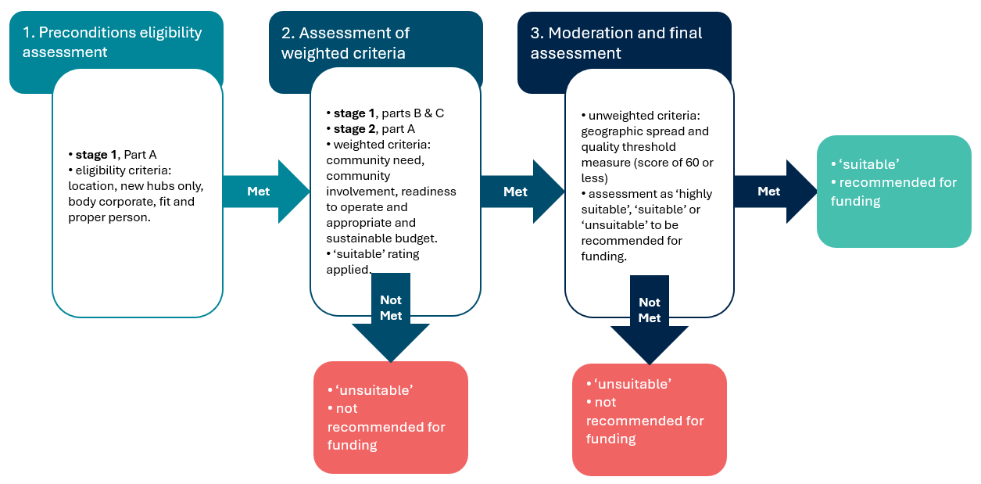

## Appendix A: Identified Statistical Areas Level 2

The Statistical Areas Level 2 (SA2s) in this document meet the following Targeted Round – Suburban University Study Hubs requirements:

* Quintile 1 or 2 according to the Australian Bureau of Statistics (ABS) [Index of Relative Socioeconomic Advantage and Disadvantage](https://www.abs.gov.au/statistics/people/people-and-communities/socio-economic-indexes-areas-seifa-australia/2021#index-of-relative-socio-economic-advantage-and-disadvantage-irsad-), and
* [Geographic classification](https://www.abs.gov.au/statistics/standards/australian-statistical-geography-standard-asgs-edition-3/jul2021-jun2026) of ‘Major Cities of Australia’ or ‘Greater Hobart’ or ‘Greater Darwin’, and
* are in identified areas, as described in the Targeted Round – Suburban University Study Hubs Application Guide.

Please note some SA2s have sections which fall outside of the ‘Major Cities of Australia’ classification and it is strongly recommended applicants check proposed Hub site addresses are in eligible locations using the [interactive map](https://ssc.carto.com/builder/714ae73c-3990-41bb-a7a1-2fb230bcffa3/embed).

### Queensland – Clusters

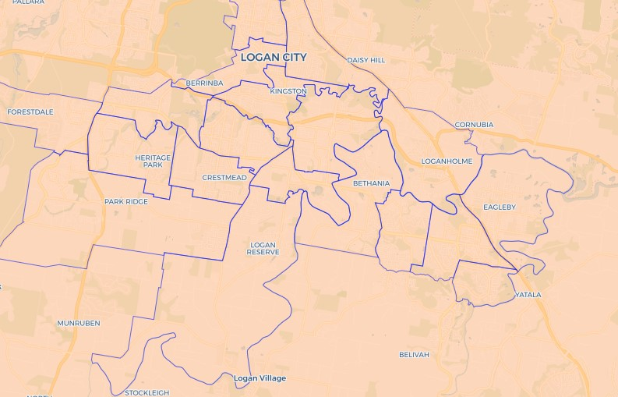**Map 1: Identified SA2s – Brisbane South cluster**

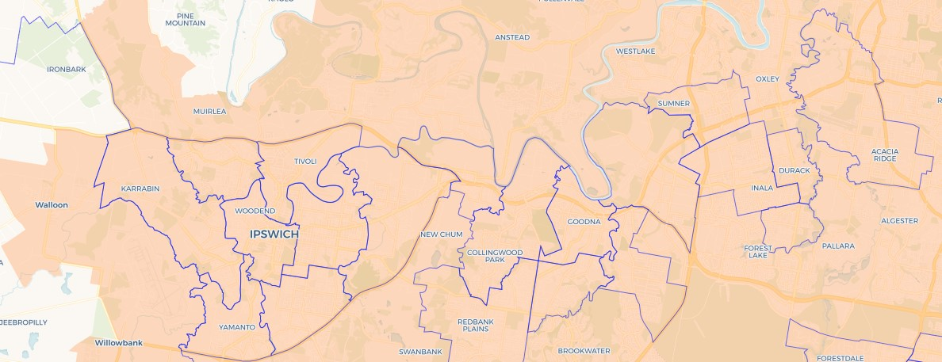**Map 2: Identified SA2s – Brisbane West cluster**

**Table 1: Identified SA2s – Queensland**

|  |  |  |
| --- | --- | --- |
|  | **Queensland – 40** |  |
| Beenleigh | Durack | Marsden |
| Bellbird Park | Eagleby | Mount Warren Park |
| Bethania - Waterford | Edens Landing - Holmview | North Ipswich - Tivoli |
| Boronia Heights - Park Ridge | Goodna | Raceview |
| Brassall | Hillcrest | Redbank Plains |
| Browns Plains | Inala - Richlands | Regents Park - Heritage Park |
| Bundamba | Ipswich - Central | Riverview |
| Camira - Gailes | Ipswich - East | Rocklea - Acacia Ridge |
| Chambers Flat - Logan Reserve | Kingston (Qld) | Rosewood |
| Churchill - Yamanto | Leichhardt - One Mile | Slacks Creek |
| Collingwood Park - Redbank | Logan Central | Wacol |
| Crestmead | Loganholme - Tanah Merah | Waterford West |
| Darra - Sumner | Loganlea | Woodridge |
| Doolandella |  |  |

### New South Wales – Clusters

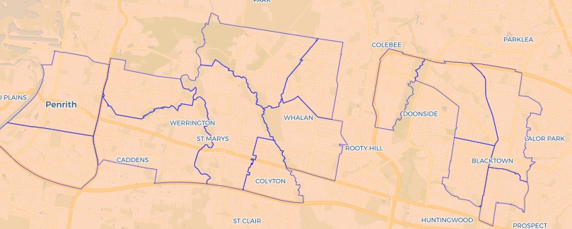**Map 3: Identified SA2s – Sydney West cluster**

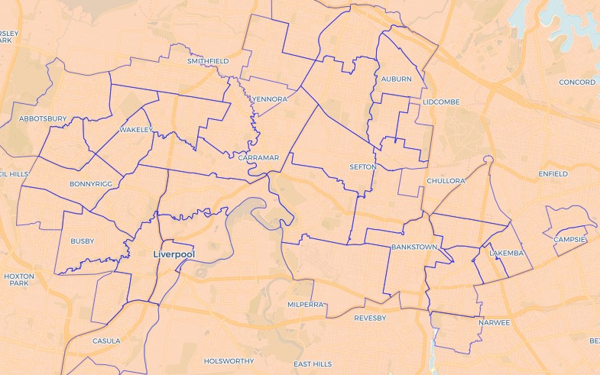**Map 4: Identified SA2s – Sydney Southwest cluster**

**Table 2: Identified SA2s – New South Wales**

|  |  |  |
| --- | --- | --- |
|  | **New South Wales – 56** |  |
| Ashcroft - Busby – Miller | Campsie – North | Jamisontown - South Penrith |
| Auburn – Central | Campsie – South | Kingswood - Werrington |
| Auburn – North | Canley Vale - Canley Heights | Lakemba |
| Auburn – South | Casula | Liverpool – East |
| Bankstown – North | Chester Hill - Sefton | Liverpool – West |
| Bankstown – South | Colyton - Oxley Park | Lethbridge Park - Tregear |
| Bass Hill - Georges Hall | Condell Park | Lurnea - Cartwright |
| Berala | Edensor Park | Merrylands – Holroyd |
| Bidwill - Hebersham - Emerton | Fairfield | Mount Druitt - Whalan |
| Blacktown – South | Fairfield – East | Penrith |
| Blacktown – West | Fairfield – West | Punchbowl |
| Blacktown (East) - Kings Park | Glendenning - Dean Park | Regents Park |
| Blacktown (North) - Marayong | Granville – Clyde | Riverwood |
| Bonnyrigg Heights - Bonnyrigg | Green Valley | Smithfield - Wetherill Park |
| Bossley Park - Abbotsbury | Greenacre – North | St Johns Park - Wakeley |
| Cabramatta – Lansvale | Greenacre – South | St Marys - North St Marys |
| Cabramatta West - Mount Pritchard | Greenfield Park - Prairiewood | Warwick Farm |
| Cambridge Park | Guildford - South Granville | Wiley Park |
|  | Guildford West - Merrylands West | Yagoona - Birrong |

### Victoria – Clusters

**Map 5: Identified SA2s – Melbourne Southeast cluster Map 6: Identified SA2s – Melbourne West cluster**

|  |  |
| --- | --- |
| A map of identified SA2s in the  Melbourne Southeast Cluster. This includes locations from Dandenong to Frankston. Details can be found in the list of Identified SA2s. | A map of identified SA2s in the  Melbourne West Cluster. This includes locations around Sunshine and St Albans. Details can be found in the list of Identified SA2s. |

**Map 7: Identified SA2s – Melbourne Southwest cluster**

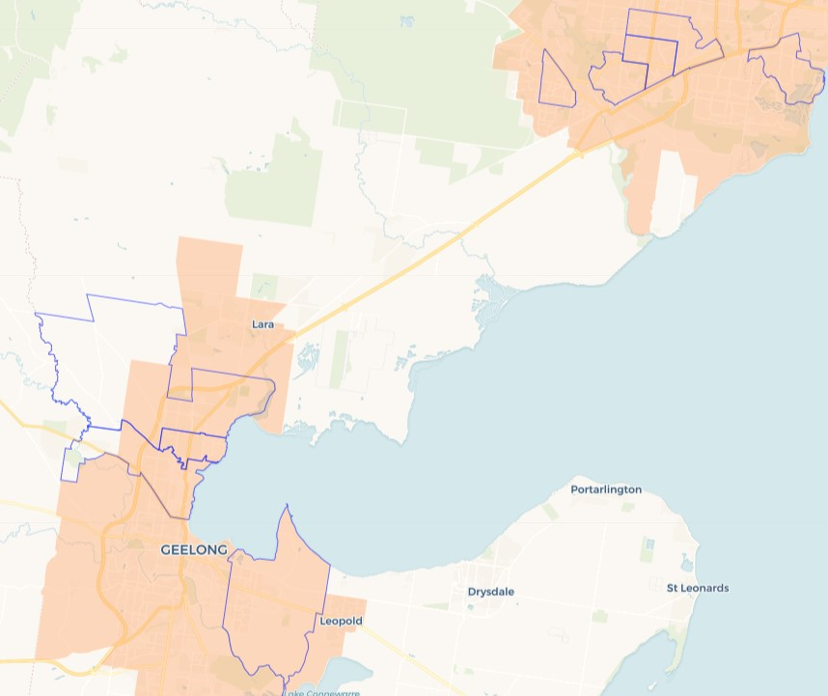

**Table 3: Identified SA2s – Victoria**

|  |  |  |
| --- | --- | --- |
|  | **Victoria – 45** |  |
| Altona Meadows | Frankston North | North Geelong - Bell Park |
| Ardeer – Albion | Hallam | Norlane |
| Braybrook | Hampton Park - East | Pakenham - North East |
| Cairnlea | Hampton Park - West | Pakenham - South East |
| Carrum Downs | Hoppers Crossing - North | Pakenham - South West |
| Corio - Lovely Banks | Hoppers Crossing - South | Springvale |
| Cranbourne | Keilor Downs | Springvale South |
| Cranbourne North - West | Keysborough - North | St Albans - North |
| Dandenong - North | Kings Park (Vic.) | St Albans - South |
| Dandenong - South | Narre Warren - South West | Sunshine |
| Dandenong North | Narre Warren South - West | Sunshine North |
| Deer Park | Newcomb - Moolap | Sunshine West |
| Delahey | Noble Park - East | Sydenham |
| Doveton | Noble Park - West | Werribee - East |
| Frankston | Noble Park North | Wyndham Vale - South |

1. [Census of Population and Housing: Socio-Economic Indexes for Areas (SEIFA), Australia, 2016 (abs.gov.au)](https://www.abs.gov.au/ausstats/abs@.nsf/Lookup/by%20Subject/2033.0.55.001~2016~Main%20Features~IRSAD~20)
2. [Remoteness Areas | Australian Bureau of Statistics (abs.gov.au)](https://www.abs.gov.au/statistics/standards/australian-statistical-geography-standard-asgs-edition-3/jul2021-jun2026/remoteness-structure/remoteness-areas)
3. [Greater Capital City Statistical Areas | Australian Bureau of Statistics (abs.gov.au)](https://www.abs.gov.au/statistics/standards/australian-statistical-geography-standard-asgs-edition-3/jul2021-jun2026/main-structure-and-greater-capital-city-statistical-areas/greater-capital-city-statistical-areas)
4. [Federal Register of Legislation - Higher Education Support (Fit and Proper Person) Instrument 2019](https://www.legislation.gov.au/F2019L01682/latest/text)