

# Task card – How to update FDC educator care addresses in the Provider Entry Point (PEP)

## Overview

This task card outlines how to update the physical address or the premises from which a family day care (FDC) educator provides care in the Provider Entry Point (PEP) through PRODA.

When an FDC educator changes care address you are required to update this for each relevant enrolment/child. This ensures that sessions submitted to the CCS system are accurate. Ensure you have this information before you start.

Find more [task cards](https://www.education.gov.au/early-childhood/provider-tool-kit#toc-task-cards) for the PEP on our website.

If you need further assistance, contact the Child Care Subsidy Provider Helpdesk on 1300 667 276 from 9 am to 5 pm AEST or [via email](mailto:CCSHelpdesk@education.gov.au) anytime.

## Logging In

Step 1

Log in to the [Provider Entry Point (PEP)](https://proda.humanservices.gov.au/prodalogin/pages/public/login.jsf?TAM_OP=login&ERROR_CODE=0x00000000&URL=%2Fmga%2Fsps%2Foauth%2Foauth20%2Fauthorize%3Fscope%3Dopenid%26state%3DalN0hw9ovD%26client_id%3DGTzCa6CRNfBsRTdfljBa%26redirect_uri%3Dhttps%253A%252F%252Fbusinessonline.humanservices.gov.au%252Fmga%252Fsps%252Foidc%252Frp%252Fchildcaresubsidy%252Fredirect%252Fproda%26response_type%3Dcode&OLDSESSION=).

Step 2

Navigate to the homepage of the service where you want to update the educator address.

It is important that you are in the appropriate service context for the address you will be updating.

Select the **Enrolments** tile.

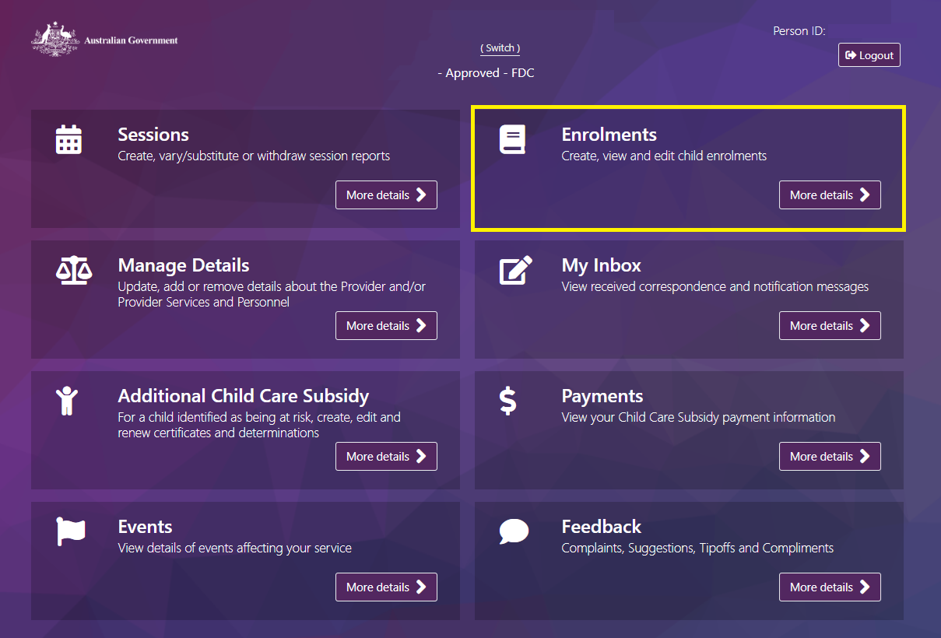

Step 3

You will be required to update the regular care address for each child that receives care from the educator.

Locate the child and click **Select.**

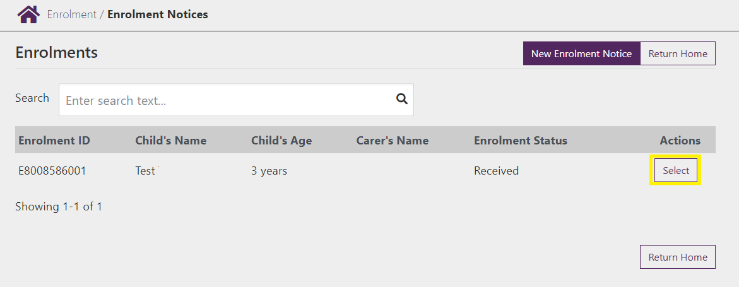

Step 4

Under the **Actions** button select **Update.**

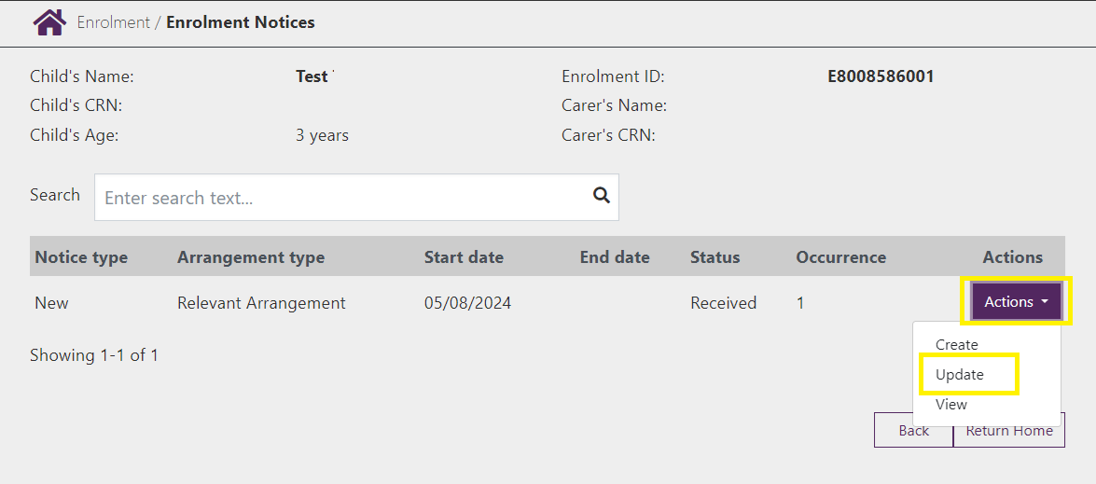

Step 5

Update the **Address of regular care educator.** Once complete select **Next.**

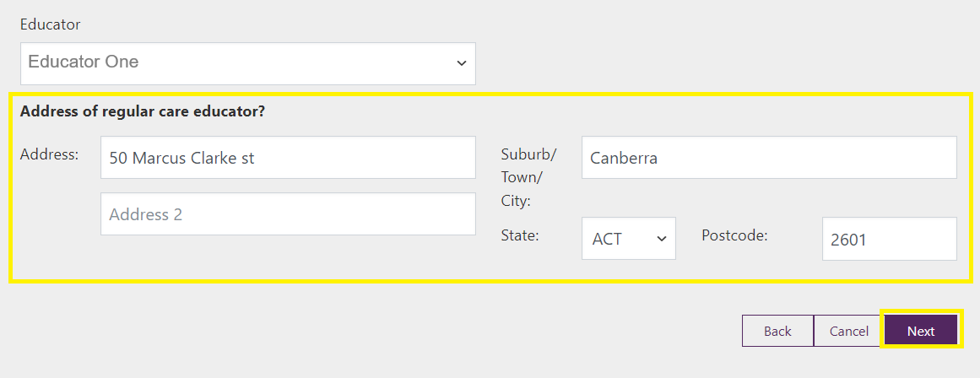

Step 5

The next screen will request you review session details, select **Next** to progress. Review the details and if correct select **Submit** to finalise.

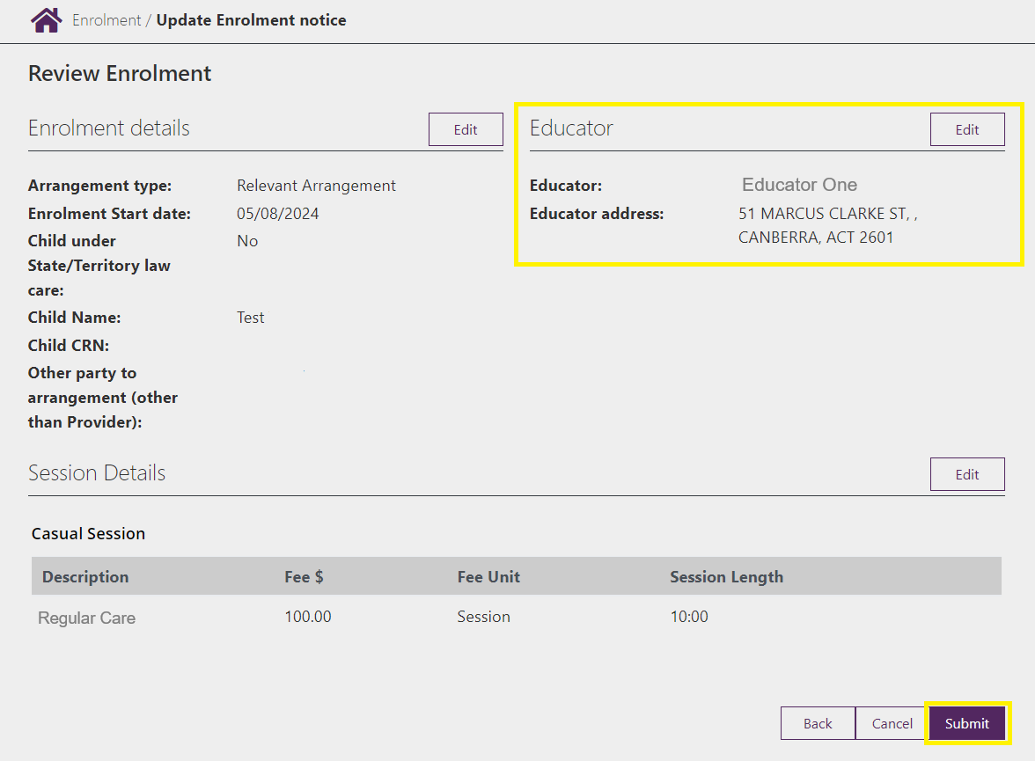

Step 6

Complete the above steps for all other impacted enrolments.