

# FAQs: Unit Completion Rate Risk Factor Calculation

VSL, HELP and Up-front Payments Tuition Protection Levies

This document provides responses to common questions from education providers regarding the unit completion rate risk factor calculation used in the VSL, HELP and Up-front Payments Tuition Protection Levies.

This information is particularly relevant for education providers where students have withdrawn for medical reasons (such as mental health), and those offering units of study with a duration of more than 12 months.

## Unit completion rate percentage calculation

The unit completion rate percentage is calculated as follows:

$$\left[\frac{Passed EFTSL}{\left(Passed EFTSL+Failed EFTSL+Withdrawn EFTSL+Ongoing EFTSL+Data missing EFTSL\right)}\right]×100$$

**EFTSL**: Equivalent full-time student load for a year

### Q1: If a student withdraws for medical reasons such as mental health, will the education provider be disadvantaged in the unit completion rate risk factor calculation?

The main data source for the unit completion rate risk factor calculation is [Element E355 - Unit of study status](https://www.tcsisupport.gov.au/element/355)[1] with the allowable values shown in Figure 1.

Figure 1: Allowable Values

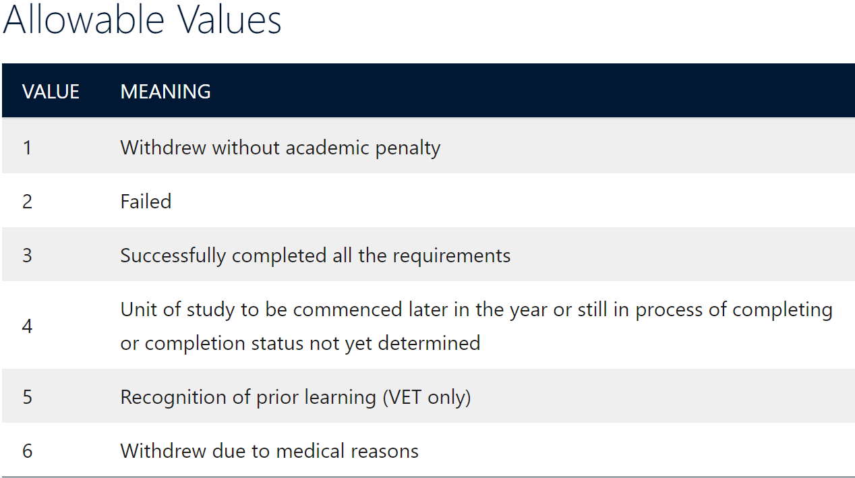

Value 3 (successfully completed all the requirements) is counted as ‘Passed’ in the numerator of the unit completion rate risk factor calculation. The denominator includes:

* Value 1 (withdrew without academic penalty);
* Value 2 (failed);
* Value 3 (completed/passed); and
* Value 4 (ongoing).

**Value 5** (recognition of prior learning) is **excluded from the calculation**.

**Value 6** (withdrew due to medical reasons) is also **excluded from the calculation** as withdrawals due to medical reasons are beyond the control of education providers and would disadvantage them unfairly.

### Q2: If an education provider offers units of study that last more than 12 months or span across more than one calendar year, how are these units treated in the unit completion rate risk factor calculation?

There are many factors that may influence a provider’s unit completion rate risk factor result, including the timing of commencement in units of study that have a duration of more than 12 months. The calculation of the unit completion rate risk factor is dependent on education providers’ up-to-date reporting in the Tertiary Collection of Student Information (TCSI) system. The calculation uses [Element E355 - Unit of study status](https://www.tcsisupport.gov.au/element/355)[2], based on equivalent full-time student load (EFTSL), for an education provider for a calendar year. This data is extracted from TCSI around the middle of the levy collection year (e.g. 2023 calendar year data used to calculate the unit completion rate risk factor for the 2024 levies is extracted around June 2024). Education providers are therefore afforded approximately six months to ensure their unit of study statuses for the previous calendar year are up to date.

Longer units mean that students remain without achievements and outcomes for longer. In the event of an education provider closure, longer units will increase the liability the provider carries, the risk to replacement providers, and the amount the Tuition Protection Service (TPS) may be required to re-credit or refund affected students.

It is up to an education provider how they establish their ‘units of study’, but they must ensure compliance with associated legislation and rules in doing so. It is strongly recommended that education providers maintain up-to-date unit of study status data in TCSI and associated systems.

1. www.tcsisupport.gov.au/element/355
2. www.tcsisupport.gov.au/element/355