

# Brief Guide

[Staff Data - Power BI report](https://www.education.gov.au/higher-education-statistics/resources/guide-using-tertiary-collection-student-data-power-bi-report" \o "Guide to using the Tertiary Collection of Student Data Power BI report)

#### Navigating Power BI Reports

1. When a Power BI report is opened, a home screen will appear and breakdowns exist within the page (e.g., Staff FTE by Classification, Staff FTE by Function, etc). Select a breakdown by clicking on one of the tabs on the top row.

1. Notes including how to use the reports and definitions about the data can be accessed by selecting the “Notes” button.

#### Using Power BI Reports

1. Below is a typical example of what a Power BI report page may look like, including a chart, table, and various filters at the top. To reset all settings, select “Reset” on the right-hand side towards the middle of the screen.

1. On some pages you may need to use the scroll bar to see all the data.

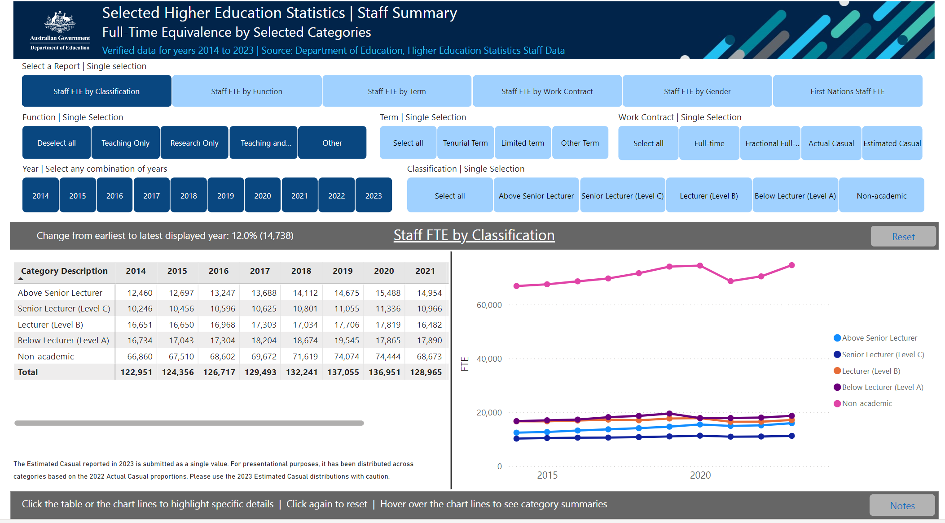

1. By hovering over a data point in a chart with the mouse pointed, the exact number can be displayed. This function works on both line charts and bar charts.

#### Extracting charts from Power Bi Reports

1. Charts can be copied as an image with a caption, and then pasted as required. Hover the mouse pointer over the individual chart, right click, hover over “Copy”, then select the “Image with caption” button. Once copied select “Copy”, as seen in the second image below.

1. Alternatively, the ‘Snipping tool’ (or similar) can be used to cut and paste charts and tables as pictures if required. It is best to use the focus mode option (described above) before snipping for the best resolution. If desired, a picture of the filters can also be snipped, so that a record is maintained of what filters were applied to the data.