****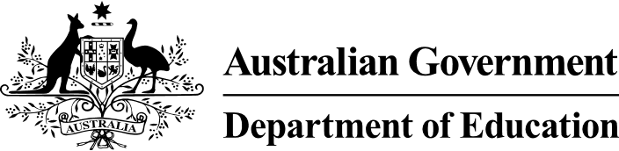

# National Higher Education Code to Prevent and Respond to Gender-based Violence

Response template

The Department is seeking your feedback on the National Higher Education Code to Prevent and Respond to Gender-based Violence (the National Code).

The Department has released an [Issues Paper](https://www.education.gov.au/action-plan-addressing-genderbased-violence-higher-education/resources/national-higher-education-code-prevent-and-respond-genderbased-violence-issues-paper) to inform your feedback. We would like your views on the proposed standards and requirements, whether any additional standards need to be considered, how to ensure the National Code aligns with education regulations and broader regulatory frameworks, and additional guidance materials needed to support providers’ implementation.

You can provide your feedback through the [online form](https://submit.dese.gov.au/jfe/form/SV_1zVyLGBl7ucQO8e) or by completing this template and emailing your feedback to [nationalgbv.code@education.gov.au](mailto:nationalgbv.code@education.gov.au). An [Issues Paper](https://www.education.gov.au/action-plan-addressing-genderbased-violence-higher-education/resources/national-higher-education-code-prevent-and-respond-genderbased-violence-issues-paper) has been released to inform your feedback. Responses will take approximately 30-40 minutes to complete.

If the topics in the survey raise any concerns for you, you can access support and advice about domestic, family and sexual violence through 1800RESPECT (1800 737 732) or visit the [1800RESPECT website](https://www.1800respect.org.au/). This is a free, confidential service available 24/7.

Please note that any information provided about a higher education provider does not constitute a formal complaint and the Department is unable to take any action. If you would like to make a formal complaint you can contact your higher education provider, or you may be able to lodge your complaint with a body such as the Australian Human Rights Commission, the Fair Work Ombudsman, your state’s ombudsman, human rights commission or workplace health and safety regulator or the Overseas Students Ombudsman.

More information on formal complaint options for students is available on the Study Assist [Higher Education Student complaints](https://www.studyassist.gov.au/support-while-you-study/higher-education-student-complaints) webpage.  
  
Responses close at 11.59pm AEST on Friday 28 June 2024.

## Questions

### For the purposes of defining gender-based violence in the context of the National Code and as part of associated compliance activities, what are key considerations for the Department?

|  |
| --- |
|  |

### How can the Department ensure the alignment of the National Code with other education regulations (e.g. Threshold Standards, ESOS National Code) and broader regulatory frameworks (e.g. privacy laws, positive duty)?

|  |
| --- |
|  |

### Do the potential Standards cover all aspects of a ‘whole-of-organisation’ approach and what is necessary to protect and promote the safety of students and staff? Are there other standards to include? Please detail what they are, and why.

|  |
| --- |
|  |

### What additional requirements should be included for each Standard? Please detail for each Standard and why.

|  |
| --- |
|  |

### How should standards account for providers’ size, student and staff profile and location/s (including regional, metropolitan and Australian and international campuses)?

|  |
| --- |
|  |

### Recognising student accommodation settings are high-risk environments, are there additional considerations for these providers under the National Code?

|  |
| --- |
|  |

### Beyond the National Code, what additional resources and materials would be required by providers to support implementation and ongoing compliance?

|  |
| --- |
|  |

### What else needs to be considered in the Department’s approach to regulating the National Code?

|  |
| --- |
|  |

### How often should the National Code be reviewed and updated?

|  |
| --- |
|  |

### What are examples of good practice that can be drawn on to inform the design and implementation of the National Code?

|  |
| --- |
|  |