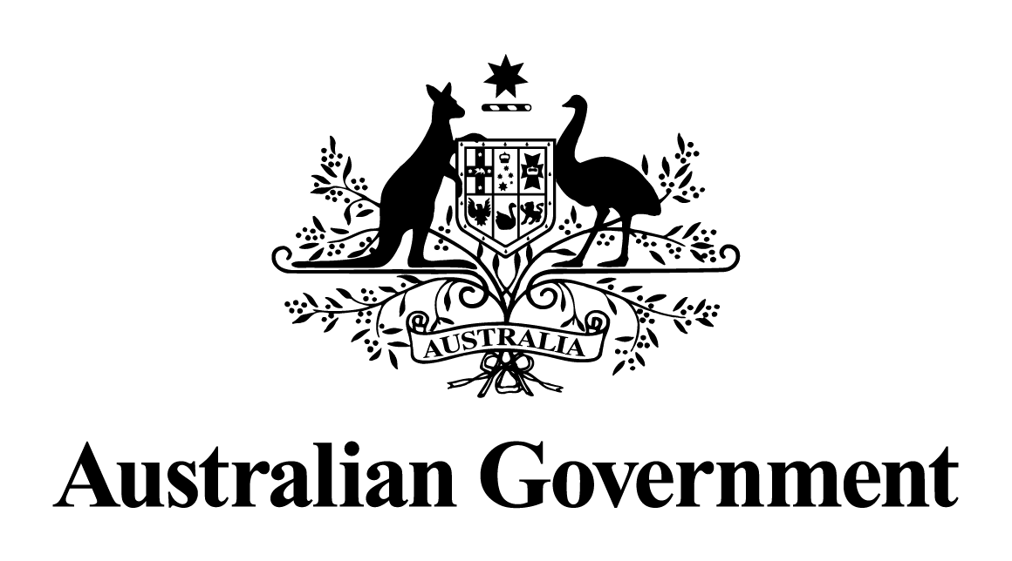

Australian Government response to the   
House of Representatives Standing Committee on Employment, Education and Training report:

Unique Individuals, Broad Skills –   
Inquiry into school to work transition

May 2024

**Overview**

On 31 May 2017, Senator the Hon Simon Birmingham, former Minister for Education and Training, referred an inquiry to the House of Representatives Standing Committee on Employment, Education and Training to examine how students are supported from school to work. The report was tabled on 30 May 2018.

**Government Response**

The Government notes **all** recommendations. However, given the passage of time since this report was tabled, a substantive Government response is no longer appropriate.