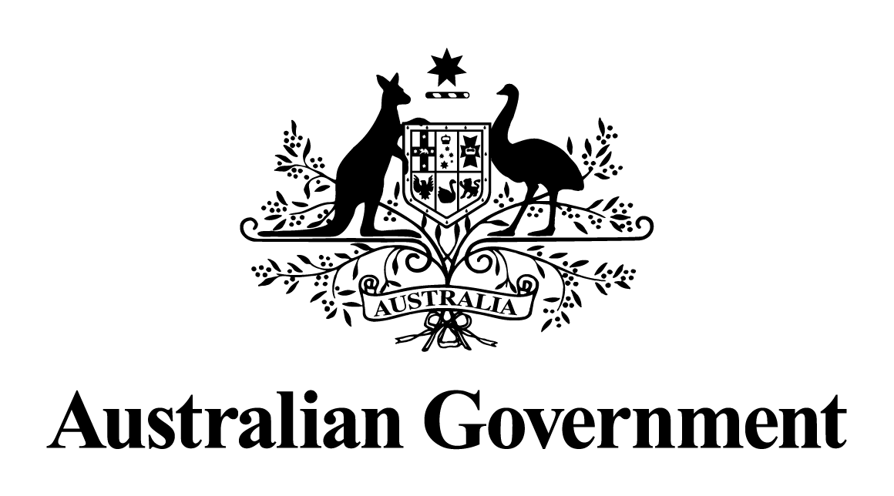

Australian Government response to the   
Senate Standing Committee on Legal and Constitutional Affairs report:

Nationhood, national identity and democracy

MAY 2024

**Overview**

On 29 July 2019 the Senate referred an inquiry into nationhood, national identity and democracy to the Legal and Constitutional Affairs References Committee. The report was tabled on 16 February 2021.

**Government Response**

The Government notes **all** recommendations. However, given the passage of time since this report was tabled, a substantive Government response is no longer appropriate.