

National School Resourcing Board

Review of the Schooling Resource Standard (SRS)  
indexation arrangements

March 2024

Board members

Professor Bronwyn Fredericks (Chair)  
Professor Janet Clinton  
Ms Valerie Gould  
Professor Andrew Whitehouse  
Professor John Firth  
Professor Lee Anne Perry AM was appointed on 15 March 2024 and assisted with the finalisation of this review.   
Professor Elizabeth Labone, who resigned on 6 March 2024, also contributed to this review.

Review of the Schooling Resource Standard (SRS) indexation arrangements   
© Commonwealth of Australia 2024

With the exception of the Commonwealth Coat of Arms, the department's logo, any material protected by a trade mark and where otherwise noted, all material presented in this document is provided under a Creative Commons Attribution 4.0 International Licence.

The details of the relevant licence conditions are available on the Creative Commons website ([https://creativecommons.Org/licenses/by/4.0/](http://creativecommons.Org/licenses/by/4.0/)) as is the full legal code (<https://creativecommons.org/licenses/by/4.0/legalcode>).

As far as practicable, material for which the copyright is owned by a third party will be clearly labelled. The National School Resourcing Board has made all reasonable efforts to ensure that this material has been reproduced in this document with the full consent of the copyright owners.

Copyright requests and enquiries concerning further authorisation should be addressed to:

The Copyright Officer  
Department of Education  
Location Code C50MA10  
GPO Box 9880   
Canberra ACT 2601

or emailed to: [copyright@education.gov.au](mailto:copyright@education.gov.au).

Where a copyright owner, other than the Commonwealth, is identified with respect to this material, please contact that third party copyright owner directly to seek permission.

**Disclaimer**

As this is an independent review authored by the National School Resourcing Board, the report does not necessarily reflect the views of the Australian Government.

This document, when attributed, must be titled as: Review of the Schooling Resource Standard (SRS) indexation arrangements.

Transmittal letter from the Chair of the National School Resourcing Board, Professor Bronwyn Fredericks, to The Hon Jason Clare MP, Minister for Education

The Hon Jason Clare MP
Minister for Education
PO Box 6022
Parliament House
CANBERRA ACT 2600

Dear Minister

On 1 February 2024, you commissioned the National School Resourcing Board (the Board) to undertake a review of the Schooling Resource Standard (SRS) indexation arrangements.

The terms of reference required the Board to consider and provide advice on the appropriateness of current SRS indexation arrangements; the suitability of the current SRS indexation floor; the appropriateness of the composite index; and the timing of the SRS indexation.

Given the technical nature of the review, the Board sought stakeholder and expert advice to inform its deliberations. The Board commissioned Deloitte Access Economics to provide an independent assessment of the current indexation arrangements. This included undertaking macro-economic modelling and analysis of the indexation arrangements that are currently being applied to the SRS.

The Board also undertook targeted consultations with stakeholders including state and territory governments, Independent Schools Australia and the National Catholic Education Commission. Stakeholders provided wage and school expenditure data to validate the economic modelling. Eighty per cent of stakeholders provided a written submission and all stakeholders had an opportunity to submit feedback on the draft report.

The Board has made seven findings and four recommendations to the Australian Government, including finding that current indexation arrangements are considered to be appropriate. Constrained timeframes and limited data availability during this review restricted the Board's ability to undertake deep analysis. Therefore, findings and recommendations have been made on-balance, noting the need for further consultation to gather relevant and quality data to support changes.

I would like to thank my Board colleagues and the Secretariat for their support in delivering this review within seven weeks.

Yours sincerely
Professor Bronwyn Fredericks
Chair, National School Resourcing Board

27 March 2024

Contents

List of figures iii

List of tables iii

Glossary v

Executive Summary vi

Findings ix

Recommendations x

Introduction 1

The task 1

Part 1: Background 2

1.1 What is indexation? 2

1.2 The role of indexation in the SRS 2

Part 2: Issues paper 5

Part 3: Consultations 6

3.1 Consultation methodology 6

3.2 Consultation summary 6

Part 4: The appropriateness of current SRS indexation arrangements 8

4.1 Introduction 8

4.2 Schooling inputs 9

4.3 Measuring schooling input prices over time 16

4.4 Comparison of schooling input prices with historical SRS indexation rates and its components 24

4.5 Drivers of WPI and CPI and their relevance to schooling 27

Part 5: The suitability of the current SRS indexation floor 28

5.1 Overview 28

5.2 Rationale for an indexation floor 29

5.3 Setting an indexation floor 31

Part 6: The appropriateness of the composite index 34

6.1 Alternative data sources for the composite index 34

6.2 Weighting of the composite index 38

Part 7: Timing of SRS indexation rates 42

7.1 Current timing of indexation and payments 42

7.2 Alternative indexation and payment timing arrangements 44

Appendix A – Terms of reference 48

Appendix B – Review process 50

Appendix C – Issues Paper 51

Appendix D – Stakeholder submissions 62

Appendix E – Consultations 63

Appendix F – Additional data 64

Appendix G – Methodology and data sources 67

Appendix H – References 72

# List of figures

Figure 1 Government sector recurrent expenditure, salary and non-salary by state and territory, 2019–20 12

Figure 2 Non-government sector recurrent expenditure, salary and non-salary by state and territory, 2019 13

Figure 3 Government school sector staff, staff function by state and territory, 2019 15

Figure 4 Non-government school sector staff, staff function by state and territory, 2019 15

Figure 5 Result of indexation formula over the past two decades 28

Figure 6 WPI and CPI forecasts 31

Figure 7 Cumulative difference in funding with and without an indexation floor 32

Figure 8 Education and training WPI - comparisons 35

Figure 9 Education and training WPI 35

Figure 10 Composite WPI/CPI measure with overall WPI and Education and training WPI 36

Figure 11 Timeline of key ABS releases and schooling dates 42

Figure 12 SRS indexation and payment timings for government and non-government schools under current arrangements 43

Figure 13 Salary increases for government sector teachers stipulated in state and territory Enterprise Bargaining Agreements. 2018–2024 64

Figure 14 Salary increases for non-government sector teachers stipulated in relevant Enterprise Bargaining Agreements, 2018–2024 65

Figure 15 Salary increases for Government sector administrative & clerical staff stipulated in relevant state and territory Enterprise Bargaining Agreements, 2018–2024 66

# List of tables

Table 1 Recurrent expenditure on government school sector by financial year 9

Table 2 Recurrent expenditure on non-government school sector by calendar year 10

Table 3 FTE staff by school sector and function, Australia, 2017–2022 14

Table 4 Estimated growth in government sector teacher wages and salaries, by state and territory 18

Table 5 Estimated growth in government sector non-teacher wages and salaries by jurisdiction, 2019–2024 21

Table 6 Growth in the WPI, original, year to June quarter 25

Table 7 Consumer Price Index, original, year to June quarter, 2019–2023 26

Table 8 Alternative data inputs for the composite index 39

Table 9 Alternative CPI/WPI quarters impact on non-government school payments - 2024 example 44

Table 10 Final indexation rates for the 2019–2023 funding years using earlier WPI and CPI quarters 46

Table 11 Government sector teaching staff Enterprise Bargaining Agreements 68

Table 12 Government sector non-teaching staff Enterprise Bargaining Agreements 69

Table 13 Non-government sector teaching staff Enterprise Bargaining Agreements 70

Table 14 Other data sources used throughout the issues paper for analysis 71

# Glossary

| Term | Definition |
| --- | --- |
| **Australian Curriculum, Assessment and Reporting Authority (ACARA)** | **An independent statutory authority which provides advice on national curriculum, assessment and reporting to all Australian education ministers** |
| **CAGR** | **Compound Annual Growth Rate is the annualised average rate of growth over time, with the effect of compounding taken into account.** |
| **CPI** | Consumer Price Index |
| **Enterprise Bargaining Agreement (EBA)** | An Enterprise Bargaining Agreement is a legal document that covers certain employers and employees and sets out minimum employment terms and conditions. |
| **Indexation** | Indexation adjusts the value of government programs for changes in the level of prices, living costs or wages. Generally, indexation aims to maintain the relative value or level of policy settings over time |
| **National School Reform Agreement (NSRA)** | A joint agreement between the Australian Government and states and territories to lift student outcomes across Australian schools. |
| **National Schools Statistics Collection (NSSC) data** | **This data set collected by ACARA is a census, conducted annually as a collaborative arrangement between State, Territory and Commonwealth education authorities and the Australian Bureau of Statistics, which collects data on a range of schooling issues. This includes government school expenditure, non-government schools’ income and expenditure and staff numbers.** |
| **Schooling Resource Standard (SRS)** | An estimate of how much total public funding a school needs to meet its students’ educational needs. It is made up of a base amount for all primary and secondary students plus six  needs-based loadings. |
| **Student** | **A person who**, at the school’s **Census date, is formally enrolled in a school and active in a primary, secondary and/or special education program at that school. Students may be enrolled at more than one school.** |
| **WPI** | **Wage Price Index** |

# Executive Summary

The Schooling Resource Standard (SRS) estimates how much total public funding a school needs to meet its students’ educational needs. It is made up of a base amount and up to six needs-based loadings.

Each year, the SRS base amount and size loading are indexed to reflect changes in prices which affect the cost of providing schooling. Indexation is a critical component of the SRS as it ensures that funding is responsive to changes in the prices of salary and non-salary inputs, allowing the real value of funding to be maintained over time.

Current SRS indexation arrangements have been in place since 2019 and are outlined in the *Australian Education Act 2013* (Cth)(the Act). The final indexation rate is determined as either:

* A rate calculated as the higher of:
* 3 per cent (the indexation ‘floor’), or
* A percentage derived from a composite index, comprising of 75 per cent of the change of the Wage Price Index (WPI) and 25 per cent of the Consumer Price Index (CPI); or
* A rate prescribed by the Minister for Education.

To date, the indexation factor has been prescribed (in 2019 and 2020), set to the indexation floor (in 2021), and set at the composite index (in 2022 and 2023).

This review of the SRS indexation arrangements (the review) is a commitment arising from the National School Reform Agreement (NSRA). In the extension of the NSRA, Ministers committed to completing the review in 2024, and several jurisdictions requested it be completed in early 2024 to inform negotiations for the next NSRA.

In accordance with Section 128 (8) of the Act, in developing the Terms of Reference (Appendix A) for the review, the Hon Jason Clare MP, Australian Government Minister for Education consulted with the Education Ministers Meeting (EMM), Independent Schools Australia (ISA) and the National Catholic Education Commission (NCEC). Following this consultation, on 1 February 2024, Minister Clare commissioned the National School Resourcing Board (the Board) to undertake the review and deliver its final report by 28 March 2024.

The Terms of Reference outline the review will consider and provide advice on:

* The appropriateness of current indexation arrangements, including whether the operation of the SRS indexation arrangements has kept pace with average schooling cost increases since 2018.
* The suitability of the current SRS indexation floor of 3 per cent.
* The appropriateness of the composite index, including its structure, weighting and possible alternatives to the current composite index – currently set as 75 per cent WPI and 25 per cent CPI.
* The timing of SRS indexation rates, including:
* the reference period for source WPI and CPI data,
* the date at which the indexation rate is confirmed for the school year, and its impact on systems and schools’ ability to effectively budget.

### The review was informed by a macro-economic analysis and consultation

Given the technical nature of the review terms of reference, the Board commissioned Deloitte Access Economics to provide an independent assessment of the current indexation arrangements. This included undertaking modelling and analysis of the indexation arrangements that are currently applied to the SRS. Extracts of Deloitte Access Economics’ work are included in this report. This was a rapid review of the current arrangements, with the analysis completed at a high level given timing and data constraints.

The data underpinning the analysis, provided in the format of an Issues Paper, was largely derived from publicly available sources. Subsequently, data received from state and territory governments, the NCEC, ISA and data for non-government schools provided by the Australian Government Department of Education were then used to verify the publicly available data.

Following the Board’s targeted consultations with state and territory governments, and   
ISA and the NCEC via consultation meetings (supported by the Issues Paper), 8 stakeholders provided written submissions in response to the Issues Paper.

These stakeholders were also offered the opportunity to provide feedback on the draft report.

Constrained timeframes and limited data availability during this review restricted the Board's ability to undertake deep analysis. Therefore, findings and recommendations have been made on-balance, noting the need for further consultation to gather relevant and quality data to support changes.

### Current SRS indexation arrangements are considered to be appropriate

The Board found that current indexation arrangements are considered appropriate. Overall, the evidence gathered by the Board was not definitive enough to recommend changes to the current SRS indexation arrangements at this time.

During stakeholder consultations, the Board heard issues related to structural changes to the delivery of school education which would require future analysis of the design of the SRS (including base and loadings). However, as this matter was not within scope of the review’s terms of reference, the Board did not make any recommendations in relation to this aspect of the SRS. Additionally, Western Australia’s unique early childhood education setting was raised however, the SRS does not apply to children attending kindergarten in the state and is therefore, out of scope for this review.

### Current indexation floor arrangements are considered appropriate

The rationale for an indexation floor is to provide funding certainty and protect the system by maintaining a minimum level of indexation during times of low inflation or deflation. The Board found current floor arrangements to be appropriate, given the strong preference for stability and certainty by the sector, and evidence regarding the way that jurisdictions typically determine salary increases over time.

The Board recommends that a floor should be maintained as a feature of indexation arrangements. Given the on-balance views of jurisdictions, the indexation floor should be maintained at 3 per cent.

Most state and territory education departments considered the 3 per cent level of the floor to be appropriate with the non-government school sector noting the 3 per cent funding floor was a necessary safeguard for all schools and particularly for non-systemic schools.

Several jurisdictions, while not expressing strong views on the need for changing of the 3 per cent level, suggested that a lower level of 2.5 per cent be explored in the context of the Reserve Bank of Australia’s (RBA) 2-3 per cent target band for inflation and wage setting in the public sector more broadly.

### Structure and weighting of the composite index are considered appropriate

The Board did not find a strong case for the use of an education specific WPI index, given that would typically closely align with economy-wide WPI measures, and it is not clear that all instances of material divergence between the indices would be ‘policy independent’.

There may be a case for an education specific CPI measure, utilising a combination of   
sub-components of the CPI that best align with non-staff school costs. However, there is incomplete evidence upon which to develop this index and it is not clear that the benefits from the use of this index would outweigh the costs of collecting the necessary data. Further, the index may be more volatile than the general CPI measure. Moreover, CPI is a survey measure relating to household expenditure rather than school expenditure, so it is not clear how a combination of CPI sub-components could be constructed to provide an accurate measure of price growth for schools’ expenditure.

On balance, there is not a compelling case for materially changing the weighting of the composite index. However, the views heard through consultation suggest that the composition of recurrent expenditure be closely monitored against the changing nature of schooling input costs.

The Board recommends that general WPI and CPI measures should continue to be used as the basis of indexation arrangements for the SRS. The current 75 per cent WPI and 25 per cent CPI split should continue to be used as the basis for determining the composite indexation rate.

### The timing of SRS indexation rates is appropriate

While there is some support for a change to the current arrangements, the Board found no conclusive evidence in support of a specific alternative approach.

On balance, the Board found a case to change current indexation arrangements to rely on an earlier measure of indexation, given the preference that jurisdictions have towards funding certainty. However, further analysis is required to determine the most appropriate timing for the application of indexation, and to understand the implications of such a change.

Indexation arrangements lagged by 12 months may be an appropriate alternative approach, as this best aligns with the approach that schools and systems take to budget planning and reflects the typical lags observed between general inflation in the economy and wage increases in the education sector. The application of a funding floor also helps to mitigate the risks associated with this change.

To better support school and system planning, alternative timing of indexation arrangements (such that the final composite indexation measure is known earlier than is the case under current arrangements) should be further examined.

# Findings

Finding 1

Current indexation arrangements are considered appropriate.

Finding 2

Current indexation floor arrangements are considered appropriate, given the strong preference for stability and certainty by the sector, and evidence regarding the way that jurisdictions typically determine salary increases over time.

Finding 3

There is currently not a strong case for the use of an education specific WPI index, given this would typically closely align with economy-wide WPI measures, and it is not clear that all instances of material divergence between the indices would be ‘policy independent’.

Finding 4

There may be a case for an education specific CPI measure, utilising a combination of sub-components of the CPI that best align with non-staff school costs. However, there is incomplete evidence upon which to develop this index and it is not clear that the benefits from the use of this index would outweigh the costs of collecting the necessary data. Further, the index may be more volatile than the general CPI measure.

Finding 5

On balance, there is not a compelling case for materially changing the weighting of the SRS composite index. However, the views heard through consultation suggest that the composition of recurrent expenditure be closely monitored against the changing nature of schooling input costs.

Finding 6

In relation to the timing of SRS indexation rates, on balance, there is a case to change current indexation arrangements to rely on an earlier measure of indexation, given the preference that jurisdictions have towards funding certainty. However, further analysis is required to determine the most appropriate timing for the application of indexation, and to understand the implications of such a change.

Finding 7

Timing of SRS indexation rates lagged by 12 months may be an appropriate alternative approach, as this best aligns with the approach that schools and systems take to budget planning and reflects the typical lags observed between general inflation in the economy and wage increases in the education sector. The application of a funding floor also helps to mitigate the risks associated with this change.

# Recommendations

Recommendation 1

The Australian Government should maintain an SRS indexation floor as a feature of SRS indexation arrangements.

Recommendation 2

In the current environment, the Australian Government should maintain the indexation floor at 3 per cent. In a low inflation environment, the Australian Government, in consultation with jurisdictions and sectors, should consider the risks associated with potential over-compensation for price changes and – if necessary – re-evaluate the setting of the indexation floor.

Recommendation 3

The Australian Government should continue to use the current composite index split of 75 per cent WPI and 25 per cent CPI as the basis for determining the composite indexation rate. As time constraints during this review did not allow for deep analysis, future consultation should be undertaken to examine alternative indices.

Recommendation 4

On balance, there is insufficient evidence to support a specific change to the indexation timing arrangements at this point. Further consultation should be undertaken to examine alternative timing and transition arrangements.

# Introduction

## The task

The Board is responsible for reviewing different aspects of the Australian Government school funding model under the Australian Education Act 2013 (Cth) (the Act). These reviews help ensure public confidence in the funding model.

The Review of the Schooling Resourcing Standard (SRS) indexation arrangements is a commitment arising from the National School Reform Agreement (NSRA). According to clause 33 of the NSRA, ‘The Commonwealth will commission the National School Resourcing Board to review the SRS indexation arrangements. The terms of reference for the review are to be agreed by the Education Council. The review will be completed and presented to Education Council in 2023.’[1]

A one-year extension to the NSRA was agreed by Education Ministers (subject to approval from First Ministers), taking the current agreement to 31 December 2024. In the extension, Ministers committed to completing the Review of SRS indexation arrangements in 2024. Several jurisdictions requested it be completed in early 2024 to inform negotiations for the next NSRA.

In accordance with Section 128 (8) of the Act, Minister Clare consulted with the Education Ministers Meeting (EMM), Independent Schools Australia (ISA) and the National Catholic Education Commission (NCEC) in developing the terms of reference for this review. Following this consultation, on 1 February 2024, Minister Clare commissioned the Board to undertake this review and deliver a final report by 28 March 2024.

The terms of reference for the review ask the Board to consider and provide advice on the appropriateness of current SRS indexation arrangements, the suitability of the current SRS indexation floor, the appropriateness of the composite index (currently set as 75 per cent WPI and 25 per cent CPI) and the timing of SRS indexation rates.

The full terms of reference are at Appendix A – Terms of reference.

1. Background
   1. What is indexation?

Indexation is a standard process used to adjust the value of government programs for changes in the level of prices, living costs or wages. In general, indexation aims to maintain the relative value or level of policy settings over time. For a number of the largest expenditure programs, the choice of indexation parameter and the frequency of its use is established in the program’s enabling legislation and is not easily changed.[2] The enabling legislation will typically specify indexation arrangements, such as the payment and threshold values subject to indexation, the indexation parameters used and the frequency of adjustments.[3]

Indexation arrangements are included in a broad range of government programs, especially those related to health and social welfare. Common indexation parameters include the CPI and the WPI. The choice of index, and the frequency with which it is applied is a key driver of changes in the costs of programs over time, especially in a high-inflation environment.[4]

* 1. The role of indexation in the SRS

The SRS is an estimate of how much total public funding a school needs to meet its students’ educational needs. It is based on recommendations made in the 2011 *Review of Funding for Schooling* led by Mr David Gonski AC.[5] It is made up of a base amount and up to 6 needs-based loadings.[6]

Each year, the SRS funding amounts per student, maximum size loading amounts and starting amounts are indexed to reflect changes in prices which affect the cost of providing schooling. Indexation is a critical component of the SRS as it ensures that funding is responsive to changes in the prices of inputs to school education delivery, allowing the real value of funding to be maintained over time.

Indexation aims to ensure schools can continue to afford the same inputs each year, to deliver a comparable standard of schooling services. Importantly, indexation is not intended to compensate for changes in the quality of schooling resources or compositional changes to schooling costs (which may be affected by changes in policy). These matters are most appropriately considered through the determination of the SRS base and loadings calculations.

This approach provides a minimum indexation rate and certainty for schools, while ensuring that funding reflects changes in wages and other costs. Indexation is weighted towards changes in wage costs reflecting that teachers’ and staff salaries are a significant driver of schools' costs.[7]

### Current arrangements

In 2018, the SRS funding amounts were prescribed in section 34 of the Act.

The indexation factor for the SRS is defined in the Act*:*

11A Definition of SRS indexation factor

* + - 1. The *SRS indexation factor*for a year is the higher of the following:

1. 1.03;
2. The number worked out under subsection (2) for the year.
   * + 1. The number is worked out using the following formula:

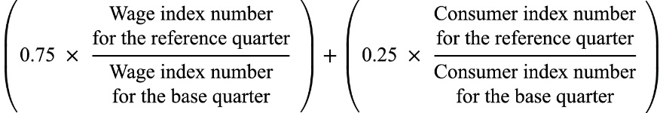

Where:

*base quarter* means the June quarter in the previous year.

*consumer index number*, for a quarter, means the All Groups Consumer Price Index number (being the weighted average of the 8 capital cities) published by the Australian Statistician for that quarter.

*reference quarter*means the June quarter in the year.

*Wage index number*, for a quarter, means the Wage Price Index (total hourly rates of pay excluding bonuses/all sectors/all Australia/original) number published by the Australian Statistician for that quarter.

* + - 1. An SRS indexation factor worked out under subsection (2) is to be calculated to 3 decimal places (rounding up if the fourth decimal place is 5 or more).
      2. Calculations under subsection (2):

1. are to be made using only the index numbers published in terms of the most recently published index reference period; and
2. are to be made disregarding index numbers that are published in substitution for previously published index numbers (except where the substituted numbers are published to take account of changes in the index reference period).
   * + 1. The regulations may prescribe the *SRS indexation factor*for a year.
       2. If the regulations prescribe the SRS indexation factor for a year, subsections (1)   
          to (4) do not apply in relation to the year.
       3. Amounts worked out using an SRS indexation factor are to be rounded to the nearest whole collar (rounding 50 cents upwards).

The indexation factor for 2019 and 2020 is specified in the *Australian Education Regulations 2023*:

For the purposes of subsection 11A(5) of the Act, the SRS indexation factor for 2019 and 2020 is 1.0356.[8]

The two current components of the SRS indexation factor, as described in the Act*,* are the CPI and WPI.

The CPI measures price inflation for the household sector as a whole; the changes in the price of a fixed ‘basket’ of goods and services over time, measured through surveys administered by the Australian Bureau of Statistics (ABS).[9] This component of the indexation factor was intended to compensate for increasing costs related to non-salary items such as educational materials and utilities.

The WPI compares the cost of wages over time for the same work level and output. This means it excludes the effects of changes in the composition of the labour force, the hours worked, employee characteristics, or the quality or quantity of work performed. The data relates to total hourly rates of pay excluding bonuses in all industries in the private and public sectors.[10]

The SRS indexation factor for 2023 was 1.042. The indexation rate for 2024 is expected to be available after 13 August 2024.[11]

1. Issues paper

The Board commissioned Deloitte Access Economics to provide an independent assessment of the current indexation arrangements. This included undertaking macro-economic modelling and analysis of the indexation arrangements that are currently being applied to the SRS. This was a rapid review of the current arrangements, with the analysis completed at a high level given timing and data constraints.

The Issues Paper explored four aspects of the current indexation arrangements as outlined in the review’s terms of reference and included discussion questions. The data underpinning the analysis in the paper was largely derived from publicly available sources. Data referred to in the review terms of reference was not used in this initial analysis due to timeframes and availability.

The Issues Paper was circulated to state and territory governments, ISA and the NCEC on 26 February 2024 to form the basis for stakeholder consultation discussions held from 27 February 2024 to 4 March 2024. (Appendix C – Issues Paper).

1. Consultations
   1. Consultation methodology

Due to timing constraints, the Board undertook targeted consultations with state and territory Departments of Education, ISA and the NCEC. The list of stakeholder consultations is at Appendix E – Consultations.

On 15 February 2024, the Board sought data from the above stakeholders to capture teaching and non-teaching school expenditure as well as information on wage increases over time and funding indexation policy specific to their jurisdictions.

On 26 February 2024 the Board circulated an Issues Paper for discussion during consultations. The consultation meetings, held from 27 February 2024 to 4 March 2024, were attended by jurisdictional and sector representatives, various Board representatives; and were supported by Deloitte Access Economics and the Board Secretariat.

Following the individual consultation meetings, the Board received written submissions from 8 stakeholders.

Stakeholders were also offered the opportunity to provide feedback on the draft report.

* 1. Consultation summary

Key themes and implications from the stakeholder consultations are outlined below:

### Appropriateness of current indexation arrangements

* Overall, jurisdictions did not express a strong case for change to the current indexation arrangements. Most jurisdictions agree that wage growth has aligned well with indexation rates over time, notwithstanding the potential for divergence in wage growth in recent times.
* Some consultees emphasised that with the new National School Reform Agreement (NSRA) currently under negotiation, it would be prudent to consider the arrangements for the SRS base funding amount and loadings.

**The most significant non-staff related operating expenses closely align with those outlined in the Issues Paper.**

* Cost increases in the areas of IT/software, maintenance and utilities were cited by all jurisdictions. Two states also noted substantial increases in natural disaster and recovery costs as exceptional costs during the last five years.
* However, it was noted that centralised whole-of-state purchasing (e.g., software licensing and electricity) occurs in three states and has provided cost savings and insulated school systems from price shocks in these areas.

### Suitability of the current indexation floor

* There is broad agreement that the 3 per cent indexation floor is appropriate, as it provides significant funding certainty.
* Several jurisdictions (state and territory government departments) noted that the starting point for wage setting in the school sector is the baseline pay increase provided to all public sector employees (e.g., nurses, paramedics etc.). This is generally set at around 2–2.5 per cent, with a further allowance for productivity growth (generally around 0.5 per cent). Starting points for pay increases have been higher in recent times due to the effects of higher levels of inflation in the economy.
* A common theme expressed by consultees was that the 3 per cent floor provides desirable security and protection from low-inflation years as well as significant policy changes and economic volatility (such as COVID-19, and its impacts on the composition of schooling inputs). It should be noted that this rationale is, arguably, in opposition to the purpose of SRS indexation to deal only with the effects of inflation on the purchasing power of the SRS.

### Structure and weighting of the composite index

* Most jurisdictions agreed that both the use and weighting of the current composite measures are appropriate.
* However, one state viewed the CPI as not fit for purpose to reflect price changes in education, and that an education-specific WPI would be preferred, noting that they believe there would be limited risk of circularity for government schools.
* Three stakeholders indicated there was no preference for an education-specific price index, and that historically the CPI has not caused any issues related to cost increases.
* A jurisdiction noted that they support the use of the economy-wide WPI as it factors in private sector salaries and therefore supports teacher retention in the broader job market.
* Three jurisdictions were of the view that the indexation rate is unlikely to drive policy decisions as salary increases occur with consideration to many different inputs. One jurisdiction noted that all government salary negotiations follow a structured industrial relations process managed by Treasury and the industrial relations areas.

### Timing of SRS Indexation

* On balance, consultees expressed a preference for budgeting certainty over contemporaneity of indexation with inflation, and that earlier timing would be beneficial.
* However, this perspective was not shared by all consultees, with some jurisdictions noting that other inputs to the SRS (in particular, student enrolment numbers) are a much more significant contributor to funding certainty as opposed to the timing of indexation arrangements.
* Of the jurisdictions that expressed a preference for greater funding certainty, consultees noted that school budget planning processes generally occur within Term 3 and 4 of the calendar year prior.
* These jurisdictions also noted that they have limited capacity to expend additional funding late in the calendar year in which it is provided, under current arrangements. In some cases, this has the potential to impact jurisdictions to comply with the Section 22A obligations under the Act.

1. The appropriateness of current SRS indexation arrangements
   1. Introduction

Indexation is intended to ensure that the SRS maintains its purchasing power so that schools can provide consistent, high-quality education over time. The purpose of the SRS indexation is to compensate schools (and schooling systems) for changes in input prices which affect schooling costs, not changes in the quantity or mix of inputs (for example, greater utilisation of different types of staff), which has the potential to impact the quality or standard of education that is delivered. The intention is that indexation will enable the same resources to be purchased as the previous year, in line with the SRS funding model.

To assess whether current SRS indexation arrangements are appropriate, the Board assessed:

* The inputs required to deliver schooling, in what proportion, and how have the prices associated with these inputs changed over time?
* How changes in input prices compare with the indexation outcomes and the relevant components of the indexation, CPI and WPI.
* The drivers of CPI and WPI, and are these components relevant for schools.
* Based on the above, have the indexation arrangements since 2019 appropriately compensated schools for price-related increases in cost?

In addition to maintaining purchasing power, the broader intentions of indexation must also be considered. Building on the principles set out by Gonski (noted above), these include:

* the need to balance funding stability and certainty (to provide schools and systems with certainty for budget planning) with responsiveness and accuracy (the ability for indexation to respond dynamically to price changes in the schooling sector)
* a preference for simple and transparent policy, and
* the potential for circularity of schooling input prices and funding (arising from the ‘the revenue theory of cost’[12]) and macroeconomic issues associated with embedding prices into wages (‘wage-price spirals’[13]).
  1. Schooling inputs

Excluding capital (which falls outside the scope of the SRS, which seeks to cover the costs of recurrent expenditure), the primary inputs used in the provision of schooling services are:

* staff, including teaching and non-teaching staff, and
* other (non-staff) inputs such as stationery and materials, utilities, property and building maintenance, and computers and information technology.

The Board commissioned Deloitte Access Economics to analyse schooling inputs. Their work uses publicly available National Schools Statistics Collection (NSSC data) retrieved from the Australian Curriculum Assessment and Reporting Authority (ACARA). The NSSC is a census, conducted annually as a collaborative arrangement between State, Territory and Commonwealth education authorities and the ABS, which collects data on a range of schooling issues. This includes government school expenditure, non-government schools’ income and expenditure and staff numbers. Box 1 below discusses how NSSC data differs to data received by stakeholders.

### Staffing inputs

Staff make up the majority of schooling inputs, measured in terms of their contribution to total recurrent expenditure. Since 2018, school staff salaries have consistently represented 74 to 76 per cent of total recurrent school expenditure across Australian schools (Table 1, Table 2). A substantial part of this expenditure is attributed to the salaries of teaching staff, accounting for between 48 and 58 per cent of overall recurrent expenses in schools.

In government schools, the proportion of expenditure dedicated to staff salaries has decreased slightly since 2018. Conversely, non-government schools have experienced a modest upward trend in the proportion of expenditure allocated to staff salaries.

Table 1 Recurrent expenditure on government school sector by financial year

|  |  |  |  |  |  |
| --- | --- | --- | --- | --- | --- |
| **Recurrent expenditure category** | **2017–18** | **2018–19** | **2019–20** | **2020–21** | **2021–22** |
| **Salary related expenditure (%)** | **75.7** | **75.5** | **75.1** | **75.6** | **73.9** |
| Teaching staff salaries (%) | 58.3 | 58.1 | 57.3 | 57.3 | 56.0 |
| Non-teaching staff salaries (%) | 17.5 | 17.5 | 17.9 | 18.3 | 17.9 |
| Redundancies (%) | 0.1 | 0.1 | 0.0 | 0.0 | 0.1 |
| **Non-salary related expenditure (%)** | **24.2** | **24.4** | **24.8** | **24.4** | **25.9** |

Note: The above analysis excludes user cost of capital.

Source: Deloitte Access Economics (2024), Australian Curriculum Assessment and Reporting Authority, *School expenditure* < https://www.acara.edu.au/reporting/national-report-on-schooling-in-australia/school-expenditure>.

Table 2 Recurrent expenditure on non-government school sector by calendar year

|  |  |  |  |  |  |  |
| --- | --- | --- | --- | --- | --- | --- |
| **Recurrent expenditure category** | **2017** | **2018** | **2019** | **2020** | **2021** | **2022** |
| **Salary related expenditure (%)** | **74.8** | **74.7** | **74.6** | **76.8** | **76.4** | **74.6** |
| Teaching staff salaries (%) | 48.7 | 48.0 | 47.5 | 48.3 | 48.3 | 46.6 |
| Non-teaching staff salaries (%) | 16.0 | 16.3 | 16.5 | 17.4 | 17.4 | 17.4 |
| Staff related expenditure (%) | 10.2 | 10.4 | 10.6 | 11.1 | 10.7 | 10.6 |
| **Non-salary related expenditure (%)** | **25.2** | **25.3** | **25.4** | **23.2** | **23.6** | **25.4** |
| Other operating expenditure (%) | 24.0 | 24.1 | 24.1 | 22.0 | 22.6 | 24.3 |
| Debt servicing (%) | 1.3 | 1.2 | 1.3 | 1.1 | 1.0 | 1.1 |

Source: Deloitte Access Economics (2024) and Australian Curriculum Assessment and Reporting Authority, *Non-government schools’ income and expenditure* 2022) <https://www.acara.edu.au/reporting/national-report-on-schooling-in-australia/school-expenditure>.

In order to validate analysis of publicly available NSSC data, stakeholders were asked to submit high-level information about recurrent expenditure and the ratio of salary to non-salary expenditure from 2019 to 2023. Stakeholders were asked to provide data on expenditure on a calendar year basis, including expenditure consistent with what is captured in the *MySchool* data collection. As outlined below, this differs in nature to the NSSC and there was some variance at the jurisdictional level in the proportions of salary- and non-salary-related expenditure across the two data sets. Further details are discussed in Box 1 below.

### Box 1: Comparison of NSSC data and stakeholder data

Stakeholder data from states and territories reveals differences in the ratio of salary-related and non-salary-related expenses compared to publicly available NSSC data retrieved from ACARA. Stakeholder-provided data are based on calendar years, while NSSC publishes financial-year data, contributing to observed variations in expenditure shares.

A request for clarification to states and territories was made to better understand these discrepancies. Stakeholders emphasised that there is a different collection method for stakeholder data (based on *MySchool* full-time equivalent (FTE) data) and NSSC, and therefore data from the two sources are not directly comparable. One stakeholder provided a table which outlines the main differences with how costs are captured between stakeholder data and NSSC (detailed on next page).

Despite variations in expenditure distribution for individual states and territories between different data sources, the average across all states and territories that provided data remains generally consistent, with variances of less than 2 per cent between data sources.

NSSC data is therefore the primary basis for expenditure proportions in this Report, for consistency and because it is publicly available.

1. (continued)

|  |  |  |
| --- | --- | --- |
| **Costs** | **MySchool Financial Data Collection** | **National Schools Statistic Collection (NSSC)** |
| Collection data set: | Calendar year data | Financial year data |
| Primary Education | Included | Included |
| Secondary Education | Included | Included |
| Vet in schools | Included | Included |
| Teacher housing | Included | Excluded |
| Payroll tax | Excluded | Included |
| Depreciation | Excluded | Included |
| Regulatory Expenses | Excluded | Included |
| Boarding | Excluded | Excluded |
| Tertiary | Excluded | Excluded |
| Student transport | Excluded | Included |
| Long Service Leave | Included | Included |
| Repairs and maintenance | Included | Included |

When considering NSSC school expenditure data across jurisdictions, the percentage of recurrent expenditure allocated to salary related costs varies. In 2019–20, salary related expenditure ranged from 62 to 79 per cent of the total expenditure for government sector schools. This percentage was notably higher in the Australian Capital Territory (79 per cent), Queensland (78 per cent), and Western Australia (77 per cent). Conversely, the Northern Territory had the lowest proportion of expenditure on salary related expenses (62 per cent), followed by New South Wales and Victoria (both at 74 per cent) (see Figure 1).

Figure 1 Government sector recurrent expenditure, salary and non-salary by state and territory, 2019–20

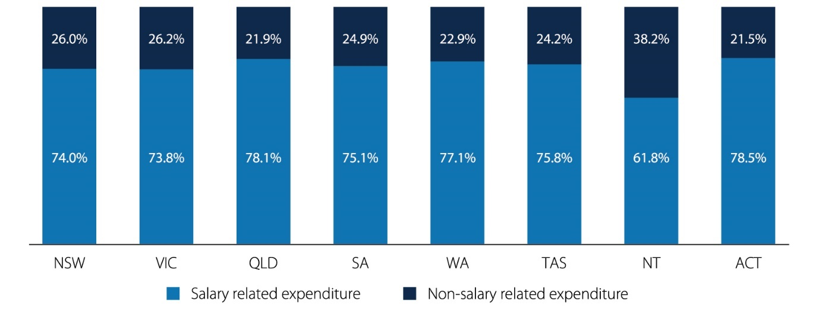

Source: Deloitte Access Economics (2024), Australian Curriculum Assessment and Reporting Authority, *School expenditure* < https://www.acara.edu.au/reporting/national-report-on-schooling-in-australia/school-expenditure>.

As an input to the review, the Australian Government Department of Education supplied expenditure data for the non-government school sector for the years 2019 and 2022. This information allows for a state/territory breakdown of total recurrent expenditure, categorised into teaching, non-teaching, non-aggregated teaching, and non-staff amounts. Variances in the 2019 distribution of salary and non-salary-related expenses were observed in the provided data when compared to the publicly available NSSC data, see Box 1 above, but were broadly aligned.

In the case of non-government schools, the proportion of recurrent expenditure on salary related expenses displayed less variability in the 2019 calendar year compared to government sector schools. Across jurisdictions, salary related expenditure constituted between 72 and 76 per cent. Similar to government sector schools, the highest share of total expenditure allocated to salary related expenses was observed in the Australian Capital Territory (76 per cent), while the Northern Territory recorded the lowest proportion (72 per cent) (Figure 2).

Figure 2 Non-government sector recurrent expenditure, salary and non-salary by state and territory, 2019

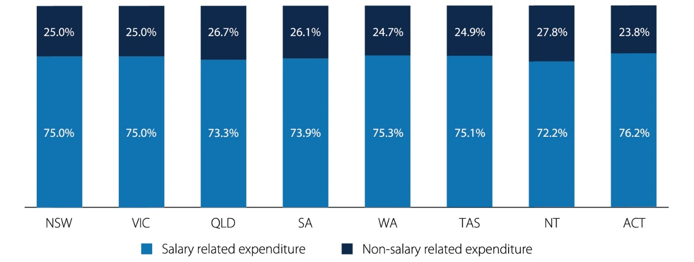

Source: Deloitte Access Economics (2024) and Australian Curriculum Assessment and Reporting Authority, *Non-government schools’ income and expenditure* (2021) <<https://www.acara.edu.au/reporting/national-report-on-schooling-in-australia/school-expenditure>>.

The distribution of salary related expenditure between teaching and non-teaching staff aligns closely with the proportional representation of these staff in schools. Teaching staff constitute the majority of FTE staff.

As part of the data request, stakeholders were asked to provide details regarding the count of FTE teaching and non-teaching staff from 2019 to 2023. In most submissions, the ratios of teaching and non-teaching staff closely match those derived from publicly available NSSC data. There was some variation:

* Data submitted by one stakeholder demonstrated a lower proportion of teaching staff constituting 67 per cent of FTE staff in 2019, decreasing to 62 per cent in 2022. In contrast, publicly available data records teaching staff as comprising 72 per cent in 2019, declining to 70 per cent in 2022.
* The data submitted by another stakeholder shows a small decrease in the proportion of teaching staff from 68 per cent in 2019 to 67 per cent in 2022. In contrast, this proportion remains consistent at 69 per cent in the publicly available NSSC data.

Since 2017, there has been a consistent decline in the proportion of teaching staff observed in both government and non-government schools (Table 3), and a steady rise in the proportion of staff in schools which are non-teaching.

The categories of non-teaching staff include:

* administrative and clerical staff, including teacher aides and assistants (forming the majority of non-teaching staff),
* building operations, general maintenance and other staff, and
* specialist support staff.

Through consultations, some stakeholders affirmed the rising proportion of non-teaching staff in schools, linked in part to the growing demand for allied health professionals and well-being staff. This trend is attributed to an enhanced emphasis on assisting students facing disadvantage and prioritising student health and well-being.

Table 3 FTE staff by school sector and function, Australia, 2017–2022

|  |  |  |  |  |  |  |
| --- | --- | --- | --- | --- | --- | --- |
| **FTE Staff** | **2017** | **2018** | **2019** | **2020** | **2021** | **2022** |
| **Teaching staff – Government sector (%)** | **70.6** | **70.6** | **69.4** | **68.9** | **68.7** | **68.3** |
| **Non-teaching staff – Government sector (%)** | **29.4** | **29.4** | **30.6** | **31.1** | **31.3** | **31.7** |
| Administrative & clerical staff (incl. teacher aides/assistants) (%) | 25.1 | 25.3 | 26.2 | 26.7 | 26.9 | 27.5 |
| Building operations, general maintenance, and other staff (%) | 1.9 | 1.9 | 1.8 | 1.8 | 1.8 | 1.8 |
| Specialist support staff (%) | 2.3 | 2.2 | 2.5 | 2.5 | 2.6 | 2.5 |
| **Teaching staff – Non-government sector (%)** | **68.0** | **67.7** | **67.0** | **66.6** | **66.1** | **65.5** |
| **Non-teaching staff – Non-government sector (%)** | **32.0** | **32.3** | **33.0** | **33.4** | **33.9** | **34.5** |
| Administrative & clerical staff (incl. teacher aides/assistants) (%) | 23.5 | 23.8 | 24.3 | 23.1 | 23.1 | 23.6 |
| Building operations, general maintenance, and other staff (%) | 5.0 | 4.9 | 4.9 | 5.7 | 5.8 | 5.8 |
| Specialist support staff (%) | 3.4 | 3.6 | 3.8 | 4.6 | 5.0 | 5.2 |

Source: Deloitte Access Economics (2024) and Australian Curriculum Assessment and Reporting Authority, *Staff numbers* (2022) <https://www.acara.edu.au/reporting/national-report-on-schooling-in-australia/staff-numbers>.

The approximate percentage of FTE staff dedicated to teaching varies across jurisdictions. In 2019, among government sector schools, the Australian Capital Territory exhibited the highest proportion of teaching staff (72 per cent), followed by New South Wales (72 per cent) and Victoria (71 per cent). Conversely, this percentage was lowest for Western Australia (62 per cent), the Northern Territory (65 per cent) and South Australia (66 per cent) (Figure 3).

Figure 3 Government school sector staff, staff function by state and territory, 2019

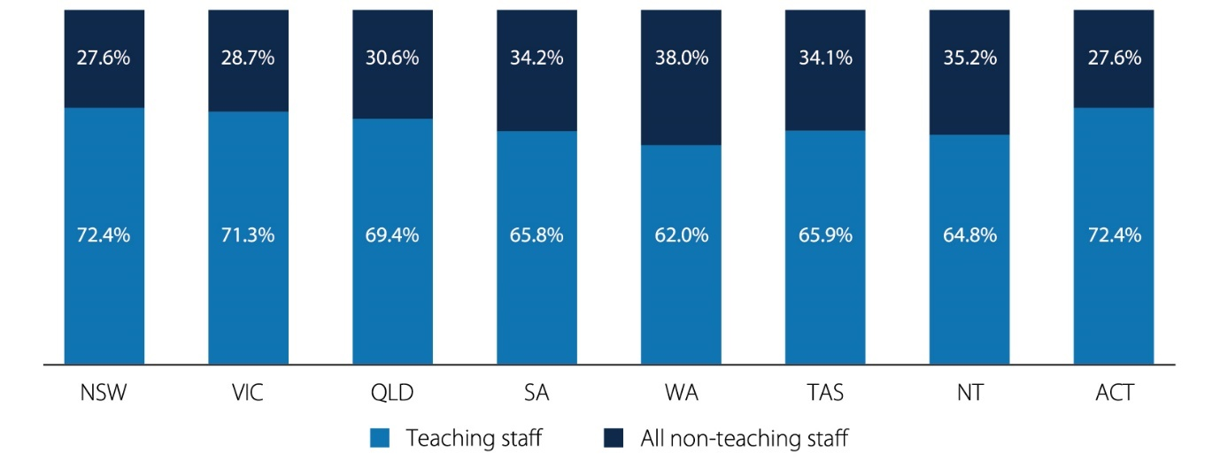

Notes: ACARA staff data is available by calendar year only. Expenditure data for government schools is by financial year while non-government schools data is published for calendar years.

Source: Deloitte Access Economics (2024) and Australian Curriculum Assessment and Reporting Authority, *Staff numbers* (2022) <https://www.acara.edu.au/reporting/national-report-on-schooling-in-australia/staff-numbers>.

In 2019, among non-government schools, the proportion of FTE teaching staff ranged from 52 per cent to 71 per cent, mirroring the variability seen in the government sector. Like government sector schools, the highest proportions of teaching staff were noted in New South Wales (71 per cent), the Australian Capital Territory (71 per cent) and Victoria (68 per cent). Conversely, the lowest share was observed in the Northern Territory (51 per cent) (Figure 4). Relative to the government sector, non-government schools tend to have a higher proportion of non-teaching staff.

Figure 4 Non-government school sector staff, staff function by state and territory, 2019

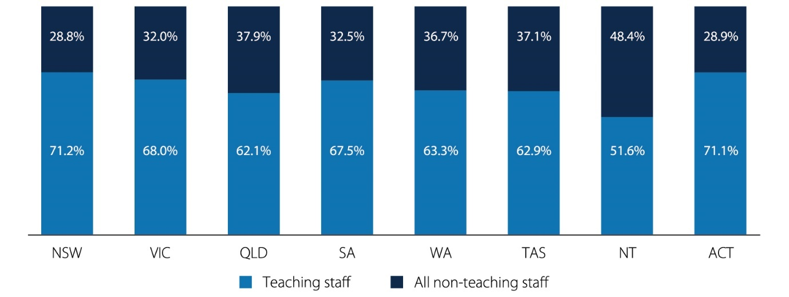

Source: Deloitte Access Economics (2024) and Australian Curriculum Assessment and Reporting Authority, *Staff numbers* (2022) <https://www.acara.edu.au/reporting/national-report-on-schooling-in-australia/staff-numbers>.

### Non-staffing inputs

Limited information is publicly available on the components of non-salary related school expenditure. The information that does exist suggests non-salary related school expenditure likely encompasses:

* general operating expenses, such as utility bills and insurance costs,
* maintenance costs for school land and buildings, and
* materials and supplies including textbooks, art supplies, or sporting equipment.[14]

Discussions with stakeholders and the subsequent written feedback predominantly affirmed these elements as crucial components of non-staffing inputs. Stakeholders emphasised the importance of:

* software, information, and communications technology,
* property management, including cleaning,
* psychology and allied health services,
* casual relief teachers (sourced through third parties), and
* insurance.

It was noted by some stakeholders that the composition of non-staffing inputs for particular jurisdictions differs quite substantially, in particular:

* higher natural disaster and recovery spending,
* disproportionate maintenance and transport spending due to high numbers of regional and remote schools,
* higher proportions of expenditure on insurance premiums for non-government schools and

costs for housing and transportation to attract and retain staff in regional and remote areas.

Analysis of the price movements experienced by jurisdictions in these areas of non-staffing inputs is provided later in this part of the report.

* 1. Measuring schooling input prices over time

### Teacher wages and salaries

In the case of government schools, the responsibility of setting salaries for teachers and school staff rests with state and territory governments. The specific details of these salaries are outlined in respective Enterprise Bargaining Agreements (EBAs) that cover teaching and non-teaching staff collectively or separately, depending on the jurisdiction.

Figure 13 in Appendix F – Additional data presents an overview of the EBAs for government sector teachers in each state and territory based on publicly available EBAs. It delineates the salary increase, specifying the amount, whether it is a percentage increase, flat rate increase, or a combination of both, and provides information on the timing of these increases. Using this data, along with additional information on the actual wages of teaching staff from the EBAs, estimates of wage changes from 2018–19 to 2023–24 were produced. Subsequently, estimates of annual salary growth rates across jurisdictions were calculated, as summarised by Deloitte Access Economics in Table 4.

In addition, stakeholders were asked to provide data on salary increases in their jurisdiction as part of the data request. This is discussed later in this part of the report.

Box 2. Salary on-costs

On-costs related to salaries, covering superannuation, employer taxes (including payroll tax), and workers' compensation, represent expenses for employers that do not generate productive returns.

During consultations, two stakeholders highlighted these costs. One stakeholder pointed out that the higher superannuation benefits for their employees contribute to a larger portion of SRS expenditure being related to salaries.

These salary on-costs are not factored into WPI calculations, or the salary increases calculated using publicly available EBAs. It is not typical for these costs to be factored into indexation arrangements for funding of public services, consequently, they have been excluded from the subsequent analysis. Unless there are material modifications to these costs over time, such as a change in the national superannuation guarantee amount, indexation arrangements should not address these expenses. In such cases, it may be that these cost changes are best addressed through adjustments to other aspects of the design of the SRS, or through a one-off adjustment, potentially made through the legislative provision for an indexation rate prescribed by the Australian Government Minister for Education.

#### Analysis based on publicly available EBAs

Publicly available EBA data reveals notable variations in teacher salaries and growth rates across jurisdictions and over different years. When considering a weighted average, with weights determined by the relative proportion of FTE teaching staff in government schools within each jurisdiction, the annual salary increase ranges between 2 and 6 per cent from 2018–19 to 2023–24. Particularly noteworthy are the substantial salary increases in 2022–23 and 2023–24, including:

* An average increase of 10.7 per cent for New South Wales teachers, attributed predominately to the implementation of a new classification structure that elevated all teachers’ salaries in November 2023
* Three separate increases across 2023 and 2024 for Australian Capital Territory teachers: an increase of $1,750 in January, a 1 per cent increase in June, and an additional increase of $1,750 in December
* A 3.5 per cent increase accompanied by a flat rate $1,000 cost of living adjustment for teachers in Tasmania in 2023
* A 4.0 per cent salary increase for Queensland teachers per year (Figure 13). In addition to the annual salary increase, in 2023 Queensland teachers received a lump sum cost of living adjustment (COLA) payment equal to 3 per cent of base wages (note COLA does not increase base salary).

The timing of salary increases also varies. Typically, jurisdictions implement a single annual increase, often occurring in the first half of the year. However, instances of multiple increases distributed throughout the year are not uncommon, especially in more recent years.

Table 4 Estimated growth in government sector teacher wages and salaries, by state and territory

|  |  |  |  |  |  |  |
| --- | --- | --- | --- | --- | --- | --- |
| **State or territory** | **2018–19** | **2019–20** | **2020–21** | **2021–22** | **2022–23** | **2023–24** |
| Victoria (%) | 3.3 | 3.3 | 1.8 | 2.1 | 2.0 | 2.0 |
| New South Wales (%) | 2.5 | 2.5 | 2.3 | 2.0 | 2.8 | 10.7 |
| Queensland (%) | 3.2 | 0.0 | 2.5 | 5.0 | 4.0 | 4.0 |
| Western Australia (%) | n/a | 1.1 | 1.1 | 3.5 | 3.4 | n/a |
| South Australia (%) | 2.0 | 1.9 | 2.3 | 2.4 | n/a | n/a |
| Tasmania (%) | 2.4 | 2.1 | 2.1 | 2.3 | 5.0 | 3.0 |
| Australian Capital Territory (%) | 1.5 | 3.0 | 3.0 | 3.0 | 3.8 | 4.1 |
| Northern Territory (%) | 2.5 | 2.5 | 2.5 | 3.0 | 3.0 | 3.0 |
| **Weighted average (%)** | **2.7** | **2.0** | **2.1** | **2.9** | **2.7** | **5.6** |

Notes: Estimated growth rates are through the year growth to the June quarter. n/a denotes cases where the EBA is either not publicly available or is presently in negotiation. The weighted average is calculated by applying weights that consider the proportion of FTE government sector teaching staff in each state/territory in the calendar year. For 2024, the FTE staff count from 2023 is utilised due to data availability. More information is available in Appendix G – Methodology and data sources.

Source: Deloitte Access Economics (2024)

In non-government schools, the responsibility for setting salaries for teachers and school staff lies with non-government school approved authorities. These authorities may encompass Catholic school approved authorities and independent school approved system authorities. Unlike government schools, which are typically bound by a uniform EBA within jurisdictions,   
non-government schools often exhibit a greater diversity in EBAs, reflecting the varied agreements negotiated by different approved authorities.

To understand the changes in salaries for non-government teaching staff, Deloitte Access Economics undertook an analysis of selected EBAs in the non-government sector for the Board, specifically concentrating on agreements spanning multiple schools rather than those designed for individual schools. The findings reveal that salary increases tend to align closely, or slightly surpass, the increases stipulated in the government-sector EBAs for teaching staff in their respective states:

* Teachers under the Victorian Catholic Education Multi-enterprise agreement, similar to their counterparts in Victorian government schools, receive a 1 per cent increase in January and July from 2022 to 2024
* The Catholic Schools (Northern Territory) Collective Enterprise Agreement outlines a 3.5 per cent increase in March 2022 and a 3.3 per cent increase in March 2023, slightly exceeding the specified annual increase of 3 per cent for teachers in Northern Territory government schools.

Certain EBAs establish specific conditions for the implementation of salary increases:

* In the South Australia Catholic Schools Enterprise Agreement, the increase is contingent upon the existence of a discrepancy in pay with Department teachers
* In the Catholic Employing Authorities Single Enterprise Collective Agreement - Diocesan Schools of Queensland, the increase in 2022 was to align with that experienced by Queensland Department of Education teachers
* In the Tasmanian Independent Catholic School Multi-enterprise agreement, the specified increase for 2022 to 2024 is linked to the salary per cent increase experienced by Tasmanian Department of Education teachers plus an additional 0.5 per cent, capped at a maximum of 2.5 per cent (Figure 14).

#### Analysis of stakeholder data

Information regarding the yearly growth in salaries for government sector teachers between 2019 and 2023 was obtained from most state and territory government stakeholders. Where data was provided, a weighted average annual salary increase from 2019 to 2023 was calculated. For states and territories without supplied data, estimates are derived using publicly available EBA information. The weights were determined as the ratio of FTE government sector teaching staff in each state/territory to the overall count in the states/territories during the specified period.

Overall, stakeholder data broadly aligns with the publicly available EBA data. From 2019 to 2023, the weighted average salary increases calculated from stakeholder data generally align with those calculated using publicly available EBA data. There is some variability observed from 2021 to 2023, with variations of around 0.5 percentage points. This divergence can be attributed to:

* Differences in timing: publicly available EBA derived estimates consider the salary change in the year to June for that specific year, whereas the precise timing adopted by each stakeholder is unclear (i.e., could be calculated for the year to December, or take an average across the calendar year). This is likely to have caused some disparities, capturing early or delayed effects in average increases.
* Weightings: in the calculations utilising EBA data, increases for different levels of teachers were averaged. However, it is unclear if stakeholder data is weighted based on position representation, potentially leading to variations when different levels of teachers experience disparate increases, or a uniform dollar amount increase is implemented.

Given these differences, the weighted average calculated using publicly available EBAs is preferred for further analysis to ensure a consistent approach is taken in estimating salary increases (discussed below).

Finally, input from consultations and written submissions provided by non-government stakeholders affirmed that wage increases for teachers in the non-government sector under EBAs often mirror the wage increases established in EBAs by the government sector.

### Non-teacher wages and salaries over time

Since 2017, there has been a rise in expenditure on non-teaching salaries, alongside an increase in number (and proportion) of non-teaching staff employed by schools and schooling systems. Considering that administration and clerical staff (including teaching aides and assistants) constitute the majority of non-teaching staff, the examination of the corresponding government sector EBAs for non-teaching roles across various jurisdictions largely focuses on these roles. The extent of coverage for these staff members under EBAs varies, with some falling under the same agreement as teachers, some having a distinct EBA, and others being encompassed by the general agreement for the public sector.

#### Analysis based on publicly available EBAs

On a weighted average basis, the annual salary increase across jurisdictions ranged from 2 to 3 per cent over 2018–19 to 2023–24. Particularly noteworthy is the higher salary increases averages observed in 2022–23, with increases in some jurisdictions exceeding 6 per cent and with the weighted increase exceeding 3 per cent. This contrasts with the other periods, where the weighted average annual increase remained below 3 per cent (Table 5). The recent upswing in the average salary increase can be partly attributed to:

* an increase in the annual increment for Teachers Aides in Queensland from 2.5 per cent per annum in 2018–2020 to headline wage increase of 11 per cent per annum spanning 2022–2024 (i.e., 4 per cent in 2022, 4 per cent in 2023 and 3 per cent in 2024[15])
* the introduction of a $60 per week annual increase for Education Assistants in Western Australia, leading to an approximate 6 per cent average increase in 2023 and 2024
* the adoption of three yearly increases in the EBA for School Assistants in the Australian Capital Territory ($1,750 increase in January, 1 per cent in June, and $1,750 in December)
* the implementation of a new classification structure for staff under the Teaching Agreement in New South Wales, resulting in an average annual increase for Education Officers exceeding 6 per cent for in 2023
* increases for Victorian Education Support staff of levels 1–1 and 1–2 of 11 and 6 per cent respectively in the 2021–22 financial year, in an effort to close the gender pay gap (Figure 15).

Similar to the EBAs for government sector teachers, those for non-teaching staff predominantly establish fixed percentage increases. However, there are instances of dollar increases or a combination of both approaches. Often, the specified annual salary increase remains consistent throughout the duration covered by the EBA. Generally, these EBAs outline one annual increase, occasionally two, with the timing of the first (or sole) increase varying from January to December.

Table 5 Estimated growth in government sector non-teacher wages and salaries by jurisdiction, 2019–2024

|  |  |  |  |  |  |  |
| --- | --- | --- | --- | --- | --- | --- |
| **State or territory** | **2018–19** | **2019–20** | **2020–21** | **2021–22** | **2022–23** | **2023–24** |
| Victoria* (%) | 3.3 | 3.3 | 1.0 | 2.0 | 2.0 | 2.0 |
| New South Wales* (%) | 2.5 | 2.5 | 2.3 | 2.0 | 2.8 | 4.0 |
| Queensland (%) | 3.1 | 0.0 | 2.5 | 5.0 | 4.0 | 4.0 |
| Western Australia (%) | 2.2 | 2.2 | 2.1 | 2.1 | 6.3 | 5.9 |
| South Australia* (%) | 2.0 | 1.9 | 2.3 | 2.4 | n/a | n/a |
| Tasmania (%) | 2.4 | 2.3 | 2.3 | 2.4 | 6.0 | 3.0 |
| Australian Capital Territory (%) | 2.1 | 2.7 | 2.7 | 2.7 | 3.9 | 3.7 |
| Northern Territory* (%) | 2.5 | 2.5 | 2.5 | 3.0 | 3.0 | 3.0 |
| **Weighted average** (%) | **2.7** | **2.0** | **2.0** | **2.7** | **3.5** | **3.7** |

Notes: Estimated growth rates are through the year growth to the June quarter. n/a denotes cases where the EBA is not publicly available or is in negotiation. *Roles are governed by the same EBA as teaching staff. The specific   
non-teaching roles covered in the analysis differ between jurisdictions, and are outlined in Figure 15. *Roles are governed by the same EBA as teaching staff. The weighted average is calculated by applying weights that consider the proportion of FTE government sector non-teaching staff in each state/territory in the calendar year. For 2024, the FTE staff count from 2023 is utilised due to data availability. More information is available in Appendix G.

Source: Deloitte Access Economics (2024) and State and territory Departments of Education (2017–2024)

#### Analysis of stakeholder data

Data on annual government sector non-teacher wage growth for 2019 to 2023 was received from most state and territory government stakeholders. Based on this data, a weighted average for annual salary increases for this period was calculated by Deloitte Access Economics, incorporating data received from state and territory stakeholders where available, and where not available, estimates for states and territories were derived using publicly available EBA information. The weights consider the ratio of FTE government sector non-teaching staff in each state/territory to the overall count.

Stakeholder data broadly aligns with the publicly available EBA data. In 2019 to 2020, the weighted measure calculated from stakeholder data aligns with data collected through publicly available EBAs, but there is divergence in 2021 to 2023, likely due to specific factors:

* In one jurisdiction, the stakeholder data covers reported salary increases for Education Support staff, whereas the EBA-calculated increases additionally include Paraprofessional staff. Stakeholder consultations noted a deliberate government decision to increase the salaries of some Education Support staff over this period. While EBA data reflects this for lower classifications, the increase across other Education Support and Paraprofessional levels was much less. The absence of data breakdown for non-teaching staff by positions likely contributes to the disparity as EBA-calculated increases are unweighted averages across all positions.
* In another jurisdiction, the reported increase for 2023 is notably lower than the EBA-calculated figure. The EBA-calculated figures only consider a small number of teaching assistant positions. The new EBA includes an additional payment for lower classified staff, potentially explaining the higher total increase compared to reported figures if those figures account for staff at higher levels.
* In another jurisdiction, government non-teaching staff reported no salary increase in 2021 and 2022, in contrast to the 2.5 and 3 per cent increase calculated using publicly available EBAs during these years. This disparity arises from variations in the positions considered, as the stakeholder-provided data accounts for the administrative EBA for staff such as special education officers who are covered by the administrative EBA, while the EBA-calculated positions focus on teaching assistants.

Similar to the data received for stakeholder teacher salaries, different approaches may have been used to calculate the provided non-teacher salary data. For consistency of calculation, Deloitte Access Economics used the weighted average calculated using publicly available EBAs for further analysis (discussed further below).

### Other operating input prices over time

Noting the limited publicly available data on non-salary-related recurrent expenditure, information from consultations and written responses indicated that major non-staff schooling inputs are:

* general operating inputs, such as utilities and insurance,
* maintenance on school land and buildings,
* materials and supplies including textbooks, art supplies, or sporting equipment,
* software, information, and communications technology, and
* casual relief teachers (sourced through third parties).

The CPI subcategories identified by stakeholders to be most relevant for schooling, outlined in Table 7 of Section 4.4, provide evidence of how prices of the above inputs may have changed for school systems in recent years.

* Transport, cleaning and maintenance products, and maintenance and repair of the dwelling saw the highest average price growth over the analysis period of 2018–19 to 2022–23, recording increases between 4.1 and 5.4 per cent.
* Utilities, newspaper, books and stationery, and Insurance and financial services saw moderate price growth of between 2.4 and 3.5 per cent.
* Audio, visual and computing equipment and services saw modest growth of 0.8 per cent on average, following three years of negative growth between 2018–19 and 2020–21.

The Review has provided an analysis of how the price growth of these CPI categories has compared to overall CPI in Section 4.4.

In addition to the evidence from CPI subcategories, stakeholders described experiencing material increases in expenditure related to the following non-staff categories in consultations and written responses. However, they were often unable to disentangle the impact of price increases from increases in quantities purchased:

* Software, IT and licencing related costs are understood to have increased across all jurisdictions, with stakeholders noting a mix of both composition and pure price changes being seen. One stakeholder emphasised that costs in this area have risen over 100 per cent in recent years. This increase, and similar increases in this area mentioned by other stakeholders, can largely be attributed to the change in technology demands and remote learning delivery models seen since the start of the COVID-19 period. Notably, one stakeholder highlighted that while the central licencing of software from large providers has decreased provision costs for Departments (through wholesale pricing), these arrangements have led to substantial price rises once widely in use.
* Increased expenditure on maintenance was cited by all stakeholders, while expenditure on natural disaster recovery has seen significant and atypical increases across some jurisdictions. The Board heard that these areas alongside cleaning and COVID-19 associated expenditure accounted for the most significant changes in non-staff expenditure over the last five years. Some stakeholders noted maintenance of ageing infrastructure as the largest increase in non-staffing expenses, however one stakeholder cited volume increases as a driver in this area (as opposed to prices). Another stakeholder stated that maintenance price increases have been incurred disproportionately due to the high proportion of regional and remote schools, however the review was unable to substantiate this in other consultations.
* Insurance premiums for schools have increased significantly, with one stakeholder noting in consultation that prices have increased over 100 per cent in some instances for independent schools since the Royal Commission into Institutionalised Child Abuse in 2017. They stated that government schools are more capable of aggregating these price increases across the school system, whilst non-government schools experience a higher cost impact at the individual level. One stakeholder noted a significant increase in work cover expenses.

It is important to consider these operating input price changes over time against the presence of compositional changes to schooling cost structures. As mentioned, one stakeholder outlined that the increases in maintenance prices are volume-based and may not purely reflect price changes.

One stakeholder raised in its consultation and written response that consideration should be given to the future outlook of schooling delivery methods and the changes expected in the non-staffing cost base, and the appropriateness of using historical data to inform future SRS indexation policy decisions. Further, they raised to the review that the original 2011 Gonski Review of Funding for Schooling envisaged that reviews of the SRS indexation rates would refer to only current ‘reference’ schools.

These points lead to a discussion of whether CPI accurately reflects costs facing schools, which is discussed later in this part.

* 1. Comparison of schooling input prices with historical SRS indexation rates and its components

### The Wage Price Index and schooling wages and salaries

The ABS WPI measure captures changes to the price of wages and salaries in the Australian labour market over time. It measures pure price changes by removing the effect of compositional factors such as quality or quantity of work or the composition of the workforce. It reflects wages and salaries of employers across all employing organisations in Australia (public and private sectors) except:

* enterprises primarily engaged in agriculture, forestry or fishing
* foreign embassies, consulates, etc.
* private households employing staff.

The WPI has increased by an average of 2.4 per cent over the period 2018–19 to 2022–23. Throughout this timeframe, publicly available EBA data indicates teacher and non-teacher salaries in the government sector have, on a weighted average basis, increased by 2.5 and 2.4 per cent (Table 6).

There is variation across jurisdictions over the period 2018–19 to 2022–2023:

* Growth in the WPI has surpassed teacher salaries in Western Australia and South Australia, kept pace with Victoria and New South Wales, but lagged behind the other states and territories.
* Growth in the WPI has been consistent with non-teacher salaries in Victoria and New South Wales, surpassed growth in Tasmania and the Northern Territory, but lagged behind the other states and territories.

Consequently, Deloitte Access Economics showed the growth in the WPI appears to have been consistent with the weighted average growth in both teacher and non-teacher salaries across Australia in recent years. As such, current indexation arrangements are considered to be broadly appropriate, noting that further consideration relating to the design of the floor and composition of the index are discussed in subsequent sections of this report.

Table 6 Growth in the WPI, original, year to June quarter

|  |  |  |  |  |  |  |
| --- | --- | --- | --- | --- | --- | --- |
| **Growth** | **2018–19** | **2019–20** | **2020–21** | **2021–22** | **2022–23** | **CAGR** |
| WPI growth (y/y%) | 2.4 | 1.7 | 1.8 | 2.6 | 3.6 | 2.4 |
| Weighted average government sector teaching wages growth calculated using publicly available EBAs (%) | 2.8 | 1.9 | 2.1 | 2.9 | 3.0 | 2.6 |
| Weighted average government sector non-teaching wages growth calculated using publicly available EBAs (%) | 2.7 | 2.0 | 2.0 | 2.2 | 4.2 | 2.6 |

Notes: Growth rates are through the year growth to the June quarter. The weighted averages reported are those calculated using the publicly available EBAs, as the specific details regarding stakeholder salary increase calculations are unclear, and therefore not directly comparable to WPI. CAGR is the annualised average rate of growth over time, with the effect of compounding taken into account.

Source: Australian Bureau of Statistics (2024) and Deloitte Access Economics (2024).

### The Consumer Price Index and other schooling input prices

The ABS CPI measures changes in the price of a basket of goods and services over time. The goods and services within the basket represent the expenditure patterns of metropolitan households. The 87 expenditure classes within the CPI are weighted according to their relative importance (in terms of contribution to total expenditure). These weights are updated annually and as such, the CPI reflects the price of a typical basket of goods and services, taking into account how that changes over time as households respond to changes in relative prices and incomes.

The CPI categories which have been identified by stakeholders in consultation and written responses as being highly relevant to schooling, as previously discussed, are outlined in Table 7. As there is no broadly applicable data available on the breakdown of non-salary expenditure within schools, the relevant CPI categories could not be weighted to inform a weighted average price increase across non-staff inputs. Whilst one stakeholder provided a breakdown of non-staffing expenses, they were not able to be categorised into CPI categories. Another stakeholder provided percentage allocations for its three major non-staffing expense categories, however a full breakdown across jurisdictions would be required to inform a rigorous analysis.

Over the analysis period, growth in the CPI tended to outpace growth in the majority of CPI categories that were noted by stakeholders as highly relevant. The key exceptions are seen in transport, cleaning and maintenance products and maintenance and repair of the dwelling.

* Transport price shocks seen in 2020–21 and 2021–22 (as previously discussed) are responsible for its higher average growth rate compared to CPI. Increases slowed significantly in 2022–23 with the category more than 4 percentage points lower than CPI growth.
* Cleaning and maintenance products have on average outpaced CPI, with significantly higher rates of growth in three out of five years over the analysis period.
* The maintenance and repair of the dwelling category modestly outpaced CPI over the analysis period, and has closely tracked CPI since 2021–22. As previously mentioned, several stakeholders noted in consultations and written responses that maintenance of their ageing infrastructure has represented rising costs for their schools, with one stakeholder stating that prices have outpaced CPI.

Table 7 Consumer Price Index, original, year to June quarter, 2019–2023

|  |  |  |  |  |  |  |
| --- | --- | --- | --- | --- | --- | --- |
| **Consumer Price Index** | **2018–19** | **2019–20** | **2020–21** | **2021–22** | **2022–23** | **CAGR** |
| Consumer Price Index (%) | 1.6 | -0.3 | 3.8 | 6.1 | 6.0 | 3.9 |
| Utilities | -0.2 | -0.8 | -4.2 | 1.6 | 13.8 | 2.4 |
| Transport | 1.7 | -7.5 | 10.7 | 13.1 | 1.9 | 4.2 |
| Audio, visual and computing equipment and services | -4.0 | -1.3 | -0.4 | 2.9 | 2.0 | 0.8 |
| Newspapers, books and stationery | -0.2 | 2.5 | 0.9 | 2.2 | 6.7 | 3.0 |
| Insurance and financial services | 0.9 | 1.7 | 0.6 | 3.4 | 8.5 | 3.5 |
| Cleaning and maintenance products | 1.0 | 9.6 | -4.6 | 8.0 | 9.2 | 5.4 |
| Maintenance and repair of the dwelling | 3.1 | 1.9 | 2.9 | 5.9 | 5.7 | 4.1 |

Notes: CAGR is the annualised average rate of growth over time, with the effect of compounding taken into account.

Source: Australian Bureau of Statistics (2024).

As mentioned, without an accurate breakdown of non-staff expenditure data provided for jurisdictions that aligns with CPI categories, evidence of actual non-staff input prices cannot be validated. However, the qualitative evidence set out by stakeholders during consultation summarised earlier confirms that price increases are being seen broadly throughout the school systems.

Finally, this analysis, in conjunction with the movements in prices detailed at ‘Other operating input prices over time’, feeds into an analysis of the appropriateness of CPI to reflect the underlying non-staffing costs facing the education sector. This is discussed further in Part 6.

* 1. Drivers of WPI and CPI and their relevance to schooling

Both WPI and CPI are affected by a range of drivers, not all of which are relevant to schooling inputs. This is an important distinction during the elevated inflationary environment Australia has experienced in recent years.

CPI reflects price growth across a broad basket of consumer goods. Between 2021 and 2023, key drivers of CPI included:

* new dwellings by owner-occupiers (with year-to price growth peaking in September 2022 at 20.7 per cent, due to construction material and worker shortages through much of 2022)
* automotive fuel (peaking in the March quarter of 2022 at 35.1 per cent during the onset of the Ukraine War)
* utilities (peaking in the March quarter of 2023 at 14.9 per cent from global energy disruptions)
* holiday travel and accommodation (peaking in the December quarter of 2022 at 17.2 per cent following the removal of border restrictions)
* rents (peaking in the September quarter of 2023 at 7.6 per cent following a surge in rental demand in 2023).

As outlined previously, utilities are a key non-salary expense for schools (though the weighting of this is uncertain). Automotive fuel prices may also be relevant for schools with vehicles, but otherwise most of these key drivers of inflation were not relevant for schools. The cost of construction materials and worker shortages are also relevant to non-government schools who are responsible for their own capital infrastructure building and maintenance costs.

Strong wages growth has emerged since the COVID-19 pandemic due to high inflation and widespread worker shortages. Education and training is only one of the industries covered by the headline WPI measure, and has not been a key driver of overall wage price growth in recent years (as EBAs have not reacted as quickly to labour market pressures). Education and training WPI rose 2.3 per cent compared to overall WPI of 2.6 per cent in the year to June 2022, and similarly tracked below overall WPI in the year to June 2023 (3.2 per cent vs 3.6 per cent respectively).

Instead, sectors like construction (which outpaced overall WPI for mid-2022 to mid-2023, in response to significant sector worker shortages) were dominant. Going forward, Education and training may become larger contributors to overall WPI movements as EBAs are renegotiated to reflect higher overall WPI and persistently high inflation. Recently released December 2023 WPI data shows that the Education and training WPI is now 4.8 per cent, higher than overall WPI at 4.3 per cent.

These factors, and their implications for the design of the composition and weighting of indexation arrangements for the SRS, are discussed further in Part 6 of this report. Most stakeholders noted that they were broadly satisfied with using headline CPI despite differences in drivers relative to schooling. This is discussed in more detail in Part 6.

**Finding 1**

Current indexation arrangements are considered appropriate.

1. The suitability of the current SRS indexation floor
   1. Overview

Current indexation arrangements specify that a minimum indexation rate of 3 per cent (an indexation floor) is applied if the calculated composite WPI/CPI measure is lower than 3 per cent. The Australian Government Minister for Education may alternatively prescribe an indexation rate which takes precedence over the indexation floor, as was the case in 2019 and 2020 to facilitate the transition to current indexation arrangements.

One method for considering the suitability of the 3 per cent floor, is by understanding how the index would have performed over time had it been in place prior to 2019. This is demonstrated in Figure 5 which considers the result of a hypothetical scenario where the indexation formula has been in place since 2002. Between 2002 and 2023, the SRS indexation formula would have returned a maximum escalation factor of 4.3 per cent (in 2008) and a minimum of 1.2 per cent (in 2020). Notably, the result of the indexation formula would have been below the 3 per cent floor for nine consecutive years between 2013 and 2021.

Figure 5 Result of indexation formula over the past two decades

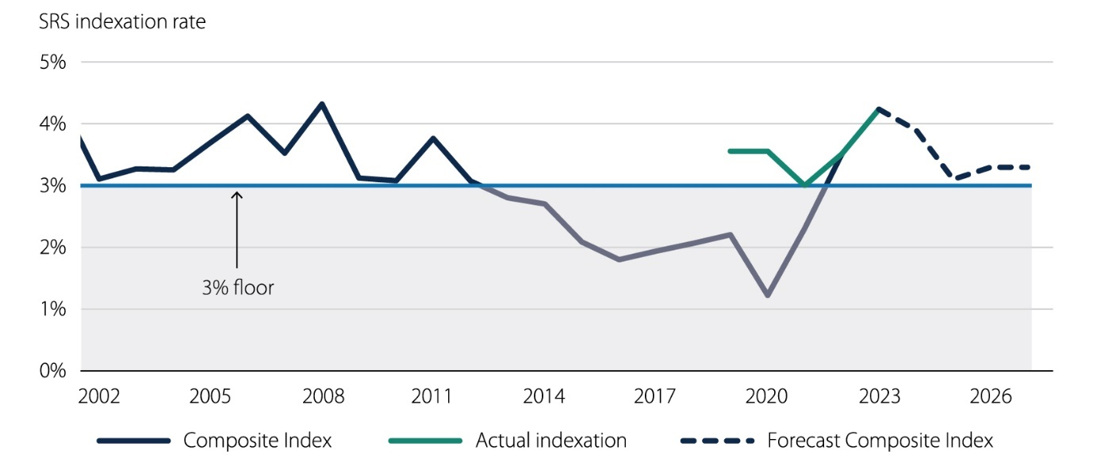

Note: This chart shows the hypothetical application of the SRS indexation formula from 2002. The result of the indexation formula (the solid blue line) is the prescribed weighted average of the CPI and WPI. The forecast (shown as a dashed blue line) is sourced from the Australian Government Department of Education and is based on the CPI and WPI forecasts contained in the 2023-24 Mid-Year Economic and Fiscal Outlook. The effect of the floor is calculated based on the cumulative result of the indexation formula including the use of the 3 per cent floor, compared to a scenario where the floor does not apply. Note that 2002 was chosen for illustrative purposes only, and any earlier would include impacts of the introduction of GST.

Source: Deloitte Access Economics (2024) and Australian Government Department of Education (2023).

The suitability of the indexation floor depends on the rationale for the floor and how that compares with the objectives of indexation itself. These considerations are discussed in the sections below.

* 1. Rationale for an indexation floor

While the rationale for the floor is not clearly stated in government policy, one key rationale may be to protect the system from transitory variability in inflation and provide a level of funding certainty. In particular, this may relate to protecting the system from deflation (that is, a decrease in nominal funding). This primary purpose was generally supported by stakeholders consulted as part of this review.

### Funding certainty

The current SRS indexation floor of 3 per cent provides certainty to systems and schools about the minimum increase via indexation. From 2013 to 2021, which can be characterised as a relatively low inflationary environment, the composite WPI/CPI measure averaged 2.1 per cent (ranging from 1.2 per cent in 2020 to 2.8 per cent in 2013). Despite the spread of composite measure results, indexation would have been set to 3 per cent because of the indexation floor, providing certainty around the SRS increase.

Stakeholders broadly agreed that the use of a floor is an appropriate feature of indexation. The certainty and stability provided by the floor is seen as largely positive by stakeholders, including playing an important role in supporting budget planning at a school and system level.

Common themes observed through written submissions and consultations were:

* The floor is effective in protecting against potentially low indexation years and supports jurisdictions in adjusting to significant policy changes and economic volatility (such as COVID-19, and its impacts on the composition of schooling inputs).
* Confirmation of the floor’s usefulness as a planning tool in absence of knowing the final indexation rate, with one stakeholder noting it is used as a starting point for budgetary planning with required adjustments from the level of the floor made later in the year.
* From a non-government schools perspective, it was emphasised that the floor provides necessary protection against certain costs that impact independent schools more than government schools, such as higher insurance premiums following the Royal Commission into Institutionalised Child Abuse (as discussed in Part 4).

### Funding accuracy and the risks of over-compensation for price increases

Notwithstanding the benefits outlined above, there is a trade-off between certainty and contemporaneity. By stipulating an indexation floor, indexation cannot as accurately respond to price changes. By definition, a floor will be engaged in relatively low inflationary environments. This can mean that, over time, indexation will increase SRS by more than required to maintain purchasing power, which is the primary objective of indexation. This is not costless to the schooling sector, as real increases in the purchasing power of systems and schools have the potential to put further pressure on the teacher workforce through an increase in workforce demand, where there is already a lack of sufficient supply and salaries are set by government across schooling systems. To the extent that staffing shortages are experienced disproportionally by disadvantaged schools and systems, this can contribute towards inequitable outcomes for students.

The possibility of addressing extra funding, or ‘overcompensation’, provided in some years by an indexation floor was also raised by one stakeholder. It was suggested that that in years where the floor is engaged where indexation would have otherwise been, for example, 2 per cent, the 1 per cent of additional indexation should be offset (subtracted from the future year(s) funding targets). While the Board acknowledges this may be a desirable mechanism for jurisdictions to meet SRS funding targets more easily and would more accurately reflect the intent of the indexation floor, it would be complex to implement in practice.

Importantly, when questioning the rationale for a floor and the conditions under which it is engaged it is important to note that Australian Government Ministerial discretion of the indexation rate is maintained as a policy feature. In any given year, the Australian Government Minister maintains the ability to set an indexation rate that aims to maintain the purchasing power of the SRS if the composite index is seen to under-provide against policy-related wage shocks, for example. While this strays from the intended ‘policy independence’ of indexation, it could be an available fall-back measure if required.

### Future inflation

The inflationary environment has changed substantially in the past two years. Both annual WPI and CPI growth have peaked in the recent past, meaning that the indexation floor was not engaged in 2022 and 2023. Instead, the WPI/CPI composite measure was used (3.5 per cent and 4.2 per cent for the respective years).

The Board heard from Deloitte Access Economics that growth in the CPI will continue to slow from its peak in late 2022, reaching the upper limit of the RBA’s target band of 2-3 per cent in 2025. CPI is expected to slow further reaching 2.3 per cent in mid-2030, and stabilising at an average of 2.5 per cent in the long term. Growth in the WPI, which lags CPI growth as it is reactive to changes in cost of living, is expected to increase in the short term and peak at 4.1 per cent in mid-2024, before slowing. WPI is expected to be relatively stable at 3.1 per cent between mid-2025 and mid-2030 (Figure 6).

Figure 6 WPI and CPI forecasts

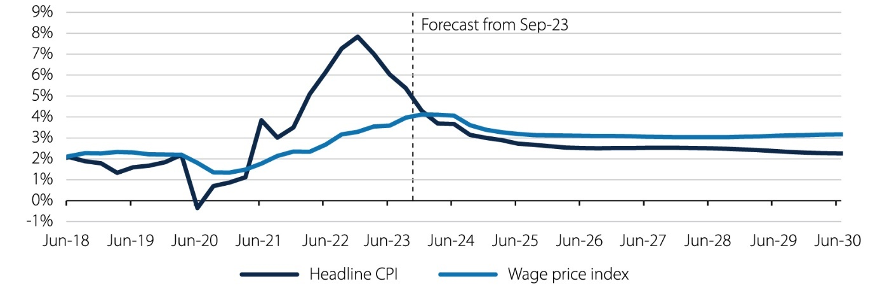

Source: ABS (2024) and Deloitte Access Economics (2024)

While difficult to predict with certainty, there are reasons to consider that the inflationary environment may be more variable in the future than was the case over recent decades prior to the pandemic. Climate change, energy transition and geopolitical disruption all have the potential to generate volatility in prices in the future. This potentially strengthens the argument for an indexation floor to guard against future deflationary (and inflationary) shocks.

* 1. Setting an indexation floor

The concept of a floor is a desirable feature of an indexation formula. It does however raise questions as to the level at which the floor should be set.

The purpose of the floor for the SRS is to impose a degree of stability in indexation over time. It is in place to reflect changes in prices and, therefore, the costs faced by schools. This approach provides certainty for schools with a minimum increase in the SRS base amount and loadings each year, as well as ensuring funding keeps up with changes in wages and other costs.

The fact that the composite measure has been below the 3 per cent floor for much of the past decade has raised questions of the appropriateness of the floor, as discussed above.

For example, had the SRS indexation formula been in place from 2002 (and funding escalated according to the formula over that time), the total funding provided in 2023 would be 8.2 per cent lower than with the use of the 3 per cent floor. However, it should be noted that this recent period of inflation (pre-COVID-19) had an unusually sustained period of low inflation that is not likely to repeat itself any time soon. The Board is aware that only looking at past data does not reflect current trends or future rates of indexation and growth.

The majority of stakeholders considered the 3 per cent level of the floor to be appropriate, to support forward planning certainty. Non-government schools’ noted that the 3 per cent indexation floor is a necessary safeguard for all schools and particularly for non-systemic schools where funding certainty is imperative.

Figure 7 Cumulative difference in funding with and without an indexation floor

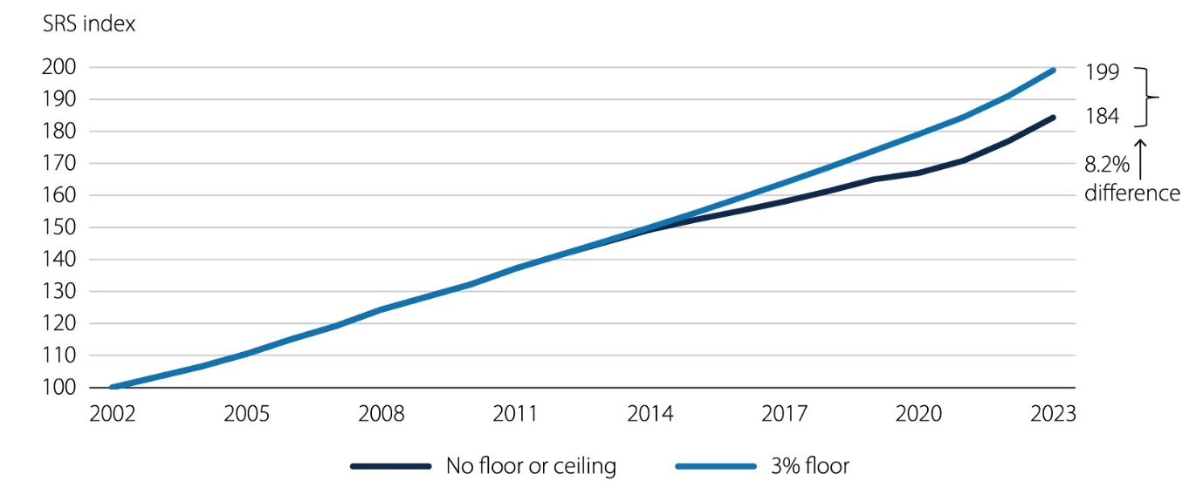

Note: The above chart shows the level of funding (assuming a base of 100 in 2002) if current indexation arrangements would have been in place since 2002.

Source: Australian Bureau of Statistics (2024), Deloitte Access Economics (2024), Australian Government Department of Education (2024).

It should be noted that indexation is used widely across government programs to maintain the relative value or level of policy settings over time.[16] Generally speaking, the intention of indexation is to compensate for inflation and, in the case of indexation on wages, productivity changes over time.

A possible reference point for such a range may be the RBA’s target band for inflation of 2-3 per cent over the medium term, with some allowance for productivity growth reflected in wages growth (noting that productivity growth in the education sector is very difficult to measure). This would represent a very conservative range, and alternative ranges may be appropriate, depending on the extent of stability that is desired for the sector.

In this context, it is notable that it is relatively uncommon for wage growth in the school education sector to fall below 2-3 per cent (as shown in Section  4.3), and therefore an indexation floor set in this range may insulate the sector from low levels of inflation that are not reflective of price changes occurring in the schooling sector.

The Act which defines the current indexation arrangements provides the Australian Government Minister for Education with the ability to set the indexation rate at any level they deem appropriate. This offers another opportunity for protection against volatility over time.

Notwithstanding these economic observations, responses from many stakeholders through consultation indicated that the current 3 per cent level of the indexation floor is considered broadly appropriate.

* The majority of stakeholders considered the 3 per cent level of the floor to be appropriate, or were neutral on the matter.
* One stakeholder noted that while they also consider the level to be appropriate given the current high wage-growth environment, 3 per cent may become excessive in periods of low wage growth.
* There was strong support for the 3 per cent level from a non-government schools perspective, noting that the 3 per cent funding floor is considered a necessary safeguard for all schools and particularly for non-systemic schools.

It should be noted that some stakeholders, while not expressing strong views on the need for changing of the 3 per cent level, suggested that a lower level of 2.5 per cent be explored in the context of the RBA’s 2-3 per cent target band for inflation and wage setting in the public sector more broadly.

* One stakeholder noted that this level would be consistent with the average WPI increase over the period 2019 to 2023 (as outlined in Table 6).
* Several stakeholders noted that the starting point for wage setting in the schooling sector is the baseline pay increase provided to all public sector employees (e.g., nurses, paramedics, etc.). This is generally set at around 2-2.5 per cent, with a further allowance for productivity growth (generally of around 0.5 per cent). The Board heard that starting points for pay increases have been higher in recent times due to the effects of higher levels of inflation in the economy.

**Finding 2**

Current indexation floor arrangements are considered appropriate, given the strong preference for stability and certainty by the sector, and evidence regarding the way that jurisdictions typically determine salary increases over time.

**Recommendation 1**

The Australian Government should maintain an SRS indexation floor as a feature of SRS indexation arrangements.

**Recommendation 2**

In the current environment, the Australian Government should maintain the indexation floor at 3 per cent. In a low inflation environment, the Australian Government, in consultation with jurisdictions and sectors, should consider the risks associated with potential over-compensation for price changes and – if necessary – re-evaluate the setting of the indexation floor.

1. The appropriateness of the composite index
   1. Alternative data sources for the composite index

The current SRS composite index is based on the WPI and CPI and is weighted more heavily towards wages growth (75 per cent) to reflect the dominance of salaries in schooling expenditure.

By using broad-based data series, the index is simple to follow and based on data that is relatively timely. Aggregate measures are less likely to be significantly influenced by education related policy decisions, reducing risks of circularity (as previously discussed). However, the composite index reflects changes in the price of a broader set of goods, services and labour that are not all relevant to schooling inputs.

An alternative measure which is more detailed would similarly trade off important principles: in particular, accuracy and simplicity.

Alternative data inputs for the composite index are considered in Figure 8, assessed against the following principles:

* Frequency and timing – is there timely data available?
* Specific to education – is the data series a broad-based economy-wide measure or specifically related to education wages or costs?
* Reflective of schools costs – is the data an appropriate proxy of schooling costs?
* Policy independence– does the data avoid circularity issues where policy changes influence rates of indexation (and vice versa)?

### Education specific measure of WPI

Of the data sources considered, the most relevant alternative data source is the Education and training WPI as it could provide a more accurate gauge of wage increases within the school sector. However, the index also measures preschool, tertiary and other education sector wages not relevant to the SRS.

An important consideration of whether the Education and training WPI is appropriate for the composite index is looking at how it has compared to overall WPI over time. In the past five years, Education and training WPI has trended above overall WPI in 2020 and mid-2021 (when inflation was still low), before falling below overall WPI from December 2021 to September 2023 (when inflationary pressures were elevated). The public and private Education and training WPIs have been largely similar in the past five years (Figure 8).

Figure 8 Education and training WPI - comparisons

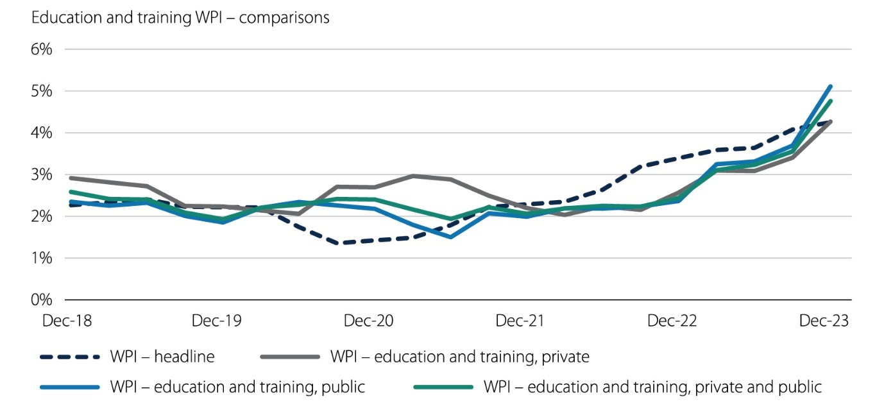

Source: Australian Bureau of Statistics (2024).

This is also supported when looking at the longer historical series back to 2007 (chosen for illustrative purposes only). Education and training WPI consistently ran about 0.5 percentage points to 1 percentage points higher than headline WPI since December 2013. This is likely driven by EBAs (which inherently ensure there is wage growth) even if the broader economy is seeing weaker wage growth, a phenomenon that is largely protected from through the application of an indexation floor (as discussed in Part 5). Even with this difference, the general direction and movements of WPI are similar, though sometimes lagged for the Education and training WPI as EBAs are multi-years and take time to flow through (a relevant consideration for the determination of the timing of indexation rates, discussed in Part 7).

Figure 9 Education and training WPI

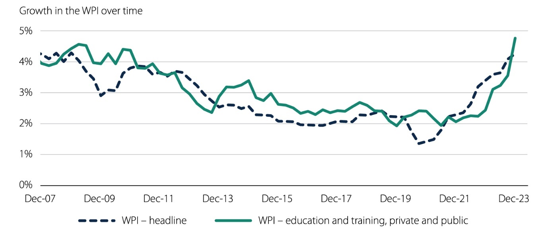

Source: Australian Bureau of Statistics (2024).

Figure 10 Composite WPI/CPI measure with overall WPI and Education and training WPI

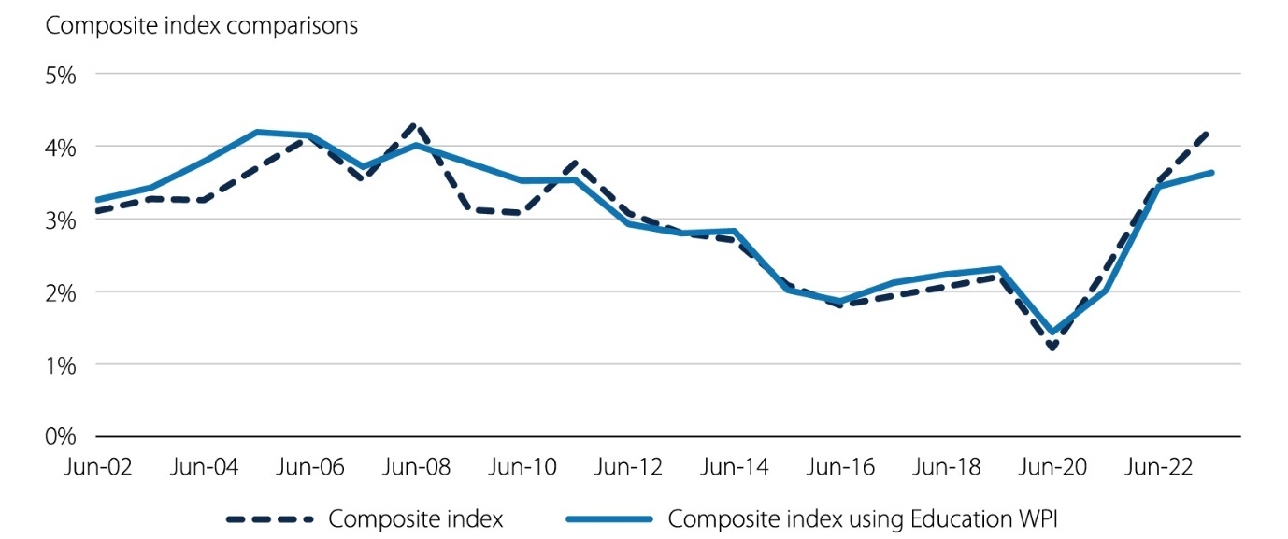

Source: Australian Bureau of Statistics (2024).

With these points in mind, consultations with stakeholders indicated a general preference or indifference towards retaining the current WPI measure. The current approach is well known by stakeholders and as no significant benefits or differences are expected from switching to an education specific measure, there is a preference to retain the same measure –particularly given the timing of upcoming NSRA discussions and education reforms. One stakeholder was a key exception who noted a preference for the education specific WPI.

It should also be noted that more sector specific data, including data from EBA agreements, would not be an appropriate basis for determining indexation. Such an approach would be subject to issues of policy independence (as discussed below), and EBA salary increases are not always representative of pure inflationary changes. EBAs often include trade-offs between salary changes and other measures that may impact productivity and the work value for teaching staff, for example, changes to face-to-face teaching requirements or class size guidelines alongside changes to salaries.

#### Policy independence

As previously outlined, policy independence and circularity are important considerations when determining an appropriate indexation measure. The ‘revenue theory of cost’ outlined by Deloitte Access Economics suggests that an increase in revenue (funding) will typically lead to an increase in total costs (expenditure), even if underlying cost drivers have remained constant. Using the Education and training WPI would present a risk of circularity, in that the index could reflect education policy decisions and final funding amounts rather than changes in the price of underlying inputs.

Two stakeholders believed that the risk of circularity of using the education specific measure of WPI was low. While the indexation rate is referenced by unions during EBA negotiations, it is overall not a key driver of EBAs. Instead, there is established ‘leapfrogging’ between whole of government policy (i.e., nurses, paramedics, and other wages). Catholic schools tend to follow state EBAs a sentiment that was echoed across a number of consultations.

While it may be the case that indexation arrangements are not a driver of wage-setting policy, the setting of wages has the potential to feed back through to indexation arrangements, if a sector-specific index is used.

In this context, it is important to understand the circumstances that might result in salary increases in the schooling sector exceeding increases in the general economy. This may occur where jurisdictions are seeking to improve the relative value proposition of teaching as a profession, seeking to boost attraction and retention in the sector.

On the one hand, such a change may occur in response to underlying pressures in the labour market (including significant teacher shortages), and therefore represent a form of general input price increase that would be appropriately reflected in indexation arrangements.

On the other hand, investments in teacher salaries may be interpreted as a form of policy decision that reflects the changing nature or quality of education delivery. Above market salary increases have the potential to increase the supply of effective teachers in the workforce and may be provided in recognition of changes to the work value of teachers’ roles, as schools become more complex and student needs change over time. Under these circumstances, it would not be appropriate for price changes to flow through to indexation, but rather, to an adjustment to the underlying base of the SRS.

Further, recent teacher salary increases in the government system have occurred in a context where most states and territories have not achieved funding levels at 100 per cent of the SRS. Given the national focus on teacher attraction and retention, investments in teacher salaries may be a valid, policy-based, investment made by jurisdictions to achieve funding at 100 per cent of the SRS benchmark. Having these salary increases feed back through to the SRS benchmark through indexation may be counterproductive to this goal.

Finally, the Board is not aware of another government funded sector where indexation is based on a measure of price increases drawn specifically from that sector. While price increases in areas like health can be based on evidence of specific underlying cost increases in the sector, these are not interpreted as indexation in an equivalent way to the arrangements used for the SRS (i.e., they are more akin to revisions in the cost inputs to the base funding model).

### Education specific measure of CPI

It is possible that a combination of certain components of the CPI would be a better measure of non-staff schooling price increases. A more detailed understanding of these expenditure items would enable a more robust analysis of how well the CPI (or subcomponents of CPI) reflects the true price increases being faced by schools.

During consultations, all stakeholders except one were broadly comfortable using headline CPI and did not think there was a strong need to switch to a measure that is education specific. Many stakeholders noted that they were unsure that it was possible to construct a more appropriate measure, and felt that it was unlikely that the benefit of transitioning to a more specific measure would outweigh the costs, especially if it relied on the provision of additional data by jurisdictions. Another stakeholder noted that they have their own ‘education price index’, which is primarily based on utilities and maintenance costs, and also raised the likely price impacts of upcoming reforms such as the disability/NDIS reform and university reform for acknowledgement by the Board.

One stakeholder noted a strong preference to use an education specific measure as headline CPI is driven by categories with limited relevance to schooling, such as housing. They suggested that a more relevant index would ideally reflect a combination of IT and professional services input prices.

Overall, it would be difficult to develop a measure of non-staffing prices relevant to education. Firstly, there is limited information about the weighting of different non-staffing categories, and consultations confirmed that these weightings would differ substantially between different jurisdictions and school types. This would make arriving at a robust national measure difficult, and reduce the simplicity and transparency of indexation arrangements.

For government schools, there is also difficulty measuring exact price changes and weighting categories because schooling costs are incurred both centrally (via state and territory governments) and by schools directly. This means that there could be substantial differences in both the price changes and weightings faced between two schools in the same jurisdiction, on top of jurisdictional differences.

One stakeholder noted examples of where the state centrally funds non-staff categories differently to other jurisdictions (such as cleaning and maintenance and software costs). They also noted that the actual price changes for different categories could behave differently depending on whether it was centrally funded or on the procurement method – for example, their government schools were largely shielded from electricity volatility due to whole of state contracts which were locked in for multiple years.

For non-government schools, the challenge of inconsistent categorisation of non-staff inputs was raised during consultation, where it was highlighted that due to inconsistencies across independent schools’ accounting practices the data would be limited and may not be useful to reliably measure changes in operating expenses over time.

* 1. Weighting of the composite index

Expenditure on salaries and wages has consistently represented around 74 to 76 per cent of total recurrent school expenditure, across both government and non-government sectors. This suggests that the current weighting remains relevant and consistent in reflecting the composition of school expenditure.

This is a view supported by all stakeholders, with the exception of one stakeholder.

* Notably, one stakeholder was of the view that there is benefit in using widely understood, easily calculated, and consistently published indices such as the CPI and WPI. The proportions of the composite index are viewed as appropriate and reflective of the fact that approximately 75 per cent of operating costs for schools are salary costs.
* Conversely, another stakeholder was of the view that the current weightings of CPI and WPI should be reconsidered against universally established definitions of employee and   
  non-employee costs. Noting the limitations of nationally consistent available data, this issue has not been able to be addressed as part of this review.

On balance, there is not a compelling case for materially changing the weighting of the composite index. However, the views heard through consultation suggest that the composition of recurrent expenditure be closely monitored against the changing nature of schooling input costs.

Table 8 Alternative data inputs for the composite index

Price Indices

|  |  |  |  |  |  |
| --- | --- | --- | --- | --- | --- |
| **Data source** | **Definition** | **Frequency and timing** | **Specific to education** | **Reflective of school costs** | **Policy independence** |
| **CPI (current arrangement)** | Changes to the price of a weighted basket of goods and services representative of a typical consumer. | Released quarterly, approximately one month after the end of the quarter.  There is also a monthly series, however it does not cover all sub-categories. | No, CPI measures changes to prices of a broad basket of goods and services.  Conceptually, certain education-relevant components of the CPI could be combined for a price measure. However, non-salary shares of school expenditure are not readily available. | Partly, but only for the non-salary proportion of school expenditure (approximately 25% of expenditure). | Yes. The CPI will not be significantly influenced by education policy. |
| **Education CPI** | Changes to the prices of preschool services and primary, secondary and tertiary education, weighted based on historical consumption patterns. | Same as for CPI. | Yes. | No. Education CPI reflects the cost of education for consumers (such as school fees), not the costs of delivering education for schools. | No. Decisions which affect the cost of education for consumers will be visible in this measure of price change. |
| **Employee Living Cost Indexes (LCIs)** | Changes to out-of-pocket living expenses for different household types based on their primary income source (i.e., ‘employees’). | Released quarterly, approximately one month after the end of the quarter. | No. The index applies to employees across all industries. | It would reflect living costs for teachers (through the broader ‘employees’ measure). This is a similar index to the CPI but includes some different factors (such as interest rates). | Yes. This index will not be significantly influenced by education policy. |

Wage Indices

|  |  |  |  |  |  |
| --- | --- | --- | --- | --- | --- |
| **Data source** | **Definition** | **Frequency and timing** | **Specific to education** | **Reflective of school costs** | **Policy independence** |
| **WPI (current arrangement)** | Changes to the price of labour, with compositional factors removed. | Released quarterly, approximately one and a half months after the end of the quarter. | No, WPI measures changes to wages across the whole economy. | Does not represent wages specifically in the education sector | Yes. The WPI will not be significantly influenced by education policy. |
| **Education and training WPI** | Changes to the price of labour in the education and training industry, with compositional factors removed | Same as for WPI. | Yes. | Yes, this will reflect wages costs faced by schools (approximately 75% of expenditure), though it also includes wages in other education institutions such as preschools and universities | No. Education policy and funding decisions have the potential flow through to changes in this index, potentially leading to circularity in prices and funding. |
| **Average weekly earnings** | Average gross weekly earnings associated with employees. | Released twice a year, estimates for May and November of each year which are released approximately three months after the end of the month. | No, it applies across all industries but does include an education and training component | Does not represent earnings specifically in education in the overall measure, but could break down into education (noting it would also include other educational institutions). | Yes. Average weekly earnings will not be significantly influenced by education policy (unless the education and training component is used). |

Other

|  |  |  |  |  |  |
| --- | --- | --- | --- | --- | --- |
| **Data source** | **Definition** | **Frequency and timing** | **Specific to education** | **Reflective of school costs** | **Policy independence** |
| **Producer Price Index – Final Demand (PPI)** | Price changes of products for final consumption from the perspective of industries that produce goods and services. | Released quarterly, approximately one month after the end of the quarter. | No. The PPI does include higher education (as a component) but does not include primary or secondary schooling | No. The PPI reflects the costs of production across the economy, not specifically in schooling | Yes. The PPI will not change in any discernible way because of changes to education policy. |

Source: Australian Bureau of Statistics (2024).

**Finding 3**

There is not a strong case for the use of an education specific WPI index, given this would typically closely align with economy-wide WPI measures, and it is not clear that all instances of material divergence between the indices would be ‘policy independent’.

**Finding 4**

There may be a case for an education specific CPI measure, utilising a combination of sub-components of the CPI that best align with non-staff school costs. However, there is incomplete evidence upon which to develop this index and it is not clear that the benefits from the use of this index would outweigh the costs of collecting the necessary data. Further, the index may be more volatile than the general CPI measure.

**Finding 5**

On balance, there is not a compelling case for materially changing the weighting of the SRS composite index. However, the views heard through consultation suggest that the composition of recurrent expenditure be closely monitored against the changing nature of schooling input costs.

**Recommendation 3**

The Australian Government should continue to use the current composite index split of 75 per cent WPI and 25 per cent CPI as the basis for determining the composite indexation rate. As time constraints during this review did not allow for deep analysis, future consultation should be undertaken to examine alternative indices.

1. Timing of SRS indexation rates
   1. Current timing of indexation and payments

Indexation is currently applied using different timing mechanisms for government and   
non-government SRS payments.

For non-government schools, the final indexation rate is applied in October following the release of June-quarter CPI and WPI data by the ABS. The final rate is therefore known by late August each year at the earliest, as shown in Figure 11 below. Australian Government Ministerial approval of the final indexation rate is required and typically received in September, providing states and territories a maximum of four months to plan the remaining expenditure for the year. The short lead time raises questions around the ability to adapt budgets to unexpected changes late in the funding year (especially given school budgets and staffing profiles are planned up to a year in advance).

Figure 11 Timeline of key ABS releases and schooling dates

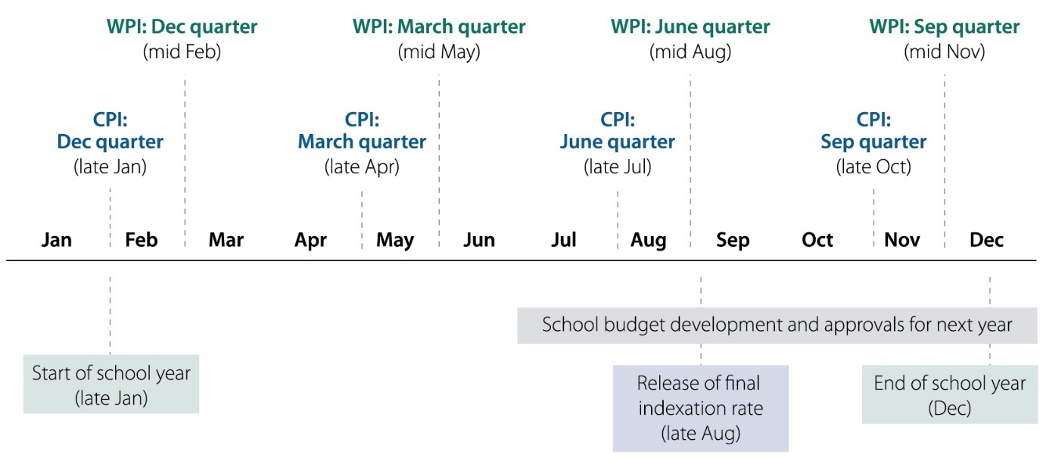

Notes: State Budgets are extremely important for school funding and the timing of State Budget development and approvals differs by jurisdiction.

Source: Deloitte Access Economics.

Indexation for government schools is applied in January using a projected indexation rate for the year, and recurring monthly payments are made to states and territories that each amount to 8.33 per cent of their estimated annual entitlement.[17] Importantly, the final monthly payment made in December is based on the final indexation rate, and accounts for the cumulative differences between the estimated payments and actual payments seen throughout the year.

Approved system authorities generally allocate funding to schools utilising their own formulas and models, drawing on Commonwealth and State and Territory funding sources. As such, the timing of the application of indexation for these systems would not generally be expected to affect the funding and resource allocation of individual schools. Nonetheless, to the extent that systems must expend their agreed SRS funding allocation at an aggregated level within the year it is allocated, there is a risk that uncertainty over the final funding payment to systems may result in an over or under-utilisation of funding relative to what is required under the terms of each system’s bilateral agreement. The presence of this issue was confirmed throughout consultations, with some smaller jurisdictions with limited fiscal capacity noting that large increases in funding targets due to indexation are difficult to meet when facing challenges such as teacher shortages, which are amplified in systems with high numbers of rural and remote schools.

Figure 12 SRS indexation and payment timings for government and non-government schools under current arrangements

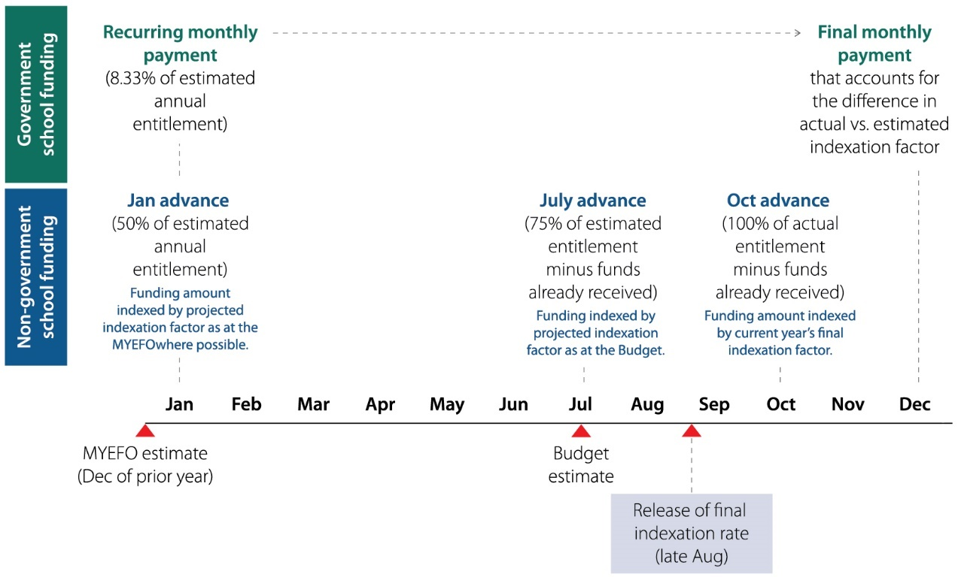

Source: Deloitte Access Economics; Australian Government Department of Education 2024, *2024 Indexation Review Background*.

Figure 12 above illustrates the difference in payment and indexation mechanisms for government and non-government schools under the current arrangements. Notably, non-government SRS payments are received in larger advances indexed at more ‘timely’ rates that capture in-year price changes, while smaller monthly payments based on estimates are received for government schools for the entire year until the December instalment.

While the December payment for government schools is based on the final indexation rate known in September, a more timely updating of payments based on available data could be beneficial to systems and schools. While not a universally held opinion, a theme from consultations is that timing arrangements could be changed to provide more certainty, and time, for jurisdictions to factor indexation into their budget planning. Evidence for the case for and against a change to the timing of indexation is discussed further below.

* 1. Alternative indexation and payment timing arrangements

Determining the most appropriate timing for the application of indexation to the allocation of funding requires balancing the trade-off between contemporaneity of funding to changes in input prices against the need to provide certainty to systems and schools when determining their budgets and allocating resources.

As discussed above, and from evidence provided during consultations, the Board understands that schools and schooling systems plan their budgets and allocation of resourcing (e.g., staffing models) in advance of funding being expended, and that late changes to the planned allocation of funding can lead to an ineffective allocation of resources.

Table 9 below shows that using CPI/WPI data from an earlier quarter increases funding certainty, as an ‘actual’ indexation rate is known earlier and applied to more payments throughout the year. However, cost changes have a lagged effect of up to six months on funding allocations, depending on which indexation rate is used.

Table 9 Alternative CPI/WPI quarters impact on non-government school payments - 2024 example

|  |  |  |  |  |
| --- | --- | --- | --- | --- |
| **Quarter** | **ABS publication date** | **Payments using actual index rate** | **Timeliness considerations** | **Certainty considerations** |
| **June 2023** | WPI: 15/08/2023 CPI: 26/07/2023 | **January, July, October** | Reflects input price changes up to 6 months prior to the funding year. | Indexation rates known well in advance of the funding year, providing close to complete certainty when school budgets are typically planned. |
| **September 2023** | WPI: 15/11/2023 CPI: 25/10/2023 | **January*, July, October** | Reflects input price changes up to 3 months prior to the funding year. | Indexation rates will be known prior to the funding year (even if it does not feed into the January payment*). |
| **December 2023** | WPI: 21/02/2024 CPI: 31/01/2024 | **July, October** | Reflects input price changes up to 1 month prior to the funding year. | Provides greater certainty as indexation rates will be known early in the year. |
| **March 2024** | WPI: 15/05/2024 CPI: 24/04/2024 | **July, October** | Reflects 3 months of input price changes within the funding year. | Provides time for schools to adjust budgets within the year (e.g., for the second half of the year, relative to the first). |
| **June 2024**  ***(current arrangement)*** | WPI: 13/08/2024 CPI: 31/07/2024 | **October** | Reflects 6 months of input price changes within the funding year. | Provides minimal funding certainty, potentially impacting schools’ and systems’ ability to budget and plan. |

* Indexation rates are required in the system in November of the previous year for the January payment. As such, the September quarter may not meet the timeframes for the January payment in some years.

Source: Adapted from Australian Government Department of Education 2024, 2024 Indexation Review Background.

The Board does not envisage that an alternative CPI/WPI quarter that is lagged by more than 12 months would be desirable for schools and systems, as it was understood through consultations that most schools finalise their school budgets and staffing plans during Terms 3 and 4 of the prior year.

Further, while government school system budgets are often determined further in advance (e.g., at the start of the financial year that precedes the forthcoming calendar year), jurisdictions have mechanisms in place to adjust budgets for schools to some extent in the lead up to (and throughout) the calendar year for which the funding is allocated. However, there are constraints around the ability of systems to adjust resourcing to schools late in the year. An example of in-year adjustments was provided by a stakeholder during consultation, with the stakeholder noting that adjustment payments have been made to schools to account for differences from earlier advance payments made based on a 3 per cent indexation rate.

Stakeholders consulted through the review indicated a modest, on-balance, preference towards using an earlier reference period to improve certainty for systems.

One stakeholder stated in its consultation the preference that the final SRS target should be finalised when the school year starts. The Board heard that in 2023, they received significantly more funding from actual indexation than what was forecasted using a projected rate, with stakeholders noting the difference exceeded the buffer for expenditure requirements under the current NSRA. In addition, two other stakeholders supported bringing forward the timing (one in a written submission and another in its consultation).

One stakeholder expressed that while changing timing arrangements would increase certainty for non-government schools, it would be more of a priority to bring forward other funding model adjustments that occur later in the year. Similarly, another stakeholder was of the view that several other factors that are determined later in the funding year than indexation (or early the following year) impact the final funding outcome, and that alternative timing must be considered in the wider context of the SRS.

One non-government stakeholder opposed a timing change, stating in its written submission that the current reference period functions well and should be maintained without changes. It was noted that other reference periods, i.e., the use of September to September data or March to March data, may result in final adjustments being missed in the October payment data (if September data is used, as the figures are not yet released) or the indexation rate less accurately reflecting the current year prices (if March data is used). Some stakeholders noted in their written submissions that the current reference period allows for partial capture of in-year costs (so is more reflective of actual school cost changes), which may be affected if the reference period was moved forward.

Table 10, below, demonstrates the difference in actual rates across the 2019–2023 funding years had data from earlier WPI and CPI quarters been used. June-quarter rates varied from December and March quarters between 2020 and 2022, however results were similar between all three sets of data in 2023.

The more significant variances between quarters in recent years are likely largely a result of the unprecedented COVID-19 pandemic and high-inflation period that has followed. Importantly, it should be noted that price changes will eventually be reflected in the WPI and CPI, regardless of quarter chosen.

Table 10 Final indexation rates for the 2019–2023 funding years using earlier WPI and CPI quarters

|  |  |  |  |  |  |  |
| --- | --- | --- | --- | --- | --- | --- |
| **Quarter** | **2019** | **2020** | **2021** | **2022** | **2023** | |
| **June quarter – previous year (%)** | 2.1 | 2.2 | 1.2 | 2.3 | 3.5 | |
| **September quarter – previous year (%)** | 2.2 | 2.1 | 1.2 | 2.4 | 4.2 | |
| **December quarter – previous year (%)** | 2.1 | 2.1 | 1.3 | 2.6 | 4.5 | |
| **March quarter – current year (%)** | 2.1 | 2.2 | 1.4 | 3.0 | 4.4 |
| **June quarter – current year (current arrangement) (%)** | 2.2 | 1.2 | 2.3 | 3.5 | 4.2 |

Source: Australian Bureau of Statistics (2024)

When considering the trade-off between certainty and contemporaneity/accuracy of indexation arrangements, three key observations should be noted:

* Changes to the timing of indexation rates does not impact overall funding provided to systems and schools over time (rather, it shifts funding allocations between periods of time).
* Lagged indexation arrangements may be appropriate given the general lag that is observed between when general inflation occurs in the economy, and salaries increase in the education sector (as illustrated by Figure 8 and Figure 9). While schools and jurisdictions do have some capacity to expend additional funding on staff during a school year, changes to salary agreements generally occur over a longer period of time.
* Any change to indexation timing would need to factor in an appropriate approach to transition, which presents administrative complexities for the sector and potential additional costs (to the extent that there is a desire to hold schools and systems harmless under any change in the short term).

**Finding 6**

In relation to the timing of SRS indexation rates, on balance, there is a case to change current indexation arrangements to rely on an earlier measure of indexation, given the preference that jurisdictions have towards funding certainty. However, further analysis is required to determine the most appropriate timing for the application of indexation, and to understand the implications of such a change. 

**Finding 7**

Timing of SRS indexation rates lagged by 12 months may be an appropriate alternative approach, as this best aligns with the approach that schools and systems take to budget planning and reflects the typical lags observed between general inflation in the economy and wage increases in the education sector. The application of a funding floor also helps to mitigate the risks associated with this change.

**Recommendation 4**

On balance, there is insufficient evidence to support a specific change to the indexation timing arrangements at this point. Further consultation should be undertaken to examine alternative timing and transition arrangements.

# Appendix A – Terms of reference

**Review of the Schooling Resource Standard (SRS) indexation arrangements**

Commonwealth funding for schools is needs-based and is calculated with reference to the [Schooling Resource Standard (SRS)](https://www.education.gov.au/recurrent-funding-schools/schooling-resource-standard). The SRS is an estimate of how much total public recurrent funding a school needs to meet its students’ educational needs and is indexed each year by the SRS indexation factor to reflect changes in prices and wages and therefore costs faced by schools.

The purpose of this Review is to consider the appropriateness of the SRS indexation arrangements to ensure arrangements reflect changes in the costs associated with meeting the educational needs of students. It fulfills a joint commitment from the Australian Government and the State and Territory Governments to review the SRS indexation arrangements in 2024 ahead of the next National School Reform Agreement.

Current SRS indexation arrangements

Since 2019, SRS funding has been indexed annually by either:

* a rate calculated as the higher of:
  + 3 per cent, or
  + a percentage derived from 75 per cent of the change of the Wage Price Index (WPI) and 25 per cent of the change of the Consumer Price Index (CPI); or
* a rate prescribed by the Minister for Education.

This approach introduced a minimum increase in funding and certainty for schools. It is weighted towards changes in wage costs reflecting that teachers’ and staff salaries are a significant driver of schools' costs.

Given the current economic climate, it is prudent to review the SRS indexation arrangements to ensure it remains current and appropriate to ensure the effective delivery of school education.

**Scope**

The Review will consider and provide advice on:

1. The **appropriateness of current SRS indexation arrangements,** including whether the operation of the SRS indexation arrangements has kept pace with average schooling cost increases since 2018.
2. The **suitability of the current SRS indexation floor** of 3 per cent.
3. The **appropriateness of the composite index**, including its structure, weighting and possible alternatives to the current composite index – currently set as 75 per cent Wage Price Index and 25 per cent Consumer Price Index.
4. The **timing of SRS indexation** rates, including;
   1. the reference period for source WPI and CPI data,
   2. the date at which the indexation rate is confirmed for the school year, and its impact on systems and schools’ ability to effectively budget.

In providing this advice, the Board will engage closely with State and Territory Governments and their relevant departments as well as the non-government sector. This includes seeking financial data to support the Review as required.

**Timing**

The Board will provide its final report to the Australian Government Minister for Education by 28 March 2024. The Minister will share the report with Education Ministers and non-government peak bodies within 5 business days of receiving the report, and will invite the Chair of the Board to present the final report to the Education Ministers Meeting.

# Appendix B – Review process

On 1 February 2024 date, the Hon Jason Clare MP, Australian Government Minister for Education commissioned the Board to undertake the Review of the Schooling Resource Standard (SRS) indexation arrangements.

The Board commissioned Deloitte Access Economics to provide an independent assessment of the current indexation arrangements, undertook consultations in response to an Issues Paper, met with stakeholders and accepted their submissions, and provided stakeholders the opportunity to provide feedback on the draft report.

The Board considered the range of experiences, ideas and insights raised by stakeholders through their submissions and the consultation process.

**National School Resourcing Board members**

Professor Bronwyn Fredericks (Chair)  
Professor Janet Clinton  
Ms Valerie Gould  
Professor Andrew Whitehouse  
Professor John Firth  
Professor Lee Anne Perry AM was appointed on 15 March 2024 and assisted with the finalisation of this review.   
Professor Elizabeth Labone, who resigned on 6 March 2024, also contributed to this review.

**Secretariat**

A secretariat from the Australian Government Department of Education supported the Board in the conduct of its business and the review process. The Secretariat operated independently of the department and reported directly to the Chair. The members of the Secretariat were:

Ms Emma Freeman, Director  
Ms Pon Chaleune, Assistant Director  
Dr June Fan, Assistant Director  
Ms Jeanie Mackinder, Assistant Director  
Ms Rachel Howe, Policy Officer

# Appendix C – Issues Paper

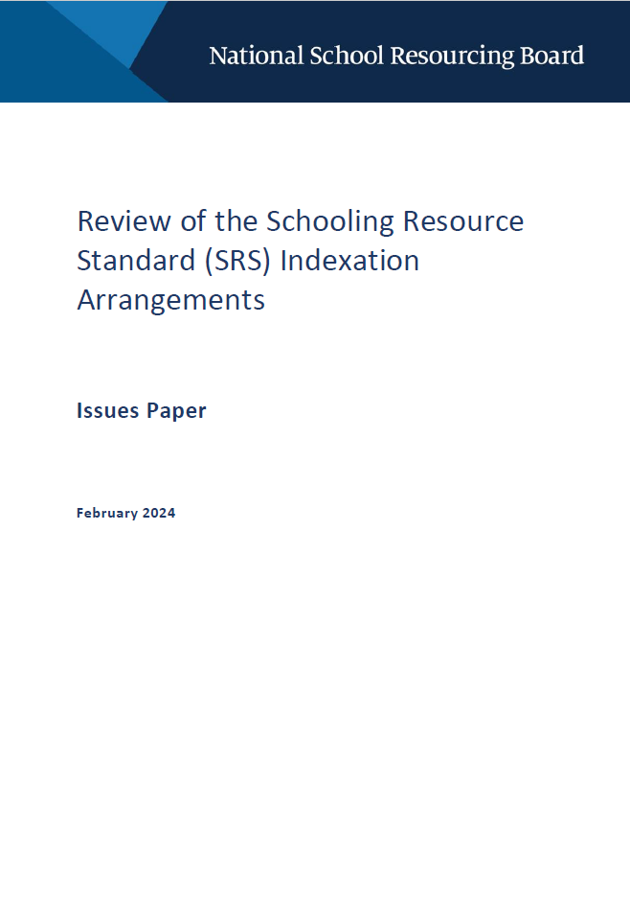

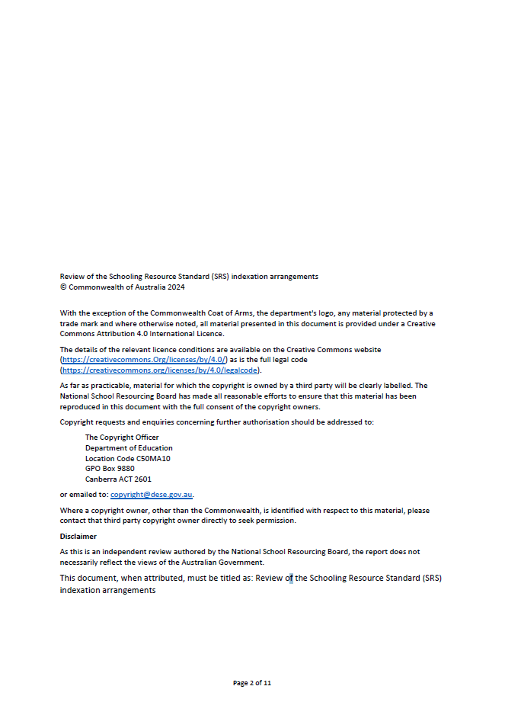

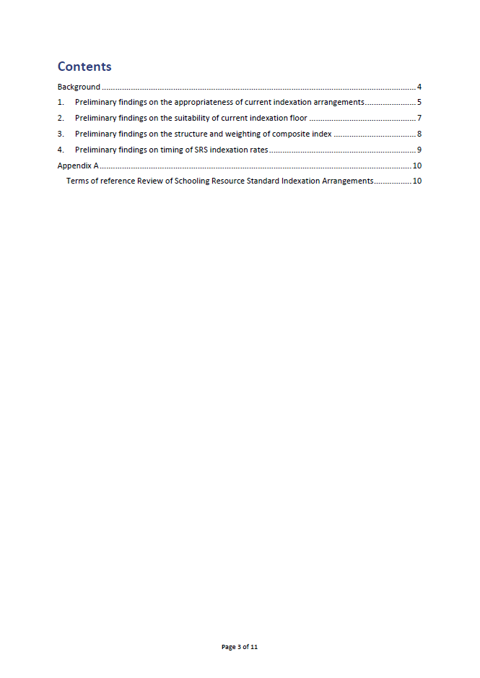

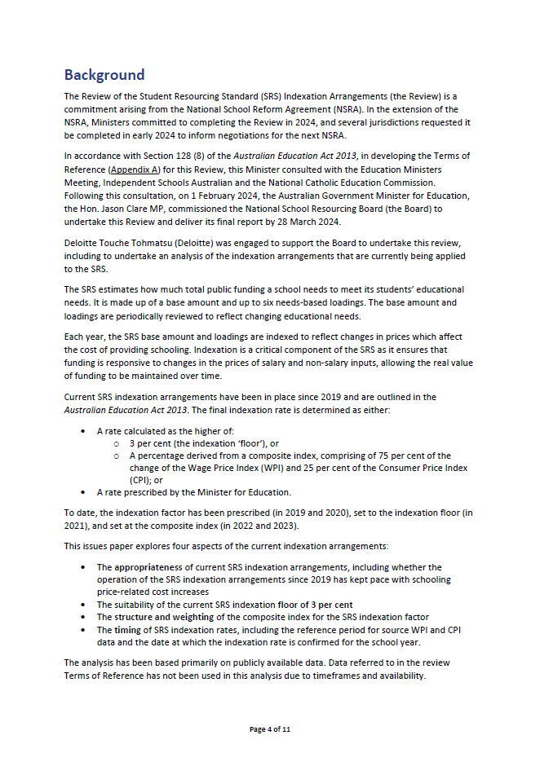

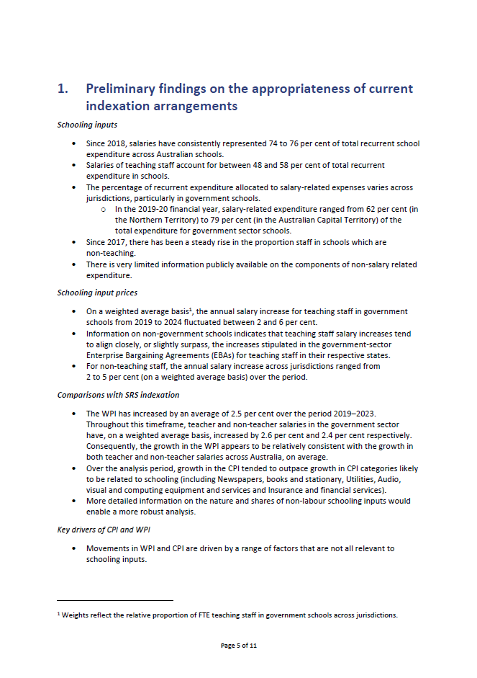

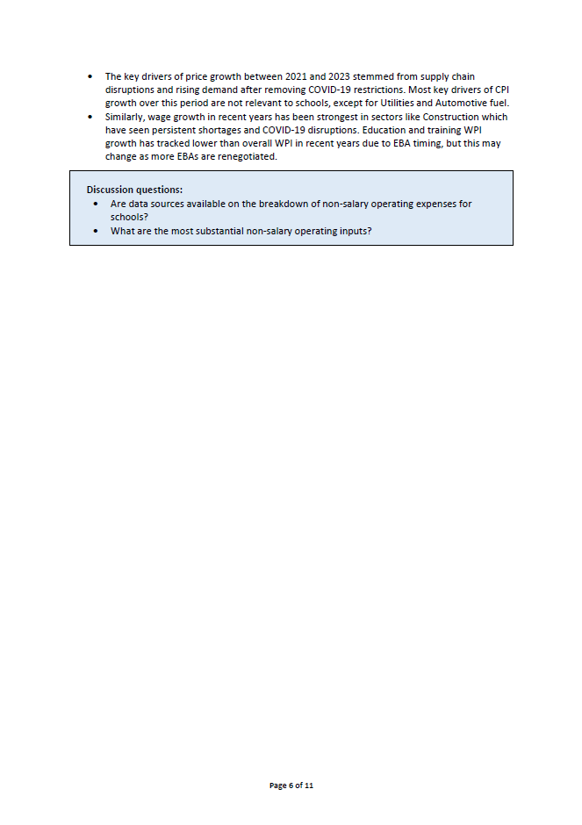

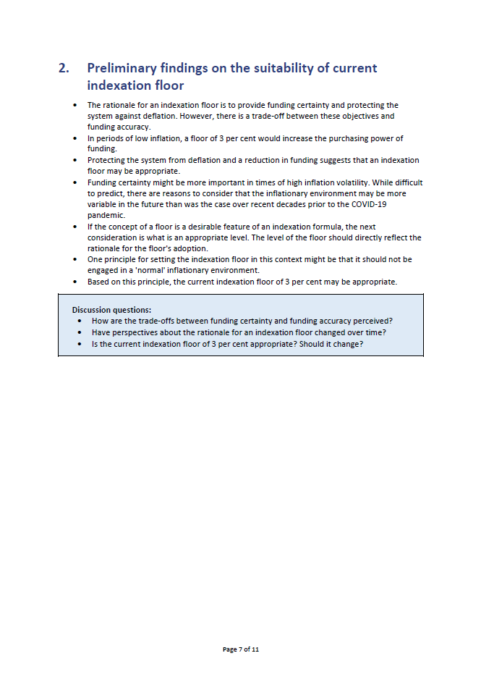

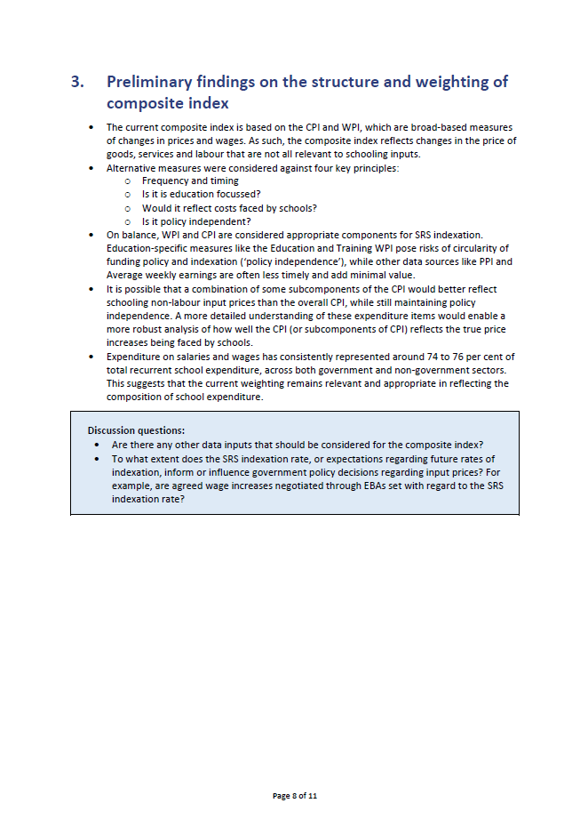

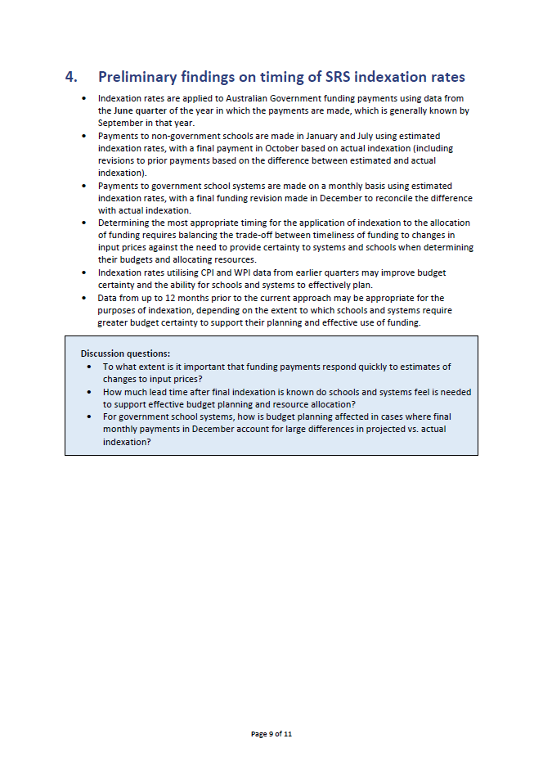

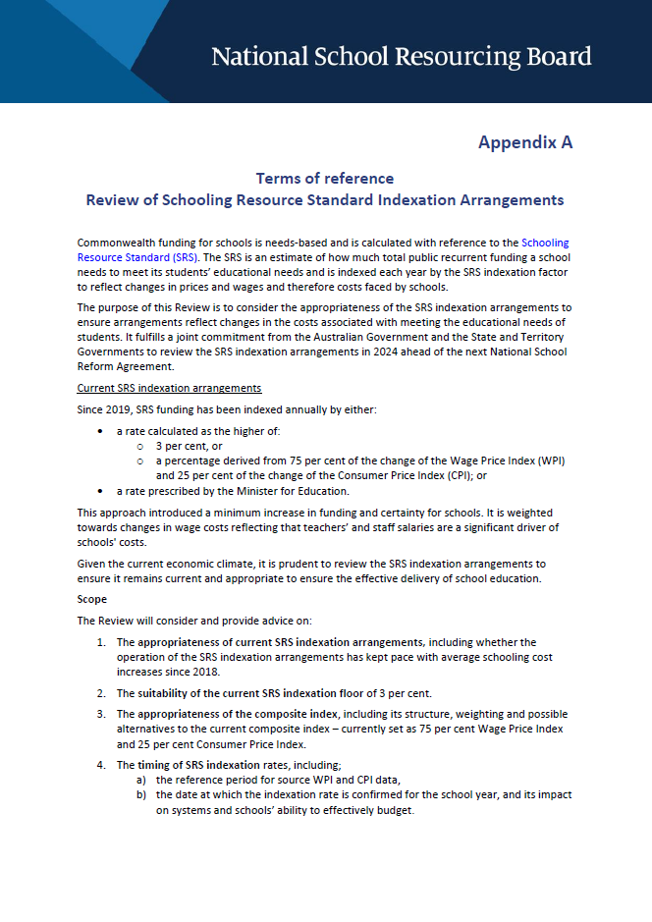

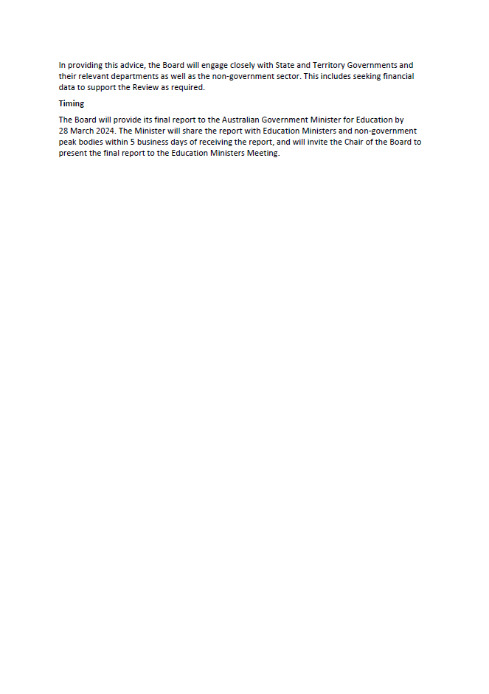

# Appendix D – Stakeholder submissions

The Board received a total of 8 submissions in response to its Issues Paper. Where stakeholders agreed to their submission being published along with this report, submissions will be published on the NSRB page on the Department of Education website.

|  |
| --- |
| List of submissions |
| Independent Schools Australia |
| National Catholic Education Commission |
| New South Wales Department of Education |
| Northern Territory Department of Education |
| Queensland Department of Education |
| South Australian Department for Education |
| Tasmanian Department for Education, Children and Young People |
| Victorian Department of Education |

# Appendix E – Consultations

In recognition of the highly technical nature of the terms of reference for the review, the Board held consultation meetings with representatives from government, independent and Catholic sector system administrators, and sought advice from the Australian Government Department of Education and Treasury.

|  |
| --- |
| Attendees |
| **GOVERNMENT SECTOR** |
| Australian Capital Territory Education Directorate |
| New South Wales Department of Education |
| Northern Territory Department of Education |
| Queensland Department of Education |
| South Australia Department for Education |
| Tasmania Department for Education, Children and Young People |
| Victorian Department of Education |
| Western Australia Department of Education |
| **PEAK BODIES** |
| Independent Schools Australia |
| National Catholic Education Commission |

# Appendix F – Additional data

### Additional data and figures

Figure 13 Salary increases for government sector teachers stipulated in state and territory Enterprise Bargaining Agreements. 2018–2024

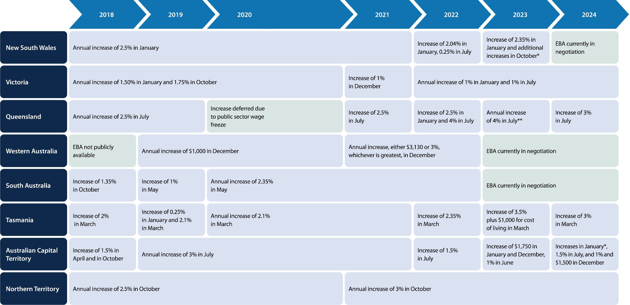

Notes: * Teaching levels were reclassified, leading to substantial salary increases for certain teachers. ** Plus cost of living lump sum (3% x base salary.

Source: Deloitte Access Economics (2024) and as outlined in Table 11

Figure 14 Salary increases for non-government sector teachers stipulated in relevant Enterprise Bargaining Agreements, 2018–2024

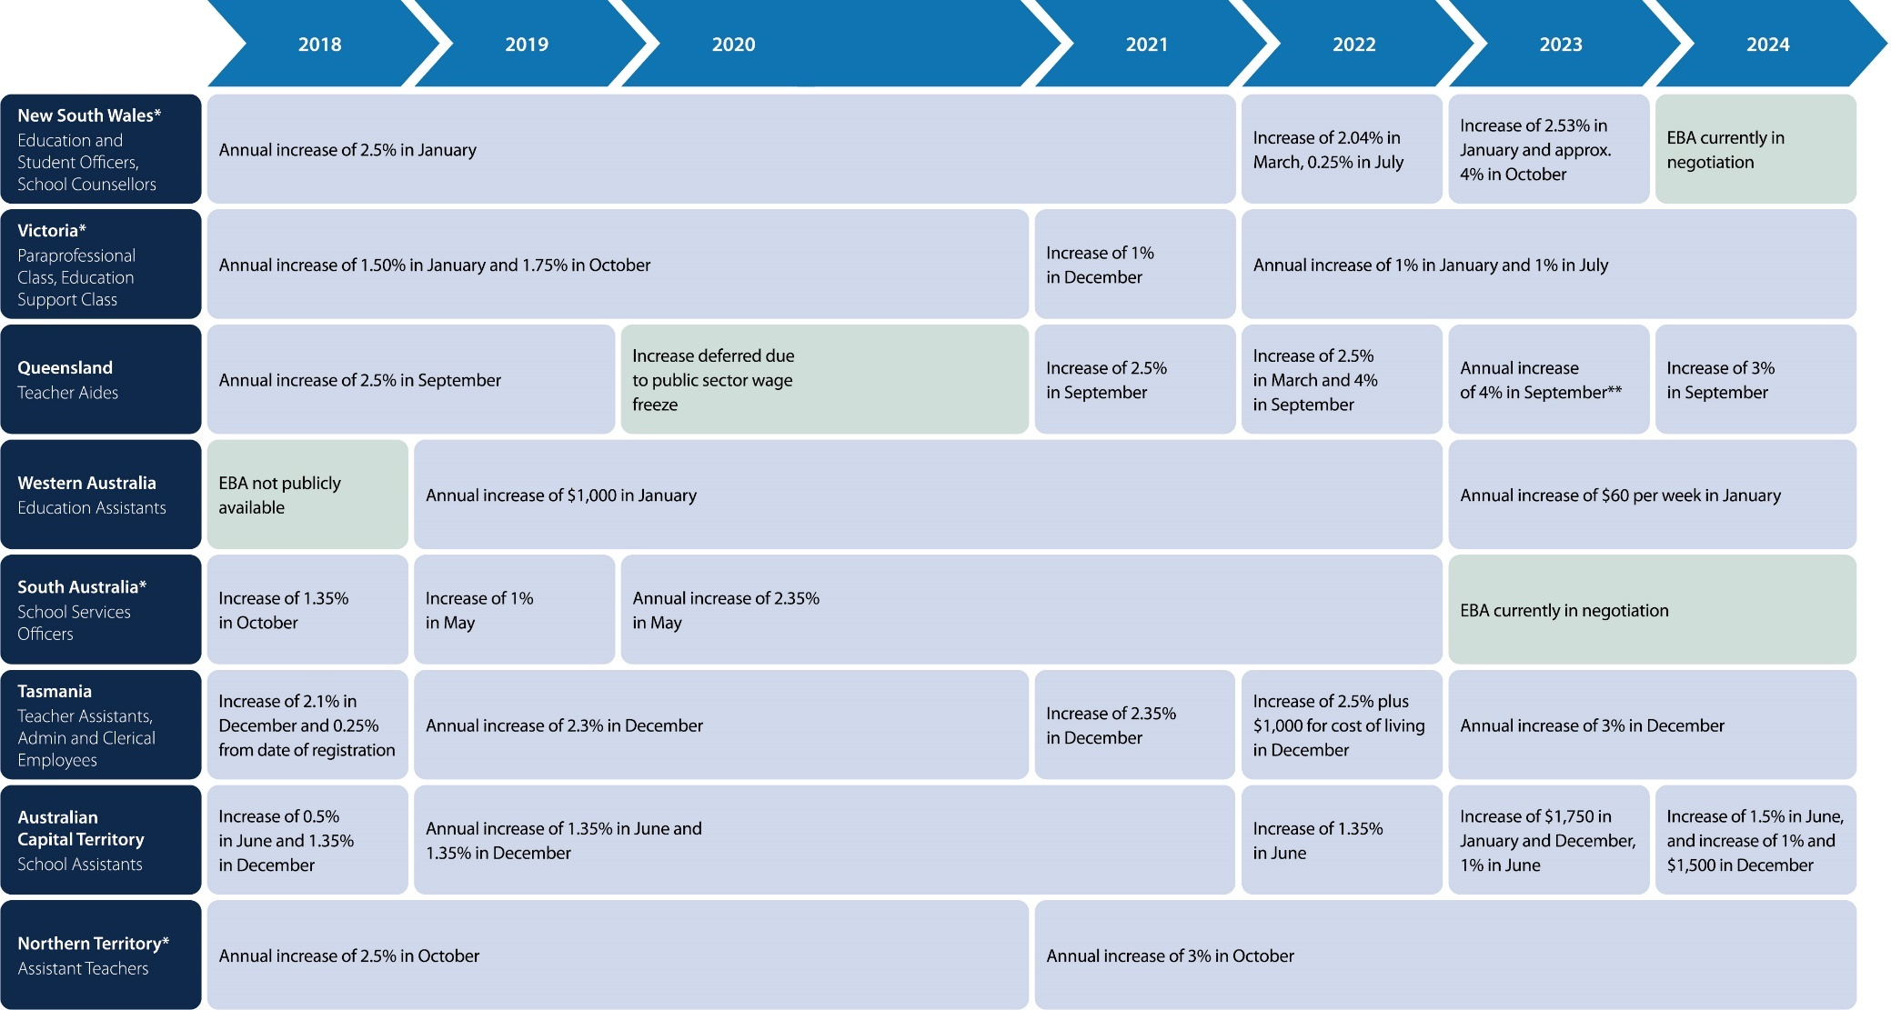

Notes: The absence of an available EBA may be due to it not being publicly accessible or not in existence at the time.

Source: Deloitte Access Economics (2024) and as outlined in Table 13.

Figure 15 Salary increases for Government sector administrative & clerical staff stipulated in relevant state and territory Enterprise Bargaining Agreements, 2018–2024

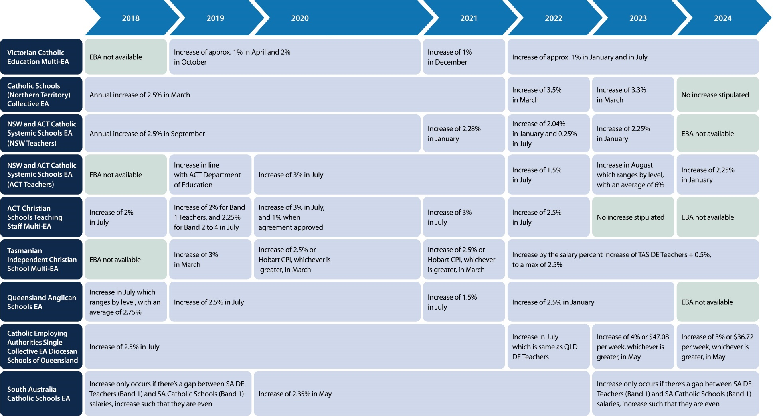

Notes: * Roles are governed by the same EBA as teaching staff. Please be aware that while Queensland specifies a 4 per cent increase in September 2022, analysis of actual wages indicates that an increase may have occurred before the commencement of the EBA. ** Plus cost of living lump sum (3% x base salary).

Source: Deloitte Access Economics (2024) and as outlined in Table 12

# Appendix G – Methodology and data sources

Estimated growth in government sector staff wages and salaries

To estimate the growth in government sector wages, this report initiated the estimation process by utilising EBAs for government sector teachers and a subset of non-teaching staff in each state and territory. Publicly available EBAs spanning the period 2018 to 2024 were compiled (see Table 11 for the government sector teaching staff EBAs considered, and Table 12 for the government sector   
non-teaching staff EBAs considered), providing detailed information on stipulated salary increases and wages at various points in time for both teaching and non-teaching roles.

For the analysis of teaching staff, the primary focus centred on classroom teachers across different pay grades. In the analysis of non-teaching staff, the primary emphasis was on administrative and clerical roles, encompassing positions like school officers, education officers, school assistants, education paraprofessional class, education support class, education assistants, and teachers’ aides.

Using the compiled EBAs and the detailed wage information within them, a month-to-month perspective of wages was established for each role in each state/territory throughout the specified period. From this month-to-month view, the annual average percentage increase in wages was calculated, considering growth from June quarter of the previous year to the June quarter of the current year. State-level averages for each year were then computed by taking an average across the different levels of staff under consideration.

Several assumptions were necessary, and these are qualified in the following caveats:

* Excluded senior teachers classified separately from classroom teachers in state/territory EBAs during the analysis of teaching staff; the impact is expected to be minimal due to most EBAs stipulating a percentage increase across all levels.
* New South Wales introduced a revised salary classification system in 2023, which increased the salaries of all teachers. The new classification is partially determined by the length of teachers' service. An average is calculated for teachers transitioning to both the lower and higher steps of the updated classification structure.

Weighted average government sector wages growth

To calculate the weighted average growth of government sector teachers and non-teaching wages, weights were applied to the estimated wage growth for each state and territory from 2019 to 2023. The weights were determined as follows:

* For government sector teacher wage growth, the weights were established based on the proportion of Full-Time Equivalent (FTE) government sector teaching staff in a state/territory relative to the total during the specified period.
* For government sector non-teacher wage growth, the weights were determined by the proportion of FTE government sector non-teaching staff.

Table 11 Government sector teaching staff Enterprise Bargaining Agreements

|  |  |  |
| --- | --- | --- |
| **State or Territory** | **Enterprise Bargaining Agreement** | **Coverage time period** |
| Victoria | Victorian Government Schools Agreement 2022 | 2022–2025 |
| Victoria | Victorian Government Schools Agreement 2017 | 2017–2021 |
| New South Wales | Crown Employees (Teachers in Schools and Related Employees) Salaries and Conditions Award 2022* | 2022–2023 |
| New South Wales | Crown Employees (Teachers in Schools and Related Employees) Salaries and Conditions Award 2020 | 2020–2022 |
| New South Wales | Crown Employees (Teachers in Schools and Related Employees) Salaries and Conditions Award 2017 | 2017–2019 |
| Queensland | Department Of Education State School Teachers' Certified Agreement 2022 | 2022–2025 |
| Queensland | Department Of Education State School Teachers' Certified Agreement 2019 | 2019–2022 |
| Queensland | Department of Education and Training State School Teachers' Certified Agreement 2016 | 2016–2019 |
| Western Australia | School Education Act Employees’ (Teachers and Administrators) General Agreement 2021 | 2022–2023 |
| Western Australia | School Education Act Employees' (Teachers and Administrators) General Agreement 2019 | 2019–2021 |
| South Australia | South Australian School and Preschool Education Staff Enterprise Agreement 2020 | 2020–2023 |
| Tasmania | Teachers Agreement 2023 | 2023–2025 |
| Tasmania | Teachers Agreement 2021 | 2021–2022 |
| Tasmania | Teachers Agreement 2019 (No 2) | 2019–2021 |
| Tasmania | Teachers Agreement 2019 | 2019 |
| Tasmania | Teachers Agreement 2017 (No 2) | 2017–2018 |
| Australian Capital Territory | Act Public Sector Education Directorate (Teaching Staff) Enterprise Agreement  2023–2026 | 2023–2026 |
| Australian Capital Territory | Act Public Sector Education Directorate (Teaching Staff) Enterprise Agreement  2018–2022 | 2018–2022 |
| Northern Territory | Northern Territory Public Sector Non-Contract Principals, Teachers and  Assistant Teachers’ 2021–2025 Enterprise Agreement | 2021–2025 |
| Northern Territory | Northern Territory Public Sector Teachers and  Assistant Teachers’ 2017–2021 Enterprise Agreement | 2017–2021 |

Notes: * In November 2023, this award was varied.

Table 12 Government sector non-teaching staff Enterprise Bargaining Agreements

|  |  |  |
| --- | --- | --- |
| **State or Territory** | **Enterprise Bargaining Agreement** | **Coverage time period** |
| Victoria | Victorian Government Schools Agreement 2022 | 2022–2025 |
| Victoria | Victorian Government Schools Agreement 2017 | 2017–2021 |
| New South Wales | Crown Employees (Teachers in Schools and Related Employees) Salaries and Conditions Award 2022* | 2022–2023 |
| New South Wales | Crown Employees (Teachers in Schools and Related Employees) Salaries and Conditions Award 2020 | 2020–2022 |
| New South Wales | Crown Employees (Teachers in Schools and Related Employees) Salaries and Conditions Award 2017 | 2017–2019 |
| South Australia | South Australian School and Preschool Education Staff Enterprise Agreement 2020 | 2020–2023 |
| Northern Territory | Northern Territory Public Sector Non-contract Principals, Teachers and  Assistant Teachers’ 2021–2025 Enterprise Agreement | 2021–2025 |
| Northern Territory | Northern Territory Public Sector Teachers and  Assistant Teachers’ 2017–2021 Enterprise Agreement | 2017–2021 |
| Queensland | Department of Education and Training Teacher Aides' Certified Agreement 2022 | 2023–2025 |
| Queensland | Department of Education and Training Teacher Aides' Certified Agreement 2018 | 2019–2021 |
| Queensland | Department of Education and Training Teacher Aides' Certified Agreement 2015 | 2015–2018 |
| Western Australia | Education Assistants' (Government) General Agreement 2023 | 2023–2024 |
| Western Australia | Education Assistants' (Government) General Agreement 2021 | 2021–2022 |
| Western Australia | Education Assistants' (Government) General Agreement 2019 | 2019–2020 |
| Tasmania | Public Sector Unions Wages Agreement 2022 | 2022–2024 |
| Tasmania | Public Sector Unions Wages Agreement 2019 | 2019–2021 |
| Tasmania | Public Sector Unions Wages Agreement 2018 | 2018–2019 |
| Australian Capital Territory | Act Public Sector Administrative and Related Classifications Enterprise Agreement 2023–2026 | 2023–2026 |
| Australian Capital Territory | Act Public Sector Administrative and Related Classifications Enterprise Agreement 2021–2022 | 2021–2022 |
| Australian Capital Territory | Act Public Sector Administrative and Related Classifications Enterprise Agreement 2018–2021 | 2018–2021 |

Notes: * In November 2023, this award was varied.

Table 13 Non-government sector teaching staff Enterprise Bargaining Agreements

|  |  |  |
| --- | --- | --- |
| **Authority** | **Enterprise Bargaining Agreement** | **Coverage time period** |
| Catholic Education Commission of Victoria Ltd | Catholic Education Multi-Enterprise Agreement 2022 | 2022–2025 |
| Diocese of Sale Catholic Education Ltd | Victorian Catholic Education Multi-Enterprise Agreement 2018 | 2018–2021 |
| Catholic Education Office Northern Territory Diocese of Darwin | Catholic Schools (Northern Territory) Collective Enterprise Agreement 2022 | 2022–2024 |
| Catholic Education Office Northern Territory Diocese of Darwin | Catholic Schools (Northern Territory) Collective Enterprise Agreement 2018–2021 | 2018–2021 |
| Catholic Employment Relations Ltd | NSW and ACT Catholic Systemic Schools Enterprise Agreement 2023 | 2023–2024 |
| Catholic Commission for Employment Relations | NSW and ACT Catholic Systemic Schools Enterprise Agreement 2020 | 2020–2021 |
| Catholic Commission for Employment Relations | NSW and ACT Catholic Systemic Schools Enterprise Agreement 2017 | 2017–2019 |
| Circular Head Catholic School Inc | Tasmanian Independent Catholic School (Teachers) Multi Enterprise Agreement 2022 | 2021–2024 |
| Circular Head Catholic School Inc | Tasmanian Independent Catholic Schools (Teachers) Multi Enterprise Agreement 2019 | 2019–2021 |
| The Anglican Schools Commission for The Corporation of the Synod of the Diocese of Brisbane | Queensland Anglican Schools Enterprise Agreement 2021 | 2021–2023 |
| The Anglican Schools Commission for The Corporation of the Synod of the Diocese of Brisbane | Queensland Anglican Schools Enterprise Agreement 2018 | 2018–2021 |
| The Corporation of the Trustees of the Roman Catholic Archdiocese of Brisbane | Catholic Employers Single Enterprise Collective Agreement – Diocesan Schools of Queensland  2023–2026 | 2023–2026 |
| The Corporation of the Trustees of the Roman Catholic Archdiocese of Brisbane | Catholic Employing Authorities Single Enterprise Collective Agreement - Diocesan Schools of Queensland 2019–2023 | 2019–2023 |
| The Corporation of the Trustees of the Roman Catholic Archdiocese of Brisbane | Catholic Employing Authorities Single Enterprise Collective Agreement – Diocesan Schools of Queensland 2015–2019 | 2015–2019 |
| Catholic Church Endowment Society Inc | South Australian Catholic Schools Enterprise Agreement 2020 | 2020–2024 |
| Catholic Church Endowment Society Incorporated | South Australian Catholic Schools Enterprise Agreement 2017 | 2017–2020 |

Table 14 Other data sources used throughout the issues paper for analysis

|  |  |
| --- | --- |
| **Source** | **Dataset name** |
| Australian Bureau of Statistics | Average Weekly Earnings  Consumer Price Index  Producer Price Index  Selected Living Cost Indexes  Wage Price Index |
| Australian Curriculum Assessment and Reporting Authority | Government expenditure on government schools (Financial year) (2022)  Non-government schools’ income and expenditure (2021)  Staff numbers (2022) |
| Productivity Commission | Report on Government Services 2024 |

# Appendix H – References

*Australian Education Act 2013,* (Cth).

*Australian Education Regulations 2023*.

Blanchard, OJ, ‘The Wage Price Spiral’, *The Quarterly Journal of Economics*, 1986, [101(3):](https://www.jstor.org/stable/i332475) 543-566.

Council of Australian Governments, [*National School Reform Agreement*](https://www.education.gov.au/download/4342/national-school-reform-agreement/23688/document/pdf), accessed 1 March 2024.

Deloitte Access Economics, 2024, unpublished.

Department of Education, 2024 *Indexation Review Background,* Australian Government, 2024.

Department of Education, [*How is school funding indexed?*](https://www.education.gov.au/download/14587/how-school-funding-indexed/34014/document/pdf)*,* Australian Government, 2023, accessed 1 March 2024.

Department of Education, [Schooling Resource Standard](https://www.education.gov.au/recurrent-funding-schools/schooling-resource-standard), Australian Government, accessed 1 March  2024.

Department of Education, Schools HUB, [*A guide for approved authorities on the use of recurrent funding*](https://schools.education.gov.au/schoolshub/help/files/Use.of.Recurrent.Funding.guide.pdf), Australian Government, accessed 1 March 2024.

Gonski, D, Boston, K, Greiner, K, Lawrence, C, Scales, B and Tannock, P, [*Review of Funding for Schooling – Final Report*](https://www.education.gov.au/download/1307/review-funding-schooling-final-report-december-2011/1280/document/pdf)*,* 2011, accessed 1 March 2024.

Martin, RE, ‘[The Revenue–to–Cost Spiral in Higher Education’](https://www.jamesgmartin.center/wp-content/uploads/2009/06/Revenue-to-Cost-Spiral.pdf), The James G. Martin Center for Academic Renewal, 2009, accessed 1 March 2024.

Parliamentary Budget Office, [*Budget explainer, 1 March 2023 – Indexation & the budget – an introduction*](https://www.pbo.gov.au/sites/default/files/2023-05/Indexation%20%26%20the%20budget%20-%20an%20introduction.pdf)*,* 2023, accessed 1 March 2024.

1. Council of Australian Governments, [*National School Reform Agreement*](https://www.education.gov.au/download/4342/national-school-reform-agreement/23688/document/pdf), p. 6, accessed 1 March 2024
2. Parliamentary Budget Office, [*Budget explainer, Indexation & the budget – an introduction*](https://www.pbo.gov.au/sites/default/files/2023-05/Indexation%20%26%20the%20budget%20-%20an%20introduction.pdf), p. 1, accessed 1 March 2024.
3. Parliamentary Budget Office, [*Budget explainer, Indexation & the budget – an introduction*](https://www.pbo.gov.au/sites/default/files/2023-05/Indexation%20%26%20the%20budget%20-%20an%20introduction.pdf)*,* p. 3, accessed 1 March 2024.
4. Parliamentary Budget Office, [*Budget explainer, Indexation & the budget – an introduction*](https://www.pbo.gov.au/sites/default/files/2023-05/Indexation%20%26%20the%20budget%20-%20an%20introduction.pdf)*,* p. 2, accessed 1 March 2024.
5. Gonski, D, Boston, K, Greiner, K, Lawrence, C, Scales, B and Tannock, [*Review of Funding for Schooling – Final Report*](https://www.education.gov.au/download/1307/review-funding-schooling-final-report-december-2011/1280/document/pdf), 2011, accessed 1 March 2024.
6. Department of Education, [Schooling Resource Standard](https://www.education.gov.au/recurrent-funding-schools/schooling-resource-standard), accessed 1 March 2024.
7. Department of Education, [*How is school funding indexed?*](https://www.education.gov.au/download/14587/how-school-funding-indexed/34014/document/pdf), p. 1, accessed 1 March 2024.
8. Australian Education Regulations 2023, section 6A SRS indexation factor
9. Parliamentary Budget Office, [*Budget explainer, 1 March 2023 – Indexation & the budget – an introduction*](https://www.pbo.gov.au/sites/default/files/2023-05/Indexation%20%26%20the%20budget%20-%20an%20introduction.pdf)*,* p. 9, accessed 1 March 2024
10. Parliamentary Budget Office, [*Budget explainer, 1 March 2023 – Indexation & the budget – an introduction*](https://www.pbo.gov.au/sites/default/files/2023-05/Indexation%20%26%20the%20budget%20-%20an%20introduction.pdf)*,* p. 11, accessed 1 March 2024.
11. Department of Education, 2023, [*How is school funding indexed?*](https://www.education.gov.au/download/14587/how-school-funding-indexed/34014/document/pdf)*,* accessed 1 March 2024.
12. The revenue theory of cost, often referred to as ‘Bowen’s rule’ was first identified in the higher education sector in the United States. The theory suggests that costs in the education sector are almost entirely a function of revenue, due to the public service nature and incentives of these institutions. See Martin (2009) for a detailed explanation.
13. A wage-price spiral is a proposed macroeconomic explanation for inflation. It describes a situation in which wage increases result in price increases, which in turn result in further wage increases. A seminal paper describing wage-price spirals is by Blanchard (1986).
14. Australian Government Department of Education, Schools HUB, [*A guide for approved authorities on the use of recurrent funding*](https://schools.education.gov.au/schoolshub/help/files/Use.of.Recurrent.Funding.guide.pdf).
15. In 2020, the Queensland Government temporarily deferred scheduled public sector wage increases, as part of one-off economic and health measures taken by the Palaszczuk Government in response to the COVID-19 pandemic. As a result, the planned increase of 2.5 per cent in 2020 was deferred to 2022.
16. Parliamentary Budget Office, [*Budget explainer, Indexation & the budget – an introduction*](https://www.pbo.gov.au/sites/default/files/2023-05/Indexation%20%26%20the%20budget%20-%20an%20introduction.pdf), accessed 1 March 2024.
17. Australian Government Department of Education, *2024 Indexation Review Background*, 2024.