

# Brief Guide

Visual Analytics Using Power BI

#### Navigating Power BI Reports

1. When a Power BI report is opened a home screen will appear, with a list of all pages within the report. Click on the page names to navigate to a section.

1. Multiple reports exist within a page, by clicking different reports, different breakdowns will be displayed based on the report selected.

1. Each page has a home button in the lower right-hand corner. Click this button to navigate back to the home page.

1. Notes including how to use the reports and definitions about the data can be accessed by selecting the “Notes” button.

#### Using Power BI Reports

1. Below is a typical example of what a Power BI report page may look like, including a chart; table; and various filters at the top.   
   To reset all settings, select “Reset” on the left-hand side towards the middle of the screen.A screenshot of a computer

   Description automatically generated
2. On some pages you may need to use the scroll bar to see all the data.

1. Individual charts can be made larger by selecting the focus mode. To do this, hover the mouse pointer over the target chart and then click on the focus mode button in the top right corner. The chart will expand to the whole windowpane. To restore the original view, click on ‘< Back to Report’ shown in the top left-hand corner of the report page.

1. By hovering over a data point in a chart with the mouse pointed, the exact number can be displayed. This function works on both line charts and bar charts.

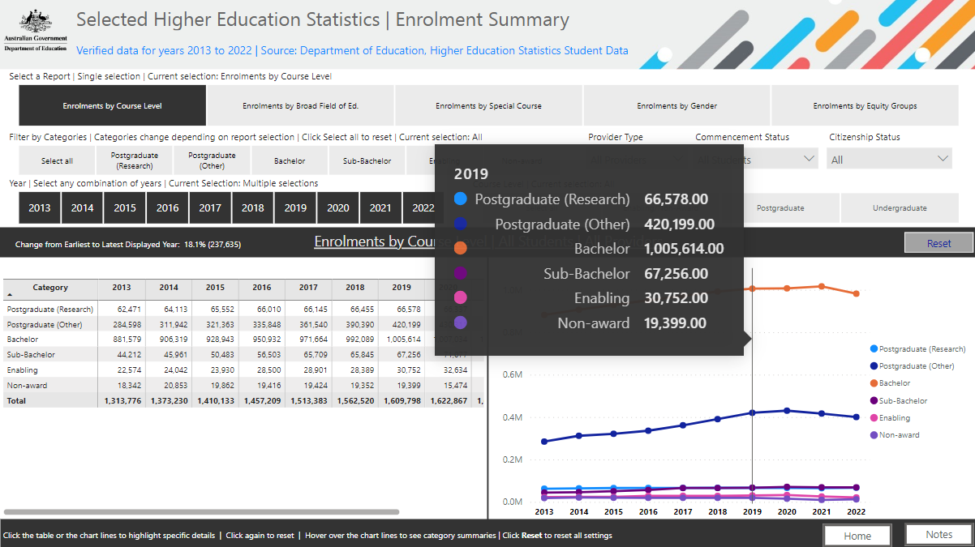

#### Extracting Charts and Tables from Power BI reports

1. Charts can be copied as an image with a caption, and then pasted as required. Hover the mouse pointer over the individual chart and select the copy as image with caption button and once copied select “Copy”, as shown below.

|  |
| --- |
|  |
|  |



1. Alternatively, it is recommended that the ‘Snipping tool’ (or similar) is used to cut and paste charts and tables as pictures if required. It is best to use the focus mode option (described above) before snipping for the best resolution. If desired, a picture of the filters can also be snipped, so that a record is maintained of what filters were applied to the data.

#### Troubleshooting: Blank Completion Rates Report

1. Some completion rate reports are only available for domestic students. If the table and graph are blank, try selecting "Domestic Incl. unknown" under Citizenship. A screenshot of a computer

   Description automatically generated