

# Alternative Providers’ Guide

Enrolling students following a CRICOS provider default

Following a CRICOS provider default, the Tuition Protection Service (TPS) aims to provide affected international students with options for continuing their studies in a similar course with an alternative Australian provider, if any such courses are available. The TPS may contact providers identified as offering suitable alternative courses with an opportunity to enrol affected students.

Alternative providers must complete the following tasks in TPS Online when enrolling international students affected by a CRICOS provider default:

1. Log in to TPS Online using PRISMS credentials
2. Enter bank account details
3. Make an offer to a student
4. Wait for the student to accept the offer in TPS Online
5. Create a Confirmation of Enrolment (CoE) in PRISMS
6. Link the accepted offer to the new CoE.

This document guides alternative providers through this process.

## Step 1: Log in to TPS Online

TPS Online is the case management system used by students and alternative providers following a provider default. Only staff members with **COE Create** or **COE Administrator** access in the Provider Registration and International Student Management System (PRISMS) can log in to TPS Online.

1. To access TPS Online, visit the [TPS website](https://www.education.gov.au/tps) and click **Access TPS Online**.

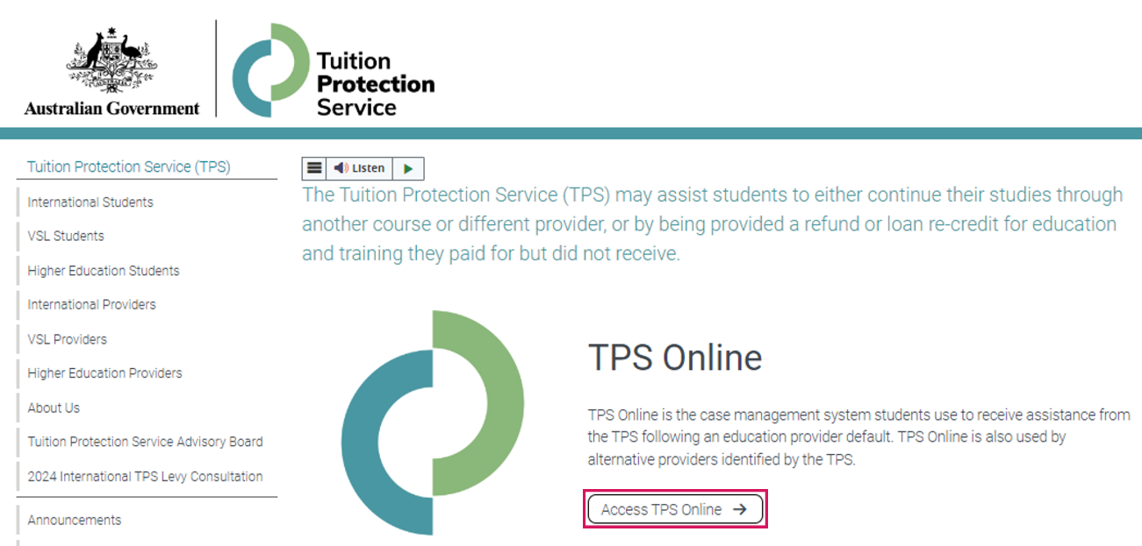

1. A staff member with **COE Create** or **COE Administrator** access in PRISMS can log in to TPS Online using their PRISMS credentials.

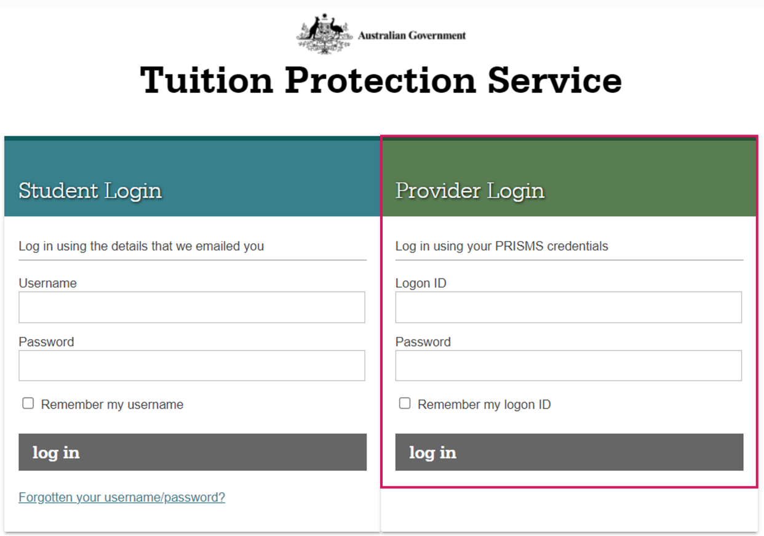

## Step 2: Enter your bank account details

Alternative providers must enter their bank account details in TPS Online. The TPS will deposit any relevant fees for the placement of international students into the nominated bank account.

* 1. From your TPS Online home page, click **Enter bank details**.

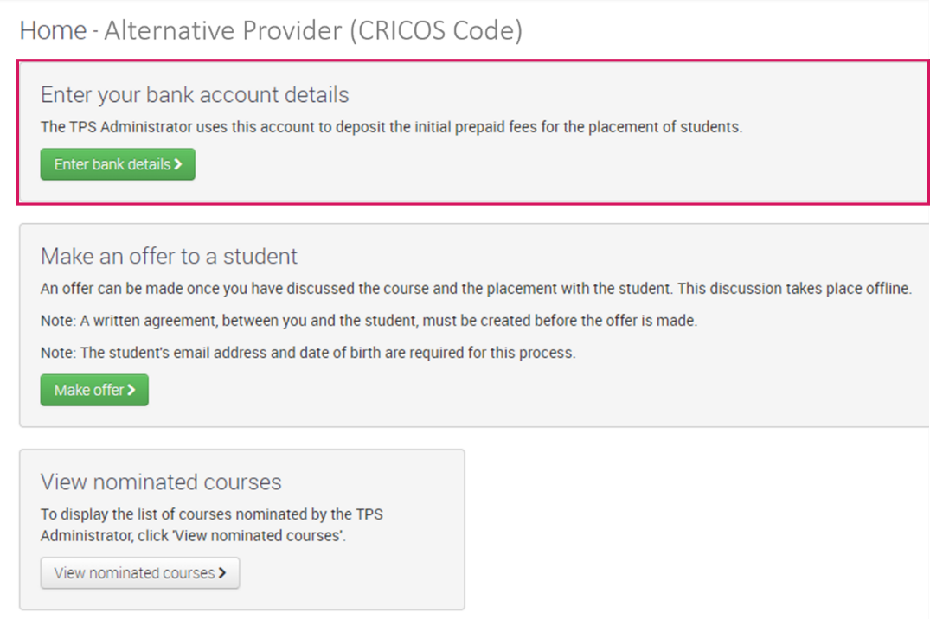

* 1. Provide the bank account details for the account you would like any payments to be transferred to then click **Save**.

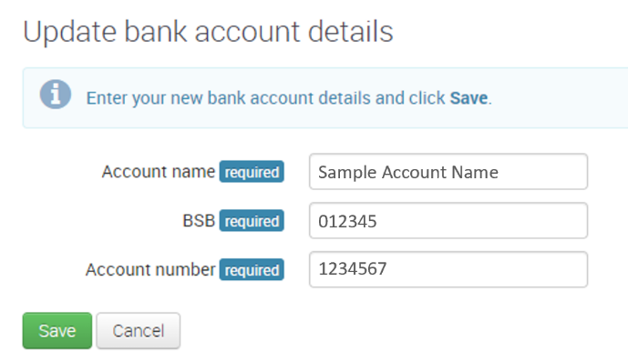

## Step 3: Make an offer to a student

An enrolment offer can be made to a student after discussing the course and placement with the student. The student’s email address and date of birth are required for this task.

Please note that a written agreement must be created before making an offer to a student.

* 1. From your TPS Online home page, click **Make offer**.

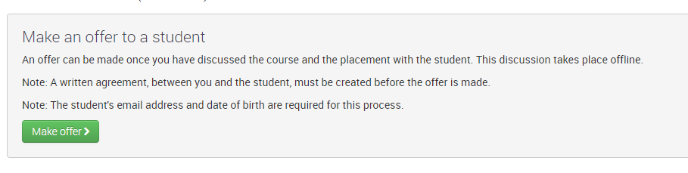

* 1. Your organisation may have multiple courses listed as suitable alternative courses. In the example below, only one course is listed as a suitable alternative course.

Select the course relevant to the student to whom you are making an offer then click **Next**.

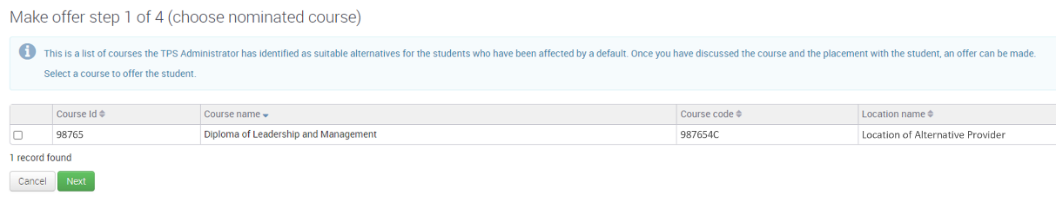

* 1. Search for the student using their email address and date of birth.

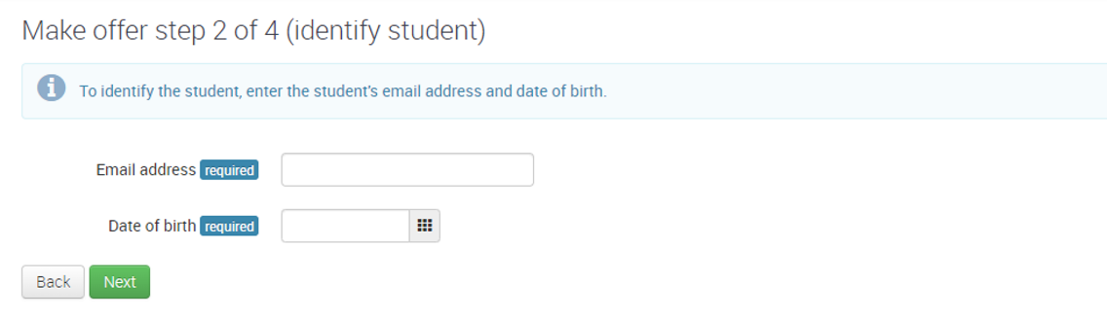

* 1. Confirm that the details for the student are correct before proceeding.

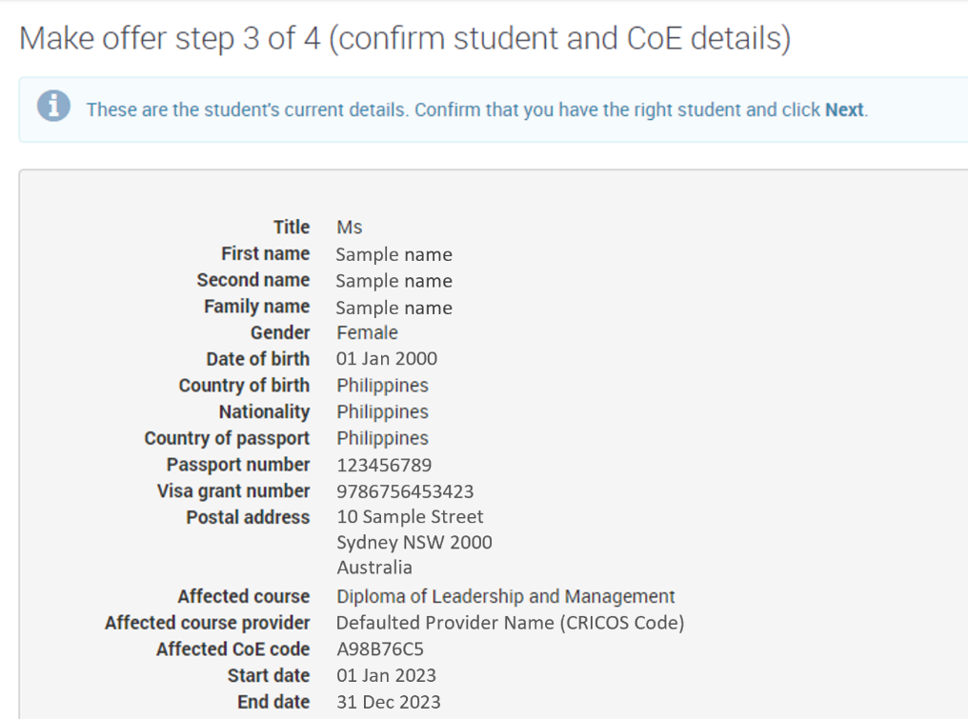

* 1. Enter the following details:
* Initial prepaid fee required prior to commencement
* Total course tuition fee
* Course start and end dates
* A copy of the written agreement between your organisation and the student.

Please note that an initial prepaid fee of $0 will result in no payment being completed.

Check that the information entered is correct then click **Finish**.

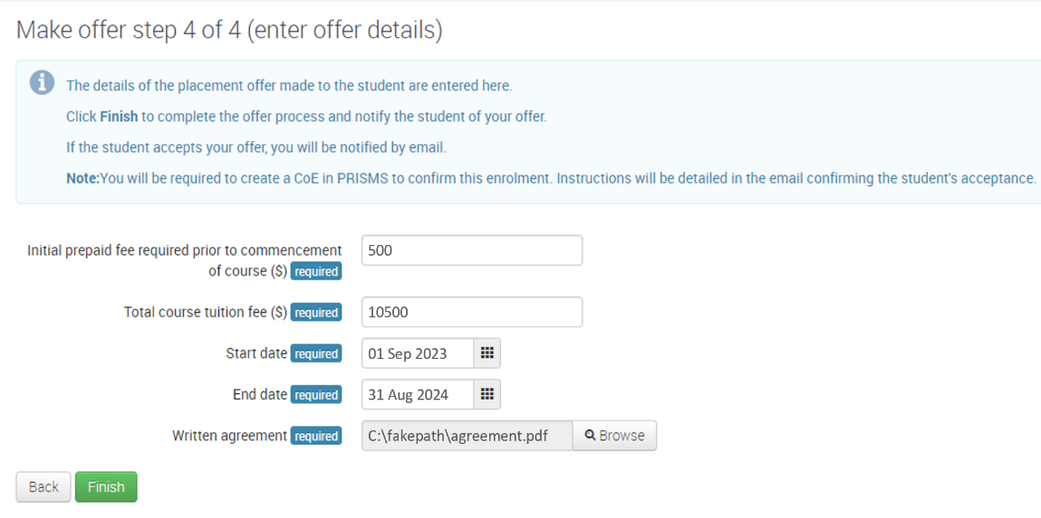

* 1. After making an offer to a student, you will be able to **view all offers** and **withdraw an offer from a student** from your TPS Online home page.

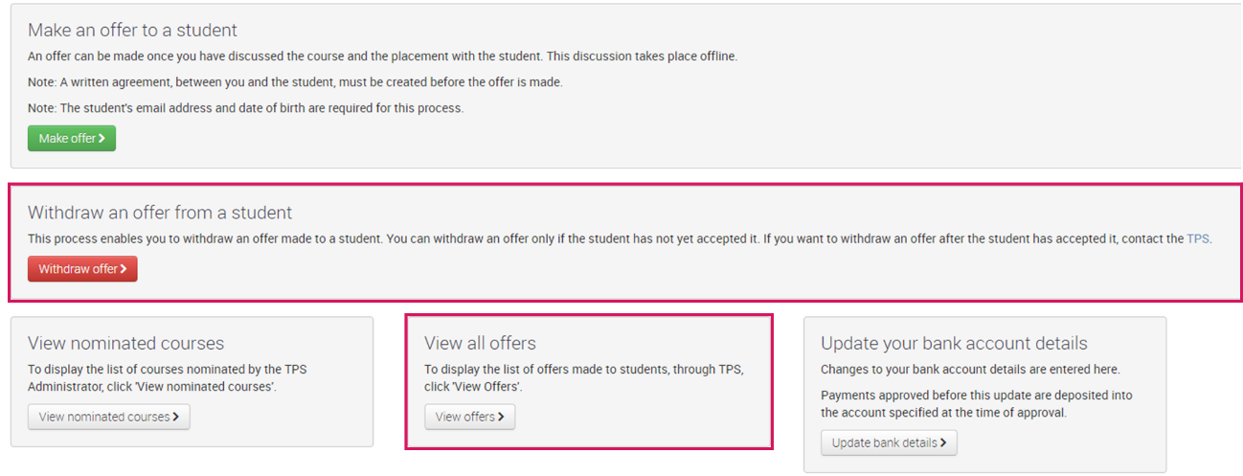

## Step 4: Wait for the student to accept the offer in TPS Online

* 1. After making an offer to a student in TPS Online, the student will be notified of your offer via email and must accept or reject it in TPS Online. You will receive an email notification when the student accepts or rejects the offer.

## Step 5: Create a Confirmation of Enrolment in PRISMS

* 1. After a student accepts an offer, a CoE **must be created in PRISMS**. Refer to the [PRISMS Provider User Guide](https://prisms.education.gov.au/Information/ShowInformation.aspx?Doc=Provider_User_Guide&key=information-provider-user-guide&Heading=) for instructions on how to add a CoE in PRISMS.

## Step 6: Link an accepted offer to a Confirmation of Enrolment

An accepted offer must be linked to a CoE. The TPS will not process any payments until this task is complete.

* 1. From your TPS Online home page, click **Link offer to CoE**.

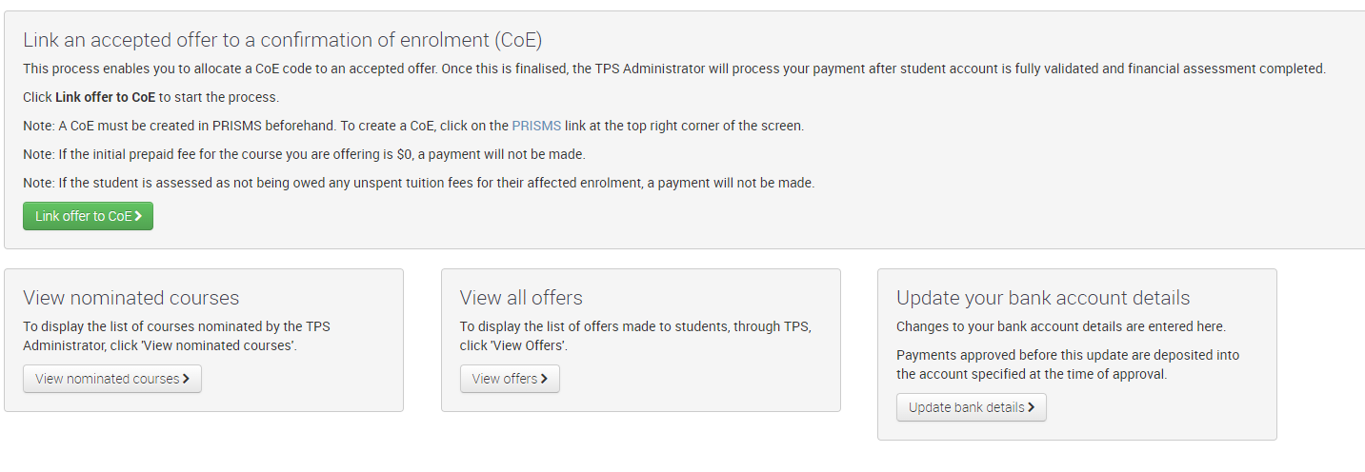

* 1. Select the offer you wish to link to a CoE then click **Next**.

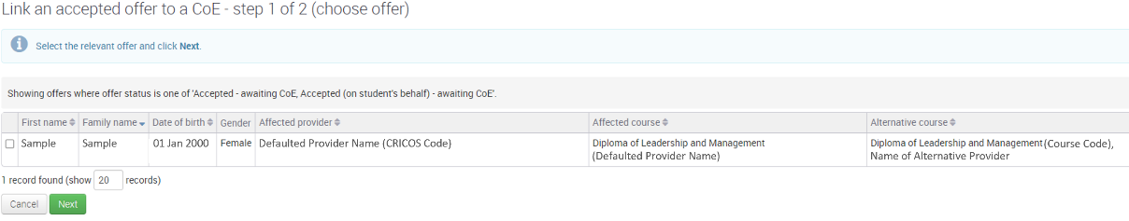

* 1. Enter the code of the CoE created in PRISMS, confirm the CoE details are correct, then click **Finish**.

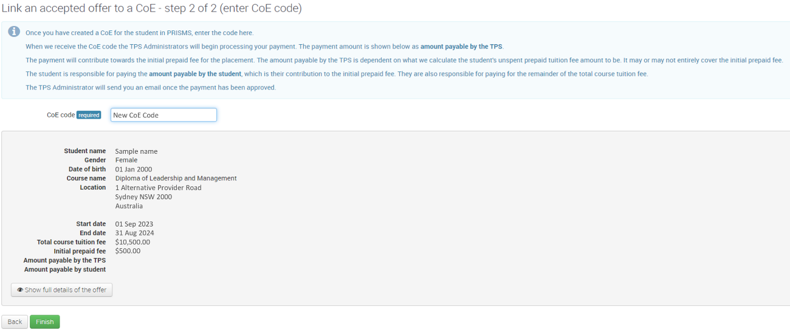

* 1. You can check that an offer has been linked to a CoE by clicking **View offers** from your TPS Online home page.

