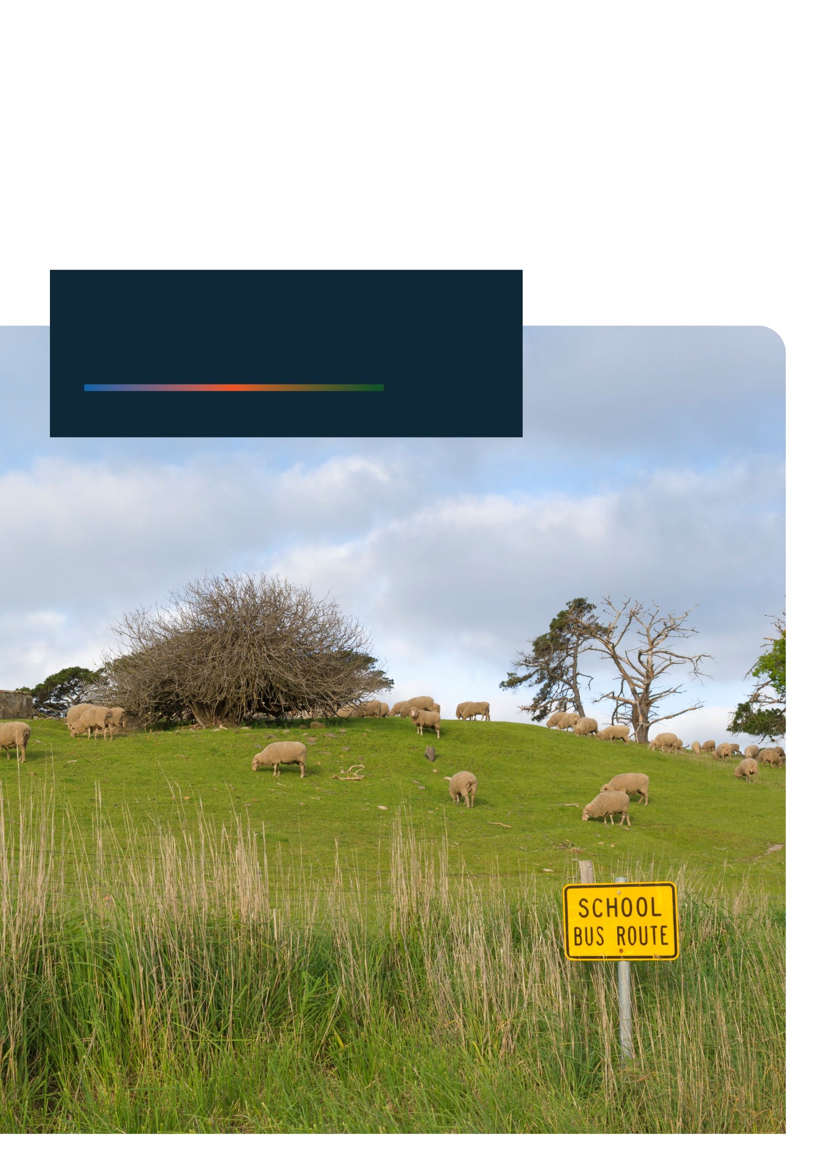


Annual Report
2023

With the exception of the Commonwealth Coat of Arms, any material protected by a trade mark and where otherwise noted all material presented in this document is provided under a Creative Commons Attribution 4.0 International (https://creativecommons.org/licenses/by/4.0/) licence.
The details of the relevant licence conditions are available on the Creative Commons website (accessible using the links provided) as is the full legal code for the CC BY 4.0 International (https://creativecommons.org/licenses/by/4.0/legalcode)
The document must be attributed as the Regional Education Commissioner Annual Report 2023.

Contents
Acknowledgement of Country iv
Regional Education Commissioner’s Foreword v
Issues for Consideration 1
Glossary 4
Education in Regional, Rural and Remote Australia 7
Access to educational opportunities and support 7
Education workforce shortages 12
Improving educational attainment to build a workforce for the future 12
Three reviews in 2022-2024 13
Stakeholder engagement 13
Early Childhood Education and Care (ECEC) 14
Hearing from stakeholders 14
ECEC access and outcomes in the regions 16
Building the ECEC workforce in regional Australia 20
School Education 21
Hearing from stakeholders 21
Snapshot of the regional school sector 22
Improving access to students’ health services 25
Increasing participation and attainment 27
Attracting and supporting our regional teaching workforce 32
Spotlight - First Nations teachers in remote communities 35
Vocational Education and Training (VET) 38
Hearing from stakeholders 38
VET aspiration and access in the regions 39
VET Delivered to Secondary Students (VETDSS) 42
VET trainers and assessors in the regions 43
Building the regional workforce through VET 43
Higher Education 45
Hearing from stakeholders 45
Higher education participation and attainment – the Napthine goals 46
Supporting regional students to succeed 49
The future of higher education in regional Australia 53
Building Stronger Regions through Education 57
Regional workforce – opportunities and challenges 58
Appendices 62
Appendix A: Consultations up to 31 October 2023 62
Appendix B: Progress responding to the Halsey Review 69
Appendix C: Measures responding to the Napthine Review 76
Appendix D: References 83

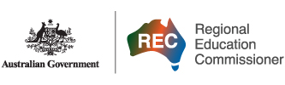
Letter to the Minister
The Hon Fiona Nash
Regional Education Commissioner
GPO Box 9880
CANBERRA ACT 2601
E: RECSecretariat@education.gov.au
24 November 2023

The Hon Jason Clare MP
Minister for Education
Member for Blaxland
House of Representatives
Parliament House
CANBERRA ACT 2600
By email: minister.clare@education.gov.au
Dear Minister
In accordance with the Terms of Reference of my appointment as Australia’s first Regional Education Commissioner, I present my 2023 Annual Report. This report covers activities and findings for the past year from December 2022 to November 2023.
Yours sincerely


The Hon Fiona Nash
Regional Education Commissioner

Acknowledgement of Country
The Regional Education Commissioner and her Secretariat acknowledge the Traditional Owners and Custodians of Country throughout Australia. The Commissioner recognises and deeply respects the strength and resilience of First Nations Australians and their continuing connection to rivers, lands and seas.
The Commissioner and her Secretariat pay respect to Elders past and present and extend that respect to all First Nations people reading this report.
The Commissioner is committed to improving education outcomes for First Nations Australians from regional, rural and remote Australia.

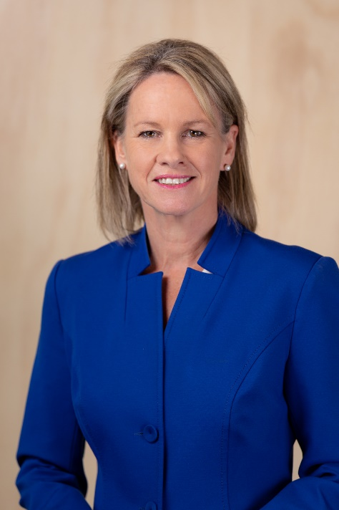
Regional Education Commissioner’s Foreword
As I finish my second year as Australia’s inaugural Regional Education Commissioner, I remain awestruck, if not at all surprised, by the collective achievements, strength, and creativity of people in regional Australia. I am fortunate to be part of important conversations with and on behalf of regional, rural and remote people about education in the regions; between people and communities, educational institutions and peak bodies, industries, policy makers and governments.
My 2023 Annual Report is an opportunity to reflect on the value of the role as a voice from and for the regions on education, from infancy to adulthood. The Regional Education Commissioner’s unique remit allows me to place the challenges and opportunities of regional education from the creche to career firmly within the national discussion about the importance of education.
The benefits of education begin before a child is born and grow throughout childhood and teenage years. That child’s chances of success will be affected by things like the educational opportunities their parents received, the distance they live from services, availability of early developmental assessment and support, and the quality and consistency of early childhood and primary school education. Other influences include access to specialist teaching, subjects, facilities and technology in secondary school, availability of information, support for their aspirations, awareness of pathways into tertiary education, support to participate and succeed, and disruption to their education caused by local, societal and environmental events.
Having lived and worked in regional Australia for decades, I am well aware of the many rewards of rural life. Growing up in a regional community can be a wonderful experience. However, regional students and their families often find themselves having to rise to challenges like greater distances to services and higher costs in accessing education outside major cities. It is crucial that we ensure people in regional communities have reliable, affordable access to every stage of education.
Great education services are a foundation for strong regions. This connection is the focus of my report’s closing chapter, highlighting the power of education to drive growth, productivity and social stability in the regions, and to give people the opportunity to imagine and create great futures for themselves.
The Australian Government initiated three broad-ranging reviews in 2022-23 that span education from early childhood to tertiary education.
As Regional Education Commissioner, I have been fortunate to have had the opportunity to engage in these three reviews, as a member of the Australian Universities Accord Panel and the National School Reform Agreement Ministerial Reference Group advising the Review to Inform a Better and Fairer Education System, and through providing advice on stakeholders and issues affecting regional people for the Productivity Commission’s public inquiry into early childhood education and care.
In reflecting on the state of education in regional Australia in 2023, this report builds on the conversations with regional stakeholders and governments that resulted in the 15 Issues for Consideration that I put forward in my 2022 Annual Report. I have been pleased with the sincerity of the response to last year’s Issues, including expansion of the network of Regional University Centres (now Regional University Study Hubs). I look forward to continuing to work with governments and departments nationally and in all states and territories to improve education outcomes for regional Australians, and have focused my 2023 Annual Report on 21 Issues for Consideration across early childhood, schools, tertiary education and pathways into the workforce.
Themes I identified last year remain relevant and continue to be reflected in my conversations with people, and there are also new ideas. Many of the challenges and opportunities in regional education can be understood through the following observations that cut across early childhood education, schools and tertiary education.
- Support needs to be timely and appropriately targeted to improve access to and participation in education.
- Helping regional students and prospective students understand their options for future pathways by improving careers advice and building aspiration as early as primary school will help them to realise their potential, support their ambition, and create great futures for themselves.
- Policy makers and funding bodies should allow for flexible delivery models, as the opportunities and challenges of education in regional Australia are different from the opportunities and challenges in our cities.
- ‘Homegrown’ workforces will improve the opportunity for regional people to stay in their local regions, and to strengthen regional development. The issue of regional workforce shortages has been a recurrent theme of stakeholder feedback in my discussions over the last two years, and supporting students who want to remain in regional communities to study will help local industries and businesses to grow, and contribute to alleviating workforce shortages in critical sectors like education and health.
- Finally, locally based solutions and local expertise and knowledge are necessary to underpin all these activities.
It has been a privilege this year to work with my fellow panellists to deliver the Australian Universities Accord review – a once in a generation review that will drive the long lasting reform needed to ensure Australia’s higher education system remains world leading. It is also an extraordinary opportunity to contribute to the future prosperity of Australia’s regions.
As has been clear over the last two years as Regional Education Commissioner, education changes people’s lives for the better, and this is nowhere more clear than in the regions.
Through the Accord process, which has had a significant focus on equity, we have had a strong engagement with people invested in the continuing success and sustainability of Australia’s higher education system and the students and communities it must support. My appointment to the Panel has ensured the education needs of regional Australians remain a priority.
In 2023 I have continued to work closely with the Minister for Education, the Hon Jason Clare MP, the Assistant Minister for Education and Assistant Minister for Regional Development, Senator the Hon Anthony Chisholm, and the Minister for Early Childhood Education and Minister for Youth, the Hon Dr Anne Aly, as well as with the Department of Education and other departments. Other ministers and members of Parliament from all states and territories have continued to engage with me productively and positively.
The most powerful motivator for the issues I have put forward here in my report are the hundreds of conversations I have had in the last year with regional stakeholders at events, roundtables, conferences, and meetings, both face-to-face and online.
My report reflects the stories, voices, and experiences of regional Australians. In sharing insights into challenges and opportunities, examples of good practice and priorities, I have been guided by regional stakeholders. It is my strong view that this is an approach policy makers should consistently adopt to make sure decisions reflect what regional people need, and that those decisions are informed by the extensive knowledge regional people hold about their local communities.
Regional communities are incredibly diverse. What works in a primary school in Western Australia’s Pilbara is unlikely to work the same way in a primary school in Ballarat, less than 150 km from Melbourne’s Central Business District. Local ideas and contexts matter.
This report picks up where last year’s finished, reflecting my thoughts on the state of education in regional Australia, and outlines my activities between December 2022 and November 2023. Over these 12 months, I have listened, heard what the challenges are, identified the priorities for action, and advocated strongly for the people of regional Australia. My focus has been on identifying actions that will do the most to improve outcomes in education across all sectors and right across the regions.
In 2024, I look forward to more inspiring, humbling conversations, and to working with regional Australians, Government and the higher education sector. I will work to ensure policy responses to the three education reviews address the ideas, needs and aspirations of regional Australians.
I thank the Department of Education, and particularly my policy secretariat team for their support, commitment and hard work. Most of all, I thank the people, communities and organisations of regional Australia who have spoken to me, invited me into their homes and businesses, told me their stories and shared their challenges and achievements. I hope they see themselves reflected in the pages of this report, which is foremost for them.

The Hon Fiona Nash
Regional Education Commissioner

Issues for Consideration

Early Childhood Education and Care
Issue for Consideration 1 (pp 17, 25): Recognising the significant need for developmental assessments and early intervention support services for children in regional areas, the availability of assessments should be evaluated, and assistance provided for the expansion of support services into regions where there is little or no access.
Issue for Consideration 2 (p 18): Extend the Assistance for Isolated Children – Distance Education (AIC-DE) allowance to 3–4-year-olds undertaking an approved pre-compulsory distance education program to reduce the financial burden for remote families who have no option other than to deliver the preschool program themselves.
Issue for Consideration 3 (p 19): Improve availability and flexibility of alternative ECEC delivery models in regional and remote communities where centre-based day care is not viable. This may include considering alternate funding models and enhancements to current ECEC services that are most suited to remote areas, such as:
- increasing the current legislative limits on educators and children in an approved Family Day Care venue, such as a council building, to allow two approved Family Day Care educators to care for no more than 14 children
- allowing for an In Home Care educator to care for children from more than one family at the same time in remote areas
- exploring a system for providing block funding for ECEC in regional and remote areas where fluctuating demand can create financial instability
- expanding access to mobile childcare services and mobile playgroups
- exploring solutions to support the provision of high-quality care in thin markets, such as delivery of online education combined with in-person care.

Schools
Issue for Consideration 4 (p 29): Increase regional students’ access to a greater variety of secondary school subjects through in person and distance education measures, such as:
- offering subsidised courses to regional teachers to undertake upskilling in specialist areas
- establishing a program to support schools entering into ‘cluster’ arrangements to share teaching and curriculum resources
- expanding funding to partnership programs linking metropolitan schools and regional schools to share resources, for example the City-Country Partnership Program
- supporting programs that provide students with opportunities to undertake specialist subjects at another school
- expanding the services of Regional University Study Hubs to include support services for secondary students, including enabling distance learning or opportunities to access specialist subjects.
Issue for Consideration 5 (p 23): Establish a Distance Education Teaching Allowance (DETA) to support Home Tutors educating geographically isolated students via distance education where there are no alternatives.
Issue for Consideration 6 (p 24): Increase the Assistance for Isolated Children (AIC) Basic Boarding Allowance to ease financial pressures caused by increased boarding fees for geographically isolated students and their families.
Issue for Consideration 7 (p 25): To limit unintended financial consequences for regional families and employers, consider exemptions to the Fringe Benefits Tax for:
- essential supervisory employees’ on-site boarding school accommodation
- employer contributions to employees’ boarding school expenses.
Issue for Consideration 8 (p 33): Create a Year 12 school leavers Teacher Aide program to assist regional schools facing a teacher shortage.

Tertiary Education
Issue for Consideration 9 (p 39): Recognising that VET and Higher Education offer parallel pathways to success, support informed student choice and aspiration by resourcing schools to provide properly targeted, expert careers advice.
Issue for Consideration 10 (p 50): Improve the administration of the Tertiary Access Payment (TAP) by:
- removing the ‘no gap year’ requirement
- providing students with the financial support prior to relocation rather than after they commence their studies.
Issue for Consideration 11 (p 50): Amend the Independent Youth Allowance eligibility criteria for regional students so that regional and remote students who need to relocate from home for tertiary study, beyond an appropriately determined distance, qualify as independent (replacing the current criteria that requires a regional or remote student to have worked at least 15 hours a week for a minimum of 2 years or earned 75% or more of wage Level A of the National Training Wage Schedule over a 14-month period to demonstrate independence).
Issue for Consideration 12 (p 53): Consideration be given to developing a financial support program for students on compulsory placements to improve higher education attainment rates in the regions.
Issue for Consideration 13 (p 54): Enhance and expand the Regional University Study Hubs program, including by exploring options such as:
- collaborating with state and territory governments to identify potential opportunities to house Regional University Study Hubs on existing TAFE sites and expand access for VET students
- enabling appropriately determined university regional campuses to host a Regional University Study Hub
- developing an appropriate model to deliver ongoing support and governance oversight for the full network of regional Hubs.
Issue for Consideration 14 (p 59): Significantly increase the number of Commonwealth Supported Places for regionally-based end-to-end medical schools to address critical medical workforce shortages in regional areas.
Issue for Consideration 15 (p 60): Immediately address the critical veterinary workforce shortage in regional and remote Australia through both short and long-term strategies, such as:
- HELP fee relief to encourage early career veterinarians to work in rural areas
- changes to admissions processes to ensure places for students with a commitment to regional and remote practice
- changes to the funding and models of training (e.g. financial support for rural placement)
- consider housing (or other) incentives to attract veterinarians to regional areas of need.
Issue for Consideration 16 (p 55): Acknowledging the significant social and economic contribution regional universities make to their local communities, change the eligibility requirements of the Growing Regions Program to allow regionally headquartered universities to apply for funding.

Cross-sector
Issue for Consideration 17 (p 30): Noting the importance of timely and relevant careers advice to students and its pivotal role in building aspiration and improving attainment rates:
- undertake a national audit to investigate the accessibility, effectiveness and quality of current careers advice delivery to primary and secondary school students, including identifying good practices
- consider how local councils, Regional University Study Hubs and other community organisations can implement strategies to improve the timeliness, accessibility and quality of careers advice.
Issue for Consideration 18 (pp 33, 43): Encourage educators to remain in, or relocate to, regional areas by offering local, accessible and subsidised professional development opportunities.
Issue for Consideration 19 (pp 22, 35, 36): Elevate First Nations ‘assistant teachers’ to ‘partner teachers’ in recognition of their unique skills and cultural knowledge.
Issue for Consideration 20 (p 61): Develop a regional education linkage program that facilitates collaboration between regional schools, VET, universities, Regional University Study Hubs, business and industry, and community to build student aspiration and address access, attainment and workforce issues in our regions.
Issue for Consideration 21 (p 61): Fund local councils to develop a strategy to keep young people connected to their regional community if they leave, facilitating a ‘pathway home’ for students to return to their region.

Glossary
Australian Qualifications Framework (AQF) is the national policy guide for regulated qualifications in the Australian education and training system. Higher education and VET qualifications are described in the AQF, which consists of ten qualification levels, corresponding to 17 qualification types, including the Senior Secondary Certificate of Education, which is not among the ten levels. AQF levels give an indication of the relative complexity, breadth and depth of achievement and autonomy required to demonstrate competency, and duration to achieve that competency (known as ‘volume of learning’). The AQF ensures a common national understanding, recognition and consistency of regulated qualifications.
Australian Statistical Geography Standard (ASGS) is a classification of Australia into statistical areas based on population, as defined by the Australian Bureau of Statistics (ABS). It is a social geography, developed to reflect the location of people and communities. In this report, Remoteness Areas are used to distinguish between regions.
Australian Universities Accord (Accord) is a review of Australia’s higher education system, led by an independent expert panel and initiated in 2022. The Accord is considering a range of issues including access and opportunity, investment and affordability, quality and sustainability, and accountability and community, to provide a long-term plan for higher education in Australia. The Accord Panel is due to provide a final report to Government in December 2023.
Australian University or ‘university’ refer to a registered higher education provider in the ‘Australian University’ provider category of the Higher Education Standards Framework, which sets out the standards all Australian higher education providers are required to meet to continue to deliver higher education courses in Australia (see ‘Australian Universities Accord’, ‘higher education’, ‘RTO’, ‘VET’, ‘tertiary education’).
Commonwealth supported places (CSPs) are places at a university or higher education provider where the Australian Government pays part of the student’s fees. This part is a subsidy, not a loan, and the student is not required to pay it back. This subsidy does not cover the entire cost of the student’s study. The remaining portion is called the 'student contribution amount', which the student is liable for.
Developmental Assessment is a comprehensive evaluation of a child's physical, intellectual, language, social and emotional development. They are usually conducted when a parent, carer, educator or medical health professional identifies that a child is having difficulty in one or more of these areas.
Halsey Review is the Independent Review into Regional, Rural and Remote Education released in 2018, conducted by Emeritus Professor John Halsey.
Higher Education in Australia refers to awards spanning Australian Qualifications Framework (AQF) levels 5-10, which include: diplomas (5); advanced diplomas (6); associate degrees (6); undergraduate degrees (a higher education qualification of six months duration covered by an existing higher education qualification at levels 5, 6, or 7); bachelor degrees (7) including honours (8); graduate certificates (8); graduate diplomas (8); masters degrees (9); doctoral degrees (10); and higher doctoral degrees (10). Higher Education providers are regulated by the Tertiary Education Quality and Standards Agency (TEQSA) (see ‘tertiary education’, ‘Australian Universities’).
Higher Education Loan Program (HELP) provides a financial loan to eligible students to pay student contributions or tuition fees from a university or other higher education provider. Students repay this loan through the Australian tax system, indexed to the cost of living, once they earn above the compulsory repayment threshold. The rate of repayment is dependent on the student’s income.
Initial Teacher Education (ITE) is a pre-service, compulsory qualification to equip graduate teachers with the necessary knowledge, skills and dispositions to start their teaching career in any Australian school.
Jobs and Skills Australia is an agency announced in July 2022 and confirmed in the October 2022 budget. The agency’s remit includes workforce planning and developing closer partnerships with state and territory governments, unions, industry and education providers.
Literacy and Numeracy Test for Initial Teacher Education (LANTITE) is a computer-based test to measure Initial Teacher Education students’ literacy and numeracy skills.
Microcredentials are a certification of assessed learning or competency, with a minimum volume of learning of one hour and less than an AQF award qualification, that is additional, alternate, complementary to or a component of an AQF award qualification (see ‘AQF’).
Metropolitan refers to those urban area that are classified as Major Cities as defined by the Australian Bureau of Statistics (ABS) under the ASGS Remoteness Area (ASGS-RA).
National Assessment Program – Literacy and Numeracy (NAPLAN) is an annual, nationwide assessment for students in Years 3, 5, 7 and 9 to allow parents/carers and educators to compare student progression in literacy and numeracy over time and against national standards.
National Broadband Network (NBN) is a publicly owned government enterprise tasked with designing, building and operating a wholesale broadband access network for Australia.
National School Reform Agreement is a joint agreement between the Commonwealth, States and Territories to lift student outcomes across Australian schools through agreed national objectives, outcomes and measures.
Napthine Review is the National Regional, Rural and Remote Tertiary Education Strategy chaired by the Hon Dr Denis Napthine and delivered in 2019, which focused on improving tertiary education participation and outcomes for students from regional, rural and remote areas.
Online learning is the use of digital technology or resources to deliver and support specific teaching and learning aims/outcomes.
Regional is used as a broad term for non-metropolitan areas of Australia. For the purposes of this report, the word regional refers collectively to regional, rural and remote areas. Where the terms ‘inner regional’, ‘outer regional’, ‘remote’, ‘very remote’ and ‘major cities’ are used, they generally correspond to the five classes of remoteness under the ASGS-RA, as defined by the Australian Bureau of Statistics (ABS) based on relative access to services. While many people and communities identify as rural, the term is not explicitly defined and does not correspond to any specific class of area within the ASGS.
Regional University Study Hubs (formerly Regional University Centres), also known as Hubs, provide facilities for the use of regional and remote students to study tertiary courses delivered by distance. Hubs provide local infrastructure including study spaces and internet access, administrative and academic support services, and student support services. Hubs are not registered higher education providers and cannot award higher education qualifications.
Registered Training Organisations (RTO) deliver and assess nationally recognised training in the VET sector, issue nationally recognised qualifications and statements of attainment, and receive government funding to provide subsidised VET services (see ‘tertiary education’, ‘TAFE’, ‘VET’).
Science, Technology, Engineering, and Mathematics (STEM) are collectively referred to as ‘STEM’.
Socio-economic status (SES) is the social and economic position of an individual, group, community or region. Common measures include income, consumption, wealth, education and employment.
Technical and Further Education (TAFE) is a government-run system of tertiary education providers providing Vocational Education and Training (VET). VET teaches specific skills for particular industries and workplaces, as opposed to higher education, which focuses on teaching conceptual knowledge and critical thinking (see ‘tertiary education’, ‘RTO’, and ‘VET’).
Tertiary education refers to all vocational education and training (VET) and higher education in Australia. Higher education and VET qualifications are described in the Australian Qualifications Framework (AQF), the national policy guide for regulated qualifications in the Australian education and training system. Many providers are dual sector providers, offering qualifications in both VET and higher education, including most TAFEs and a number of universities (see ‘Australian Universities’, ‘Higher Education’, ‘RTO’, ‘TAFE’ and ‘VET’).
Vocational Education and Training (VET) refers to the training and work-ready qualifications related to occupational skills, trades and competencies. The VET sector recognises AQF qualification levels 1-6 and 8 (Certificates I-IV, Diploma (5), Advanced Diploma (6), Graduate Certificate and Graduate Diploma (8)). The VET sector is regulated by the Australian Skills Qualification Agency (ASQA) (see ‘tertiary education’, ‘RTO’ and ‘TAFE’).
VET Delivered to Secondary Students (VETDSS) refers to programs delivered as part of the secondary education system which provide students with the opportunity to engage in vocational learning and work towards attaining a nationally recognised VET qualification as part of their secondary study.

Education in Regional, RURAL and Remote Australia
Australia’s regions are great places to grow up, live and work. However, even for students in well-resourced communities, isolation, distance between and from services and smaller populations increase the challenges of accessing education compared to students in cities.
Education improves people’s lives. The learning opportunities provided to children from their early years through school into tertiary education and the workforce will shape their futures. These opportunities, and the benefits of education, should not be limited by location.
Achievement and participation in early childhood education and care (which is referred to as ECEC throughout this report), school and the tertiary sectors are tightly linked. The Commissioner’s view across all aspects of regional education provides insights into how events and outcomes in one stage of a student’s life can substantially affect their future participation in education and the choices available to them into adulthood.
For example, students who thrive in the early years of primary education continue to have better educational outcomes than their peers – an advantage that increases over time and into secondary education. It is important to identify learning difficulties, particularly related to development as soon as possible in early childhood to allow for the best possible outcome for the child. Further along the learning pathway, subject availability and selection, specialised teachers, informed aspiration, careers advice and access to tertiary education will have a significant impact on a person’s future career and lifetime earning capacity – and in turn will affect the education outcomes of their children.

Access to educational opportunities and support
In Australia, location measurably affects the delivery and outcomes of education from early childhood to post-school study. Growing up in a regional community comes with great benefits but also brings educational challenges.
ECEC options are more limited than in our cities, which may mean that a child cannot attend childcare or preschool regularly, or sometimes at all. Lack of reliable childcare also reduces opportunities for their parents to participate in the local community, workforce or further education and training.
School may be a table in the kitchen, a boarding school far from home, or a multi-grade single building many kilometres down the road – and it may not offer the specialist facilities, subjects, or the teachers skilled in delivering them, that some students require to pursue their ambitions.
Tertiary education may not be available in the region where students have grown up, meaning they have to leave home to pursue their post-school aspirations, with the associated costs and loss of support networks.
As several inquiries in recent years have shown, from the Halsey Review into regional schools to the Napthine Review into regional tertiary education, there is a gap between the educational outcomes and attainment levels of regional students and metropolitan students. More children in regional areas will not attend pre-school, will not complete high school and will not complete a tertiary qualification. An update on the progress responding to the Halsey Review can be found at Appendix B, and an update on the measures taken in response to the Napthine Review can found at Appendix C.
Disparity with metropolitan participation and attainment is greatest for remote and very remote areas and First Nations children. This report spotlights issues that are heightened for remote and First Nations children and identifies examples of locally-led initiatives that are working towards improving educational attainment and aspiration in their communities.
Financial assistance, career guidance and healthcare all play a role in building the support network needed for a student to succeed. Improving access to educational opportunities and support means removing or lowering those barriers that make it more difficult for regional students to succeed. Barriers range from lack of ECEC and basic access to schooling for students in very remote areas, to the high cost of relocation, to the extent and availability of student support services at school and university.
The road distance between a student’s home and school or university is one measure of education ‘access’. The increasing challenge of access to education faced by regional and remote Australians as they move through from primary school to university is shown in three maps generated by the Centre for Australian Research into Access (CARA) (Figure 1).
These maps illustrate the distribution of Australian addresses coloured by the road distances to the nearest:
- government primary school (Figure 1A),
- government secondary school (Figure 1B), and
- university campus (Figure 1C).
They clearly show how distance increases with each education level.
While it is not practical to have a university campus in every town, as is the case for primary schools, ongoing investment in alternative options is needed to improve access to education.

Figure 1A Road distances to nearest government primary school
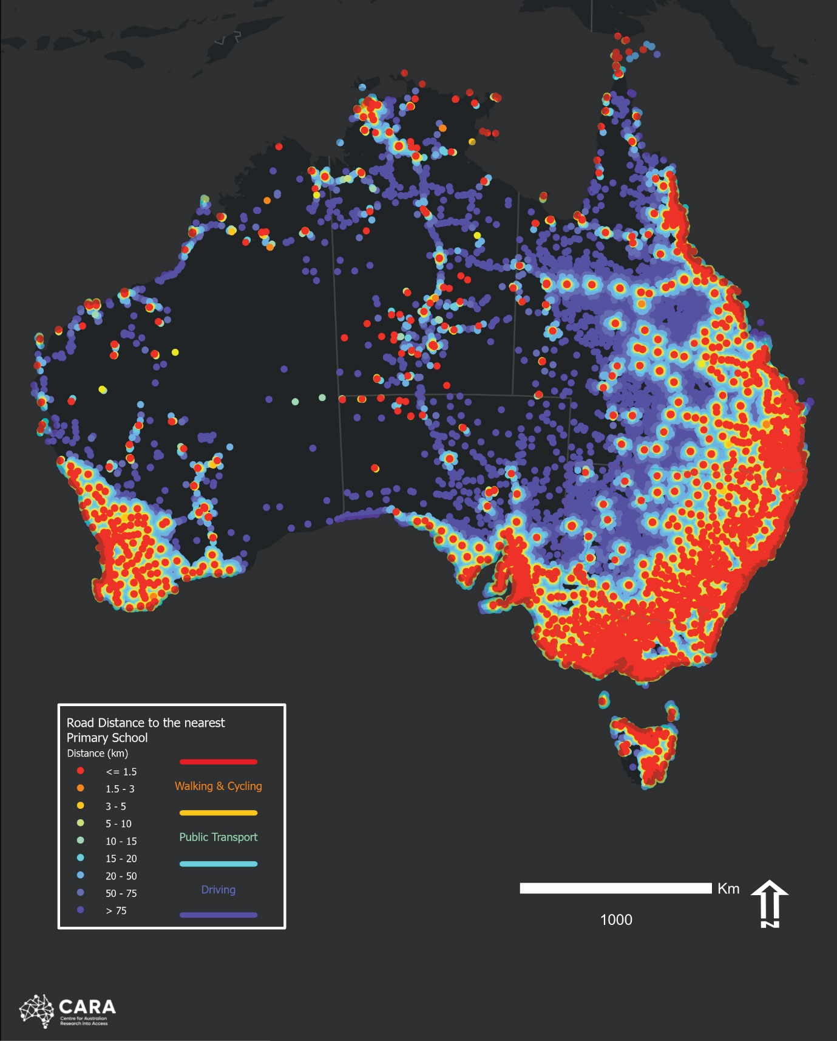
Data sources: Australian Curriculum, Assessment and Reporting Authority (ACARA), Department of Industry, Science and Resources (GNAF), Precisely, Esri
Figure 1B Road distances to nearest government secondary school
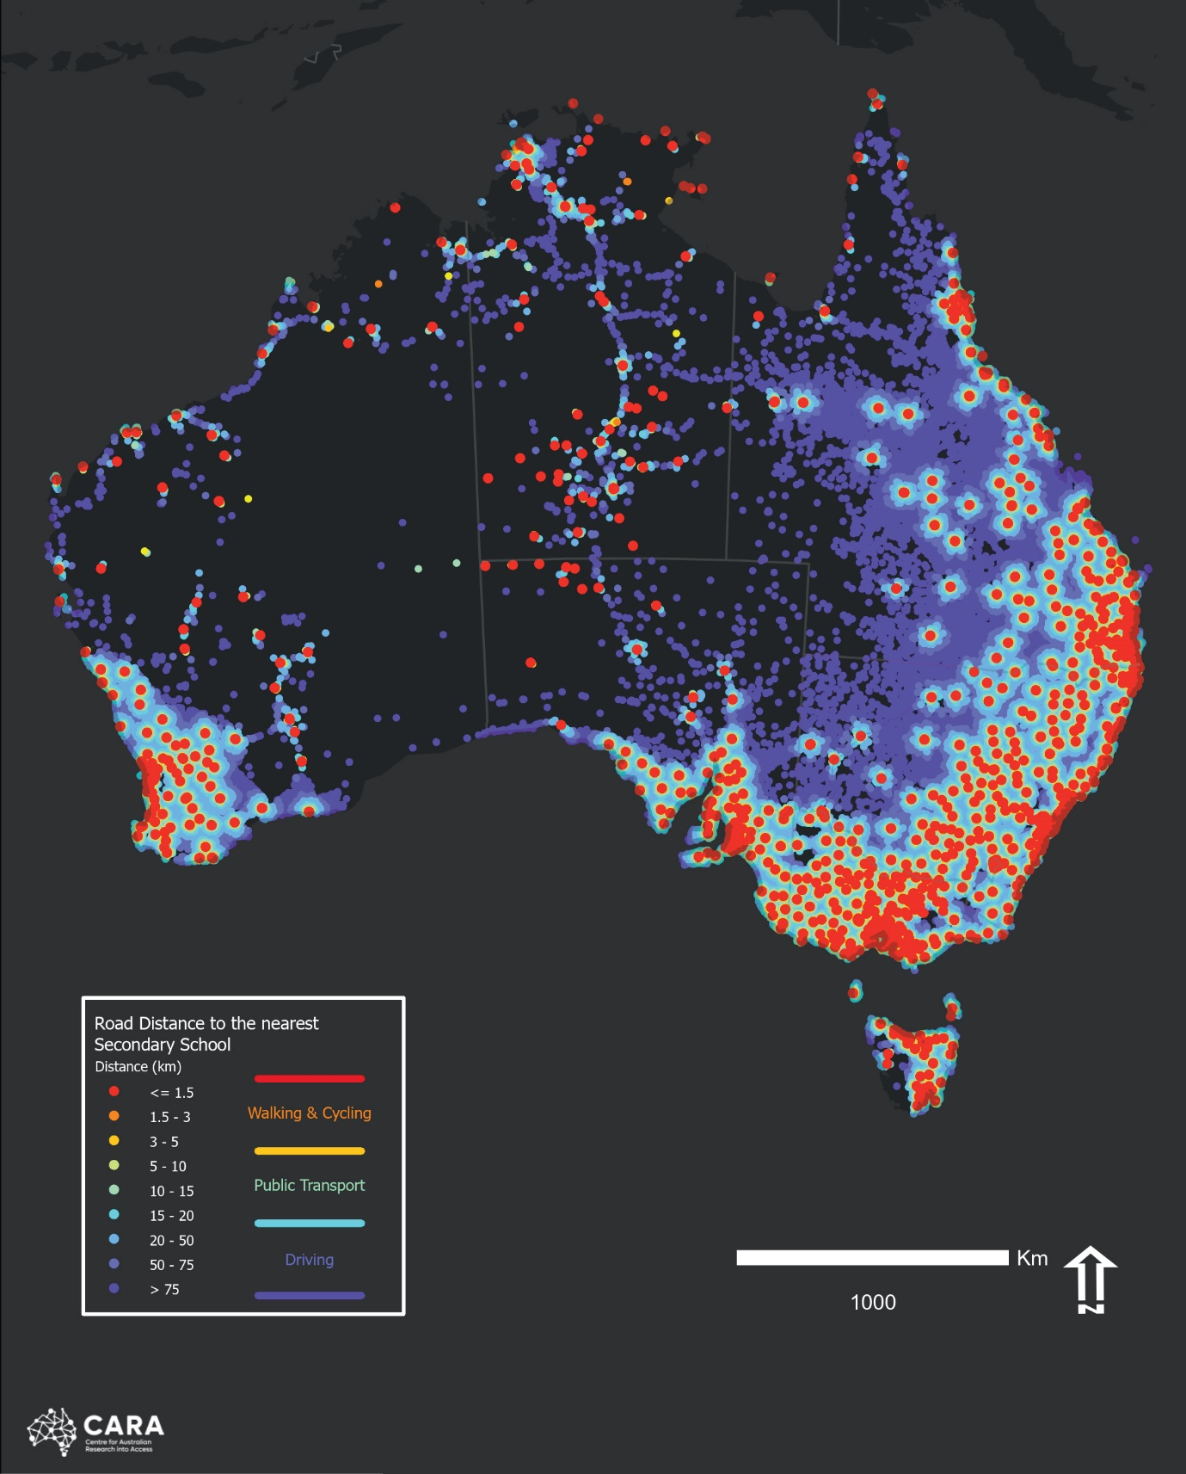
Data sources: Australian Curriculum, Assessment and Reporting Authority (ACARA), Department of Industry, Science and Resources (GNAF), Precisely, Esri
Figure 1C Road distances to nearest university campus
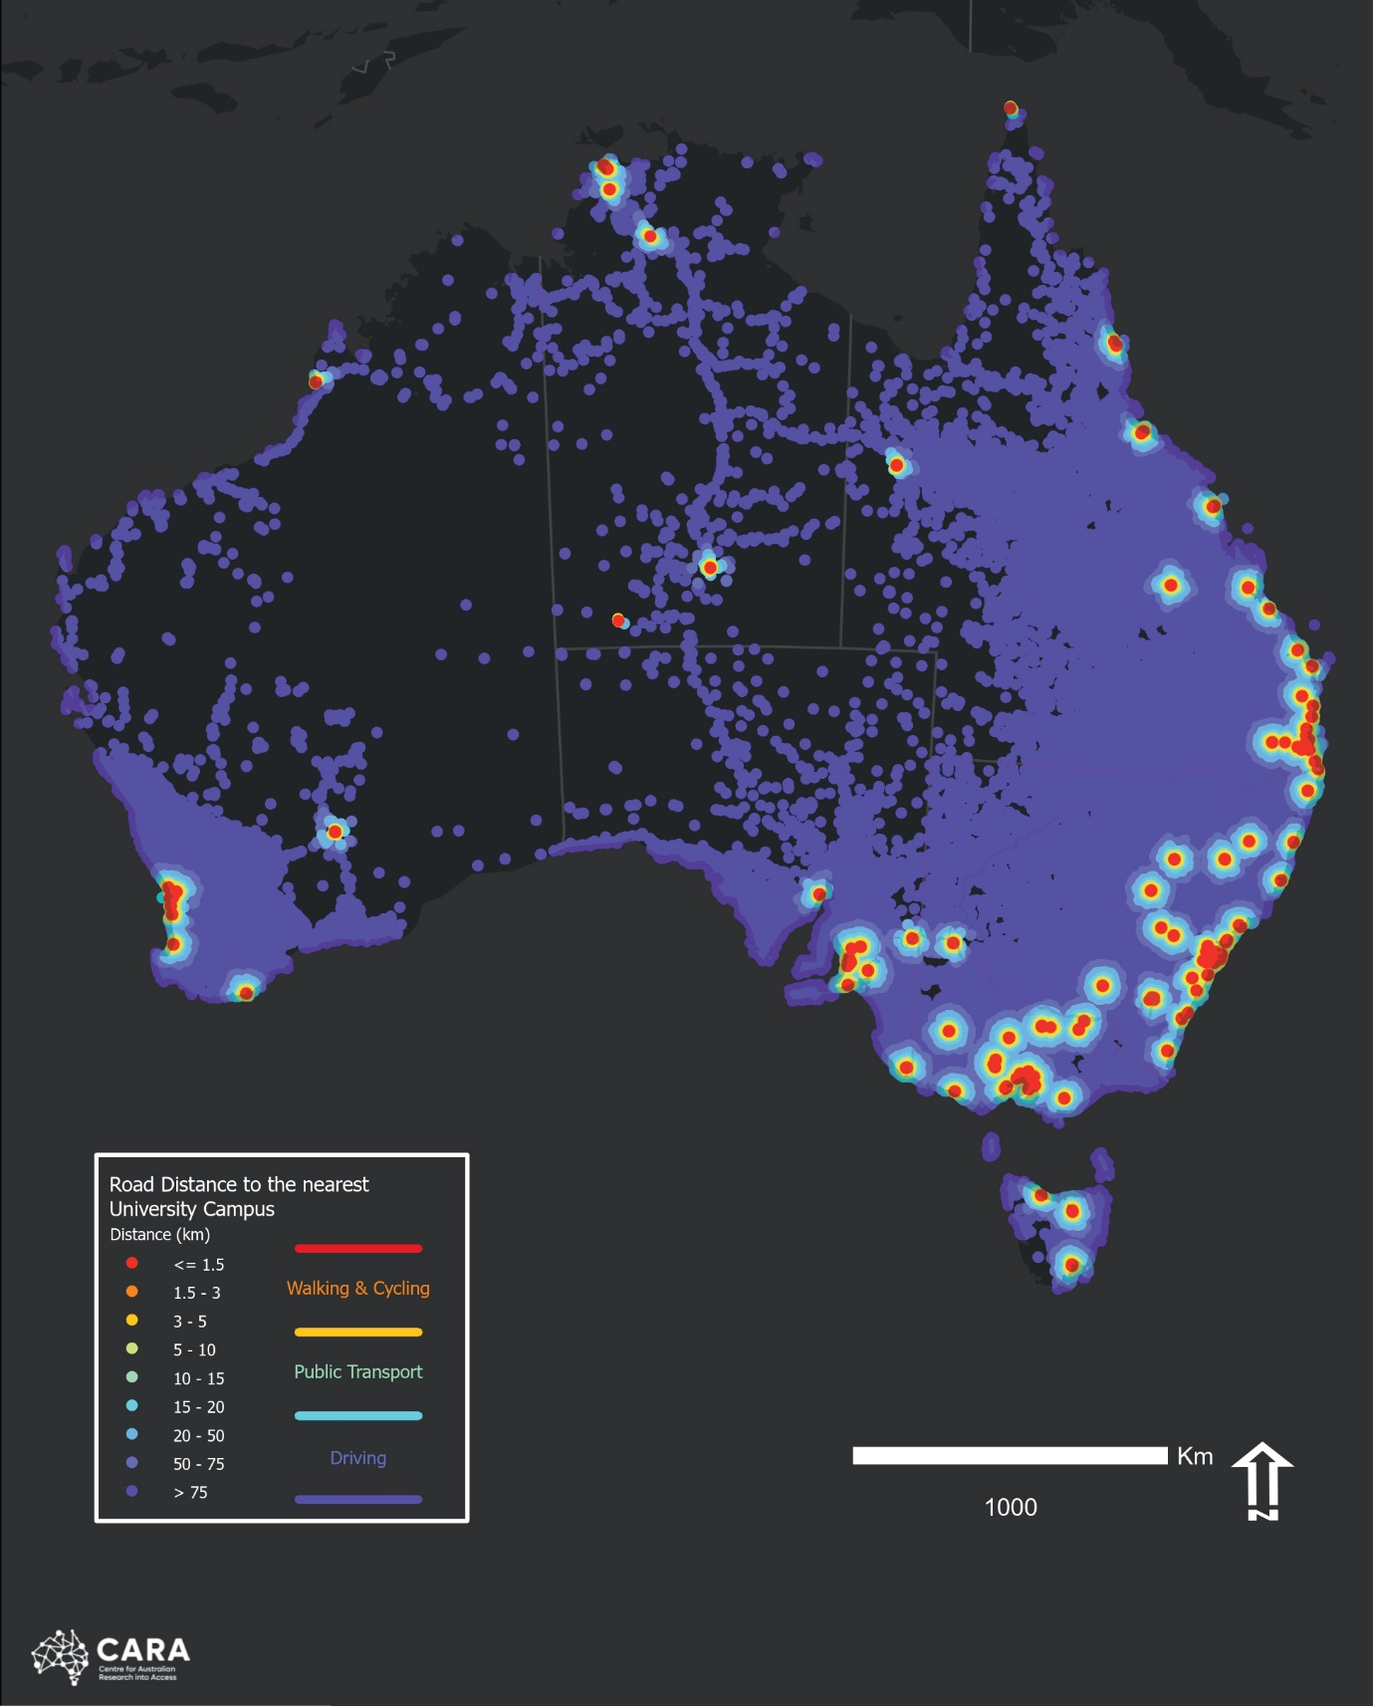
Data sources: Universities Australia (Main and Other Campuses), Department of Industry, Science and Resources (DISR), Precisely, Esri

Education workforce shortages
Teaching workforce shortages exist across all sectors in regional Australia but are particularly evident in the ECEC sector and in specialist Science, Technology, Engineering and Mathematics (STEM) subjects in secondary schools. This report highlights several different strategies that could be implemented to build the regional teaching workforce.
Local, accessible training opportunities can help to create and sustain a ‘homegrown’ workforce. These opportunities include training for teachers to upskill in specialist subjects. Supporting early career teachers through placements, training and mentorships can assist in retaining teachers in regional areas. Focusing on the many positive aspects of working in regional communities would also help attract new teachers to these areas and welcome back people who may have moved away to pursue tertiary education. Alleviating workforce shortages would unburden currently overwhelmed regional teachers, schools and parents and would positively influence the quality of education for regional students.

Improving educational attainment to build a workforce for the future
Policy makers need to plan from early childhood to ensure that students have the best available support and opportunities to maximise their learning outcomes. Technological change will influence the composition of the workforce, and who benefits; over time, the strongest growth is in the jobs that require the highest skills. Over the next five years, 90% of new jobs will require post-school qualifications, with more than 50% requiring a bachelor’s degree or higher.
To meet this demand, the Australian higher education system would need to have at least 1.2 million Commonwealth supported students in 2035 and 1.8 million in 2050. There are around 900,000 students today, which means an increase of 300,000 by 2035 and 900,000 more by 2050 – double the number of current students.
Participation will need to grow significantly to meet the demand for qualified workers, and that growth will need to come from groups historically underrepresented in higher education, including students from regional areas. The Accord Interim Report projects that at least half of the additional students will need to come from regional Australia. To move more of these students into skilled careers that need tertiary qualifications, we need to increase the number of students completing Year 12.

Three reviews in 2022-2024
In recognition of the challenges facing Australian education, the Government initiated three broad-ranging reviews in 2022-23. The Productivity Commission’s inquiry into ECEC, led by Professor Deborah Brennan AM, delivered its draft report on 23 November 2023 with a final report due by June 2024.
The Review to Inform a Better and Fairer Education System led by Dr Lisa O’Brien AM, focussed on schooling, will advise the National School Reform Agreement process. The Expert Panel delivered its report to Education Ministers on 31 October 2023.
The Australian Universities Accord, a review of the higher education system led by Professor Mary O’Kane AC, is expected to deliver its findings in December 2023.
The Commissioner is a member of the Accord Expert Panel, and the National School Reform Agreement Ministerial Reference Group advising the Expert Panel for the Review to Inform a Better and Fairer Education System. The Productivity Commission inquiry sought the Commissioner’s advice on relevant issues and stakeholders in ECEC in regional Australia.
The findings and recommendations of the reviews will inform policies to address disparities in educational outcomes and attainment. As the reviews are underway at the same time, issues that cut across sectors can be considered, such as the way in which the school curriculum and environment needs to support post-school education and the transition to employment, through skilled teaching, scaffolded support, and building informed aspiration. The Commissioner’s broad cross-sector perspective on regional education has given her a unique role in these three reviews and allowed her to advocate strongly for issues specific to education in regional Australia.

Stakeholder engagement
Throughout the year and across Australia, the Commissioner has engaged with individuals, communities, organisations, and local governments in all sectors. A full list of stakeholder engagement can be found in Appendix A of this report.
Communities in regional Australia experience common challenges including difficulty accessing education, support for students, workforce shortages, and access to careers advice that helps them understand pathways to and through tertiary education. However, although regions share challenges and can (and do) learn from each other, every community is unique, and local community knowledge should be a contributing factor to policy and program design.
Regional Australia is a huge part of the continent, with diverse environments, communities, and geography. People in the regions have emphasised that locally based solutions, tailored to the unique needs of their communities, give the best outcomes. Designing policy with local communities rather than for them is another important characteristic of successful programs aiming to improve outcomes for regional students. Local communities have insights into what they need and the best approaches. Case studies of good practice are highlighted throughout this report, capturing the knowledge and expertise of people on the ground in regional communities.

Early Childhood Education and Care (ECEC)
Education helps people imagine and create better futures for themselves and their communities, and this starts in early childhood. These benefits of education, aspiration, and workforce participation that ECEC provides should not be limited by location.
Regional Australian communities are great places to grow up and raise children. However, discussions this year have reiterated that even the most resilient and well-resourced regional and remote communities face challenges delivering and accessing ECEC that their metropolitan equivalents do not experience. Approaches that work for people in cities often fail in thinner regional markets, particularly as population density and the availability of skilled workers decrease.

Hearing from stakeholders
This year the Commissioner engaged with many communities, organisations, peak bodies, state and federal ministers, and government agencies on matters related to ECEC. Barriers to ECEC access and availability, particularly in remote communities, remain a central concern in these conversations. Attracting and retaining ECEC staff, and navigating complex regulatory requirements, also present significant challenges in regional communities.
The ECEC sector is currently undergoing a period of extensive review. The Commissioner has engaged with many inquiries and reviews this year, raising the challenges of delivering and accessing ECEC in regional Australia and proposing actions to ensure reliable, high-quality ECEC is available to all families.
The Commissioner has also attended several events hosted by ECEC sector stakeholders, including opening the 52nd Annual Conference of Isolated Children’s Parents’ Association of Australia (ICPA), held across 26 and 27 July 2023 and speaking at Early Childhood Australia NSW’s Conversations Evening on 12 October 2023.

Image Caption: ICPA Federal Conference, 25 July 2023 L-R; Elise Petty, nbn Australia, the Regional Education Commissioner, the Hon Fiona Nash, and Jen Medway, Regional Tech Hub

Submissions, reviews and representations

Productivity Commission Early Childhood Education and Care Inquiry
The Productivity Commission ECEC Inquiry is examining ECEC across all modes of delivery, including centre-based day care, preschools, Family Day Care, outside hours care and In Home Care. The Productivity Commission is considering cost and availability barriers that affect access to ECEC services, and ways to support better outcomes for children, their families, and ECEC providers.
The Commissioner made a submission encouraging the Productivity Commission to examine the practicality of specific interventions for increasing access to and participation in ECEC in regional Australia. Her submission also noted workforce shortages as a significant issue in the regions, including for the ECEC sector, and advised that a lack of sustained access to childcare is a barrier to participation in education and the workforce.
Additionally, the Commissioner met with the Productivity Commission on 13 June 2023 to discuss the unique needs of regional and remote communities. The ECEC Inquiry subsequently contacted her seeking advice on key regional ECEC stakeholders and where to hold regional consultation meetings.

Australian Competition & Consumer Commission Childcare Inquiry 2023
The Australian Competition & Consumer Commission (ACCC) is conducting an inquiry into the market for the supply of childcare services. The inquiry will provide a final report by 31 December 2023.
The Commissioner met with the ACCC on 18 April 2023 to discuss the provision of ECEC for regional families, raising the challenges of thin markets and market failure particularly in remote communities, and the effect that a lack of access has on local workforce. The Commissioner also noted the importance of finding flexible ways for centres to continue to operate in thin markets, especially those where the number of families seeking childcare may fluctuate.

Early Years Strategy
The Australian Government is currently developing an overarching Early Years Strategy with the aim of improving coordination between the numerous programs, frameworks and funding schemes that the Commonwealth operates in the ECEC sector.
The Commissioner attended the National Early Years summit on 17 February 2023. The Summit brought together parents, community organisations and representatives across government, non-government, academic and business sectors to discuss the development of the Early Years Strategy. The Commissioner was additionally invited to attend two consultation roundtables on 25 May to aid development of the Strategy.
The Commissioner used these opportunities to elevate the issues consistently raised by people in regional and remote communities, stressing the unique challenges facing regional children and families as compared to their metropolitan counterparts.

Department of Education Reviews
This year the Department of Education commissioned independent reviews of the In Home Care and the Inclusion Support programs. The Commissioner met with the teams conducting these reviews in May 2023 to provide insights on the specific needs of regional and remote families and the opportunities for these programs to support them better. She noted the need for flexibility in implementation including exploring the possibility of delivering the ‘education’ component of ECEC online, in situations in which qualified carers are available but there is a shortage of educators.

ECEC access and outcomes in the regions

Developmental outcomes
The first few years of a child’s life, before the age of 5, lay the foundations for their future behaviour, learning, and success. The younger a child is, the more adaptable the connections in their brain are likely to be, which is why early monitoring of development and behaviour is so important – because this is when interventions are most likely to be effective. Ensuring children have the right support in these early years can have a major positive effect on their future. However, children in regional and remote Australia are far more likely to be developmentally vulnerable by the time they start school than children in major cities.
This is particularly true for children in Remote and Very Remote Australia and First Nations children. Australian Early Development Census (AEDC) data indicates that in 2021, 34.4% of children in Remote and Very Remote were developmentally vulnerable on one or more domains (compared to 20.8% in major cities and 24.4% in regional Australia). 34.3% of First Nations children were assessed as developmentally on track in all five domains of the AEDC. This is a decrease from 35.2% in 2018 and is well below the 54.8% of all Australian children developmentally on track on all five domains. Ensuring all children are developmentally on track in each of the domains is critical for their future, as the AEDC domains have been shown to predict children’s later outcomes in health, wellbeing and academic success.
Figure 2: Percentage of children developmentally vulnerable by domain (2021)
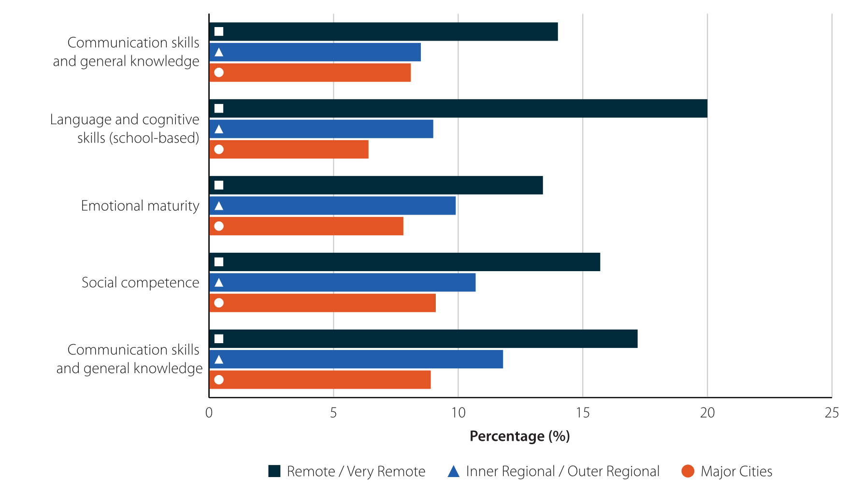
Source: Australian Early Development Census 2021, Australian Government, 2021
There is a lack of data on the availability of developmental assessments and intervention support services in our regions. It is currently unclear how many children can access developmental assessments. Even if every child had access to an assessment, there is limited information on what supports are currently available to children in the regions should a need for intervention be identified. To ensure regional children are supported to be developmentally on track when they start school, the current availability of formal developmental assessments and access to ongoing support in regional and remote Australia needs to be better understood. This would require cooperation between relevant sectors, including the early childhood education and health sectors.
Issue for Consideration 1
Recognising the significant need for developmental assessments and early intervention support services for children in regional areas, the availability of assessments should be evaluated, and assistance provided for the expansion of support services into regions where there is little or no access.

Case Study: Thrive By Five
Thrive by Five is an initiative of the Minderoo Foundation focussed on reforming the ECEC system to ensure it is high quality and universally accessible.
Following the release of the Mitchell Institute’s 2022 report on ‘childcare deserts’, partially funded by the Minderoo Foundation, Thrive by Five has continued the strong focus on gaps in access and outcomes that exist between children in the regions, and First Nations children, in comparison to children growing up in major cities.
In November, Thrive by Five launched the ‘Every Child’s Right to Thrive by Five – Make It Law’ campaign. The campaign asks all levels of government to work together to pass legislation that creates a guarantee of access to early childhood services for young children across Australia.
In addition to legislating nationwide entitlements to parental leave, healthcare and education, the proposed legislation would also include defining a high-quality, inclusive and integrated early childhood development system that crosses sectors, location and tiers of government.
Thrive by Five’s campaign aims to bring together all the services and systems that impact children in their early years, including ECEC, maternal and child health, paid parental leave and other community services such as playgroups, into one coordinated system. This approach recognises the different influences on a child’s development in the early years and aims to improve outcomes across Australia through equitable nationwide entitlements.

Access
The ECEC landscape looks very different in regional and remote Australia compared to metropolitan areas, with more approved childcare places per child available in Major Cities than in the regions, even when adjusted for differences in population size. The difference is particularly pronounced when comparing the number of places per child in Major Cities (391 per 1000 children) with Remote (212 per 1000 children) and Very Remote (166 per 1000 children) areas. Furthermore, while the number of approved childcare places across Australia increased by 17% between 2018 and 2022, the number of approved places in Remote and Very Remote Australia remained stable.
Centre-based day care and outside school hours care made up 97% of all childcare services in Australia in 2018, however most of these services are located in Major Cities and Inner Regional Australia. Roughly two-thirds of all In Home Care services are located in regional and remote Australia, but the number of In Home Care services across Australia has declined since 2018.
A number of factors may influence a provider’s choices of where to deliver ECEC, including potential profit, a desire to meet the needs of children and households in particular areas, or in some cases, both. These decisions are also shaped by expectations of a potential service’s viability, which is heavily influenced by location. Compared to areas of relative advantage, there are fewer incentives to operate services in remote areas. For example, demand for ECEC tends to be greater in metropolitan areas, and centre-based day care services in remote areas had significantly higher operating costs than those in Major Cities or regional Australia in 2022.
Feedback to the Commissioner this year has noted that many regional and remote areas have limited or no capacity to deliver centre-based day care, and that the predominant delivery of this form of ECEC has reduced focus on other care types that regional communities rely upon.
Under the Preschool Reform Agreement, Australian children are entitled to at least 15 hours of quality programmed preschool education in the year before they start school. However, there are barriers that prevent children in regional and remote areas from accessing this entitlement, including the distance from remote locations to physical preschool programs. The year before formal schooling is critical in preparing children for school, and additional funding should be provided to ensure all children can reliably access quality preschool education by extending the Assistance for Isolated Children – Distance Allowance (AIC-DE) for remote families who have no choice but to provide preschool at home.
Issue for Consideration 2
Extend the Assistance for Isolated Children - Distance Education (AIC-DE) allowance to 3–4-year-olds undertaking an approved pre-compulsory distance education program to reduce the financial burden for remote families who have no option other than to deliver the preschool program themselves.

Flexible delivery
Providing access to ECEC services is a significant challenge for many regional and remote communities. These communities need to be supported to provide universal access to ECEC services, but this cannot be achieved in a uniform way. Delivery models need to be flexible and account for the specific needs of the communities they serve. This includes the need to consider models that would not be constrained by the number of children seeking care.
Community representatives have noted that, while important for assuring quality, the strict requirements for operating ECEC services make attracting quality staff difficult, particularly when the number of families in need of childcare fluctuates. Online delivery of education combined with in-person care may be a solution worth exploring to ensure that quality childcare is available where no other options exist.
Issue for Consideration 3
Improve availability and flexibility of alternative ECEC delivery models in regional and remote communities where centre-based day care is not viable. This may include considering alternate funding models and enhancements to current ECEC services that are most suited to remote areas, such as:
- increasing the current legislative limits on educators and children in an approved Family Day Care venue, such as a council building, to allow two approved Family Day Care educators to care for no more than 14 children
- allowing for an In Home Care educator to care for children from more than one family at the same time in remote areas
- exploring a system for providing block funding for ECEC in regional and remote areas where fluctuating demand can create financial instability
- expanding access to mobile childcare services and mobile playgroups
- exploring solutions to support the provision of high-quality care in thin markets, such as delivery of online education combined with in-person care.

Case Study: RAISEducation
Founded in 2020, RAISEducation aims to improve educational outcomes for children living in remote and isolated farming communities across Australia. RAISEducation provides individualised learning plans to enhance essential Literacy and Numeracy skills from early childhood to the end of primary school.  RAISEducation supports ECEC in isolated locations by providing ongoing individualised support to families. This support includes identifying each child’s strengths and areas for development when creating individualised learning plans, providing a range of engaging activities that develop a child’s phonological awareness, oral language, and numeracy skills, and developing opportunities for geographically isolated children to interact and engage with their peers. RAISEducation also provides the necessary support and coaching for parents and home tutors to become their child’s first teacher. | 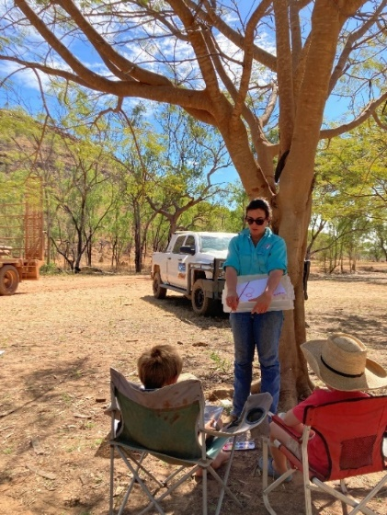  Image Caption: Kylie Jones, Founding Director, with children participating in RAISEducation programs

Building the ECEC workforce in regional Australia
In conversations with and representations to the Commissioner over the last two years, people in the regions continue to highlight the significant challenge of attracting and retaining qualified ECEC staff in regional, and particularly remote, communities. This shortage has a notable effect on the broader regional workforce, as a lack of childcare options leaves parents unable to join or return to work or further education and training.
In some cases, addressing workforce shortages may include attracting qualified locals back to the profession. A study into childcare in the Maranoa and Western Downs regions of Queensland found there are nearly twice as many people with relevant childcare qualifications as there are employed in the childcare industry in these regions, with pay and work conditions cited as core reasons qualified ECEC educators were leaving the profession.
Commissioner’s Note
The promotion of careers and pathways into the ECEC profession to secondary students and prospective mid-career entrants should be supported as a way to bolster the regional ECEC workforce.

School Education
There are 1.1 million students enrolled in regional schools – over a quarter of all school students in Australia. Although no two regional schools are alike, ranging from one teacher schools, distance education classrooms, boarding schools and regional schools with large enrolments, parent and community groups, local councils, schools and educators have emphasised similar challenges across regional areas in their conversations with the Commissioner.
Regional students face more challenges to access education and achieve educational milestones than their metropolitan peers. School workforce shortages, access to school, and student support continue to be pressing issues for regional communities that are further exacerbated in remote areas of Australia. However, examples of good practice set out in this chapter show the positive outcomes that schools and teachers generate for their students and communities through locally led programs.
Local schools have a very important role in creating and sustaining community in regional areas. Similar to the role of universities discussed in the upcoming higher education chapter, schools act as an anchor point for regions and have a significant influence on outcomes for students and the wider community.

Hearing from stakeholders
Throughout the year, consulting with regional schools and parent and community organisations, the Commissioner has seen and heard about tailored, community-based solutions for school and support services (see Appendix A for a list of stakeholders). Some of these initiatives are described in this chapter. They demonstrate the best of living in regional Australia: committed people and organisations dedicated to ensuring their students can access the best opportunities while enjoying the advantages of belonging to a close-knit regional community.
The Commissioner heard from people, organisations and communities across the country about the successes and challenges of schooling in regional Australia. This chapter discusses their concerns and experiences, which form the basis of her submissions to several reviews in 2023.
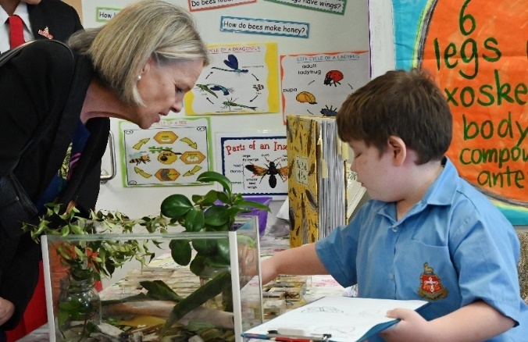
Image Caption: Visit to Rockhampton Grammar School, 17 May 2023

Submissions, reviews and representations
As a member of the National School Reform Agreement Ministerial Reference Group and through a submission to the Expert Panel, the Commissioner contributed significantly to the Review to Inform a Better and Fairer Education System this year. Her August 2023 submission recommended establishment of a Distance Education Teaching Allowance (DETA) to support geographically isolated students, exploration of options for First Nations students to board on Country, fully subsidised mental health support for all remote students and a national advertising campaign focussing on drawing existing teachers to the regions.
The Commissioner also made a submission to the Northern Territory Review of Secondary Education encouraging consideration of how First Nations ‘assistant teachers’ could be elevated to ‘partner teachers’ (Issue for Consideration 19).
In May, the Commissioner made a submission to the Teacher Education Expert Panel, established to reform initial teacher education (ITE). The Commissioner proposed increasing the number of First Nations teachers and support workers to ensure culturally appropriate education. She also proposed increasing funding for regional universities providing ITE courses that have high rates of graduate regional employment, and teaching apprenticeships to support new regional teachers.

Snapshot of the regional school sector
The gap in outcomes between metropolitan and regional students evident in participation and attainment rates and NAPLAN results, is reflected in 2023 NAPLAN data, and continues over a school student’s educational lifetime.
In the 2023 NAPLAN results, for example, 54.2% of Very Remote Year 3 students need additional support in numeracy compared to 8.2% of Year 3 students in Major Cities. In Year 7, the proportion of Very Remote students needing additional support was 58.8% compared to 7.2% of students in Major Cities. Across all tests and all measured year groups, there is a significant disparity between students in remote and very remote areas, in comparison to students in major cities.
While estimated Year 12 certification rates are increasing across Australia, the gap between metropolitan and regional students remains the same. Similarly, school attendance rates for all students in Years 1-10 are generally in decline but regional and remote attendance rates remain below those in metropolitan areas – 63.1% in Very Remote communities compared to 87.5% in Major Cities. School participation and attainment for regional students is affected by barriers to access including financial costs, health issues (including mental health), career aspiration, and engagement with teachers and the curriculum.

Improving access to education
In regional Australia, distance and lack of services and infrastructure are barriers to accessing quality education and adequate health services. When local schools are not an option, families in remote locations rely on distance education or boarding schools. The Commissioner’s 2022 Annual Report identified high financial costs as a barrier to accessing education in remote areas. For students undertaking distance education, parents and carers must sacrifice time and income to supervise their children’s leaning or hire a tutor. A DETA, as proposed in several of the Commissioner’s submissions this year as well as an Issue for Consideration in 2022 and 2023, could help ease the additional financial burden on families of geographically isolated students.
Issue for Consideration 5
Establish a Distance Education Teaching Allowance (DETA) to support Home Tutors educating geographically isolated students via distance education where there are no alternatives.

Online learning
Online learning is a valuable tool for extending the reach of education into regional areas – particularly in very remote areas.
Online learning is a well-established teaching method in distance education but is now used more broadly to allow students to study secondary subjects and take up educational opportunities that they would otherwise have been unable to access.
Case Study: Aurora College Opportunity class (Virtual Delivery)
Aurora College is a virtual selective school for regional students in NSW from Years 5-12. Students enrolled in a local regional NSW state school can access the Aurora selective streams in mathematics, science, English and technology through a virtual learning environment.
Virtual delivery allows students to study subjects not available at their local schools, without having to leave their community.
The school has developed the Young and Deadly Mob initiative to identify high-achieving First Nations students to study virtually at Aurora College while staying connected to Country.
A reliable internet connection is needed to access a high-quality online education. Current initiatives include the federal government’s School Student Broadband Initiative, in collaboration with NBN, to provide up to 30,000 families who have no internet at home with free NBN until the end of 2024.
The Commissioner is investigating internet access for tertiary students as part of a research project expected to be finalised in 2024; although focused on tertiary education, the recommendations from this report will address barriers and inform improvements that can be made to regional students’ internet access across all education sectors.

Studying away from home
Boarding school is often the only alternative for students living in regional or remote areas without a physical school nearby. More than three quarters of Australia’s boarding school students are from regional areas and around 20% are First Nations students boarding off country.
‘Most boarders are from regional communities where they don’t have the option to continue high school in their local area. Boarding school is not a choice but a necessity for these families and comes at a considerable expense.’
Richard Stokes, Chief Executive Officer, Australian Boarding Schools Association (ABSA)
There are significant costs for regional families to send their children to boarding school which could be eased by extending financial support.
The Commonwealth Regional Scholarship is a pilot program that will provide scholarships to students from regional communities to assist with boarding school fees and associated costs. The program area of the department sought the Commissioner’s feedback on the Administrative Guidelines, adopting improvements she suggested, including broadening eligibility to include students whose locally available school could not meet their aspirations (for example in access to elective subjects); financial need assessments to take into account change in circumstances to address fluctuating incomes; options for applicants to provide a reference from a community organisation with their applications; allowing scholarship funds to be directed to other educational costs that would support the student (such as a laptop) in addition to boarding fees; and not limiting the number of scholarships per family.
The pilot program will provide funding for up to 50 low-income families of $20,000 per student per year, and another 50 low to mid-income families to be funded $10,000. If the evaluation of the pilot program shows that the program has been successful in assisting regional families, the Commissioner would support expanding the program to assist a greater number of regional boarders, whose families are experiencing financial hardship, to access these educational opportunities.
The Assistance for Isolated Children (AIC) Basic Boarding Allowance provides financial support to families to assist with boarding school expenses. This allowance was set up in 1973 to cover half of the average boarding school fees to assist geographically isolated students to access boarding schools. However, over time, the allowance has not kept pace with increasing boarding school fees. Approximately 4000 geographically isolated students across Australia receive the Basic Boarding Allowance, receiving $9,396 in basic allowance (or cost of boarding, whichever is lower) per year. According to a survey of a cross section of Isolated Children’s Parents’ Association (ICPA) members, 75% of geographically isolated respondents spend over $5000 per term in out-of-pocket costs which the allowance does not cover.
The ICPA has advocated for a $4000 increase to the Boarding Allowance to cover the additional costs families currently bear, and to cover at least 55% of average boarding fees. The Commissioner supports the proposal to increase the allowance, acknowledging that accessing boarding school is an essential part of many geographically isolated students’ education, and the burden boarding school fees place on their families.
Issue for Consideration 6
Increase the Assistance for Isolated Children (AIC) Basic Boarding Allowance to ease financial pressures caused by increased boarding fees for geographically isolated students and their families.
Fringe Benefits Tax arrangements are also contributing to the financial burden of boarding school expenses on regional families. For boarding schools located outside remote areas, the accommodation where essential supervisory boarding staff reside onsite to care for children is treated as a fringe benefit. The Australian Boarding Schools Association and ICPA have noted that the cost is being passed on to regional families through increased school fees. Boarding schools in remote areas (defined as not ‘in or near an urban centre’) are exempt from this tax, however the exemption should be extended to boarding schools in or near urban areas due to the impact on boarders’ families, the majority of which are from regional communities.
Regional employers who provide financial contributions towards the boarding expenses of staff members’ children are also levied with a Fringe Benefits Tax on those contributions. This acts as a deterrent to employers assisting employees and may require regional families to leave employment and relocate to metropolitan areas if they cannot afford boarding expenses and have no other options for educating their children.
Issue for Consideration 7
To limit unintended financial consequences for regional families and employers, consider exemptions to the Fringe Benefits Tax for:
- essential supervisory employees’ on-site boarding school accommodation
- employer contributions to employees’ boarding school expenses.

Improving access to students’ health services
For regional students to make the most of their education they need access to appropriate physical and mental health services. Across this year, people in the regions have told the Commissioner that there are too few services available in regional areas to support the health of students.
Limited access to paediatric psychology services means the burden of mental health support often falls to teachers in addition to their teaching and pastoral workloads. Existing government programs such as the Federal BeYou Program and the Victorian Mental Health in Primary Schools program can address some of these barriers to accessing mental health support services.
Royal Far West’s Telecare for Kids program is an example of how technology can extend the reach of health services into under-resourced regional communities, and the positive effects that these accessible mental and physical health services bring to young students.
As outlined in the ECEC chapter and Issue for Consideration 1, there is significant improvement in children’s long‐term health and developmental outcomes when there are resources available to support them with services like health checks and therapy sessions. Twenty-two percent of all Australian children are identified as developmentally vulnerable in one or more domains which predict a child’s outcomes in health, wellbeing and academic success. For First Nations children, it is 42.3%. Programs such as Royal Far West’s Paediatric Developmental Program, which provides a week-long in person developmental assessment followed by ongoing remote care for children under 12, have a positive effect on learning outcomes, participation rates, and Year 12 attainment.
Case Study: Royal Far West Telecare for Kids
Royal Far West’s Telecare for Kids program provides physical and mental health services to more than 1200 children aged 3-12 in 110 regional schools and communities in New South Wales and Queensland. The service offers screening, assessment and therapy services for children to ensure early intervention, access to psychology, speech pathology and occupational therapy services and effective support. Families, schools, and health professionals can refer children to the Telecare program. Based in Manly, Sydney, Royal Far West specialists conduct the sessions through online video consultations with the child at home, school, or health clinic. This year, the Commissioner attended Narromine Public School to acknowledge and celebrate Royal Far West’s eight-year partnership with the school.
In the wake of the devastating flooding across New South Wales’ Northern Rivers and Southeast Queensland communities in 2022, Royal Far West clinicians are working in thirty schools and pre-schools as a part of the Federal Government’s Community Recovery Program to support children as they grapple with the psychological impacts of being displaced, witnessing destruction of their homes and communities, and seeing their parents and caregivers in distress.

Increasing participation and attainment
Students need to feel engaged with school and to understand the role education plays in helping to shape their futures. If students think that the only purpose of school is as a pathway to higher education, and they do not imagine higher education as part of their future, they may disengage from learning. Students need access to information about options and role models to aspire to a range of career pathways and understand how they might apply their interests and skills. Aspiration needs to be supported with accurate, accessible information about how to achieve goals, and relevant curriculum, including access to a broad range of secondary subjects and educators skilled in teaching them.
The estimated percentage of remote and very remote students awarded a Year 12 certificate has increased from 51% in 2009 to 63% in 2021. While the improvement is positive, there is still a pronounced gap between these remote and very remote outcomes and the rates in major cities, where the Year 12 certification rate is 82%. A research project overseen by the Commissioner is currently examining good practice methods for retaining students in regional, rural and remote areas to Year 12, and to identify key retention factors that may include physical barriers, subject availability, curriculum relevance and available careers advice. It will deliver its final report in December 2023.

Access to secondary subjects
A common observation from people in the regions is that the variety of secondary subjects offered in regional schools is markedly lower than in metropolitan schools.
This has been a persistent issue. Low enrolments, small class sizes, teachers having to teach out of field, and poor access to specialist teachers and facilities needed for particular subjects was a concern noted in many submissions to the Halsey review in 2018.
While these issues remain current, many regional schools are finding creative ways to share teaching resources and expertise and extend access to subjects and facilities to more students.
Case Study: The Eyre Peninsula Local Delivery Program (Cluster Model)
The Eyre Peninsula Local Delivery Program is a senior studies access program developed by secondary schools across South Australia’s Eyre Peninsula allowing students to virtually access subjects not available at their local school. Local Delivery students enrol at their home school for the subjects available locally and enrol in linked schools to access subjects virtually that their local school cannot provide. Students are mentored by a teacher from the Local Delivery site with regular contact and tutorial support.
The Program provides flexibility to allow for different student pathways, offering South Australian Certificate of Education (SACE) subjects, VET subjects and School-based Apprenticeships.
The Program also allows First Nations students to participate in the South Australian Aboriginal Secondary Training Academy (SAASTA). This program provides Year 10, 11 and 12 First Nations students to study the SACE with a novel sporting and cultural curriculum.
Partnership models between metropolitan schools and regional schools produce two-way benefits for students and staff at both schools. Well-resourced metropolitan schools can provide access to specialist staff, subjects, and facilities, for example delivering secondary subjects virtually to regional schools or seconding staff with subject expertise. Regional schools can share their regional cultural experience with metropolitan staff and students through school visits, exchanges, and professional development programs.
Case Study: City-Country Partnership Program (Partnership Model)
The City-Country Partnerships Program (CCP) was established as part of the Australian Government’s first Implementation Plan under the National Agreement on Closing the Gap. Facilitated by the Yadha Muru Foundation, the program establishes partnerships between high-performing government and independent metropolitan schools and remote government schools with a high proportion of First Nations students.
The program is co-designed to improve outcomes and attendance for First Nations students, and to accelerate progress towards meeting Target 5 of the Closing the Gap Agreement, for 96% of First Nations 20–24-year-olds to attain a Year 12 qualification or equivalent by 2031.
The expanding network of Regional University Study Hubs could also provide learning space for secondary students. Where schools do not have the facilities for some specialist subjects, Hubs could help fill this gap. Implementation would require careful planning and cooperation between jurisdictions and sectors but could have considerable benefits.

Issue for Consideration 4
Increase regional students’ access to a greater variety of secondary school subjects through in person and distance education measures such as:
- offering subsidised courses to regional teachers to undertake upskilling in specialist areas
- establishing a program to support schools entering into ‘cluster’ arrangements to share teaching and curriculum resources
- expanding funding to partnership programs linking metropolitan schools and regional schools to share resources, for example the City-Country Partnership Program
- supporting programs that provide students with opportunities to undertake specialist subjects at another school
- expanding the services of Regional University Study Hubs to include support services for secondary students, including enabling distance learning or opportunities to access specialist subjects.

Making curriculum content relevant to regional students
In consultation with parents, community groups and teachers over 2023, the Commissioner has heard that current standardised approaches to curriculum and testing can disadvantage regional students, in part by not acknowledging their unique lived experiences. Recent research by UNSW academics supports these claims, finding that adapting educational materials including textbooks, slides, and multi-media content to students’ cultural context will noticeably improve educational outcomes. Improving the diversity of examples in publicly available resources and standardised tests such as the NAPLAN would allow regional students to apply their knowledge to familiar environments without requiring teachers to tailor their lessons.
‘Research shows cultural context has an impact on student achievement in standardised tests such as NAPLAN. This is because familiarity with the examples used in questions clouds a student’s ability to demonstrate the skill being tested. For example, having to write about a beach when you have never been to one.’
Dr Phillip Roberts, Associate Professor in Curriculum Inquiry and Rural Education, University of Canberra

Case Study: Innovation and entrepreneurship: BOP Industries and Red Dirt Robotics
As the workforce becomes increasingly reliant on technology, students will require innovative problem solving and entrepreneurial skills as they transition from school to further education and careers. BOP Industries and Red Dirt Robotics travel to schools in regional Australia to deliver innovative programs to give students the opportunity to engage with the latest technology and pitch their own original design ideas which align with school curriculum in STEM subjects.
First Nations students living in the regions need relevant curriculum content. Curriculum content designed to be culturally relevant for First Nations students living in regional Australia would provide a more engaging and relevant school experience. Opened in 2021 in the Gunyangara community of East Arnhem Land, the Dhupuma Barker is an independent school which offers bilingual education for 35 Yolngu students from Kindergarten to Year 6. The curriculum combines Australian curriculum with traditional Yolngu teachings and builds students English language skills in conjunction with Yolngu Matha (language), Rom (law) and Galtha (ways of learning).
Commissioner’s Note
The lives and experiences of regional students are different from metropolitan students. All children benefit if they see themselves, their cultures, experiences and future reflected in their learning resources.

Early, informed careers advice and support
Student options are shaped well in advance of their final school years. Career information and inspiration, beginning in primary school, will help equip children to imagine and begin to create the futures they want for themselves. Geographically isolated children do not have proximity to the range of tertiary providers or visibility of the variety of industries that metropolitan students do. Role models who have already travelled pathways between school and post-school, and supportive, informed networks to help students and their primary influencers navigate these pathways, are needed to help regional students realise their aspirations and ambitions.
Careers advice should equip students, their parents and other influencers to understand the effects of their choices at different decision points on their options to pursue vocational education and training and higher education. All students should have sufficient advice to make informed decisions. While streaming students within secondary schools into ATAR and non-ATAR/VET pathways may encourage students to pursue further education aligned to their skills and interests, early or uninformed streaming can unnecessarily limit or misdirect a student’s choices.
Careers advisers need to be aware of all post-school pathways available. The WA Career Practitioner program is a good practice example recognising the importance of training careers advisors and providing them with a dedicated role in a school or available to a school. Under this initiative, 70 career practitioners completed a 12-month qualification in career development before commencing placements in schools across WA. The program identifies that careers advice is a specialised field separate from teaching, that requires dedicated and qualified staff resources.

Issue for Consideration 17
Noting the importance of timely and relevant careers advice to students and its pivotal role in building aspiration and improving attainment rates:
- undertake a national audit to investigate the accessibility, effectiveness and quality of current careers advice delivery to primary and secondary school students, including identifying good practices
- consider how local councils, Regional University Study Hubs and other community organisations can implement strategies to improve the timeliness, accessibility and quality of careers advice.
There are a range of community-led strategies that could help to build aspiration through improved delivery of careers advice. Local careers fairs or expos, in partnership with councils and business and industry, could help to build regional people’s aspirations. Expanding on the traditional careers fair, targeted funding would allow local government to organise businesses, VET and higher education providers, schools, and community organisations to showcase what they do, and what skills industries are looking for. These events would allow primary and secondary school students to see how their subject choices translate into careers and could potentially match school students with businesses where they are interested in work placements. They could also help community members looking to change careers or re-enter the workforce to explore further education options and engage with local employers and training organisations.
To expand access to career resources beyond education providers, the Commissioner would support the development of career information resource packs to be made available to students and community members via local councils, libraries, or community organisations. Expanding the services offered by Regional University Study Hubs to include careers advice and information could also help reach more students in regional communities.
Once students have made an informed choice as to what and where they want to study, they need adequate information about the support available to them. In 2023, the National Careers Institute sought the Commissioner’s advice when updating the regional, rural, and remote school leavers information kit. The Commissioner recommended that the school leavers guide include more information on available scholarships and mental health and wellbeing support programs for regional school leavers as well as specific references to Independent Youth Allowance for rural and remote students.
Completion of high school and continuation to tertiary education is significantly influenced by the presence of supportive school and community networks. Support networks that connect students with mentors who can speak of their experiences in tertiary education and provide families with information to nurture student aspiration will assist regional students’ transitions to tertiary education. The NSW Government’s Regional School Alumni Events Program is an example of an effective program for delivering alumni events such as speed networking and information sessions in regional schools.
Students can’t aspire to be what they can’t see. Choices, whether informed or not, and availability of subjects, will dictate whether a student can pursue particular tertiary education and careers, particularly in STEM subjects. The CSIRO Young Indigenous Women program recognises this issue by providing support for students from Year 8.
Case Study: CSIRO Young Indigenous Women’s STEM Academy
The CSIRO’s Young Indigenous Women’s STEM Academy supports young Indigenous women by promoting access to STEM careers through a range of tailored opportunities. Run across target regions in Australia, the Academy is a national place-based program for students in Years 8-12, with a residential camp featuring STEM activities and online assemblies where students can meet others through virtual learning. Participants are given a ‘Personal Success Plan’ and schools have monthly wellbeing visits. Students are mentored by a dedicated CSIRO academic coordinator and the program is designed with communities to ensure that First Nations knowledge, technologies and processes are integral.
The academy uses existing STEM and Commonwealth assistance to support students to completion of a degree.
Once students are in Year 12, they can transition to the CareerTrackers Indigenous Internship Program, which links Year 12 and university students to employers to undertake 12-week paid internships throughout their degree.

Attracting and supporting our regional teaching workforce
One third of Australia’s teacher workforce works in regional schools, facing high reported workload, stress and out-of-field teaching as well as challenges in attraction and retention. Attrition levels (the rates at which teachers leave the profession) are also higher for regional schools compared to metropolitan schools. In a survey by the Australian Institute for Teaching and School Leadership in 2020, regional or remote teachers who indicated that they intended to leave the profession within 10 years cited ‘workload and coping’ as the most common reason. Teachers in remote and very remote areas are also 10% more likely to work more than 50 hours a week compared to other areas, in part due to workforce shortages.
Local training opportunities can allow regional communities to build a ‘homegrown’ teaching workforce. To address workforce shortages, in addition to attracting more teachers to the regions, there needs to be an increase in local training options to allow future teachers to study and qualify in-region and experienced teachers to undertake professional development to progress their careers. Some states currently offer regional pathway programs for teachers, including the Rural and Remote Teacher Experience program in Queensland, Victoria’s Teach Rural pilot in 2022-23 and Country Education Partnership’s Teach Rural Program.
Another proposed solution is the creation of a Teacher Aide gap year program to enable exiting year 12 students to work as Teacher Aides during a gap year before undertaking further education. Under this proposal, Participating Year 12 school leavers would take a gap year to work as a Teacher Aide in a regional school before commencing their tertiary education. Consideration should be given to HECS relief and VET FEE-HELP, and recognition of prior learning for those who complete the program. This would benefit both regional students and regional schools.
Issue for Consideration 8
Create a Year 12 school leavers Teacher Aide program to assist regional schools facing a teacher shortage.
To improve retention of early career teachers, the Commissioner recommended in submissions to the Review to Inform a Better and Fairer Education System and ITE Expert Panel that teacher training include more region-specific training and placements, to help manage expectations and provide guidance to early-career teachers about working in regional areas. Pre-service placements in regional areas prepare early career teachers for multi-age classrooms, isolation and appreciating the different experiences of their students. In her submission to the ITE Expert Panel, the Commissioner recommended provision of financial support to assist with travel and other costs associated with regional placements – an idea ultimately recommended in the ITE Panel’s final report.
There are several state programs that provide financial incentives for metropolitan teachers to relocate to regional areas, including one-off or regular payments in addition to salary, and relocation allowances. However, financial incentives alone will not improve retention of the existing workforce and attract new teachers or those who have left to study and not yet returned. In her submission to the Review to Inform a Better and Fairer Education System, the Commissioner recommended a national advertising campaign highlighting the benefits of regional life and teaching in the regions. A state-level example is Western Australia’s Teach in WA campaign.
The Commissioner also highlights the need for accessible professional development opportunities for teachers in the regions, including facilitating in-person workshops in communities. Regional teachers have reported difficulty accessing and participating in professional development opportunities due to cost of travel and accommodation, the cost of bringing a specialist in-school, and availability of casual and relief teachers, which are in short supply in regional areas. Less than a quarter of regional teachers surveyed by the Australian Institute for Teaching and School Leadership (AITSL) in 2021-2022 described being able to access relevant or appropriate professional learning.
Issue for Consideration 18
Encourage educators to remain in, or relocate to, regional areas by offering local, accessible and subsidised professional development opportunities.
As observed in the Commissioner’s Review to Inform a Better and Fairer Education System submission, professional development and career progression opportunities increase retention and create strong school leadership. Providing local teachers with the opportunity to upskill in subjects with workforce shortages will help improve local access to secondary subjects and will reduce the workload stress associated with teaching out-of-field.
Case Study: Teach for Australia Future Leaders Program (FLP)
Teach for Australia’s Future Leaders program is a year-long professional development program designed for educators in regional, rural, and remote areas to build on their strengths and develop crucial skills to help them, their students, and schools to thrive. Approximately 170 future leaders have participated in the program over three years.
Figure 3: Cohort Participation Data
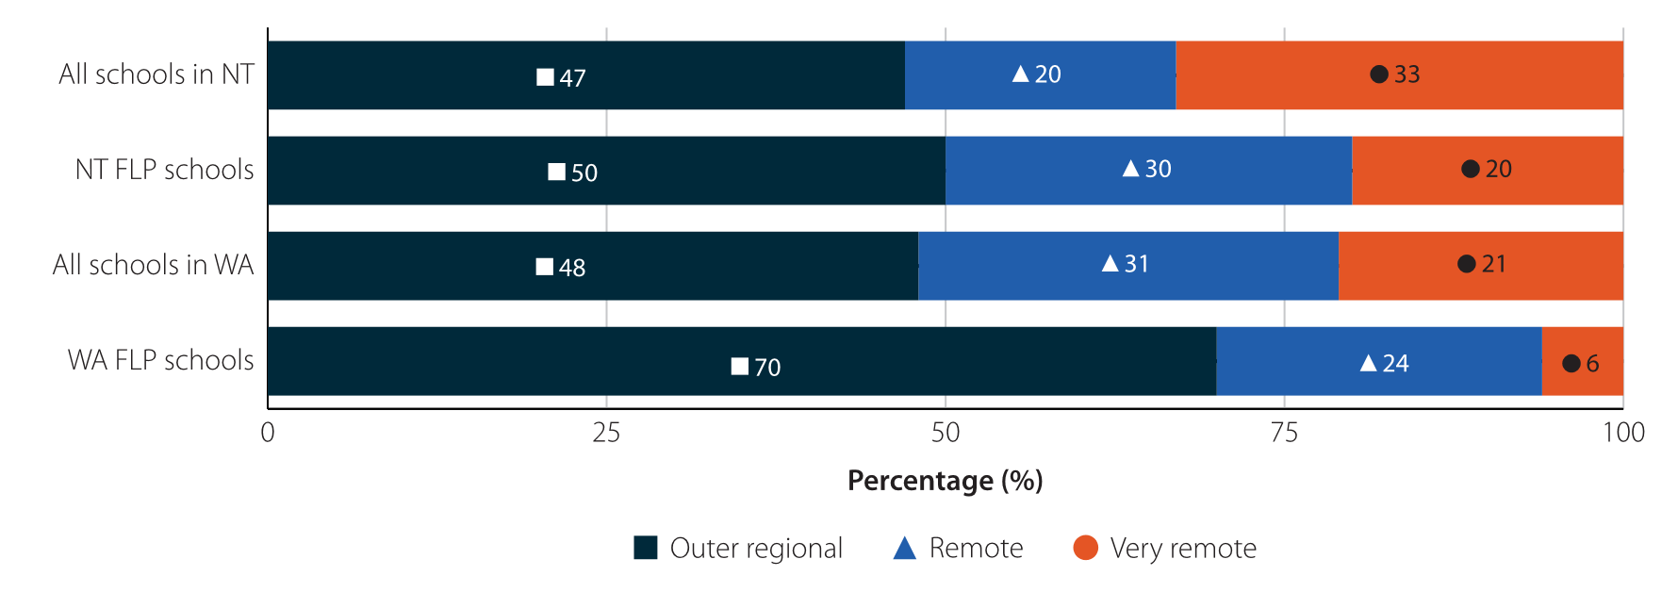
Source: FLP Cohort 1 participation data, Evaluation of the Future Leaders Program: Initial Report, 26.
Nearly 40% of the first cohort of students have been promoted to a position of leadership since starting the program, and 94% of the participants are still working in regional schools. Programs such as the FLP equip regional teachers with the skills to develop professionally, manage their workloads and advance in their careers without having to leave their community – building a ‘homegrown’ workforce of future school leaders.

Spotlight - First Nations teachers in remote communities
Increasing the number of First Nations school teachers would have a positive impact on student aspiration, participation, and retention in remote areas. Only 2% of the teaching workforce are First Nations teachers, compared to 6% of students. A diverse workforce can lift student achievement for all students, as educators are role models and ‘cultural bridges’ in the classroom. Increasing the proportion of First Nations teachers would help address teacher shortages in remote and very remote areas and improve diversity in teaching while also having a positive influence on teachers, students, and their communities.
First Nations teachers share the unique experiences of First Nations students, and nurture and certify their cultural knowledge. First Nations knowledge is essential for developing culturally relevant and bilingual curricula. In the Northern Territory and Western Australia, assistant teachers from First Nations communities work alongside teachers and support students’ learning.
‘There are profound benefits to recognising the contribution that assistant teachers make to educating children in their communities and acting as valuable role models. Raising their status would acknowledge both cultural expertise and bring economic benefit to their community.’
Mark Grant, Chief Executive Officer, Australian Institute for Teaching and School Leadership (AITSL)
In her NT Review and Review to Inform a Better and Fairer Education System submissions, the Commissioner proposed considering how First Nations assistant teachers could be elevated to ‘partner teachers’ in recognition of their unique skills and cultural knowledge.
Issue for Consideration 19
Elevate First Nations ’assistant teachers’ to ’partner teachers’ in recognition of their unique skills and cultural knowledge.
To qualify as teachers, assistant teachers currently need to study an undergraduate degree followed by Initial Teacher Education (ITE). Prior to graduating ITE, students must sit the Literacy and Numeracy Test for Initial Teacher Education (LANTITE) to demonstrate that they have been assessed in the top 30% of the adult population for personal literacy and numeracy. This test, which is only required for students undertaking an Australian-based ITE course, may act as a barrier for First Nations assistant teachers or aspiring teachers from polylingual backgrounds from enrolling in teaching degrees. Other common barriers for remote students pursuing teaching qualifications include financial costs, difficulty relocating for study and accessing internet.
The National Teacher Workforce Action Plan (NTWAP) recommendations provide opportunities for implementing this proposal.

Recognition of prior learning
An option being explored by stakeholders is to give recognition of prior learning (RPL) for cultural language skills and expertise in lieu of the language component of LANTITE and potentially some parts of a teaching qualification.
RPL has been foreshadowed in Action 11 of the NTWAP, which acknowledges that LANTITE should not be a barrier to First Nations teachers. More specifically, under Action 9, the Australian Council of Deans of Education (ACDE) will develop a framework that includes measures to ensure the skills, expertise and prior learning of First Nations peoples, mid-career professionals and paraprofessionals are recognised credit towards their teacher qualification, while maintaining robust qualification requirements. The proposal outlined in Issue for Consideration 19 could be considered as part of the co-designed national First Nations teachers’ strategy the Government is developing in close partnership with First Nations education organisations under Action 10 of the NTWAP, and the recognition of the value of First Nations (and regional) teachers under Action 23.

A new qualification
An alternative to using RPL would be to create a new classification of ‘community teacher’ or ‘partner teacher’ which requires different study and language prerequisites from standard teaching qualifications in recognition of the unique cultural expertise of First Nations assistant teachers. This new category would attract salary conditions equivalent to a teacher, but its implementation could be limited to on Country schools to reflect the expertise of the teaching practitioner.

Benefits for remote communities
Elevating First Nations assistant teachers to partner teachers would have significant positive impacts. First, for the assistant teachers themselves, who are overwhelmingly women and often Elders in their communities, it would recognise cultural expertise and significant value in the classroom. As role models, lifting their status would support aspiration for community members.
In addition, this proposal is a long-term investment in the community. The additional income from higher salaries would lead to economic growth in their communities. These teachers would usually remain in communities long-term, creating a stable and knowledgeable local workforce, rather than communities needing to rely on regular turnover of placed teachers from cities. Although the proposal is currently directed to the school sector, it could be extended to early childhood education as well, to provide early cultural support for young First Nations children.
The higher education sector should work closely with First Nations communities to design culturally appropriate teaching qualifications and options for delivering education on Country. Access issues for First Nations teachers can be addressed through improving access to teaching courses and better targeting of support for First Nations people while they study. ITE should provide appropriate financial, academic and culturally appropriate pastoral support as the Commissioner proposed in her submissions to the Review to Inform a Better and Fairer Education System and Teacher Expert Panel.

Vocational Education and Training (VET)
With 9 of every 10 future jobs expected to require post-school qualifications, VET has a central role to play in meeting Australia’s workforce needs. This is particularly important in regional Australia where people are generally more likely than to have a VET qualification than in cities. VET’s strength in regional and remote Australia comes from its direct and practical nature, and close links with local businesses and industries – courses provide tangible career pathways.

Hearing from stakeholders
The Commissioner has engaged widely with the VET sector this year, including visits to and meetings with Registered Training Organisations (RTOs), dual sector university campuses and Regional University Study Hubs. In these discussions, stakeholders have highlighted a range of unique challenges that reflect the diversity of regional Australia.
Access to courses and work placements, lack of resources and teaching workforce shortages continue to place strain on both students and providers. However, there is also a sense of pride about VET in regional Australia, and an optimism that with the right settings in place, there is real opportunity to develop a strong regional workforce for the jobs of the future.

Submissions, reviews and representations

Jobs and Skills Australia
In 2023 the Commissioner engaged with Jobs and Skills Australia (JSA) on regional and remote workforce and skills issues. JSA is a statutory body providing independent advice on current, emerging, and future workforce, skills and training needs. In January, JSA released a discussion paper on their proposed future structure, governance, and approach to engagement as a permanent body.
The Commissioner responded to this discussion paper, and the JSA Director, Professor Peter Dawkins, invited her to discuss the provision of VET in regional Australia. The Commissioner’s submission referred to barriers including geographical isolation and reduced access to resources, the importance of flexibility and a local perspective, and the need to support foundational skills in the regions more broadly. A key recommendation was to establish a regional, rural and remote team within Jobs and Skills Australia to understand the unique labour market and skills supply issues outside of Australia’s capital cities. A regional workforce team has been established, which will ensure a consistent regional lens across the work of JSA.

The Australian Universities Accord
This year, the Commissioner had a central role in education reform as a panel member of the Australian Universities Accord. While the Accord is principally focussed on higher education, the Panel has considered the tertiary sector as a whole. A recurring theme, and a focus of the Commissioner, has been the desire for a more integrated post-secondary education system. The Accord Interim Report has highlighted the benefits that a strong VET sector aligned and better integrated with higher education could bring for students, employers and the Australian economy as a whole.
‘Australia’s skills needs will only be met if the higher education system and an expanded VET system, with TAFE at its core, work together within a more integrated system to deliver the flexible, transferable skills people want and need.’
Australian Universities Accord Interim Report

VET aspiration and access in the regions
VET is a broad and diverse sector made up of over 4,000 RTOs. These range from government-funded TAFEs, dual sector universities, and private skills providers – with students from regional and remote areas increasingly likely to access VET through a private RTO. Regional RTOs offer a wide range of delivery modes, such as on-campus, in-school, at the workplace, mixed mode and online, that provide students with flexibility in their study choices. This flexibility of access, alongside connections to local industry, is an important factor in VET’s uptake in the regions.

Aspiration and career pathways
Location should not be a barrier to aspiration. Regional students should have the opportunities and support to make informed education and career decisions. However, isolation and a lack of reliable connectivity and facilities can often mean regional, and particularly remote, students do not have access to the information and support they need.
VET and higher education should be viewed equally as tertiary education options. In regional areas VET is a preferred pathway for many students that more closely aligns to their career goals. The complementary nature of VET and higher education should be emphasised and pursued. VET and higher education are not in competition; further development of collaboration opportunities, shared infrastructure, and pathways between should be the goal of both sectors, regulators and governments.
Issue for Consideration 9
Recognising that VET and Higher Education offer parallel pathways to success, support informed student choice and aspiration by resourcing schools to provide properly targeted, expert careers advice.
Relevant, timely career guidance is central to helping regional students and their informal advice networks (which may include family, friends, peers, teachers, and other mentors) understand the options available to them, including tertiary education. Students need to see and understand the variety of pathways and opportunities available to them to make informed choices.
VET delivered as part of the high school curriculum can be a valuable link between a student’s secondary schooling and further education, training and/or employment. Expanding regional students’ outlooks and providing evidence of tangible training pathways can help raise career aspirations and expectations for school leavers and those already in the workforce.

Access
While VET tends to be more accessible for regional students than higher education, it is affected by many of the barriers associated with education in regional Australia, including distance, cost of delivery, and access to teaching staff, which have real effects on students, the quality of their education, and their ability to access it in the first place.
VET students from regional and remote areas made up 34% of all program enrolments in 2020, while accounting for 28% of Australia’s population. While overall enrolment numbers are fewer than in major cities, regional and remote attainment rates up to and including Certificate III often surpass those in metropolitan locations.

Geographic barriers
Engagement with local VET study increases with remoteness. This reflects the value of community for regional Australians, with many students preferring, or needing, to remain close to family and other local support during their training rather than relocating. However, the geography and sparser population of regional and remote Australia can also be a barrier to accessing a broader range of skills training options. While there is a higher reliance on VET in the regions, there are fewer training providers overall. This results in greater reliance on a smaller number of RTOs and courses.
In discussion with the Commissioner, many people have described the difficult reality of operating in thin markets in regional Australia, with distance and lower student numbers often making economies of scale unrealistic. These factors are compounded by the cost of providing the high-quality infrastructure and equipment that are vital resources for skills training. There are instances of development of cutting-edge teaching infrastructure in regional hubs, but this level of delivery is not possible everywhere. This means students must either compromise on less-preferred local study options or relocate, or undergo significant and costly commutes, in order to access their preferred course.
Cross-sector collaboration within regions could provide a local solution to some of the barriers facing VET in regional and remote Australia. While not currently widespread, this approach could have significant benefits for economies of scale. Central Regional TAFE (WA) representatives identified that their Geraldton campus draws on students from the multiple nearby schools (including Independent, Catholic and Government schools) to make up class sizes. Longreach State High School (a school-based RTO in Queensland) has started a cluster model called ‘VET in the West’ which enables students in smaller surrounding schools to participate in VET in secondary schools (VETDSS) programs comprising of a number of Certificate I and II courses.

Online delivery
Online delivery has increasingly become a necessary and efficient way to reach a wide range of students who may not otherwise have access to their preferred program locally. Having developed rapidly since the COVID-19 pandemic, online classes and courses offer a potential solution to some of the barriers affecting VET in our regions – however issues remain.
Underpinning all discussions of online learning is the requirement for reliable internet access in regional Australia. Particularly for remote and very remote students, connectivity must be reliable for effective online learning delivery. Some stakeholders have indicated that they are increasingly confident in the expansion of internet across remote Australia (particularly through satellite options like NBN SkyMuster and StarLink), but access to technology remains a significant barrier. Internet access has been an ongoing priority for the Commissioner and is currently being investigated as part of a separate research project expected to deliver in 2024.
A core benefit of vocational education is practical and hands-on work experience – something that does not immediately align with online learning. However, virtual work placements are increasingly common and allow students in remote areas to obtain work experience in situations where there are no local opportunities. There are skills that cannot be solely taught online, and most skills-training will require some hands-on practical experience. Where necessary, virtual delivery should be accompanied by face-to-face study or placement components.
Similarly, there are concerns about the quality of student learning, and potentially wellbeing, from solely undertaking courses online without the benefits of face-to-face interaction. Increasingly, VET providers are offering hybrid course structures that integrate online and place-based classes. Local support options also facilitate online learning, such as through the Regional University Study Hubs and other support programs such as the School of Isolated and Distance Education.
Case study: School of Isolated and Distance Education (SIDE)
SIDE is a Department of Education (WA) funded RTO that uses digital technology to deliver VET classes (in Certificates I and II) to Government school students in regional, rural and remote areas. The SIDE RTO began in 2019 with 50 students and has now increased to nearly 250 students, demonstrating an appetite for access to this type of VET program in the regions.

Relocation and living expenses
Where online or hybrid courses are not available in a regional area, financial support programs can assist some VET students who need to relocate to study. The Tertiary Access Payment (TAP), implemented in 2021, provides eligible students relocating to study a Certificate IV or higher qualification with a one-off payment to assist with relocation costs. However, there are several issues with the TAP eligibility criteria that may be impacting its effectiveness, which are discussed in detail in the Higher Education chapter.
The main issues for VET students are that they may be unaware that the TAP exists, or are not eligible for the payment. For example, regional apprentices who relocate to undertake their training at an Australian Apprenticeships provider (Australian Apprentices) are currently not eligible to receive the TAP. The ICPA has advocated for the TAP to be extended to regional and remote Australian Apprentices who relocate to take up an apprenticeship. These students face similar financial costs to tertiary students in relocating as part of their trade career pathway, and should receive the same support as students moving away to study at a tertiary education provider.
Commissioner’s Note
Exploring new ways to promote the TAP to VET providers and students, and extending the TAP to include regional Australian Apprentices, would increase the number of VET students accessing financial assistance to relocate for study or training.

VET Delivered to Secondary Students (VETDSS)
VETDSS provides students with the opportunity to attain a nationally recognised VET qualification as part of their schooling. Approximately 30% of students completing VET in school programs are in regional and remote areas, equivalent to 72,090 Australian students.
Last year, the Commissioner engaged a consultant to undertake research into the provision of VETDSS in regional and remote Australia. This came in response to Recommendation 4 of the Napthine Review, and its reference to the role of high quality VETDSS in providing students with a clear pathway into further education, training and/or employment. The research project examined the current state and challenges of VETDSS delivery and good practice examples, and recommended options for improving access to high quality VETDSS programs in our regions.
‘VETDSS programs work well in RRR (regional, rural and remote) areas, as there are typically stronger post-school pathways, given the links to the local economy, compared to metropolitan areas.’
Stakeholder feedback in VETDSS Report
VETDSS varies between areas: in some very remote areas, VET trainers deliver courses at the school, while in other regional areas, training is delivered through TAFE or training centre hubs. The most common delivery model is where the school delivers VET as part of a system RTO, however training may also be delivered through a school-based RTO or through another school or RTO.
VETDSS programs in regional and remote Australia face unique challenges compared to their metropolitan counterparts, and when they face similar challenges, they tend to be exacerbated in the regions. Geographic distance, access to qualified trainers, and insufficient student numbers are barriers to the provision of local, in person training. To address these challenges, VETDSS methods should make use of technology, collaboration and industry linkages to reach as many students as want to participate in VET training.
Case Study: Maritime and Fisheries Partnership Program
The Northern Territory Maritime Program was established in 2016 as an innovative partnership between four very remote schools in the East Arnhem Land region of the Northern Territory. The program equips students with the skills, knowledge and experience required for employment within the maritime industry.

VET trainers and assessors in the regions
Attracting and retaining trainers and assessors in regional Australia is challenging, particularly in remote or very remote areas. The Commissioner has heard that access to qualified educators is the most significant barrier in providing VET to regional students.
Relocating to a regional or remote town for work can be an isolating experience for those without community support, and there are often challenges that come with settling in a geographically isolated area, including reduced availability of housing and childcare. Beyond geography and isolation, attracting people to training and/or assessor roles can be notably difficult due to the often substantially lower salaries than they could attract working in an industry trade role. Stakeholders have also noted that meeting regulatory standards, including the required completion of a Certificate IV in Training and Assessment, may act as a barrier for industry professionals to move into training roles because of the associated costs and time.
Two options for increasing the regional training workforce are to attract more VET teachers to the regions and to upskill some of the local workforce to become VET teachers. Each option could be accommodated through a mix of financial incentives and professional development opportunities. For out-of-area VET teachers, assistance with relocation costs and subsidising housing and/or childcare would remove some of the barriers associated with relocation. To encourage locals to seek training qualifications, options like subsidising training costs or providing up-front incentive payments could be considered. In addition to potential financial incentives, people with the required skills should be encouraged to move to the regions or gain qualification as a VET teacher as a new avenue for professional and career development.
Issue for Consideration 18
Encourage educators to remain in, or relocate to, regional areas by offering local, accessible and subsidised professional development opportunities.

Building the regional workforce through VET
By aligning with local industries and tapping into identified skills needs, VET can play a vital role in delivering a ‘homegrown’ regional workforce and the economic prosperity that comes with it.
A recurring theme in discussions with the Commissioner is the importance of flexible and locally tailored training options in improving career outcomes, increasing workforce participation, and boosting the local economy. The varied experiences of living in diverse and distinct regional communities means that one-size-fits-all approaches to skills training simply do not work. Where possible, skills programs in the regions need to reflect the needs of the communities they serve – not only in addressing the sorts of access barriers discussed above, but also providing practical pathways to support local students moving into local workforces. Regional RTOs collaborating with regional industries, and aligning their programs with local skills needs is an important way to ensure that VET students retain a tangible connection to their local communities.
Case Study: Cert IV in Leadership & Mentoring for Pilbara First Nations Community
Established through a partnership between the Pilbara Kimberley University Centres (PKUC) and the RTO Trainwest, a pilot program has been developed to deliver the Certificate IV in Leadership & Mentoring for Pilbara First Nations Community to First Nations employees of Rio Tinto, and the broader community in the Pilbara, in a culturally relevant and locally contextualised way on Country. This involved blocks of face-to-face learning and workshops at PKUC in Karratha (together with continual individual face to face support), and the implementation of a co-facilitation model of delivery by a Trainwest facilitator and a Karratha-based First Nations leader.
The initial pilot has engaged 28 students, one of whom has recently graduated, with plans to develop further in the Pilbara and expand into the Kimberley.
Collaboration with local industry is evident in the largest and most successful VET programs. This type of collaboration benefits the community by creating a skilled ‘homegrown’ workforce relevant to local industry; and benefits students by providing a training pathway into employment, with real-world, paid experience and apprenticeships. As raised by the National Centre for Vocational Education Research (NCVER) in 2023, ‘an understanding of local skills needs, especially in regional, rural and remote Australia, cannot be gained through quantitative data alone’ – it must be supplemented with local knowledge gathered through collaboration and partnerships.
The deepening integration of VET and industry highlights an opportunity to develop the skilled regional workforce Australia needs. Much has been reported on future skills needed for a rapidly changing job market, particularly in the context of an oncoming net-zero transition. A strong, flexible, and industry-aligned VET sector, with the ability to train new workers and reskill existing ones, has a central role to play in providing a specialised workforce for emerging regional industries such as clean energy and modern agriculture.
Commissioner’s Note
When people train in the regions, they are far more likely to work in the regions. By supporting people to train locally, and linking them to local industries, we can create a strong, ‘homegrown’ workforce that will contribute to the economic growth of regional communities.

Higher Education
Higher education in regional Australia allows students to pursue highly skilled careers, drives innovation and growth in the regions, and increases workforce participation in areas currently affected by skills shortages. The Australian Universities Accord Interim Report cites a prediction that by 2050, 55% of employees will require a higher education qualification. The focus on higher education this year through the Accord has highlighted its potential for improving people’s lives. The Accord aims to improve access to and participation in higher education in Australia so students from educationally under-represented backgrounds, including regional areas, can reach their full potential. Meeting this goal will have significant flow-on effects to the workforce, industry and growth in regional Australia.

Hearing from stakeholders
Through her membership of the Accord Panel, the Commissioner’s engagement with the higher education sector and associated industries, has been broad and deep in 2023 (see Appendix A). As outlined in the preceding chapters of this report, the Commissioner heard from many industry peak bodies, employers and communities about severe workforce shortages in our regions and the long-term impact of these shortages not only on individual well-being but also on the regions and the country more broadly.
In addition to meeting virtually with representatives from 21 universities, a number of universities welcomed the Commissioner onto their regional campuses where they showcased the innovative research undertaken in regional Australia and the commitment of academic and professional staff in supporting students to succeed.
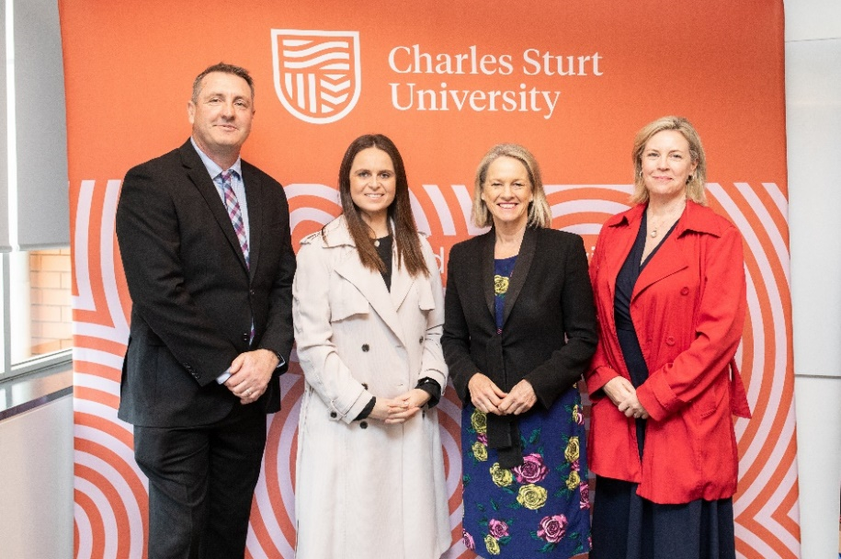
Image Caption: Launch of Charles Sturt University’s International Nursing Degree 14 August 2023. Left to right: James McKechnie, CSU, Samantha Beresford, CSU, the Hon Fiona Nash, and Julia Andrews, CSU. © Charles Sturt University.

Submissions, reviews and representations

The Australian Universities Accord
As a member of the Australian Universities Accord panel the Commissioner ensured the voices of regional students, communities, business and industry, and institutions were heard. In August 2023 the panel released an interim report that affirmed the Napthine goals, flagged even more ambitious equity targets and highlighted that ‘fundamental changes in tertiary education participation will be needed’. At the time of writing, the Accord panel is preparing its final report and recommendations for the Minister.

Higher education participation and attainment – the Napthine goals

Participation rates
Data from the Australian Census shows that participation in higher education remains consistent for all location categories (Major Cities, Inner and Outer Regional, and Remote) between 2016 and 2021 (Figure 4). However, although there has been little change in the proportion of students participating in higher education by region, when considered as total student numbers there is a sizeable increase from 2016 to 2021 in the number of regional people enrolled in a higher education qualification (Table 1). For example, in outer regional areas student enrolments have risen from 42,211 to 44,991 (representing a 6.6% increase in total number of students).
Figure 4: Participation in higher education for major cities, inner regional, outer regional and remote areas from the 2016 and 2021 Australian Census.
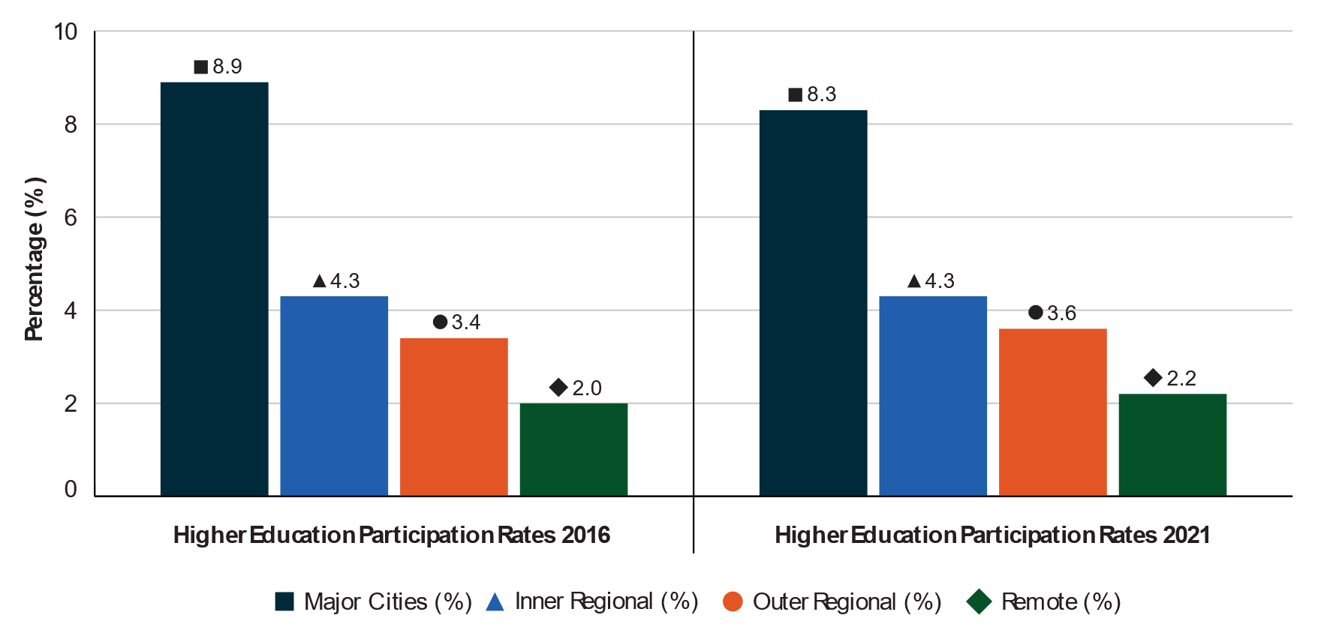
Note: Participation rates are derived by dividing the number of enrolments by the number of Australians aged 15-64. ABS (2016, 2021) Census.
Table 1: Higher education student enrolment numbers for major cities, inner regional, outer regional and remote areas from the 2016 and 2021 Australian Census.
Year | Major Cities | Inner Regional | Outer Regional | Remote
2016 | 992,436 | 111,466 | 42,211 | 6,330
2021 | 1,007,136  (+1.5%) | 117,177  (+5.1%) | 44,991  (+6.6%) | 6,946  (+9.7%)
Note: Higher Education participation numbers is the total enrolments of students aged 15-64. ABS (2016, 2021) Census.

Attainment rates
The Napthine Review set an ambitious target to ‘halve the disparity’ between metropolitan and each regional and remote location category for attainment rates of higher education for 25 to 34-year-olds by 2030 (Napthine target). Education attainment refers to ‘the highest level of education completed by a person, shown as a percentage of all persons in that age group’. It is positive that education attainment rates have improved across all sectors and all regional and remote location categories (Figure 5). For Bachelor and above qualifications for 25–34-year-olds, inner regional attainment rates lifted by 4.8 percentage points (pp) from 20.5% in 2016 to 25.3% in 2021, with improvements also seen for outer regional and remote areas.
While education attainment rates across regional and remote Australia have improved, the attainment rate gap between regional and metropolitan students has not closed, measured in percentage point changes. This is because metropolitan areas saw an even greater percentage point improvement in attainment over the same 2016-2021 period. If metropolitan attainment rates had remained stable, then small gains against the Napthine target would have been made; but the percentage point increase in metropolitan attainment rates was greater than for any regional and remote categories (Table 2).
Figure 5: Increase in education attainment rates 2016 and 2021 for major cities, inner regional, outer regional and remote areas from the 2016 and 2021 Australian Census.
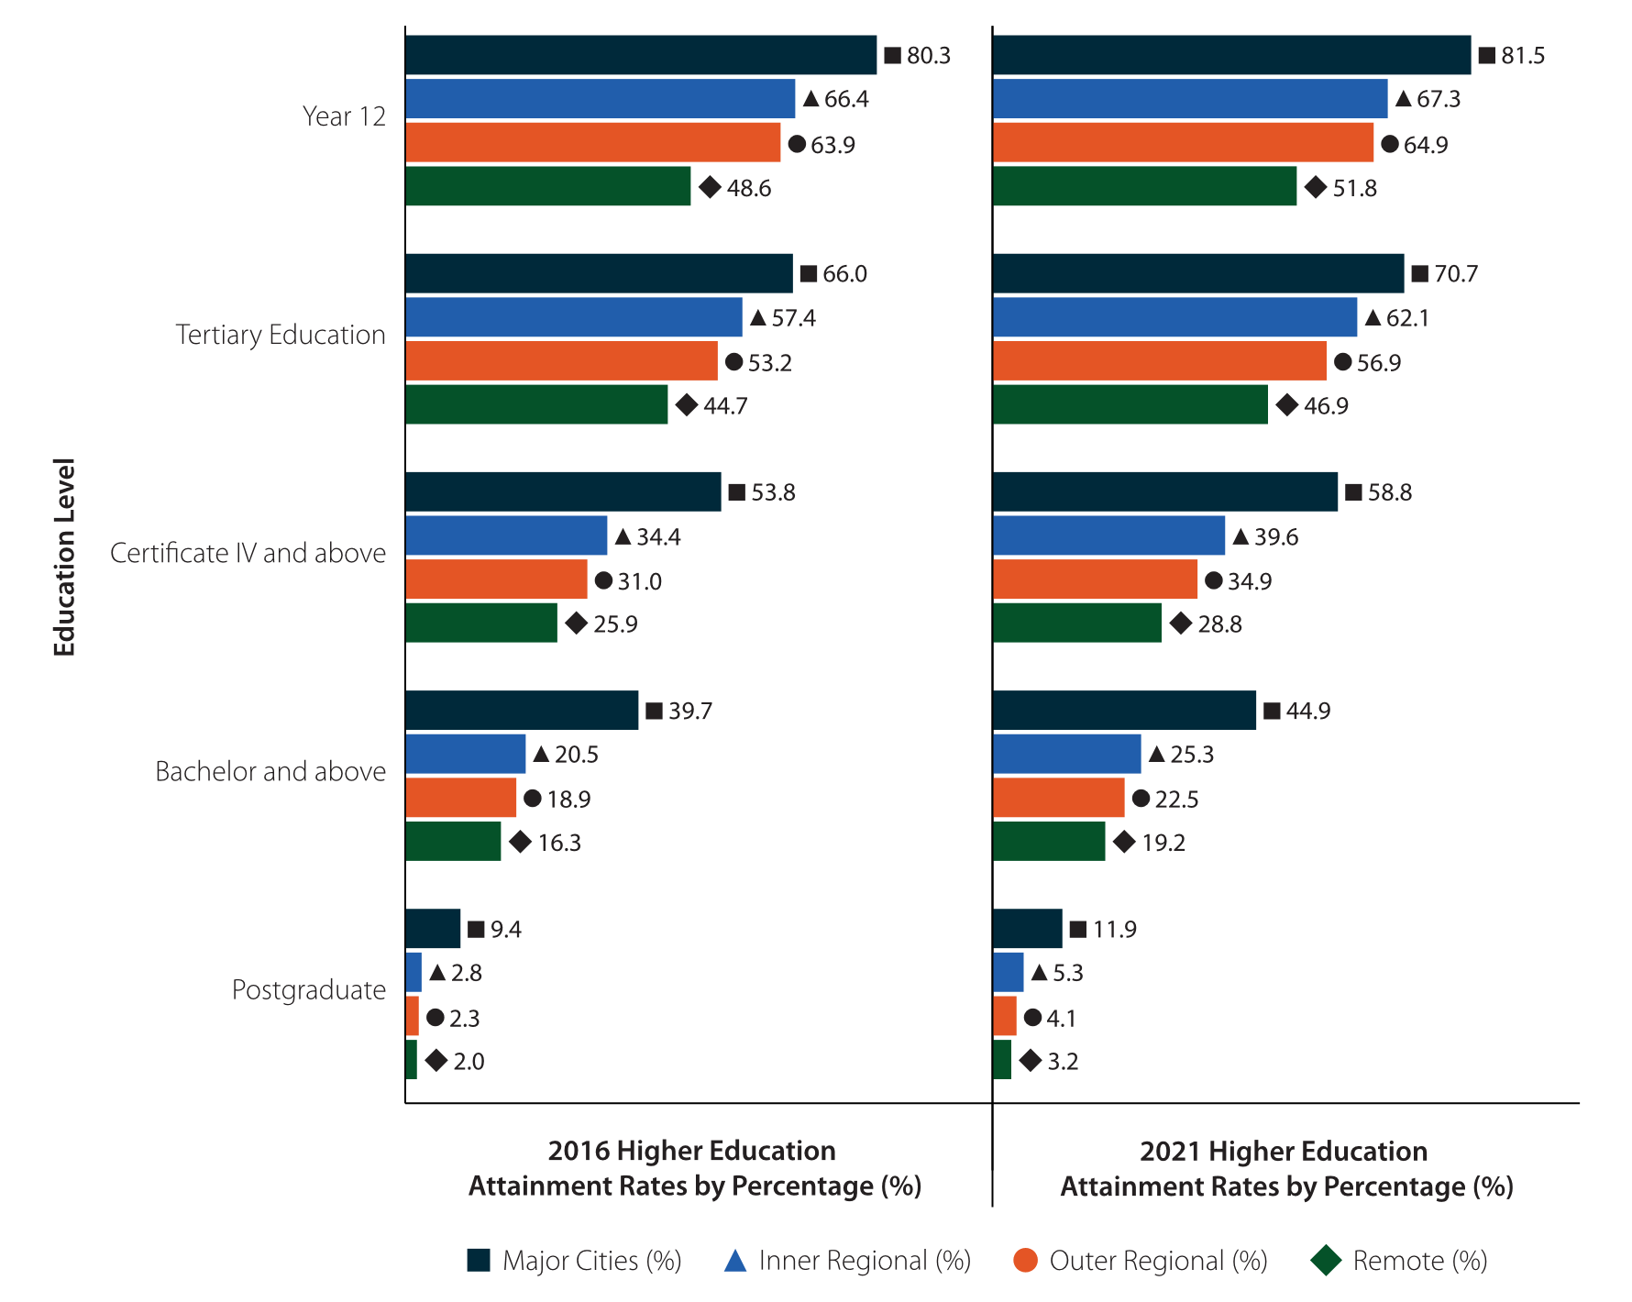
Note: Year 12 rates are for people aged 19. Tertiary qualifications are for people aged 25-34. Remote includes remote and very remote. Source: Australian Bureau of Statistics (ABS) (2016, 2021) Census of Population and Housing.
Table 2: Disparity between metropolitan and each regional and remote location category for attainment rates of higher education for 25–34-year-olds.
Remote Location | 2016 Disparity | 2021 Disparity | 2030 Target | Progress against target
Major Cities – Inner Regional | 19.2pp | 19.6pp | 9.6pp |  0.4%
Major Cities – Outer Regional | 20.8pp | 22.4pp | 10.4pp | 1.6%
Major Cities – Remote | 23.4pp | 25.7pp | 11.7pp | 2.3%
Note: Table refers to disparity (percentage point (pp) difference) between major cities and each regional and remote location category. Percentage points are derived by calculating the difference between percent (%) attainment in major cities and percent (%) attainment in each regional and remote location category. 2030 targets are devised by halving the 2016 disparity.
For First Nations people, there continues to be a notable gap in higher education access, participation, and outcomes. The Closing the Gap higher education target is for 70% of Indigenous Australians between the ages of 24 to 34 to have a tertiary qualification (Certificate III and above) by 2031. While First Nations student university enrolments have more than doubled between 2008 and 2021, rising from 9,490 to 23,967, enrolment remains below First Nations population parity (i.e. 3.2% of the total Australian population), representing 2.08% of all domestic enrolments in 2021.

Supporting regional students to succeed
Regional students are more likely to face challenges when moving into higher education than their metropolitan counterparts. While surveys of graduates consistently show that regional universities provide high-quality student experience and graduate outcomes, many regional (and particularly remote) students require additional support to access these opportunities, make the most of them, and succeed in university and beyond.
The form of this support should align with regional students’ needs as they progress through higher education: initial relocation support to aid with the costs of moving, targeted ongoing support through their time at university, and support to help regional students undertake valuable, but costly, work placements.

Relocation and living expenses
For many regional and remote students, moving on to higher education after finishing school means either leaving their homes or undertaking costly commutes. This is a significant expense and, in many cases, may prevent the student from furthering their education. Regional students need to know that financial support will be available prior to relocation in order to aspire to tertiary study.
One financial support program, the Tertiary Access Payment (TAP), was implemented in response to the Napthine review and has been operational for 3 years. Despite the good intent of this program, limitations of eligibility and timing of the payments have likely diminished its overall success in helping regional students to access university.
The Commissioner supports adjusting the timing of the TAP so that students can receive the funds upfront when they incur relocation expenses, rather than being back paid after the teaching period census date as currently occurs. The census date at university is the date on which a student’s enrolment is considered finalised and the last date a student can withdraw from a subject or course without financial penalty. Census dates are typically 4-6 weeks after commencement of classes.
The alignment between the TAP and university census dates was designed to ensure the payment is granted to students genuinely intending to study. However, unless regional students can receive the TAP when they incur relocation expenses it is unlikely to reduce moving costs as an up-front barrier, instead possibly being useful only to students who would probably have relocated for university without the TAP.
To be eligible for the TAP, students need to begin study immediately following Year 12. Students who take a gap year in order to work to save for relocation and study, or to qualify for Independent Youth Allowance, are not eligible to apply for the TAP.
Issue for Consideration 10
Improve the administration of the Tertiary Access Payment (TAP) by:
- removing the ‘no gap year’ requirement
- providing students with the financial support prior to relocation rather than after they commence their studies.
Access to the Independent Youth Allowance payment is a further financial hurdle for regional students moving straight from school to tertiary study. Currently, the criteria for Independent Youth Allowance for regional, rural, and remote school leavers are that a student can only qualify for the payments if they demonstrate independence through having worked at least 15 hours a week for a minimum of 2 years or earned 75% or more of wage Level A of the National Training Wage Schedule over a 14-month period.
This means students who have no choice but to leave home for tertiary study on campus have no access to Independent Youth Allowance support until these requirements are met.
The Commissioner supports the approach outlined in the Napthine review, which is to ‘allow all students who relocate from an RRR [regional, rural, remote] area to automatically qualify as independent for Youth Allowance purposes.’ This would incorporate all tertiary qualifications that span at least one year and would be in addition to the one-off ‘relocation allowance’ (the TAP) provided at the beginning of a qualification.
Issue for Consideration 11
Amend the Independent Youth Allowance eligibility criteria for regional students so that regional and remote students who need to relocate from home for tertiary study, beyond an appropriately determined distance, qualify as independent (replacing the current criteria that requires a regional or remote student to have worked at least 15 hours a week for a minimum of 2 years or earned 75% or more of wage Level A of the National Training Wage Schedule over a 14-month period to demonstrate independence).

Studying on Country
For First Nations people considering their options for study after school, there are limited opportunities to undertake higher education study on Country, meaning they usually have to relocate. First Nations students who leave their communities often experience isolation and a lack of cultural safety. Schools and tertiary institutions should explore opportunities to work with communities to create possibilities for tertiary study on Country. Building links between schools and these tertiary institutions, can improve pathways for First Nations students to aspire to and learn on Country.
In August 2023, the Government announced $6.4 million in funding for the Garma Institute, a First Nations led higher education and VET provider in Gulkala, in Central Arnhem Land.

Case Study: Garma Institute
Based at Gulkala, the Garma institute is a Yolngu owned and run tertiary and vocational education facility, built in partnership with the Yothu Yindi Foundation (YYF) and the University of Melbourne.
Education works best when its driven by the local community, and YYF is working hand-in-hand with local families every step of the way, ensuring there’s community involvement in everything from the design of the buildings to what’s taught in the classroom. By properly integrating Yolngu knowledge and philosophy in the curriculum, we will unleash the potential of the next generation, and improve educational and employment outcomes.
Yothu Yindi Foundation
The faculty will consist of senior knowledge holders who will shape curriculum across all levels of the university, which will centre on Yolngu knowledge. The Garma Institute will offer bridging programs for those aged 16 and over, and Yolngu-designed tertiary study options for Yolngu students. It will also be home to the Dilthan Yolngu’nha (Women’s Healing) programs and facilities.

Early intervention and ongoing support
From the point at which regional students start their course the provision of ongoing support, and early intervention when challenges arise, will help provide the conditions in which they can thrive in higher education. This support can come in many forms, such as mentoring and pastoral care, accessible affordable health facilities, academic support, and targeted financial assistance, and should be tailored where possible to the needs of the student.
As online learning becomes increasingly common and relied-upon in higher education, particularly for regional and remote students, providers must ensure that these students are as well supported academically and pastorally as their peers attending campuses. Support measures should ensure students accessing university online or via mixed mode delivery are provided with experiences of comparable quality to those attending in-person. Online learning centres, such as the Regional University Study Hubs and dedicated university online hubs like Edith Cowan University’s Learning Centre in Busselton, are solutions in place to ensure online students are supported.

Case Study: ECU Learning Centre Busselton
In September 2023, the Commissioner attended the opening of ECU’s Learning Centre in Busselton, providing over 300 online learning students with support, collaboration spaces, meeting rooms and conferencing facilities. The Learning Centre will allow students to experience parts of campus life, build a professional network and access facilities not available to them at home.
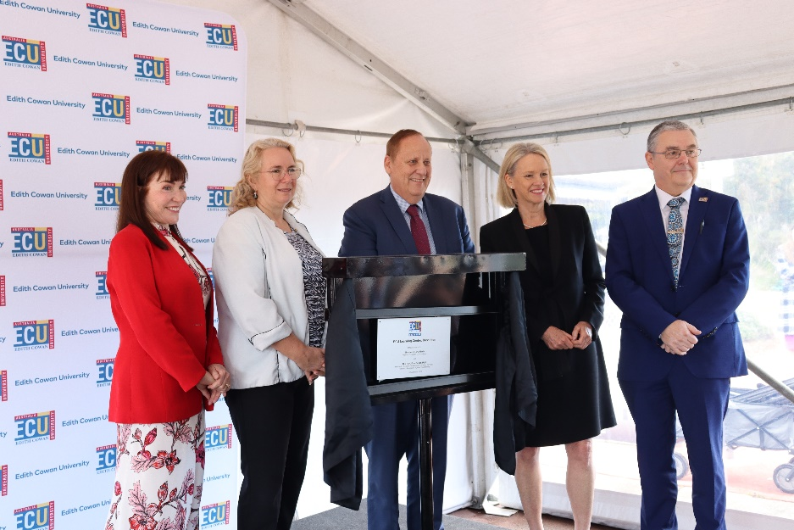
Image Caption: Opening of ECU Learning Centre Busselton, 6 September 2023. Left to right: Professor Cobie Rudd (Deputy Vice-Chancellor (Regional Futures) and Vice-President), Denise Goldsworthy (ECU Chancellor), the Hon Don Punch (WA State Minister for Regional Development; Disability Services; Fisheries; Seniors and Ageing; Volunteering), the Hon Fiona Nash (Regional Education Commissioner), and Professor Steve Chapman (ECU Vice-Chancellor)
© WEST AUSTRALIAN NEWSPAPERS LIMITED
Online delivery of both VET and higher education courses has significantly reduced barriers to access and allows students to remain in their local communities when they want to or need to. However, the success of online delivery is highly dependent on the digital infrastructure available in regional areas. Initiatives like Regional University Study Hubs recognise the need to provide these resources to students, however Regional University Study Hubs are not in reach of all regional students. Extending digital access to as many regional students as possible should be a priority alongside improving physical infrastructure in regional communities.

Placements
Forty per cent of domestic undergraduates enrolled at regional universities are studying degrees in health and education which require them to undertake many hours of compulsory placement. The underlying cost of relocation to pursue higher education, having to cover fuel costs as a result of a lack of public transport options, and forgoing paid employment are particular challenges for regional students undertaking placements. For students with children, these challenges are compounded by needing to access and afford childcare.
In 2023 the Australian Council of Heads of School of Social Work commissioned a survey to explore the financial burden of work experience placements on social work students. Results showed that unpaid placements are ‘directly linked to workforce shortages of social workers in some (particularly regional and remote) areas’, as students could not continue their degrees to completion. The research also highlighted several potential ways to fix the situation including changes to the Fair Work Act, paying students a minimum wage, and changing how learning is measured.
There is strong agreement from stakeholders on the value of placements to build networks, develop and demonstrate competencies and facilitate workforce readiness and as such further consideration must be given to alleviating the financial pressures.
Issue for Consideration 12
Consideration be given to developing a financial support program for students on compulsory placements to improve higher education attainment rates in the regions.

The future of higher education in regional Australia
Higher education drives innovation and growth, and provides opportunities for people to learn, grow and participate in the workforce and community in a way that rewards their endeavours. In a period of significant change to Australia’s higher education sector, it is important that the vital role of regional universities is recognised.

Regional University Study Hubs
In 2023, the Commissioner heard from local government associations, individual local councils and community members about their enthusiasm for the Regional University Study Hubs program and discussed opportunities for the expanding network of centres. The Universities Accord Review panel recommended in its Interim Report expanding the program, and the Government has committed $66.9 million to establish up to 20 additional Regional University Study Hubs and up to 14 Suburban University Study Hubs.
In addition to expanding the number of Hubs through establishment of new facilities, the Commissioner also supports expanding the Regional University Study Hub network through better use of existing education infrastructure. Opportunities for housing Hubs on existing TAFE or regional university campus sites should be explored. This may present a cost-effective way to expand access to support offered by the Hubs to students who are completing their studies online but are not studying with a local provider.
There are now 34 established Regional University Study Hubs across Australia and 20 more in the pipeline. With the success of the program and more Hubs soon to be established, to ensure a high-performing operational environment, a model to provide ongoing support and governance oversight for all Hubs should be developed.
Issue for Consideration 13
Enhance and expand the Regional University Study Hubs program by exploring options such as:
- collaborating with state and territory governments to identify potential opportunities to house Regional University Study Hubs on existing TAFE sites and expand access for VET students
- enabling appropriately determined university regional campuses to host a Regional University Study Hub
- developing an appropriate model to deliver ongoing support and governance oversight for the full network of regional Hubs.

Regional universities as anchor institutions
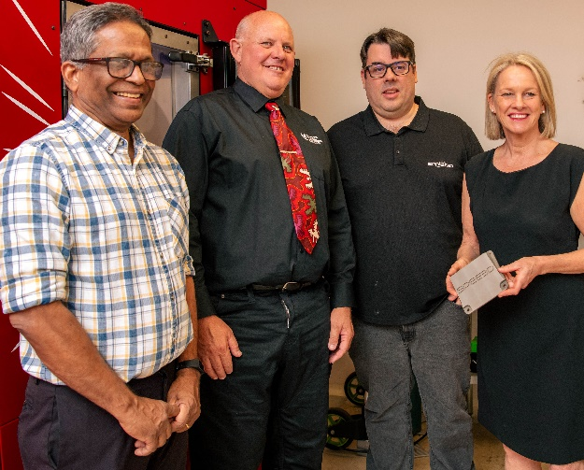
Image Caption: Charles Darwin University Spee3D visit, 25 July 2023. Left to right: Krishnan Kannoorpatti, Scott Bowman, Steven Camilleri and the Hon Fiona Nash (Regional Education Commissioner).
Regional universities contribute enormously to their local communities, providing more than $1.7 billion in real GDP and over 115,000 students each year, and deliver significant technological, social, and cultural infrastructure. However, regional universities face unique challenges including poor economies of scale, attracting and retaining staff, and difficulty in maintaining a comprehensive range of courses and research opportunities.
Despite these challenges, regional universities continue to deliver outstanding graduate outcomes. In 2022, all regional universities recorded above average employment outcomes, with Charles Sturt University (90.7%), Central Queensland University (86.9%) and the University of New England (86.8%) the three top performers across the country.
Through droughts, bushfires, floods, and pandemics regional universities have demonstrated their role as pillars of regional communities. When record breaking floods struck Queensland’s Southeastern and NSW’s Northern Rivers communities in early 2022, Southern Cross University’s Lismore campus was the main evacuation centre for residents and headquarters of many relief efforts. In the devastation of the aftermath, more than 20 local organisations were based on the Lismore campus. In 2023, the campus continued to house consulting rooms for health practitioners, three schools and TAFE NSW programs. The continued role Southern Cross University’s Lismore campus plays in the community’s rebuilding shows the importance of regional universities beyond their role as education providers.
Charles Sturt University, Central Queensland University, University of the Sunshine Coast, Federation University and the University of New England provided similar support and community engagement in response to bushfire events. Our regional universities not only supported their own students through scholarships and other emergency assistance, but supported the whole community through immediate crisis actions like firefighter accommodation on campus and longer-term work including research projects on the recovery of the natural environment and future disaster preparedness. It is then often the graduates of these regional institutions who remain and work locally to provide essential services to their community.

Regional university funding and models
Conversations across 2023 identified the need for a tertiary funding model that acknowledges the additional costs involved in teaching students from under-represented cohorts, including those from regional and remote areas. The Commissioner supports the establishment of a funding model that offers longer-term stability, that responds to changes in student diversity and demand, and that protects against rapid shifts in funding that are beyond the capacity of institutions to manage.
The Regional Universities Network outlined the need for centralised student support systems, distributed in a ‘Gonski-style’ as-needed basis, to replace the scattering of the current regional and support loading provisions. University enrolments have increased 45% since 2008 and as more students participate in tertiary education universities increasingly have to respond to the needs of diverse cohorts. Governments and universities need to ensure good practice principles and strategies are used to support students from under-represented cohorts to succeed.
In addition to housing educational facilities and research infrastructure, regional university campuses also provide critical social and cultural infrastructure for the benefit of all community members. But many regional universities are ‘multi-campus’ institutions compounding the associated infrastructure and maintenance costs. There is no dedicated funding program available for university infrastructure, which has a significant impact on the sustainability of many regional campuses.
Issue for Consideration 16
Acknowledging the significant social and economic contribution regional universities make to their local communities, change the eligibility requirements of the Growing Regions Program to allow regional universities to apply for funding.
Noting the local and national importance of existing regional universities, the inherent challenges faced by some regional campuses and the significant increase in participation and attainment from regional students required to meet future workforce needs, the Accord panel has considered the merit of alternative models that build on and strengthen higher education in our regions. The Commissioner led round table discussions with students, industry and vice-chancellors of regional universities to explore ‘big ideas’ like the creation of a second ‘national university’, a National Regional University.
Commissioner’s Note
Regional universities do the heavy lifting in educating the highest proportion of students from equity cohorts. However, the playing field is not level. Significant investment is needed to ensure the success of existing regional universities, and alternative thinking is required to expand higher education in our regions and ensure regional Australia’s future skills needs are met.

Building Stronger Regions through Education
Education has a central role to play in building stronger regions. Strong regional population growth can stimulate regional economies, and provide a potential solution to workforce shortages, when governments, industry and the education sectors work together to ensure regional people have appropriate opportunities to build skills and knowledge.
During the COVID-19 pandemic in 2020 and 2021, more people moved to the regions to experience the benefits of living in regional Australia, contributing to population growth outside of capital cities exceeding capital city population growth for the first time this century. In May 2023, research from the Regional Australia Institute found one in five people (or 3.5 million) wanted to leave their cities for the regions.
While this trend is expected to slow or reverse again as overseas migration to Australia recovers, the 2023 Intergenerational Report projects that the historic growth gap between Australia’s capital cities and rest-of-state will narrow over the next 40 years. Regional Australia needs a strategic approach to education and workforce to sustain this growth. Population growth in the absence of strategic, targeted investments in all education sectors will put increasing strain on regional communities and the opportunities available to its growing population.
Case Study: Regional Australia Institute
The Regional Australia Institute is an independent think tank focussed on building stronger regional communities and economies and improving quality of life in regional Australia. In September 2023, the Commissioner attended the Regional Australia Institute’s National Summit where the first progress report on the Regionalisation Ambition 2032 framework was presented.  The progress report paints a positive picture for regional Australia and showcases inspiring education and skills related initiatives from right across the nation. | 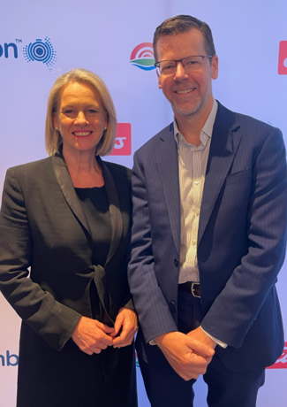  Image Caption: The Hon Fiona Nash, Regional Education Commissioner with Tony Cook PSM, Secretary of the Department of Education at the Regional Australia Institute’s 2023 National Summit – 13 to 14 September 2023.

Regional workforce – opportunities and challenges
Education supports workforce participation, which increasingly requires tertiary qualifications. Over the next 10 years, more than 9 out of 10 newly created jobs will require post-secondary qualifications. This is significant, given that Napthine Review identified that Australians in regional and remote areas are 40% less likely to gain a higher-level tertiary education qualification and half as likely to gain a Bachelor level qualification by the time they are 35, compared to Australians in capital cities.
However, students from regional communities who do pursue tertiary education are more likely to choose to work in a regional area than their metropolitan peers. Nurturing the aspiration of regional students and supporting their pathways into tertiary study will significantly expand the ‘homegrown’ regional workforce to address skills shortages and bring benefits to the regions and the nation.
As reflected in this report, Australia’s regional teaching workforce faces a skills shortage across all education sectors. Challenges in attracting and retaining teachers in the regions are compounded by poor access to other services, in particular health services and housing. Regional workforce shortages will not improve solely through attraction and recruitment of skilled metropolitan workers. Retention of local teachers and encouraging trained teachers who grew up regionally to return to work in regional Australia are other necessary elements of any effective strategy to build a skilled regional education workforce.
Ae well as education workforce shortages, stakeholders have repeatedly raised critical shortages in the regional health and veterinary industries with the Commissioner. The following case studies showcase specific issues raised and potential solutions in these two sectors, acknowledging that many other industries in regional areas also face workforce issues.
Case Study: Medical Education
The 2023 national report from the Medical Schools Outcomes Database confirmed previous reports that students from a regional or remote background have a greater desire to work in regional and remote locations, and that regional placements also have a positive influence on desire to work in the regions for all students. This data speaks to the critical importance of offering high quality medical education and training opportunities in regional locations.
Although it was positive to see an increase of 80 new CSPs for regionally trained medical students, more needs to be done to address current medical workforce shortages in regional and remote areas and the resultant health outcomes disparity. The Rural Health Commissioner and the Regional Education Commissioner continued to meet regularly throughout 2023 exploring many of the regional education and health-related issues, including workforce maldistribution.
‘More levers can be used to manage Australia’s current health workforce maldistribution. For example, most of Australia’s health training models are primarily delivered in metropolitan centres, geared towards enrolling metropolitan students, producing health professionals who are most likely to practise in high density metropolitan centres within familiar, well-resourced health systems.’
Adjunct Professor Ruth Stewart, National Rural Health Commissioner.
The James Cook University (JCU) medical program was the first in Australia to be based outside a metropolitan area. The program has had significant success in addressing health workforce shortages by producing doctors with the skills and commitment to work in regional and remote Australia. Graduates from the JCU program are more likely to practice in rural, regional and remote areas; are working in regions where doctors are needed; are more likely to choose generalist careers; and are making an impact in the rural health workforce.

Issue for Consideration 14
Significantly increase the number of Commonwealth Supported Places for regionally-based end-to-end medical schools to address critical medical workforce shortages in regional areas.

Case Study: Veterinary Science Education
In 2023 the Commissioner heard from individuals, industry groups and peak bodies that the veterinary workforce in regional and remote Australia is at crisis point. This is a crisis not only in terms of the well-being of regional vets but a potential crisis in terms of biosecurity, wildlife conservation, animal welfare, food safety and security, and ultimately the wider economy.
In June 2023 Dr Helen Scott-Orr (former Chief Veterinary Officer of NSW and Australian Inspector-General of Biosecurity) delivered the ‘Rethinking Veterinary Education’ report commissioned by The Veterinary Schools of Australia and New Zealand (VSANZ). The report makes a strong case for change to models of veterinary education including widening admissions processes and ensuring a pipeline of students committed to veterinary practice in regional and remote communities. It also reiterated calls for student debt relief for vets practicing in the regions, and changes to the funding rate per student load to cover the actual cost of training a veterinarian. The report also identifies strategies that have been successful in health and medical education (such as the Rural Health Multidisciplinary Training Program), and suggests that Governments should consider similar partnership models to improve recruitment and retention of vets in regional and remote Australia.
In NSW, a parliamentary inquiry is underway examining the shortage of veterinarians, with a focus on trying to determine the underlying causes of the shortage, implications for the profession and NSW community more broadly, and specific challenges faced in regional, rural, and remote areas. The inquiry received over 200 submissions, several of which reiterated recommendations from the VSANZ Veterinary Education report.

Issue for Consideration 15
Immediately address the critical veterinary workforce shortage in regional and remote Australia through both short and long-term strategies, such as:
- HELP fee relief to encourage early career veterinarians to work in rural areas
- changes to admissions processes to ensure places for students with a commitment to regional and remote practice
- changes to the funding and models of training (e.g. financial support for rural placements)
- consider housing (or other) incentives to attract veterinarians to regional areas of need
Ensuring that regional students are actively aware of educational opportunities will help them to create better futures in stronger regional communities. Strengthening connections and engagement across all education sectors, regional industry and community organisations will develop more visible and varied pathways. A cross-sector approach will help to nurture a student’s aspiration as they grow through early childhood into school and beyond, providing them with educational opportunities like mentoring, careers advice and internships that allow them to find their most suitable path into skilled regional workforces.
Issue for Consideration 20
Develop a regional education linkage program that facilitates collaboration between regional schools, VET, universities, Regional University Study Hubs, business and industry, and community to build student aspiration and address access, attainment and workforce issues in our regions.
Such a program could be delivered by locally based ‘brokers’ in regional communities, who could build upon existing relationships and connections with local schools, tertiary institutions, employers and industries to strengthen collaboration, facilitate development opportunities for students (including work placements and internships), provide students with informed careers advice and identify a future ‘homegrown’ workforce for regional businesses and industries.
It is important to maintain connections with regional students who move away from home to ensure that they can more easily return to their region in the future should they be keen to do so. This ‘pathway home’ is another avenue for bringing skilled workers back into regional communities. Local councils are well placed to establish and build on this ongoing relationship with their ‘community alumni’ through, for example, allowing students who are leaving or have left the region to opt into an online register for regular communications.
Issue for Consideration 21
Fund local councils to develop a strategy to keep young people connected to their regional community if they leave, facilitating a 'pathway home' for students to return to their region.
As the examples of good practice throughout this report have shown, initiatives that are community-led, locally focussed and sufficiently flexible to adapt to diverse regional areas achieve better outcomes for regional communities. Regional areas are rich with knowledge and lived experience, from First Nations culture to agricultural practice and emerging industrial knowledge. Students’ interests and career pathways should be informed by an understanding of the wider opportunities available outside regional areas, but they should also have the opportunity to remain in their communities to study or work. The strength of regional communities is dependent on the people who live in them. Increasing educational opportunities for regional people will grow stronger regions to improve the future for all Australians.

Appendices

Appendix A: Consultations up to 31 October 2023

Stakeholders
Stakeholders Sector of Concern
 Early Childhood Education and Care
 Schools
 Tertiary (VET & Higher Education)

Early Childhood Education and Care
- Australian Competition & Consumer Commission Childcare Inquiry 2023
- Early Childhood Australia
- Early Childhood Australia NSW
- Early Learning Association Australia
- Goodstart Early Learning
- In Home Care Program Review
- Inclusion Support Program Review
- Productivity Commission Inquiry into Early Childhood Education and Care

Schools
- Alice Springs School of the Air
- Ardrossan Area School
- Australian Boarding Schools Association
- Australian Institute for Teaching and School Leadership
- BOP Industries
- Future Anything
- Independent Schools Australia
- Mount Gambier High School
- Narromine Public School
- RAISEducation
- Rockhampton Grammar School
- Royal Robotics - Red Dirt Robotics
- South Australian Area State School Leaders Association
- Teach for Australia

Students, parents and community
- Australian Education Union
- Bulloo Shire Council
- Coalition of Regional Independent Schools Association
- Committee for Gippsland
- Community Connections Solutions Australia
- Country Mayors Association of NSW
- Country Women’s Association of NSW
- Contact Inc.
- Federation of Parents and Citizens Association of NSW
- Gunnedah Shire Council
- Isolated Children’s Parents’ Association
- National Aboriginal and Torres Strait Islander Principals Association
- National Centre for Student Equity in Higher Education
- Regional Australia Institute
- Regional Education Support Network
- Royal Far West
- 2023 South Australia Rural Youth Ambassador, Jackson Moffat
- Temora Shire Council
- Toowoomba Regional Council

Tertiary Education (including Vocational Education and Training and Higher Education)
- Charles Darwin University
- Charles Sturt University
- Council of Australian Postgraduate Associations
- Country Universities Centre
- Curtin University
- Edith Cowan University
- Equinim College
- Flinders University
- Federation University Australia
- Independent Tertiary Education Council Australia
- Innovative Research Universities
- James Cook University
- Kimberley Universities Centre
- La Trobe University
- Lumen Wheatbelt Regional University Centre
- National Centre for Vocational Education Research
- National Tertiary Education Union
- National Union of Students
- Pilbara Kimberley Universities Centre
- Regional Universities Network
- Southern Cross University
- Train West
- University of Adelaide, Rural Clinical School
- Universities Australia
- University of Canberra
- University of Melbourne
- University of Newcastle
- University of New England
- University of Southern Queensland
- University of Tasmania
- University of the Sunshine Coast
- University of Wollongong
- Wells Advisory
- Western Sydney University

Industry and employment
- Anthologie
- Australian School of Entrepreneurship
- Chief Entrepreneur of QLD & Founder, Engage and Create Consulting, Julia Spicer
- Groei Education
- Health 104
- Telein
- Jobs and Skills Australia
- National Broadband Network Australia
- National Rural Health Alliance
- Pointer Remote
- The Conversation International
- Youth Development Australia

Health
- Australian Rural Health Education Network
- Charles Sturt University, Three Rivers Department of Rural Health
- Medical Deans Australia and New Zealand
- National Rural Health Commissioner
- National Rural Health Alliance
- National Aboriginal Community Controlled Health Organisation
- University of Canberra, Faculty of Health

Cross-sector
- Australian Local Government Association
- Australian Rural Leadership Foundation
- Australian Veterinary Association
- Emeritus Professor John Halsey, author of the Independent Review into Regional, Rural and Remote Education
- Equine Vets Association
- Forage – Education Partnerships Australia
- James Martin Institute for Public Policy
- Lisa Paul AO PSM, Co-Chair of the Independent Review of the NDIS
- Local Government Association of Queensland
- Queensland Government, Department of Tourism, Innovation and Sport
- South West Queensland Regional Organisation of Councils (SWQROC)
- Yadha Muru Foundation

Federal Ministers, Shadow Ministers and MPs
- Minister for Education, the Hon Jason Clare MP
- Assistant Minister for Education and Assistant Minister for Regional Development, Senator for Queensland, Senator the Hon Anthony Chisholm
- Minister for Social Services, the Hon Amanda Rishworth MP
- Minister for Early Childhood Education and Minister for Youth, the Hon Dr Anne Aly MP
- Shadow Minister for Regional Education, the Hon Darren Chester MP
- Federal Member for Indi, Dr Helen Haines MP
- Federal Member for Capricornia, the Hon Michelle Landry MP
- Federal Member for Riverina, the Hon Michael McCormack MP
- Federal Member for Solomon, Luke Gosling OAM, MP
- Shadow Minister for Education, Senator for Victoria, Senator the Hon Sarah Henderson
- Federal Member for North Sydney, Kylea Tink MP
- Deputy Leader of the Nationals, Shadow Minister for Water, Emergency Management and Senator for New South Wales, Senator Perin Davey

State and Territory Ministers, Shadow Ministers and MPs
- Treasurer, Minister for Infrastructure, Planning and Logistics, Minister for Education and Minister for Territory Development, Territory Member, the Hon Eva Lawler MP
- Queensland Minister for Employment & Small Business and Training and Skills, State Member for Bulimba, the Hon Di Farmer MP
- Former NSW Minister for Education and Early Learning, the Hon Sarah Mitchell MLC
- State Member for Wagga Wagga, Dr Joe McGirr MP
- Shadow NSW Minister for Skills, TAFE and Tertiary Education, Member for Albury, Justin Clancy MP
- Former NSW Minister for Education, the Hon Adrian Piccoli

State and Australian Public Service senior executive
- Mr Tony Cook PSM, Secretary, Department of Education
- Mr Ben Rimmer, Deputy Secretary, Higher Education, Research and International, Department of Education
- Ms Kylie Crane, Deputy Secretary, Early Childhood and Youth, Department of Education
- Ms Meg Brighton, Deputy Secretary, Schools Group, Department of Education
- Mr Jim Betts, Secretary, Department of Infrastructure, Transport, Regional Development, Communications and the Arts
- Mr Andrew Metcalf AO, former Secretary, Department of Agriculture, Fisheries and Forestry
- Ms Lisa Rogers, Director General, Western Australia Department of Education
- Ms Melesha Sands, Deputy Director General, Western Australia Department of Education

Engagements

Visits
- 30 March 2023: Charles Darwin University, Alice Springs Campus (NT)
- 11 May 2023: The University of Melbourne, Dookie Campus and Rural Medical School (VIC)
- 17 May 2023: The Rockhampton Grammar School (QLD)
- 1 June 2023: James Cook University, Townsville Campus (QLD)
- 24 July 2023: Narromine Public School (NSW)
- 25 July 2023: Charles Darwin University, Casuarina Campus (NT)

Roundtables attended
- 17 February 2023: Australian Government’s National Early Years Summit Roundtable
- 25 May 2023: Regional, Rural & Remote, and Early Childhood Education & Care Sector roundtable for Federal Department of Education Early Years Strategy Roundtable
- 15 June 2023: National School Reform Agreement Expert Panel
- 11 September 2023: Preschool Outcomes Measure Consultation Session

Events
- 31 March 2023: Charles Darwin University, Better Health Futures Symposium (Alice Springs, NT)
- 3 May 2023: Country Universities Centre Far West Study Tour (virtual)
- 18 May 2023: Regional Activators Alliance Quarterly Meeting (virtual)
- 1 June 2023: James Cook University, 2023 Mabo Lecture (Townsville, QLD)
- 14 August 2023: Charles Sturt University International Nursing Degree Launch (Dubbo, NSW)
- 6 September 2023: Edith Cowan University Learning Centre Opening (Busselton, WA)
- 12 September: AgriFutures Rural Women’s Award Dinner (Canberra, ACT)
- 21 September 2023: Northern Territory Leaders of Tomorrow Program Presentation (virtual)
- 27 September 2023: Regional Universities Network (RUN) Learning and Teaching Showcase (virtual)

Conferences
- 13 February 2023: Local Government Association of Queensland Webinar (virtual) (speaking engagement)
- 22 & 23 February 2023: Universities Australia, Higher Education Conference (Canberra, ACT) (speaking engagement)
- 26 July 2023: Isolated Children’s Parents’ Association of Australia, Annual Federal Conference (Darwin, NT) (speaking engagement)
- 13 September 2023: Regional Australia Institute Regions Rising National Summit (attended) (Canberra, ACT)

Appendix B: Progress responding to the Halsey Review

Priority 1: Establishing a national focus for regional, rural and remote (RRR) education
Recommendations | Implementation | Status
Recommendation 11: Establish a national focus for RRR education, training and research to enhance access, outcomes and opportunities in RRR Australia. | The Australian Government continues to work with state and territory education departments and other educational authorities to ensure all students can access a high-quality education regardless of where they live. | Ongoing.
Recommendation 11: Establish a national focus for RRR education, training and research to enhance access, outcomes and opportunities in RRR Australia. | The National Careers Institute (NCI) developed a Regional, Rural and Remote School Leavers information booklet to help young people aged 15 to 24 years with information on education, training and work. It was developed in consultation with a representative sample of RRR students to ensure its relevance and usefulness. | Ongoing - the NCI’s Regional, Rural and Remote School Leavers information booklet is available free for download on the Your Career website (youcareer.gov.au). The booklet is regularly distributed to schools, career expos and job fairs.  The Regional, Rural and Remote School Leavers information booklet complements the suite of School Leavers products that are updated regularly in collaboration with key stakeholders and tested with the target audience.
Recommendation 11: Establish a national focus for RRR education, training and research to enhance access, outcomes and opportunities in RRR Australia. | All Australian Government departments continue to report annually through the Regional Ministerial Budget Statement on progress in delivering improved access, outcomes and opportunities | Ongoing - reporting released with the annual Budget cycle.

Priority 2: Enhancing leadership, teaching, curriculum and assessment
Recommendations | Implementation | Status
Recommendation 1: Establish and/or refine processes for ensuring the relevance of the Australian Curriculum and state/territory assessment processes for RRR students and communities. | Version 9.0 of the Australian Curriculum was endorsed by all Education Ministers on 1 April 2022.  State and territory curriculum authorities and school authorities are responsible for the implementation of the Australian Curriculum in their schools in line with system and jurisdictional policies and requirements. | Ongoing - the Government will continue to work through the Education Ministers Meeting to implement curriculum and assessment initiatives, and support programs and incentives to place quality teachers and leaders into RRR schools.  Jurisdictions can implement the revised curriculum from 2023.
Recommendation 2: Ensure RRR challenges and opportunities are explicitly included in the selection and pre-service education of teachers, initial appointment processes and their on-going professional support. | On 15 April 2021, the Government launched the Quality Initial Teacher Education Review.  The Expert Panel, chaired by Lisa Paul AO PSM, consulted widely with stakeholders and undertook a number of engagement activities including webinars, focus groups, surveys and workshops. | Completed – the Final Report of the Review was released in February 2022.  The Government allocated funding to respond to the Review in the October 2022-23 Budget.  Education Ministers agreed to the National Teacher Workforce Action Plan in December 2022.
Recommendation 2: Ensure RRR challenges and opportunities are explicitly included in the selection and pre-service education of teachers, initial appointment processes and their on-going professional support. | From 2024, the Australian Government will provide undergraduate and post graduate scholarships of up to $40,000 ($10,000 a year over four years for undergraduate students and $10,000 a year over two years for postgraduate students) to attract high achieving students into teaching, including students from RRR areas.  A top up payment of $2,000 may be available for scholarship recipients who undertake their final year professional experience placement in a remote area. | The Government allocated funding for the Commonwealth Teaching Scholarships in the October 2022-23 Budget.  Scholarships will be available from 2024.
Recommendation 2: Ensure RRR challenges and opportunities are explicitly included in the selection and pre-service education of teachers, initial appointment processes and their on-going professional support. | The Government committed $28.7 million over 2018-19 to 2022-23 to deliver the High Achieving Teachers (HAT) Program. This program is delivered by Teach For Australia (TFA) and La Trobe University. Funding to deliver an additional 760 places from 2023 is being provided to TFA and La Trobe University.  In addition, under the National Teacher Workforce Action Plan, the Government committed $78.8 million over 2022–23 to 2026–27 to expand the HAT Program to support an additional 1,500 professionals to retrain as teachers. | The department manages current contracts for the HAT Program with TFA and La Trobe University.  In the last quarter of 2023, the Department of Education will seek proposals for innovative employment based pilots to deliver the 1,500 additional places.
Recommendation 2: Ensure RRR challenges and opportunities are explicitly included in the selection and pre-service education of teachers, initial appointment processes and their on-going professional support. | The Australian Institute for Teaching and School Leadership (AITSL) is delivering initiatives relevant to RRR education, including developing cultural competency resources to support classroom teachers. | AITSL developed a suite of resources and tools to better support the cultural capability of the teaching profession. AISTL released the intercultural development toolkit in 2022 and it is available for all teachers to access on their website Building a culturally responsive Australian teaching workforce (aitsl.edu.au).
Recommendation 2: Ensure RRR challenges and opportunities are explicitly included in the selection and pre-service education of teachers, initial appointment processes and their on-going professional support. | The Australian Teacher Workforce Data collection (ATWD) will support future national collaborative work.  In the 2021-22 Budget, the Government provided $5.8m to continue the ATWD, providing nationally consistent data on the teacher workforce including in RRR areas. | Ongoing – nationally consistent data will assist in identifying opportunities and challenges to attracting, developing, supporting and retaining high quality teachers.
Recommendation 3: Ensure RRR contexts, challenges and opportunities are explicitly included in the selection, preparation, appointment and ongoing professional support of educational leaders. | AITSL developed a spotlight publication detailing the challenges and opportunities for teachers in accessing high quality professional learning in RRR contexts. | AITSL has published the document Professional learning for RRR teachers on its website.
Recommendation 3: Ensure RRR contexts, challenges and opportunities are explicitly included in the selection, preparation, appointment and ongoing professional support of educational leaders. | In 2019, the Government committed $7.5 million for Teach For Australia (TFA) to develop and pilot a new Future Leaders Program (FLP). | The FLP pilot is operating over three years (2021–2023) with 170 participants anticipated.  In 2023, schools in WA, NT and QLD are participating in the program.
Recommendation 8: Improve opportunities for RRR schools to implement entrepreneurship in education through curriculum, teaching, system and cultural changes and building on good practice. | The Government committed $2 million to expand the Country Education Partnership’s Rural Inspire program to encourage young people in rural communities to set their sights high, develop their motivation and increase their ability to choose and achieve positive career, life and learning goals.  In 2020 Rural Inspire expanded into New South Wales and South Australia, in 2021 to QLD and NT (with a focus on First Nations participants) and to WA and Tasmania during 2022. | The national expansion has been achieved, with the program having established links to the relevant education authorities in all participating jurisdictions.

Priority 3: Improving information and communications technology (ICT)
Recommendations | Implementation | Status
Recommendation 9: Improve ICT for schools | The Government’s School Student Broadband Initiative is providing up to 30,000 families with no internet at home with 12 months of free NBN to boost education opportunities and narrow the digital divide.  In-need families are nominated by partnering organisations such as schools, education authorities and charities/community organisations.  Free services are available across all NBN technologies including fixed-wireless and satellite. | In the October Budget 2022-23 the Government provided NBN Co a $4.5 million grant to support delivery of this commitment.  The initiative was launched in February 2023.  As of September 2023, over 20,000 vouchers have been issued and over 3,000 families have been connected to a free NBN service.
Recommendation 10: Support RRR communities to implement innovative approaches to education delivery designed to improve education access and outcomes for students living in remote communities | Over time, NBN Co has been developing satellite products to meet the needs of a wider range of users, including Sky Muster Plus.  The Government is investing $2.4 billion so NBN Co can upgrade an additional 1.5 million premises from fibre to the node (FTTN) to enable access to full-fibre services.  The Government has also provided $480 million to NBN Co to support an upgrade to the entire NBN Fixed Wireless and Satellite networks. | Once this upgrade is complete around 90 per cent of fixed-line premises will be able to access speeds of up to 1 Gigabit per second.  The First Nations Digital Advisory Group, will provide advice to the Minister for Communications on ways to support First Nations digital inclusion, including in remote communities.

Priority 4: Enhancing transitions into and out of school
Recommendations | Implementation | Status
Recommendation 4: Ensure RRR children start school with a strong foundation for learning. | The Preschool Reform Agreement is an Australian Government commitment to make $2 billion available to support state and territory governments to deliver universal access to 15 hours of preschool a week to children in the year before full time school. | From 2022 to 2025, the Government is providing funding through the Preschool Reform Agreement.  The Government and States and Territories are working to deliver a reform agenda to ensure all children benefit from Commonwealth funding, lift preschool enrolment and attendance, and help understand the impact of preschool.
Recommendation 4: Ensure RRR children start school with a strong foundation for learning. | The Australian Government’s Child Care Safety Net includes funding for the Connected Beginnings program, which is expanding to 50 sites nationally by 2025. | The Connected Beginnings program currently supports 40 First Nations communities. The expansion is being implemented in a staged approach, with an additional seven to eight sites being established in 2023-24.
Recommendation 5: Expand the availability, affordability and accessibility of high-quality work experience placements, VET, dual VET/university options and two-year associate degree programs for RRR students. | The Australian Government partnered with states and territories to establish a $1 billion 12-month Skills Agreement.  The Agreement commences on 1 January 2023 and delivers 180,000 Fee Free TAFE and vocational education places throughout 2023.  Further information can be found in the Skills and Training fact sheet on the 2022-23 Budget website. | Delivery plans are being finalised.
Recommendation 6: Support RRR students to make successful transitions from school to university, training, employment and combinations of them. | The School Leavers Information Service (SLIS) was delivered to young people aged 15 to 24 years in RRR areas through career guidance sessions with a career practitioner, and workshops and presentations delivered in schools. The Service was delivered from 1 October 2020 to 30 June 2023. | Over the course of the SLIS there were more than 18,000 engagements, including 5,000 career guidance sessions delivered to young people across Australia.  The NT pilot ran across Darwin, Humpty Doo, Alice Springs, Katherine and Tennant Creek. The pilot delivered a number of outreach activities with schools resulting in over 6,000 student and stakeholder engagements, including over 340 career guidance sessions, presentations and face to face attendance at in-school career expos.
Recommendation 7: Encourage the philanthropic sector to play a greater role in raising achievements and improving opportunities for RRR students. | The department undertakes regular discussions with philanthropic organisations such as Australian Schools Plus about their Smart Giving program and other work with schools. | Ongoing

Appendix C: Measures responding to the Napthine Review

Forward funded to 2020-21 to 2023-24
In 2019, the Napthine Review made seven recommendations intended to strengthen regional, rural and remote (RRR) participation in VET and higher education against the high-level targets to halve the disparity in tertiary education attainment and participation between regional, rural and remote and metropolitan students by 2030. The Government announced a package of measures in response. In 2022-23, through the Australian Universities Accord Review, the Government is examining the higher education sector.

Tertiary Access Payment
Funding | Commencing date | Implementation and outcomes
$177.8 million (over four years) for a payment of up to $5,000 to encourage and assist regional and remote students to access tertiary study immediately following Year 12 | 1 January 2021 | As of August 2023, 9,352 payments have been made to eligible university, VET and NUHEP students since the commencement of the program. This includes:  2,125 payments in 2021; and  3,896 payments in 2022*.  *Note 2022 granted payments are correct as of August 2023. Granted and rejected data may change if claims are assessed or reassessed in the following year.  Of the 376 TAP recipients surveyed in the 2021 TAP program evaluation, the majority reported the TAP greatly assisted their relocation, with some indicating without it, the relocation would not have been possible.  A future second stage evaluation of the TAP will consider the longer-term effects of the program including its impacts on access, participation and attainment.

Increased Commonwealth Grant Scheme funding for regional university campuses
Funding | Commencing date | Implementation and outcomes
$146 million to increase Commonwealth Grant Scheme funding for regional university campuses by 3.5% a year | 1 January 2021 | Funding growth is provided for additional Commonwealth supported students based on the distribution of non-medical bachelor level enrolments across campuses and regionality:  3.5% at regional campuses  2.5% at campuses in high-growth metropolitan areas  1% at campuses in low-growth metropolitan areas.  Transitional arrangements apply over 2021 to 2023, with full growth rates applying from 2024.

Demand-driven places for Aboriginal and/or Torres Strait Islander students from regional and remote areas
Funding | Commencing date | Implementation and outcomes
$17.1 million for demand driven Commonwealth-supported places for First Nations students from regional and remote areas | 1 January 2021 | Initial payments to universities commenced on 7 January 2021 and payments are revised based on the latest Commonwealth supported enrolment estimates of their regional and remote First Nations student load. This measure provided a total of $46.8 million for approximately 3,940 EFTSL (equivalent full-time study load) for all regional and remote First Nations students at 36 Table A universities in 2023.  This measure will be reviewed in 2024, however university estimates indicate demand may have been affected by COVID-19 travel restrictions and shutdowns, as it has for all other students.  Priority Actions arising from the Australian Universities Accord Interim Report  One of the priority actions under the Accord Interim Report was to extend demand driven funding to metropolitan First Nations students, meaning all Aboriginal and Torres Strait Islander students in Australia will be guaranteed a Commonwealth supported place at a Table A university of their choice (for bachelor level courses other than medicine), when accepted into their chosen course of study. Relevant legislative amendments received Royal Assent on 6 November 2023.

Enhance and strengthen the Regional University Centres (RUC) program
Funding | Commencing date | Implementation and outcomes
$21 million to establish up to eight additional RUCs (now called Regional University Study Hubs); and to strengthen the existing program | From 2021 | Establishment of up to 8 new Regional Hubs – following a competitive process in early 2022, 8 successful applicants were agreed:  Wheatbelt Region (Narrogin, York, Merredin, Wongan Hills), WA  Kimberley Region (Broome), WA  Cape York Region (Cooktown), QLD  Tablelands Region (Atherton), QLD  Port Lincoln, SA  Roxby Downs, SA  Mallee Region (Swan Hill), VIC  Mount Isa, QLD  Six of the eight hubs are now operational, with Mallee to commence operations from Semester 2,2023, and Mount Isa from Semester 1, 2024.  RUC Network established in April 2021 as a centralised support network for all RUCs. Following an initial one-year funding period, a new Conditions of Grant was signed in September 2022 with funding through to 30 June 2026.  A first stage evaluation of the Regional University Study Hubs program was completed in mid-2021, with a second stage planned for 2023-24.  The RUC Partnerships research project was completed by PhillipsKPA in late 2021. As an outcome of this project, new Hubs will be able to access a specific stream of partnerships funding, instead of being to direct a small number of Commonwealth Supported Places to university partners.  As of April 2023 (latest full data collection), approximately 3400 students are supported by the existing Regional University Study Hubs.  Priority Actions arising from the Australian Universities Accord Interim Report  On 18 July 2023, in response to the first priority action of the Australian Universities Accord Interim Report, the Hon Jason Clare MP, Minister for Education, announced $66.9 million to double the number of University Study Hubs, including expanding the concept to the outer suburbs of major cities for the first time.  Up to 20 additional Regional University Study Hubs, and up to 14 new Suburban University Study Hubs will be established.  An application round to determine up to 10 Regional University Study Hubs opened on 28 September 2023, with applications closing on 15 December 2023.  - A further round to determine up to another 10 Regional Hubs will occur in 2024-25.  A Consultation Paper was developed to inform the design and implementation of the Suburban University Study Hubs Program and was open for consultation from 3 September to 2 October 2023.  A competitive application process will also be held to establish the new Suburban Hubs, with timing to be determined.

Regional Research Collaboration (RRC) program
Funding | Commencing date | Implementation and outcomes
$48.8 million to enhance the research collaboration capacity of regional universities | From 2021 | Six projects were funded under round 1 of RRC from September 2021, totalling $19.9 million.  Five projects were funded under round 2 of RRC from April 2022, totalling $19.5 million.

Regional Partnerships Project Pool Program (RPPPP)
Funding | Commencing date | Implementation and outcomes
$7.2 million (over four years) for the Regional Partnerships Project Pool Program to support universities and Hubs to deliver higher education outreach initiatives to enable the aspiration of students in regional and remote Australia | From 2022 | Program is using a two-phase process to co-design (Phase 1) and deliver (Phase 2) targeted outreach initiatives in regional and remote Australia.  Six Phase 1 projects commenced in August 2022, with total funding of $704,628 awarded. The 6 project teams comprise 21 Hubs and 33 universities working with local communities across Australia.  Two successful Phase 2 projects were awarded a further total of $6.5 million and commenced delivery in July 2023.  The Northern Territory Youth Engagement in Allied Health (YEAH!) project, led by Flinders University, will support regional and remote First Nations youth in the NT to consider an allied health higher education pathway.  The Eastern Australia Regional University Centre Partnership project, led by University of Technology Sydney, will work with over 30 Hubs and universities to deliver targeted outreach projects to communities across QLD, NSW and VIC.

Expansion of the Higher Education Participation and Partnerships Program (HEPPP)
Funding | Commencing date | Implementation and outcomes
No additional funding.  Existing funding of $140.1 million is indexed each year ongoing.  $145.2 million was available in 2023. | 1 January 2021 | From 1 January 2021, the HEPPP was expanded to support students from regional and remote areas and Indigenous students alongside those from low SES backgrounds. Universities are allocated HEPPP funds based on their proportion share of students from each of the three equity cohorts.  Following a four-year transition, the 2024 allocation will be the first calculated under the fully expanded funding formula. From 2024, the formula will allocate 45% of funds based on low SES student enrolments, 45% based on regional and remote student enrolments and 10% based on First Nations student enrolments.

Regional Education Commissioner
Funding | Commencing date | Implementation and outcomes
$6 million to establish and support a Regional Education Commissioner to oversee implementation of the Napthine Review response, and report to the Government on regional education. | 13 December 2021 | Annual workplan for 2023 provided to Government in February 2023.  Several cross-sector research projects have been completed and/or commenced:  Mapping current provision of tertiary access programs, including careers advice in regional, rural and remote areas.  Investigating best-practice methods of retaining RRR students to Year 12 (research underway, due to report December 2023)  Investigating internet requirements of regional, rural and remote students and how to meet their needs (procurement underway, due to report mid 2024)  Developing an education specific RRR geographical classification tool (scoping commenced).  Access to secondary subjects for senior school students in regional, rural and remote areas (completed June 2023).  Leading an evaluation of measures implemented in response to the Napthine Review.  Second annual report to Government, due November 2023.  Advice provided to Department of Education in the development of the Commonwealth Regional Scholarship program  Advice/submission provided to the Productivity Commission’s review into the early childhood education and care sector  Submission provided to the Review to Inform and Better and Fairer Education System  Submission provided on JSA discussion paper that informed its structure, governance and approach to engagement as a permanent statutory body  Member of the National School Reform Agreement Ministerial Reference Group  Member of the Australian Universities Accord Expert Panel

Improvements to Fares Allowance
Funding | Commencing date | Implementation and outcomes
$0.7 million for improvements to Fares Allowance, administered through Services Australia | 1 January 2021 | From 1 January 2021, the initial waiting period to claim Fares Allowance was reduced from 6 months to 3 months. This means eligible students can access Fares Allowance for the mid-year break in their first year of study.  The total amount paid to Austudy and Youth Allowance students was approximately:  $86,740 as of August 2023  $86,721 as of August 2022  $91,383 as of August 2021  These figures do not include ABSTUDY Fares Allowance expenditure.  Data is not available on the number of students who have received payments.  Administered by Services Australia, with policy owned by the Department of Social Services.

Appendix D: References
ABS. Table 46a Students (FTE) by ASGS Remoteness Indicator and Affiliation, State and Territories, 2022 (https://www.abs.gov.au/statistics/people/education/schools/2022/Table%2046a%20Students%20%28FTE%29%20by%20ASGS%20Remoteness%20Indicator%2C%202022.xlsx) [data set]. abs.gov.au. 2022.
ABSA. ABSA Census 2023. (https://www.boarding.org.au/our-community/the-absa-census). 2023.
ACARA. NAPLAN national results. (https://www.acara.edu.au/reporting/national-report-on-schooling-in-australia/naplan-national-results) [data set]. 2023.
ACARA. National Report on Schooling in Australia data portal, (https://acara.edu.au/reporting/national-report-on-schooling-in-australia) [data set], 2023.
ACARA. Student Attendance rates (https://www.acara.edu.au/reporting/national-report-on-schooling-in-australia/student-attendance) [data set]. 2022.
ACARA. Year 12 certification rates (https://www.acara.edu.au/reporting/national-report-on-schooling-in-australia/year-12-certification-rates) [data set]. 2021.
ACCC. Childcare inquiry 2023 – June 2023 interim report (https://www.acara.edu.au/reporting/national-report-on-schooling-in-australia/year-12-certification-rates) June 2023.
ACCC. Childcare inquiry 2023 – September 2023 interim report (https://www.accc.gov.au/inquiries-and-consultations/childcare-inquiry-2023/september-2023-interim-report). September 2023.
AEDC. Australian Early Development Census National Report. (https://www.aedc.gov.au/resources/detail/2021-aedc-national-report). Australian Government. 2021.
AITSIL. Australian Teacher Workforce Data (2021-2022) Key Metrics (https://www.aitsl.edu.au/research/australian-teacher-workforce-data/key-metrics-dashboard/). AITSIL website, 2023.
AITSIL. ‘Spotlight The impact of Aboriginal and Torres Strait Islander educators.’ (https://www.aitsl.edu.au/research/spotlights/the-impact-of-aboriginal-and-torres-strait-islander-educators). AITSIL website. 2021.
AITSIL. ‘Spotlight Professional Learning for Rural, Regional and Remote Teachers.’ (https://www.aitsl.edu.au/research/spotlights). AITSIL website. 2018.
Aly, The Hon Dr A and Senator The Hon M McCarthy. Ensuring First Nations children are school ready (https://ministers.education.gov.au/aly/ensuring-first-nations-children-are-school-ready-0) [media release]. Ministers of Education Portfolio. 4 August 2023.
Australian Government. Intergenerational Report 2023: Australia’s Future to 2063 (https://treasury.gov.au/publication/2023-intergenerational-report). 24 August 2023. 55.
Australian Government Treasury. Working Future: The Australian Government’s White Paper on Jobs and Opportunities (https://treasury.gov.au/employment-whitepaper/final-report). 25 September 2023.
Australian Universities Accord. Interim Report (https://www.education.gov.au/australian-universities-accord/resources/accord-interim-report). 30 June 2023.
BIS OE. Higher Education Qualification Demand, unpublished. Australian Universities Accord. Interim Report. 30 June 2023.
Car, Prue. True impact of teacher shortages in NSW public schools revealed: nearly 10,000 lessons without a teacher each day (https://www.nsw.gov.au/media-releases/public-school-teacher-shortages) [media release] Deputy Premier, Minister for Education and Early Learning, Minister for Western Sydney. 24 October 2023.
CARA. ‘Road distance between students home’s and school or university’ (https://greateraccessforall.com/). 2023.
Chisholm, A. ‘Principal calls for teaching to be added to approved agricultural industries visa list amid shortage’ (https://www.abc.net.au/news/2023-02-28/principal-fights-to-keep-foreign-teachers-amid-shortage/102029602). ABC. 28 February 2023.
Department of Education. VET Delivered to Secondary Students: Investigating the provision of VET to secondary students in regional, rural, and remote areas (https://www.education.gov.au/regional-education-commissioner/resources/report-vet-delivered-secondary-students). 2023
Garma Institute. 'Tertiary and Vocational Education' (https://yyf.com.au/garma-institute/) youthuyindufoundation.com.
Halsey, J. Independent Review into Regional, Rural and Remote Education: Final Report (https://www.education.gov.au/quality-schools-package/resources/independent-review-regional-rural-and-remote-education-final-report). Department of Education and Training. January 2018.
ICPA. ‘AIC Basic Boarding Allowance Discussion Brief’ (https://icpa.com.au/au/news/increase-aic-petition). ICPA, 6 October 2023.
JCU. JCU medical pathway nurtures rural and regional health (https://www.jcu.edu.au//JCU-Medicine-Mid-Career-Outcomes-White-Paper) 16 November 2021.
JSA. Vocational education and training in regional, rural and remote Australia (https://www.jobsandskills.gov.au/reports/vocational-education-and-training-regional-rural-and-remote-australia). 2023
Medical Schools Outcomes Database. National Data Report 2023 (https://medicaldeans.org.au). July 2023.
Morley, C et al. ‘’This unpaid placement makes you poor’: Australian social work students’ experiences of the financial burden of field education’. Social Work Education, 2023, 42(1): https://doi.org/10.1080/02615479.2022.2161507.
Napthine, The Hon Dr D. National Regional, Rural and Remote Tertiary Education Strategy: Final Report (https://universitiesaustralia.edu.au/publication/universities-australia-indigenous-strategy-annual-report/). Department of Education. 19 August 2019.
National Rural Health Commissioner. Submission to the Australian Universities Accord Interim Report (https://www.education.gov.au/australian-universities-accord/consultations/consultation-accord-interim-report/submission/172305). September 2023.
National Skills Commission. ‘Projecting employment to 2026’ (https://www.nationalskillscommission.gov.au/insights/projecting-employment-2026). nationalskillscommission.gov.au. 29 March 2022.
NCVER. VET delivery in regional, rural and remote Australia: barriers and facilitators (https://www.ncver.edu.au/research-and-statistics/publications/all-publications/vet-delivery-in-regional,-rural-and-remote-australia-barriers-and-facilitators). 2023
NCVER. VET in Schools 2020 (https://www.ncver.edu.au/research-and-statistics/collections/vet-in-schools). July 2021.
NSW Department of Education. Rural and Regional Education Project: Final Report (https://education.nsw.gov.au/teaching-and-learning/regional-rural-and-remote/rural-and-regional-education-project7). July 2023.
OECD. ‘Educational attainment.’ In OECD Factbook 2015-2016: Economic, Environmental and Social Statistics (https://doi.org/10.1787/factbook-2015-72-en). 2016.
QILT, 2022 Graduate Outcomes Survey. (https://www.qilt.edu.au/surveys/graduate-outcomes-survey-(gos)). February 2023
Regional Australia Institute. Big Skills Challenge Report (https://www.regionalaustralia.org.au/libraryviewer?ResourceID=105&_zl=IoDa2&_zs=kJ9Nn&utm_campaign=Organic%20EDM&utm_medium=Organic&utm_source=EDM). May 2023.
Regional Australia Institute. Big Movers: Regional Renaissance: A Rise in Migration to Regional Australia (https://www.regionalaustralia.org.au/libraryviewer?ResourceID=108). September 2023.
Regional Australia Institute. Maranoa and Western Downs Childcare Study – Final Report (https://regionalaustralia.org.au/Web/Web/Projects-Campaigns/Maranoa_and_Western_Downs_Childcare_Study.aspx). March 2023.
Regional Australia Institute. Regionalisation Ambition 2032: Rebalance the Nation. (https://regionalaustralia.org.au/Web/Web/Research-Policy/Regionalisation_Ambition_2032.aspx). 2022.
Rice, S et al. ‘Australia’s teacher workforce has a diversity problem. Here’s how we can fix it’ (https://theconversation.com/australias-teacher-workforce-has-a-diversity-problem-heres-how-we-can-fix-it-214564). The Conversation. 9 October 2023.
Roberts, P et al. Cultural Context in Standardised Tests (http://www.edhub.unsw.edu.au/projects/cultural-context-in-education). UNSW Economics of Education Knowledge, 12 December 2021.
RUN. ‘Crucial support from regional universities during bushfire crisis’ (https://www.run.edu.au/crucial-support-from-regional-universities-during-bushfire-crisis/). run.edu.au. 2023. accessed 7 November 2023.
RUN. Economic Impact of the Regional Universities Network (https://www.run.edu.au/publications/). Nous Group. August 2020.
Southern Cross University. ‘Seeds of hope sprout one year on from 2022 floods’ (https://www.scu.edu.au/news/2023/seeds-of-hope-sprout-one-year-on-from-2022-floods/scu.edu.au). 3 March 2023.
Roberts, P. ‘Australian students in rural areas are not ‘behind’ their city peers because of socioeconomic status. There is something else going on’ (https://theconversation.com/australian-students-in-rural-areas-are-not-behind-their-city-peers-because-of-socioeconomic-status-there-is-something-else-going-on-207007). The Conversation. 6 June 2023.
The Smith Family. Pathways, Engagement and Transitions: Dynamic post-school pathways of young people experiencing disadvantage (https://www.thesmithfamily.com.au/media/research/reports/post-school-transitions-among-young-people-experiencing-disadvantage). 10 July 2023.
The Veterinary Schools of Australia and New Zealand (VSANZ). Rethinking Veterinary Education (https://vsanz.org/wp-content/uploads/2023/07/VSANZ_Rethinking-Vet-Ed_Low-Res-FINAL-CLEAN.pdf). 16 July 2023.
Universities Australia. Indigenous Strategy: Annual Report (https://universitiesaustralia.edu.au/policy-submissions/diversity-equity/universities-australias-indigenous-strategy-2022-2025/). July 2023.
Universities Australia. 2022 Higher Education Facts and Figures (https://universitiesaustralia.edu.au/publication/higher-education-facts-and-figures-2022/). June 2022.

Centre for Australian Research into Access (CARA), ‘Road distance between students home’s and school or university’, 2023. The maps illustrate components of a larger database maintained by CARA, a partnership between Deakin Rural Health, Deakin University, and Grampians Health. Data for the external territories of Christmas Island, Cocos Keeling Islands and Norfolk Island has not been included as part of these maps.
Australian Government, Intergenerational Report 2023: Australia’s Future to 2063, 24 August 2023, 55.
National Skills Commission, ‘Projecting employment to 2026’ nationalskillscommission.gov.au, 29 March 2022.
Australian Universities Accord, Interim Report, July 2023, 14.
53%, Australian Universities Accord, Interim Report, July 2023, 14.
Australian Early Development Census (AEDC), Australian Early Development Census National Report, Australian Government, 2021, 41.
AEDC, Australian Early Development Census National Report, 9.
Australian Competition and Consumer Commission (ACCC), Childcare inquiry 2023 – June 2023 interim report, June 2023, 52.
ACCC, June 2023 interim report, 52.
ACCC, June 2023 interim report, 51.
ACCC, June 2023 interim report, 41.
ACCC, June 2023 interim report, 48.
ACCC, Childcare inquiry 2023 – September 2023 interim report, September 2023, 9.
ACCC, September 2023 interim report, 28.
ACCC, September 2023 interim report, 31.
ACCC, September 2023 interim report, 16, 73.
Regional Australia Institute, Maranoa and Western Downs Childcare Study – Final Report, March 2023, 24.
1 103 723.1 students live in regional areas, ABS (Australian Bureau of Statistics), Table 46a Students (FTE) by ASGS Remoteness Indicator and Affiliation, State and Territories, 2022 [data set]. abs.gov.au, 2022.
J Halsey, Independent Review into Regional, Rural and Remote Education: Final Report , Department of Education and Training, January 2018, p 49
Given the changes in the NAPLAN testing this year, it is not possible to compare these results directly to previous years but the large disparity in outcomes was also evident in previous years and has not improved. Australian Curriculum, Assessment and Reporting Authority (ACARA) NAPLAN national results [data set], 2023.
ACARA, National report on schooling. In 2021, only 63.2% of remote and very remote students and 74.4% of outer regional and 71.0% of inner regional students attained the Year 12 certificate, compared to 82.1% in metropolitan areas, ACARA, Year 12 certification rates [data set], 2021.
Attendance rates in remote areas (79.3%) and inner and outer regional areas (85.1% and 84.4%) were higher, however still not equivalent to the rate of 87.5% in major cities. ACARA, Student attendance [data set], 2022.
Australian Boarding Schools Association (ABSA), ABSA Census 2023, 2023, accessed 8 November 2023. Of the 20,347 boarding students in Australia in 2023, 3,959 were First Nations students.
Isolated Children’s Parents Association (ICPA), ‘AIC Basic Boarding Allowance Discussion Brief,’ ICPA, 6 October 2023.
ICPA, ‘AIC Basic Boarding Allowance’.
NSW Department of Education, Rural and Regional Education Project: Final Report, 7 July 2023, 9.
AEDC, Australian Early Development Census, 14.
AEDC, Australian Early Development Census, 29.
ACARA, National Report on Schooling in Australia data portal, [data set], 2023.
ACARA, National Report on Schooling, [data set].
J Halsey, Independent Review into Regional, Rural and Remote Education: Final Report , Department of Education and Training, January 2018, 34.
Roberts, P et al, Cultural Context in Standardised Tests, UNSW Economics of Education Knowledge, 12 December 2021.
Roberts, P. ‘Australian students in rural areas are not ‘behind’ their city peers because of socioeconomic status. There is something else going on’, The Conversation, 6 June 2023
The Smith Family, Pathways, Engagement and Transitions: Dynamic post-school pathways of young people experiencing disadvantage, 10 July 2023.
In December 2022, with 480 vacancies, regional teaching vacancies were more than six times what they were in 2012, and up over 20% yearly, Regional Australia Institute, Big Skills Challenge Report, May 2023, 86. In 2022, 86% of regional and remote teachers cited 'workload and coping' as the reason for their intent to leave the profession, and rates of out-of-field teaching were higher in regional and remote areas in 2020 in areas such as Mathematics (37%), English (30%) and Science (29%): Australian Institute for Teaching and School Leadership (AITSIL), Australian Teacher Workforce Data (2021-2022) Key Metrics, AITSIL website, [data set], 2023, accessed 2 August 2023.
Australian Institute for Teaching and School Leadership (AITSIL), Australian Teacher Workforce Data (2021-2022) Key Metrics, AITSIL website, [data set], 2023, accessed 2 August 2023.
For example, Queensland Government’s Recognition of Rural and Remote Service (RoRRS) scheme; New South Wales Government’s Rural Teacher Incentive, South Australian Government’s Country Incentive Zone Allowance (CIZA) payments.
AITSIL, Spotlight Professional Learning for Rural, Regional and Remote Teachers, AITSIL website, 2018, accessed 4 October 2023
AITSIL, ‘Spotlight The impact of Aboriginal and Torres Strait Islander educators,’ AITSIL website, 2021, accessed 4 October 2023.
S Rice, A Garner and L Graham, ‘Australia’s teacher workforce has a diversity problem. Here’s how we can fix it,’ The Conversation, 9 October 2023, accessed 9 October 2023.
Car, Prue, True impact of teacher shortages in NSW public schools revealed: nearly 10,000 lessons without a teacher each day, [media release] Deputy Premier, Minister for Education and Early Learning, Minister for Western Sydney, 24 October 2023.
The National Teacher Workforce Action Plan December 2022, Action 11: In recognition that the Literacy and Numeracy Test for Initial Teacher Education (LANTITE) should not be a barrier, all teaching students will undergo initial assessment of their personal literacy and numeracy skills in their first year to ensure they can receive targeted support if they need it.
The National Teacher Workforce Action Plan December 2022, Action 9: Recognise previous study, work experience and skills that may be transferable to teaching.
The National Teacher Workforce Action Plan December 2022, Action 10: Co-design actions to attract and retain more First Nations teachers; Action 23: A targeted national campaign to raise the status and value the role of teachers.
National Skills Commission, ‘Projecting employment to 2026’ nationalskillscommission.gov.au, 29 March 2022, 7.
Jobs and Skills Australia (JSA), Vocational education and training in regional, rural and remote Australia, 2023, 6.
Australian Universities Accord, Interim Report, July 2023, 15.
Australian Universities Accord, Interim Report, 15.
JSA, Vocational education, 25.
JSA, Vocational education, 25.
JSA, Vocational education, 7.
NCVER, VET in Schools 2020, July 2021, 3.
Department of Education, VET Delivered to Secondary Students: Investigating the provision of VET to secondary students in regional, rural, and remote areas, 2023, 11.
Department of Education, VET Delivered to Secondary Students, 8.
NCVER, VET delivery in regional, rural and remote Australia: barriers and facilitators, 2023, 3.
BIS OE, Higher Education Qualification Demand, unpublished, in Australian Universities Accord, Interim Report, 30 June 2023.
The Hon Dr D Napthine, National Regional, Rural and Remote Tertiary Education Strategy: Final Report, Department of Education, 19 August 2019, 43.
Organisation for Economic Cooperation and Development (OECD), ‘Educational attainment’ in OECD Factbook 2015-2016: Economic, Environmental and Social Statistics, 2016.
Universities Australia. Indigenous Strategy: Annual Report, July 2023, 5.
Garma Institute, 'Tertiary and Vocational Education,' youthuyindufoundation.com.
Regional Universities Network (RUN), Economic Impact of the Regional Universities Network. Nous Group, August 2020.
‘C Morley et al., ‘This unpaid placement makes you poor’: Australian social work students’ experiences of the financial burden of field education’, Social Work Education, 2023, 42(1): https://doi.org/10.1080/02615479.2022.2161507.
RUN, Economic Impact of the Regional Universities, 7.
QILT (Quality Indicators for Learning and Teaching), 2022 Graduate Outcomes Survey2022 Graduate Outcomes Survey, February 2023, 7.
Southern Cross University, ‘Seeds of hope sprout one year on from 2022 floods,’, 3 March 2023, accessed 15 August 2023.
RUN, ‘Crucial support from regional universities during bushfire crisis’, run.edu.au, 2023, accessed 7 November 2023
Universities Australia, 2022 Higher Education Facts and Figures, June 2022, 33.
Regional Australia Institute, Big Movers.
Australian Government, Intergenerational Report 2023: Australia’s Future to 2063, 24 August 2023, 55.
Regional Australia Institute, Regionalisation Ambition 2032: Rebalance the Nation, 2022.
Australian Government Treasury, Working Future: The Australian Government’s White Paper on Jobs and Opportunities, 25 September 2023, ix.
The Hon Dr D Napthine, National Regional, Rural and Remote Tertiary Education Strategy, 8.
Medical Schools Outcomes Database, National Data Report 2023, July 2023.
National Rural Health Commissioner, Submission to the Australian Universities Accord Interim Report, 5 September 2023.
James Cook University (JCU), JCU medical pathway nurtures rural and regional health, 16 November 2021.
The Veterinary Schools of Australia and New Zealand (VSANZ), Rethinking Veterinary Education, 16 July 2023.

