Tuition Protection Service

Guide to TPS Online for VSL Students

# TPS Online

The Tuition Protection Service (TPS) assists VET Student Loans (VSL) students who are impacted by an education provider closure to continue their studies with a replacement provider or, if a replacement provider is not available, arrange a loan re-credit.

TPS Online is the case management system students use to receive assistance from the TPS following an education provider closure. TPS Online can be accessed by visiting the [TPS website](https://www.education.gov.au/tps)[1].

This document guides VSL students through TPS Online.

Summary of steps

**Step 1**: Log in to TPS Online 2

**Step 2**: Multi-factor authentication 3

**Step 3**: Change your password 4

**Step 4**: Your current situation 5

**Step 5**: Proof of your identity 6

**Step 6**: Review your contact details 8

**Step 7**: Enrolment information 10

# Step 1: Log in to TPS Online

Visit the [TPS website](https://www.education.gov.au/tps)[2] and click ***Access TPS Online*** to be redirected to TPS Online.

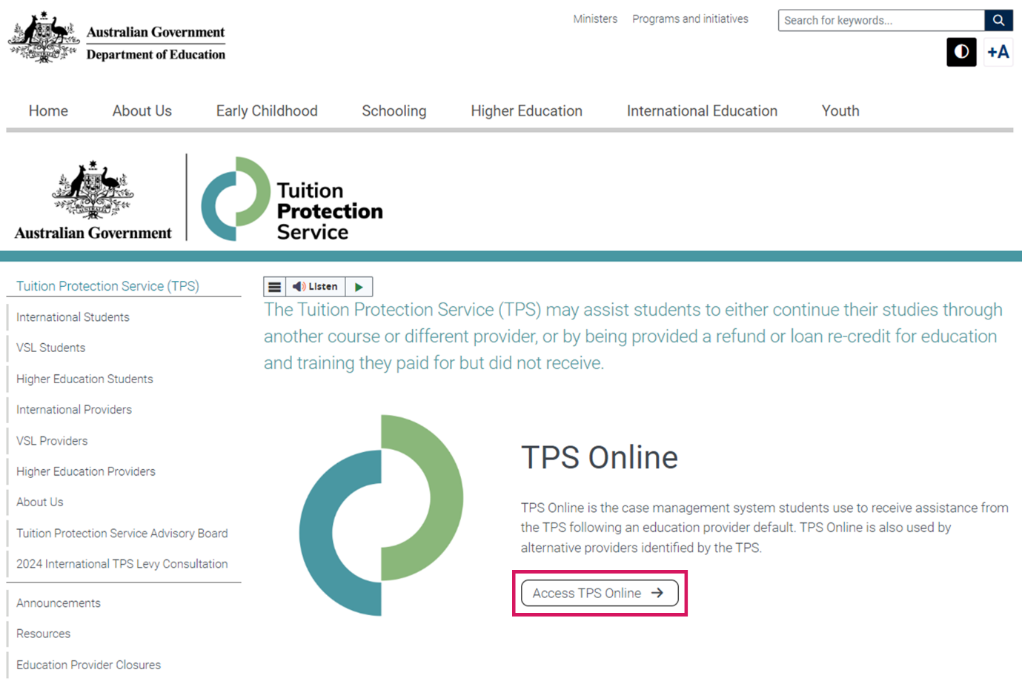

Log in to TPS Online using the login details emailed to you from the TPS.

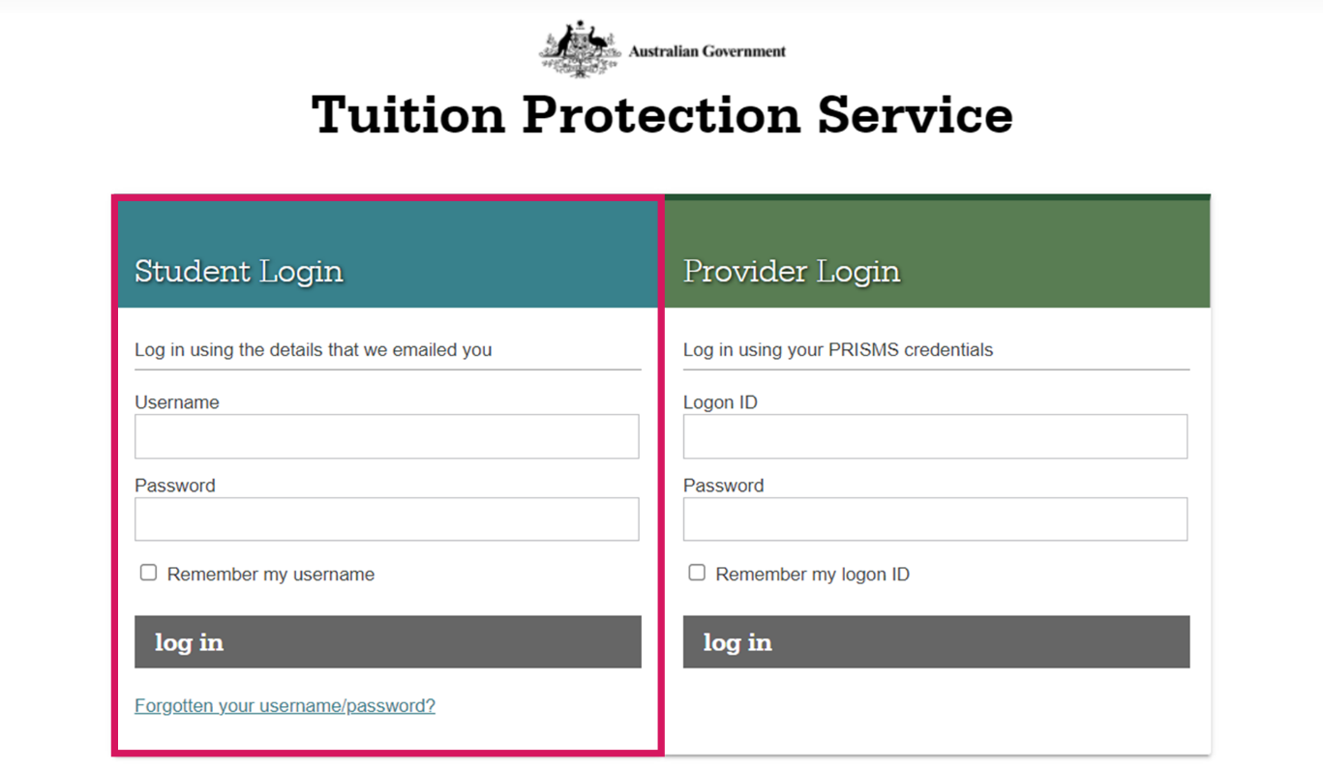

# Step 2: Multi-factor authentication

After logging in to TPS Online for the first time, you will be asked if you would like to enable multi-factor authentication to enhance the security of your account. By enabling multi-factor authentication, you will receive one-time codes each time you log in to TPS Online.

To enable multi-factor authentication, click ***enable***. You can choose to receive one-time codes via an authenticator app or via email.

If you do not wish to enable multi-factor authentication or if you would like to enable it later, click ***enable later***. You can enable multi-factor authentication later by clicking ***My account*** then ***Multi-Factor Authentication***.

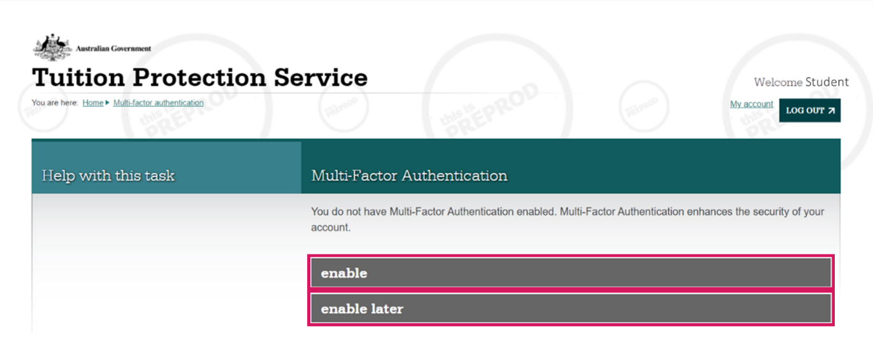

# Step 3: Change your password

When logging in to TPS Online for the first time, you will be prompted to change your password. From your TPS Online homepage, click ***change password***.

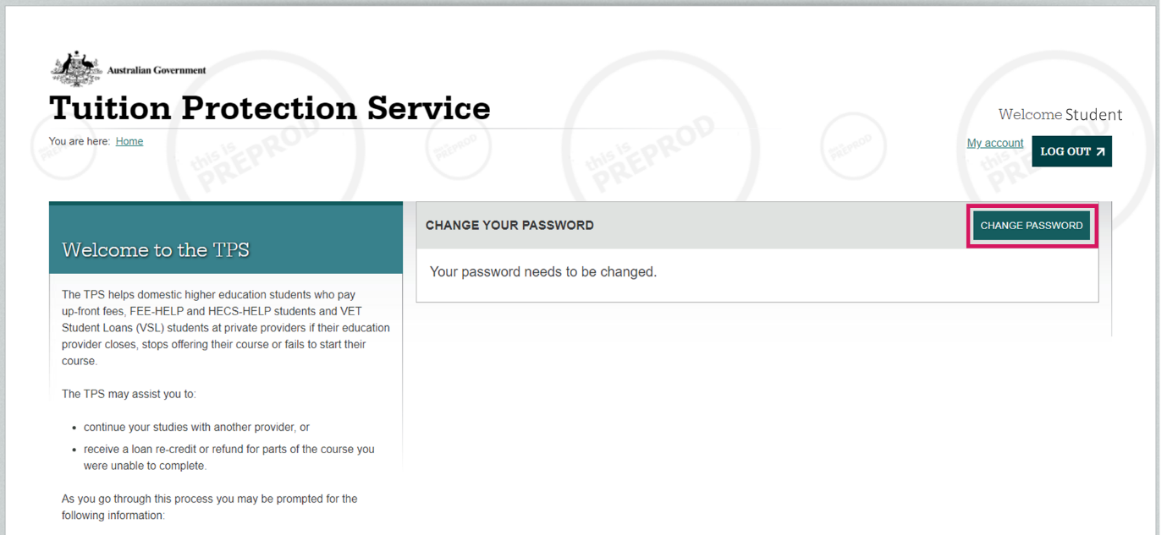

Your new password must be at least **14 characters** long and include **three different character types** (e.g. uppercase and lowercase letters, numerals and symbols).

Enter your new password twice and choose a security question and answer, then click ***save***.

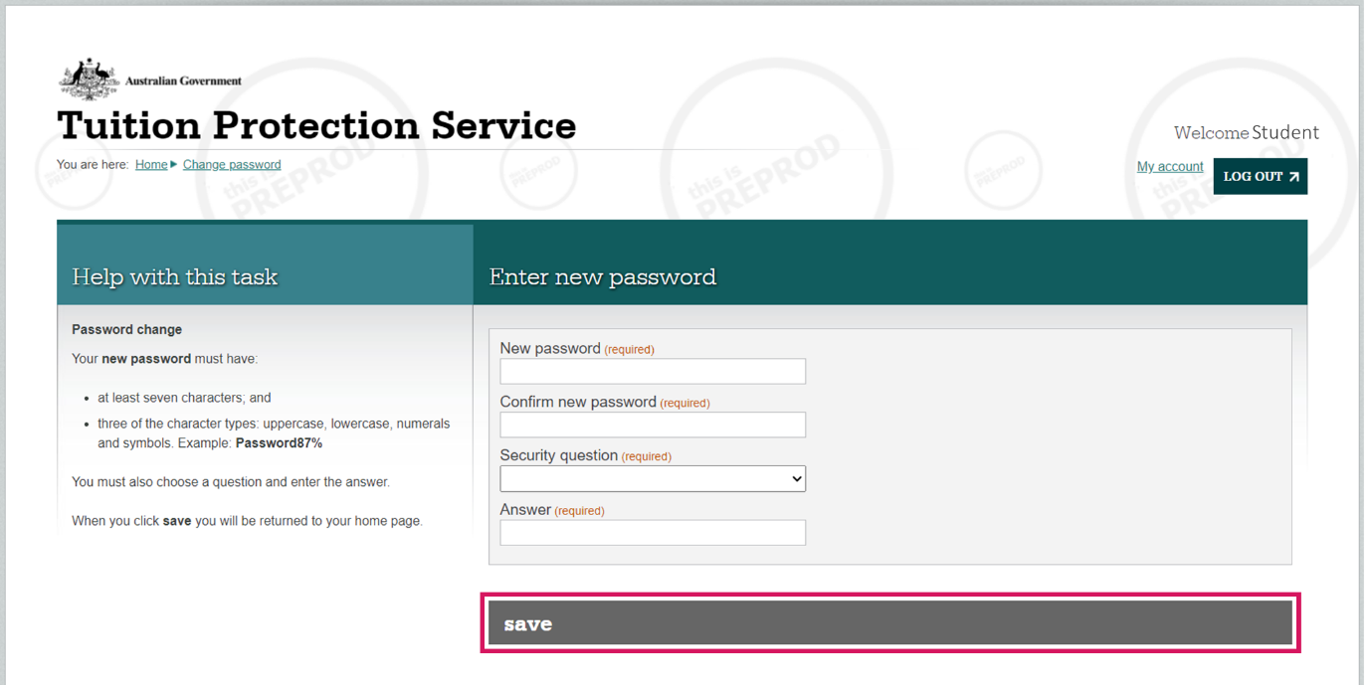

# Step 4: Your current situation

For the TPS to assist you, you will need to tell the TPS about your situation in relation to the provider closure. From your homepage, click ***next*** on the task titled ‘Your Current Situation’.

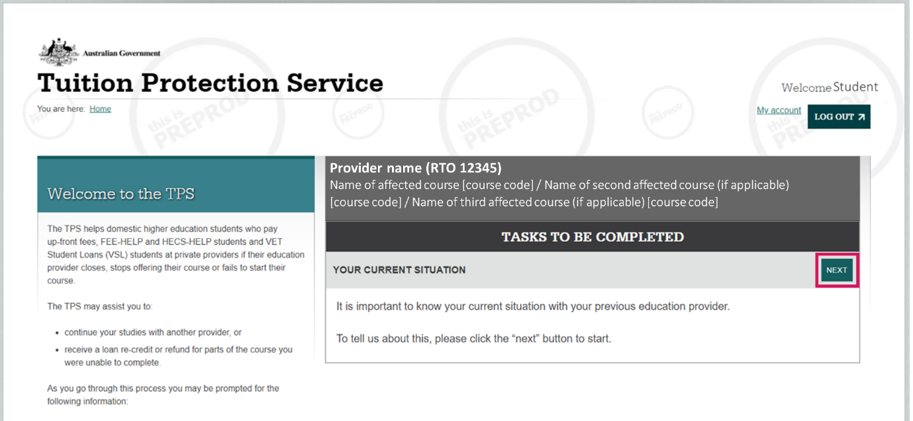

Read each option carefully and select the option that best describes your situation, then click ***save***.

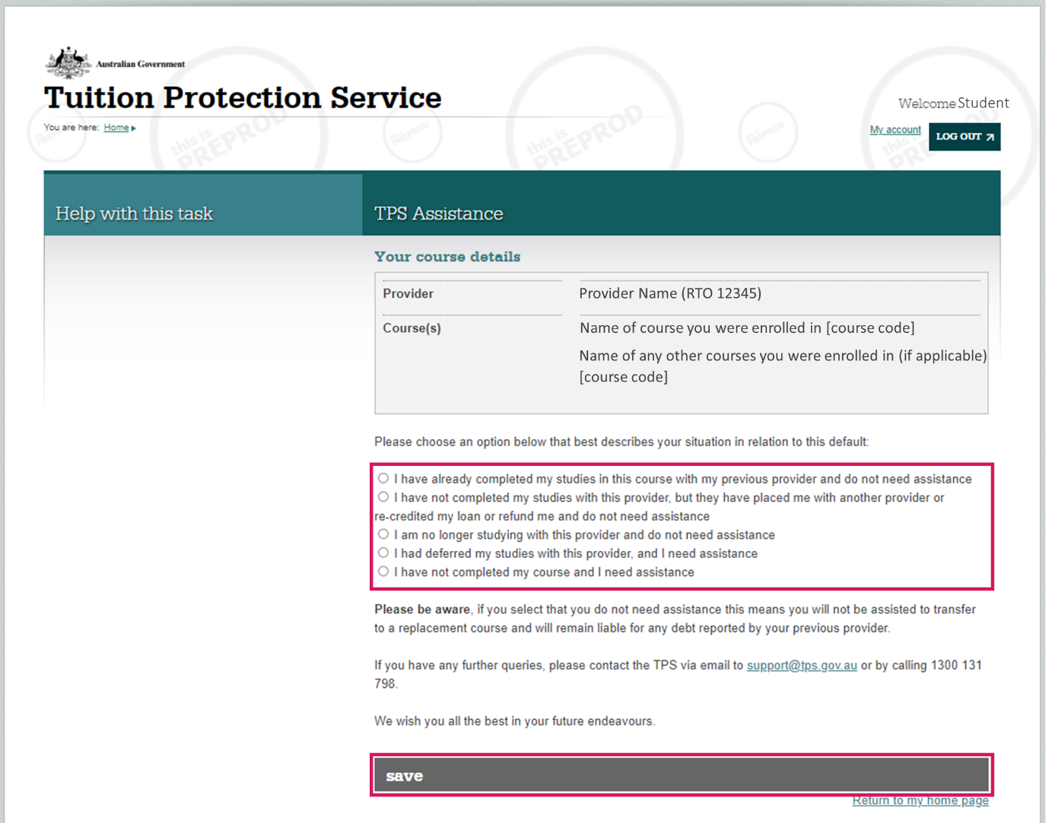

# Step 5: Proof of your identity

You must provide proof of your identity, such as a copy of your passport or driver’s licence, to receive assistance from the TPS. From your homepage, click ***start*** on the task titled ‘proof of your identity’.

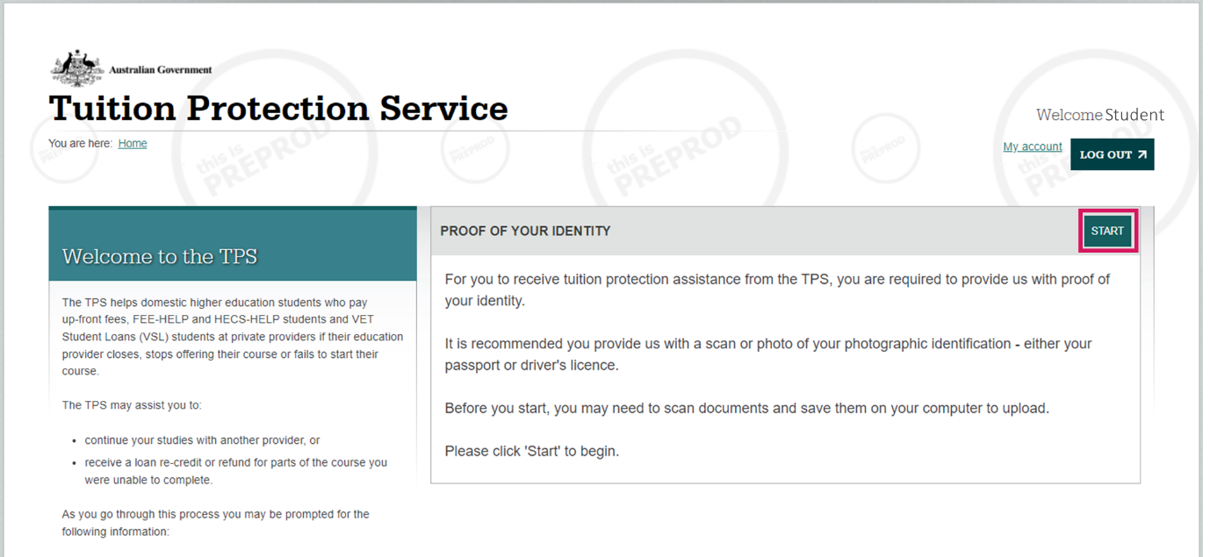

Click ***browse*** to upload a copy of your passport or driver’s licence from your device. Click ***next*** once you have uploaded your document.

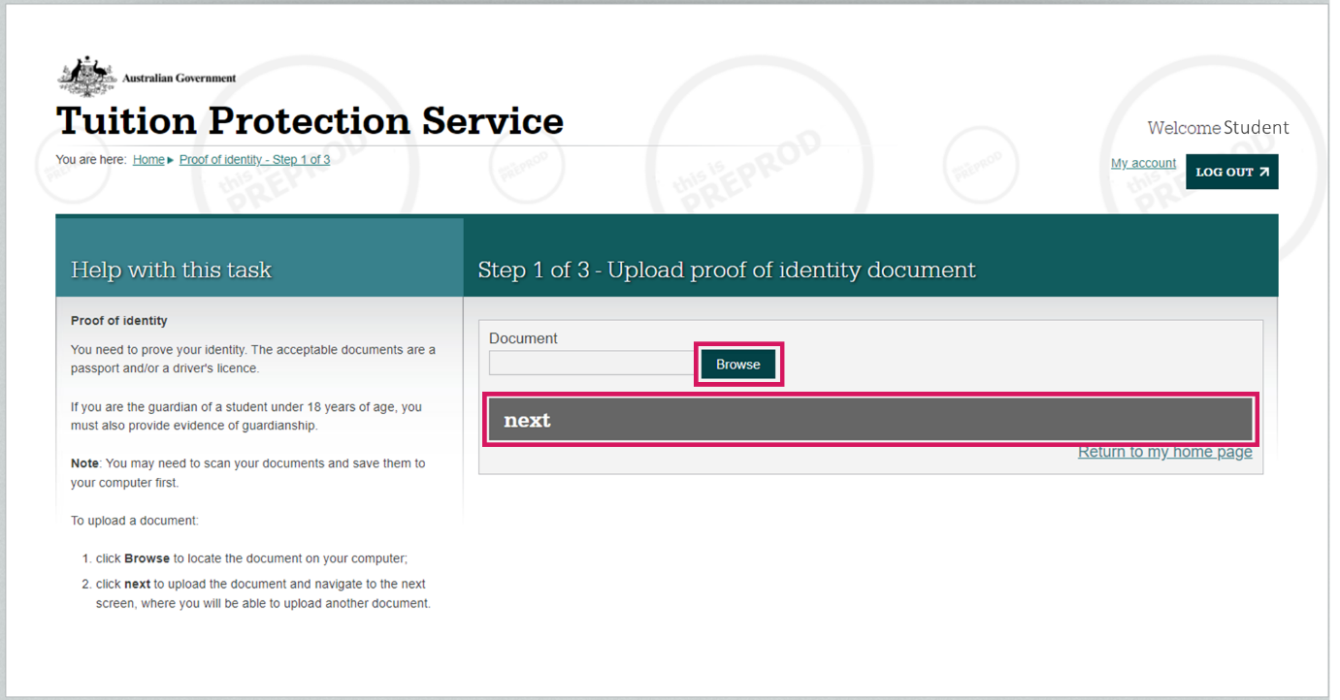

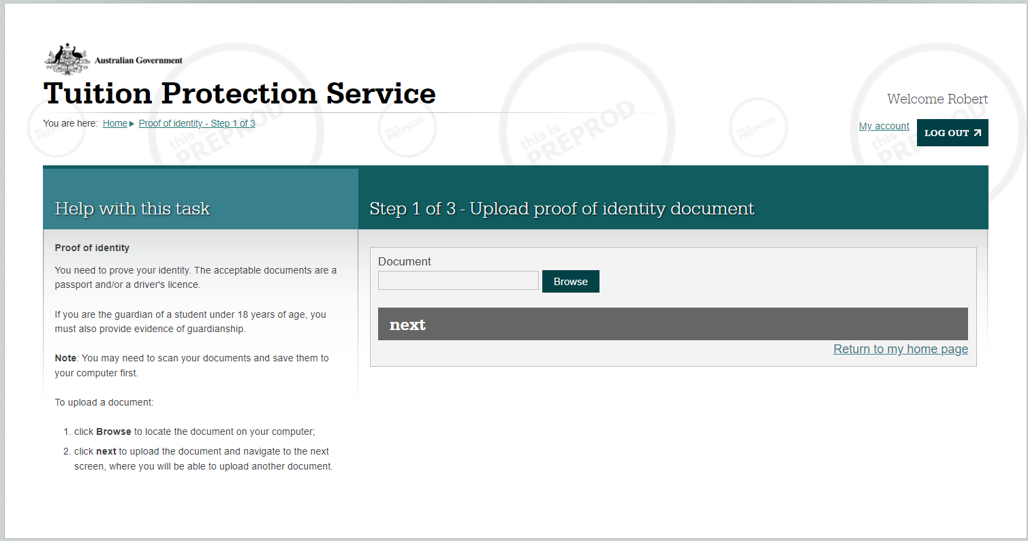

Student

You will be asked to review your proof of identity document(s). ***View*** the document you uploaded to make sure it is the right document. If you have uploaded an incorrect document, click ***delete*** then ***add another document***. If you are happy with the document, click ***next***.

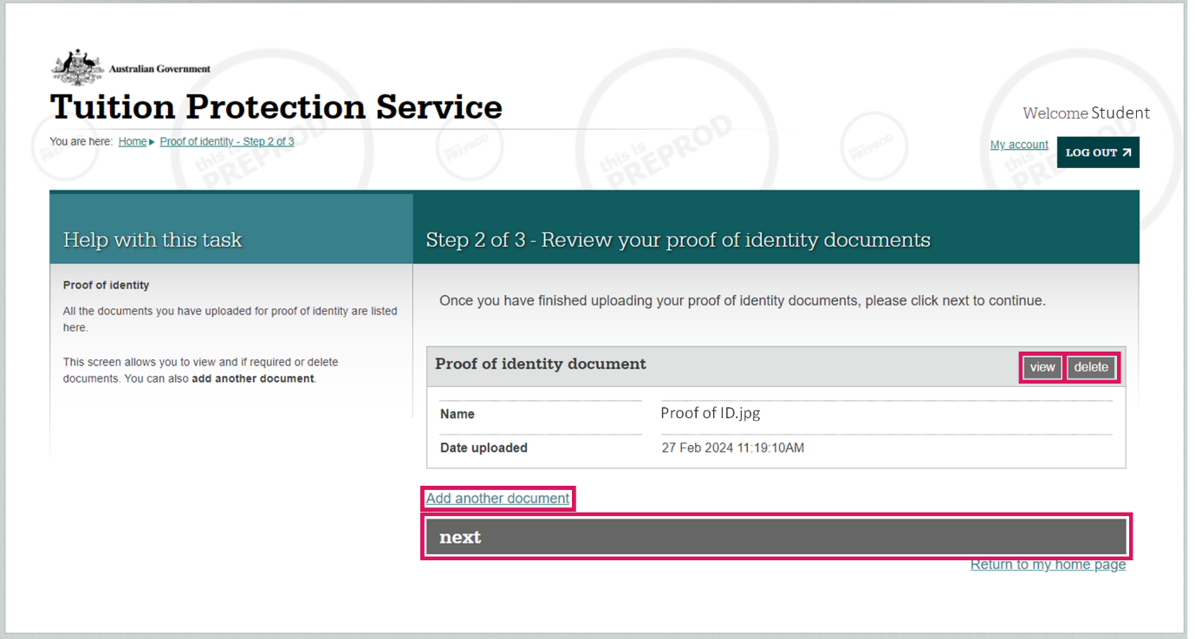

Read the declaration. If you are happy to proceed, **tick all three boxes** then click ***submit***.

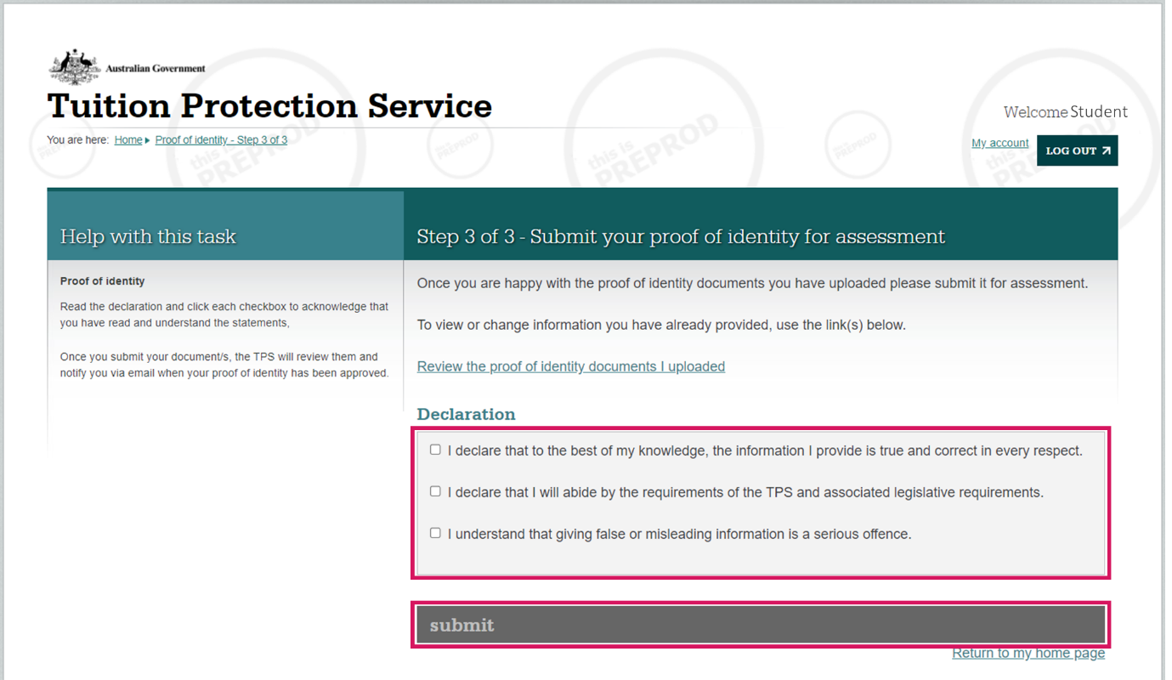

# Step 6: Review your contact details

From your homepage, click ***review*** on the task titled ‘review your contact details’ to make sure your contact details are correct.

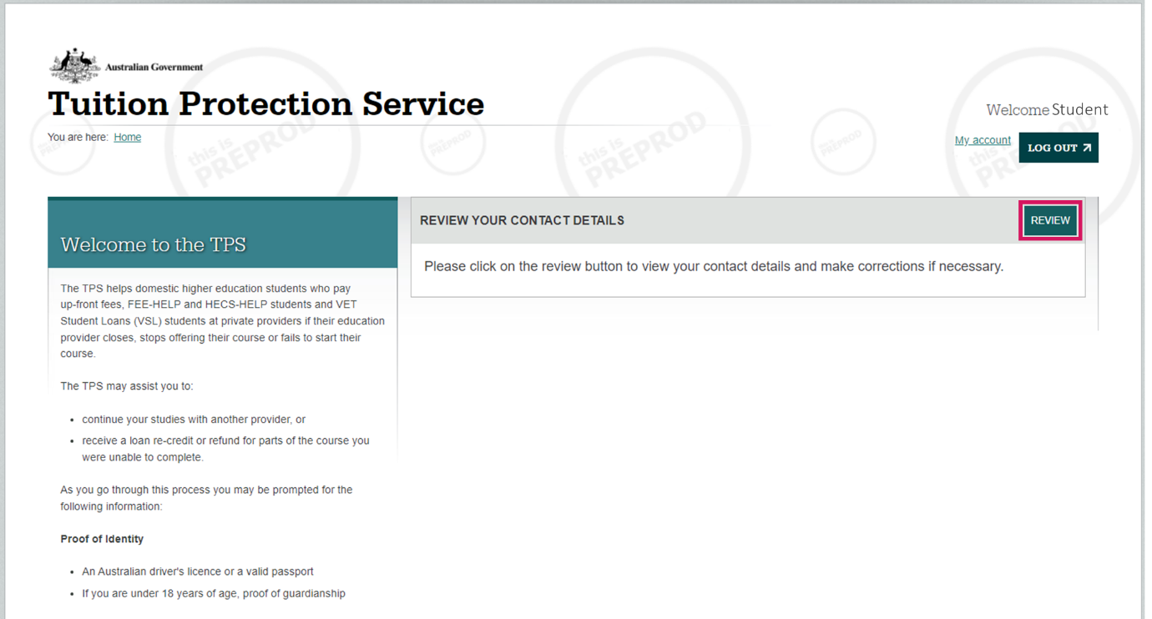

Click ***yes, my contact details are correct*** if all details are correct.

If your contact details are incorrect, click ***no, update my contact details*** and make any necessary changes.

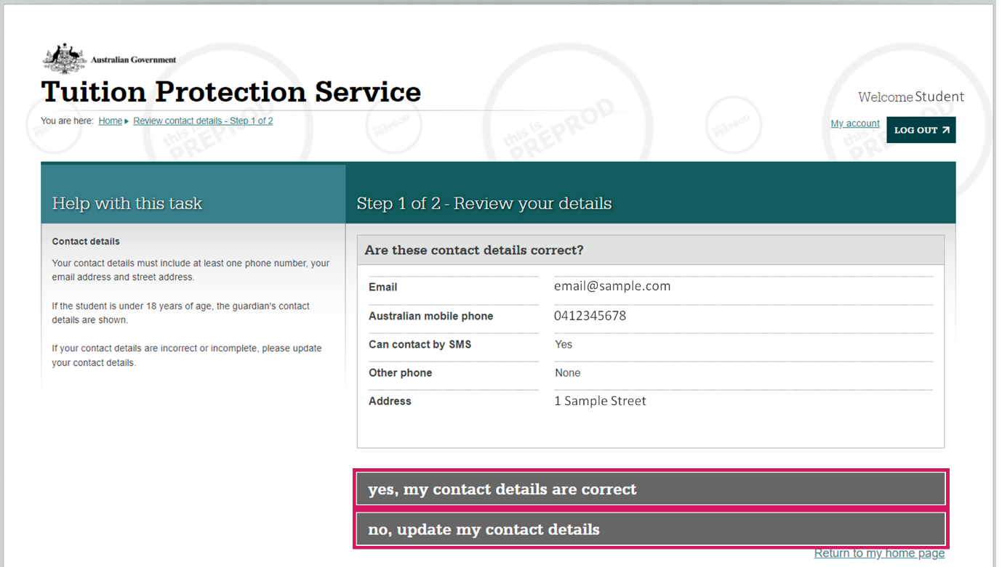

Repeat this process for the second page.

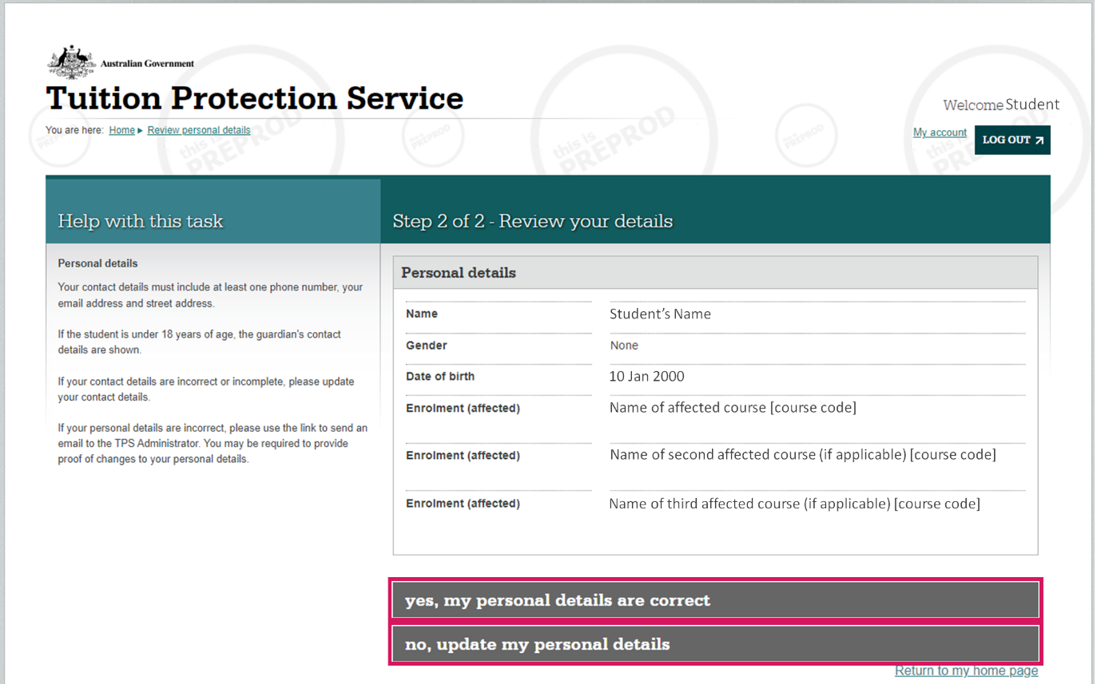

# Step 7: Enrolment information

You will be asked to provide information about your studies with the provider that closed. From your homepage, click ***start*** on the task titled ‘enrolment information’.

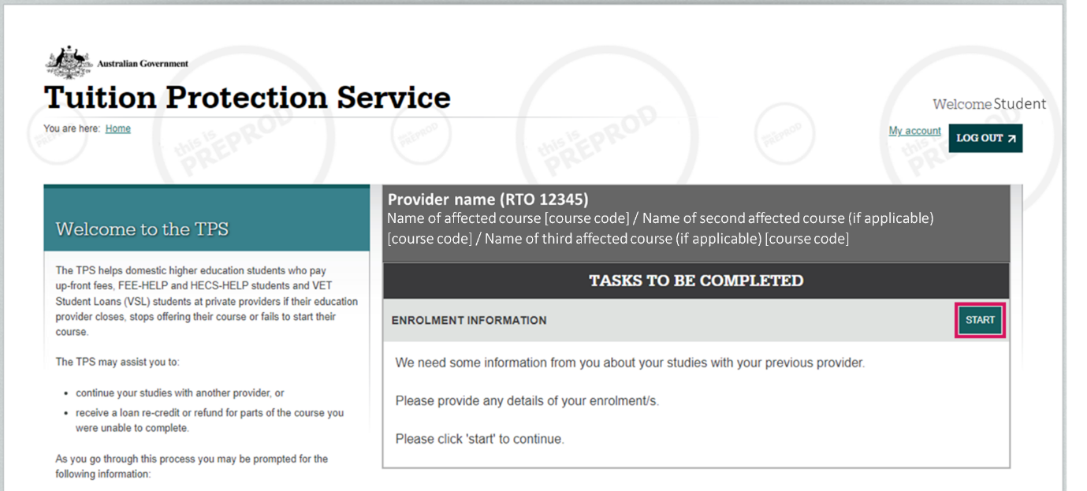

Review your enrolment information, then click ***next***.

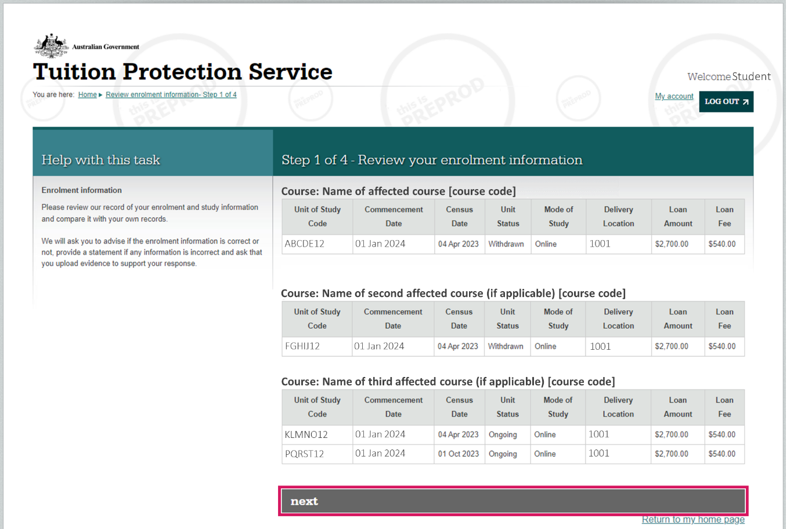

Indicate whether the enrolment information recorded in TPS Online is complete and correct using the drop-down menu.

If your enrolment information is correct, please confirm this in the ‘student statement’ box.

If your details are incorrect, please specify clearly which details are incorrect in the ‘student statement' box. You will have the opportunity to upload supporting documentation in the next step. You are welcome to also email the TPS at [support@tps.gov.au](mailto:support@tps.gov.au) advising of any inconsistencies in your enrolment information and attach any relevant documentation to support your case.

Click ***next*** to proceed.

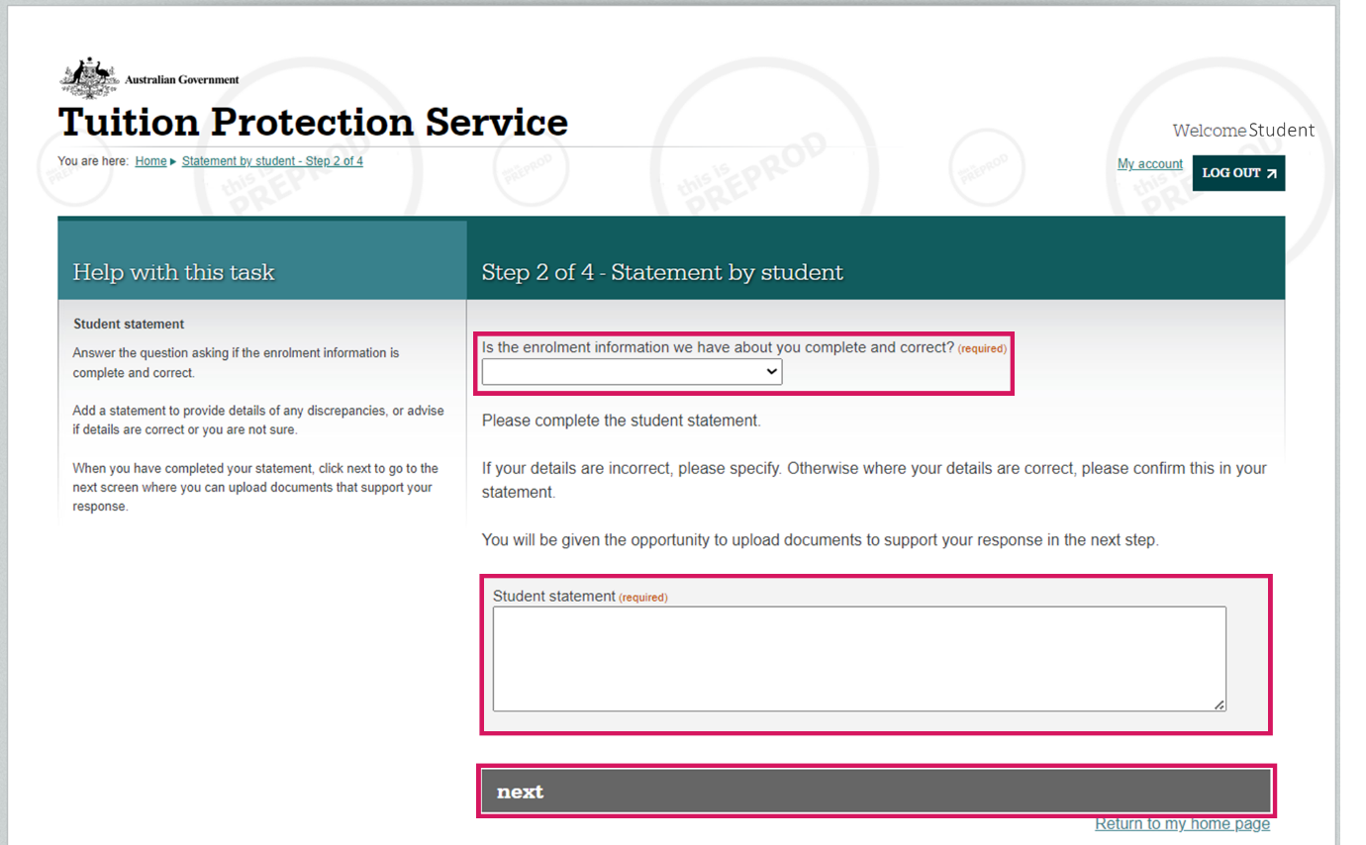

Regardless of whether your enrolment information was correct or incorrect, you **must** upload a copy of any documents that support your statement and will help the TPS to verify your enrolment information. Documents may include:

* Notification of acceptance into your course(s)
* Course structure
* Statement of Covered Fees
* Academic transcript and/or statements of attainment
* Anything else you think might assist the TPS in verifying your enrolment information, such as email correspondence you may have had with your provider regarding your enrolment.

Click ***browse*** to upload your first document, then click ***upload***.

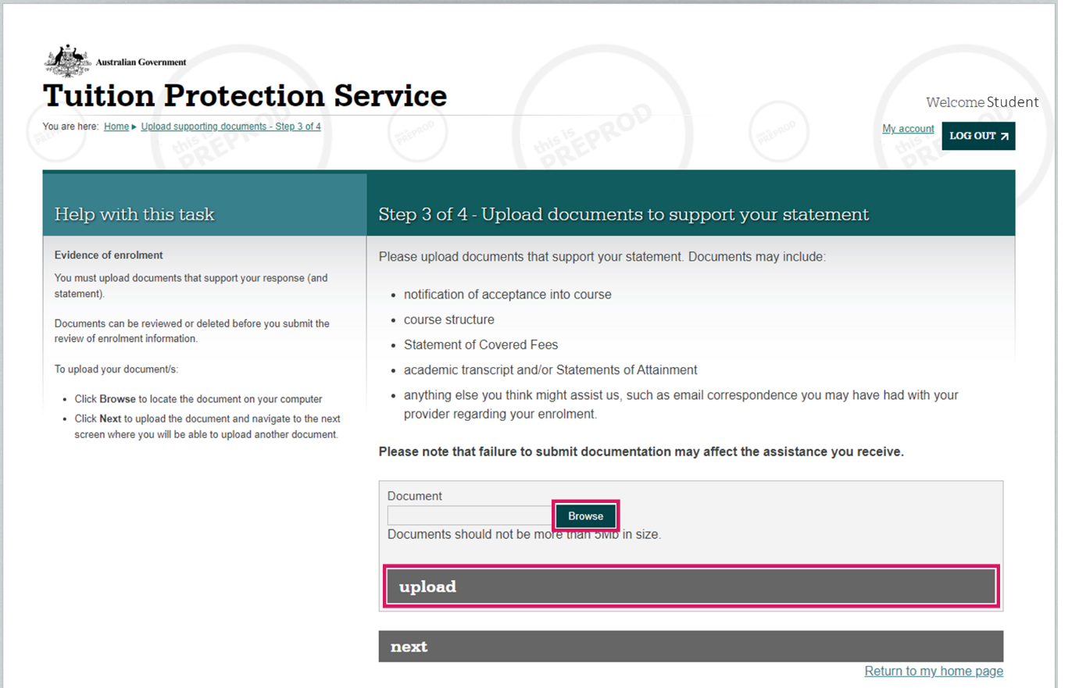

You can upload additional documents from this screen by clicking ***upload another document***.

When you have uploaded all the documents you wish to upload, review your statement then click ***submit***.

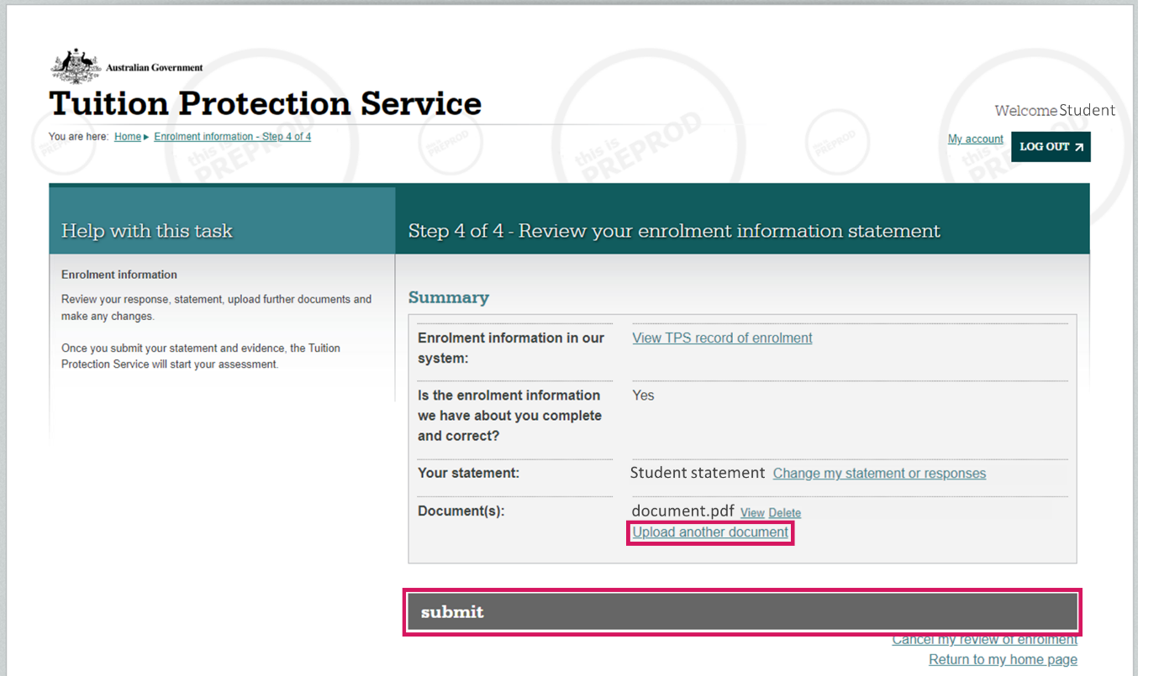

After submitting your review of enrolment information, the following notice will appear on your homepage.

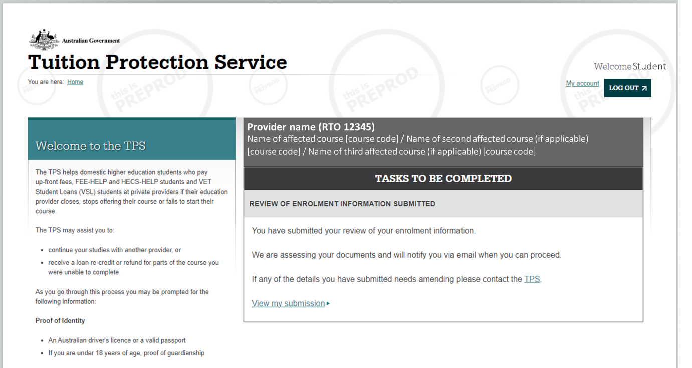

If the TPS requires more documentation to assess your enrolment information, you will be notified via email to log back in to TPS Online to provide further information. From your homepage, click ***revise*** on the task titled ‘revise your enrolment information’ to provide the additional information requested.

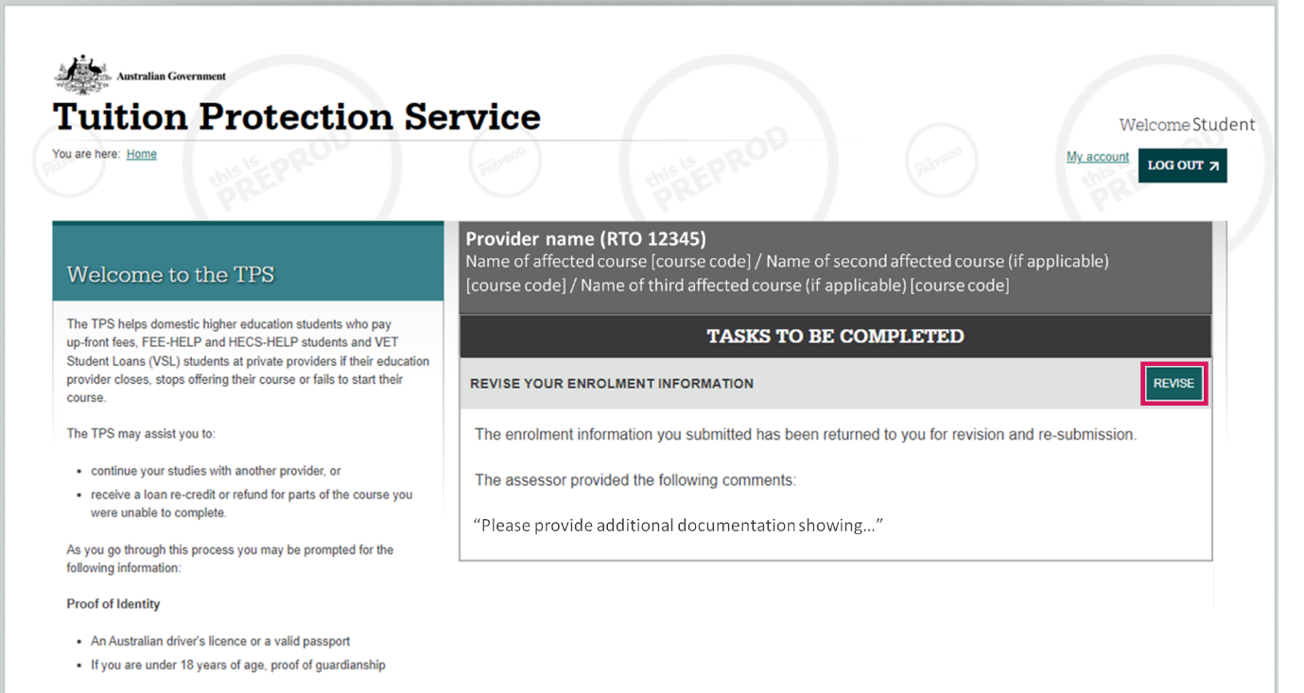

Once the TPS has assessed and verified your enrolment information, the following confirmation notice will appear on your TPS Online homepage.

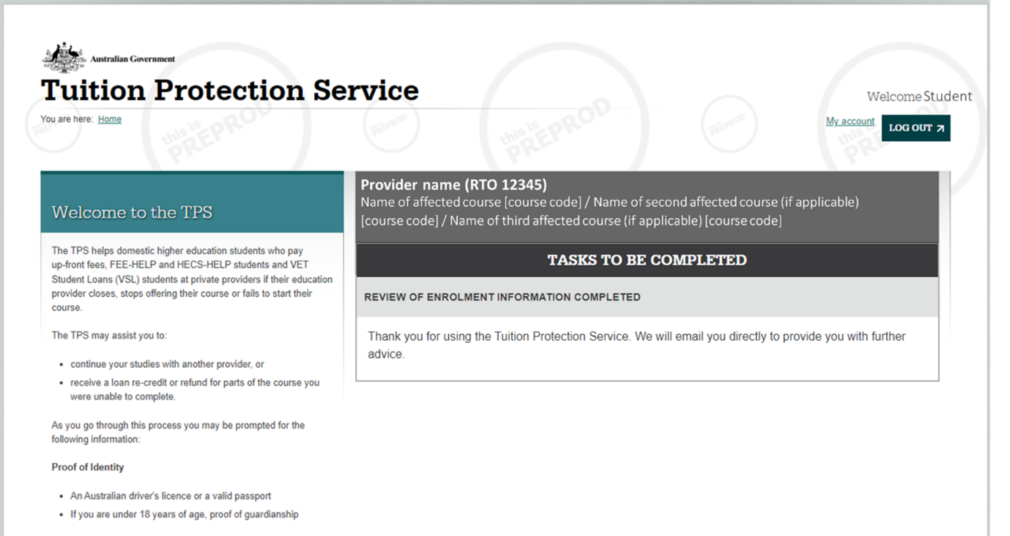

1. www.education.gov.au/tps
2. www.education.gov.au/tps