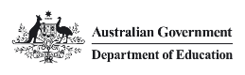

Our differences make us stronger

Inclusion and Diversity Strategy

2024–25

**Our differences make us stronger**

**Copyright**

Creative Commons BY logo

With the exception of the Commonwealth Coat of Arms, the Department’s logo, any material protected by a trade mark and where otherwise noted all material presented in this document is provided under a [Creative Commons Attribution 4.0 International](https://creativecommons.org/licenses/by/4.0/) (<https://creativecommons.org/licenses/by/4.0/>) licence.

The details of the relevant licence conditions are available on the Creative Commons website (accessible using the links provided) as is the full legal code for the [CC BY 4.0 International](https://creativecommons.org/licenses/by/4.0/legalcode) (<https://creativecommons.org/licenses/by/4.0/legalcode>).

The document must be attributed as the Department of Education Inclusion and Diversity Strategy 2024–25.

Contents

Acknowledgement of Country 5

Message from the Secretary 6

Vision 8

Purpose – why inclusion and diversity is important to us 8

Our Commitment 8

What is Diversity and Inclusion? 9

Our People (Percentage of staff at 31 December 2023*) 9

Supporting Inclusion and Diversity 10

Our Diversity Champions 10

Listening to your voice 10

Our Employee Networks 10

Inclusion and Diversity Team, People Branch 10

Celebrating Inclusion and Diversity 10

Legislative Requirements 12

Supporting Documents 12

Our Diversity Memberships 12

Our Strong Foundations 13

Our Focus Areas 15

Focus area 1 – A diverse workforce 15

Focus area 2 – Positive employee experience 15

Focus area 3 – Good governance 15

Our Strategy in Action 16

What our employees can do 16

What our leaders can do 16

Measuring Success 16

Inclusion and Diversity Action Plan 18

1: A diverse workforce 18

2: Positive employee experience 19

3: Good governance 20



# Acknowledgement of Country

The Department of Education acknowledges the Traditional Owners and Custodians of Country throughout Australia and their continuing connection to land, waters and community. We pay our respects to them and their cultures, and Elders past and present.

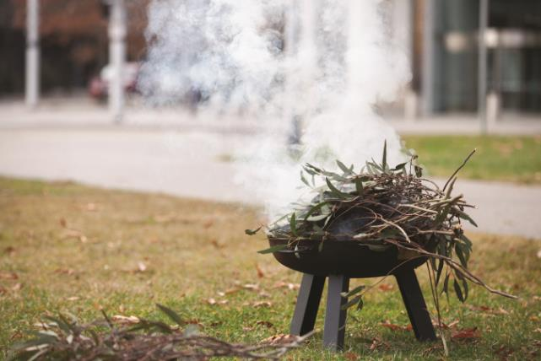

# Message from the Secretary



Colleagues,

I am pleased to present the Department of Education’s Inclusion and Diversity Strategy 2024–25.

This Strategy reflects our unwavering commitment to fostering an inclusive, safe and diverse workplace and aligns with our Inclusion and Diversity Action Plan, and Reconciliation Action Plan.

Our goal is to enhance representation and nurture and embed our core values deeply into our inclusive workplace culture to ensure that everyone can bring their whole selves to work and feel respected, valued and safe.

At our department, empowering and supporting Australians is at the heart of everything we do. This is reflected internally, by providing avenues for personal and professional development —in capability, mobility, flexibility, or a diverse array of work opportunities available to all employees.

Our focus areas are not mere objectives; they are the heartbeat of our department, inspiring us to fulfil our purpose with integrity through action. We want our department to reflect the community we serve and recognise the richness that diverse identities and perspectives bring.

We want to offer an employee experience that empowers all of us to be proud of who we are and the work we do together to benefit the Australian people.

Our senior Diversity Champions, Employee Networks, and the dedicated HR Strategy and Inclusion team are committed to guiding the implementation of the meaningful deliverables outlined in the Action Plan. Together, we will weave the threads of progress and inclusivity.

**Tony Cook PSM**   
Secretary

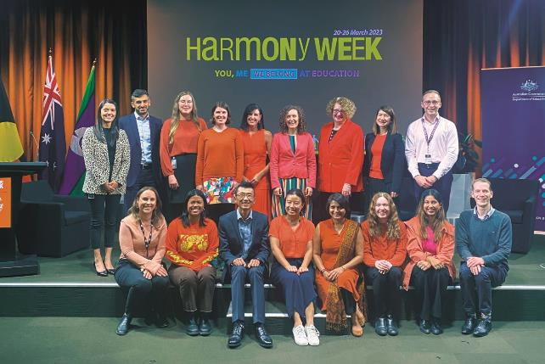

Inclusion and diversity supports people of CALD to not only be seen, but actively included in key decisions affecting them. – Fred

# Vision

The Department of Education is a place where employees feel included, safe, valued, have mutual respect for one another and have access to opportunities that support full participation at work. We demonstrate integrity by fostering and strengthening our inclusive workplace, ensuring diversity is at the heart of our core values and work culture.

# Purpose – why inclusion and diversity is important to us

The department’s purpose is to create a better future for all Australians through education. We add value by:

* providing robust, evidence-based policy advice to our Ministers
* delivering policies and programs on behalf of the government for the Australian people
* supporting Australians to achieve their full potential through education

To achieve this we must have a diverse range of perspectives and skills to support Australia’s future prosperity through our work to improve the lives of all Australians through education.

The way we do business is just as important as the business itself. An inclusive, safe and respectful culture promotes attraction and retention of our diverse workforce and a positive experience at work, where everyone can contribute to their full potential.

# Our Commitment

We value and respect difference. Being a diverse and inclusive organisation provides a shared sense of connection, cohesion and belonging, with equal opportunity for everyone to contribute, participate and achieve their full potential.

We are committed to:

* fostering a safe, respectful and inclusive culture where employees have a sense of belonging, meaningful contribution and purpose, and a positive experience at work
* building a workforce that represents, understands and best serves the Australian community
* ensuring our people embody acceptance and respectful relationships without prejudice so we can all work in a safe and inclusive workplace
* recognising that people’s identities and experiences are multi layered
* providing all employees with equal access to employment opportunities, ensuring that they are treated with fairness and respect and are not subject to discrimination or harassment in the workplace
* providing flexible workplace practices for all employees to achieve a balance between work and family responsibilities
* recognising and supporting the future inter‑generational workforce

# What is Diversity and Inclusion?

**Diversity** is the range of human differences, personal and social characteristics that make us unique and shape our view of the world, including but not limited to our backgrounds, life experiences, thoughts and beliefs. Diversity is also about recognising, respecting and valuing differences based on (but not limited to) race, colour, ethnicity, gender and gender identity, age, disability, sexual orientation, relationship/family status and caring responsibilities.

**Inclusion** is getting the right mix of diverse people in an organisation to work together to improve performance and wellbeing. It is achieved when a diversity of people feel they are respected, connected, contributing and progressing at work.[1]

# Our People (Percentage of staff at 31 December 2023*)

Our People (Percentage of staff at 31 December 2023*)
* Based on employees who choose to self-identify in the HR system
Infographic showing the following values:
3.2% First Nations
6.3% People with Disability
8.1% People from non-English speaking backgrounds**
** Calculated using NESB 1 definition provided by the APSC. NESB 1 refers to people born overseas who arrived in Australia after the age of five and whose first language is not English.
37% Mature Age employees (45 years +)^
^ The Australian Bureau of Statistics defines mature age workers as 45+.
12% LGBTQIA+ employees#
# Based on employees who responded to the 2023 APS Employee Census.
67.8% Female employees

* Based on employees who choose to self-identify in the HR system

** Calculated using NESB 1 definition provided by the APSC. NESB 1 refers to people born overseas who arrived in Australia after the age of five and whose first language is not English.

^ The Australian Bureau of Statistics defines mature age workers as 45+.

# Based on employees who responded to the 2023 APS Employee Census.

# Supporting Inclusion and Diversity

## Our Diversity Champions

The department’s diversity champions provide visible leadership, sponsorship and commitment to inclusion and diversity. They play an important role in supporting our people who identify with diversity groups through raising awareness, and promoting initiatives that support our people to develop and adopt inclusive practices to support their colleagues who identify with diversity groups.

## Listening to your voice

Our Employee Network members shared with us what inclusion and diversity means to them. You can find their insights and perspectives throughout this strategy.

## Our Employee Networks

The department’s employee networks are integral in driving and promoting diversity and inclusion initiatives. They provide peer support and connection for employees who identify with specific diversity groups and allies. They work with People Branch to drive inclusive workplace conversations, training, initiatives, and events. Our networks are:

* Ability and Carers
* Aboriginal and Torres Strait Islander Employee Network
* Culturally and Linguistically Diverse (CALD)
* Gender Equity (GEN)
* Pride

## Inclusion and Diversity Team, People Branch

The Inclusion and Diversity team drive the implementation of this Strategy, support the Diversity Champions and Employees Networks, and facilitate reporting and compliance activities.

## Celebrating Inclusion and Diversity

The department supports inclusion and diversity by promoting and celebrating a number of days of significance. These days are coordinated corporately in collaboration with our employee networks. Please refer to the Inclusion and Diversity Intranet page for the calendar of events.

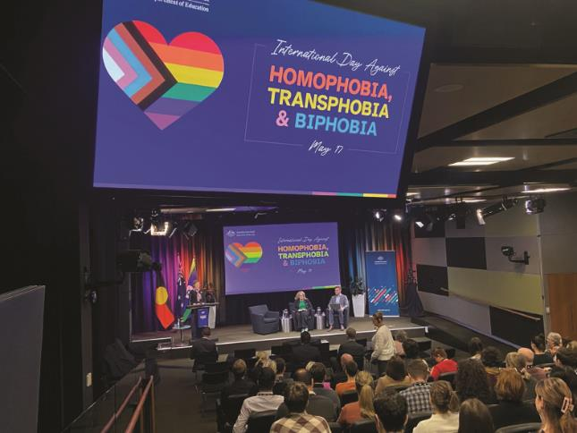

Inclusion and diversity means recognising and celebrating our differences by creating a workplace that values, connects, and empowers us. – Sunita

# Legislative Requirements

As an employer, and program and service provider, the Department is bound by several Commonwealth laws. Some of those that relate to the Strategy are:

* 1. Public Service Act 1999
  2. Australian Human Rights Commission Act 1986
  3. Age Discrimination Act 2004
  4. Sex Discrimination Act 1984
  5. Racial Discrimination Act 1975
  6. Disability Discrimination Act 1992
  7. Workplace Gender Equality Act 2012
  8. Carer Recognition Act 2010
  9. Fair Work Act 2009

# Supporting Documents

This Strategy is supported by the department’s [Reconciliation Action Plan 2023–2025](https://www.education.gov.au/preview-link/node/6146/6e385756-6c1c-450c-8470-a98873af3bf1) and is informed by [Commonwealth Aboriginal and Torres Strait Islander Workforce Strategy 2020–2024](https://www.apsc.gov.au/working-aps/diversity-and-inclusion/aboriginal-and-torres-strait-islander-workforce/commonwealth-aboriginal-and-torres-strait-islander-workforce-strategy-2020-2024), the [APS Disability Employment Strategy 2020–25](https://www.apsc.gov.au/publication/australian-public-service-disability-employment-strategy-2020-25), and the [APS Gender Equality Strategy 2021–26](https://www.apsc.gov.au/publication/australian-public-service-gender-equality-strategy-2021-26).

# Our Diversity Memberships

* Australian Network on Disability
* Diversity Council of Australia
* JobAccess
* Pride in Diversity

Our Diversity Memberships

Australian Disability Network.  Job Access. Driving disability employment.  

# Our Strong Foundations

This Strategy seeks to build on the department’s already strong ongoing initiatives, frameworks and programs to strengthen our commitment to workplace inclusion and diversity now and into the future.

Inclusion and diversity in action at our department looks like:

* Progress against our Reconciliation Action Plan
* A dedicated Indigenous Liaison Officer
* A dedicated Disability Contact Officer
* Accredited Breastfeeding Friendly workplace
* Participation in whole of government entry-level programs and career pathways programs
* Participation in the Jawun secondment program and Pat Turner Scholarship
* Annual diversity calendar to recognise and celebrate dates of national significance, including NAIDOC week and National Reconciliation Week
* Use of Affirmative measures recruitment and Employment Program
* Workplace adjustments
* Range of training options such as First Nations Cultural Awareness, Disability Awareness, Mental Health First Aid and Ally Awareness training.
* Dedicated management and leadership programs with access to professional coaching services
* Generous study assistance
* A range of inclusive and contemporary employment entitlements such as flexible work, cultural leave, parental leave, support for employee’s affected by domestic and family violence, support for breastfeeding in the workplace, support for gender affirmation and transitioning employees.
* Employee Networks are consulted on relevant policy development through the department’s Consultative Committee.
* A range of [**wellbeing supports**](https://sharedservicescentre.sharepoint.com/sites/edu-people/SitePages/Workplace-Mental-Health-Hub.aspx) including Employee Support Officers and Employee Assistance Program, providing free counselling and support to employees and their families.

**In 2023, 83% of the department’s APS employee census respondents, said that the department supports and actively promotes an inclusive workplace culture.’**



Inclusion and diversity means acceptance by all for who you are as a person and not where you originated from. – Trini

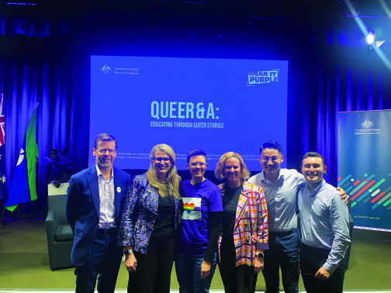

Inclusion and diversity means empowering people by respecting and embracing what makes them different! – Simone

# Our Focus Areas

The department has three focus areas for progressing inclusion and diversity in our workplace that support our Inclusion and Diversity Action plan.

**1**

## Focus area 1 – A diverse workforce

Our workforce is representative of the Australian community we serve. We are a workplace that values the unique skills, experiences and perspectives of every employee.

**2**

## Focus area 2 – Positive employee experience

Our people foster collaboration and connection, and value and recognise diversity. We are a workplace that is accessible, safe, respectful and inclusive. We provide opportunities to grow awareness, and understanding of inclusion and diversity, including cultural capability and integrity.

**3**

## Focus area 3 – Good governance

Our workplace actively participates in the implementation of Commonwealth diversity strategies and programs to embed inclusive work practices. We ensure our reporting mechanisms reflect any commitments to report progress on priority actions.

# Our Strategy in Action

## What our employees can do

* Actively seek and consider a diverse range of perspectives to inform day-to-day work
* Actively practice inclusive behaviours and report, or constructively challenge, non-inclusive behaviour
* Join an employee network and participate in inclusion and diversity initiatives and events
* Be curious and commit to learning about cultural differences and participate in learning opportunities to develop your awareness and understanding
* Update your diversity details in HUB to enable a better understanding of our workforce and tailor services and support
* Share stories and experiences to contribute to inclusion and diversity in Education

**In 2023, 85% of the department’s APS Employee Census respondents said they receive the respect that deserve from their colleagues at work’**

## What our leaders can do

* Cultivate an safe environment where employees can share ideas and speak up when they have differing views
* Set a positive example for your team by demonstrating inclusive behaviours
* Encourage and support your team members to actively contribute to inclusion activities and initiatives, by participating in events, employee networks and training opportunities
* Actively pursue opportunities to drive the department’s inclusion and diversity agenda and build our reputation as an inclusive employer
* Take appropriate action to address behaviours not in line with APS Values and Code of Conduct
* Ensure diverse perspectives are applied in all that we do, including policy advice, development and delivery

**In 2023, 87% of the department’s APS Employee Census respondents said that their supervisors actively ensure that everyone can be included in workplace activities’**

# Measuring Success

The Strategy will be reviewed on an annual basis to monitor progress on actions to ensure ongoing relevance and alignment to the department’s strategic goals. It will be managed and monitored by People Branch in consultation with the diversity champions and the diversity employee networks. Progress reports will be provided to the People, Culture and Integrity Committee (PCIC) twice a year. PCIC will oversee the Strategy, providing direction and reviewing progress against commitments.

To measure our progress, information will be gathered from the following evidence-based insights:

* Employee representation data
* Training participation, affirmative measures recruitment and reasonable adjustments data
* Annual APS Employee census data – with attention to employee sentiment on inclusion, wellbeing, flexibility, mobility and leadership
* Annual Gender pay-gap analysis
* Progress against the Inclusion and diversity action plan and the Reconciliation Action plan.

Our external reporting activities include: Annual Report, State of the Service Report, APS Employment Database, Reconciliation Australia and APS Census Action Plans.

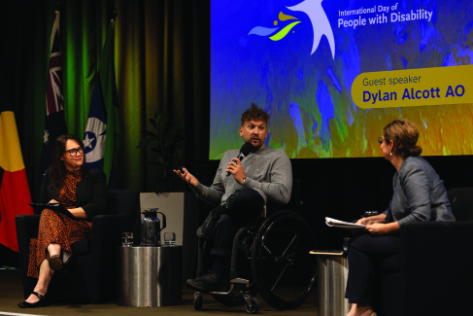

Strength. Respect. Integrity in action. United through our uniqueness. To me, it means having a sense of belonging and connection. – Stacey

# Inclusion and Diversity Action Plan

Building on our strong ongoing foundations, we will continue to prioritise inclusion and diversity through the Inclusion and Diversity Action Plan. Actions will be undertaken in consultation with the relevant stakeholders including Employee Network and Diversity Champions.

## 1: A diverse workforce

Our workforce is representative of the Australian community we serve. We are a workplace that values the unique skills, experiences and perspectives of every employee.

|  |  |  |
| --- | --- | --- |
| Action | Delivery | Owner |
| **1.1** Ensure recruitment experience is accessible for all candidates, through improved panel guidance | 2024 – design and deliver  2025 – embed and review | * People Branch: Recruitment, Inclusion & Diversity * Indigenous Liaison Officer * Disability Contact Officer |
| **1.2** Review approach to assessment of need during on-boarding, to ensure reasonable adjustments are understood and provided | 2024 – design and deliver  2025 – embed and review | * People Branch: Recruitment, Inclusion and Diversity and Health and Performance. |
| **1.3** Encourage the use of affirmative measure recruitment, leveraging best practice knowledge from across the APS to attract diverse candidates | 2024 – embed  2025 – embed and review | * People Branch: Recruitment, Inclusion & Diversity * Indigenous Liaison Officer * Disability Contact Officer * Business areas |
| **1.4** Participate in programs and pathways to attract employees from diverse backgrounds, including the Indigenous Apprenticeship Program and the Stepping Into Program | 2024 – deliver and embed  2025 – deliver and embed | * People Branch: Recruitment, Inclusion & Diversity * Indigenous Liaison Officer * Disability Contact Officer |

## 2: Positive employee experience

Our people foster collaboration and connection, and value and recognise diversity. We are a workplace that is accessible, safe, respectful and inclusive. We provide opportunities to grow awareness, and understanding of inclusion and diversity, including cultural capability and integrity.

|  |  |  |
| --- | --- | --- |
| Action | Delivery | Owner |
| **2.1** Refresh induction to include information about our commitment to inclusion and diversity, supports, networks and champions | 2024 – design and deliver  2025 – embed and review | * People Branch: Recruitment, Inclusion & Diversity |
| **2.2** Development of Employee Network allyship resources to foster a culture of support and advocacy | 2024 – design and deliver  2025 – embed | * Communication Branch: Corporate Communication * People Branch: Inclusion and Diversity * Employee Network Chairs * Diversity Champions |
| **2.3** Facilitate the refresh and relaunch of the Employee Networks to increase awareness and membership | 2024 – design and deliver  2025 – embed | * Communication Branch: Corporate Communication * People Branch: Inclusion and Diversity * Employee Network Chairs * Diversity Champions |
| **2.4** Develop a communication campaign focused on showcasing our Indigenous Liaison Officer and Disability Contact Officer roles | 2024 – design and deliver  2025 – embed | * Communication Branch: Corporate Communication * People Branch: Inclusion and Diversity |
| **2.5** Refresh and promote the department’s Aboriginal and Torres Strait Islander Cultural Protocols Guide | 2024 – design and deliver  2025 – embed | * People Branch: Inclusion and Diversity * Communication Branch: Corporate Communication * Indigenous Liaison Officer |
| **2.6** Support the professional development of diverse employees and stay current with best practice strategies to promote cultural safety and integrity. This includes membership with peak diversity organisations, for example, Pride in Diversity and the Australian Network on Disability and attendance at meetings and events within budget requirements | 2024 – design and deliver  2025 – embed | * People Branch: Inclusion and Diversity * Diversity Champions * Employee Networks |
| **2.7** Champions and Employee Network Chairs connect with industry experts in inclusion and/or diversity to uplift their capability and participate in APS wide bodies and networks | 2024 – design and deliver  2025 – embed | * People Branch: Inclusion and Diversity * Communication Branch: Corporate Communication * Diversity Champions * Employee Networks |
| **2.8** Diversity Champions and Employee Network Chairs meet regularly throughout the year to agree on priorities, leverage intersectionality and celebrate success | 2024 – design and deliver  2025 – deliver and embed |  |

## 3: Good governance

Our workplace actively participates in the implementation of Commonwealth diversity strategies and programs to embed inclusive work practices. We ensure our reporting mechanisms reflect any commitments to report progress on priority actions.

|  |  |  |
| --- | --- | --- |
| Action | Delivery | Owner |
| **3.1** Promote the benefits of sharing and updating personal details, including diversity status, in the HR system. | 2024 – design and deliver  2025 – embed | * People Branch: Recruitment, Inclusion & Diversity * Indigenous Liaison Officer * Disability Contact Officer |
| **3.2** Support exit processes that ensure a safe environment for employees to disclose reasons for leaving | 2024 – embed  2025 – embed and review | * People Branch: Recruitment, Inclusion and Diversity and Health and Performance. |
| **3.3** Regular monitoring and reporting of our diversity profile to relevant stakeholders | 2024 – deliver  2025 – deliver |  |

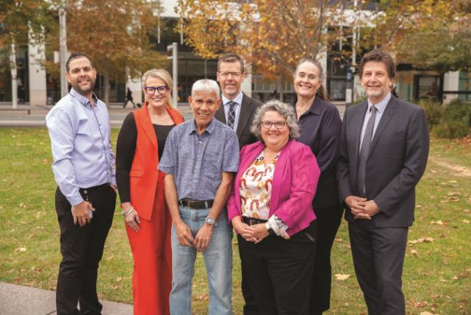

For me, inclusion and diversity means cultural safety. I can walk in two worlds and still belong! – David

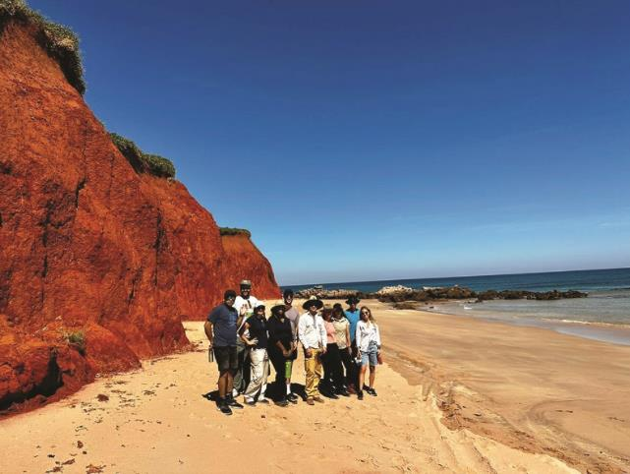

True inclusion and diversity means building a culture of true understanding and acceptance, not one of mere tolerance but one that celebrates all that makes us unique. – Mackenzie

**Our differences make us stronger**



2715

1. Diversity & Inclusion Explained | Diversity Council Australia ([dca.org.au](http://dca.org.au))