****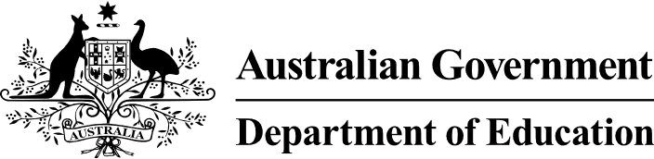

# Note on India’s Scheme for Promotion of Academic and Research Collaboration Phase III

At the 6 November meeting of the Australia India Education and Skills Council, the Indian Minister of Education announced dedicated funding as part of **India’s Scheme for Promotion of Academic and Research Collaboration** (SPARC) for joint Australia-India research projects. Phase III of the SPARC program aims to bring together Indian and Foreign universities to work on specific sectoral research. This is pooled funding and will not all be allocated to a single project.

Submissions from eligible Australian institutions are encouraged in areas of national strength and expertise and where there are synergies with India such as rare-earths, critical minerals, agritech and advanced computing (particularly quantum). Submissions will also be accepted in other thematic areas.

The scheme enables productive academic cooperation in areas including joint research projects, exchange of faculty and students and joint degrees. Successful proposals will be funded up to   
31 March 2026.

#### Call for Project Proposals

India’s Ministry of Education is currently [Calling for Proposals](https://sparc.iitkgp.ac.in/assets/pdf/Final-SPARC-Calll.pdf) for this funding. Proposals must be submitted online through the [SPARC website](https://sparc.iitkgp.ac.in). The Call for Proposals will close on **15 February 2024**.

The [Call for Proposals](https://sparc.iitkgp.ac.in/assets/pdf/Final-SPARC-Calll.pdf) document contains further information regarding points that should be addressed in a project submission, essential criteria and expected project outcomes.

#### Contacts

Potential applicants should contact Nathaniel Webb, First Secretary (Education and Research) ([Nathaniel.Webb@dfat.gov.au](mailto:Nathaniel.Webb@dfat.gov.au)) and Anu Jain, Senior Policy Officer ([Anu.Jain@dfat.gov.au](mailto:Anu.Jain@dfat.gov.au)) for further information.