**Review of policy interventions to increase socio-economic diversity and improve learning outcomes**

Report commissioned by the Independent Expert Panel for the Review to Inform a Better and Fairer Education System

24 October 2023

Contents

1 Executive summary 1

2 Context and approach 4

2.1 Project objective and context 4

2.2 Project approach 5

3 Findings 8

3.1 Legislated quotas 8

3.2 Removal of fees 12

3.3 Capping fees 16

3.4 Reducing academic selectivity and tracking by schools 21

3.5 School zone flexing and lotteries 25

3.6 Preference matching, including controlled choice 30

3.7 Financial incentives to schools 35

3.8 Incentives to educators 39

3.9 Alternative teaching, assessment and delivery models 45

3.10 Networked schools and teaching capacity exchange 51

4 Policy implications for Australia 55

4.1 The greatest impact can be achieved through a combination of interventions 55

4.2 Concurrent policies can also undermine each other 55

4.3 Concentrations of First Nations students are a special case 56

4.4 International lessons transcend differences in politics, culture and geography 58

4.5 Changes can be phased in 58

4.6 There are several factors common to successful interventions 58

5 Recommendations 59

5.2 Policy interventions that could be tested 59

5.3 Proposals to strengthen accountability and regulation 60

5.4 Recommended follow-up areas of enquiry 62

Appendix A Measuring school and community differences 64

Appendix B Additional PISA analysis 66

# Executive summary

Governments and school systems around the world use different policy interventions to address the risk or emergence of concentrations of disadvantage and segregation along racial or socio-economic lines. Nous Group (Nous) was engaged by the Australian Government Department of Education to undertake a policy scan of such reforms to explore their efficacy and transferability to an Australian context. This report provides our findings to inform the work of the Review to Inform a Better and Fairer Education System (the Review), which in turn will serve as a key input into negotiations on a new National School Reform Agreement (NSRA).

**Conceptual framework and method**

To structure the research, Nous – working with two associates, Chris Bonnor and Tom Greenwell – developed a taxonomy of relevant interventions. We found ten interventions that are relevant to the goal of reducing the concentrations of disadvantage in some schools. These interventions fall into two categories – those that seek to:

Prevent or reduce concentrations of disadvantage by influencing who enrols in a school and weighting those enrolments in such a way as to promote more diversity. These interventions look to overcome the ‘natural’ advantages of location where an advantaged school reflects an advantaged neighbourhood, or to deliberately incentivise more mixed school enrolments by schools that are selective or in demand.

Improve the performance and reputation of the local (typically public) school with large concentrations of disadvantaged students. These interventions look to arrest and reverse a tendency for families with the means to avoid sending their children there by relocating or seeking out-of-zone enrolments at a different public school (including selective ones) or to opt for a non-government school with a better reputation, broader curriculum and additional features. Such interventions also may aim to attract more highly effective teachers and principals to the school.

The latter interventions (numbers seven through ten in Table 1 below) do not strive for desegregation but can be seen as a mechanism for cultivating more diverse peer groups (i.e., by attracting higher socio-economic status [SES] students to the school) and, at the same time, providing the conditions for improved learning engagement and outcomes among low-SES and other equity cohorts, including First Nations students and those in regional, rural and remote areas. In other words, these interventions may reverse concentrations of disadvantage even if that is not their primary goal.

For this research, Nous examined the literature on the ten interventions, analysed national and international data sets, including from the Organisation for Economic Co-operation and Development (OECD)’s Program for International Student Assessment (PISA), and conducted ten research interviews with leading international education economics and policy experts. This included the OECD’s Education Director, Andreas Schleicher and former OECD Education Director, Barry McGaw. The report presents our high-level assessment of the effectiveness of each intervention in terms of a) improving in-school diversity (in respect of racial, migrant-background or socio-economic status) and b) improving educational outcomes (which are generally assessed in terms of improved attendance, graduation rates or performance on standardised tests).

We also analysed the extent to which each of the interventions could be deployed in an Australian context using the following questions:

* How scalable is it? (i.e., can it be applied on a wide scale but in such a way as to also takes account of distinctive rural and regional contexts?)
* How similar is it to current approaches in Australia? (i.e., is it radically different to current approaches used in Australia?)
* How likely is it to be widely supported? Is it likely to receive broad support, including from political parties, education stakeholders and the public?
* How easy will it be to implement in practical terms? Is extensive legislation change or funding increases required?

**Overview of findings**

The results are summarised in Table 1, below. Note that these are indicative and offered as a high-level guide only. There is more detail and nuance in the body of the report. Also, the success or otherwise of interventions depends significantly on how they were implemented, so while the research evidence reviewed on an intervention may suggest it was ineffective in one setting, it may be more successful elsewhere.

Table 1 | The impact and transferability of selected policy interventions improving diversity in schools

|  |  |  |  |  |
| --- | --- | --- | --- | --- |
| Policy intervention | | Impact on SES diversity | Impact on educational outcomes | Transferability to Australia (High, Mixed, Low) |
| Interventions to diversify enrolments at schools with high concentrations of disadvantage | | | | |
| 1 | Legislated quotas | Mixed | Mixed | Low - medium |
| 2 | Removal of fees | High | Mixed | Low - medium |
| 3 | Capping fees | Mixed | Unclear | Low |
| 4 | Reducing academic selectivity in schools | High | Mixed | Medium |
| 5 | School zone flexing including lotteries | Mixed | Mixed | Medium |
| 6 | Controlled choice including preference matching | High | Medium | Low |
| Interventions to make disadvantaged schools more attractive to a diverse range of students | | | | |
| 7 | Financial incentives to schools | High | High | High |
| 8 | Incentives to educators | Unclear | Mixed | High |
| 9 | Alternative teaching, assessment and delivery models | High | High | High |
| 10 | Networked schools and teaching capacity exchange | Unclear | High | High |

**Policy implications and recommendations**

Several policy-relevant insights emerge from this review:

* The greatest impact can be achieved through a combination of interventions – there is no single ‘fix’. The most effective policy interventions have been accompanied by other reforms that draw on a range of levers including funding, regulation and governance.
* Concurrent policies can also undermine each other – sometimes they work at cross-purposes, as in the case of the continuation of ‘tracking’ of students alongside the introduction of legislated quotas.
* Concentrations of First Nations students are a special case – while we did not go deeply into Australian examples in our research, we are aware of the importance of ensuring that schools are culturally safe which, for some students, can mean a critical mass of people from the same cultural and language background. This is particularly important with respect to our Indigenous students who should be brought into the centre in terms of education design and delivery rather than marginalised in a system dominated by a non-Indigenous paradigm and multiple structural issues including legacies of racist policies, practices and attitudes.
* International lessons transcend differences in politics, culture and geography – it would be simplistic to assume that interventions applied in other Anglo countries would be more transferable, as this obscures the great many differences between systems in Canada, the United Kingdom, New Zealand and Australia.
* Changes can be phased in – even where a package of reforms may be progressed in tandem, this should not imply a ‘big bang’ approach. There are several interventions that could be introduced gradually.
* There are several factors common to successful interventions – aspects such as community engagement and careful attention to learnings from past experiences and comparable examples.

Our recommendations build on these insights and offer proposals for practical next steps in terms of what might be taken into the NSRA negotiations and what further work could be done to build the evidence base.

Our first recommendation concerns testing three specific combinations of interventions to gauge levels of interest and, where there is strong buy-in, conducting further research and pilots with evaluations. The three proposed combinations are set out in Figure 1 below.

Figure 1 | Recommended policy combinations

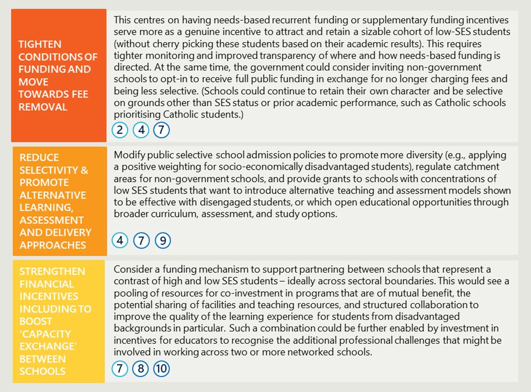

The second recommendation offers more specificity on how to tighten accountability and incentivise more focused attention on the issues of socio-economic diversity in schools. Our focus here is on specific metrics to include in reporting, and on potential to adopt a different regulatory approach that both widens the focus of what regulators look for as measures of success and raises the bar to promote striving for excellence and continuous improvement rather than compliance with minimum standards.

The final recommendation sets out potential areas of further research that the Department of Education may wish to consider, or the Review may wish to recommend, or for which there is strong stakeholder interest.

# Context and approach

|  |
| --- |
| This section provides the policy context for this review and describes the approach and methodology, including a taxonomy of policy interventions, framework for assessing transferability, and limitations of the data and method. |

## Project objective and context

This review of policy interventions to improve socio-economic diversity was commissioned by the Australian Department of Education on behalf of the Expert Panel conducting the Review to Inform a Better and Fairer Education System. It is intended to be one input to their report which will inform the negotiation of the next National School Reform Agreement.

##### Concentrated disadvantage in Australian schools is growing with apparent deleterious effects

The increasing segregation of students by economic status, and resulting residualisation of schools with large and growing concentrations of disadvantage, is a clearly evident phenomenon in Australia. Driven by a pattern of socio-economically advantaged and aspirational families removing their (typically better-performing) children from schools that have large proportions of disadvantaged families, this residualisation effect both reflects and contributes to growing inequity. Further, it compounds the challenges of improving education outcomes to break cycles of disadvantage by making residualised schools less appealing to highly capable teachers and leaders owing to the greater professional difficulties, and less likely to attract additional private resources (i.e., from advantaged families).[1]

“Some consensus has emerged on the detrimental impact of attending schools with many low achievers – and the benefits of having high-achieving schoolmates.”

OECD 2018 *Balancing School Choice and Equity*

The growing socio-economic segregation among Australian schools and school communities is correlated with a sharply declining share of low SES students and schools achieving top Year 12 results, and a decline in the reading performance of Australian disadvantaged andadvantaged students between 2009 and 2018.[2] In other words, this increasing residualisation is harming students of all backgrounds, limiting their potential, with knock-on effects for national productivity and social cohesion. Conversely, modelling based on evidence about positive peer effects suggests that a socio-economically mixed classroom will lift the education outcomes of lower-performing disadvantaged students.[3]

The purpose of this research is to explore the hypothesis about the extent to which socio-economic desegregation leads to improved outcomes for disadvantaged students (with no adverse consequences for their advantaged classmates) by looking at policy interventions that aim to create more socially mixed classrooms. Key questions driving our inquiry concern:

* Which interventions have a positive effect on diversity and education outcomes?
* Have there been unintended consequences?
* What might be transferable to an Australian context to reverse the residualisation trend?

##### School systems can counter this phenomenon through targeted policy interventions

Analysis of PISA data suggests that school systems can mitigate the impact of socio-economic disadvantage on a child’s learning and life outcomes.[4] High-equity countries have a smaller gap between most and least advantaged children than there is between highest and lowest mean SES status.[5] Evidence suggests also that creating more diverse and inclusive classrooms can improve both the sense of belongingness and wellbeing of students from minority cohorts or disadvantaged backgrounds, which combined with the academic benefits helps children achieve their potential as well as foster social-emotional growth, self-esteem and peer acceptance.[6] Importantly, such improvements do not necessarily come at the cost of the wellbeing or educational achievement of advantaged students in the same school or classroom.[7]

These results have been achieved through various policy interventions – some historic and organic, and others more recent and deliberate – at the national, subnational levels, district or school level (an example of the latter is ‘de-tracking’ students). Of note is that many of the deliberate interventions were targeted at improving social diversity as a public good in its own right, without necessarily forming part of a more comprehensive strategy to improve education outcomes. Part of our challenge in this research is to assess whether the improved social diversity was accompanied by improved education outcomes for all students.

## Project approach

|  |  |
| --- | --- |
| **Interviews** | |
| 1 | Andreas Schleicher (OECD) |
| 2 | Toby Greany (United Kingdom, UK) |
| 3 | Kenneth Wong (United States (US) |
| 4 | Mike Hollings (New Zealand (NZ) |
| 5 | Darren Leafe (UK) |
| 6 | Ricky Cambell-Allen (UK, US, Australia) |
| 7 | Barry McGaw (OECD, Poland and Australia) |
| 8 | Emiliana Vegas (Chile) |
| 9 | Julien Grenet (France and Belgium, US) |
| 10 | Johan Wennstrom (Sweden) |

This research was undertaken in September and October 2023 and involved both desktop analysis of data and documentation, and interviews with leading experts in selected international school systems.

Nous developed a taxonomy of policy interventions to structure the inquiry. This aimed to categorise the policy approaches discussed in national and international policy and academic literature, and relate them to key government levers (i.e., regulation, legislation, funding, governance). Priority was given to policy interventions focused on improving economic or racial diversity, with adequate data, and which we assessed as being relevant to the challenge in Australia (see Figure 2, overleaf). In terms of quantitative data, we focussed on OECD PISA and school graduation data for its comparability and availability since 2000 which supports identification of trends within and across systems. This was supplemented by targeted analyses and reviews of national and subnational data, such as of school enrolments and diversity measures.

Each intervention was analysed to determine its merits with respect to improving both:

1. Diversity – measured in terms of racial or socio-economic diversity (e.g., the OECD’s ‘dissimilarity index’) or ability to improve the representation of target cohorts (e.g., migrant children) as low, medium, mixed, or high.
2. Education outcomes – measured in terms of improved attendance, graduation rates and / or performance in standardised tests as low, medium, mixed, or high.

See Figure 2 which summarises the results of these assessments. Note that these are indicative and offered as a high-level guide only. Also, the success or otherwise of interventions depends significantly on how they were implemented; some (such as legislated quotas and school zone flexing) are particularly sensitive to variations in design or implementation approach. This means the research reviewed may suggest an intervention was ineffective in one setting but was more successful elsewhere.

Figure 2 | Policy interventions examined in this review 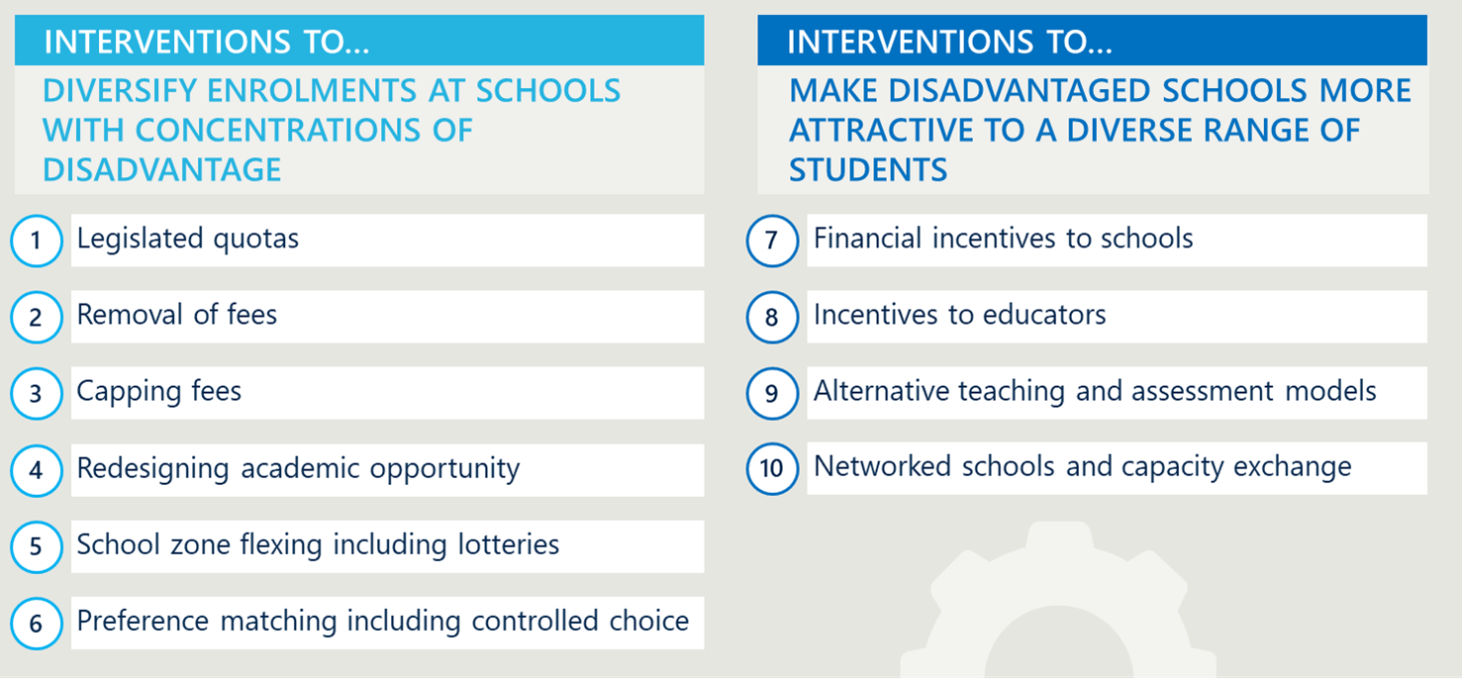

We then assessed these interventions’ relevance to Australia by considering questions of scalability, degree of departure from current arrangements, the likely appetite for change, and the practical aspects of implementation. This was done through applying four key questions, each answered on a sliding scale: low, medium, or high.

1. How scalable is it? I.e., can it be applied on a wide scale but in such a way as to also takes account of distinctive rural and regional contexts?
2. How similar is it to current approaches in Australia? I.e., is it radically different to current approaches used in Australia?
3. How likely is it to be widely supported? Are Australia’s political parties, education stakeholders and the public likely to support the change?
4. How easy will it be to implement in practical terms? Are extensive legislation changes or funding increases required?

##### Scope

This targeted scope and limited timeframe resulted in some types of interventions being excluded, such as relocation and transport interventions.[8] We also didn’t focus on initiatives within schools to reduce inequalities, despite this estimated to account for up to 75 per cent of the difference observed in student academic performance across the OECD,[9] recognising that this has been explored separately by the Expert Panel. Finally, this review did not examine in any detail the potential impact of using two or more levers in combination, though it notes that this is what other school systems do and offers commentary on what might be most efficacious in an Australian context.

##### Data analysis and limitations

Nous interrogated PISA data for the locations and periods indicated in our literature review, in an effort to draw more conclusive findings about the impact of national and subnational jurisdictions’ interventions on key indicators of equity and learning outcomes.

It was difficult to disentangle and isolate the impact of specific policy interventions for myriad reasons, including the following:

1. Concurrent reforms: policy interventions directed at the same purpose are often deployed in combination as part of a multi-dimensional policy solution. For example, Chile’s system-wide reform to its public school system from 2017 included removal of fees, removal of selectivity, introduction of financial incentives, transition arrangements and governance reform.
2. Iterated mechanisms: policy interventions can be iterative, evolving through multiple versions over time.
3. Variation in implementation: fidelity in implementation is not always clear or sought across subnational and local levels (where local adaptation to context can help), while other unobservable aspects of implementation may considerably influence the intervention’s success or failure.
4. Small footprint: the impact of localised interventions is likely to be hidden (or hard to discern) within national aggregated data.
5. Presence of other, unrelated education reforms: educational outcomes can be impacted by many other factors, including curriculum reform or improvements in teaching effectiveness.

Further, it is important to note that socio-economic status is measured differently in different countries, subnational jurisdictions and local school districts. The research relies most heavily on the PISA measurement of socio-economic status, which is the index of economic, social and cultural status (ESCS). This is described by the OECD as “a composite measure that combines into a single score the financial, social, cultural and human-capital resources available to students”. The index is derived from several variables related to students’ family background that are then grouped into three components: parents’ education, parents’ occupations, and an index summarising a number of home possessions that can be taken as proxies for material wealth or cultural capital.[10]

# Findings

|  |
| --- |
| This section presents the findings of our review of selected policy intervention with reference to:  Drivers and objectives  Operation and locations  Outcomes (on diversity and education)  Evidence base (extent and validity of sources cited)  Transferability |

|  |
| --- |
| Legislated quotas |
|  |

Legislated quotas are a policy intervention characterised by the use of legislation and regulation which stipulates a minimum number or percentage of students from vulnerable cohorts in high-demand schools or these cohorts’ prioritisation for spare places, in order to reduce concentrations of disadvantage and associated learning challenges. Vulnerable cohorts targeted are typically children of migrant or refugee background, which in the countries examined are typically from low and very low SES households. Noncompliance incurs penalties such as reduced public funding. (Residential segregation is discussed further in Appendix A).

### Drivers and objectives

Legislated quotas respond to a mix of political, ideological and economic concerns regarding the negative educational, economic and social cohesion consequences to individuals, families and communities of high and increasing socio-economic and cultural concentration of students in schools. A key concern is lower academic performance in these schools with high disadvantage, which results in a disproportionately high amount of these students being tracked (streamed) to lower-prestige, vocationally-oriented senior secondary schools with reduced post-school options compared to general or university-oriented schools.

### Operation and locations

Legislated quotas were introduced in Belgium from 2007 to increase the social diversity of schools after previous attempts to increase diversity had failed, resulting in school segregation that exceeded residential segregation, and which contributed to much higher proportions of children of immigration background being allocated to vocational secondary schools. Such segregation is linked to a strong tradition of parent choice in both the Flemish and French communities of Belgium, which was uncontrolled before these reforms.

Belgium introduced national legislation with local regulation and administration by French Community and Flemish Community school systems through use of student data and allocation mechanisms. In the beginning, it applied only to in-demand public schools, but was extended over time. For example, a 20 per cent quota for disadvantaged students in every French Community school in Belgium, introduced in 2011, followed two years of local experimentation with different enrolment systems to identify most effective approaches. Administration of the law varied due to the devolution of implementation to local negotiation platforms (over 72 in Flemish Community system alone) who worked with local schools and other stakeholders to determine the criteria for choosing students from within the priority cohort, such as proximity, students’ ranking of preferences or first-come-first-served basis.[11]

Legislated quotas in Belgium were not widely supported. Backlash at all levels and some turmoil at local levels resulted in multiple changes to the legislation and implementation guidance. However, greater support and implementation success was observed in areas where there was greater devolution to the local platforms and greater input from families and schools to these platforms around the specifics of administration.[12]

In Chile, quotas were included as part of a package of educational reforms to create a more equitable education system from what had become one of the most privatized and inequitable in the world.[13] Chile’s 2015 Law of Inclusion and accompanying regulation required (previously) private schools to reserve 15 per cent of places for students classified as vulnerable as a condition of receiving government funding, with penalties for non-compliance. (The law also requires phasing out of school fees and academic selection of students and provided additional resources for these vulnerable students [an incentive]. These are discussed in sections 3.4 on reversing academic selectivity and 3.7 on financial incentives).

In Shanghai, quotas were introduced from around 2013 for graduates of high achieving students from low-performing primary and secondary schools to proceed to “the best” senior secondary schools, colleges and universities. The thinking behind this intervention is that these students must be exceptionally bright and diligent and could achieve even greater potential in higher-performing institutions. It is also thought that these reserved spaces “will improve the morale” of the teachers, principals and students in the school of origin, presumably because they know academic brilliance is recognised and rewarded. However, the ‘creaming’ of these students from local senior schools could exacerbate residualisation.[14]

In the US, ‘soft quotas’ are used by magnet schools (public schools with advanced courses attracting high-performing students from aspirational families) to ensure a mix of different racial and cultural backgrounds broadly representative of the school district and/or nearby schools.[15]

### Outcomes

##### Diversity

In Belgium, diversity may have slightly increased. However, statistical analysis of two databases between 2006 and 2015 concluded the law didn’t achieve its objective of increasing social and economic diversity and reducing segregation, particularly at secondary levels.[16] Nevertheless, more recent analysis by the OECD suggests a slight decrease in social segregation between 2009 and 2018.[17]

In Chile, where 15 per cent quotas for low SES students were introduced in private schools from 2016 along with incentives for compliance and penalties for noncompliance, socio-economic diversity improved in most public schools and across all but the top SES quintile (for which students remained concentrated in fee-charging private schools).[18]

**Education**

In Belgium, educational outcomes have deteriorated since the introduction of quotas. There was a significant decline in the overall PISA performance and decline in the reading results of both advantaged and disadvantaged student cohorts between 2009 and 2018. Belgium continues to have one of the greatest correlations between disadvantaged backgrounds and low performance.[19]

By contrast, in Chile, educational outcomes improved significantly for advantaged and disadvantaged students on national tests, and the gap between these cohorts closed. Chile’s PISA scores improved faster than the OECD average between 2009 and 2012, and ahead of all other Latin American nations.[20] Secondary school graduation rates have steadily risen from 79 per cent in 2010 to 91 per cent in 2020.[21]

Shanghai has risen to the top of the PISA performance tables across most measures, despite being a city characterised by high inequalities and social stratification. Of note is that Andreas Schleicher attributes this high performance and equity to investments in teachers and networked capacity (see 3.9) more than any other lever, including quotas.[22]

### Evidence base

Despite extensive data on schooling diversity and educational outcomes in Belgium, it is difficult to confidently attribute any causation to legislated quotas because of the near-continuous iterations of the legislation, regulatory requirements and the diversity in local implementation.

Evidence is also muddied by the impact of streaming within Belgium’s school systems which is highly correlated with inequities and stronger connections between students’ educational outcomes and SES background. This means that any benefits of legislated quotas, or other interventions in Belgium, could be hidden or overridden by influence of tracking.

In Chile, there is strong evidence of improvements to both school diversity and educational performance. However, it is difficult to isolate the impact of legislated quotas from other interventions introduced as part of a cohesive reforms package, including the removal of fees, reversal of selectivity and other interventions.

### Transferability

##### Relevance to Australia

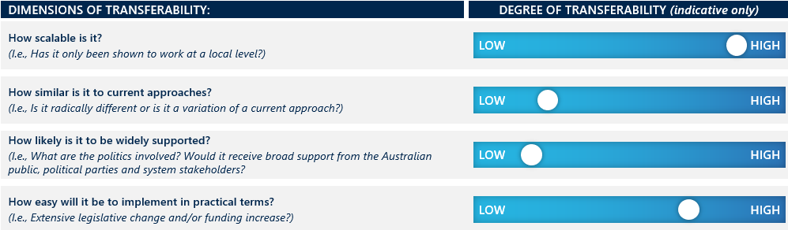

Legislated quotas are used at national, regional and city levels elsewhere, indicating in-principle feasibility in government and non-government school systems and in metro, regional and rural areas in Australia. Enrolment prioritisation is already used across Australia (e.g., through zoning, faith, enrolled siblings). However, reserving places in government and in non-government schools on criteria such as SES or cultural background could be highly contested by parents and school leaders as unfair. Further, this intervention would require a new level of administration and oversight, especially of non-government schools, requiring additional resourcing.

Introduction of quotas could be phased in by:

* Starting low such as five per cent and increasingly incrementally.
* Making quotas voluntary or aspirational (i.e., ‘soft’ quotas or aspirational targets).
* Linking them to funding incentives or agreements.
* Involving local input into their design and administration.

Any quota-based system would require careful regulation and oversight to prevent ‘creaming’ of talent from low SES schools.

|  |
| --- |
| Removal of fees |
|  |

This intervention refers to decisions by government to effectively fully-fund schools so that they do not (and cannot) charge fees. Typically, it involves bringing schools into the public system on the same terms and conditions. For example, not being able to select students for their abilities while allowing for a continuation of special characteristics (e.g., being faith-based, Montessori) to preserve their distinctiveness and attractiveness to certain segments of the population. Fee removal is also arguably an important condition of the success of other policy interventions that seek to promote greater socio-economic diversity.

### Drivers and objectives

Fee removal is typically intended to remove financial barriers to accessing private schools, so that all families can exercise choice and/or improve the diversity of schools that otherwise were serving more advantaged students. It may be part of an effort to ‘equalise’ different school sectors and create an even playing field in terms of both regulation and funding.

### Operation and locations

In Canada, full public funding was introduced to provide families and minority communities with choice. In three Canadian provinces a significant minority of students attend separate denominational schools which are fully publicly funded and do not charge tuition fees: Alberta (24 per cent), Ontario (30 per cent) and Saskatchewan (23 per cent).[23] In Ontario – Canada’s largest province – English-language Catholic schools educate over 575,000 students in more than 1,500 schools.[24] These schools retain control over curriculum and ethos, and are governed by Boards of Trustees, elected by ratepayers.

In Chile, fees were removed to reduce social segregation and lift achievement. Chile’s Preferential School Subsidy (SEP), introduced in 2008, allowed private schools to opt into a scheme which provided a 50 per cent funding loading for priority students from the bottom 40 per cent of the income distribution, and prohibited schools from charging fees to priority students or selecting students on the basis of academic tests.[25] The School Inclusion Law (2015) began a process of gradually expanding the provision of fully publicly funded no-cost school places and the incremental reduction and elimination of private co-payments.[26]

In Hong Kong, fee-free non-government schools have historically been a central feature of its education system. Eighty per cent of schools, known as aided schools, receive full government funding and do not charge admission fees, but are operated by churches, trade associations and other non-profit organisations. Ninety-four per cent of Hong Kong primary students are enrolled in aided schools.[27] Aided schools are complemented by a relatively small number of government-owned and operated schools, and a smaller number of regulated, high-fee schools.

### Outcomes

A range of international evidence indicates that removal of fees is a powerful lever to increase socio-economic diversity and improve student achievement. This is especially (and unsurprisingly) the case where fees are high enough to be a consideration alongside other factors influencing school choice such as faith and convenience.

**Diversity**

The absence of fee-charging schools is associated with lower levels of segregation. This is evident in a comparison of Canadian provinces, where social segregation is much lower than other advanced economies.

Figure 3 I Segregation is much lower in Canadian provinces where fees have been removed[28]  
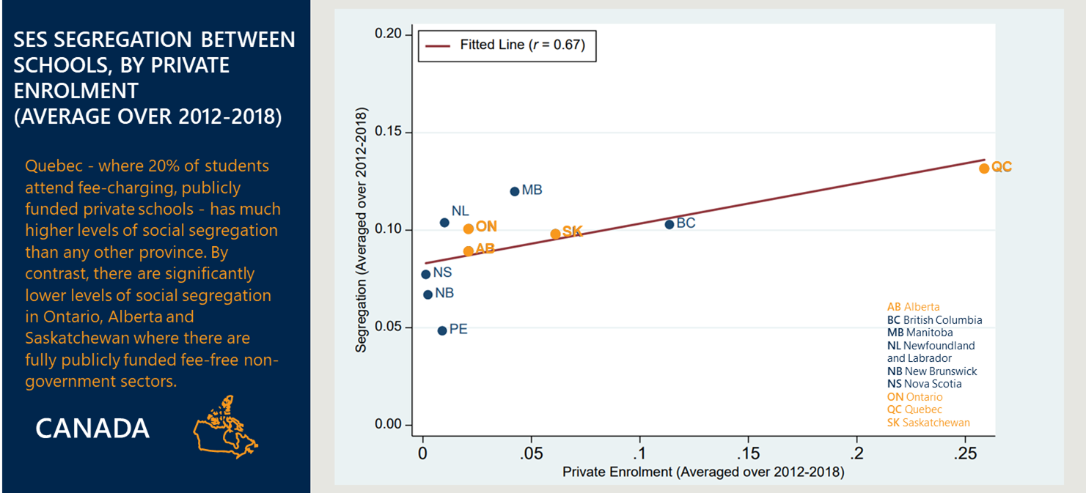

With respect to Chile, Nous analysis of OECD data has found a decline in segregation of students in the 20th and 50th ESCS percentiles since the introduction of fee-free places in 2008. The analysis found that dissimilarity indices[29] of the 20th and 50th ESCS percentiles has dropped from a high of 0.53 and 0.52 in 2006 to a low of 0.49 and 0.47 respectively.

Hong Kong schools are less segregated than Australia, despite significant tracking into academic and vocational programs (which normally leads to segregation – see section 3.2 and section 4).[30]

“With a five-year high school graduation rate of 64 per cent for the public network, Quebec presents the worst performance at the Canadian level”

Institut du Québec

**Education**

In Canada, there is a strong association between the absence of fee barriers in separate denominational schools in Ontario, Alberta and Saskatchewan and high levels of student achievement. Alberta is a very high PISA performer. As a province, in 2018 it was third in the world in reading after Singapore and ahead of Macao (China); and it performed extremely well overall.[31] Ontario is also a strong PISA performer, well ahead of Australia. Chmielewski and Maharaj find an association between SES achievement gaps and variation in social segregation between provinces, “consistent with the idea that school segregation may be related to inequality in students’ academic outcomes.”[32]

Equally significant, in Quebec – where publicly funded schools are permitted to charge fees and there are higher levels of social segregation – there are dramatically lower levels of secondary school completion than in other Canadian provinces. And completion rates are much lower than Ontario’s: “in the public system, the graduation gap between Quebec and Ontario is now 25 percentage points for boys.”[33]

Hong Kong has one of the most successful school systems in the world in terms of both achievement and equity. In PISA 2018, the gap between socio-economically advantaged students and disadvantaged students in reading was 59 score points compared to the OECD average of 89 score points.[34] Socio-economic status explained only 5 per cent of the variation in mathematics performance in PISA 2018 in Hong Kong (China) compared to 14 per cent on average across OECD countries, suggesting a positive impact resulting from enrolment by 94 per cent of the population in aided schools.

Chile achieved substantial improvement in Year 4 maths after removing fees for disadvantaged students. When fees were removed for students in the lowest 40 per cent of the income distribution, maths scores rose by 16 points for students at the 20th percentile, and 10 points for students at the 80th percentile.[35]

### Evidence base

Data sources drawn on here include PISA and national standardised tests. While Quebec has very high school dropout rates, its PISA results are comparable to other provinces.[36] This suggests that withdrawal from school by low achievers before the sitting of PISA may be artificially inflating Quebec’s results.[37]

While Chile’s school diversity has improved since 2008, factors such as residential segregation and academic tracking appear to contribute to continued relatively high levels of segregation.[38] For broader context, Chile (with Uruguay) is the highest performing education system in Latin America, but it is two years behind the OECD average.[39] Chile’s improvement in PISA, since the test’s inception, was more marked in the period before 2009[40] which may be due to the earlier implementation of complementary reforms which provided a foundation for this and other interventions.

### Transferability

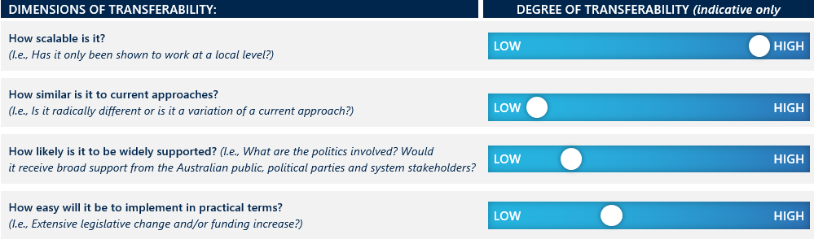

Removal of fees is a highly effective means of increasing socio-economic diversity and improving student achievement, particularly when the fees charged are high. (See separate discussion on fee capping in section 3.3, overleaf, which looks at the example of New Zealand as well as Hong Kong’s non-aided schools.)

In an Australian context, where fees can vary significantly, notwithstanding the levels of public subsidisation, the removal of fees could expand access for First Nations students and other equity cohorts to schools where they are currently under-represented – enabling access through means other than academic scholarships. However, fee removal would not be applicable in locations where there are no fee-charging non-government schools, the case in many regional, rural and remote locations.

This intervention is more likely to be accepted if it is targeted, and schools can opt-in to a program of offering disadvantaged students fully publicly funded fee-free places – again, without there being an element of academic selectivity (which would likely defeat the purpose of reducing concentrations of disadvantage). Chile’s Preferential School Subsidy exemplifies this approach. It would likely be viewed as fair.

Finally, it is important to note that where other policy interventions have succeeded in increasing diversity and achievement – such as financial incentives in England and Wales or alternative modes of delivery in New Zealand – this has occurred within a context where fees have been removed as a factor in segregation. In Australia, fee removal may similarly be most effective if deployed in concert with other policy interventions.

|  |
| --- |
| Capping fees |
|  |

This intervention involves regulation that sets the upper limit of school fees (also known as attendance dues or tuition fees), requires approval of the fees to be charged or attaches conditions to the imposition of fees. Overseas school systems that limit private school fees have typically done so in exchange for significant public funding.

### Drivers and objectives

As with removing fees, the goal is to make non-government schools more accessible, in the interests of opening up choice and providing equitable opportunities to find a school that best meets a student’s needs. In this case, the barrier to access is lowered rather than removed altogether.

### Operation and locations

New Zealand’s state-integrated schools can charge ‘attendance dues’, approved by the Minister, for reasonable capital expenditure only. The policy objective is to ensure the ongoing viability and affordability of a diverse range of educational options in New Zealand. As in Australia, New Zealand’s Catholic system came under significant financial strain in the 1960s and 1970s due to the post-war baby boom, the increase in secondary completion rates and a decline in those entering the teaching workforce as a religious vocation. In response, the *Private Schools Conditional Integration Act* (the Act) was passed in 1975 and came into force the following year.

Of all New Zealand schools, 11.4 per cent are State-Integrated Schools (SIS). (Non-integrated non-government schools constitute just four per cent of New Zealand’s education sector.)[41] SIS receive full recurrent funding from the New Zealand Government but retain their special character and ownership of school buildings, for which they are permitted to charge regulated ‘attendance dues’. State-integrated schools are mostly systemic Catholic schools, but they also include Anglican, Muslim, Jewish, Steiner and Montessori schools. Attendance dues are approximately NZ$500 for primary school students and around NZ$1,000 for secondary school students.[42]

SIS cannot increase attendance dues without the approval of the Minister of Education.[43] Further, the Act specifies that attendance dues cannot be used “to provide or improve the school buildings and associated facilities to a standard higher than that approved from time to time by the secretary (of the Ministry of Education ) as appropriate for a comparable state school.”[44]

Donations over and above attendance dues can be made but are voluntary. SIS and state (normal public) schools in all but the three most advantaged deciles can receive additional funding of $NZ150 per student for that year in exchange for *not* seeking donations.[45] Additionally, SIS are subject to a ‘maximum roll’ which stipulates the:

* Total number of funded places at the school.
* Requirement that the school only enrol up to a maximum of 5 per cent of its student body from outside the school’s designated ‘special character’ (e.g., non-Catholic family background with respect to a Catholic school).

Hong Kong has three types of schools:

1. Schools owned and operated by the government (approximately ten per cent of schools),
2. aided schools run by voluntary charitable or religious organisations, but which receive full government funding (approximately 80 per cent of schools – as discussed in section 3.2),
3. Direct Subsidy Scheme (DSS) schools, run by voluntary organisations but which are permitted to charge tuition fees in addition to government funding (approximately ten per cent of schools).

Our focus here is the latter, which numbered 71 in total in 2023.[46]

The goal of the DSS, established in the 1990s, is to “promote effectiveness, flexibility, innovation, and choice through the market approach for basic education”[47] with the underlying rationale that the introduction of competitive pressures (via the establishment of DSS) will have a broader positive impact on the whole Hong Kong school system, promoting wider-scale innovation and improved system responsiveness.

While government and aided schools follow the same curriculum guidelines, use the same officially approved textbooks and prepare students for a common examination, DSS schools have greater autonomy to be “innovative and flexible in their design of curricula, pedagogies, and assessments”, ostensibly enabling them to better “meet students’ diverse learning needs.”[48] They also have greater control over their language of instruction, staffing and student admissions.

The regulation governing DSS schools allows them to charge fees, with conditions intended to enable access for low-income families.[49] Even so, fees in DSS primary schools range from AUD$2,000 to $15,000; in DSS secondary schools they can be as high as AUD$20,000.[50] Schools must set aside ten per cent of their fee income for scholarships. Once fees exceed two-thirds of a baseline resource standard, 50 per cent must be allocated to the scholarship scheme. The fee caps operate on a sliding scale: the subsidy cuts out if fees reach 233 per cent of the baseline.

DSS schools have the autonomy to admit their own students, including scholarship students, according to self-determined selection criteria, which may include academic criteria. However, transparency is expected: schools are required to publish full details of the scholarship scheme in their prospectus, admission application form, and on the school website.

### Outcomes

##### Diversity

International evidence indicates feecapping regulation can successfully enhance socio-economic diversity, but the effectiveness of this intervention significantly depends on its design.

New Zealand’s SIS have promoted diversity, unlike Hong Kong’s DSS schools. In New Zealand’s SIS, disadvantaged students are represented in significant numbers, though the proportions of highly disadvantaged students are lower than for mainstream state schools. While students from the two most disadvantaged deciles are under-represented in SIS, the proportion of students in the next three most disadvantaged deciles in SIS is broadly representative of the general population.

Significantly, a much higher proportion of New Zealand SIS serve student populations that are disadvantaged, compared to the proportion of Australian systemic Catholic schools serving disadvantaged students:

1. 42 per cent of New Zealand SIS are in the five most disadvantaged deciles – Decile 1 – 5 per cent; Decile 2 – 6 per cent; Decile 3 – 10 per cent; Decile 4 – 10 per cent; Decile 5 – 11 per cent.
2. Fewer than 22 per cent of Australian Catholic schools are found in the five most disadvantaged deciles – Decile 1: 3.24 per cent; Decile 2: 1.65 per cent; Decile 3: 3.12 per cent; Decile 4: 4.89 per cent Decile 5: 8.77 per cent).[51] See Figure 4 below.

Overall, New Zealand rates 82.4 per cent on the OECD index of social inclusion, indicating lower levels of social segregation than Australia, which is at 75.6 per cent. (The OECD average is 76.1 per cent.)

This provides clear evidence that New Zealand’s Catholic schools (being the majority of SIS) are significantly more inclusive than Australian Catholic schools, and a powerful indicator of the effectiveness of fee capping in facilitating access to non-government schools by low-income families, and thereby increasing the socio-economic diversity in schools across sectors.

Figure 4 | Distribution of Catholic schools in Australia and State Integrated schools in New Zealand by socio-economic indicators in 2022

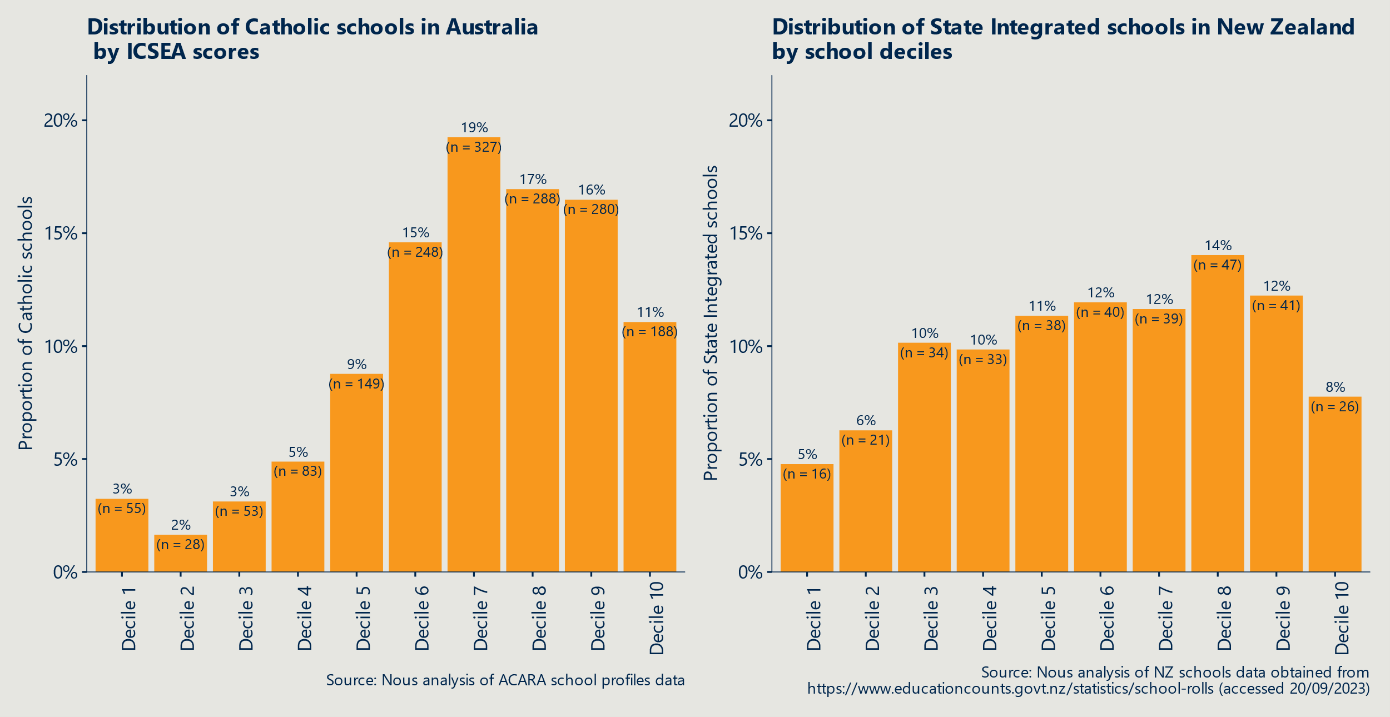

With respect to cultural diversity, the New Zealand Catholic Education Office reported in 2019 that Pacific students were over-represented in Catholic SIS schools, constituting 15.7 per cent of the Catholic school student population, compared to around 10 per cent of the total student population. On the other hand, Māori students made up 14.5 per cent of students at SIS Catholic schools compared to 25 per cent of the overall student population.[52]

What is perhaps remarkable is the extent to which New Zealand’s SIS are perceived as being fair, including by leaders in the faith-based community. In 2012, the Chief Executive Officer of the New Zealand Catholic Education Commission, Brother Pat Lynch, wrote “… the Integration Act was brought about through a remarkable compromise by a range of interested parties who focused on the well-being of the nation rather than their own particular interests. As a result, the New Zealand Parliament managed to do what has eluded other jurisdictions including the United States and Australia, i.e., to bring about a fair system of education for all its citizens.”[53]

In Hong Kong, the admission fees charged by DSS schools are still seen as unaffordable for many Hong Kong families.[54] Researchers who surveyed 910 parents found that high-income parents are over seven times more likely than lower income parents to consider DSS schools for their children. Apart from affordability, DSS schools have considerable autonomy in selecting students. Consequently, the scholarship provisions notwithstanding, DSS schools are not particularly socio-economically diverse.[55]

##### Education

Education outcomes are more mixed in New Zealand, and in Hong Kong, the impact on DSS schools’ performance was, if anything, negative.

Higher levels of socio-economic diversity in New Zealand schools is associated with a greater likelihood that disadvantaged students will be taught by expert teachers. The OECD found that, in Australia, 24.3 per cent of advantaged students were in schools whose teachers held a Master’s (or higher) degree, compared with 12.6 per cent of disadvantaged students.[56] Perhaps related to this, New Zealand’s average 2018 PISA scores for Reading, Maths and Science were marginally higher than Australia’s.[57] In New Zealand, disadvantaged students are actually *more likely* to be in a school with highly qualified teachers: 17.4 per cent of disadvantaged students were in that category compared to 15.5 per cent of advantaged.

That said, the socio-economic gap in reading in New Zealand was slightly larger than in Australia, and socio-economic status was a slightly stronger predictor of performance in mathematics and science in former than in the latter.

In Hong Kong, researchers found that “once we accounted for students’ socio-economic background, students in DSS schools actually performed worse in all three assessed subjects.”[58] This suggests that DSS schools not only do not contribute to Hong Kong’s otherwise strong performance in PISA and other international standardised tests, they actually detract from it.

Given that available evidence indicates that students from disadvantaged backgrounds are significantly under-represented in DSS schools, it is difficult to attribute the inclusion of ‘scholarship students’ in the school as being the reason for this lacklustre academic performance.

### Evidence base

Evidence cited here is mostly based on different OECD data and system level data, which is stronger than relying on PISA data alone.

Note that comparisons between New Zealand and Australia may need to adjust for the large proportion of New Zealand students with backgrounds that typically correspond with lower educational outcomes associated with experiences of colonisation (25 per cent Māori; ten per cent Pacific Islander). This is further discussed as part of section 4.4, International lessons transcend differences in politics, culture and geography.

### Transferability

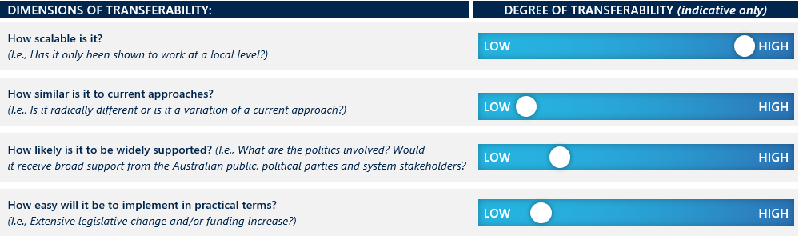

The New Zealand model for SIS is not without its critics, and the issues they highlight offer lessons for the potential transferability of this intervention into the Australian context. Key areas of concern are that:

* On occasions, attendance dues are approved at levels that appear unreasonably high.
* Voluntary donations can be very substantial and introduce inequity into the school system.
* Where the special character of a school is ill-defined, the maximum roll requirements can become meaningless, and SIS become de facto selective schools.[59]

Notwithstanding these risks to effective design and implementation, fee capping – either through regulation or funding agreements — can be a powerful intervention to increase socio-economic diversity within schools. Moreover, given the cultural and historical similarities between Australia and New Zealand, it is significant that New Zealand’s Catholic system has successfully been incorporated into a fully funded and essentially free public system and that, as a result, it is serving more disadvantaged students than in Australia.

Fee regulation is highly scalable, but it will have less relevance to remote locations where there are no fee-charging non-government schools. In terms of its broader reception in Australia, it does mark a significant departure and would be resisted by non-government school authorities. However, parents would likely welcome it and adverse reactions could potentially be countered through gradual implementation, including along the lines of Hong Kong’s sliding scale approach.

Fee regulation would require legislative change and additional funding to schools that opt in, to provide their full entitlements under the School Resourcing Standard (SRS).

|  |
| --- |
| Reducing academic selectivity and tracking by schools |
|  |

This intervention seeks to reduce the unintended negative consequences of academic sorting via academically selective public schools and tracking (streaming students into different types of secondary or senior secondary schools, and / or into vocational versus higher education-oriented pathways). Another aspect of academic selectivity is the use of merit-based scholarships, which can be a response to the challenge to improve social or cultural diversity. This latter variant is not considered here as it tends to feature at the margins, and it does not speak to the underlying hypothesis that a more mixed classroom – one that reflects different socio-economic backgrounds – is likely to generate positive peer effects among those who do not have a track record of strong academic performance.

While tracking is prominent in many European nations, selective public schools are not, given that selective schools in places other than Australia are normally associated with the private (non-publicly funded) school system.

For context, in Australia, selective public schools can be found in New South Wales (NSW), which has 22 public fully selective schools, Victoria, which has four and Queensland, which has three. There are important differences particularly between the selective public schools in NSW and Victoria: NSW’s selective schools begin in Year 7, while Victoria’s start in Year 9. Victoria restricts the number of students being drawn from any one feeder secondary school to no more than five per cent, whereas in NSW, there are no such restrictions. Further, Victoria’s four selective schools reserve ten per cent of places for students from low-income families or equity cohorts (primarily students from Aboriginal and Torres Strait cultural heritage).[60] NSW is following Victoria’s example by introducing 20 per cent quotas for target cohorts.[61]

### Drivers and objectives

Selective schools are designed to provide optimal learning conditions for students – usually academically high-performing or gifted students – to realise their potential and meet their particular needs. Their prestige means that they often attract more applications than there are places, with selection based on performance in assessment tests. This gives higher-performing students from an advantaged background greater chances of access. Not just because there is a high correlation in inequitable schools’ systems between socio-economic status and education achievement, but because of the requirement to actively seek out opportunities for a ‘better’ education experience and to have the wherewithal to travel (in most cases) longer distances to attend. Students from advantaged families are also more likely to be able to pay for coaching or tutoring that improves the chances of being selected.

Tracking similarly intends to cater to the differing needs of students. It is based on the view that grouping by ability enables teachers to engage with struggling learners and high achievers more effectively – to ‘meet them where they are’. This approach is designed to avoid the risk of faster learners becoming bored through under-stimulation and lower learners feeling left behind and becoming disengaged.

In both cases, the research suggests that academic selectivity can exacerbate differences in learning between students and increase educational inequity. In particular, selective schools are known to create a ‘brain drain’ (i.e., an aspect of residualisation) within the public system and schools they left (or never enrolled in).[62]

It follows that to improve socio-economic diversity in schools, appropriate policy interventions would be those that wind back school selectivity or tracking.

### Operation and locations

Chile introduced measures to wind back academic selectivity in the public school system as part of its major reforms in 2008 to reduce socio-economic segregation (detailed in section 3.5.2). To receive high-value student subsidies in the form of vouchers, schools had to agree to not select students based on their academic performance, thereby reducing the incentive for academic selectivity.

Poland delayed its academic tracking system as part of major reforms to improve equity and educational outcomes. In 1999, Poland extended the period of generalised education by one year, such that tracking would occur when students reached 15 years old rather than 14. As a result of this, most students in Poland are now enrolled in lower secondary schools with residence-based admission policies.

The Polish reforms were very controversial at the time. They were opposed by teachers who were concerned about the difficulties in teaching a broader spectrum of academic ability. The education minister persisted and invested in significant professional learning for all teachers to equip them for the shift. The broader public only accepted the reform once PISA results showed the strong, positive impact for students compared to other nations and past performance.

### Outcomes

##### Diversity

##### There is general evidence to suggest that a reduction in academic selectivity improves diversity.

Research suggests that social segregation across schools is negatively correlated with equity in education.[63] Across OECD countries, changes between 2009 and 2018 in the percentage of students attending a school where admission is never based on the student’s record of academic performance were positively correlated with changes in equity and reading.[64]

Following the reduction of academic selectivity in Chile from 2008, the selective private subsidised sector saw the most notable decrease in segregation with greater integration of students from lower SES percentiles.[65] However, non-selective public schools showed some increases in segregation, with small, but statistically significant increases in the concentration of students in the 20th and 50th percentiles.[66]

Prior to its major reforms, Poland was among the countries with most substantial variation in student performance between schools. However, PISA 2003 data reveals that by delaying academic tracking, Poland saw a sharp increase in the variation within schools and reduced variation between schools, quickly reaching levels similar to those of Scandinavian countries.[67]

In a study of differentiation policies across the OECD, countries using the ‘individualised integration model’ – which describes a schooling system with long common core curriculum, automatic grade promotion of students, heterogenous classrooms, and a generalised use of individualised teaching – had the lowest percentage of ‘disadvantaged low achievers’ and the highest percentage of ‘disadvantaged high achievers.’[68]

Similar research was conducted on common, ‘classical’ curriculum, through which all students access strong foundation in the same core subjects, versus differentiated and ‘post-modern’ curriculums, which can lead to lower SES students being offered a narrower or altered curriculum (i.e., a similar experience to students who are ‘tracked’. It showed a positive correlation between the common curriculum and higher academic performance, equity and social mixing. Conversely, a shift from a common, classical approach to a post-modern curricular approach has been linked to declines in performance and equity in Finland, Sweden and beyond.[69]

##### Education outcomes

##### The positive impact of reduced academic selectivity on education outcomes is compelling.

“Poland’s dramatic improvement in quality following the abandonment of streaming and the introduction of comprehensive secondary schools can challenge Australia to examine the impact of the marked differentiation among its schools in resources and governance models.”

B. McGaw 2021 *Quality and equity in education: simultaneous pursuits or trade-offs?*

In Chile, between 2009 and 2015, the proportion of school admissions based on academic performance fell by 16 percentage points. Encouragingly, these measures improved student outcomes across the board while also narrowing the achievement gap between disadvantaged and advantaged students. [70]

In Poland, delaying academic tracking was shown to drastically improve educational outcomes. Inter-school variation and reading proficiency improved, moving from below the OECD average to above the OECD average by 2009 for both metrics.[71]

The hypothesis underpinning Poland’s results is that students who have been ‘tracked’ into non-academic streams may internalise negative perceptions of their abilities, leading to a lower self-esteem. Reversing or delaying this tracking, therefore, keeps expectations and motivation higher.

### Evidence base

It is important to note that reducing academic selectivity was one of several aspects of Chile’s school system, which also included removal of school fees, as well as taking part in an accountability system that made schools responsible for the use of financial resources to demonstrate improved student outcomes.[72] Therefore it is difficult to attribute improved outcomes to this single intervention.

### Transferability

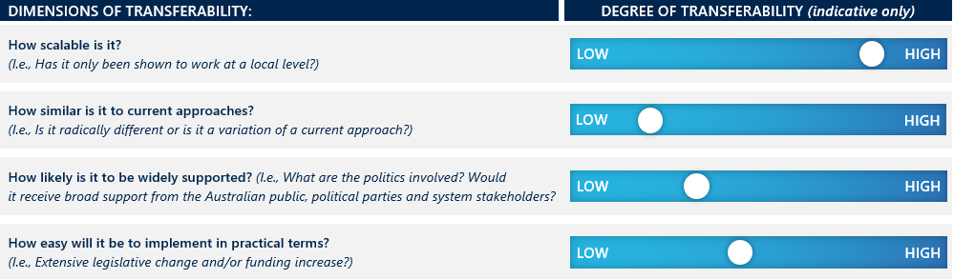

Reducing academic selectivity is doable but potentially fraught and with uncertain benefits. It also really only applies in the three jurisdictions with selective public schools. Backtracking on selective public schools will be challenging given their appeal to parents of those selected, and in the community. However, educators (and potentially parents) who are witnessing first-hand the negative impact of the selective schooling may be more supportive.

At a minimum there is an argument for jurisdictions with selective schools to adopt elements of the selection process used in Victoria, where admission commences from Year 9 and priority is given to marginalised cohorts. While many would recognise this reform to selective schools as fairer, it is uncertain whether advantaged families and the general public recognise the scale of the problem and current inequities. They may be wary or opposed to something they might perceive as social engineering or playing to special interest groups.

However, even with these modifications to enhance social-economic diversity, selective schools would still apply an academic filter which means no tangible effect on the residualisation phenomenon. Indeed, they risk further distorting the academic profile of the feeder schools that might have a high concentration of disadvantaged students by accelerating or enabling the ‘brain drain’ and locking in negative peer effects.

With respect to tracking, a retreat from this practice is less relevant in Australia as it has been falling out of favour for some time. Moreover, the current policy focus on creating stronger parity between vocational and academic ‘leanings’ is driving systems away from anything that looks like a ‘two-tier’ system. For example, Victoria is abandoning its separate Year 12 Certificate of Applied Learning, which was essentially the destination point for students tracked into a vocational stream of upper secondary school. Instead, it is integrating its Year 12 qualifications, still allowing for a ‘Vocational Major’ and school-based apprenticeships, but in so doing, seeking to consciously avoid creating two separate and impermeable pathways that hold higher and lower status.

|  |
| --- |
| School zone flexing and lotteries |
|  |

School zone flexing refers to opportunities that are created to enable children from outside a school’s designated catchment area to enrol in that school. Relaxing school zones can help to overcome geographic segregation which is often a driver of school segregation.[73] It is often done in conjunction with lotteries that are administered at a school, district or system level to provide more equitable access or to fill spaces in schools under legislated quotas.

School zone flexing can take the form of re-drawing zones to include a more mixed student population or building in exceptions to allow out-of-zone enrolments.

### Drivers and objectives

More than half of OECD countries in 2010 reported winding back their zoning restrictions to increase choice in selecting among public schools,[74] but in most of these cases the main driver was to promote market competition and innovation. In other cases, jurisdictions that have sought to relax zoning restrictions to improve utilisation of school facilities and/or improve school diversity.

“Our findings show that small changes to the attendance boundaries of neighbouring schools in many cases could make a big difference for school integration.”

Urban Institute,   
‘Dividing Lines’

(Sep 2021)

The objective behind using lotteries is to provide a fair mechanism for out-of-zone students to access in-demand schools. The randomness of lottery systems arguably offers the most equitable approach given that the process cannot be ‘gamed’ (unlike in the case of preference matching, for example). Importantly, not all lottery systems have an objective of ensuring representation of different socio-economic or cultural groups. Rather they may simply be used to manage oversubscription at popular schools. They are most relevant to improving diversity if used expressly to overcome residential segregation or to support fulfillment of an externally or internally imposed quota.

### Operation and locations

Eden Prairie, Brandywine and Wake Country in the United States intentionally use irregular shaped attendance zones to improve the diversity of families in school catchment areas. Other jurisdictions have deliberately re-drawn their boundaries to improve diversity. Zurich is one such example, where the goal was to address social inequality and school segregation. Montgomery County in Maryland is another: it has in the past used various strategies, including boundary changes, to promote diversity and reduce racial and socio-economic segregation in its schools. Re-drawing the boundaries was most recently under consideration in 2021.

Flexing of school zones has been a feature of policies in Berlin and in Paris’ secondary schools as well. In the former, the system uses lotteries, and in Paris, ‘dynamic zoning’ is used in combination with preference matching to reduce social segregation in high schools (see section 3.6).

There are many more examples of the use of lotteries: they have been implemented in countries such as the US, the Netherlands, Sweden, New Zealand and Singapore.

One of the most-studied case studies for the use of lotteries is in Chicago’s public school (CPS) system, which allows students to express a preference to enrol in schools outside their neighbourhood but within the same school district.

Lottery systems are commonly used by charter schools in states across the US. Integration-minded charter schools use a two-tiered lottery system specifically to improve student diversity. With thresholds often set by the school’s governing body and based on the racial profile of the local district, target groups (e.g., Black, Hispanic) are allocated a certain number of seats which are then assigned by lottery. The intent may be to ensure an appropriate mix of either racial representation or SES background, but in practice there is significant overlap.[75] Note this practice is in question after a recent Supreme Court ruling that the consideration of race in college applications was unconstitutional, leading to expectations of using SES indicators instead.

### Outcomes

##### Diversity

A recent systematic review of literature on school rezoning produced mixed findings about the impacts of rezoning on segregation and concentrations of disadvantage.[76] In the US, the intentionally irregular attendance zones of Eden Prairie, Brandywine and Wake Country were found to be associated with higher levels of racial integration, with no change in residential segregation.[77] In contrast, analysis of rezoning conducted for Charlotte-Mecklenburg schools, to assign students to their closest school, found that more advantaged families, in this case, typically White families, would relocate as a result of rezoning, resulting in higher levels of residential and educational segregation.[78] ‘Gerrymandering’ in some US districts (e.g. Atlanta) has also exacerbated racial and SES segregation[79], with the most pronounced harm in districts experiencing rapid racial and ethnic change.[80]

Zurich, however, has successfully used highly targeted altered school zones at a neighbourhood block level to produce a more mixed student population.[81] This effect was also noticed in a study across six Swiss cities, which found that small changes to catchment boundaries, taking into account linguistic and socio-economic origin, “can create considerable [social mix] balance between schools.”[82]

One notable study of the impact of Montgomery County’s boundary changes was released in 2021. Although boundary changes in the 1990s appear to have had a positive influence on diversity and desegregation (in terms of race and poverty), the more recent analysis found that demographic changes had seen a re-emergence of the problems that the re-drawn boundaries were intended to address. Namely: overcrowded schools (over half of the County’s schools were over-utilised) and uneven representation of the County’s diverse population in its schools, including schools that had large concentrations of children in poverty.[83] This highlights the need to continually re-draw boundaries to reflect changing demographics and patterns in housing.

With respect to flexing school zones, Berlin provides an example where enabling out-of-zone enrolments through lotteries coincided with improved SES and cultural diversity.[84] This was despite the fact that a majority of places in the school could be filled on the basis of academic achievement.

Flexing of school zones to allow out-of-zone enrolments elsewhere has been associated with improved socio-economic diversity, but much depends on the approach to implementation. For example, a zoning and lottery mechanism was included as part of a major school admission reform in Bristol, UK in 2007. This reform led to no statistically significant change in segregation, as lottery priority was given to same-catchment students. This, along with constrained school capacity, meant few out-of-zone students benefited.[85]

The use of lotteries in Chicago, even within their selective enrolment schools, has successfully supported sustained racial diversity within its most competitive schools.[86] However the Century Foundation suggests the methodology for assessing socioeconomic status could be further nuanced to increase socioeconomic diversity.[87] Importantly, where lotteries are implemented alongside zone flexing to address oversubscription of desirable schools, positively weighting or prioritising disadvantaged students and vulnerable groups has shown to improve diversity. Lotteries cannot be relied upon to improve diversity in schools unless weighting occurs, but lotteries are an improvement over allocation mechanisms that allow for ‘creaming’.

**Education**

A recent systematic review of literature on school rezoning showed little consideration of the impact of rezoning on academic achievement (as opposed to its impact on cultural or racial diversity).[88] Evidence for Charlotte-Mecklenburg indicates improved academic outcomes for some cohorts in newly drawn zones. However, Billings et al. 2014 (in Castro et al. 2023) attributes such changes to increases over time in resource allocation to disadvantaged schools.[89]

A study using Chicago public school administrative data showed that there was little evidence of lottery winners having better performance outcomes compared to losers.[90] Specifically, it saw “no average gain in test scores from attending first choice schools” as determined by a lottery. However, others note that this was potentially due to disadvantaged parents prioritising criteria unrelated to school performance (such as proximity to home). This means the lottery outcome was not necessarily producing a more socio-economically mixed school cohort (i.e., if there is strong residential segregation and a desire among many to have their children in local schools).[91]

On this point of factors that influence parental choice, analysis of changes resulting from the abolition of school zones in Germany’s North Rhine-Westphalia region in 2008 revealed that less educated parents were more likely to send their children to the local school, but well-educated parents selected schools with a lower proportion of disadvantaged or migrant children.[92] This speaks to the argument put forward by several commentators about the need for guidance for parents to accompany lottery systems. While lotteries are less vulnerable to gaming, the point has been made that lottery systems require “target groups (to be) informed and even assisted in applying” in order to overcome socio-economic imbalance between schools.[93]

Separately, researchers have looked at the impact of combining a reduction in high school size with a attempts to improve diversity. Certain schools in New York City showed that reducing school sizes, (from more than 1,400 students to less than 500, roughly 100-120 students per grade)[94] and using randomised lotteries to place students, increased graduation rates by 9.5 per cent across both advantaged and disadvantaged students.[95] The schools in question used a system similar to Chile’s School Admission System, which is described more in section 3.6.

### Evidence base

As noted, there is a reasonable number of examples of zone-flexing in conjunction with lotteries, but fewer on the impact of re-zoning as a standalone initiative. Because the intervention occurs at the city of school district level, there is no opportunity to examine outcomes based on international standardised testing. This may explain in part why there is more information on diversity outcomes rather than education outcomes.

### Transferability

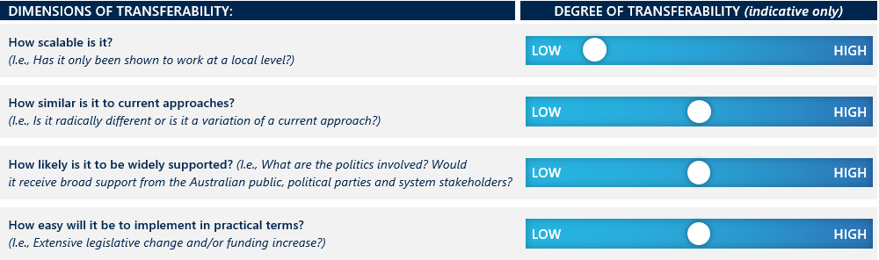

In Australia, State and Territory Governments are responsible for public school catchment zones, and may already consider SES mix and other measures of diversity in zone boundaries in cities. Applicability is limited in regional and rural areas, where it is more likely that only one public school is within convenient distance.

Non-government schools are not zoned however, and this presents as an option with bolstered effectiveness if used in conjunction with fee regulation. The idea of ‘gerrymandering’ boundaries would be controversial in Australia, and giving responsibility for boundary-setting to an independent body might make changes more palatable and more likely to be perceived as fair.

Simply flexing school zones will not be effective against well-informed and higher income parents who have the means to overcome zoning constraints by relocating or other means. It also invites the problem of having to continually re-draw the boundaries (as is done by the Australian Electoral Commission with respect to electorates) to account for changing demographics.

Weighted lotteries can be used to ‘even out’ access and distribution of places to out-of-zone students to high-demand schools. They therefore could be an attractive option when used as part of a formal or informal quota system, not least because they are less vulnerable to gaming. However, their novelty in Australia would make them harder to implement.

|  |
| --- |
| Preference matching, including controlled choice |
|  |

Preferencing matching refers to a system where parents can apply to schools in a designated area, ranking schools for their child in order of preference. An algorithm then objectively matches preferences to school enrolments taking multiple factors into account. There are two main models used: an immediate allocation model, and a deferred allocation model.

### Drivers and objectives

The main reasons cited for introducing controlled choice or preference matching are to reduce racial or cultural concentrations or improve socio-economic diversity. Controlled choice opens up access to out-of-zone schools and in-demand schools, enabling families to overcome residential segregation. More recently, particularly in Europe, the focus has been on using preference matching to better integrate children of migrants into the school system and support social cohesion.

### Operation and location

“Where school quality is unevenly distributed over neighbourhoods, district-wide choice affords all students a shot at schools viewed as high-quality.”

Angrist, J et. al  
*‘Still worth the trip?”*

The most established and well-known model of preference matching is referred to as the Boston Schools Match (BSM) model, which was introduced in early 1990s to boost both social integration and learning by decoupling school assignment from underlying residential segregation. From 1999, however, race was no longer considered in school assignments, and the BSM model evolved.

In practice, the adoption of controlled choice in Massachusetts was initially closely linked to bussing policies, because free transport was provided to all students who did not live in a 1.5 km radius of the school they attended. But, whereas bussing was court-imposed, the decision on whether to seek to attend a school in a different part of a district was voluntary.

This distinction meant that controlled choice was relatively (if not entirely) uncontroversial at the time. It was seen as preferable not only to bussing, but to fully unfettered school choice, for it was assumed that the latter would lead to reduced funding for public schooling. Recently, however, particularly under Republican administrations (e.g., in Florida), there has been a strong push for uncontrolled school choice. Moreover, a recent Supreme Court ruling makes it illegal now to use race as a basis for different or preferential treatment.

Other examples of areas in the US that have used preference matching are the Wake County Public School System in North Carolina (which implemented controlled choice in 2000) and Seattle’s Public Schools (which did so in the late 1990s). Both sought to produce greater socio-economic diversity.

Since 2007, controlled choice has been used alongside flexing school zones to allocate students to central public high schools in **Paris**. Using a priority point system, students entering high school receive points based on social indicators, in addition to their academic performance, and those with the most points are given priority when choosing which school to attend. Social bonuses consider both the student’s family income situation (whether they receive social-security payments) and the social composition of the middle school they attended. The social bonus currently applies only to Parisian public high schools, while the other aspects of controlled choice are used throughout France.

Chile’s School Admission System (SAS) was enshrined in their Inclusion Law and provides a centrally run, online admission process using a transparent algorithm that seeks to be impartial to students’ advantages and minimise opportunities to ‘game the system’.[96]

Sweden became increasingly inequitable after introducing a voucher system in the 1990s, dropping from 7th to 23rd place in the PISA rankings for equity from 2000-12. To address this, in recent years several parts of the country (presumably more densely populated districts) introduced a controlled choice mechanism for school enrolment.

In districts with controlled choice, places at over-subscribed schools are typically allocated by algorithms that reflect family preferences in the form of a rank-order list and a limited set of school ‘priorities’. These can include geographic proximity, attendance of the school by a sibling, language or special education needs. For example, since 2015, secondary schools in Amsterdam have used the Deferred Acceptance (DA) mechanism to match students to schools. Students submit a rank-ordered list, which can be as long as the number of available schools. There are provisions for prioritising some students’ preferences – for example, having a specific pedagogical relationship between the primary school a student attended and the secondary school on the student’s list, having an older sibling in the school, or a parent employed there (though the latter two provisions are being phased out). Priority on the basis of home-school distances is not allowed, however, and ties for places are resolved through a lottery.[97]

Schools *may* also prioritise students from low-income backgrounds or historically marginalised communities. Note that this is not always the case: certain schools in New York City are allowed to ‘screen’ applicants through consideration of test scores, interviews, or auditions. Also, not all schools are necessarily included in the lottery system.

The BSM model was heavily criticised and, as a result, replaced by a DA model, which shifted from an immediate first-preference placement algorithm, to one where students would be notionally allocated to a school, but final placements are not confirmed until all preferences are considered and the most stable alignment between school priorities and student choices is found. The DA model, which is the variant most widely adopted elsewhere (including centralised placement processes used in Amsterdam, Paris, Hungary and Taiwan), is seen as being more ‘strategy-proof’ – that is, it circumvents efforts by savvy parents to game the results and instead incentivises people to reveal their true preferences. Whether it represents an unequivocal improvement on the BSM, however, has been challenged.[98]

Moreover, there remain issues about the extent to which students self-select out of some available options. For example, where oversubscribed schools can screen students by test scores in cases of tied results, students may decide it is not worth putting forward that school as a preference.[99]

### Outcomes

##### Diversity

Most studies are from the US and focus on the impact of controlled choice models in terms of racial integration, and find, generally, that the results have been positive, though they vary of course as the demographic concentrations have changed (e.g., the growth of the Hispanic community in some districts). Research has revealed moderately strong evidence that increased choice “exacerbate concentrations of disadvantage in schools” as advantaged families are more capable of navigating and exercising choices.[100] A 2022 study into the effects of being educated outside one’s neighbour concluded that “non-neighbourhood enrolment has substantial integrating effects, especially for Black applicants…(boosting) integration in the sense of reducing minority applicants’ same race exposure and, for Blacks in Boston and Hispanics in New York, by reducing minority isolation.”[101]

In Parisian public high schools, the implementation of controlled choice was accompanied by ‘dynamic zoning’ based on achieving greater SES diversity. The overall effect was to reduce segregation by 30-40 per cent in only two years.[102] However, our interview with French economist and educational researcher professor Julien Grenet revealed limitations of the Parisian approach, arguing that segregation between students attending public schools and private schools (enrolling close to 50 per cent of students in high schools) continues to increase. Additionally, segregation in middle schools remains a significant problem, with social mixing only taking place relatively late in a student’s educational journey. On a more encouraging note, Julien Grenet suggested that the introduction of collective social bonuses, based on the social composition of a student’s middle school, may incentivise parents to choose lower performing middle schools. Although it is too early to be sure, anecdotally, the bonuses appear to encourage more affluent parents to send their children to these schools – their objective being to increase the likelihood of their child being prioritised for enrolment in their preferred high school.

##### Education outcomes

Early indications about the effects of desegregation in Boston showed a positive correlation with improved education outcomes for African American students. Evidence from more recent periods is mixed,[103] for example, one study found that the impacts on education outcomes (in this case, increased learning and college enrolment) were not as strong as those on diversity.[104] However, OECD Education Director Andreas Schleicher made the point to us in an interview that any effects of increased school diversity are likely be marked in the early stages but fall-off over time, absent another major innovation or disruption; this is because the intervention will have created a new baseline.

There is some suggestion that the longer travel time to attend a school assigned through controlled choice (or, indeed, any system that allows for out-of-zone enrolments) may have a negative effect on engagement, but this does not necessarily translate to poorer test scores.[105]

The libertarian think tank CATO, is less equivocal, reporting that controlled choice had not had a positive effect on education outcomes – primarily (it seems) due to ongoing ‘white flight’ and antagonism towards the allocation model:

“A review of controlled-choice plans in six large districts in North Carolina, Kentucky, and Florida shows considerable and ongoing higher-income and white losses in these districts. While other demographic forces cannot be ruled out (e.g., urban to suburban movement for reasons unrelated to schools), neither can the unpopularity of controlled choice. More importantly, none of these districts have demonstrated significant closing of achievement gaps between higher and lower income students, one of the main justifications for these plans.”[106]

The author concedes that scale maybe an issue, suggesting that controlled choice works in smaller districts and/or where it is not controversial, but does not see any merit in a mandatory approach over a fully voluntary one. To support this argument, he references an uncited study that analysed student test scores and socio-economic status from three statewide databases and found that school economic integration had virtually no effect on maths or reading scores once individual socio-economic status was considered.

However, in Paris, when the two most prestigious public high schools were brought into the centralised allocation system in 2022, both the diversity and average educational level of those admitted were slightly higher than those of the previous cohort.[107] More broadly, the introduction of controlled choice across Paris did not result in a ‘flight’ towards private schools and early evidence suggests there has been no significant deterioration of academic performance in comparison to private schools.[108]

It is difficult to assess the validity of these findings without the opportunity to look at impact over time and to be clear on how the peer effects were isolated from other drivers. Certainly, modelling in Australia would suggest that trajectories of disadvantaged students’ growth improve significantly in more socio-economically mixed school environments.[109]

### Evidence base

The changes in countries like Sweden and the Netherlands are too recent to be able to analyse. OECD Education Director Andreas Schleicher commended these examples to us as evidence of the effective application of controlled choice, but we cannot find any studies as of yet that provide a strong evidence base. Indeed, given the prevalence of preference matching, it is surprising that there isn’t more research available on its impact on both diversity and education outcomes. As with lotteries, however, the challenge is that this intervention is usually introduced at the district level, which makes getting access to data and reliable comparisons difficult.

### Transferability

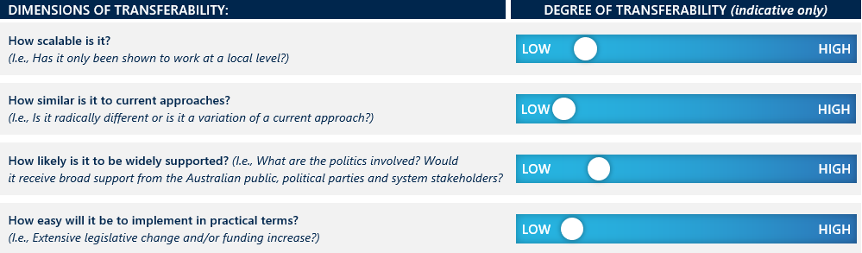

In Australia, preference matching for schools would be highly controversial and difficult to implement in a practical sense, particularly when the evidence is mixed and mostly from very different countries. In the Netherlands, to minimise the negative reaction to curtailing school choice, it was framed as an initiative to strengthen ties between schools and their local communities. This appeared to have some success.[110] (It probably helped, too, that around 80 per cent of students can enrol in one of their top-three preferred schools.) Preference matching seems to work best when it includes all or almost all schools – that is public schools and publicly funded but privately run schools. Where a significant minority of schools do not participate – such as in Paris or Sweden – the benefits are reduced. That said, 75-80 per cent of students are placed in their first or second schools in these locations also.

Any effort to introduce controlled choice would involve significant administrative costs and require investment in the development and governance of the preference matching mechanism (which could vary around the country). The most common algorithm in use is still contested, and there are issues around the extent to which schools’ ‘priorities can distort outcomes (even if parents’ strategies to game the system are overcome). Further, it would be difficult to scale outside the public system (which the Parisian example demonstrates is essential to truly address residualisation) and beyond metro areas.

The only upside is that it provides a degree of choice for those who have no real prospect currently of accessing high-demand public schools, assuming that the schools’ selection powers are weak.

|  |
| --- |
| Financial incentives to schools |
|  |

Financial incentives encourage schools to enrol disadvantaged students by providing extra funds to cover the educational expenses associated with meeting their greater educational needs. This enables the school to support higher educational growth and outcomes for its students, making it more attractive to a wider range of families and teachers.

### Drivers and objectives

Financial incentives, such as premiums or loadings that apply as part of or in addition to needs-based school funding models, can work to reduce or avoid concentrations of disadvantage and their effects. Such objectives derive from a combination of economic, educational, and social policy considerations. This policy intervention generally holds relatively strong public support based on a perception of it being “fair” or grounded in “common sense”.[111]

### Operation and locations

Financial incentives are used across the world in similar ways. They are provided to schools by one or more education authorities (i.e., federal government, state government and/or local district/authority) in the form of additional funding aligned to the number or proportion of disadvantaged students and/or the level of this disadvantage. School systems define disadvantage in different ways, such as eligibility for free school lunch (in the UK and US), or a combination of SES, language, cultural background and disability status (Australia, the UK and others) and/or indicators of relative need for additional academic support (Hong Kong and Chile). The funding can be an amount that is calibrated to the difference in degree of disadvantage using a single metric, or a combination of ‘loadings’ that relate to different dimensions of disadvantage. In federal or devolved systems, the forms can differ widely between school systems (e.g., between states and school districts in the US).

In England, Pupil Premiums were introduced in 2011 and involved an annual additional allocation of funding to state-funded schools for each qualifying student (eligible for free school meals or in state care).[112] This additional funding is provided to schools or multi-academy trusts (MATs) and can be combined with other funding to be used in the most effective way – such as investing in additional professional learning for teachers, recruiting additional teachers, or remedial tuition. As a condition of funding, schools/MATs must articulate how their strategy for using the Pupil Premium contributes to improving the educational outcomes of the qualifying students, with a strong focus on learning gain. Pupil Premiums complement a needs-based, weighted funding system to further increase funding for disadvantaged students.

In Hong Kong, additional resources are provided to schools to support students struggling academically irrespective of their SES or cultural background. In primary schools, this takes the form of additional funding on a per-student basis for each student two or more years behind (using a state-developed test) in at least two of the three core subjects (Chinese, English and maths). As in the UK, schools choose how to use the funds. In secondary schools, the Education Bureau allocates additional teachers to schools with high proportions of students scoring in the bottom ten per cent and the bottom third of the secondary school admissions exams.[113]

In Chile, the national government passed *Preferential School Subsidy* reforms in 2008, which increased the value of funding (described as a voucher) by 50 per cent for “priority students” – that is, those students whose family incomes fell within the bottom 40 per cent of the national distribution. In addition to this, schools with large proportions of ‘priority students’ received per-student concentration bonuses, which increased as the proportion of such students within the student body increased. For schools to be eligible to accept higher-valued vouchers, they were required to waive fees for “priority students” and accept high accountability requirements. Chilean schools that fail to improve students’ maths and reading scores risk losing funding or their license.

### Outcomes

Being one of the highest performing and highest equity school systems in the OECD, Hong Kong performs well against both diversity and education outcomes criteria. It has one of the highest percentiles of resilient students, defined as the students from the lowest socio-economic quartile who are among the top performers on PISA. Findings related to the UK and Chile appear below.

##### Diversity

The clearest data is from the UK. Since the introduction of the Pupil Premium in 2011, concentrations of highly disadvantaged students decreased, with long-term disadvantaged students becoming “substantially less clustered in specific schools in their first year and throughout their remaining school years”.[114] Studies also indicated that extra funding from the Pupil Premium could be used to implement additional measures to support disadvantaged children, such as catch-up programmes.[115]

“The segregation of long-term disadvantaged pupils and their peers reduced in Years 1 and 6, and their attainment improved relative to their peers at ages 7 and 11... relative attainment for poor pupils improved markedly in the Pupil Premium era, even in regions like the North of England which have faced criticism for apparently “failing“ their poor pupils.”

Gorard, Siddiqui and Huat-See (2021)

*Assessing the impact of Pupil Premium funding on primary school segregation and attainment*

As noted above and in earlier sections, Chile has seen a marked shift towards desegregation since 2006 and especially since 2016. While students of similar SES backgrounds tend to attend school together, reflecting continued SES patterns across neighbourhoods, there is a greater mix of students in schools from all but the top SES quintile (who remain largely enrolled in high-fee private schools). Emiliana Vegas advised that the voucher system was initially an opt-in intervention. However, after seeing such strong improvements in diversity, the program was implemented across the entire system.

##### Education

In the UK, educational outcomes of disadvantaged students improved, and this appears to have contributed to the UK’s movement up international rankings. The educational attainment of students qualifying for the Pupil Premium improved relative to their peers.[116] Meanwhile, the PISA reading scores of advantaged and disadvantaged students in the UK both increased significantly between 2009 and 2018. The reading scores of English students as measured by PIRLS in 2021 was also statistically higher than the international median score and has not fallen since 2016 (unlike most other education systems).[117]

Trends in Chilean student test scores suggest that the SEP reforms were successful in improving student outcomes for disadvantaged students. Mathematics scores of Chilean fourth grade students increased substantially four years after the introduction of SEP for students of all levels of family income. Most importantly, the income-based test score gap declined by over one third between 2005 and 2012 (20.8 points to 13.3 points).[118] It is important to note however, that it was equally as important that Chile held schools to account for learning results when implementing additional resources to disadvantaged students. The quality gap between schools mostly enrolling the poor and the non-poor has also decreased, indicating the benefits of this package of interventions and potentially also the greater social mix in schools and classrooms.[119]

Of particular note is that educational economist and policy advisor, Emiliana Vegas, considered the supplementary funding to schools for enrolling disadvantaged students to have been the most powerful intervention in Chile’s suite of reforms. This was due to its direct, positive impact on social mixing and its contribution to lifting learning outcomes.[120]

### Evidence base

Evidence for the UK is strong. While all four independent studies of the impact of the Pupil Premium in the UK were by the same author, Stephen Gorard (sometimes with others), these analyses went beyond previous research to assess the prevalence of free school meal eligibility, private school attendance, duration of poverty and other factors that may influence school diversity. The studies’ findings consistently point to a significant decline in segregation that can be attributed at least in part to the introduction of the Pupil Premium in 2011. As noted above, the positive educational and social diversity impact is also reflected in PISA and PIRLS results.[121]

However, it unclear whether improved education outcomes are due to greater diversity in school (and resulting peer effects), higher resourcing levels, or concurrent initiatives such as curriculum and school governance reform (see section 3.10).

Hong Kong overhauled its education system from 1997. The school funding system is but one element of its strong performance on learning and equity measures. Other influences on outcomes likely include: a modern curriculum and pedagogies that focus on learning for deep understanding and applications across different contexts; extension of compulsory secondary schooling to 6 years; investments in teacher and school leader development; and teaching being a high-status, highly paid profession. As noted earlier, 80 per cent of Hong Kong Schools are run by charitable or religious organisations, fully funded by the government, and follow a national curriculum underpinned by the availability of high-quality curriculum resources. Further, large proportions of students enrol in private after-school tuition to prepare for the admission exams for secondary school and university.[122]

### Transferability

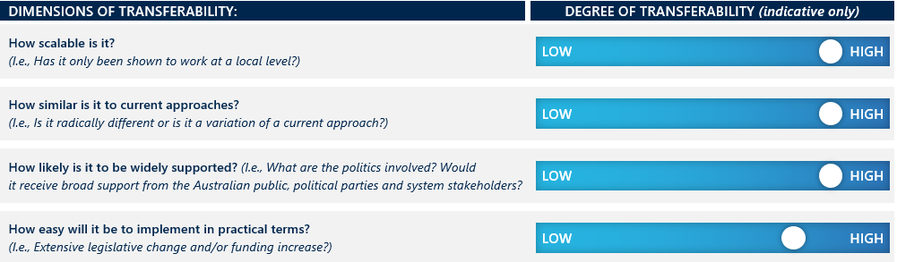

The UK’s Pupil Premium supplementary funding to state (public) schools complements its needs-based funding allocation model through the provision of supplementary funding to state (public) schools. It is a simpler model than Australia’s school funding formula, and has the advantage of making it easier to ‘follow the money.’ The downside is its ‘black-and-white’ eligibility (i.e., in terms of a student being part of the ‘free lunch’ program or not).

An intervention similar to a Pupil Premium would be highly scalable in Australia and could be implemented if approached as a complement to the current needs-based funding models that apply loadings based on school factors of disadvantage as well as student characteristics. It would require careful design and tight controls on implementation to ensure fair and consistent distribution proportionate to relative need, and effective accountability for use of the funds. The information required to make funding decisions could be readily sourced and integrated with other data sets to support effective targeting.

Needs-based funding holds strong public support[123] and so it is likely that a variation of a Pupil Premium would similarly be welcomed. As with previous school funding reforms, however, implementation difficulty would depend on the extent to which a new model would create ‘winners and losers’ among schools.

|  |
| --- |
| Incentives to educators |
|  |

Many systems worldwide use financial and other incentives to encourage individual teachers and school leaders to move to, work in, and remain in hard-to-staff schools. These often include schools in rural and remote areas, or those with high concentrations of disadvantage. In some places, these incentives extend to professional learning offerings over and above what might be regarded as ‘standard’ opportunities.

Such incentives can be both ‘direct’ and ‘indirect.’ Direct financial incentives refer to an outright payment for educators, such as a salary increase or performance bonus. Indirect incentives pertain to rewards or benefits that would be expected to result in financial benefit or relief over time – for example, forgiveness of student debt or prioritisation for promotion.

### Drivers and objectives

It is well-established that highly effective teachers are the most powerful in-school contributor to improved student educational outcomes, followed by highly effective school leaders.[124] Financial incentives to educators are a response to evidence that schools in rural and remote locations, or with high concentrations of disadvantage, are less likely to attract and retain highly effective and Masters-qualified teachers.[125] This evidence suggests that working in complex and highly disadvantaged schools is seen or experienced in different ways. While some teachers seek out opportunities to work in such settings for the professional challenge and satisfaction, others – particularly in systems which post newly graduated teachers to far-flung or difficult locations – see it as a way to ‘earn’ the right to move to an easier location within the public system. Among both groups, teachers become burnt out or demoralised from the difficult working conditions with inadequate support, recognition or reward, and opt for schools in more advantaged areas or the private sector, which typically offers higher pay and greater supports for the teachers (such as administrative and technical support) and students (more individual and small group tuition, onsite counsellors etc), allowing teachers more time to teach.[126]

It follows that schools with concentrations of disadvantage are therefore more likely to: experience staff shortages, struggle to retain highly effective educators, and employ the least experienced, least qualified teachers.[127] This negatively impacts the quality and continuity of students’ education and perpetuates a cycle of residualisation, making it harder for the remaining students and teachers to maintain a positive learning environment.[128]

Conversely, having high proportions of highly-skilled teachers in disadvantaged schools can contribute to their success.[129] If there is a turnaround in academic performance in those schools, arguably aspirational and advantaged families will be more likely to send or keep their children there, countering the residualisation trend.

### Operation and locations

###### Direct incentives

Golden Hello, offered in some regions of England, provides financial incentives to attract teachers to areas with teacher shortages, including highly disadvantaged schools. The program targets early career teachers and teachers qualified to teach specific subjects within specific schools and local authorities and provides greater payments for those teaching in high needs schools.[130]

Many Canadian provinces offer financial incentives for educators working in regional and remote areas, typically including a combination of additional allowances, financial student bursaries, subsidised accommodation or travel.[131] Yukon offers additional allowances for educators in rural communities and a ‘Yukon bonus’ to offset travel costs. Educators become eligible for the bonus after the first two years of continuous service and every year thereafter on the continuous service date.[132] Other provinces and territories offer allowances to allow teachers who work in remote or northern communities to offset the higher cost of living in these areas. In 2023, the Rural British Columbia District offered ‘Welcome to Community’ awards, providing $10,000 cash welcome gifts to attract new teachers, with higher incentives for teachers agreeing to move to small towns and communities. These are funded by an anonymous donor rather than government.[133]

New Zealand has a voluntary bonding scheme for primary and secondary teachers where teachers receive a $NZ10,500 payment after three years of teaching, and $NZ3,500 after their fourth and fifth years.[134] This is an expansion of a teacher supply initiative to encourage newly graduated teachers to teach in areas of high need, such as the most socio-economically disadvantaged schools, or priority subjects maths, science and te reo Māori.[135]

China’s performance-based wage places emphasis on rewarding and encouraging high performing teachers, in particular those who contribute to alleviating the effects of poverty.[136]

###### Indirect incentives

In England, the Teaching and Leadership Innovation Fund supports teachers and leaders in challenging schools for three years, offering them opportunities for professional development and leadership training, with the objective of reinforcing their skills and supporting their retention and progression. It includes opportunities for face to-face training and/or workshops, coaching or mentoring; opportunities to collaborate with other leaders and teachers; and access to online communities, materials and resources.[137]

China has a policy initiative to encourage outstanding teachers and former teachers to take up jobs for at least a year in impoverished rural areas.[138] The Chinese promotion structure includes several levels and titles for teachers and principals and uses incentives to encourage highly experienced ‘master teachers’ to work in disadvantaged areas. Teachers with experience in either teaching in rural areas or supporting other teachers to do so are given preference for promotion, and those seeking advancement are encouraged to relocate to rural and less-developed regions.[139] The chances of securing promotion increase the longer they remain in rural and remote areas. Additionally, leading teachers willing to teach in disadvantaged schools can postpone their retirement by three to five years, a significant incentive in China where people often wish to work beyond the mandatory retirement age.[140]

The US Department of Education has three indirect incentive programs of high relevance to this review:

* The Teacher Incentive Fund (TIF) provides funding for projects that develop and implement performance-based teacher and principal compensation systems in high-need schools. Programs include peer-to-peer coaching, job-embedded professional development, performance-based compensation, and career development opportunities. [141]
* The Teacher and School Leader (TSL) Incentive Program builds on the TIF program and promotes performance-based compensation and comprehensive human capital management systems for teachers, principals, and other school leaders in high-need schools.[142]
* The Teacher Loan Forgiveness (TLF) program allows teachers who teach for five years full-time in a low-income school to be eligible for forgiveness on students’ loans of up to $17,500.[143]

### Outcomes

Analysis of international use of financial incentives for educators suggest that they can play a positive role in attracting highly effective teachers to disadvantaged schools. However, the incentives must be designed carefully to be of sufficient value and duration to deliver the sustained improvement necessary for there to be an impact on a school’s reputation that prevents ‘flight’ or avoidance by wealthier parents. While some evidence indicates that financial incentives for educators directly improve educational outcomes of the students concerned, the influence on diversity is less clear. At best, an inference could be drawn from the findings that improved teaching quality, retention and educational outcomes leads to a more favourable view of the school by current and prospective families, which can then counter any residualisation trend. But there is nothing more definitive on this.

Further, while limited or short-term incentives were found to address immediate staffing shortages in several countries’ school systems, not all of the interventions outlined above were in place long enough to have a marked impact on teacher retention. Therefore, impacts on education and diversity outcomes are hard to detect.

##### Diversity

###### Direct incentives

Little evidence is available to link direct or indirect incentives for educators to improved diversity within schools. Instead, the literature typically focuses on the impact of financial incentives for educators on recruiting effective teachers and improving retention, teaching quality and educational outcomes. In other words, while there may be a follow-on effect that the school becomes more desirable to a more diverse representation of the population, this has not been studied sufficiently to draw any definitive conclusions.

###### Indirect incentives

Of the interventions examined, the US’ Teacher and School Leader Incentive Program was the only intervention with priorities relating directly to improved equity for disadvantaged students. All participating districts proposed steps to identify and address equity gaps as part of their TSL grant application. However, to date, only four districts have reported prioritising and taking steps to address equity challenges. The outcomes of their actions have yet to be evaluated.[144]

##### Education

###### Direct incentives

In the US, TIF showed small positive improvements in student achievement by the second year of implementation.[145] From that time onwards, students’ achievements on standardised tests were one to two percentage points higher in reading and maths – the equivalent of about four weeks of additional learning for schools that offered pay-for-performance bonuses compared to those that did not. This difference was statistically significant in all years of the program for reading and in one year for maths, unrelated to either district or school characteristics.[146]

In contrast, China’s performance-based pay policy had little impact on teacher performance in disadvantaged rural areas.[147] Literature reveals that even among schools that claim to have implemented performance-related pay schemes, teachers tend to receive equal sized payments, regardless of their performance, indicating that the policy has only been nominally implemented.[148] Commentators suggest that decentralised education systems like the Chinese system, where each school determines its own approach to compliance with national performance-based pay policies, typically result in relatively weak structures that do not incentivise behaviour change.[149]

However, Chinese schools that did apply a pay-for-percentile incentive scheme were effective in improving the average math score of students by 0.10 standard deviations. This improvement was especially pronounced for students in the bottom percentiles of their class (0.15 standard deviations), although mid and top performers also saw small gains.[150]

With respect to indirect incentives in the UK, the evidence indicates that the TILF projects may have contributed to improved progress and attainment for some pupils. However, the cancelation of national exams in 2020 and 2021 prevented a full evaluation.[151]

A School Workforce Census (SWC) meta-analysis showed that TILF had a positive impact on teacher retention, but no noticeable impact on their career progression. Participants in TILF projects were significantly more likely than other teachers in the UK to remain in the teaching profession, in challenging schools and in the same school. The Golden Hello also eased recruitment and retention challenges in areas with teacher shortages, including highly disadvantaged schools.

By contrast, in the US, researchers found that the TLF Program had no significant impact on retaining teachers or on attracting them to high-need schools.[152] Rather than incentivising teachers to remain in one school for five years to become eligible for debt forgiveness, promotion of the program seems to have primarily increased uptake by teachers who had already completed five years in their school.[153] This suggests that loan forgiveness is a weaker incentive than financial bonuses or subsidies.

However, a recent assessment of the United States TLF found that $5,000 of debt forgiveness would break a tie between two equivalent schools by 16 percentage points, increasing the probability of a teacher selecting a disadvantaged school to 66 per cent.[154] The same study suggested that the complex administrative processes required to apply for debt forgiveness may explain why the uptake of TLF had been lower than expected.[155]

### Evidence base

The available evidence, while broadly positive, is limited in relation to impact on school diversity outcomes over time. Many of the financial incentives employed have either been small-scale or short-term initiatives, and their total effect on education outcomes or diversity are difficult to isolate from other factors, including concurrently occurring reforms. This applies in particular to the UK, New Zealand and the US examples. Some initiatives focusing on improving retention rates in rural and regional areas also lack definitive results.[156]

Overall, evidence suggests that financial incentives appear promising for attracting highly effective teachers and improving educational outcomes, but it is difficult to point to a discernible effect on reversing concentrations of disadvantage.[157] This is because uptake and retention is generally less than desired, and the overall impact lower than anticipated and harder to measure.

### Transferability

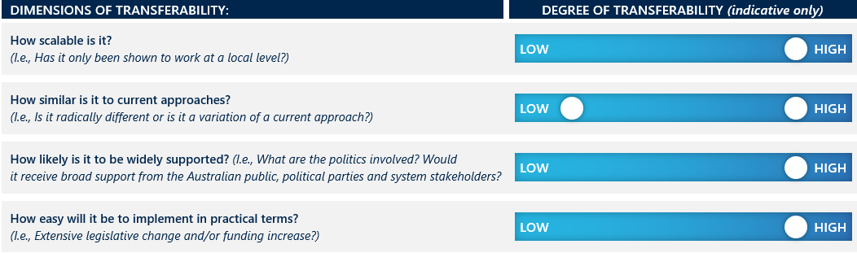

The impact of incentives is proportional to their size and accessibility. Financial incentives for educators are more likely to appeal to younger and more mobile teachers who are less likely to be geographically constrained by family considerations such as their partner’s place of employment. This is a limitation of the intervention.[158]

This intervention is highly scalable, likely to be widely supported, and can be implemented in ways that are similar to or deviated from past and current approaches. While the Chinese performance-based pay and postponed mandatory retirement interventions differ from existing Australian approaches, Australia’s jurisdictions have already experimented with other incentives for teachers and school leaders. For example, Victoria has recently announced very generous initiatives of up to $50,000 per teacher to take up positions in rural, remote and ‘otherwise hard to staff’ schools.

Ease of implementation depends on the design of the incentive schemes – namely the financial amounts and conditions attached. Incentives with many conditions attached make it harder for teachers and schools to participate, reducing impact through reduced participation. In contrast, fewer conditions (e.g., shorter requirements for teaching in disadvantaged schools) could reduce impact by contributing to educator turnover in disadvantaged schools.

|  |
| --- |
| Alternative teaching, assessment and delivery models |
|  |

This intervention aims to better meet student needs (especially at-risk students) and improve learning and related outcomes through fundamentally different teaching and learning models. It does so in a variety of ways including through reconfiguring schools to provide greater personalised and community-based education, through online or hybrid delivery, and increasing the range of valued and measured student outcomes. By demonstrating success and a more individualised approach to education, schools adopting these alternative models – initially with cohorts who are disadvantaged and disengaged – become more attractive to advantaged families, thereby improving the socio-economic mix.

### Drivers and objectives

Traditional models of schooling do not meet the needs of all students, nor do they always meet all the needs of the rapidly changing economy and society they are entering. New approaches have typically responded to high and increasing numbers of disengaged and under-engaged students,[159] as well as students excluded from schools (for example, for repeated disruptive behaviour) or self-excluded (for example, due to bullying, inadequate learning progress, or mental health issues).

“Australia still has an industrial model of school education… it is not designed to differentiate learning… nor does it incentivise students to innovate and continuously improve”.

Report of the Review to Achieve Educational Excellence in Australian Schools

While these issues are present among students of all backgrounds, school disengagement and early leaving disproportionately affects students from low SES backgrounds, students in regional and remote areas, and First Nations students.[160] As a consequence, these students are also less likely to have access to a curriculum of sufficient breadth and depth, especially during senior years, or to access specialist teachers at any year level.[161]

The situation has been perpetuated by assumptions and expectations that schools are physical places that ought to operate in familiar ways, something which can underpin the way schools market themselves in a competitive school market. In this process, the drivers of traditional schooling can also become drivers of complacency.[162]

Alternative models of teaching, assessment and delivery challenge the prevailing view that education success equates to eligibility to gain entry to higher education qualifications. For example, the final report of the *Review of senior secondary pathways into work, further education and training* (the “Shergold Report”) called for all [Australian] students to leave [school] with a Learner Profile.[163] For those concerned about equitable access to quality education and post-school opportunities, the hypothesis is that, by valuing a broader range of skills, students from more disadvantaged backgrounds will remain engaged in learning for longer, and will develop a stronger sense of self-esteem and agency. Students from all backgrounds would, however, benefit from a recognition of the full range of strengths and knowledge that they bring to bear (and can offer to future employers). This, again, can mitigate the risk of flight from a school with concentrations of disadvantage.

### Operation and location

The schools that challenge the norms of traditional education and assessment are outliers,[164] but some are seen by education authorities as useful innovations to respond to gaps in education provision, and are supported. The three variations on the theme of offering alternative teaching, assessment and delivery models are:

* Online and hybrid delivery as the norm rather than exception – we focus on the examples of Aurora College in New South Wales, the Victorian Virtual Learning Network (VVLN) based in Bendigo, andTe Aho o Te Kura Pounamu (Te Kura) in New Zealand.
* Changed assessment models that widen the range of what is valued – this is an approach being adopted in several overseas jurisdictions (e.g., the Philippines), but with prime examples (such as the ‘New Metrics project’ schools) in Australia.
* Expanding access to innovative and inclusive learning designs – the key example of this is the Big Picture model, that has its origins in the US but which has been implemented in over 40 schools across Australia (every state except Northern Territory and South Australia).[165]

Each is discussed briefly in turn.

**Online and hybrid delivery**

Aurora College is a Sydney-based online selective school serving rural and regional NSW. Students attend their local high school but also log in to Aurora’s online conferencing system each day for lessons.[166] Residential gatherings are held twice each year and students have access to specialised lessons and leading scholars.[167]

The Victorian Virtual Learning Network (VVLN) is an initiative of the principal and staff of Bendigo Senior Secondary College (BSSC). While Aurora College in NSW delivers synchronous lessons, the VVLN has packaged eight VCE subjects for students. to access at any time, with eight specialist teachers reaching 270 students in 69 schools. The online contact and support includes teacher visits to their far-flung students at least once each year.[168]

*Te Aho o Te Kura Pounamu* (Te Kura), was previously a correspondence school and is now New Zealand’s largest school delivering mostly online education to almost 30,000 students. Former Chief Executive Mike Hollings reshaped the school to develop personalised learning and community-based projects, combining distance education with a network of physical academies based on Māori and Big Picture learning (the latter is discussed further below).

“Coming to Te Kura saved these kids’ lives”

Mike Hollings,   
*former Te Kura Chief Executive*

Most students are referred to it through other entities due to the students’ exclusion or self-exclusion from mainstream schools (for bullying, racism, behavioural and learning problems). About 12,000 of its students enrol in one to four subjects (such as advanced calculus or Māori law and philosophy) that they would not normally be able to access at their home school. A further 5000 students are young adults (16-19 years old) who are no longer required to be at school but have an entitlement to free education.

Importantly, participating students remain enrolled in their ‘home’ school and closely connected to their local communities, so there is reduced risk of residualisation. Students can access wider curriculum and a range of online supports without having to leave their home school, so it weakens the desire or need for students in lower SES areas to flee to another school to pursue their interests and ambitions.

##### Changed assessment models that widen the range of what is valued

A related innovation seeks to broaden the knowledge and skills that are recognised and formally included certification of school achievement. This is starting to happen at a systemic level with the SACE Board in South Australia piloting a new senior secondary certificate that involves teacher assessments of students against the general capabilities in the Australian Curriculum, and not just academic achievement. More radical models seek to value and codify forms of knowledge and experience acquired and observed outside the school environment – for example, by providing formal recognition of First Nations’ students contributions to caring for Country or learning language.

The model in Australia that has begun to develop the strongest evidence base – for the ability to assess these broader competencies, if not yet to demonstrate an impact on equity and outcomes – is the New Metrics project auspiced by the University of Melbourne. Around 40 Victorian schools participate in a program that seeks to cultivate and assess students’ capabilities in areas such as critical and creative thinking or communication skills. The assessment is based on observations within school (in the course of the students’ regular work and extra-curricular activities) and beyond the school gate (e.g., in part time employment, sports, or volunteering), with competency recorded by teachers and relevant people in the community (such as scout leaders, managers). The results are captured in a learner profile or similar credential to use alongside or instead of a record of academic achievement.[169]

Participating students and schools emphasise the benefits to students from valuing non-academic measures, which not only open opportunities but lift motivation, deepen engagement in learning and facilitate post-school transitions.[170] All variants of the New Metrics model put significant store in developing student esteem and agency as part of the process, with the intent to address inequities in the school system. By the same token, it is important in these models to control for adverse impacts on equity by giving advantage to students who have more access to extra-curricular activities, which might be counted towards a learner profile. For this reason, there is emphasis on capturing the competencies demonstrated through activities such as caring for family members and caring for country, and not just participation in team sports and other similar activities.

“The learner profile has the potential to create a more level playing field for accessing university than the ATAR ranking or use of passports and portfolios”.

Centre for Study of Equity in Higher Education

##### Expanding access to innovative and inclusive learning designs

As noted, the Big Picture learning design has its origins in the US but has evolved in Australia. The concept centres on engaging students who learn through personal passions and connections to opportunities outside school, and supporting the transition to meaningful post-school pathways, including university. Being personalised, inclusive and strengths-based, the model is intended to cater to all students in every context, catering to their wellbeing as well as their academic potential.

In Australia, the Big Picture model is typically offered within a mainstream secondary school, both within the government and non-government sectors. Its learning design is characterised by the following ‘12 distinguishers’. [171]

Figure 5 I The 12 distinguishers of the Big Picture Learning Design

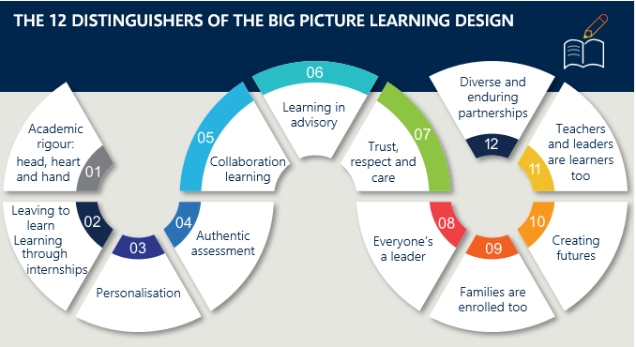

### Outcomes

##### Diversity

Big Picture schools were initially considered a response to the needs of low SES students, but over time they have drawn a wider range of students with different, including more advantaged, family backgrounds (many of whom had disengaged from mainstream schools). In its NSW schools, for example:

* Cooks Hill Campus of Newcastle High School has 150 students drawn from 14 local schools, reflecting the full spread of SES categories.
* Hunter Sports High School, a specialist sports academy with four Big Picture advisories (classes) enrols half of its Big Picture students from the sports academy and half from the local (low-SES) community.
* Morisset High School is in a significantly disadvantaged community but has managed to attract a high proportion of lower to middle SES families. The school has five Big Picture advisories.[172]

The inclusiveness of the schools reflects their approach to student assessment, with a comprehensive end-of-school credential, the International Big Picture Learning Credential (IBPLC), now warranted by the University of Melbourne. [173]

Te Kura is New Zealand’s most socio-economically and culturally diverse school, enrolling students of all backgrounds and locations across New Zealand. Its school population and diversity jumped higher again during COVID, where at the request of the education minister, it expanded its access and enrolment to serve students for whom remote learning at their schools of origin was unsuccessful. The New Metrics program brings together elite private schools, highly disadvantaged public schools in very low SES locations (each with strong cultural diversity), and dozens of other schools between these extremes. All participating schools consider the program to cultivate and assess capabilities as being a drawcard for current and potential students.

##### Education

Big Picture schools and academies perform well across a wide range of educational measures, including in academic performance, retention and transition to further education, training, or employment. They achieve similarly or superiorly to schools with similar cohorts, and their students achieve more than their previous schools (where they have changed schools). A substantial evaluation of Big Picture, across a wide range of critical outcomes, indicates that the improvement in student outcomes is causative. [174]

Five Islands Secondary College in Port Kembla offers an interesting case study. According to Viv White, Co-Founder and CEO of Big Picture Learning Australia:

“(u)p until 6 years ago, it was a last chance Year 11 and 12 senior college with most young people having failed in the local schools. These young people have significant disadvantages. Their Family Occupation and Education Index (FOEI) (a measure of SES) was 180 but with the expansion to Big Picture, their FOEI has gone down to 100.[175] This means that they have lost $600,000 annually and the more affluent young people coming to the school have significant undiagnosed issues and it is costing the school more to support. This is a consequence of students of a higher SES from private and Catholic schools enrolling in the Big Picture design. Some travel many hours to get to the Big Picture program. It now has 150 students and 10 advisories (classes) drawing from across the Illawarra including elite private schools and Catholic colleges. As a result, they have moved from a low SES full cohort to a mixed SES group.”[176]

Te Kura has been evaluated by the NZ Ministry of Education, the schooling model is recognised as innovative in digital learning, proven adaptability during COVID-19 pandemic, and effective in student re-engagement as “ongoing modest gains in student engagement and achievement can be seen across the school”.[177]

### Evidence base

The evidence on these alternative models of learning, assessment, and delivery, though encouraging, is inconsistent. In particular, we have yet to see accumulated evidence of the impact on outcomes of deploying different models of learning recognition that value a broader range of knowledge and skills.[178]

Further, models such as Aurora College and VVLN are hard to assess in terms of academic outcomes for the student participants as their information is included in the results of their various ‘home’ schools.

### Transferability

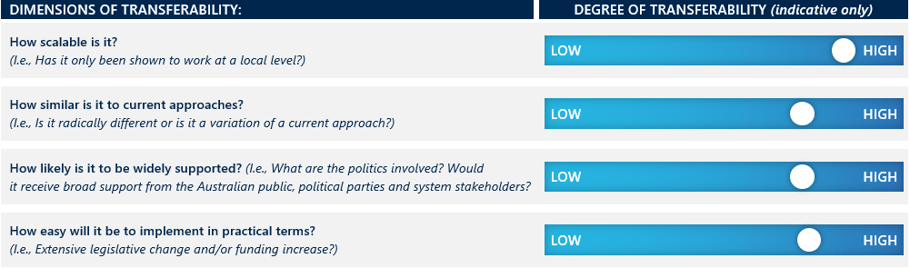

The presence of these alternative learning, assessment and delivery models in Australia indicates their feasibility in metro and regional locations. As noted, one jurisdiction is already trialling a broader learning recognition system, and the number of schools employing this type of innovation (which includes not only the cluster of New Metrics schools but also Big Picture schools, which have their own internationally recognised certification for graduating students) is growing. The costs involved are relatively low,[179] though investment is required in new forms of pedagogy and assessment.

There is unlikely to be any significant political risk in opening-up access to these alternative models. A key implementation concern, however, is to ensure that the focus is on supporting schools with a concentration of disadvantage that may be vulnerable to the ‘residualisation’ phenomenon.

The downsides of expanding their presence seem few in number, especially when considering the students who are at high risk of disengaging from learning, though it would be important to establish stronger evidence about impacts to build a truly compelling argument for adopting the models at scale in Australia.

|  |
| --- |
| Networked schools and teaching capacity exchange |
|  |

Capacity sharing occurs when two or more schools pool resources, share facilities, collaborate in professional learning communities and/or share responsibility for the delivery of curriculum. Such arrangements enable teachers and school leaders to move between schools, and to bring students from different schools and backgrounds together to take part in common curricular and co-curricular activities. Accordingly, they can serve to improve the experience and outcomes for students in schools where there are concentrations of disadvantage, mitigating the risk of ‘flight’ to other schools and attracting more students from higher-SES backgrounds. In other words, the outcome over time might see also a ‘capacity exchange’ of students as well as of teachers and school resources more broadly.

### Operation and objectives

In England, Academy schools, which are fully publicly funded but independently operated, have increasingly been brought under the control of trusts – non-profit companies that operate under funding agreements with the Secretary of State for Education. These ‘Multi-Academy Trusts’ (MATs) are now responsible for over a third of all schools in England, educating around half of all students.[180] According to a 2022 Department for Education white paper, the broad intent was to see each MAT responsible for at least 10 schools. At this stage, around half of the current MATs are smaller than that.[181]

MATS seek to:

* Deploy common approaches to curriculum, assessment and pedagogy between schools
* Build knowledge and expertise
* Identify and share successful practices.

In practice, the intent is to lift the performance of under-performing schools by matching them with schools further along the journey to excellence.

There are two types of academies in the MATs: sponsored academies, which are compelled to come under the sponsorship of a trust due to poor performance, and converter academies, which voluntarily apply to join a MAT. Sponsored academies and converter academies accounted for 18 per cent and 44 per cent of secondary schools respectively in 2017.

To achieve their goals MATs use professional learning communities, peer view visits, learning walks (structured school visits), multi-school research and development projects, and ‘sharing excellence weeks’ in which schools share success stories. In larger MATs these processes may be facilitated by centrally employed subject consultants who move between schools identifying and sharing best practice.[182]

United Learning is an example of a large MAT that runs in 91 schools located across England, serving over 55,000 students. It is distinctive in that it oversees a diverse group of academies, independent and free schools and offers students opportunities to develop connections through practical interactions. United Learning brings teachers together from across its schools for subject-specific training, and brings students together for activities like music, dance, sport, drama, art, cultural festivals, charity events and public speaking, as well as online lectures from leading experts from academia and industry.[183]

In Shanghai under the empowered management program, school districts contract a high-performing school to work with a low-performing school for a period of two years, with the possibility of extension. The Shanghai Education Commission makes a grant to the high-performing school intended to cover the cost of the intervention, but also to provide a financial incentive to participate in the scheme.[184] Participation by high-performing schools is also viewed as “a social commitment to promote equity in the schools in the city.”[185]

Typically, a school leadership team from the high-performing school will be stationed in the partner school. They lead a process of diagnosis, intervention and implementation of new programs and practices aimed at addressing underachievement. Teachers and school leaders are able to move between the two schools to share knowledge and build capacity. Exemplary groups of teachers lead professional development sessions.

The Victorian Virtual Learning Network (discussed in section 3.8) helps meet the demand for specialist teachers in otherwise disadvantaged schools and communities, mostly in rural areas. We do not have visibility of the academic performance or backgrounds (SES or cultural) of enrolled students, because they remained enrolled in their local schools.

### Outcomes

##### Diversity

The research we have been able to access on outcomes related to diversity within the MATs and the Shanghai system is very limited in the case of the former, and non-existent in the case of the latter.

In England, the only study we could find relates to an Academy within a MAT that caters to students with special needs. The study found that schools that sponsored academies were more likely than converter academies to decrease the proportion of pupils with special needs and remove additional support for them.[186] Academies with a commitment to inclusion do exist, but there is no obligation to be accessible to all.[187]

In terms of broader context for the MATs, it is important to note that academies have been criticised for “undercutting funding for public schools, using exclusionary admissions criteria, and failing to provide appropriate support for diverse students or those with special educational needs.”[188] Some argue that the development of a variety of school types reduces diversity in the student population within each school type and has heralded the arrival of a two-tier system based on socio-economic boundaries.[189]

In Shanghai it appears the empowered-management program focusses primarily on educational equity, specifically, improved student achievement through equal access to quality education, rather than socioeconomic diversity. PISA 2018 data reveals that the B-S-J-Z (China) remains substantially above the OECD average in terms of segregation of both advantaged and disadvantaged students.[190]

##### Education

The United Kingdom performed above average in all subject areas in PISA 2018, but there was not a statistically significant difference in average achievement compared to Australia.[191] Greany and McGinity concluded from their analysis of the evidence produced from a number of studies that there are “wide variations in performance within the MAT sector, and that the sector as a whole is performing at or slightly below the national average.”[192] There is no available evidence that delineates the effect of capacity sharing practices on the overall performance of MATs.

Significant international focus on Shanghai has been stimulated not only by its outstanding overall achievement, but the success of its schools in serving the city’s most disadvantaged students. Researchers have observed that “the poorest ten percent of students in Shanghai perform at a level in math that is on average 28 months ahead of the poorest ten percent of students in the United States.”[193] Huang and Sebastian find that, internationally, it is rare for jurisdictions to have statistically significant variations between schools in terms of reducing within-school gaps in achievement associated with socio-economic disadvantage. Shanghai is internationally unique in this regard: 14 per cent of its schools can be described as ‘bridging schools’, where within-school variation is substantially minimised, and overall achievement is maximised.[194]

### Evidence base

The empowered-management program is only one of multiple major policies that define Shanghai’s education system. Others include a form of needs-based funding, legislated quotas, and enhanced standards for entry into the teaching profession.[195] The role of the empowered-management program in Shanghai’s success on education performance metrics is therefore unclear. Jensen and Farmer report that: “Precise and transparent quantitative measures of how the empowered-management program impacts student learning are not available to help outside observers discern the effectiveness of the program.” [196] There is a lack of available evidence concerning impact on the high-performing school that takes on significant additional responsibilities, as well as the low-performing school which is the target of the intervention.[197]

### Transferability

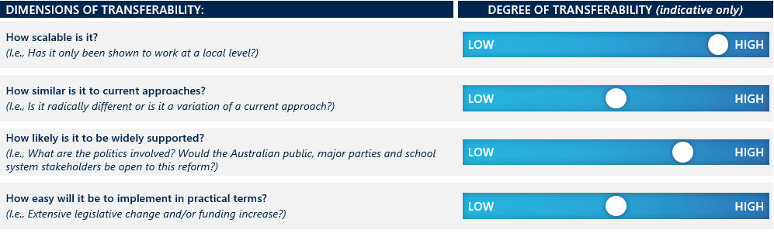

Forms of capacity sharing are already in evidence across Australia’s education systems, sometimes involving cross-sectoral collaboration as in the case of subject-specific professional associations. However, there may be challenges associated with implementing deeper forms of capacity sharing as instanced internationally. The response of teachers and school leaders in host schools to colleagues from other schools, designated as performing at a higher level, is open to question. Capacity sharing, in the cases discussed, occurred under the auspices of a bureaucratic authority (MATs in the England, municipal authorities in Shanghai). Without such an authority in Australia, the scope for cross-sectoral or cross-jurisdictional capacity sharing may be limited. In that context, there may be a role for academically selective public schools to partner with other schools in their jurisdiction.

# Policy implications for Australia

|  |
| --- |
| This section pulls out overarching findings and implications from across all the interventions examined. It emphasises that no single policy is effective in isolation, and that concurrent policies can either reinforce or undermine a policy’s success against its objectives.  This section also speaks to insights for Australia from these international jurisdictions (despite cultural and geographic differences) and other changes, implementation considerations, and additional considerations around concentrations of First Nations students, especially in remote areas. |

## The greatest impact can be achieved through a combination of interventions

An overarching finding from our review is that there is no silver bullet – no single policy intervention is effective in isolation. Most school systems – be they at local, subnational, or national levels – deploy a suite of policy interventions as part of a package, drawing on a combination of government levers, most frequently regulatory and funding powers, supported by robust and respected governance structures.

Figure 6 | Trends in Chilean students’ maths performance, by family income percentile[198]

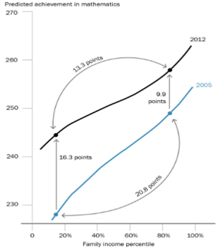The greatest benefits are when concurrent policies are designed as a cohesive package in which each element reinforces the others. For example, Chile’s education reform involved four of the policy interventions explored in this review – removal of fees, removal of academic selectivity, introduction of legislated quotas, preference matching and introduction of added financial incentives – pursued through tight funding agreements and accountability mechanisms underpinned by legislative reform. These reforms benefitted all students, but particularly the most disadvantaged students who were falling further behind in what had become one of the most segregated school systems in the world. See Figure 6, which shows how maths scores increased for all students between 2005 and 2012 and that the gap between the most advantaged and disadvantaged students decreased from 20.8 points to 13.3 points.

## Concurrent policies can also undermine each other

Our research also revealed that policy interventions can be weakened or counteracted by other policies in place. For example, in Belgium, Netherlands, Germany and France, the continuation of tracking students from around 12 years of age into different types of secondary schools with different post school destinations. This reinforces the influence of family background on school enrolment profiles and educational outcomes and undermines the positive impact of legislated quotas and controlled choice to reduce school segregation and residualisation. These countries have among highest impacts of segregation on student learning outcomes among wealthy countries respectively, as shown in Figure 7.[199]

Figure 7 | The socio-economic compositional effects across developed countries[200]

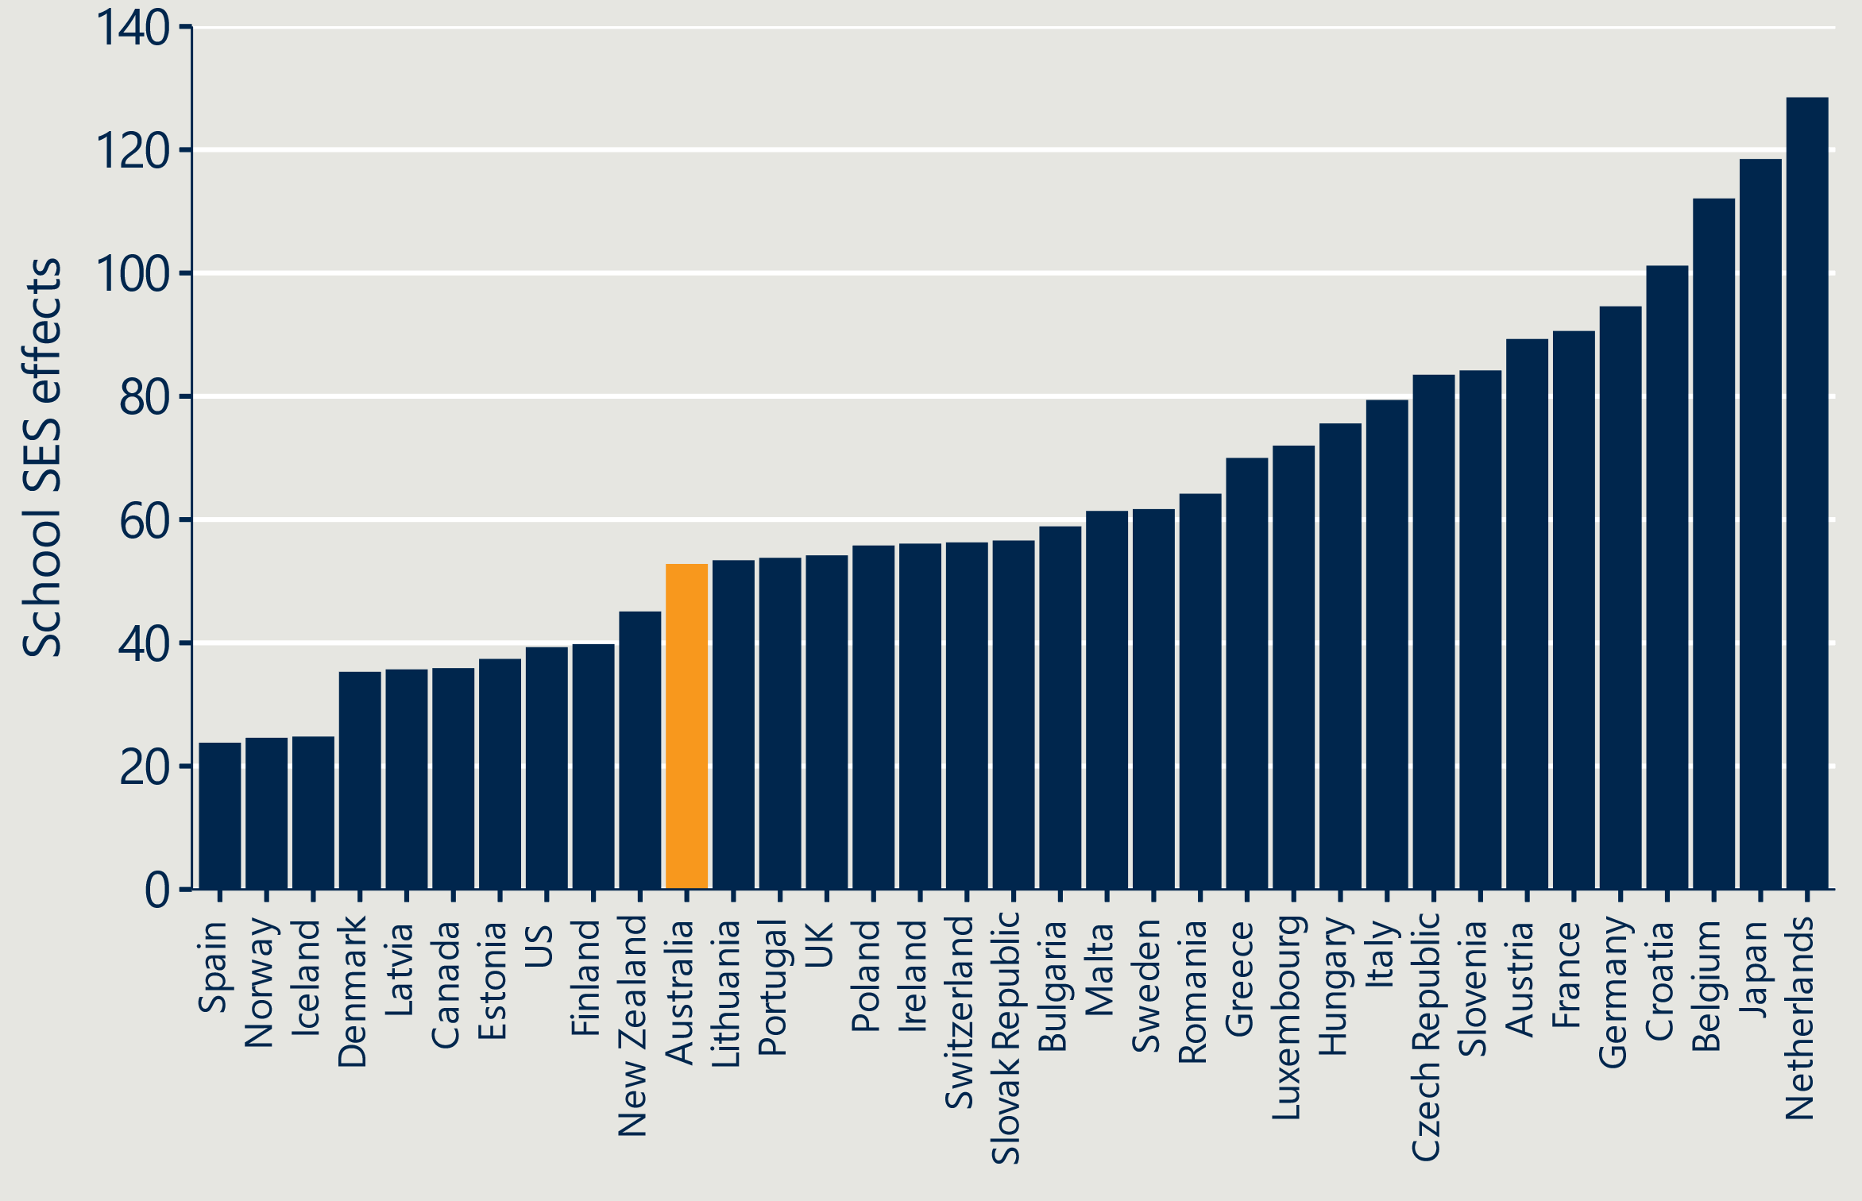

## Concentrations of First Nations students are a special case

The large and persistent gap in education between First Nations students across Australia and their non-Indigenous classmates merits special consideration.

Cultural safety refers to “an environment that is spiritually, socially, and emotionally safe, as well as physically safe for students; where there is no assault challenge or denial of their identity, of who they are, and what they need. It is about shared respect, shared meaning, shared knowledge, and experience of learning together.

Robyn Williams.

These young people are far less likely to achieve the four key educational milestones reflected in Australia’s national goals for schooling:

* Developmentally on track across all indicators in their first year of primary school (62 per cent First Nations meet this milestone versus 80 per cent non-Indigenous)
* Performing above the national minimum standard in both literacy and numeracy in Year 7 (40 per cent versus 78 per cent)
* Attaining a Year 12 certificate of equivalent (58 per cent versus 83 per cent and fully engaged in education, training and work at age 24 (41 per cent versus 71 per cent).[201]

While educational gaps have narrowed since 2008, they remain unacceptably large, with deleterious effects for these young people, their communities, and the country. Gaps are correlated with remoteness and socio-economic status. The further a student lives from a capital city, and the lower the family income and education levels, the lower their chance to achieve these milestones and go on to achieve their full potential.

Many factors contribute to the yawning gap, including the impacts of colonisation and intergenerational trauma, sustained access to skilled teachers (especially in remote schools), inadequately funded schools (especially in rural and remote areas), learning in one’s second (or third or fourth language), underlying and un(der)-treated health concerns, racism, and a lack of cultural safety in schools.

As Robyn Williams articulated in 1999, “the issue of cultural safety cannot be avoided”[202] if Australia is to genuinely address the challenges of Indigenous health and education. This is echoed by the Australian Institute of Teaching and School Leadership (AITSL), which advised in its landmark report on growing teachers’ cultural responsiveness that “the cultural safety of Australian schools and other education settings for students, teachers, and ancillary staff is foundational to meeting the learning needs and aspirations of Aboriginal and Torres Strait Islander learners, along with the needs and aspirations of their families and communities.”[203]

Cultural safety can be enhanced when the curriculum, pedagogy and school community reflect, value, and respond to cultural knowledge, understanding, language and ways of being, such as learning On Country, from Country, and inclusion of First Nations languages and concepts, as a vehicle for engaging students and providing them with access points to the curriculum and strong literacy, numeracy, and other core capabilities.

For this reason, we do not advise seeking to reduce concentrations of Indigenous students within schools, but rather, ensuring the schools they attend are fully equipped to meet their educational needs in a culturally safe way.

The people most able or equipped to provide a culturally safe atmosphere are people from the same culture.[204] Regrettably, the proportion of First Nations teachers is far smaller than the proportion of First Nations people in the general population, and while there are scattered initiatives to recruit, train, support and retain First Nations Teachers scattered across Australia, they are inadequate, with Australia continuing to lose current and future teachers at each stage of the workforce pipeline. It is hoped that the forthcoming co-design of actions to attract and retain more First Nations teachers (Action 10 of the National Teacher Workforce Action Plan), $14.1m investment in teaching of First Nations Languages, and AITSL’s work with First Nations education experts, students, teachers, families and communities to build a cultural competency professional learning toolkit can grow cultural safety and contribute to closing the educational gaps between Indigenous students and their non-Indigenous peers.

## International lessons transcend differences in politics, culture and geography

The countries covered in this report by virtue of their policy interventions to improve diversity or counter the effects of residualisation differ from each other, and Australia, in multiple meaningful ways. Even countries most like Australia hold distinct differences. For example:

* New Zealand shares with Australia history of a British colony with a Westminster parliamentary system, proud continued First Nations population, population concentrated in capital cities, and strong immigration. However, it also differs culturally and linguistically. There is only one Māori language, and the Māori proportion of the national student population is much larger than Australia’s Aboriginal and Torres Strait Islander student proportion (20 per cent versus 6 per cent). There is not a federal system of government, and, even when there were national standards, these were based on overall teacher judgments, not standardised tests such as NAPLAN.
* Canada, like Australia has a relatively young population with very high proportions of first- and second-generation migrants and many different First Nations people with their distinct languages and cultures. But while it is a federation, its federal government has no school system funding, policy, or regulatory roles. Provinces have greater responsibilities – and ability to meet these through far greater fiscal powers. But Canada is also bilingual, with the French-speaking population concentrated in Quebec.

Despite these differences, our overarching insights still hold. This report shows that countries with very different political systems, histories, geographies, sizes, and cultural mixes can effect significant change through concerted effort and well-designed policy packages.

## Changes can be phased in

Even when pursuing a combination of interventions as one package, reform does not have to be done in one ‘big bang’. Several of the interventions we have studied could be introduced gradually. For example:

* Reducing selectivity among public schools or raising of the ‘'selection’' age from Grade 6 (in NSW) to Year 9 with priority for First Nations and very low SES students, as is the case in Victoria.
* Imposing enrolment boundaries on non-government schools as a condition of public funding.
* Introducing ‘soft’ quotas or targets, potentially in tandem with a lottery element.
* Capping fees or using a sliding scale where the public subsidy (post application of the ‘capacity to pay’ adjustment) reduces beyond a certain fee threshold.

## There are several factors common to successful interventions

The research suggests the following factors are associated with achievement of policy goals related to promoting in-school diversity. Several that loom are:

* Clear objectives – a well-articulated definition of the policy objective and benefits accruing to students, communities and the nation.
* Careful design – including consideration of system influences and interaction with concurrent policies.
* Sound evidence – a critical review of past policy failings, recognising change is possible.
* Community buy-in – building networks or coalitions of support and enable meaningful community input to the design and implementation of reforms.
* Optionality– avoiding an over-reliance on compliance versus incentives and allow for schools to opt-in where this does not compromise longer-term objectives of more systemic change.

# Recommendations

|  |
| --- |
| This section outlines the recommendations for further action based on the findings and implications set out in this report. |

##### Nous has developed recommendations falling into three categories:

* Policy interventions that could be tested and explored with States, Territories, and non-government school sector representatives in the context of negotiations for a new National School Reform Agreement (NSRA) concerning agreed policy directions and priorities.
* Proposals to strengthen accountability and regulation. This includes a proposal to include metrics in the NSRA to monitor levels and trends of concentrated disadvantage, and to build into the regulatory frameworks a requirement to assess schools’ performance in terms of equity and wellbeing as well as education quality.
* Recommended follow-up areas of enquiry. We offer ideas for research topics for investigation by the Department of Education or partners.

Each is discussed briefly in turn.

## Policy interventions that could be tested

|  |
| --- |
| **Recommendation 1**: Explore interest among system stakeholders in developing or trialling a combination of the highest-rated interventions in terms of our assessments of their effectiveness and transferability. |

The high-level assessments of the ten interventions discussed in this report – their effectiveness in terms of promoting diversity and lifting educational outcomes, and the ease by which they could be adopted in Australia – suggest that pursuit of the following would be the most worthwhile:

* Removal of fees (Intervention 2)
* Financial incentives for schools (Intervention 7) and educators (Intervention 8)
* Alternative learning, assessment and delivery models (Intervention 9)
* Networked schools and teacher capacity exchange (Intervention 10).

As noted in the previous section, the greatest impact would likely derive from implementing a range of interventions as part of a mutually-reinforcing package of reforms.

Below, we propose three such combinations which we consider worth exploring further with the jurisdictions, non-government school system peak bodies, and other peak stakeholder groups. These are outlined below.

Figure 8 I Proposed policy combinations

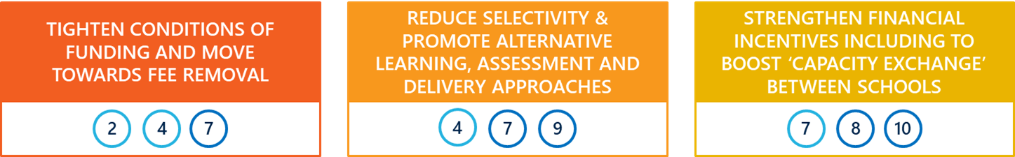

**Combination 1 – Tighten conditions of funding and move towards fee removal**

This centres on having needs-based recurrent funding or supplementary funding incentives serve more as a genuine incentive to attract and retain a sizable cohort of low-SES students (without cherry picking these students based on their academic results). This requires tighter monitoring and improved transparency of where and how needs-based funding is directed. At the same time, the government could consider inviting non-government schools to opt-in to receive full public funding in exchange for no longer charging fees and being less selective. (Schools could continue to retain their own character and be selective on grounds other than SES status or prior academic performance, such as Catholic schools prioritising Catholic students.)

**Combination 2 – Reduce selectivity and promote alternative learning, assessment, and delivery models**

Modify public selective school admission policies to promote more diversity (e.g., applying a positive weighting for socio-economically disadvantaged students), regulate catchment areas for non-government schools, and provide grants to schools with concentrations of low SES students that want to introduce alternative teaching and assessment models shown to be effective with disengaged students, or which open educational opportunities through broader curriculum, assessment, and study options.

**Combination 3 – Strengthen financial incentives, including to boost ‘capacity exchange’ between schools**

Consider a funding mechanism to support partnering between schools that represent a contrast of high and low SES students – ideally across sectoral boundaries. This would see a pooling of resources for co-investment in programs that are of mutual benefit, the potential sharing of facilities and teaching resources, and structured collaboration to improve the quality of the learning experience for students from disadvantaged backgrounds in particular. Such a combination could be further enabled by investment in incentives for educators to recognise the additional professional challenges that might be involved in working across two or more networked schools.

Incentives for educators could complement the second and third policy combinations.

## Proposals to strengthen accountability and regulation

|  |
| --- |
| **Recommendation 2**: Strengthen accountability through metrics and regulation:   1. Consider securing national agreement to regulatory approaches that move away from minimum standards based on quality and safety, to broader considerations of equity and wellbeing. 2. Adopt new measures in the NSRA to track levels and trends of concentrated disadvantage as a measure of equity. |

While not identified as a separate intervention, the degree of accountability and transparency attached to the deployment of some of the initiatives has played an important role in their success (where relevant).

The concept ‘tight-loose’ control is based on the principle of giving individuals or organisations freedom to innovate, within a clear policy, funding and/or regulatory frame. This works well in situations where there is no systemic risk or performance issue that requires active management from central authorities and tight day-to-day oversight and direction. Applying a ‘tight-tight’ frame like this in normal conditions is disempowering and deskilling. The opposite approach – a ‘loose-loose’ model – however, leads to fragmentation, highly variable performance, misaligned incentives and standards and counter-productive sub-cultures. Arguably, the governance of Australia’s schooling system fits into the ‘loose-loose’ category, at least when considered as a whole. (States and Territories might argue, with good reason, that their management of their respective public-school systems is closer to the ‘tight-loose’ model.)

“The more discretion and autonomy that schools have, the stronger the central regulatory frameworks must be; Australia has the balance wrong.”

Andreas Schleicher  
*OECD Education Director*

With that context in mind, we propose that there could be greater clarity about the expectations of schools to contribute to equity goals, in exchange for their ability to operate (particularly in the non-government sector) with significant freedom and discretion. Those expectations should then inform appropriate accountability and regulatory frameworks.

**Changes to regulatory approaches**

School regulation is largely a State/Territory matter and so each jurisdiction’s regulatory framework and approach is different. The common elements, however, are a concern to ensure that providers in the market are acting within the bounds of relevant legislation, including with respect to the quality of the education services being provided and the safety of the students. Non-government schools must also demonstrate that they are operating genuinely as a not-for-profit enterprise.

There is an opportunity to harmonise regulatory frameworks, if not how those frameworks are implemented, to promote a stronger focus on lifting performance on key metrics that include broader measures of wellbeing and inclusivity (e.g., ‘belonging’) and equity (e.g., diversity). To be clear: we do not propose a compliance regime that leads to stark ‘pass’ or ‘fail’ results along the lines of Ofsted in the UK. But there is arguably scope to strengthen the role of school regulators to be a force for positive change, including to achieve agreed strategic national policy objectives on equity.

A model to look at perhaps is the Education Review Office (ERO) approach to school reviews in New Zealand. The reviews conducted by ERO include community members on the panel and are very transparent. Their findings provide a ‘warts and all’ view, but the intent is to focus on learning and improvement at a strategic level. They are not punitive in any way or designed to produce rankings and league tables.

We note that this recommendation will have greatest direct impact on the non-government sector – particularly independent schools – given that public schools are, to a large degree, already regulated by education departments in such a way as to ensure attention is paid to a broader range of metrics. It would nevertheless be powerful to have a single national framework (not unlike the one used in the early childhood education and care sector) to inform a more consistent approach used by jurisdictions and the Catholic education systems through their delegated authority. (An alternative option is to agree nationally that that regulatory authority is not delegated to enable an even more consistent and comparable approach.)

**New measures and monitoring under the NSRA**

The Review to Inform a Better and Fairer Education System has called for perspectives on what ought to be included as new measures in the NSRA, including to sharpen the focus on aspects of wellbeing, funding accountability and transparency (as recommended by the Productivity Commission). In considering what those measures might be, we would advocate for the inclusion of measures that:

* Require closer tracking of how needs-based funding is allocated – while it is difficult to ‘follow the money’ in such a complex system as ours, as part of a ‘tight-loose’ structure, it is not unreasonable, nor beyond capability, to move closer to a true ‘funding follows the child’ paradigm. We do not propose abandoning the SRS and disadvantage loadings for something like the UK’s Pupil Premium, but advocate using data collection and analysis to incentivise greater consideration of how needs-based funding is being used, would be important not only to making the loadings operate more like incentives (as discussed above) but raising the stakes for systems and schools to fulfil the intent of the ‘Gonski’ reforms. Ideally the reporting required would be at both the strategy and outcomes levels, so that it prompts deeper consideration of specific initiatives that might be deployed to lift performance in the areas of equity and diversity, and how this deployment might differ across different contexts, including school population profiles, and location (metro, regional, rural, and remote).
* Report with reasonable granularity on the levels and trends related to concentrations of disadvantage – the Department has recently undertaken detailed analysis of MySchool data, continuing work begun several years ago to observe changes in concentrations of disadvantage among Australia’s schools. Such work should continue and be shared to raise awareness about the problem – not just from a schooling perspective, but a community perspective. As part of this work, it will be important to address the issue that continually arises about the relationship between residential segregation and school segregation. While current measures of geographic SES distribution are imperfect for using in school-based analysis and should be used with caution (see Appendix A), there is a base to build on. Monitoring of these trends at a school-level will be important not only to deepen understanding of particular localities and cohorts being affected, but also to assess more thoroughly the impact of any interventions designed to counter the residualisation trend.

## Recommended follow-up areas of enquiry

|  |
| --- |
| **Recommendation 3**: Fund or auspice further research to build the evidence base |

It is clear from the analysis in this report that there are gaps in the evidence related to several of the interventions, as well as potentially fruitful areas of enquiry to support related policy and strategy development. A selection of some areas that could be the focus of follow-on research follows (noting this is not an exhaustive list):

* Controlled choice models – the research is patchy given that these interventions are typically applied at a district level. The findings that are available are mixed. However, we were struck by Andreas Schleicher’s comments that suggest two things: the impact is strong at first but then becomes less observable given a new ‘normal’ has been established, meaning reliance on recent PISA data (which is aggregated anyway) may not be helpful; and the on-the-ground reality in the Netherlands and Belgium tells a much more compelling story than is suggested by the data. Developing a firmer view on their impact and the specific aspects of their design and implementation would be valuable, as introducing a degree of controlled choice in Australia may be the most viable way to nudge the system away from being overly market oriented.

“Parents in the Netherlands have created approximately 90 parent groups that use school choice as an effective means to desegregate schools and provide a quality education for all”.

OECD 2019 *PISA Results: Balancing Choice and Equity*

* Parent-led initiatives – the Netherlands provides an example of grass-roots initiatives that emerged to counter arguments from the pro-school choice lobby (that has been quite dominant). Understanding how these formed, and which of their strategies were most effective, would be helpful again in an Australian context, where the reflexive position of most parents would be to support choice (even if they are highly sympathetic to the intent of the “Gonski reforms” as restoring some fairness into Australian schooling).
* Education outcomes from Big Picture Learning – the data we received on individual schools’ level of diversity was encouraging, but it would be helpful to understand more comprehensively the impact that this (and similar models) is having on students’ post-school pathways, including through comparison with a control group. Certainly, it would be important to have this evidence base before committing to any government-funded incentive to support schools to adopt this learning design.
* Peer effects in a hybrid delivery model – the Aurora and Te Kura models are interesting from the point of view of understanding whether creating virtual classrooms that are more diverse generates similar peer effects to those observed in mixed in-person classrooms. Given the extensive analysis of online learning and its impacts during COVID, there may be data to leverage on this which would, at minimum, provide the counterfactual of online learning with the regular classroom cohort, versus online learning involving peers from a much wider variety of backgrounds and locations.

In addition, we would support efforts to develop a regression model – specifically a generalised additive mixed model – to estimate the effect sizes of interventions on different measures of equity and PISA scores. This would require research to identify the best measure, including to confirm that the dissimilarity index is the most appropriate. The model would account for the autocorrelations in a country's PISA data across the different waves of reforms, and for between-country differences. The analysis provided here would provide a strong basis for coding the interventions into a form for use in a regression model.

1. Measuring school and community differences[205]

Many students are not local to their school. Schools that are able to do so, routinely enrol students from well beyond the locality of the school, creating a mismatch between the socio-educational status of communities and the equivalent measure of their school(s). Low SES schools commonly have an enrolment more disadvantaged than represented in their local community.

### Available data

The school measure is the Index of Community Socio-Educational Advantage (ICSEA), which reveals the socio-educational advantage (SEA) of each school’s enrolments. ICSEA is created from information on student enrolment records about such things as parental occupation, level of education and language background.

The community measures are two Socio-Economic Indexes for Areas (SEIFA) created by the Australian Bureau of Statistics (ABS).

* 1. The Index of Relative Socio-Economic Advantage and Disadvantage (IRSAD) uses indicators of both advantage (including income and qualifications) and disadvantage (including employment status, income, house size).
  2. The Index of Education and Occupation (IEO) includes indicators of both.

Both ICSEA and SEIFA describe socio-economic and/or educational status. Some things to think about:

* each measure needs to be, or close to, the same year. Note the five-year interval between each census
* there needs to be sufficient statistical correlation between the two indices
* the validity of comparisons using the two, and conclusions derived, needs to be considered
* ongoing comparisons are important, given that data from both indices will change over time
* the comparisons and conclusions will be more robust for larger groups of schools.

It is not easy to identify the particular ABS local area which best approximates to the locality of each school. Government schools serve a prescribed drawing area, but school enrolment catchments are not an ABS construct. The closest the ABS goes is to present data for postcodes and State Suburb, albeit with variations. In metropolitan areas, postcodes can be a reasonable proxy for the locality of each school. The SEIFA data for postcode 2073 in Sydney, for example, is not going to vary greatly between Pymble and West Pymble – and the ICSEA values for the seven schools in that area only range from 1157 to 1214. On the other hand, postcodes in provincial and rural areas often encompass larger areas with diverse communities. The ICSEA of schools in Tamworth NSW (postcode 2340) range from 667 to 1065. In Bendigo Victoria (postcode 3550) they range from 850 to 1105. In such places, the smaller State Suburb index more closely reflects the area in which each school is located.

### Some findings

Given local factors and impacts might be quite unique, how much weight can be placed on fine-grained comparisons between individual schools? On the other hand, such comparisons can be very useful for large groups of schools where overall system equity and balance need to be assessed. On this larger scale, it is clear that schools with ICSEAs above their local SEIFA indices have a more advantaged population than found in the school’s locality – and low ICSEA schools tend to be more disadvantaged than people in their locality. In the following table, schools are categorised into six ICSEA groups. The table shows the average ICSEA for groups of schools in various ICSEA ranges. The SEIFA data in the table is the average of the two SEIFA indices for each school’s locality, in this case postcode.

Table 2 | School ICSEA values and ABS SEIFA indices - all Australian schools[206]

|  |  |  |  |  |  |  |
| --- | --- | --- | --- | --- | --- | --- |
| ICSEA group | 1200 & over  (54 Schools) | 1100-1199  (1115 schools) | 1000-1099  (3363 schools) | 900-999  (3331 schools) | 800-899  (504 schools) | Under 800  (288 schools) |
| Average school ICSEA | 1218 | 1138 | 1042 | 958 | 867 | 664 |
| Average postcode SEIFA | 1140 | 1093 | 1005 | 948 | 921 | 872 |
| ICSEA/SEIFA gap (difference) | +78 | +45 | +37 | +10 | -54 | -208 |

Higher ICSEA schools, the schools enrolling more socio-educationally advantaged students, have a positive ICSEA/SEIFA gap. These schools have an enrolment even more advantaged than might be the case if they just enrolled students from their postcode. The numbers for the lowest ICSEA schools suggest that advantaged students who live locally go elsewhere to school - to the higher ICSEA schools. As demonstrated, the bigger ICSEA/SEIFA gaps are found in schools at either end of the advantaged-disadvantaged spectrum.

### Issues

The concentration of disadvantage in low SES schools might be better addressed if more is known about the demographic imbalance between each school and its locality. However, unless more precision is possible, it may not be valid to use such data to support such interventions as quotas or incentive funding. However, as an indicator of system health and how it changes over time, comparisons between school ICSEA and local SEIFA should be seriously considered. At stake are not only student outcomes but wider issues around sustaining and growing both school and community social/cultural capital.

1. Additional PISA analysis

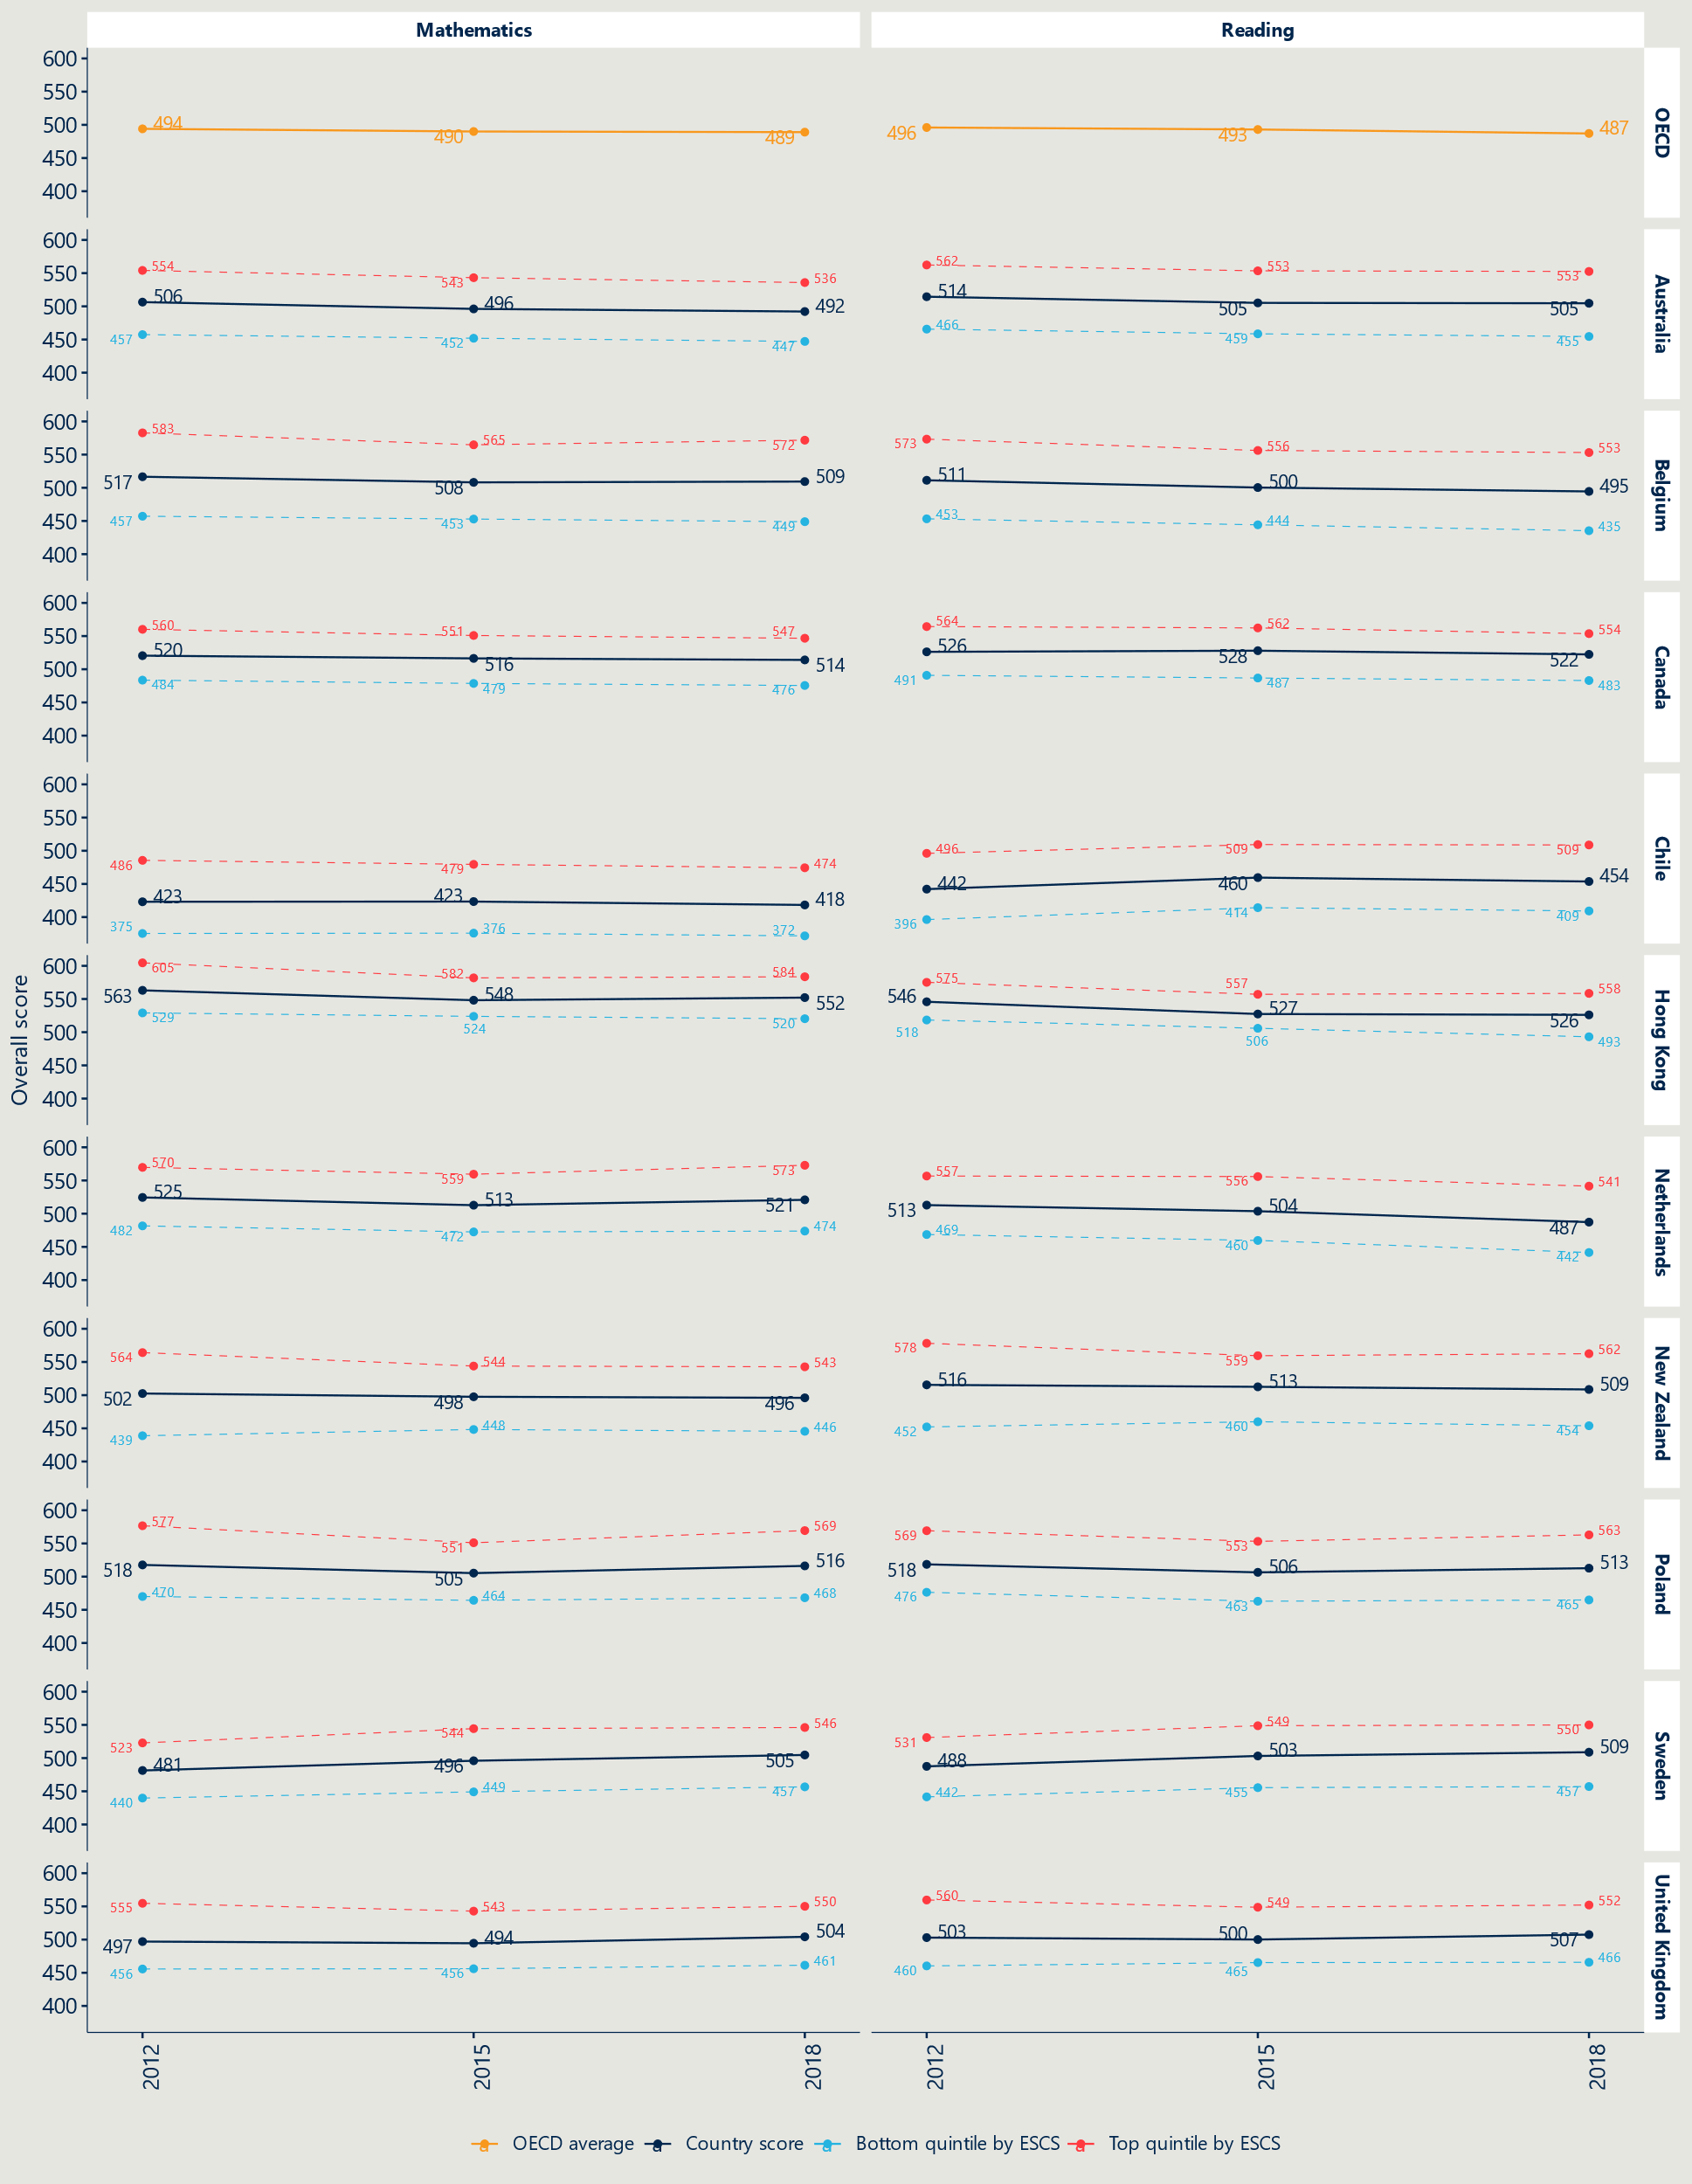Figure 9 | Performance in reading and maths by SES cohort across selected countries (Commentary overleaf)

Figure 9 shows the reading performance of students in the bottom and top SES quartiles from the nations we have repeatedly referred to across this report for their use of policy interventions to improve diversity and reduce residualisation and its ill effects. It shows, for instance, that Canada has retained a high and stable performance with small gaps between SES groups; that Belgium is trending down across all groups and measures; and that Poland and the UK have seen a lift in average performance with similar or slightly widening gaps during the 2015-2018 time period.

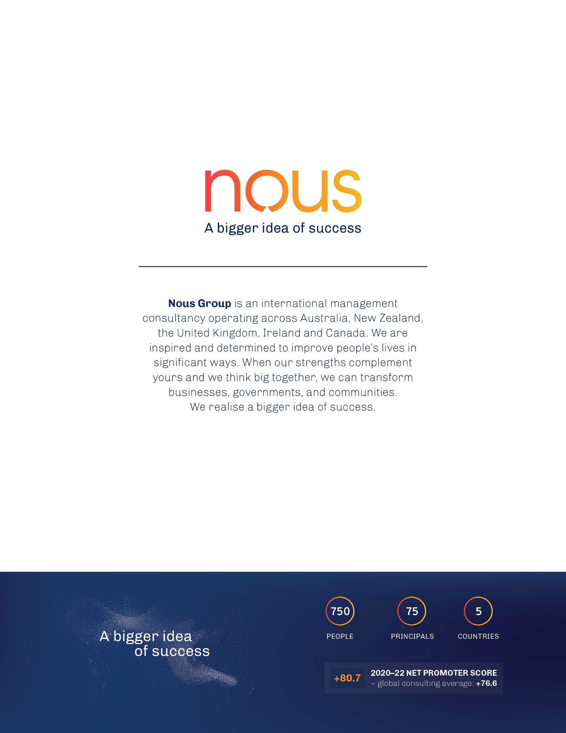

1. S. Lamb (2007) ‘[School Reform and Inequality in Urban Australia: A case of residualising the poor](https://link.springer.com/chapter/10.1007/978-1-4020-5916-2_27)’, in R. Teese & S. Lamb (eds.) *Education and Equity: International Perspectives on Theory and Policy*, Vol 3. Melbourne, Springer; Nous Group (2011) [*Schooling Challenges and Opportunities: a report for the Gonski Review of School funding*](https://apo.org.au/node/26252)*,* Prepared for the Australian Government Review of Funding for Schools, Melbourne, Nous Group.
2. S. Lamb et al (2020*) ‘*[Educational Opportunity in Australia: Who succeeds and who misses out](https://www.vu.edu.au/sites/default/files/educational-opportunity-in-australia-2020.pdf)’, Melbourne, Mitchell Institute; and OECD (2019) [*PISA 2018 Results: Where all students can succeed, Volume 2*](https://www.oecd-ilibrary.org/education/pisa-2018-results-volume-ii_b5fd1b8f-en), OECD Publishing, Paris.
3. Nous Group (2011) *op. cit.* 
4. G. Erreygers, P. Clarke and T. Van Ourti (2012), ‘“*Mirror, mirror, on the wall, who in this land is fairest of all*?”—Distributional sensitivity in the measurement of socio-economic inequality of health’, Journal of Health Economics, Vol. 31, Iss. 1, pp. 257-270.
5. The seven countries that excel at minimising the impact of SES background on school education outcomes are Belarus, Denmark, Finland, Japan, the Russian Federation, Slovenia and Ukraine. OECD (2019) ‘Chapter 2. *Students socio-economic status and performance’* in PISA 2018 Results: *Where all students can succeed,* Volume 2, Paris, OECD Publishing.
6. Monash University (2023). ‘What works to address concentrations of disadvantage in schools? A rapid scoping review.’ Behaviour Works Australia; UNESCO, 2020[83]) cited in OECD (2023) Equity and Inclusion in Education: Finding strength through diversity, OECD Publishing, Paris.
7. Rui, N., (2009), ‘[Four decades of research on the effects of detracking reform: Where do we stand](https://onlinelibrary.wiley.com/doi/full/10.1111/j.1756-5391.2009.01032.x#:~:text=The%20evidence%20with%20respect%20to,and%20high%2Dability%20student%20achievement.)?’ *A systematic review of the evidence’ Journal of Evidence Based Medicine*, Vol. 2, Iss. 3; B. McGaw (2006) ‘[Achieving quality and equity education’](https://www.unisa.edu.au/contentassets/09c08546060243cda62e35c3c6ae073b/barrymcgaw_presentation_aug06.pdf). Melbourne Education Research Institute.
8. Housing programs are predominantly used in the US and take the form of relocation vouchers or subsidised home ownership. Relocation vouchers (such as the Moving to Opportunity program) were found to have limited uptake and no observable impact on educational outcomes Vicki Ware (2010) Addressing locational disadvantage effectively (international evidence)Australian Housing and Urban Research Institute,Melbourne. Investments in rental housing have little to no effect. Conversely, subsidising home ownership was associated with decrease in the percentage of socio-economically disadvantaged students in some local schools and increases in standardised maths and reading tests scores. CC. Chelman, IG Ellen, BJ McCabe, AE Schwarz & L Stiefl (2011) ‘Does city-subsidised owner-occupier housing improve school quality?’ *Journal of American Planning*,Vol 77, Is 2, pp.127-141. Given the very high cost and limited supply of homes to buy and rent in Australia, this intervention was ruled out of consideration for Australia.
9. A. Schleicher (2023) Interview with project team, 27 September.
10. OECD (2019) ‘Chapter 2. Students’ socio-economic status and performance’ in [*PISA 2018 Results: Where all students can succeed*](https://www.oecd-ilibrary.org/docserver/b5fd1b8f-en.pdf?expires=1698027744&id=id&accname=guest&checksum=02957AD535C0A0693F9E3535EEFD53CE),Volume 2, Paris, OECD Publishing. Further detail is available in the OECD’s PISA technical reports.
11. D. Nusche, et al. (2015). ‘[Provision of school places in the Flemish Community of Belgium](https://doi.org/10.1787/9789264247598-7-en)*,’* *OECD Review of Schools Resources: Flemish Community of Belgium*, Paris, OECD Publishing.
12. J. Danhier & N. Friant (2018) ‘[Assessing local socio-economic desegregation: The effects of successive decrees regulating school choice in the Belgian-French community](https://journals.sagepub.com/doi/10.1177/1474904118813075)*’*, *European Educational Research Journal,* Vol. 18, Iss.2, pp.248-268; V. Dupriez & M. Verhoeven (2023) ‘[School Desegregation Policies in Belgium](https://link.springer.com/chapter/10.1007/978-3-031-36147-0_8)’ in Educational Markets and Segregation,pp.151-166.
13. Under Pinochet equal-value vouchers that families could use to enrol at any school, which saw the proportion of students in public schools drop from around 70-80 per cent to around 30 per cent (depending on location) and extreme stratification.
14. M. Zhang (2014) in M. Tucker (ed) ‘[Chinese Lessons: Shanghai’s Rise to the Top of the PISA League Tables](https://files.eric.ed.gov/fulltext/ED556320.pdf)*’,* Centre for International Education Benchmarking, a program of the National Centre on Education and the Economy.
15. K. Wong (2023) Interview with project team, 27 September.
16. Dupriez & Verhoeven (2023) *op. cit*.; Danhier & Friant (2018) *op cit.* 
17. OECD (2019) ‘[Chapter 2. Students’ socio-economic status and performance’](https://www.oecd-ilibrary.org/docserver/b5fd1b8f-en.pdf?expires=1698026286&id=id&accname=guest&checksum=D1F0F7133C6F7822F83AF3172B7D1F27), in *PISA 2018 Results (Volume II):* Where all students can succeed*,* Paris, OECD Publishing.
18. Brookings, as cited in OECD (2023) *Choice and Fairness,* Paris, OECD Publishing, p.25.
19. OECD (2019) ‘Chapter 2. Students’ socio-economic status and performance’, in *PISA 2018 Results (Volume II):* [*Where all students can succeed*](https://www.oecd-ilibrary.org/docserver/b5fd1b8f-en.pdf?expires=1698026286&id=id&accname=guest&checksum=D1F0F7133C6F7822F83AF3172B7D1F27)*,* Paris, OECD Publishing. 
20. G. S. Zinny (2014), [‘Chile’s education system is the best in Latin America – so why is it being overhauled?’](https://www.atlanticcouncil.org/content-series/latamsource/chile-best-education-system/#:~:text=Chile's%20performance%20has%20also%20been,complete%20a%20full%20secondary%20education.), *Atlantic Council*; E. Vegas & P. Zoido (2017), ‘[Latin American countries pay attention to global assessments of student learning’](https://www.brookings.edu/articles/latin-american-countries-pay-attention-to-global-assessments-of-student-learning/), *Brookings.*
21. OECD (2023) [‘Education at a Glance2023*:* OECD Indicators*’*](https://www.oecd-ilibrary.org/docserver/e13bef63-en.pdf?expires=1698028120&id=id&accname=guest&checksum=46DE236706ECDEDA0A234A617AFAB052), Paris, OECD Publishing.
22. A. Schleicher (2023) Interview with the Project team, 27 September.
23. A. Chmielewski & S. Maharaj (2022), [’Socio-Economic Segregation Between Schools in Canada](https://static1.squarespace.com/static/5b06c8abe17ba31ac307c5fe/t/624eeb8444fc16051305e6c6/1649339269270/RIES+-+Technical+Report+-+Socio-Economic+Segregation.pdf.)’, Future Skills Research Lab, University of Toronto, pp.7.
24. Ontario Catholic School Trustees’ Association (2023), ‘[Catholic Schools in Ontario](https://www.ocsta.on.ca/catholic-schools-in-ontario/)’.
25. E. Vegas (2018), ‘[5 lessons from recent educational reforms in Chile’](https://www.brookings.edu/articles/5-lessons-from-recent-educational-reforms-in-chile/), Brookings Institute. Accessed 27 September 2023.
26. Government of Chile (2016), ‘[School Inclusion Law: 10 Key Points](https://www.gob.cl/en/news/the-school-inclusion-law-10-key-points/)’; M. Sevilla & E. Trevino (2021), ‘[Socio-economic segregation between and within curriculum tracking](https://www.gob.cl/en/news/the-school-inclusion-law-10-key-points/)’, *International Journal of Educational Development*, Vol. 87, pp.2.
27. Y. Wong & P. Kwan (2019), ‘School Choice and Whose Choice: The Case of Direct Subsidy Scheme Schools in Hong Kong’, *Journal of School Choice*, Vol.13, Issue 3, pp. 343.
28. A. Chmielewski el al. (2022). ‘[Socio-economic segregation between schools in Canada](https://tspace.library.utoronto.ca/bitstream/1807/123895/1/RIES%20-%20Technical%20Report%20-%20Socio-Economic%20Segregation.pdf),’ FutureSkills Research Lab. Callout from page16, graph from pp19.
29. The dissimilarity index was calculated among the pairs of groups: students in the lowest quintile by ESCS scores and everyone else; and students in the bottom of half by ESCS scores and everyone else in Chile. A value of zero indicates that the proportion of both groups in every school is equal to the proportions found in the population (i.e., there is no segregation) and a value of one indicated complete segregation of students between the two groups.
30. OECD (2019), ‘[Hong Kong (China) – Country Note – PISA 2018 Results](https://www.oecd.org/pisa/publications/PISA2018_CN_HKG.pdf)’, pp.4.
31. D. Allison (2022), ‘[What International Tests (PISA) Tell US about Education in Canada](https://www.fraserinstitute.org/sites/default/files/what-international-tests-PISA-tell-us-about-education-in-canada.pdf)’, Fraser Institute, pp.15.
32. Chmielewski & Maharaj (2022), ‘[Socio-Economic Segregation Between Schools in Canada’](https://nousgroup.sharepoint.com/sites/TS18412/Shared%20Documents/General/Deliverables/Socio-Economic%20Segregation%20Between%20Schools%20in%20Canada’), pp.23.
33. M. Homsy & Savard (2018), ‘[School dropouts in Quebec: ten years of standing still, despite funding Efforts’](https://www.conferenceboard.ca/product/school-dropouts-in-quebec-ten-years-of-marking-time-despite-the-money-spent/), Montreal, Institut du Québec, p.3; N. Elez & K. Zeman (2022), ‘[High school graduation rates in Canada,](https://www150.statcan.gc.ca/n1/en/pub/81-599-x/81-599-x2022002-eng.pdf?st=d01G0u9D) [2016/2017 to 2019/2020](https://www150.statcan.gc.ca/n1/en/pub/81-599-x/81-599-x2022002-eng.pdf?st=d01G0u9D)’, Statistics Canada, Catalogue no. 81-599-X – No. 17.
34. OECD (2019), ‘[’Hong Kong (China)’ – Country Note – PISA 2018 Results’](https://www.oecd.org/pisa/publications/PISA2018_CN_HKG.pdf), pp. 4.
35. R. Murnane, M. Waldman, J. Willett, M. Bos, & E. Vegas (2017), ‘[The Consequences of Educational Voucher Reform in Chile’](https://publications.iadb.org/en/consequences-educational-voucher-reform-chile), *NBER Working Paper No. 23550*, pp.50 ; C. Neilson (2013). ‘[Targeted vouchers, competition among schools, and the academic achievement of poor students’](https://christopherneilson.github.io/work/documents/Neilson_SEPVouchers.pdf). Working paper. Yale University, pp. 45; A. Mizala & F. Torche (2017). ‘[Means-tested school vouchers and educational achievement: Evidence from Chile’s universal voucher system](https://journals.sagepub.com/doi/full/10.1177/0002716217732033)’. *The Annals of the American Academy of Political and Social Science,* Vol. 674, Iss.1, pp.180.
36. C. Haeck & P. Lefebvre (2021). ‘[Trends in Cognitive Skill Inequalities by Socio-Economic Status across Canada’](https://www.utpjournals.press/doi/full/10.3138/cpp.2019-039). *Canadian Public Policy*, Vol. 47, Iss.1, pp.105; Also see Chmielewski & Maharaj (2022), pp.23.
37. L. Volante, F. Borgonovi, J. Ritzen (2019), ‘[Global education rankings may overlook poor graduation rates](https://theconversation.com/global-education-rankings-may-overlook-poor-graduation-rates-127170)’, *The Conversation*.
38. M. Sevilla & E. Trevino (2021), *op. cit.,* pp. 1&2.
39. E. Di Gropello, M. J. Vargas, M. Y. Pagans (2019), ‘[What are the main lessons from the latest results from PISA 2018 for Latin America](https://blogs.worldbank.org/latinamerica/what-are-the-main-results-pisa-2018-latin-america)?’, *World Bank Blog*.
40. OECD (2019), ‘[*Chile - Country Note - PISA 2018 Result*s](https://www.oecd.org/pisa/publications/PISA2018_CN_CHL.pdf)’, p. 3.
41. New Zealand Ministry of Education (2023) [‘School roll statistical collections’](https://www.educationcounts.govt.nz/statistics/school-rolls.)*, Education Counts*.
42. New Zealand Catholic Education Office (2023) ‘[Summary gross Attendance Dues Rates 2023’](https://www.nzceo.org.nz/resource-items/attendance-dues-rates-2/), *Attendance Dues Rates*.
43. New Zealand Ministry of Education (2023) ‘[Fees, charges and donations'](https://www.education.govt.nz/school/funding-and-financials/fees-charges-and-donations/).
44. Parliamentary Counsel Office, (2023) ‘[Private Schools Conditional Integration Act 1975’](https://www.legislation.govt.nz/act/public/1975/0129/7.0/DLM437585.html)*,* New Zealand Government.
45. New Zealand Ministry of Education (2023) [‘School Donations’](https://www.educationcounts.govt.nz/find-school/donations-summary), *Education Counts*.
46. National Centre on Education and the Economy (2023) [‘Hong Kong,’](https://ncee.org/country/hong-kong/) Top-Performing Countries ; Hong Kong Education Bureau (2023) ‘[General Information on DSS,’](https://www.edb.gov.hk/en/edu-system/primary-secondary/applicable-to-primary-secondary/direct-subsidy-scheme/info-sch.html) Special Administrative Region.
47. Legislative Council Panel on Education (2000) ‘[Modifications to Direct Subsidy Scheme’](https://www.legco.gov.hk/yr00-01/english/panels/ed/papers/264e02.pdf), *Paper No. CB(2)264/00-01(02 ;* Y. Zhou, Y. Wong, & W. Li, (2015). [’Educational choice and marketization in Hong Kong: the case of direct subsidy scheme schoo](https://eric.ed.gov/?id=EJ1082855#:~:text=Direct%20subsidy%20scheme%20(DSS)%20schools,%2C%20staffing%2C%20and%20student%20admission.)ls’, *Asia Pacific Education Review*, Vol.16, pp.627.
48. Y.L. Wong & P. Kwan (2019), [’School choice and whose choice: The case of direct subsidy scheme schools in Hong Kong’](https://www.tandfonline.com/doi/full/10.1080/15582159.2019.1610687), *Journal of School Choice*, Vol.13, Iss. 3, pp. 340.
49. Hong Kong Education Bureau (2023) ‘[General Information on DSS’](https://www.edb.gov.hk/en/edu-system/primary-secondary/applicable-to-primary-secondary/direct-subsidy-scheme/info-sch.html).
50. Legislative Council Panel on Education (2000) ‘[Modifications to Direct Subsidy Scheme’](https://www.legco.gov.hk/yr00-01/english/panels/ed/papers/264e02.pdf), Paper No. CB(2)264/00-01(02); Y. Zhou, Y. Wong, & W. Li, (2015). ’[Educational choice and marketization in Hong Kong: the case of direct subsidy scheme schools’](https://eric.ed.gov/?id=EJ1082855#:~:text=Direct%20subsidy%20scheme%20(DSS)%20schools,%2C%20staffing%2C%20and%20student%20admission.), *Asia Pacific Education Review*, Vol. 16, pp. 627.
51. Australian Curriculum and Reporting Authority (2023).
52. M. Otto (2019), [‘Ethnic mix changing in Catholic schools](https://nzcatholic.org.nz/2019/02/11/ethnic-mix-changing-in-catholic-schools/)‘, *NZ Catholic.*
53. P. Lynch (2012), ’A brief history of the integration of Catholic Schools in New Zealand into the state system of schools’, New Zealand Catholic Education Office.
54. Y.L. Wong & P. Kwan (2019), *op. cit.* p.342.
55. Y.L. Wong & P. Kwan (2019), *op cit.* p.351.
56. OECD (2019), ‘[PISA 2018 Results (Volume II): Where All Students Can Succeed](https://doi.org/10.1787/b5fd1b8f-en)’, PISA, Paris, OECD Publishing, p.23.
57. A. Echazarra & M. Schwabe (2019), ‘[Results from PISA 2018, Country Note - Australia](https://www.oecd.org/pisa/publications/PISA2018_CN_AUS.pdf),’ pp.4.; F. Avvisati, A. Echazarra, P. Givord and M. Schwabe (2019) ['Results from PISA 2018, Country Note - New Zealand'](https://www.oecd.org/pisa/publications/PISA2018_CN_NZL.pdf).
58. Y. Zhou, Y. Wong, & W. Li, (2015), *op. cit.* p. 635.
59. New Zealand Post Primary Teachers Association (2009), [’Integration or disintegration](https://www.ppta.org.nz/publication-library/annual-conference-papers-2017-2018/document/299;)?; E. O’Dwyer (2022), [’State-integrated schools: preserving elitism or providing diversity?](https://www.stuff.co.nz/national/education/128392315/stateintegrated-schools-preserving-elitism-or-providing-diversity)’, *Stuff* ; T. Fitzsimons (2017), [’Special characters: The state-funded schools that ask pupils for $5000 and more’](https://www.stuff.co.nz/dominion-post/news/94231092/special-characters-the-statefunded-schools-that-ask-pupils-for-5000-and-more)*, Stuff.*
60. M. Tham (2021) [‘Selective schooling and equity: policy proposals for addressing socio-economic and academic stratification in Australian schools.’](https://www.vu.edu.au/sites/default/files/cires-policy-brief-02-2021.pdf) *CIRES Working Paper 02/2021: Policy Brief*. Melbourne, Centre for International Research on Education Systems, Victoria University.
61. NSW Department of Education (2023) ‘[Equity placement model](https://education.nsw.gov.au/public-schools/selective-high-schools-and-opportunity-classes/general-information/equity-placement-model)’.
62. C. Ho, (2018). ‘[Institutionalised Separation: The Impact of Selective Schools’](https://cpd.org.au/wp-content/uploads/2018/07/Institutionalised-Separation-Report-13-July.pdf), Sydney, Centre for Policy Development,pp. 4.
63. OECD (2019) ‘[Chapter 4. How school choice policies are related to quality and equity in education.’](https://www.oecd-ilibrary.org/sites/958d7736-en/index.html?itemId=/content/component/958d7736-en) *Balancing school choice and equity, an international perspective based on PISA,* Paris, OECD Publishing, pp.66 – 71.
64. OECD (2023) ‘[Chapter 2. Governing and designing education systems to promote equity and inclusion](https://www.oecd-ilibrary.org/sites/5a0ce712-en/index.html?itemId=/content/component/5a0ce712-en).’ *Equity and inclusion in Education*, pp.101.
65. G. Gutiérrez (2021) ‘[Chile’s enduring educational segregation: A trend unchanged by different cycles of reform](https://bera-journals.onlinelibrary.wiley.com/doi/full/10.1002/berj.3746)’ *British Educational Research Association.*
66. Ibid.
67. B. McGaw (2021) ‘Quality and equity in education: simultaneous pursuits or trade-offs?’ Presentation at the Jubilee Symposium, The Social Futures of Australia, of the Academy of the Social Sciences.
68. A, Castejon & A. Zancajo (2015) ‘[Educational differentiation policies and the performance of disadvantaged students across OECD countries](https://journals.sagepub.com/doi/10.1177/1474904115592489).’ *European Educational Research Journal.* Vol. 14, Iss.3-4, pp. 234; However, it should be noted that this study does not use a method from which one can infer causality, and national educational policies and social conditions may differ significantly.
69. Interview with J. Wennström 20 October 2023; M. Henrekson & J. Wennström (2022) *Dumbing Down: The Deinstitutionalization and Fragmentation of the Swedish School System,* Palgrave Macmillan.
70. OECD (2019) ‘Chapter 4. How school choice policies are related to quality and equity in education.’ *Balancing school choice and equity, an international perspective based on PISA,* Paris, OECD Publishing, pp.39.
71. M. Jakubowski (2021). ‘[Poland: Polish Education Reforms and Evidence from International Assessments’](https://link.springer.com/chapter/10.1007/978-3-030-59031-4_7#:~:text=The%20reforms%20implemented%20between%201999,how%20successful%20these%20changes%20were.). *Improving a Country’s Education*. Springer, Cham.
72. R. Murname et al (2017), ‘[The consequences of Educational Voucher reform in Chile](https://www.nber.org/system/files/working_papers/w23550/w23550.pdf),’ *NBER Working Paper No. 23550,* pp.5.
73. S. Saporito (2017). ‘[Shaping Income Segregation in Schools: The Role of School Attendance Zone Geography](https://doi.org/10.3102/0002831217724116),’ *American Educational Research Journal*, Vol, 54, Iss. 6, pp. 1345–1377.
74. OECD (2010), “[What school choices are available and what measures do countries use to promote or restrict school choice](https://doi.org/10.1787/eag-2010-29-en)?” *Education at a Glance 2010: OECD Indicators*, Paris, OECD Publishing.
75. Monash University (2023). ‘What works to address concentrations of disadvantage in schools?’ A rapid scoping review. Behaviour Works Australia. UNESCO, 2020[83]) cited in OECD (2023) Equity and Inclusion in Education: Finding strength through diversity, OECD Publishing, Paris.
76. A. Castro et al. (2023) ‘[Drawn into policy: A systematic review of school rezoning rationales, processes, and outcomes’](https://doi.org/10.3102/00346543231195816), *Review of Educational Research.*
77. S. Saporito (2017), ‘[Irregularly-shaped school attendance zones and racial integration](https://www.sciencedirect.com/science/article/abs/pii/S0049089X16300060#:~:text=Third%2C%20irregularly%2Dshaped%20attendance%20zones,and%20scale%20of%20residential%20segregation.)’ *Social Science Research,* Vol. 46.
78. A. Castro et al. (2023) ‘[Drawn into policy: A systematic review of school rezoning rationales, processes, and outcomes’](https://doi.org/10.3102/00346543231195816), *Review of Educational Research.*
79. T. Monarrez et al. (2021) ‘Dividing Lines: Racially Unequal School Boundaries in US Public School Systems,’ *Urban Institute Centre on Education Data and Policy.*
80. M. Richards (2014) ‘[The gerrymandering of school attendance zones and the segregation of public schools: a geospatial analysis’](https://files.eric.ed.gov/fulltext/EJ1045657.pdf), *American Educational Research Journal,* Vol. 51, Iss. 6, pp.119.
81. O. Dlabac et al (2022) ‘[School mixing: more equity through intelligent school zoning. Optimised school catchment areas for Swiss cities’,](https://villejuste.com/wp-content/uploads/2022/04/School_mixing_intelligent_school_zoning_report.pdf) *Study reports of the Centre for Democracy Studies Aarau, No. 17.*
82. Ibid.
83. O. Dlabac et al (2022) ‘[School mixing: more equity through intelligent school zoning. Optimised school catchment areas for Swiss cities’,](https://villejuste.com/wp-content/uploads/2022/04/School_mixing_intelligent_school_zoning_report.pdf) *Study reports of the Centre for Democracy Studies Aarau, No. 17.*
84. Basteck, C. et al (2021) ‘[How Lotteries in School Choice Help to Level the Playing Field,](https://www.sciencedirect.com/science/article/abs/pii/S0899825621000671)’ *Games and Economic Behaviour,* Vol. 129, pp. 198-23.
85. R. Allen et al. (2010),‘[The early impact of Brighton and Hove’s school admission reforms](https://www.bristol.ac.uk/media-library/sites/cmpo/migrated/documents/wp244.pdf)’, *The Centre for Market and Public Organisation*, Working Paper No 10/244.
86. K. Quick (2016) ‘[Chicago Public Schools: Ensuring Diversity in Selective Enrolment and Magnet Schools](https://tcf.org/content/report/chicago-public-schools/)’, *The Century Foundation*.
87. Ibid.
88. A. Castro et al. (2023) ‘[Drawn into policy: A systematic review of school rezoning rationales, processes, and outcomes’](https://doi.org/10.3102/00346543231195816), *Review of Educational Research*.
89. Ibid.
90. J. B. Cullen et al. (2006) ‘[The effect of school choice on participants: evidence from randomized lotteries](https://pricetheory.uchicago.edu/levitt/Papers/schoolchoicelottery.pdf)’, *Econometrica*, Vol. 74, No. 5, pp.1191–1230.
91. J. S. Hastings et al. (2006) ‘[Preferences and heterogeneous treatment effects in a public school choice lottery](https://www.nber.org/papers/w12145)’, *NBER Working Paper* Series, No. 12145.
92. I. Ramos Lobato (2021) ‘[From catchment areas to parental choice: education policy reforms and their effects on school segregation](https://doi.org/10.17899/on_ed.2021.11.4).’ *Journal for Research and Debate*, Vol. 4, Iss.1.
93. C. Stasz et al. (2007) ‘The Use of Lottery Systems in School Admissions’*, RAND Europe Working Paper* *WR-460-SUT.*
94. H. Bloom & R. Unterman (2014), ‘[Can Small High Schools of Choice Improve Educational Prospects for Disadvantaged Students?](https://onlinelibrary.wiley.com/doi/10.1002/pam.21748)’, *Journal of Policy Analysis and Management.*
95. H. Bloom & R. Unterman (2014) in Monash University (2023). *What works to address concentrations of disadvantage in schools?* A rapid scoping review. Behaviour Works Australia.
96. J. Oyarzun et al. (2023) in Monash University (2023). ‘What works to address concentrations of disadvantage in schools?’ A rapid scoping review. Behaviour Works Australia.
97. H. Oosterbeek et al. (2021) ‘[Preference heterogeneity and school segregation’](https://www.sciencedirect.com/science/article/pii/S0047272721000360), *Journal of Public Economics,* Volume 197.
98. A. Abdulkadiroglu et al (2011) ‘[Resolving Conflicting Preferences in School Choice: The "Boston Mechanism" Reconsidered’](https://www.jstor.org/stable/41038793), *American Economic Review* Vol.101 Iss.1, pp. 399-410.
99. G. Fack et a. (2019) ['Beyond Truth-Telling: Preference Estimation with Centralized School Choice and College Admissions.'](https://www.aeaweb.org/articles?id=10.1257/aer.20151422) *American Economic Review,* Vol.109, Iss. 4, pp.1486-1529.
100. Monash University (2023) ‘What works to address concentrations of disadvantage in schools? A rapid scoping review.’ Behaviour Works Australia ; UNESCO, 2020[83]) cited in OECD (2023) ‘Equity and Inclusion in Education: Finding strength through diversity’, OECD Publishing, Paris.
101. Angrist et al (2022) [‘Still Worth the Trip? School Busing Effects in Boston and New York’](http://www.nber.org/papers/w30308), *National Bureau of Economic Research Working Paper 30308*.
102. P. Charousset et al. (2023) [‘La réforme d’Affelnet-lycée à Paris: une mixité sociale et scolaire en forte progression dans les lycées publics’](https://www.ipp.eu/wp-content/uploads/2023/02/Note_IPP_88.pdf), *Institute des Politiques Publiques;;* G. Fack (2014) ‘[Can we increase the social and academic mix in the education system? The impact of allocation procedures on lycée students in the Paris region](https://shs.hal.science/halshs-02539802/document)’, *Institute des Politics Publiques Policy Briefs*.
103. Angrist et al (2022) [‘Still Worth the Trip? School Busing Effects in Boston and New York’](http://www.nber.org/papers/w30308), *National Bureau of Economic Research Working Paper 30308*.
104. Ibid.
105. Ibid.
106. D. Armor (2019) ‘[The Problems with Economic Integration and Controlled Choice’](https://files.eric.ed.gov/fulltext/ED606648.pdf), *CATO Institute, Number 880.*
107. P. Charousset & J. Grenet (2023) ‘[Peut-on concilier ouverture sociale et excellence scolaire? Un premier bilan de l’intégration des lycées Henri-IV et Louis-le-Grand à la procédure Affelnet](https://www.ipp.eu/publication/peut-on-concilier-ouverture-sociale-et-excellence-scolaire-un-premier-bilan-de-lintegration-des-lycees-henri-iv-et-louis-le-grand-a-la-procedure-affelnet/)’, *Institut des Politiques Publiques*.
108. P. Charousset & J. Grenet (2023) ‘[La réforme d’Affelnet-lycée à Paris : une mixité sociale et scolaire en forte progression dans les lycées publics’](https://www.ipp.eu/publication/reforme-daffelnet-lycee-a-paris-quels-effets-sur-la-mixite-sociale-et-scolaire/), *Institut des Politiques Publiques*.
109. Nous Group (2011) *op. cit*.
110. W. R. Boterman and R. Lobato. I (2022) ‘[Meddling with school choice: comparing education policy interventions and their impact on school segregation](https://www.tandfonline.com/doi/full/10.1080/03050068.2022.2055297),’ *Comparative Education,* Vol. 58, Iss. 4, pp. 470-488.
111. Jung-Sook Lee et al. (2020) [‘ NSW Adults’ Beliefs and Attitudes about Educational Equity](https://www.gie.unsw.edu.au/sites/default/files/documents/Equity%20Survey%20Technical%20Report%20Final%2019%20July.pdf)’, Sydney, *Gonski Institute for Education;*

     L. Connors er al. (2015) [‘Imperatives in Schools Funding: Equity, sustainability and achievement’,](https://research.acer.edu.au/cgi/viewcontent.cgi?article=1024&context=aer) *Australian Education Review,* Melbourne, Australian Council for Educational Research; OECD (2012), [*Equity and Quality in Education: Supporting Disadvantaged Students and Schools*](https://www.oecd.org/education/school/50293148.pdf)Paris, OECD Publishing; Australian Education Union, [‘New OECD report highlights unmet need for Australia's public schools’](https://www.aeuvic.asn.au/new-oecd-report-highlights-unmet-need-australias-public-schools).
112. Department for Education UK (2023), ‘[Pupil premium: overview](https://www.gov.uk/government/publications/pupil-premium/pupil-premium)’.
113. National Centre on Education and the Economy (2023) [‘Hong Kong,’](https://ncee.org/country/hong-kong/) *Top-Performing Countries*.
114. S. Gorard, N. Siddiqui & B.H. See (2021) ‘[The difficulties of judging what difference the Pupil Premium has made to school intakes and outcomes in England](https://www.tandfonline.com/doi/full/10.1080/02671522.2019.1677759)‘, *Research Papers in Education,* Vol. 36, Iss 3, pp355-370; S. Gorard (2022) ‘What is the evidence on the impact of Pupil Premium funding on school intakes and attainment by age 16 in England?’, *British Educational Research Journal*, Vol 48, Iss 3, pp 446-468; S. Gorard, N. Siddiqui & BN See (2022) ‘Assessing the impact of Pupil Premium funding on primary school segregation and attainment’, *Research Papers in Education*, Vol. 37 Iss 6, pp/992-1019.
115. Monash University (2023). ‘What works to address concentrations of disadvantage in schools? A rapid scoping review.’ Behaviour Works Australia ; UNESCO, 2020[83]) cited in OECD (2023) ‘Equity and Inclusion in Education: Finding strength through diversity’, OECD Publishing, Paris.
116. Hoard, Siddiqui & See (2021) *op. cit*.
117. A. Lindorff et al (2023) ‘[PIRLS 2021: National Report for England](https://assets.publishing.service.gov.uk/government/uploads/system/uploads/attachment_data/file/1156633/PIRLS_2021_-_national_report_for_England__May_2023.pdf)’*,* London, Department for Education.
118. E. Vegas (2018) ‘5 lessons from recent educational reforms in Chile’, *The Brookings Institution*.
119. P. Cummings et al (2023) ‘C[hile’s Inclusion Law: the arduous drive to regulate an unequal education system, 2006-19](https://www.tandfonline.com/doi/epdf/10.1080/00131911.2023.2234661?needAccess=true), *Educational Review,* pp.1-26.
120. E. Vegas (2023) Interview with the Project team, 21 October 2023.
121. OECD (2019) ‘Chapter 2. Students’ socio-economic status and performance’ *op. cit*.
122. National Centre on Education and the Economy (2023) [‘Hong Kong,’](https://ncee.org/country/hong-kong/) *Top-Performing Countries*.
123. Jung-Sook Lee et al. (2020) *op cit.* L. Connors er al. (2015) *op. cit.;* OECD (2012) [*Equity and Quality in Education: Supporting Disadvantaged Students and Schools*](https://www.oecd.org/education/school/50293148.pdf)Paris, OECD Publishing; Australian Education Union, Victoria (2023) [‘New OECD report highlights unmet need for Australia's public schools’](https://www.aeuvic.asn.au/new-oecd-report-highlights-unmet-need-australias-public-schools).
124. B. Pont, D. Nusche & H. Moorman (2008) ‘[Improving School Leadership, Volume 1: Policy and Practice](https://doi.org/10.1787/9789264044715-en)’, OECD Publishing, Paris; OECD (2005), ‘[Teachers Matter: Attracting, Developing and Retaining Effective Teachers](https://www.oecd.org/education/school/attractingdevelopingandretainingeffectiveteachers-finalreportteachersmatter.htm)’, OECD Publishing.
125. OECD (2005) ‘[Teachers Matter: Attracting, Developing and Retaining Effective Teachers](https://www.oecd.org/education/school/attractingdevelopingandretainingeffectiveteachers-finalreportteachersmatter.htm)’, OECD Publishing.
126. P. Burge, et al. (2021) ‘[Understanding teacher retention: Using a discrete choice experiment to measure teacher retention in England](https://www.rand.org/pubs/research_reports/RRA181-1.html).’ Rand Europe. Office of Manpower Economics, pp.10.
127. L. Ingvarson and K. Rowe (2007) “[Conceptualising and evaluating teacher quality: substantive and methodological issues”,](https://research.acer.edu.au/cgi/viewcontent.cgi?article=1007&context=learning_processes) *Australian Journal of Education*, Vol. 52, No. 1, pp. 5-35; OECD (2005), [Teachers Matter: Attracting, Developing and Retaining Effective Teachers](https://www.oecd.org/education/school/attractingdevelopingandretainingeffectiveteachers-finalreportteachersmatter.htm), OECD Publishing.
128. L. Darling-Hammond, (2010) ‘[Organizing for Success: From Inequality to Quality. The flat world and education: How America’s commitment to equity will determine our future](https://library.villanova.edu/Find/Record/1258147/TOC)‘ *Teachers College Press*, New York, pp. 234-277; OECD (2005), [Teachers Matter: Attracting, Developing and Retaining Effective Teachers](https://www.oecd.org/education/school/attractingdevelopingandretainingeffectiveteachers-finalreportteachersmatter.htm), OECD Publishing.
129. OECD (2012) ‘[Equity and Quality in Education: Supporting Disadvantaged Students and Schools](https://www.oecd-ilibrary.org/education/equity-and-quality-in-education_9789264130852-en)’, OECD Publishing.
130. Department of Education, UK (2019) ‘[Guidance: early-career payments for teachers](https://www.gov.uk/guidance/early-career-payments-guidance-for-teachers-and-schools)’.
131. D. Gereluk & A. Burns (2018) ‘[Community-based teacher education](https://www.edcan.ca/articles/community-based-teacher-education/)’, *EdCan Network*.
132. Yukon (2023) ‘[Pay, benefits and pension](https://yukon.ca/en/pay-benefits-pension)’.
133. A. Joannou (2023) ‘[Private donation helps attract teachers to rural B.C. with $10,000 cash welcome gifts](https://www.theglobeandmail.com/canada/british-columbia/article-private-donation-helps-attract-teachers-to-rural-bc-with-10000-cash/)’, *The Global Mail*.
134. New Zealand Ministry of Education (2023) ‘[Voluntary Bonding Scheme Guide](https://www.teachnz.govt.nz/assets/Uploads/Voluntary-Bonding-Scheme/ELS-0261-VBS-Application-Guide.pdf)’.
135. New Zealand Ministry of Education (2023) ‘[Voluntary Bonding Scheme](https://www.teachnz.govt.nz/finding-a-teaching-job/voluntary-bonding-scheme/)’.
136. M. Zhang, X. Ding & J. Xu (2016) ‘[Developing Shanghai’s Teachers](https://files.eric.ed.gov/fulltext/ED587438.pdf)’ *National Center on Education and the Economy*.
137. Department of Education, UK (2023) ‘Teaching and Leadership Innovation Fund evaluation and project reports’.
138. Ministry of Education, China (2023) ‘[China releases plan for reemployment of retired teachers](http://en.moe.gov.cn/documents/laws_policies/202309/t20230901_1077834.html)’.
139. M. Zhang, X. Ding & J. Xu (2016) ‘[Developing Shanghai’s Teachers](https://files.eric.ed.gov/fulltext/ED587438.pdf)’ *National Center on Education and the Economy;* Z. Shou (2022) ‘[Ministry pushes to get more talented teachers in rural areas](https://global.chinadaily.com.cn/a/202204/15/WS6258c8c6a310fd2b29e5721a.html)’, *China Daily*.
140. M. Zhang, X. Ding & J. Xu (2016) ‘[Developing Shanghai’s Teachers](https://files.eric.ed.gov/fulltext/ED587438.pdf)’ *National Center on Education and the Economy*.
141. Department of Education, USA, Office of Elementary and Secondary Education (2018) ‘[Teacher Incentive Fund](https://oese.ed.gov/teacher-incentive-fund/)’.
142. Office of Elementary and Secondary Education (2023), ‘[Teacher and School Leader Incentive Program](https://oese.ed.gov/offices/office-of-discretionary-grants-support-services/effective-educator-development-programs/teacher-and-school-leader-incentive-program/)’.
143. Department of Education, ‘[Federal Student Aid, Teacher Loan Forgiveness](https://studentaid.gov/manage-loans/forgiveness-cancellation/teacher)’.
144. A. Wellington, et al. (2023). ‘[Federal Support for Attracting, Training, and Retaining Educators: How Districts Receiving Teacher and School Leader Grants Use Their Funds](http://ies.ed.gov/ncee)’ (NCEE 2023–002). Washington, DC: U.S. *Department of Education, Institute of Education Sciences, National Center for Education Evaluation and Regional Assistance*.
145. H. Chiang, (2017) ‘[Evaluation of the Teacher Incentive Fund: Final Report on Implementation and Impacts of Payfor-Performance Across Four Years](https://www.mathematica.org/publications/evaluation-of-the-teacher-incentive-fund-final-report-on-implementation-and-impacts) (NCEE 2017-4004). Washington, DC: *National Center for Education Evaluation and Regional Assistance, Institute of Education Sciences, U.S. Department of Education*.
146. Ibid.
147. W. Fu, et al. (2013) ‘Reform of teachers’ pay for performance system and balanced development of compulsory education: a survey based on forty counties (cities) in eight provinces*.’ Contemporary Educational Science.*
148. Mi and Dai (2011) ; Ren and Luo (2015), Loyalka, S. et al. (2019) as cited in Chang, F., et al. (2020) ‘[The impact of pay-for-percentile incentive on low-achieving students in rural China](https://www.sciencedirect.com/science/article/abs/pii/S0272775719300676)’, *Economics of Education Review,* Vol. 75.
149. Springer & Taylor (2016) ; Marsh, et al., (2011) as cited in Chang, F., et al. (2020) ‘[The impact of pay-for-percentile incentive on low-achieving students in rural China](https://www.sciencedirect.com/science/article/abs/pii/S0272775719300676)’, *Economics of Education Review,* Vol. 75.
150. F. Chang, et al. (2020) ‘[The impact of pay-for-percentile incentive on low-achieving students in rural China](https://www.sciencedirect.com/science/article/abs/pii/S0272775719300676)’, *Economics of Education Review,* Vol. 75.
151. Department of Education (2022) ‘[Teaching and Leadership Innovation Fund (TLIF): Fund-level evaluation: Final Report](https://assets.publishing.service.gov.uk/government/uploads/system/uploads/attachment_data/file/1104047/Teaching_and_Leadership_Innovation_Fund__TLIF__Fund-level_evaluation.pdf)’. Government Social Research.
152. B. Jacob, D. Jones & B.J. Keys, (2023), ‘[The Value of Student Debt Relief and the Role of Administrative Barriers: Evidence from the Teacher Loan Forgiveness Program](https://www.nber.org/papers/w31359).’ *National Bureau of Economic Research*.
153. B. Jacob, D. Jones & B.J. Keys, (2023), ‘[The Value of Student Debt Relief and the Role of Administrative Barriers: Evidence from the Teacher Loan Forgiveness Program](https://www.nber.org/papers/w31359).’ *National Bureau of Economic Research*.
154. Ibid.
155. Ibid.
156. B. H. Morris, R. Gorard, S. Kokotsaki & S. Abdi, (2020). ‘[Teacher Recruitment and Retention: A Critical Review of International Evidence of Most Promising Interventions](https://nousgroup.sharepoint.com/sites/TS18412/Shared%20Documents/General/Deliverables/educsci10100262).’ *Education Sciences*, Vol.10, Iss.10.
157. Ibid.
158. F. Chang et al. (2020) ‘[The impact of pay-for-percentile incentive on low-achieving students in rural China](https://www.sciencedirect.com/science/article/abs/pii/S0272775719300676)’ *Economics of Education Review,* Vol. 75.
159. M. Angus et al. (2010) [‘Pipeline Project: Trajectories of classroom behaviour and academic progress: a study of student](https://core.ac.uk/download/pdf/81694583.pdf)

     [engagement with learning’](https://core.ac.uk/download/pdf/81694583.pdf) *Edith Cowan University*.
160. S. Lamb et al (2020) ‘[Educational Opportunity in Australia: Who succeeds and who misses out’](https://www.vu.edu.au/sites/default/files/educational-opportunity-in-australia-2020.pdf), Melbourne, Mitchell Institute.
161. P. Weldon (2016) ‘[Out-of-Field Teaching In Australian Secondary Schools’](https://research.acer.edu.au/cgi/viewcontent.cgi?article=1005&context=policyinsights) *Australian Council for Education Research Policy Insights;* M. Wienk (2020), ‘[The state of mathematical sciences and statistics in Australia’,](https://amsi.org.au/?publications=the-state-of-mathematical-sciences-2020-7th-discipline-profile-of-mathematics-and-statistics-in-australia)AMSI.
162. G. Savage (2014) ‘[Why markets can’t deliver excellence and equity in schools’](https://theconversation.com/why-markets-cant-deliver-excellence-and-equity-in-schools-25711), *The Conversation*.
163. Education Council (2020) ‘[Looking to the Future: Report of the Review of Senior Secondary Pathways into Work, Further Education and Training](https://www.education.gov.au/quality-schools-package/resources/looking-future-report-review-senior-secondary-pathways-work-further-education-and-training)’*,* Education Services Australia.
164. S. Waslander et al. (2010) ‘[Markets in Education: An Analytical Review of Empirical Research on Market Mechanisms in Education](https://www.oecd-ilibrary.org/education/markets-in-education_5km4pskmkr27-en)*.’ Working Paper 52.* Paris, OECD Publishing.
165. Big Picture Learning Australia (2023) ‘Big Picture Education Partnership Schools’.
166. T. Greenwell (2017) [‘Inside Australia’s first virtual school’](https://insidestory.org.au/inside-australias-first-virtual-school/), *Inside Story*.
167. T. Greenwell & C. Bonnor (2022) ‘[Waiting for Gonski: How Australia Failed its Schools’](https://unsw.press/books/waiting-for-gonski/)*,* Sydney, UNSW Press, pp. 301,
168. D. Pearce (2023) Interview with Chris Bonnor, 14 September.
169. L. Furze (2021) ‘[New Metrics for Success. Rethinking Assessment](https://nousgroup.sharepoint.com/sites/TS18412/Shared%20Documents/General/Deliverables/:%20https:/rethinkingassessment.com/rethinking-blogs/new-metrics-for-success/)’ ; University of Melbourne (2023) “[New assessments: Acknowledging Student Success](https://education.unimelb.edu.au/__data/assets/pdf_file/0007/3938029/Talking-Teaching-S4E4-transcript.pdf)”.
170. N. Crawford et al (2021) ‘[An Equity perspective on the development of student learner profiles](https://www.ncsehe.edu.au/equity-perspective-student-learner-profiles/)’, National Centre for the Study of Equity in Higher Education, Curtin University.
171. Big Picture Learning Australia (2023) ‘[Big Picture School distinguishers](https://www.bigpicture.org.au/schools/big-picture-school-distinguishers-0)’.
172. Data supplied by Big Picture Learning Australia.
173. Big Picture Learning Australia (2023) ‘[What is the International Big Picture Learning Credential?’](https://www.bigpicture.org.au/what-international-big-picture-learning-credential).
174. E.g. Yule Brook College (public school) in Perth (ICSEA 870) has NAPLAN scores close to other schools enrolling students from similar backgrounds, and its Year 9 NAPLAN scores are often ahead of Australian averages. The Central Coast Sports College (an independent school) and Launceston Big Picture School (a public school) perform similarly to schools with similar student population profiles.

     Big Picture Learning Australia, [‘BPLA in NSW: The Data Story’](https://www.bigpicture.org.au/bpla-nsw-data-story).
175. Family Occupation and Education Index. Higher FOEI scores indicate higher levels of need (i.e., lower SES).
176. Email to Chris Bonnor received 12 September 2023.
177. Education Review Office (2021) [‘Te Aho o te Kura Pounamu’](https://ero.govt.nz/sites/default/files/2021-11/Te%20Aho%20o%20te%20Kura%20Pounamu%20Education%20Review%20Report%205%20November%202021.pdf), *Education Review Report,* pp. 22.
178. Nous is about to commence a three-year research study of this on behalf of Learning Creates Australia and funded by the Paul Ramsay Foundation.
179. The cost of establishing the VVLN was less than $2 million with an additional $10,000 to each of the local schools. There also seem to be cost benefits of Big Picture schools. This is despite low average student group size (18). Savings may accrue because less executive level support is needed. The extent of savings is being researched by Mike Saxon, Principal of Liverpool Boys High School in Sydney.
180. T. Greany & R. McGinity (2021) ‘[Structural integration and knowledge exchange in multi-academy trusts: comparing approaches with evidence and theory from non-educational sectors](https://www.tandfonline.com/doi/full/10.1080/13632434.2021.1872525)’, *School Leadership & Management*, Vol. 41, Iss. 4-5, pp. 311-333.
181. UK Government (2022), [‘Opportunity for all: strong schools with great teachers for your child’](https://www.gov.uk/government/publications/opportunity-for-all-strong-schools-with-great-teachers-for-your-child).
182. T. Greany, ‘[Sustainable improvement in multi-school groups](https://assets.publishing.service.gov.uk/government/uploads/system/uploads/attachment_data/file/917070/School_Improvement_in_Multi-School_groups_-_FINAL_10122018.pdf)’*,* Nottingham, UCL Institute of Education, University of Nottingham and Department for Education, pp.111.
183. J. Coles (2023) ‘[Welcome to United Learning](https://unitedlearning.org.uk/about-us/welcome-to-united-learning)’.
184. B. Jensen & J. Farmer (2013) ‘[School Turnaround in Shanghai: The Empowered-Management Program Approach to Improving School Performance](https://www.americanprogress.org/wp-content/uploads/sites/2/2013/05/ShanghaiReport-2.pdf)’, Center for American Progress, pp.31.
185. M. Tucker (2014)‘[Chinese Lessons: Shanghai's Rise to the Top of the PISA League Tables](https://files.eric.ed.gov/fulltext/ED556320.pdf)*’,* National Center on Education and the Economy, pp. 10.
186. Y. Lui et al. (2020) ‘[School autonomy and educational inclusion of children with special needs: Evidence from England](https://bera-journals.onlinelibrary.wiley.com/doi/full/10.1002/berj.3593),’ *British Educational Research Paper,* Vol. 46, Iss. 3, pp.532-552.
187. A. Black et al. (2019) ‘[Academisation of Schools in England and Placements of Pupils With Special Educational Needs: An Analysis of Trends, 2011–2017](https://www.frontiersin.org/articles/10.3389/feduc.2019.00003/full),’ *Sec. Special Educational Needs,* Vol. 4.
188. D. Lane et al. (2022) ‘[Inclusion in a multi-academy trust: possibilities and perils,](https://nasenjournals.onlinelibrary.wiley.com/doi/10.1111/1467-8578.12396)’ *British Journal of Special Education*, Vol 49, Iss.1, pp. 64-83.
189. B. Norwich & A. Black (2015) ‘[The placement of secondary school students with statements of special educational needs in the more diversified system of English secondary schooling](https://ouci.dntb.gov.ua/en/works/lmwXP2n7/)’, *British Journal of Special Education,* Vol. 42, Iss. 2. pp.128–151.
190. A. Schleicher (2018) ‘[PISA 2018, Insights and Interpretations](https://www.oecd.org/pisa/PISA%202018%20Insights%20and%20Interpretations%20FINAL%20PDF.pdf)’, OECD.
191. OECD (2019) ‘[PISA 2018, United Kingdom - Country Note](https://www.oecd.org/pisa/publications/PISA2018_CN_GBR.pdf)*’*, pp.1.
192. T. Greany & R. McGinity (2021) ‘[Structural Integration and knowledge exchange in multi-academy trusts: comparing approaches with evidence and theory from non-educational sectors](https://www.tandfonline.com/doi/full/10.1080/13632434.2021.1872525)’, *School Leadership and Management¸* Vol. 4, Issue 4-5, pp.311-333.
193. Jensen & Farmer, *op. cit.* pp. 2.
194. H. Huang & J. Sebastian (2015) ‘[The role of schools in bridging within-school achievement gaps based on socio-economic status: a cross-national comparative study](https://nousgroup.sharepoint.com/sites/TS18412/Shared%20Documents/General/Deliverables/10.1080/03057925.2014.905103), *Compare: A Journal of Comparative and International Education*, Vol. 45, Iss. 4, pp. 501-525.
195. M. Tucker (2014), *op. cit.,* pp.16-21.
196. Jensen & Farmer, *op. cit.*, pp.31.
197. Ibid. pp.40.
198. R. Murnane et al (2017) ['The Consequences of Educational Voucher Reform in Chile'](https://www.nber.org/papers/w23550) *National Bureau of Economic Research Working Paper 23350*, Cambridge Massachusetts, NBER.
199. Schiffer et al., (2022a) *Op. cit.*
200. Ibid.
201. Lamb et al (2020), drawing on data sets from the Australian Bureau of Statistics, Australian Curriculum and Assessment Authority, Australian Early Development Census and jurisdictional data.
202. R. Williams (1999) ‘[Cultural Safety – what does it mean for our work practice](https://onlinelibrary.wiley.com/doi/epdf/10.1111/j.1467-842X.1999.tb01240.x)?’ *Australian and New Zealand Journal of Public Health,* Vol. 23, Iss. 2, pp.213.
203. AITSL (2022) ‘[Building a culturally responsive Australian teaching workforce. Final report for Indigenous cultural competency project](https://www.aitsl.edu.au/docs/default-source/comms/cultural-competency/aitsl_indigenous-cultural-competency_final-report.pdf)’*,* Melbourne, AITSL.
204. Williams (1999) *op. cit.* 
205. This commentary is based on unpublished work by Chris Bonnor.
206. Source: My School 5.0 and 2016 census.