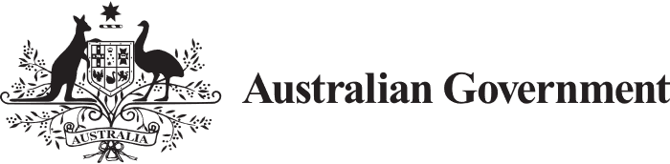

# Improving Outcomes for All

Australian Government Summary Report of the Review to Inform a Better and Fairer Education System 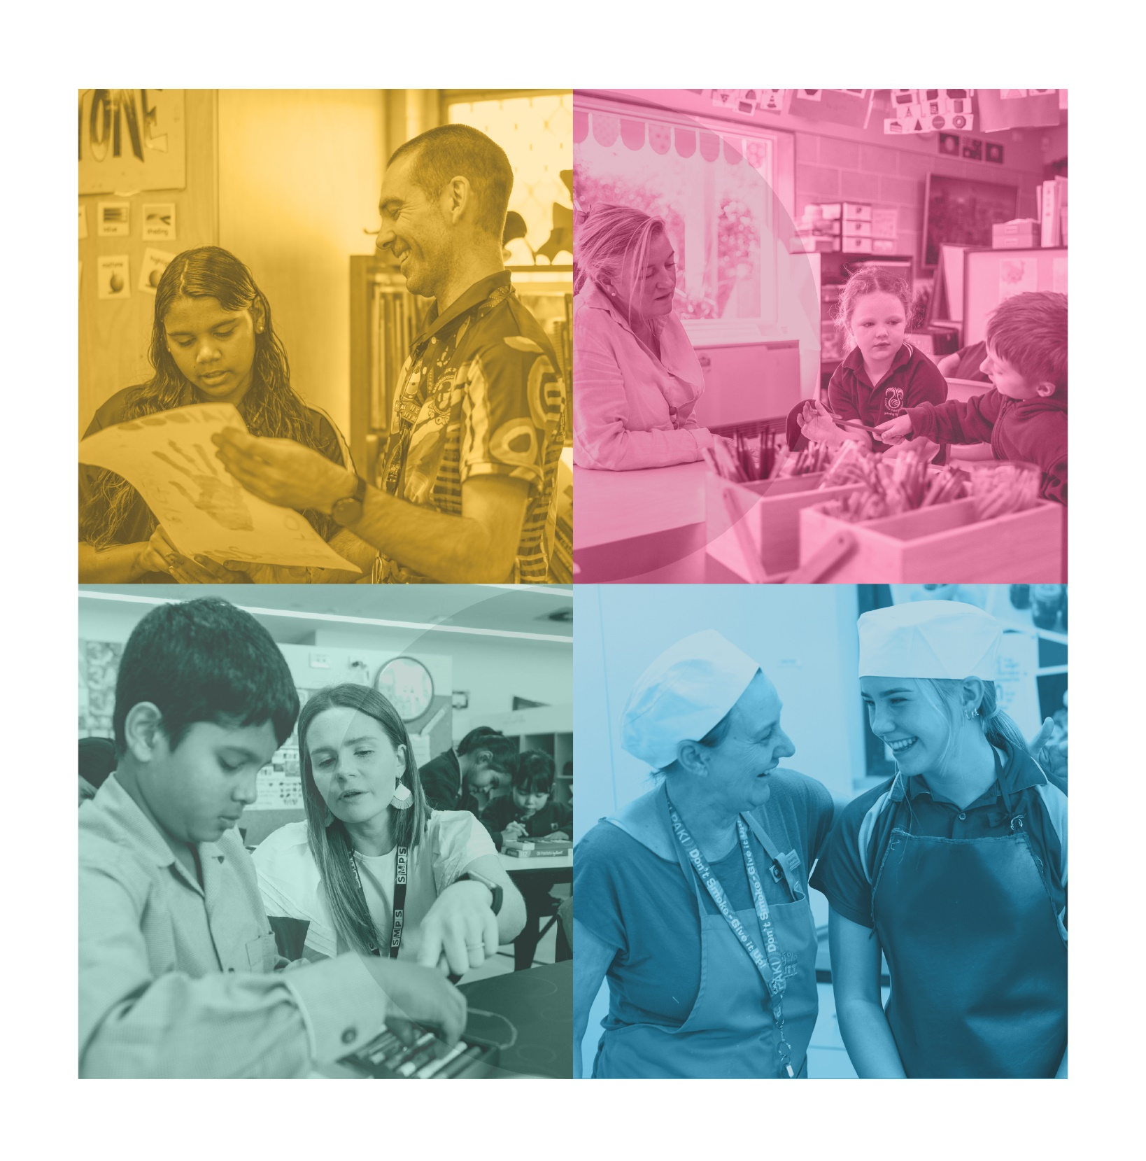

Cover images clockwise from top left are from the: WA Department of Education; VIC Department of Education; WA Department of Education; VIC Department of Education.

.

With the exception of the Commonwealth Coat of Arms, the Department’s logo, any material protected by a trade mark and where otherwise noted all material presented in this document is provided under a [Creative Commons Attribution 4.0 International](https://d2tic4wvo1iusb.cloudfront.net/documents/projects/NTP-RCT1-report-final.pdf) (https://creativecommons.org/licenses/by/4.0/) licence.

The details of the relevant licence conditions are available on the Creative Commons website (accessible using the links provided) as is the full legal code for the [CC BY 4.0 International](https://creativecommons.org/licenses/by/4.0/legalcode) (https://creativecommons.org/licenses/by/4.0/legalcode).

**Disclaimer**

This Summary Report has been prepared by the Australian Government as a summary of the Review to Inform a Better and Fairer Education System. As such, this document reflects the views of the Expert Panel and does not necessarily reflect the views of the Australian Government or the governments of states and territories.

The document must be attributed as the *Improving Outcomes for All: Australian Government Summary Report of the Review to Inform a Better and Fairer Education System*.

## Table of contents

Table of contents 3

Overview 4

Introduction 6

A good school system that can be made even better and fairer 6

The starting point – fair and equitable funding 8

Reform directions to create a better and fairer education system 8

Priority area 1: Equity 9

1. Lift student outcomes 9

2. Improve equity 10

Priority area 2: Wellbeing 12

3. Improve Student Wellbeing 12

Priority area 3: Workforce 14

4. Attract and Retain Teachers 14

Data, transparency, accountability and timescales 16

5. Reduce Data Gaps and Limitations 16

6. Enhance Funding Transparency and Accountability 17

7. Support Innovation and Achieve Reform 17

Summary of the Expert Panel’s recommendations 19

## Overview

Over the course of 2023, the Expert Panel (the Panel) of the Review to Inform a Better and Fairer Education System (the Review) visited many schools, met with key stakeholders, and received submissions to inform the next Education Funding and Reform Agreement (the Agreement).

The Panel’s Report acknowledged that the ambition of the Gonski reforms, including the commitment to fund students and schools to a defined Schooling Resource Standard (SRS), has yet to be achieved. In the context of continuing funding inequity and growing workforce shortages, the school system has performed well but could be better and fairer.

The Panel was clear in the Report that full funding to 100 per cent of the SRS is a critical prerequisite for successful education reform and student learning and wellbeing improvement across the country. Funding in the next Agreement should be applied to those specific reforms that will further support student outcomes and wellbeing, building on the excellent work that governments, schools, and systems are undertaking to ensure all students receive a high-quality education.

During recent years, the education system has performed well against the backdrop of the COVID-19 pandemic, workforce shortage challenges and broader societal changes. That education results have largely held up during this period is a testament to the dedication of Australia’s school leaders, teachers and school staff. The Panel heard that Australia has a good education system, but it can be better and fairer. To do that governments and school systems need to ensure every student is supported to succeed so that no one is held back or left behind.

The Panel expressed their appreciation for Australia’s dedicated educators and school leaders whose committed efforts give Australia’s young people the very best start in life, and give Australia the confident, creative, successful lifelong learners, active and informed citizens it will need in the future.

Addressing funding inequity, coupled with targeted reforms in three priority areas of equity, wellbeing and workforce, will help level the playing field and make Australia’s schools even better and fairer.

In its recommendations, the Panel suggested some areas for focus and investment including:

* consistent screening of students’ progress in developing fundamental literacy and numeracy skills in Year 1, supported by whole of school approaches to ensure no student is left behind, for example with programs like catch-up tutoring
* strengthening high-quality professional development, support and connection for principals, teachers and other educators
* support for schools and teachers to teach the curriculum, including by improving access to high quality resources
* building on measures to improve principal and teacher attraction and retention
* strengthening links between schools and community and health services, particularly in the most disadvantaged communities, to ensure that schools and students receive the support they need
* better supporting teacher and student wellbeing in schools, for example by investing in wellbeing coordinators.

The Panel also made recommendations on enabling reforms including data collection and use, funding transparency and accountability, and that the next Agreement is a 10-year agreement with a five-year review point. It called for greater transparency over the way needs-based funding is being allocated to ensure that parents and communities are assured that funding fully meets student need.

The Panel proposed a number of targets around early schooling, student learning gains, learning proficiency, equity, post-school pathways, attendance and workforce diversity. These targets are intended to guide the parties negotiating the Agreement.

The reforms presented in the Panel’s Report will be considered by Education Ministers alongside other inputs into the development of the next Agreement, such as the Productivity Commission’s Review of the current National School Reform Agreement, the National Disability Insurance Scheme (NDIS) Review, and the Royal Commission into Violence, Abuse, Neglect and Exploitation of People with Disability.

## Introduction

On 15 December 2022, Commonwealth, State and Territory Education Ministers agreed to establish the Review to inform the next Agreement, with a focus on driving real improvements for students, with a particular focus on students most at risk of falling behind, improving wellbeing, attracting and retaining teachers, how data collected can best inform decision-making and ensuring accountability and transparency of public funding.

The Panel members were: Dr Lisa O’Brien AM (Chair), Ms Lisa Paul AO PSM (Deputy Chair), Ms Dyonne Anderson, Dr Jordana Hunter, Prof Stephen Lamb and Prof Pasi Sahlberg.

The Terms of Reference for this Review asked the Panel to consider reforms that are evidence-based, leverage existing systems and are high impact, and provide advice to Education Ministers on five focus areas:

1. targets and reforms to drive real improvements for all students, particularly those most at risk of falling behind
2. improving student mental health and wellbeing
3. attracting and retaining teachers
4. using data collection to best inform improvements to student outcomes
5. ensuring transparency and accountability of public funding.

The Terms of Reference stated that the Review would not revisit how the SRS is calculated.

The Panel's Report contained analysis, findings and recommendations which offered a set of options to strengthen the Australian education system to further lift outcomes and improve equity. These were informed by extensive consultation with schools, education experts, education peak organisations, community organisations, unions, and students, parents and educators.

The Panel noted that due to the hard work and commitment of all dedicated education staff, the future of Australian students is in good hands.

## A good school system that can be made even better and fairer

*The Panel heard that schools provide a world-class education for most students, but not all students currently experience the best that schools have to offer.* The evidence shows Australia’s schools perform well by world standards. However, the Panel found that the uneven playing field and funding shortfalls the Gonski reviews sought to correct persist and need to be addressed.

The positive side of the story is worth celebrating:

* between 2011 and 2022 the proportion of 20 to 24 year-olds who have attained Year 12, Certificate III or higher has increased from 82.7 per cent to 90.1 per cent, and First Nations young people have experienced an even bigger increase, from 51.8 per cent in 2011 to 68.1 per cent in 2021
* Australia continues to perform above the OECD average in PISA
* socio-economic status had a lower-than-average impact on reading performance in PISA 2018, and average impact on mathematics performance in PISA 2022
* the enrolment rate in upper secondary vocational education and training is above the OECD average for 20 to 24 year-olds
* the attainment rate in tertiary education is also above the OECD average.

But there is a need for greater focus and collaboration from all governments and sectors to help lift student achievement, with:

* high school completion rates in public schools falling in the past six years from 83 per cent to 76 per cent (also known as the apparent retention rate)
* disadvantaged students three-times more likely to fall behind their classmates
* more than one in three students not meeting 2023 National Assessment Program – Literacy and Numeracy (NAPLAN) literacy and numeracy proficiency standards
* school attendance declining since 2015, with less than half of students attending school 90 per cent of the time in 2022
* only 74 per cent of students from low socio-economic backgrounds completing Year 12 in 2021, compared to 85 per cent of all students.

In light of these mixed results, and given the challenges that both COVID-19 and ongoing workforce pressures have brought to bear on the nation's education system, the Panel found that further action is needed to realise the original ambition of the Gonski reforms, including ensuring schools receive full and fair funding. Negotiation of the next Agreement is an opportunity to pursue reforms that will embed the practices and supports needed for students and educators.

### The starting point – fair and equitable funding

The Panel heard that a prerequisite for improving the performance and equity of schools is achieving a better and fairer funding model.

The 2010 Review of Funding for Schooling (the ‘Gonski Review’) called for a minimum level of funding for every student with additional needs-based funding to reflect that students experiencing disadvantage require targeted support. The Gonski Review considered that this funding should be based on a benchmark to support most students to achieve above the national minimum standard for literacy and numeracy. The 2017 Review to Achieve Educational Excellence in Australian Schools (‘Gonski 2’) made recommendations on how investment could be focused to improve student outcomes. While progress has been made, Gonski’s vision has not yet been achieved. While almost all non‑government schools are at or above the minimum funding standard, most government schools are not. While public schools have performed well in this context, it is an obvious and serious inequity that must be addressed. It is crucial that all governments and school systems aim to achieve 100 per cent of the SRS for every school as soon as possible.

The Panel noted in the Report that this is the priority for all governments. The Commonwealth Government is committed to working with state and territory governments to get every school to 100 per cent of its fair funding level. The Commonwealth Government and state and territory governments are committed to working together in good faith towards this outcome.

The Panel recognised that new investment would need to be accompanied by ongoing evidence-informed education reform. Everyone involved in schools will need to be involved, most notably principals and teachers, whose commitment needs to be supported, including through the development of the next generation of educators to meet growing workforce needs. Success will also require reform, simplification and renewal of systems and implementation mechanisms that underpin the provision of effective schooling. Part of this work will centre on enabling best practice and strong partnerships to be systemically applied over the life of the next Agreement.

### Reform directions to create a better and fairer education system

To address this situation and make the education system fairer and better, the Panel identified seven reform directions underpinned by specific, measurable and evidence-based recommendations and targets that could be prioritised through the next Agreement. These seven reform directions are designed to:

1. lift student outcomes
2. improve equity
3. improve student wellbeing
4. attract and retain teachers
5. reduce data gaps and limitations
6. enhance funding transparency and accountability
7. support innovation and achieve reform.

These reform directions broadly point towards three priority areas for the next Agreement:

* *equity* – to improve outcomes and address student needs, especially for priority equity cohorts, and reduce concentrations of disadvantage in schools (reform directions 1 and 2)
* *wellbeing* – to ensure all students and staff feel supported and belong (reform direction 3)
* *workforce* – to grow and diversify the workforce of confident and capable teachers and other educators, and ensure they are well supported to strengthen their practice and collaborate (reform direction 4).

There is already significant investment in many of these areas from governments, school systems and approved authorities. The Panel highlighted these and the many good practices they witnessed in the 92 school visits across every state and territory and the school-based submissions it received. Sharing and scaling these practices so that every student and every educator can benefit is the critical work of the next stage of reform.

## Priority area 1: Equity

1. Lift student outcomes

The Panel heard that the starting place for lifting student outcomes is to more effectively support school leaders, teachers and other educators.

The Panel’s Report recognised how vital it is for governments, school systems and approved authorities to put in place mechanisms that will ensure all students receive high-quality evidence-based instruction in the classroom. It suggested this be structured around a multi-tiered system of supports, where high-quality instruction benefits all students, with targeted supports in place for students to catch-up and keep-up.

In practice, this means ensuring students attain core literacy and numeracy skills to equip them for learning. The Panel heard that strong foundations are crucial not only for its own end but also for preparing learners to develop other attributes and skills, like intellectual curiosity, intellectual self-confidence, deep subject knowledge, creativity, leadership skills, employability skills, and more – sometimes referred to as general capabilities or 21st-century skills.

The Panel stated in the Report that the starting point is strengthening existing and effective universal screening for literacy, including phonics, and numeracy in Year 1, followed up by ongoing screening and targeted individual or small group support for all students who need it. Good practice such as this ensures all students who are falling behind or at risk of falling behind can be identified early and provided the help they need to catch up, keep up and reach their potential. This will help close the persistent gaps in achievement between the lowest and highest performing students, including those from priority equity cohorts. The Panel heard strong support from stakeholders about the positive impact of tiered and targeted support in lifting outcomes for students with disability or other complex needs.

The Panel heard that the most essential ingredients in the classroom are knowledgeable and skilled teachers, the curriculum they work with, and the relationships and expectations they develop with their students. To lift student outcomes, Australian educators need to be respected as true professionals through support for their professional development and access to the opportunities and tools they need to do what they’re best at: teaching. This means ensuring all educators access structured, ongoing, quality-assured and evidence‑based professional learning programs. It also means supporting them as they use their expertise to teach the curriculum and providing them support to develop effective lesson plans that work for all students in the classroom. The Panel suggested strengthening professional learning, mentoring and curriculum resources, including the establishment of a national framework for professional development accreditation and quality-assuring curriculum materials.

The impact educators have on their students reaches beyond schooling. Indeed, preparing young people for their life ahead is what schooling is all about. As outlined in the Panel’s Report, some jurisdictions are already working to reform their pathways, curriculum, and assessment systems to help more students to make a successful post-secondary transition, including through improved career education. However, the Panel heard that more needs to be done to ensure all students can transition successfully to further training, education and employment when they finish school.

1. Improve equity

The Panel’s Report stated that all students should have access to a high-quality education, irrespective of their circumstances, socio-economic background, ethnicity or postcode. However, the Panel reported on significant evidence of growing concentration of disadvantage in systems and that far too many students from disadvantaged backgrounds find it much harder to participate equally and succeed.

The Panel outlined that the first step to ensuring all students receive the supports they need must be to ensure that full funding to 100 per cent of the SRS is achieved as soon as possible. This includes the SRS loadings which provide extra funding for priority equity cohorts and disadvantaged schools to help disadvantaged students achieve their full potential. The Panel’s Report highlighted that full and fair funding is a precondition to levelling the playing field for all students.

#### Equity at the system-level

Australian schools have some of the highest levels of social segregation among OECD countries, which can affect student learning outcomes and aspirations. This trend has worsened over time. The Panel heard that the nature of the Australian education system leads to limited socio-educational diversity in some schools and entrenches disadvantage for many students. The Panel proposed that significant further work is required by governments,school systems and approved authorities to make schools more socio-educationally diverse and ensure affluent and non-affluent students do not grow up strangers to each other. To support this work, the Panel’s Report also suggested that socio‑educational diversity be measured at the system-level during the next Agreement.

#### Equity at the school-level

Principals and teachers using high-impact teaching and learning approaches make a big difference, particularly for disadvantaged students. Building on existing practices in a number of jurisdictions, the Panel has suggested that incentives be provided to attract and support highly effective leaders and teachers to stay in disadvantaged schools.

The Panel was told that far too many students do not come to school ready to learn because they face difficulty in navigating and accessing the services they need to effectively engage in their education. They have recommended action to strengthen connections between schools and community services to support schools to better connect students to a wide range of community and health services (including allied health services so important to learning, like speech and occupational therapists). The Panel’s Report highlighted the success of ‘full-service school’ models in strengthening connections between schools and services and recommended that such models be more widely implemented in the most disadvantaged communities. There are many models of full-service schools that aim to work in partnership with health and community services – importantly, the Panel emphasised that these schools should not take on the funding and delivery of all services or be used to ‘cost shift’ from other portfolios into education, and should be cognisant of workforce pressures across the education, health and community sectors.

#### Equity for students from priority equity cohorts

If schools are not funded to their full and fair levels, the number of students who are left behind and stay behind is likely to grow. The Panel proposed that governments and school systems should provide additional tiered and targeted support that would enable students, particularly those from priority equity cohorts, to catch up, stay on track and reach their potential.

Students from priority equity cohorts – such as First Nations students, students living in regional, rural and remote locations, students with disability and students from educationally disadvantaged backgrounds – were three times more likely to fall below NAPLAN’s former national minimum standards. Concerningly, the Panel heard that the learning gap between students in equity cohorts and other students increases over time, meaning that, on average, these students not only stay behind their peers but also fall further behind. In addition, the learning outcomes of students are negatively influenced in schools with higher concentrations of students experiencing educational disadvantage. This particularly impacts students from priority equity cohorts, and the Panel concluded that it is important to take steps now to build a better and fairer education system for all.

The Panel heard that a more equitable system needs to better support students with disability. Over one in five students receive an educational adjustment in Australian schools, and nearly nine in ten students with a disability attend a mainstream school. The Panel’s Report suggested that inclusive education policies should be codesigned with students with disability.

The Panel heard that far too many First Nations students are not being supported to reach their full learning potential. To better support these students, the Panel recommended there be a First Nations led approach to developing a national First Nations Education Policy which could be adapted by systems, school leaders and educators to suit local needs and contexts. The policy could support governments, school systems and approved authorities to implement evidence-based approaches to build the cultural responsiveness of teaching staff, assessments and assessment tools. The policy could also inform the design of national curriculum, projects, and resources to ensure they are culturally appropriate.

**Figure 1: Attainment of Year 12 or equivalent; or a non-school qualification at Certificate level III or above, 20-24 years old**

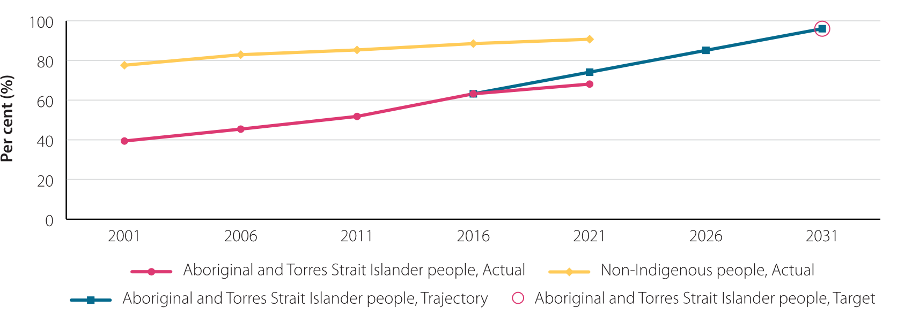Source: table CtG5A.1, ABS (unpublished) Census of Population and Housing, Derived from ABS (unpublished) Census of Population and Housing, Joint Council National Agreement on Closing the Gap.

## Priority area 2: Wellbeing

1. Improve Student Wellbeing

Positive mental health and wellbeing are well-recognised and crucial foundations for lifting student attendance, engagement and achievement. The Panel heard that this has been a focus for parents, educators and policy makers across the nation for many years, especially since the COVID-19 pandemic led to online engagement for long periods of time, isolating young people and affecting their emotional wellbeing.

The Panel heard that students with strong social and emotional wellbeing are more engaged with learning and tend to have higher levels of academic achievement and attainment. However, students with poor wellbeing may have challenges with their ability to engage and learn, their academic achievement, and their relationships and social interactions at school. For example, data indicates that Year 7 to 12 students experiencing poor mental health have, on average, more than double the number of absent days and by Year 9 are, on average, 1.5 years to 2.8 years behind in literacy and numeracy outcomes. Wellbeing is very much connected with learning, and vice versa.

The Panel cited data showing that psychological distress has increased among young people over the last 10 years. While governments, school systems and approved authorities have all made substantial investments in student mental health and wellbeing initiatives, the Panel heard that in some places, there is a cluttered and fragmented landscape of supports which can be difficult for students, families and schools to navigate, and is contributing to overall increased workload in schools.

**Figure 2: Extent to which supporting student health and wellbeing is important to role as an educator**

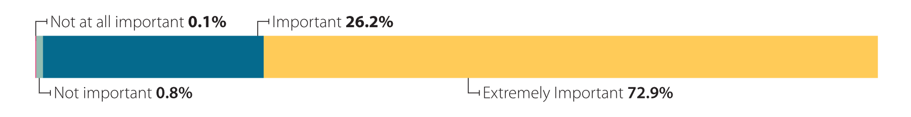Source: SW_T_2 To what extent is it important or not important to your role as an educator to support student health and wellbeing? Social Research Centre (2023) [Department of Education: Review to Inform a Better and Fairer Education System – initial consultation surveys: summary analytical report](https://www.education.gov.au/review-inform-better-and-fairer-education-system/resources/initial-consultation-surveys-summary-report), Department of Education, Australian Government, accessed 27 October 2023.

The drivers of poor wellbeing in school-aged children and young people are varied, and improving student wellbeing cannot be the work of schools alone. However, as the places where young people spend much of their formative years, the Panel considered that schools constitute an obvious and effective place to concentrate increased resources.

The Panel heard that improving and measuring the wellbeing of students across Australia is important, and have called for the development of a national wellbeing measure in the next Agreement to enable visibility at a national level as to whether investments in wellbeing support are having an impact. Many aspects of student wellbeing are of course well outside the control of any school and reflects challenges and changes in broader society. This is why the Panel recommended that the measure should focus only on domains squarely within the remit of schools, such as belonging, safety, cultural safety, engagement, and classroom disruption.This should also build on the work already happening within state and territories.

The Panel suggested that a national measure will allow governments, school systems and approved authorities to monitor and evaluate the effectiveness of actions that aim to improve the wellbeing of students nationally and in each relevant age range, as well as retain the ability for schools to implement initiatives that are most relevant to their needs. This measure should not be used to compare the performance of schools or schooling systems, add to the workload of school leaders and educators, or lead to cost-shifting between government systems.

In addition, the Panel heard that access to specialist staff, professional development, and evidence-based resources for staff, as well as better linkages between schools and allied services, can more effectively meet the wellbeing needs of students. For example, the presence in schools of ‘wellbeing coordinators’, access to professional counselling and psychology services either inside or outside schools as appropriate, strategies to promote safe and inclusive environments, and whole-of-school preventative approaches, and approaches to create positive cultures and environments provide possible ways to improve student wellbeing.

## Priority area 3: Workforce

1. Attract and Retain Teachers

Australia’s teachers are skilled, knowledgeable and committed; they care about young people and want to do their best to give them the very best start in life. The Panel highlighted that the nation owes them broad support for taking on the crucial task of educating its young people.

Their chosen profession is both rewarding and challenging. It requires broad expertise, deep pedagogical and content knowledge, and the ability to manage complex and confronting classroom and school situations. What they do matters. The evidence shows that teaching is the most influential in-school factor in improving student outcomes.

Teachers make a profound difference, but they do not succeed in isolation. Highly effective teaching happens in well-led and well-organised schools. It is invariably accompanied by effective support and training for educators, a positive learning environment in the school that promotes a culture of learning, access to the right resources, and supportive partnerships between principals, teachers, parents and communities. Governments, school systems and schools bring out the best in teachers by creating an environment in which they can do their best work.

The Panel’s Report acknowledged the work being undertaken by governments, school systems and schools to attract and retain teachers, including through the National Teacher Workforce Action Plan. The Panel concluded however that there is more that governments and school systems can do to grow and support the teaching workforce. The Panel found that the workload and expectations on teachers and school leaders has grown over time, affected by the changing economic, cultural and demographic conditions that are transforming every profession. Such demands, including change and reform, are taking a toll on the teaching workforce, undermining efforts to attract new entrants and retain those with experience, including principals.

Schools serving disadvantaged as well as regional and rural communities find recruitment and retention of staff even more difficult – and the Panel heard that teacher workload in such schools tends to be growing, including due to the complexity of student need and greater challenges accessing the wider range of supports locally. The current teacher shortage is likely to make support of these schools that much harder.

To support attraction and retention, the Panel suggested that it will be necessary to continue work to reduce teacher workloads and celebrate the profession. Building on the National Teacher Workforce Action Plan, the Panel recommended concentrated efforts towards creating supportive and inclusive school cultures, providing teachers and principals with more and better leadership training, and providing better professional development, including induction, mentoring and coaching.

The Panel recommended that further work be done to broaden the diversity of the profession. The Panel heard that greater diversity among classroom teachers in schools would ensure the profession better reflects the community. Addressing cultural safety and racism is an important part of ensuring everyone (students and educators alike) feels like they belong in the classroom, and improving cultural safety would also help attract and retain educators.

The Panel also heard that many teachers do not feel adequately recognised or valued. While matters for employers, they highlighted in the Report that better incentives, enhanced career pathways, better employment conditions, and improved remuneration and recognition are needed to attract and retain teachers and school staff.

The Panel heard from some teachers and principal associations that greater national teacher registration consistency would support teachers to move between jurisdictions and help streamline and standardise registration requirements. They concluded that jurisdictions should work together to drive the harmonisation of teacher registration across Australia, encourage teacher mobility, and allow for greater data sharing.

**Figure 3: Most important factors to help educators improve student outcomes (top 5 selected by teachers)**

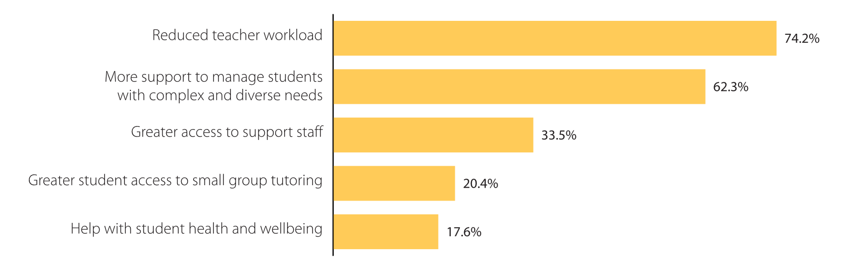Source: SMAR_T_1 Thinking about the following factors, which three factors would help you most to improve student outcomes? Social Research Centre (2023) [Department of Education: Review to Inform a Better and Fairer Education System – initial consultation surveys: summary analytical report](https://www.education.gov.au/review-inform-better-and-fairer-education-system/resources/initial-consultation-surveys-summary-report), Department of Education, Australian Government, accessed 27 October 2023.

## Data, transparency, accountability and timescales

1. Reduce Data Gaps and Limitations

Data is becoming a more useful tool in the education world, offering insights into how to address each student’s learning needs and how to organise school systems. But promising advances in technology need quality data to work effectively and the Panel heard evidence that currently too many data gaps exist, especially relating to priority equity cohorts – most notably for students with disability. The Panel heard that the lack of adequate data collected or publicly reported constrains governments, school systems and approved authorities from fully understanding system performance, promoting accountability, and supporting improvements in student outcomes.

Many systems and schools have data collection, monitoring, and reporting frameworks relevant to their local context and reform priorities, much of which is publicly reported. At the same time, and notwithstanding the current Productivity Commission performance dashboard, the Panel heard that reporting on current Agreement priorities and targets is dispersed, with no complete standalone source capable of giving stakeholders a ‘clear read’ of progress against NSRA outcomes. They recommended that an existing independent body take on the role of data custodian, with the task of developing a more mature approach to data governance and sharing. Its work would support coordination and sharing of education data.

The Panel heard concerns from stakeholders about additional data collection, including the potential for unfair comparisons between schools and systems, and the administrative burden its collection could place on teachers and schools already facing workload pressures. Where possible, the Panel suggested the better use of existing data collected by governments, school systems and approved authorities, and its more effective linkage to related information.

The Panel’s Report argued that the development of the Unique Student Identifier (USI) should be accelerated and broadened to better support children who are moving between schools, jurisdictions and systems, and to support transitions post-school. They suggested that the USI should also be expanded to enable a clearer picture to be gained of each student’s education journey.

The Panel heard that the Measurement Framework for Schools in Australia should be improved to provide a more complete picture of progress against reforms, including for outcomes data on priority equity cohorts. The Panel identified actions to ensure the Measurement Framework is equipped to track national priority outcomes and objectives – to ensure education, disability, and Closing the Gap related initiatives achieve their full potential.

1. Enhance Funding Transparency and Accountability

The Panel’s Report noted that school systems are often best placed to allocate funding and resources according to local context, and this should be accompanied by highly transparent funding and accountability arrangements. The Panel heard from stakeholders about a desire for greater transparency and accountability, including from families and communities seeking more access to information on the allocation and use of school funding. This includes information about how funding, including needs-based funding, is provided to systems and schools to support students from disadvantaged backgrounds. They also heard about the need to ensure this does not result in further administrative burden and workload for schools.

The Panel proposed mechanisms to increase funding transparency, including to ensure families and communities can access consistent and easy-to-understand information about how funds are allocated and spent by systems and schools. The Panel suggested that this will build on existing transparency requirements, support public trust in the system, and drive the most effective use of recurrent and needs-based funding.

Critically, the Panel advised that this additional funding transparency should be from existing data sources where possible, to prevent any additional data collection burden being imposed on schools.

The Panel also called for greater transparency around data about students with disability, to increase school-level accountability around obligations under the *Disability Standards for Education 2005*, including current levels of adjustment and outcomes for students with disability.

1. Support Innovation and Achieve Reform

The Panel heard from educators and system administrators about the toll that constant change imposes on the teaching workforce.

For this reason, the Panel suggested that proposed reforms should be given adequate time to be designed, implemented, measured, and evaluated in a longer timeframe, which acknowledges the impact of constant change within schools. The Panel recommended the next Agreement should therefore have a 10-year operation cycle, balanced with shorter bilateral agreements and a midpoint review to adjust direction as required. This would provide the education system with the time and consistency needed to implement reforms and learn from practice, research, and evidence to realise shared national objectives.

The Panel heard about the benefits of targets to drive reform, but also that these should be sharply focused on reform priorities, be based on existing data where possible and not create additional administrative burden for schools. To improve reporting, the Panel proposed the seven targets to be considered in negotiations for the next Agreement – six focused on measuring student outcomes and one focused on the workforce. These include targets around early schooling, learning proficiency, equity (of attainment), attendance and workforce diversity as well as recommendations to develop measures of student learning gains, equity (of outcomes), and post-school pathways which could support future targets.

These targets are intended to guide the parties negotiating the next Agreement and replace the existing targets and sub-outcomes in the current NSRA.

The Productivity Commission recently expressed its concern that the lack of a standalone report on Australia’s performance on current NSRA measures is diminishing the transparency of the reform process. As such, the Panel has proposed building on publicly available reporting mechanisms to ensure parents and the community have visibility of the progress that is made against the targets and reforms agreed by governments, including for priority equity cohorts.

**Figure 4: Overview of the targets proposed by the Expert Panel**

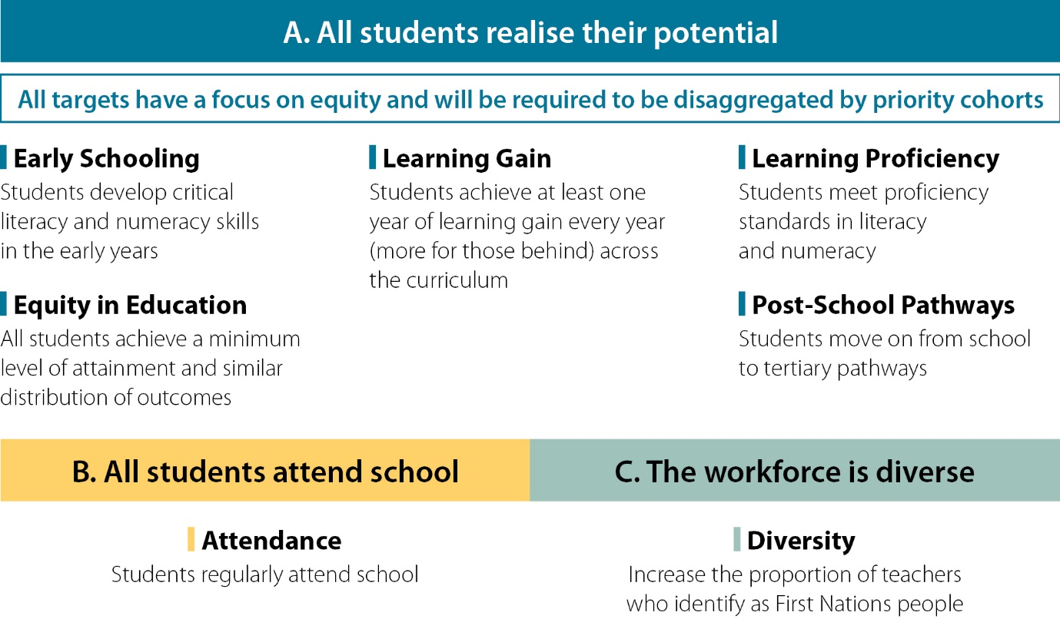

## Summary of the Expert Panel’s recommendations

**The first half of a table that provides a summary of the Expert Panel's recommendations. The summary lists the theme that each group of recommendations applies to. This includes: 
1. Student outcomes: All students realise their potential (which applies to Recommendations 1A, 1B, 1C, and 1D). 
2. Addressing disadvantage: No student is held back (which applies to Recommendations 2A, 2B, 2C, and 2D). 
3. Wellbeing: Students are supported and belong (which applies to Recommendations 3A and 3B). **

**The second half of a table that provides a summary of the Expert Panel's recommendations. The summary lists the theme that each group of recommendations applies to. This includes: 
4. Teacher workforce: Valued, strengthened, diverse (which applies to Recommendations 4A, 4B, 4C, and 4D). 
5. Making better use of our data: Greater accountability to improve student outcomes (which applies to Recommendations 5A, 5B, and 5C). 
6. Performance and transparency: Funding the glows in the dark (which applies to Recommendations 6A and 6B). 
7. Supporting innovation: And reform efforts (which applies to Recommendations 7A, 7B, 7C, 7D, and 7E). **