# Literature review on potential impacts of linking quality to funding

## Background

The Quality Initial Teacher Education Review (Department of Education, Skills and Employment 2022) recommended strengthening the link between performance and funding of Initial Teacher Education (ITE). ITE providers must meet Accreditation Standards, but there is no incentive or reward for improvement beyond these minimum standards. One way to incentivise improved ITE course quality is to link quality with Commonwealth funding.

The Teacher Education Expert Panel (TEEP) was established to provide advice on reforms to strengthen this link between ITE quality and funding (among other topics).

The Department of Education proposed three stages for establishing this link. The Department asked the Behavioural Economics Team of the Australian Government (BETA) to provide initial advice based on an international literature review on the potential behavioural impact of these three stages.

This literature review contains international examples of similar funding arrangements and evidence of their impact, when known. The summary presented here is based on a limited review of relevant literature and is intended for consideration by the TEEP.

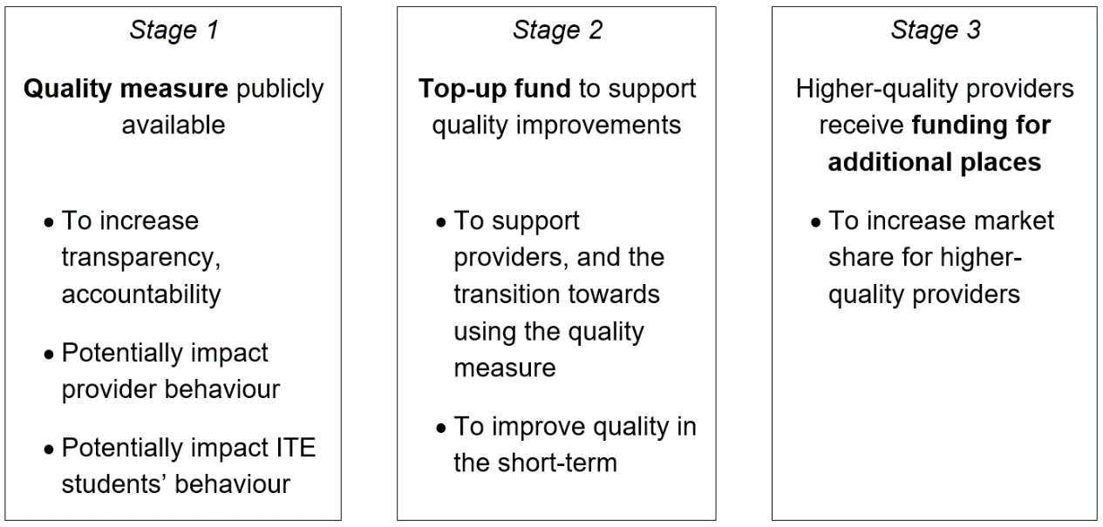

## Executive Summary

* BETA scanned the literature for international examples of transparency and funding measures that are similar to the measures being proposed (as shown above).
* We selected only 2-3 examples of each measure, and were drawing from a relatively limited pool. It was particularly difficult to find examples where funding was intended to impact market share (Stage 3).
* The effects of these measures on course quality have not always been evaluated. Overall experience with these measures appears to be positive, with perverse outcomes appearing to be relatively rare.

## Stage 1: Making quality measures publicly available

Making quality measures publicly available will help to reduce the information asymmetry between universities (who know what quality education entails) and incoming students (who do not). Education is understood to be an *experience good*, meaning its quality can only be judged after consuming it (Jongbloed et al. 2018). Quality measures can therefore help prospective students make an informed decision about which provider to choose.

### UK

The UK introduced the Teaching Excellence Framework (TEF) to better inform students’ choices about where and what to study, and recognise and reward excellent teaching (among other objectives) (Gunn 2018). The TEF began development in 2015, and underwent a series of policy development stages, technical consultations, and co-development with the higher education sector. The TEF consists of three components (teaching quality, learning environment, and student outcomes), and results in each provider receiving a Bronze, Silver, or Gold rating.

There was preliminary evidence that the TEF has increased the perceived importance of teaching among university leaders (Gunn 2018). There is also some evidence that TEF influences prospective students’ behaviour. A survey of 9,000 students found half would have reconsidered or not applied to their university if they had known it would be rated Bronze (Trendence UK 2017).

### Japan

Japan has been collecting survey data and publishing national databases since 1948 (Huang 2018). For example, the Annual National School Survey includes questions about funding, infrastructure, graduates, faculty members, and students. In the 90s, each national university was required to self-monitor and self-evaluate its education and research activities. Since 2002, universities have also been required to be evaluated by an external quality assurance agency. Both the university’s self-evaluation and the external evaluation must be publicly available. These evaluations include information about six-year plans, use of public funding, and academic performance (Huang 2018).

### China

China has gathered and published data about undergraduate education since 2007. The database includes information about faculty members, teaching, educational expenses, teaching and research equipment and student bodies (Huang 2018). One of the aims of this database is to evaluate teaching actitivites, and monitor, supervise, and control the quality of teaching (Huang 2018).

## Stage 2: Top-up fund to support quality improvements

France and Germany have both implemented schemes that provided universities with additional funding to improve teaching quality. In both cases, universities applied for the additional funding by submitting proposals, and funding lasted at least several years, meaning longer-term projects could be attempted.

### Germany

Germany had the ‘Pact for Quality in Teaching’ from 2011 to 2020. Around €2 billion was provided to universities to improve staffing, support the qualification of staff, and develop high-quality teaching (Federal Ministry of Education and Research 2022). Universities were given discretion about how they spent that money. For example, some universities chose to improve student-to-staff ratios in overcrowded courses, while others focused on developing new elite programs (Grove 2017).

The Pact for Quality in Teaching was evaluated over its entire program length (Schmidt et al. 2020). University stakeholders rated the program positively. The large amount of funding made the importance of teaching much more salient and helped inspire cultural and institutional change at universities. The projects funded by the program also appeared to be sustainable past 2020, after the end of program funding (Schmidt et al. 2020).

### France

In France, the Excellence Initiatives in Innovative Education (IDEFI) scheme funded projects focused on promoting innovative educational approaches and new content (National Research Agency 2020). IDEFI was initiated in 2012 and ended in 2019, and funded 36 projects. For example, at the University of Toulouse, additional funding allowed them to create a training program for new teachers, develop innovative learning spaces, and implement workshops for students to better understand international issues (University of Toulouse n.d.).

## Stage 3: Higher-quality providers receive additional funding for additional places

The examples provided below are of countries where governments funded additional higher education places. The additional funding was **not** tied to quality, but they may still provide some insight into the possible effects of higher-quality providers offering additional places.

### Australia

Australia’s demand-driven university system (in place from 2010 to 2017) meant that universities could admit additional students, if there was demand from those students. In this respect, it has some similarities to the current proposal to allow higher-quality providers to provide more places (which may not be filled if there is no demand for them).

The Productivity Commission (2019) found that the demand-driven university system led to a higher proportion of young people attending university. The ‘additional students’ – those who would not have attended university if the system had not been in place – typically had lower literacy and numeracy and a lower ATAR than other students (The Productivity Commission 2019). As Norton (2020) describes, ‘easier admission requirements are a near-inevitable consequence of increased higher education participation rates’ (p. 23). Students from a low socioeconomic background and ‘first in family’ students were also more likely to attend university – however First Nations people and people from regional or remote areas did not seem to benefit from the demand-driven system (The Productivity Commission 2019).

Most of the additional students (96%) did *not* attend a Group of Eight university. This meant that most of the changes (e.g. to admission processes and student support services) happened in universities outside the Group of Eight (The Productivity Commission 2019). Norton (2020) notes that the demand-driven system was a mechanism for moving student places (and funding) between institutions, because some universities would gain students at the expense of other universities. Under the block grant system, there was no mechanism for such a movement of funds.

### China

In China, higher education underwent rapid expansion in 1992-93: by 1993, annual enrolments in higher education had increased by 49% relative to 1991 (Dai et al. 2021).

An analysis conducted with large Census data showed the higher education expansion led to a significant increase in the quantity *and* quality of teachers during 1990 – 2005. This increase was especially pronounced for women and for teachers living in less-developed regions. Compared to young people educated before the higher education expansion, young people who experienced the expansion were more likely to become teachers and were thus able to enter a competitive labour market in which they could earn more and also enjoy more non-pecuniary benefits (e.g. job security, pension benefits, higher job satisfaction; Dai et al. 2021).

### Ethiopia

In Ethiopia, higher education was expanded aggressively in the early 21st century. The Ethiopian higher education sector remains very different to Australia’s higher education sector, but it may be worth noting that higher student numbers led to overcrowded classrooms, higher student-faculty ratios, and decreasing teaching quality (Akalu 2014).

## References

Dai F, Xu L and Zhu Y (2021) [*Higher Education Expansion and Supply of Teachers in China*](https://www.econstor.eu/handle/10419/250486), Institute of Labor Economics (IZA), accessed 3 February 2023.

Department of Education, Skills and Employment, (2022) [*Next Steps - Report of the Quality Initial Teacher Education Review*](https://www.dese.gov.au/quality-initial-teacher-education-review/resources/next-steps-report-quality-initial-teacher-education-review), accessed 23 March 2022.

Federal Ministry of Education and Research (29 March 2022) ['Qualitätspakt Lehre'](https://www.bmbf.de/bmbf/de/bildung/studium/qualitaetspakt-lehre/qualitaetspakt-lehre.html), Federal Ministry of Education and Research, accessed 2 February 2023.

Grove J (17 January 2017) ['Germany’s teaching excellence drive ‘creates new hierarchy’](https://www.timeshighereducation.com/news/germanys-teaching-excellence-drive-creates-new-hierarchy)', Times Higher Education, accessed 2 February 2023.

Gunn, A. (2018). [The UK Teaching Excellence Framework (TEF): The Development of a New Transparency Too](https://doi.org/10.1007/978-3-319-77407-7_31)l. In: Curaj, A., Deca, L., Pricopie, R. (eds) *European Higher Education Area: The Impact of Past and Future Policies*. Springer.

Huang, F. (2018). [What Is Transparency of Higher Education in East Asia? Case Studies of Japan and China](https://doi.org/10.1007/978-3-319-77407-7_28). In: Curaj, A., Deca, L., Pricopie, R. (eds) *European Higher Education Area: The Impact of Past and Future Policies*. Springer.

Jongbloed, B., Vossensteyn, H., van Vught, F., Westerheijden, D.F. (2018). [Transparency in Higher Education: The Emergence of a New Perspective on Higher Education Governance](https://doi.org/10.1007/978-3-319-77407-7_27). In: Curaj, A., Deca, L., Pricopie, R. (eds) *European Higher Education Area: The Impact of Past and Future Policies*. Springer.

National Research Agency (2020) ['Excellence initiatives in Innovative Education: experimenting and training for transformation'](https://ra2019.anr.fr/en/agency-committed-research/excellence-initiatives-innovative-education-experimenting-and-training/), National Research Agency, accessed 2 February 2023.

Norton A (2020) [*After demand driven funding in Australia: Competing models for distributing student places to universities, courses and students*](https://www.hepi.ac.uk/wp-content/uploads/2020/03/After-demand-driven-funding-in-Australia.pdf), Higher Education Policy Institute, accessed 3 February 2023.

Productivity Commission (2019) [*The Demand Driven University System: A mixed report card*](https://www.pc.gov.au/research/completed/university-report-card), Productivity Commission, accessed 3 February 2023.

Schmidt U, Besch C, Schulze K, Heinzelmann S and Andersson M (2020) [*Evaluation des Bund-Länder-Programms für bessere Studienbedingungen und mehr Qualität in der Lehre*](https://www.bmbf.de/bmbf/de/bildung/studium/qualitaetspakt-lehre/qualitaetspakt-lehre.html), Center for Quality Assurance and Development, accessed 2 February 2023.

Trendence UK (2017) [*Teaching excellence: the student perspective*](https://studentsunionresearch.files.wordpress.com/2017/11/tef-pr-research-report.pdf), Trendence UK,, accessed 31 January 2023.

University of Toulouse (n.d.) ['IDEFI CHALLENGE Diversity'](https://www.univ-toulouse.fr/des-formations-pour-tous/idefi-defi-diversites), University of Toulouse, accessed 2 February 2023.