1. 

Developing an Australian Framework for Measuring Quality in Initial Teacher Education

Research Team:

Professor Claire Wyatt-Smith

Dr Melanie Spallek

Dr Chantelle Day

John Ryan

02 February 2023

Table of Contents

Developing an Australian Framework for Measuring Quality in Initial Teacher Education 1

What is the purpose of a quality measure? 1

Defining the quality measure 2

Principles 2

Quality measure and performance indicators 2

Reporting 6

References 16

## **Developing an Australian Framework for Measuring Quality in Initial Teacher Education**

This paper presents an Australian framework developed for measuring quality in initial teacher education (ITE). The purpose of the proposed quality measure is discussed first. This is followed by the definition of the quality measure; the principles that informed the design; and a rationale for the quality measure and identified performance indicators. The paper concludes with an overview of the applied function of the framework and the proposed reporting method.

Entry to a profession typically requires successful completion of a professionally accredited program assessed against defined standards and stated evidence requirements. In ITE in Australia, programs are reviewed against the requirements of ‘*Accreditation of Initial Teacher Education Programs in Australia: Standards and Procedures’* (‘Standards and Procedures’; AITSL, 2022), and the *Australian Professional Standards for Teachers* (APSTs; AITSL, 2011; revised 2018). These official requirements provide the foundation for the accreditation process and for determining that ITE students meet the APSTs at the graduate career stage. Accreditation is conducted by state-based regulatory authorities to provide formal recognition that an ITE program has met the Standards and Procedures.

Currently there is no consistent or transparent public reporting of evidence from accreditation outcomes to improve public confidence in the quality of teacher preparation. While accreditation provides a regulatory framework for assessing ITE programs against stated standards, it does not include the following:

* An externally defined threshold (benchmark) for assessing course quality across ITE higher education providers (HEPs)
* A national approach to recognise HEPs that consistently demonstrate excellent performance in ITE
* An established external reference point (performance indicators) for HEPs to track progress and demonstrate improvement in course quality
* Nationally consistent data on course quality to inform the public and students about HEP performance.

The only nationally consistent data in use in ITE is that associated with national data collections through Quality Indicators of Learning and Teaching (QILT) and the Australian Teacher Workforce Data (ATWD). The Quality Initial Teacher Education (QITE) Review (Australian Government, 2022a) identified limitations in the effectiveness of the Performance-Based Funding scheme and established a warrant for assessing the quality of ITE courses (see Recommendation 15, p. x).

### What is the purpose of a quality measure?

The purpose of the quality measure is to recognise high quality courses and identify areas for targeted improvement. It seeks to define and measure the quality of ITE and promote transparency and national consistency in reporting. It achieves this by providing an explicitly stated reference that specifies evidence expectations and applies across HEPs.

The quality measure will:

* Offer a nationally consistent and transparent measure of outputs and longer-term outcomes applied across HEPs
* Inform where ITE courses can improve and where they are performing well on stated outcomes, to drive continuous improvement in course quality
* Develop a quality measure that enables performance-based assessments of ITE courses and assists in student choice
* Reward HEPs that score highly on the measure
* Increase transparency by making publicly available information on how each HEP scores on the quality measure (see Recommendation 15 of the QITE Review: Australian Government, 2022a, p. x).

### Defining the quality measure

The quality measure includes two components: (1) categories for assessing quality, and (2) performance indicators for each category. The indicators will measure the performance of HEPs within the categories.

The four categories are:

1. Selection: This category focuses on entry and participation of diverse groups in ITE (e.g., First Nations, regional and remote locations, and low socio-economic backgrounds).
2. Retention: This category focuses on the proportion of students who leave their course in the first year and those who separate within six years.
3. Classroom readiness: This category focuses on students’ perceived preparedness for entering the teaching profession and their satisfaction with the quality of their course.
4. Transition: This category focuses on the employment outcomes of recent graduates and early career teachers.

The selection of categories and indicators used in the measure was informed by a review of international literature. They provide a framework for assessing how well ITE programs perform across four key elements of preparation from selection into an ITE course, through preparation, and transition into the teaching workforce. The categories align to the structure of ITE accreditation and related frameworks for assessing quality. The QITE Review (Australian Government, 2022a) assessed ITE programs across similar domains. Data for the quality measure will be available in the ATWD to assess HEP performance.

### Principles

The quality measure and indicators should:

* Be relevant to the Australian context
* Be cost effective, drawing on available, relevant and accurate data
* Provide a common set of indicators for reporting course quality
* Be applicable across courses, contexts and cohorts
* Exclude requirements that would be more appropriate in accreditation.

### Quality measure and performance indicators

#### Category 1: Selection

Selection refers to the basis of admission for selecting who is given entry to teacher education. This category measures the participation of diverse cohorts in ITE. Both in Australia and internationally, a key focus of selection has been to increase participation of students from diverse backgrounds that have been historically disadvantaged and underrepresented in ITE and higher education more broadly. For example, the importance of ensuring equity of participation in selection is outlined in the Australian Higher Education Standards Framework (‘HES Framework’, 2021), which stipulates that HEPs are required to give “specific consideration… to the recruitment and admission” of recognised equity cohorts (HES Framework, 2021, Part A, S.2.2).

##### Performance Indicators

The proposed performance indicators for this category are:

* Participation of First Nations Students: The proportion of First Nations students enrolled in initial teacher education
* Participation of regional and remote students: The proportion of regional and remote students enrolled in initial teacher education
* Participation of low socio-economic status students: The proportion of low socio-economic status students enrolled in initial teacher education

These performance indicators measure the extent to which higher education providers are enrolling diverse cohorts, including First Nations, low socio-economic status and regional and remote students. This aligns with the focus of selection criteria and strategies in Australian and other countries to improve equity of participation for these cohorts.

##### Why is this important?

Measuring the participation of diverse groups in ITE recognises that these students have been underrepresented in ITE and the teacher workforce. The QITE Review reported stakeholders emphasised the importance of attracting diverse cohorts to the profession to better reflect school student populations. For example, Aboriginal and Torres Strait Islander students make up six per cent of the school student population but only one per cent of graduate teachers (QITE Review: Australian Government, 2022a).

Research highlights the importance of a diverse workforce, where a diverse teaching workforce facilitates positive outcomes for all students and especially diverse students (Gershenson et al., 2022). This is because a diverse workforce can better support and engage a diverse student population, ensuring that learning includes local, regional and cultural knowledge, and experience of Aboriginal and Torres Strait Islander people. Broadly speaking, teachers from diverse backgrounds, including rural, regional, and remote areas, provide valuable role models for post-school transition and pathways, and work in partnership with local communities (Gershenson et al., 2022; Ingersoll et al., 2019). For example, Aboriginal and Torres Strait Islander teachers and paraprofessionals can help meet student and community needs and provide culturally responsive educational experiences that “authentically connect schools with local indigenous communities to promote educational opportunity and respect for cultural ways of knowing, being and doing” (Gruppetta et al., 2018, p. 3).

These performance indicators recognise the success of policies and efforts of higher education providers to improve participation of diverse cohorts. This could include policies to:

* increase representation through access opportunities (e.g., foundation and short courses) and a range of pathways into ITE to diversify the future teaching workforce (O’Sullivan et al., 2019; QITE Recommendation 11: Australian Government, 2022a).
* use “transparent selection for entry to teaching” to increase equity of participation (QITE Recommendation 2: Australian Government, 2022a, p. xii)

#### Category 2: Retention

Retention refers to retaining students over the duration of the course from entry to graduation. This indicator focuses on retention at the first and sixth year and includes all students. This category measures the extent to which enrolled ITE students graduate from their course. In the Australian higher education policy landscape, the HES Framework (2021) stipulates that HEPs are required to regularly review “analyses of progression rates, attrition rates, completion times” of ITE candidates (HES Framework, 2021, Part A, 5.3.4).

##### Performance indicators

The proposed performance indicators for this category are:

* First-year attrition rate: the proportion of students leaving initial teacher education in their first year
* Six-year dropout rate: the proportion of commencing students leaving within six years

These performance indicators measure the extent to which students leave their ITE course shortly after commencement and the proportion of students who dropout from ITE. First-year attrition reflects the initial outcome of a student’s transition into their ITE course. The six-year dropout rate captures the proportion of commencing students who have separated from their course within six years, while also accounting for part-time students who may still be enrolled in their course after six years. These reflect the outcome of a student’s pathway through their course.

##### Why is this important?

Measuring the proportion of retained students recognises the high proportion of students who commence but do not graduate as a teacher. Six-year ITE completion rates of students commencing an undergraduate ITE course declined by eight percentage points between 2010 and 2015 (from 56 per cent to 48 per cent respectively, rounded estimates). Similarly, six-year ITE completion rates of students commencing a postgraduate ITE course declined by five percentage points over the same period (from 79 per cent to 74 per cent, rounded estimates; see Australian Government, 2022b).

The first year of preparation is widely recognised to be a time when candidates assess their suitability for teaching (AITSL, 2019, 2022b) and is the “the most common indicator of high risk to students” (TEQSA, 2017, p. 7). A focus on six-year dropout rates provides for an extended period of candidature and indicates the extent to which students are being supported throughout their course (AITSL, 2019). Higher education providers play an important role in the retention of students through the design and quality of their courses and supports available to students (Darling-Hammond, 2006; Darling-Hammond et al., 2019). For example, an analysis of student progression through ITE shows the timing of performance assessments affects the likelihood of graduating (Wyatt-Smith et al., 2021). Similarly, other higher education characteristics increase the likelihood of dropout including external enrolments, a lower proportion of senior academic staff employed, and lower percentage of full-time employed staff (TEQSA, 2017).

These performance indicators recognise the success of policies and efforts of higher education providers to retain students from course entry to course completion. This could include policies to:

* identify barriers to success and design targeted improvements for diverse student groups (Dunst, 2019; Wyatt-Smith et al., 2022)
* make evidence-informed decisions about known risks of separation (Ng et al., 2018).
* monitor progression through key assessment milestones, especially at the first and sixth year timepoints and including practicum placements (Hobson et al., 2009).

#### Category 3: Classroom readiness

Classroom readiness refers to the preparedness of teachers to begin employment in a school or learning centre on completion of the ITE course. This includes the academic and professional practice (school-based) components. This category measures student satisfaction with the ITE course and their perceived preparedness for entering the teaching profession. In Australia, a key focus of classroom readiness has been for higher education providers to prepare confident, effective graduates assessed against the Australian Professional Standards for Teaching (Program Standard 1.4: AITSL, 2022).

##### Performance indicators

The proposed performance indicators for this category are:

* Student satisfaction with the quality of their course (evidence from Student Satisfaction question – QILT survey data)
* Graduate preparedness for employment (Graduate Outcomes Survey: Preparedness to teach question).

These performance indicators align with an international focus on the assessment of graduate perceptions of program quality, through graduate or exit surveys (Bastian et al., 2017), and assessment of graduate competence in leading classroom learning. This survey data captures direct ratings of course quality.

##### Why is this important?

Classroom readiness reflects international research findings that teachers are the biggest in-school influence on student learning (Burroughs et al., 2019; Hattie, 2008, 2012). The knowledge and skills taught in initial teacher education are vital to ensuring all school students have a well-prepared teacher from a teacher’s first day in the classroom. Teachers who are well prepared for the classroom are more confident and effective in their teaching (Cochran-Smith et al., 2021; Mayer et al. 2017).

The design and quality of ITE programs has an important influence on graduates’ preparedness to teach. Equipping students with the required skills and knowledge for effective teaching supports classroom readiness, including supporting students to use evidence-based practices. The QITE Review (Australian Government, 2022a) noted that many stakeholders, including employers, higher education providers, professional associations and ITE graduates themselves have reported that graduate teachers are considered under prepared in a number of key areas. These areas included the teaching of reading, cultural competency, supporting diverse learners and students with disability, classroom management, family/carer engagement and rural and remote educational contexts.

These performance indicators recognise the success of policies and efforts of higher education providers to develop classroom ready teachers. This could include policies to:

* Co-design ITE courses with school-based teacher educators (Hudson & Hudson, 2013; Young, 2020)
* Promote co-teaching by school-based teacher educators and HEP-based teacher educators in the interpretation and use of classroom evidence of learning (Burn & Mutton, 2015; FTTS, n.d.; Sahlberg, 2012)
* Strengthen mentoring approaches that are shown to be effective in promoting classroom readiness (Hudson & Hudson, 2013; Young, 2020)

#### Category 4: Transition

Transition refers to entry into teaching employment, at the graduate level and in a school context. It includes: casual/relief teachers, part-time, full-time, and ongoing/permanent arrangements. The category measures employment outcomes of recent graduates and early career teachers. In Australia and internationally, a key focus of transition has been to assess the proportion of beginning teachers who are retained in the teaching workforce.

##### Performance indicators

The proposed performance indicators for this category are:

* Graduate employment outcomes: Proportion of teaching graduates employed upon graduation
* Longer-term employment outcomes: Proportion of graduates registered and employed at the end of the second year post graduation
* Employment in areas of workforce need: Proportion of graduates employed in areas of workforce need, such as science and maths teachers

These performance indicators measure the proportion of ITE graduates who transition successfully into classroom teaching and are in areas of workforce need. Data long-term employment outcomes will become available as the Australian Teacher Workforce Data collection matures and could be made more robust with the inclusion of administrative employment data. Data on areas of workforce need will be available from 2024 under the National Teacher Workforce Action Plan. These performance indicators align with international approaches to support beginning teachers in the classroom (Carroll et al., 2018; McLennan et al., 2017).by assessing and monitoring transitions into the workforce. For example, the United Kingdom tracks graduate employment outcomes through a Graduate Outcomes Survey 15 months after graduation (Higher Education Statistics Agency, n.d.a, n.d.b).

##### Why is this important?

Transition is an important indicator of course quality in that it reflects the success of preparation provided by HEPs. It represents a critical juncture in the move from being a student to being a teacher responsible for leading classroom learning. The QITE Review (Australian Government, 2022a) reported that stakeholders would welcome greater involvement by higher education providers in providing supportive transitions from ITE to employment. It also recognised that ITE plays a critical role in meeting the demand requirements of Australia’s schooling systems, through supplying teachers across geographical locations and subject specialisations. It reported a sense among some employers that the current system encourages higher education providers to ensure they are able to meet their obligations to students (to maximise their potential enrolment), more than ensuring an appropriate and adequate supply of graduates with the right specialisations.

A focus on ITE as a long-term partnership with employers is well-recognised in several countries (e.g., United Kingdom, New Zealand, and the United States). A critical feature of the partnerships between universities, employers, schools, and communities, is that it extends beyond ITE to support early career teachers in schools (Allen, 2013; Gordon, 2020; Ronfeldt & McQueen, 2017). ITE providers that gather and use data to evaluate their own courses and develop partnerships to sustain early career learning can ease transition and improve teacher retention (White et al., 2020).

These performance indicators recognise the success of policies and efforts of higher education providers to support the successful transition of ITE students into the workforce. This could include policies to:

* enable governments, universities, schools and other employing authorities to work collaboratively to enhance supports for successful transition of beginning teachers into the classroom and through the early years of practice (e.g., induction and mentoring; Australian Government, 2022b).
* increase partnerships between HEPs and employers to enhance graduate readiness through explicit connections between the theory and practice (Ovenden-Hope et al., 2018).

### Reporting

Reporting and assessing higher education performance using the quality measure should identify:

1. Improvement of HEPs’ performance on the quality indicators over time
2. Consistent high performance (where further improvement is unlikely to occur)

Consideration needs to be given to accommodate the different contexts of HEPs such as the characteristics of student cohorts and course delivery. Alternative options should be available to report on the performance of HEPs with small student cohorts where quantitative measures should not be reported.

#### Methodology consideration for threshold setting

Two approaches for reporting and analysis of the quality performance indicators were considered: (1) relative performance approach, and (2) improvement approach.

1. *Relative performance approach*

This approach compares HEP performance against predicted HEP performance, factoring in student and course characteristics known to influence performance on these quality indicators using regression techniques. Variables may include age, gender, basis of admission, mode of delivery, type of enrolment (full-time, part-time), and degree type. This approach is recognised to be statistically robust, though its use in higher education performance frameworks has been criticised due to its complexity and opaque nature (Wheelahan, 2007). For example, the Australian Learning and Teaching Performance Fund (LTPF; 2005 to 2009) sought to reward institutions “that best demonstrate excellence in learning and teaching” (Nelson, 2003, p. 29) and initially used regression analysis of quantitative measures to measure university performance. However, in the final year of the LTPF, funding was allocated based on whether institutions had improved on their metrics from the previous year (Coaldrake & Stedman, 2016). The ‘relative performance approach’ is not recommended for the reporting and analysis of the quality measure.

1. *Improvement approach*

This approach includes benchmarking HEP performance against previous long-term performance[1] at the individual institution level, to examine improvement over time, taking account of individual HEP’s context. For example, HEPs offering postgraduate courses only, may perform more strongly on certain indicators compared to those offering a mixture of under- and post-graduate ITE courses. With this approach, the individual HEP’s contextual information is directly accounted for, as the HEP performance is compared only to itself, resulting in an accurate and unbiased evidence base for improvement.

Small improvements in performance should be considered appropriate with the acknowledgment that the quality measure is an annual assessment of performance, where small incremental annual improvements lead to significant long-term change.

*Limitations of this approach relate to:*

* Showing further improvement of already high-performing HEPs
* Demonstrating improvement for HEPs with a small sample size.

*To overcome these limitations:*

* A threshold at or above the national average should be set for each indicator to recognise HEPs with consistently high performance, and hence, little room for further improvements. Setting the threshold to the national average would encourage continuous improvement, as improved performance of individual providers would also lift the national average.
* Providers should have the option to provide a qualitative submission, as seen in the performance funding models in other countries (e.g., United Kingdom: UK Department for Education, 2019a; United States: State of Louisiana Board of Regents, 2019a) and in previous Australian funding schemes (e.g., the Commonwealth Government’s LTPF). The submission allows HEPs to include relevant contextual details, including student characteristics, strategies, and efforts to improve performance on quality indicators and comments on sample size (specifically for HEPs with small cohorts).

The following section describes performance for each indicator on the preferred reporting method. Results presented are indicative only and based on data available at the time. In the case of the proportion of Indigenous students enrolled in ITE, half a percentage point is considered an improvement given the small proportion of Indigenous students enrolled in ITE. For the other non-survey-based performance indicators, one percentage point is considered an improvement. For the survey-based measures, a statistically significant increase is considered an improvement.

#### Category 1: Selection

##### Performance indicator: Proportion of Indigenous students enrolled in ITE

The proportion of Indigenous students enrolled in ITE courses was two per cent in 2020. This proportion varies between a low of zero and a high of nine per cent across higher education providers.

* 30 higher education providers had Indigenous student enrolments below the average. Of these, however, four improved their proportion of Indigenous enrolments relative to their long-term average by at least half a percentage point.

Figure 1. Proportion of Indigenous enrolments in ITE in 2020 relative to their pooled prior (2016 to 2019) proportion of Indigenous enrolments (2016-2019), by higher education provider (HEP).

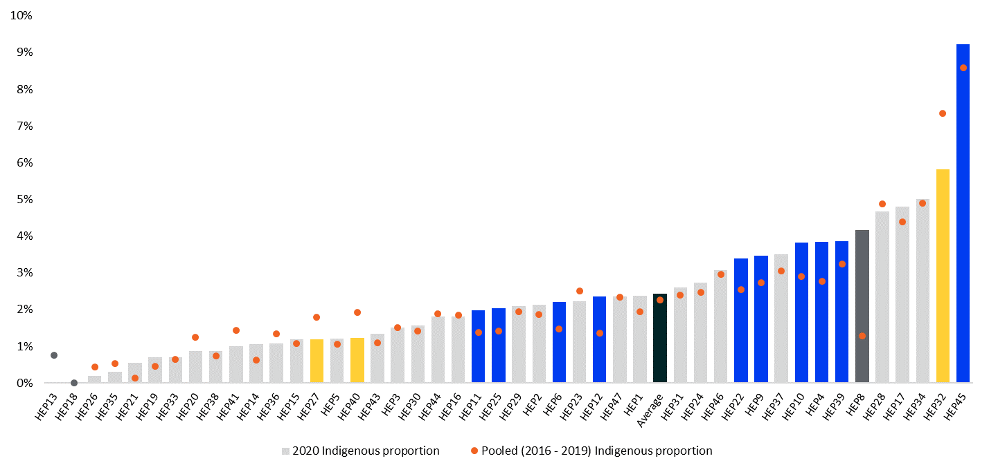

*Source:* Higher Education Statistics Collection, Department of Education, 2016 to 2020, [www.education.gov.au](http://www.education.gov.au)

*Notes:*

Dark grey shaded bars indicate higher education providers with one of these data limitations: had less than 26 domestic ITE students enrolled and/or had insufficient data to construct a long-term average across four years (between 2016 to 2019).

Blue bars represent at least half a percentage point improvement against the long-term average. Yellow bars represent at least half a percentage point deterioration against the long-term average.

##### Performance indicator: Proportion of regional and remote students enrolled in ITE

The proportion of regional and remote students enrolled in ITE courses was 25 per cent in 2020. This proportion varies between a low of one per cent and a high of 98 per cent across higher education providers.

* 33 higher education providers had regional and remote student enrolments below the average. Of these, however, one improved their proportion of regional and remote enrolments relative to their long-term average by at least one percentage point.

Figure 2. Proportion of regional and remote enrolments in ITE in 2020 relative to their pooled prior (2016 to 2019) proportion of regional and remote enrolments (2016-2019), by higher education provider (HEP).

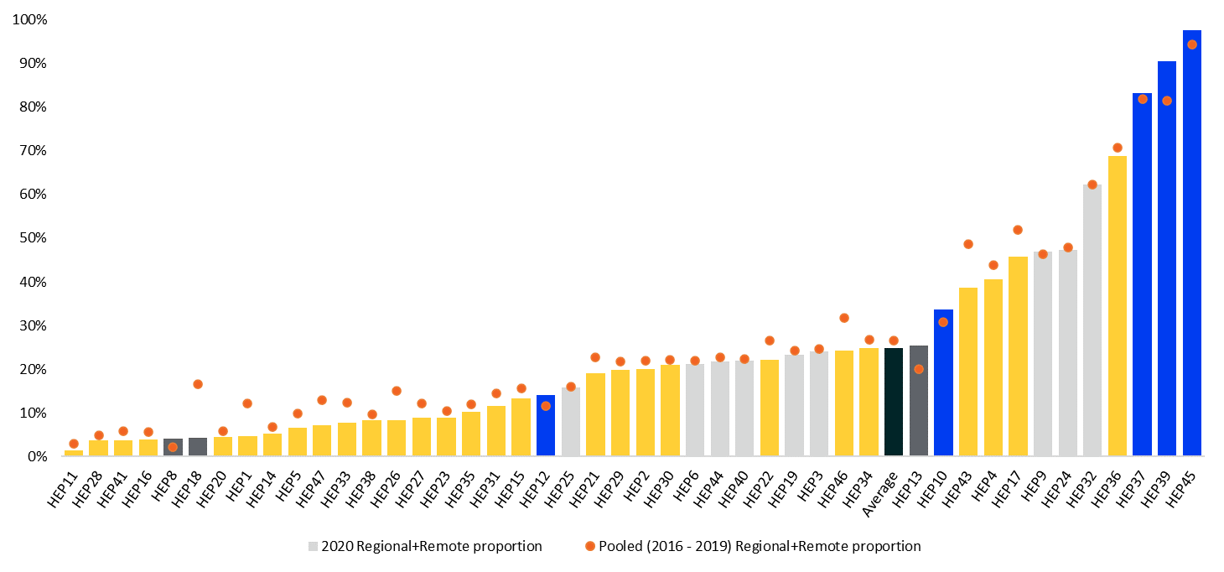

*Source:* Higher Education Statistics Collection, Department of Education, 2016 to 2020, [www.education.gov.au](http://www.education.gov.au)

*Notes:*

Dark grey shaded bars indicate higher education providers with one of these data limitations: had less than 26 domestic ITE students enrolled and/or had insufficient data to construct a long-term average across four years (between 2016 to 2019).

Regional and remote classification is based on the location of the student’s first home address in the Higher Education Statistics Collection, which is a student’s address before commencing study. A student's first home postcode is mapped to a Remoteness Area classification under the Australian Bureau of Statistics' 2016 Australian Statistical Geography Standard (ASGS) classification of regions.

Blue bars represent at least a one percentage point improvement against the long-term average. Yellow bars represent at least a one percentage point deterioration against the long-term average.

##### Performance indicator: Proportion of low socio-economic status students enrolled in ITE

The proportion of low socio-economic status students enrolled in an ITE course was 20 per cent in 2020. This proportion varies between a low of six per cent and a high of 42 per cent across higher education providers.

* 24 higher education providers had low socio-economic status student enrolments below the average. Of these, however, one improved their proportion of low socio-economic status enrolments relative to their long-term average by at least one percentage point.

Figure 3. Proportion of low socio-economic status (SES) student enrolments in ITE in 2020 relative to their pooled prior (2016 to 2019) proportion of low socio-economic status students enrolments (2016-2019), by higher education provider (HEP).

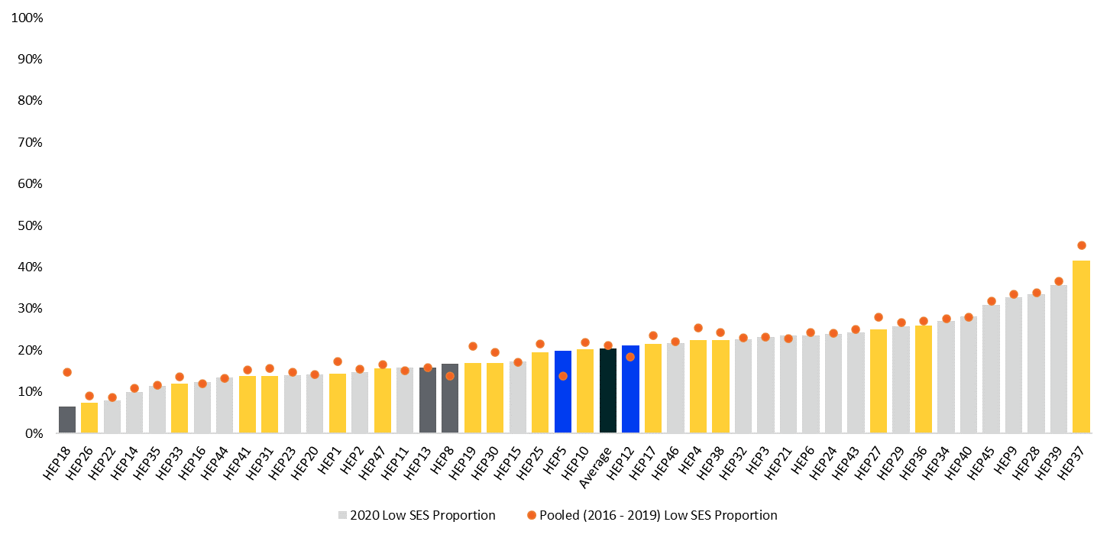

*Source:* Higher Education Statistics Collection, Department of Education, 2016 to 2020, [www.education.gov.au](http://www.education.gov.au)

*Notes:*

Dark grey shaded bars indicate higher education providers with one of these data limitations: had less than 26 domestic ITE students enrolled and/or had insufficient data to construct a long-term average across four years (between 2016 to 2019).

The SES classification is based on the location of a student’s first home address in the Higher Education Statistics Collection, which is a student’s address before commencing study. SES status was determined using the Australian Bureau of Statistics’ Socio-Economic Indexes for Areas (SEIFA) 2016 – The Index of Education and Occupation; students are considered low SES if they live in a SA1 (Statistical Area) in the bottom 25 per cent of the SEIFA for 15–64-year-olds.

Blue bars represent at least a one percentage point improvement against the long-term average. Yellow bars represent at least a one percentage point deterioration against the long-term average.

#### Category 2: Retention

##### Performance Indicator: First-year attrition

The average first-year attrition rate of ITE students commencing in 2019 was 22 per cent. This varies between a low of ten per cent and a high of 59 per cent across higher education providers (excluding one higher education provider with a small number of observations).

* 21 higher education providers had an attrition rate above the average. Of these, however, two improved their attrition rate relative to their long-term average by at least one percentage point.

Figure 4. First-year attrition rate of ITE students commencing in 2019 compared with their pooled prior attrition rate (2015 to 2018), by higher education provider (HEP).

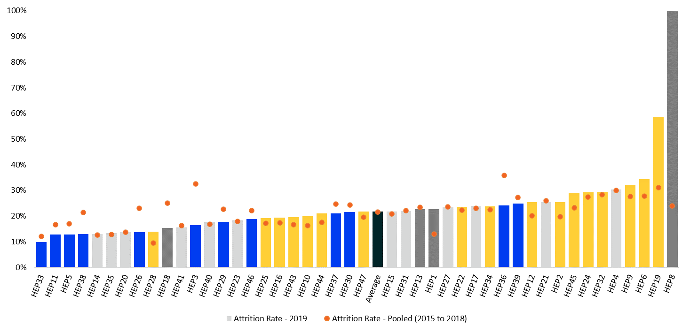

*Source:* Higher Education Statistics Collection, Department of Education, 2015 to 2019, [www.education.gov.au](http://www.education.gov.au)

*Notes:*

The attrition rate for 2019 is the proportion of students who commenced an ITE course in 2019 who neither complete an ITE course in 2019 or 2020 nor return to an ITE course 2020.

Dark grey shaded bars indicate higher education providers with one of these data limitations: had less than 26 domestic ITE students enrolled and/or had insufficient data to construct a long-term average across four years (between 2015 to 2018).

Blue bars represent at least a one percentage point improvement against the long-term average. Yellow bars represent at least a one percentage point deterioration against the long-term average.

##### Performance indicator: Six-year dropout rates

The average six-year dropout rate of ITE students commencing in 2015 was 38 per cent. This varies between a low of 14 per cent and a high of 51 per cent across higher education providers.

* 21 higher education providers had a dropout rate above the average. Of these, however, four improved their dropout rate relative to their long-term average by at least one percentage point.

Figure 5. Six-year dropout rates of ITE students commencing in 2015 compared with their pooled prior six-year dropout rates (2011 to 2014), by higher education provider (HEP).

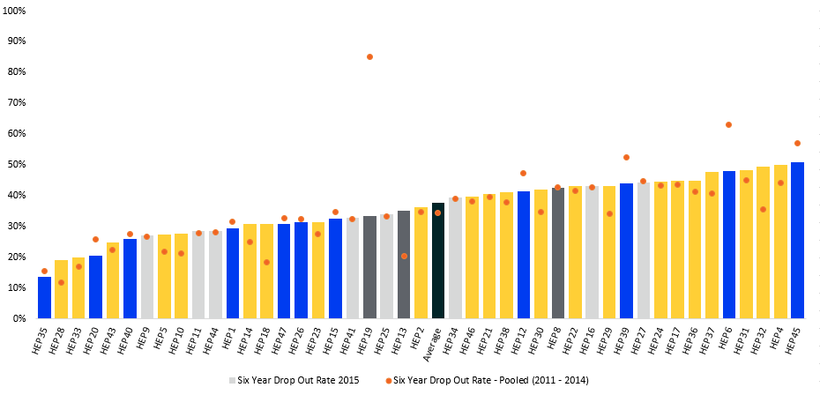

*Source:* Student Data (2011 - 2020), Higher Education Statistics Collection, www.education.gov.au

*Notes:*

The six-year dropout rate indicates the proportion of students who had dropped out of their ITE course one to six years after commencement. This measure is an indication of the proportion of students who are not expected to complete their course.

Dark grey shaded bars indicate higher education providers with one of these data limitations: had less than 26 domestic ITE students enrolled and/or had insufficient data to construct a long-term average across four years (between 2011 to 2014).

Blue bars represent at least a one percentage point improvement against the long-term average. Yellow bars represent at least a one percentage point deterioration against the long-term average.

HEP3 only had ITE courses from 2015 onwards and therefore a pooled dropout rate for 2011 to 2014 commencing students cannot be calculated.

#### Category 3: Classroom readiness

##### Performance indicator: Student satisfaction with the quality of teaching

On average, 78 per cent of ITE students in 2021 were satisfied with the quality of teaching in their course. This rating varies between a low of 57 per cent and a high of 95 per cent across higher education providers (excluding one higher education provider with a small number of observations).

* 17 higher education providers had a quality of teaching satisfaction rating significantly below the average. Of these, however, one statistically significantly improved their quality of teaching rating relative to their long-term average.

Figure 6. The proportion of students satisfied with the quality of teaching in 2021 compared with their pooled prior satisfaction rating for the quality of teaching (2017 to 2020), by higher education provider (HEP).

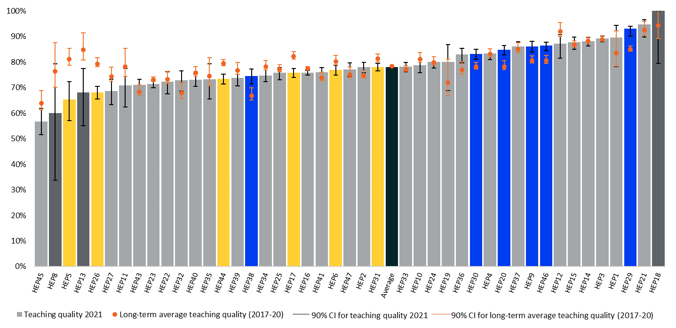

*Source:* Student Experience Survey (qilt.edu.au), Department of Education, 2017 – 2021

*Note:*

Dark grey shaded bars indicate higher education providers with one of these data limitations: had less than 26 domestic ITE students enrolled and/or had insufficient data to construct a long-term average across four years (between 2017 to 2020).

Confidence intervals are calculated using the Agresti-Coull method with finite population corrections.

HEP28 has not been included as not enough data was available to calculate a result for 2021.

Blue bars represent a statistically significant improvement against the long-term average. Yellow bars represent a statistically significant deterioration against the long-term average.

##### Performance indicator: Graduate preparedness for employment

This measure assesses the proportion of graduates who felt that their qualification prepared them well for their teaching role. The proportion of Education students answering that they were prepared well for employment in 2021 was 81 per cent. This varies between a low of 61 per cent and a high of 93 per cent across higher education providers (excluding four higher education provider with small observation numbers).

* Six higher education providers had a graduate preparedness for employment rating significantly below the average. Of these, however, one statistically significantly improved their graduate preparedness for employment rating relative to their long-term average.

Figure 7. The proportion of Education students who perceived that their university qualification prepared them for teaching in 2021 compared with their pooled prior results (2017 to 2020), by higher education provider (HEP).

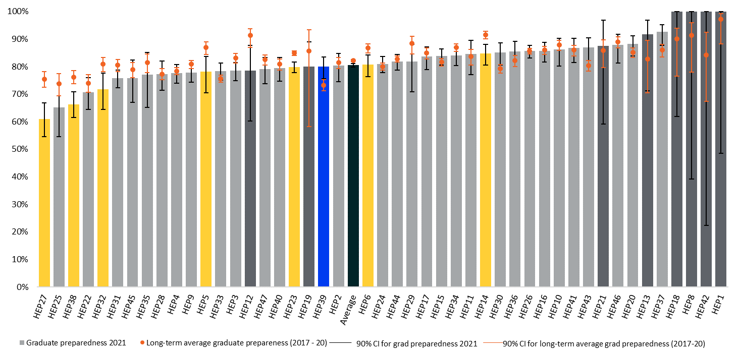

*Source:* Graduate Outcomes Survey (qilt.edu.au), Department of Education, 2017 - 2021

*Note:*

Dark grey shaded bars indicate higher education providers with one of these data limitations: had less than 26 domestic Education students enrolled and/or had insufficient data to construct a long-term average across four years (between 2017 to 2020).

Confidence intervals are calculated using the Agresti-Coull method with finite population corrections.

Blue bars represent a statistically significant improvement against the long-term average. Yellow bars represent a statistically significant deterioration against the long-term average.

#### Category 4: Transition

##### Performance indicator: Graduate employment outcomes

The proportion of Education students employed as teachers four months after graduation in 2020 was 92 per cent. This varies between a low of 83 per cent and a high of 100 per cent across higher education providers.

* Nine higher education providers had a graduate employment outcome proportion significantly below the average. Of these providers, none statistically significantly improved their graduate employment outcome relative to their long-term average.

Figure 8. Graduate employment outcomes (proportion of Education students employed as teachers four months after graduation) in 2020 compared to their pooled prior graduate employment outcomes (2016 to 2019), by higher education provider (HEP).

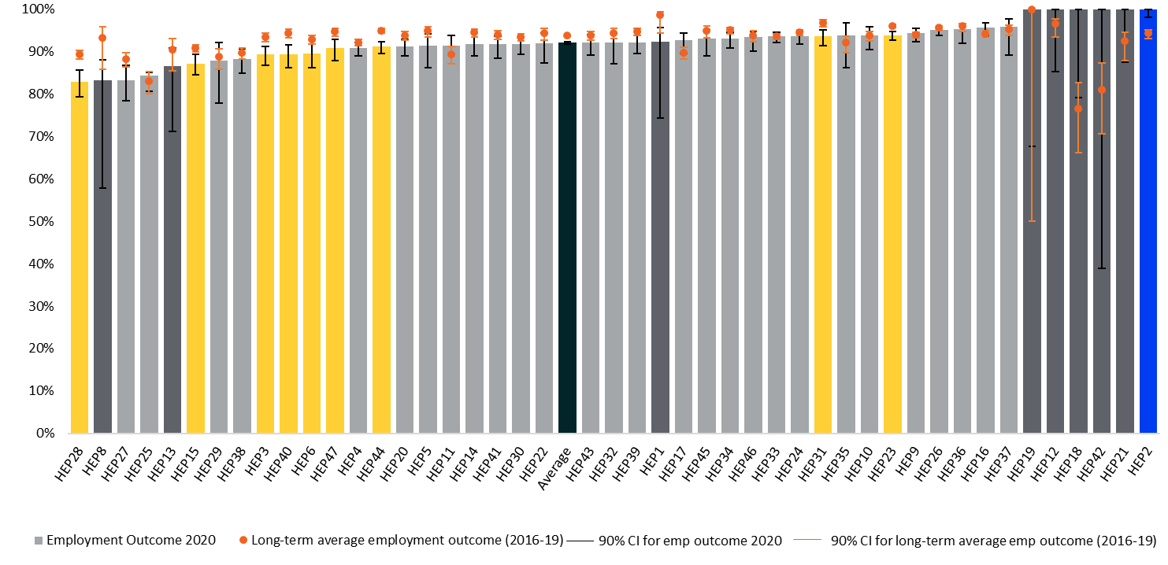

*Source:* Graduate Outcomes Survey (qilt.edu.au), Department of Education, 2016 - 2020

*Note:*

Dark grey shaded bars indicate higher education providers with one of these data limitations: had less than 26 domestic Education students enrolled and/or had insufficient data to construct a long-term average across four years (between 2017 to 2020).

Confidence intervals are calculated using the Agresti-Coull method with finite population corrections.

Blue bars represent a statistically significant improvement against the long-term average. Yellow bars represent a statistically significant deterioration against the long-term average.

### References

Agresti, A., & Coull, B. A. (1998). Approximate is Better than “Exact” for Interval Estimation of Binomial Proportions. *The American Statistician*, 52, pp. 119-126.

AITSL. (2011; revised 2018). *Australian professional standards for teachers*. <https://www.aitsl.edu.au/teach/standards>

AITSL. (2019). *Initial teacher education: Data report 2019*. Australian Institute for Teaching and School Leadership.

AITSL. (2022a). *Accreditation of initial teacher education programs in Australia: standards and procedures.* <https://www.aitsl.edu.au/docs/default-source/national-policy-framework/accreditation-of-initial-teacher-education-programs-in-australia.pdf?sfvrsn=e87cff3c_48>

Allen, J. M., Howells, K., & Radford, R. (2013). A ‘partnership in teaching excellence’: Ways in which one school–university partnership has fostered teacher development. *Asia-Pacific Journal of Teacher Education, 41*(1), 99-110. <https://doi.org/10.1080/1359866X.2012.753988>

Australian Government. (2022a). *Next Steps: Report of the Quality Initial Teacher Education Review*. <https://www.education.gov.au/quality-initial-teacher-education-review/resources/next-steps-report-quality-initial-teacher-education-review>

Australian Government. (2022b). *Issues paper: Teacher workforce shortages*. <https://ministers.education.gov.au/sites/default/files/documents/Teacher%20Workforce%20Shortages%20-%20Issues%20paper.pdf>

Bahr, N., & Mellor, S. (2016). *Australian Education Review: Building quality in teaching and teacher education*. Australian Council for Educational Research. <https://research.acer.edu.au/aer/15/>

Bastian, K., Sun, M., Lynn, H. (2017). *What Do Graduate Surveys Tell Us About Teacher Preparation Quality?* <https://www.education.uw.edu/epal/wp-content/uploads/2017/10/1.-Bastian_-Sun_-Lynn_-2017_-What-Do-Graduate-Surveys-Tell-Us-.pdf>

Burn, K., & Mutton, T. (2015). A review of ‘research-informed clinical practice’ in Initial Teacher Education. Oxford Review of Education, 41(2), 217-233. <https://doi.org/10.1080/03054985.2015.1020104>

Burroughs, N., Gardner, J.,· Lee, Y., Guo, S., Touitou, I., Jansen, K., & Schmidt, W. (2019). A review of the literature on teacher effectiveness and student outcomes. In Teaching for excellence and equity. IEA Research for Education (Vol 6). Springer. <https://doi.org/10.1007/978-3-030-16151-4_2>

Carroll, D., Parasnis, J., & Tani, M. (2018, December). *Teaching, gender and labour market incentives*. (SSRN Working Paper No. 3318801). <https://doi.org/10.2139/ssrn.3318801>

Coaldrake, P., & Stedman, L. (2016). *Raising the stakes: gambling with the future of universities* (2nd ed.). University of Queensland Press.

Cochran-Smith, M., Stringer Keefe, E., & Smith, R. J. (2021). A study in contrasts: Multiple-case perspectives on teacher preparation at new graduate schools of education. *The New Educator, 17*(1), 96-118. <https://doi.org/10.1080/1547688X.2020.1822485>

Darling-Hammond, L. (2006). Constructing 21st-century teacher education. *Journal of Teacher Education, 57*(3), 300-314. <https://doi.org/10.1177/0022487105285962>

Darling-Hammond, L., Saunders, R., Podolsky, A., Kini, T., Espinoza, D., Hyler, M., & Carver-Thomas, D. (2019). *Best practices to recruit and retain well-prepared teachers in all classrooms.* Learning Policy Institute. <https://learningpolicyinstitute.org/sites/default/files/product-files/Leandro_Best_Practices_Recruit_Retain_REPORT.pdf>

Derrington, M. L., & Campbell, J. W. (2018). High-stakes teacher evaluation policy: US principals’ perspectives and variations in practice. *Teachers and Teaching, 24*(3), 246–262. <https://doi.org/10.1080/13540602.2017.1421164>

Dunst, C. J., Hamby, D. W., Howse, R. B., Wilkie, H., & Annas, K. (2019). Metasynthesis of preservice professional preparation and teacher education research studies. *Education Sciences, 9*(50), 1-36. doi:10.3390/educsci9010050

FTTS. (n.d.). FTTS. Finish Teacher Training Schools. <https://ftts.fi/>

Gershenson, S., Hart, C. M. D., Hyman, J., Lindsay, C. A., & Papageorge, N. W. (2022). The Long-Run Impacts of Same-Race Teachers. *American Economic Journal: Economic Policy, 14*(4), 300–342. <https://doi.org/10.1257/pol.20190573>

Gordon, A. L. (2020). Educate – mentor – nurture: Improving the transition from initial teacher education to qualified teacher status and beyond. *Journal of Education for Teaching, 46*(5), 664-675. <https://doi.org/10.1080/02607476.2020.1807296>

Gruppetta, M., Southgate, E., Ober, R., Cameron, L., Fischetti, J., Thunig, A., Heath, T., Burns, K., & Clifton, S. (2018). *Yarning the way: The role of Indigenous education paraprofessionals in guiding the post-school transitions of Aboriginal and Torres Strait Islander youth.* University of Newcastle, <https://www.ncsehe.edu.au/wp-content/uploads/2018/10/76_MareeGruppetta_Accessible.pdf>.

Hattie, J. (2008). *Visible learnings: A synthesis of over 800 meta-analyses relating to achievement*. Routledge.

Hattie, J. (2012). *Visible classrooms for teachers: Maximizing impact on learning*. Routledge.

Higher Education Standards Framework. (2021). Higher Education Standards Framework (Threshold Standards) 2021 (au). Australian Government.

Higher Education Statistics Agency. (n.d.a). *Graduate outcomes survey*. [Graduate Outcomes Survey Results record 2021/22 | HESA](https://www.hesa.ac.uk/collection/c21072)

Higher Education Statistics Agency. (n.d.b). *Statistical bulletins and first releases*. [Statistical bulletins and first releases | HESA](https://www.hesa.ac.uk/data-and-analysis/statistical-first-releases?date_filter%5bvalue%5d%5byear%5d=&topic%5b%5d=811)

Hobson, A. J., Malderez, A., Tracey, L., Homer, M., Ashby, P., Mitchell, N., McIntyre, J., Cooper, D., Roper, T., Chambers, G., & Tomlinson, P. (2009). *Becoming a teacher: Teachers’ experiences of initial teacher training, induction and early professional development* (Research Report No DCSF-RR115). Department for Children, Schools and Families. <https://core.ac.uk/download/pdf/4160415.pdf>

Hudson, S., & Hudson, P. (2013). Re-structuring preservice teacher education: Introducing the School-Community Integrated Learning (SCIL) pathway. *Journal of Education and Learning, 2*(1), 9-19.

Ingersoll, R., May, H., & Collins, G. (2019). Recruitment, employment, retention and the minority teacher shortage. *Education Policy Analysis Archives, 27*(37), 1-42. <https://eric.ed.gov/?id=EJ1213628>

Mayer, D., Dixon, M., Kline, J., Kostogriz, A., Moss, J., Rowan, L., Walker-Gibbs, B., & White, S. (2017). *Studying the effectiveness of teacher education: Early career teachers in diverse settings*. Springer.

McLennan, B., McIlveen, P., & Perera, H. N. (2017). Pre-service teachers’ self-efficacy mediates the relationship between career adaptability and career optimism. *Teaching and Teacher Education, 63*, 176–185. <https://doi.org/10.1016/j.tate.2016.12.022>

Nelson, B. (2003). *Our Universities: Backing Australia's Future*. <http://www.voced.edu.au/content/ngv%3A38781>

Ng, P. T., Lim, K. M., Low, E. L., & Hui, C. (2018). Provision of early field experiences for teacher candidates in Singapore and how it can contribute to teacher resilience and retention. Teacher Development, 22(5), 632–650. <https://doi.org/10.1080/13664530.2018.1484388>

Ng, P. T., Lim, K. M., Low, E. L., & Hui, C. (2018). Provision of early field experiences for teacher candidates in Singapore and how it can contribute to teacher resilience and retention. *Teacher Development, 22*(5), 632–650. <https://doi.org/10.1080/13664530.2018.1484388>

O’Sullivan, K., Burns, G., & Bird, N. (2019). *Diversifying Initial Teacher Education: Who Utilises Alternative Entry Routes to Teaching & How They Compare to Direct Entry Students*. <https://doi.org/10.4995/HEAD19.2019.9409>

Ovenden-Hope, T., Blandford, S., Cain, T., & Maxwell, B. (2018). RETAIN early career teacher retention programme: Evaluating the role of research informed continuing professional development for a high quality, sustainable 21st century teaching profession. *Journal of Education for Teaching, 44*(5), 590–607. <https://doi.org/10.1080/02607476.2018.1516349>

Rauschenberger, E., Adams, P., & Kennedy, A. (2017). *Measuring quality in ITE: A literature review for Scotland’s MQuITE study*. Scottish Council of Deans of Education.

Ronfeldt, M., & McQueen, K. (2017). Does New Teacher Induction Really Improve Retention? *Journal of Teacher Education, 68*(4), 394-410.

Rowan, L., Bourke, T., L’Estrange, L., Lunn Brownlee, J., Ryan, M., Walker, S., & Churchward, P. (2021). How does initial teacher education research frame the challenge of preparing future teachers for student diversity in schools? A systematic review of literature. *Review of Educational Research, 91*(1), 112-158. <https://doi.org/10.3102/0034654320979171>

Sahlberg, P. (2012). The most wanted: Teachers and teacher education in Finland. In L. Darling-Hammond & A. Lieberman (Eds.), *Teacher education around the world: Changing policies and practices* (pp. 1–21). Routledge.

State of Louisiana Board of Regents (2019a). *GRAD Act*. <https://regents.louisiana.gov/grad-act/>

TEQSA. (2017). *Characteristics of Australian higher education providers and their relation to first-year student attrition*. Tertiary Education Quality and Standards Agency. <https://www.teqsa.gov.au/sites/default/files/attrition-report-june-2017-19dec2017.pdf?acsf_files_redirect>

UK Department for Education (2019a). *Evaluation of Provider-level TEF 2016–17 (Year 2): Measuring the initial impact of the TEF on the higher education landscape research report*. <https://assets.publishing.service.gov.uk/government/uploads/system/uploads/attachment_data/file/914169/TEF_Year_2_Evaluation_Report__6_.pdf>

Wheelahan, L. (2007). How not to fund teaching and learning. *Australian Universities Review, 49*, 31–38.

White, M. E., Hirschboeck, K., Donahue, C., & Torre Gibney, D. (2020). *Strengthening the data use and continuous improvement capacity of teacher preparation programs*. WestEd.

Wyatt-Smith, C., Haynes, M., Day, C., Spallek, M., & Smith, A. (2021). *Quality of Initial Teacher Education Through Longitudinal Analysis of Linked Datasets: Study 1: Examining performance trajectories from admission to graduation: Executive Summary*. Australian Government Department of Education. <https://www.education.gov.au/teaching-and-school-leadership/resources/quality-initial-teacher-education>

Wyatt-Smith, C., Spallek, M., Smith, A., Day, C., & Ryan, J. (2022). *Improving postgraduate pathways: Evidence-informed innovations for attraction, progression and supporting transition into teaching. A Report Prepared for the Queensland Department of Education*. Australian Catholic University.

Young, K. (2020). Innovation in initial teacher education through a school–university partnership. *Journal of Curriculum and Teaching, 9*(1), 15-29. <https://doi.org/10.5430/jct.v9n1p15>

1. Measured as the average performance of the previous four years based on available data , noting that comparisons to averages of previous five years are more commonly applied (<https://www.abs.gov.au/statistics/health/causes-death/provisional-mortality-statistics/jan-2020-dec-2021>, [https://www.aihw.gov.au/getmedia/a69ee08a-857f-412b-b617-a29acb66a475/aihw-phe-287.pdf.aspx?inline=true](https://aus01.safelinks.protection.outlook.com/?url=https%3A%2F%2Fwww.aihw.gov.au%2Fgetmedia%2Fa69ee08a-857f-412b-b617-a29acb66a475%2Faihw-phe-287.pdf.aspx%3Finline%3Dtrue&data=05%7C01%7CMelanie.Spallek%40acu.edu.au%7C9288515ef0034d663def08db097d98a1%7C429af009f196448fae7958c212a0f2ce%7C0%7C0%7C638114207250906303%7CUnknown%7CTWFpbGZsb3d8eyJWIjoiMC4wLjAwMDAiLCJQIjoiV2luMzIiLCJBTiI6Ik1haWwiLCJXVCI6Mn0%3D%7C3000%7C%7C%7C&sdata=8Cn32iMZGRXnhXVdXIkbo77JK4E17e%2Fk%2BZ3lrohfRuw%3D&reserved=0))