****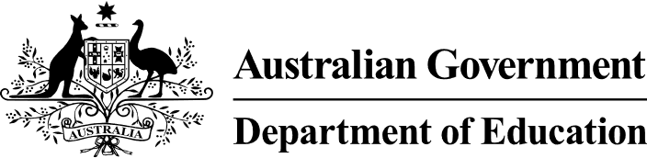

# Preschool Outcomes Measure

Factsheet for preschool services

The Preschool Outcomes Measure is a nation-wide teaching tool. It will be trialled in selected services in 2025. It is a formative assessment tool to help teachers and educators understand a child’s learning and development against learning progressions.

## What is the measure?

The Preschool Outcomes Measure is a key reform under the Preschool Reform Agreement. It's a joint initiative of the Australian and state and territory governments.

There are three parts to the measure:

* a new national formative assessment tool
* a focus on national learning progressions in two domains: executive function and oral language and literacy
* criteria and processes for aligning existing tools to the learning progressions.

The tool will be developed throughout 2024 in consultation with stakeholders. A national trial will take place for selected services in 2025.

## Who will use it?

The Preschool Outcomes Measure is for preschool teachers and educators. It will be designed to boost high-quality practice by:

* providing an evidence-based formative assessment tool
* enhancing understanding of a child’s strengths and capabilities
* supporting planning of the next steps in a child’s learning and development.

Services that provide a preschool program for children in the year before they start full time school will be eligible to use the tool. This includes services at school-based or community preschools and Centre Based Day Care. It will be voluntary to use.

## How will it work?

The Preschool Outcomes Measure will be designed to build on teachers’ and educators’ existing practice. It will support their rich pedagogical knowledge and streamline and enhance existing practices.

The new learning progressions will be designed to align with existing benchmarks of quality preschool, including:

* National Quality Standard
* Early Years Learning Framework V2, or state-approved equivalents.

The Preschool Outcomes Measure will be designed to be used in play-based learning and will complement observations of children’s learning and development.

It will also support nationally consistent language around children’s learning and development. This will make it easier for children to move between services.

## How will it benefit children?

Teachers and educators will be able to use the Preschool Outcomes Measure to:

* see how far children have come in their learning
* draw on resources for support on what children are ready to learn next.

It will support teachers and educators to teach all children, including:

* First Nations children
* children from culturally and linguistically diverse backgrounds
* children of varying abilities.

**The Preschool Outcomes Measure will not be a test**. It will not be used to benchmark teachers, educators, services, children or jurisdictions.

## How does it support learning?

The Preschool Outcomes Measure will focus on two age appropriate domains:

**Executive function**, to support children to plan, focus, remember instructions and juggle multiple tasks.

**Oral language and literacy**, to support children to speak, listen, read, view, write and create.

These domains were selected because they have a strong evidence base. They are also foundational skills that support children to thrive. Supporting children to build these skills is critical to addressing disadvantage.

## Tell me more about the trial?

All Education Ministers have agreed to a national trial in 2025. Options for states and territories to participate in the trial include:

* trialling the new national assessment tool, or
* trialling a tool that is already in use that aligns with the new national learning progressions, or
* trialling a combination of tools.

States and territories will decide how services are selected to participate in the trial.

Professional development materials will be available for services participating in the trial.

Services participating in the trial may receive some funding from the Australian Government. This will be determined by state and territory education departments. n