

# Inclusion Support Portal

Frequently asked questions

Contents

1. What is the Inclusion Support Portal? 3

2. What is the IS Portal used for? 3

3. Who can access the IS Portal? 3

4. What are the requirements for gaining access to the IS Portal? 3

5. Do I need to have a PRODA account? 4

6. How do I login to the IS Portal? 4

7. Can I request IS Portal access for multiple services? 4

8. Which email address should I use when requesting IS Portal access? 4

9. How can I change the email address associated with my IS Portal access? 4

10. When requesting access to the IS Portal which role should I choose? 5

11. For Inclusion Support Program Providers 5

12. What should we do if our service does not have an Authorised Access Delegate or does not know who the Authorised Access Delegate is? 6

13. Where can I access the online Inclusion Support Portal Helpdesk form from? 6

14. The IS Portal records show that I am listed as Authorised Personnel, but I cannot access the IS Portal. Why? 7

15. I can access my service Provider Entry Point, but I cannot access the Inclusion Support Portal for my service. Why? 7

16. I am the Authorised Access Delegate but cannot access my services Strategic Inclusion Plan (SIP), what do I need to do? 7

17. How do I switch between the role of Authorised Access Delegate and SP ISS User? 7

18. When completing my IS Portal access request, I cannot find the service provider I work for. What do I do? 8

19. After submitting IS Portal access request for the first time, it says a verification email has been sent to me, but I did not receive one. What do I do? 8

20. I have had IS Portal access in the past but now when I log in, I don’t have access to any service (or a particular service). Why? 9

21. My request to access the IS Portal has been denied. Why? 9

22. Why did I receive notification that my access was approved and then subsequent notifications saying it was denied? 9

23. We have received a new CCS approval. Do we need to request new IS Portal access request? 9

24. I want to request IS Portal access but received a ‘Server Error’ message after entering the PRODA second step verification code. My PRODA username and password are correct as I can log in to my PRODA account. Where can I access help? 9

25. I am experiencing technical issues with the IS Portal, what should I do first to troubleshoot? 10

26. What email address will the IS Portal use to communicate with our service? 11

27. What type of information will be emailed to my service from the IS Portal? 11

28. Do users need access to the IS Portal to submit claims for Inclusion Support funding? 12

Further information 12

### What is the Inclusion Support Portal?

The Inclusion Support Portal (IS Portal) is a web-based application which manages all early childhood education and services’ (ECEC) interactions with the Inclusion Support Program (ISP).

### What is the IS Portal used for?

* Strategic Inclusion Plan (SIP) - development, management and review
* Inclusion Development Fund (IDF) cases– applications, approvals, viewing claims submitted and payments made

### Who can access the IS Portal?

The IS Portal can be accessed by ECEC service provider representatives (users), Inclusion Professionals and the Inclusion Development Fund Manager team.

The service’s Authorised Access Delegate(s) can approve the addition and removal of users able to access the IS portal on the service’s behalf. Services may choose to limit access to specified personnel only. Alternatively, services may decide to give access to room leaders, or to all educators in the service, which may facilitate collaboration on the development of their Strategic Inclusion Plan.

### What are the requirements for gaining access to the IS Portal?

Gaining access to the Inclusion Support Portal requires each user to:

1. Have a PRODA account; and
2. Gain permission to act on behalf of the service in one or more roles.

Service representatives who are required to access the IS Portal in the role of Authorised Access Delegate when the service already has a person approved in this role, only need to:

1. Have a PRODA account; and
2. Gain permission to act on behalf of the service in one or more roles.

When a service does not have anyone in the role of Authorised Access Delegate or are unable to identify who they are, the service representative must also:

1. Be linked to the services Child Care Subsidy System (CCSS) as a Person with Management or Control of the Provider, or as a Persons Responsible for the Day-to-Day Operation of the Service; and
2. After submission of the IS Portal access request, submit an online [Inclusion Support Contact Form](https://employment.au1.qualtrics.com/jfe/form/SV_23Q5nmkEW1EBK29) to *Request approval for IS Portal access (Delegate Only)*

* **Supporting resources:**
* Task Card - Requesting access to the Inclusion Support Portal in the role of Authorised Access Delegate
* Task Card - Requesting access to the Inclusion Support Portal as a Service Provider SP ISS User

### Do I need to have a PRODA account?

Yes, all users who wish to access the Inclusion Support Portal require a PRODA account.

Users from Early Childhood Education and Care (ECEC) services who already have a PRODA account for accessing the Child Care Subsidy System (CCSS) will use the same PRODA account for accessing the IS Portal.

Users must [register in PRODA](https://proda.humanservices.gov.au/pia/pages/public/registration/account/createAccount.jsf) if they don’t already have an account.

### How do I login to the IS Portal?

To login to the IS Portal each user must have a PRODA account and have gained approval to act on behalf of their service in one or more roles. Once approved a user can access the IS Portal by either:

[logging into PRODA](https://proda.humanservices.gov.au/pia/pages/public/registration/account/createAccount.jsf) and selecting the Inclusion Support Portal tile

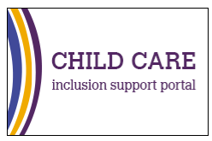

or

Accessing the [IDFM website](https://idfm.org.au) and clicking on the IS Portal Login button located on the top ribbon.

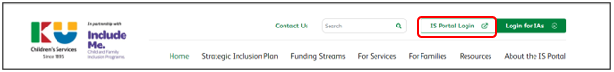

### Can I request IS Portal access for multiple services?

Yes. However, you must complete a **separate access request** for each service.

### Which email address should I use when requesting IS Portal access?

It is recommended that you use the same email address as the one you used for your PRODA account. This should be a personal email address that you can easily access, not an email address linked to a service.

### How can I change the email address associated with my IS Portal access?

The email address can be changed on IS Portal Entry Point page by clicking on ‘Update my contact details’. Refer to the image on the next page.

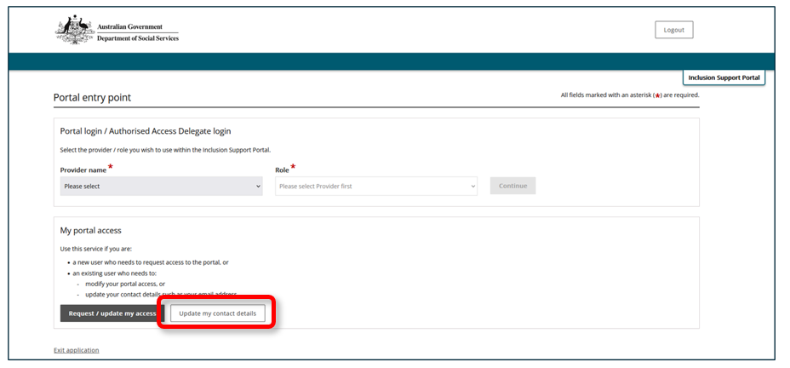

### When requesting access to the IS Portal which role should I choose?

#### For Service Providers

**SP ISS User**

This role is for ECEC service representatives (users) who need to access to the Inclusion Support Portal to be able to develop and manage their services Strategic Inclusion Plan (SIP) and/or Inclusion Development Fund cases.

* **Supporting Resource**:
* Task Card - Accessing the Inclusion Support Portal as a Service Provider SP ISS User.

**Authorised Access Delegate**

This role is for service provider representatives who are required to manage access to the Inclusion Support Portal for other users in the service.

* **Supporting Resource:**
* Task Card - Requesting access to the Inclusion Support Portal in the role of Authorised Access Delegate.

**Note:** A service provider representative can have both roles if they will be required to interact with the service’s SIP and manage access to the IS Portal for other users in the service

### For Inclusion Support Program Providers

**IDF Manager**

This role is for users who work for the Inclusion Development Fund Manager only.

**Inclusion Professional**

The role is for users that work for Inclusion Agencies only.

* **Supporting Resource**
* **Task Card - Accessing the Inclusion Support Portal as an Inclusion Agency Representative**

### What should we do if our service does not have an Authorised Access Delegate or does not know who the Authorised Access Delegate is?

After a new user completes their portal access request via the Portal Entry Point, the system will send an email to the service’s Authorised Access Delegate for action. The new user should check with the service provider’s management team to see if anyone has received an email requiring action.

Authorised Access Delegates can sometimes be a person who is listed as CCS Authorised Personnel. Authorised Personnel are people who have been authorised to act on behalf of the service in the Provider Entry Point (PEP).

The service can verify these people by logging into the PEP and checking who is listed as CCS Authorised Personnel. This may assist the service to determine the identity of the Authorised Access Delegate.

* Supporting Resource:
* [Task card - How to add, remove or update childcare personnel details in the Provider Entry](https://www.education.gov.au/child-care-package/resources/how-add-update-and-remove-personnel-details-provider-entry-point)

Alternatively, contact your Inclusion Agency (IA) or the Inclusion Development Fund Manager (IDFM) on 1800 824 955 for assistance. They will be able to share with you information about who is listed as Authorised Personnel in the IS Portal. The IDFM and IA teams do not have access to information about who the Authorised Access Delegate is. However, the information they provide may assist the service to determine this.

If your Service Provider is unable to identify the Authorised Access Delegate is for the service, or the service does not have an Authorised Access Delegate, one service representative can request access. Please do not submit multiple requests for access.

Once approved, the Authorised Access Delegate will be able to approve access requests for other representatives (users)of the service as a SP ISS user and/or Authorised Access Delegate.

### Where can I access the online Inclusion Support Portal Helpdesk form from?

The online [Inclusion Support Portal Helpdesk form](https://employment.au1.qualtrics.com/jfe/form/SV_23Q5nmkEW1EBK29) can be accessed from the department’s website

or via the [About the IS Portal](https://idfm.org.au/about-the-is-portal) page on the IDFM Website.

### The IS Portal records show that I am listed as Authorised Personnel, but I cannot access the IS Portal. Why?

The list of Authorised Personnel found on the IS Portal displays the names of people who are linked to the service providers Chid Care Subsidy System (CCSS) as a Person with Management or Control of the Provider, or as a Persons Responsible for the Day-to-Day Operation of the Service.

To gain access to the IS Portal, Authorised Personnel are required to gain permission to act on behalf of the provider, in one or more roles, by submitting an IS Portal access request.

### I can access my service Provider Entry Point, but I cannot access the Inclusion Support Portal for my service. Why?

The Provider Entry Point (PEP) is a different platform to the Inclusion Support Portal (IS Portal). You will need to submit an IS Portal access request to gain access to the Inclusion Support Portal for the service in one or more roles.

### I am the Authorised Access Delegate but cannot access my services Strategic Inclusion Plan (SIP), what do I need to do?

Accessing a services SIP requires each user to have SP ISS User access. A person who has access to the IS Portal as an Authorised Access Delegate will also require access as an SP ISS User to be able to interact with the services SIP.

An Authorised Access Delegate can add the role of SP ISS User to themselves on the Identity Manager (IDM) 'Access requests' page.

* Supporting Resources
* Task card for Authorised Access Delegates – Managing Access to the Inclusion Support Portal.

To access the service’s Strategic Inclusion Plan, on the Portal Entry Point page select your **Provider’s name** and **SP ISS User** as your role when logging in.

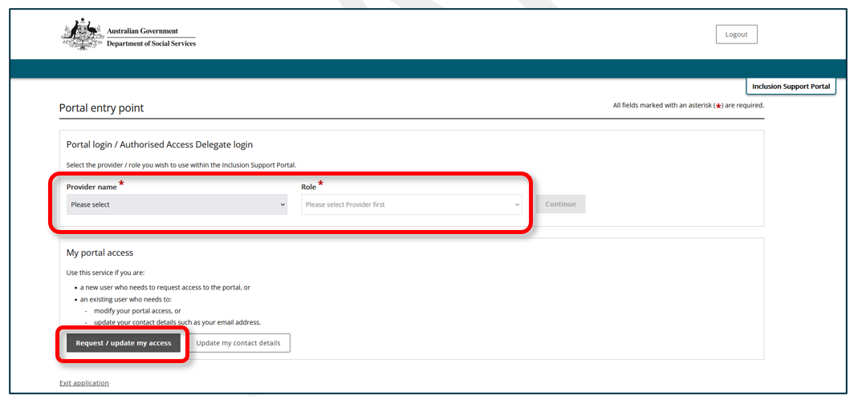

### How do I switch between the role of Authorised Access Delegate and SP ISS User?

There are two options to switch between user roles:

When on the Inclusion Support Portal click **change role/mange access** on the top righthand side of the screen.

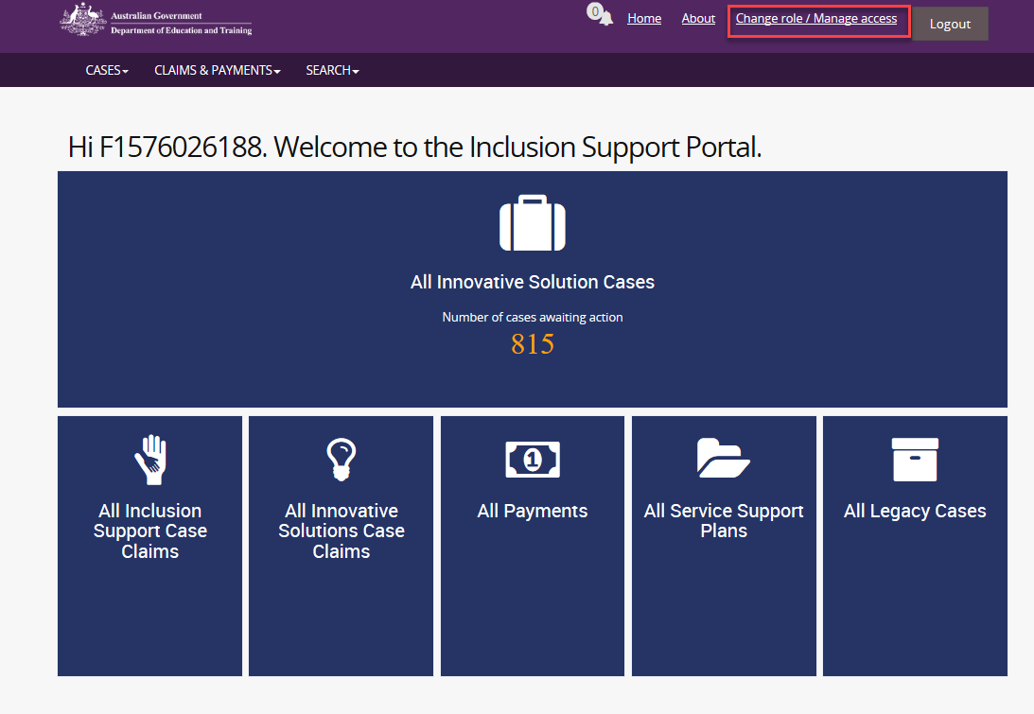

When logging in, on the Portal entry point page, select your **provider name** and required the screen.



### When completing my IS Portal access request, I cannot find the service provider I work for. What do I do?

Try searching by using one of the following options:

* Search by ABN ONLY
* Search by Postcode ONLY
* Or by ABN and Postcode together

**Note:** Do not complete all fields in the search as this will likely return no results

If you are still unable to locate your service, first contact your Inclusion Professional to confirm that status of the services Strategic Inclusion Plan (SIP) is in “Active” then, if required, contact the [IS Portal Helpdesk](mailto:inclusionsupportportalhelpdesk@education.gov.au).

### After submitting IS Portal access request for the first time, it says a verification email has been sent to me, but I did not receive one. What do I do?

Check your email inbox and junk folders for your verification email.

The possible reasons for not receiving the verification email may include:

* The system is experiencing and unexpected delay in sending the verification email.
* When requesting IS Portal access an incorrect or incomplete email address has been entered.
* Sometimes users have more than one personal email account; ensure that you are checking the inbox and junk folders for the correct email account.

If a verification email cannot be located, contact the [IS Portal Helpdesk](mailto:inclusionsupportportalhelpdesk@education.gov.au) for further support.

### I have had IS Portal access in the past but now when I log in, I don’t have access to any service (or a particular service). Why?

If you still require IS Portal access, you will need to submit a new IS Portal access request.

It seems that your IS Portal access has been revoked. Check with your services Authorised Access Delegate (if there is one) for details as to why.

### My request to access the IS Portal has been denied. Why?

There are several reasons why your request may have been denied”

* You lodged multiple requests for access.
* The name you provided when requesting access to the IS Portal is different to the name on your PRODA account.
* Your service’s Authorised Access Delegate has declined your request.

### Why did I receive notification that my access was approved and then subsequent notifications saying it was denied?

If you made multiple requests for access, in many cases your first request will be approved and then your subsequent requests will be denied avoiding errors occurring. **Please only make one request for access.**

Try accessing the IS Portal. If you are unable to login, email the [Inclusion Support Portal Helpdesk](mailto:inclusionsupportportalhelpdesk@education.gov.au) for assistance. You will need to provide the following information so that the issue can be investigated:

* your full name,
* the email address that you use for your IS Portal access,
* user role/s that you are requesting,
* your service name,
* your service CCS Approval ID (the number starts with 1900),
* Details of the issue you are experiencing e.g. “I receive notification that my access was approved and then subsequent notifications saying it was denied. I am unable to login to the IS Portal.”

### We have received a new CCS approval. Do we need to request new IS Portal access request?

Yes. Before proceeding with your IS Portal access request for the new service approval, please contact your Inclusion Agency to ensure a Strategic Inclusion Plan (SIP) has been created for the new service approval and the SIP is in a status of ‘Active’.

### I want to request IS Portal access but received a ‘Server Error’ message after entering the PRODA second step verification code. My PRODA username and password are correct as I can log in to my PRODA account. Where can I access help?

You can access help by emailing the [Inclusion Support Portal Helpdesk](mailto:inclusionsupportportalhelpdesk@education.gov.au). You will need to provide the following information so that the issue can be investigated.

* a screenshot of the ‘Server Error’ message,
* your full name,
* the email address that you want to use for your IS Portal access,
* user role/s that you are requesting,
* your service name,
* your service CCS Approval ID (the number starts with 1900).

Please note that some of these technical issues may take some time to resolve. You may wish to have other representatives of your service request access to the IS Portal if you continue to receive errors. This will allow your service to access the IS Portal while any technical difficulties are being resolved.

### I am experiencing technical issues with the IS Portal, what should I do first to troubleshoot?

#### Clear the cache

The IS Portal is a web-based application, and the user experience may be impacted through storing old and temporary internet files when using the application. Clearing the cache in your chosen web browser regularly will help the IS Portal to function as intended. Users can also set up their web browser to automatically clear their cache each time they close their browser.

Click on the relevant link below to find out how to clear the cache in your chosen browser:

* [Google Chrome](https://support.google.com/accounts/answer/32050?hl=en&co=GENIE.Platform%3DDesktop)
* [Microsoft edge](https://support.microsoft.com/en-us/search?query=edge%20clear%20cookies%20and%20cache)
* [Apple Safari – for Mac users](https://support.apple.com/en-au/guide/safari/sfri47acf5d6/mac)
* [Mozilla Firefox](https://support.mozilla.org/en-US/kb/how-clear-firefox-cache)

Please note that this is not an exhaustive list, alternate browsers options can be used.

#### ****IS Portal support****

Services can use the [Inclusion Support Contact form](https://employment.au1.qualtrics.com/jfe/form/SV_23Q5nmkEW1EBK29) located to request assistance with the following IS Portal related issues.

* Child Care Management Software (CCMS) Credentials - User Name and Password Request
* Rejected Claim for Payment
* Issue with CCMS usernames and/or password
* Remittance Advice
* Change Financial Email Address
* Request Approval for IS Portal access (Delegate Only)

#### ****IDFM help line information****

The IDFM help line 1800 824 955 is currently answered between 10 am and 4 pm eastern standard time. Phone messages will be returned as soon as possible. Alternatively, please email your query to the [IDFM](mailto:%20idfm@ku.com.au).

### What email address will the IS Portal use to communicate with our service?

All communication from the IS Portal will be sent to the email address listed in the Service Provider Details of the Strategic Inclusion Plan on the IS portal.

**If there is no email address listed the service will not receive Inclusion Development Fund approval letters or other important communications.**

To check and update the email address linked to the service, when logged into the IS Portal, click on the Manage SIP and Approvals and view the *Service Provider Details* 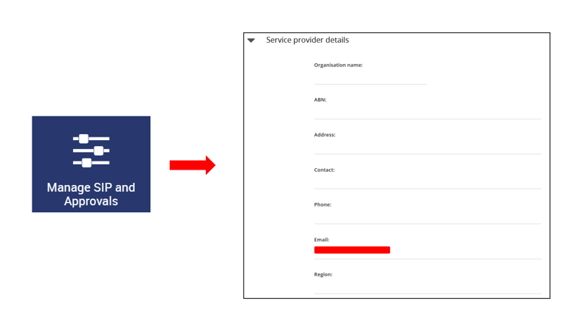

It is the responsibility of services to ensure the mailbox for this email address is managed appropriately to ensure alerts and advice about the Inclusion Support Program are read and where relevant, actioned, by the person responsible for managing the IS Portal on behalf of the service.

### What type of information will be emailed to my service from the IS Portal?

Information that will be emailed from the IS Portal will come from the following email address [isp_noreply@dss.gov.au](mailto:isp_noreply@dss.gov.au) and may include:

* Requests for additional information from the IA or IDF Manager about the SIP, IS Case or Innovative Solutions Case for the service’s action
* Notification of the outcome of all applications for the IDF
* Notice before an Approved IS Case has a status changed to ‘Inactive’ or ‘Withdrawn’
* Notice to acquit funding for Innovative Solutions Cases
* Notice when an IS Case is due for renewal
* Notice that a SIP yearly review is due to be completed
* Notice to remind services to claim their IDF support.

### Do users need access to the IS Portal to submit claims for Inclusion Support funding?

No, claims for Inclusion Support funding are submitted through the service’s third-party software.

### Further information

General Inclusion Support Program and Inclusion Support Portal information can be found on [Department of Education](https://www.education.gov.au/early-childhood/inclusion-support-program)  website.

Information of how to Register for an Individual PRODA Account can be accessed via the [PRODA](https://proda.humanservices.gov.au/pia/pages/public/registration/account/createAccount.jsf) website or the PRODA Helpdesk: 1800 700 199.

Use the [Inclusion Support contact form](https://employment.au1.qualtrics.com/jfe/form/SV_23Q5nmkEW1EBK29) for IS Portal access approval when there is no Authorised Access Delegate at the service.

For further assistance with the Inclusion Support Portal contact your [Inclusion Agency](https://www.education.gov.au/child-care-package/resources/inclusion-support-program-contact-details) or the [Inclusion Development Fund Manager.](https://idfm.org.au/contact-us)