

# How to Request IS Portal Access as an Inclusion Professional

**Before you start this process**: your PRODA account cannot be linked to a service provider. Ask for your IS Portal access to be revoked or contact [inclusionsupportprogramhelpdesk@education.gov.au](mailto:inclusionsupportprogramhelpdesk@education.gov.au) for assistance.

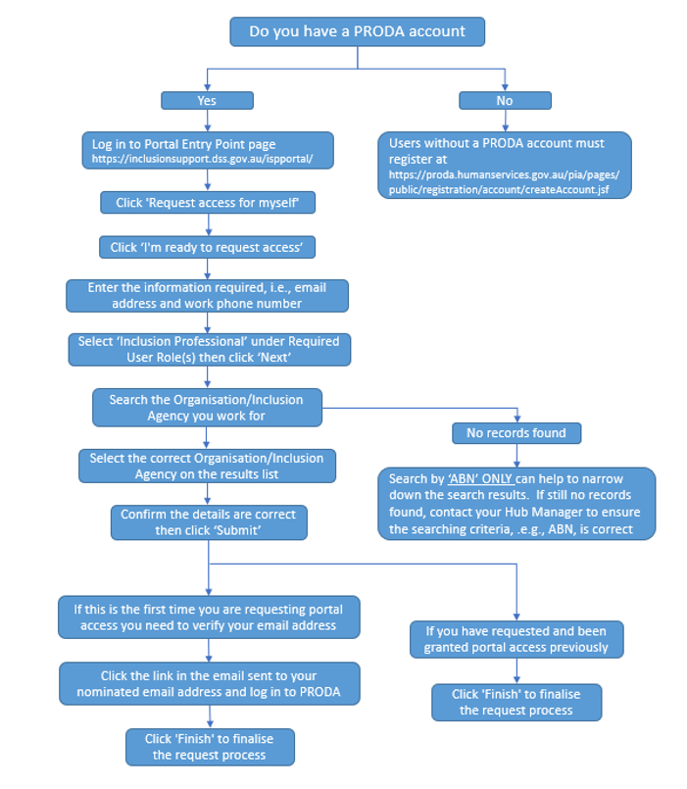

Clicking ‘Finish’ exits the IS Portal and takes you to the Inclusion Support Program website. It also sends email notification to the Inclusion Support Portal Help Desk to review your request. After your request is reviewed, you will receive another email telling you whether your request was approved or denied. If you do not receive a confirmation email or your request was denied, contact your Hub Manager or the Inclusion Support Portal Help Desk at [inclusionsupportportalhelpdesk@education.gov.au](mailto:inclusionsupportportalhelpdesk@education.gov.au)

**Note:** Individual Inclusion Agencies may have additional processes that need to be followed when requesting access to the IS Portal. Please check in with your Inclusion Agency Manager to confirm their requirements.