

# How to Request IS Portal Access as an Authorised Access Delegate

* 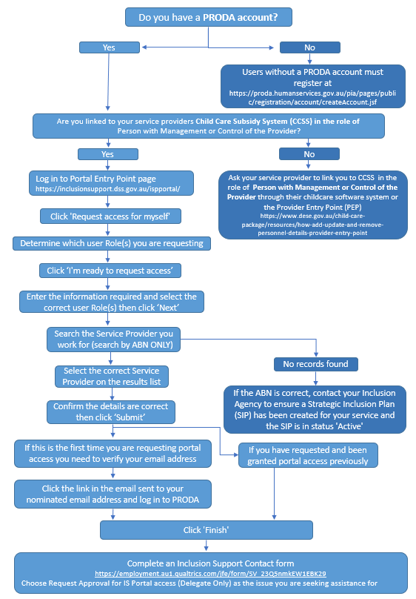When a service does not have anyone in this role or is unable to identify who they are.