


Final Report

Enhancing Cyber Security

Across Australia’s University Sector



Acknowledgement of Country
RMIT University acknowledges the people of the Woiwurrung and Boon wurrung language groups of the eastern Kulin Nations on whose
unceded lands we conduct the business of the University. RMIT University respectfully acknowledges their Ancestors and Elders, past and present.
RMIT also acknowledges the Traditional Custodians and their Ancestors of the lands and waters across Australia where we conduct our business.
Artwork: Luwaytini by Mark Cleaver, a proud Palawa person and RMIT Master of Human Resource Management student.
2



A message from the Project Lead

As Project Lead, it has been an honour to deliver this important piece of work on behalf of the entire university sector. This project formed part of the 2020 Australian Cyber Security Strategy and has national significance. I wish to express my gratitude for the support and continued guidance provided by the Department of Education (formerly the Department of Education, Skills and Employment - DESE) over the duration of this project. I also appreciate the collaborative approach that all university stakeholders, government departments and relevant observers brought in their engagement with this project.
Universities at their core are social institutions that operate in an open environment to educate, teach, research and share knowledge. They interact with all sectors of the Australian economy through their research and education activities and hold a vast amount of personal data with over 1.3 million students and 130,000 employees in Australian universities (ABS, 2021). Unique and complex, the sector remains a significant target for cyber criminals and foreign interference attacks.
Over the life of this two-year project, the sector experienced dynamic change. In 2020, the sector swiftly transitioned to online ways of teaching and operating as a result of COVID-19 and subsequent lockdowns. In 2021, the sector underwent legislative reform with the higher education sector being deemed critical infrastructure. And, in 2022 the sector has adapted to a rapidly changing cyber and foreign interference threat environment exacerbated by geopolitical factors.
While each university varies in size, maturity and level of exposure to cyber threats, there is a need to share and learn from one another and form a united interface with government against such threats. The Trusted Cyber Security Forums that formed part of this project allowed for these trusted conversations between university executives and government to take place, the sharing of knowledge on a range of cyber security areas, and building strong and meaningful partnerships.
A suite of cyber security resources in the form of handbooks, executive blueprints, an online tool and training programs were also developed by the RMIT project team and disseminated to the sector in August 2022. Depending on the needs of each university, they can download, utilise and implement the resources as appropriate for their community. It has been pleasing to see Australian universities utilise these resources.
As the project comes to a formal conclusion in December 2022, the community of practice formed through the Trusted Cyber Security Forums will remain. We look forward to building on the project’s success through new initiatives between the Australian government and the university sector.

Professor Matt Warren,

Director of the RMIT Centre of Cyber Security Research and Innovation, RMIT University

Project Team
Acknowledgement of Project Team
Project Team Member | Project Role
Professor Matthew Warren | Project Lead
Gabriela Cincotta | Senior Project Coordinator
Mary-Anne Mwendwa | Project Support Coordinator
Lee-Ann Phillips | Lead Education Designer
Dr Vindaya Senadheera | Research Fellow
Nikolaos Nikolopolous | Research Assistant
Dr Ansam Khraisat | Research Fellow
Dr Fida Hasan | Research Fellow
Meredith Jones | Research Assistant
Dr Ishan Senarathna | Research Fellow
Daniel Mannix | Research Assistant
Joan Tran | Graphics Assistant
Eshrar Osman | Research Assistant
Dr Anagi Gamachchi | Research Fellow
Dr Ruwan Nagahawatta | Research Assistant
Dr Suku Sukunesan | Education Designer
Lucy Ngo | Education Designer

The success of the Enhancing Cyber Security Across Australia’s University Sector Project would not have been possible without the support and assistance of many individuals and institutions.
We wish to thank the Department of Education, (formerly the Department of Education, Skills and Employment - DESE) for their constant guidance and support and for providing the required funds for this project. We are also appreciative of the efforts of the Project Lead Professor Matthew Warren; without his expertise the project would not have the relevance and significant importance to the university sector and higher education sector more broadly.
We would also like to express our gratitude to the project team, researchers, learning designers, and consultants associated with this project. Their contributions have made the achievements and milestones of this project possible.

Participants and Relevant Stakeholders
Our thanks and appreciation go to all 39 Australian public universities, various government bodies, and industry professional associations for their support, participation at events, and input and development of the resources that form part of this project.
In particular, we would like to thank the following departments, governing bodies and professional organisations who played an integral role in the success of the project:

- Australian Department of Education;
- Australian Cyber Security Centre;
- Australian Department of Home Affairs;
- University Foreign Interference Taskforce & Cyber Security Working Group;
- Universities Australia;
- CAUDIT.

4


Contents

Executive Summary 6
Project Overview 7
Project Impact 8
Deliverable 1 8
Deliverable 2 9
Impact Beyond the Project 9
Deliverable 1 10
Objectives 10
Insights 11
Participation Feedback on Deliverable 1 12
Challenges and Lessons Learned 13
Deliverable 2 14
Objectives 14
Challenges and Lessons Learned 16
Deployment of Resources to the University
Sector 17
Deployment Communication Strategy 18
Usage of SharePoint Resources 19
Highlights Early August to November 2022 19
Most Popular Resources 19
Insights 19
Sector Feedback on Cyber Security Training and Resources 21
External Evaluation 22
Evaluation Recommendations 22
Closing Comments and Future Outlook 24
Continuation of Trusted Cyber Security
Forums 24
Maintenance of Training Programs and Cyber Security Resources 24
Future Work Beyond 2024 24

5

6


The RMIT University’s Centre for Cyber Security Research and Innovation (CCSRI) was engaged by the Australian Government Department of Education to deliver the Enhancing Cyber Security Across Australia’s University Sector Project.

Executive Summary

Commencing in September 2020, the project aimed to create greater resilience within the Australian university sector in response to constantly evolving cyber security threats. Stemming from the COVID-19 global pandemic, cyber security has been an integral element of the university sector’s ability to respond to the threat of foreign interference. The project helped refocus the sector to adapt to the increased digital operating environments and built on the previous work of the University Foreign Interference Taskforce (UFIT) in developing the Guidelines to Counter Foreign Interference in the Australian University Sector (the Guidelines), published in November 2019.
The objectives of this project were to enhance the capability and resilience of the Australian university sector to evolving cyber security threats by creating mechanisms to share threat intelligence, develop common threat models, and enable a more coordinated and tailored response in collaboration with government.
It achieved this by: (i) establishing a Trusted Cyber Security Forum (TCSF) in which relevant issues can be discussed and shared, supporting peer-led improvement in information sharing and cyber security practices across the sector and with government; (ii) developing best practice guidelines and blueprints; and (iii) sharing threat intelligence and the development of threat models which help identify intractable or complex security problems. This contributed to developing tangible outcomes for the sector in the form of a suite of cyber security resources that can help to build robust nationwide capabilities in partnership with Australian universities.
The project required an agile approach due to the changing context surrounding the project, in particular, the introduction of the Security Legislation Amendment (Critical Infrastructure Protection) Act 2021 (SLACIP Act), the ACSC announcing the Critical Infrastructure Uplift Program (CI-UP) in April 2022, and the Work Order Variation issued by Department of Education in December 2021 that altered the project’s scope.
The project was evaluated by an independent agency and they concluded that for Deliverable 1 there was a strong perception amongst cyber security representatives and stakeholders of an ongoing need for a sector-specific forum for sharing targeted complex, high-value information relevant to enhancing cyber security in a counter foreign interference context. For Deliverable 2, the perception was shaped towards the immediate availability of high-quality and relevant materials that will almost certainly support an enhancement in the overall cyber security capability and resilience of the Australian university sector. It was observed that Deliverable 2’s materials will require ongoing updates to retain currency as the technological, threat, and regulatory environments continue to develop.
RMIT’s CCSRI is incredibly proud to have played such an important role in uplifting the Australian university sector’s cyber security capability through this project. Beyond the project end date of 31 December 2022, RMIT University will continue to deliver the Trusted Cyber Security Forums in 2023 and beyond in a virtual capacity. As the custodian of the suite of cyber security resources, RMIT University will also maintain and update cyber security training resources until December 2023. To maintain resources beyond 2023, and to build on existing tools and extend the reach of resources to the higher education sector more broadly, additional financial investment is required.


Project Overview

This project built on the previous work of the University Foreign Interference Taskforce (UFIT) in developing the Guidelines to Counter Foreign Interference in the Australian University Sector (the Guidelines), published in November 2019.

Commencing in September 2020, this project aimed to enhance the cyber security capability and resilience of the Australian university sector in the context of evolving cyber security threats and integrated with the broader response to foreign interference to the sector. Funded by the then Department of Education, Skills and Employment, (now recognised as the Department of Education), this project formed part of the 2020 Australian Cyber Security Strategy (Section 40), with support from the UFIT Cyber Security Working Group.

The purpose of this project was to enhance the capability and resilience of the Australian university sector to evolving cyber security threats by creating mechanisms to share threat intelligence, develop common threat models, and enable a more coordinated and tailored response in collaboration with government. The deliverables of the project are:

- Establishment of a trusted and nationally recognised cyber security forum (referred to as Deliverable 1 in this report);
- Development of sector-specific standardised threat and countermeasure sharing mechanisms to enhance capabilities and resilience to cyber contemporary threats, threat actors and responses to combat risks (referred to as Deliverable 2 in this report).

7
77
7

Project Impact

Deliverable 1

The aim of Deliverable 1 was to establish a trusted and nationally recognised cyber security forum that included the design, development and delivery of a sector-led, nationally recognised, and trusted forum to advance cyber-resilience, particularly in the context of foreign interference, across the university sector. One of the key elements involved in the set-up of the Trusted Cyber Security Forum (TCSF) was the development of a Forum Charter to set out the aims, vision, membership and outcomes of the trusted forum.
Driven by the goal of strengthening the security posture of the Australian university sector, the project facilitated trusted spaces for universities to engage with each other as well as with critical government departments.
The project empowered universities to learn and grow from each other, strengthening the sector holistically. The project developed a base for industry/university/government partnerships to help build robust cyber capabilities.











Highlights
All 39 universities attended the forums
Over 500 participants attended the forums
30 unique presenters across government, universities and industry who spoke on a range of cyber security topics
Strengthened relationship between ASD and the sector
Strong demand for forums to continue in the future
Forum Topics
UFIT Guidelines and foreign interference
Critical infrastructure policy reforms
ACSC Threat Report updates
eSafety & cyber security
Impact of cyber security on a university
Industry / association presentations
(Telstra, CAUDIT, Palo Alto)
ASIO ‘Think before you link’ campaign

Figure 1: Trusted Cyber Security Forum Highlights and Topics
8

Deliverable 2
This project was tasked with the creation and provision of resources (underpinned by extensive research) to the Australian university sector. These resources will enable universities to make the appropriate changes within their institution to protect their information, people, and assets and improve their cyber security capability. To assist universities with implementation, resources were developed for different target audiences: handbooks and the online tool were designed for technical IT / cyber staff, blueprints were designed for executives, and training modules had specific target audiences.
1
Resources Developed for the Project
The resources developed by this project are relevant and of significant importance to the university sector and higher education sector more broadly.
18
Reports
4
Handbooks
1
Online Tool
4
Training Programs
5
Executive Blueprints
10
Support Training Resources

Figure 2: Resources Developed for the Project

Blueprints - High level briefing documents for board members, executives and managers which focus on reporting requirements, best practice activities and threat intelligence.
Handbooks - Technical documents that provide IT professionals with information on existing cyber security training materials, as well as handbooks that describe different threat models.
Training - Training programs covering topics ranging from foreign interference, cyber security governance, cyber security for executives to cyber security basics for students. These courses are available to download in a range of formats to facilitate distribution to university staff and students through the institution's learning management system or via an intranet site.
Online Tool - The tool consists of a series of questions designed to determine the university's alignment with the Protective Security Policy Framework and the Information Security Manual. The tool assists in identifying areas where the university can improve its cyber security resilience.
These resources were updated as required from August to November 2022. An additional blueprint on Privacy Protection created in December 2022.

Impact Beyond the Project

Beyond the outputs of Deliverables 1 and 2 outlined above, this project has had a meaningful wider impact on cyber security in the university sector and the broader higher education sector. In addition to the project outputs, the project team:

- Delivered a cyber workshop as part of Universities Australia Foreign Interference Conference in 2021;
- Expanded reach through involvement with TEQSA;
- Engaged as the Chair of the TEQSA Cyber Security Advisory Board;
- Delivered a cyber security presentation at the TEQSA Conference in 2022;
- Delivered a presentation to the AHECS Committee on project outputs in March 2022;
- Shared resources with UFIT Training Steering Committee in September 2022;
- Presented resources at the CAUDIT Community of Practice in October 2022.
9

Deliverable 1
10

Objectives

Over the course of two years, RMIT University as part of the project, established a trusted and nationally recognised cyber security forum that included the design, development and delivery of a sector-led, nationally recognised, and trusted forum to advance cyber-resilience, particularly in the context of foreign interference, across the university sector. One of the key elements involved in the set-up of the Trusted Cyber Security Forum (TCSF) was the development of a Forum Charter which set out the aims, vision, membership and outcomes of the trusted forum.
Feature Event - Systems of National Significance Reforms
4th TCSF & Workshop
6th TCSF
Inaugural TCSF
Nov 2021
2nd TCSF & Workshop
3rd TCSF & Workshop
5th TCSF & Workshop
March 2022
June 2021
March 2021
June 2022
May 2021
Nov 2020

Figure 3: Timeline of Trusted Forum Activities Across Project Life

Across the span of the project, six Trusted Cyber Security Forums, four workshops and a feature event were delivered as part of the project. All 39 Australian public universities engaged and participated in the Trusted Cyber Security Forums, with over 500 attendees participating across the six forums.
These events involved over 30 different government, university sector and industry speakers talking on a variety of cyber security and foreign interference related topics. The breadth of topics included:

- ACSC’s Annual Threat Reports;
- ASIO Campaigns – Think Before You Link and The Nitro Portal;
- Reforms to the Critical Infrastructure Bill;
- Countering Foreign Interference;
- The UFIT Guidelines Refresh and Strategic Overview;
- University Cyber Security Baseline and Maturity Survey Results – CAUDIT;
- The ASD’s Cyber Threat Information Sharing (CTIS) Platform;
- Threats Facing the University Sector – Industry Perspectives;
- University Insights on the Impact of a Cyber Attack;
- Cyber Safety and the Responsibility of Universities;
- Enhancing Cyber Security Project Updates.

Figure 4 provides an overview of the respective government, university and industry representatives that presented at each Trusted Forum event.


June ‘22
Speakers from:
- ASIO
- The eSafety
011
Commissioner
- Palo Alto Networks
- Victoria State Government
06
Nov ‘20
Speakers from:
- ASIO
- ACSC
- Department of Education
- CSWG
- RMIT Project Lead
02
March ‘22
Speakers from:
- Department of Home Affairs
- Curtin University CISO
- CAUDIT
- Australian Signals Directorate
March ‘21
Speakers from:
- ACSC
- Department of Home Affairs
- CAUDIT
- RMIT University
05
Delivery of a sector-led, nationally recognised, and trusted forum to advance cyber- resilience, particularly in the context of foreign interference, across the university sector
03
Dec ‘22
Speakers from:
- Telstra
- Department of Home Affairs
- ACSC
- RMIT University CISO
04
May ‘21 Feature Event
An hour-long webinar with Department of Home Affairs focused on the Systems
of National Significance Reforms and the impact on the university sector.

June ‘21
Speakers from:

- TEQSA
- Department of Home Affairs
- CAUDIT
- ACSC

Figure 4: Trusted Cyber Security Forum Event Speakers

Insights

Across all project events (forums, workshops and feature events) there was a total of 509 attendees.
Of these attendees, 82% were representatives from the university sector, with the remaining 18% being made up of government and observers.

Event Attendance by Role
57%
CISO, CIO, Cyber
43%
Executives*
*Executives includes:
- Government and Observers;
- University VC, Council, DVC, Other;
- University CRO and Risk;
- University CFO, COO.

Figure 5: Attendance Breakdown by Role
11

Across all events, there was a total of 416 university representatives, with representation from all 39 Australian public universities at one or more events. Figure 6 reflects the attendance representation per state.
12

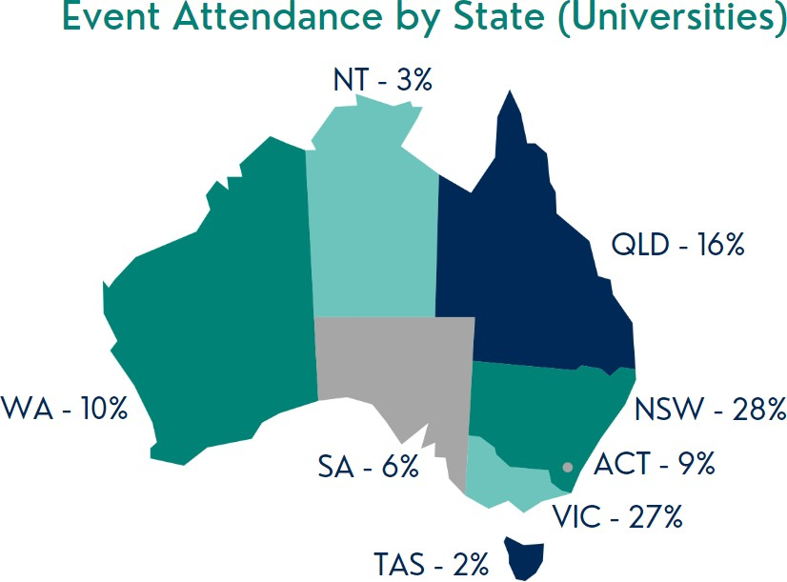

Figure 6: Reflection of University Participation by State

Participation Feedback on Deliverable 1
The following is a sample of the feedback received from participants who attended the Trusted Cyber Security Forum events.
Forum Participant
Forum Participant
These have been really useful events for learning what others are doing and thinking
- both from presenters but also through the questions asked.
Wide and relevant representation from Government. Online delivery ensured much wider representation of the uni sector than would have likely occurred in person.
Forum Participant
I strongly suggest continuation. Especially, collaboration among universities, government, with industry under the scoping of workshops and/or exchanging dialogs.
Figure 7: Participant Feedback on Deliverable 1


13

Challenges and Lessons Learned

- Delivery Location and Format - It was initially intended for the forums to take place in person in Canberra. However, due to COVID-19 travel restrictions, the first five forums were planned and delivered virtually using Microsoft Teams (November 2020 forum) and the Virtual Events Conference Platform. Despite plans for a hybrid event in June 2022, appetite for this delivery format was low, and as such delivered virtually.
- Audience - A challenge experienced across forums was attracting senior executives outside of those who hold a Cyber / CISO related role. Given the strategic and policy focus, the intent of the forums was also to attract those in Vice-Chancellor, Risk, Financial and Operating roles, however RMIT acknowledge that executives across all levels are limited by time capacity.
- Topics - With such a varying audience, selecting topics that suited everyone's needs and focus areas was a difficult task. Holistically, feedback suggests that the presentations were relevant, engaging and provided university representatives with the opportunity to connect with government. There was feedback that more specific and complex concepts on risk management, foreign interference and critical infrastructure reforms and implementation are valuable for the audience.

During the course of the forums, the audience’s cyber security maturity knowledge continued to expand over the two-year period, and as such requests for different topics were taken into consideration, but may not have always been able to be delivered (e.g. ACSC and the level of detail they could divulge at this forum due to classified information).
An adaptive approach was taken by RMIT University in the delivery of events, which included:

- Trialling hybrid in-person events, although moving back to online delivery due to low demand;
- Regularly seeking feedback from stakeholders on preference for delivery, topics and areas for improvement;
- Adjusting the event duration in June 2022, the workshop was discontinued and time duration of forum was reduced based on feedback.

Maintaining an adaptive approach will be imperative to the ongoing success of the Trusted Cyber Security Forums in the future.

Deliverable 2
14

Objectives

Deliverable 2 was very different in nature to the first deliverable. It was research and training focused, with a total of 24 resources made available to the university sector. The discovery research itself was the first of its kind in its applicability to uplift cyber security across the university sector, building on the 2019 and subsequent 2021 UFIT Guidelines to Counter Foreign Interference. It required the research to be adaptive to cyber threats, and a changing political and legislative landscape that occurred from 2020 to 2022.

To enhance the cyber capability and resilience of the Australian university sector, the research involved:

Investigating the university sector’s current capabilities to counter foreign interference through a surveys and historical analysis.


Examining existing mechanisms to receive and share threat intelligence, and connecting the sector to existing threat sharing mechanism platforms.


Developing threat models and mechanisms through the development of an online tool.


Developing a comprehensive suite of resources in line with government resources to assist universities with upskilling their entire community.


The 42 research project outputs were generated in the form of:

- 18 Project Reports;
- 4 Handbooks;
- 5 Executive Blueprints;
- 1 Online Tool;
- 4 Training Programs;
- 10 Supporting Training Resources (Blueprints).

Research was undertaken in consultation with the Department of Education, the Department of Home Affairs, and the Australian Cyber Security Centre. This was particularly important as the university sector was deemed critical infrastructure within the 2020-2022 period.
A total of 10 universities collaborated on the scope of the project deliverables as well as providing input and feedback on training resources for the sector, with those institutions ranging in size, maturity and geographical location. We thank the following institutions for their valuable contributions:

- The Australian National University (ACT);
- Macquarie University (NSW);
- Charles Darwin University (NT);
- Central Queensland University (QLD);
- James Cook University (QLD);
- The University of Queensland (QLD);
- The University of Adelaide (SA);
- RMIT University (CISO Office) (VIC);
- Monash University (VIC);
- Curtin University (WA).

15
As outlined in Table 1, the objectives, activities and outputs highlight the complex nature of this deliverable.

Objectives | Action/Activities | Outputs
Develop a standardised two-way mechanism amongst universities and government to share threat intelligence, countermeasure best  practice and threat models. | Implementation of integrating threat intelligence feeds within the sector, and between the sector, and ASD’s CTIS platform. | RMIT held workshops between the CTIS team and the sector to ensure sector needs could be adopted into the system.  RMIT also produced documents to explain threat modelling and develop IT professionals and executives to better understand and adopt different threat models. These documents were in the form of:  - 4 Reports;  - 2 Handbooks;  - 2 Blueprints.
Develop a standardised threat model for universities to assist in guiding investment and cyber security uplift. | - Assess capabilities across the sector.  - Identify critical gaps.  - Develop standardised threat models. | RMIT collaborated with CAUDIT to undertake a baseline and maturity survey of the university sector’s cyber security practices and posture.  Using these survey results, and further research from TEQSA compact documents, an analysis of cyber incidents was able to identify critical gaps.  With an understanding of the gaps, as well as government frameworks including the Essential Eight, Information Security Manual and Protective Security Policy Framework, the standardised threat model was established in the form of the Online Tool.  The below outputs were produced as a result of this work:  - 13 Reports;  - 1 Handbook;  - 1 Blueprint;  - 1 Online Tool.
Develop a comprehensive suite of sharable best practice guidelines or “blueprints” that draw from existing government risk information (e.g.  Essential Eight, Australian Information Security Manual, Practical Guidelines) that can be applied proportionate to each university’s level of risk. | Develop a comprehensive suite of sharable best practice guidelines. | Based on research and outputs from all project activities, a catalogue of resources was developed for the university sector.  These resources explained reporting requirements for executives, with the training programs covering cyber security and foreign interference, applicable for all audiences including executives, IT professionals, academics, risk and government staff, and students.  The outputs included:  - 1 Report;  - 1 Handbook;  - 2 Blueprints;  - 4 Training Programs;  - 10 Supporting Training Resources (Blueprints).

Table 1: Deliverable 2 Objectives, Activities and Outputs



Challenges and Lessons Learned

The aim of Deliverable 2 changed significantly during 2021 and was formally updated in December 2021 as part of the Work Order Variation. The reason behind the change was a result of several key factors, including:

- On 10 December 2020, the Minister for Home Affairs introduced the Security Legislation Amendment (Critical Infrastructure) Bill 2020 to Parliament. This bill proposed the introduction of the higher education sector as a critical infrastructure sector. This meant that aspects of this project were now in scope for the ACSC to undertake for the entire critical infrastructure sector.
- RMIT was conscious not to undertake activities that would be superseded. The activity to create a Cyber Threat Intelligence Sharing (CTIS) platform was already being undertaken by the Australian Signals Directorate (ASD)/ Australian Cyber Security Centre. To avoid duplicating efforts, the deliverable was rescoped to focus on how to best integrate the sector into the CTIS platform.
- In April 2022, the Australian Cyber Security Centre introduced the Critical Infrastructure Uplift Program (CI-UP), a new program that aims to create maturity models for the sector. Given the close proximity to the project deliverable due date of 30 June 2022, RMIT made note of the documents that would be superseded from this activity.

16
1616

17


Deployment of Resources to the University Sector
RMIT is the custodian of the suite of Deliverable 2 resources, and as part of the project was responsible for the appropriate dissemination of resources to the sector. RMIT will maintain these resources until December 2023.
All resources are housed in a secure RMIT SharePoint site, where the Enhancing Cyber Security Project team can monitor and share access with appropriate contacts at each respective university. The SharePoint site is secure, in that resources can only be accessed once email addresses have been verified, and the site allows for the ability to track and monitor usage from the university sector on individual resources. While hosting this information on an open source website may be an easy way to disseminate resources, it could be used by malicious actors, and the ability to track usage diminishes.
The main vehicle for providing the resources to the sector, the Enhancing Cyber Security Project SharePoint site, was completed by the project team in June 2022. The original intent was to share the resources with the sector in July, however the release was pushed back to early August to allow for other government departments to provide feedback.
The delay had minimal impact on the communication plan, with universities provided with access to the SharePoint site in early August. From August to November, a series of communications were sent to the university sector to promote, share and provide access to the cyber security resources.
The deployment communication plan can be seen in Figure 8 detailing the steps and timeframes for sharing these resources with the university sector.
17

Deployment Communication Strategy
Approach: Purpose: | Introduction of Resources to Sector  14 June 2022  Presentation of resources to university sector at Trusted Cyber Security Forum.  Inform sector of the resources developed.
Approach: Purpose: | Collecting University Contacts  Email 1: Confirmation of university key contacts/register interest. 26 July 2022  Communication with all university stakeholders who had engaged with the TCSF inviting them to nominate contacts at their university to be added to SharePoint site.
Approach: Purpose: | Notifying VC Offices of Resources 2 August 2022  Email 2: Vice-Chancellor (VC) communication about available resources.  Ensure VCs are aware of resources and request assistance in amplifying the message with their CISO teams.
Approach: Purpose: | Call to Action Reminder  Email 3: Universities to provide a contact to access resources. 4 August 2022  Reminder for key contacts at the universities who have not yet listed a contact, encouraging them to nominate a contact for the SharePoint site.
Approach: Purpose: | Facilitate Access to SharePoint  Email 4: Access to the SharePoint site for confirmed/nominated contacts. 4 August 2022  Provide access to and instructions on how to use the SharePoint site and resources.
Approach: Purpose: | Review SharePoint Access  22 August 2022  Email 5: Advise of new resource available in SharePoint.  Reminder to access the ECS Project SharePoint site and resources and advise of additional resource.
Approach: Purpose: | Collecting Feedback 14 September 2022  Email 6: Invitation to provide feedback.  Invite university stakeholders who have accessed and downloaded resources from the site to complete a feedback survey.



Figure 8: Communication Strategy for the Deployment of Cyber Security Resources to the University Sector
18

Usage of SharePoint Resources

Highlights: Early August to November 2022



32 universities accessed and utilised the resources on the SharePoint site
115 stakeholders provided with access to SharePoint site
83 stakeholders visited the Sharepoint site

19

Most Popular Resources

- Cyber Security for Executives Training Program.
- Guidelines to Counter Foreign Interference Training Program.
- Cyber Security Self Assessment (CSSA WP) Tool User Handbook.
- Existing Cyber Security Resources Handbook.
- Enhancing Cyber Security Awareness Training Program.

Insights

SharePoint Usage by University Role
60
CISO, CIO, Cyber
23
Executives*
*Executives includes:
- University VC, Council, DVC, Other;
- University CRO and Risk;
- University CFO, COO.

Figure 9: SharePoint Usage by Role

- The suite of resources allowed universities to utilise and download resources that are most relevant and useful to their institution, with some universities downloading a handful of resources, while others downloaded all resources.
- Resources targeting executives (i.e. blueprints and training programs) feature in the most popular resources, indicating a desire to educate on cyber security matters with a top-down approach.
- Technical documents in the form of threat modelling handbooks were also popular, indicating strong interest from those with an operational background.
- Strong interest in UFIT related resources demonstrates that there is a focus from universities to align with UFIT endorsed practices.

Below is a visual snapshot of the types of resources downloaded by universities in the July – November 2022 period.
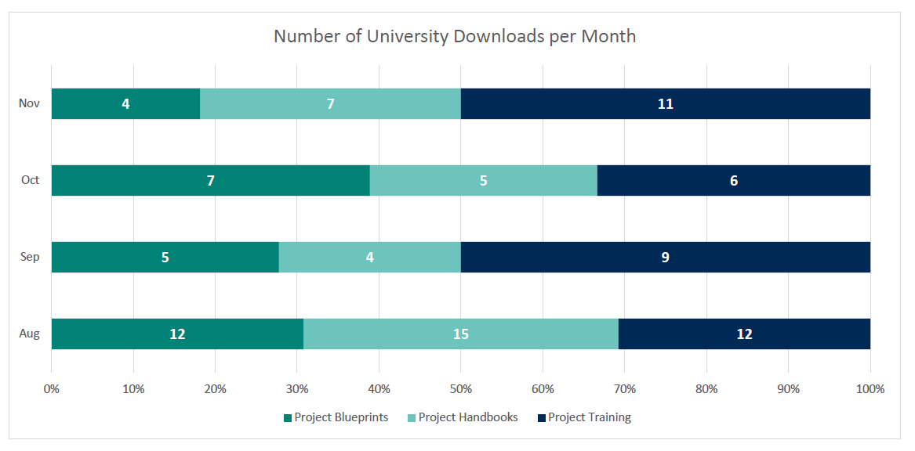
Figure 10: Monthly SharePoint Downloads
209

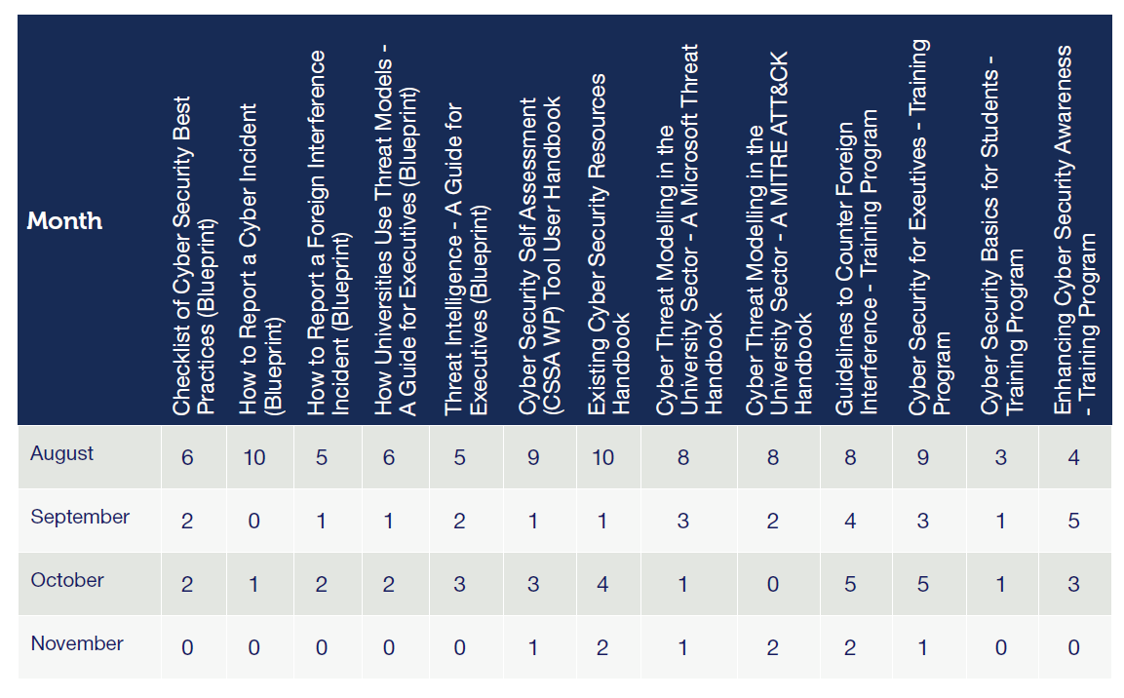

Table 2: Number of Universities that Downloaded per Month

Sector Feedback on Cyber Security Training and Resources
21

Feedback collated as part of the formal review / co-design of resources

I've finished making my way through the course and I just wanted to say how impressed I was with the material. It was extremely well presented, comprehensive in coverage, and led me to thinking deeply and reflecting on [University's] approach to CFI. Thank you again for the opportunity to review this.

It's clear a lot of work has gone into this. It felt polished and followed the same structure as the guidelines. I definitely
learned a few things while reviewing it and will probably go through it again at some point. I think the target audience is going to find this extremely useful.

This is a great piece of work and is going to be a massive help to getting FI awareness into the university.

Feedback more broadly captured from survey responses and usage of resources

Exceptionally helpful for both students and staff, the material is of a very high quality… we have incorporated the training into our executive stream.

We are using handbooks for IT staff and wider staff, executive blueprints for execs and council, the online tool for alignment with cyber awareness month, and training programs in our LMS for staff and students.

What other resources would help improve your university cyber security practices?

There is initial positive feedback from the sector about the training and resources. In the evaluation session with university stakeholders, there was discussion around the ongoing maintenance and upkeep of the materials to ensure their longevity. While there are education designers on board to assist with university feedback and deployment of resources, it will also be useful to take into consideration any plans on how this can be maintained in the future.

Some handbook info on "Critical Infrastructure and the Security Legislation Amendment Critical Infrastructure Protection Act".

I would love to see handbooks around some of the CISO and university documentation, such as policy and strategy. Blueprints on insider threat material would be very handy.

External Evaluation
22
An independent assessment of the Enhancing Cyber Security Across Australia’s University Sector Project was undertaken by an external consulting company from July to September 2022.
The assessment involved a detailed review and evaluation of the project’s documented materials, followed by targeted information collection through interviews with key stakeholders and subject matter experts.
Over the course of the review, the consulting company interviewed 15 representatives from the Australian university sector, peak representative bodies, industry, and the Department of Education, with an emphasis on providing a holistic analysis and evaluation of the project’s deliverables to inform their report.
A review of the project materials and governance reporting demonstrated that RMIT satisfied the governance framework outlined in the project plan in a professional manner. RMIT leveraged the clear roles, responsibilities, and accountabilities defined by the Department of Education to provide a positive reporting function centred on the project’s progress, accounting, milestone events, and governance.
Below is a summary of the recommendations from the evaluation for each deliverable.

Evaluation Recommendations

Deliverable 1:

The TCSF demonstrated its value to the Australian university sector as a trusted and nationally recognised peak forum. Stakeholders provided a broad range of feedback towards its conduct; however, almost no feedback questioned either its purpose or ongoing value to the sector.
From this review, a number of recommendations have been collated to inform any future initiatives or similar projects:

- Organising and hosting the TCSF is a complex task amongst a sector with specific but diverse needs. Dedicated professional staff who are able to bridge academia, CISOs’ operational environments, and key Australian government agencies and industry would prove valuable towards its ongoing role.
- Risk management emerged as an important element of Australian universities’ cyber security, broader counter foreign interference efforts, and SoCI awareness. Incorporation of tailored and targeted risk management presentations into future events would represent a practical and valuable activity for universities.
- CISOs and cyber security professionals maintain a high level of current knowledge and understanding towards general cyber security matters, and leverage other forums. Any future TCSF should focus on complex, sector-specific cyber security topics and themes related to foreign interference and critical infrastructure. Examples could include emerging topics and initiatives related to the Australian government, case studies from peer organisations, international examples, Defence and the Defence Industry Security Program, and managing dual use technology-related research.
- Continuation of the partnership with the ACSC and ASD should be a standing component of any future TCSF.
- Future TCSF events should be shorter in duration and less frequent to provide higher value, specifically targeted knowledge sharing. Events should be a maximum of one day’s duration, with half-day events with accompanying networking sessions likely representing the ideal duration.
- Online feature events of approximately one hour’s duration are popular, valuable mechanisms for maintaining engagement across the TCSF’s members.
- A strong feedback mechanism is essential to enable TCSF members to influence future events’ topics to meet their needs as a sector.
- Key representatives and experts in cyber security within the Australian university sector have distinct knowledge and information requirements as compared to senior executives and other roles. Whilst some targeted information will provide common value for both groups, targeting presentations and topics to suit each group will provide better value for their respective needs and responsibilities.
- Inclusion of presentations by representatives of international universities implementing their respective counter foreign interference and critical infrastructure frameworks is likely to provide valuable exposure for the Australian university sector.


23

Deliverable 2:

A review of the materials and feedback provided by stakeholders demonstrated that Deliverable 2 satisfied the project requirements and its performance was noteworthy. However, feedback also identified that the relevance and utility of the resources developed is dependent on their regular update synchronised with changes to the cyber and foreign interference threat environment, technological development, and the legislative frameworks governing counter foreign interference and critical infrastructure in Australia. Such updates are beyond the scope of the project and this review.
From this review, a number of recommendations have been collated to inform any future initiatives or similar projects:

- Review and update of the Deliverable 2’s content commensurate with the rate of change of that particular topic area is necessary to ensure that the resources retain currency.
- While the Cyber Security Self Assessment Working Prototype (CSSA WP) tool will be an aid for users to evaluate and address their cyber security capabilities, it could also be a tool for gathering data from across the sector. The user responses will provide data and highlight key areas where there are gaps in the cyber security strategy. Specific areas where maturity levels are lacking or areas where the maturity is quite high could be identifiable through this data, and could then be used to prioritise efforts across Australian universities.
- Availability of the resources to Australian university sector-aligned organisations (e.g. the Group of 8 or Universities Australia) supports the sector’s interest and development.
- Collecting direct feedback from a selection of users on the useability, applicability, usefulness, and other aspects of the resources could aid in any future updates or reviews.

In summary, using combined analysis, this review found that the CCSRI satisfied the requirements of the Project Plan and Work Order Variation. This was despite the significant disruptive pressures over the duration of the project, and rapid pace of change in environment influencing cyber security at Australian universities.
The observations regarding each deliverable were complex, with a broad range of conclusions and recommendations made. The most apparent for Deliverable 1 is a strong perception amongst cyber security representatives and stakeholders of an ongoing need for a sector-specific forum for sharing targeted complex, high-value information relevant to enhancing cyber security in a counter foreign interference context. For Deliverable 2, the perception is shaped towards the immediate availability of high quality and relevant materials that will almost certainly support an enhancement in the cyber security capability and resilience of the Australian university sector. Deliverable 2’s materials will require ongoing updates to retain currency as the technological, threat, and regulatory environments continue to develop.
The solutions developed for both deliverables reflected positively on the performance of RMIT University’s CCSRI and its staff. It is also important to note that the project’s solutions for both deliverables were consistent with the requirements of the Guidelines at all stages. Project governance and reporting satisfied the Department of Education’s requirements.

Closing Comments and Future Outlook
RMIT’s CCSRI is incredibly proud to have played such an important role in uplifting the Australian university sector’s cyber security capability through this project. As part of the 2020 Australian Cyber Security Strategy, this project had national significance and involved a truly collaborative approach between government and the university sector.
Through the Trusted Cyber Security Forums, a community of practice was developed between university sector and government, to share knowledge on important strategic cyber security topics and legislative reforms. These virtual events allowed for all universities, of varying sizes, maturities, and locations to contribute and participate in a trusted environment.
The suite of cyber security resources were specifically tailored for the university sector, allowing universities the flexibility to choose the resources most relevant for their institution. The resources were made available in a range of formats and securely housed in an RMIT University SharePoint site to ensure appropriate access. These resources will provide immediate value to a range of stakeholders at universities, including executives, technical staff, professional and academic staff as well as students.

Continuation of Trusted Cyber Security Forums

RMIT is pleased to continue delivering Trusted Cyber Security Forums virtually in 2023 and beyond. This continuation is based on overwhelming feedback from university and government stakeholders.
Topics for future forums will look to include:

- Presentations on reforms to the Privacy Act;
- Presentations from ACSC on the new Critical Infrastructure Uplift Program (CI-UP);
- Presentations from ASIO and Counter Foreign Interference Coordination Centre (CFICC) to discuss foreign interference and espionage;
- A presentation on the impact and roll out of the Enhancing Cyber Security Project;
- Presentation from the Critical Technologies Policy Coordination Office discussing their function.

Maintenance of Training Programs and Cyber Security Resources

The extensive suite of cyber security resources are currently static resources. From January – December 2023, RMIT will ensure these resources are updated to reflect any changes to legislation and cyber security best practices. However, beyond 2023, financial investment is required to ensure that these resources remain current.

Future Work Beyond 2024

Online Tool Development
With increasing cyber attacks within the university sector, the need for institutions to assess their maturity levels has intensified, and there is strong interest in guidance on what is required to ensure compliance. The Online Tool is a working prototype and in November 2022 the tool underwent an update to reflect changes to the Information Security Manual and Protective Security Policy Framework. Future financial investment would be required to make this an ongoing, functional tool that universities can continue to use into the future.

Translating the Resources to the Higher Education Sector More Broadly
Many of the resources developed for the university sector hold relevance for the higher education sector more broadly (TAFE, and privately owned Registered Training Organisations). This presents an opportunity to adapt the resources created in this project to the higher education sector, so that they too can benefit from the value of resources. This too would require investment, but with far reaching impact for the entire higher education sector.

24



The Enhancing Cyber Security Project created positive impact for the entire university sector, and was made possible through the collaborative approach between universities and government departments. Cyber security will continue to be of paramount importance to the university sector and Australia more broadly, and it is imperative for such projects and initiatives to continue through funding and investment.

25
25







Connect with us

By email
ccsri@rmit.edu.au

Website
rmit.edu.au/cyber

