



Australian Universities Accord

Discussion Paper: February 2023

Title

Creative Commons

With the exception of the Commonwealth Coat of Arms, the Department’s logo, any material protected by a trade mark and where otherwise noted all material presented in this document is provided under a [Creative Commons Attribution 4.0 International](https://creativecommons.org/licenses/by/4.0/) (https://creativecommons.org/licenses/by/4.0/) licence.

The details of the relevant licence conditions are available on the Creative Commons website (accessible using the links provided) as is the full legal code for the [CC BY 4.0 International](https://creativecommons.org/licenses/by/4.0/legalcode) (https://creativecommons.org/licenses/by/4.0/legalcode)

The document must be attributed as the Australian Universities Accord Discussion Paper: February 2023.

Contents

Chair’s Foreword 4

1 Introduction: the role of higher education in Australia’s future 5

1.1 Purpose of the review 5

1.2 Consultation and engagement 6

1.3 The nature and purpose of Australian higher education 6

2 Challenges and opportunities for Australia 9

2.1 Population and community structure 9

2.2 Impact of new and emerging technologies 9

2.3 Equality, participation and democracy 9

2.4 International engagement, global security and geopolitical competition 10

2.5 Sustainability, environmental challenges and biosecurity 10

2.6 Economic transformation, changing jobs, industries and capabilities 11

3 Challenges and opportunities for the higher education system 12

3.1 Quality teaching delivering quality learning 12

3.2 Meeting Australia’s knowledge and skills needs 12

3.3 Connection between the vocational education and training and higher education systems 18

3.4 A system that delivers new knowledge, innovation and capability 20

3.5 Creating opportunity for all Australians 23

3.6 Governance, accountability and community 26

3.7 Quality and sustainability 29

3.8 The role of international education 32

3.9 Investment and affordability 33

4 Conclusion 37

References 38

Appendix A - Review terms of reference 41

Purpose of the review 41

Key areas for review 41

Consultation 42

# Chair’s Foreword

Australia’s ambitions, aspirations and potential are all intimately linked to its higher education sector.

Higher education prepares and inspires us to continue to press forward and emboldens us to meet the challenges heading our way. It delivers endless, intangible benefits to the nation, far beyond any individual qualification or job it provides.

The Australian Universities Accord process provides a unique opportunity to capture the abilities and achievements of the sector, and to re-imagine it for the future over a 10, 20 and 30-year horizon.

The Panel has been set an ambitious task, and our Terms of Reference for the review are broad and bold.

However, this process is bigger than the Panel. It involves the sector, all levels of government, industry, students, staff, graduates and the community. It needs you. You can help us to provide advice on delivery of an Accord for the higher education system that supports a dynamic approach to higher education policy making for the betterment of the nation.

We need all stakeholders to be a part of our review and respond to this discussion paper. Submissions can be made on the [Accord website](https://www.education.gov.au/australian-universities-accord).

We are asking *big* questions: What kind of higher education system does Australia need in two and three decades’ time? What actions and solutions are needed now, to address the major changes underway in our society, economy and environment? How can we ensure all Australians have the opportunity to participate in higher education?

And we are asking *many* questions. We recognise that some people will focus on one and others will respond to all. Whatever form your submission takes, be bold. Think big and think beyond the immediate challenges, and help us articulate the role the higher education sector should play in Australia’s development, what the system should look like in 30 years’ time, and how we get there.

Mary O’Kane

# Introduction: the role of higher education in Australia’s future

## Purpose of the review

The Australian Government is working to establish an Australian Universities Accord to drive lasting alignment between Australia’s high quality higher education system and national needs. The Accord is a way to develop a shared, long-term commitment among the stakeholders in Australian higher education, and improve the way they work together to address major challenges and opportunities, thus strengthening the system over time.

Accords bring people together to discuss challenges and agree a joint path forward. In higher education this could mean a continuous dynamic partnership involving Government (with bipartisan support), higher education providers and their students and staff, businesses, unions and community leaders to agree on the best way that higher education can meet Australia’s economic, cultural and social aspirations. The Accord could aim, for example, to increase equity of opportunity, meet future skills needs and deliver high quality research that is useful to communities, industry and governments. The Accord will enable these aspirations to be continually developed over time as the needs of our nation change.

The Minister for Education, the Hon Jason Clare MP, has appointed a panel (the Panel) to make recommendations for Government, the sector, and other relevant stakeholders about delivery of a higher education system that meets the nation’s current and future needs.

The Panel has been asked to explore all aspects of the higher education system, and to be bold in recommendations that will enable the system to meet Australia’s priorities and needs, now and in the future.

The task includes identifying achievement targets for the future system and making recommendations on how an Accord process should be structured and focused to achieve effective change, build stronger working relationships across the system, and strengthen the system’s ability to meet future challenges.

The Terms of Reference for the review address seven main themes:

* Meeting Australia’s knowledge and skills needs, now and in the future
* Access and opportunity
* Investment and affordability
* Governance, accountability and community
* The connection between the vocational education and training (VET) and the higher education systems
* Quality and sustainability
* Delivering new knowledge, innovation and capability.

The full Terms of Reference are included in Appendix A.

## Consultation and engagement

Wide-ranging consultation and engagement are essential for the review and for the long-term success of the Accord.

Following establishment in November 2022, the Panel has already undertaken many discussions with stakeholders, experts and sector leaders, and received over 180 submissions and 1,900 survey responses to the consultation request on the Terms of Reference.

All these are being considered carefully and will be reflected in the analysis and priorities put forward by the Panel.

This discussion paper invites input on the kind of higher education system Australia needs in two and three decades’ time, and the actions and solutions that are needed to achieve this as well as to address immediate challenges.

In providing this input, the Australian community is asked to consider the context of the current standing and quality of Australian institutions and the major changes under way in our society, economy and environment.

In June the Panel will provide an interim report to the Minister. It will articulate priorities and directions for the system, and present options for how to make those priorities a reality to create enduring reforms for the long-term benefit of Australian higher education and the Australian community. The report will provide an opportunity to test the possible direction of the Panel’s final recommendations, using evidence and analysis about the current operations of and future options for the higher education system.

After the interim report is released, the Panel will undertake further consultation to refine its observations, explore the grounds for consensus and prioritise recommendations for the final report.

As mandated in the Terms of Reference, the Panel will submit its final report in December 2023.

## The nature and purpose of Australian higher education

A priority for the Panel is to explore the fundamental role of higher education in contemporary Australia. This includes how, through education and research and engagement in the community, Australia’s higher education providers (universities, university colleges and institutes of higher education) underpin and contribute to the intellectual, cultural, community and economic development of the nation.

Australian higher education providers are diverse, autonomous institutions. They create public good in varied, wide-ranging ways and they are accountable in different ways to the public interest, to the community and to governments. Variously, they perform different combinations of education, research and engagement with the community, industry and business.

Many providers have deep roots in their communities, and a strong commitment to serving the changing needs of those communities, often with a specific mission, ethos or focus.

They are funded by governments as well as by students, industry and community partners, and their own entrepreneurial activities. They are regulated via federal legislation. Universities, in general, are established by Acts of Parliament in their home State or Territory (except the Australian National University established under Commonwealth legislation).

These institutions play a crucial role in Australia’s intellectual, economic and social development. As such, they are required to engage with the evolving opportunities and demands of a changing society. The part played by different providers varies according to many factors, including historical context, mission, location, size, character, type and international profile. For example, regional universities have missions closely tied to their location and the needs and aspirations of their local community.

The Accord needs to address how providers can deliver most effectively to achieve national priorities and imperatives, including for skills and industry development, equity of access and opportunity, solving complex societal problems, and powering innovation.

Australian higher education providers together educate more than 1.6 million students per year, including almost 440,000 students who come from overseas. In 2021 there were 1.1 million undergraduate students (870,000 domestic and 250,000 international), 420,000 postgraduate coursework students (250,000 domestic and 170,000 international) and 65,000 higher degree by research students (42,000 domestic and 23,000 international).[1]

In 2021, over 40% of 19-year-old Australians enrolled in higher education. The percentage of the Australian population aged 25 to 34 who are educated to bachelor level or above is now 44.6%, compared to 12% in 1989.[2] The target set by the Bradley Review of Australian Higher Education for 40% higher education attainment has been met.[3]

Higher education is a big national research and development (R&D) contributor, collectively carrying out over a third of the nation’s research.[4]

In 2020, Australia was the third most popular study destination for international students, after the United States (US) and the United Kingdom (UK).[5] International students are integral to higher education’s contribution to Australian society, bringing significant economic, cultural and community benefits. Australia attracts students from over 190 countries, and this collective diversity and knowledge feeds into our education institutions, workplaces and communities.[6]

Higher education contributes to sovereign capability through the development of advanced expertise, critical technologies and ensuring strong cultures of scholarship and critical enquiry. In recent years this contribution has been brought back into focus by the growth of geopolitical tension and challenges to globalisation, the experience of the global pandemic, the risks of cyberattack and unauthorised surveillance, and concern about foreign interference and sovereign risk.

The consequences of the pandemic have also increased challenges of financial sustainability for higher education, focusing longstanding questions about the role of public funding and investments, the sources of income for different providers, the contribution to national objectives and community needs, and how these can be sustainably funded in the years ahead as the higher education system responds to further growth in participation, attainment and impact.

As the system confronts these challenges and opportunities, its evolution may include examining the specialised focus and reach of different institutions, the mix of face to face and online or remote activity, and the different combinations of learning opportunities, teaching, research, community partnership and innovation delivered by different providers and combinations of providers.

These challenges require us to ask how the system could evolve over time, whether the current institutional structures, regulation, governance, funding, and outcome measurements are right for the future, and how they could be changed to serve the needs of the Australian community better.

The Panel has been asked to make recommendations for new targets and reforms, to address Australia’s needs now and into the future, and to deliver a system that is fit for purpose.

This task includes proposing a new long-term target for Australia’s rates of higher education participation and attainment.

The current measure of bachelor degree attainment for people aged 25 to 34 is above the average for OECD countries (41.5% in 2021), but lags behind the highest achieving countries such as the Netherlands (54.3%), Switzerland (52.3%) and the UK (51.2%). This is despite increases in graduate numbers over the past two decades.[7]

Figure : Proportion of population aged 25-34 years with a bachelor degree or higher qualification, 2021 (%)

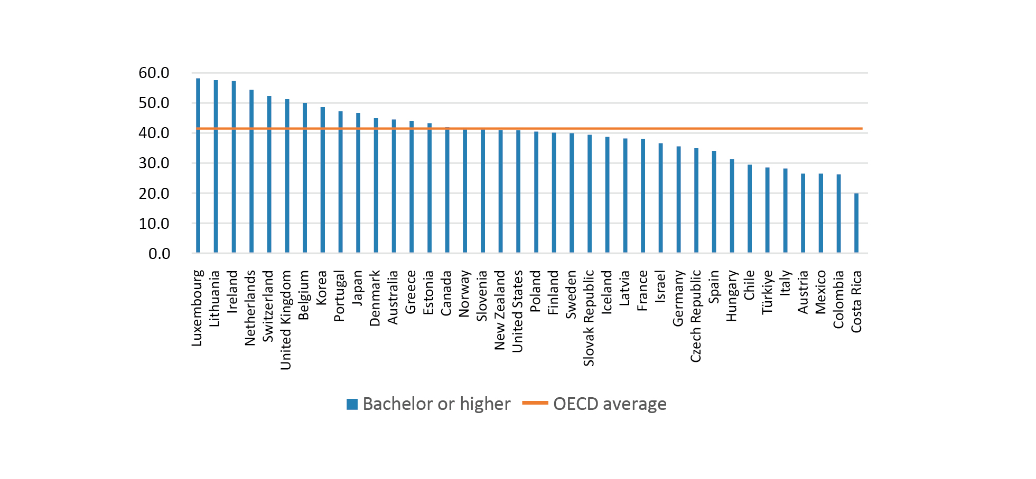

Source: OECD 2021.

Q1 How should an Accord be structured and focused to meet the challenges facing Australia’s higher education system? What is needed to overcome limitations in the current approach to Australian higher education?

Q2 How can the diverse missions of Australian higher education providers be supported, taking into account their different operating contexts and communities they serve (for example regional universities)?

Q3 What should the long-term target/s be for Australia’s higher education attainment by 2030 and 2040, and how should these be set and adjusted over time?

# Challenges and opportunities for Australia

Australia has experienced rapid and complex change in its economy, society and environment over the past few decades. Disruption and change will continue, presenting challenges and opportunities for Australian higher education over the next 10, 20 and 30 years.

## Population and community structure

Australia’s population is growing, projected to reach 29.9 million by 2033.[8] As of 2021, 28% of Australians were born overseas, from a wide range of countries. The top five countries of birth are England, India, China, New Zealand and the Philippines.[9] The Panel notes that diversity is a strength, with migrants to Australia bringing significant economic and social benefits.[10]

Australia’s rural, regional, urban and suburban population mix is changing, with rapid population growth in outer suburban communities, major cities becoming denser and more diverse, and regional communities developing rapidly.[11]

Supporting an ageing population will require many more people working and gaining skills in personal care, including in specialist fields such as health, disability and aged care, and a more highly skilled workforce overall to drive productivity gains to maintain economic prosperity.

Meeting the demand for jobs, skills and talent will require Australia to lift the number of people with higher levels of knowledge and skills dramatically. These people will necessarily come from a wider range of backgrounds, including those who have been historically under-represented in higher education.

## Impact of new and emerging technologies

Technological advancement is reshaping the way the higher education sector organises itself and contributes to economic and community development. For example, the transformation of Australia’s energy system creates huge demand for skills, knowledge and technological solutions.

At the same time, artificial intelligence (AI) and automated complex systems are developing rapidly and are increasingly integrated into activities across every part of the economy including higher education. Changing technologies create new demands and possibilities for research, innovation and entrepreneurship, as well as new ways to design and deliver learning experiences and educational services, all bringing fresh challenges and opportunities for higher education providers.

A national commitment to the broad development of a knowledge economy can broaden Australia’s industrial base away from traditional reliance on export of minerals and fossil fuels, which accounted for over half of total exports in 2019-20.[12] It can also reduce economic risks from climate change-related events and geopolitical shocks, or from reduced demand in key markets.

## Equality, participation and democracy

Australia, like many nations around the world, also faces challenges of inequality and participation in democracy and civil society. Strengthening the place of First Nations people, knowledges and culture in Australia’s national life, and reducing the inequalities and marginalisation that reduce the wellbeing and opportunity of First Nations Australians, is fundamental to our national agenda. The commitment of the Australian Government to enshrining an Aboriginal and Torres Strait Islander Voice to Parliament in the Constitution provides a new opportunity for First Nations-led development and expansion of culturally inclusive approaches to education and research. A major challenge is to ensure that the benefits of higher education are shared by all Australians, regardless of their background. First Nations Australians, people with disability, people from regional, rural and remote areas, and people from low socioeconomic status (low SES) backgrounds remain substantially under-represented. Many previous reviews have set targets to increase access and participation but, while some progress has been made, they have not been met. These include the Bradley Review recommendation that by 2020, 20% of undergraduate level enrolments should be people from low SES backgrounds. In addition, the Review of Higher Education Access and Outcomes for Aboriginal and Torres Strait Islander People (Behrendt Review) recommended a parity goal for First Nations student enrolments.[13]

## International engagement, global security and geopolitical competition

Higher education is deeply entwined with Australia’s international engagement. For example, Asia now accounts for nearly two-thirds of our total two-way trade. International education was Australia’s fourth most valuable export in 2019-20, bringing hundreds of thousands of international students to study with Australian providers both onshore and offshore.[14]

The region’s own higher education systems and research landscape are developing rapidly, with seven Chinese universities in the global top 100.[15] Growth in Asian universities, and their growing research dominance, brings new competition for universities as well as opportunities for new partnerships.[16]

Engagement through higher education can help Australia to build our reputation as a contributor to peace and sustainable prosperity, and to promote Australia as an attractive destination for people, business and investment. International education also provides a platform from which we can elevate our broader engagement, developing personal networks in neighbouring countries.

At the same time, Australia is constantly responding to a complex array of national security threats. Foreign interference and cyberattacks are examples of why our institutions and defence and intelligence operations need to be constantly vigilant.

## Sustainability, environmental challenges and biosecurity

Sustainability is an urgent priority across Australian society and the world, reflecting the need to reduce emissions and develop and adapt to new energy sources, and requiring new skills across the workforce.

As Australia is a large, dry continent, responding to climate change is a multifaceted challenge which will shape Australia’s ability to maintain economic and social progress. Our country and our region are vulnerable to climate extremes and consequent severe bushfires, record floods and rising sea levels.

Australia needs the expertise, innovation and combined impact of higher education providers to help lead efforts to ameliorate and collectively adapt to climate change and the development of more resilient and sustainable solutions. Our exports and energy sources are also moving over time to more sustainable and renewable options. Higher education providers are looked to as leaders, educators and exemplars in making these changes.

## Economic transformation, changing jobs, industries and capabilities

Across every sector of Australia’s economy, the mix of knowledge, skills and technologies used to develop and deliver products and services is changing rapidly. Preparing the workforce to meet the changing needs of industry and contribute to a more innovative, productive economy is a major challenge for higher education.

The higher education system must meet existing skills shortages, whilst emerging industries and challenges demand new and flexible capabilities in new disciplines and advanced research skills. Australia’s higher education system has proven that it can adapt to (and in some cases be at the leading edge of) new disciplines, both in teaching and learning and in research.

Higher education is not alone in addressing the skills challenge. There’s an important role for VET and a need to bring these systems closer together to ensure people completing study in both systems have the right skills for our future needs.

Q4 Looking from now to 2030 and 2040, what major national challenges and opportunities should Australian higher education be focused on meeting?

Q5 How do the current structures of institutions, regulation and funding in higher education help or hinder Australia’s ability to meet these challenges? What needs to change?

Q6 What are the best ways to achieve and sustain future growth in Australian higher education, given the changing needs of the population and the current pressures on public funding?

Q7 How should the mix of providers evolve, considering the size and location of existing institutions and the future needs of communities?

# Challenges and opportunities for the higher education system

## Quality teaching delivering quality learning

Learning is at the centre of Australia’s higher education system. A quality learning environment should provide students with the knowledge they need for interesting and satisfying careers; a consistent and certifiable skillset; and a supportive and formative experience. This requires institutions to have knowledge and skills in planning and implementing authentic teaching and learning experiences, supporting students, and assessing and monitoring outcomes with a focus on student success.

It also requires quality teachers who can inspire students throughout their lives and encourage a commitment to lifelong learning. It requires innovative teaching models and modes of delivery that are tailored to students’ preferred modes of learning and cultural backgrounds. And it requires resources that are constantly informed by new developments in educational practice and research. Strength in higher education teaching is a critical element in ensuring strength in the sector as a whole.

It is also crucial that the skills students learn in higher education are applicable and useful for the jobs they will hold in the future.

Q8 What reforms are needed to promote a quality learning environment and to ensure graduates are entering the labour market with the skills and knowledge they need?

## Meeting Australia’s knowledge and skills needs

Jobs and Skills Australia projects that, from 2021 to 2026, more than 90% of new jobs will require post-school qualifications.[17] This includes over 50% requiring bachelor degree or higher qualifications.

A big shift is needed in Australia’s approach to developing workforce skills and capabilities, and both higher education and vocational education must contribute. Figure 2 shows that an increasing share of future jobs will require the highest level of skills, with a decreasing share at all other skill levels.

Figure : Changes in the skill requirement of occupations 2000-2026 (%)[18]

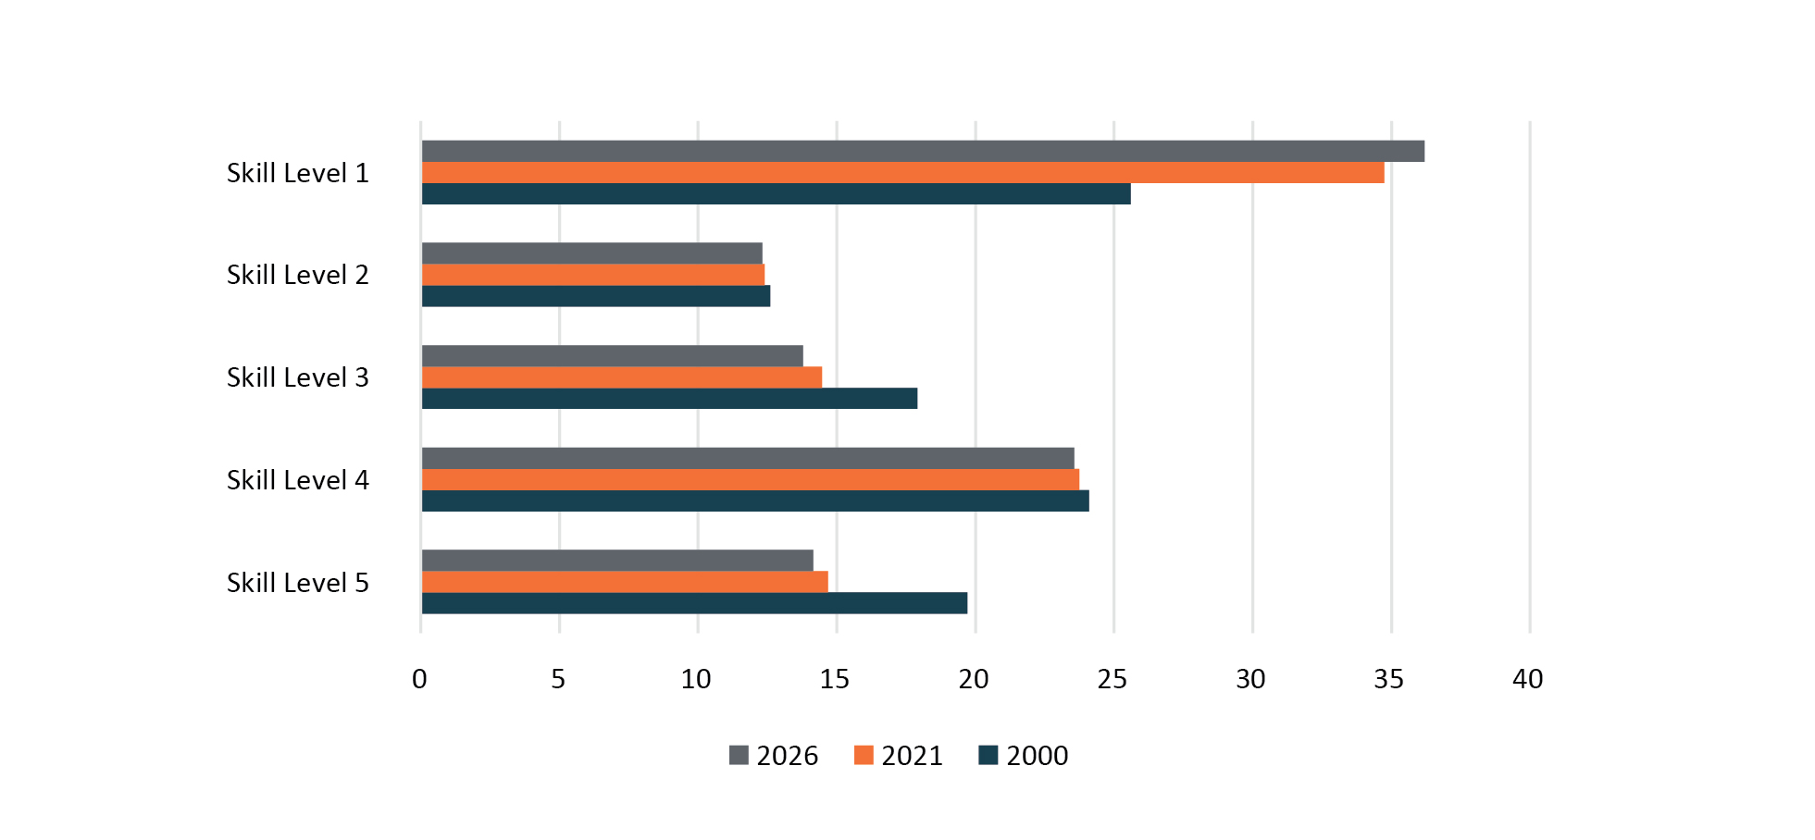

Sources: National Skills Commission 2021b; National Skills Commission 2021c.

Meeting demand for knowledge and skills over the next 10 to 20 years will require many more people to gain the knowledge and skills associated with higher education. As new jobs and industries emerge, new mixes of knowledge, skills and capabilities will be required. While deep technical and vocational skills and professions are always needed, high quality, generic skills including communication, collaboration, problem-solving, critical thinking and digital literacy are also key to success in life and work.[19]

### Meeting skills needs through higher education

A key question for Australian higher education providers is how to respond to the various employer and entrepreneurial needs across the labour force. There is also a role for Australia’s migration and VET systems in answering this question, and the three elements need to work together.

Universities currently offer a comprehensive range of disciplines and pathways across most major fields of employment, with some variation in the percentage of students in different disciplines between institutions. This contrasts, for example, with smaller institutes of higher education that are generally specialised, with focused effort on teaching in particular disciplines (Table 1).[20]

Table : Share of enrolment by university and broad field of education, 2021[21]

| **Institution** | **Agriculture Environmental and Related Studies** | **Architecture and Building** | **Creative Arts** | **Education** | **Engineering and Related Technologies** | **Health** | **Information Technology** | **Management and Commerce** | **Natural and Physical Sciences** | **Society and Culture** |
| --- | --- | --- | --- | --- | --- | --- | --- | --- | --- | --- |
| Australian Catholic University | 0.03% | 0.00% | 1.95% | 23.74% | 0.26% | 39.85% | 0.67% | 4.39% | 7.01% | 22.09% |
| Bond University | 0.22% | 3.49% | 2.93% | 0.94% | 0.19% | 45.40% | 1.56% | 12.12% | 5.72% | 27.44% |
| Charles Darwin University | 0.51% | 0.69% | 6.96% | 13.77% | 2.34% | 34.64% | 3.52% | 2.84% | 12.71% | 22.02% |
| Charles Sturt University | 4.79% | 0.05% | 2.82% | 15.04% | 0.48% | 21.51% | 3.23% | 5.63% | 10.40% | 36.04% |
| CQUniversity | 0.99% | 1.16% | 5.26% | 12.13% | 5.47% | 33.77% | 2.79% | 9.16% | 14.80% | 14.47% |
| Curtin University | 0.67% | 4.92% | 10.21% | 12.16% | 7.11% | 20.76% | 3.50% | 12.72% | 13.24% | 14.70% |
| Deakin University | 1.41% | 2.10% | 5.77% | 8.49% | 2.22% | 17.34% | 5.02% | 12.53% | 12.41% | 32.70% |
| Edith Cowan University | 0.50% | 0.02% | 8.72% | 30.09% | 2.44% | 23.10% | 5.80% | 6.92% | 7.15% | 15.25% |
| Federation University Australia | 1.16% | 0.00% | 4.47% | 18.51% | 2.65% | 32.17% | 3.72% | 7.36% | 11.59% | 18.36% |
| Flinders University | 0.31% | 0.00% | 6.56% | 8.62% | 3.81% | 32.38% | 2.36% | 4.85% | 15.27% | 25.85% |
| Griffith University | 0.87% | 1.20% | 10.73% | 8.02% | 3.62% | 15.50% | 2.68% | 14.09% | 13.58% | 29.70% |
| James Cook University | 0.79% | 0.33% | 1.90% | 6.94% | 3.33% | 43.71% | 3.71% | 6.30% | 17.19% | 15.81% |
| La Trobe University | 2.94% | 0.12% | 2.50% | 8.97% | 1.19% | 35.29% | 3.49% | 8.88% | 13.67% | 22.93% |
| Macquarie University | 0.99% | 0.16% | 5.06% | 6.72% | 2.06% | 4.88% | 6.31% | 20.27% | 12.86% | 40.69% |
| Monash University | 0.73% | 1.33% | 4.55% | 6.06% | 6.26% | 16.11% | 4.45% | 10.98% | 20.24% | 29.29% |
| Murdoch University | 2.44% | 0.12% | 4.58% | 10.27% | 1.80% | 15.66% | 4.40% | 4.75% | 19.09% | 36.89% |
| Queensland University of Technology | 0.51% | 4.55% | 9.91% | 8.12% | 7.44% | 14.00% | 7.43% | 15.30% | 10.60% | 22.15% |
| RMIT University | 1.00% | 6.83% | 14.22% | 2.37% | 13.43% | 6.83% | 8.38% | 18.27% | 10.86% | 17.79% |
| Southern Cross University | 2.21% | 0.07% | 7.50% | 13.68% | 1.40% | 21.74% | 1.35% | 11.58% | 17.78% | 22.70% |
| Swinburne University of Technology | 0.00% | 1.14% | 16.70% | 17.95% | 10.13% | 3.91% | 7.81% | 14.84% | 7.16% | 20.36% |
| The Australian National University | 2.85% | 0.00% | 4.09% | 0.05% | 3.99% | 5.13% | 5.00% | 5.69% | 17.86% | 55.35% |
| The University of Adelaide | 2.75% | 1.31% | 6.45% | 2.26% | 8.81% | 19.93% | 4.24% | 8.98% | 17.74% | 27.53% |
| The University of Melbourne | 3.27% | 3.42% | 10.36% | 6.16% | 3.92% | 14.94% | 3.15% | 10.33% | 17.18% | 27.26% |
| The University of New England | 3.54% | 0.81% | 3.79% | 17.82% | 0.24% | 8.04% | 1.96% | 7.22% | 15.86% | 40.71% |
| The University of Newcastle | 1.52% | 5.23% | 5.50% | 12.30% | 6.46% | 22.71% | 1.71% | 6.65% | 16.37% | 21.54% |
| The University of Notre Dame Australia | 0.35% | 0.17% | 3.30% | 21.27% | 0.00% | 33.86% | 0.00% | 5.91% | 6.99% | 28.14% |
| The University of Queensland | 3.70% | 1.32% | 4.10% | 3.17% | 9.61% | 20.52% | 2.86% | 8.55% | 20.28% | 25.89% |
| The University of Sydney | 1.13% | 2.30% | 6.95% | 4.69% | 7.33% | 23.60% | 3.47% | 8.76% | 14.97% | 26.81% |
| The University of Western Australia | 1.50% | 2.22% | 4.70% | 2.55% | 7.23% | 14.33% | 3.46% | 12.62% | 22.61% | 28.77% |
| Torrens University Australia | 0.00% | 4.08% | 30.57% | 2.47% | 0.00% | 28.37% | 1.23% | 29.19% | 0.56% | 3.53% |
| University of Canberra | 0.80% | 4.46% | 12.62% | 10.74% | 1.44% | 17.28% | 6.39% | 10.90% | 14.31% | 21.07% |
| University of Divinity | 0.00% | 0.00% | 0.00% | 0.00% | 0.00% | 0.00% | 0.00% | 0.00% | 0.00% | 100.00% |
| University of New South Wales | 0.78% | 4.46% | 7.81% | 2.29% | 14.31% | 8.01% | 9.05% | 14.36% | 19.44% | 19.50% |
| University of South Australia | 0.33% | 4.76% | 9.77% | 11.06% | 4.32% | 21.22% | 5.13% | 14.04% | 10.92% | 18.46% |
| University of Southern Queensland | 0.70% | 0.34% | 7.00% | 18.92% | 10.63% | 17.89% | 4.01% | 8.60% | 12.49% | 19.43% |
| University of Tasmania | 3.88% | 1.53% | 8.82% | 10.02% | 3.31% | 33.22% | 1.72% | 4.21% | 13.07% | 20.22% |
| University of Technology Sydney | 0.53% | 4.17% | 11.01% | 2.16% | 14.02% | 10.72% | 7.03% | 19.87% | 15.64% | 14.85% |
| University of the Sunshine Coast | 2.68% | 0.35% | 12.80% | 10.22% | 2.05% | 24.43% | 2.80% | 7.26% | 17.52% | 19.90% |
| University of Wollongong | 0.57% | 0.00% | 7.93% | 10.37% | 6.40% | 14.57% | 4.32% | 11.66% | 15.84% | 28.33% |
| Victoria University | 1.04% | 2.69% | 1.98% | 13.72% | 3.44% | 23.75% | 1.93% | 7.62% | 11.05% | 32.79% |
| Western Sydney University | 0.75% | 2.53% | 5.23% | 5.81% | 7.78% | 20.02% | 3.02% | 10.88% | 13.32% | 30.66% |
| Batchelor Institute of Indigenous Tertiary Education | 0.00% | 0.00% | 0.00% | 0.00% | 0.00% | 0.00% | 0.00% | 0.00% | 0.00% | 100.00% |
| **Total** | **1.4%** | **2.2%** | **7.4%** | **9.1%** | **5.8%** | **19.2%** | **4.3%** | **11.1%** | **14.1%** | **25.4%** |

Source: Department of Education 2021b.

Meeting the changing demand for skills, knowledge and capabilities across Australia’s workforce may need a very different mix of courses, pathways and enrolments across the tertiary education system.

The Panel has heard mixed feedback on the merits of offering incentives to people to undertake study in areas of skills need. Specific initiatives like varying student contributions for different subjects, HELP debt reductions, scholarships, offering a supplemental living allowance through an income contingent loan arrangement, guarantees for job placement, career advice and skills forecasting have all been raised. There is also concern about the risks of prioritising specific technical skills over general capabilities that are highly enduring and transferable.

Concurrently, there is a call for higher education to work more directly with industry, the professions and other cross-sector partners to ensure that the courses, knowledge and skills that students develop are better aligned with the changing capabilities and skills needed across the workforce.

Q9 How should Australia ensure enough students are studying courses that align with the changing needs of the economy and society?

Q10 What role should higher education play in helping to develop high quality general learning capabilities across all age groups and industries?

### Increasing demand from future students

Meeting a new attainment target will require more people to participate in higher education. In recent years, the number of applications from school leavers has decreased.[22] The number of people applying to study in higher education has further slowed since 2021,[23] as prospective students choose to take up opportunities for jobs in a strong labour market. It is expected there will be a significant increase in the number of school leavers over the next decade, due to the baby boom of 2005-2008.[24] Encouraging these students to take up higher education will be crucial to meeting a new target.

Efforts are needed to promote the opportunities of higher education, to rebuild post-school transitions and to attract a broad mix of students of all ages. However, this will require consideration of admissions practices and student engagement and the cost of investing in education to support a wider cohort of students, along with greater clarity about the relationship between senior secondary, vocational education and higher education pathways.

### Ensuring adequate provision

The implementation of demand-driven funding for universities over 2012-2017 resulted in a significant expansion in Commonwealth supported enrolments in bachelor level courses.[25] However, growth in Commonwealth Grant Scheme (CGS) funding has been limited since this time, although the Job-ready Graduates (JRG) package has provided some funding for growth since 2021.

How to target funding to ensure that Commonwealth supported places (CSPs) are provided in areas of skills priority also needs to be considered. The JRG changes targeted growth in funding to support universities to increase the number of CSPs they offer each year, but this funding is tied to universities and not aligned with growth in student demand or expansion in some critical fields.[26] It has also been pointed out that CGS subsidies do not meet the real cost of providing places or ensure that the costs of increased enrolments and maintaining continued quality are sufficiently funded.

See section 3.9.3 for a specific discussion of the JRG package.

Q11 How should Australia boost demand from people to study in the higher education system?

Q12 How should an adequate supply of CSPs be sustained and funded, as population and demand increase?

### Collaboration with industry

By international standards, the current links in Australia between higher education and industry in learning and teaching are under-developed.[27] There is scope to enhance engagement with industry to improve the quality of the curriculum, enhance the student experience, increase opportunities for work placements and improve employment outcomes. This should be viewed in the context of supporting continued lifelong learning.

Work-integrated learning (WIL) enables students to apply knowledge they gain in the classroom to practical settings, thereby growing industry-relevant experience and giving employers access to highly skilled, career-ready graduates.

While there are opportunities to expand the current scale and form of WIL placements, engaging a wider range of employers and creating high quality experiences that provide better-aligned skills is a challenge. There may be opportunities to expand the use of placements, internships and other forms of WIL, in particular into fields and occupations where this is less common, such as the not-for-profit sector. The availability of work placement opportunities on scale could be improved, including both formal WIL undertaken for course credit or broader work experience. WIL can be a particular problem for students from regional, rural and remote areas.

Major limitations on increasing enrolments in many fields, notably health care and teaching, include the inability to guarantee placements for each student enrolled in a course, and the stringent or rigid requirements for accreditation in certain fields.

Q13 How could an Accord support cooperation between providers, accreditation bodies, government and industry to ensure graduates have relevant skills for the workforce?

Q14 How should placement arrangements and work-integrated learning in higher education change in the decades ahead?

### Lifelong Learning

Within Australia, formal study is largely undertaken by young people (85% of domestic enrolments in 2021 were people aged less than 35).[28] To increase the numbers of people with higher education qualifications, more people will need to be encouraged to enrol and re-enrol in higher education later in life. Lifelong learning can take many forms: from enrolling in microcredentials and short courses, to studying a diploma or bachelor degree, to taking up postgraduate study or undertaking a PhD, to ‘reverse articulation’ upskilling with VET qualifications.

Lifelong learning can help to ensure that workforce skills are up to date and that jobs in high demand can be filled, as well as enabling people to create new job opportunities through innovation. Shorter forms of learning may be particularly helpful to enable people to respond rapidly to changes in the labour market, and meet skills needs in real time. The Panel has heard microcredentials are likely to be increasingly in demand, particularly those that are industry led; map against the Australian Skills Classification;[29] and can directly and quickly address skills needs.

Encouraging and enabling lifelong learning will require funding, credit and regulatory changes – for example, through recognition of prior learning or work experience or options for students to ‘stack’ or combine qualifications, including microcredentials, between different institutions (including overseas institutions) and across the higher education and VET sectors.

Q15 What changes are needed to grow a culture of lifelong learning in Australia?

Q16What practical barriers are inhibiting lifelong learning, and how can they be fixed?

## Connection between the vocational education and training and higher education systems

Higher education connects with a broader post-secondary education system, alongside the VET system. Historically, higher education providers have focused on advanced-level knowledge and research, while VET providers generally focused on vocationally oriented and applied knowledge and skills.

While the two systems have different approaches to learning, as well as different funding and regulation settings, they are becoming increasingly intertwined. In consultations the Panel has heard that there is increasing overlap in relation to diplomas and advanced diplomas. This reinforces the need for a non-hierarchical and flexibly applied qualifications framework that encourages recognition of credit and prior learning, as identified by the Review of the Australian Qualifications Framework (AQF).[30]

Over the last two decades, innovation and growth in both systems has led to increasing interactions and overlaps. The Commonwealth and the states and territories are working on a range of skills and VET reform initiatives to boost participation in areas of demand, strengthen public TAFE systems, and create stronger connections with industry and higher education.

### Strengthened tertiary system

Australia’s long-term needs for knowledge, skills and workforce development require a stronger, more coherent relationship between the two systems. Many stakeholders, including within the sector and business groups, have raised the need for a strengthened tertiary system as a key area for reform.

The Panel has heard there are immediate opportunities to leverage the strengths of the two sectors. A focus on building the connection in occupations that span both VET and higher education qualifications, integrating digital platforms, and leveraging existing initiatives such as the newly created Jobs and Skills Australia, could be early steps towards a more harmonised system. Harmonisation could deliver a student-centred approach, where graduates with a range of applicable skills are empowered to enter the workforce, yet also remain in lifelong learning across the tertiary education system. Understanding what these immediate opportunities are, and practical solutions to implement them, will be crucial.

Both systems are vital to meeting Australia’s skills needs, and both offer students a pathway to meaningful careers and strong employment outcomes. How to enable them to work more effectively together, with parity of esteem and collaboration across governments, providers and industry partners, remains a complex challenge.

Q17 How should better alignment and connection across Australia’s tertiary education system be achieved?

Q18 What role should reform of the AQF play in creating this alignment?

Q19 What would a more effective and collaborative national governance approach to tertiary education look like?

### Pathways for students

Pathways between the VET and higher education systems (including discipline-specific formalised systems for recognition of prior learning) need improvement. In 2021 30,000 domestic students commenced a bachelor degree on the basis of a VET qualification.[31] The largest enrolments were in Nursing (20% of VET entry students) and Teacher Education (14%).

These pathways are important as they help to support lifelong learning and can support enhanced access to higher education for students from under-represented groups. First Nations, low-SES and female students more commonly use VET to higher education pathways. In 2021 19% of First Nations commencing bachelor students were admitted to a bachelor degree on the basis of a VET qualification compared to 11% of non-First Nations students; females were 13% compared to 9% for males; and low SES were 15% compared to 13% for medium SES and 8% for high SES. However, pathways of this nature are limited by the under-representation of students from the above groups in higher level VET qualifications (Cert IV and above),[32] which universities largely require in their admissions policies.

The pathway between VET and higher education is not one directional. Some students also choose to enrol in VET after completing a higher education qualification. In 2021 there were 265,390 students undertaking a VET qualification whose previous highest qualification was at the bachelor degree/higher degree level.[33]

In consultations to date, the Panel has heard concerns from industry and students that navigating the pathway between the two systems is complicated. Getting this pathway right is a crucial element of our review.

Dual sector universities have had some success in linking the two sectors, admitting a higher than average proportion of bachelor students on the basis of a VET qualification (24% average against a sector average of 12%), though regionally-headquartered universities also have a higher than average VET-entry rate (20% average, noting three are also dual sector).[34]

These institutions are also prominent in establishing linked qualification pathways, which may include formalised arrangements for credit.[35] However, they still grapple with the difficulties of operating in two systems.[36] More needs to be done to break down barriers to cross-system collaboration, and to spread successful examples of linkages with VET across the higher education system.

Q20 How can pathways between VET and higher education be improved, and how can students be helped to navigate these pathways?

Q21 How can current examples of successful linkages between VET and higher education be integrated across the tertiary education system?

Q22 What role do tertiary entrance and admissions systems play in matching learners to pathways and supporting a sustained increase in participation and tertiary success?

## A system that delivers new knowledge, innovation and capability

For Australia to increase its world-leading new knowledge, innovation and capability, what would need to change?

Higher education is key to research and innovation in Australia. The current university research system is high quality: two-thirds of Australian university research output is assessed by the Australian Research Council (ARC) as being above or well above world standard.[37] Expenditure on research carried out in universities totalled $12.7 billion in 2020,[38] with approximately half coming from general university funds. And Australian universities account for 36% of the nation’s research and development (R&D) expenditure, high by OECD norms.[39] The university sector also does the underpinning work for Australia’s innovation and R&D systems, training PhD students, carrying out the bulk of basic and strategic basic research,[40] and producing most of our scientific publications.[41]

However, in terms of international innovation rankings such as the Global Innovation Index, Australia has for many years scored poorly compared to OECD peers, with Australia ranking 37th in knowledge and technology outputs, behind such countries as Switzerland (1st), the US (3rd), the UK (8th) and Japan (11th).[42] While Australia, ranking 19th, has reasonable innovation inputs (stable business and legal systems, good education and research systems), it fails to translate these into high impact innovation outputs (new processes, products and services).

### Collaborating to a purpose – solving big challenges

University research, when leveraged effectively, can help to spur innovation by adding knowledge, talent and technical infrastructure to solve practical challenges and create new ways of doing things.

Collaboration between institutions and across disciplinary boundaries is often one of the best ways to achieve research breakthroughs.

Australian universities are skilled at building effective research collaborations to achieve high impact results. These are often assisted by various government programs supporting collaboration such as the ARC Centres of Excellence Program and other research collaboration programs.

Australian universities are also strong international collaborators: 61% of Australian scholarly publications involved an international co-author in 2022, higher than the EU (46%) and the US (39%).[43] This foundation can help to open doors and create opportunities, both for Australian expertise to solve problems around the world and for sharing innovative ideas from our neighbours to test and develop within the Australian system.

While universities are good at collaborating with other research organisations, an ongoing, multi-decadal question in Australia is why the links and collaboration between industry and universities are not stronger and more productive. There are several examples of excellent collaboration, especially where formal research brokering bodies (AMIRA Global, research and development corporations, etc) are active. But the synergies between industry and universities are not extensive, despite long-running grant programs such as the ARC Linkage grants and programs which incentivise collaboration such as the Cooperative Research Centres program, and the growing focus on universities as anchor tenants of innovation precincts around Australia with the intended role of fostering entrepreneurship, job creation and innovation ecosystems.

Q23 How should an Accord help Australia increase collaboration between industry, government and universities to solve big challenges?

Q24 What reforms will enable Australian research institutions to achieve excellence, scale and impact in particular fields?

### Investment in types of research

Basic research is crucial to Australia’s capacity to solve wicked problems and develop new technology that advances knowledge in the national interest and contributes to long term, sustainable growth. Expenditure in pure basic and strategic basic research needs to be complemented by applied research and experimental development to produce new products and services that are market ready.

Australia is fortunate to have a high concentration of investment in pure basic and strategic basic research. Expenditure in these areas is high (22%) compared to countries like Israel (10%), Japan (13%) and the US (15%)[44] which have higher concentrations of investment in applied research and experimental development. Most expenditure in basic research is by the higher education sector, while business expenditure, which is more focused on applied research and experimental development, is relatively low by international comparisons. Is this a problem? Or is it that universities should do more experimental development and applied research?

Figure : Type of research activity by source of spending

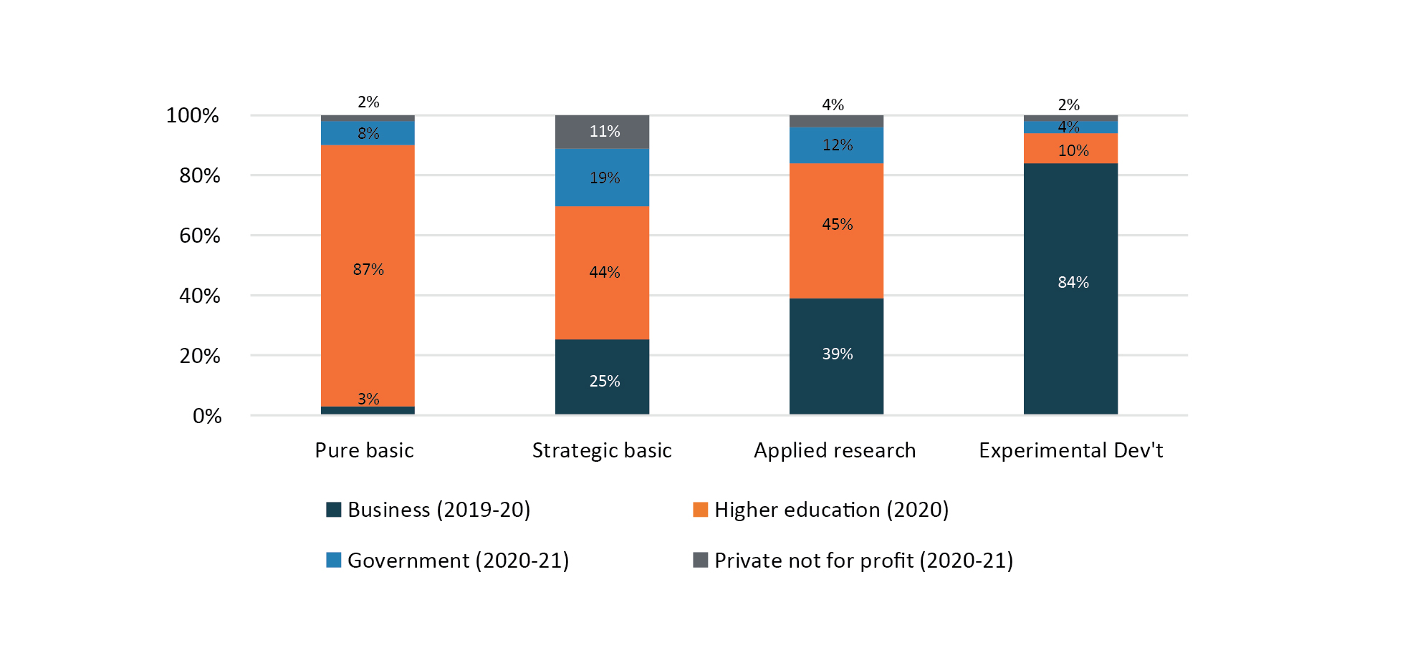

Sources: ABS FY2019-20; ABS 2020; ABS FY2020-21; ABS2022b.

### Research strengths – the need to be responsive

Nationally, Australia has strengths in particular fields, for example medical-related fields, especially biomedical, health sciences and biological sciences.[45] Drawing on these strengths benefited the nation during the COVID-19 pandemic. However, the effect of the pandemic has also changed the relative balance of research effort, with research in natural and physical sciences declining relatively.[46] Ensuring we are prepared for future challenges will likely require strengthening the ability to boost effort in various fields of research rapidly in response to new industry, government and societal needs as they emerge.

### Relationship to ARC Act Review

On 30 August 2022 the Minister for Education, Hon Jason Clare MP, announced the independent review into the *Australian Research Council Act 2001* (ARC Act Review). The ARC Act Review will consider whether the role and purpose of the ARC set out in its legislation remains contemporary for Australia’s current and future needs and is enabled by modern and effective governance regimes.[47] The recommendations of the ARC Act Review will be considered as part of the findings and recommendations of this Accord Review.

Further, the Panel is interested to address fundamental questions about how the impact and relevance of research in the Australian higher education sector can be best ensured and enhanced –in particular, whether the current arrangements provide sufficient focus on quality, opportunity to focus on clear missions of national importance, and support for the specialisation of different institutions across Australian higher education.

Q25 How should Australia leverage its research capacity overall and use it more effectively to develop new capabilities and solve wicked problems?

Q26 How can Australia stimulate greater industry investment in research and more effective collaboration?

### Research workforce

A high-quality research workforce is essential for the development of Australia’s research and innovation systems. At present, Australia performs relatively well in training future researchers. Australia ranks above the OECD average for the proportion of doctorate holders in the population, and is among the top 10 of OECD countries for researchers and doctorate holders in the workforce.[48] However, the number of domestic students completing higher degrees by research has been relatively static over the past decade, and declined from a peak of 6,800 in 2019 to 6,000 in 2021.

Figure : Domestic higher degree by research completions, 2011 to 2021

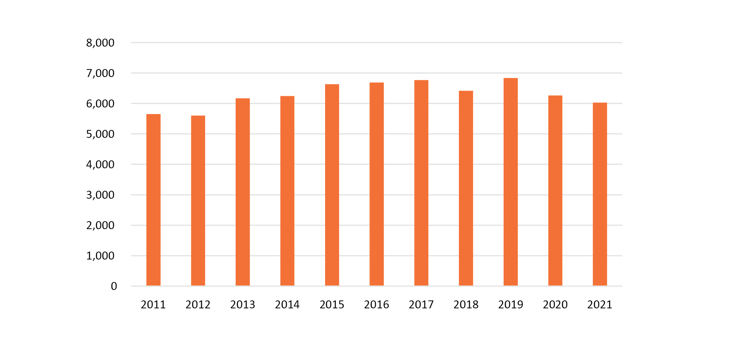

Source: Department of Education 2021b.

Support for the pipeline of researchers will be necessary for the research system to continue to deliver well into the future. Building the diversity of the academic workforce and supporting early career researchers will be crucial. The Panel has heard that adequacy of research training program stipends is one factor limiting the number of people who can enter the research workforce.

The value of students undertaking HDR (higher degree by research) training programs with strong connection to industry and government – for example, through improving pathways for these students to come from industry or to work in industry during or after their research program – is also being increasingly emphasised.

Q27 How can we improve research training in Australia including improving pathways for researchers to gain experience and develop high-impact careers in government and industry?

## Creating opportunity for all Australians

Australia needs a system that delivers equal access to higher education for all, irrespective of location, financial circumstance, cultural background, gender or other factors, if it is to meet future skills needs and ensure prosperity is equally shared among all members of society.

Participation in learning and research by people from every facet of Australia’s diverse population enriches the outcomes of higher education and the life of its institutions. Making sure the opportunities and benefits of higher education are open to everyone is a priority for reform.

Meeting a national target for overall attainment that is representative of the whole population will not be possible without strong growth in numbers of students from groups which are currently under-represented in the higher education system. In 2021, 17% of higher education students were from a low SES background, 2.4% were First Nations Australians, 21% were from regional or remote areas, and 9% were students with a disability. [49]

Figure 5 gives the relative participation ratio for these cohorts. Ratios below 1.0 indicate that there is a lower proportion of students from this cohort enrolled in higher education compared to the proportion in the general population.

Figure : Participation ratio for under-represented groups at Table A institutions, 2005 to 2021[50] [51]

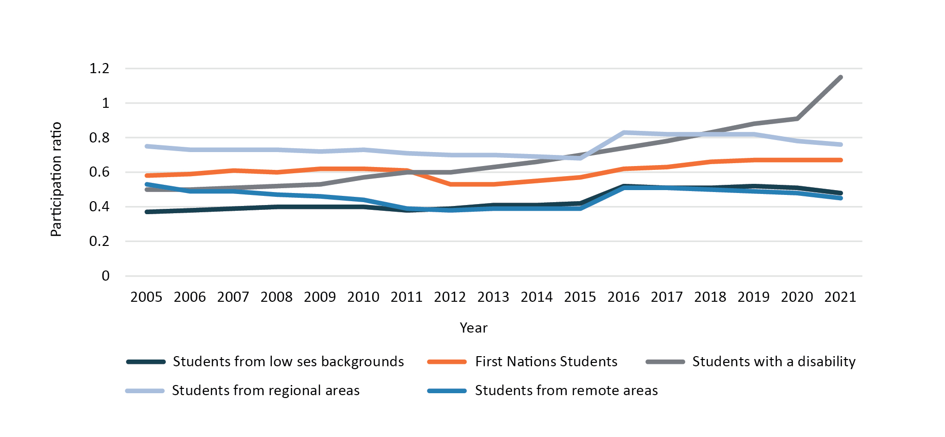

Source: Department of Education 2021b.

### Academic preparedness

The decision to undertake further study is an individual one, taken outside of higher education institutions. Prospective students assess their eligibility based on their own understanding of their potential and may be deterred from applying for a variety of reasons. Students from under-represented groups need supportive pathway programs and effective academic support.

Ensuring students are academically prepared and socially supported to undertake higher education requires dedicated institutional support and resourcing. All students – not just those from under-represented groups – need foundational skills, particularly literacy, numeracy, reasoning and digital skills.

The school system, along with enabling and support programs and the tertiary admissions system, is crucial in supporting a sustained increase in participation and attainment. But higher education providers also need to work with communities with a history of low participation, to help raise aspirations and build effective partnerships.

The Panel is considering the need for targets beyond overall participation in higher education, to drive better long-term outcomes for students. This includes exploring the whole of the student lifecycle to improve access, participation, success, completion, and graduate outcomes.

Q28 What is needed to increase the number of people from under-represented groups applying to and prepared for higher education, both from school and from other pathways?

Q29 What changes in provider practices and offerings are necessary to ensure all potential students can succeed in their chosen area of study?

### Addressing barriers to access

Many stakeholders have highlighted the costs of undertaking higher education, including the increased cost of living and the need to supplement income support, as a significant barrier to successful participation. This is particularly challenging for students who have dependents, are relocating to take up the opportunity to study, or come from financially disadvantaged backgrounds.

Personal factors can also affect the ability to attend higher education, such as caring responsibilities, geographic location, and distance to campuses.

Providers, governments, students and their families and communities, as well as employers, need to work effectively together for the overall system to work better. New pathways are needed to support those who do not have the opportunity to enrol directly from high school. The voices of people with lived experience should be at the centre of new solutions.

Q30 How can governments, institutions and employers assist students, widen opportunities and remove barriers to higher education?

Q31 How can the costs of participation, including living expenses, be most effectively alleviated?

### System-wide approaches to increasing access and equity

There are many examples of innovative ways of teaching and learning that support students from under-represented groups to overcome barriers to participation and enjoy success.

During the pandemic, improvements in online learning enabled many students to remain in their community while studying. Models such as the Regional University Centres program allow students to access the benefits of social and other support in a campus-like environment, while still studying in their home community.[52]

Cultural safety on campus also supports student learning and engagement, with various initiatives across the sector, such as dedicated First Nations learning centres, to create and extend culturally safe learning opportunities and environments.

Several stakeholders raised concerns about the higher costs of supporting students from under-represented groups, and that programs to support some specific cohorts of students are often limited and siloed in small, targeted activities. Some suggestions for better integrating the cost of teaching students from under-represented groups into the funding system have been made to the Panel.

Q32 How can best practice learning and teaching for students from under-represented groups be embedded across the higher education system, including the use of remote learning?

Q33 What changes to funding and regulatory settings would enable providers to better support students from under-represented groups in higher education?

## Governance, accountability and community

### Communities

Australia’s universities and higher education providers are embedded in, and contribute directly to the development of, their diverse and multi-layered communities. They co-exist with the obligation of higher education to serve the public interest.

Australia’s unique geography is reflected in a wide spread of higher education institutions with connections to their communities ranging across international, state, city and local boundaries and encompassing their alumni diaspora. Many institutions are influential in the economic, social and physical development of their communities, and important contributors to place-making and infrastructure development.

Community engagement and partnership varies widely, extending from an institution’s staff and students to local communities, including schools and civic organisations, to industry and business, to international partners and networks.

It is essential that institutions are supported to continue to develop and contribute to the communities they serve.

Q34 How should the contribution of higher education providers to community engagement be encouraged and promoted?

Q35 Where providers make a distinctive contribution to national objectives through community, location-based or specialised economic development, how should this contribution be identified and invested in?

### Regulation and governance

The regulatory and reporting landscape for higher education is crowded and complicated. Providers are subject to regulatory requirements including those stemming from the *Higher Education Support Act 2003* (HESA), the Tertiary Education Quality and Standards Agency (TEQSA) and Higher Education Standards Framework (Threshold Standards) and the Australian Qualifications Framework (AQF). Providers which teach international students must comply with a range of specific regulations, including the *Education Services for Overseas Students Act 2000* (ESOS Act). Providers operating in the VET system are subject to a different set of regulations overseen by the Australian Skills Quality Authority (ASQA) or state-based regulators in Victoria and Western Australia.

Higher education providers are set up under a range of legal structures, depending on their status as for-profit and not-for-profit corporate entities. Universities are established under individual Acts of Parliament in the respective state or territory or, in the case of the Australian National University, the Commonwealth. Each jurisdiction has separate, but not dissimilar, approaches to governance in these Acts, as well as requirements for financial, risk, probity, information and research ethics regulation and reporting.

Most institutions have a governing body (a board, senate or council) with responsibility for strategic planning and oversight of management including in planning, financial, educational, research, legal and risk management matters.

The Panel has heard concerns from stakeholders about the make-up of these bodies, including whether they hold sufficient sector expertise. For some universities established under state or territory acts, some members are directly appointed by the relevant government. It is also common for governing bodies to include representatives from staff, student bodies and alumni.

It was suggested to the Panel that a more specialised and coherent national approach to administering Australia’s higher education system might be needed. Given the intersection between the Commonwealth and states and territories for regulatory requirements, and the overlapping responsibilities for and delivery of higher-level skills and vocational programs, research and infrastructure, there may be scope for a more effective federation-wide approach.

Q36 What regulatory and governance reforms would enable the higher education sector to better meet contemporary demands?

Q37 How could a more coherent and dynamic national governance system for higher education be achieved?

### Academic workforce

Australia needs a capable and highly skilled academic workforce to deliver future skills needs through teaching and learning and to boost innovation through the research system. In 2021, 129,178 staff (FTE) were employed at universities in Australia: 92,035 full-time, 16,838 part-time and 20,305 casual staff.[53]

Figure : University staff employed on a full-time or fractional full-time basis, by function, 1989 to 2020 (full-time equivalent)[54]

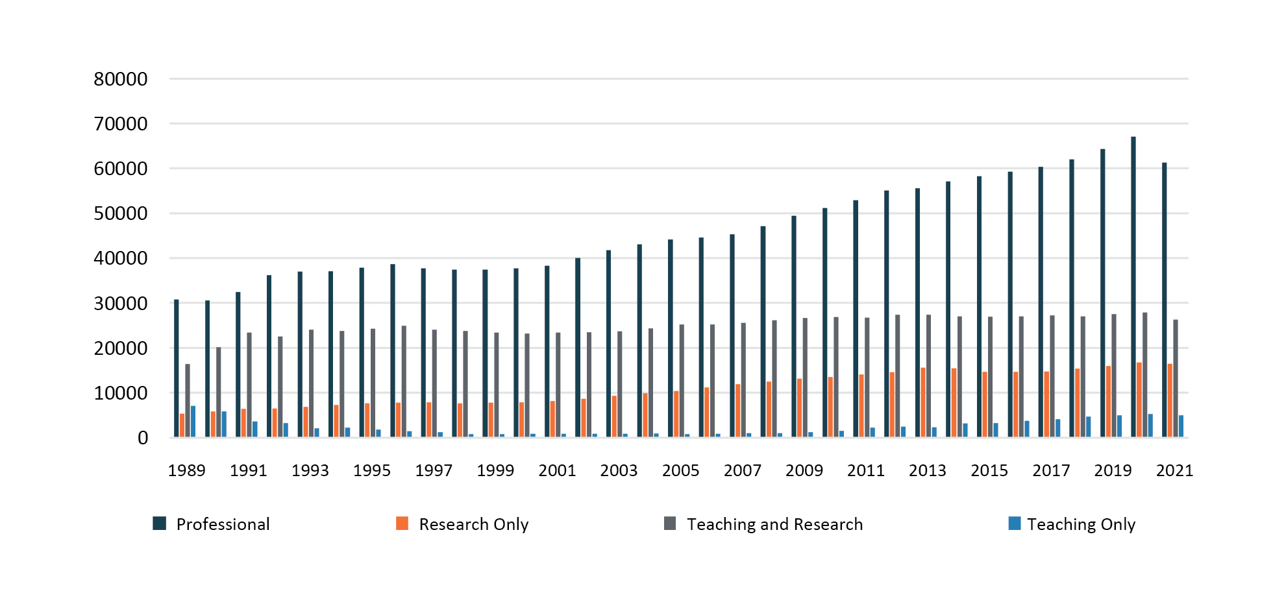

Source: Department of Education 2021a.

Figure : University staff employed on a casual basis, by function, 1989 to 2020 (full-time equivalent)[55]

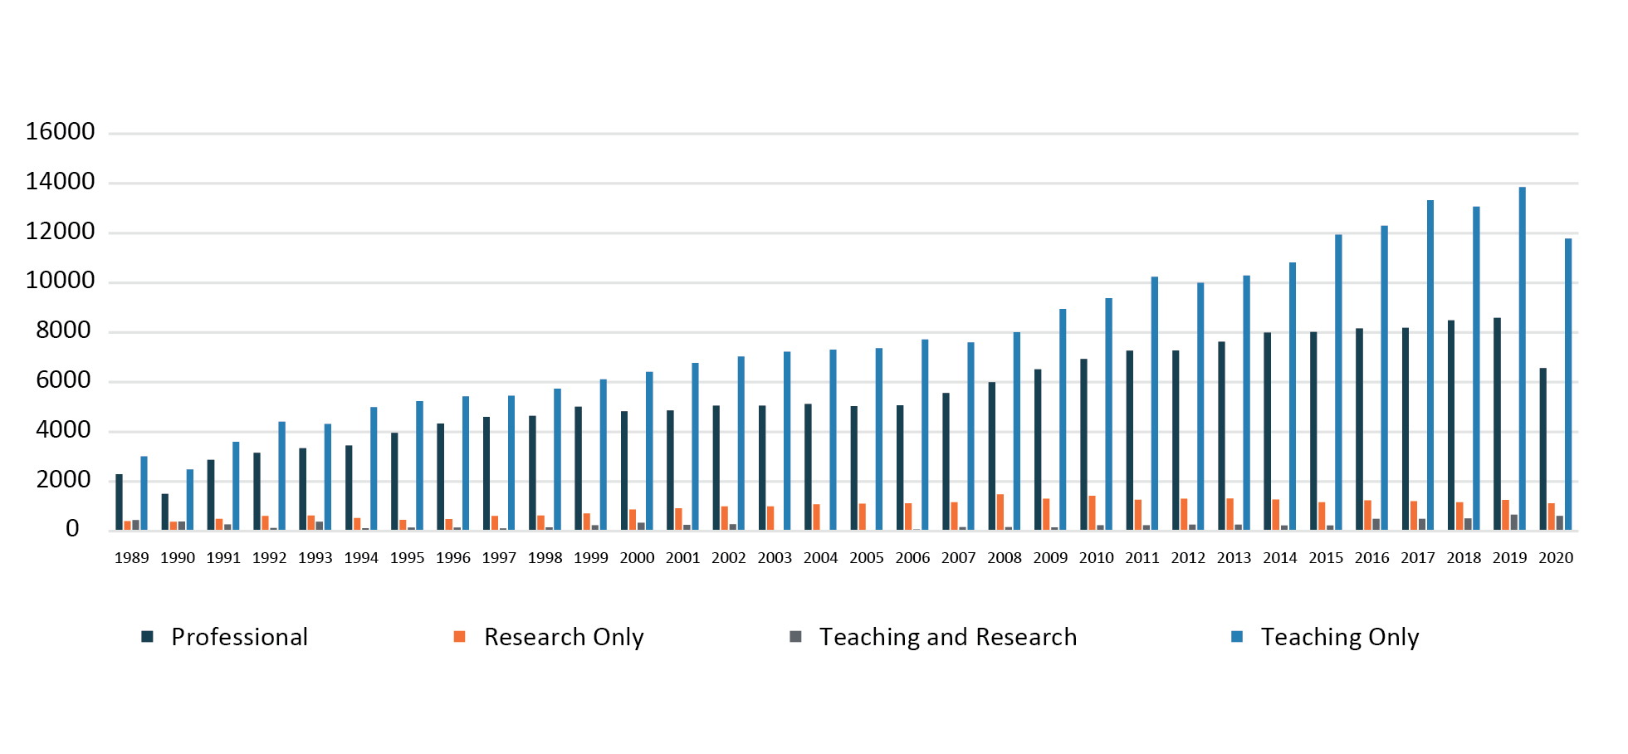

Source: Department of Education 2021a.

Academic staff workloads vary across the sector. Universities with a greater focus on research have a higher proportion of staff in research only roles, as opposed to many regional universities where a higher proportion are in teaching only or teaching and research positions.[56] Among staff employed on a full-time basis, there is a relatively high concentration of joint teaching and research roles. This reflects industrial arrangements commonly agreed in universities to appoint staff to roles combining these two functions.

Numbers of casual staff employed at universities have continued to trend upwards. From 2010 to 2019, the number of casual staff (FTE) increased from 17,979 to 24,350. This declined in 2020 to 20,092 as the pandemic hit the sector.[57]

Several stakeholders indicated that financial uncertainty, including government funding changes, can influence the employment decisions of providers. As seen below, the growth of casual academic staff mirrors the growth of international students.[58]

Figure : Growth in student load and staffing numbers, 2005 to 2020 (full-time equivalent)[59]

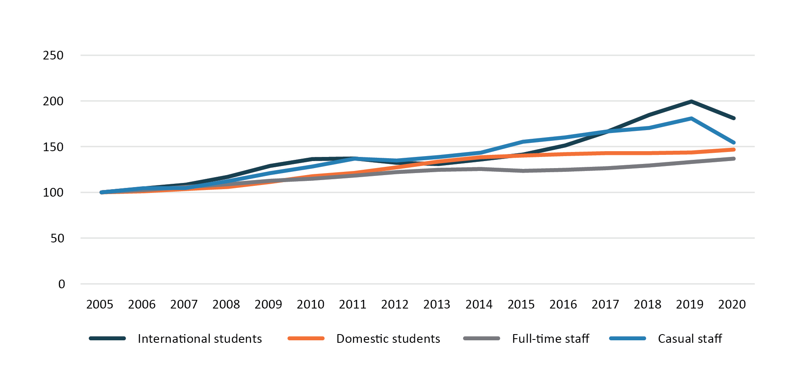

Source: Department of Education 2021a; Department of Education 2021b.

Many stakeholders raised concerns about insecure work and underpayment in the higher education sector, particularly for casual or sessional staff. It is estimated that 50-80% of undergraduate teaching in universities is delivered by sessional staff.[60]

Q38 How can the Accord support higher education providers to adopt sector-leading employment practices?

## Quality and sustainability

Achieving goals for innovation and skills will require a higher education system that is both high quality and sustainable over the coming decades.

### Quality experience for students

In addition to providing students with a quality learning experience (see 3.1), it is also necessary to provide a quality student experience.

Historically, students have valued Australia’s higher education system, with high levels of positive ratings of the student experience, although ratings from international students are generally lower than for domestic students.[61]

The pandemic brought new challenges for students, with restrictions on access to campus life and rapid adoption of online learning by higher education providers. This resulted in a major decline in students’ ratings of the quality of their entire educational experience from 79% in 2019 to 70% in 2020. While there were moderate drops in ratings for skills development and learning resources, learner engagement was significantly affected, falling by over 10 percentage points for domestic and for international students.

Student ratings improved in 2021 as institutions and students adapted to the changing teaching and learning environment, although ratings remain lower than in 2019. Ratings of student experience recorded in the UK and US were also negatively impacted by the pandemic, indicating these issues are not unique to Australia.[62]

Figure : Domestic undergraduate student experience, 2019 to 2021 (percentage positive rating)

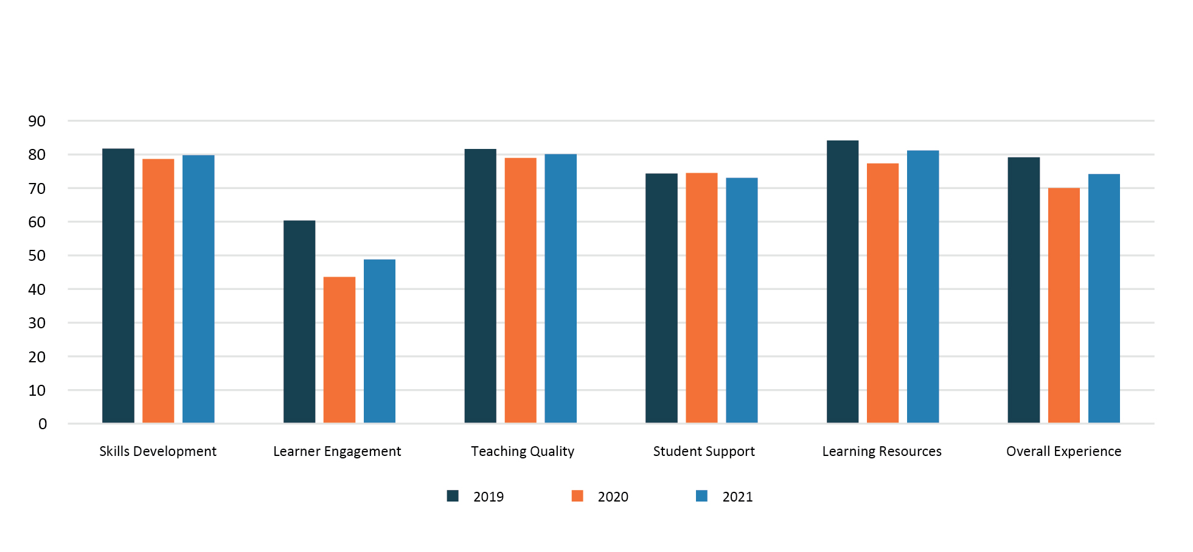

Source: QILT 2021a.

Figure : International undergraduate student experience, 2019 to 2021 (percentage positive rating)

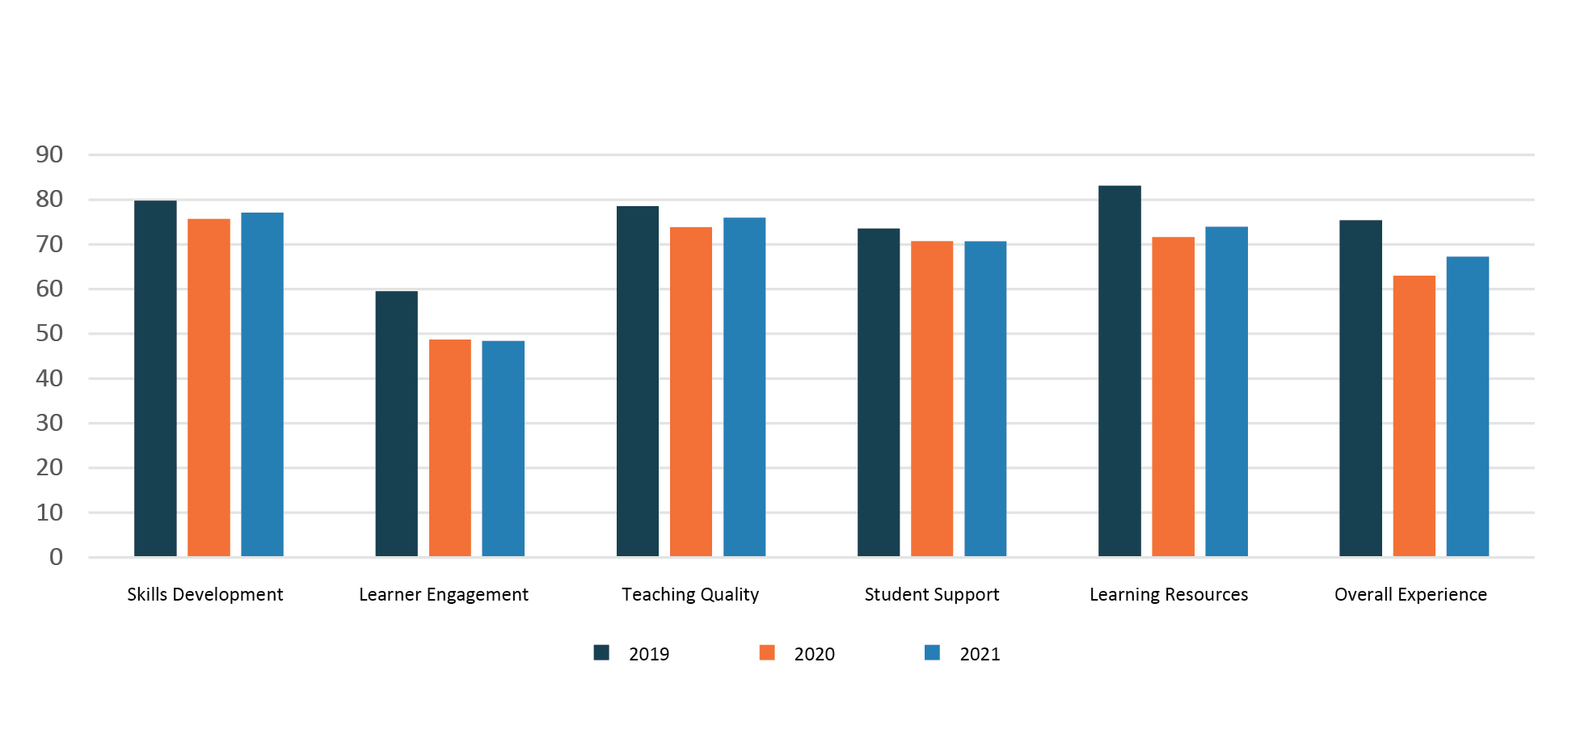

Source: QILT 2021a.

In 2022, most higher education providers re-opened their campuses to students for in-person teaching in combination with online delivery. The trend towards hybrid teaching methods is expected to continue. Hybrid teaching methods can be attractive to students requiring flexibility, including those in regional, rural and remote areas, mature age students and students with caring and family responsibilities.

A range of factors affects a student’s experiences including how well they can balance their studies against competing demands of family and cultural responsibilities and paid employment. The Panel heard that many students experience challenges with their wellbeing and safety, including navigating mental health concerns. The 2021 National Student Safety Survey found that one in 20 students had experienced sexual assault since starting university.[63]

It is also important to provide appropriate oversight and addressing of student complaints or concerns. The Panel heard that there are challenges for students who have issues they wish to pursue. Confusion around the roles and remit of consumer protection laws, the ombudsman, the Human Rights Commission and TEQSA, as well as different pathways for international students, can make the system hard to navigate.

Q39 What reforms are needed to ensure that all students have a quality student experience?

Q40 What changes are needed to ensure all students are physically and culturally safe while studying?

### Research quality

As nations strive to achieve competitive advantage from their key resources, including people, skills and expertise, their ability to measure, analyse and learn how quality research outcomes and impact are achieved will become more important. Measures of research quality and impact allow for benchmarking of performance across institutions and disciplines. This can provide the basis for targeted management effort, and redirection of resources or other investments to achieve higher levels of performance.

Since the introduction of Excellence in Research for Australia (ERA) in 2010, Australia’s research quality has improved across each round of assessment.[64] Providing assurance of the quality and value of research impact is an important component of building social licence for the continuing level of investment in both the system and institutions. Good data, supported by examples and case studies constructed to support analytical insights, are key to this assurance.

Australian universities are globally recognised for their strong standards and integrity, quality international collaborations, and consistent research output. Australia is a leader in promoting collaborative research while managing national security risks and providing guidance to other like-minded countries. Australia is the sixth largest producer of international joint publications in 2021 despite being the ninth largest research producer overall. Amongst the top 20 research producers in the world, Australia produces the fifth highest proportion of international research collaborations.[65] Within the Asia-Pacific region, Australia is looked to as a knowledge partner of choice, with our institutions and researchers partnering extensively with other universities and academics.[66]

Q41 How should research quality be prioritised and supported most effectively over the next decade?

### Academic integrity

A significant challenge for the sector will be maintaining academic quality and integrity. The emerging democratisation of information, automation, and proliferation of digital technologies provide both opportunities for innovation and threats of disruption to the sector’s traditional practices. It will be essential to maintain appropriate standards to protect the future integrity of the sector.

Breaches in academic integrity weaken the sector’s reputation. TEQSA defines academic integrity as “the expectation that teachers, students, researchers and all members of the academic community act with honesty, trust, fairness, respect and responsibility”*.[67]*Higher education providers must ensure that upholding standards of academic integrity is central to educational standards and research performance, that the standards’ importance and meaning are communicated to students and staff, and that breaches and academic misconduct are pursued in systematic and fair ways.

Providers are constantly responding to new forms of cheating that threaten academic integrity. The increased threat and prevalence of organised or ‘contract cheating’ services for students in recent years has been a major concern. In addition, generative AI software presents a range of complex challenges for academic integrity in higher education.[68] Its use by students and academics is likely to lead providers to reimagine traditional methods of teaching and knowledge transfer, and to devise more robust processes of assessment and review. As the AI challenge continues to evolve, alongside the refinement of the technology itself, measures to protect academic integrity must keep pace.

Q42 What settings are needed to ensure academic integrity, and how can new technologies and innovative assessment practices be leveraged to improve academic integrity?

## The role of international education

Australia’s international education sector has been very successful over the past 20 years. In 2020, Australia was the third most popular study destination for international students, after the US and the UK.[69] Between 2002 and 2019, international student enrolments in higher education institutions increased by 253%.[70]

International students are integral to higher education’s contribution to Australian society, bringing social, cultural and community benefits. As demonstrated by their absence during the pandemic experience, international students provide vital part-time workers across many sectors of the economy. Australia’s international students come from over 190 countries, and their collective diversity and knowledge add to our education institutions, workplaces and communities.[71]

The COVID-19 pandemic significantly affected Australia’s entire international education sector, including our higher education providers, and continues to present ongoing challenges. In 2020-21, international education was worth $27.5 billion. Despite dropping from $37.3 billion in 2019-20, the industry remains the fourth largest export industry in Australia, and the largest non-natural-resource industry.[72] Rebuilding and strengthening it in the wake of the pandemic is a key focus for the sector. The *Australian Strategy for International Education 2021-2030* aims to achieve a more sustainable and diverse international education sector, with increased opportunities for growth.

International education helps to deepen Australia’s engagement and influence with strategic partners such as the Pacific and Southeast Asia, particularly with priorities like climate change and sustainable development, and contributes to jobs, skills, investment, and industry development in Australia too.

However, traditional source markets in our region, such as China and Malaysia, are also emerging as competitors and attractive study destinations for international students. In 2018 China appeared to offer around 10,000 scholarships to students within our region.[73] UNESCO data indicates that China and Malaysia are both destinations of choice for globally mobile tertiary students.[74]

The Panel sees international education as an integral, necessary, and positive part of Australian higher education and the Australian community. To thrive, Australian higher education must avoid over-reliance on any one country as a source of revenue for education, research and infrastructure. Also the continued development of robust and resilient ways to govern and regulate international education activities must be part of the mainstream life of our institutions.

Q43 How should the current recovery in international education be managed to increase the resilience and sustainability of Australia’s higher education system, including through diversification of student enrolments from source countries?

Q44 How can the benefits of international education be shared broadly across the system, including in regional areas, and what level of reporting should there be?

## Investment and affordability

The Australian higher education system relies on multiple revenue streams, with Australian Government funding (direct grants for teaching, research and engagement) and student fees making up the largest components. In 2021, total revenue for Australian universities was $38.9 billion, up from $35.2 billion in 2020.[75] Growth in international student fee income has continued to rise, peaking at 27.3% of university revenue in 2019.[76]

Figure : Total provider revenues from continuing operations, 2004 to 2021 ($ ’000)[77]

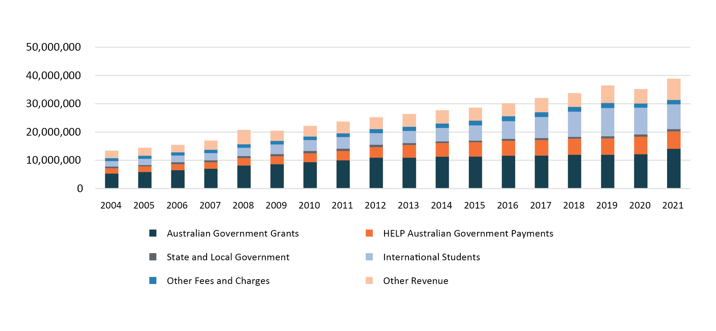

Source: Department of Education 2020 and unpublished data.

Australian higher education must be underpinned by a sustainable funding model if it is to be successful. This model must allow the system to meet parallel needs across teaching, student support, research, research training, engagement, administration and infrastructure, and capital investment. The pandemic exposed the current complex funding arrangements and vulnerabilities within the international student market and demonstrated the challenges of managing various and precarious revenue streams.

One issue frequently raised with the Panel is funding for the full spectrum of university activities, many of which are not directly funded but are nonetheless essential to university operations. How universities fund research and manage infrastructure costs, including research infrastructure, is a challenge. Another concern is the increase in cross-subsidisation within institutions, largely from international student revenue to research, highlighting calls for full funding of research. It was pointed out that universities with lower revenue from international students are also less able to invest in innovation and other priorities such as infrastructure.

Q45 How should the contribution of different institutions and providers to key national objectives specific to their location, specialist expertise or community focus be appropriately financed?

Q46 How can infrastructure development for higher education be financed, especially in regional and outer urban locations?

### Commonwealth funding for higher education research and teaching and learning

In 2023, the Australian Government is providing around $19.8 billion to the higher education system through the Education portfolio, predominantly paid to the 39 Table A providers.[78]

The Commonwealth Grant Scheme (CGS) and student contributions (deferred through the Higher Education Loan Program (HELP)) make up most of this expenditure ($12.7 billion in 2023) and, collectively, are based on an assessment of costs of teaching and scholarship by discipline (the basis for which is widely queried in the higher education sector).

The Commonwealth contributes to university research through a dual funding system of competitive grants and research block grants (RBGs). In 2023, $3.0 billion will be provided through these streams.

Commonwealth funding is also provided to universities for various engagement activities. This includes activities to encourage WIL and smaller programs focussed on increasing access and widening participation.

The Panel was told often that there is an onerous level of reporting across government programs. Stakeholders have also suggested access to funding for teaching and learning should be available to a wider group of providers to facilitate greater student choice.

Q47 What structure of Commonwealth funding is needed for the higher education sector for the system to be sustainable over the next two decades?

### Student contributions and the Higher Education Loan Program

Debates over the level of funding for learning and teaching, and how the costs are shared between the public and students, have continued over decades. The share borne by the student has been steadily increasing. As shown in Figure 12, the proportion paid by students increased from just over 20% in 1989 to a projected 47% in 2024. Changes to student contributions through the JRG package are structured around an assessment of the relative priority of each field of education in addressing skills needs, but result in wide variation in the actual contribution paid by individual students of between 13% and 93% of their degree costs, depending on the field of education.

Figure : Share of CSP funding between Commonwealth and student contributions

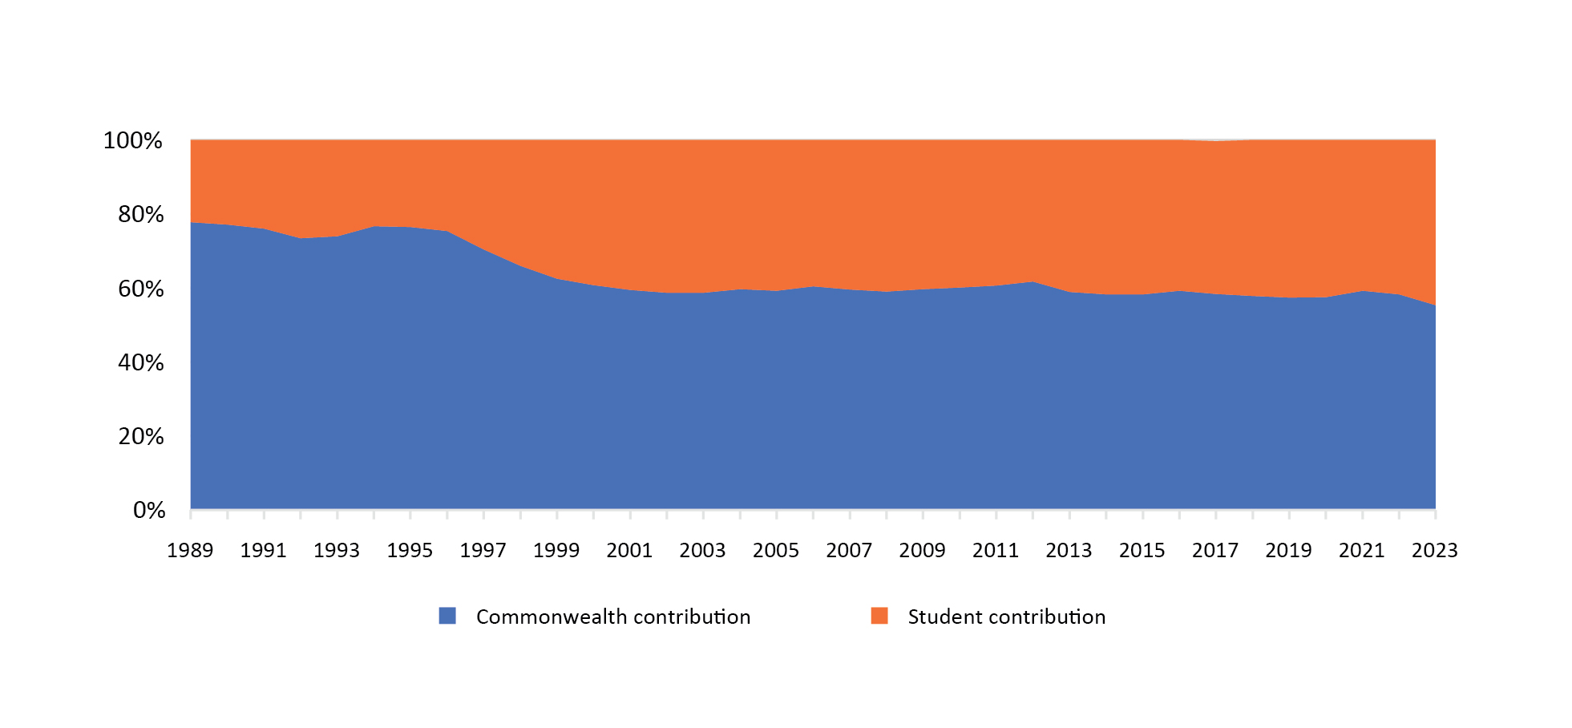

Source: Department of Education unpublished data.

HELP removes the upfront financial barrier that would otherwise exist for entry and opens the doors to higher education for many Australians. However, many stakeholders expressed concern about the current level of debt for some students, how long individuals can spend paying back their debt, and the impact of current indexation (which has been increasing in recent years due to increases in CPI). These debts also affect an individual’s borrowing capacity for other loans.[79] While the average student has paid off their HELP debt in under 10 years,[80] people on lower incomes may never pay it off and will make a small repayment from their already low incomes for their entire working life.

Some stakeholders raised concerns that students who choose to undertake undergraduate study in full-fee paying (unsubsidised) places at non-university providers are charged an additional 20% fee on their loan, which can discourage students from enrolling with these providers.

Q48 What principles should underpin the setting of student contributions and Higher Education Loan Program arrangements?

### Job-ready Graduates (JRG) package

The Panel has been asked to review the JRG package implemented in 2021. In consultation to date, the Panel has heard widespread concerns about elements of this package and its impact on both students and institutions.

The Panel welcomes further insights on the impact of these changes and opportunities to improve on them. To inform this feedback, a summary of the changes is at the [Accord website](https://www.education.gov.au/australian-universities-accord).

Some stakeholders welcome the flexibility given to providers to determine which programs to offer within their allocated funding envelope, but expressed concern about how funding will grow following these changes. However, others are concerned about the adequacy of Commonwealth contributions, and the impact on students of variations in contributions to different units in different ‘funding clusters’.

The Productivity Commission’s current *Interim 5 Year Productivity Report* considered the JRG changes and noted that “there is little evidence that differential subsidies effectively address skills shortages”.[81]

A major issue raised with the Panel is that the impact of changes to student contributions is not being felt evenly across different student groups, with female and First Nations students being most affected by the largest fee increases introduced by the JRG changes. This is because the fields of study with the highest increases in student contributions, such as humanities and communications, are fields in which these students are over-represented.[82]

Many options have been put to the Panel on how to change student contributions as part of the Review. Some stakeholders have proposed a single contribution rate, while others promote options to rebalance the amount students pay so there is less variation between fields of education.

Q49 Which aspects of the JRG package should be altered, and which should be retained?

# Conclusion

This discussion paper has been prepared by the Panel which is undertaking a Review of Australia’s Higher Education System. It summarises the challenges and opportunities that face Australian higher education with a view to informing the many stakeholders of the system. The Panel now welcomes feedback, ideas and insights to help it develop further reports and recommendations in accord with the Review’s Terms of Reference.

As stated in the Foreword, the Panel needs all stakeholders to be part of the Review and to respond to this paper. We ask you to respond to the questions that most resonate with you – and to be bold in your comments and submissions.

For further information on how to make a submission, see the [Accord website](https://www.education.gov.au/australian-universities-accord).

# References

Australian Bureau of Statistics (ABS) (FY2019-20) [*Research and Experimental Development, Businesses, Australia*](https://www.abs.gov.au/statistics/industry/technology-and-innovation/research-and-experimental-development-businesses-australia/latest-release) [Data Set], accessed 15 February 2023.

——(2020) [*Research and Experimental Development, Higher Education Organisations, Australia*](https://www.abs.gov.au/statistics/industry/technology-and-innovation/research-and-experimental-development-higher-education-organisations-australia/latest-release) [Data Set], accessed 15 February 2023.

——(FY2020-21) [*Research and Experimental Development, Government and private non-profit organisations, Australia*](https://www.abs.gov.au/statistics/industry/technology-and-innovation/research-and-experimental-development-government-and-private-non-profit-organisations-australia/2020-21) [Data Set], accessed 15 February 2023.

——(2021a) [*Cultural Diversity, Census*](https://www.abs.gov.au/statistics/people/people-and-communities/cultural-diversity-census/2021) [Data Set], accessed 15 February 2023.

——(2021b) [*Regional Population*](https://www.abs.gov.au/statistics/people/population/regional-population/latest-release) [Data Set], accessed 15 February 2023.

——(2022a) [*Education and Work, Australia*](https://www.abs.gov.au/statistics/people/education/education-and-work-australia/latest-release) [Data Set], accessed 15 February 2023.

——(2022b) [*Technology and Innovation*](https://www.abs.gov.au/statistics/industry/technology-and-innovation), ABS Website, accessed 15 February 2023.

Australian Prudential Regulation Authority (APRA) (2022) [*Macroprudential Policy Credit Measures*](https://www.apra.gov.au/sites/default/files/2022-06/Letter%20to%20ADIs%20-%20Macroprudential%20Policy%20credit%20measures%20.pdf) [Letter to All Authorised Deposit-Taking Institutions], APRA, Sydney, accessed 15 February 2023.

Australian Research Council (2018) [*ERA Outcomes 2010-2018*](https://dataportal.arc.gov.au/ERA/Web/Outcomes) [Data Set], accessed 15 February 2023.

——(2018-19) [*State of Australian University Research: ERA National Report*](https://dataportal.arc.gov.au/ERA/NationalReport/2018/), ARC, Australian Government, accessed 15 February 2023.

——(n.d.) [*Excellence in Research for Australia*](https://www.arc.gov.au/evaluating-research/excellence-research-australia), ARC Website, accessed 15 February 2023.

Australian Taxation Office (ATO) (FY2021-22) [*HELP Statistics*](https://data.gov.au/dataset/ds-dga-ce4c58ec-c930-4a05-8a37-f244d960e5f8/distribution/dist-dga-0661912a-d114-4155-8b42-63ab1417adea/details?q=) [Data Set], data.gov.au, accessed 15 February 2023.

Baré E and Bexley E (2017) ‘Redesigning the Higher Education Workforce: A New Architecture’, in James R, French S and Kelly P (eds) [*Visions for Australian Tertiary Education*](https://melbourne-cshe.unimelb.edu.au/__data/assets/pdf_file/0006/2263137/MCSHE-Visions-for-Aust-Ter-Ed-web2.pdf), Melbourne Centre for the Study of Higher Education, Melbourne, accessed 15 February 2023.

Behrendt L, Larkin S, Griew R, and Kelly P (2012) *Review of Higher Education Access and Outcomes for Aboriginal and Torres Strait Islander People: Final Report*, Australian Government.

Benner M (2022) *Asia’s Rising Research Dominance: Universities and State Building*, Edward Elgar Publishing, Cheltenham.

Bradley D, Noonan P, Nugent H, and Scales B (2008) *Review of Australian Higher Education: Final Report*, Australian Government.

Centre for Population (2022) [*Population Statement*](https://population.gov.au/sites/population.gov.au/files/2023-01/population_statement_2022_0.pdf), Centre for Population, Australian Government, accessed 15 February 2023.

Clarivite (2021) [*InCites Benchmarking and Analytics*](https://incites.clarivate.com/#/landing) [Data Set], incites.clarivate.com, accessed 9 February 2023.

Department of Education (2020) [*Finance Publication*](https://www.education.gov.au/higher-education-publications/finance-publication)[Data Set], education.gov.au, accessed 15 February 2023.

——(2021a) [*Higher Education Statistics – Staff Data*](https://www.education.gov.au/higher-education-statistics/staff-data) [Data Set], education.gov.au, accessed 15 February 2023.

——(2021b) [*Higher Education Statistics – Student Data*](https://www.education.gov.au/higher-education-statistics/student-data) [Data Set], education.gov.au, accessed 15 February 2023.

——(2021c) [*Higher Education Statistics – Undergraduate Applications, Offers and Acceptances*](https://www.education.gov.au/higher-education-statistics/undergraduate-applications-offers-and-acceptances-publications) [Data Set], education.gov.au, accessed 15 February 2023.

——(2022a) [*Australian Qualifications Framework Review*](https://www.education.gov.au/higher-education-reviews-and-consultations/australian-qualifications-framework-review), Department of Education Website, accessed 15 February 2023.

——(2022b)[*International Education Data and Research*](https://www.education.gov.au/international-education-data-and-research) [Data Set], education.gov.au, accessed 15 February 2023.

——(2023a) [*Regional University Centres*](https://www.education.gov.au/regional-university-centres), Department of Education Website, accessed 15 February 2023.

——(2023b) [*Review of the Australian Research Council Act 2001*](https://www.education.gov.au/higher-education-reviews-and-consultations/review-australian-research-council-act-2001), Department of Education Website, accessed 15 February 2023.

Department of Education, Skills and Employment (DESE) (2021a) [*Australian Strategy for International Education 2021-2030*](https://www.education.gov.au/australian-strategy-international-education-2021-2030), Department of Education Website, accessed 15 February 2023.

——(2021b) [*University-Industry Collaboration in Teaching and Learning Review*](https://www.education.gov.au/higher-education-reviews-and-consultations/university-industry-collaboration-teaching-learning-review), Department of Education Website, accessed 15 February 2023.

Department of Foreign Affairs and Trade (DFAT) (2021)[*Trade and Investment at a Glance*](https://www.dfat.gov.au/publications/trade-and-investment/trade-and-investment-glance-2021#minerals-and-fuels-sector), DFAT, Australian Government, accessed 15 February 2023.

Elsevier Research Intelligence (2023) [*SciVal Bibliometric Database*](https://id.elsevier.com/as/authorization.oauth2?platSite=SVE%2FSciVal&ui_locales=en-US&scope=openid+profile+email+els_auth_info+els_analytics_info&response_type=code&redirect_uri=https%3A%2F%2Fwww.scival.com%2Fidp%2Fcode&prompt=login&client_id=SCIVAL) [Data Set], id.elsevier.com, accessed 10 February 2023.

Hodge S and Knight E (2021) [*The best of both worlds? Integrating VET and Higher Education*](https://www.ncver.edu.au/__data/assets/pdf_file/0043/9669751/The-best-of-both-worlds-Integrating-VET-and-higher-education.pdf), National Centre for Vocational Education Research, Adelaide, accessed 15 February 2023.

Ithaca Group (2018) [*Credit Pathways in VET and Higher Education*](https://www.education.gov.au/higher-education-reviews-and-consultations/resources/credit-pathways-vet-and-higher-education), report to the Australian Government Department of Education and Training, accessed 15 February 2023.

Jobs and Skills Australia (2022) [*Australian Skills Classification*](https://www.jobsandskills.gov.au/australian-skills-classification) [Data Set], jobsandskills.gov.au, accessed 15 February 2023.

Klopper CJ and Power BM (2014) ‘[The Casual Approach to Teacher Education: What Effect does Casualisation Have for Australian University Teaching?](https://ro.ecu.edu.au/cgi/viewcontent.cgi?article=2225&context=ajte)’ *Australian Journal of Teacher Education*, 39(4):101-114, doi:10.14221/ajte.2014v39n4.1, accessed 15 February 2023.

Mindzak M and Eaton SE (5 November 2021) ‘[Artificial Intelligence is Getting Better at Writing, and Universities Should Worry About Plagiarism](https://theconversation.com/artificial-intelligence-is-getting-better-at-writing-and-universities-should-worry-about-plagiarism-160481)’, *The Conversation*, accessed 15 February 2023.

Moodie G and Wheelahan L (2018) [*Implications of The Human Capability Approach for Relations Between Australian Vocational and Higher Education*](https://www.monash.edu/__data/assets/pdf_file/0009/1476144/Moodie_Wheelahan1.pdf),Monash University, Melbourne, accessed 15 February 2023.

National Centre for Vocational Education Research (NCVER) (2021) [*Total VET Students and Courses – Program Enrolments*](https://www.ncver.edu.au/research-and-statistics/publications/all-publications/total-vet-students-and-courses-2021) [Data Set], ncver.edu.au, accessed 15 February 2023.

National Skills Commission (2021a) [*Employment Outlook Industry and occupation trends over the five years to November 2026*](https://www.nationalskillscommission.gov.au/sites/default/files/2022-03/NSC%20Report%20-%20Employment%20Outlook%20-%20March%202022.pdf), NSC, Australian Government, accessed 15 February 2023.

——(2021b) [*Employment Projections*](https://www.nationalskillscommission.gov.au/topics/employment-projections) [Data Set], nationalskillscommission.gov.au, accessed 15 February 2023.

——(2021c) [*The State of Australia’s Skills 2021: Now and Into the Future*](https://www.nationalskillscommission.gov.au/reports/state-of-australia-skills-2021), NSC, Australian Government, accessed 15 February 2023.

Norton A (2022) [*Submission on Priority Student Funding Policy Issues for the Universities Accord*](https://andrewnorton573582329.files.wordpress.com/2023/01/accord-priorities-submission-andrew-norton-december-2022-3-1-23-version.pdf), Andrew Norton, accessed 15 February 2023.

Organisation for Economic Co-operation and Development (OECD) (2019) [*Education at a Glance: Indicator B7*](https://www.oecd-ilibrary.org/sites/8389c70e-en/index.html?itemId=/content/component/8389c70e-en) [Data Set], oecd-library.org, accessed 15 February 2023.

——(2021) [*OECD.Stat – Educational Attainment and Labour-Force Status*](https://stats.oecd.org/Index.aspx?datasetcode=EAG_NEAC) [Data Set], stats.oecd.org, accessed 15 February 2023.

——(2022) [*Main Science and Technology Indicators*](https://www.oecd.org/sti/msti.htm) [Data Set], oecd.org, accessed 15 February 2023.

Patton S (4 November 2022) ‘[Crumbling Cornerstone? Australia’s Education Ties with Southeast Asia](https://www.lowyinstitute.org/publications/crumbling-cornerstone-australia-s-education-ties-southeast-asia#footnote37_zzq3d69)’, *Lowy Institute*, accessed 15 February 2023.

Productivity Commission (2022) [*5-Year Productivity Inquiry: From Learning to Growth – Interim Report No.5*](https://www.pc.gov.au/inquiries/completed/productivity/interim5-learning/productivity-interim5-learning.pdf), Productivity Commission, Australian Government, accessed 15 February 2023.

Quality Indicators for Teaching and Learning (QILT) (2021a) [*Student Experience Survey*](https://www.qilt.edu.au/surveys/student-experience-survey-(ses)), QILT Website, accessed 15 February 2023.

——(2021b) [*2021 Student Experience Survey: National Report*](https://www.qilt.edu.au/docs/default-source/default-document-library/2021-ses-national-report.pdf?sfvrsn=e2bcbdf0_2), QILT Website, accessed 15 February 2023.

Social Research Centre (2021) [*National Student Safety Survey*](https://www.nsss.edu.au/results), National Student Safety Survey Website, accessed 15 February 2023.

Tertiary Education Quality and Standards Agency (TEQSA) (2022) [*What is Academic Integrity?*](https://www.teqsa.gov.au/students/understanding-academic-integrity/what-academic-integrity), TEQSA Website, accessed 15 February 2023.

Times Higher Education (2023) [*World University Rankings*](https://www.timeshighereducation.com/world-university-rankings/2023/world-ranking), Times Higher Education Website, accessed 15 February 2023.

United Nations Educational, Scientific and Cultural Organisation (UNESCO) Institute for Statistics (2020) [*Global Flow of Tertiary-Level Students*](https://uis.unesco.org/en/uis-student-flow) [Data Set], uis.unesco.org, accessed 15 February 2023.

——(2022) [*Education – Number and Rates of International Mobile Students (Inbound and Outbound)*](http://data.uis.unesco.org/) [Data Set], data.uis.unesco.org, accessed 15 February 2023.

World Intellectual Property Organisation (2022) [*Global Innovation Index: What is the Future of Innovation-Driven Growth?*](https://www.globalinnovationindex.org/gii-2022-report), WIPO, Geneva, doi: 10.34667/tind.46596, accessed 15 February 2023.

# Appendix A - Review terms of reference

## Purpose of the review

The Government has committed to establish an Australian Universities Accord to drive lasting reform in Australia’s higher education system. The Accord is a review (the review) of Australia’s higher education system, led by the Minister for Education with advice from a panel of eminent Australians (the panel).

The panel will make recommendations for Government, the sector and other relevant stakeholders to deliver a higher education system that meets the current and future needs of the nation, and targets to achieve this. The panel will report to the Minister for Education, providing an interim report on priority actions by June 2023, with a final report to be delivered by December 2023.

## Key areas for review

### 1. Meeting Australia’s knowledge and skills needs, now and in the future

Enhance the delivery of quality education that meets the needs of students across all stages of lifelong learning and develops the skills needed now, and in the future. This will include recommendations for new targets and reforms recognising that more than nine in ten new jobs will require post-school qualifications, and fifty per cent of new jobs are expected to require a bachelor’s degree or higher.

### 2. Access and opportunity

Improve access to higher education, across teaching, learning and research. This will include recommendations for new targets and reforms to support greater access and participation for students from underrepresented backgrounds (including First Nations Australians, those from low socio-economic backgrounds, people with disability, and regional and rural Australians).

### 3. Investment and affordability

Explore funding and contribution arrangements that deliver equity, access, quality and longer-term investments to meet priorities in teaching, research, workforce and infrastructure. This will include a review of the Job-ready Graduates package.

### 4. Governance, accountability and community

Enhance regulatory and workplace relations settings to support universities to meet their obligations to both staff and students.

Explore the contribution that higher education makes to the Australian community, national security, and sovereign capability.

### 5. The connection between the vocational education and training and higher education systems

Explore possible opportunities to support greater engagement and alignment between the vocational education and training (VET) and higher education systems. In particular, the panel will have regard to the experience of students in navigating these systems and ensuring a cohesive and connected tertiary education system.

### 6. Quality and sustainability

Examine the challenges faced by domestic and international students and staff due to the COVID-19 pandemic and the temporary and permanent impacts on the way the higher education sector works.

Support a competitive and resilient international education sector, reflecting the important role international students play in our society and economy, and Australia’s interest in deepening partnerships abroad.

### 7. Delivering new knowledge, innovation and capability

Support a system of university research that delivers for Australia, securing the future of the Australian research pipeline, from basic and translational research to commercialisation. In doing so, the Accord will explore relevant initiatives and other opportunities and to further boost collaboration between universities and industry to drive greater commercial returns.

The review will synchronise with the ARC review and consider issues raised through that review and other areas of government that impact on the capacity of the higher education system to meet the nation’s current and future needs.

## Consultation

The panel will engage across all sectors and groups affected by higher education policy. This will include but is not limited to universities, higher education and VET providers, educators and researchers, students, parents, unions, business, state and territory governments and groups who have been underrepresented in higher education. A key aim of the consultation process will be to ensure the voices of First Nations Australians and people from underrepresented groups are heard and reflected in the interim and final report.

1. Department of Education 2021b.
2. ABS 2022a.
3. Bradley et al. 2008.
4. ABS 2020.
5. UNESCO 2022.
6. DESE 2021a.
7. OECD 2021.
8. Centre for Population 2022.
9. ABS 2021a.
10. Centre for Population 2022.
11. ABS 2021b.
12. Calculated from DFAT 2021.
13. Behrendt et al. 2012.
14. DFAT 2021.
15. Times Higher Education 2023.
16. Benner 2022.
17. National Skills Commission 2021a.
18. A Skill Level 1 occupation is an occupation that requires skills development commensurate with a bachelor degree or higher qualification; Skill Level 2 an advanced diploma or diploma; Skill Level 3 a certificate III or IV; Skill Level 4 a certificate II or III; Skill Level 5 a certificate I or secondary education. Additional experience or on-the-job training may also be required.
19. DESE 2021b.
20. Department of Education 2021b.
21. Initial analysis provided by Professor Alan Pettigrew.
22. Department of Education 2021c.
23. Department of Education 2021c.
24. Productivity Commission 2022.
25. Department of Education 2021b.
26. Norton 2022.
27. DESE 2021b.
28. Department of Education 2021b.
29. Jobs and Skills Australia 2022.
30. Department of Education 2022a.
31. Department of Education 2021b.
32. Moodie and Wheelahan 2018.
33. NCVER 2021.
34. Department of Education 2021b.
35. Hodge and Knight 2021.
36. Ithaca Group 2018.
37. ARC 2018-19.
38. ABS 2020.
39. ABS FY2019-20.
40. ABS 2022b.
41. Elsevier Research Intelligence 2023.
42. World Intellectual Property Organisation 2022.
43. Elsevier Research Intelligence 2023.
44. ABS FY2019-20; ABS 2020; ABS FY2020-21; OECD 2022.
45. Australian Research Council (n.d); Elsevier Research Intelligence 2023.
46. Elsevier Research Intelligence 2023.
47. Department of Education 2023b.
48. OECD 2019.
49. Table A institutions only. Department of Education 2021b.
50. Prior to 2011 low SES is based on postcode, subsequently based on Statistical Area 1. From 2016 low SES and regional/remote is First Address.
51. There has been a significant increase in the reporting of students experiencing mental health conditions and associated disability from 2020 to 2021. This peak coincides with the COVID-19 Pandemic.
52. Department of Education 2023a.
53. Department of Education 2021a.
54. Professional staff include administrative, technical and other staff who are not assigned to a teaching or research function.
55. Latest available casual staff data is 2020. Professional staff include administrative, technical and other staff who are not assigned to a teaching or research function.
56. Department of Education 2021a.
57. Department of Education 2021a.
58. Department of Education 2021a; Department of Education 2021b.
59. Latest available casual staff data is 2020. Student load and staff numbers both measured as full-time equivalent. Table A universities only.
60. Klopper and Power 2014; Baré and Bexley 2017.
61. QILT 2021a.
62. QILT 2021b.
63. Social Research Centre 2021.
64. Australian Research Council 2018.
65. Clarivite 2021.
66. Clarivite 2021.
67. TEQSA 2022.
68. Mindzak and Eaton 2021.
69. UNESCO Institute for Statistics 2022.
70. Department of Education 2022b.
71. DESE 2021a.
72. DFAT 2021.
73. Patton 2022.
74. UNESCO Institute for Statistics 2020.
75. Department of Education 2020.
76. Department of Education 2020.
77. Other revenue includes investment income, consultancies and contracts, donations and bequests, and other income.
78. Unless otherwise noted, data in this section is from unpublished Department of Education administrative data.
79. APRA 2022.
80. ATO FY2021-22.
81. Productivity Commission 2022.
82. Department of Education 2021b.