

# Task card

How to create, view and edit child enrolments in the Provider Entry Point

Overview 1

Logging in 2

Creating an enrolment 3

Viewing an enrolment 10

Editing an enrolment 14

## Overview

This task card outlines how to:

* create enrolments
* view enrolments
* edit enrolments.

This task card is for providers that use the Provider Entry Point (PEP). If you use third-party software, contact your software provider for help.

Find more [task cards](https://www.education.gov.au/child-care-package/provider-tool-kit#toc-task-cards) for the PEP on our website.

If you need further assistance, contact the Child Care Subsidy Helpdesk on 1300 667 276 9am to 5pm AEST or [via email](mailto:CCSHelpdesk@education.gov.au) anytime.

## Logging in

Step 1

Log in to the [Provider Entry Point (PEP)](https://proda.humanservices.gov.au/prodalogin/pages/public/login.jsf?TAM_OP=login&ERROR_CODE=0x00000000&URL=%2Fmga%2Fsps%2Foauth%2Foauth20%2Fauthorize%3Fscope%3Dopenid%26state%3DalN0hw9ovD%26client_id%3DGTzCa6CRNfBsRTdfljBa%26redirect_uri%3Dhttps%253A%252F%252Fbusinessonline.humanservices.gov.au%252Fmga%252Fsps%252Foidc%252Frp%252Fchildcaresubsidy%252Fredirect%252Fproda%26response_type%3Dcode&OLDSESSION=).

Enter your username and password. This is the username and password you created for your PRODA account. If you have forgotten your username, click on the hyperlink to recover this information. If you have forgotten your password, click on the hyperlink to reset your forgotten password.

Select **Sign In**. The provider/service summary page will open.

Step 2

Once logged in, select the service where the enrolment applies.

## Creating an enrolment

### Before you begin

To commence an enrolment you will need to know the following details.

#### The type of care arrangement

There are four types of arrangements:

* Complying Written Arrangement (CWA)
* Relevant Arrangement
* Provider Eligible Arrangement (PEA)
* Arrangement with Organisation.

Refer to the [Child Care Provider Handbook](https://www.education.gov.au/child-care-package/child-care-provider-handbook/enrolling-children) for a description of each arrangement type.

#### Customer details

If you’re creating a CWA or PEA enrolment, you’ll need the following information for both the Child Care Subsidy (CCS) claimant and the child:

* Customer Reference Number (CRN) – these can be provided later if not yet available
* date of birth.
* Care status (if the child is under care of the state/territory)

CCS/ACCS is not payable where children are under the care of a person (other than a foster parent) under a state/territory child welfare law.

#### Start date of enrolment

You’ll need to provide:

* the date the provider and individual/organisation entered into an arrangement for care, or
* the start date of the certificate for a PEA enrolment.

#### Reason for late submission (if applicable)

You must provide a reason when an enrolment or enrolment update is submitted outside the required timeframe. Refer to the [Child Care Provider Handbook](https://www.education.gov.au/child-care-package/child-care-provider-handbook/enrolling-children) for timeframes.

#### Session and usual fee details

These are only required for CWA and PEA enrolments.

* Important information
* Persons with management or control of the provider and persons responsible for the day-to-day operations of a service can create and update enrolments.
* The enrolment notice must reflect the arrangement you have entered into with the individual in relation to their child.
* If the CCS claimant disputes any details in their enrolment, you will need to update the enrolment.
* Making false statements or providing misleading information is a serious offence.

If you have completed your online Transition Form, you will be able to log in to the Provider Entry Point (PEP) and create enrolments.

Step 1

From the service home page, select **More details** under **Enrolments**.

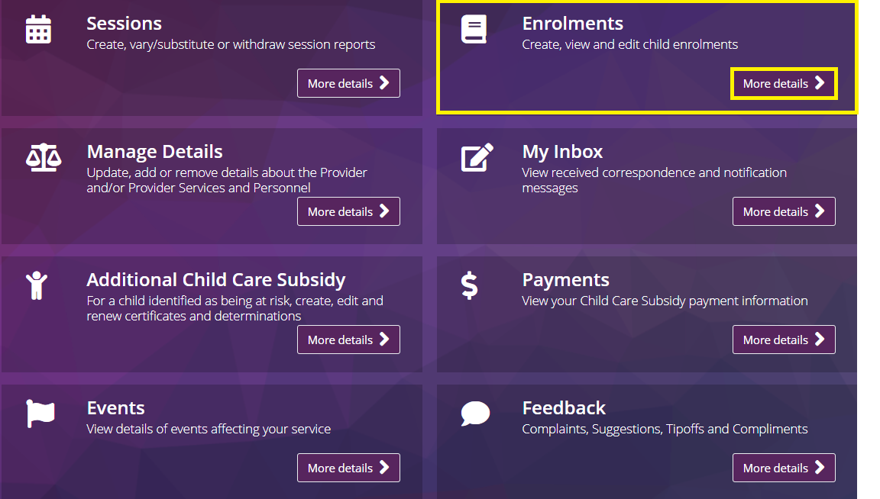

Step 2

Select the **New Enrolment Notice** button. A New Enrolment Notice window will open.

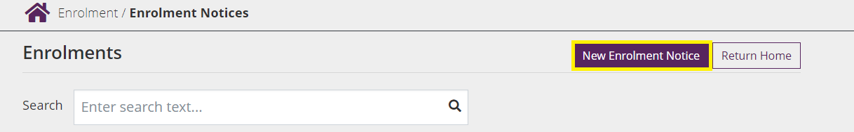

Step 3

Select an **Arrangement Type** from the drop down menu.

Select **Yes** or **No** as applicable if the child is under care of state/territory child welfare law.

Input the **arrangement start date** (which cannot be a date in the future) and **end date** (if applicable).

*Note: The system will indicate if the enrolment information is being submitted late. If submitted late, a reason will need to be recorded in the free text fields. Please refer to the* [*Child Care Provider Handbook*](https://www.education.gov.au/child-care-package/child-care-provider-handbook/enrolling-children) *for further details about required timeframes.*

Provide the **CRN, first name, last name** and **date of birth** of the child for whom care is being provided.

For Family Day Care or In Home Care services, select the **educator** who is the primary educator for the child from the list of registered educators.

*Note: the educator must have been registered in PRODA and added as an educator of the service for this step to occur.*

Screenshot of the new enrolment notice screen. 

Highlighted multiple fields requiring completion in a Complying Written Arrangement and notification - child and carer's CRN are optional, but payment cannot be made until both provided. Next button highlighted.

Step 4

Where the following arrangement types are selected additional information is required.

**Complying Written Arrangement**

* Select **Yes** or **No** as applicable if the CCS claimant is also the person who entered into the arrangement for care with the provider.
* If **Yes**, the claimant’s name will autofill the **Party to the arrangement** field.
* If **No**, you will need to enter the name of the person who entered into the arrangement with the provider.

*Note: To be eligible for CCS either the claimant, or their partner, must have incurred the liability to pay for the fees under a CWA.*

**Relevant Arrangement**

* Provide **first name** and **last name** of the parent who entered into the care arrangement with the provider.

**Arrangement with an Organisation**

* Provide **name of the organisation** who is liable for the fees for the child.

Select **Next**.

Step 5

Enter **session** and **usual fee** details.

This is **not** the weekly session reporting, but the type of care expected under the enrolment and details of any routine sessions (‘booked days’) for the child. This must be updated if the arrangement changes on an ongoing basis.

*Note: This information will be provided to the parent to confirm. For CWA enrolments, it is important that the information provided correctly reflects the care arrangement established with the parent. This information is only required for CWA enrolments and ACCS (Child wellbeing) – provider eligible enrolments.*

Select the **type of care**.

Select one of the following options from the **session type** drop-down menu:

* Routine sessions (casual permitted)
* Routine sessions only (no arrangement for casual care)
* Casual sessions only

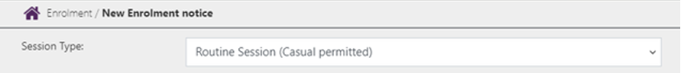

Record **weekly** or **fortnightly cycle**.

This allows you to indicate if a child’s sessions of care are the same week to week, or occur on a fortnightly basis (i.e. the routine sessions are different in the first week of each CCS fortnight to the second week). This may assist in booking a child’s routine days over a fortnight, noting parents’ subsidised hours are allocated per fortnight (not per week) for CCS.

If the child is booked to attend the same sessions of care each week, select **Weekly**.

If the child is booked to attend different sessions on alternating weeks, select **Fortnightly**.

If **Fortnightly** – is there at least one routine session in each week of the fortnight?

* Select **Yes** if the child is booked to attend at least one routine sessions of care in both weeks of the fortnight.
* Select **No** if the child is booked to attend routine sessions of care in only one week of each fortnight.

If **Fortnightly** – in which week is/was the child’s first routine session?

* This date is required to ensure routine sessions entered for a fortnightly cycle align with **CCS fortnights**.

Screenshot of the new enrolment notice screen highlighting session type of routine session (casual permitted), fortnightly cycle and no routine sessions in each week. 

Calendar and search function highlighted.

Record **session** and **usual fee** details

* For **Routine sessions (casual permitted):** the start time, end time, usual fee and fee unit (per session/hour) fields are mandatory for each routine session of care. It is optional to provide details for casual sessions of care to be provided.
* For **Routine sessions only (no arrangement for casual care):** the start time, end time, usual fee amount and fee unit (per session/hour) fields are mandatory for each routine session of care.
* For **Casual sessions only**: a minimum of one casual fee description, usual fee amount and fee unit (per session/hour) is mandatory. Session length is mandatory if fee unit is per session.
* If **Fortnightly cycle** is selected, two weeks of routine sessions will display.
* Additional sessions may be added for a day by clicking the **actions** button and then selecting **add**. These can be deleted by selecting **remove**.

Select **Next**.

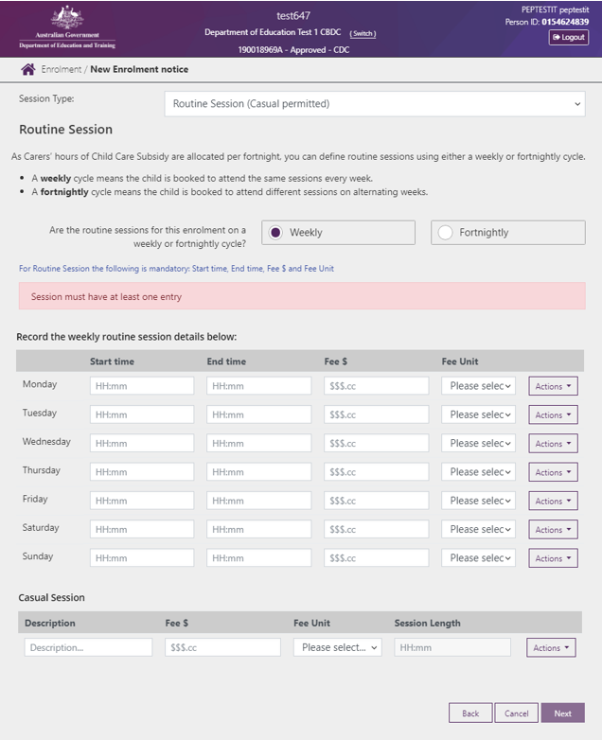

Step 6

Review the enrolment details.

To make changes to any of the details, select **Edit**.

To finalise the enrolment, select **Submit**.

Once submitted, an **Enrolment Notice Receipt** will be generated. Note the details.

Select **Return Home** to return to the provider home page or select **Continue** to return to the enrolment summary page.

### Next steps

**Family confirmation of enrolment (CWA enrolments only)**

* The enrolment details will be sent to the parent/guardian (the individual CCS claimant) for review. The status of the enrolment will be **Pending Confirmation**.
* The parent must confirm the details of the enrolment are correct before their CCS/ACCS entitlement can be paid to you on their behalf. This process is managed by Services Australia and does not require any action from the service or provider.
* If the parent disputes a detail about the enrolment, or indicates their child is not enrolled at the service at all (‘rejects’ the enrolment), you will receive a notification through the PEP advising of this. The status of the enrolment will also reflect the action the parent took i.e. **disputed** or **rejected**.
* If an enrolment is **disputed**, it will need to be updated with the correct information and the claimant will need to reconfirm this information before CCS/ACCS can be paid to you on the parents behalf.
* If an enrolment is **rejected**, you will not be able to update the enrolment. A new enrolment will need to be created if you have a care arrangement with the parent.
* The enrolment status will change from **Pending Confirmation** to **Confirmed** once the parent confirms the enrolment.

## Viewing an enrolment

### Before you begin

You must be a CCS approved provider to view enrolment status details (i.e. you have completed the transition workflow). The person viewing the enrolments must be linked to the CCS organisation as one of the following personnel:

* person with management or control of the provider
* person responsible for the day-to-day operational responsibility of a service
* service contact.

The **Enrolment Status** field can help you identify:

* if the parent (claimant) is eligible for CCS
* if the parent has confirmed the enrolment (required for CCS to be paid)
* when parent entitlement details should be available (e.g. CCS %, subsidised hours, including where parents’ entitlement is zero)
* when you can submit session reports for an enrolment
* when CCS can be calculated and paid for those sessions
* shows the steps to view enrolment status, and
* explains what each enrolment status means and what you or your parents may need to do next.

The following table outlines the **enrolment statuses for CWA enrolments** – some are not applicable to other arrangement types. Additional transitory statuses may appear in enrolment records.

|  |  |  |  |  |  |
| --- | --- | --- | --- | --- | --- |
| **Enrolment status** | **Definition** | **Next steps** | **Parent entilement displayed?** | **Can you submit session reports?** | **Can CCS be paid?** |
| **Received** | New enrolment submitted without child and/or parent CRN (previously ‘informal’) | Parent needs to provide CRN/s to provider. Provider updates enrolment with CRN/s. | No | Yes | No |
| **Pending eligibility\*** | Parent has not lodged a CCS claim for this child (may have claimed for other children) | Parent should lodge a claim as soon as possible. Enrolment confirmation will be part of claim process. | No | Yes | No |
|  | Parent has lodged a CCS claim and it is being processed (requires manual assessment) | Parent notified when claim assessment is finalised. Needs to confirm the enrolment. |  |  |  |
|  | Parent has lodged a CCS claim and is not eligible for the child | Parent notified if not eligible. May lodge new claim if circumstances change (e.g. residency status). |  |  |  |
| **Pending confirmation** | Parent has claimed (and is eligible) for the child before the enrolment was submitted | Parent notified. Needs to review the enrolment. | No | Yes | No |
| **Confirmed** | Parent has reviewed and confirmed the enrolment | Provider notified. Parent entitlement information available. Processing of session reports submitted before confirmation is triggered. CCS can be paid. | Yes | Yes | Yes |
| **Disputed** | Parent has reviewed the enrolment and indicated one or more details are not correct | Provider notified. Review enrolment. Discuss with parent and submit update notice. | No | Yes | No |
| **Rejected** | Parent has reviewed the enrolment and indicated the child is not enrolled at the service | Provider notified. Review enrolment. Discuss with parent and submit new enrolment notice if child is enrolled | No | No | No |
| **Ceased** | Enrolment end date reached | Ceased enrolments cannot be reactivated. Submit new enrolment notice if child is enrolled again. | No | No | No |
|  | 8 continuous weeks of non-attendance |  |  |  |  |
|  | Service/provider operations cease |  |  |  |  |

*If the parent is CCS eligible for another child, or has previously been CCS eligible for a child, they will be able to view and confirm these enrolments.

Step 1

From the service landing page, select **More details** under **Enrolments.**

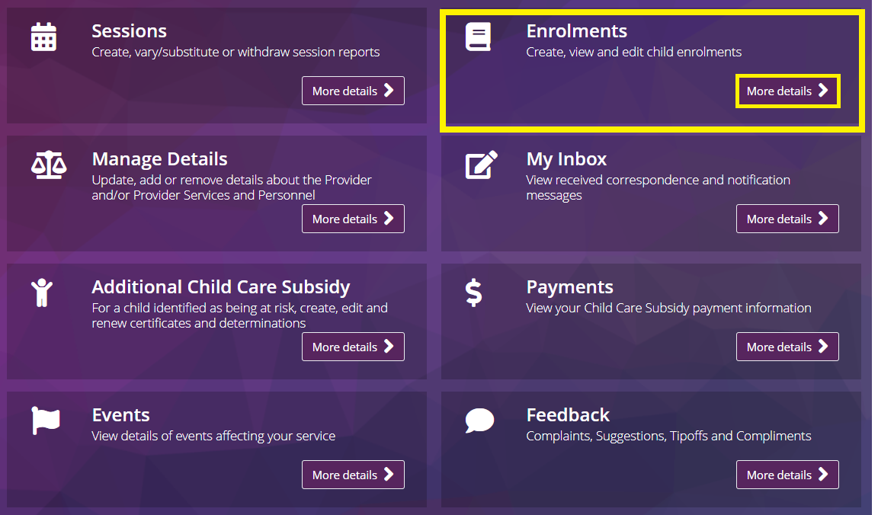

Step 2

The **Enrolment summary** page will open, displaying the most recent status for each enrolment. Definitions of each enrolment status are listed in the table above.

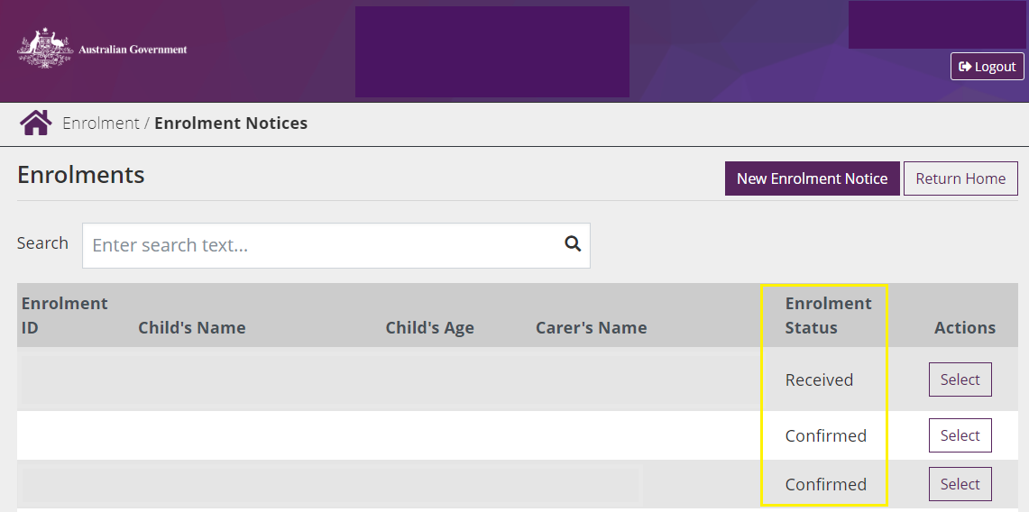

Step 3

The **enrolment detail** page also has the enrolment status displayed

This page appears if you select an individual enrolment from the list of enrolment notices in the summary page.

Screenshot of the enrolment notices screen.


### Next steps

You may need to help families confirm their enrolment. Below is a quick guide of how parents and carers can confirm their enrolments in their [Centrelink online account](https://www.servicesaustralia.gov.au/centrelink-online-account).

#### How to confirm your enrolment

Child Care Subsidy can only be paid to your child care provider if you have confirmed your child’s enrolment details. To do this you need to log in to your [Centrelink online account](https://www.servicesaustralia.gov.au/centrelink-online-account) through myGov.

1. From the menu go to **Child Care Subsidy** and then **Enrolments**.
2. If the **Enrolment Status** is **unconfirmed** click **Review**
3. Select **Yes** or **No** to whether the enrolment details are correct then click **Next**
4. If all the details are correct, read the declaration. If you understand and agree with the declaration, select **I accept this declaration**. Then select **Submit**.
5. Note of the **Claim ID** for your records, then select **Return Home**

To check your enrolment details have3 been updated, click the menu and go to **Child Care Subsidy** and then **Enrolments**.

## 

## Editing an enrolment

### Before you begin

Refer to the [Child Care Provider Handbook](https://www.education.gov.au/child-care-package/child-care-provider-handbook/enrolling-children) for information on when an enrolment needs to be updated.

Step 1

From the service landing page, select **More details** under **Enrolments.**

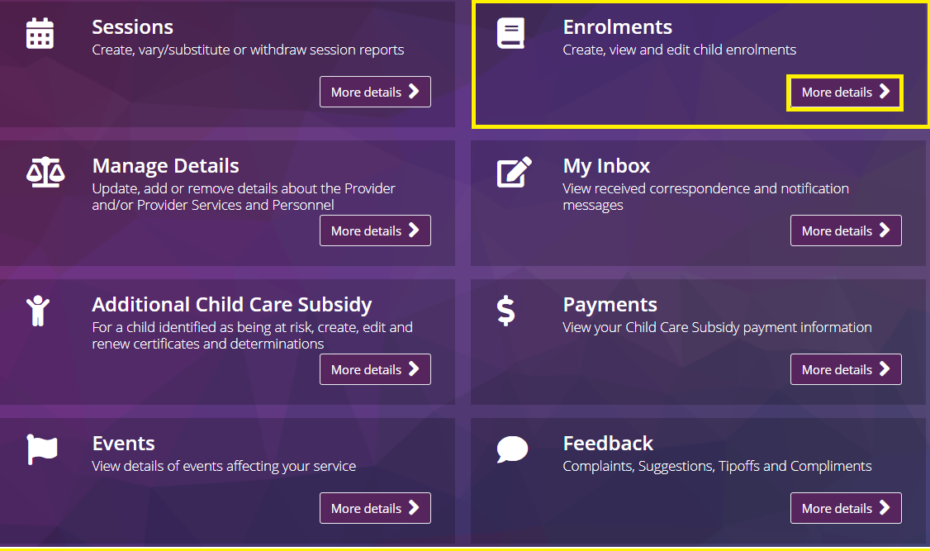

Step 2

All existing enrolment details associated with the service will be displayed. Select the enrolment you want to edit

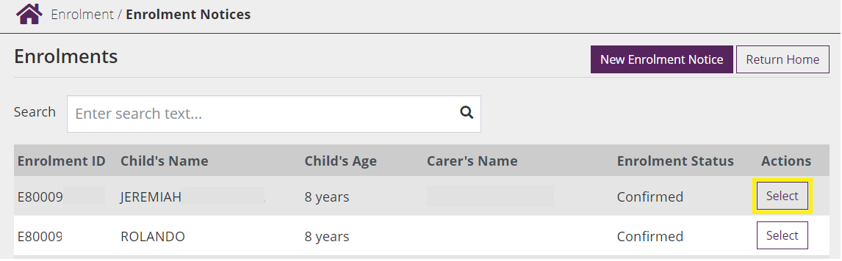

Step 3

Select **Update** from the **Actions** drop down menu.

The following fields of the enrolment are editable:

* Child under state/territory care (yes/no)
* Enrolment start and end dates
* CRN for the child/parent, only where these were not provided previously
* Party to arrangement/organisation name (if applicable)
* Educator details, where the primary educator for Family Day Care and In Home Care enrolments has changed.

Enter the date that the care details changed under **date of event**.

Select **Next**.

*Note: Where an enrolment is being updated following a parent dispute, the date of event should be the date the parent submitted that response (providers will be notified when this occurs).*

Additional information will need to be recorded if the enrolment information is being submitted late. Please refer to the [Child Care Provider Handbook](https://www.education.gov.au/child-care-package/child-care-provider-handbook/enrolling-children) for further details about allowed timeframes.

*Note: The system will indicate if the enrolment information is submitted late. If submitted late, a reason will need to be recorded in the reason field. For further details, please refer to the Provider Handbook.*

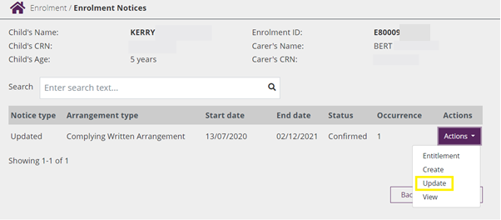

Step 4

Review and update the following information as needed by selecting **Edit**:

* Session type (type of care)
* Details of routine sessions (start time, end time, fee amount and fee unit)
* Details of casual fees (description, fee amount, fee unit (session or hourly) and session length)

Select **Submit.** An **enrolment notice receipt** will be generated. Note the details.

Click **Return Home** to return to the Provider Home Page. Click **Continue** to return to enrolment summary page