



Choice and Affordability Fund

2020 Annual Report

Creative Commons

With the exception of the Commonwealth Coat of Arms, the Department’s logo, any material protected by a trade mark and where otherwise noted all material presented in this document is provided under a [Creative Commons Attribution 4.0 Australia](https://creativecommons.org/licenses/by/4.0/) licence.  
The details of the relevant licence conditions are available on the Creative Commons website (accessible using the links provided) as is the full legal code for the [CC BY 4.0 AU licence](https://creativecommons.org/licenses/by/4.0/legalcode).

The document must be attributed as the Choice and Affordability Fund 2020 Annual Report.

Table of Contents

Executive Summary 4

Chapter 1: Overview of the Choice and Affordability Fund 4

Introduction 5

CAF priorities 6

A - Choice and affordability of schools 6

B - Transition assistance 7

C - Special circumstances funding 7

D - Strengthening outcomes for schools and educationally disadvantaged schools and students 7

E - Student wellbeing and support 7

F - Other priorities identified from time to time 7

Use of funding 8

Legislative framework 8

Deferred Funding 9

How do schools access the CAF? 9

Annual reports and accountabilities 9

CAF workplans 10

Annual reports and annual financial statements 11

Chapter 2: Reported progress against CAF priorities in 2020 14

Summary of progress against CAF priorities 14

Extraordinary delivery challenges in 2020 15

Choice and affordability of schools 16

Transition assistance 17

Special circumstances funding 18

Strengthening outcomes for schools and educationally disadvantaged schools and students 19

Student wellbeing and support 20

Enhancements coming out 2020 annual reporting process 21

Chapter 3: Summary of the CAF Financial Position 22

Table 1—Breakdown of 2020 CAF expenditure by category for all NGRB 22

Payments to NGRBs 23

Table 2— CAF payments to NGRBs 2021-2022 23

Table 3— Estimated CAF allocations to NGRBs 2022-2029 24

Chapter 4: Timetable of significant events and next steps 26

Summary of key actions 26

# Executive Summary

The Choice and Affordability Fund (CAF) commenced on 1 July 2020 with an estimated $1.2 billion to be provided to the non-government school sector to 2029. The CAF was established as a key mechanism to empower the non-government sector to support schools to deliver choice and affordability and transition to the Direct Measure of Income (DMI) funding arrangements. The CAF also provides support for schools facing financial hardship in special circumstances, to improve student outcomes and support student wellbeing.

The CAF is delivered through independent and Catholic non-government representative bodies (NGRBs) in each state and territory, recognising NGRBs are best placed to understand the challenges faced by their individual schools and to develop appropriate mechanisms for support. NGRBs are required to report annually on how the CAF has been used to achieve the priorities and activities agreed with the Australian Government.

The 2020 reporting reflects that 2020 was the first year of the CAF. Within the set parameters of the CAF, NGRBs have flexibility to use the CAF over ten years. The unprecedented impact of COVID-19 in 2020 and the limited time available in 2020 due to the CAF commencing mid-year is also reflected in the reporting.

Notwithstanding these factors, NGRBs made reasonable progress on all CAF priorities in 2020 with metrics indicating that hundreds of schools, and thousands of students and families, benefitted from CAF support in 2020. CAF funds were distributed directly to schools to support the DMI transition and to respond to COVID and used to support the implementation of important programs for student mental health, Indigenous students, providing fee relief for families in need, and child safety, and wrap-around services for disadvantaged students. NGRBs also undertook key preparatory work to comprehensively plan and establish activities, refine methods for accurately gauging future needs across years, and bring together appropriate systems to provide flexible and timely support in preparation for situations where higher demand may be realised in future years.

NGRBs reported spending $35.0 million of the total $103.0 million CAF allocation for 2020, of which approximately $30.7 million (or 87.8 per cent) was distributed directly to schools by NGRBs. NGRBs reported deferring $68.0 million of the total 2020 allocation to use in later years, reflecting the greater need for transition support anticipated from 2022, when the DMI funding arrangements are fully implemented.

The impact of COVID-19 was different for all NGRBs. In some cases, NGRBs reported spending more than had been budgeted due to an unforeseen need arising due to COVID-19 and the impacts of this on student wellbeing. In other situations, such as where delivery was not possible due to health restrictions, planned activities were rescheduled. Consequently, some NGRBs deferred more CAF funds in 2020 than planned and have adjusted plans for future years to address underspends in 2020.

As the first year of the CAF, 2020 was a learning process for all. Overall, the NGRB reporting for 2020 has demonstrated how funds have been allocated to help schools and, generally, NGRBs delivered the majority of activities as planned. There was a good level of detail provided on the activities undertaken and consistency with CAF agreements and associated plans. Following receipt and assessment of the 2020 annual reports, the former Department of Education Skills and Employment, (now the Department of Education) worked closely with NGRBs to refine implementation and reporting processes.

# Chapter 1: Overview of the Choice and Affordability Fund

## Introduction

As part of the Australian Government’s commitment to providing choice to Australian families, the Government announced the Choice and Affordability Fund (CAF). The CAF provides $1.2 billion over ten years from 2020 to 2029 to address specific challenges in the non-government school sector. The CAF is delivered through independent and Catholic non-government representative bodies (NGRBs) in each state and territory.

The CAF began in 2020, and payments commenced from July 2020, with an estimated $726 million allocated to Catholic sector from 2020 to 2029, including non-systemic Catholic schools represented by their Catholic NGRB, and $455 million for Independent schools over the same period. The difference in funding by sector is due to the greater number of schools and students represented by Catholic NGRBs.

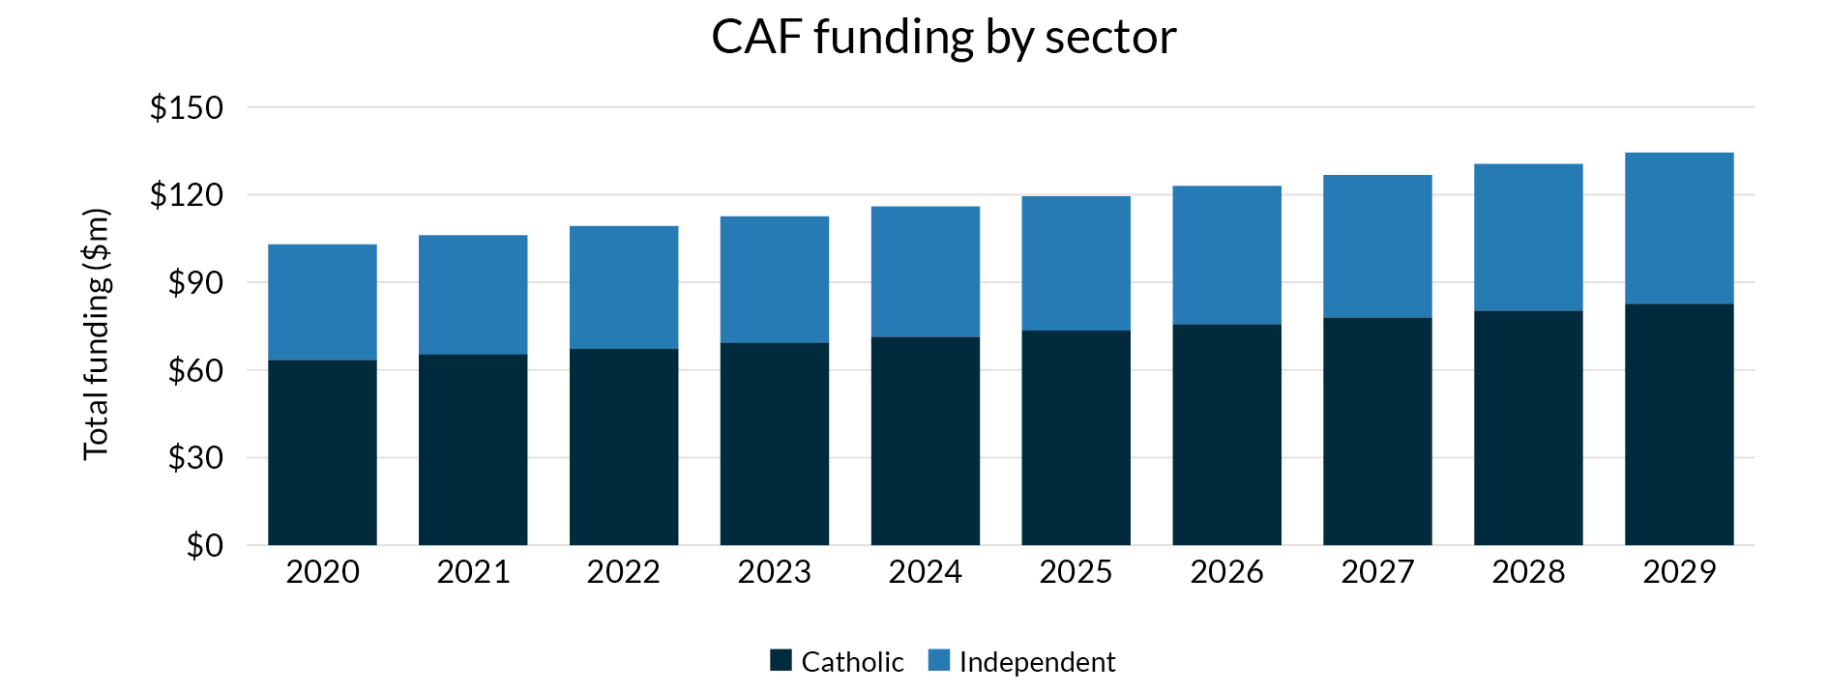

To guide implementation of the CAF, the former Department of Education, Skills and Employment (now the Department of Education, herein the Department) undertook several stages of consultation:

* Initial consultation occurred on broad policy intent, considerations, and timelines with the National Catholic Education Commission (NCEC) and Independent Schools Australia (ISA) to inform the development of the CAF agreements and CAF Guidelines.
* Consultation continued with state and territory Associations of Independent Schools (AIS), Catholic Education Commissions (CEC) and other interested authorities, and
* Formal consultation with respect to the legislative changes required to establish the CAF were conducted through state and territory Education Ministers, as required under the *National School Reform Agreement*.

Funding for the CAF is provided under the *Australian Education Act 2013* (the Act), and in accordance with the Australian Education Regulation 2013 (the Regulation). The Regulation requires that funding received from the CAF must be used by NGRBs for the purpose of supporting school education, and in accordance with the CAF Guidelines, the written funding agreement with the NGRB, and any written directions of the Minister for Education.

The CAF was established as a key mechanism to assist the non-government school sector to support schools to deliver choice and affordability. The CAF was designed to be administered by the non-government school sector at the state and territory level, on the basis that those most directly connected to schools are best placed to determine the relative need within school sectors. The CAF recognises the Australian Government is the majority funder of non‑government schools. States and territories, as the majority funder of government schools, already provide additional non‑recurrent support to government schools that is not available to non‑government schools.

Among other national priorities, the CAF prioritises assistance for non-government schools transitioning to the Direct Measure of Income (DMI) funding arrangements, with funding quarantined for regional and remote schools. Under the CAF, a minimum of 9 per cent of funding is required to be quarantined to directly assist regional schools to transition. The independent sector is quarantining a greater proportion of funding at the national level (33 per cent) for regional transition.

The Government has a range of supports in place to assist schools with the transition to the DMI, including arrangements for a gradual transition of recurrent funding through to 2029 for schools transitioning downwards to their target share of the Schooling Resource Standard (SRS).

The CAF also prioritises special circumstances funding, including for when schools are affected by drought or other natural disasters; providing choice to parents of an affordable school that will best suit their child; enhancing student wellbeing and support initiatives; and strengthening outcomes for schools and educationally disadvantaged schools and students. Further detail about the CAF National Priorities is provided next.

CAF priorities

Under the CAF, NGRBs must address the CAF national priorities of *Transition assistance* (including transition assistance for regional schools) and *Special circumstances* funding. NGRBs have discretion to address the other CAF national priorities and any local priorities aligned with the national priorities, however *Transition assistance* and *Special circumstances* funding must be prioritised over the other priorities NGRBs have chosen to address.

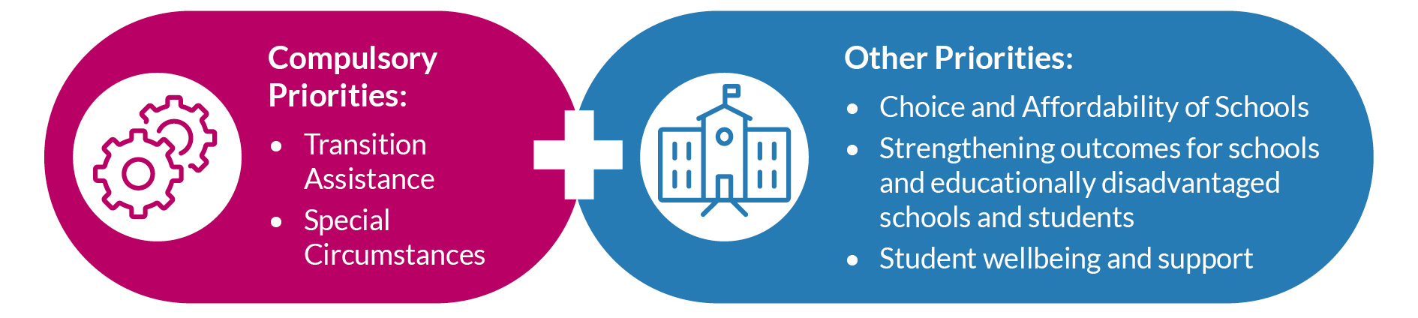

A subset of priorities that each NGRB will address are detailed in a written agreement between the NGRB and the Department. Where new priorities emerge, the Minister will consult with NGRBs on priorities to be progressed by the agreement of both parties in accordance with the NGRB’s CAF agreement. The CAF is not intended as a replacement for other sources of Commonwealth funding.

The national priorities of the CAF are:

A - Choice and affordability of schools   
The CAF provides funding for initiatives that facilitate parental choice and opportunity giving parents the ability to choose an affordable school that will best suit their individual child.

### B - Transition assistance

The CAF incorporates the National Adjustment Assistance Fund which was established to provide transition funding support for non-systemic independent schools. This means NGRBs make financial and other transition support available for schools that would have met the criteria to have access to support through the National Adjustment Assistance Fund; that is, non-systemic independent schools which are expected to experience reductions in per student funding due to changes in Commonwealth recurrent funding settings over 2020 to 2029. The CAF also provides support for schools in general to transition to a new capacity to contribute model for recurrent funding.

C - Special circumstances funding   
The CAF supports schools and students impacted by special circumstances or in priority areas such as rural, regional and remote locations and areas affected by drought or other natural disasters.

Special circumstances funding is prioritised for schools requiring short term emergency assistance when unexpected circumstances or events cause severe and temporary financial difficulty. Assistance should be provided for schools in situations that satisfy all of the following criteria:

* **unexpected**
  + Could not have been reasonably foreseen.
* **causing severe financial difficulty**
  + Where a school faces a real prospect of having to cease a large part of its educational activities or significantly lower its educational services.
* **short term**
  + Schools should be able to overcome their financial difficulty and resume operations and must provide a five-year business and recovery plan.
* **a special need** 
  + Schools have exhausted all other options to remedy the financial situation of the school.

### D - Strengthening outcomes for schools and educationally disadvantaged schools and students

The CAF supports initiatives that strengthen outcomes for schools such as helping underperforming schools improve outcomes including through school industry partnerships, and supporting educationally disadvantaged schools and students.

### E - Student wellbeing and support

Student wellbeing is essential for both academic and social development. The CAF supports schools that require additional assistance to ensure safe, supportive and respectful learning environments.

### F - Other priorities identified from time to time

There is scope within the CAF for other priorities to be identified by the Minister from time to time, as specified in any written direction by the Minister issued under the Regulation to the NGRB.

## Use of funding

### Legislative framework

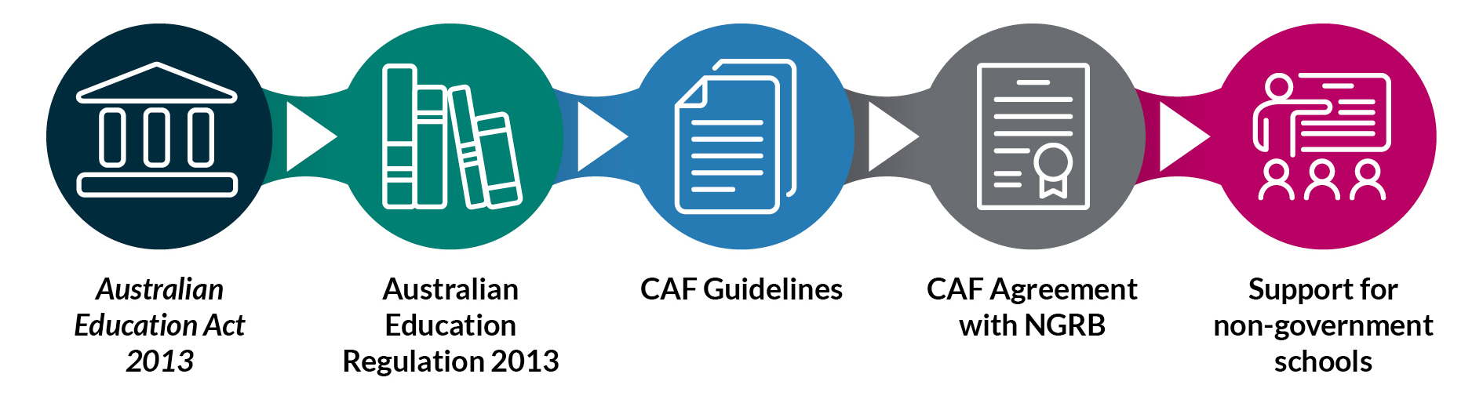

Funding is paid to NGRBs under section 70 of the Act, and administrative arrangements for the CAF are set out in the CAF Guidelines and written agreements with NGRBs in accordance with the Regulation.

The Act and Regulation:

* Place a cap on the amount for the CAF and list matters the Minister must consider when determining funding to NGRBs, and
* Impose rigorous accountability and reporting requirements to ensure funding is used in accordance with the Government’s objectives for the CAF.

Within the high-level requirements for the CAF outlined above and below, NGRBs have flexibility to determine the nature and level of support provided for their schools to best achieve the priorities according to their school’s individual circumstances. This includes flexibility to adjust the expenditure profile to defer of funds to later years when greater need is anticipated in future years.

CAF funding is used to provide financial assistance and support to non‑government schools including directly distributing funding to schools or delivering centralised programs to schools.

CAF funding *must* be used for the purposes of supporting school education. Further, NGRBs, approved authorities and non‑government schools *must* only spend, or commit to spend, CAF funding for:

* Implementing and delivering activities directly for the benefit of or on behalf of non-government schools in line with the activities specified in the NGRB’s written agreement.
* Administration costs of the NGRBs directly associated with implementing the activities and up to two per cent of total funding provided over the ten years from 2020 to 2029 to meet the costs of administering the CAF.

In addition, NGRBs must spend, or commit to spend, all funding provided under the Act by 31 December 2029, unless a later date is approved by the Minister. NGRBs can request such an approval in writing and are required to provide any supporting information required by the Minister, prior to the end of 2029. An approval of a later date will generally only be considered in exceptional circumstances.

NGRBs can only spend, or commit to spend, CAF funding for the benefit of schools that the NGRB is approved by the Minister at that time to represent. NGRBs are expected to work collaboratively with the schools they represent to support local priorities and to deliver on their agreement, ensuring that all represented schools are afforded equity of access to appropriate initiatives and activities. Each NGRB will determine the equitable share of funding for its schools in accordance with the allocative mechanism applied by that NGRB and in accordance with its agreement.

### Deferred Funding

To support flexibility, NGRBs can spend CAF funding over the period 2020 to 2029 in order to best achieve objectives aligned to the agreed national priorities and according to their local circumstance. Expenditure of some or all of the CAF funds received may occur in later years, as long as the NGRB commits to the expenditure before 31 December 2029, or a later date if approved by the Minister.

Although the expenditure of some or all of the CAF funds received may occur in later years subject to limitations, NGRBs cannot bring expenditure forward where such a commitment would rely on an *unreleased* amount of CAF funding.

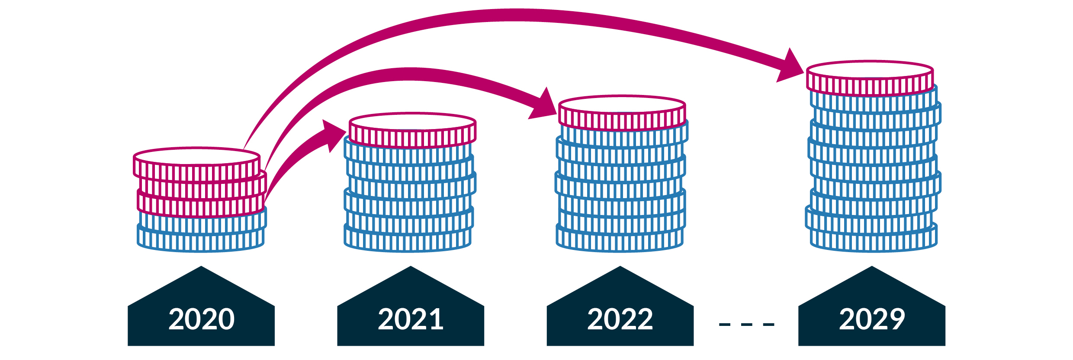

The Department closely monitors the movement of funds through the reporting mechanisms and NGRBs are required to report interest earned on funds deferred to later years. Any interest earned on CAF funding must be reported to the Department and used in the same way as CAF funding and be reinvested into activities in accordance with the Regulation.

### How do schools access the CAF?

Non-government schools interested in gaining support under the CAF should contact their NGRB for further information.

## Annual reports and accountabilities

As NGRBs can use funds flexibly over the period from 2020 to 2029, in accordance with the CAF Guidelines and the NGRB’s stated plans for investment in addressing the CAF National Priorities, it is important to have clear and transparent accountabilities and reporting requirements.

Where an NGRB anticipates a consistent approach in the delivery of the national priorities *Choice and Affordability of Schools, Transition assistance* or *Special circumstances funding*, the written agreement with each NGRB provides the mechanism for reporting and accountability. Where there are delivery approaches planned by the NGRB which are subject to change over time, are more complex in nature, or involve centralised delivery by the NGRB, these work programs require more detailed two or four-year workplans to support clear reporting and accountability. The written agreement will state if an NGRB also requires a workplan.

The written agreements with each NGRB, including workplans, are publicly available on the Department’s [Choice and Affordability Fund Agreements page](https://www.dese.gov.au/quality-schools-package/fact-sheets/what-choice-and-affordability-fund/caf-agreements).

Payment of instalments of the CAF are subject to a satisfactory workplan being received and approved (where applicable), and all other reporting requirements having been met.

CAF workplans

If required by the written agreement with an NGRB, the NGRB must have an approved workplan detailing activities or initiatives to support the agreed priorities listed in the written agreement. The workplan must include objectives and expected outcomes and measures of success for each activity or initiative.

Each NGRB workplan (where there is such requirement) must include:

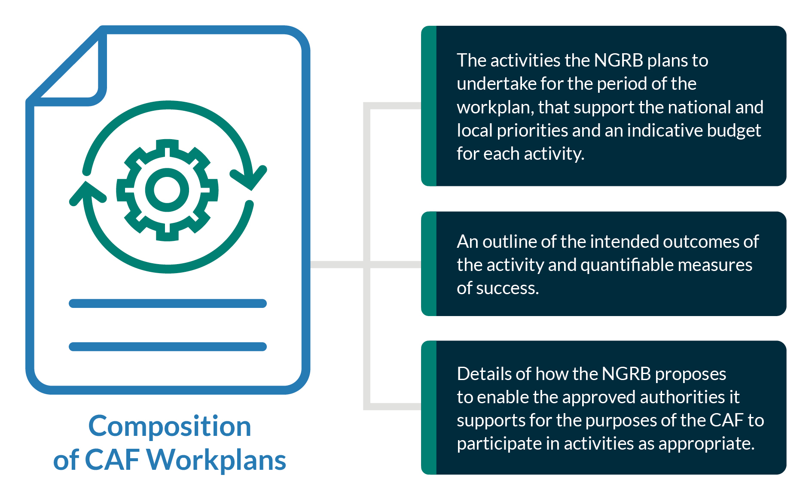

Once approved, the NGRB workplan forms part of the written agreement and in accordance with the agreement, any variations to an approved workplan must also be agreed in writing.

The CAF workplan must be submitted and approved prior to provision of CAF funding for the period covered by the workplan. While two-year CAF workplans were required to cover the period 2020 to 2021, the next iterations of CAF workplans are required to cover the four-year period 2022 to 2025, and then renewed again to cover 2026 to 2029.

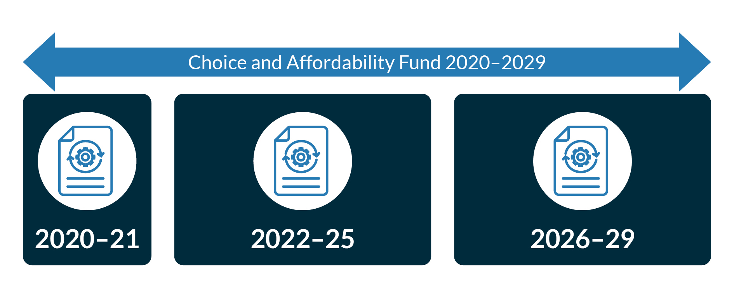

The two-year 2020-2021 CAF workplans allowed time for NGRBs and schools to work together to develop transition plans ahead of the full implementation of the DMI from 2022.

Prior to the conclusion of a CAF workplan, an updated CAF workplan must be submitted to, and approved by, the Secretary to continue receiving CAF funding for the following period. Payment is subject to a satisfactory CAF workplan being approved.

Annual reports and annual financial statements

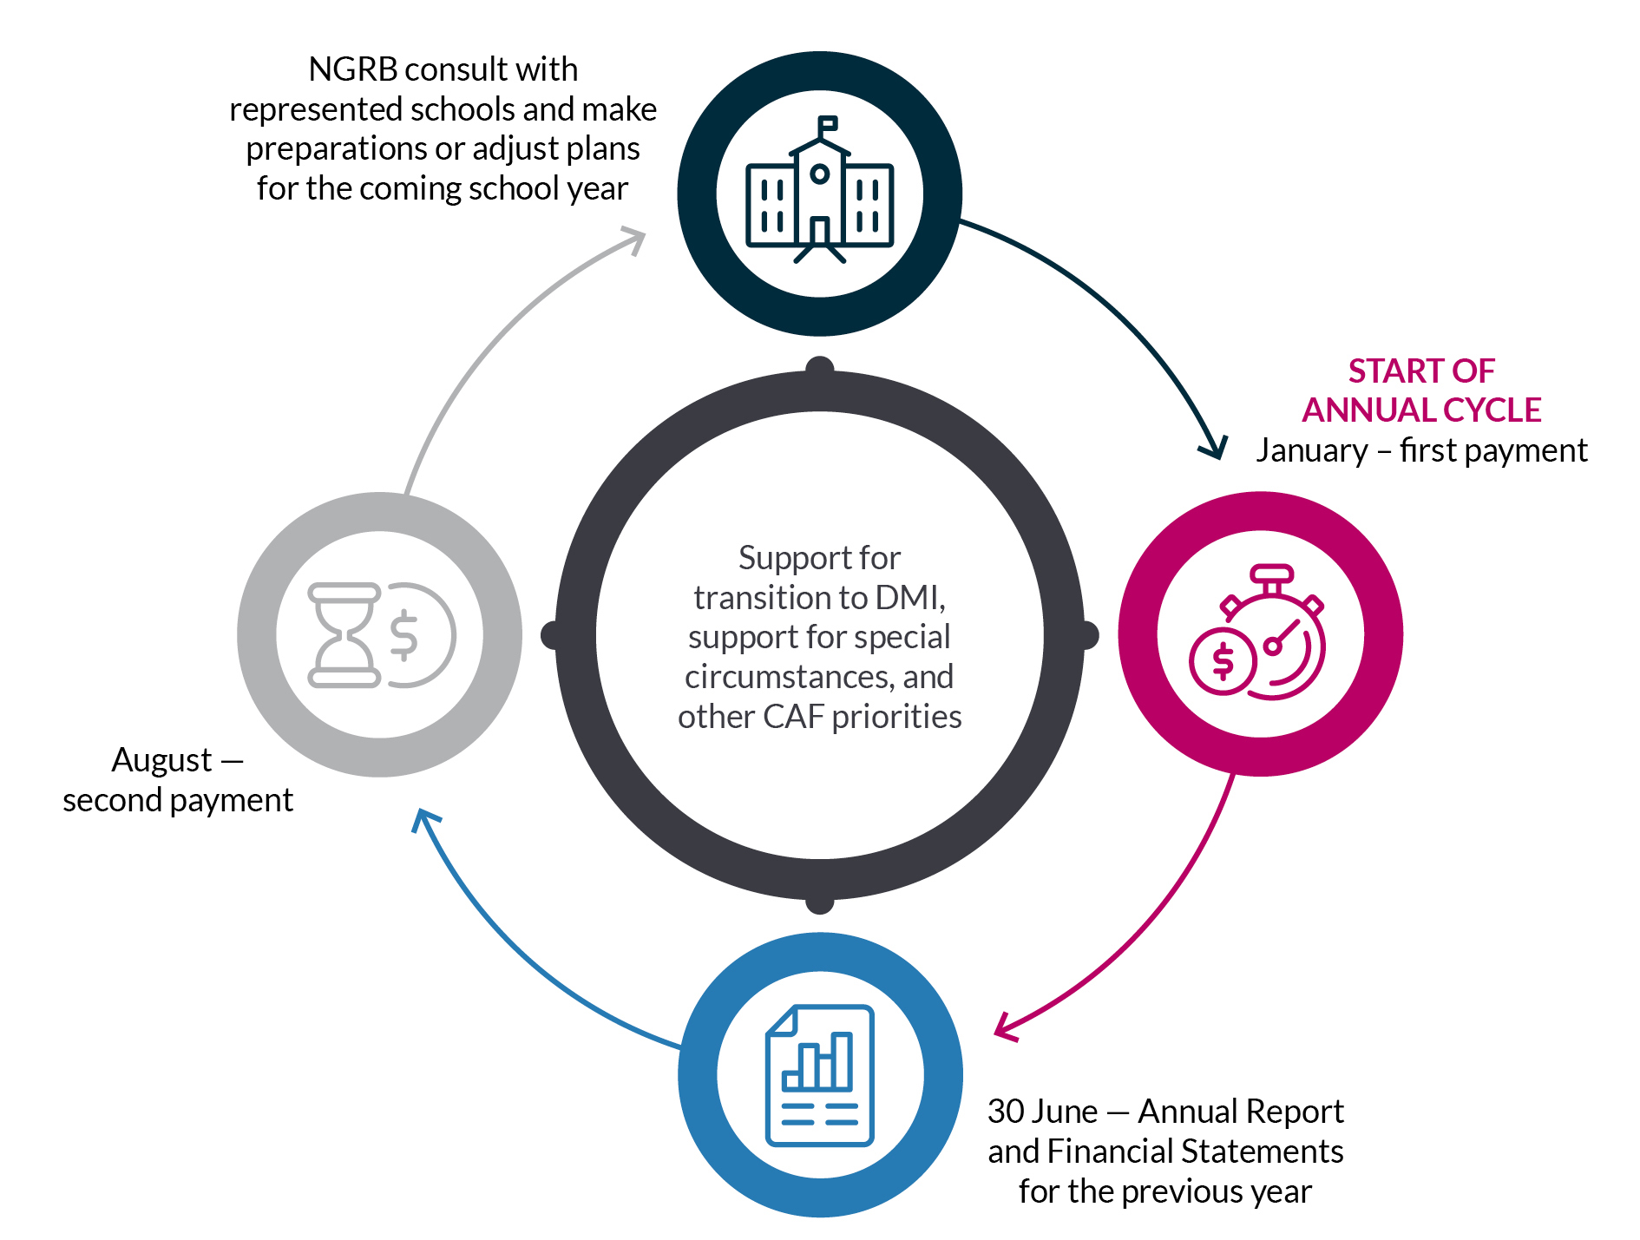

Under the Regulation, by 30 June of each year, NGRBs must provide an annual report in relation to their activities for the previous year. The annual report outlines the NGRB’s progress in achieving the agreed priorities, stated objectives, and intended outcomes identified in the written agreement, and where required, the CAF workplan.

The annual reporting requirements are set out in the CAF Guidelines and written CAF agreements and were developed in consultation with NCEC, ISA and the NGRBs.

The Department analyses the CAF annual reports to confirm funding has been used in accordance with the CAF Guidelines, written agreements and workplans, and approval of each NGRBs CAF annual report is a condition of ongoing CAF funding.

At a minimum, the NGRB’s CAF annual report must include:

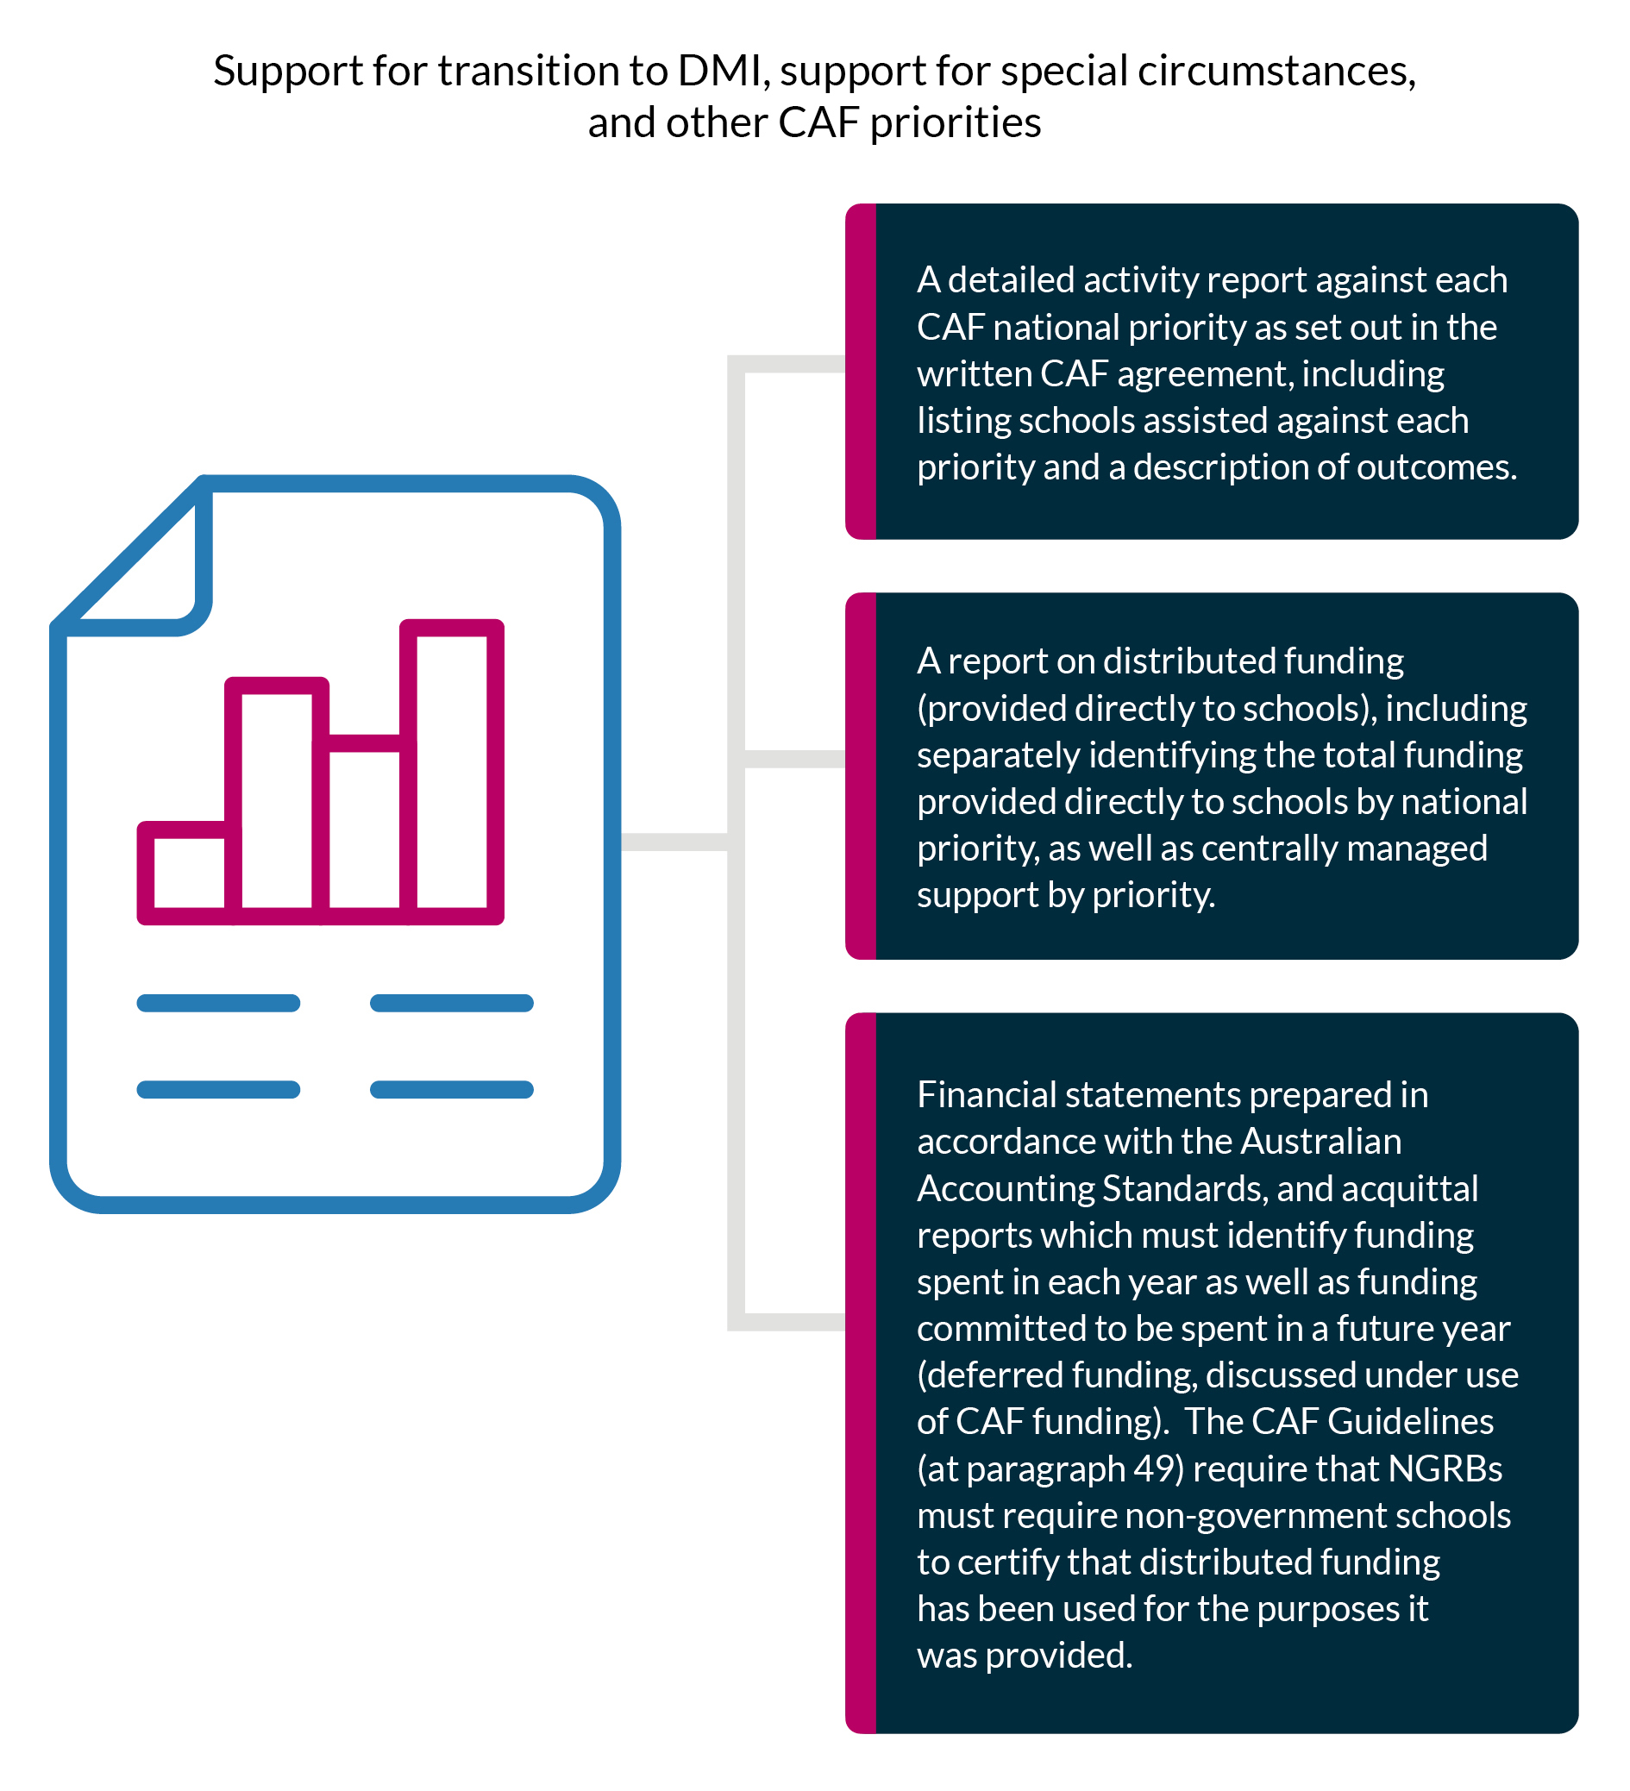

* A detailed activity report against each CAF national priority as set out in the written CAF agreement, including listing schools assisted against each priority and a description of outcomes.
* A report on distributed funding (provided directly to schools), including separately identifying the total funding provided directly to schools by national priority, as well as centrally managed support by priority.
* As outlined in the Regulation, financial statements prepared in accordance with the Australian Accounting Standards, and acquittal reports which must identify funding spent in each year as well as funding committed to be spent in a future year (deferred funding, discussed under use of CAF funding). The CAF Guidelines (at paragraph 49) require that NGRBsmust require non-government schools to certify that distributed funding has been used for the purposes it was provided.

The Minister’s approval of the NGRB’s CAF annual report is required as a condition of ongoing funding. Paragraph 53 of the CAF Guidelines notes that the Minister’s approval of ongoing funding focuses on the assessed *consistency* of an NGRB’s CAF annual reporting with the priorities outlined in the CAF agreement and if relevant, CAF workplan. The Minister’s approval of ongoing funding also focuses on the distribution of funding to the NGRB’s represented schools.

Paragraph 66 of the CAF Guidelines requires each NGRB to ensure that it makes its approved CAF annual reports publicly available, with 2020 annual reports already available on NGRB websites.

Following assessment of the NGRB CAF annual reports, the Department is required to publish a consolidated annual report on the expenditure of CAF funding. The Department will publish this annual report each year following receipt and assessment of the NGRB annual reports.

# Chapter 2: Reported progress against CAF priorities in 2020

Summary of progress against CAF priorities

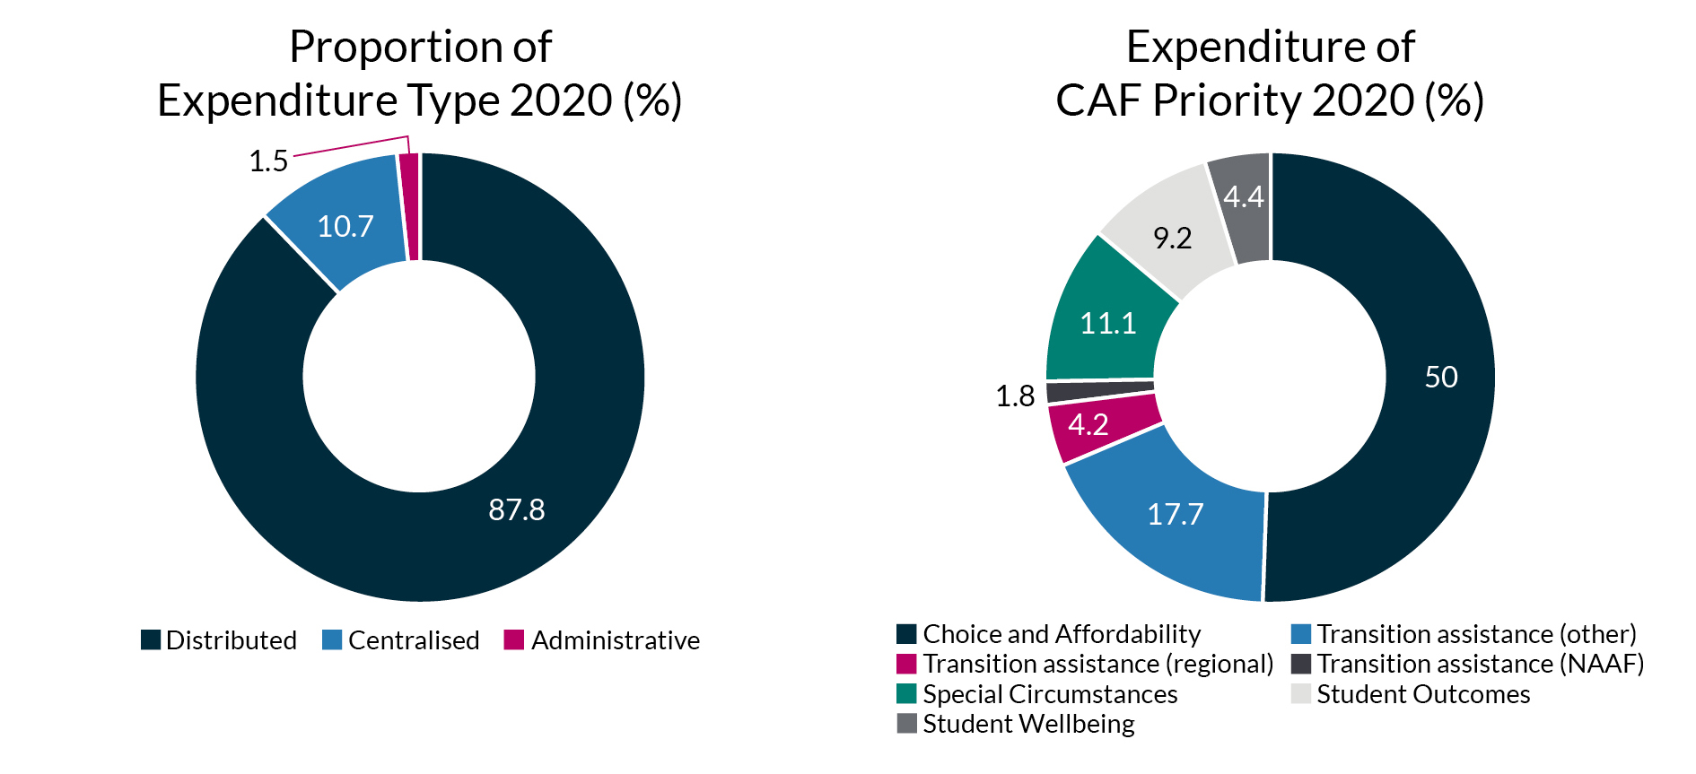

The CAF agreements with the 16 NGRBs include a range of approaches to use CAF funding flexibly to achieve the priorities of the fund according to their own schools’ circumstances. In addition to addressing the two compulsory national priorities of *Transition Assistance* and *Special Circumstances funding* in 2020, most NGRBs also addressed the non-compulsory national priorities: *choice and affordability of schools*, *strengthening outcomes for schools and educationally disadvantaged schools and students*, and *student wellbeing and support*.

The NGRB reporting for 2020 has demonstrated how funds have been allocated to help schools. On the whole, NGRBs delivered the majority activities as planned, and across the board there was a good level of detail provided on the activities undertaken and consistency with CAF agreements and workplans. The reporting against stated objectives also demonstrated that NGRBs have made reasonable progress on CAF priorities in 2020 with metrics indicating that hundreds of schools, and thousands of students and families, benefitted from CAF support in 2020.

With the CAF payments commencing in July 2020, the scope of some activities planned were limited by the time available in 2020. Further, some CAF agreements were finalised after July 2020 following additional consultation and negotiation, which had minor impacts on the delivery of the original scope of activities that NGRBs undertook to achieve in 2020.

NGRBs used the time in 2020 to develop strategies for the transition period 2020-2029 that will determine the best transition path to the new DMI funding arrangements while ensuring quality student outcomes and financial viability of schools. This is in keeping with NGRBs’ original plans to develop methods for distributing the funding from 2022 and to develop appropriate mechanisms for support to address other CAF priorities such as special circumstances. Consequently, NGRBs have also deferred a considerable proportion of 2020 CAF funds to be used from 2022 as planned, recognising when the impact of the DMI is more likely to be felt by represented schools.

NGRBs reported targeted efforts in 2020 (and continuing through 2021) to ensure that systems are established to support the distribution of *regional transition assistance* to schools and that this assistance meets the agreed (and required) minimum commitment expected from NGRBs over the life of the CAF. NGRBs also reported on their work to ensure that appropriate mechanisms for support had been developed to set aside CAF funding for special circumstances such as natural disasters and other unforeseen events which could arise in the future.

It is important to note that 2020 was the first year of the CAF and as such a learning process for all. There was also the unprecedented impact of COVID-19, which is discussed in further detail in this chapter. While each NGRB is responding to its own local context, for the duration of the CAF NGRBs will have the opportunity to continue to learn from each other’s experience, both in terms of the types of activities being undertaken as well as reported innovations in networking and delivery such as those deployed to maintain CAF delivery in the face of COVID-19.

In some cases, NGRBs reported spending more than had been budgeted due to an unforeseen need arising from a range of disruptive factors caused by COVID-19 and the impacts on student wellbeing. In other situations, such as where delivery was not possible due to health restrictions, planned activities were rescheduled. NGRBs explained how they balanced their budgets to provide additional funding.

As part of the inherent flexibility of the CAF to serve local needs, the CAF allows some variances between budgeted and actual expenditure. Variances must be within the allowable tolerances provided by the CAF Guidelines and NGRBs are required to report and explain variances. Overall, while such variances were reported in 2020, the delivery of the CAF in 2020 appears on track. The NGRBs affected by a range of disruptions noted the management actions and approach they will take to ensure the attainment of goals over the life of the CAF.

Extraordinary delivery challenges in 2020

Against the backdrop of 2020, a year which brought many challenges including bushfires, drought and the COVID-19 pandemic, there were many reports of planned CAF activities being impacted in different ways by unforeseen events. Due mainly in part to the COVID-19 pandemic, some of the restrictions put in place made it very challenging for NGRBs to engage schools across the various projects and initiatives. NGRBs reported that the impacts were not only confined to their delivery and capacity to roll out projects, and that some represented schools had reportedly expressed concerns about committing to too much or situations where schools had a necessary focus on managing periods of remote delivery to students.

As such, NGRBs reported that in 2020 more time was spent in refining planning than was expected, thereby increasing activity involving centralised expenditure during 2020, and increasing the amount of funding deferred. Many NGRBs described this rescheduling as beneficial because plans have been refined and will guide increased efforts to engage with schools in 2021. Other NGRBs noted that the rescheduling which resulted in additional planning work will mean there will be reduced centralised expenditure in 2021.

NGRBs were proactive about finding ways to overcome barriers to delivery, reporting that although initial planning for some projects was based on the hope that COVID-19 travel and gathering restrictions would allow more face-to-face activities towards the end of 2020, NGRBs held online events or in some instances, postponed activity to 2021 to ensure the impact of the work was not diminished.

The majority of NGRBs reported making good progress against many of their planned activities, with time used to establish and prepare piloting of initiatives in 2020 which continue through 2021, and other work completed with schools, laying foundations for rollouts in 2021. Several NGRBs reported that for 2020, they had made progress meeting most of the indicators of success, with some activities fully achieved in 2020, and other work completed in 2020 laying the foundation for full implementation in 2021.

NGRBs have been asked to provide more information in future reporting about how they are progressing delivery in 2021 and managing the ongoing risk of COVID-19.

The next section of this chapter outlines the range of activities being delivered by NGRBs in 2020 against the CAF priorities, and the numbers of schools assisted to date.

Chapter 3 of this report summarises NGRB expenditure of the CAF in 2020, and where funding has been deferred to later years.

Choice and affordability of schools   
*The CAF provides funding for initiatives that facilitate parental choice and opportunity giving parents the ability to choose an affordable school that will best suit their individual child.*

|  |  |
| --- | --- |
| **Summary of activities undertaken in 2020 and overall rating of progress.**  The overall progress made in respect of CAF Priority A in 2020 is considered very good. Activities under this priority have delivered choice of affordable education for families, including through fee relief, which was particularly important in 2020 when considering the economic impacts from the COVID-19 pandemic since January 2020. | |
| Activities being delivered under the CAF national priority—*Choice and Affordability* of schools, include:   * Centralised assistance from NGRBs emphasising support for financial sustainability, including development of governance improvement tools and independent reviews of school financial practices to develop continued viability. * School-level business development planning to streamline business practices and improve efficiency.   + Activities delivered range from engagement of professionals such as chartered accountants and other school finance and school improvement experts to work with schools to assess their financial health, to direct assistance provided to schools working with the experts to cover their costs and to support for the implementation of structural adjustments to streamline business practices to meet their long-term financial needs. * Fee remission for disadvantaged schools or students and/or support for schools that provided fee concessions to families because of the impacts of COVID-19 where families have been unable to pay school fees due to their financial situation because of job losses or reduced working hours. * Development of a digital presence to help principals assist families to make the correct choice when choosing a school for their child. | |
| **Progress and Achievements** | |
| * Centrally managed activity delivered to the benefit of 168 schools nationally. | * Direct assistance in the form of distributed CAF funds provided by NGRBs to 226 schools nationally. |

Transition assistance

*The CAF incorporates the National Adjustment Assistance Fund which was established to provide transition funding support for non-systemic independent schools. This means NGRBs make financial and other transition support available for schools that would have met the criteria to have access to support through the National Adjustment Assistance Fund; that is, non-systemic independent schools which are expected to experience reductions in per student funding due to changes in Commonwealth recurrent funding settings over 2020 to 2029. The CAF also provides support for schools in general to transition to a new capacity to contribute model for recurrent funding*.

|  |  |
| --- | --- |
| **Summary of activities undertaken in 2020 and overall rating of progress.**  The overall progress made in respect of CAF Priority B in 2020 is considered satisfactory to good. Many NGRBs focused on planning and development of systems to support the appraisal of school needs for transition assistance. As the full impacts of the DMI are not felt until 2022, NGRBs plans to date indicate progress is on track comprehensive support from 2022. The Department has also encouraged NGRBs to focus on communicating plans with schools to provide certainty ahead of 2022. | |
| Activities being delivered under the CAF national priority—Transition Assistance, include:   * Professional assistance for the development and implementation of transition plans at the school level to support schools during their transition to their 2029 recurrent funding levels. NGRBs are taking similar approaches with support from the CAF with these activities focused on:   + Supporting schools to develop Transition Plans to help schools consider their viability and business model into the future and outline clear transition paths to the DMI arrangements by 2029.   + Assisting schools to adapt their existing business models to support transition through developing models of forensic analysis of existing school business models and financials and a process for schools to develop transition plans (including for schools which would have been eligible under the National Adjustment Assistance Fund). * Development of funding distribution models to schools, for implementation from 2022 when the DMI has wider effects, in consultation with schools. NGRBs are working to develop transparent processes and criteria for assessing school need.   + This includes support for regional and remote schools that are negatively impacted by the DMI funding arrangements and schools that would have been eligible for funding under the former National Adjustment Assistance Fund (NAAF) funding (see Attachment D). * In most cases, these activities are continuing in 2021 to prepare schools for transition changes required over 2022 to 2029. | |
| **Progress and Achievements** | |
| * Centrally managed activity delivered to the benefit of 21 schools nationally. | * Direct assistance in the form of distributed CAF funds provided by NGRBs to 74 schools nationally. Includes:   + 21 regional schools; and   + 15 schools that would have been eligible to receive NAAF. |

Special circumstances funding   
*The CAF supports schools and students impacted by special circumstances or in priority areas such as rural, regional and remote locations and areas affected by drought or other natural disasters.*

*Special circumstances funding is prioritised for schools requiring short term emergency assistance when unexpected circumstances or events cause severe and temporary financial difficulty. Assistance should be provided for schools in situations that satisfy all of the following criteria:*

* ***unexpected***
  + *Could not have been reasonably foreseen.*
* ***causing severe financial difficulty***
  + *Where a school faces a real prospect of having to cease a large part of its educational activities or significantly lower its educational services.*
* ***short term***
  + *Schools should be able to overcome their financial difficulty and resume operations and must provide a five-year business and recovery plan.*
* ***a special need*** 
  + *Schools have exhausted all other options to remedy the financial situation of the school*.

|  |  |
| --- | --- |
| **Summary of activities undertaken in 2020 and overall rating of progress.**  The overall progress made in respect of CAF Priority C in 2020 is considered good. Many NGRBs have focused on planning and development of systems to provide for equitable responses to schools in need of short-term support and to ensure that resources can be quickly deployed where any unforeseen events may give rise to schools experiencing a severe financial difficulty impacting educational services.  A number of NGRBs used CAF to help schools respond to challenges presented by COVID-19 and continue to provide school education. Another NGRB focused on providing support to schools where the school community were dealing with the impacts of drought. The Department has encouraged NGRBs to learn from each other and consider how the CAF can continue support to schools in relation to COVID-19 in 2021. | |
| As the CAF national priority—Special circumstances funding is to be specifically prioritised for schools requiring short term emergency assistance when unexpected circumstances or events arise. Special circumstances funding represents the most flexibly responsive part of the CAF and may not always be consumed in the period for which it is allocated.  Activities being delivered under the CAF national priority—Special Circumstances, include:   * NGRBs developed transparent methods for setting aside notional amounts per year that will be drawn down if short term emergency needs arise, or reallocating funding from other priorities to meet requirements as they occur. Some NGRBs have established governance models where special circumstances funding is considered on a case-by-case basis by a sub-committee, or where activity funding will be informed by an independent reference group. * Drought relief for schools in Queensland. * Establishing a student counselling program in response to COVID-19, to assist with urgent need in regional areas where there were limited services available. * Providing direct grants to support schools with the increased costs associated with maintaining safe environments for staff and students in relation to COVID‑19. | |
| **Progress and Achievements** | |
| * Centrally managed activity delivered to the benefit of 89 schools nationally. | * Direct assistance in the form of distributed CAF funds provided by NGRBs to 151 schools nationally. |

Strengthening outcomes for schools and educationally disadvantaged schools and students

*The CAF supports initiatives that strengthen outcomes for schools such as helping underperforming schools improve outcomes including through school industry partnerships, and supporting educationally disadvantaged schools and students*.

|  |  |
| --- | --- |
| **Summary of activities undertaken in 2020 and overall rating of progress.**  The overall progress made in respect of CAF Priority D in 2020 is considered good. The 2020 CAF annual reports demonstrated that NGRBs have supported a wide range of students and school communities, noting that COVID-19 had impacted planned delivery to differing extents. The extent of barriers to delivery varied depending on the necessary response by health authorities to contain COVID-19 in different jurisdictions. The NGRB reporting demonstrated the strategic planning being conducted by NGRBs to ensure that alternative methods for delivery are considered and that support is maintained in the face of significant challenges. | |
| Activities being delivered under the CAF national priority—Strengthening outcomes for schools and educationally disadvantaged schools and students, include:   * NGRB initiatives working with Curriculum and Re-Engagement (CARE) Schools to improve attendance and engagement of secondary disengaged students to improve educational outcomes, and initiatives working with Aboriginal Community Schools and with CARE Schools, to identify underperforming schools for intensive intervention, to improve student outcomes. * Engagement of a Curriculum Consultant to work with schools and provide regular, relevant professional learning targeted to each school’s context, and education officers to work with schools to assist in the identification of educationally disadvantaged students. * A School Industry Partnership Program, where the NGRB brokered and facilitated collaborations between teachers and industry experts to help teachers design learning experiences for students that are innovative, engaging and reflect contemporary practices. * Provision of professional learning, early intervention, coaching for schools and measurement and evaluation processes. * Programs to improve literacy, numeracy, and other academic outcomes of Aboriginal and Torres Strait Islander students. * Providing STEM opportunities to students from underrepresented groups to improve practical knowledge, skills and confidence of students using immersive technologies. * Initiatives aimed at driving improvements for students in the key areas of Identity, Literacy, Numeracy, Belonging and Relationships, which will support school-based staff to provide a system-wide approach to strengthening student outcomes. | |
| **Progress and Achievements** | |
| * Centrally managed activity delivered to the benefit of 138 schools nationally. | * Direct assistance in the form of distributed CAF funds provided by NGRBs to 53 schools nationally. |

Student wellbeing and support

*Student wellbeing is essential for both academic and social development. The CAF will support schools that require additional assistance to ensure safe, supportive and respectful learning environments*.

|  |  |
| --- | --- |
| **Summary of activities undertaken in 2020 and overall rating of progress.**  The overall progress made in respect of CAF Priority E in 2020 is considered good. Similarly, to CAF Priority D, the 2020 CAF Annual Reports demonstrated that NGRBs provided effective support to a wide range of students although COVID-19 had impacted planned delivery timeframes. NGRBs again demonstrated plans to ensure that progress remains on track in providing general support to student wellbeing through maintaining safe and respectful learning environments. | |
| Activities being delivered under the CAF national priority—Student wellbeing and support, include:   * Development of policies and procedures for schools to use to provide safe, supportive learning environment and support student mental health. * Development of programs for students, predominantly from educationally disadvantaged communities and regional areas, focused on well-being, engagement, agency, and skill development, staffing, resourcing, and materials. * Appointment of consultants to support independent schools to embed inclusive practice and wellbeing initiatives in schools, including developing and leading school based professional learning. * Creating opportunities for workshops for school boards and school staff and a cross-sector collaboration project aimed at improving students’ social and emotional wellbeing and minimising bullying. * An NGRB is providing support for schools to implement child safe organisations to improve practices required under registration standards. * Development of plans to improve school and student outcomes and programs that focus on wrap around services and additional in‑school support, particularly for Aboriginal and Torres Strait Islander students and students in remote areas. | |
| **Progress and Achievements** | |
| * Centrally managed activity delivered to the benefit of 248 schools nationally. | * Direct assistance in the form of distributed CAF funds provided by NGRBs to 26 schools nationally. |

Enhancements coming out 2020 annual reporting process

Given the common risks identified in 2020 and drawing from lessons learned from the assessment of the first CAF annual reports, the Department has been working with NGRBs to continue to enhance annual reporting and accountabilities. This includes, through the Department’s formal response to each NGRB, requesting NGRBs to consider how they will manage barriers to delivery and engagement (such as COVID-19) going forward, and how NGRBs will continue to effectively communicate their plan to support schools over the life of the CAF (noting the CAF is most effective when funding certainty can be provided for schools, as this assists schools to plan long-term).

The Department has also revised the CAF reporting suite (the CAF 2022-25 Workplan and CAF 2021 Annual Report templates), and supporting guidance, to enhance the focus on risk management and stakeholder engagement. The supporting guidance helps all NGRB staff working on designing, implementing, and managing CAF initiatives and associated activities, by setting out the Department’s general interpretation of key clauses in the legislation, CAF Guidelines and agreements.

Using 2020 as a learning process and clearly communicating ongoing requirements and expectations to NGRBs was considered reasonable as it recognised 2020 was the first year of annual reporting for the CAF.

# Chapter 3: Summary of the CAF Financial Position

The Department’s assessment of the NGRBs’ CAF 2020 annual reports showed that $35.0 million (or 34 per cent) of the total 2020 CAF allocation of $103.0 million, was spent in 2020. The remaining balance of $68.0 million (or 66 per cent) is being deferred to a later year. Table 1 below summarises how NGRBs used the investment from the CAF in 2020 and allocated it to national priorities, or where funding had been deferred for national priorities in later years.

The deferral of funds to later years was greater than anticipated due to factors such as the impacts of COVID-19, or less demand for assistance from schools than anticipated, where such planned assistance involved face-to-face activity with educators and students. Noting the well-known challenges which presented over 2020, the overall quantity of deferred funds could reasonably be expected for reasons that 2020 was essentially used by NGRB to comprehensively plan and establish activities, refine methods for accurately gauging future needs across years, and bring together appropriate systems to provide flexible and timely support in preparation for situations where higher demand may be realised in future years.

Notwithstanding the challenging environment, approximately $30.7 million or 87.8 per cent of the total expenditure in 2020 had been distributed directly to schools by NGRBs, with $16.5 million distributed for the national priority of *Choice and Affordability*, $8.3 million distributed for the national priority of *Transition Assistance*, and $3.8 million distributed under *Special Circumstances*.

Table 1—Breakdown of 2020 CAF expenditure by category for all NGRB

|  |  |  |  |
| --- | --- | --- | --- |
| **Expenditure category** | **2020 expenditure** | **\*Proportion of total 2020 allocation** | **\*Proportion of total 2020 expenditure** |
| Total 2020 allocation | $102,999,998 | 100 per cent | N/A |
| Total 2020 expenditure | $35,011,786 | 34.0 per cent | 100 per cent |
| Deferred to later years | $67,988,212 | 66.0 per cent | N/A |
| *By expenditure type* |  |  |  |
| Distributed | $30,725,451 | 29.8 per cent | 87.8 per cent |
| Centralised | $3,753,074 | 3.6 per cent | 10.7 per cent |
| Administrative | $533,261 | 0.5 per cent | 1.5 per cent |
| *By CAF priority* |  |  |  |
| Choice and Affordability | $17,504,614 | 17.0 per cent | 50.0 per cent |
| Transition assistance (other) | $6,202,054 | 6.0 per cent | 17.7 per cent |
| Transition assistance (regional) | $1,486,117 | 1.4 per cent | 4.2 per cent |
| Transition assistance (NAAF) | $642,298 | 0.6 per cent | 1.8 per cent |
| Special Circumstances | $3,879,407 | 3.8 per cent | 11.1 per cent |
| Student Outcomes | $3,227,975 | 3.1 per cent | 9.2 per cent |
| Student Wellbeing | $1,536,061 | 1.5 per cent | 4.4 per cent |

*Please note that there has been some rounding of the underlying data which will affect the total sum of figures in each column.

## Payments to NGRBs

CAF 2020 funding allocations for Catholic and independent schools are prescribed in the Regulation, and the 2020 allocations to NGRBs are set out in Table 2 below.

The total funding allocated to the Catholic and independent sectors was fixed in 2020 based on the number of schools in each sector at that time, recognising that some non-systemic Catholic schools have nominated to be represented by their Catholic NGRB.

The allocations are indexed annually from 2021 using the SRS indexation factor, which is available in September of the relevant year. Annual allocations must also consider any change to a sector’s CAF funding distribution between NGRBs in different states but within the same sector (independent or Catholic) as advised to the Minister in accordance with administrative arrangements. The final 2021 allocation is set out in Table 2 below. Estimated funding allocations for each NGRB are published on the Department’s website in October each year and the latest estimates for 2022 onwards (as of October 2021) are set out in Table 3 below.

Table 2— CAF payments to NGRBs 2021-2022

|  |  |  |
| --- | --- | --- |
| **NGRB by Sector** | **Total CAF Funding 2020** | **Total CAF Funding 2021** |
| **Catholic NGRBs** | |  |
| Catholic Schools New South Wales (CSNSW) | $16,333,123 | $20,381,026 |
| Catholic Education Commission of Victoria (CECV) | $15,481,119 | $16,685,428 |
| Queensland Catholic Education Commission (QCEC) | $10,478,318 | $15,142,914 |
| South Australian Commission for Catholic Schools (SACCS) | $2,874,850 | $4,147,158 |
| Catholic Education Western Australia (CEWA) | $4,866,025 | $5,637,492 |
| Tasmanian Catholic Education Office (TCEO) | $1,196,513 | $1,544,842 |
| Catholic Education, Archdiocese Canberra, and Goulburn (CECG) | $11,395,760 | $999,866 |
| Catholic Education Office Northern Territory (CEONT) | $697,675 | $684,362 |
| **Independent NGRBs** | |  |
| Association of Independent Schools New South Wales (AISNSW) | $12,585,940 | $12,963,518 |
| Independent Schools Victoria (ISV) | $8,496,313 | $8,751,202 |
| Independent Schools Queensland (ISQ) | $8,924,507 | $9,192,242 |
| Association of Independent Schools South Australia (AISSA) | $2,522,381 | $2,598,052 |
| Association of Independent Schools Western Australia (AISWA) | $4,322,376 | $4,452,048 |
| Independent Schools Tasmania (IST) | $1,068,225 | $1,100,272 |
| Association of Independent Schools of the ACT (ACT) | $413,319 | $425,718 |
| Association of Independent Schools Northern Territory (AISNT) | $1,343,554 | $1,383,860 |

Table 3— Estimated CAF allocations to NGRBs 2022-2029

|  |  |  |  |  |  |  |  |  |
| --- | --- | --- | --- | --- | --- | --- | --- | --- |
| **NGRB by Sector** | | | | | | | | |
| **Catholic NGRBs** | | | | | | | | |
| **NGRB Name** | **2022** | **2023** | **2024** | **2025** | **2026** | **2027** | **2028** | **2029** |
| Catholic Schools New South Wales (CSNSW) | $20,992,454 | $21,622,228 | $22,270,894 | $22,939,022 | $23,627,194 | $24,336,008 | $25,066,088 | $25,818,072 |
| Catholic Education Commission of Victoria (CECV) | $17,185,990 | $17,701,572 | $18,232,618 | $18,779,596 | $19,342,984 | $19,923,274 | $20,520,972 | $21,136,602 |
| Queensland Catholic Education Commission (QCEC) | $15,597,200 | $16,065,116 | $16,547,070 | $17,043,482 | $17,554,786 | $18,081,430 | $18,623,872 | $19,182,590 |
| South Australian Commission for Catholic Schools (SACCS) | $4,271,574 | $4,399,720 | $4,531,712 | $4,667,664 | $4,807,694 | $4,951,926 | $5,100,480 | $5,253,498 |
| Catholic Education Western Australia (CEWA) | $5,806,616 | $5,980,816 | $6,160,242 | $6,345,048 | $6,535,398 | $6,731,462 | $6,933,404 | $7,141,406 |
| Tasmanian Catholic Education Office (TCEO) | $1,591,186 | $1,638,922 | $1,688,090 | $1,738,732 | $1,790,896 | $1,844,620 | $1,899,960 | $1,956,958 |
| Catholic Education, Archdiocese Canberra, and Goulburn (CECG) | $1,029,862 | $1,060,758 | $1,092,580 | $1,125,358 | $1,159,118 | $1,193,892 | $1,229,710 | $1,266,600 |
| Catholic Education Office Northern Territory (CEONT) | $704,894 | $726,038 | $747,822 | $770,256 | $793,364 | $817,164 | $841,680 | $866,928 |

|  |  |  |  |  |  |  |  |  |
| --- | --- | --- | --- | --- | --- | --- | --- | --- |
| **Independent NGRBs** | | | | | | | | |
| **NGRB Name** | **2022** | **2023** | **2024** | **2025** | **2026** | **2027** | **2028** | **2029** |
| Association of Independent Schools New South Wales (AISNSW) | $13,352,422 | $13,752,996 | $14,165,586 | $14,590,554 | $15,028,270 | $15,479,120 | $15,943,492 | $16,421,798 |
| Independent Schools Victoria (ISV) | $9,013,738 | $9,284,150 | $9,562,674 | $9,849,556 | $10,145,042 | $10,449,392 | $10,762,876 | $11,085,762 |
| Independent Schools Queensland (ISQ) | $9,468,010 | $9,752,050 | $10,044,610 | $10,345,950 | $10,656,328 | $10,976,018 | $11,305,298 | $11,644,458 |
| Association of Independent Schools South Australia (AISSA) | $2,675,994 | $2,756,274 | $2,838,962 | $2,924,132 | $3,011,856 | $3,102,210 | $3,195,278 | $3,291,134 |
| Association of Independent Schools Western Australia (AISWA) | $4,585,608 | $4,723,178 | $4,864,872 | $5,010,818 | $5,161,142 | $5,315,978 | $5,475,458 | $5,639,720 |
| Independent Schools Tasmania (IST) | $1,133,280 | $1,167,280 | $1,202,296 | $1,238,366 | $1,275,516 | $1,313,782 | $1,353,196 | $1,393,792 |
| Association of Independent Schools of the ACT (ACT) | $438,490 | $451,644 | $465,194 | $479,150 | $493,524 | $508,330 | $523,580 | $539,288 |
| Association of Independent Schools Northern Territory (AISNT) | $1,425,376 | $1,468,140 | $1,512,182 | $1,557,548 | $1,604,274 | $1,652,404 | $1,701,976 | $1,753,034 |

# Chapter 4: Timetable of significant events and next steps

## Summary of key actions

In the second half of 2021, the 2022-2025 workplans, where workplans are applicable due to the nature of the activities being delivered, were negotiated and finalised with eight NGRBs. The agreed 2022-2025 CAF workplans are available from the Department’s website.

As part of this, the Department conducted consultation with NGRBs to discuss the CAF 2022-25 Workplan and 2021 Annual Report templates, and to share learning from assessment of the 2020 CAF reporting. The recent refresh of the reporting templates built on the previous CAF reporting suite while rationalising financial reporting requirements. The templates were guided by aspects of the consultation and adjusted to ensure there is clear guidance about how to use the updated documents.

The first payments for 2022 were made in January 2022, on the basis all NGRBs met the preconditions for this payment, including submitting satisfactory 2020 annual reports and having agreed 2022-25 CAF workplans were applicable.

The next CAF annual reports for the 2021 funding year must be submitted to the Department for review and approval by 30 June 2022. The second 2022 payment will be subject to a satisfactory 2021 annual report being submitted to the Department.

|  |  |  |
| --- | --- | --- |
| **What needs to be actioned** | **Who needs to take action** | **When does it need to be delivered** |
| ***Making adaptations to activities for the current or future years***  Under paragraphs 46 and 33 of the CAF Guidelines, if an NGRB is anticipating significant changes in its activities for the current or future years compared to its Agreement and/or workplan (if applicable) and considers the Agreement and/or Workplan no longer provides an accurate account for reporting and accountability, these changes must be agreed with the Department as soon as possible. This includes changes in response to COVID-19 lockdowns.  Under the CAF arrangements there is no scope for retrospective changes to be proposed for Agreements or workplans after the current year has passed. Any variations to an approved workplan that results in a significant redirection of resources or a significant impact on intended outcomes must be agreed by both the Secretary and the relevant NGRB in writing. | NGRBs and the Department. | **As soon as possible where an NGRB expects changes to its planned activities** |
| ***First CAF payments for 2022***  Subject to the NGRB having met all requirements, the first 2022 payment will be made in January 2022 based on the minimum three per cent SRS indexation factor applying in 2022. | The Department. | **January 2022.** |
| ***CAF 2021 Annual Reports***  CAF annual reports are due by 30 June each year. NGRBs must provide the Secretary with a CAF annual report in relation to its activities for the previous year, as provided for by the Regulation.  Along with the CAF annual report delivered by 30 June each year, NGRBs must comply with the financial statement, reporting and acquittal requirements as specified by the Regulation. | NGRBs and the Department. | **By 30 June 2022.** |