# Australian Government Logo

# **GUIDING PRINCIPLES**

# FOR SCHOOL-BUSINESS RELATIONSHIPS

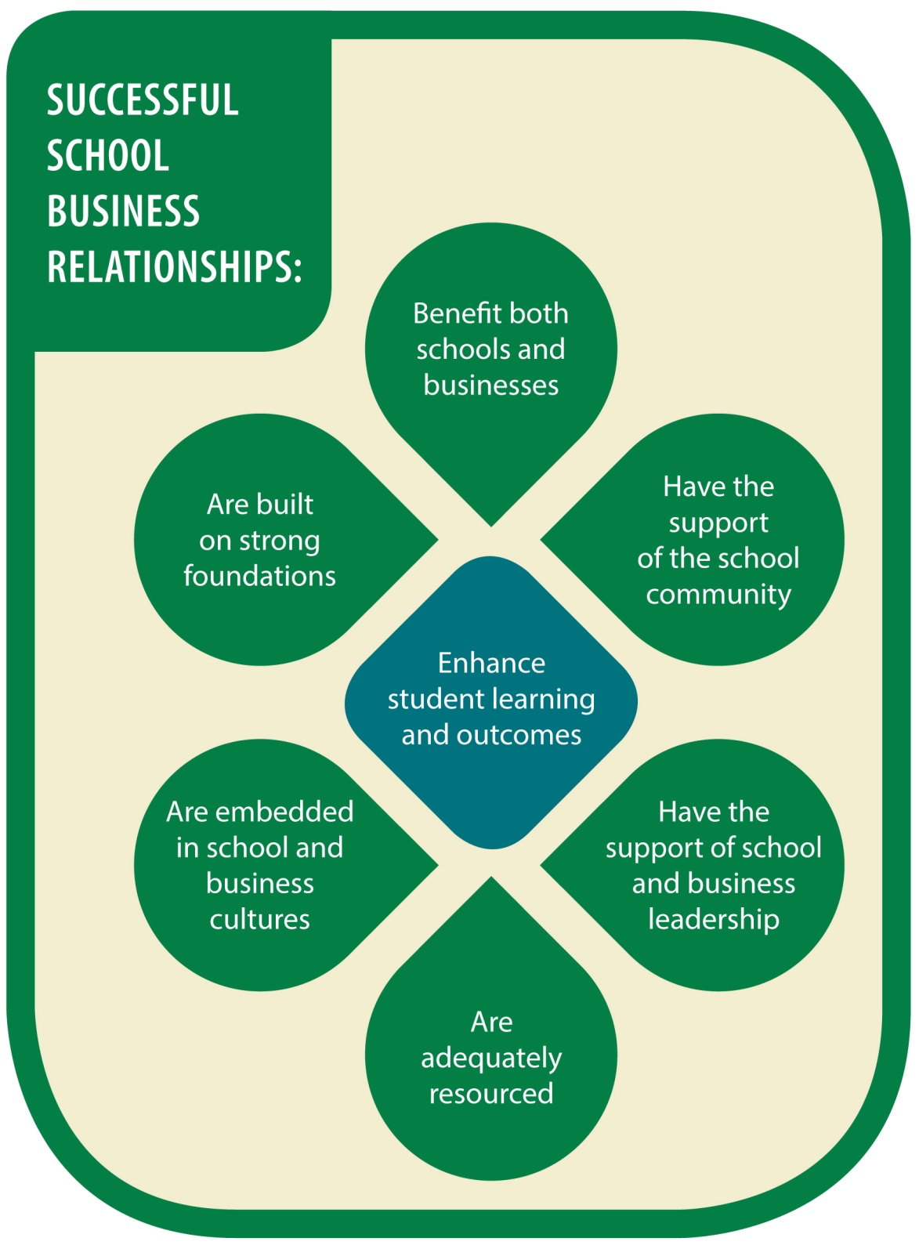

cid:image003.png@01CDB06B.76BBC9A0

Except where otherwise noted, copyright in this publication is owned by the Commonwealth of Australia represented by the Department of Education.

With the exception of the Commonwealth Coat of Arms and except where otherwise noted, all material presented in this document that is owned by the Commonwealth of Australia is provided under a Creative Commons Attribution 3.0 Australia (<http://creativecommons.org/licenses/by/3.0/au/>) licence.

The details of the relevant licence conditions are available on the Creative Commons website (accessible using the links provided) as is the full legal code for the CC BY 3.0 AU licence (<http://creativecommons.org/licenses/by/3.0/au/legalcode>).

The document must be attributed as the *Guiding Principles for School-Business Relationships*.

Disclaimer:

The information contained in this publication is intended for general information purposes only and does not constitute professional advice. While the Commonwealth of Australia has exercised reasonable care in publishing this material, it does not warrant or represent that the material contained herein is accurate, reliable, current or complete. As the circumstances of the readers may vary greatly, the material contained in this publication is not intended to provide specific guidance for particular circumstances and should not be relied on as the basis for any decision to take action or not take action on any matter which it covers. Readers are advised to exercise their own independent skill or judgement before relying on the information contained in this publication. To the maximum extent permitted by law, the Commonwealth of Australia does not accept any legal liability or responsibility for any injury, loss or damage incurred by the use of, or reliance on, the information contained in this publication.

Copies of this document can be downloaded from:   
<http://education.gov.au/partnerships-between-schools-businesses-and-communities-reports-and-research>

# Introduction

Partnerships between students, parents, carers and families, the broader community, business, schools and other education and training providers bring mutual benefits and maximise student engagement and achievement. Partnerships engender support for the development and wellbeing of young people and their families and can provide opportunities for young Australians to connect with their communities, participate in civic life and develop a sense of responsible citizenship.

Melbourne Declaration on Educational Goals for Young Australians, 2008

Partnerships between schools and businesses have long formed part of the Australian education landscape. The number and scope of school-business relationships continues to grow, and they can now be found in all educational sectors, and at all levels of schooling.

School-business relationships are motivated first and foremost by the desire to improve educational opportunities and outcomes for students. They recognise that business has much to contribute to this goal.

In 2011 the *Business-School Connections Roundtable* recommended that principles be developed to provide general guidance for schools and businesses in relationships.

These *Guiding Principles for School-Business Relationships* are the result. They are relevant for informal school-business relationships through to complex partnerships with formal governance arrangements, detailed documentation and long-term projects.

The principles were developed through a comprehensive consultation process around Australia with schools, businesses, education departments, industry bodies, parent bodies and broker organisations.

The principles have been endorsed by the Australian Government Department of Education, Employment and Workplace Relations.

The *Guiding Principles for School-Business Relationships* highlight features that contribute to effective and sustainable school-business relationships. They are aspirational, describing benchmarks which individual school-business relationships can aim to achieve over time. At any point in the lifecycle of a relationship, some principles will be more relevant than others.

The guiding principles can be used at any point in the life of school-business relationship. Asking questions such as ‘how are we going against this benchmark’, and ‘do we need to do anything about this principle at the moment’ will help you to gauge the current state of your relationship, and identify possible areas for improvement.

The activities which occur under school-business relationships are often subject to guidelines, policies, or procedures which are the responsibility of education departments, businesses and other relevant authorities. Both schools and businesses have a responsibility to ensure that all parties are aware of the requirements which apply to particular activities (eg in areas such as duty of care, visitors to schools, and workplace health and safety). The *Guiding Principles for School-Business Relationships* complement, but in no way replace, these requirements.

The next section describes each of the seven guiding principles in theory and practice. This is followed by case studies of Australian school-business relationships, highlighting two or three guiding principles in each relationship.

# The Seven Guiding Principles

This section describes the *Guiding Principles for School-Business Relationships* in theory and practice*,* and suggests some questions to consider.

While the principles are numbered for ease of reference, and the first principle would be regarded by many as central to all school-business relationships, there is no hierarchy between principles 2-7.

|  |  |
| --- | --- |
| SUCCESSFUL SCHOOL-BUSINESS RELATIONSHIPS… | 1. ENHANCE STUDENT **LEARNING** AND OUTCOMES |
| **Description** | Effective school-business relationships are founded on an underlying desire to improve the learning experience and educational outcomes of students. Businesses’ investments in schools are most likely to be successful, sustained and supported by the community if this is recognised as the core goal of school-business relationships. |
| **In Practice** | Enhancing student learning and outcomes will generally appear as a clear goal in written agreements between schools and businesses, and form the cornerstone of monitoring and evaluation plans. Activities directly aimed at improving student learning and outcomes might focus on developing particular skills (eg literacy, numeracy, information technology, leadership, teamwork); broadening horizons and raising career aspirations; or increasing engagement in education. Relationships can also enhance student learning and outcomes indirectly through activities such as mentoring of principals; curriculum design; or community capacity-building. |
| **Questions to Consider** | • Have we identified how our relationship and activities contribute (directly or indirectly) to student learning and outcomes?  • Is this clearly understood by everyone?  • Are we measuring the impact and reporting it to stakeholders?  • Can we increase the positive impact on student learning? |

Notes

|  |  |
| --- | --- |
| SUCCESSFUL SCHOOL-BUSINESS RELATIONSHIPS… | 2. **BENEFIT** BOTH SCHOOLS AND BUSINESSES |
| **Description** | School-business relationships work best when both schools and businesses see clear benefits for their organisations from working together. Each recognises that it is appropriate and desirable for the relationship to create benefits for the other partner, as well as for students. This supports a long-term commitment to the relationship. |
| **In Practice** | Ideally, the expected benefits for all participants are set out in an agreement from the outset of the relationship. These can range from immediate tangible outcomes to long-term and indirect rewards, including broad social and economic benefits. Benefits that schools have reported from school-business relationships include increasing internal resources or access to external resources; enriching school curriculum and approaches to teaching; and building the capacity and social capital of school communities and school leaders. Benefits that businesses have reported include providing opportunities to contribute to the development of young people; adding value to local industry; and improving the community reputation of the business. |
| **Questions to Consider** | • Do we all benefit from the relationship?  • Do we all understand what the benefits are?  • Can we increase or extend the benefits by involving others in the relationship? |

Notes

|  |  |
| --- | --- |
| SUCCESSFUL SCHOOL-BUSINESS RELATIONSHIPS… | 3. ARE BUILT ON STRONG **FOUNDATIONS**  includingshared goals, accountability and evaluation |
| **Description** | In strong school-business relationships the partners have a shared sense of what they are trying to achieve. They start with a clear understanding of what each partner sees as successful outcomes, often documented as goals and action plans. All parties share accountability for implementation and outcomes, and participate in evaluating the relationship and its activities. |
| **In Practice** | Expectations for success need to be clearly defined and agreed. Setting up a systematic evaluation process helps partners to document results and build confidence with each achievement. Partners in effective school-business relationships evaluate the actual relationship as well as the programs that occur within it, and commit to continuous improvement through flexible measurement and evaluation. They also clearly assess the risks and benefits of the relationship and the activities within it. |
| **Questions to Consider** | • Have we agreed and documented our purpose, goals, action plans and definitions of success?  • Is there shared accountability for implementation and outcomes?  • Do we have open communication and shared decision-making?  • Do we have an evaluation strategy (formal or informal) to review our relationship and the activities we undertake? |

* For guidance on evaluating your school-business relationship, see *Evaluate to Grow: A Guide to Getting the Most Out of Your School-Business Relationships through Evaluation*, downloadable from <http://education.gov.au/partnerships-between-schools-businesses-and-communities-reports-and-research>

Notes

|  |  |
| --- | --- |
| SUCCESSFUL SCHOOL-BUSINESS RELATIONSHIPS… | 4. HAVE THE SUPPORT OF THE SCHOOL **COMMUNITY** |
| **Description** | School-business relationships are most effective when they have clear endorsement from teachers, students and parents. This ensures that the school community understands the purpose of the relationship and its activities, and is confident that these are compatible with the core values and mission of the school. |
| **In Practice** | The first step in gaining in-principle support of the school community is ensuring that the community is aware of and understands the purpose of the relationship and the nature of the programs and activities. Schools should have a good understanding of their student and parent communities and communicate the benefits to them. This may include communicating how the values and activities of business partners fit with the school's mission, and that the school mission can engage meaningfully with the culture of the business without creating ethical or procedural problems. |
| **Questions to Consider** | • Does the community understand the purpose of our relationship, what we are doing, and how this will enhance student learning and outcomes?  • Are we keeping the community informed of our activities and outcomes?  • Have we considered opportunities to involve the community? |

Notes

|  |  |
| --- | --- |
| SUCCESSFUL SCHOOL-BUSINESS RELATIONSHIPS… | 5. ARE **EMBEDDED** IN SCHOOL AND BUSINESS CULTURES |
| **Description** | For long-term sustainability, it is critical that school-business relationships are embedded in organisational cultures. By explicitly including the relationship in their operational structures and processes, both schools and businesses make the relationship ‘core business’ and help to ensure that it is maintained when personnel change. |
| **In Practice** | Relationships that reflect this principle are underpinned by a clear management process and structure. School and business representatives with responsibility for the relationship meet frequently to build trust, mutual respect and understanding of each other’s cultures. A culture of partnering in schools and the business community is facilitated by ensuring high visibility in both the school and business organisation, clearly designating roles and responsibilities, and distributing these across a range of key staff. Where appropriate, the relationship may be embedded through formal documentation such as a partnership agreement or memorandum of understanding. |
| **Questions to Consider** | • Have we clearly identified roles and responsibilities?  • Are these roles and responsibilities shared appropriately?  • Is our relationship visible within our organisations and part of our organisational cultures?  • Do we need formal documentation?  • Is our relationship proofed against staffing changes in each organisation? |

Notes

|  |  |
| --- | --- |
| SUCCESSFUL SCHOOL-BUSINESS RELATIONSHIPS… | 6. HAVE THE SUPPORT OF SCHOOL AND BUSINESS **LEADERSHIP** |
| **Description** | School-business relationships are most likely to be effective and sustainable when supported at all levels of leadership in the schools and businesses. Commitment from senior leadership (eg CEO, Principal) generally needs to be complemented by support from other key levels such as department managers, human resource areas, executive staff and teachers. |
| **In Practice** | Successful programs have visionary and committed leadership on both sides and a high level of visibility supported by top-level engagement. Program leaders confirm the commitment of the school and business at all levels of operation. It is particularly advantageous to attract the personal involvement of senior leadership in key milestones such as program initiation and events organised to celebrate success. |
| **Questions to Consider** | • Are we keeping senior leaders in our organisations involved or informed?  • Are other levels of leadership engaged and supportive?  • Is our relationship proofed against changes in leadership? |

Notes

|  |  |
| --- | --- |
| SUCCESSFUL SCHOOL-BUSINESS RELATIONSHIPS… | 7. ARE ADEQUATELY **RESOURCED** BY BOTH SCHOOLS AND BUSINESSES |
| **Description** | In effective school-business relationships, both businesses and schools contribute to the overall resources needed to translate values and vision into action. Resources may be tangible or intangible, and include money, staffing, time, energy, skills and expertise. |
| **In Practice** | The level and type of resources, and the relative contributions of the partners, will vary from program to program. The time commitment of partners is critical and successful programs often specify this to ensure there is sufficient capacity. Successful relationships clearly identify resource requirements and availability, including time and resources for program coordination; administrative capacity available from both partners; and expectations concerning the availability and use of infrastructure. Where adequate resources are not identified, successful relationships find ways to increase the resources available, or adjust their plans to reduce the resources required. |
| **Questions to Consider** | • Have we identified all the resources needed for our relationship and activities, including cash, time and in-kind resources?  • Do we have sufficient resources to meet these needs?  • Are all our organisations contributing resources?  • Do we have strategies to address any resource gaps?  • Have we considered how to make the resourcing sustainable? |

Notes