SOME QUESTIONS TO CONSIDER:

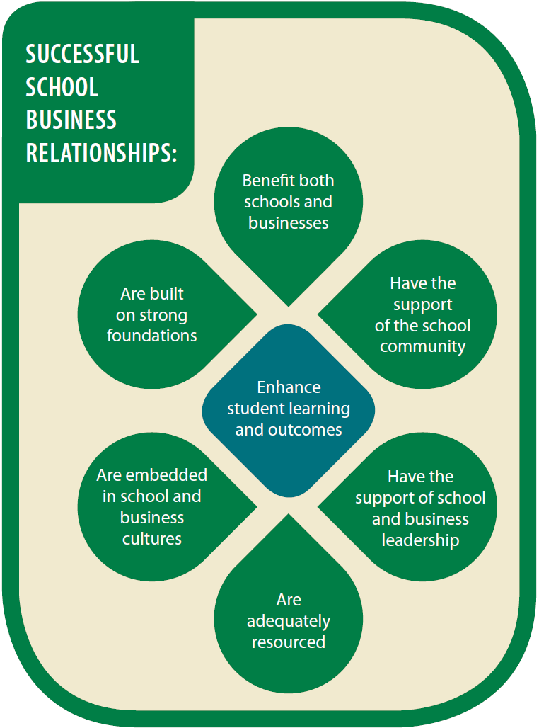
ENHANCE STUDENT LEARNING AND OUTCOMES
have we identified how our relationship and activities contribute (directly or indirectly) to student learning and outcomes?
is this clearly understood by everyone?
are we measuring the impact and reporting it to stakeholders?
can we increase the positive impact on student learning?
BENEFIT BOTH SCHOOLS AND BUSINESSES
do we all benefit from the relationship?
do we all understand what the benefits are?
can we increase or extend the benefits by involving others in the relationship?
ARE BUILT ON STRONG FOUNDATIONS
have we agreed and documented our purpose, goals, action plans and definitions of success?
is there shared accountability for implementation and outcomes?
do we have open communication and shared decision-making?
do we have an evaluation strategy (formal or informal) to review our relationship and the activities we undertake?
HAVE THE SUPPORT OF
THE SCHOOL COMMUNITY
does the community understand the purpose of our relationship, what we are doing, and how this will enhance student learning and outcomes?
are we keeping the community informed of our activities and outcomes?
have we considered opportunities to involve the community?
ARE EMBEDDED IN SCHOOL AND BUSINESS CULTURES
have we clearly identified roles and responsibilities?
are these roles and responsibilities shared appropriately?
is our relationship visible within our organisations and part of our organisational cultures?
do we need formal documentation?
is our relationship proofed against staffing changes in each organisation?
HAVE THE SUPPORT
OF SCHOOL AND
BUSINESS LEADERSHIP
are we keeping senior leaders in our organisations involved or informed?
are other levels of leadership engaged and supportive?
is our relationship proofed against changes in leadership?
ARE ADEQUATELY RESOURCED BY BOTH SCHOOLS AND BUSINESSES
have we identified all the resources needed for our relationship and activities, including cash, time and in-kind resources?
do we have sufficient resources to meet these needs?
are all our organisations contributing resources?
do we have strategies to address any resource gaps?
have we considered how to make the resourcing sustainable?
For more information and resources visit http://education.gov.au/partnerships-between-schools-businesses-and-communities-reports-and-research

