**The impact of the COVID-19 pandemic on children in Australian early childhood education and care**

**A rapid review prepared for the Australian Government Department of Education, Skills and Employment**

**January 2022**

The impact of the COVID-19 pandemic on children in Australian early childhood education and care  
Version 1.0

This report was prepared by the Centre for Community Child Health, Murdoch Children’s Research Institute for the Australian Government Department of Education, Skills and Employment.

Suggested Citation: Centre for Community Child Health. (2022). The impact of the COVID-19 pandemic on children in Australian early childhood education and care. Rapid review prepared by the Centre for Community Child Health, Murdoch Children’s Research Institute for the Commonwealth Department of Education, Skills and Employment.

We acknowledge the writing contributions provided by Megan Keyes, Jun Guo, Carly Molloy and Sharon Goldfeld. We also acknowledge research, data, editing and literature search contributions provided by Elodie O’Connor, Meredith O’Connor, Jacqueline Ding, Jayne Ballingall, Sarah Gray, and Poh Chua.

This work is copyright. To request permission to reproduce any part of this material or communication of, please contact the Centre for Community Child Health.

The Centre for Community Child Health is a research group of the Murdoch Children’s Research Institute and a department of The Royal Children’s Hospital, Melbourne.

Centre for Community Child Health

The Royal Children’s Hospital Melbourne  
50 Flemington Road, Parkville  
Victoria 3052 Australia  
Telephone +61 9345 6150  
Email [enquiries.ccch@rch.org.au](mailto:enquiries.ccch@rch.org.au)   
[www.rch.org.au/ccch](http://www.rch.org.au/ccch)

Contents

Executive summary / key messages 1

Introduction 1

Background 1

Aim of this report 1

Findings 1

Introduction 4

Background 4

Aim of this report 5

Our approach 6

Literature search 6

Analysis of Xplor data 6

Findings 7

Direct impact of COVID-19 on children 0 – 5 years 7

Indirect impact of COVID-19 on children 0 – 5 years 8

Impact of COVID-19 on young children with existing additional health and developmental needs 12

Attendance at Australian ECEC: 2019 v 2020 13

Impact of ECEC attendance disruptions during COVID-19 17

Likely length of impact of COVID-19 on children 0 – 5 years 20

Limitations 21

Conclusions 21

Appendices 24

Appendix 1: Search terms 24

References 28

## Executive summary / key messages

### Introduction

* The first 5 years of a child’s life are critical for laying the foundations for healthy development.
* Adverse events or circumstances that occur during these years can have a significant impact on children’s health and developmental outcomes.

### Background

* The COVID-19 pandemic is unlike any previous pandemics or natural disasters, in terms of its scale and duration.
* Public health measures brought in to limit the spread of the virus have caused significant changes to children’s routines, including confinement, isolation and closures of early childhood education and care services, affecting children’s sense of structure, predictability and security.
* Attendance at high quality early childhood education and care (ECEC) supports positive child development and wellbeing and is a crucial early intervention for children with additional health and developmental needs (AHDN).

### Aim of this report

* The Australian Government Department of Education, Skills and Employment engaged the Centre for Community Child Health, Murdoch Children’s Research Institute to review the direct and indirect impact of COVID-19 on children 0 – 5 years, including the impact of disruptions to ECEC attendance and the likely length of all impacts.

### Findings

#### Direct impact of COVID-19 on children 0 – 5 years

* Direct health impacts on young children (0 – 5 years) have been relatively minimal, with low infections in children in Australia. As at 5 September 2021, 22 per cent of all COVID-19 cases had been among children or adolescents aged less than 19 years, and of those, 43 per cent were among children aged 9 years or younger.
* Approximately 5 – 14% of children who contract COVID-19 may have persistent symptoms (‘long COVID’) 4 weeks or more after infection. More research is needed to confirm this, and whether it is applicable to children 0 – 5 years.

#### Indirect impact of COVID-19 on children 0 – 5 years

* Research on the indirect (psycho-social) impacts of COVID-19 on young children is limited, but some evidence is emerging. Australian and international studies suggest that public health measures and their impact on family dynamics have led to the following issues for children 0 – 5 years: worsening behaviour and mood; increased clinginess, anxiety and levels of stress; increased hyperactivity and inattention; increased abuse and neglect; decreased physical activity and increased screen time; and possible disruptions to the length and quality of sleep.
* Children with pre-existing AHDN are at increased risk for physical, psychological, emotional and behavioural problems during the COVID-19 pandemic, and increased incidences of behavioural problems such as aggression have been reported. Changes to daily routines, due to public health measures, are particularly detrimental for children with ASD, and reduced access to in-person care has left children with AHDN more vulnerable.
* Many parents that have been subject to isolation and confinement measures – particularly parents of young children – are experiencing high levels of stress and mental distress due to financial pressures, juggling care of children with work demands, and the loss of support from family and friends. As the early home environment is a key indicator of future outcomes for children, this places children at risk of negative health and developmental outcomes. At greatest risk will be children with AHDN.

#### Impact of COVID-19 on children with existing AHDN

* Most studies have reported increased challenges for parents of children with AHDN throughout the pandemic.
* Young children with Autism Spectrum Disorder (ASD) and other neurodevelopmental disorders are at high risk of increased psychological, emotional and behavioural problems, including aggressive behaviours and oppositional defiant problems.
* Ongoing contact with ECEC has been found to be a protective factor for children with ASD during the pandemic. When ECEC services are closed or disrupted, this places additional strain on families as they try to navigate online special education.
* Fears of a child with AHDN contracting the virus, particularly children with respiratory conditions, multiple learning difficulties or other long-term medical conditions, leads to many parents removing their child from ECEC or reducing the number of hours attended.

#### Attendance at Australian ECEC: 2019 v 2020

* Attendance at Australian ECEC has been disrupted, through a combination of parent and child fear of the virus, more parents working from home, and ECEC service closures. Even prior to the COVID-19 pandemic, attendance hours and rates for children with AHDN were lower than children without AHDN.
* Attendance hours and rates for all children dropped substantially at the beginning of the pandemic as public health measures were being introduced (March 2020). Lowest attendance hours and rates were recorded in early April 2020.
* Attendance started to recover for all children after the introduction of fee-free ECEC by the Australian Government later in April 2020. However, attendance for children with AHDN continued to be lower.

#### Impact of ECEC attendance disruptions during COVID-19

* Disrupted ECEC attendance is likely to have detrimental effects on children’s health and development, particularly for children with AHDN.
* Most evidence to date on the impact on children comes from international studies (where ECEC closures were more substantial than in Australia). Parents of children who were not able to return to ECEC reported greater negative impacts on their child’s social and emotional development than parents of children who continued attending.
* Providers of ECEC expressed concerns about the impact of lockdowns on children without access to green spaces (which were often children from lower socio-economic areas). They also expressed concerns about children’s ability to assimilate back into ECEC, and the social-emotional support they would require.
* One study of children 8 – 36 months found that receptive vocabulary growth (the number of words a child can understand) was greater in children who had been able to continue ECEC.
* Disrupted ECEC attendance may contribute to children ‘falling off the radar’ (both children with existing AHDN and children that have not yet been identified as having AHDN).
* We anticipate seeing an initial decrease in diagnoses of children with AHDN, followed by a surge in diagnoses as health and education services return to capacity. We also anticipate ECEC and other health and development services will see an increase in children experiencing social-emotional and behavioural problems resulting from the COVID-19 public health measures.

#### Likely length of impact of COVID-19 on children 0 – 5 years

* Data on the likely length of impact of the COVID-19 pandemic on younger children is limited. Most children are unlikely to experience symptoms of ‘long COVID’. Following previous disasters and pandemics, most children returned to typical psychological functioning, provided they had responsive and mentally well parents or caregivers. However, the scale and duration of the COVID-19 pandemic, and the long-term lockdowns in many states and territories, could increase the duration of children’s psycho-social recovery.
* Young children at greatest risk will be those with pre-existing AHDN, previous experience of trauma, and those whose parents are experiencing health disorders, substance misuse or financial hardship.

#### Conclusions

* Young children require stability and security for healthy growth and development. Significant changes to daily routines should be minimised to protect children during this critical phase of development.
* Australian parents are experiencing a high degree of stress, and this is impacting young children’s health and development. Parents of young children need support to alleviate household stress, and parents of children with AHDN will require even greater support.
* Children who have experienced increased levels of mental distress and anxiety will also require additional support as they readjust to new routines following public health measures.
* It is likely that both the direct and indirect impacts on children with pre-existing AHDN will be longer-lasting and more severe than children without AHDN, particularly given reduced access to early interventions, including ECEC.
* There is an urgent need for more research and data on the impact of the pandemic on young children, including the likely length of these effects.

## Introduction

The COVID-19 pandemic has caused unprecedented disruption to the lives of children and families across the globe. Like many countries, Australia introduced serious measures to prevent the spread of COVID-19, including lockdowns, social distancing, and closures of businesses, schools and, in some states, early childhood education and care (ECEC) services.

Attendance at ECEC supports the development of foundational skills across multiple domains (physical, social, emotional, language and communication) and is particularly vital for children experiencing adversity or disadvantage. It is therefore important we understand the impact of disruption to ECEC attendance on children’s health and development.

While research into previous pandemics and periods of confinement offers some general insights into the likely psychological impact of restrictions, drawing specific conclusions from those studies to the current situation could be tenuous, given the scale, extent, and duration of the COVID-19 pandemic. Research exploring the specific effects of the current pandemic is required.

## Background

The first 5 years of a child's life are critical for laying the foundations for healthy development (Molloy et al., 2021). Adverse events or circumstances that occur during these years can have a significant impact on children’s health and developmental outcomes. The COVID-19 pandemic has caused momentous changes to children’s lives, which has the potential to impact their health, development and wellbeing (Araújo et al., 2021).

The social determinants of health – the conditions in which people are born, grow, work and live and their access to resources – are a useful framework for considering the impacts of the pandemic on children (World Health Organisation, 2021). Considering social determinants allows us to look beyond the direct effects of the virus in children to the implications for children of the public health measures employed throughout the pandemic, including isolation, confinement and service closures.

Public health measures have led to significant changes in children’s routines, which may affect children’s sense of structure, predictability and security. Young children, including infants and toddlers, notice and respond to stress in their parents and caregivers. Young children may experience strong feelings (for example, fear, anger or sadness) in response to what they hear and see about the pandemic and may worry about their own safety and the safety of loved ones (Dym Bartlett et al., 2020).

Considering all aspects of children’s lives, the potential impacts on children as a result of the pandemic are substantial, and include:

* poor health and development, including infant bonding
* poor mental health
* poor academic achievement
* poverty, food insecurity and lack of physical activity contributing to obesity
* increased screen time
* exposure to domestic violence, parental mental illness and child abuse
* reduced family income
* increased household stress (Goldfeld, 2021; Singh et al., 2021).

For children with existing additional health and developmental needs (ADHN), these impacts can be compounded by the removal of personal, social and therapeutic supports and the increased likelihood of parental stress. An example of the possible impacts on a young child with cerebral palsy and developmental delay is shown in Figure 1.

**Example social determinants for Tyler and family**

**Social Determinants of Health**

**Government finances, health services**

**School or ECEC closures, housing stability**

**Poverty, parental health, child abuse, bereavement**

**Attachment and**

**bonding**

**Mental and physical**

**health**

**Special needs holiday club closes due to funding cuts**

**ECEC closes due to pandemic; wait times for health appointments increase**

**Grandparents cannot provide childcare as they are isolating**

**Father loses job, household income reduced**

**Mother becomes depressed**

**Appointments with healthcare cancelled**

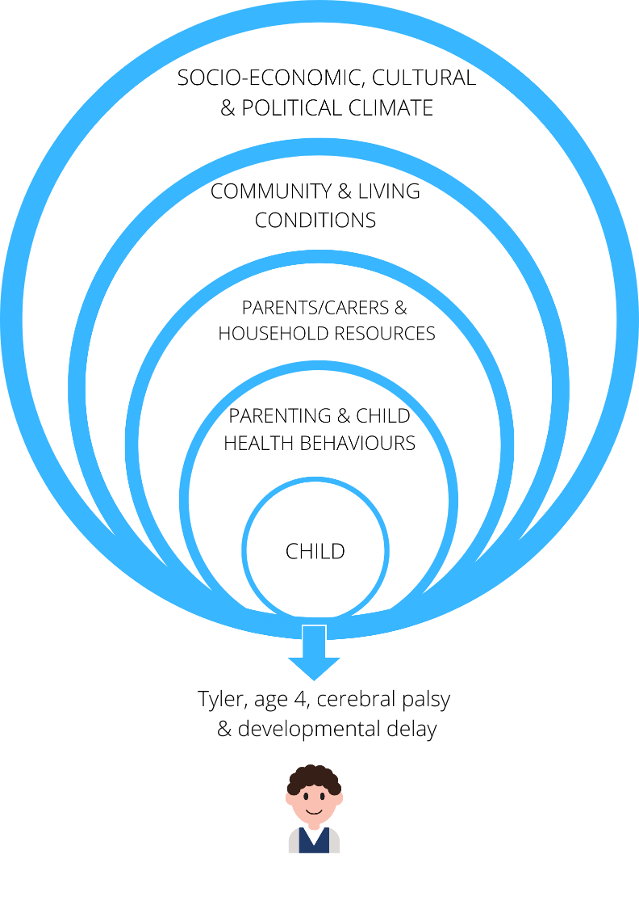

Figure 1: A social determinants of health view of the potential impacts of COVID-19 on a young child with additional health and developmental needs (adapted from Singh et al., 2021).

## Aim of this report

Understanding the direct and indirect impacts of COVID-19 on young children (0 – 5 years) is important for government decision-making and for the provision of appropriate services and supports for young children and their families. Governments have the difficult task of balancing the need to protect children from the direct effects of the virus, with the need to ensure healthy growth and development during this critical period in children’s lives.

The Australian Government Department of Education, Skills and Employment (DESE) engaged the Centre for Community Child Health, Murdoch Children’s Research Institute (MCRI) to conduct a review of the direct and indirect impacts of COVID-19 on children 0 – 5 years, including the potential impacts of disruptions to ECEC attendance.

This report outlines:

* the direct impact of COVID-19 on young children
* the indirect impacts of COVID-19 on young children
* the impact of COVID-19 on young children with existing AHDN
* the impact of COVID-19 on children’s attendance at Australian ECEC services, particularly those with AHDN
* the impact of disruptions to ECEC attendance on children
* the likely length of both direct and indirect impacts on young children.

## Our approach

Our approach to developing this report was two-fold, including conducting a review of the literature and analysing Australian ECEC attendance data.

### Literature search

We conducted a search for current literature on the direct and indirect effects of COVID-19 on young children 0 – 5 years, including published, peer-reviewed material and grey literature. We were particularly interested in any Australian studies.

Peer-reviewed material was obtained via a search of Medline, Embase and PubMed databases (see Appendix 1: Search terms) and Google Scholar (search terms “early years”, “attendance” and “COVID-19”). Results were limited by year (2019 – 2021), age group (children 0 – 5 years), and language (English).

Previous MCRI reports on COVID-19 and children were reviewed for context and further sources of peer-reviewed material. Google searches were used to find grey literature.

### Analysis of Xplor data

Software provider Xplor is used by Australian long day care and kindergartens/preschools to record enrolments, attendance, Child Care Subsidy submissions and a range of related products (for example, payment statements for parents). In 2019 and 2020, approximately 55 per cent of long day care and kindergartens/preschools used Xplor. Our analysis sampled data from approximately 38% of long day care and 41% of kindergartens/preschools. The service sample for our analysis represented all Australian states and territories and contained a mix of higher and lower socio-economic areas.

We extracted data from Xplor on attendance hours and attendance rates at ECEC services pre-pandemic (2019) and during the COVID-19 pandemic (2020). This data was used to explore the ECEC attendance patterns of children across Australia, including children with AHDN, at three significant time points associated with COVID-19 (23rd March 2020: Borders closed; 6th April 2020: Fee-free ECEC starts; 13th July 2020: Fee-free ECEC ends).

## Findings

### Direct impact of COVID-19 on children 0 – 5 years

To date, the direct health impacts of the COVID-19 virus have been relatively minimal for children globally, including with the Delta variant (Ibrahim et al., 2021; McLaws, 2020; Rajmil et al., 2021; Shen et al., 2020). Figure 2 includes the latest data from the Australian Government on COVID-19 cases and deaths in the 0 – 9 age group.

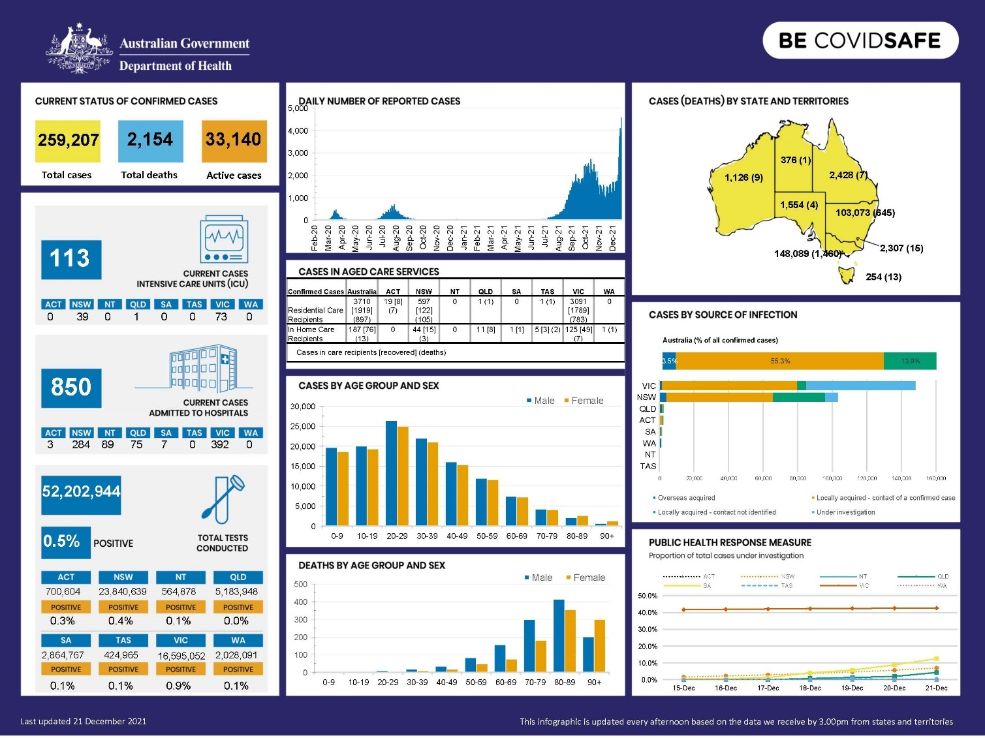

Figure 2: Australian Government COVID-19 statistics as at 21 December 2021, including cases and deaths by age group and sex (sourced from health.gov.au).

As at 5 September 2021, 22 per cent of all COVID-19 cases had been among children or adolescents aged less than 19 years. Of these, 43 per cent were among children aged 9 years or younger (MCRI COVID-19 Governance Group, 2021). Admissions to hospital for children in Australia are uncommon. In 2020, about 50 children were admitted to hospital with COVID-19 (MCRI COVID-19 Governance Group, 2021), although this number is anticipated to be higher for 2021.

Even following the return of face-to-face learning, infections appear to be stable in children and adolescents in Victoria and have declined in New South Wales. This could be due to high vaccine coverage in children 12 years+ and ongoing implementation of test, trace, isolate and quarantine measures (Ong, 2021).

However, children living with some pre-existing health conditions, including obesity, chronic respiratory disease and cardiovascular disease, do have an increased risk of severe disease or even death from COVID-19 (Tsankov et al., 2021). Obesity has been found to be a notable risk factor for more severe symptoms, including in children (Zachariah et al., 2020). Other serious comorbidities include chronic respiratory disease, chronic kidney disease, immunosuppression and cancer (MCRI COVID-19 Governance Group, 2021; Shekerdemian et al., 2020).

Multisystem inflammatory syndrome in children (MIS-C) is a serious condition that occurs approximately one month after exposure to COVID-19 and can cause inflammation in different parts of the body (Centers for Disease Control and Prevention, 2021). Children and adolescents with MIS-C usually have a fever, rash and abdominal pain and children with more severe disease often need admission to an intensive care unit. In Australia, MIS-C is very rare. As at 5 September 2021, there had been four confirmed cases and two possible cases of MIS-C since the start of the pandemic (MCRI COVID-19 Governance Group, 2021).

Persistent symptoms of loss of smell, headaches, cognitive difficulties and sore throat and eyes (‘long COVID’) have been reported in children, but at low rates (2 to 8 per cent more symptoms reported in children after COVID-19 infection than in without infection). Approximately 5 to 14 per cent may have multiple persistent symptoms 4 weeks or more after infection (Behnood et al., 2021). Further research is needed to confirm these findings and whether they are applicable to children 0 – 5 years.

The direct impact of COVID-19 on young children may also change as further data on the Omicron variant becomes available.

### Indirect impact of COVID-19 on children 0 – 5 years

There is limited data on the indirect (namely, the psycho-social) impact of COVID-19 on children 0 – 5 years, with most research focusing on school-aged children, adolescents, and adults. It is recognised that this is currently a gap in knowledge, and it is likely we will see further research on this age group in future. In Australia, several longitudinal studies have commenced that are exploring this age group.

As the Australian Government DESE has a particular interest in evidence emerging from the Australian context, we will first outline Australian data on the indirect impacts of COVID-19 before turning to the international evidence.

#### Australian data

Prior to the pandemic, MCRI – with support from a number of partners including the Victorian Government – developed the Generation Victoria (GenV) initiative (genv.org.au). All babies born in Victoria during 2021 to 2023 – and their parents – will be invited to join the initiative. Despite being designed prior to the COVID-19 pandemic, data collected through GenV will provide powerful insights into children’s health and development from 2021 and beyond.

Our literature search returned three key studies on the indirect impacts of COVID-19 on young children in Australia (De Young, 2021; Gibson et al., 2021; Westrupp et al., 2021). The first, COVID-19 Unmasked*,* aims to understand the mental health impacts of the pandemic on young children (1-5 years) and their families (De Young, 2021).

COVID-19 Unmaskedconducted surveys of parents of young children at four time points: May – July 2020; 3 months follow-up, 6 months follow-up and 12 months follow-up. At the time of preparing this report, data was available from the first and second surveys (May – July 2020 and August – November 2020).

During the second survey period, Victoria experienced a second and stricter lockdown (known as ‘Stage 4’ restrictions), while other states and territories maintained local COVID-19 social restrictions and border closures. This provided comparison data between Victoria and other states that had not at the time experienced a second lockdown.

The surveys found that young children were most affected by changes to routines, missing important events and not seeing close family members or friends (De Young, 2021). While most children who did not experience a second lockdown were reported to have good mental health and wellbeing, children who experienced a second lockdown were reported to have significantly increased mental health difficulties (up to 12 per cent ‘very high’ levels of mental health difficulties and 21 – 47 per cent ‘high’ levels). The most commonly reported mental health concern was anxiety, followed by symptoms of depression and attachment seeking behaviours (De Young, 2021).

Following the second survey, further lockdowns were implemented in Victoria and some other states, including closure of ECEC services in Victoria. Results from the third and fourth waves of data collection will be important to inform the impact of longer-term confinement.

A second Australian study (the COVID-19 Pandemic Adjustment Survey or ‘CPAS’) is collecting longitudinal data from parents of children aged 0 – 18 years to understand the impact of COVID-19 on family life (Westrupp et al., 2021). Findings from the first wave of data (8 – 28 April 2020) found:

* higher levels of depression, anxiety, and stress in parents, particularly those with young children
* higher parenting irritability (for parents of children 0 – 9 years)
* higher rates of smoking and alcohol consumption
* moderately higher child anxiety (for single parents compared to coupled parents)
* higher child anxiety and depression, lower family positive expressiveness/higher negative expressiveness, higher parenting irritability, and higher couple conflict (for parents with a child with Attention Deficit Hyperactivity Disorder [ADHD] or Autism Spectrum Disorder [ASD])
* higher child anxiety and symptoms of depression (for parents with pre-existing health conditions)
* higher parent depression, child anxiety, and parenting irritability (for parents juggling paid work with having a child to supervise at home)
* higher levels of parent stress and child depression and lower levels of family positive expressiveness (for parents living in home with higher levels of overcrowding).

Having a larger number of children appeared to provide a small protective factor against child anxiety, however it also contributed to greater parenting irritability and higher levels of family negative expressiveness (Westrupp et al., 2021).

Overall, parent participants were not functioning well across a number of areas of day to day life including in relation to their own self-care and the care of children. Given what we know about the importance of positive parent-child attachments during the first five years of life, these findings are cause for concern. Subsequent waves of data from this study will be vital to understand the longer-term effects of extended lockdowns on young children and their families.

The third study compared responses from parents in an existing ORIGINS cohort (Western Australia) with responses from parents in an existing Born in Bradford cohort (UK) about the initial impact of COVID-19 on children 0 – 4 years. Parents from both cohorts provided similar responses regarding their worries and challenges during the lockdown period. Most concerns related to:

* financial insecurity and employment
* anxieties about contracting COVID-19
* educating and caring for children
* the impact of COVID-19 on society
* child development and wellbeing
* child and parent mental health
* not seeing friends and family.

Examples of comments from parents specific to children’s behaviour or development included (Gibson et al., 2021):

“My son has GDD (Global Development Delay) and has challenging behaviours. Worry about him not getting the support he needs as structured activities have stopped for him”.

“Child becoming more clingy and co-dependent because his world has shrunk (currently only seeing people in two households)”.

“Worried about daughter’s learning and development as she only recently started nursery and was starting to develop but going back to her pre-nursery phase now”.

As Western Australia did not experience the same lockdown restrictions as the UK (and the eastern states of Australia), future waves of data collection from these cohorts will provide important insights into the impact of isolation and confinement measures (compared to children who did not experience these measures) on parental stress and anxiety and child development and wellbeing.

#### International data

International evidence on the psycho-social impacts of COVID-19 on children 0 – 5 years is limited. While there are systematic reviews referencing the impact on children aged 0 – 12 years (Cachón-Zagalaz, 2020), 0 – 18 years (Araújo, 2021), and 0 – 20 years (Viner et al., 2021), the papers selected within those reviews largely reported on older children.

Of the small number of papers that specifically referenced children 0 – 5 years, findings were similar to that reported in the Australian studies.

##### **Behavioural, developmental and psychological responses**

In Scotland, parents reported a worsening of their child’s behaviour and/or worsening of their child’s mood, with some 4-7 year olds scoring very highly for emotional difficulties, conduct problems and hyperactivity/inattention (Watson, et al., 2020).

In China, children aged 3-6 years were more likely than older children to show problem behaviour including clinginess and fear about family members contracting the virus (Jiao et al., 2020). Other smaller studies from a range of countries reported high levels of stress (Russell et al., 2020), anxiety, behavioural difficulties and hyperactivity/inattention (Di Giorgio et al., 2020) in young children.

##### **Sleep**

International data on the impact of COVID-19 on young children’s sleep is mixed. One study found no change in sleep duration (Di Giorgio et al., 2020), one found only a slight decrease in sleep time for 3 – 5 year olds (López-Bueno, 2020), while another found a 32 per cent reduction in 2 – 4 year olds sleeping through the night (Watson et al., 2020).

##### **Abuse and neglect**

Isolation and confinement within the home can put children at greater risk of maltreatment and abuse, particularly in families with a high degree of conflict pre-pandemic. There were increased reports of child abuse, neglect and exploitation throughout the pandemic (Australian Institute of Health and Welfare, 2021); Chanchlani et al., 2020; Merrill et al., 2021). The lockdown has also contributed to increased rates of intimate partner violence, which can produce anxiety and trauma responses in children (Singh, 2020).

In the first month of the pandemic in the United Kingdom, there was a significant increase in admissions for suspected abusive head trauma (Kuehn, 2020). As public health measures have contributed to less attendance at ECEC and health services and therefore fewer child interactions with adults outside the home, these statistics may not reflect the actual scale of levels of abuse resulting from the pandemic (Kang & Jain, 2020).

Reduced access to maternal and child health services in conjunction with social isolation and stress could also result in poor infant-caregiver bonding and attachment. These infants could present later with emotional and behavioural difficulties (Singh et al., 2021).

##### **Physical activity and screen time**

Young children of preschool age require 180 minutes of active play a day, including 60 minutes of moderate to vigorous-intensity physical activity (Ricci, 2020). They should also not engage in more than 60 minutes of sedentary screen time (Guan et al., 2020). However, with children spending a lot more time in the home, parent self-reports indicated that children of all ages, including the 3 – 5 year age group, experienced a reduction in physical activity and an increase in screen exposure (López-Bueno, 2020).

### Impact of COVID-19 on young children with existing additional health and developmental needs

There has been widespread concern about the impact of COVID-19 on children with vulnerabilities and particular needs, including ADHN. Research on the impact of COVID-19 on children with ADHN is somewhat mixed.

A UK longitudinal study on families with children with an intellectual disability compared quality of life and psychological distress in parents and children, pre-pandemic and during the pandemic. The results showed no difference in quality of life or levels of psychological distress, either for the parents or the child (Bailey et al., 2021). However, the ‘during the pandemic’ data was collected in the initial stages of the COVID-19 pandemic (from March 2020 – July 2020). A follow up wave of data collection further into the pandemic may produce different results.

Most studies have reported greater challenges for parents and caregivers of children with AHDN throughout the pandemic. With therapies often moving to an online format, a deterioration in physical outcomes has been observed. For example, children with Cerebral Palsy have experienced impairment in epileptic seizure control and worsening of spasticity and motor control throughout the pandemic, due to a lack of in-person clinical care (Ben-Pazi, 2020).

Young children with ADHN, particularly those with neurodevelopmental disorders such as ASD, are also at high risk of increased psychological, emotional and behavioural problems (Cantiani et al., 2021). Changes to routines and daily schedules can be particularly distressing for children with ASD, and can lead to increased anxiety, depressive symptoms, and externalizing problems, including aggressive behaviours and oppositional defiant problems (Viola, 2021). This can be compounded by reduced access to usual clinical care.

Children with ASD are also at greater risk of unhealthy weight compared to children without ASD, and these differences can be seen in children as young as 2 years (Hill et al., 2015). A sedentary life during COVID-19 confinement could increase the risk of obesity in people with ASD (Yarimkaya & Esentürk, 2020), and that risk in turn could increase the risk of severe outcomes from contracting the COVID-19 virus (Shekerdemian et al., 2020).

Ongoing contact with ECEC services has been found to be a protective factor for children with ASD during the pandemic (Cantiani et al., 2021). When ECEC services are closed, this places additional strain on families as they try to navigate the provision of online special education, which is often not suitable for children with ASD or other AHDN. A survey conducted by Children and Young People with Disability Australia found that parents who were already under strain pre-pandemic, reported significant additional challenges during the pandemic, with implications for their own mental health and wellbeing and that of their children (Dickinson, 2020).

In addition, while most children have missed a substantial number of days at ECEC services, fears of a child contracting the virus reduced attendance for children with ADHN even further, particularly for children with respiratory conditions, multiple learning difficulties or other long-term medical conditions (Dickinson, 2020; The Office for Standards in Education, 2020).

All these factors together put children with AHDN at greater risk of further physical, emotional, and behavioural problems. For children with ASD in particular, it is suggested that post-traumatic stress disorder could be a potential longer-term implication of a pandemic (Taylor & Gotham, 2016).

### Attendance at Australian ECEC: 2019 v 2020

Data from software provider Xplor was obtained to understand how children’s attendance at Australian ECEC changed throughout the pandemic. The overall sample available was 382,360 children (2019: n=229,349; 2020: n=229,468) from 6125 long day care and preschools/kindergartens nation-wide. Children with AHDN comprised a small proportion of the sample: n=2176 and 2254 nationally in 2019 and 2020 respectively. However, there were a lot of missing data for this variable, since only those parents that specifically responded “yes” to a child having AHDN were captured.

Children with ECEC data from early March to early December 2020 (i.e., week 9 to week 49) were selected for analysis, given that most children in Australia have stable attendance rates during the March to December period.

#### Attendance hours

In 2019, the average hours of attendance for children without AHDN was 21 hours per week, while for children with AHDN the average attendance was just under 20 hours per week.

Children’s hours of attendance dropped substantially in 2020 (to around 12 hours per week) around the time border closures, social distancing and non-essential business closures were introduced in March. Attendance hours had reached a low of approximately 7 hours per week when the Australian Government implemented a period of fee-free childcare on 6 April 2020. This caused attendance hours to rise again, and they have remained relatively stable (at around pre-pandemic levels) since the fee-free period ended on 13 July 2020.

Children with AHDN attended less hours of ECEC throughout 2020 than children without AHDN. The average numbers of hours attended overall for all children was 18.3 hours per week compared with 16.9 hours per week for children with AHDN (see Figure 3).

However, the discrepancy between attendance for children with AHDN versus those without was highest just prior to the first of the pandemic restrictions being introduced nation-wide (approximately 3 hours per week less for children with AHDN). This discrepancy may have been the result of fear from the lack of information about COVID-19 at that time, and the reporting of growing infections in Australia.

The lowest discrepancy in attendance hours between the two cohorts was at the second and third weeks of the fee-free period and around mid-September to mid-October 2020 (less than an hour difference). As shown in Figure 4, differences in attendance hours re-emerged soon after the introduction of the fee-free period (maximum difference was approximately 3 hours). Although the gap in attendance hours decreased post-fee-free period, children with AHDN attended less hours overall during all weeks of 2020.

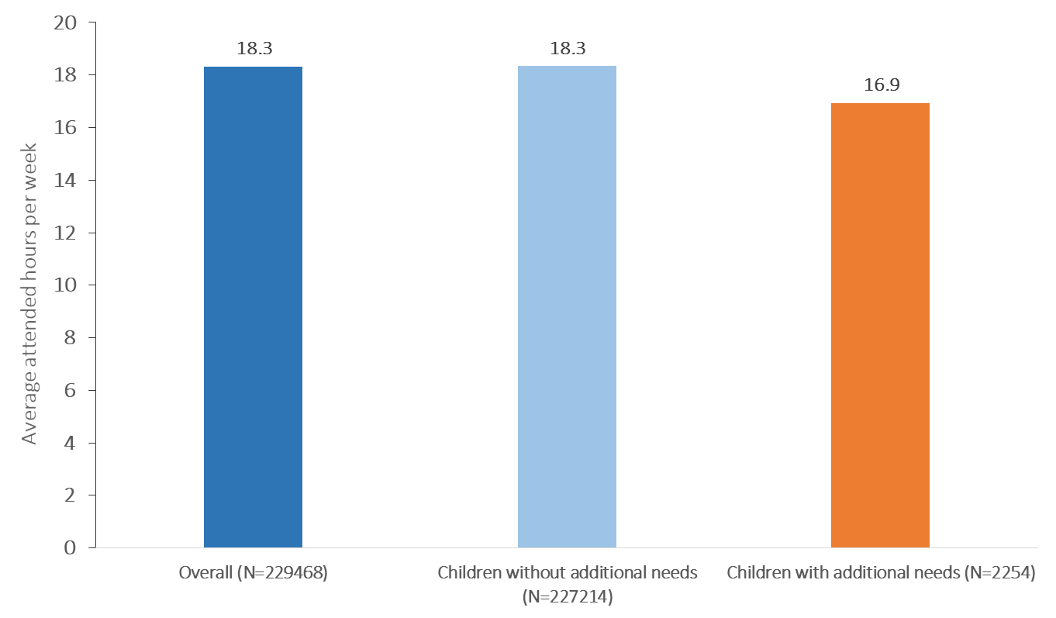

**Figure 3: Average attendance hours per week between March and December 2020 by child’s medical status.**

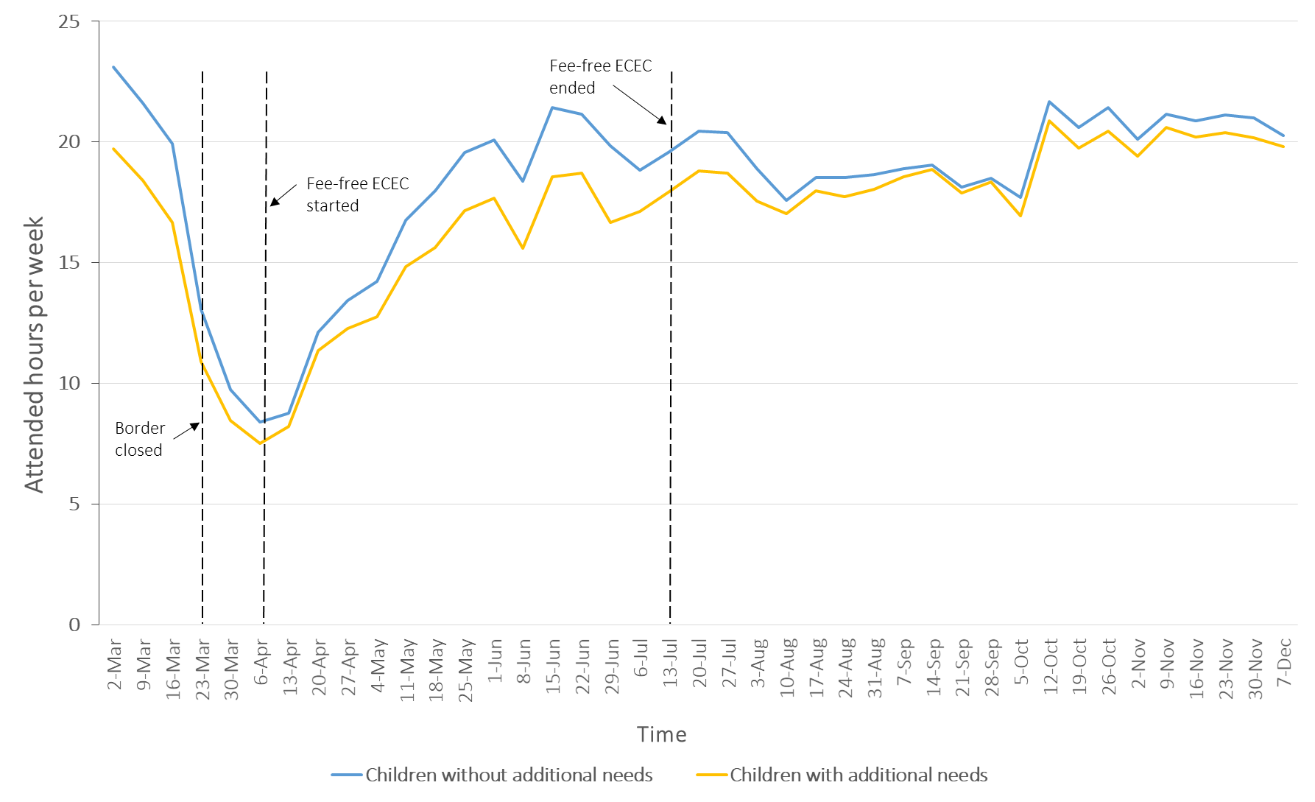

Figure 4: Fluctuations in average attendance hours per week between March and December 2020 by child’s medical status. Note: 23rd March 2020 (Borders closed); 6th April 2020 (Fee-free ECEC starts); 13th July 2020 (Fee-free ECEC ends).

#### Attendance rates

In 2019, approximately 62 per cent of children without AHDN attended 15 hours or more of ECEC per week. For children with AHDN, this figure was slightly less, at 59 per cent.

In 2020, attendance rates of 15 hours or more per week dropped. Approximately 53 per cent of children without AHDN attended for 15 or more hours, while just under 50 per cent of children with AHDN attended 15 or more hours on average (see Figure 5).

Attendance rates for children with AHDN in the period just before pandemic restrictions were being introduced nation-wide were around 5 to 9 per cent less per week compared with children without AHDN (Figure 6). Attendance rates declined rapidly in mid-March as COVID-19 cases increased throughout Australia and public health measures were put in place. At the introduction of fee-free ECEC, as with previous analyses, rates increased sharply for both groups. At around week 17 (mid-April) attendance discrepancies re-emerged. The attendance rate gap grew to a peak difference of 8.4 per cent between children with and without AHDN during the fee-free period. Post fee-free subsidy attendance rates stabilised for several weeks with similar attendance patterns between the two groups until the end of the year.

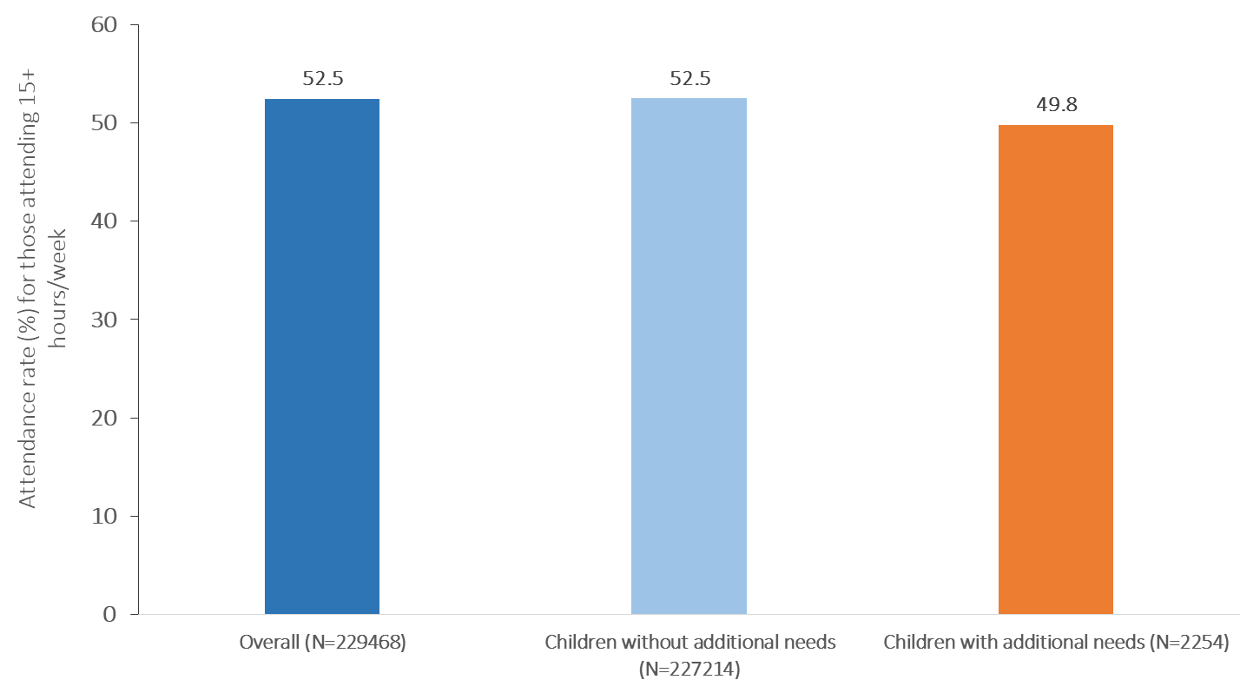

Figure 5. Average attendance rate from March to December 2020 by child’s medical status.

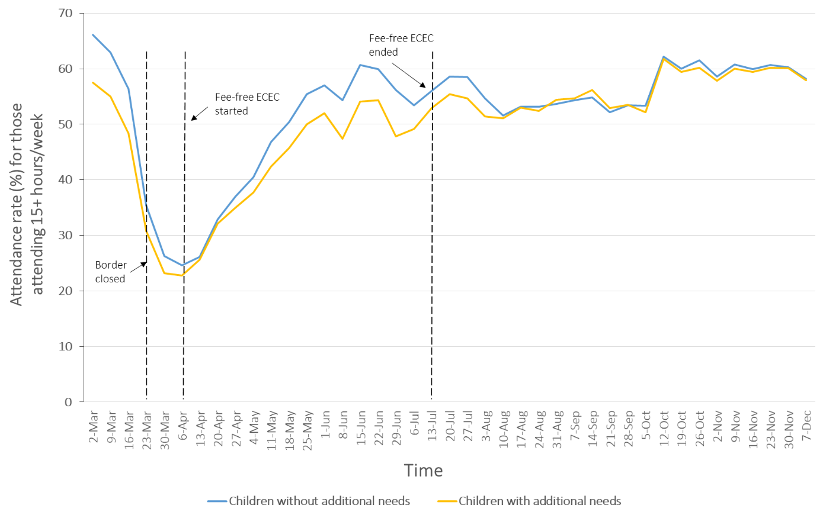

Figure 6. Fluctuations in average attendance rate per week in 2020 by child’s medical status. Note: 23rd March 2020 (Borders closed); 6th April 2020 (Fee-free ECEC starts); 13th July 2020 (Fee-free ECEC ends).

Attendance hours and rates are not available for 2021 currently, but we know that attendance hours and rates will be impacted by ECEC closures in Victoria and the substantial time spent in lockdown in Victoria and New South Wales.

### Impact of ECEC attendance disruptions during COVID-19

ECEC plays a vital role in children’s early development. In the US, about 60 per cent of preschool children 3-5-years-old usually attend an early years service (Corcoran & Steinley, 2017), but widespread closures in 2020 meant that many children had their 2019-2020 education year cut short. From May – June 2020 a survey of 945 households was undertaken to determine how children 3 – 5 years were being supported (either by ECEC services or parents) in their learning and development during the lockdown (Barnett, 2020).

The study determined that children lost, on average, three months of learning time (at the time the study was conducted). It was also determined that most parents did not make up for the lost learning at home, most likely due to their own work and home responsibilities and pandemic-related stresses (Barnett, 2020). The authors concluded that the consequences of the pandemic in relation to its effects on young children’s learning and development were likely to be substantial.

In the UK, the early years sector provides services to about 2.1 million children under the age of 5 years. Isolation measures resulted in the closure or restricted opening of a large number of early years providers.

The Sutton Trust in the UK has released a number of research briefs on the impact of COVID-19. Their fourth brief focused on the early years, following a survey of parents of children aged 2 – 4 years. The survey found that 65 per cent of parents felt stressed, worried or overwhelmed during the pandemic, and 45 per cent of parents thought the pandemic had had a negative impact on their child’s social-emotional development and wellbeing (Pascal et al., 2020).

Negative impacts were most likely to be reported by those whose children had been unable to attend ECEC during lockdown, compared to those who had been able to continue (for example, children of essential workers) or those who had not attended ECEC before the pandemic. A number of parents also reported they would not send their child back to ECEC even when allowed to do so, due to fears of either transmitting or contracting the virus (Pascal et al., 2020).

As part of the same UK study, ECEC providers in Birmingham were surveyed on their perceptions of the impact of the pandemic and service closures on children. Providers expressed concern about the physical development of children living in high rise apartments with limited green spaces (Pascal et al., 2020). There was also concern from providers about the development and wellbeing of children who had not been able to access services. One provider wrote:

“There are some children who have been at home with both parents who were trying to juggle work with looking after their child and attempting to home school. These children have not had a positive experience, they have had no social interaction with other children, have lost confidence and have been living in a very stress filled environment.”

Another UK study surveyed early years providers from 35 settings across Better Start Bradford, University of Leeds, City of York Council and the Aspirer Teaching Alliance. Providers were asked what they thought children would struggle with most as a result of the pandemic, and the most frequent responses included children’s personal, social and emotional development, followed by children’s communication and language (Bowyer-Crane et al., 2021). Providers also noted that children with AHDN (or potential AHDN) were missing out on assessments and other professional support, and that referrals for speech and language and the need for individual support plans had increased (Bowyer-Crane et al., 2021).

A further study from the UK examined growth in language and executive functions (i.e. working memory, flexible thinking, and self-control) in 8 – 36 month olds by exploring the influence of time spent in ECEC and socio-economic background. The study found that receptive vocabulary growth (the number of words a child can understand) was greater in children who continued to attend ECEC, and that there was a stronger positive effect for children from lower socio-economic backgrounds (Davies & Hendry, 2021).

In Canada, a survey of educators was conducted to determine what they were most concerned about when children returned to ECEC. Following apprehensions about hygiene and contracting the virus, educators reported feeling concerned about children’s social-emotional development and ability to readjust to the learning setting over and above concerns about how much children learned during the lockdown period (Spadafora et al., 2021) (see Figure 7).

0%

25%

Students’ ability to follow any new protocols if necessary

Students’ ability to keep proper hygiene in class and at school

Students’ readjustment to routines

Behavioural support for students

Children’s decrease in physical activity during school closures

Differences in how much students learned during the school closures

Myself or my student contracting COVID-19

Students’ ability to self-regulate in the school setting

Emotional support for students

Support I might need when we return to school (e.g., support from staff like EA, ESL, mental health)

How much students learned during the school closure

Nutritional support for students (e.g., nutritional/breakfast program

50%

75%

100%

Figure 7: Concerns of Canadian educators regarding children’s return to ECEC following a period of lockdown (Source: Spadafora et al., 2021).

Another effect of ECEC attendance disruptions is the prospect of children with undiagnosed AHDN ‘dropping off the radar’. During the height of the pandemic, access to routine but essential services for child health and development, including maternal and child health, paediatric and allied health services, was limited (Eapen, 2021). Even following the easing of restrictions, families have been reluctant to take their children to health facilities for what they perceive as non-urgent issues, due to concerns about contracting the virus or adding to the burden on already stretched health services (Eapen, 2021).

For vulnerable children, those with particular needs, and those whose parents have been struggling with home learning due to work or challenging home lives, the COVID-19 pandemic has been an extremely difficult time. It is clear that there are significant worries about the social and emotional health of young children after months of lockdown and isolation.

### Likely length of impact of COVID-19 on children 0 – 5 years

As we move into a different phase of ‘living with’ the COVID-19 pandemic and then beyond, questions arise as to what happens when restrictive public health measures end, for how long impacts persist, and whether certain groups are affected more than others.

On the one hand, evidence from natural disasters suggest that most children eventually return to their pre-disaster functioning when they receive appropriate support from responsive caregivers (Dym Bartlett, 2020). On the other hand, the scale of the COVID-19 pandemic has been momentous, global, and is still ongoing. It is likely the economic impact will last years, which also means the mental health effects (at least in adults) are likely to be more sustained than has been the case for previous disasters and pandemics (McGorry, 2020).

Specific data on the likely length of impact either of the current COVID-19 pandemic or previous pandemics on children aged 0 – 5 years is limited. Research on children and adults (6 – 65 years) suggests biopsychosocial consequences up to 3 years after lockdown measures end, including anxiety disorders, depression, and post-traumatic stress disorder (PTSD) (see Figure 8) (Muehlschlegel et al., 2021).

**Short-term**

**(≤ 1 month)**

**Medium-term**

**(1-6 months)**

**Long-term**

**(> 6 months)**

* Acute stress disorder
* Impaired morale or work performance
* Alcohol intoxications
* Increased mental health service use by both adults and children
* Elevated stress markers
* Increased suicidality
* Alcohol abuse or dependence symptoms
* PTSD, anxiety and depression symptomatology and diagnoses of psychological disorders
* Stigmatisation and discrimination
* Anxious and avoidant behaviours, for example, avoiding crowded spaces and patient contact
* Weight gain and dietary changes

Figure 8: Biopsychosocial consequences of pandemic lockdown measures.

Another study found that 33 per cent of children who had experienced isolation or quarantine due to the H1N1, SARS or avian influenza pandemics began using mental health services, either during or after the pandemic, related to their experience (Sprang, 2013). Children who experienced isolation or quarantine were more likely to meet the clinical cut-off score for PTSD than those who had not been in isolation or quarantine. However, the age of the children in this study was not provided, therefore these findings may not be applicable to children 0 – 5 years.

Detrimental effects on children’s health and development are likely to be seen if parents and caregivers experience sustained impacts on their typical psycho-social functioning. Young children at greatest risk will be those with pre-existing ADHN, previous experiences of trauma, and those whose parents struggle with [mental health disorders](https://www.ncbi.nlm.nih.gov/books/NBK215117/), [substance misuse](https://www.nctsn.org/what-is-child-trauma/populations-at-risk/trauma-and-substance-abuse), or [financial](https://www.urban.org/sites/default/files/publication/32706/412899-The-Negative-Effects-of-Instability-on-Child-Development-A-Research-Synthesis.PDF) hardship (Roubinov et al., 2020; Whitehead et al., 2021; Yoshikawa et al., 2020).

It is predicted that the economic fallout of the COVID-19 pandemic will last well into 2022 and potentially beyond. We should expect the physical, psychological and developmental impact of the crisis to impact young children, particularly vulnerable young children, for at least that period of time.

## Limitations

As this was a time-limited rapid review, we prioritised review of the highest quality evidence by employing a ‘top-down’ approach, starting with the synthesis of systematic reviews. This provided the best opportunity to obtain the most recent and relevant evidence for this report. However, we also employed a ‘snowball’ approach, where we used articles referenced within systematic reviews to search for other relevant literature and followed up on specific areas that did not appear in the original search results with searches of Google Scholar.

As noted throughout the report, research on the impact of COVID-19 on young children was limited. Most studies focused on children aged 6 years and above, adolescents and adults. There were no studies detected that compared rates of pre-pandemic diagnoses of AHDN with diagnosis of ADHN during the pandemic. Similarly, there was little evidence on the impact of ECEC service closures on young children and their families, and those that were available typically relied on parent or provider self-report. Most research on children focused on the impact of school closures.

The sample of children identified as having AHDN within Xplor – the software program used by many Australian ECEC service providers – was small. We assume a lot of missing data on this variable, as it requires parents to respond “yes” to their child having an AHDN. This impacts the reliability with which we can assess differences in attendance hours and attendance rates between children with AHDN and children without AHDN.

## Conclusions

Early childhood is a critical period for health and social, emotional and cognitive development, including learning how to deal with powerful emotions and to build skills that support positive interactions with others. The COVID-19 pandemic has significantly disrupted young children’s lives for the better part of two years. Much of this impact has been the result of the indirect effects of the pandemic, including lockdowns and home confinement, increased parental stresses, financial hardship, and loss of social contact with family and friends leading to poorer physical and mental health and the risk of child abuse or neglect (Singh et al., 2021).

It is clear that the indirect impact of the pandemic will disproportionately affect more disadvantaged children, including children with AHDN. Children with AHDN are more likely to suffer from the significant changes to daily routines, including closures of ECEC, and reduced access to support services. They are also less likely to benefit from any remote access to ECEC services (Cantiani et al., 2021; Viola, 2021).

Even pre-pandemic, children with AHDN attended ECEC less than other children. The additional fear associated with a new virus circulating resulted in parents removing children with AHDN from ECEC or reducing their attendance further. International evidence suggests that children with AHDN may not return immediately to ECEC, even when further information on the direct effects of the virus is known and when they are permitted to do so by the local authority. Efforts to engage with these families will be vital.

Australian ECEC data showed that despite an initial significant drop in attendance at the outset of the pandemic, which affected both children with AHDN and children without AHDN, attendance increased again when the Australian Government introduced a fee-free policy, signifying that government support is vital to drawing children back into ECEC. There is currently no national approach to COVID safe ECEC settings. This may delay a return to ECEC for children with AHDN.

Given that children were less able to access maternal and child health services (for developmental screening), paediatricians and allied health services, it is anticipated there will be a decrease in diagnoses of AHDN, followed by a surge in late diagnoses as we move beyond the pandemic. This means ECEC will play an even more important role in early identification of children with AHDN as well as providing a high quality learning environment for all children, particularly those that have missed out on other early intervention services.

The indirect psycho-social impacts of the pandemic are likely to contribute to AHDN in children who previously may not have been considered children of concern. The dramatic increase in household stress, including financial stress, combined with significant disruptions to routine and loss of social and family contacts has resulted in reported symptoms of depression and anxiety in young children. It is anticipated this will affect children’s behaviour, social interactions and adjustment back into ECEC settings. This may be so even for children without previous AHDN.

The 2021 Australian Early Development Census (AEDC) data collection will be an important indicator of whether the pandemic has increased vulnerability in young children. AEDC data (collected nationally in children’s first year of school) will highlight any significant changes to children’s development across multiple domains (physical, social, emotional, language and communication). The 2021 data is due for release in early 2022. As a license holder the Centre for Community Child Health holds this data and, if needed, could undertake the necessary analysis when appropriate.

There is an urgent need for more research and more data on the impact of the pandemic on young children, including the likely length of these effects. This will be vital in the Australian context. However, research on previous pandemics and natural disasters tells us that support for children and their family’s mental health will need to be a priority, particularly for more vulnerable children and families, both in the short- and longer-term (Singh, 2020).

Quality ECEC remains an important intervention for children with pre-pandemic AHDN, children who are socio-economically disadvantaged, and children who have suffered the effects of lockdown measures throughout the pandemic. Efforts to ensure all children have access to high quality ECEC into the future should be an important part of the pandemic recovery.

## Appendices

### Appendix 1: Search terms

#### Medline

|  |  |
| --- | --- |
|  |  |
| 1. | COVID-19/ or SARS-CoV-2/ |
| 2. | covid-19 testing/ or covid-19 serological testing/ or covid-19 nucleic acid testing/ |
| 3. | COVID-19 Vaccines/ |
| 4. | (Abdala or AstraZeneca or BNT162b2 or Comirnaty or Convidecia or Convidicea or CoronaVac or COVAX or Covaxin or Covid-Vac or Covigenix or COVIran or Covishield or CoviVac or EpiVacCorona or EuCorVac or FAKHRAVAC or FINLAY-FR-2 or Janssen or KoviVac or Medigen or Minhai or MIVAC or Moderna or mRNA-1273 or MVC-COV1901 or Nanocovax or Novavax or pakvac or Pastu-Covac or Pfizer or picoVacc or QazCovid-in or QazVac or Razi-Cov-Pars or Sinopharm or Sinovac or Soberana-01 or Soberana-02 or Soberana-1 or Soberana-2 or Spikevax or Sputnik-Light or Sputnik-V or Vaxzevria or Vietnam-domestic-vaccine or ZF2001 or Zifivax or ZyCov-D).tw,kf,ot. |
| 5. | (2019-novel or 2019nCoV or 2019-nCoV or COVID-19 or COVID19 or COVID-2019 or COVID2019 or CONVID-19 or CONVID19 or CORVID-19 or CORVID19 or CoV2 or CoV-2 or HCoV* or Ncov* or Ncorona* or Ncorono* or NcovChina* or NcovChinese* or NcovHubei* or NcovWuhan* or SARS2 or SARS-2 or SARScoronavirus2 or SARScoronavirus-2 or SARScoronovirus2 or SARScoronovirus-2 or SARSCov19 or SARSCov-19 or SARS-CoV-2 or SARSCoV-2 or SARSCoV2 or WN-CoV or WNCoV or wuhan-virus).tw,kf,ot. |
| 6. | ((pneumonia* or outbreak* or respiratory-illness* or respiratory-disease* or respiratory-symptom* or seafood-market* or food-market* or wildlife) and (Wuhan or China or Chinese or Hubei or Huanan)).tw,kf,ot. |
| 7. | ((new or novel or nouveau or "19" or "2019" or Wuhan or Hubei or Huanan or China or Chinese) adj3 (coronavirus* or corona virus* or betacoronavirus* or CoV or HCoV)).tw,kf,ot. |
| 8. | (longCOVID* or postCOVID* or postcoronavirus* or postSARS*).ti,ab,kf,ot. |
| 9. | (coronavirus/ or betacoronavirus/ or coronavirus infections/) and (disease outbreaks/ or epidemics/ or pandemics/) |
| 10. | ((coronavirus* or corona-virus* or betacoronavirus*) adj3 (pandemic* or epidemic* or outbreak* or crisis)).tw,kf,ot. |
| 11. | 1 or 2 or 3 or 4 or 5 or 6 or 7 or 8 or 9 or 10 |
| 12. | (additional-health-and-developmental-need* or special-need* or disable* or disability* or chronic-disease* or developmental-delay* or medical-condition* or health-condition* or mental-health-condition* or physical-condition? or behavio?ral-concern* or behavio?ral-problem* or social-emotional-problem* or special-educational-need* or special-health-care-need* or special-healthcare-need* or special-educational-need* or health-and-developmental-concern* or speech-and-language-problem* or speech-and-language-delay* or off-track or offtrack or falling-behind or vulnerable or impact* or effect*).tw,kf. |
| 13. | *Disabled Children/ |
| 14. | exp *Chronic Disease/ |
| 15. | exp *Neurodevelopmental Disorders/ |
| 16. | 12 or 13 or 14 or 15 |
| 17. | (newborn* or new-born* or baby or babies or neonat* or neo-nat* or infan* or toddler* or pre-schooler* or preschooler* or kinder or kinders or kindergarten* or kinder-aged or early-childhood or child* or children or preprimary or pre-primary).af. |
| 18. | (childcare or child-care).af. |
| 19. | Schools, Nursery/ |
| 20. | exp Child Day Care Centers/ |
| 21. | 17 or 18 or 19 or 20 |
| 22. | (close* or closure* or interrupt* or cease* or closing or reopen* or open*).tw,kf. |
| 23. | 11 and 16 and 21 and 22 |
| 24. | limit 22 to (english language and yr="2019 -Current") |
| 25. | limit 23 to (case reports or comment or editorial or guideline or letter or practice guideline) |
| 26. | 24 not 25 |

#### Embase

|  |  |
| --- | --- |
|  |  |
| 1. | coronavirus disease 2019/ |
| 2. | SARS coronavirus/ |
| 3. | experimental coronavirus disease 2019/ |
| 4. | COVID-19 testing/ |
| 5. | COVID-19 nucleic acid testing/ |
| 6. | COVID-19 serological testing/ |
| 7. | exp SARS-CoV-2 vaccine/ |
| 8. | (Abdala or AstraZeneca or BNT162b2 or Comirnaty or Convidecia or Convidicea or CoronaVac or COVAX or Covaxin or Covid-Vac or Covigenix or COVIran or Covishield or CoviVac or EpiVacCorona or EuCorVac or FAKHRAVAC or FINLAY-FR-2 or Janssen or KoviVac or Medigen or Minhai or MIVAC or Moderna or mRNA-1273 or MVC-COV1901 or Nanocovax or Novavax or pakvac or Pastu-Covac or Pfizer or picoVacc or QazCovid-in or QazVac or Razi-Cov-Pars or Sinopharm or Sinovac or Soberana-01 or Soberana-02 or Soberana-1 or Soberana-2 or Spikevax or Sputnik-Light or Sputnik-V or Vaxzevria or Vietnam-domestic-vaccine or ZF2001 or Zifivax or ZyCov-D).tw,kf,ot. |
| 9. | (2019-novel or 2019nCoV or 2019-nCoV or COVID-19 or COVID19 or COVID-2019 or COVID2019 or CONVID-19 or CONVID19 or CORVID-19 or CORVID19 or CoV2 or CoV-2 or HCoV* or Ncov* or Ncorona* or Ncorono* or NcovChina* or NcovChinese* or NcovHubei* or NcovWuhan* or SARS2 or SARS-2 or SARScoronavirus2 or SARScoronavirus-2 or SARScoronovirus2 or SARScoronovirus-2 or SARSCov19 or SARSCov-19 or SARS-CoV-2 or SARSCoV-2 or SARSCoV2 or WN-CoV or WNCoV or wuhan-virus).tw,kf,ot. |
| 10. | ((pneumonia* or outbreak* or respiratory-illness* or respiratory-disease* or respiratory-symptom* or seafood-market* or food-market* or wildlife) and (Wuhan or China or Chinese or Hubei or Huanan)).tw,kf,ot. |
| 11. | ((new or novel or nouveau or "19" or "2019" or Wuhan or Hubei or Huanan or China or Chinese) adj3 (coronavirus* or corona virus* or betacoronavirus* or CoV or HCoV)).tw,kf,ot. |
| 12. | (longCOVID* or postCOVID* or postcoronavirus* or postSARS*).ti,ab,kf,ot. |
| 13. | Coronavirinae/ |
| 14. | Betacoronavirus/ |
| 15. | Coronavirus infection/ |
| 16. | epidemic/ |
| 17. | pandemic/ |
| 18. | ((coronavirus* or corona-virus* or betacoronavirus*) adj3 (pandemic* or epidemic* or outbreak* or crisis)).tw,kf,ot. |
| 19. | severe-acute-respiratory-syndrome-coronavirus-2.hw. |
| 20. | coronavirus-disease-2019.hw. |
| 21. | 1 or 2 or 3 or 4 or 5 or 6 or 7 or 8 or 9 or 10 or 11 or 12 or 13 or 14 or 15 or 16 or 17 or 18 or 19 or 20 |
| 22. | (additional-health-and-developmental-need* or special-need* or disable* or disability* or chronic-disease* or developmental-delay* or medical-condition* or health-condition* or mental-health-condition* or physical-condition? or behavio?ral-concern* or behavio?ral-problem* or social-emotional-problem* or special-educational-need* or special-health-care-need* or special-healthcare-need* or special-educational-need* or health-and-developmental-concern* or speech-and-language-problem* or speech-and-language-delay* or off-track or offtrack or falling-behind or vulnerable or impact* or effect*).tw,kf,ot,hw. |
| 23. | *Disabled children/ |
| 24. | exp *Chronic disease/ |
| 25. | exp *Neurodevelopmental disorders/ |
| 26. | 22 or 23 or 24 or 25 |
| 27. | (newborn* or new-born* or baby or babies or neonat* or neo-nat* or infan* or toddler* or pre-schooler* or preschooler* or kinder or kinders or kindergarten* or kinder-aged or early-childhood or child* or children or preprimary or pre-primary).tw,kf,ot,hw. |
| 28. | (childcare or child-care).tw,kf,ot,hw. |
| 29. | nursery school/ |
| 30. | child day care/ |
| 31. | 27 or 28 or 29 or 30 |
| 32. | (close* or closure* or interrupt* or cease* or closing or reopen* or open*).tw,kf,ot,hw. |
| 33. | 21 and 26 and 31 and 32 |
| 34. | limit 33 to yr="2019 -Current" |
| 35. | limit 34 to (conference abstract or "conference review" or editorial or letter) |
| 36. | 34 not 35 |
| 37. | limit 36 to english language |

#### PubMed

PubMed

#1 All fields

“Abdala” OR “AstraZeneca” OR “BNT162b2” OR “Comirnaty” OR “Convidecia” OR “Convidicea” OR “CoronaVac” OR “COVAX” OR “Covaxin” OR “Covid-Vac” OR “Covigenix” OR “COVIran” OR “Covishield” OR “CoviVac” OR “EpiVacCorona” OR “EuCorVac” OR “FAKHRAVAC” OR “FINLAY-FR-2” OR “Janssen” OR “KoviVac” OR “Medigen” OR “Minhai” OR “MIVAC” OR “Moderna” OR “mRNA-1273” OR “MVC-COV1901” OR “Nanocovax” OR “Novavax” OR “pakvac” OR “Pastu-Covac” OR “Pfizer” OR “picoVacc” OR “QazCovid-in” OR “QazVac” OR “Razi-Cov-Pars” OR “Sinopharm” OR “Sinovac” OR “Soberana-01” OR “Soberana-02” OR “Soberana-1” OR “Soberana-2” OR “Spikevax” OR “Sputnik-Light” OR “Sputnik-V” OR “Vaxzevria” OR “Vietnam-domestic-vaccine” OR “ZF2001” OR “Zifivax” OR “ZyCov-D”

#2 All fields

“2019-novel” OR “2019nCoV” OR “2019-nCoV” OR “COVID-19” OR “COVID19” OR “COVID-2019” OR “COVID2019” OR “CONVID-19” OR “CONVID19” OR “CORVID-19” OR “CORVID19” OR “CoV2” OR “CoV-2” OR “HCoV*” OR “Ncov*” OR “Ncorona*” OR “Ncorono*” OR “NcovChina*” OR “NcovChinese*” OR “NcovHubei*” OR “NcovWuhan*” OR “SARS2” OR “SARS-2” OR “SARScoronavirus2” OR “SARScoronavirus-2” OR “SARScoronovirus2” OR “SARScoronovirus-2” OR “SARSCov19” OR “SARSCov-19” OR “SARS-CoV-2” OR “SARSCoV-2” OR “SARSCoV2” OR “WN-CoV” OR “WNCoV” OR “wuhan-virus”

#3 All fields

(“pneumonia*” OR “outbreak*” OR “respiratory-illness*” OR “respiratory-disease*” OR “respiratory-symptom*” OR “seafood-market*” OR “food-market*” OR “wildlife”) AND (“Wuhan” OR “China” OR “Chinese” OR “Hubei” OR “Huanan”)

#4 All fields

(“new” OR “novel” OR “nouveau” OR “19” OR “2019” OR “Wuhan” OR “Hubei” OR “Huanan” OR “China” OR “Chinese”) AND (“coronavirus*” OR “corona virus*” OR “betacoronavirus*” OR “CoV” OR “HCoV”)

#5 All fields

“longCOVID*” OR “postCOVID*” OR “postcoronavirus*” OR “postSARS*”

#6 All fields

(“coronavirus*” OR “corona-virus*” OR “betacoronavirus*”) AND (“pandemic*” OR “epidemic*” OR “outbreak*” OR “crisis”)

#7 All fields

#1 OR #2 OR #3 OR #4 OR #5 OR #6

#8 Title and abstract

(“special-need*” OR “disable*” OR “disability*” OR “chronic-disease*” OR “developmental-delay*” OR “medical-condition*” OR “health-condition*” OR “mental-health*” OR “behavior” OR “behaviour” OR “social-emotional-problem*” OR “special-educational-need*” OR “special-healthcare-need*” OR “special-educational-need*” OR “speech-and-language” OR “off-track” OR “offtrack” OR “falling-behind” OR “vulnerable” OR “impact*” OR “effect*” OR neurodevelop*” OR “chronic” OR “chronic-disease”)

#9 Title and abstract

(“close*” OR “closure*” OR “interrupt*” OR “cease” OR “open*” OR “reopen*”)

#10 Title and abstract

(“baby” OR “babies” OR “infan*” OR “toddler” OR “pre-schooler*” OR “kinder*” OR “kinder-aged” OR “early-childhood” OR “child*” OR “children” OR “preprimary”)

#11 All fields

NOTNLM OR publisher[sb] OR inprocess[sb] OR pubmednotmedline[sb] OR indatareview[sb] OR pubstatusaheadofprint

#12

#7 AND #8 AND #9 AND #10 and #11

## References

Araújo, L. A., Veloso, C. F., Souza, M. C., Azevedo, J., & Tarro, G. (2021). The potential impact of the COVID-19 pandemic on child growth and development: a systematic review. *Jornal de pediatria*, *97*(4), 369-377. <https://doi.org/https://doi.org/10.1016/j.jped.2020.08.008>

Australian Institute of Health and Welfare. (2021). *Child protection in the time of COVID-19. Cat. no. CWS 76*.

Bailey, T., Hastings, R. P., & Totsika, V. (2021). COVID-19 impact on psychological outcomes of parents, siblings and children with intellectual disability: longitudinal before and during lockdown design. *J Intellect Disabil Res*, *65*(5), 397-404. <https://doi.org/10.1111/jir.12818>

Barnett, W. S., & Jung, K. (2020). Understanding and responding to the pandemic’s impacts on preschool education: What can we learn from last spring? National Institute for Early Education Research.

Behnood, S.A., Shafran, R., Bennett, S.D., Zhang, A.X.D., O’Mahoney, L.L., Stephenson, T.J., Ladhani, S.N., DeStavola, B.L., Viner, R.M., Swann, O.V. (2021). Persistent symptoms following SARS-CoV-2 infection among children and young people: a meta-analysis of controlled and uncontrolled studies. Jounral of Infection. <https://doi.org/10.1016/j.jinf.2021.11.011>

Ben-Pazi, H., Beni-Adani, L., & Lamdan, R. (2020). Accelerating Telemedicine for Cerebral Palsy During the COVID-19 Pandemic and Beyond. *Frontiers in neurology*, *11*, 746. <https://doi.org/https://doi.org/10.3389/fneur.2020.00746>

Bowyer-Crane, C., Bonetti, S., Davies, C., Dixon, M., Dysart, E., Newton, R., & Tracey, L. (2021). Early years settings and the COVID-19 pandemic. *Research Briefing.* Retrieved 21 December 2021 from https://www.niesr.ac.uk/wp-content/uploads/2021/10/Early%20Years%20Survey.pdf.

Braun-Lewensohn, O. (2015). Coping and Social Support in Children Exposed to Mass Trauma. *Current Psychiatry Reports*, *17*(6). <https://doi.org/10.1007/s11920-015-0576-y>

Cachón-Zagalaz, J., Sánchez-Zafra, M., Sanabrias-Moreno, D., González-Valero, G., Lara-Sánchez, A. J., & Zagalaz-Sánchez, M. L. (2020). Systematic Review of the Literature About the Effects of the COVID-19 Pandemic on the Lives of School Children. *Frontiers in Psychology*, *11*. <https://doi.org/https://doi.org/10.3389/fpsyg.2020.569348>

Cantiani, C., Dondena, C., Capelli, E., Riboldi, E. M., Molteni, M., & Riva, V. (2021). Effects of COVID-19 Lockdown on the Emotional and Behavioral Profiles of Preschool Italian Children with and without Familial Risk for Neurodevelopmental Disorders. *Brain Sci*, *11*(4). <https://doi.org/10.3390/brainsci11040477>

Centers for Disease Control and Prevention (CDC). Multisystem Inflammatory Syndrome (MIS) U.S.: CDC; 2021 [updated Feb 24; cited 2021 Dec 22]. Available from: <https://www.cdc.gov/mis/mis-c.html>.

Chanchlani, N., Buchanan, F., & Gill, P. (2020). Addressing the indirect effects of COVID-19 on the health of children and young people. *Canadian Medical Association Journal*, *192*(32), E921-E927. <https://doi.org/10.1503/cmaj.201008>

Corcoran, L. & Steinley, K. (2019). Early Childhood Program Participation, Results from the National Household Education Surveys Program of 2016: First look. National Center for Education Statistics.

Davies, C., Hendry, A., Gibson, S.P., Gliga, T., McGillion, M., Gonzalez-Gomez, N. (2021). Early childhood education and care (ECEC) during COVID-19 boosts growth in language and executive function. *Infant and Child Development.* <https://doi.org/10.1002/icd.2241>

De Young, A., Paterson, R., March, S., Hoehn, E., Alisic., Cobham, V., Donovan, C., Middeldorp, C., Gash, T., and Vasileva, M. (2021). *COVID-19 Unmasked Young Children Report 2: Impact of the second wave in Australia on the mental health of young children and parents.*

Di Giorgio, E., Di Riso, D., Mioni, G., & Cellini, N. (2020). The interplay between mothers’ and children behavioral and psychological factors during COVID-19: An Italian study. *European Child & Adolescent Psychiatry*, 1-12.

Dickinson, H., Smith, C., Yates, S., Bertuol, M. (2020). *Not even remotely fair: Experiences of students with disability during COVID-19*.

Dym Bartlett, J., Griffin, J., Thomson, D. (2020). Resources for Supporting Children’s Emotional Well-being during the COVID-19 Pandemic. In: Child Trends.

Eapen, V., Hiscock, H. & Williams, K. (2021). Adaptive innovations to provide services to childen with developmental disabilities during the COVID-19 pandemic. *Journal of Paediatrics and Child Health.* <https://doi.org/10.1111/jpc.15224>

Gibson, L. Y., Lockyer, B., Dickerson, J., Endacott, C., Bridges, S., McEachan, R. R. C., Pickett, K. E., Whalan, S., Bear, N. L., Silva, D. T., Prescott, S. L., & Davis, J. A. (2021). Comparison of Experiences in Two Birth Cohorts Comprising Young Families with Children under Four Years during the Initial COVID-19 Lockdown in Australia and the UK: A Qualitative Study. *Int J Environ Res Public Health*, *18*(17). <https://doi.org/10.3390/ijerph18179119>

Goldfeld, S., O'Connor, E., Sung, V., Roberts, G., Wake, M., West, S., Hiscock, H. (2021). A narrative review of the potential indirect impacts of the COVID-19 pandemic on children using a community child health lens. *Pre-print*.

Guan, H., Okely, A. D., Aguilar-Farias, N., del Pozo Cruz, B., Draper, C. E., El Hamdouchi, A., Florindo, A. A., Jáuregui, A., Katzmarzyk, P. T., Kontsevaya, A., Löf, M., Park, W., Reilly, J. J., Sharma, D., Tremblay, M. S., & Veldman, S. L. C. (2020). Promoting healthy movement behaviours among children during the COVID-19 pandemic. *The Lancet Child & Adolescent Health*, *4*(6), 416-418. <https://doi.org/10.1016/S2352-4642(20)30131-0>

Heckman J. J. (2008). Schools, Skills, and Synapses. Economic inquiry, 46(3), 289. https://doi.org/10.1111/j.1465-7295.2008.00163.x

Hill, A. P., Zuckerman, K. E., & Fombonne, E. (2015). Obesity and Autism. *Pediatrics*, *136*(6), 1051-1061. <https://doi.org/10.1542/peds.2015-1437>

Ibrahim, L. F., Tham, D., Chong, V., Corden, M., Craig, S., Buntine, P., Jani, S., Zhang, M., George, S., Kochar, A., O’Brien, S., Robins-Browne, K., Tosif, S., Daley, A., McNab, S., Crawford, N. W., Wilson, C., & Babl, F. E. (2021). The characteristics of SARS-CoV-2-positive children who presented to Australian hospitals during 2020: a PREDICT network study. *Medical Journal of Australia*. <https://doi.org/https://doi.org/10.5694/mja2.51207>

Jiao, W. Y., Wang, L. N., Liu, J., Fang, S. F., Jiao, F. Y., Pettoello-Mantovani, M., & Somekh, E. (2020). Behavioral and Emotional Disorders in Children during the COVID-19 Epidemic. *The Journal of pediatrics*, S0022-3476(0020)30336-X. <https://doi.org/10.1016/j.jpeds.2020.03.013>

Kang, K. T., & Jain, N. (2020). Child abuse and neglect in the covid-19 era: A primer for front-line physicians in British Columbia. *British Columbia Medical Journal*, 238-240.

Kuehn, B. M. (2020). Surge in Child Abuse, Harm During COVID-19 Pandemic Reported. *JAMA*, *324*(7), 621. <https://doi.org/10.1001/jama.2020.14433>

López-Bueno, R., López-Sánchez, G. F., Casajús, J. A., Calatayud, J., Gil-Salmerón, A., Grabovac, I., Tully, M. A., & Smith, L. (2020). Health-Related Behaviors Among School-Aged Children and Adolescents During the Spanish Covid-19 Confinement. *Front Pediatr*, *8*, 1.

McGorry, P. (2020). Mental health and COVID-19: Are we really all in this together? *Medical Journal of Australia*, *213*(10), 454-455.

McLaws, M. L. (2021). COVID-19 in children: time for a new strategy. *Med J Aust*. <https://doi.org/10.5694/mja2.51206>

Melbourne Institute (2021). Which families are feeling the pinch of the pandemic the most? The unprecedented disruption to family income caused by the COVID-19 pandemic is limiting children’s opportunities during a crucial time in their health and development. *Research Insight, 14/21.* October. https://blogs.rch.org.au/ccch/files/2021/11/2110-ResearchInsight-1421pdf.pdf

Merrill, K., William, T., Joyce, K. M., Roos, L., & Protudjer, J. (2021). Potential psychosocial impact of COVID-19 on children: A scoping review of pandemics & epidemics. *Journal of Global Health Reports*, *4*, e2020106.

Molloy, C., Moore, T, O'Connor, M, Villanueva, K, West, S, Goldfeld, S. (2021). A Novel 3-Part Approach to Tackle the Problem of Health Inequities in Early Childhood. *Acad Pediatr*, *2*(21), 236-243.

Muehlschlegel, P. A., Parkinson, E. A., Chan, R. Y., Arden, M. A., & Armitage, C. J. (2021). Learning from previous lockdown measures and minimising harmful biopsychosocial consequences as they end: A systematic review. *Journal of Global Health*, *11*. <https://doi.org/10.7189/jogh.11.05008>

Murdoch Children’s Research Institute (MCRI) COVID-19 Governance Group. (2021). COVID-19 and child and adolescent health. *Research Brief.* 13 September 2021. Retrieved 21 December 2021 from <https://www.mcri.edu.au/sites/default/files/media/documents/covid-19-and-child-and-adolescent-health-140921.pdf>

Ong, D.S., Hart, J. & Russell, F. (2021). COVID-19 and children’s surveillance report. Number 2. Murdoch Children’s Research Institute, Melbourne. Retrieved 21 December 2021 from <https://www.mcri.edu.au/sites/default/files/media/documents/covid-19_and_childrens_surveillance_report_2_101221.pdf>

Pascal, C., Bertram, T., Cullinane, C. & Holt-White, E. (2020). COVID-19 and social mobility. *Impact Brief #4: Early Years.* The Sutton Trust. Retrieved 21 December 2021 from: <https://dera.ioe.ac.uk/35885/1/Early-Years-Impact-Brief.pdf>

Rajmil, L., Hjern, A., Boran, P., Gunnlaugsson, G., Kraus de Camargo, O., & Raman, S. (2021). Impact of lockdown and school closure on children’s health and well-being during the first wave of COVID-19: a narrative review. *BMJ Paediatrics Open*, *5*(1), e001043. <https://doi.org/10.1136/bmjpo-2021-001043>

Ricci, F., Izzicupo, P., Moscucci, F., Sciomer, S., Maffei, S., Di Baldassarre, A., Mattioli, A. V., & Gallina, S. . (2020). Recommendations for Physical Inactivity and Sedentary Behavior During the Coronavirus Disease (COVID-19) Pandemic. *Front Public Health*, *8*, 199. <https://doi.org/https://doi.org/10.3389/fpubh.2020.00199>

Roubinov, D., Bush, N. R., & Boyce, W. T. (2020). How a Pandemic Could Advance the Science of Early Adversity. *JAMA Pediatrics*. <https://doi.org/10.1001/jamapediatrics.2020.2354>

Russell, B. S., Hutchison, M., Tambling, R., Tomkunas, A. J., & Horton, A. L. (2020). Initial Challenges of Caregiving During COVID-19: Caregiver Burden, Mental Health, and the Parent-Child Relationship. *Child Psychiatry Hum Dev*, *51*(5), 671-682. <https://doi.org/10.1007/s10578-020-01037-x>

SAMHSA. (2018). Behavioural health conditions in children and youth exposed to natural disasters. In *Disaster Technical Assistance Center Supplemental Research Bulletin*: Substance Abuse and Mental Health Services Administrator.

Sandstrom, H. & Huerta, S. (2013). The negative effects of instability on child development: A research synthesis. *Low-Income Working Families, Discussion Paper 3.* Retrieved 21 December 2021 from <https://www.urban.org/sites/default/files/publication/32706/412899-The-Negative-Effects-of-Instability-on-Child-Development-A-Research-Synthesis.PDF>

Shekerdemian, L. S., Mahmood, N. R., Wolfe, K. K., Riggs, B. J., Ross, C. E., McKiernan, C. A., Heidemann, S. M., Kleinman, L. C., Sen, A. I., Hall, M. W., Priestley, M. A., McGuire, J. K., Boukas, K., Sharron, M. P., & Burns, J. P. (2020). Characteristics and Outcomes of Children With Coronavirus Disease 2019 (COVID-19) Infection Admitted to US and Canadian Pediatric Intensive Care Units. *JAMA Pediatrics*, *174*(9), 868. <https://doi.org/10.1001/jamapediatrics.2020.1948>

Shen, K.-L., Yang, Y.-H., Jiang, R.-M., Wang, T.-Y., Zhao, D.-C., Jiang, Y., Lu, X.-X., Jin, R.-M., Zheng, Y.-J., & Xu, B.-P. (2020). Updated diagnosis, treatment and prevention of COVID-19 in children: experts’ consensus statement (condensed version of the second edition). *World Journal of Pediatrics*, *16*(3), 232-239.

Singh, A., Shah, N., Mbeledogu, C., & Garstang, J. (2021). Child wellbeing in the United Kingdom following the COVID-19 lockdowns. *Paediatrics and Child Health*, *31*(12), 445-448. <https://doi.org/10.1016/j.paed.2021.09.004>

Singh, S., Roy, D., Sinha, K., Parveen, S., Sharma, G., & Joshi, G. (2020). Impact of COVID-19 and lockdown on mental health of children and adolescents: A narrative review with recommendations. . *Psychiatry Research*, *293*(Nov).

Spadafora, N., Reid-Westoby, C., Pottruff, M., Wang, J. & Janus, M. (2021). From full day learning to 30 minutes a day: A descriptive study of early learning during the first COVID-19 pandemic school shutdown in Ontario. *Pre-print.* <https://doi.org/10.35542/osf.io/4hwbv>

Sprang, G., & Silman, M. . (2013). Posttraumatic Stress Disorder in Parents and Youth After Health-Related Disasters. *Disaster Med Public Health Prep*, *7*(1), 105-110. <https://doi.org/10.1017/dmp.2013.22>

Sylva, K., Melhuish, E., Sammons, P., Siraj-Blatchford, I. & Taggart, B. (2004). *The Effective Provision of Pre-school Education (EPPE) Project: Findings from pre-school to end of key stage 1.* Nottingham, United Kingdom: Department for Education and Skills.

Taylor, J. L., & Gotham, K. O. (2016). Cumulative life events, traumatic experiences, and psychiatric symptomatology in transition-aged youth with autism spectrum disorder. *Journal of Neurodevelopmental Disorders*, *8*(1). <https://doi.org/10.1186/s11689-016-9160-y>

The Office for Standards in Education, C. s. S. a. S. (2020). COVID-19 series: Briefing on special educational needs and disabilities provision. In *Evidence from education, health and social care leaders and practitioners between 1 September and 4 December 2020* (Vol. November).

Tsankov, B. K., Allaire, J. M., Irvine, M. A., Lopez, A. A., Sauvé, L. J., Vallance, B. A., & Jacobson, K. (2021). Severe COVID-19 Infection and Pediatric Comorbidities: A Systematic Review and Meta-Analysis. *International Journal of Infectious Diseases*, *103*, 246-256. <https://doi.org/10.1016/j.ijid.2020.11.163>

Viner, R., Russell, S., Saulle, R., Croker, H., Stansfeld, C., Packer, J., Nicholls, D., Goddings, A.-L., Bonell, C., Hudson, L., Hope, S., Schwalbe, N., Morgan, A., & Minozzi, S. (2021). Impacts of school closures on physical and mental health of children and young people: a systematic review. *medRxiv*, 2021.2002.2010.21251526. <https://doi.org/10.1101/2021.02.10.21251526>

Viola, T. W., & Nunes, M. L. . (2021). Social and environmental effects of the COVID-19 pandemic on children. . *Jornal de pediatria*, *21*(S0021-7557), 122-124.

Watson, M., Sarica, S., Parkinson, J., Mitchell, R., & Wason, D. (2020). COVID-19 Early Years Resilience and Impact Survey (CEYRIS). In: Report.

Westrupp, E. M., Bennett, C., Berkowitz, T., Youssef, G. J., Toumbourou, J. W., Tucker, R., Andrews, F. J., Evans, S., Teague, S. J., Karantzas, G. C., Melvin, G. M., Olsson, C., Macdonald, J. A., Greenwood, C. J., Mikocka-Walus, A., Hutchinson, D., Fuller-Tyszkiewicz, M., Stokes, M. A., Olive, L., Sciberras, E. (2021). Child, parent, and family mental health and functioning in Australia during COVID-19: comparison to pre-pandemic data. *Eur Child Adolesc Psychiatry*, 1-14. <https://doi.org/10.1007/s00787-021-01861-z>

Whitehead, M., Taylor-Robinson, D., & Barr, B. (2021). Poverty, health, and covid-19. *BMJ*, *372*, n376. <https://doi.org/10.1136/bmj.n376>

World Health Organization, W. (2021). COVID-19 and the Social Determinants of Health and Health Equity. In *Evidence brief.* Geneva: World Health Organisation.

Yarımkaya, E., & Esentürk, O. K. (2020). Promoting physical activity for children with autism spectrum disorders during Coronavirus outbreak: benefits, strategies, and examples. *International Journal of Developmental Disabilities*, 1-6. <https://doi.org/10.1080/20473869.2020.1756115>

Yoshikawa, H., Wuermli, A., Britto, P., Dreyer, B., Leckman, J., Lye, S., Ponguta, L., Richter, L., & Stein, A. (2020). Effects of the global coronavirus disease-2019 pandemic on early childhood development: Short- and long-term risks and mitigating program and policy actions. *The Journal of pediatrics*, *223*, 188-193. <https://doi.org/10.1016/j.jpeds.2020.05.020>

Zachariah, P., Johnson, C. L., Halabi, K. C., Ahn, D., Sen, A. I., Fischer, A., Banker, S. L., Giordano, M., Manice, C. S., Diamond, R., Sewell, T. B., Schweickert, A. J., Babineau, J. R., Carter, R. C., Fenster, D. B., Orange, J. S., McCann, T. A., Kernie, S. G., Saiman, L., Lakhaney, D. (2020). Epidemiology, Clinical Features, and Disease Severity in Patients With Coronavirus Disease 2019 (COVID-19) in a Children’s Hospital in New York City, New York. JAMA Pediatrics, 174(10), e202430. <https://doi.org/10.1001/jamapediatrics.2020.2430>