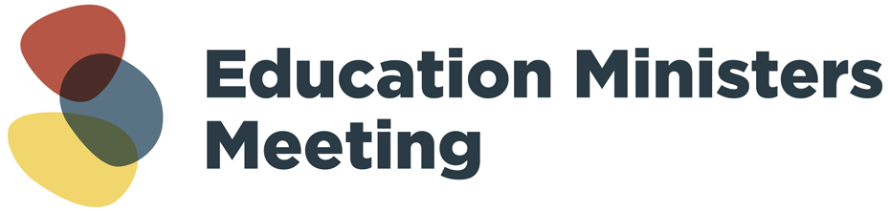

16 March 2022

Improvements to NAPLAN from 2023

Australian Education Ministers have agreed to critical improvements to the National Assessment Program – Literacy and Numeracy (NAPLAN) giving teachers the additional information they need about student performance earlier in the year.

From next year, NAPLAN, which traditionally has been held in Term 2 of the school year, will be held in Term 1.

Bringing the test forward puts information in teachers’ hands sooner, allowing for more targeted support for students to ensure they are gaining important literacy and numeracy skills.

The Australian Curriculum, Assessment and Reporting Authority (ACARA), state and territory education departments, and non-government school authorities will work with schools to ensure they are well prepared for the change.

Australian Education Ministers also agreed that the existing NAP sample assessments in Science, Civics and Citizenship, and ICT Literacy (to be renamed and re-designed as Digital Literacy), which involve some students in Years 6 and 10 every three years, should take place in Term 2 from 2023.

Separate opt-in assessments in these same domains and year levels will also be available in Term 2 each year for any school or system. Science will be available in 2024, with Civics and Citizenship added in 2025 and Digital Literacy in 2026.

The results of these opt-in assessments will be available to participating schools and systems to support their teaching and learning programs and will not be reported publicly by ACARA.

Enquiries: [emmsupport@dese.gov.au](mailto:emmsupport@dese.gov.au)