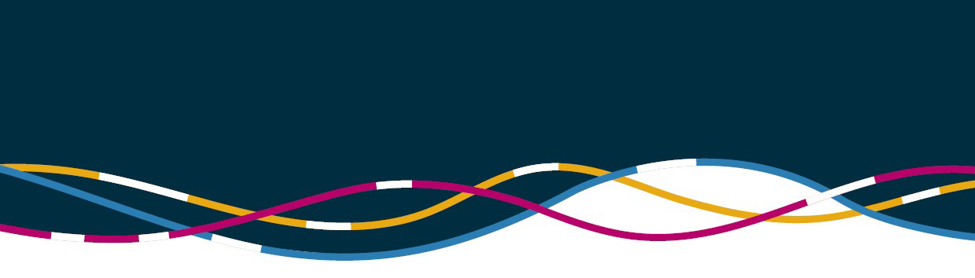

Regulatory fee relief

Australian Strategy for International Education 2021‑2030

On 26 November 2021, the Australian Government released the *Australian Strategy for International Education 2021-2030* and key initiatives supporting its implementation.

The Government has committed a further $27.8 million to give education providers fee relief from regulatory charging. This additional support recognises that even with borders opening to fully vaccinated international students from 1 December 2021, it will take some time for students to return. Extending regulatory fee relief will assist the international education sector to ramp up capacity as students return and help Australian providers to bounce back quickly.

This measure extends the waiver of certain fees for Australian Skills Quality Authority (ASQA), Tertiary Education Quality and Standards Agency (TEQSA), Commonwealth Register of Institutions and Courses for Overseas Students (CRICOS) registrations and the Tuition Protection Service (TPS) Levy in 2022. This is in addition to the previous two years of regulatory fee relief which has saved education providers about $65.2 million between 1 January 2020 and 31 December 2021.

# When will regulatory charging resume?

The department’s revised CRICOS charges have been waived for 12 months and will resume from 1 January 2023. The international TPS Levy will be waived for 2022 and will resume in 2023.

TEQSA’s charges have been waived for a further 12 months and will resume from 1 January 2023. This also includes a 12-month delay to the commencement of a phased transition to increased cost recovery for TEQSA.

The majority of ASQA’s fees and charges for registered training organisations and CRICOS providers have been waived for six months and will resume from 1 July 2022. This measure will delay implementation of ASQA’s move to full cost recovery by six months. This delay will see the introduction of the new cost recovery arrangements aligned to ASQA’s financial year charging cycles. ASQA’s charging arrangements for standalone ELICOS providers will resume on 1 January 2023, providing 12 months fee relief to these providers reliant solely on international student enrolments.

Regulatory charging relief covers all TEQSA and ASQA fees and charges except initial registration fees for new providers and course accreditation fees for new applicants.

# Start date

The current regulatory fee relief is set to end on 31 December 2021. The extension will extend fee relief from 1 January 2022 for between 6-12 months in 2022. No action is required of providers and fees will automatically be waived.

# Further information

[www.asqa.gov.au](http://www.asqa.gov.au) [www.teqsa.gov.au](http://www.teqsa.gov.au)