

Smarter Schools National Partnerships

Improving Teacher Quality

Low Socio-Economic Status School Communities

Literacy and Numeracy

Closing the Gap in the Northern Territory – Initiatives Supporting Quality Teaching and Literacy and Numeracy

Northern Territory

Progress Report 2011

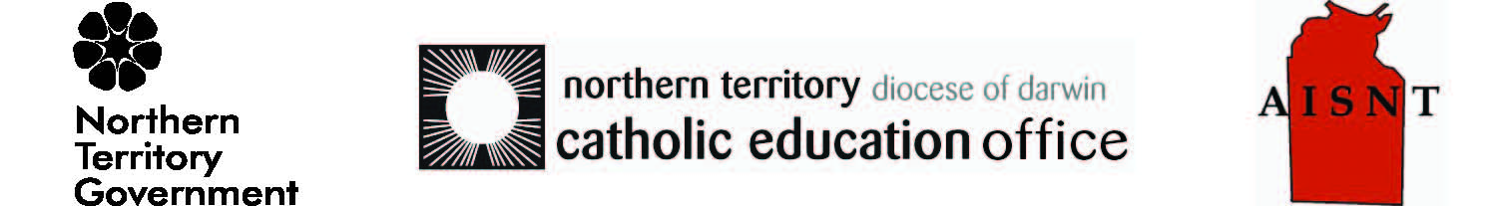

Section 1 | Overview of progress | Page 2
Section 2 | Improving Teacher Quality National Partnership | Page 3
Section 3 | Low Socio-Economic School Communities National Partnership | Page 9
Section 4 | Closing the Gap National Partnership  (Initiatives Supporting Quality Teaching and Literacy and Numeracy) | Page17
Section 5 | Literacy and Numeracy National Partnership | Page 25
Section 6 | Milestone report against all Smarter School National Partnerships | Page 29

Section 1 – Overview of Progress
The Smarter School National Partnerships (SSNPs), including the Quality Teaching and Enhancing Literacy components of the Closing the Gap (CTG) National Partnership, support the delivery of education reform priorities in the Northern Territory as articulated in the Northern Territory’s Territory 2030 strategy, the Department of Education and Training’s Strategic Plan 2011-2014, and strategic plans across non-government education sectors.
Desired outcomes for education reform effort in the Northern Territory are aligned to the National Goals for Young Australians, and focus on achieving the vision articulated under both the National Education Agreement and the National Indigenous Reform Agreement.

During this reporting period, positive indicators are being seen in student enrolment and attendance across schools receiving support under the SSNPs, in particular for Indigenous students. This increased engagement with schooling is beginning to impact on enhanced student academic outcomes, as evidenced by mid-year measures of student attainment against the Northern Territory Curriculum Framework (NTCF).
The Territory 2030 reform underway, assisted by the SSNPs, focuses on education as core to building the social, economic and environmental capacity across the Northern Territory. The Strong Start, Bright Futures model is a vehicle for this, utilising education and schooling to support Territorians to improve their life outcomes through integrated and relevant support from birth through to jobs, and beyond. To this end, the Northern Territory’s SSNPs effort focuses on:
- Building strong partnerships between schools and families community, business and industry
Territory 2030 model for growth
- Developing inclusive and integrated early years programs to provide the best start for young people and families
- Attracting, developing and retaining a strong, effective remote workforce to enhance the quality of teaching in schools, homeland centres and boarding school facilities
- Providing innovative and flexible learning opportunities, in particular for middle and secondary year students, to maintain engagement in schooling and ensure effective transition to post schooling pathways
This report provides a progress update on initiatives funded under the SSNPs for the period 1 January 2011 to 30 June 2011. The reporting period for initiatives under Closing the Gap NP extends to 30 September 2011.

Section 2 – Improving Teacher Quality
Significant Activities (1 January to 30 June 2011)
The Northern Territory has continued to contribute to the development of national facilitation reforms and ensure that agreed directions are embedded in legislation, regulation and policy.
Attracting, retaining and developing quality teachers to remote schools continues to be a priority for the Northern Territory, with an emphasis on better preparation, support and incentives for teachers in remote contexts, and on building the capacity of the Indigenous workforce to increase the number of qualified local recruits in schools.
Improved workforce data systems are also positioning the Northern Territory to monitor and report more effectively, and are informing evidence-based decision making about the suitability of the strategies being implemented.
Partnerships with other jurisdictions and tertiary institutions are enhancing work around remote teacher recruitment and retention and are ensuring practicum programs offer opportunities for real remote experiences as part of pre-service teacher education programs.
Progress Against TQNP Facilitation Reforms (1 January to 30 June 2011)
National Professional Standards for Teachers
Following finalisation of the National Professional Standards for Teachers (NPST) in April 2011, the Teacher Registration Board of the Northern Territory endorsed a phased implementation plan. This will ensure a smooth transition between now and January 2013 when the NPST will be used for all aspects of teacher registration. Until that time, the Standards for Competent Teachers guide the transition of teachers from Provisional to Full Registration, as well as renewal of registration requirements for fully registered teachers.
Systemic requirements to support use of the National Professional Standards are being addressed. A pilot study is underway, in partnership with the Centre for School Leadership, Learning and Development, to determine the suitability of the current illustrations of practice (evidence) protocols in relation to the new NPST.
The Board and other stakeholders continue to work closely with the Australian Institute for Teaching and School Leadership with particular focus on finalising the illustrations of practice and development of support materials to assist registered teachers to understand the use and application of the NPST.
National Certification of Accomplished and Lead Teachers
The Northern Territory has introduced a new Highly Accomplished and Leading Teacher (HALT) program that acknowledges, through remuneration and career opportunities, practicing teachers who achieve high standard of teaching leading to improved student outcomes. There are currently 32 teachers participating in the program who, on successful completion, will be eligible for Highly Accomplished or Lead Teacher status in 2012. The Northern Territory is committed to ensuring that HALT teachers are available to support schools in most need, including remote schools. Of the 2011 participants, one third are from remote or very remote schools. Leading teacher positions have been established at 11 remote and very remote sites across the Northern Territory for Term 1 2012.
The Northern Territory will continue to participate in the ongoing development of agreed guidelines for the national recognition and certification of teachers at higher levels. The HALT program will be reviewed by December 2012 to take into consideration any relevant national directions.
Nationally Consistent Registration of Teachers
The Teacher Registration Board of the Northern Territory has endorsed the implementation plan to transition to a nationally consistent approach to teacher registration, based on the National Professional Standards for teachers, from January 2013. Transitional arrangements will begin in 2012, including some required amendments to the Teacher Registration (Northern Territory) Act and relevant policies.
National Consistency in Accreditation of Pre-service Teacher Education Courses
Following legislative changes in 2010, enabling the Teacher Registration Board authority to accredit pre-service teacher education programs, the Northern Territory has participated in development of the national accreditation process. The national framework is expected to be in use by the end of the year.
Professional Development and Support for Principals
The Northern Territory continues to maintain a focus on building capacity of principals to drive school improvement and deliver improved outcomes for students. The Centre for School Leadership, Learning and Development is delivering a range of programs which aim to:
- provide high quality professional learning and development programs and activities for school leaders, aspiring school leaders and teachers. Programs will have a strong focus on teaching instruction and instructional leadership, in particular targeting the needs of leaders operating in remote schools. Funding under the Low SES NP, the Preparation for School Leadership program was delivered to 74 teachers during this period.
- build leadership capability of current and aspiring school leaders through the introduction of the National Professional Standards for Principals and the National Professional Standards for Teachers
- conduct research and provide advice about innovative and cutting edge leadership and professional learning program content and design in order to respond to workforce capacity demands in the Northern Territory.
In addition the Northern Territory
- is trialling a range of site-specific inclusive leadership models in very remote schools, that provide enhanced support to principals to develop strong partnerships with local community leaders/families and enhance the cultural connections with the school and education
- has introduced a strengthened organisational structure that enhances the support for principals through a regional service delivery model including six-regionally based Directors of School Performance, whose role is to support principals drive school improvement and enhance performance to deliver improved outcomes for students

- is assisting principals to better lead school improvement through the introduction of enhanced regional and school-based support for literacy and numeracy learning, teaching of multi-lingual learners, data literacy/diagnostic systems and business support systems. In addition, through the development of Regional Plans aligned to system priorities, principals are provided with enhanced clarity about the associated performance targets and measures of success expected their schools.
Improved Performance Management and Continuous Improvement in Schools
The Northern Territory continues to drive improvement in schools and support the performance of teachers. These activities include:
- the release and implementation of the probation and performance management policy, which is underpinned by the Competency and Leadership Framework and self / peer and management assessment tools endorsed during this period by the Strategic Workforce Committee
- an online training tool has been developed to provide guidance on the roles and responsibilities related to performance management. In addition, a performance assessment tool has been trialled in a number of selected schools and there is currently a focus on strengthening and streamlining the performance management processes in small remote schools.
- the development of new performance planning tools and processes linked to staff progression within and across levels. These include the Classroom Teacher (CT) 5 to CT 6 Progression Assessment Process and new tools for performance planning across the new SA01 and SA02 levels
- an enhanced selection and induction process that ensures the recruitment of educators with the appropriate skills and disposition to work in challenging remote schools. The new teacher screening and selection process recruited 147 teachers to the Territory in 2011. Recruitment is now underway for 2012.
- a new regional induction framework to provide new teachers with information specific to their regions and communities as well as the support mechanisms available in their own regions. Remote Teacher Support Officers have been established in five regions to provide one-on-one support to teachers and “RTS Online” has been developed as a hub to support the well-being and professional learning of remote teachers
- new teachers are participating in professional development opportunities during the first two years of their employment through the orientation recall programs which ensure ongoing and timely support
- introduction of the Teaching Excellence Program which support the development of highly performing remote and very remote teachers. Twelve experienced remote teachers (10 government and two non-government) participated in the program in 2011.
- activity enabled through the Teacher and Educator 2010-2013 Enterprise Agreement such as trial of extended school day/year arrangements, the introduction of HALTs and incentives for the remote workforce.

New Pathways into Teaching
The Northern Territory has is piloting the Teach for Australia model in the Remote Centres of Excellence. The selection of up to six Teach for Australia Associates will be identified for Barkly College and Katherine High School, with Associates commencing in Term 1 2012. Schools will also identify high performing teachers within these schools to be trained as mentors under the Teach for Australia Mentoring program from December 2011.
Better Pathways into Teaching
The Northern Territory’s reforms in this area have been focused on supporting teaching professionals and paraprofessionals upgrade and obtain formal qualifications. These reforms are discussed in more detail in the Indigenous Education Workforce Pathways section of this report under the CTG National Partnership.
Improved Quality and Availability of Teacher Workforce Data
The Northern Territory continues to contribute to national activity to improve workforce data through participation on the taskforce associated with the Teacher Quality reform agenda and representation on the National Teacher Datasets sub-group.
A significant focus has been on increasing the availability of workforce data to improve the quality, coverage and completeness of staff demographics, occupancy and payroll information within the Northern Territory Department of Education and Training. This is being achieved through:
- development of a professional learning system that will enable all staff professional learning to be captured centrally from 2012
- enhancements to the Staff Management System to collect and report on more granular datasets
- improved reporting functionality in the Teaching in the Territory online recruitment application
- the establishment of metrics for longitudinal workforce reporting to inform strategic decision making
- close tracking and monitoring of Remote Teaching Service teachers to assist with identifying reasons for resignation or movement from remote schools, to better inform the selection and induction process and monitor success.
Aboriginal and Torres Strait Islander Education Workforce Pathways
This area of reform is a significant priority for the Northern Territory not only to assist in building a sustainable workforce but ensure to Indigenous culture is embedded into the school curriculum and practices. The Department of Education and Training recently made a commitment to a stretch target of 200 additional Indigenous teachers by 2018.
During this period a range of initiatives have supported this reform, including:
- development of the Standards for Assistant Teachers. Using a similar mapping framework to the National Professional Teacher Standards, these identify pathways for Assistant Teachers and provide clarity to schools on the knowledge and experience expected of Assistant Teachers at different levels. The standards will provide a common understanding and language for professional discussions between Assistant Teachers, Principals, Teacher Educators and learning institutions
- the graduation of two Indigenous teachers from three year to four year teaching degrees under the Indigenous Teacher Upgrade Program
- the redesign and development of resources for the onsite delivery of the Diploma of Teaching and Learning by Batchelor Institute of Indigenous Tertiary Education
- the Catholic education sector’s Growing Our Own initiative, where the first cohort of teacher graduates are now mentoring the second cohort of 15 students undertaking the program
- the continuation of the Remote Indigenous Teacher Education (RITE) program at Maningrida School and Shepherdson College where eight participants are due to complete their qualifications in 2012.
Quality Placements
The Northern Territory is committed to enhancing pre-service teacher education programs to prepare future educators for careers in the Northern Territory. During Semester 1 2011, the Northern Territory worked with partner universities to generate greater awareness of teaching in remote Northern Territory schools and pre-service placement programs. From the information sessions, 38 applications were received and 30 pre-service teachers have been selected to complete a 4-week placement in remote Northern Territory schools in Semester 2 2011.
In collaboration with the CDU, the Department of Education and Training operates the Teaching School program, where accredited schools aim to prepare workplace ready graduates who fit the current schooling paradigm from day one of employment. Teaching Schools work in partnership with the academic staff of the School of Education to align the academic learning and professional experience of teachers. There are currently 37 government and 4 independent schools involved in the Teaching School program of which 26 are primary, 5 are middle, 6 are secondary and 4 are combined schools.
School Centres of Excellence
Approval has been given for the Teach for Australia program to be delivered at two Remote Centres of Excellence – Barkly College and Katherine High School. The program will enable new teachers to access formalised, comprehensive, coherent and sustained training to enhance their instructional practices with experience teaching in the Northern Territory’s remote and very remote contexts. The program will:
- develop high potential experienced teachers into quality mentors through an accreditation course
- provide quality supervision, mentoring and support to Teacher for Australia Associates and other pre-service teachers and new teachers
- provide scholarships for pre-service teachers to undertake final year practicum placements at the Centres.
The program will provide these schools with access to highly competent staff with specialist knowledge in hard to fill subject areas. This is expected to build the capacity of these schools by providing effective and high quality mentoring and support for teachers.

Support for Targeted Student Cohorts, including Aboriginal and Torres Strait Islander Students (1 January to 30 June 2011)
The key reforms under the Northern Territory’s Improving Teacher Quality National Partnership (TQNP) are focused on building a capable and quality remote workforce where teachers are equipped with tools to deliver appropriate instruction to improve the outcomes of students living in some of the most challenging contexts in Australia. The alignment (and funding) of many of these reforms to the CTG National Partnership ensures that Indigenous students living in prescribed communities and town camps receive targeted support.
A strong focus in the Northern Territory is on growing the Indigenous workforce, not only to ensure program planning and school operations reflect the needs of the community, but to provide a sustainable and consistent workforce.
Showcase Activities (1 January to 30 June 2011)

The Northern Territory has been leading the National Alliance for Remote Indigenous Schools (NARIS) by partnering with Queensland, Western Australia, South Australia, New South Wales, the Stronger Smarter Institute and the Australian Government to drive improvement of quality teaching in remote and very remote schools across Australia.
NARIS logo
The overall aim of the NARIS is to work together to improve the distribution of quality teachers and school leaders in remote Indigenous communities across Australia and to create further capacity to impact positively on life choices for those living in remote communities.
14 key projects have been identified to support joint recruitment, common orientation and induction, and shared professional development strategies for teachers and school leaders in remote regions. The Northern Territory is responsible for coordinating the development of these projects and is leading four projects: Indigenous Student Support, the Numeracy Package, new staff Selection Tools and Process and the Virtual Teaching Network as well as the development and delivery of a common orientation program in 2012.
In October 2011, the Northern Territory hosted the first National Remote Teaching Conference in Alice Springs. This conference was well received by attendees, which provided the opportunity for teachers in, often isolated, remote communities to join with peers across Australia and share best practice:
‘it is about special skills and a different way of working…we can come together and share what we know, what we have discovered…the opportunity we have had to connect with new people and reconnect with people we already know has just lifted everybody’s spirits’
Teacher, Borroloola School.

Section 3 – Low SES School Communities
Significant Activities (1 January to 30 June 2011)
School level initiatives
Supporting the empowerment of school leaders to adopt site-based solutions to locally identified challenges, under the Low Socio-Economic Status School Communities (Low SES) National Partnership and the Closing the Gap (CTG) National Partnerships, a number of targeted initiatives provide grant funding to schools. The focus of these initiatives is to improve student enrolment and attendance through strong family and community engagement and relevant curriculum and vocational learning opportunities. Incremental progress is being seen, with average attendance in all schools eligible under the Low SES National Partnership increasing from 71.9% in Term 1, 2010 to 73.6% in Term 1, 2011. In particular, average attendance of Indigenous students has risen from 65.5% to 68.2% across the same period. Student attainment as measured against the NTCF is also showing signs of improvement. Average student band increase between Term 2 of 2010 to 2011 was 43% improved in English and 34% improved in Maths, compared with the same measure between Term 2 of 2009 to 2010.
Through the Remote Whole School Reform (RWSR) initiative, larger very-remote sites are supported to enhance community engagement, student enrolment, attendance and student achievement. During this period 22 schools (19 government and 3 non-government) were supported and initiatives undertaken include:
- Strengthening of school councils and employment of cultural advisors to ensure strong school leadership which is representative of both the school and local community
- Development of 3-9 programs, community libraries and homework centres to engage adults and parents within the community in schooling
- Delivery of a range of vocational programs, including first aid, fitness, rural operations and manual arts programs, as well as market garden and nutrition projects.
The Engaging Urban Students (EUS) initiative provides support to schools in urban and regional areas (Provincial, Remote and Very Remote sites under the Schools Geographic Locational Classification Scheme). The focus of this initiative is addressing the barriers to learning for disadvantaged young people, in particular through strengthening links between home and schools as key foundations for effective learning and achievement.
Nearly two years on from the initiation of EUS, signs of success are being seen. In Term 1 2011 the proportion of student attending over 80% across the 16 EUS schools was 6.5%. This compares to 3.7% in Term 1, 2010. In particular, the Indigenous student cohort attendance over 80% increased from 0.8% students in Term 1 2010 to 4.1% in Term 1 2011. Following on from stronger attendance, student improvement against the NTCF is positive. Average student band increase between Term 2 of 2010 to 2011 and Term 2 of 2009 to 2010 was improved by 45% and 24% across English and Maths, respectively. For Indigenous students the improvement between the same time periods was 33% for English, and 30% for Maths.
The range of activities undertaken at EUS sites contributing to these improved outcomes includes:
- Employment of Home Liaison Officers and Aboriginal and Islander Education Workers and Indigenous mentors to create, strengthen and maintain links between families and the school
- Development of ‘Ready for School’ kits, funding for school uniforms and school breakfast and lunch programs to ensure each child is ready and able to engage in schooling alongside their peers
- Delivery of school playgroups, parent and child reading sessions and school open days targeting parents and care givers of young children to ensure children receive positive early years learning experiences and remove barriers to education.
The Engaging Remote Indigenous Students (ERIS) initiative targets the same outcomes as the RWSR initiative, but provides support to 55 (50 government, 5 non-government) smaller remote and very remote schools. Activity under ERIS began in 2011, and highlights to date include:
- Community engagement programs including home visits and initiatives to make the school a more welcoming place, such as bilingual school notice boards
- Incentive programs targeting improved school attendance of whole families, not just individual children
- Development of non-formal channels through which local community members not wishing to take a formal role within the school or the school council can engage and inform program delivery at the school.
Regional initiatives
Allowing for a flexible approach to the design and delivery of initiatives targeting region and school specific challenges, regional grants are available under the Low SES National Partnership. Funds are available to regions to deliver initiatives to enhance Local Family and Community Engagement. Strategies to date have included:
- Community empowerment and engagement programs such as MindMatters and the Indigenous Parent Factor Program
- The development of school and community links through formalised industry partnerships which provide both work experience and job pathways for students
- The delivery of programs to enhance parent and care givers readiness to support their children in learning and comfort in the school environment, for example play group, preschool and outreach programs.
To improve Local Attendance and Engagement, grants have been used across the regions to deliver locally determined initiatives. Strategies employed to target these outcomes have been:
- Attendance award and incentive programs, engaging families in their children’s school attendance
- Implementation of programs to re-engage middle and senior year students such as the Stronger Sisters and Sporting Chance programs

- Purchase and use of reading and technology resources which enable students entering school for the first time in later years of schooling to access content appropriate resources at their achievement level.
Leadership Development
Building the capacity of school leaders to deliver site based reform in challenging school contexts is a focus under all the SSNPs. Under the Low SES National Partnership, Regional Mentor Capacity Building positions are providing targeted mentoring and coaching support at the school level to help build strong school leadership. Regional Business Support Consultants are also providing flexible support to school leaders, with a focus during this period on identification of key strategic priorities and resource management to ensure timely and effective implementation. In the Catholic education sector, a project officer is working with eligible schools to develop a sector wide systems to support Principals effectively manage their schools’ resources and assets.
With a particular focus on supporting early career Principals, through the Centre for School Leadership, Learning and Development (The Centre), 74 teachers have been undertaking the Preparation for School Leadership Program and all are due to graduate by the end of 2011. Recognising the importance of integrating culture into schooling, and pivotal role in community to develop this, The Centre has completed training of 15 Cultures of Collaboration Facilitators to work with Principals across the Territory. These facilitators have already begun working with school leaders and teachers to create a culture in which the local community are engaged and empowered to work as true partners with the school.
In Semester 1 the Low SES National Partnership School Improvement Awards rewarded leaders and staff across four schools. Awards were made for improvement in enrolment and attendance, the National Assessment Program Literacy And Numeracy (NAPLAN), performance and participation against the curriculum, and staff retention.
Support for teachers of Multi-Lingual Learners
To provide explicit learning for teachers in design and delivery of programs for Multi-Lingual Learners a Graduate Certificate in Education (TESOL for Indigenous Learners) has been developed in partnership with Charles Darwin University. During this period, delivery of Unit One of the course was completed by representatives from government and non-government schools, Batchelor Institute of Indigenous Tertiary Education, the Department of Education and Training and the Catholic Education Office. The total number of teachers who have now completed five days of intensive ESL training through the unit stands at 140. All educators undertaking the course, as well as those who have graduated, have access to a professional learning community facilitated through a digital portal, online discussion forum and newsletter.

Student well being
To create a positive school environment, enabling students to focus on learning, the Wrap Support Team has been working with government and non-government schools delivering a range of programs to build students resilience, leadership, problem solving and communications skills. These have included:
- Development of School Wide Positive Behaviour (SWPB) teams at 21 schools (17 government, four non-government), supporting school leaders and teachers to adopt whole school approaches and monitor these through use of data and staff review. A particular focus has been on implementation of SWPB in Indigenous Communities, with the Northern Territory presenting on this topic at a SWPB conference in Cairns in Term 1 2011
- Student Representative Council Forums, focussing on managing bullying in schools. These forums facilitated the development of whole school plans, identification of role and responsibilities in bullying, and students’ problem solving, resilience and leadership skills in tacking this problem.
The Stronger Smarter Sisters programs is being delivered at Katherine High School and Centralian Middle school, working with young Indigenous girls to enhance their self-esteem and engender pride in engaging with both the school and their local community.
Innovative and flexible program delivery
Innovative and flexible programming is key to efforts to enhance outcomes for students in remote and very remote locations. Under the Low SES National Partnership, Virtual Schooling course development is underway. Following success of previous program development, Stage 1 and 2 Northern Territory Curriculum subjects are being developed for Design and Technology, Personal Learning Planning and Workplace Practices. These courses are being designed to ensure ESL strategies are embedded in learning materials and the design of engaging activities to allow learners to meet Northern Territory Certificate of Education and Training (NTCET) subject performance criteria. Following successful installation and testing of the media server for delivery, these courses are expected to be online for a pilot in 2012.
Support for Targeted Student Cohorts, including Aboriginal and Torres Strait Islander Students (1 January to 30 June 2011)
Across the 116 schools eligible to receive support under the Low SES National Partnership, 77% of students identify as Indigenous. Consequently, support for Aboriginal and Torres Strait Islander Students is a consideration in the development and delivery of all initiatives under this National Partnership.
Key to improvement of Indigenous student outcomes is the school and community empowerment to select and deliver of contextually relevant programs which are supported by all parties. To this end, a Community Engagement team has been supporting schools and communities to create strategic frameworks in which to select, develop, manage and deliver initiatives targeting improved student outcomes at their school. Engaging with local families, community, business and industry, School and Community Partnership Agreements have been finalised and signed in 15 communities, with an additional 32 in progress.

To enhance delivery to education for students with learning disabilities, development of a Special Needs Data Management System is underway. Higher quality data for these students will enable schools, regions and the system to engage in evidence based decision making to better meet the learning needs of students with learning difficulties.
Showcase Activities (1 January to 30 June 2011)

Lajamanu School is located 580km southwest of Katherine, and provides education for students in preschool through to senior years. 100% students at the school identify as Indigenous, most speaking Warlpiri as their primary language. Attendance and engagement of students has been identified as a challenge by the school, in particular for senior year students. Using a Local Attendance and Engagement grant, the school has developed a program call Lajamanu Champions. Students are selected who have 100% attendance as well as having the support and commitment of their immediate family. The purpose is to further engage these students and their families to become champions for schooling across their peers and the broader community. As Champions, students have access to a number of resources including iPads, MacBooks and digital cameras which are used to tell stories in the form of podcasts. These are uploaded onto their own website which has been developed by the Champion’s teacher. The link to the website can be found here. The success of the Champions program was picked up by the media, and profiled by the ABC in August.
As part of the Remote Whole School Reform (RSWR) group, the school has developed a Manual Arts Program. This program is targeted at providing more practical learning opportunities for senior students across three sectors; automotive, engineering and woodwork. Bendigo Technical Education Centre recently visited the school to provide their students with practical work in conducting maintenance around the school, enhancing senior years students’ feelings of ownership at the school. This partnership will continue as selected students from Lajamanu School complete work experience at Bendigo.
Lajamanu Champions developing their stories
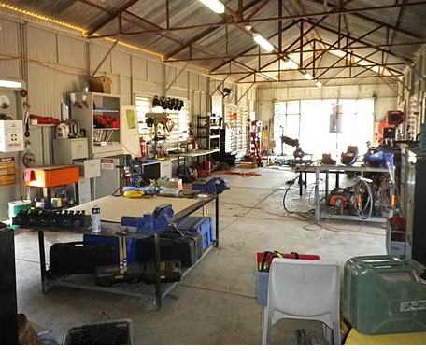
Senior students have been further engaged at the schools through establishment of fitness facilities. The senior students now have an opportunity to development a better understanding of physical education and an opportunity to undertake a Certificate 1 in fitness training. The community have also been encouraged to come into the school to use the fitness facility which is helping to build the school as a hub for the community.
Workshop facility at Lajamanu School

The gardening program, started from SSNPs funding in 2010 has continued and provides an additional program for students who are re-engaging with schooling. The success of the program is evident: all students participating in the gardening program have gained the skills and confidence required to move in to mainstream classes this year.

Tennant Creek High School is located in the Barkly region, and provides schooling for approximately 233 students across Years 7 to 12. Through Smarter Schools National Partnerships the school received an Attendance and Engagement grant to develop two projects aimed at improving senior year students’ engagement with schooling. ‘The Club’ targets improvement of attendance on Fridays, when historically students have not regularly attended school. Recreational and vocational activities are run during the last session of the day, and students can select a course for the term which interests them.
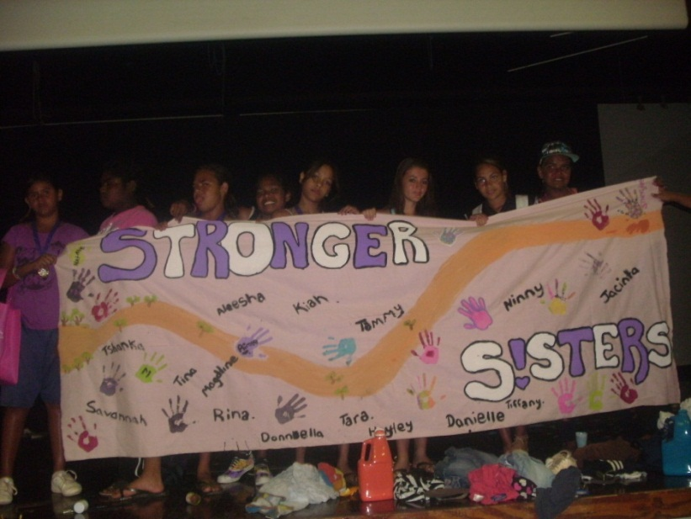
To support female students to be actively involved in the school and community, the Stronger Sister Club provides a number of after school activities available to female students on the proviso that they attend school regularly during the week. Sport forms a strong part of the program planning, and students recently travelled to Darwin to attend the Under 16 Northern Territory School Sports Football Development camp and selection trials. As a result of their discipline to training nine of the students were selected for the Northern Territory team, with a further three selected as reserves.
The Stronger Sisters display their new banner.
The Stronger Sisters program is having a positive impact on school attendance, with 30% of students in the program showing average attendance at or above 90% in Term 1 2011. Another important aspect of the program is the development of students to become strong, positive female leaders within the community. A number of the students are utilising their new identity to re-engage with both school and the community:
“I love being a part of Stronger Sisters because it’s awesome and the opportunities to improve our sporting skills and to get to know more of the people in our community”
Aimee, member of the Stronger Sisters program.

Alekarenge School is located 170km south of Tennant Creek where it provides education for students from preschool to middle years. The Index of Community Socio-Educational Advantage (ICSEA) value of the school is 582 (compared to the national average of 1000) with 97% of students identifying as Indigenous. The school is participating in the Remote Whole School Reform (RWSR) initiative under the Low Socio Economic Status Schools National Partnership. To drive their reform agenda a literacy and numeracy strategy was developed at the start of 2011 in consultation with all staff across the school. This outlined a whole school approach to literacy and numeracy through four key area; planning, teaching, assessing and reporting. Through RWSR funds, a School Programs Coordinator has been employed to provide targeted professional development for staff to enhance instructional teaching of literacy and numeracy at the school. Given the high staff turnover the school experienced at the end of the 2010 (95% turnover of teachers, with four out of nine of the new teachers coming into the school as graduate teachers), the opportunity for a coordinator to work closely with all teachers has enabled consistent approaches to teaching across the school, including the implementation of First Steps Number and Reading programs. The coordinator’s role has also enhanced the cultural integration of the school, providing weekly mentoring to Indigenous assistant teacher to enhance their ability to support the literacy and numeracy improvement agenda at the schools, as well as to facilitate the Indigenous language and Culture program.
As a result of the focus and hard work of all staff at Alekarenge School, attendance rates have significantly improved; average attendance for Semester 2, 2011 is 16% higher than the same time period last year. Student achievement results are also showing strong progress, with NAPLAN results for students across all domains and year levels higher in 2011 than 2010.
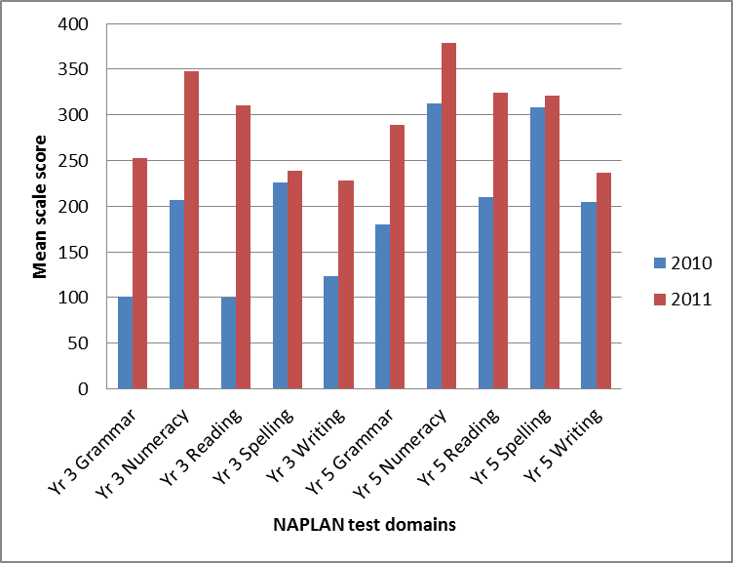
Figure 1: Alekarenge School NAPLAN results

The Residential Care Workers Project (RCW) is led by the Northern Territory Christian Schools Association. This aims to enhance the capacity and quality of care workers across six of the Northern Territory’s residential boarding colleges eligible under the Smarter Schools National Partnerships: Kormilda College, Marrara College, Woolaning Christian College, Tiwi College, St. Johns College and Yirara College. Residential care workers play a key role in the education and development of young people, supporting the academic, emotional and social development of students in often complex and challenging community environments.
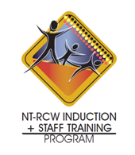
To date the RCW project has developed the Northern Territory Residential Care Workers Induction and Staff Training Program. This program considers the professional development and mentoring needs of staff at each stage along their career pathway. Whilst development is still underway, currently thirty staff are undertaking the Certificate IV in Community Service course, and training has been provided in use of a Restorative Practices Framework across the colleges to support the development and maintenance of healthy relationships between school teachers, residential care workers, students and their families.
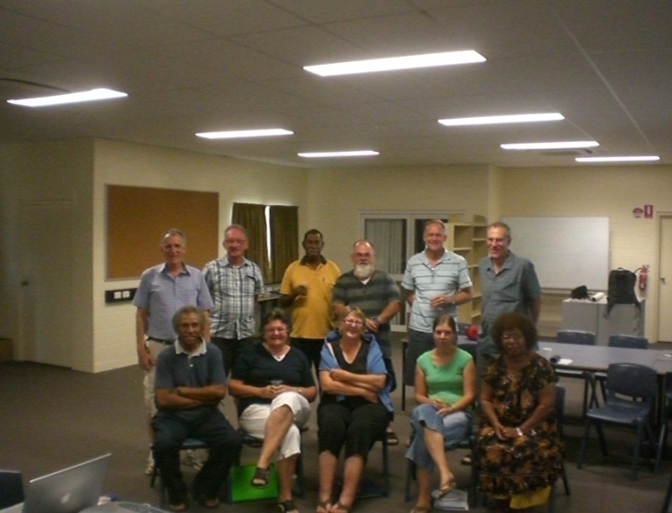
A network of residential care workers has been established, to facilitate ongoing peer support and coaching, and a quarterly newsletter developed to enhance cohesion between residential care workers, who are often geographically isolated from one another. Schools are starting to see benefit in their involvement in the program:
Residential Care Workers studying for their Cert IV.

“The initial efforts of the RCW programme have given our House Parents the opportunity to review together their professional and personal needs. Working together with a Restorative Practices Framework and then 1:1 with the facilitator over a period of several days, the culture at the school is shifting. A more positive, collaborative culture is developing between students, staff and families which will lay the foundations for better student behaviour, academic attainment and staff retention outcomes”.
Principal, Woolaning Homeland Christian College

Section 4 – Closing the Gap
Significant Activities (1 January to 30 September 2011)
The Closing the Gap (CTG) National Partnership transitions the Northern Territory Emergency Response (NTER) to a three year development phase to build on and enhance existing measures. The National Partnership maintains and strengthens core NTER measures while placing greater emphasis on community engagement and partnerships, and building capability and leadership within Indigenous communities. The focus of the Enhancing Education schedule under this agreement is to improve the quality of education, increasing school participation and employment outcomes for Indigenous students living in prescribed communities.
The Indigenous education reform agenda is at the centre of the Northern Territory’s strategies to enhance the life outcomes of Indigenous people. In particular, A Working Future and Territory 2030 make explicit the requirement for schooling as a centre to social, economic and community wellbeing.
To this end integrated models of education delivery are being piloted through the Strong Start, Bright Futures (SSBF) model, building birth to jobs pathways for those living in remote locations. The model emphasises the importance of community leadership and partnership, positive early years experiences and lifelong learning.
In addition to 3 Arnhem region SSBF colleges, two Central Australia sites, Walpiri Triangle and N’taria College, started operating under this model in 2011. Through school and community partnerships, the Strong Start Bright Futures colleges have been delivering strategies such as:
- School governance workshops to establish action plans and a base of support for initiatives to be delivered under the SSBF model
- Enhancement of program delivery options, especially for students in secondary years where subject choice in remote locations is limited. These include vocational programs such as manual arts and land management, as well as online learning options.
- Development of out of hours (3-9) education opportunities for students disengaged with traditional schooling, as well as the community. These include opportunities to study areas such as nutrition and hygiene, Yolngu dance, cooking and woodwork.
West Arnhem College is included in the showcase of activities below.
Enhancing early years support, three Child and Family Service Leaders are working at Groote Eylandt, Ngukurr and Gunbalanya. They are improving engagement with early years support by mapping services in communities so families can more effectively access services delivered by multiple providers including government and non-government, early years, health and education organisations.

100% of students eligible under the CTG National Partnerships live in remote or very remote locations. Recognising the challenges facing schools to maintain engagement of young people in these locations where often ranges of courses and specialist teacher availability is limited, the Middle Years VET program targets students at risk of disengaging with the schooling system. During this reporting period, 63 students from six very remote schools participated in the Certificate 1 programs of Manufacturing Pathways (42) or Hospitality (21).
To support the delivery of quality education in homeland centres, preparations for the Interactive Distance Learning Pilot are underway, with Yirrkala and Maningrida schools preparing to test this model for education distance delivery in 2012.
Enhancing the support provided to young people to enable transition from school into the workforce, further training or education or to take a leadership role within their community, the second phase of the Remote Personal Learning Plan subject is underway. In 2011, 96 students have enrolled in the subject (compared to 77 students in 2010). This Stage 1 NTCET subject is being delivered across six remote schools: Gapuwiyak (17), Gunbalanya (30), Millingimbi (20), Umbakumba (9), Yirrkala Homelands (5) and Angurugu (15). Students selecting this subject have the opportunity to access support, information and mentoring to inform their post-education choices both in their home community and further afield.
One of the enablers to building a meaningful education experience is the development and maintenance of strong industry partnerships to connect schooling with opportunities beyond the classroom. Industry Partnerships Officers are working across the 20 Growth Towns to build effective partnerships with the purpose of both increasing students’ readiness to enter the workforce, as well as providing job opportunities for students when they leave school. A Frequent Attenders Program has been launched with four corporate partners to provide incentives for students to regularly attend and engage with schooling. Training opportunities are also being developed; a Memorandum of Understanding has been signed between Borroloola School and MacArthur River Mining Community Benefits Trust to embed training into the school curriculum, provide work experience opportunities and ultimately provide post-school pathways for young people.
Menzies School of Health Research are carrying out a longitudinal evaluation the Northern Territory’s Indigenous education reform agenda, in particular the components underpinning the Strong Start, Bright Futures college model. This is well underway at 3 sites: West Arnhem, Groote Eylandt and Yambirrpa (Yirrkala) College.
Strong and effective school leadership is a key enabler for school improvement, and ultimately the improvement of student outcomes. Supplementing support provided under the Low SES National Partnership, leadership support is being provided with specific focus on the requirements of teaching in remote and very remote contexts.

The Centre for School Leadership, Learning and Development has delivered Preparation for School Leadership Programs to 74 teachers across the Barkly, Palmerston and Rural, Alice Springs, Darwin and Katherine regions. Participants attended a 2 day conference on the topic of Instruction Leadership in a Global Context, offering aspiring leaders, particularly where working in remote and often isolated settings, an opportunity to further build knowledge and networks. The 11 participants from the Barkly region completed the course in June, with the remaining teachers expected to complete by the end of the year.
Coaching remains core to the Northern Territory’s model for enhancing school leadership and as such, in addition to the coaching element across all leadership courses, 20 school leaders from SSNPs schools are undertaking a nine month program to become Growth Coaching facilitators. In the Catholic Education sector, the Indigenous School Leadership program, delivered by ACEL commenced in Semester 2. 15 emerging and six current leaders across six schools are taking part. This supplements ongoing support school leaders in the Catholic Education sector receive from the leadership development and support consultant.
Recognising the significant proportion of students in remote and very remote locations for who English is not their primary language, seven Teaching Multi-Lingual Learners (TML) specialists have been working across Katherine, Barkly, Alice Springs, Arnhem and Palmerston and Rural regions to support teachers and school leaders in appropriate program planning and delivery. In the Alice Springs region particular focus has been given to building capacity of classroom teachers in interpreting the Northern Territory Curriculum ESL moderation framework, and use of this as a diagnostic tool to enhance the evidence base for program selection and delivery for each student. To further enhance the use of quality of evidence in teaching for multi-lingual learners, a set of assessment tasks relevant to integrated ESL program delivery for multilevel learners are being developed.
With specific focus on enhancing literacy and numeracy instructional teaching, 24 Literacy and Numeracy coaches have been working with school teachers and leaders across the Northern Territory. During this period, their targeted support is changing the way in which school leaders plan for literacy and numeracy, from pre-school to senior years, as well shifting the way literacy and numeracy are delivered in the classroom. Activities during this period have included:
- Development of online and offline professional learning communities to enhance peer to peer support and learning
- Delivery of professional development to teachers and school leaders, including First Steps training
- Development of a Primary Connections program to deliver literacy and numeracy through ‘hand on’ science work in the classroom
- Supporting school leaders in development and delivery of whole school approaches to enhancing literacy and numeracy
- Providing in class support to enhance teachers ability to design and deliver programs targeted to individual students and specific cohorts
- Definition and delivery of early years pre-literacy and numeracy programs to ensure students enter the school setting ready to access learning.

Regional Indigenous Education Managers are working to support regional approaches to delivery of effective Indigenous education at both region and school levels. In the case of the Central Australia region, during this reporting period this has included the Indigenous Education Manager working with both the regional Data Literacy and Diagnostic Systems Project Officer and the Director of School Performance, as well as Congress, to manage an integrated approach to better identifying students who move across Northern Territory, Western Australia and South Australia borders.
In the Catholic education sector, expansion of the Indigenous Catholic Community Schools Specialist Support Team to six positions, particular focus has been on the following during this period:
- Mentoring and coaching classroom teachers to increase their confidence and capacity to deliver education to ESL learners
- Support for schools to deliver vocational training
- Enhanced use of data and assessment tools in planning and delivery of numeracy teaching.
Key to providing a consistent workforce in remote and very remote schools, and to provide a cultural context for learning in the classroom, Indigenous Workforce Development is a priority in the Northern Territory. 15 Indigenous Workforce Development specialists are working with Indigenous paraprofessionals and professionals across the Territory to enhance strengthen and grow remote Indigenous workforces in schools. During this period, 30 graduated from their courses. These professionals and paraprofessionals are increasingly empowered to guide curriculum and lesson delivery, as well as lead orientation of new staff into the school and community.
In the Catholic education sector, the Growing our Own Indigenous workforce development program is being delivered for a second cohort of students. Details are included in the highlights, overleaf.
An Early childhood workforce development pilot is underway, working across all organisations employing early childhood workers. An Early Childhood Workforce Development co-ordinator has been recruited in Yuendumu, and is building connections between preschools, schools, crèches, safe houses and childcare centres. Three additional Early Childhood Workforce Development positions are under recruitment. Batchelor Institute of Tertiary Education has been selected as the training provider and study modules are under development to be ready for test in 2012.
Support for Targeted Student Cohorts, including Aboriginal and Torres Strait Islander Students (1 January to 30 September 2011)
The Closing the Gap National Partnership focuses on providing support for Indigenous students. Incremental improvement is starting to be seen, with average student attendance in Term 1 2011 standing at 63.1% compared with 60.4% for the same period in 2010. Indigenous student performance against the NTCF increased between 2010 and 2011 compared with 2009 and 2010. Average student band increase between Term 2 of 2010 to 2011 was 22% improved in English, and 40% improved in Maths.

Addressing the impacts on learning from conductive hearing loss suffered by many Indigenous students, work during this period has been carried out at both the strategic level, liaising with the Department of Health and NGOs delivering services in regions, and operational level. Professional development to support teachers to deliver lessons and programs suitable to meet the needs of students with hearing loss have been carried out across the Territory, in addition to the development of materials which embed ear and hearing health messages into the curriculum.
Showcase Activities (1 January to 30 September 2011)
Growing Our Own is a professional learning and pathways development initiative delivered within the Catholic education sector to grow the Indigenous workforce in schools. This provides for not only a more stable school workforce, contrasting with the historically low retention rates of teachers coming from outside communities, but a cultural context for the delivery of education, including the requirements for bilingual education in some schools.
At Our Lady of the Sacred Heart, Wadeye, three paraprofessionals at the school have recently upgraded their diploma level qualifications to degree qualifications, enabling them to become fully qualified teachers at the school. Included in their new roles as Indigenous teachers are mentoring responsibilities to support the second cohort of paraprofessionals undertaking study as well as teachers participating in the Emerging Leaders unit of the Indigenous Leadership Program. As members of the schools’ Indigenous Leadership group, they also plan and deliver the culture and community program which involves both integrated curriculum programming and significant community member participation.
Wadeye students in front of their school

West Arnhem College is located in Kakadu approximately 300km east of Darwin. The college comprises of two schools located in Gunbalanya and Jabiru as well as three homeland learning centres in Gumarrirnbang, Mamadawerre and Manmoyi.
Improved school governance and augmented leadership are core drivers for community partnership, which is key to delivery of the Strong Start, Bright Futures model. A change in leadership structure has taken place during this period, with two co-principals now working together at Gunbalanya School.
Co-principals at the Gunbalanya campus
The college also adopted a 3 domain approach to delivery of education at the college: Class, Crew and Culture. The approach acknowledges each domain is important to the student’s education and learning, as are highlighted below:
- Class: Young people to exceed the national standards for literacy and numeracy
- Culture: Young people are fluent in their own cultures and enjoy the best of both worlds
- Crew: Young people build their understanding outside of the classroom and curriculum.
Supporting the Class Domain, a high flyers class has been developed for students who have high attendance. In Semester 1, 38 students of this class travelled to Darwin to see the replica Endeavour ship. Their experiences were shared with their peers on their return to encourage regular attendance of others across the school.
The Culture Domain is supported in part through the role of the Assistant Teachers across the college. They provide local language and knowledge of the community to develop and communicate curriculum to students in ways that are relevant to them. The Assistant Teachers are also responsible for providing a cultural awareness program for new staff to the college to aid their integration into the community.
The Crew Domain is supported through allocating Fridays for extra curricula activities. These include arts, vocational and sports programs and incorporate Clontarf and Girls Academy which are underway at the college. A recent partnership with Territory Alliance provides students with vocational training and practical work experience. To build the Crew Domain beyond students currently attending the school, the college has implemented a Wole Woleh (3-9) program, offering a range of programs outside of normal school hours that all members of the community can access. These include:
The High Flyer Class’ trip to Darwin
- a school library for community use, including access to a range of literature as well as computers.
- a driver license program to enable students and local people to obtain a learner license.
- a zumba class which was especially requested by the community!
A vodcast on the 3 domains approach at West Arnhem College has been developed, and is available here.
The direction set is being recognised through repositioning schooling for young people and the community:
“ensuring each domain receives equal attention provide a complete integrated education. Although formally through the school, this approach is starting to successfully engage parents, community and partners with a common vision which looks beyond tests and exam results”
Director, West Arnhem College
Improvement is being seen in student attendance rates. In Semester 1 2011 there was a 20% increase in student attendance rates, compared with Semester 1 2010. This equates to an extra 86 students coming to school each day and there has been a 200% increase in the number of students achieving over 90% attendance.

Nyangatjatjara College is located in Central Australia, near the tri-state border of the Northern Territory, South Australia and Western Australia. The college delivers education to 77 middle school students across four campuses; Kaltukatjara, Mutjitjulu, Imanpa and Yulara. In 2011 the school embarked on a strong reform agenda, supported by funding from the CTG National Partnership.
During the last year, the school community has become increasingly involved in delivery of education for their young people. Through the school governance board, the community has provided direction and guidance regarding program delivery at their school. In October 2010 the community decided to make a three year commitment to the MindMatters program using community funds, and the school worked in partnership to deliver this program. The program is designed to build resilience and a sense of self identity to help address mental health and wellbeing issues. In particular, the school community chose to focus the program on engaging both school aged students and young people in their 20’s and 30’s, to strengthen cultural ties and ensure strong leadership for the community as the next generation. The model for delivery is such that ownership remains with local people: the Aboriginal staff member who received formal training in Melbourne acts as a tutor to mentor local staff to deliver this program.
Artwork at Nyangatjartjara College
Focussing further on engagement of Indigenous community members, and to enhance student academic attainment at the school, as part of delivery of the Accelerated Literacy (AL) program Assistant Teachers have been training in the AL based ‘helping children read program’. This has provided the Assistant Teachers with additional tools to take an active role in the delivery of literacy teaching.
Relationships have continued to be strengthened between the school and the school community through employment of an attendance officer at Mutjitjulu. The officer goes out into the community to talk with families and collect students to take them to school, obtaining accurate and meaningful information in regard to student absences where necessary. This is essential in not only understanding the barriers to student attendance, but tracking the movement of students across the borders to South Australia and Western Australia to ensure, where possible, continuity of education for mobile students. At Mutjitjulu School, average daily attendance has risen from 5.2 students in Term 1 2011 to 12.8 students in Term 2 2011.
Recognising the Indigenous Protected Area on which the school is located, a ranger program has been established between the school and Parks Australia to build cultural identity and develop employment opportunities for students within the community. This ‘Healthy Country, Healthy People’ program, comprises teaching of men and women’s stories as well as provision of practical work experience in environment and land management skills.

To further enhance students’ integration into the community, and as an additional pathway from schooling to employment, Maruku Arts has been working closely with the school. Developing the artistic skills of young people in the community through the assistance of artists from the local and surrounding areas, students have taken part in wood carving and painting workshops creating both ‘traditional’ dot paintings and contemporary ‘walka boards’. Students’ work experience is building skills across a range of areas, from customer service to cash handling and basic book keeping.

Yirrkala School & Yirrkala Homeland School are situated in Arnhem land, approximately 20km from Nhulunbuy. 180 students are enrolled in Yirrkala School, and 156 across Homeland School sites, with approximately 99% of students identifying as Indigenous.
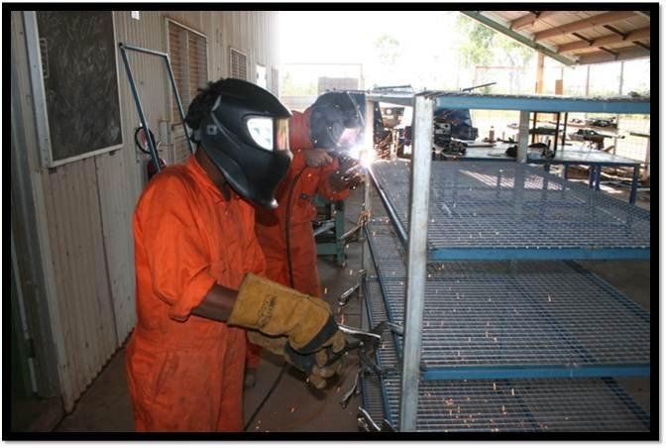
A focus for these schools, in line with the Closing the Gap reform agenda, has been on strengthening middle years education, a time at which students often become disengaged with traditional schooling. The VET in middle years program is underway at the school, with 12 students working towards their Certificate I in Hospitality, and a further 9 enrolled in Manufacturing Pathways. Students, on completion of the courses, will not only receive accredited training but relevant skills with which to transition into employment either in the community, or elsewhere.
To provide a framework in which the school can provide support for young people in planning their pathways beyond school, Yirrkala is delivering the newly developed Personal Learning Plan (PLP) Stage 1 NTCET subject. Through this, Year 10 students work with teachers, mentors and community members to identify future goals, creating action plans to achieve these. To enable delivery of this subject, teachers from the school have joined others across the Northern Territory to received face to face training for planning, delivery and assessment of the subject as well as ongoing support to deliver the subject. This increased capacity in pathways planning will support a ‘birth to jobs’ strategic vision.
Middle Year students taking part in the Manufacturing Pathways program
To strengthen the integration of education delivery across Yirrkala School and the Homeland School sites, a new trial of technology is underway. Yirrkala School is being set us as an Interactive Distance Learning Hub (IDL), from which the four of
the homeland sites (Dhalingbuy, Gan Gan, Borawuy and Garthalala) will be linked. Through IDL, the hub and each of the homelands, will be able to receive and broadcast teaching and learning sessions. This will enable schools to draw upon their strengths and share their expertise with other learning centres.

Section 5 – Literacy and Numeracy
Significant Activities (1 January to 30 June 2011)
Activity under the Literacy and Numeracy (L&N) National Partnership in the Northern Territory supports the strategic direction set in The Department of Education and Training 2011 – 2014 Strategic Plan, and A Smart Territory. The L&N National Partnership enhances system, regional and school level support delivered by sectors in line with these strategic agendas, as well as complementing support provided by the Low SES, ITQ and CTG National Partnerships.
In order to enhance instructional school leadership and classroom practice with a focus on evidence based teaching of literacy and numeracy, system level support has been engendered to develop and endorse a number of programs and products.
The Evidence Based Practice Framework (EBPF) has been designed to support schools, regions and the system to critically appraise literacy and numeracy approaches, in particular for targeted student cohorts. At the school level, the EBPF has been embedded into the Department of Education and Training’s Accountability and Performance Improvement Framework as the vehicle for school planning. To build a culture of ongoing evidence based practice outside of the formal school planning process, workshops have been carried out with regional officers in the Palmerston and Rural, Barkly and Arnhem regions focussing on use of the EBPF as part of the T-9 Diagnostic net. At a system level, alignment of programs to the critical features of the framework has resulted in two additional programs being approved for system endorsement.
Following the recommendations of the National Literacy and Numeracy diagnostic tools project, the Northern Territory has selected 19 diagnostic assessment tools for use in schools. A further tool, the e-asTTle New Zealand has been aligned to the Northern Territory Curriculum Framework and is undergoing trials in six schools.
Regional support is being provided to schools to support the use of evidence and analysis in literacy and numeracy program selection. Four Data Literacy and Diagnostic Systems Project Officers are challenging schools’ pedagogical practices through a multi-layered approach across the regional, school, classroom and individual student level. Support provided during this period has included:
- Facilitation of ‘data groups’ with school leaders in the Katherine region to build regional leadership capacity in evidence based whole school approaches to enhancing literacy and numeracy
- Collaborative planning days in the Palmerston and Rural region to ensure all key stakeholders appreciate the stages of analysis, insight development and prioritisation involved in developing strong school literacy and numeracy strategies
- Working with individual school to develop a data plan in the Alice Springs region to ensure schools not only identify evidence from their current data, but set up processes to ensure tracking data is available on an ongoing basis.
- Creation of student level baseline data sets in both the Alice Springs and the Barkly regions to provide richer student assessment data from which to develop whole school strategies as well as inform classroom program planning.
To increase the empowerment of principals to drive whole school engagement with literacy and numeracy, grants supporting place-based evidence based practice initiatives are being used across regions. Based on the needs identified in each school through the school planning processes, initiatives have included:
- Delivery of intervention programs, such as Quicksmart, to enhance outcomes for targeted groups of students
- Development of early years oracy programs to measure and improve students’ readiness to engage literacy and numeracy learning
- Revision of curriculum maps and development of schools’ scope and sequence materials which both aligning to the Northern Territory Curriculum Framework and reflect the individual schools context
Targeting schools with the necessary foundations in place to accelerate students’ literacy and numeracy attainment, 22 schools (20 government and 2 non-government) were included in the Maximising Literacy and Numeracy (MILaN) program in 2011. Aligned to school strategies for improving literacy and numeracy outcomes, schools implemented a range of initiatives that included:
- Introduction of school wide programs such as First Steps and Accelerated Literacy
- Enhanced use of data in schools through professional development and inclusive whole school planning approaches
- Purchase of materials to support targeted students, including Reading Doctor and Mathletics
- Flexible staffing solutions to allow relief for senior teachers to take a stronger role in definition and delivery of whole school approaches to literacy and numeracy.
Extending the Indigenous Workforce Development efforts funded through CTG National Partnership, 44 paraprofessionals working in schools with high numbers of Aboriginal and Torres Strait Islander Students have been supported to gain educational qualifications through the Strong Literacy and Numeracy in Communities Pilot. As a second phase to the initial pilot, paraprofessionals from four schools from Central Australia and one from the Palmerston and Rural region were funded through SSNPs and completed their studies in May. Across the cohort of graduates, 18 achieved Certificate III level qualifications, 15 Certificate IV qualifications, and 11 Diploma level qualifications.
A review of Literacy and Numeracy strategies across the Northern Territory, led by the Australian Council for Education Research, has been completed. From the findings of the review, five systemic priority areas for action have been identified by the Chief Executive of the Department of Education and Training, and working groups formed to implement these. To complement the review of literacy and numeracy strategies, an internal evaluation is underway to consider specific literacy and numeracy approaches and programs. This is expected to be completed in early 2012.

Support for Targeted Student Cohorts, including Aboriginal and Torres Strait Islander Students (1 January to 30 June 2011)
Closing the gap between Indigenous and Non-Indigenous student attainment is a priority for the Northern Territory, as reflected in the Department of Education and Training 2011-2014 Strategic Plan, and A Smart Territory. As such, all levels of delivery within the Literacy and Numeracy National Partnership: system, regional and school have a specific focus on Aboriginal and Torres Strait Islander Students in both design and delivery.
Showcase Activities (1 January to 30 June 2011)
Manunda Terrace Primary School is situated in the northern suburbs of Darwin with a school population of approximately 230 students. Students from the school have diverse backgrounds, representing 22 ethnic groups. Manunda Terrace has a whole school approach to enhancing literacy and numeracy, which has been delivered with support from both the Low SES and Literacy and Numeracy National Partnerships.

With a focus on increasing the accessibility of learning for students from whom English is not their primary language, the school has employed a full time teacher to use new technologies. The school set up a specific classroom with computers, electronic whiteboards and cameras for students. Students have been encouraged to use these technologies to engage in learning and express their understanding, enhancing their numeracy and literacy capabilities.
A parent sees their child's work in the resources room.
Manunda Terrace was one of four schools involved in the Strong Literacy and Numeracy in Communities Pilot where the objective was to support training of paraprofessional staff who work with large cohorts of Aboriginal/or Torres Strait Islander students. Of the seven paraprofessional staff members all gained their certificate training in Education Support Worker Certificate IV. Two additional paraprofessional staff members were also employed to support the literacy and numeracy grouping program by reducing the adult to student ratio for the morning as this is uninterrupted time allocated each day for the teaching of literacy and numeracy.
Extending the support for students, a Homework Centre has been set up at the school. Currently 60 students regularly attending the centre, which ensures a happy and comfortable learning place where students have pastoral care outside of normal school hours and their families can input into their child’s learning.
Testament to the reform underway at Manunda Terrace Primary School is their recent success at the Low SES NP School Improvement Awards. The school won two awards this year; Greatest improvement in staff retention and Greatest improvement in NAPLAN results.

The Barkly region stretches 283,605 square kilometres across Central Australia and contains 18 schools in some very remote places in Australia. Despite geographical dispersion, schools across the Barkly region work together to deliver evidence based, strategically focussed programs targeting the particular needs of each student. The region has carried out a baseline data assessment of each and every student across a raft of literacy and numeracy measures. This detailed student data allows for teachers to adapt their program planning to meet student needs, and monitor the effectiveness of this. At a regional level, the Data Literacy Officer monitors baseline data sets, alongside other evidence such as NAPLAN results, to inform the development of strategy and systemic support requirements.
Three Literacy and Numeracy Coaches work with schools across the region, supporting leaders in creation of whole school improvement agendas, as well as individual teachers’ pedagogical approaches within classrooms. A particular focus during this period has been on use of interactive technologies within program planning, as well as provision of First Steps Numbers training, which is being rolled out as a region wide approach.

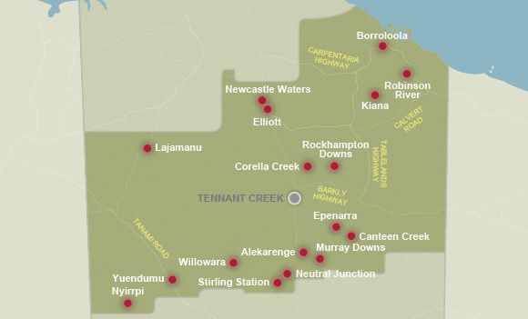
The integrated, multilayered approach being taken in the Barkly region is showing positive results, in particular for students’ numeracy achievement:
Schools receiving SSNPs support across the Barkley region
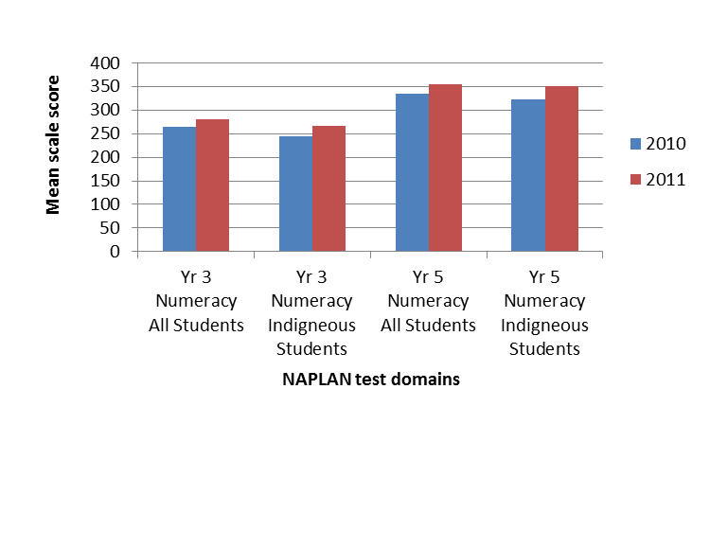
Figure 2: Barkly region NAPLAN results

Section 6 – Milestone Reporting Improving Teacher Quality NP

Part 1 - Milestones not reported/not achieved/partially achieved in Annual Report for 2010
Milestone | Milestone achievement at July 2011. | Reasons for partial achievement and expected future progress.
- First Very Remote Centre of Excellence established | Partially achieved | Two sites and the model for delivery have been agreed by NT DET Executive Board. Implementation is now underway.
Part 2 - Milestones in Progress Report - (Achieved 1 January to 30 June 2011)
Milestone | Milestone achievement at July 2011. | Reasons for partial achievement and expected future progress.
- Evaluation of pre-service internship and education career pathways programs underway to determine appropriateness and success factors | Achieved

Section 6 – Milestone Reporting Low SES School Communities NP

Part 2 - Milestones in Progress Report - (Achieved 1 January to 30 June 2011)
Milestone | Milestone achievement at July 2011. | Reasons for partial achievement and expected future progress.
- School Improvement Plans Published for all 113 schools involved in this National Partnership | Achieved.
- School Annual Reports for all National Partnership schools with published school improvement plans explicitly identifying involvement in Smarter Schools, relevant future activity and reporting on achievements and progress (as appropriate) | Partially achieved. | Funding sources to schools are many and varied. Further work is required to ensure every School Annual Report explicitly links Smarter Schools National Partnerships to initiatives carried out.
- RWSR, ERIS and EUS schools are accessing direct funding or being provided support to provide access to programs or services that target priority areas such as:  - Improving literacy and numeracy outcomes  - Enhanced community and family engagement  - Student attendance and engagement | Achieved.
- All participating schools have access to regional/sectoral and/or system programs and/or services that support delivery of reforms to enhance:  - family and community engagement  - student attendance and wellbeing  - flexible and innovative remote delivery | Achieved.
- Ten Accomplished and Leading Teachers in remote schools | Achieved.
- Five Regionally Based Mentor Capacity Building Support officers employed | Partially achieved. | Two roles are in place. Regions are determining the most appropriate model for support. This may not require all positions.
Section 6 – Milestone Reporting Closing the Gap NP

Part 2 - Milestones in Progress Report - (Achieved 1 January to 30 June 2011)
Milestone | Milestone achievement at July 2011. | Reasons for partial achievement and expected future progress.
- Eight Regionally based multi-lingual learners coordinators established | Partially achieved. | Seven regionally based multi-lingual leader coordinators are in position.
- 20 Literacy, Numeracy and multi-lingual learners coaches supporting schools | Achieved.
- Interim Strong Start Bright Futures evaluation report completed | Partially achieved. | The evaluation looks to medium and long term outcomes, as such the timescales for delivery of reports have been extended since milestones were originally determined. Progress is strong however, with evaluative activity underway at the phase 1 college sites and the Quality Teaching component of the evaluation receiving Board approval.
- School improvement plans for all prescribed schools include Closing the Gap targets | Achieved.
- Consultation and negotiation underway for embedding Closing the Gap reforms to sustain progress toward improvement targets | Achieved.

ACARA have advised 2011 NAPLAN writing results are not directly to comparable to 2010 due to a change of test content.

