

|  |
| --- |
| **Australian Government** |
| **Department of Education, Skills and Employment** |

**DRAFT**

**COST RECOVERY IMPLEMENTATION STATEMENT**

**Regulation of Providers listed on the Commonwealth Register of Institutions and Courses**

**for Overseas Students**

**2022**

|  |
| --- |
| Cost recovery involves government entities charging regulated organisations some or all the efficient costs of a regulatory activity. This may include goods, services or regulation, or a combination of them. The Australian Government Charging Framework (Charging Framework), which incorporates the Cost Recovery Guidelines (the CRGs)[1], sets out the framework under which government entities design, implement and review regulatory charging activities. |

Contents

1 INTRODUCTION 4

1.1 Purpose and scope of the CRIS 4

1.2 Description of the regulatory charging activity 5

1.3 Who will pay the regulatory charges? 5

2 POLICY AND STATUTORY AUTHORITY TO COST RECOVER 6

2.1 Government policy approval to cost recover CRICOS charging arrangements 6

2.2 Statutory authority to charge 6

3 COST RECOVERY MODEL 6

3.1 Scope 6

3.2 CRICOS Activities, outputs and business processes 7

3.3 Design and Costing of Application and Non-Application Based Activities 8

3.3.1 Application-based activities 10

3.3.2 Non-Application-based activities 11

3.4 Costs of the regulatory charging activity 14

3.4.1 Direct Costs 14

3.4.2 Indirect Costs 14

3.5 Cost Management Strategies 15

3.6 Design of Regulatory Charges 15

3.6.1 Application based charges 15

3.6.2 CRICOS Annual Registration Charge 16

4 RISK ASSESSMENT 17

5. STAKEHOLDER ENGAGEMENT 17

4.1 Initial consultation 17

4.2 Subsequent consultation 18

4.3 Legislation 18

5 FINANCIAL ESTIMATES 19

6 FINANCIAL PERFORMANCE 19

7 NON-FINANCIAL PERFORMANCE 20

8 KEY FORWARD DATES AND EVENTS 20

9 CRIS APPROVAL AND CHANGE REGISTER 21

Glossary 22

Attachment A: CRICOS Service Catalogue 24

Attachment B: CRICOS Output Costs with Cost Recovery Funding Mechanism 29

Attachment C: CRICOS Charging Risk Assessment 30

Figures and Tables

Figure 1: Education services for overseas students 4

Figure 2: Typical Five Year CRICOS Registration Business Flow 5

Table 1: CRICOS Activities and Outputs 7

Figure 3: Methodology for determining CRICOS Costs 9

Table 2: Proficient Officer Effort for Initial Provider Registration 10

Table 3: Proficient Officer Effort for Renewal of Provider Registration 11

Table 4: Proficient Officer Effort to deliver key tasks in Outputs 1.1 to 1.6 12

Table 5: Proficient Officer Effort to deliver key tasks in Outputs 2.1 to 2.4 12

Table 6: Proficient Officer Effort to deliver key tasks in Outputs 3.3 to 3.9 13

Table 7: Estimated volumes for Initial Registration and Renewal of Registration Applications 13

Table 8: Metrics for each element of the Annual Charge 13

Table 9: Aggregate cost and ASL requirements for the CRICOS program (Reference - Attachment B) 14

Table 10: CRICOS individual charge details for 2022 (Reference data: Attachment A) 15

Table 11: CRICOS Annual Registration Charge details for 2022 16

Table 12: Example of charge cost based on provider profile based on CARC Enrolments 16

Table 13: Financial Estimates of Expenses and Revenue for the CRICOS program 19

Table 14: Historical Financial Performance of the CRICOS program (Note: there is no financial performance history for the new cost recovery model) 20

# INTRODUCTION

The *Education Services for Overseas Students Act 2000* (ESOS Act) establishes requirements and standards for the quality assurance of institutions offering education and training courses to international students in Australia on a student visa. The ESOS Act also provides tuition fee protection for international students. The Australian Government recovers the costs of regulating education providers against the ESOS Act and the ESOS legislated standards.

Australian education providers (both public and private) must be approved for registration on the *Commonwealth Register of Institutions and Courses for Overseas Students* (CRICOS) before they can promote or deliver courses to overseas students. CRICOS lists all Australian education providers approved to teach overseas students, and the courses that they offer.

CRICOS registered providers must have met, and continue to meet, the requirements of the ESOS Act and the *National Code of Practice for Providers of Education and Training to Overseas Students 2018* (National Code). Any providers wishing to deliver English Language Intensive Courses for Overseas Students (ELICOS) or Foundation Program courses must also meet the ELICOS or Foundation Program Standards as relevant.

The registration, regulatory, compliance and enforcement functions under the ESOS Act are shared across the ESOS agencies:

* the Australian Government Department of Education, Skills and Employment (the department)
* the Australian Skills Quality Authority (ASQA)
* the Tertiary Education Quality and Standards Agency (TEQSA).

The ESOS policy, legislative and regulatory framework is detailed at Figure 1.

Figure 1: Education services for overseas students

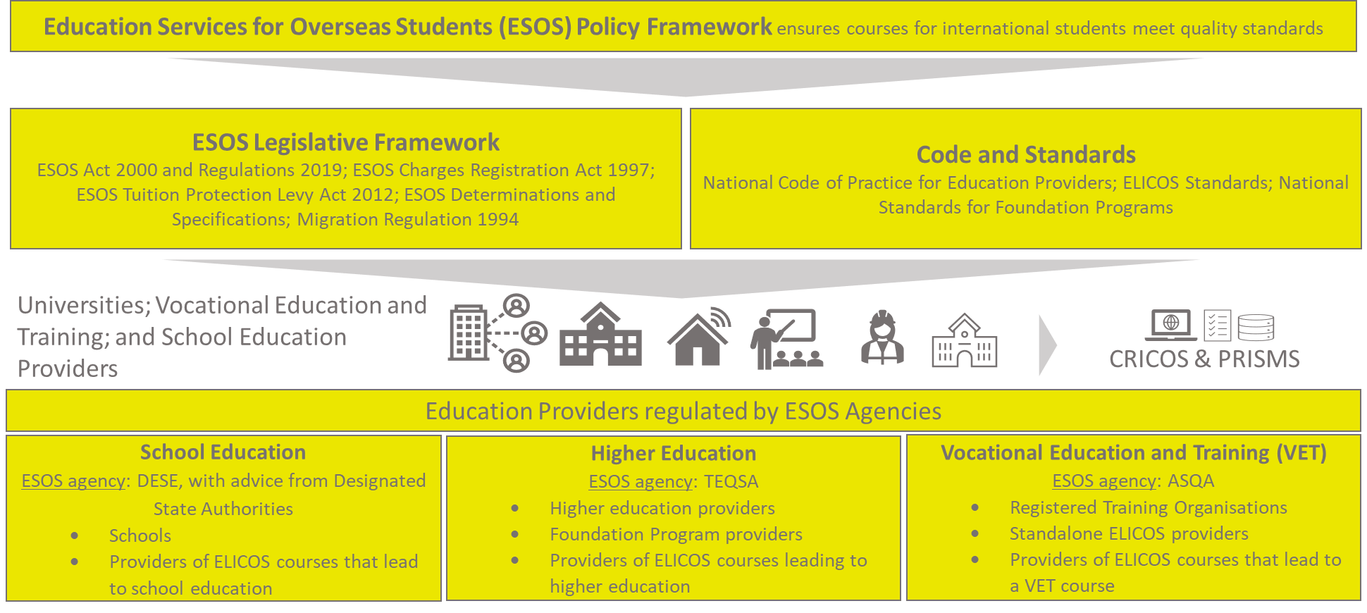

## Purpose and scope of the CRIS

This Cost Recovery Implementation Statement (CRIS) provides information on how the department implements cost recovery for its regulatory responsibilities under the ESOS Act. It reports the financial and non-financial performance information for the CRICOS program and contains financial forecasts for 2021-22 and three forward years. Consistent with the Australian Government Charging Framework (the Charging Framework), the department will maintain the CRIS until the activity or cost recovery for the activity has been discontinued.

Relying on separate legislation, TEQSA and ASQA impose charges for some of their CRICOS specific regulatory effort as well as their non-CRICOS regulatory effort. The arrangements will ensure that ESOS agencies are resourced to provide the necessary regulatory oversight and guidance to providers. TEQSA and ASQA regulatory charging activities are not included in this CRIS.

## Description of the regulatory charging activity

The department’s ESOS regulatory charging activities and charging mechanism are described below.

The CRICOS Annual Registration Charge (CARC) will recover the department’s costs for:

* national oversight of the regulation for all CRICOS providers in accordance with the ESOS Act including stakeholder education and policy guidance
* management of the Provider Registration and International Student Management System (PRISMS) and CRICOS online register including system upgrades and maintenance
* school sector wide components of the department’s role as the ESOS agency regulating school providers including engagement with Designated State Authorities and monitoring school providers.

The department’s application-based charges for schools are:

* a school initial registration charge for the assessment and registering of new school providers
* a school renewal registration charge for the assessment and registering renewing school providers.

The department’s regulatory charging arrangements align with the Government’s priority to simplify the sector’s interactions with Government and maintain a consistent approach to regulation and cost recovery. The CRICOS charging arrangements are part of the Government’s broader charging approach, in which providers who create the need for regulation should bear those costs.

Ensuring that all providers of international education meet Australia’s quality education standards supports the industry’s recovery from COVID-19, its ongoing development and cement Australia’s reputation as a professional and high-quality destination for international students.

Figure 2 details a typical five-year business flow from initial registration to renewal of registration. This business flow also articulates the timing of the CRICOS Annual Registration Charge.

Figure 2: Typical Five Year CRICOS Registration Business Flow

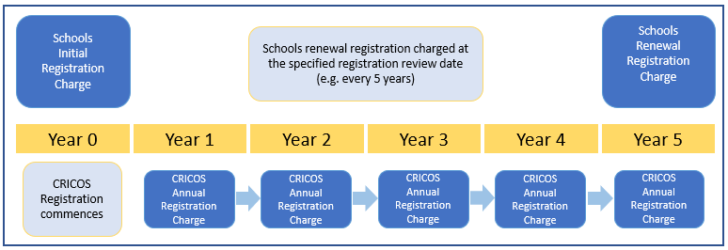

## Who will pay the regulatory charges?

Education providers on CRICOS who provide, or seek to provide, education services to overseas students are subject to these regulatory charges. This includes schools, vocational education and training providers, higher education providers, ELICOS and Foundation Program providers.

# POLICY AND STATUTORY AUTHORITY TO COST RECOVER

## Government policy approval to cost recover CRICOS charging arrangements

The Australian Government agreed in the 2021-22 Budget[2] to fully cost recover the department’s CRICOS regulatory activities. The Australian Government provided policy authority:

* to reset CRICOS regulatory charges to fully cost recover and align with the Charging Framework
* to align commencement of new CRICOS charging arrangements with the commencement of TEQSA’s and ASQA’s new cost recovery arrangements on 1 January 2022
* for legislative amendments to implement the new CRICOS cost recovery arrangements.

## Statutory authority to charge

The department has amended existing legislation to implement the revised policy authority for CRICOS. Authority to charge for CRICOS arrangements is set out in the *Education Services for Overseas Students Act 2000* (ESOS Act)[3] and the *Education Services for Overseas Students (Registration Charges) Act 1997[4]* (ESOS Charging Act).

The department is committed to only recovering the efficient costs of its regulation. The department has set its charging provisions in regulations allowing the department to be responsive to changes in necessary regulatory effort over time, including reducing (or increasing) charges where appropriate. The description and calculation methodology for the department’s CRICOS charges are detailed in the *Education Services for Overseas Students (Registration Charges) Regulations 2021.*

# COST RECOVERY MODEL

## Scope

The Australian Government considers the types of activities that are most appropriate to cost recover on a case-by-case basis. Key considerations are:

|  |  |
| --- | --- |
| Consideration | Assessment |
| The nature of the government activity, including whether the government would be the only provider of the service or product. | The ESOS agencies are the only entities empowered to regulate providers. |
| Whether charging on a cost recovered basis will not adversely impact competition, innovation, or the financial viability of those who have, or seek, approval to be registered providers. | As education institutions may also be subject to regulations, either at the Commonwealth or state level, the department consults with regulators to coordinate and maintain regulations and ensure charges are at the minimum necessary level to meet the costs of the regulatory activities. |
| Whether cost recovery can be executed efficiently and only reflect the costs of the provided services. | The department has determined that it is efficient to cost recover the CRICOS related activities. The costs of administering cost recovery are appropriate and only activities that have a direct relationship with a regulated entity will be charged for. Cost recovery is aligned to the policy goals that applicants and industry participants do not seek or maintain provider or course registration unnecessarily. |

## CRICOS Activities, outputs and business processes

The cornerstone of the CRICOS cost model is the *CRICOS Service Catalogue*(Attachment A). Consistent with the Charging Framework, the Service Catalogue splits the key CRICOS functions into regulatory activities. Each activity is then broken down into outputs and then each output is further broken down into specific business process that are required to deliver the output.

The *Service Catalogue* identified three distinct regulatory activities, delivering 19 specific outputs through 88 business processes for which cost recovery was considered. The department costed each CRICOS business process to ascertain the overall cost of the CRICOS program and made an assessment against each business process to determine whether it was cost recoverable or not within the context of the Charging Framework. Some activities are not cost recoverable; however, these have been included in the *Service Catalogue* for completeness. Only activities that were in-scope of the Charging Framework as cost recoverable were used in the calculation of charges.

Table 1: CRICOS Activities and Outputs

| **Activity** | **Outputs** |
| --- | --- |
| 1. Provider Registration and International Student Management System (PRISMS) and Commonwealth Register of Institutions and Courses for Overseas Students (CRICOS) | 1.1 Stakeholder engagement, education, training, and conference attendance |
| 1.2 Annual education provider charge collection and reconciliation |
| 1.3 PRISMS upgrades and maintenance |
| 1.4 PRISMS and CRICOS data analysis and reporting |
| 1.5 CRICOS Register |
| 1.6 Helpdesk and IT support |
| 2. Administering Education Services for Overseas Students (ESOS) framework | 2.1 Stakeholder education and training relating to the ESOS legislative framework |
| 2.2 Stakeholder and peak body engagement |
| 2.3 ESOS Policy Guidance and Helpdesk |
| 2.4 Maintaining and updating the ESOS legislative framework |
| 3. School Regulation | 3.1 Assessments - provider renewal |
| 3.2 Assessments - provider registration |
| 3.3 Provider suspension and cancellations |
| 3.4 Compliance audits |
| 3.5 Enforcement activities |
| 3.6 Reporting |
| 3.7 Provider education and awareness |
| 3.8 Designated State Authority (DSA) and Peak’s forums/engagement |
| 3.9 Policy advice and issues management, management of email inbox |

## Design and Costing of Application and Non-Application Based Activities

The department has two types of charges: Application Based Activities (pre-market activities) and Non‑Application Based Activities (post-market activities). For both types of charging arrangements, the same costing architecture and costing methodology were used, as described below.

The department:

1. identified all relevant CRICOS costs at the business process level by using recording templates to capture effort, volumes and other data
2. determined the allocation of direct and indirect costs and volumetric drivers, where applicable
3. applied whole-of-government and departmental parameters to the resulting amounts to calculate the full cost or each CRICOS business process.

For example, all costs related to the process of renewing a provider CRICOS registration were identified and based on an estimated volume of renewals each year, a cost per renewal was established.

Figure 3 illustrates the methodology for how CRICOS regulatory activities were costed.

Figure 3: Methodology for determining CRICOS Costs

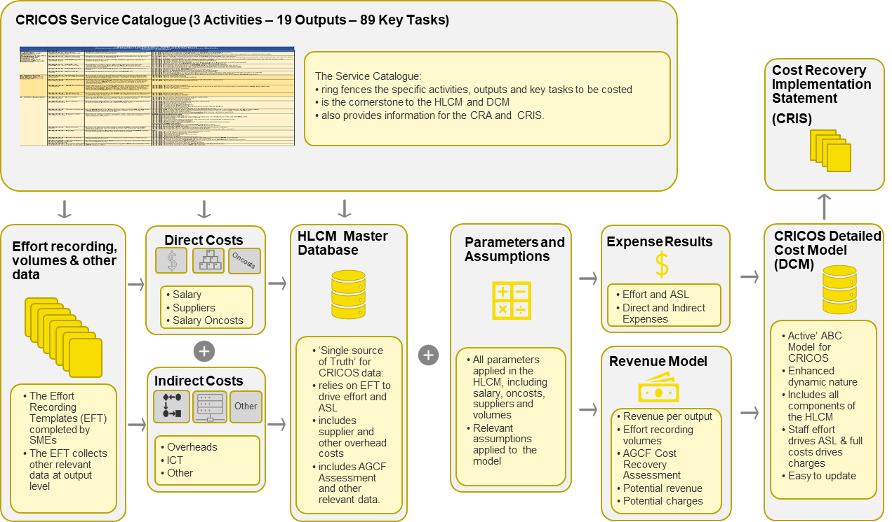

### Application-based activities

In line with the Charging Framework, application-based activities are recovered through a charge to individual organisation as the costs can reasonably be attributed to an individual or organisation, in this instance CRICOS initial and renewal registrations. As the ESOS agency for schools, the department’s application-based charges are:

1. ***schools initial registration charge*** (described in Table 2); and
2. ***schools renewal registration charge*** (described in Table 3).

The rate for assessing an initial CRICOS registration is based on the efficient time it takes to assess that application. The 30 hours per application is made up of effort by staff across different salary classifications and results in a cost of $2,691 for an initial CRICOS Registration.

The rate for assessing a provider renewal registration, is based on the efficient time it takes to assess the application for renewal. The six hours per registration is undertaken by staff at different salary classifications and results in a cost of $1,083 for a renewal of CRICOS Registration.

Table 2: Proficient Officer Effort for Initial Provider Registration

| No. | Output | Key Tasks/ Business Processes | Efficient time per Initial Registration (Mins) |
| --- | --- | --- | --- |
| 3.2 | Assessments - provider registration  Registration of school provider as a CRICOS provider as recommended by the Designated State Authority and requested by the school. | Receive, initial review | 60 |
| Assessment | 1,140 |
| Decision | 360 |
| Notification to provider | 45 |
| Issue initial registration invoice | 30 |
| Issue initial TPS levy invoice | 30 |
| Confirm payment of registration and TPS invoices | 10 |
| Finalisation of initial registration | 75 |
| Issue and collection of registration charges | 60 |
| **Total** | **1810 mins**  **(30 hours)** |

Table 3: Proficient Officer Effort for Renewal of Provider Registration

| No. | Output | Key Tasks/ Business Processes | Efficient time per Registration Renewal (Mins) |
| --- | --- | --- | --- |
| 3.1 | Assessments - provider renewal  Renewal of CRICOS provider registration as recommended by the Designated State Authority and requested by the registered school provider | Receive, initial review | 12 |
| Detailed Review | 142.5 |
| Decision | 150 |
| Notification | 48 |
| **Total** | **352.5 mins**  **(6 hours)** |

### Non-Application-based activities

Non-Application based activities are activities that can be recovered through an annual charge as the cost of these regulatory activities can be reasonably attributed to a group of individuals or organisations. Typical activities that can be recovered include development and promulgation of advisory material; maintenance of national standards and legislation, policy advice, monitoring and compliance activities, and on-going maintenance of IT systems that underpin regulatory activities or functions.

The CARC has three components, which will recover the costs of the outputs which are delivered to groups of CRICOS providers.

* Part A includes all CRICOS registered providers for outputs
  + CRICOS Activity 1 - Provider Guides, Training and PRISMS[5]  system support
  + CRICOS Activity 2 - ESOS regulation and support
* Part B includes CRICOS registered schools Activity 3 education and engagement outputs
* Part C includes CRICOS registered schools Activity 3 oversight and management outputs

**CRICOS Activity 1:** Provider Registration and International Student Management System (PRISMS) and Commonwealth Register of Institutions and Courses for Overseas Students (CRICOS).

Table 4: Proficient Officer Effort to deliver key tasks in Outputs 1.1 to 1.6

|  |  |  |
| --- | --- | --- |
| **No.** | **Output** | **Staff effort per week (Mins)** |
| **1.1** | Stakeholder engagement, education, training, and conference attendance | 1,350 |
| **1.2** | Annual education provider charge collection and reconciliation | 1,125 |
| **1.3** | PRISMS upgrades and maintenance | 11,250 |
| **1.4** | PRISMs and CRICOS data analysis and reporting | 7,200 |
| **1.5** | CRICOS Register | 450 |
| **1.6** | Helpdesk and IT support | 5,400 |
|  | **Total** | **26,775 mins**  **(446 hours)** |

Regulatory effort across Outputs 1.1 to 1.3 is constant across providers, therefore the department will recover the costs of these outputs evenly across all CRICOS providers.

Regulatory effort across Outputs 1.4 to 1.6 is variable across all providers. The driver of regulatory effort is the number of enrolments in the PRISMS system. Output costs are divided by the total number of system enrolments (from previous year) to determine the system enrolment unit cost. This unit cost is multiplied by the number of provider enrolments to determine this element of the charge to pay.

**CRICOS Activity 2:** Administering Education Services for Overseas Students (ESOS) framework

Table 5: Proficient Officer Effort to deliver key tasks in Outputs 2.1 to 2.4

|  |  |  |
| --- | --- | --- |
| **No.** | **Output** | **Staff effort per week (Mins)** |
| **2.1** | Stakeholder education and training relating to the ESOS legislative framework | 225 |
| **2.2** | Stakeholder and peak body engagement | 1,350 |
| **2.3** | ESOS Policy Guidance and Helpdesk | 1,125 |
| **2.4** | Maintaining and updating the ESOS legislative framework | 2,025 |
|  | **Total** | **4,725 mins**  **(79 hours)** |

The regulatory effort for outputs 2.1 to 2.4 is constant across providers - for example education products are made for the industry, the costs are not linked to how much a provider accesses them.

**CRICOS Activity 3:** Regulation of School CRICOS Providers

Table 6: Proficient Officer Effort to deliver key tasks in Outputs 3.3 to 3.9**[6]**

|  |  |  |
| --- | --- | --- |
| **No.** | **Output** | **Staff effort per week (Mins)** |
| **3.3** | Provider suspension and cancellations | 225 |
| **3.4** | Compliance audits | 1,350 |
| **3.5** | Enforcement activities | 225 |
| **3.7** | Provider education and awareness | 225 |
| **3.8** | Designated State Authority (DSA) and Peak forums/engagement | 450 |
| **3.9** | Policy advice and issues management, management of email inbox | 900 |
|  | **Total** | **3,375 mins**  **(56 hours)** |

The regulatory effort across the outputs above is constant across school providers only, therefore the department will recover the costs of these outputs evenly across all CRICOS school providers.

**Volumes**

The department has made the following assumptions on volumes:

* provider volumes will remain static, that is the number of registered providers will not alter significantly
* provider renewals will also remain static, that is that currently registered providers will retain their registrations into the future
* provider initial registrations have the potential to reduce, however, this is not evident at the drafting of this CRIS and is being monitored closely.

On these assumptions, for the purposes of setting charges for 2022, the volume will remain static, and if volumes change these will be recalibrated as part of the annual CRIS review.

The department estimates the following volumes for ‘Application Based Activities’ will remain static.

Table 7: Estimated volumes for Initial Registration and Renewal of Registration Applications

|  |  |  |
| --- | --- | --- |
| **Activity** | **2022 Volume** | **Entity cohort** |
| Initial CRICOS Registration | 15 | Applicant |
| Renewal of CRICOS Registration | 80 | Applicant |

The department estimates the following provider metrics for ‘Non-Application Based’ activities for 2022.

Table 8: Metrics for each element of the Annual Charge

|  |  |  |
| --- | --- | --- |
| **Activity** | **Volume** | **Metric** |
| PRISMS and CRICOS Systems (Part A) | 1,249 | All CRICOS Providers |
| PRISMS and CRICOS Systems (Part A) | 431,790 | CARC Enrolments - All CRICOS Providers |
| ESOS Framework (Part A) | 1,249 | All CRICOS Providers |
| Schools Regulation (Part B and C) | 364 | Schools CRICOS Providers |

## Costs of the regulatory charging activity

The total cost of the CRICOS program for 2022 is $4,042,723, with $3,653,830 being cost recoverable consistent with the Charging Framework. The balance of $388,892 are ancillary ESOS services, essential for the on-going operation of the ESOS program, however not appropriate to be recovered from the regulated population. These ancillary services are budget funded.

Table 9 provides an overview by CRICOS activity of the direct and indirect costs of the CRICOS program and ASL requirements.

Table 9: Aggregate cost and ASL requirements for the CRICOS program (Reference - Attachment B)

|  |  |  |  |  |  |  |  |  |  |  |
| --- | --- | --- | --- | --- | --- | --- | --- | --- | --- | --- |
| **CRICOS Activity** | **Direct Costs** | | | | | **Indirect Costs** | | |  |  |
| **Salaries ($)** | **Salary Oncosts ($)** | **Suppliers ($)** | **ICT Costs ($)** | **Total Direct Costs**  **($)** | **Overheads ($)** | **Capital ($)** | **Total Indirect Costs ($)** | **ASL (#)** | **Total Costs**  **($)** |
| 1. PRISMS and CRICOS Systems | 1,061,707 | 191,107 | 428,733 | 1,200,000 | **2,881,548** | 338,352 | - | **338,352** | 11.8 | **3,219,900** |
| 2. Administering ESOS Framework | 232,258 | 41,806 | 63,330 | - | **337,395** | 61,920 | - | **61,920** | 2.1 | **399,315** |
| 3. School Regulation | 253,853 | 45,694 | 52,234 | - | **351,781** | 71,727 | - | **71,727** | 2.5 | **423,508** |
| **Total** | **1,547,819** | **278,607** | **544,297** | **1,200,000** | **3,570,723** | **471,999** | **-** | **471,999** | **16.4** | **4,042,723** |

### Direct Costs

Salary costs: An effort recording exercise has been used to determine the efficient cost of staff undertaking CRICOS key tasks. Effort recording was based on a proficient officer completing specified tasks. Salary oncosts have been applied to the direct salary costs, which includes a 15.4 per cent loading for superannuation and 2.6 per cent for Long service Leave requirements. A conservative 1.5 per cent per annum increase to salaries has been used for the years beyond 2022.

Supplier costs: Historical expenditure over previous financial years has been used to determine a baseline for supplier cost for 2022. All supplier costs have been apportioned to the output where the costs were incurred. Historically there has been a gradual increase in supplier costs of approximately 2 per cent. This rate of increase has been applied to supplier costs in the out-years.

ICT Operating Costs: Historical expenditure of maintaining PRISMS and CRICOS systems, no indexation has been applied to ICT expenditure. ICT expenditure has been apportioned against the two outputs where those ICT costs have been incurred.

### Indirect Costs

Overheads: ASL drives the overhead costs for the CRICOS program. There is approximately $26,000 of overheads costs per 1 ASL. These costs include: Workers Compensation Premium, HR Support costs, Organisation service costs, Desktop IRT service costs, property operating costs and a training component.

Capital Costs: there are no capital expenditure costs for the CRICOS program in 2022.

## Cost Management Strategies

Consistent with the Charging Framework, the department is committed to continually examining the cost drivers of the CRICOS program. Whilst these cost drivers are stable now, where changes occur the department will factor these changes into the cost recovery model. Where changes are significant, the department will consult with stakeholders to discuss the drivers of these changes, mitigating strategies and potential alternatives in addressing these cost driver changes.

The department has made consistent efforts to remove red tape for CRICOS-registered providers. Between 2015 and 2020, the value of deregulatory efforts delivered cumulative savings of $60 million to providers. The 2021-22 Budget included a measure to remove a requirement for private CRICOS-registered providers to report their tuition fees monthly, delivering $7.1million in ongoing annual savings.

The Government has also demonstrated a willingness to provide fee relief to providers when circumstances warrant. In response to the COVID-19 pandemic, fees were waived between 1 January 2020 and 31 December 2021. The power to refund or waive fees when circumstances warrant has been included in both the ESOS primary legislation and supporting regulations.

## Design of Regulatory Charges

### Application based charges

The two CRICOS application charges are:

* schools initial registration charge
* schools renewal registration charge

These charges only apply to schools, for which the department is the relevant ESOS Agency. Providers regulated by ASQA and TEQSA will pay any comparable registration and renewal fees to those agencies.

Table 10 provides a breakdown of CRICOS charges and the relationship between the charges and costs of outputs and related business processes of the activity.

Table 10: CRICOS individual charge details for 2022 (Reference data: Attachment A)

|  |  |  |  |  |
| --- | --- | --- | --- | --- |
| **Charge title** | **Est. 2022**  **volume** | **Cost of Relevant Outputs ($)** | **Output Business Processes** | **Charge Rate**  **($)** |
| Schools renewal registration charge | 80 | 86,608 | 3.1.01 - 3.1.04 | 1,080[7] |
| Schools initial registration charge | 15 | 40,368 | 3.2.01 - 3.2.09 | 2,690[8] |

### CRICOS Annual Registration Charge

For CRICOS post-market activities the department uses an annual cost recovery charge to recoup the costs of regulating CRICOS education providers. These activities include:

* PRISMS and CRICOS IT Systems management and provider support[9]
* ESOS Policy Framework administration and Support
* CRICOS School Providers regulation[10]

The CARC has multiple components, reflecting the different regulatory effort and outputs that the charge recovers for, and the different charge metrics used to reflect regulatory effort.

Table 11: CRICOS Annual Registration Charge details for 2022

|  |  |  |  |  |  |  |
| --- | --- | --- | --- | --- | --- | --- |
| **Annual Charge**  **(Elements)** | **Provider Cohort** | **Provider Allocation** | **Metric** | **Cost of Relevant Outputs** | **Output Business Processes** | **Element Amount ($)**  **(rounded)** |
| Part A Base - CRICOS Systems | All | Equally to all providers | 1 | $224,818 | 1.1 | $180 |
| Part A Base - ESOS Regulation and Support | All | Equally to all providers | 1 | $322,455 | 2.1~2.2, 2.4 | $260 |
| Part A Pro Rata -CRICOS Systems | All | Pro-rata based on number of CARC Enrolments | CARC Enrolments | $2,706,568 | 1.2~1.6, 2.3 | $5 |
| Part B - School Regulation - Education and Engagement | Schools | Equally to all school sector providers | 1 | $44,382 | 3.7~3.8 | $116 |
| Part C - School Regulation - Oversight and Management | Schools | Equally to all school sector providers with at least 1 CARC Enrolment | 1 | $228,630 | 3.3~3.5, 3.9 | $695 |

The annual charge amount for a CRICOS school provider is $1,248 plus $5 for each CARC Enrolments that the provider has. The annual charge for all other CRICOS providers is $436 plus $5 for each CARC Enrolment that the provider has.

The department has determined the most reflective proxy for regulatory effort for PRISMS and CRICOS IT systems is the number of CARC Enrolments on the PRISMS system. An example of how the system enrolment unit cost is applied in this cost recovery model is set out in Table 12. The highlighted row in the following table shows the amounts the provider would pay depending on if they had 20,000; 5,000 or no CARC Enrolments.

Table 12: Example of charge cost based on provider profile based on CARC Enrolments

|  |  |  |  |  |  |  |
| --- | --- | --- | --- | --- | --- | --- |
| **Elements** | **School Provider CARC Enrolments** | | | **Non School Provider** | | |
| **CARC Enrolments** | **20,000** | **5,000** | **0** | **20,000** | **5,000** | **0** |
| CRICOS Systems | $179 | $179 | $179 | $179 | $179 | $179 |
| CRICOS Systems | $100,000 | $25,000 | $0 | $100,000 | $25,000 | $0 |
| ESOS Regulation and Support | $257 | $257 | $257 | $257 | $257 | $257 |
| School Regulation | $811 | $811 | $116 | $0 | $0 | $0 |
|  | **$101,247** | **$26,247** | **$552** | **$100,436** | **$25,436** | **$436** |

# RISK ASSESSMENT

The COVID-19 pandemic has affected the international education sector any ongoing effects on the number of providers and student enrolments is difficult to predict. The Government provided CRICOS fee relief between 1 January 2020 and 31 December 2021.

The CRICOS charging arrangements to apply from 1 January 2022 are a significant change from previous practice. The department is introducing a new application charge and an annual charge, with a revised calculation methodology, which will ensure greater alignment of costs to those who create the need for the regulatory functions. Nevertheless, the changes will reduce the amount providers pay to the department and clear communication will mitigate any resulting confusion of charging obligations on providers.

Ensuring synergy with the separate but related regulatory entities, TEQSA and ASQA, as shown in Figure 1, will require coordination and communication. The department has robust engagement processes and undertakes regular stakeholder forums and workshops at the Commonwealth level and with CRICOS providers (including the State and Territory Education Departments) to advise, and be advised, of issues arising in the sector.

# 5. STAKEHOLDER ENGAGEMENT

## Initial consultation

On 28 January 2020, the department publicly released a CRICOS Cost Recovery Consultation Paper, outlining draft changes to the CRICOS charges and related legislative amendments. The consultation period closed on Tuesday, 11 February 2020.

The proposed changes included:

* removal of the Entry to Market Charge
* separate charging by each ESOS agency for their CRICOS-related regulatory activity
* charging by the department its cross-sectoral CRICOS regulatory effort, payable in an annual registration charge
* charging by the department of initial registration, registration renewal and annual compliance and monitoring fees for CRICOS-registered schools
* charging by the department of an annual Overseas Students Ombudsman charge.

The department received feedback on the proposed changes from 11 organisations, including peak bodies teaching English as a second language, higher education providers, education standards bodies, and state and Commonwealth government entities. Overall, responses were supportive of the proposed changes but assurances were sought on the following issues:

* that cost recovery would not result in “double charging”
* administrative burdens would be minimised
* cross-subsidisation would not result in effective providers paying for the regulation of, and compliance activities for, less effective providers
* greater transparency would be provided on the proposed costs of the regulatory activities and how these translate to the proposed charges.

Organisations asked for a further opportunity to be consulted on the financial impact for individual providers and the detail of the calculations of the charges.

## Subsequent consultation

A further consultation was undertaken from 12 May 2021 to 1 June 2021. The consultation paper described:

* a new CRICOS Service Catalogue
* a revised suite of proposed charges and their components
* a proposed schedule of charge amounts.

The inclusion of the proposed charge amounts allowed stakeholders to calculate the impact on any particular provider.

The department received six submissions in response to the 2021 consultation, from individual providers and peak stakeholder bodies. While some submissions raised questions over the timing of the introduction of new charges given COVID-19 effects in the sector, the submissions were broadly supportive of the proposed arrangements, and indicated an interest in being able to compare charges across all ESOS Agencies (ASQA and TEQSA in addition to the department) as well as a detailed breakdown of all charge components and how these were developed. A minority of submissions questioned whether it would be simpler for there to be only one entity charging for CRICOS-related regulatory activity.

## Legislation

The ESOS Cost Recovery Legislation Package to support these new charging arrangements was introduced to the Australian Parliament on 24 June 2021. For Constitutional reasons a package of four Bills is required and the effect of each of these is described below.

The **Education Services for Overseas Students (Registration Charges) Amendment Bill 2021** is the main Bill in the package. It amends the *Education Services for Overseas Students Registration Charges Act 1997* to update the CRICOS registration charges to be applied from 1 January 2022.

1. The **ESOS Amendment (Cost Recovery and Other Measures) Bill 2021** will amend the *Education Services for Overseas Students Act 2000* to ensure the legislative framework is consistent and aligns with the changes to the Registration Charges Act, particularly to:
   1. require registered providers to be in good standing with all ESOS agencies with regard to their CRICOS regulatory fees and charges
   2. remove the entry to market charges proposed by this Bill, it is proposed that ASQA and TEQSA will impose separate fees (under existing fee powers) related to entry to market costs.
   3. clarify the compliance powers of ESOS agencies by making it explicit that they are able to undertake compliance audits
   4. make the CRICOS annual registration charge payable within 30 days of an invoice being issued by the Secretary of the Department. In practice the annual charge will be invoiced at a similar time each year, though this amendment will allow future flexibility in the timing if necessary.
2. the **Education Services for Overseas Students (TPS Levies) Amendment Bill 2021** will amend the *Education Services for Overseas Students (TPS Levies) Act 2012* to update the definition of ‘total enrolments’ to ensure a workable definition remains in the legislative framework. The definition will clarify the total number of enrolments to be factored into the calculation for the TPS levy. This ensures the TPS levies will continue to function as intended.
3. the **Tertiary Education Quality and Standards Agency (Charges) Amendment Bill 2021** (TEQSA Charges Bill) will amend the *Tertiary Education Quality and Standards Agency (Charges) Act 2021* to remove reference to the old charging framework to eliminate the possibility of double charging.

# FINANCIAL ESTIMATES

In 2021-22, the regulatory cost of the CRICOS program is $4.043m, of which $3.527m is subject to cost recovery. There are a range of administrative support activities, worth $0.516m, that DESE undertakes which sit outside the scope of the Charging Framework and are therefore not subject to cost recovery from the sector. These activities have been budget funded.

Activity costs are estimated to increase over the forward estimates. For example, it is assumed that staff salaries will increase at 1.5 per cent per annum, reflecting the ABS’ wage price index[11]. The financial estimates will be updated appropriately to reflect any changes to these assumptions. Consistent with the increase in salaries, it is also anticipated that supplier costs will also increase in the outyears and a conservative estimate of 2 per cent has been applied to outyear costs for the program.

Table 13: Financial Estimates of Expenses and Revenue for the CRICOS program**[12]**

|  |  |  |  |  |  |
| --- | --- | --- | --- | --- | --- |
|  | A | B | C | D | E |
|  | 2021-22 | 2021-22  Update during budget year | 2022-23 | 2023-24 | 2024-25 |
| Expenses (‘000) | $4,043 | $ | $4,082 | $4,121 | $4,162 |
| Revenue (‘000) | $3,654 | $ | $3,709 | $3,765 | $3,822 |
| Balance (‘000) | ($389) | $ | ($373) | ($356) | ($340) |
| Cumulative balance (‘000) | $0 | $ | $0 | $0 | $0 |
| Explain materiala variance | The negative balance of the CRICOS program is from expenses of activities that cannot be cost recovered consistent with the Charging Framework. | | | | |
| Explain balance management strategy | The department will review the budget on an annual basis to ensure all relevant expenses are cost recovered. | | | | |
| a As defined by AASB1031 and Division 12 – Materiality and Disclosure of the Finance Minister’s Orders. | | | | | |

# FINANCIAL PERFORMANCE

In the 2021-22 Budget, the Australian Government refreshed policy authority for the CRICOS program to be fully cost recoverable. Given the revised financial structure of the CRICOS program there is no historical financial data as it only commenced from 2021-22.

The department will maintain data to report on its financial performance in the coming years and will use Table 14 to report financial performance and any material variation between actual annual expenses and revenue for the CRICOS activity, including impact on the balance management strategy.

Table 14: Historical Financial Performance of the CRICOS program   
(Note: there is no financial performance history for the new cost recovery model)

|  |  |  |  |  |  |
| --- | --- | --- | --- | --- | --- |
|  | 2021-22 | 2022-23 | 2023-24 | 2024-25 | 2025-26 |
| Expenses = X | - | - | - | - | - |
| Revenue = Y | - | - | - | - | - |
| Balance = Y – X | - | - | - | - | - |
| Cumulative balance | - | - | - | - | - |
| Explain materiala variance | - | | | | |
| Explain impact on balance management strategy | - | | | | |
| a As defined by AASB1031 and Division 12 – Materiality and Disclosure of the Finance Minister’s Orders. | | | | | |

# NON-FINANCIAL PERFORMANCE

The department currently collects information on a range of non-financial performance measures, designed to either improve the experience of the regulated entity or maintain the integrity of the ESOS Framework. Current key performance indicators (KPIs) are

* regulators do not unnecessarily impede the efficient operation of regulated entities
* communication with regulated entities is clear, targeted, and effective
* actions undertaken by regulators are proportionate to the regulatory risk being managed
* compliance and monitoring approaches are streamlined and coordinated
* regulators are open and transparent in their dealings with regulated entities
* regulators actively contribute to the continuous improvement of regulatory frameworks.

With the move to the new cost recovery model, the department will consult with providers on the adequacy of the current KPIs and whether specific cost recovery KPIs are required to be included. The department will also review financial and non-financial performance, along with monitoring and compliance performance, as part of the upcoming 2022 Portfolio Charging Review.

Consistent with the Charging Framework, the department is cognisant that the number of performance measures and other types of relevant information should be influenced by the complexity of the regulatory activity, the materiality of the arrangement and the sensitivity of the activity or specific risk factors, where including a KPI would benefit both education providers and the overall operation of the ESOS framework.

# KEY FORWARD DATES AND EVENTS

Key forward dates for the CRICOS program includes:

* 2022 Education, Skills and Employment Portfolio Charging Review (PCR) – As part of this PCR, the department will explore options to improve monitoring and compliance activities of CRICOS School Providers. This work will also involve consultation with the sector and address how CRICOS provider risks can be minimised.
* 2022-23 Budget Update – On an annual basis, the department will update CRICOS actual expenditure, financial forward estimates of expenses and revenue and any changes in CRICOS charge amounts.

The department will also use existing regular consultation mechanisms with stakeholders to gather feedback on the performance of the new charging arrangements, including the Education Visa Consultative Committee and the International Education Stakeholders Forum.

# CRIS APPROVAL AND CHANGE REGISTER

|  |  |  |  |
| --- | --- | --- | --- |
| **Date of Event** | **CRIS change** | **Approver** | **Basis for change** |
| XX/09/2021 | Certification of the CRIS | **DESE Action:** Insert title of accountable authority and date | Revised regulatory charging activity |
| XX/10/2021 | Agreement to the CRIS | **DESE Action:** Insert Title of responsible minister and date | Revised regulatory charging activity |
| XX/11/2021 | Approval for the CRIS release | **DESE Action:** Insert Title of Finance Minister and date | High risk rating for the regulatory charging activity |
| XX/11/2021 | Publication of CRICOS CRIS | **DESE Action:** Insert approver to publish and date | Public release of CRICOS CRIS |

# Glossary

**AfS**: Audit for Schools

**ASQA**: Australian Skills and Quality Agency

**CAAWs**: Confirmations of Appropriate Accommodation and Welfare

**CARC Enrolment:** A Confirmation of Enrolment that was in ‘Studying’ status for at least part of the previous calendar year. For CoEs in Studying status for less than 13 weeks during the previous calendar year, a quarter (0.25) CARC Enrolment is recorded; for CoEs in Studying status for less than 26 weeks duration during the previous calendar year, a half (0.5) CARC enrolment is recorded. CoEs in Studying status for more than 26 weeks during the previous calendar year have a full (1) CARC enrolment is recorded. Multi-year CoEs will be counted as CARC enrolments each year the CoE remains in Studying status.

**CoEs**: Confirmation of Enrolments

**CRICOS**: Commonwealth Register of Institutions and Courses for Overseas Students

**CRIS**: Cost Recovery Implementation Statement

**CRGs**: Cost Recovery Guidelines

**DESE**: The Department of Education, Skills and Employment

**DSAs**: Designated State Authorities

**ELICOS**: The [English Language Intensive Courses for Overseas Students (ELICOS) Standards](https://internationaleducation.gov.au/regulatory-information/Education-Services-for-Overseas-Students-ESOS-Legislative-Framework/ESOS-Regulations/Documents/ELICOS%20Fact%20Sheet%20FINAL%20171215.pdf)outline specific quality requirements for registered providers delivering English language courses to overseas students and are in addition to the National Code requirements.

**ESOS**: Education Services for Overseas Students

**ESOS Act**: Australia provides rigorous protection for international students through the [*Education Services for Overseas Students Act 2000*](https://www.legislation.gov.au/Details/C2018C00210)(ESOS Act) and related legislation, which protects and enhances Australia’s reputation for quality education, provides tuition protection and supports the integrity of the student visa program.

**ESOS Charging Act**: *Education Services for Overseas Students (Registration Charges) Act 1997*

**Foundation Programs**: are designed to equip international students with the skills and capabilities to seek entry into higher education programs in Australia.

**Home Affairs**: The Department of Home Affairs

**OSO**: Overseas Students Ombudsman

**PRISMS:** Provider Registration and International Student Management System

**Regulators**: DESE, ASQA and TEQSA

**TEQSA**: Tertiary Education Quality Standards Agency

**The department**: The Department of Education, Skills and Employment

**VET**: Vocational Education and Training

# Attachment A: CRICOS Service Catalogue

| **CRICOS Activities** | **Output** | **Output Description** | **Business Processes** |
| --- | --- | --- | --- |
| **1. Provider Registration and International Student Management System (PRISMS) and Commonwealth Register of Institutions and Courses for Overseas Students (CRICOS)** | **Output 1.1** - Stakeholder engagement, education, training, and conference attendance | Stakeholder engagement - user guidance materials, delivering training and webinars, conference attendances | 1.1.01 Continued development and maintenance of PRISMS and CRICOS User Guides  1.1.02 Continued development of ESOS Online training materials and guidance  1.1.03 Development of bespoke and general training materials for providers, regulators, other government users and the broader sector  1.1.04 Delivering developed training to specific and general audiences |
| **Output 1.2** - Annual education provider charge collection and reconciliation | Administration of the Commonwealth Register of Institutions and Courses for Overseas Students (CRICOS) | 1.2.01 Annual systems changes to allow calculation of PRISMS and CRICOS charges  1.2.02 Annual PRISMS and CRICOS charges collection process - communications, issuing of invoices, payment confirmation, follow -up, and late charge levying  1.2.03 PRISMS and CRICOS charges collection - communications, issuing of invoices, payment confirmation follow-up, and late charge levying  1.2.04 Payment compliance and sanctioning. |
| **Output 1.3** - PRISMS upgrades and maintenance | Ongoing maintenance of the system, software upgrades, updates for legislative changes, bug fixes | 1.3.01 Systems upgrades due to legislative changes and requirements  1.3.02 Systems changes due to operational or functional requirements  1.3.03 Bug fixes and emergency releases  1.3.04 System security fixes and changes to meet Australian Government or Departmental security requirements  1.3.05 Updates and fixes to PRISMS front end at PRISMS.education.gov.au |
| **Output 1.4** - PRISMS and CRICOS data analysis and reporting | Responding to routine, regular, and bespoke data requests from the department, regulators, Home Affairs, Designated state Authorities (DSAs). Development and maintenance of specific database for international education data area, which releases statistics monthly | 1.4.01 Development and maintenance of PRISMS reports and reporting database  1.4.02 Development and maintenance of PRISMS MIS (management information system) for international education data team  1.4.03 Development, implementation, and communication of bespoke data requests for internal clients  1.4.04 Development, implementation, and communication of bespoke data requests for external client |
| **Output 1.5** - CRICOS Register | Maintenance of the CRICOS Register and CRICOS.education.gov.au website | 1.5.01 Maintenance of the CRICOS website  1.5.02 Maintenance of the CRICOS data release on data.gov.au  1.5.03 Update to CRICOS database fields in response to legislative change |
| **Output 1.6** - Helpdesk and IT support | Responding to individual provider's queries on PRISMS use | 1.6.01 Answering of queries from users and regulators (level 1 support)  1.6.02 Resolution of technical or more complicated issues from users, regulators, and other government users (level 2 support)  1.6.03 Liaison between business and IT in relation to issues, bugs and technical fixes required  1.6.04 Provides PRISMS admin support for Providers and Home Affairs in relation to mergers and other specific PRISMS functions |
| **2. Administering Education Services for Overseas Students (ESOS) framework** | **Output 2.1** - Stakeholder education and training relating to the ESOS legislative framework | Responding to individual provider's queries on PRISMS use | 2.1.01 Develop educational product  2.1.02 Update educational product  2.1.03 Review and approve educational product |
| **Output 2.2** - Stakeholder and peak body engagement | Development of education products including tools, webinars, fact sheets, resources, publications, website materials on regulatory requirements and implementation of changed requirements. Input into training materials for providers and education agents. | 2.2.01 Conference attendance, presentations, and stakeholder engagement  2.2.02 Secretariat for relevant working groups |
| **Output 2.3** - ESOS Policy Guidance and Helpdesk | Peak body engagement through attendance at meetings, conferences, presentations etc where DESE receives and answers queries and provides and clarifies advice. DESE may also receive business intelligence from these engagements that highlights potential compliance issues that needs to be investigated further | 2.3.01 Receive and assess response  2.3.02 Research and information gathering (including consultation with other teams/legal/government bodies (Department of Home Affairs, Commonwealth and state and territory Ombudsmen)  2.3.03 Prepare Response  2.3.04 Review and approve response |
| **Output 2.4** - Maintaining and updating the ESOS legislative framework | Responding to provider, student and industry stakeholder queries regarding rights and obligations under the ESOS legislative framework and related issues including visa obligations, requirements for under 18 students and specific requirements for VET, English Language Intensive Courses for Overseas Students (ELICOS) and higher education sectors. (Enquiries are primarily received through the ESOS inbox or ministerial correspondence) | 2.4.01 Monitor emerging issues  2.4.02 Consult appropriate stakeholders  2.4.03 Implement regulatory change |
| **3. School Regulation**  **3. School Regulation (continued)** | **Output 3.1** - Assessments - provider renewal | Renewal of CRICOS provider registration as recommended by the Designated State Authority and requested by the registered school provider | 3.1.01 Receipt and acknowledgement of renewal registration  3.1.02 Assessment of renewal registration  3.1.03 Decision on renewal registration  3.1.04 Notification of decision to applicant |
| **Output 3.2** - Assessments - provider registration | Registration of school provider as a CRICOS provider as recommended by the Designated State Authority and requested by the school | 3.2.01 Receipt and acknowledgement of new initial registration  3.2.02 Assessment of initial registration  3.2.03 Decision on initial registration  3.2.04 Notification of decision to applicant  3.2.05 Issuing of initial Registration Invoice  3.2.06 Issuing of initial TPS levy invoice  3.2.07 Confirmation of payment of initial Registration charge and TPS levy  3.2.08 Finalisation of initial registration  3.2.09 Issuing and collection of registration charges |
| **Output 3.3** - Provider suspension and cancellations | Use of ESOS Agency for Schools powers under section 10B and 83 of the ESOS Act (including required actions under s87), as well as acting on recommendations under Section 10C | 3.3.01 Designated State Authority (DSA) or department makes finding/recommendation that suspension is required (output 1, 4, 5) or under s10C.  3.3.02 Brief compiled with evidence and recommendation to delegate to impose under s10B or s83 of ESOS Act.  3.3.03 Delegate makes decision to impose.  3.3.04 Provider informed of decision to impose sanction (this decision is potentially appealable).  3.3.05 Sanction/ cancellation actioned on PRISMS |
| **Output 3.4** - Compliance audits - site visits, desk audits | Execution of actions related to compliance audits - data and evidence collection both electronically and on-site, site visits to collect evidence, review and undertaking of audits, etc. | ESOS Agency for Schools led audits  3.4.01 Identify providers to be audited  3.4.02 Develop annual audit plan  3.4.03 Develop individual audit plan for each entity, including type of audit (desk, full audit, joint with DSA, etc.)  3.4.04 Gather evidence including site visit as required  3.4.05 Conduct audit  3.4.06 Liaise with audited entity re proposed audit outcomes and management comments, etc.  3.4.07 Finalise audit and recommendations  3.4.08 Delegate approval of audit outcomes  3.4.09 Audit outcomes provided to entity and responses to recommendations identified  3.4.10 Ongoing monitoring of responses  Involvement in DSA audit activities  3.4.11 Determine Level of ESOS Audit for Schools (AfS) involvement in DSA Audit  3.4.12 ESOS AfS input to DSA audit plan  3.4.13 Provision of required data out of PRISMS if not readily available  3.4.14 Collection and provision of evidence held by ESOS Agency for Schools to DSA  3.4.15 Involvement in DSA site visits  3.4.16 ESOS AfS reviews draft audit outcomes  3.4.17 ESOS AfS decision to take actions arising from DSA audit outcomes (e.g. conditions or suspensions) |
| **Output 3.5** - Enforcement activities | Execution of enforceable undertakings with both DSAs and other ESOS agencies, monitoring and searching providers and issuing and analysing production notices | 3.5.01 Collection and analysis of evidence potentially requiring enforcement response  3.5.02 Development, delivery, and analysis of production notices  3.5.03 Development and execution of enforceable undertakings including with other regulators |
| **Output 3.6** - Reporting | Development of annual Regulator Performance Framework report, quarterly delegations reports and ad-hoc data reporting | Regulator Performance Framework:  3.6.01 Development of data assets required to complete report  3.6.02 Review of agency functions against KPIs  3.6.03 Development of initial report  3.6.04 Consultation with DSAs and peak bodies  3.6.05 Finalisation of report  3.6.06 Approval by delegate  3.6.07 Publication on internationaleducation.gov.au |
| **Output 3.7** - Provider education and awareness | Engagement with the sector, including peak organisations, conferences, direct training to providers | 3.7.01 Outreach to providers in relation to welfare and other school specific ESOS requirements  3.7.02 Attendance at conferences and other sector events  3.7.03 Provision of training in PRISMS and specific schools’ functions (CAAWs) to regulators, providers |
| **Output 3.8** - Designated State Authority (DSA) and Peaks’ forums/engagement | Quarterly engagement with DSAs to ensure regulatory alignment and to pass on issues/intelligence, etc. | 3.8.01 Secretariat of quarterly DSA meetings  3.8.02 Secretariat of 6-monthly peak body forums  3.8.03 Development of papers and analysis for meetings |
| **Output 3.9** - Policy advice and issues management, management of email inbox | Management of enquiries from schools, agents, DSAs and students in the ESOS compliance inbox | 3.9.01 Responding to enquiries through ESOS Compliance and Registration inbox  3.9.02 Provision of advice to schools, DSAs and students |

# Attachment B: CRICOS Output Costs with Cost Recovery Funding Mechanism

|  |  |  |  |  |  |  |  |  |  |  |  |  |  |  |
| --- | --- | --- | --- | --- | --- | --- | --- | --- | --- | --- | --- | --- | --- | --- |
|  |  | **Direct Costs ($)** | | | | | **Indirect ($)** | | |  | **Funding Mechanisms** | | | |
| **Activity** | **Output** | **Salaries** | **Salary Oncosts** | **Suppliers** | **ICT Costs** | **Direct Costs** | **Overhead** | **Capital** | **Indirect Costs** | **Total  ($)** | **Single Charge ($)** | **CARC ($)** | **Budget ($)** | **Revenue  ($)** |
| 1. PRISMS and CRICOS Systems | 1.1 Stakeholder engagement & education | 54,102 | 9,738 | 144,241 | - | 208,081 | 16,737 | - | 16,737 | 224,818 | - | 224,818 | - | 224,818 |
| 1.2 Annual provider charge collection and reconciliation | 46,963 | 8,453 | 144,241 | - | 199,657 | 14,474 | - | 14,474 | 214,131 | - | 214,131 | - | 214,131 |
| 1.3 PRISMS upgrades and maintenance | 453,202 | 81,576 | 46,750 | 1,140,000 | 1,721,528 | 142,986 | - | 142,986 | 1,864,514 | - | 1,864,514 | - | 1,864,514 |
| 1.4 PRISMs and CRICOS data analysis and reporting | 293,933 | 52,908 | 46,750 | - | 393,591 | 91,400 | - | 91,400 | 484,991 | - | 163,672 | 321,319 | 484,991 |
| 1.5 CRICOS Register | 16,539 | 2,977 | 46,750 | 60,000 | 126,266 | 4,594 | - | 4,594 | 130,860 | - | 86,806 | 44,054 | 130,860 |
| 1.6 Helpdesk and IT support | 196,969 | 35,455 | - | - | 232,424 | 68,161 | - | 68,161 | 300,585 | - | 300,585 | - | 300,585 |
| 2. Administering Education Services for Overseas Students (ESOS) framework | 2.1 Stakeholder education and ESOS framework | 14,197 | 2,555 | 10,766 | - | 27,519 | 3,780 | - | 3,780 | 31,299 | - | 31,299 | - | 31,299 |
| 2.2 Stakeholder and peak body engagement | 76,290 | 13,732 | 31,032 | - | 121,054 | 17,174 | - | 17,174 | 138,228 | - | 138,228 | - | 138,228 |
| 2.3 ESOS Policy Guidance and Helpdesk | 44,483 | 8,007 | 10,766 | - | 63,256 | 13,604 | - | 13,604 | 76,860 | - | 76,860 | - | 76,860 |
| 2.4 Maintaining ESOS legislative framework | 97,287 | 17,512 | 10,766 | - | 125,565 | 27,362 | - | 27,362 | 152,928 | - | 152,928 | - | 152,928 |
| 3. School Regulation | 3.1 Assessments - provider renewal | 58,031 | 10,446 | - | - | 68,477 | 18,131 | - | 18,131 | 86,608 | 86,608 | - | - | 86,608 |
| 3.2 Assessments - provider registration | 27,364 | 4,926 | - | - | 32,290 | 8,078 | - | 8,078 | 40,368 | 40,368 | - | - | 40,368 |
| 3.3 Provider suspension and cancellations | 9,947 | 1,790 | - | - | 11,737 | 2,859 | - | 2,859 | 14,597 | - | 14,597 | - | 14,597 |
| 3.4 Compliance audits - site visits, desk audits | 69,218 | 12,459 | 26,117 | - | 107,794 | 17,364 | - | 17,364 | 125,158 | - | 125,158 | - | 125,158 |
| 3.5 Enforcement activities | 11,427 | 2,057 | 26,117 | - | 39,601 | 2,707 | - | 2,707 | 42,307 | - | 42,307 | - | 42,307 |
| 3.6 Reporting | 16,402 | 2,952 | - | - | 19,354 | 4,164 | - | 4,164 | 23,518 | - | - | 23,518 | 23,518 |
| 3.7 Provider education and awareness | 10,714 | 1,929 | - | - | 12,643 | 2,843 | - | 2,843 | 15,486 | - | 15,486 | - | 15,486 |
| 3.8 Designated State Authority & Peaks engagement | 19,688 | 3,544 | - | - | 23,232 | 5,665 | - | 5,665 | 28,897 | - | 28,897 | - | 28,897 |
| 3.9 - Policy advice & issues management | 31,062 | 5,591 | - | - | 36,653 | 9,915 | - | 9,915 | 46,569 | - | 46,569 | - | 46,569 |
| **Total** |  | **1,547,819** | **278,607** | **544,297** | **1,200,000** | **3,570,723** | **471,999** | **-** | **471,999** | **4,042,723** | **126,977** | **3,526,854** | **388,892** | **4,042,723** |

Attachment C: CRICOS Charging Risk Assessment

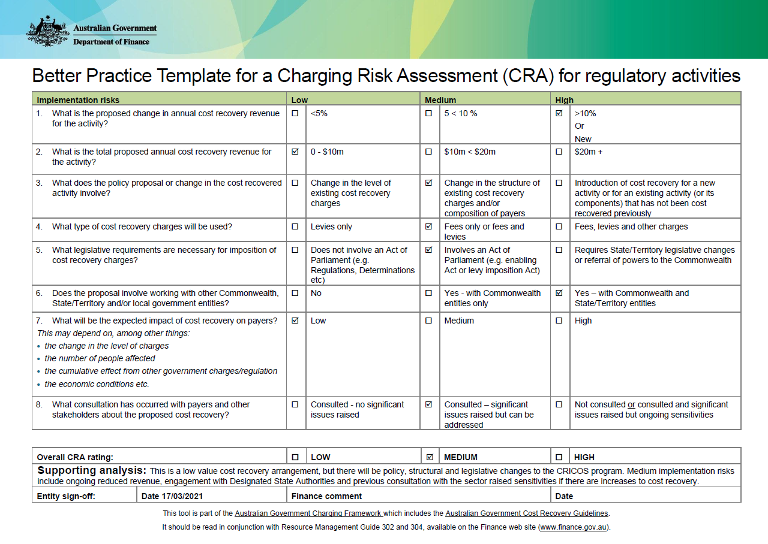

1. The Australian Government Charging Framework and the Cost Recovery Guidelines are available on the Department of Finance website ([www.finance.gov.au](http://www.finance.gov.au)).
2. <https://ministers.dese.gov.au/tudge/more-support-international-education-providers>
3. <https://www.legislation.gov.au/details/c2021c00258>
4. <https://www.legislation.gov.au/details/c2016c00773>
5. Provider Registration and International Student Management System.
6. Note Output 3.6 is excluded from this list as these key tasks in this output is not cost recoverable under the Charging Framework.
7. Renewal Registration Charge rate has been rounded to the nearest $10. Actual charge rate is $1082.60.
8. Initial Registration Charge rate has been rounded to the nearest $10. Actual charge rate is $2691.20.
9. Noting that some elements of Outputs 1.4 and 1.5 are not cost recoverable under the Charging Framework.
10. Noting that Output 3.6 is not cost recoverable under the Charging Framework.
11. https://www.abs.gov.au/statistics/economy/price-indexes-and-inflation/wage-price-index-australia/latest-release.
12. Columns A to E in Table 13 are for the 2022 budget year, and columns B will be updated throughout the year (e.g. at Additional Estimates or Supplementary Budget Estimates, as applicable). Column A remains unchanged to provide a comparison between the original estimates and results for the budget year.