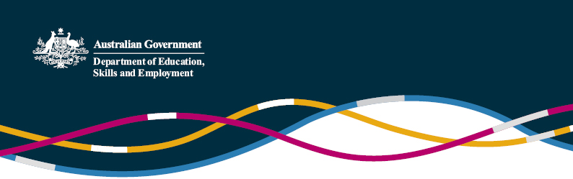

China-Australia Free Trade Agreement

(Information current as at 12 January 2015)

The Prime Minister, the Hon Tony Abbott MP and Chinese President Xi Jinping announced the conclusion of negotiations for the China-Australia Free Trade Agreement (ChAFTA) on 17 November 2014. ChAFTA is an excellent deal for Australia, providing a high-quality and balanced package of outcomes that will lay a historic foundation for the next phase of Australia’s economic relationship with China. ChAFTA will enter into force following domestic legal and parliamentary processes on both sides.  
  
In addition to concluding negotiations for the Free Trade Agreement, on the afternoon of 17 November, the Minister for Education, the Hon Christopher Pyne MP signed, with Chinese Vice Minister for Education Hao Ping, agreements between Australia and China on higher education qualifications recognition and student, academic and researcher mobility. These agreements complement the ChAFTA and reflect the strong and long-standing education and research relationship that exists between Australia and China.

China is already Australia’s largest education services export market, worth more than $4 billion in 2013-14. The Australian and Chinese Governments have agreed to work together to increase the marketing and recruitment opportunities for Australian education institutions in China. Additionally, Australia and China will work to increase student and teacher exchanges, providing Australians with the language and cultural skills to more meaningfully engage with China.  
  
The Australian Government is committed to enhancing Australia’s reputation for quality education and works with all Australian education institutions to maximise the opportunities presented by strong demand for education services in China. China’s agreement to list on its ‘Study Abroad’ (JSJ) website ([www.jsj.edu.cn](http://www.jsj.edu.cn/)) an additional 77 Australian private higher education institutions registered on the Commonwealth Register of Institutions and Courses for Overseas Students (CRICOS) is an excellent outcome, and testament to the quality and reputation of Australian education. It also reflects the high regard China has for Australia’s robust regulatory framework. China has agreed to continue to discuss listing additional CRICOS-registered institutions on the JSJ website over time.

More information on the Free Trade Agreement with China is available from the Department of Foreign Affairs and Trade website (<http://dfat.gov.au/fta/chafta>). This site will be updated with developments as they occur.

For further enquiries, please contact the [Education and Research Section](mailto:education.research@dfat.gov.au) of the Australian Embassy in Beijing.