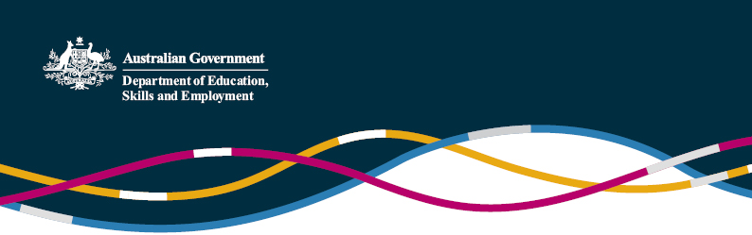

Chinese universities establishing programs and campuses in foreign countries

# (Information current as at 6 September 2016)

A growing number of Australian education institutions have been involved in discussions with Chinese schools, universities and investment companies looking to establish campuses or schools in Australia. The [first wholly owned Chinese tertiary college in Australia](http://gbca.edu.au/) accepted its first students in 2016. China is ramping up its outbound foreign investment, not just in Australia but globally, particularly through its “One Belt One Road” program.

China has been actively encouraging Sino-foreign joint programs in China, to help develop and internationalise its education system, for many years. China has also more recently been looking at ways to encourage and establish Sino-foreign cooperation in education in foreign countries.

Under China’s education fiscal policy, public Chinese education institutions are not allowed to invest in overseas education. Any funding for overseas education relies on raising money from private investment or partnership with local or foreign enterprises.

Until recently, China had its 2003 Interim Measures for the Administration of Universities and Colleges Engaged in Overseas Education covering the approvals processes for establishing Chinese degree courses offered overseas. These interim measures lapsed in October 2015, and were one of the policies removed in a recent Ministry of Education (MOE) [cull of redundant policy guidelines](https://internationaleducation.gov.au/international-network/china/PolicyUpdates-China/Pages/China%E2%80%99s-World-Class-2-0-an-update.aspx). In the absence of this approval authority, new institutions can be established overseas without needing approval from the MOE.

While there are no current guidelines outlining responsibilities and regulations for Chinese institutions looking to develop and establish programs and campuses in foreign countries, we understand that Chinese institutions are continuing to use the old guidelines as a rule of thumb.

According to data from the MOE, under the 2003 Interim Measures the MOE had approved Chinese universities to establish four overseas education institutes with a further 98 overseas education programs offered in 14 countries and regions.

The four MOE approved overseas education institutes or campuses are:

* Soochow University Laos – the first foreign university approved by the Laos Ministry of Education, with its first intake in 2012
* Xiamen University Malaysia Campus – registered as a university in Malaysia as an independent legal entity, with its first intake in 2015
* YUFE Business School in Bangkok – a cooperation between Yunnan University of Finance and Economics and Thailand’s Rangsit University, approved by the Thai Ministry of Education in 2014 and
* BLCU Tokyo College – a cooperation between Beijing Languages and Cultural University and the Japan ISI Corporation, launched in 2015.

Since the lapse of the Interim Measures, two more institutions or campuses have been set up:

* BNU Cardiff Chinese College – a joint college between Beijing Normal University and Wales’ Cardiff University, launched with financial support from the Welsh Department of European and External Affairs and
* Global Innovation Exchange (GIX), a partnership between Tsinghua University and the University of Washington with foundational support from Microsoft. Based in a new facility in the Seattle area, this is the first time that a Chinese research university has established a physical presence in the US.

Much of the interest in hosting Chinese transnational education programs has come from developing foreign countries involved in strategies like China’s “One Belt One Road”, which are looking to China for assistance in developing their education systems or in developing their engineering and technical capacity.

The MOE is encouraging high quality vocational education institutions to cooperate with Chinese enterprises to “go out” especially to work with Chinese high-speed rail and telecom enterprises to train their workforces where China is developing infrastructure under “One Belt One Road”. The MOE is actively supporting this “going out” approach through policy guidance and through identifying funding incentives, including through State foreign aid programs.

Recent statements from MOE officials indicate ongoing support for Chinese institutions establishing programs and campuses overseas, and the MOE is in the process of developing new guidelines to support this. The MOE is also looking to develop strategic policy planning and help Chinese institutions undergo capacity building.

Chinese institutions delivering programs overseas have to adhere to the teaching and quality standards of the programs that they deliver in China. In order to ensure this, the MOE is strengthening evaluation and monitoring work on curriculum design, teaching, and administration for overseas education institutes and programs. The MOE is also studying the establishment of overseas education quality evaluation standards and quality monitoring systems to ensure the quality of programs and campuses operated in foreign countries.

The Australian Government is working with the MOE to support closer cooperation between Australian quality regulators and their Chinese counterparts, to help share knowledge around quality control of local qualifications delivered offshore. China considers Australia a world leader in the area of tertiary education quality assurance.

For further enquiries, please contact the [Education and Research Section of the Australian Embassy](mailto:education.research@dfat.gov.au)in Beijing.