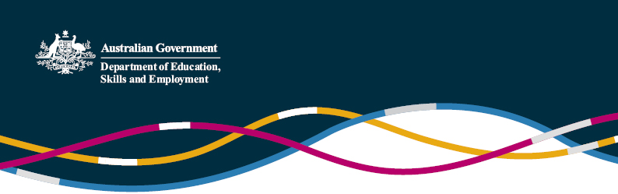

China – New Directive for International Education

# (Information current as at 22 September 2016)

In May this year, the Central Committee of the Communist Party of China and the State Council released a directive that outlines what is essentially China’s international education strategy: “Opinions on the work of the opening-up of education in the new era”. An [unofficial literal translation](https://internationaleducation.gov.au/international-network/china/PolicyUpdates-China/Documents/Opinions%20on%20the%20work%20of%20the%20opening-up%20of%20education%20in%20the%20new%20era%20-English%20translation.pdf) of the [executive summary](https://internationaleducation.gov.au/international-network/china/PolicyUpdates-China/Documents/Opinions%20on%20the%20work%20of%20the%20opening-up%20of%20education%20in%20the%20new%20era%20-Chinese%20version.pdf) has been prepared by the education section of the Australian Embassy in China.

China’s international education strategy is similar in scope to those released by other counties over the last couple of years, including Australia’s recent [National Strategy for International Education](https://internationaleducation.gov.au/International-network/Australia/InternationalStrategy/Pages/National-Strategy.aspx). It has a focus on investment and quality in education, and mobilising resources to strengthen China’s education system.

As outlined in recent policy updates, the strategy includes elements on strengthening China’s education system to [make its universities world class](https://internationaleducation.gov.au/international-network/china/PolicyUpdates-China/Pages/China%E2%80%99s-World-Class-2-0-an-update.aspx), and supporting and encouraging universities and vocational colleges to [expand overseas](https://internationaleducation.gov.au/international-network/china/PolicyUpdates-China/Pages/Chinese-universities-establishing.aspx). It also includes an emphasis on taking a leading role in developing qualifications systems, and a focus on improving and enhancing transnational education delivered into China - specifically identifying the disciplines of natural science and engineering as two disciplines urgently needed in this area.

The strategy also emphasises the role of people-to-people mechanisms, such as two-way student and academic exchange, in actively promoting China’s development achievements and culture.

There are a number of areas of close alignment between China’s and Australia’s international education strategies, and Australia and China have been working closely together taking a leading role in a number of areas around qualifications recognition and harmonisation. China and Australia are [the only two countries](http://www.unesco.org/eri/la/convention.asp?KO=48975&language=E) to have ratified the Asia-Pacific Regional Convention on the Recognition of Qualifications in Higher Education (the Tokyo convention), and in 2014 the two countries signed an updated [Arrangement on Higher Education Qualifications Recognition](https://internationaleducation.gov.au/International-network/china/publications/Documents/U-Chi-282.PDF).

The release of China’s strategy comes at a good time, as Australia is already working closely with China to support cooperation and engagement in quality assurance of transnational education. The Australian Skills Quality Agency (ASQA) completed a [joint pilot audit](http://www.asqa.gov.au/verve/_resources/Regulating_offshore_delivery_of_VET_-_ASQAs_2015_pilot_audit_program.pdf#search=china%20joint%20audit) of Sino-Australian vocational programs delivered in China in 2015, and will be undertaking a second round of joint audits later this year, while the Tertiary Education Quality Standards Agency (TEQSA) has just signed memorandums of understanding with the Higher Education Evaluation Centre (HEEC) of the Chinese Ministry of Education and the Chinese Service Centre for Scholarly Exchange (CSCSE).

For further enquiries, please contact the [Education and Research Section of the Australian Embassy](mailto:education.research@dfat.gov.au)in Beijing.