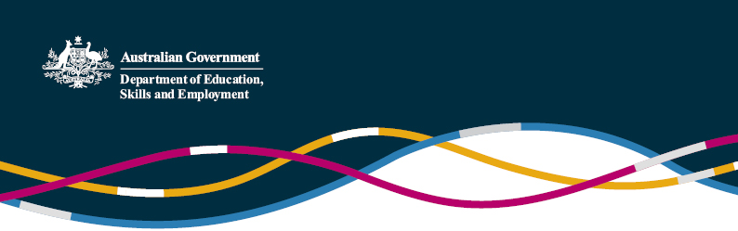

Reforms to China’s National Higher Education Entrance Examination – the Gaokao

(Information current as at 29 November 2016)

The “Gaokao” is China’s National Higher Education Entrance Examination, which determines whether or not students will be able to study in their preferred university or college. More than 9 million students took the exam in 2016, and a majority of Australian universities now accept the Gaokao for entrance into their courses in Australia.

 In 2014, the State Council issued a document that outlined reforms to China’s exam based admissions system, designed to address perceived shortcomings in the Gaokao and provide a greater emphasis on a more well-rounded education system and development of individual competencies across a broader range of areas. From 2017, the first group of students from selected provinces will graduate under the reformed Gaokao.

 Under the reforms, students will be given more flexibility and autonomy. Chinese, Math and English will continue to be compulsory Gaokao subjects, but students will now be given two attempts to pass their English test. They will no longer have to choose between being streamed into either “science based” or “liberal arts based” exams - instead, they will be able to select three elective subjects of their choice that match their desired major at their desired institution, including both science and liberal art type subjects if they wish. This model is now being interpreted by many provincial governments as the “3+3” model.

 The State Council document appointed Shanghai and Zhejiang as pilot provinces to implement these reforms from autumn 2014, with the intention that the reforms would be fully implemented nationwide by 2017. The first students from Shanghai and Zhejiang will sit the new Gaokao in 2017.

 Non-pilot regions are using feedback from Shanghai and Zhejiang to design their own implementation plans. Beijing, Tianjin and Shandong have all released their implementation plans this year, reflecting the “3+3” model. Jiangsu province has sought and received permission to delay its implementation plan until 2018, with the first students in Jiangsu sitting the new Gaokao in 2021. Other provinces and regions are expected to announce their plans shortly.

 In early October 2016, the Chinese Ministry of Education issued an official test syllabus for English for 2017, which increases the test’s English vocabulary from 3,200 to 3,500 words, showing that a strengthened English unit is still an integral part of the Gaokao system.

 Alongside this, the MOE is developing a [new national English proficiency testing and rating system](http://www.chinadaily.com.cn/china/2016-11/14/content_27364436.htm). The new English proficiency scale, which will outline standards from primary school through to university level, professional and “high-end English talents”, is expected to be published next year and implemented in full by 2020. By 2020, it is expected that China will use this single national test for English proficiency, replacing a range of different teaching and testing systems currently used in different provinces and regions for assessing English proficiency for the Gaokao.

For further enquiries, please contact the [Education and Research Section of the Australian Embassy](mailto:education.research@dfat.gov.au)in Beijing.