




​Please update resources at the URL above for accessibility and branding. NB - these have been already published and are existing resources on the website so do not require approval (so no Director approval sought below).

From <https://sharedservicescentre.sharepoint.com/sites/edu-communication/Lists/Web%20Publishing%20Request/NewForm.aspx?RootFolder=> 




Updating published resource for branding/accessibility

Graphic header with the Australian Government crest and branding of the former Department of Education, Skills and Employment

China announces major reform to vocational education sector

# (UPDATED: Information as at June 2019)

On 13 February 2019, the Chinese State Council published its “[Implementation plan on National Vocational Education Reform](http://www.gov.cn/zhengce/content/2019-02/13/content_5365341.htm)” (in Chinese), signalling a significantly strengthened focus on vocational education, which was reinforced in early March 2019 by Chinese Premier Li Keqiang. In his 2019 Government Work Report, Premier Li announced the transfer of 100 billion RMB (20 billion AUD) in funding from the unemployment insurance fund into vocational training to support 15 million people to upgrade their skills.

The plan prioritises reform of vocational education in China to better equip the labour force to meet the demands of the economy now and into the future. It contains 7 priority objectives and 20 detailed actions. A high level summary of the plan and an unofficial translation of the objectives are included below.

In 2018, China had 26.9 million total vocational education students and annual commencements of 9.3 million.[1] The proposed reform of the vocational education sector follows a reported decline in China’s labour force over recent years – largely due to China’s well publicised aging population. China’s working age population shrank by almost 3 % between 2011 and 2018, and accounts for around 65% of China’s 1.4 billion population.[2] This percentage is estimated to further reduce to 57% in 2030.[3] The reform plan is also quite timely in the lead up to Shanghai playing host to the World Skills Competition 2021.

# Key points of the plan

The plan seeks to raise the status of vocational education - an attempt to eradicate a common mindset that vocational education is a “second choice” to an academic degree.

Through the plan, China is seeking to reform its entire vocational education framework, including occupational standards, assessment and evaluation mechanisms, teacher training & recruitment, and industry engagement. The State Council will establish a National Vocational Education Guidance Advisory Committee (official translation of “国家职业教育指导咨询委员会”) to oversee the reform.

China’s vocational education system will transform from having a “quantity focus” (数量扩张) to a “quality focus” (质量提升), with greater importance being placed on teaching quality. In 2018, China had 1.3 million teaching staff at vocational institutions, of which fewer than 40% were reported to have both the practical work experience and teaching skills required for their field. The plan seeks to increase the proportion of teachers who have at least 3 years work experience in industry and a 3 year vocational diploma. A part-time employment mechanism for professional experts will also be introduced. From 2020, teaching positions for specific courses at VET institutes and applied universities will generally not be open to new graduates.

By 2022, China aims to transform select universities into “practical” institutions – Universities of Applied Sciences - where students can acquire a diploma plus a number of certificates of vocational skills, a mechanism known as the “1+X” model. The “1+X” model allows vocational institutions and universities to offer an educational qualification plus a number of skills certificates. The model will be tested in select institutions from March 2019.

Commencing in 2019, a “credit bank” for vocational studies will be established to record individual vocational education credits to enable the transfer and conversion of those credits towards other certification.

The plan also seeks to increase vocational education opportunities. China’s vocational education is separated into secondary vocational and higher vocational. Secondary vocational education is offered to junior high school graduates (equivalent to Australian grade 9) who do not wish to pursue further studies at an academic senior high school. Higher vocational education is offered to senior high school graduates, and admits students through the “Gaokao” (College Entrance Exam). The plan proposes to maintain an approximately equal proportion of high school students studying at academic high schools and secondary vocational schools, and would like to see students who did not complete high school (both junior and senior high school), veterans, retired athletes, laid-off workers and returned migrant workers have secondary vocational education opportunities. According to the 2019 Government Work Plan, China promises to greatly increase fiscal support for vocational colleges and will establish a national scholarship for secondary vocational education.

In 2014, the State Council published a reform plan to allow entrance into higher vocational colleges through multiple channels other than the National College Entrance Exam (Gaokao).[4] Instead of taking the Gaokao, students can sit an ‘academic plus skills test’ organised by local governments or higher vocational institutions to be accepted. This path is often taken by graduates from secondary vocational schools. For those who graduate from academic high school, they can use their high school result to satisfy the academic requirement, and only take a skills test. In the past three years, this reform has seen more than half of the newly-enrolled students into higher vocational education enter through the non-Gaokao channel.[5] The plan seeks to continue exploring this new model to enrol more quality students with practical skills.

This year, China wants to expand higher vocational college enrolment by one million to address the shortage of highly-skilled personnel.[6] Two months after the reform plan was published, a new strategy was announced by the Chinese Ministry of Education (MoE) and Ministry of Finance to develop world-class higher vocational colleges – the Double High-Level initiative (unofficial translation of “[中国特色高水平高职学校和专业建设](http://www.moe.gov.cn/srcsite/A07/moe_737/s3876_qt/201904/t20190402_376471.html)”). The new initiative aims to develop China’s higher vocational colleges and disciplines, similar to the Double First-Class initiative for higher education. According to the plan, 50 higher vocational colleges and 150 disciplines groups will be given priority for development. By 2022, China aims to see significant improvement in its higher vocational education system. The Education and Research section will continue to monitor and report developments surrounding this initiative.

For ease of understanding, the below diagram shows the vocational education pathway in China.

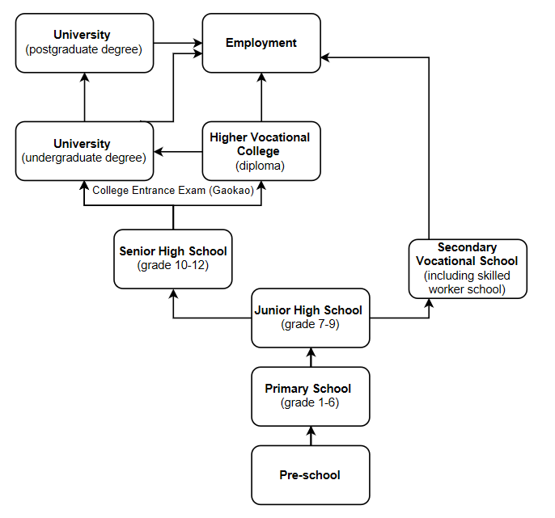[7]

Over five to ten years’ time under the plan, the vocational education system will gradually shift from one designed largely by government to one driven by the market. Enterprises are strongly encouraged to support the development delivery of vocational education, including through the establishment of practical training bases. The plan encourages Chinese vocational institutions to learn from Germany, Japan and Switzerland for this model.

It is expected that provinces will soon publish their own detailed reform implementation plan. The Chinese Ministry of Education (MoE) has also confirmed that 4-5 supporting documents will be published in the upcoming months.  These plans and documents will be important to identifying areas for future Australia-China collaboration on vocational education.

**Unofficial translation of the Plan’s Objectives**  
**1. To improve the National Vocational Education System**  
a. Improve the national vocational education system framework  
b. Improve secondary vocational education  
c. Promote development of high quality higher vocational education  
d. Improve training system for high-level professionals with practical skills (eg ensuring greater applied/technical learning and practical training in vocational education; incorporating military-related vocational education into the national vocational education system)  
  
**2**. **Establish national standards for vocational education**  
a. Improve teaching standards in vocational education  
b. Pilot the 1 + X certification system  
c. Support and promote high quality vocational training with adequate policy  
d. Construct a national ‘credit bank’ for vocational education through which an individual’s learning outcomes can be recorded, and to enable conversion of education outcomes into other certificates/qualifications (importantly, this objective proposes a pilot project to develop a national qualifications framework)  
  
**3. Promote the integration of vocational schools with industry**  
a. Pursue the combination of ‘knowledge and practice, work and study’ through things like apprenticeships, internships and training  
b. Deepen cooperation between vocational colleges and industry  
c. Construct high-level vocational education training bases which integrate academic learning with professional training.  
d. Recruit more teachers with both academic knowledge and applied skills  
  
**4. Establish a vocational education system that is supported by various bodies**  
a. Promote industry involvement in running high quality vocational education  
b. Establish vocational education evaluation organizations to develop vocational skill level standards, implement vocational skills assessment and evaluation, and issue certificates  
  
**5.  Improve policies to safeguard the benefits of skilled professionals**  
a. Improve wages and benefits for skilled professionals  
b. Improve the funding mechanism for vocational education (including government, fundraising, philanthropy, and scholarship with a focus on the central and western regions, poverty-stricken areas and ethnic areas)  
  
**6. Strengthen the quality supervision and evaluation of vocational education**  
a. Establish and improve the quality evaluation and supervision system of vocational education (including to issue annual report on vocational education and conduct random checks on the issuing of vocational certificates)  
b. Establish a National Vocational Education Steering Guidance Advisory Committee (国家职业教育指导咨询委员会) *(to advise on China’s vocational education reform, provide policy research, participate in drafting of vocational education laws and regulations, and contributes to the government’s decision-making process)*  
  
**7. Effectively implement the reform**  
a. Strengthen the Party’s overall leadership in vocational education  
b. Improve Inter-Ministerial Joint Meeting Mechanism on the Vocational Education of the State Council (国务院职业教育工作部际联席会议制度）

For further enquiries, please contact the [Education and Research Section](mailto:education.research@dfat.gov.au) of the Australian Embassy in Beijing.

1. Han, Jiahui, editor. “‘China Has 11,700 Vocational Institutions' 我国已有职业院校1.17万所.” Xinhua News Agency, 19 Feb. 2019, [www.xinhuanet.com/politics/2019-02/19/c_1210063195.htm](http://www.xinhuanet.com/politics/2019-02/19/c_1210063195.htm). 
2. “Chart of the Day: China’s Shrinking Workforce.” Caixin Global , 29 Jan. 2019, [www.caixinglobal.com/2019-01-29/chart-of-the-day-chinas-shrinking-workforce-101375782.html](http://www.caixinglobal.com/2019-01-29/chart-of-the-day-chinas-shrinking-workforce-101375782.html).  
3. Based on calculations of statistics from the Ministry of Human Resources and Social Security of the People's Republic of China (China’s population will reach 1.45 billion in 2030) and Circular of the State Council on the Issuance of the National Population Development Plan (2016-2030)(China’s working population will reach 830 million in 2030)
4. “The State Council Publishes 'Opinion on Implementing Deepened Reform on Admissions System Based on Examination.” [国务院印发《关于深化考试招生制度改革的实施意见》], The State Council of the People's Republic of China , 4 Sept. 2014. [www.gov.cn/xinwen/2014-09/04/content_2745653.htm](http://www.gov.cn/xinwen/2014-09/04/content_2745653.htm).
5. The Ministry of Education, “MOE Press Conference to Present Progress on Vocational Education Action Plans.” MOE Press Conference to Present Progress on Vocational Education Action Plans, 9 Nov. 2018. <http://en.moe.gov.cn/news/press_releases/201811/t20181112_354312.html>. 
6. “Full Text of 2019 Government Work Report '2019年政府工作报告全文'.” Full Text of 2019 Government Work Report '2019年政府工作报告全文', The State Council of the People's Republic of China ,5 Mar. 2019. [www.gov.cn/zhuanti/2019qglh/2019lhzfgzbg/index.htm](http://www.gov.cn/zhuanti/2019qglh/2019lhzfgzbg/index.htm).
7. This diagram was prepared by the [Education and Research Section](mailto:education.research@dfat.gov.au) of the Australian Embassy, Beijing. It is not an official diagram.