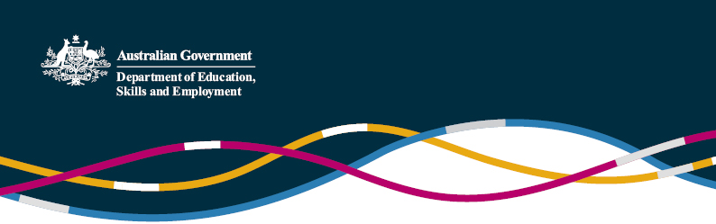

Ministry of Education announces new measures to assist stranded Chinese international students

# (Information as of 18 September 2020)

On 16 September 2020, China’s Ministry of Education (MoE) announced four new temporary measures to assist Chinese international students enrolled in overseas institutions but who remain in China, unable to travel to their overseas study destination as a result of the pandemic, to continue their studies The announcement – titled (translated) *MoE adopts active measures to address difficulties for Chinese students to travel abroad during the pandemic period* - is available on the MoE website [here](http://www.moe.gov.cn/jyb_xwfb/gzdt_gzdt/s5987/202009/t20200916_488192.html), and a summary (based on an unofficial translation) is provided below.

The four measures include:

**1. Assistance for students undertaking online classes in China**, including by clarifying the Chinese Government’s flexible approach to recognition of qualifications obtained partly online due to COVID-19

The MoE’s announcement referred to the ‘special notice’ issued in April 2020 by the Chinese Service Center for Scholarly Exchange (CSCSE), which indicated students who were: affected by the pandemic; unable to return to school; and chose to continue their studies online would not be penalised when it came to the verification of their academic degree This approach is a temporary departure from China’s usual policy of not recognising overseas qualifications obtained online More information is available in our policy piece [here](https://internationaleducation.gov.au/international-network/china/PolicyUpdates-China/Pages/Formal-advice-on-degree-verification-for-Chinese-international-students---online-learning-due-to-COVID-19.aspx).

**2. Allow certain Chinese universities to provide short term learning and exchange opportunities** for these students, pursuant to exchange agreements with foreign universities.

**3. Allow certain MoE-approved Chinese-Foreign joint institutes and programs (including some with Australian providers) to accept Chinese international students**by encouraging eligible joint institutes and programs to expand their undergraduate and postgraduate recruitment for the 2020-21 academic year

The transcript of a Q&A session between the head of the MoE’s Department of International Cooperation and Exchanges (Office of Hong Kong, Macao and Taiwan Affairs) and the press was published by the MoE on the same day as the announcement, which offered some insight into the MoE’s consideration for making the decision. The transcript is available on the MoE website [here](http://www.moe.gov.cn/jyb_xwfb/s271/202009/t20200916_488189.html).

An attachment list containing all eligible projects identified by the MoE was provided with the transcript document. The list includes 41 eligible joint institutes (Tier 1 and Tier 2) and 49 eligible joint programs in Beijing, Tianjin, Hebei, Liaoning, Shanghai, Jiangsu, Zhejiang, Anhui, Fujian, Jiangxi, Shandong, Henan, Hubei, Hunan, Guangdong, Hainan, Sichuan, Guizhou and Shanxi.

The list contains **four Chinese-Australian joint institutes:**

· **SILC Business School, Shanghai University** (partnership between University Technology, Sydney and Shanghai University)

· **Southeast University-Monash University Joint Graduate School(Suzhou)** (partnership between Monash University and Southeast University )

· **International Engineering College of Xi’an University of Technology** (partnership between James Cook University and Xi’An University of Technology)

· **Xi’an University of Architecture and Technology University of South Australia An De College** (partnership between University of South Australia and Xi’An University of Architecture and Technology )

It also contains **four Chinese-Australian joint programs:**

· **Master of Management Specializing in Technology and Innovation program** (partnership between Australian National University and Tsinghua University)

· **Master of Applied Finance program**(partnership between Macquarie University and Tsinghua University)

· **Bachelor of Business Program** (partnership between Victoria University and Central University of Finance and Economics) and

· **Master of Educational Leadership and Management Program** (partnership between University of Canberra and Hangzhou Normal University)

The list also contains 11 US joint institutes and 17 joint programs; 15 UK joint institutes and 7 joint programs[1]; one New Zealand joint institute and one joint program; and four Canadian joint programs.

It is understood that the enrolment quotas for each of the listed institutes and programs are being extended by a certain amount to take on additional students, and these students will be considered ‘non-quota’, meaning they will not affect the ordinary enrolment quotas for the institute or program. The MoE announcement does not specify the enrolment numbers However, some individual institutes have posted figures on their website For example, the Xi’An Jiaotong Liverpool University joint institute has advertised it will take 100 students The Lancaster University College at Beijing Jiaotong University, also a joint institute, has announced it will take 104 students.

Interested students need to apply for admission into these programs. If successful in a merit-based process, they would study the foreign curriculum/course only (instead of the usual practice in joint institutes and programs of studying both the Chinese and foreign courses), and be awarded the foreign degree only

**4. Strengthen external communication –**The MoE noted it had provided advice to the education sections of Chinese embassies and consulates abroad to liaise with education authorities and universities in host countries to address the problems associated with the ‘academic hindrance of Chinese international students.’

For further enquiries, please contact the [Education and Research Section](mailto:education.research@dfat.gov.au) (Department of Education, Skills and Employment) of the Australian Embassy in Beijing.

1. The Faculty of International Media, Communication University of China is a joint institute established between Communication University of China, New York Institute of Technology from US and Nottingham Trent University from the UK. This joint institute is counted towards the total number of joint institute for both US and UK.