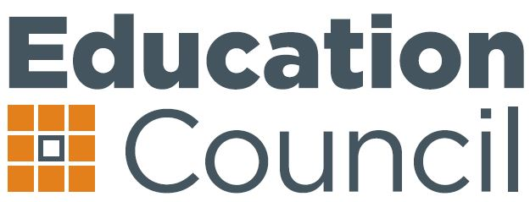 | Education Council Meeting  15 August 2014 by TelePresence

Communiqué
Ministers met as the Education Council for the first time in a national video-conference on 15 August 2014. The Education Council succeeds the former Standing Council on School Education and Early Childhood (SCSEEC) following a decision by the Council of Australian Governments (COAG) in late 2013 to reform the Ministerial Council structure. COAG is expected to consider Terms of Reference for the Education Council in coming months.

Universal Access to Early Childhood Education
The Education Council discussed the findings of the Review of the National Partnership Agreement on Universal Access to Early Childhood Education (NP UAECE), conducted for Council by Deloitte Access Economics.
Ministers noted that there have been significant successes achieved by governments since 2008 in increasing children’s access to, and participation in, preschool programs in the year before full-time school. However, the Universal Access commitment was not fully met by 30 June 2013 and there is still further work to do regarding universal access and in reaching all of the targets of the National Partnership.
The Review Report highlights the significant progress against indicators including access to quality programmes, access to early childhood programmes for disadvantaged and vulnerable children, access by indigenous children and early childhood programme availability throughout the country. The Education Council agreed that the Review Report would be finalised and published as soon as possible with commentary from all governments on progress made under the Universal Access National Partnership.
The meeting discussed the urgent need for a funding decision from the Australian Government for universal access, to provide certainty for families and the sector as soon as possible. Council agreed to commence discussions regarding the appropriate next steps following the expiry of the NP UAECE as soon as possible.

Non-government Distance Education
Ministers noted the preliminary work the Australian Government is undertaking to develop an understanding of the provision of distance education. Ministers agreed that further work will be progressed through senior officials to determine the types of students accessing distance education, the level of support provided to these students, and what support is currently being provided by individual jurisdictions.

Update from the Vocational Education and Training in Schools (VETiS) Working Group
The Education Council noted the progress report on the VETiS Working Group, which was established to update the vocational education in schools framework from 2001. The Council noted a draft framework would be submitted for consideration in December 2014.

Australian Curriculum: Work Studies
Council welcomed receipt of the Australian Curriculum: Work Studies Years 9-10 from Australian Curriculum, Assessment and Reporting Authority (ACARA). This work studies elective is designed for all students, whether they pursue a vocational or an academic path, and has been written in response to key work-related issues facing young people today. Work Studies Years 9-10 is an applied learning curriculum that adapts discipline-based learning to work contexts and allows for a cross-curriculum disciplinary mode of delivery.
Ministers agreed that ACARA make the curriculum available on its website for use by states and territories pending finalisation of the Australian Government’s Review of the Australian Curriculum.

Student Attendance Reporting: Data Collections for 2014
Education Ministers considered advice from ACARA on arrangements for collection of Semester 1 student attendance rates for Years 1-10 by Indigenous status in November 2014. This is the first step in delivering the decision of COAG to report school-level attendance for all students twice yearly, broken down by Indigenous and non-Indigenous students.
Ministers noted that ACARA will provide further advice to Council in October about arrangements to implement a new attendance measure, agreed by COAG, to report the proportion of students attending school less than 90 per cent of the time, and a number of other implementation matters.

__
Media enquiries: Greg Donaghue, Education Council Secretariat, 3 9639 0588 or greg.donaghue@ec.edu.au

