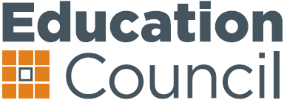**Thirteenth Education Council Meeting**

18 May 2017, Adelaide

**18 May 2017**

**Schools funding and reform**

**Communiqué**

The Education Council discussed the Australian Government’s proposed new school funding arrangements and implementation issues.

Ministers noted the terms of reference for the Review to Achieve Educational Excellence in Australian Schools (the Review), Chaired by David Gonski AC, and that the Chair will be invited to provide an update to Education Council on the work of the panel in the second half of 2017.

The Education Council agreed to undertake further work to inform discussion on funding and reform principles for any future national schooling agreement at the next Council of Australian Governments (COAG) meeting.

Education Ministers agreed to advise COAG that the Education Council will consider the content of any future agreement on national schooling following the finalisation of the Review.

Media queries: Greg Donaghue, Education Council secretariat, 0423 748 320 or [greg.donaghue@ec.edu.au](mailto:greg.donaghue@ec.edu.au)

1