**Youth connections**

**subjective wellbeing report**

PART A: the report

Report 6.0

April, 2014

Adrian Tomyn, Ph.D

Discipline of Psychology, School of Health Sciences,

RMIT University, Australia.

In association with the Australian Federal Government Department of Education.

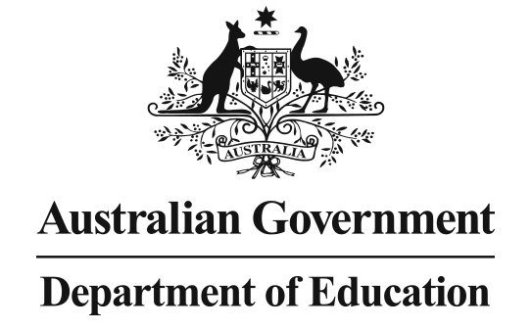

**FOREWORD**

Within the academic literature, the relationship between student outcomes such as attitudes toward school, academic performance, engagement, school satisfaction and wellbeing are well-established. Indeed, a bi-directional relationship between these variables exists. Mental health and wellbeing can enhance/hinder student outcomes and student outcomes can facilitate/interfere with the experience of normal psychological functioning.

Conservative estimates suggest that up to 15% percent of Australian high-school students will experience some form of mental health problem before they complete year 12 or equivalent. This risk is heightened for young people experiencing social and economic disadvantage and other barriers to successful engagement with education and post-secondary training. These include, but not exclusively, behavioural problems, socialisation issues, inadequate family support, caregiving responsibilities, disability, drug and alcohol problems and homelessness. As such, there is a need to identify and support young people in need at the earliest possible time, before negative thought patterns, behaviors and circumstances are reinforced over time, posing additional barriers toward their successful transition through their schooling and onto post-secondary training and employment.

The Department of Education’s Youth Connections Programis a national program that provides flexible and personal support to help ‘at-risk’ young people across Australia engage with education and employment and make positive life choices. By addressing the complex challenges facing many young people, Youth Connections creates pathways that enable young people to reconnect, thereby increasing educational and employment outcomes that will provide them with the greatest opportunity to build successful, secure, fulfilling and happy futures for themselves and their families.

The Youth Connections Subjective Wellbeing Research Project aims to measure and monitor the psychological wellbeing of young people participating in the program. This research represents an important undertaking by the Australian Federal Government, who has demonstrated their commitment to the independent, objective, evidence-based scientific evaluation of Youth Connections from the perspective of personal wellbeing.

I would like to extend my thanks to the Department of Education for funding this very important and worthwhile research and to the many service providers across Australia on the front line involved in collecting the research data comprising this report. All people associated with Youth Connections should be commended on the work they undertake servicing the needs of some of Australia’s most underprivileged and vulnerable young people on a daily basis.

|  |
| --- |
| Dr Adrian Tomyn is the author of this report and a Lecturer in the Discipline of Psychology at Melbourne’s RMIT University.  **Dr Adrian Tomyn** is an expert in psychological wellbeing, a Lecturer in the Discipline of Psychology at Melbourne’s RMIT University and the author of this report. |

**Table of Contents**

Executive Summary ix

1 Introduction 21

2 Overall subjective wellbeing and domain happiness scores 30

3 Gender 34

4 Age 39

5 Connection level 49

6 Residency 54

7 Youth characteristics 62

8 Barriers to progression 66

9 Recent activities in the past month 74

10 Happiness with School 84

11 The subjective wellbeing of young Indigenous Australians 89

12 The subjective wellbeing of humanitarian refugees 111

13 Subjective wellbeing at follow up interview 116

14 Outcomes achieved 127

References 150

**Index of Figures**

Figure 2.1: Comparison between Youth Connections and Mainstream SWB data 30

Figure 2.2: Distribution of young people in each PWI group compared to mainstream 32

Figure 2.3: Mean PWI and domain happiness scores for normal and high-risk young people 33

Figure 3.1: Mean PWI scores for females and males 34

Figure 3.2: Distribution of females and males in each PWI group 34

Figure 3.3: PWI and domain happiness scores for females and males 35

Figure 3.4: Mean SWB for females and males compared to mainstream 36

Figure 3.5: Distribution of YC and mainstream females in each PWI group 37

Figure 3.6: Distribution of YC and mainstream males in each PWI group 38

Figure 4.1: Age and subjective wellbeing for Youth Connections and mainstream 39

Figure 4.2: Age and PWI group distribution 40

Figure 4.3: Mean scores for Standard of Living domain by age 41

Figure 4.4: Mean scores for Health domain by age 42

Figure 4.5: Mean scores for Achieving in Life domain by age 43

Figure 4.6: Mean scores for Relationships domain by age 44

Figure 4.7: Mean scores for Safety domain by age 45

Figure 4.8: Mean scores for Community Connection domain by age 46

Figure 4.9: Mean scores for Future Security domain by age 47

Figure 4.10: Age, gender and SWB 48

Figure 5.1: Mean PWI scores and Connection level 50

Figure 5.2: Connection level and PWI groups 50

Figure 5.3: Connection level, SWB and domain happiness scores 51

Figure 5.4: Connection level, gender and SWB 52

Figure 5.5: Connection level, age and SWB 53

Figure 6.1: State of residence and SWB 54

Figure 6.2: State of residence and PWI groups 55

Figure 6.3: State of residence, gender and SWB 56

Figure 6.4: State of residence, Connection level and SWB 57

Figure 6.5: Accessibility/Remoteness Index of Australia (ARIA) and SWB 58

Figure 6.6: Accessibility/Remoteness Index of Australia (ARIA) and PWI groups 59

Figure 6.7: Accessibility/Remoteness Index of Australia (ARIA) and PWI domains 60

Figure 7.1: Youth characteristics and SWB 62

Figure 7.2: Youth characteristics and SWB 63

Figure 7.3: The debilitating effect of mental health problems 64

Figure 7.4: The debilitating effect of mental health problems 64

Figure 8.1: Family and living type barriers to progression and SWB 66

Figure 8.2: The compounding effect of multiple family and living type barriers to progression on SWB 67

Figure 8.3: Physical and psychological health type barriers to progression and SWB 68

Figure 8.4: Anti-social and behavioural type barriers to progression and SWB 69

Figure 8.5: Substance use and misuse type barriers to progression and SWB 70

Figure 8.6: Learning/academic type barriers to progression and SWB 71

Figure 8.7: Barriers to progression not otherwise classified 72

Figure 9.1: Approximate number of days in the last month the young person attended school, education or training and their SWB 74

Figure 9.2: Approximate number of days in the last month the young person attended school, education or training and their domain happiness scores 75

Figure 9.3: Approximate number of days in last month the young person had contact with their family or caregiver and their SWB 76

Figure 9.4: Approximate number of days in last month the young person had contact with their family or caregiver and their domain happiness scores 77

Figure 9.5: Approximate number of days in last month the young person had contact with their friends and their SWB 78

Figure 9.6: Approximate number of days in last month the young person had contact with their friends and their domain happiness scores 79

Figure 9.7: Approximate number of days in last month the young person participated in an activity outside their home/regular residence and their SWB 80

Figure 9.8: Approximate days in last month the young person participated in an activity outside their home/regular residence and their domain happiness scores 81

Figure 9.9: PWI and domain profile for young people categorised into the 28-31 day group for all four recent events described compared to mainstream 82

Figure 9.10: PWI and domain profile for young people categorised into the two lowest activity/contact groups for all four recent events described compared to mainstream 83

Figure 10.1: Happiness with School for Youth Connections and mainstream young people 84

Figure 10.2: Happiness with School for females and males 85

Figure 10.3: Happiness with School and age 85

Figure 10.4: Happiness with School for females and males in each age group 86

Figure 10.5: Connection level and happiness with School 87

Figure 10.6: Happiness with school for young people by residency 87

Figure 10.7: Happiness with school according to the ARIA 88

Figure 11.1: SWB and domain happiness scores for Indigenous and non-Indigenous YC participants 89

Figure 11.2: Proportion of Indigenous and non-Indigenous youths in each PWI group 90

Figure 11.3: PWI and domain happiness scores for Indigenous and mainstream young people 91

Figure 11.4: SWB and domain happiness scores for Indigenous females and males 92

Figure 11.5: Proportion of Indigenous Australian females and males by PWI group 93

Figure 11.6: SWB amongst Indigenous young people in each age group 94

Figure 11.7: Proportion of Indigenous young people in each PWI group by age 95

Figure 11.8: PWI, domain happiness scores and Connection level 96

Figure 11.9: Proportion of Indigenous young people in each PWI group by Connection level 97

Figure 11.10: State of residence and SWB 98

Figure 11.11: Accessibility/Remoteness Index of Australia (ARIA) and SWB 99

Figure 11.12: SWB and domain happiness scores at initial and at follow up interview (Indigenous youths) 100

Figure 11.13: SWB and domain happiness scores at initial and at follow up interview: Indigenous females 101

Figure 11.14: SWB and domain happiness scores at initial and at follow up interview: Indigenous males 102

Figure 11.15: Outcome achieved: Re-engaged with education (Indigenous) 103

Figure 11.16: Outcome achieved: Commenced in education (Indigenous) 104

Figure 11.17: Outcome achieved: Addressed low numeracy/literacy (Indigenous) 105

Figure 11.18: Outcome achieved: Addressed family support issues (Indigenous) 106

Figure 11.19: Outcome achieved: Addressed family support issues (Indigenous) 107

Figure 11.20: Happiness with school for young Indigenous people by residency 108

Figure 11.21: Happiness with school according to the ARIA 109

Figure 11.22: Happiness with school according to the ARIA 110

Figure 12.1: Mean PWI and domain happiness scores for refugees and non-refugees 111

Figure 12.2: Refugees and non-refugees according to PWI groups 112

Figure 12.3: Mean PWI and domain happiness scores for refugees and mainstream 112

Figure 12.4: Mean PWI and domain happiness scores for male and female refugees 113

Figure 12.5: Female and male refugees in each PWI group 114

Figure 12.6: Mean SWB for refugees in each age group 114

Figure 12.7: Mean SWB for refugees residing in each Australian state and territory 115

Figure 13.1: SWB and domain happiness scores at initial (pre-program) and at follow up (post-program) interviews 117

Figure 13.2: Proportion of young people in each PWI group pre-post program 118

Figure 13.3: Post-program PWI groups for young people who scored between 0-50 pre-program 119

Figure 13.4: Post-program PWI groups for young people who scored between 51-69 pre-program 120

Figure 13.5: Post-program PWI groups for young people who scored in the normal 70+ group pre-program 121

Figure 13.6: Female SWB and domain happiness scores at initial and at follow up interview 122

Figure 13.7: Male SWB and domain happiness scores at initial and at follow up interview 123

Figure 13.8: Female and male post-program PWI scores compared to mainstream 124

Figure 13.9: Pre and post-program mean PWI scores for young people in each age group 125

Figure 13.10: Pre and post-program PWI scores for various sub-groups of high-risk young people 126

Figure 14.1: Outcome achieved: School attendance improved 129

Figure 14.2: Outcome achieved: Educational performance improved 130

Figure 14.3: Outcome achieved: Re-engaged with education 131

Figure 14.4: Outcome achieved: Commenced education 132

Figure 14.5: Outcome achieved: Engaged with employment 133

Figure 14.6: Outcome achieved: Addressed inadequate family support 134

Figure 14.7: Outcome achieved: Addressed mental health issues 135

Figure 14.8: Outcome achieved: Addressed self-esteem issues 136

Figure 14.9: Outcome achieved: Addressed bullying issues 137

Figure 14.10: Outcome achieved: Addressed socialisation issues 138

Figure 14.11: Outcome achieved: Addressed disability 139

Figure 14.12: Outcome achieved: Addressed behavioural problems 140

Figure 14.13: Outcome achieved: Engagement with education strengthened 141

Figure 14.14: Outcome achieved: Minimised negative experiences with education 142

Figure 14.15: Outcome achieved: Addressed anger management issues 143

Figure 14.16: Outcome achieved: Addressed low numeracy/literacy 144

Figure 14.17: Outcome achieved: Addressed alcohol/drug use/misuse 145

Figure 14.18: Outcome achieved: Addressed barriers created by financial distress 146

Figure 14.19: Outcome achieved: Addressed learning difficulty 147

Figure 14.20: Outcome achieved: Addressed abuse/violence 148

Figure 14.21: Program outcomes associated with the highest increases in mean SWB 149

# Executive Summary

**Defining and measuring subjective wellbeing**

Subjective wellbeing (SWB) is defined as “*a normally positive state of mind that involves the whole life experience”.*

Also referred to as ‘personal wellbeing’ or ‘happiness’, SWB concerns people’s affective and cognitive evaluations of their life and personal circumstances.

The instrument used to measure SWB in this research report is the Personal Wellbeing Index – School Children (PWI-SC; Cummins and Lau, 2005). Respondents indicate their level of ‘happiness’ with seven life domains using an 11-point end defined scale (0 = Very Sad; 10 = Very Happy).

The seven domains are:

1. Standard of Living

2. Health

3. Achieving in Life

4. Relationships

5. Safety

6. Community Connection

7. Future Security.

Scores on these seven domains are averaged to form a single composite personal wellbeing score that is standardised onto a 0-100 percentage point scale.

The following guidelines for the interpretation of individual SWB scores measured using the PWI-SC are offered:

70+ points = ‘Normal’: A person is likely to be experiencing a normal level of wellbeing.

51-69 points = ‘Challenged’: Personal wellbeing is likely to be challenged/compromised.

<50 points = ‘High-risk’: Very low personal wellbeing / strong likelihood of depression.

The findings presented throughout this report concern the sixth wave of data collected between March 2011 and 9 January, 2014.

## *Participants*

Participants were 27,743 young people aged 12-19 years (*M* = 15.30 years, *SD* = 1.63 years). There were slightly more males (14,750; 53.2%) than females (12,993; 46.8%). 4,779 were Indigenous (17.2%). Participants were from all Australian states and territories – with the highest number living in NSW ( n = 10,769; 38.8%) and the lowest in the NT (n = 172; .6%).

## *Comparative adolescent data set*

Data from a convenience sample of 1,329 Victorian high-school students aged between 12 and 18 years are presented throughout this report for comparative purposes. This sample is referred to as the ‘mainstream’ sample group.

## 

## Results Summary

### **Overall subjective wellbeing**

Mean personal wellbeing for YC participants (72.48 points; *SD* = 15.25 points) is significantly lower than mainstream (76.51 points; *SD* = 13.14 points).

Less than two-thirds of YC participants (62.6%) scored in the normal 70+ range for personal wellbeing compared to three-quarters of mainstream young people.

YC participants are almost two times more likely than mainstream (9.6% vs. 5.0%) to score < 50 points on the PWI-SC and who are likely to be depressed or a high-risk for depression.

YC participants scored very low on the domains of ‘Standard of living’ and ‘Health’ (9.98 points and 5.75 points lower than mainstream respectively). It is clear that many young people and their families are experiencing financial hardship and that a substantial proportion of young people may have physical and/or psychological health problems that need to be addressed.

YC participants also scored 5.67 points lower than mainstream on the domain of ‘Future security’, suggesting that many young people have concerns about what may happen to them later on in their lives (e.g., employment opportunities, meeting the cost of everyday living expenses and availability of suitable housing).

|  |
| --- |
| * **YC participants are a significantly higher risk than mainstream adolescents for experiencing low personal wellbeing and depression.** * **Despite the heightened level of risk in this group, many young people in Youth Connections are maintaining a normal level of personal wellbeing and demonstrating resilience in the face of adverse circumstances.** * **It is evident that participants are, on average, ‘at-risk’ and therefore most likely to benefit from a targeted, global intervention program such as Youth Connections.** * **The data support the efforts of Youth Connections in creating pathways for disengaged young people to reconnect, thereby increasing educational and employment outcomes that will provide them with the greatest opportunity to build successful, secure, fulfilling and happy futures for themselves and their families.** |

### **Follow up data: Pre-post program changes in subjective wellbeing**

7,181 young people (25.9%) have completed the PWI-SC on two occasions – at their first meeting with their case manager and at the completion of their time in the YC Program. The average length of time between initial and follow up surveys was 159.0 days (*SD* = 96.8 days) or approximately 5.1 months (*SD* = 3.1 months).

A significant 6.26 point increase in overall personal wellbeing was observed pre-post program (from 73.12 points to 79.38 points).

Significant post-program improvements were observed across all seven PWI-SC domains - a result that was consistent for both genders and across all age groups.

The proportion of young people who met the criteria for very low personal wellbeing (< 50 points) reduced by over half post-program, from 8.2% to 3.3%; while the proportion of young people that scored in the normal 70+ range increased significantly by 17.3% from 64.6% to 81.9%.

Of the 588 young people who scored < 50 points on the PWI-SC pre-program, only 17.9% remained in this group post-program; with 36.9% and 45.2% moving into the 51-69 group and normal 70+ group respectively.

Of the 1,957 young people who scored in the ‘challenged’ range (51-69 points) pre-program, over two-thirds (68.7%) moved into the normal 70+ group post-program.

|  |
| --- |
| * **Successfully completing the YC Program resulted in a significant reduction in the proportion of young people who are likely to be depressed or a high-risk for depression; and for many of these young people, restoration of their personal wellbeing back within their normal set-point range.** * **Post-program follow up data suggests that many young people are feeling much happier about their lives more generally and are likely to be feeling considerably more hopeful and optimistic about their futures.** * **There is overwhelming scientific evidence that the YC program is achieving one of its major aims − improving psychological outcomes for a significant proportion of young people who successfully complete the program, at least in the short term.** * **There is little doubt that for many young people, their experiences with Youth Connections will be a major turning point in their lives and a catalyst for long-term behavior change that supports their psychological well-being into adulthood.** |

### **The relationship between ‘Outcomes achieved’ data and subjective wellbeing**

The relationship between Youth Connections Program outcomes and SWB for the 7,181 YC participants who completed the program and subsequent PWI-SC measure on both occasions is discussed in Chapter 14.

Substantial improvements in mean personal wellbeing and domain happiness scores were evident across each of the 20 different program outcomes described. Most notable were post-program improvements in overall personal wellbeing on: ‘Engaged with employment’ (11.58 points); ‘Addressed mental health issue’ (10.55 points); ‘Addressed abuse/violence’ (10.45 points); ‘Financial distress addressed’ (9.87 points); ‘Addressed barriers created by inadequate family support’ (9.44 points); ‘Reengaged with education’ (9.02 points); and ‘Commenced education’ (8.87 points).

|  |
| --- |
| * **Substantial improvements in overall personal wellbeing and domain happiness scores were evident across a range of key program outcomes, including education and employment and mental health related outcomes.** * **The domains associated with the most consistent and substantial improvements across many key outcomes were ‘Standard of Living’, ‘Future Security’, ‘Health’ and ‘Achieving in Life’.** * **The evidence partially supports a causal link between the attainment of objectively quantifiable Youth Connections program outcomes and psychological wellbeing, further highlighting the positive and pervasive impact that the YC Program is having on the lives of many young people who complete the program.** |

### **Gender and subjective wellbeing**

Males (74.83 points) have significantly higher SWB than females (69.82 points).

Males scored significantly higher than females on all seven PWI-SC domains.

The most significant differences between the genders were on the domains of Health and Achieving in Life, with males scoring 7.86 points and 7.10 points higher respectively.

Females are almost two times more likely than males (12.8% versus 6.7%) to report very low SWB (< 50 points) and who are most likely to be depressed or a high-risk for depression.

YC females are two and a half times more likely than mainstream to have very low SWB.

|  |
| --- |
| * **On average, females have significantly lower SWB than males and have been identified as a higher-risk group for depression.** * **Disengagement/disconnection from education and/or family and community appears to have a more negative and pervasive impact on the psychological wellbeing of females.** |

### 

### **Age and subjective wellbeing**

Personal wellbeing decreases with age with the means for 12 and 13 year olds significantly higher than the means for 16 to 19 year olds.

19 years olds are almost two times more likely than 12 year olds (13.6% vs. 7.3%) to have very low SWB (< 50 points) and who are likely to be depressed or high-risk for depression. This is caused, in part, by their very low mean score on the domain of Standard of Living (56.31 points).

The decrease in happiness with age from early to late adolescence is consistent for both genders. However, the means for females aged between 15 and 17 years and 19 years are all below the normal 70+ range.

On average, young people of all age groups have significantly lower personal wellbeing than mainstream, with the exception of young people aged 16 years.

|  |
| --- |
| * **The data support the need to intervene early as younger adolescents are likely to have experienced fewer years of disengagement and may be more responsive to intervention strategies.** * **The decreasing trend in SWB from early to late adolescence further strengthens the need for supportive services that assist young people to overcome and adapt to the challenges they will face in their mid to late teenage years and beyond.** * **The finding that only 54.7% of 19 year olds scored in the normal range for personal wellbeing is very worrying, with many of these young adults on a trajectory toward a lifetime of disadvantage and poor mental health if their circumstances do not improve.** |

### **Connection level and subjective wellbeing**

Connection level 1 young people have significantly higher personal wellbeing (75.13 points) than 2a (71.90 points) and 2b (70.87 points) respectively.

Connection level 1 young people scored significantly higher than 2a on all seven PWI-SC domains; and significantly higher than 2b on all domains except Safety.

A higher proportion of Connection level 2a (10.0%) and 2b (11.4%) young people have very low SWB (< 50 points) and are most likely depressed or high-risk for depression compared to Connection level 1 (6.8%).

|  |
| --- |
| * **A clear relationship between disengagement and personal wellbeing has emerged, with Connection level 1 young people reporting significantly higher SWB than 2a and 2b.** * **It is essential that young people showing signs of disengagement are identified and supported at the earliest possible time.** |

### **Residency and subjective wellbeing**

On average, young people living in the NT have the highest mean personal wellbeing (75.96 points); while young people living in the ACT have the lowest (69.06 points).

Mean SWB for young people in all other states and territories are above the normal 70+ range. However, this is not true for females, who scored below the normal range in SA, TAS, VIC and WA.

The incidence of very low SWB (< 50 points) is highest in the ACT (14.4%) followed by SA (13.2%), with only 52.8% and 57.0% of young people in these locations respectively scoring in the normal 70+ range.

Young people living in Remote communities have the highest collective personal wellbeing (77.49 points); while young people living in Very remote parts of the country have the lowest (72.09 points).

Young people living in Remote communities scored significantly higher than young people living in Major cities and both Inner and Outer regional parts of the country on five of the seven PWI-SC domains.

|  |
| --- |
| * **Mean SWB is highest in the NT and lowest in the ACT.** * **Young people living in Remote parts of the country have significantly higher SWB than young people living in all other geographic locations.** |

### **Youth characteristics and subjective wellbeing**

Approximately one in four YC participants has a suspected/diagnosed mental health issue. Their mean SWB (66.27 points) is substantially lower than the mean for young people without a suspected/diagnosed mental health issue (74.51 points).

Young people with a disability have significantly lower SWB (69.99 points) than young people without a disability (72.59 points).

Young people receiving Centrelink income support have significantly lower SWB (71.30 points) than young people not receiving Centrelink income support (72.92 points).

Young carers have significantly lower personal wellbeing (70.61 points) than young people who do not identify as having caregiving responsibilities (72.51).

|  |
| --- |
| * **It is vital that young people with a mental health issue and/or a disability receive ongoing evaluation and support from trained health care professionals to ensure their needs are being adequately met.** * **Adult caregivers have amongst the lowest collective personal wellbeing of any group in Australia. It important that young caregivers, who are already showing signs of compromised wellbeing, are provided with appropriate support and resources to assist them in this important role.** * **Successfully completing the YC Program may be the first step for many young people experiencing physical/psychological and/or social/economic disadvantage toward a longer term commitment to receiving support and assistance and maximising these resources in an effort to live more independent, satisfying and happier lives.** |

### **Barriers to progression and subjective wellbeing**

Homeless adolescents have amongst the lowest collective wellbeing of any group measured in this research, with mean SWB for these 947 young people (64.08 points) indicative of a group of people who are likely to be, on average, experiencing depressive-type symptomology.

Inadequate family support, unstable living arrangements and the experience of abuse/domestic violence are all associated with very low mean happiness and have been identified as major risk factors for depression.

Young people with ‘Physical or psychological’ health type barriers to progression, including those with a disability, mental/medical health issue and/or low self-esteem, are significantly less happy than young people without such barriers.

Young people with ‘Antisocial/behavioural’ type barriers to progression, including current or previous juvenile justice orders, socialisation issues and anger management issues, are significantly less happy than young people without such barriers.

Substance use and misuse is associated with low personal wellbeing, with the means for young people abusing drugs and/or alcohol and volatile substances substantially lower than the means for young people not abusing these substances.

Experiencing bullying (either as perpetrator or victim), financial distress and a recent critical life event are all associated with significantly lower mean personal wellbeing.

On a more positive note, young people who are believed to be gifted have higher personal wellbeing (74.27 points) than young people who are not (72.46 points), however, this difference is not statistically significant.

|  |
| --- |
| * **‘Family and living’ and ‘Physical or psychological’ health type barriers to progression have been identified as major risk factors for low personal wellbeing and depression.** * **Low personal wellbeing and depression risk increases when multiple ‘family and living’ type barriers to progression present.** * **Abusing drugs and/or alcohol is detrimental to personal wellbeing.** * **It is essential that intervention strategies target young people and their families.** |

### **Recent activities and subjective wellbeing**

On average, young people who participated in school or an education setting 16 or more days in the previous month have significantly higher SWB than young people who participated on fewer days. This, in part, is attributed to higher mean scores on the domains of ‘Standard of living’ and ‘Achieving in life’.

|  |
| --- |
| * **Frequent participation in an education setting is associated with higher personal wellbeing and supports efforts by Youth Connections to create pathways that help young people to successfully connect with school, education and/or training.** |

On average, young people who had contact with their family or caregiver(s) between 28 and 31 days over the previous month have significantly higher SWB than young people who had contact on fewer or no days at all.

The 587 young people who had no contact at all with their family or caregiver over the previous month have very low mean personal wellbeing (66.62 points). These young people are a very high-risk group for depression.

|  |
| --- |
| * **Young people who rarely see their family or caregiver(s) are a considerably higher risk for low personal wellbeing and depression compared to young people who stay in more frequent contact.** * **The data highlight the important role that a young person’s family has on their psychological wellbeing.** |

On average, young people who had been in contact with their friends between 28 and 31 days over the previous month reported significantly higher personal wellbeing than young people who had fewer days of contact.

The 1,121 young people who had no contact at all with their friends over the previous month reported very low mean personal wellbeing (65.66 points). These young people are a very high-risk group for depression.

|  |
| --- |
| * **It is evident that regular contact with friends is important to the psychological wellbeing of many young people.** * **Mutually supportive personal relationships are among the most ‘protective’ factors to a young person’s psychological wellbeing. Therefore, interventions should be aimed at facilitating meaningful interpersonal relationships and friendships between young people.** |

On average, young people who participated in any activity outside of their home / regular residence between 28 and 31 days over the previous month reported significantly higher personal wellbeing than young people who participated on fewer days.

On average, young people who did not participate in any activity outside of their home / regular residence at all over the previous month has lower than normal personal wellbeing. This is concerning because one in five young people fall into this very low activity group.

|  |
| --- |
| * **There is a strong, positive association between the number days over the past month a young person participated in activities outside of their home / regular residence and their personal wellbeing.** * **The data supports regular participation in activities outside of home/regular residence as important to the personal wellbeing of many young people.** |

### **Happiness with school**

Mean happiness with School amongst YC participants is substantially lower than mainstream (53.28 points versus 72.54 points).

Mean happiness with School is significantly, but not substantially, higher for males than females (55.32 points versus 50.93 points).

Happiness with School is highest at age 19 years (68.94 points) and lowest at age 15 years (50.38 points).

Connection level 1 young people are significantly happier with School (58.78 points) than 2a (48.90 points).

Mean happiness with school is highest in the NT (66.15 points) and lowest in QLD (50.66 points).

Young people living in Remote parts of the country have the highest mean happiness with School (62.26 points); while young people living in Inner regional parts of the country have the lowest (49.95).

|  |
| --- |
| * **Happiness with School amongst YC participants is concerning and must be addressed if they are to engage successfully with their education and go on to complete year 12 or equivalent.** * **Young people living in Remote parts of the country report the highest mean happiness with School.** |

### **The subjective wellbeing of Indigenous respondents**

Data from 4,779 (17.2%) Indigenous young people were analysed. Their mean personal wellbeing (75.68 points) is significantly higher than non-Indigenous (71.81 points) and only slightly lower than mainstream (76.51 points).

Indigenous males have significantly higher personal wellbeing (77.79 points) than females (73.34 points).

Indigenous females are more than one and a half times more likely than males (9.2% versus 5.0% respectively) to score < 50 points on the PWI-SC and who are most likely to be depressed or a very high-risk for depression.

12 year olds have the highest mean SWB (78.37 points); while 19 year olds have the lowest (72.66 points).

SWB generally decreases with age, with the proportion of Indigenous young people who scored in the normal 70+ range reducing from a high of 78.6% at age 12 years to a low of 65.0% at age 19 years.

Connection level 1 Indigenous young people have significantly higher SWB (78.57 points) than 2a (75.38 points) and 2b (73.75 points) respectively. These differences are largely driven by group differences in mean scores on the domain of ‘Standard of Living’.

Indigenous young people living in Remote communities have the highest mean SWB.

1,014 Indigenous adolescents completed the PWI-SC on two occasions - pre-post program. Both males and female respondents demonstrated significant improvements in mean personal wellbeing at the conclusion of their time in the YC Program.

A substantial 10.45 point increase in mean SWB was observed in the group of 167 Indigenous young people who achieved the program outcome ‘Addressed abuse/domestic violence issues’.

Education and employment-related program outcomes (e.g., ‘Re-engaged with education’, ‘Commenced education’, ‘Numeracy/literacy improved’, ‘Learning difficulty addressed’ and ‘Engaged with employment’) were associated with significant improvements in mean personal wellbeing among Indigenous young people who achieved these outcomes.

|  |
| --- |
| * **On average, Indigenous young people enrolled in Youth Connections have higher SWB than non-Indigenous.**      * **Indigenous females have significantly lower personal wellbeing than males and are a higher risk for depression.** * **Indigenous young people living in Remote towns and communities have the highest mean SWB; while SWB is lowest in Very Remote parts of the country.** * **On average, participation in the YC Program resulted in a significant improvement in mean personal wellbeing for Indigenous young people who completed the program.** |

### **The subjective wellbeing of humanitarian refugees**

Data from 458 humanitarian refugees who have been granted permanent residency in Australia were analysed. Their mean SWB (74.54 points) is significantlyhigher than the mean for non-refugees (72.45 points). However, their mean is significantly lower than mainstream.

Refugees scored significantly higher than non-refugees on the domains of Health, Achieving in Life and Relationships.

Refugees scored significantly lower than non-refugees on the domains of Standard of Living and Community Connection.

Male refugees have significantly higher SWB (75.90 points) than females (72.92 points) and are more than one and a half times less likely to score in high-risk range for low personal wellbeing and depression (6.8% versus 11.0%).

141 humanitarian refugees completed the PWI-SC on two occasions - pre-post program. Their mean SWB score increased significantly from 76.57 points to 81.44 points.

|  |
| --- |
| * **Refugees have significantly higher SWB than non-refugees enrolled in Youth Connections, but lower than mainstream.** * **There are differences in the personal wellbeing domain happiness profiles for refugees and non-refugees.** * **Female refugees have significantly lower personal wellbeing than males and are a higher risk for depression.** * **Post-program data suggests that humanitarian refugees, on average, have higher SWB after having completed the program and are a lower risk for depression.** |

# 1 Introduction

One of the major aims of this research is to investigate the subjective wellbeing (SWB) of young people participating in the Department of Education’s Youth Connections Program (YC Porgram); and to monitor the impact of a range of individualised case managed supportive services being offered to these young people.

Following a general introduction to the topic of subjective quality of life, this report will describe SWB Homeostasis Theory as the underlying theoretical paradigm that is the basis for the interpretation of SWB data. This report will then proceed to describe the current research methodology and the results.

## Objective versus subjective quality of life

Quality of life (QOL) is a broad construct with complex composition, comprising both objective and subjective components. Objective components concern concrete, identifiable aspects of a person’s life, such as material wealth, physical health, education and employment status. On the other hand, the subjective component concerns how a person *perceives* various aspects of his/her life, for example, satisfaction with their standard of living, health and their personal relationships.

Research has shown that objective and subjective dimensions of QOL share a complex relationship. For example, objective health and wealth are not necessary pre-conditions for a happy and satisfying life. Moreover, there are many instances of remarkable people living under objectively poor circumstances, yet manage to maintain a positive and hopeful outlook on life. In this light, understanding the subjective wellbeing concept is useful because it offers important insights into how people feel and think about themselves and their lives, independent of their circumstances.

## Defining subjective wellbeing

SWB can be defined as a normally positive state of mind that involves the whole life experience. More commonly referred to as ‘happiness’, SWB comprises both affective (e.g., positive mood) and cognitive (thought) components.

There are two types of happiness. The first type, referred to as ‘state’ happiness, is a short-term, transient emotional response, usually directed at something good or pleasant. The second type, known as ‘trait’ happiness, is best conceptualised as a stable, enduring positive mood that reflects how people think and feel about themselves at the most global, abstract level. Trait happiness is dominated by a sense of contentment and satisfaction, flavored with a touch of happiness and excitement.

This report concerns the latter, trait happiness, and is best explained and understood by SWB Homeostasis Theory.

## Subjective wellbeing Homeostasis theory

SWB Homeostasis Theory (Cummins, 2010) is based on the premise that each person has a biologically determined level of SWB that is actively maintained and controlled within a narrow, positive range of values around a ‘set-point’. The goal of homeostasis is to defend the affective core of SWB, termed Homeostatically Protected Mood (HPMood), because a positive sense of personal wellbeing is adaptive and provides the motivation for living.

Homeostasis theory predicts that under normal, relatively unchallenging life circumstances, our sense of personal wellbeing is controlled by the homeostatic system. Under these low threat conditions, people will experience a level of wellbeing that reflects their normal set-point range (approximately 5-6 percentage points on either side of their set-point). Ceiling effects ensure that the provision of additional resources, such as money and supportive relationships, will have little long-term positive impact on a person’s wellbeing.

While the average SWB set-point is believed to be 80 points, *individual* variation in SWB suggests that set-points normally range between 60 points and 90 points. While a person with a low SWB set-point is not necessarily depressed, a person who has the luxury of a high set-point is at lower risk for depression and likely has a homeostatic system that is more robust and less prone to failure (resulting in depression).

Life experiences, such as unemployment, chronic illness, disconnection from family and friends or the death of a close family member, are examples of life events and experiences that can threaten a person’s self-beliefs and challenge the capacity of homeostasis to maintain their normal level of SWB. When the threat to a person’s SWB exceeds their resources to cope, the result is a drop in personal wellbeing below the set-point range, and this may be experienced as depression. Under such challenging life circumstances, positive factors such as money and supportive relationships can strengthen a person’s adaptive resources, allowing them to regain control of their wellbeing. However, when these challenges are persistent and noxious and if protective resources are not available or insufficient, homeostasis can be defeated. When this occurs, negative thoughts associated with the cause of challenge (e.g., sadness, anger and hopelessness) may assume control over one’s sense of wellbeing.

A homeostatic system operating at optimal functioning is essential to life. When people experience a positive level of wellbeing, they generally feel happy with themselves and with the things in their lives, they feel content, energised, motivated and have a strong sense of optimism about the future.

Unfortunately, however, not all homeostatic systems operate at the same protective capacity. Homeostatic fragility places some people at higher risk for depression than others. For example, by virtue of genetics, some people have an inherent weakness in their homeostatic systems ability to maintain their SWB. It is believed that people with a low set-point for happiness (approximately 60-65 points or less) comprise those people who are most at-risk for depression in the face of challenging life circumstances and which are heightened for people low on financial and interpersonal resources.

In summary, humans have evolved a complex mechanism that serves to maintain and protect personal wellbeing around a biologically determined set-point. It is for this reason that SWB for most people is normally quite positive, stable and predictable within a narrow range of values. Most homeostatic systems are quite robust and during challenging times, work hard to ensure a person experiences a positive view of themselves and their lives. However, when the demands placed on a person exceed their capacity to cope, homeostasis can be challenged, even defeated and depression may result. In time, however, provided a person has resources available to them, homeostasis will regain control and SWB will return back within the normal set-point range.

## Measuring subjective wellbeing: The Personal Wellbeing Index (PWI)

It is generally agreed that SWB can be measured through questions of satisfaction directed at people’s feelings about themselves and their lives. The simplest measure is General Life Satisfaction (GLS) which can be estimated through the use of a single question: *“How satisfied are you with your life as a whole”?* (0 = No satisfaction at all; 10 = Completely Satisfied).

However, a more robust measure is made by the Personal Wellbeing Index (PWI; IWG, 2013). The PWI generates a composite variable, calculated by averaging life satisfaction scores on seven important life domains as: Standard of Living, Health, Achieving in Life, Relationships, Safety, Community Connection and Future Security. Scores on these seven domains are combined, averaged and then converted into a single, composite, percentage of scale maximum score (%SM) which has a range of 0-100 points. The PWI exhibits adequate psychometric properties in Australia and overseas and is currently used by hundreds of researchers in over 50 countries.

## The Personal Wellbeing Index – School Children (PWI-SC)

The items comprising the Personal Wellbeing Index - School Children (PWI-SC) are based on the PWI for adults and have been modified for use with high-school age students (12-19 years). Several items have been reworded to increase understanding and relevance for adolescents, whilst maintaining the essence of the original adult scale. For example, the item *“How satisfied are you with your future security?”* is modified to *“How happy are you about what may happen to you later on in your life?”*

The PWI-SC also differs from the adult PWI in that respondents indicate their level of ‘happiness’ rather than ‘satisfaction’. The adjective ‘happy’ is argued to be less abstract and more comprehensible for school age children.

The PWI-SC has been validated for use with Indigenous and non-Indigenous young people and also includes an optional eighth domain, happiness with ‘School’ (see Tomyn and Cummins, 2011; Tomyn et al. 2013).

## The wording of the Personal Wellbeing Index – School Children*

| **Domain** | **Item Wording** |
| --- | --- |
| 1. Standard of Living | How happy are you about the things that you have? Like the money you have and the things you own? |
| 1. Health | How happy are you with your health? |
| 1. Achieving in Life | How happy are you with the things that you want to be good at? |
| 1. Relationships | How happy are you about getting on with the people you know? |
| 1. Safety | How happy are you with how safe you feel? |
| 1. Community Connection | How happy are you about doing things away from your home? |
| 1. Future Security | How happy are you about what may happen to you later on in your life? |
| 1. School (optional) | How happy are you with your school? |

*Cummins, R. A., & Lau, A. L. D. (2005). *Personal Wellbeing Index - School Children (PWI-SC). (3rd ed.).* Melbourne: Deakin University.

## Interpretation of subjective wellbeing data

Several diagnostic approximations regarding the personal wellbeing of people and groups can be made based on the following information:

1. That each person has a genetically determined SWB set-point that lies somewhere in the 60-90 point range, with the average set-point for individuals at 80 percentage points.
2. The lower limit for optimal psychological functioning and resilience based on Individual SWB scores is 70 points.

Then:

1. If an individual SWB score lies at or above 70 points, it is likely that the homeostatic system is functioning normally and the person is not depressed. This is because 70 points is argued to represent the lower border line of resistance of the homeostatic range for SWB for the average person and that which the homeostatic system is defending.
2. If an individual’s score is equal to or below 50 points, then the person is likely to be depressed, regardless of whether he/she has a low SWB set-point.
3. Although the diagnostic meaning of scores between 51 and 69 points is uncertain , it can be predicted that as scores fall toward and below the 70 point line of resistance and increasingly approximate 50 points or lower, the greater the likelihood that a person is homeostatically challenged, even defeated, rather than having a low happiness set-point.

In this light, the following guidelines for the interpretation of SWB scores are offered: 70+ points = normal; 51-69 points = either a low SWB set-point or strong homeostatic challenge; 50 points or less = homeostatic defeat and strong likelihood of depression.

## Methodology

### Participants

Participants were 27,743 adolescents who commenced their involvement in the YC Program between March 2011 and January 9, 2014. They ranged in age from 12 to 19 years (*M* = 15.30 years (*SD* = 1.63 years) and included 14,750 males (53.2%) and 12,993 females (46.8%).

Participants represented young people from all Australian states and territories as NSW (38.8%), VIC (22.4%), QLD (19.6%), WA (8.3%), SA (6.3%), TAS (2.7%), the ACT (1.3%) and the NT (.6%).

ARIA data were available for 22,628 participants (81.6%), with 48.7% living in Major cities, 32.4% and 16.3% living in Inner and Outer regional towns and centers; and 2.1% and .6% living in Remote and Very remote parts of the country respectively.

Finally, 17.2% of respondents identify as being of Indigenous decent.

### Procedure

To be eligible for Youth Connections, a young person must be identified as being at risk of disconnecting from education or training (and therefore not attaining Year 12 or equivalent) and at risk of not making a successful transition to further study, post-secondary training or employment.

Young people referred to the program (e.g., by parents, teachers or Centrelink) or who presented at one of a number of service providers across Australian (e.g., self-referral), were invited to participate in this research by their case managers at their first meeting together. Participants and their parent/guardian were informed about the aims of the wellbeing research project and how their responses would be used. Young people were also informed that participation was completely voluntary and that they could withdraw their involvement at any time if they wished to do so.

All Youth Connections participants who gave their consent to take part in this research were verbally administered the PWI-SC by their case managers. Case managers then entered their data from the completed questionnaires into the YATMIS system (government database). A secondary, de-identified data set was then exported to the Project Leader, Dr Adrian Tomyn, in Microsoft Excel format. The data were then exported from Excel into SPSS (Version 20.1) for data cleaning, preparation and analysis.

### Data analytic strategy and presentation of the results

*Standardisation.* All PWI-SC data have been converted to a Percentage of Scale Maximum (%SM) score which transforms the 0-10 scale response data onto a standardised 0–100 percentage point scale. Throughout this report, the magnitude of differences presented between different groups of young people will be expressed in terms of percentage points converted in this way.

*Response set.* To ensure the integrity of the data, all responses have been examined for response set. This occurs when a respondent consistently scores at the scale maximum (10) or minimum (0) for all seven PWI-SC domains, often due to ‘acquiescence’ (a tendency to respond in the affirmative) or misunderstanding. Regardless of the cause, these data are considered unreliable and were removed prior to the main analyses.

From a grand total of 28,162 respondents, 419 (1.5%) response sets were evident (411 x 100s and 8 x 0s). 317 of the 100’s were male respondents (77.1%); while 246 (59.9%) were aged between 14 and 16 years. Finally, of the 100’s, 152 (37.0%) were Indigenous, of which, 105 (69.1%) were male.

*Significance testing.* All data were analysed at the significance level of p <.05, unless otherwise stated. To control for familywise error rate that frequently occurs when conducting multiple group comparisons, the Bonferroni test of significance of group differences was used. The Bonferroni method is a conservative test that allows multiple comparisons while maintaining the overall confidence coefficient. The Bonferroni method is also a valid approach when comparing groups of unequal sizes, of which there are numerous presented throughout this report.

For ANOVA, where the homogeneity of variance assumption has been violated, Dunnett’s T3 Post-Hoc Test has been used. In the case of t-tests, the SPSS option for significance when equality of variance cannot be assumed was employed.

### Comparative adolescent data set

Throughout this report, comparisons will be made between the 27,743 YC participants and a convenience sample of 1,329 Victorian high-school age students (44% female; 56% male) with a mean age of 14.75 years (*SD* = 1.80 years). The comparative adolescent sample group is referred to as the ‘mainstream’ sample for the purpose of this report.

It is important to reiterate that this sample is a convenience sample of Victorian high-school age children and not reflective of the qualities and characteristics of all adolescents across Australia. Nonetheless, these comparisons will provide meaningful insight into the personal wellbeing of YC participants compared to a sample of young Australians who do not typically present with such complex backgrounds and needs.

Importantly, as there were no 19 year olds in the mainstream sample, comparative data for this group were drawn from the first 28 surveys of the Australian Unity Wellbeing Index. In total, data for 660 19 year olds sampled across Australia were included as an extension of the mainstream sample; however, their data did not undergo statistical analysis. These participants completed the adult PWI (IWG, 2013), which functions equivalently to the PWI- School Children (Tomyn et al. 2011).

The mainstream high-school sample completed the PWI-SC in their regular classroom time under conditions of privacy and informed consent.

## Glossary of terms

*Subjective wellbeing (SWB).*The scientific term for mood happiness and the construct measured by the Personal Wellbeing Index (PWI). SWB reflects a person’s level of happiness/satisfaction with their lives and is synonymous with ‘personal wellbeing’.

*‘Personal wellbeing’ or ‘wellbeing’.*Synonymous with ‘subjective wellbeing’.

*The Personal Wellbeing Index - School Children (PWI-SC).* The measure of SWB. The PWI-SC comprises seven domains rated on an 11-point end-defined Very Sad - Very Happy scale. The seven domains are averaged to form a single composite variable, standardised onto a 0-100 point scale.

*Subjective Wellbeing Homeostasis Theory.*This theory proposes that SWB is actively maintained and defended around a ‘set-point’ in much the same way as body temperature.

*Subjective wellbeing homeostasis***.** The process which maintains a person’s SWB around their biologically determined ‘set-point’.

*Post-hoc test.*Test of the significance of difference between two or more group mean scores. Post-hoc tests are presented throughout Part B of this report and discussed where relevant in Part A.

*Significant or significance testing.*A statistical exploration of how likely a result is to occur by chance alone. A difference between two mean scores that is significant (p < .05) is likely to reflect a true difference between the means and is unlikely to have occurred by chance. Significance level is represented by the ‘p’ value, with smaller numbers indicating greater significance. Throughout this report, the minimum significance criteria employed is p < .05 – in other words, we can be 95% confident that a result did NOT occur by chance.

*Mean or mean score (M).*The combined average scores for a group of respondents on a particular variable.

*Standard deviation (SD).*A SD is the measure of the spread of scores around a mean value. Lower standard deviations indicate a lower dispersion of scores round the mean, and vice versa.

*Youth Connections (YC).*Abbreviation when referring to ‘Youth Connections’ or the ‘Youth Connections’ Program.

*Connection level.*Young people have been classified into one of three groups, depending on their level of risk of disengaging, or if they already disengaged from education, and/or family and the community. These are:

*Connection level 1.*Young people currently attending school who are most at risk of disengaging. Young people receiving these services may have personal barriers impacting their school participation and behaviour, and other factors such as low literacy/numeracy, disability and socialisation issues.

*Connection level 2a.*Young people who are presently enrolled in school, but at imminent risk of disengaging, or have recently disengaged (within the last 3 months) from school or another education environment.

*Connection level 2b.*Young people who are severely disengaged from school, education, training or work, family and community. It is expected that these young people have not attended school for a period of at least 3 months.

All young people, regardless of Connection level, may have multiple barriers, highly complex personal situations and no plans to complete/re‐engage with year 12 or equivalent.

*Accessibility/Remoteness Index of Australia (ARIA).*A standard classification and index of remoteness for the whole of the country. Geographical areas are given a score (continuous between 0 to 15) based on the road distance to service towns of different sizes. Scores for regions are derived by averaging scores of 1 km2 grid. The index scores can be classified into various categories. The five Remoteness Areas are*:

1. Major Cities (ARIA score 0 <= 0.20) - relatively unrestricted accessibility to a wide range of goods and services and opportunities for social interaction.
2. Inner Regional (ARIA score greater than 0.20 to <=2.40) - some restrictions to accessibility of some goods, services and opportunities for social interaction.
3. Outer Regional (ARIA score greater than 2.40 to <=5.92) - significantly restricted accessibility of goods, services and opportunities for social interaction.
4. Remote (ARIA score greater than 5.92 to <=10.53) - very restricted accessibility of goods, services and opportunities for social interaction.
5. Very Remote (ARIA score greater than 10.53 to <=15.00) - very little accessibility of goods, services and opportunities for social interaction.

*Source: [Website to ARIA classification](http://www.oesr.qld.gov.au/about-statistics/statistical-standards/national/aria.php)

<http://www.oesr.qld.gov.au/about-statistics/statistical-standards/national/aria.php>

# 2 Overall subjective wellbeing and domain happiness scores

Figure 2.1 shows mean subjective wellbeing (represented by ‘PWI’) and domain happiness scores for the entire sample of 27,743 Youth Connections (YC) participants compared to the comparative sample of 1,329 mainstream young people. More information is available in Table B2.2.

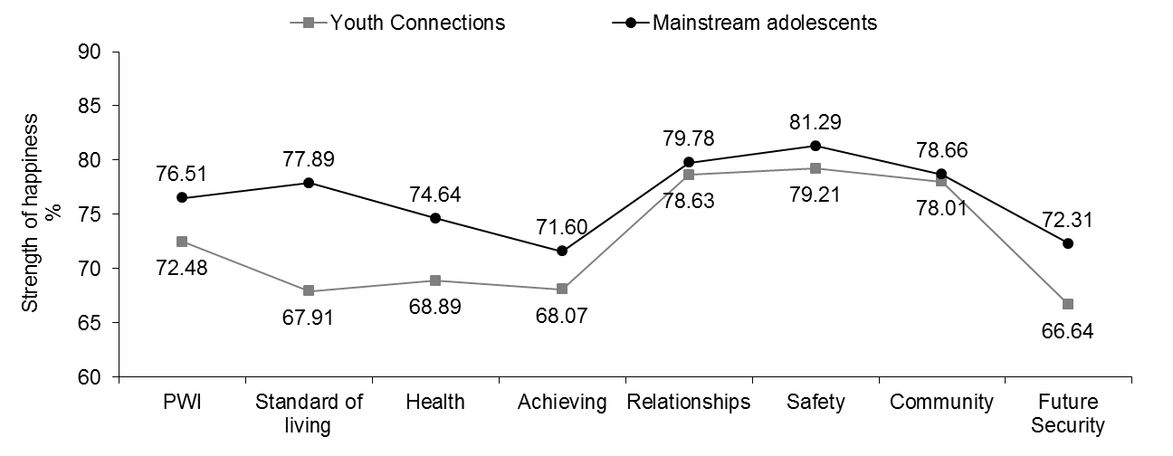

Figure 2.1: Comparison between Youth Connections and Mainstream SWB data

Mean SWB for YC participants (72.48 points) is significantly lower than mainstream (76.51 points). The lower mean indicates that they are experiencing a level of collective challenge in their life which is compromising their wellbeing, placing a higher than normal proportion of young people at-risk for depression.

Despite their complex backgrounds and personal circumstances, mean SWB for YC participants is above the normal 70+ range indicating that a majority are currently maintaining a relatively normal level of personal wellbeing.

Examination of PWI domain scores reveals potential sources of challenge among the YC sample. Compared to mainstream, YC participants scored significantly lower on Standard of Living (9.98 points), Health (5.75 points), Future Security (5.67 points), Achieving in Life (3.53 points) and Safety (2.08 points).

The very low mean score for Standard of Living suggests that many YC participants are very aware of their economic disadvantage. Indeed, 27.2% of young people sampled are receiving Centrelink income support, with 28.9% are categorised as experiencing ‘financial distress’. Moreover, social comparisons to adults, peers and other young people represented on television, in print media and on social networking sites who appear to have more money and/or material possessions, may contribute, in part, to lower perceived happiness with this domain.

A low mean score for the Health domain suggests that many young people may have concerns about their physical and/or psychological wellbeing and may not be accessing the services they require. In support of this, 57.0% of YC participants are classified as having low self-esteem, 30.4% have a suspected or diagnosed mental health issue; while 4.0% have a disability. Thus, it is imperative that young people are aware of and utilise health services that are available to them.

A lower mean score for the domain of Achieving in Life appears consistent with the level of disengagement that characterises this group of young people, particularly with respect to education. Australian society places great importance and pressure on young people to complete school and successfully transition to post-secondary education and/or training. Difficulties at school which result in poor attendance and/or performance may be a cause, at least in part, to a lower mean score on this item which asks “*How happy are you with the things you want to be good at?”*

The very low mean for the domain of Future Security is also concerning. However, it is intuitive that for many young people, perceived lower standard of living in addition with to a lower sense of what one is achieving will foster a negative outlook and uncertainty about *‘what may happen later on in life’*. Such a pessimistic outlook is counterproductive and may have a negative impact on many participants’ motivation to re-engage with education and make more sensible life choices.

On a more positive note, the mean for the domain of Community Connection was no different to mainstream. This suggests that many young people are likely to be connecting, at least to some extent, with people and services outside of their home and in their local communities. For many young people, honoring their commitment to actively participate in the YC Program and meeting with their case managers is evidence of their willingness to improve their circumstances.

Similarly, the mean for the domain of Relationships was no different to mainstream. This is a very positive outcome because close interpersonal relationships with friends and/or family can be an important source of comfort, reassurance and support during difficult times. Research conducted on the Australian adult population as part of the Australian Unity Wellbeing Index highlights the important role that mutual and supportive relationships have on personal wellbeing, for example, by acting as a ‘buffer’ against the effects of emotional harm.

Finally, although statistically significantly lower than the mainstream sample mean (which is most likely an artifact of large sample size), the mean for the domain of Safety (79.21 points) is encouraging and suggests that many young people enrolled in Youth Connections feel safe and secure.

Figure 2.2 displays the proportion of YC participants and mainstream adolescents categorised into the normal, challenged or high-risk group based on their overall PWI score. More information is available in Table B2.3.

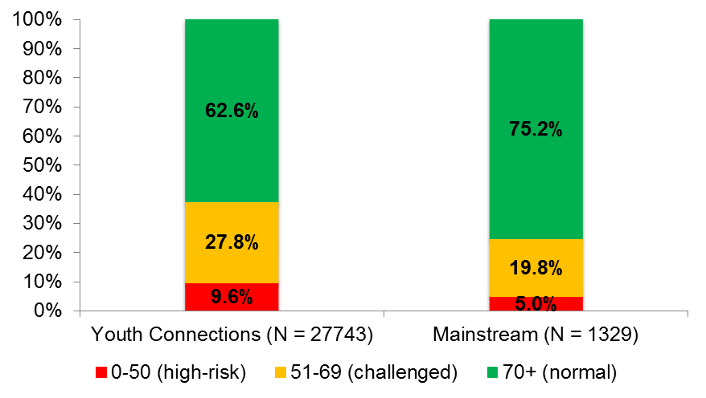

Figure 2.2: Distribution of young people in each PWI group compared to mainstream

62.6% of YC participants scored in the normal range for personal wellbeing, however, this proportion is significantly lower than the three-quarters of mainstream adolescents who also score in this range.

YC participants are almost two times more likely than mainstream adolescents (9.6% versus 5.0%) to score 50 or less on the PWI and who are most likely depressed or a high-risk for depression.

A further 27.8% of YC participants scored between 51-69 points, (compared to only 19.8% of mainstream), suggesting they are significantly more likely to be experiencing a level of challenge in their lives, resulting in the experience of lower than normal personal wellbeing.

Collectively, these results suggest that while the majority of YC participants are maintaining a normal level of SWB, demonstrating psychological resilience under challenging life circumstances, a considerably higher proportion than mainstream are likely to be depressed, or a high-risk for depression and in great need of supportive services. Moreover, the data suggest that disengaged young people are most likely to benefit from a program such as YC and support the Australian Federal Government’s substantial investment in servicing the needs of this disadvantaged group.

Figure 2.3 below is presented as a provocative insight into personal wellbeing of the 2,656 participants (9.6%) that scored in the high-risk range for personal wellbeing compared to the 17,369 (62.6%) participants that scored in the normal 70+ range. More information is available in Table B2.4.

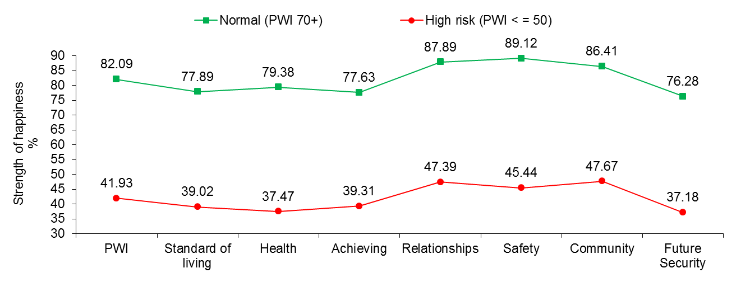

Figure 2.3: Mean PWI and domain happiness scores for normal and high-risk young people

The difference in mean personal wellbeing and domain happiness scores between the two groups is striking. Sadly, all mean scores for the high-risk group are less than 50 points and lie in the ‘Sad’ range of the Very Sad - Very Happy rating scale.

Mean scores for the high-risk group suggest chronic and pervasive challenges to their personal wellbeing and this is precisely the domain profile that we would expect from a group of people who are, on average, moderately-highly depressed and with little hope for the future. It is very likely that many of these young people are on a trajectory toward experiencing a lifetime of social and economic disadvantage and crippled by poor mental health if their circumstances do not improve.

# 3 Gender

12,993 females (46.8%) and 14,750 males (53.2%) participated in this research. Figure 3.1 shows mean SWB for female and male respondents (orange and blue bars respectively). More information is provided in Table C3.1.

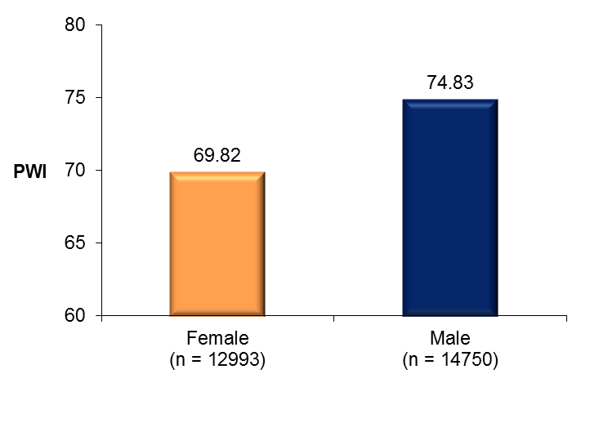

Figure 3.1: Mean PWI scores for females and males

Mean SWB for males (74.83 points) is significantly higher than for females (69.82 points). The mean score for females is below the normal 70+ range, which is very concerning and suggests that a higher than normal proportion compared to males are depressed, or a very high-risk for depression.

Figure 3.2 shows the proportion of males and females categorised into the normal, challenged or high-risk group based on their overall PWI score. More information is available in Table C3.2.

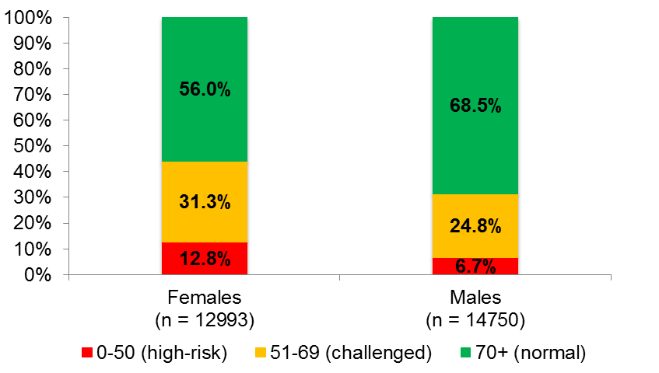

Figure 3.2: Distribution of females and males in each PWI group

As expected, significantly fewer females (56.0%) than males (68.5%) scored in the normal range for SWB.

Females are almost two times more likely than males (12.8% versus 6.7%) to have scored in the high-risk range and who are most likely depressed or a high-risk for depression.

Females are also significantly more likely than males to score in the ‘challenged’ range for SWB and who are likely to be experiencing a level of happiness below their normal set-point range.

Figure 3.3 displays mean domain happiness scores for females and males. More information is provided in Table C3.1

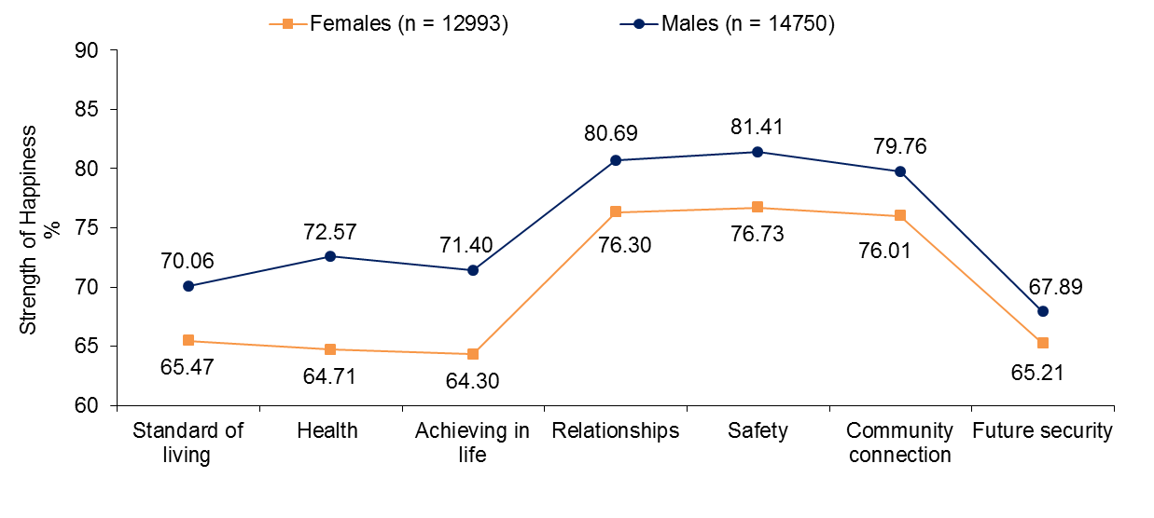

Figure 3.3: PWI and domain happiness scores for females and males

Males scored statistically significantly higher than females on all seven PWI domains, with the greatest differences between the genders on Health (7.86 points), Achieving in Life (7.10 points) and Safety (4.68 points).

One plausible explanation as to why females scored lower than males is that disengagement and associated anti-social/disruptive/aggressive type behaviors characteristic of some young people enrolled in Youth Connections, is inconsistent with typical female gender roles. As a consequence, females who display certain anti-social/aggressive traits and tendencies (typically more accepted/reinforced among young males) generate unwanted attention/feedback that has negative consequences for important educational, social and mental health-related outcomes.

Moreover, there may be fewer opportunities for older females who have made the decision to leave school to engage with post-secondary training or employment. Consequently, females may experience lower standard of living which can negatively impact their satisfaction/happiness with other aspects of life, such as their sense of achieving and purpose in life and dependence on other people.

The lower mean score for ‘Safety’ reported by females is also worrying, further suggesting that disengagement places adolescent girls at greater risk for emotional and/or physical harm.

Figure 3.4 displays mean SWB scores for females and males compared to mainstream. More information is provided in Tables C3.3 and C3.5.

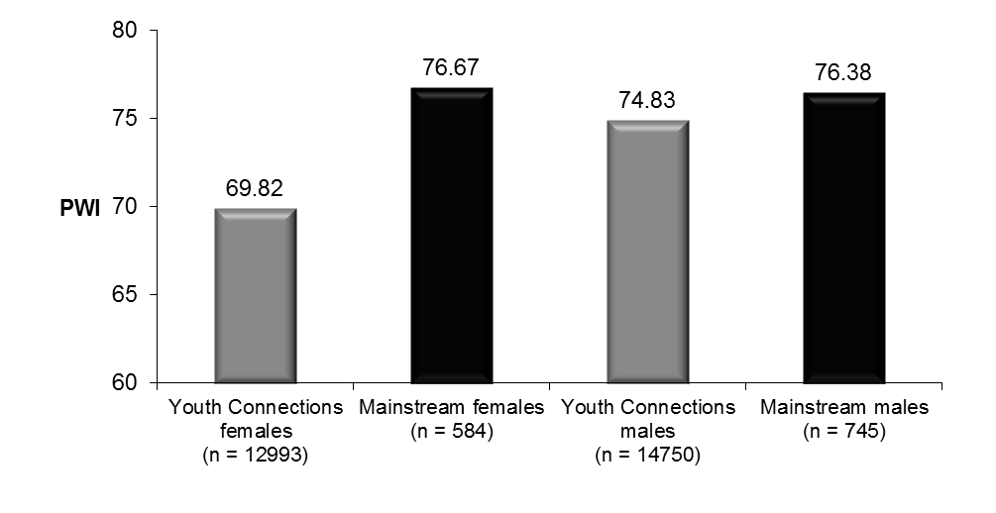

Figure 3.4: Mean SWB for females and males compared to mainstream

Mean personal wellbeing for YC females and males is significantly lower than corresponding means for mainstream. However, the difference is much lower between males (1.55 points) than females (6.85 points).

The greatest differences between YC and mainstream females are on the domains of Standard of Living (12.48 points), Health (9.14 points) and Future Security (8.39 points). These differences are large and concerning.

Similarly, the greatest differences between YC and mainstream males also include Standard of Living (7.79 points), Future Security (3.41 points) and Health (2.68 points).

The evidence suggests that financial/economic issues and concerns about the future are primarily responsible for differences in personal wellbeing between YC and mainstream young people. Thus, addressing these concerns through strategies and interventions that target educational and employment-related outcomes should be a priority for government policy.

Figure 3.5 displays the proportion of YC and mainstream females categorised into the normal, challenged or high-risk group based on their overall PWI score. More information is available in Table C3.4.

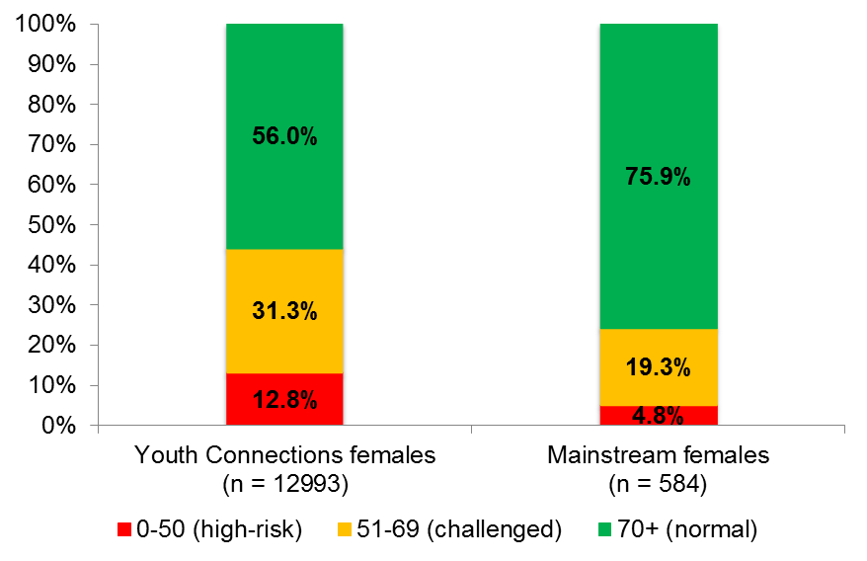

Figure 3.5: Distribution of YC and mainstream females in each PWI group

56.0% of YC females have normal levels of SWB, compared to 75.9% of mainstream – this difference is both substantial and significant.

YC females are approximately two and a half times more likely than mainstream (12.8% versus 4.8%) to score less than or equal to 50 on the PWI and who are likely to be depressed or a very high-risk for depression.

YC females are significantly more likely than mainstream (31.3% versus 19.3%) to score in the challenged range and who are likely to be experiencing lower than normal personal wellbeing.

Collectively, these results reaffirm the belief that YC females are a higher-risk group for experiencing low personal wellbeing and depression.

Figure 3.6 displays the proportion of YC and mainstream males categorised into the normal, challenged or high-risk group based on their overall PWI score. More information is available in Table C3.6.

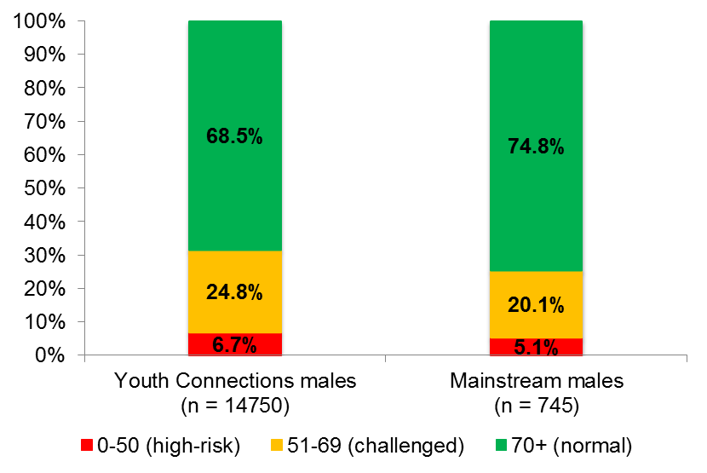

Figure 3.6: Distribution of YC and mainstream males in each PWI group

Just over two-thirds of YC males (68.5%) have normal levels of SWB, compared to three-quarters of mainstream males – this difference is significant.

While a higher proportion of YC males scored in the high-risk and challenged ranges for SWB compared to the mainstream, these differences are not statistically significant.

From these data, it is evident that YC males are a higher risk group for low personal wellbeing and depression compared to mainstream. However, this risk appears lower than the relative risk for YC females compared to mainstream.

# 4 Age

Participants ranged in age from 12 to 19 years (*M* = 15.30 years (*SD* = 1.63 years). All age groups are well represented, with the minimum number of respondents in the 19 year old age group (n = 773) and the maximum in the 15 year old age group (n = 6,474).

Figure 4.1 displays the mean PWI scores for YC participants in each age group compared to mainstream. More information is available in Tables D4.1 and D4.5.

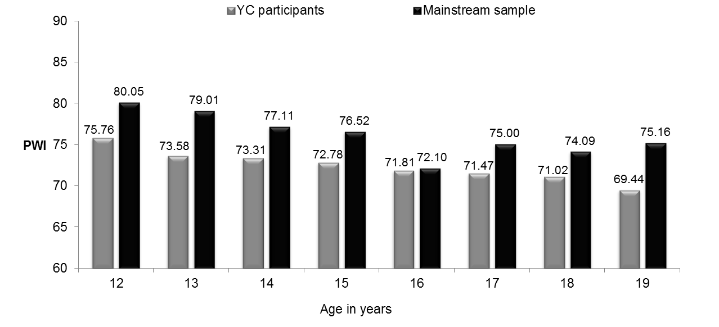

Sample Size (YC participants): 12 = 1124; 13 = 2611; 14 = 5214; 15 = 6474; 16 = 5737; 17 = 4047; 18 = 1763; 19 = 773

Sample Size (Mainstream sample): 12 = 171; 13 = 196; 14 = 264; 15 = 250; 16 = 168; 17 =177; 18 = 103; 19 = 660

Figure 4.1: Age and subjective wellbeing for Youth Connections and mainstream

Mean SWB for YC participants is significantly lower than mainstream at all age groups, except age 16 years.

It is evident that YC participants have a complex range of personal circumstances and backgrounds not typically seen in the mainstream adolescent population and which negatively impacts upon their personal wellbeing throughout all stages of adolescent development.

The finding, however, of no significance difference between the means for 16 year olds is very interesting and highlights the physiological, social and emotional challenges that all young people face during mid-adolescence.

Another interesting observation from Figure 4.1 is that personal wellbeing generally decreases with age from early to mid-adolescence in both samples. With respect to the YC sample, personal wellbeing continues to fall between the ages of 16 and 19 years, before reaching a low of 69.44 points. In contrast, mean SWB for mainstream recovers from a low of 72.10 at age 16 years, to 75.00, 74.09 and 75.16 points respectively at ages 17, 18 and 19 years.

One plausible explanation for these findings is that mainstream young people may be better equipped to cope with the challenges they face as they approach early adulthood. For example, they may have greater levels of support available from their families and institutions; as well as greater employment and educational opportunities that present for those young people who successfully complete year 12 or equivalent.

These data also highlight the impact of unresolved issues and conflicts (e.g., familial, developmental and social) that may continue to threaten the personal wellbeing of older disengaged adolescents as they enter adulthood and struggle to gain independence.

Figure 4.2 displays the proportion of young people categorised into the normal, challenged or high-risk group based on their overall PWI score. More information is provided in Table D4.4.

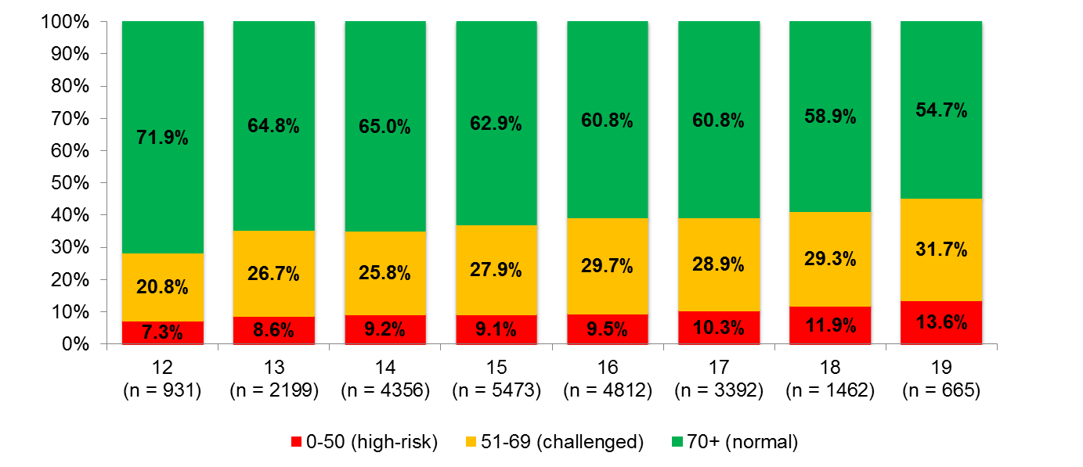

Figure 4.2: Age and PWI group distribution

The proportion of young people who scored in the normal 70+ range decreases with age from a high of 71.9% at age 12 years to a low of 54.7% at age 19 years.

The proportion of young people who scored in the challenged and high-risk groups generally increases with age, with young people aged 18 years (11.9%) and 19 years (13.6%), substantially more likely than 12 and 13 year olds (7.3% and 8.6% respectively) to score in the high-risk range for SWB and who are likely to be depressed or a high-risk for depression.

Collectively, these data again highlight the complex and pervasive challenges facing many young people from early to late adolescence and which appears to have a profound and detrimental impact on their psychological wellbeing. Moreover, the finding that only 54.7% of 19 year olds scored in the normal range for personal wellbeing is very worrying, with many young people on a trajectory toward a lifetime of social and economic disadvantage and poor mental health if their circumstances do not improve.

## Domain happiness scores for each age group

Mean domain happiness scores for young people in each age group are presented in the following figures. See Table D4.1 for more information.

1. **Standard of living**

Figure 4.3 displays the mean score for the domain of Standard of Living for each age group.

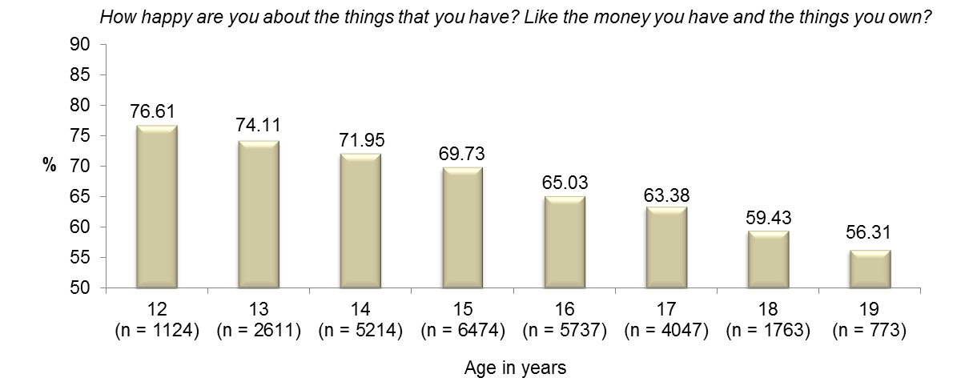

Figure 4.3: Mean scores for Standard of Living domain by age

Mean happiness with Standard of Living decreases with age, with the mean for 12 year olds a considerable 20.30 points higher than the mean for 19 year olds. This difference highlights the single greatest decline in any one domain with age and arguably one of the most pressing issue facing YC participants as they approcach adulthoood – financial dependency.

There are several possible explanations for such a dramatic decrease in happiness with this domain from early to late adolescence. For example, younger adolescents are typically more reliant on their parents, carers, and families than are older adolescents for the provision of essentials such as food, clothing and shelter, as well as everyday luxury items and ‘wants’. In this light, their standard of living is likely to be determined in large part by their families’ ability to provide for them. With a considerable proportion of YC participants and their families on low incomes, it is likely that many adolescents will become more aware of their economic disadvantage as they grow older.

Another explanation may be that as young people approach adulthood, they may find themselves increasingly less reliant on their families for support and more responsible for providing for themselves. For those who are unemployment and/or receiving basic financial support (e.g., from Centrelink), meeting day-to-day living expenses may prove difficult. This is likely to be be the case for many older adolescents, particularly those who have failed to engage successfully with school, education and/or post-secondary training and who may have fewer employment options available to help support themselves financially.

Finally, social comparisons with their peers, who may be successfully making the transition from school to post-secondary education, training and employment (and who may be perceived as living more fun/enjoyable lives), may further exacerbate feelings of relatively unhappiness with this domain.

1. **Health**

Figure 4.4 displays the mean score for the domain of Health for young people in each age group.

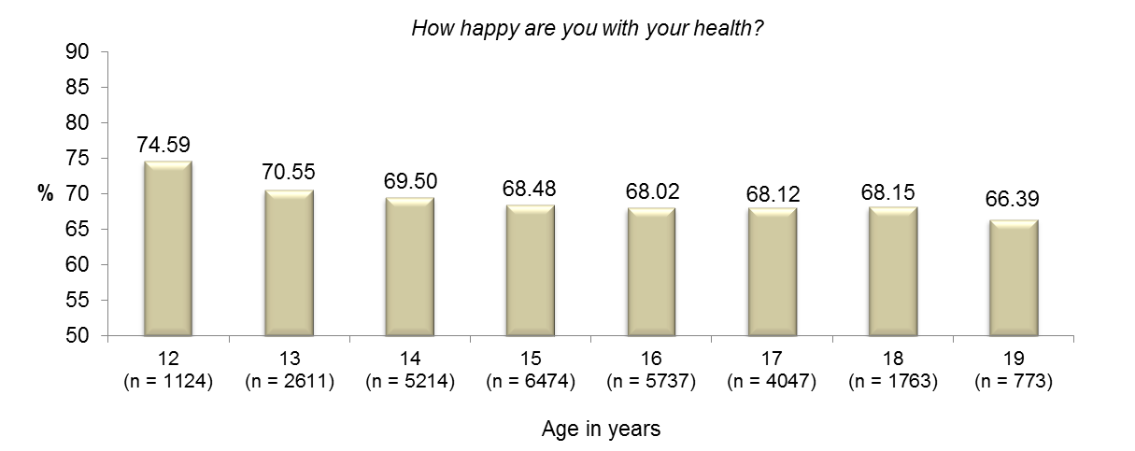

Figure 4.4: Mean scores for Health domain by age

Mean happiness with Health generally decreases with age, with the mean for 12 year olds significantly higher than the means for young people aged 13 to 19 years. The lowest mean recorded is among the 19 year old age group.

The onset of puberty and associated physiological changes, poor choices/lack of education with respect to exercise and diet, feelings of hopelessness, stress, anxiety and depression and a failure/inability to access essential medical and mental health services, are all possible explanations for the general decrease in happiness with Health from early to late adolescence.

It is important that young people with physical and psychological health needs are identified early and that they are aware of where and how to access the appropriate services during adolescence and into early adulthood. However, financial issues may make some treatments and medications difficult to access/obtain. This further strengthens the need to encourage young people to reconnect with their education and seek to engage with employment.

1. **Achieving in life**

Figure 4.5 displays the mean score for the domain of Achieving in Life for young people in each age group.

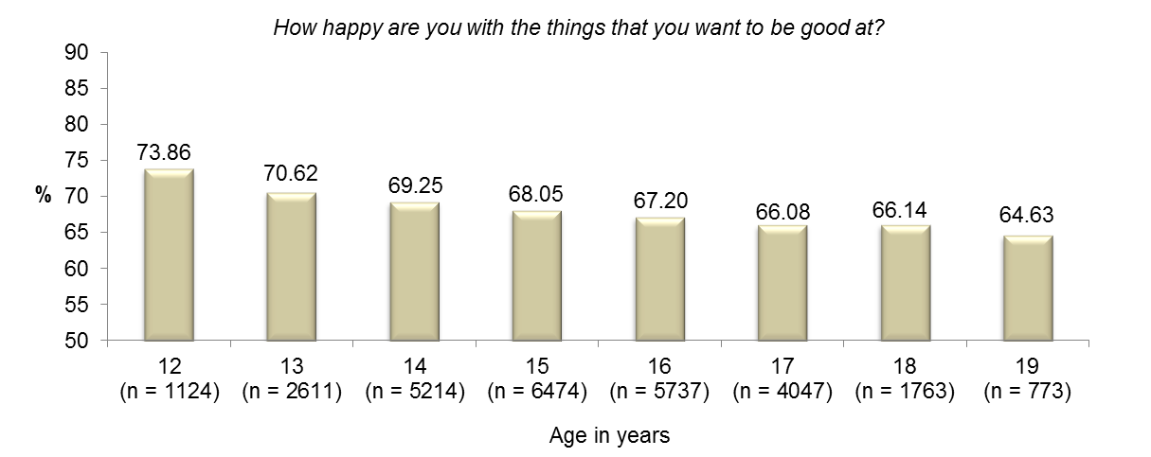

Figure 4.5: Mean scores for Achieving in Life domain by age

Mean happiness with Achieving in Life decreases with age, with the mean for young people aged 12 years significantly higher than the means for 13 to 19 year olds. Most notable is the significant 9.23 point difference between 12 year olds and 19 year olds.

The finding that happiness with Achieving in Life decreases with age is not unexpected if we consider that relative to their younger peers, older adolescents may have experienced more years of disengagement with education and/or employment and this may lead to feelings of substantially less happiness regarding their achievements/ability to achieve in areas of life that they feel are important to them, such as education, employment, sport and music.

1. **Relationships**

Figure 4.6 displays the mean scores for the domain of Relationships for young people in each age group.

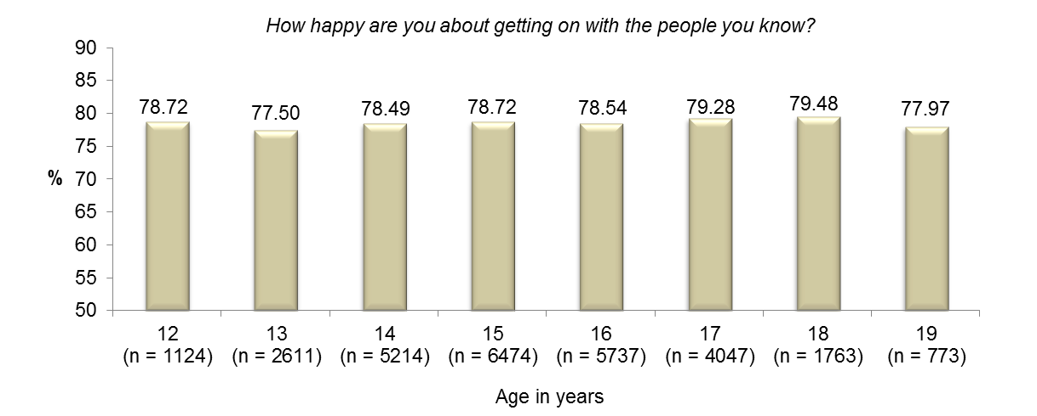

Figure 4.6: Mean scores for Relationships domain by age

All mean scores vary within a very narrow 1.98 percentage points from 77.50 points amongst 13 year olds to 79.48 points amongst 18 year olds.

These results are encouraging and suggest that young people across all age groups are generally quite happy about *‘getting on with the people they know*’. According to research, mutual and supportive interpersonal relationships are paramount to a person’s wellbeing, most likely through the ‘buffering’ effect they provide against stressful/challenging life experiences. Supportive relationships also provide an outlet for open and honest communication, sharing of ideas, expressing feelings and concerns and facilitate positive experiences.

It is important that young people are encouraged to develop and maintain healthy and positive relationships with their peers. Also, there is a need for young people with anti-social and behavioral problems to learn more appropriate ways of interacting with other people if they are to experience the psychological benefits associated with having close, interpersonal relationships.

1. **Safety**

Figure 4.7 displays the mean scores for the domain of Safety for young people in each age group.

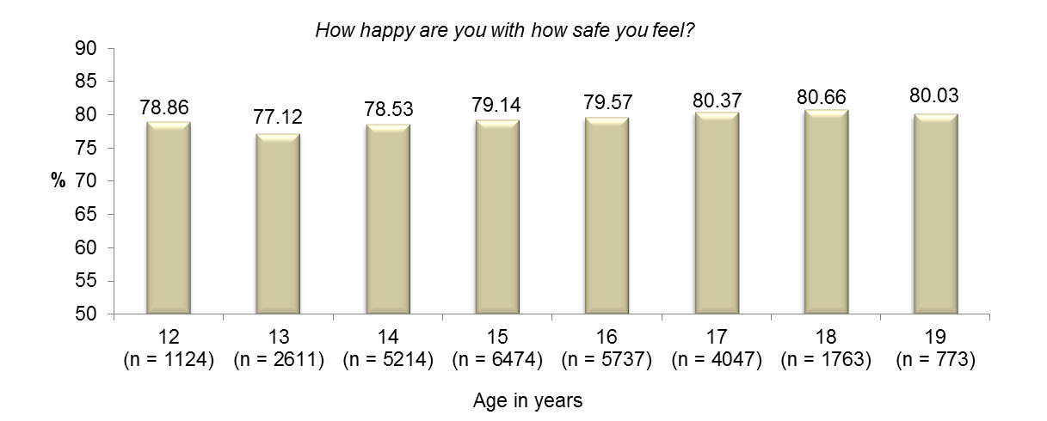

Figure 4.7: Mean scores for Safety domain by age

All means for this domain are held within a narrow 3.54 points from 77.12 points at age 13 years to 80.66 points at age 18 years.

With respect to significance, the means for 17 and 18 year olds are higher than the means for 13 and 14 years olds; while the means for 15 and 16 year olds are higher than the mean for 13 year olds. However, these differences are small and likely due to large sample size that increases the likelihood of obtaining a significant result.

Overall, these results are encouraging and suggest that a majority of young people sampled do not perceive a great deal of risk/threat to their physical and/or emotional wellbeing.

1. **Community Connection**

Figure 4.8 displays mean scores for the domain of Community Connection for young people in each age group.

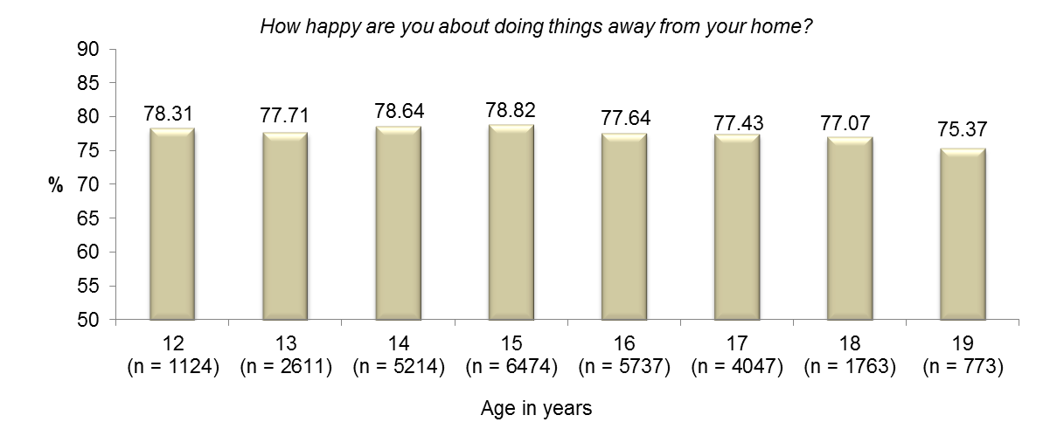

Figure 4.8: Mean scores for Community Connection domain by age

Mean happiness with the domain of Community Connection varies by 3.45 points from 75.37 points at age 19 years to 78.82 points at age 15 years.

With respect to significance, the mean for young people aged 15 years is higher than the mean for young people aged 17 and 19 years; while 14 year olds scored higher than 19 year olds.

Collectively, the results suggest that the majority of young people across all age groups generally feel happy about ‘*doing things away from their home’*. However, it is important that older adolescents remain connected with their communities and community resources and do not become isolated from the people and services that are available to support and assist them as they enter adulthood.

1. **Future Security**

Figure 4.9 displays the mean scores for the domain of Future Security for young people in each age group.

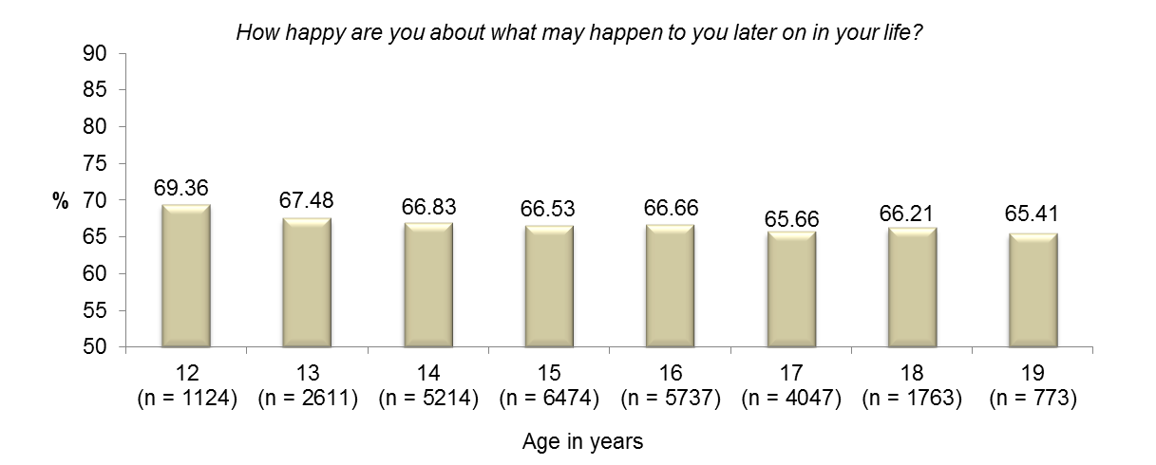

Figure 4.9: Mean scores for Future Security domain by age

All mean happiness scores for the domain of Future Security are significantly lower than the mainstream sample mean of 72.31 points.

Relatively lower scores on this domain are not unexpected given that many YC participants have disengaged, or are at high-risk of disengaging from their school, their family and their local communities.

With respect to significance, the mean for young people aged 12 years is higher than the means for young people aged 14 and 19 years.

It is likely that many young people have fears and concerns about what may happen to them later on in their lives, for example, with respect to employment and finances, availability of support networks and security of living arrangements.

These results support the efforts of The Department of Education and Youth Connections in creating pathways for adolescents to reconnect, thereby increasing educational and employment outcomes that will provide them with the greatest opportunity to build successful and secure futures for themselves and their families.

## Age, gender and SWB

Figure 4.10 displays the relationship between age, gender and SWB. More information is available in Tables D4.2 and D4.3.

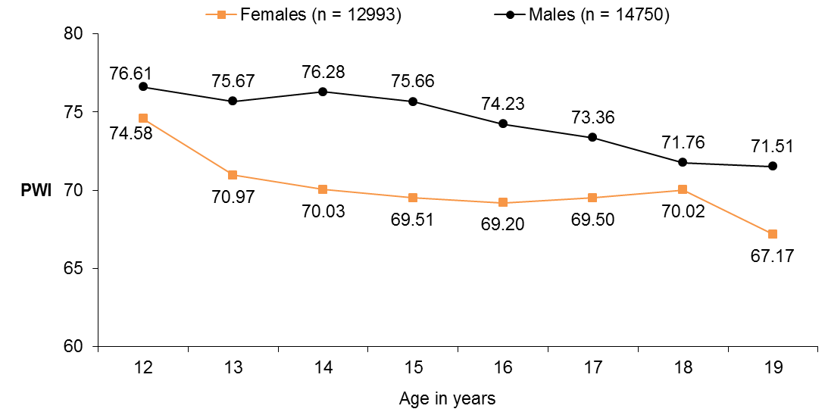

Sample Size (Female): 12 = 472; 13 =1160; 14 = 2476; 15 = 3030; 16 = 2762; 17 = 1974; 18 = 751; 19 = 368.

Sample Size (Male): 12 = 652; 13 = 1451; 14 = 2738; 15 = 3444; 16 = 2975; 17 = 2073; 18 = 1012; 19 = 405.

Figure 4.10: Age, gender and SWB

A general decrease in mean SWB from early to late adolescence is consistent across both genders. However, among female respondents, mean SWB decreases sharply between the ages of 12 and 13 years and again between 18 and 19 years. The low mean of 67.17 points among 19 year old females is very concerning and suggests that older females are a particularly high-risk group for depression.

For males, personal wellbeing at all age groups is within the normal 70+ range, from a high of 76.61 points at age 12 years to a low of 71.51 points at age 19 years. The lower means for 18 and 19 year old males are worrying nonetheless and highlight the difficult time that many males are having in early adulthood and the impact on their collective wellbeing.

Overall, the results suggest that both males and females are exposed to challenges in their lives from early to late adolescence which increasingly threatens their personal wellbeing. Fewer job opportunities for people who have failed to successfully progress through high-school is a likely cause of lower wellbeing among the older age groups. This is reflected in very low scores for both males and females on the domains of ‘Standard of Living’ and ‘Achieving in Life’.

The more pronounced decline in the SWB among females further strengthens the need for supportive services that target females specifically and which assists them to overcome and adapt to the challenges they will face in their mid to late teenage years and beyond.

# 5 Connection level

Young people have been classified into one of three groups, depending on their risk of disengaging, or if they already disengaged from education and/or family and their community. The three groups are:

**Connection level 1 (n = 8,074; 29.1%).** These are young people currently attending school/education and who are showing signs of disengaging. For example, they may have behavioural problems, socialisation issues and a recent history of poor attendance. Young people receiving these services may also have personal barriers impacting on school participation and their behaviour and other factors such as low literacy/numeracy, a disability or a mental health issue (e.g., anxiety).

54.9% of Connection level 1 young people are male; with 79.3% aged between 12 and 15 years (*M* = 14.41 years; *SD* = 1.40 years).

**Connection level 2a (n = 10,034; 36.2%).** These are young people who are currently attending school, but who are at imminent risk of disengaging, or have recently disengaged (within the last 3 months) from school or another education environment.

52.2% of Connection level 2a young people are male; with 72.6% aged between 14 and 16 years (*M* = 15.02 years; *SD* = 1.39 years).

**Connection level 2b (n = 9,635; 34.7%).** These are young people who are severely disengaged from school, education or training, employment, their family and the community. These young people have not attended school for a period of at least 3 months.

52.7% of Connection level 2b young people are male; with 74.3% aged between 16 and 19 years (*M* = 16.35 years; *SD* = 1.46 years).

All young people, regardless of connection level, may have multiple barriers to progression, highly complex personal situations and no plans to re‐engage with their schooling or complete year 12 or equivalent.

Figure 5.1 shows mean SWB for young people in each Connection level described. More information is provided in Table E5.1.

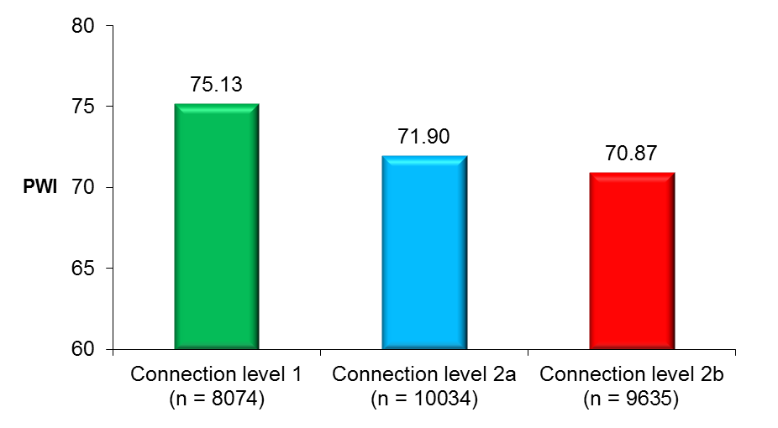

Figure 5.1: Mean PWI scores and Connection level

Connection level 1 young people have significantly higher personal wellbeing than 2a and 2b; while the mean for 2a is significantly higher than 2b.

From these data, it is evident that increased disengagement is associated with lower mean personal wellbeing. With over three-quarters of 2b young people aged between 16 and 19 years, there is a need to identify young people at-risk of disengaging in early adolescence and provide them with appropriate support and resources.

Figure 5.2 below shows the proportion of young people categorised into the normal, challenged or high-risk group based on their overall PWI score. More information is provided in Table E5.2.

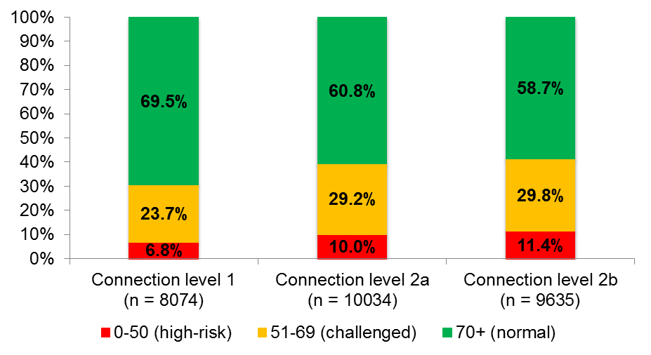

Figure 5.2: Connection level and PWI groups

The proportion of young people who scored in the normal 70+ range decreased with increasing level of disconnection.

Connection level 2a and 2b young people are approximately 50% more likely to score in the high-risk range compared to Connection level 1 young people.

These data reinforce the notion that disengagement is a major risk factor for low SWB and depression.

Figure 5.3 shows the mean domain happiness scores for each Connection level described. More information is provided in Table E5.1.

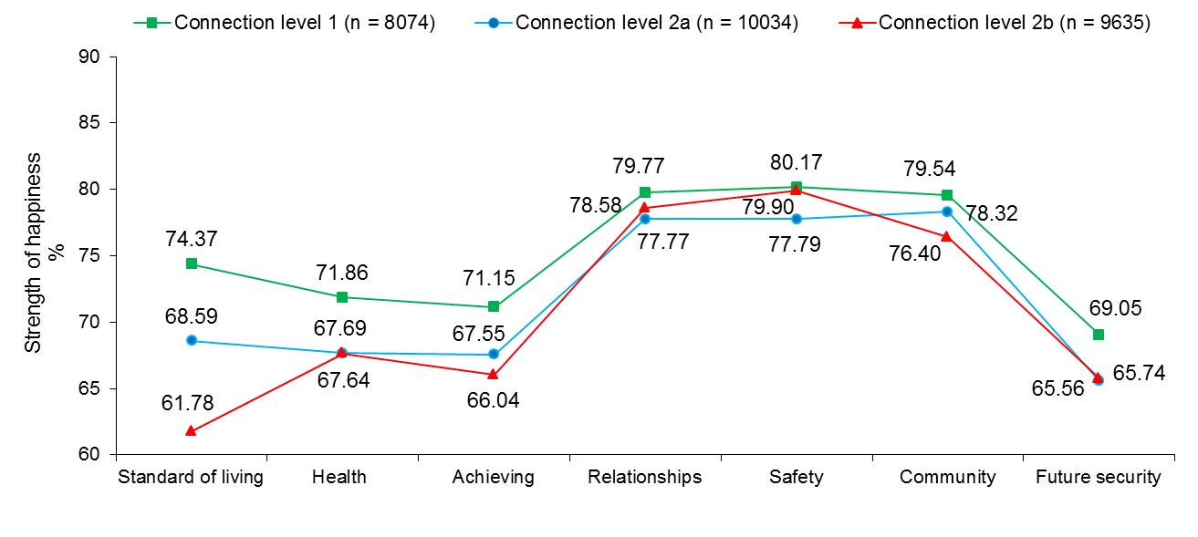

Figure 5.3: Connection level, SWB and domain happiness scores

Connection level 1 young people scored significantly higher than 2a and 2b on all domains except Safety (which they score higher than 2a).

The greatest difference between the three groups is on the domain of Standard of Living, with Connection level 1 young people scoring a substantial 12.59 points higher than 2b and 5.78 points higher than 2a respectively. These differences may, in part, be attributed to poorer educational outcomes resulting in fewer opportunities for employment for the most disengaged. Also, it is possible that many disengaged young people may be less likely to be supported financially by their parents and families whom they may seldom be in contact with or who are from low socio-economic backgrounds.

Other notable between group differences concern the domains of Achieving in Life and Health, with Connection level 1 young people scoring substantially higher than 2a and 2b respectively. The lower scores for Health are concerning and suggest that the physical and/or psychological health needs of some of the more disengaged young people are not being addressed. Moreover, Connection level 2b young people, by definition, are not expected to have attended school for at least the previous 3 months. Thus, this may be reflected by the score on the domain which asks *‘How happy are you with the things you want to be good at”?*

Finally, it is notable that Connection level 2b young people scored significantly higher than 2a on the domain of Safety. This seems intuitive as a higher proportion of 2b young people are in their later teenage years and may be more capable of defending themselves against physical and/or emotional harm.

Figure 5.4 displays PWI scores for females and males according to their level of connection. More information is available in Table E5.3.

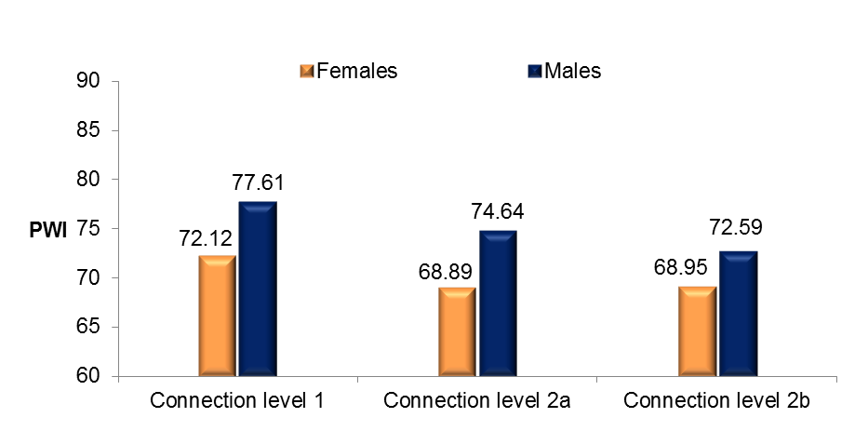

Sample Size (Female): Type 1 = 3642; Type 2a = 4794; Type 2b = 4557

Sample Size (Male): Type 1 = 4432; Type 2a = 5240; Type 2b = 5078

Figure 5.4: Connection level, gender and SWB

The relationship between connection level and SWB described is consistent for both genders, with Connection level 1 females and males reporting significantly higher personal wellbeing than 2a and 2b respectively.

Females report significantly lower personal wellbeing than males across all connection levels. Moreover, while mean personal wellbeing for Connection level 1, 2a and 2b males are all above the normal 70+ range, this is not true for females, with the means for 2a and 2b below the critical value of 70 points.

Collectively, all three mean scores for females are suggestive of a group of young people who are, on average, experiencing considerable challenge in their lives, with a higher than normal proportion experiencing depression or depressive type symptomology.

However, the mean for 2b males should not be ignored as this group score is significantly lower than the mainstream mean and an indication that a considerably higher proportion of severely disengaged males are having trouble coping with the challenges they are facing in life and which appears to be compromising their collective personal wellbeing.

Figure 5.5 displays mean PWI scores for young people in each age group according to their level of connection. More information is provided in Table E5.4.

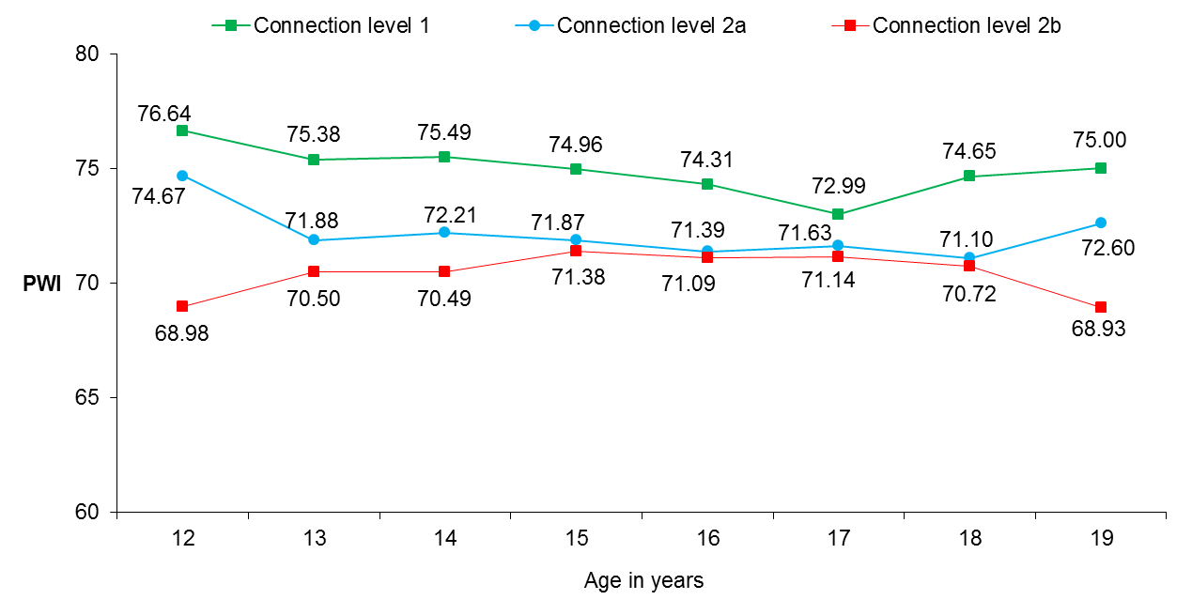

Sample Size (Connection level 1): 12 = 762; 13 = 1372; 14 = 2136; 15 = 2136; 16 = 1093; 17 = 446; 18 = 107, 19 = 22

Sample Size (Connection level 2a): 12 = 313; 13 = 980; 14 = 2331; 15 = 2914; 16 = 2039; 17 = 1079; 18 = 306, 19 = 72

Sample Size (Connection level 2b): 12 = 49; 13 = 259; 14 = 747; 15 = 1424; 16 = 2605; 17 = 2522; 18 = 1350, 19 = 679

Figure 5.5: Connection level, age and SWB

What is most evident from Figure 5.5 is that mean SWB for Connection level 1 young people (represented by the green line) is higher than 2a and 2b at all ages.

Connection level 2b young people at age 12 and 19 years have the lowest collective personal wellbeing of all the groups depicted, with means below 70 points.

With respect to significance, 1 > 2a and 2b between the ages of 13 and 16 years; while 1 > 2b at age 12 and 18 years.

# 6 Residency

The state of NSW was best represented in this research (38.8%); followed by VIC (22.4%) and QLD (19.6%). The fewest number of respondents sampled were from the NT (n = 172, < 1%).

Figure 6.1 displays mean SWB for participants in each of the eight Australian states and territories. More information is provided in Table F6.1.

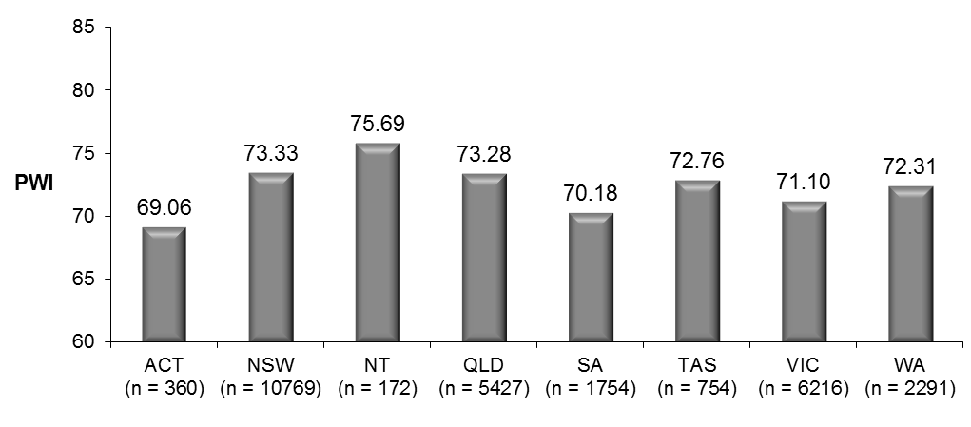

Figure 6.1: State of residence and SWB

Mean SWB is highest in the NT. This can be attributed, in part, to relatively higher scores on the domains of Health and Achieving in Life compared to young people living in the other states and territories.

Means in the NT, NSW and QLD are significantly higher than in the ACT, SA and VIC.

Mean SWB is lowest in the ACT, followed by SA, primarily driven by relatively lower scores on the domains of Achieving in Life and Safety compared to other states.

Other notable findings are that in QLD, the mean for Safety (81.02 points) is significantly higher than the corresponding mean in all other states and territories (except in the NT); while young people living in the NT scored significantly higher than young people living in all other states and territories (except TAS) on Achieving in Life.

Finally, it is notable that young people living in TAS scored significantly higher than young people living in QLD, SA, VIC and WA on Standard of Living. This result is surprising given that Tasmania has amongst the highest rates of youth unemployment in Australia.

In summary, mean SWB and domain happiness profiles appear to vary between the states and territories. This suggests that there may be unique challenges facing young people across the country. Such an interesting proposition would benefit from a large scale study involving Australian adolescents more broadly and would have major implications for government and educational policy.

Figure 6.2 below shows the proportion of young people in each state and territory categorised into the normal, challenged or high-risk group based on their overall PWI score. More information is provided in Table F6.6.

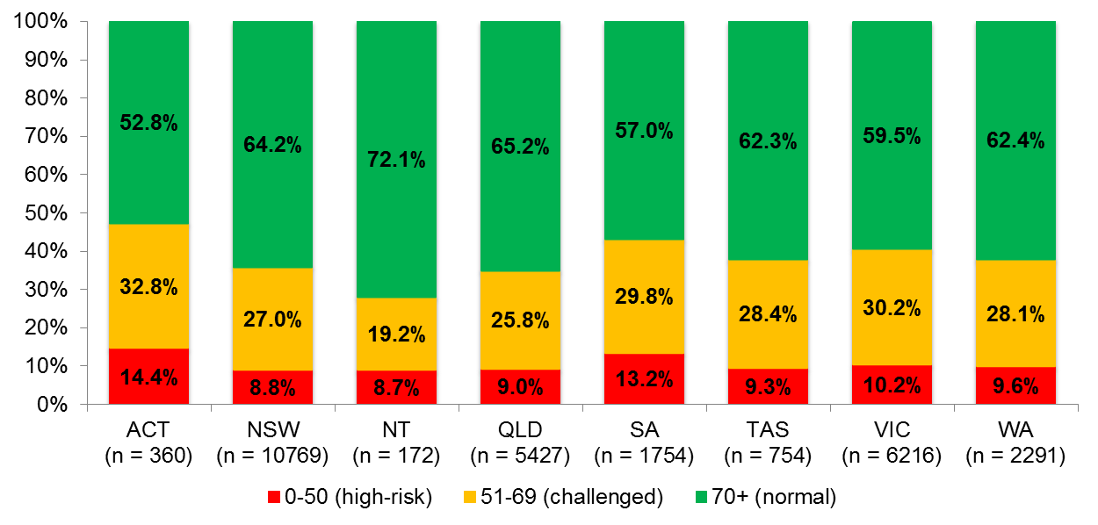

Figure 6.2: State of residence and PWI groups

The proportion of young people who scored in the normal range for personal wellbeing is highest in the NT and lowest in the ACT and SA respectively.

Not surprisingly, the proportion of young people who scored in the high-risk range for personal wellbeing was highest in the ACT (14.4%), followed by SA (13.2%); and the lowest in the NT (8.7%).

In VIC, only 59.5% of respondents scored in the normal 70+ range, suggesting that many young people living in this state are experiencing a level of SWB below their set-point and may be a high-risk for depression or depression type symptomology.

The situation is only marginally better in TAS and WA, with 62.3% and 62.4% of young people respectively scoring in the normal range.

Figure 6.3 displays mean PWI scores for males and females who live in each of the eight Australian states and territories. More information is provided in Table F6.2.

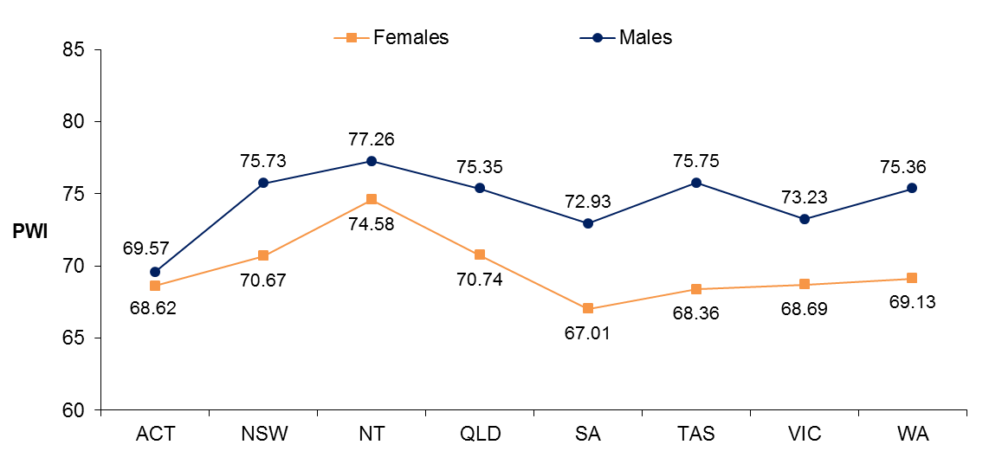

Sample Size (Females): ACT =194; NSW =5121; NT = 83; QLD =2440; SA = 815; TAS = 305; VIC = 2915; WA = 1120

Sample Size (Males): ACT = 166; NSW = 5648; NT = 89; QLD = 2987; SA = 939; TAS = 449; VIC = 3301; WA = 1171

Figure 6.3: State of residence, gender and SWB

Mean personal wellbeing for males is significantly higher than females in all locations except in the ACT and the NT.

The greatest differences in mean personal wellbeing between males and females were in TAS (7.39 points) and WA (6.23 points). Such discrepancies warrant further investigation into the unique challenges facing adolescent girls in these states.

With respect to personal wellbeing, it appears that life for both genders is equally challenging in the ACT, but perhaps more hopeful in the NT. Underlying reasons for these curious results in this sample are not well established.

Finally, it is most concerning that five of the eight mean personal wellbeing scores for females are below the normal 70+ range, with the lowest mean recorded in SA. These findings further highlight the negative impact that disengagement has on the personal wellbeing of young women across the country.

Figure 6.4 displays mean SWB scores for Connection level 1, 2a and 2b young people who live in each of the eight Australian states and territories. More information is provided in Table F6.4.

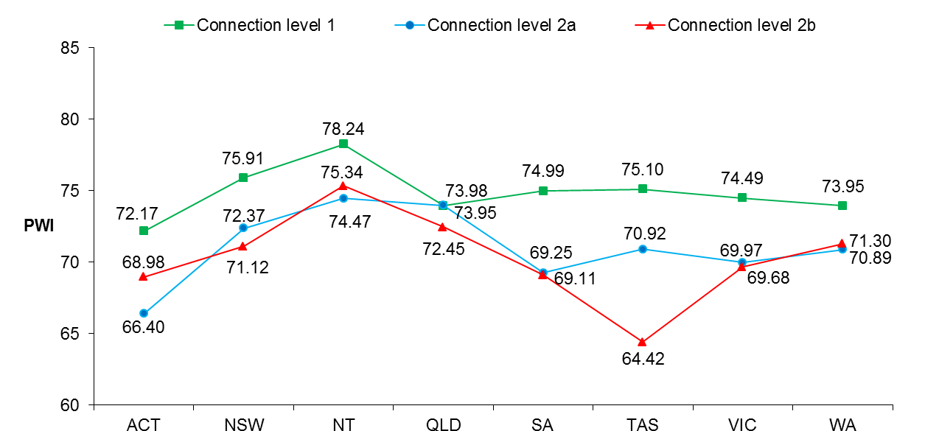

Sample Size (1): ACT =150; NSW =3948; NT = 56; QLD = 435; SA = 305; TAS = 495; VIC = 1711; WA = 974

Sample Size (2a): ACT = 175; NSW = 3877; NT = 63; QLD = 2494; SA = 576; TAS = 154; VIC = 2045; WA = 650

Sample Size (2b): ACT = 35; NSW = 2944; NT = 53; QLD = 2498; SA = 873; TAS = 105; VIC = 2460; WA = 667

Figure 6.4: State of residence, Connection level and SWB

In all states and territories, except in QLD, Connection level 1 young people have higher SWB than 2a and 2b respectively. This finding highlights the non-discriminatory and negative impact that disengagement has on the psychological wellbeing of adolescents across the country.

The pattern of results for Connection level 2a and 2b young people is not entirely predictable, with the means for 2a and 2b only marginally different in the NT, VIC and WA. Interestingly, the mean for 2b is 2.58 points higher than 2a in the ACT.

The greatest discrepancy *within* each state is in TAS, with Connection level 1 young people scoring 10.68 points higher than 2b. It is likely that uneducated, unskilled and severely disengaged young people will suffer the most in this state which has high levels of unemployment compared to other parts of the country.

## Accessibility/Remoteness Index of Australia (ARIA) and SWB

The ARIA is a standard classification and index of remoteness for the whole of the country. Geographical areas are given a score (continuous between 0 to 15) based on the road distance to service towns of different sizes. Scores for regions are derived by averaging scores of 1 km2 grid. The index scores can be classified into various categories. The five Remoteness Areas are:

1. Major Cities (ARIA score 0 <= 0.20) - relatively unrestricted accessibility to a wide range of goods and services and opportunities for social interaction.
2. Inner Regional (ARIA score greater than 0.2 to <=2.40) - some restrictions to accessibility of some goods, services and opportunities for social interaction.
3. Outer Regional (ARIA score greater than 2.40 to <=5.92) - significantly restricted accessibility of goods, services and opportunities for social interaction.
4. Remote (ARIA score greater than 5.92 to <=10.53) - very restricted accessibility of goods, services and opportunities for social interaction.
5. Very Remote (ARIA score greater than 10.53 to <=15) - very little accessibility of goods, services and opportunities for social interaction.

Figure 6.5 displays mean SWB for young people who live in each region described. Data were available for 22,628 respondents (81.6%). The greatest number of cases are represented in the ‘Major cities’ group (n = 11,021) and the smallest in the ‘Very remote’ group (n = 127). More information is provided in Table F6.5.

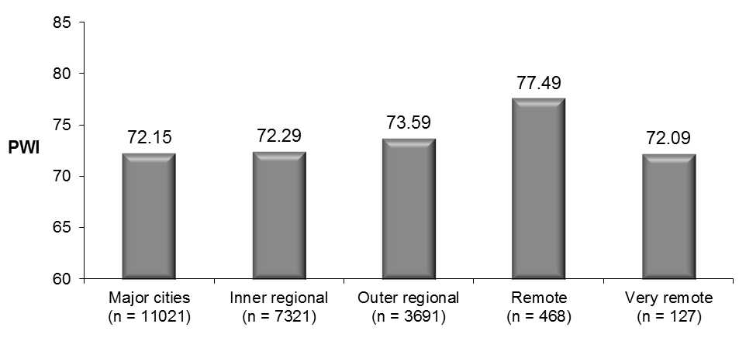

Figure 6.5: Accessibility/Remoteness Index of Australia (ARIA) and SWB

Mean SWB is highest in Remote communities and comparatively lower in all other locations. This is a very interesting result as by definition, people living in remote parts of the country have *‘very restricted accessibility of goods, services and opportunities for social interaction’*. These data highlight the lack of correspondence between objective and subjective data and the limitations of using objective data as a proxy for subjective evaluations of life happiness/satisfaction.

The exception, however, is that very remote living appears to be associated with considerably lower SWB. In this light, there may be an optimum level of geographic isolation that acts to protect personal wellbeing.

Figure 6.6 below shows the proportion of young people who live in each of the locations according to the ARIA categorised into the normal, challenged or high-risk group based on their overall PWI score. More information is provided in Table F6.7.

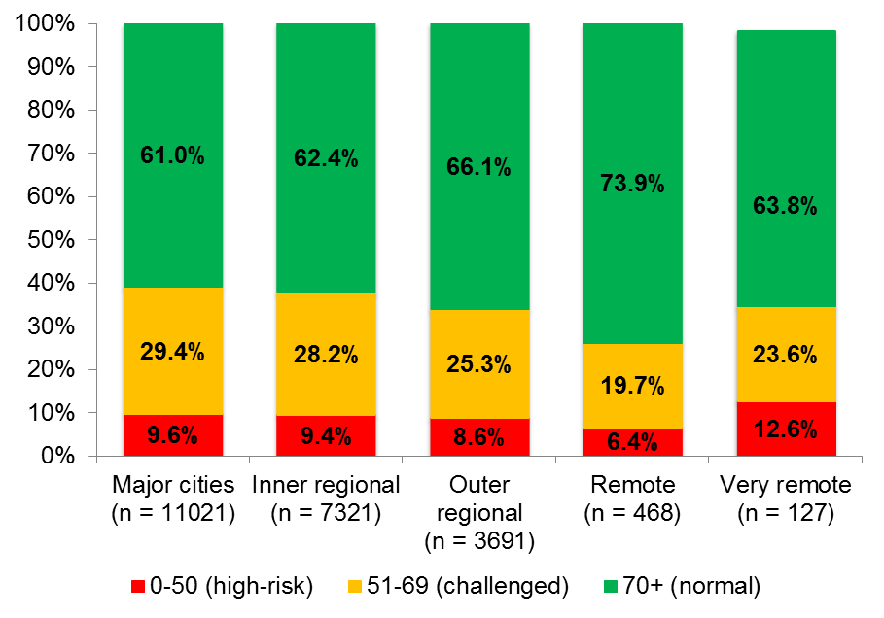

Figure 6.6: Accessibility/Remoteness Index of Australia (ARIA) and PWI groups

The proportion of respondents who scored in the normal range is highest in the Remote group (73.9%), with only 6.4% scoring < 50 points.

Young people living in Very remote parts of the country are the highest risk for low SWB and depression, with 12.6% scoring < 50 points.

With almost half of all young people living in Major cities, it is concerning that only 61.0% scored in the normal range. Thus, despite ‘*relatively unrestricted accessibility to a wide range of goods and services and opportunities for social interaction’,* many of these young people appear to be experiencing considerable challenge in their lives which is compromising their collective wellbeing.

Figure 6.7 displays the mean domain happiness scores for young people who live in each location according to the ARIA. More information is provided in Table F6.5.

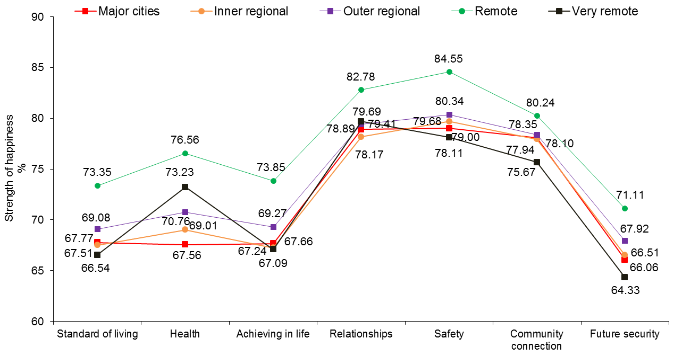

Figure 6.7: Accessibility/Remoteness Index of Australia (ARIA) and PWI domains

Young people living in Remote communities scored significantly higher than young people living in Major cities, Inner regional and Outer regional parts of the country on all domains, except Community Connection. They also scored significantly higher than young people living in Very Remote parts of the country on the domains of Standard of living, Achieving in life, Safety and Future Security.

Young people living in Major cities, Inner regional parts of the country and Very remote communities scored low on the domains of Standard of living and Achieving in life. This is counter intuitive, particularly for the city kids, if we assume the extensive network of resources and infrastructure characteristic of larger cities will meet their needs. Moreover, according to the ARIA classification system, living in a major Australian city implies “*relatively unrestricted accessibility to a wide range of goods and services and opportunities for social interaction*”. These findings exemplify the non-linear relationship between objective and subjective quality of life frequently reported in the literature and highlight the need to explore the unique challenges facing young people living in larger cities and their impact on personal wellbeing.

Moreover, these data seem to suggest that city living may be associated with a range of challenges and opportunities that aversely impacts upon the psychological wellbeing of many disengaged young people and which are not typically seen in smaller communities. For example, higher cost of living, inequitable wealth distribution, greater access to drugs and/or alcohol and more opportunities to engage in anti-social behavior (e.g., violence and crime).

On the other hand, however, Very remote living may present unique challenges of its own. For example, poorer access to health services, educational facilities, employment and basic needs such as adequate housing, which may impact upon a wide range of developmental and psychological outcomes. Indeed, young people who live in Very remote parts of the country reported the lowest mean scores on all PWI domains except Health.

Based on these findings, there is a need for a more in depth investigation examining the causes and correlates of adolescent personal wellbeing across Australia, from large city centers to very remote locations. The data and insights generated from a study of this nature would have major implications for government policy and service delivery.

# 7 Youth characteristics

Figures 7.1 and 7.2 compare mean personal wellbeing for individuals who do (‘Yes’) and do not (‘No’) meet the criteria for each of 10 identified Youth Characteristics.

Characteristics depicted in Figure 7.1 are: (a) Indigenous Australian; (b) Young person from a culturally and/or linguistically diverse background; (c) Humanitarian refugee, (d) Refugee background; and (e) Young carer. The sample sizes (n) represent the number of participants who met the criteria (‘Yes’) for each characteristic described. More information is provided in Table G7.1.

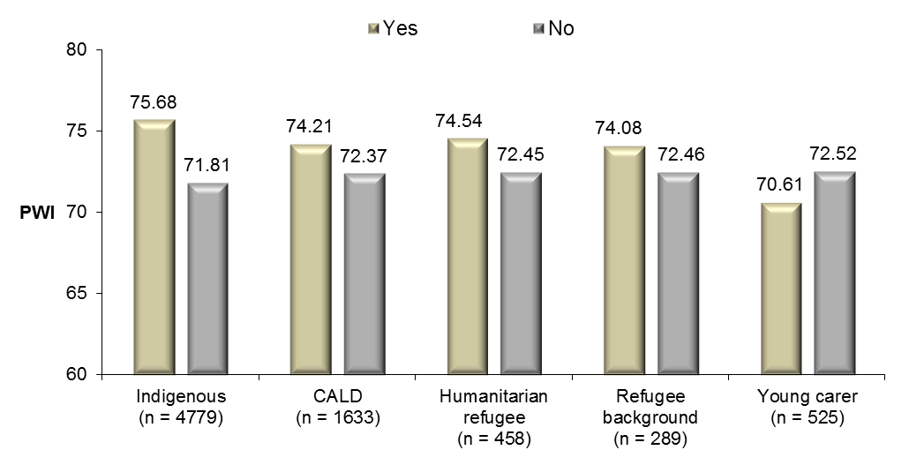

Figure 7.1: Youth characteristics and SWB

Indigenous young people report significantly higher personal wellbeing than non-Indigenous. The SWB of young Indigenous Australians will be described in more detail in Chapter 11.

Young people who are culturally and/or linguistically diverse have significantly higher personal wellbeing than young people not classified in this way.

Young carers have significantly lower personal wellbeing than non-carers. Similarly to adult carers, caregiving responsibilities expose adolescents to a variety of personal challenges that compromises their wellbeing. It is important that young carers are supported to ensure that their own developmental, educational, financial and social needs are adequately met.

Humanitarian refugees report significantly higher SWB than non-refugees. The SWB of Humanitarian refugees will be described in more detail in Chapter 12.

Characteristics depicted in Figure 7.2 are: (f) Receiving Centrelink income support; (g) Young parent; (h) Suspected/diagnosed mental health issue; (i) Disability; and (j) New Zealand citizen. More information is provided in Table G7.1.

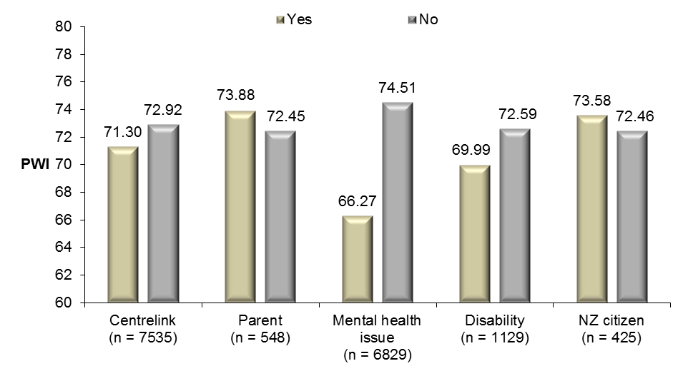

Figure 7.2: Youth characteristics and SWB

Young people receiving Centrelink income support have significantly lower SWB than young people who do not receive Centrelink income support. This result highlights the negative impact of financial hardship on the personal wellbeing of many young people from economically disadvantaged backgrounds and supports efforts by Youth Connections to assist young people to engage with education, thus improving their future employment opportunities and prospects of attaining financial independence.

Young people with a suspected/diagnosed mental health issue report significantly lower mean SWB than young people not classified in this way. Moreover, their very low score (66.27 points) suggests that a considerable proportion may in fact be experiencing depression or depressive type symptomology in addition to other mental health issues (e.g., anxiety, bi-polar disorder, low self-esteem, suicide ideation).

On average, young people with a disability have significantly lower SWB than young people without a disability. This, in part, can be attributed to lower mean scores on the domain of Safety and interpersonal domains of Community Connection and Relationships. These findings are intuitive given the additional challenges that having a disability pose to a young person's life, such as social exclusion and isolation, difficulties with transportation and accessibility and finding suitable employment.

Finally, New Zealand citizens participating in the YC Program have significantly higher SWB than non-New Zealand citizens.

Figure 7.3 highlights the debilitating impact of a mental health issue on personal wellbeing. This figure displays mean SWB for three groups: 1. Mainstream sample; 2. Young people enrolled in Youth Connections without a suspected/ diagnosed mental health issue; and 3. YC participants with a suspected/ diagnosed mental health issue.

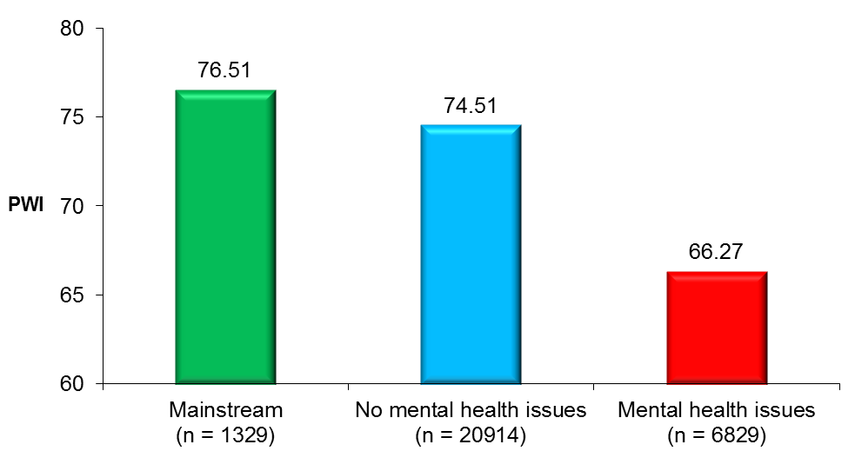

Figure 7.3: The debilitating effect of mental health problems

It is evident that young people with a suspected/diagnosed mental health issue are experiencing a level of collective challenge that is severely compromising their personal wellbeing, scoring 10.24 points and 8.24 points lower respectively than mainstream young people and YC participants without a suspected/diagnosed mental health issue.

Figure 7.4 displays mean domain happiness scores for each of the three groups described.

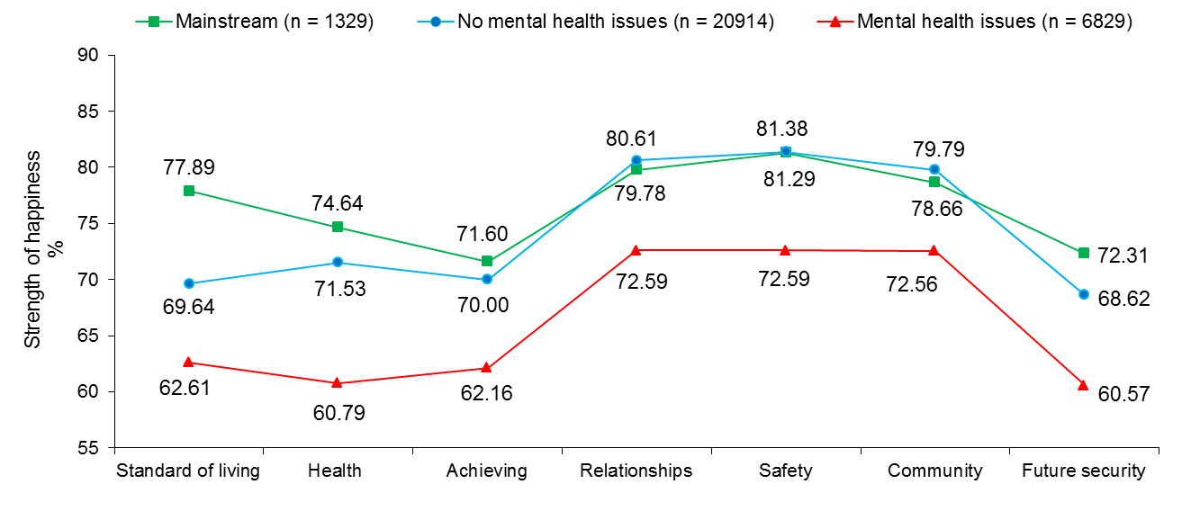

Figure 7.4: The debilitating effect of mental health problems

Relative to the comparative groups, young people with a suspected/diagnosed mental health issue scored very low on all seven domains - most notably, Health, Safety and Future Security. Servicing the needs of young people with mental health issues is important, particularly in light of the fact that they comprise nearly one-quarter of all YC participants.

Collectively, these data suggest that more funding and resources must be directed toward servicing the needs of young Australian’s with mental health problems.

# 8 Barriers to progression

A number of barriers to progression have been identified as major obstacles facing young people and their successful engagement with education, employment and connection with their families and communities. For the purpose of reporting, each barrier has been categorised into one of six groups as:

1. Family and living type barriers to progression
2. Physical and psychological health type barriers to progression
3. Anti-social and behavioural type barriers to progression
4. Substance use and misuse type barriers to progression
5. Learning/academic type barriers to progression
6. Barriers to progression not otherwise classified

## Family and living type barriers to progression

Family and living type barriers to progression and their influence on personal wellbeing are presented in Figure 8.1. See Table H8.1 for more information.

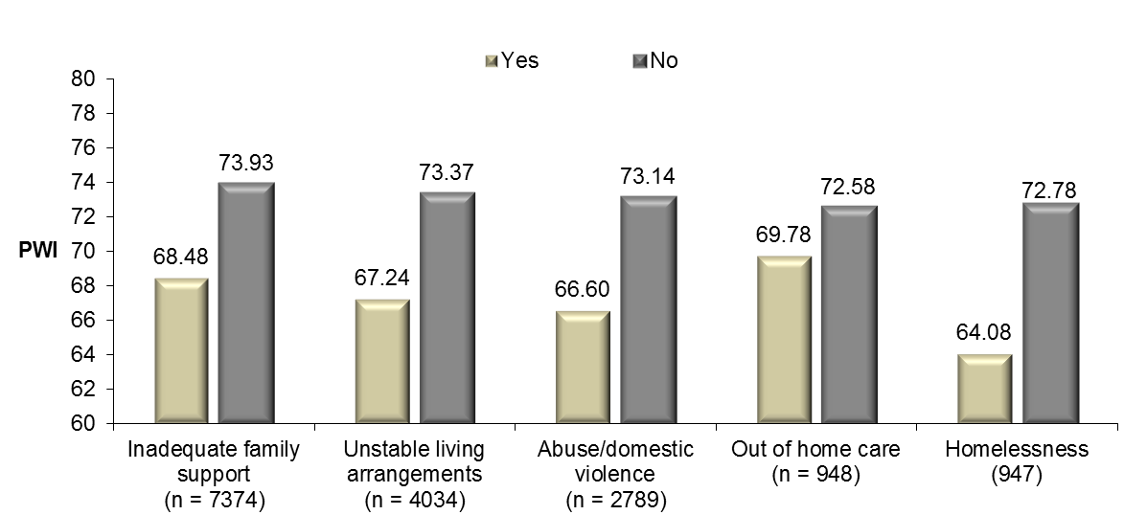

Figure 8.1: Family and living type barriers to progression and SWB

26.6% of respondents are classified as having inadequate family support; 14.5% as having unstable living arrangements; 10.1% as being exposed to/experiencing abuse/domestic violence; 3.4% as living in out of home care; and 3.4% as homeless.

All of the mean differences in personal wellbeing between young people classified and not classified as meeting these Family and living type barriers are statistically significant. In fact, mean SWB scores for all five groups are below the normal 70+ range, suggesting that a higher than normal proportion of young people in these groups are experiencing a level of challenge in their lives which is compromising their personal wellbeing.

On a more positive note, average SWB for young people who do not meet the criteria for any of the family and living type barriers to progression in Figure 8.1 is within the normal 70+ range.

Figure 8.2 below shows the compounding effect of multiple family and living type barriers to progression on personal wellbeing. See Table H8.2 for more information.

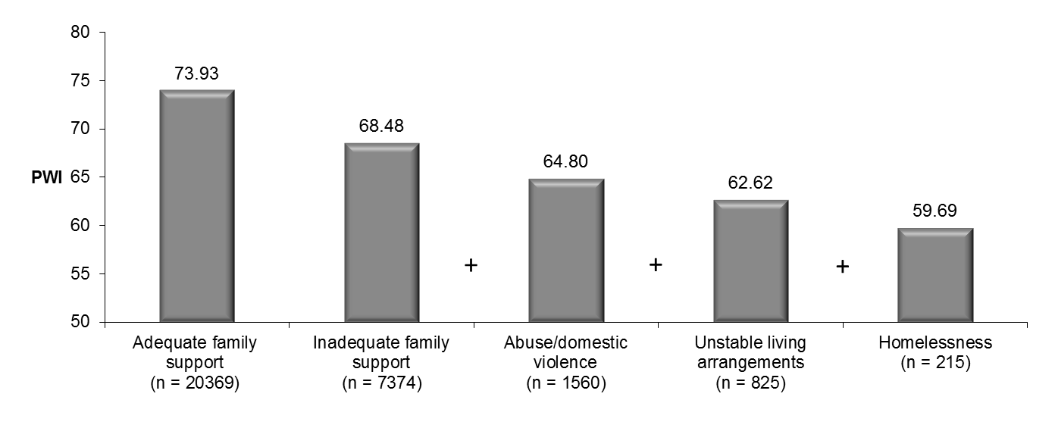

Figure 8.2: The compounding effect of multiple family and living type barriers to progression on SWB

The first column displays young people with adequate family support. As shown, their mean SWB is several points clear of the normal 70+ range, suggesting that the majority of people in this group are maintaining a relatively normal level of SWB.

Among those young people with inadequate family support, mean SWB drops a considerable 5.45 points to 68.48 points, suggesting that a substantially higher proportion are experiencing a level of challenge in their lives that is severely compromising their SWB.

When young people classified as having been exposed to/experiencing domestic abuse/violence and having unstable living arrangements remain, mean SWB reduces a further 3.68 points and 2.18 points respectively.

The final column depicts young people who experience four of the five barriers (excluding ‘out of home care’). Sadly, the inclusion of homelessness into the equation depresses SWB by a further 2.93 points to an extremely low 59.69 points, suggesting that many of these 215 young people are a very high risk for very low personal wellbeing and depression and are in immediate need of support. In fact, only 29.3% have a personal wellbeing score within the normal 70+ range, with approximately the same proportion scoring less than or equal to 50 (over three times higher than the entire YC sample).

## Physical and psychological health type barriers to progression

Physical and psychological health type barriers to progression and their influence on personal wellbeing are presented in Figure 8.3. See Table H8.3 for more information.

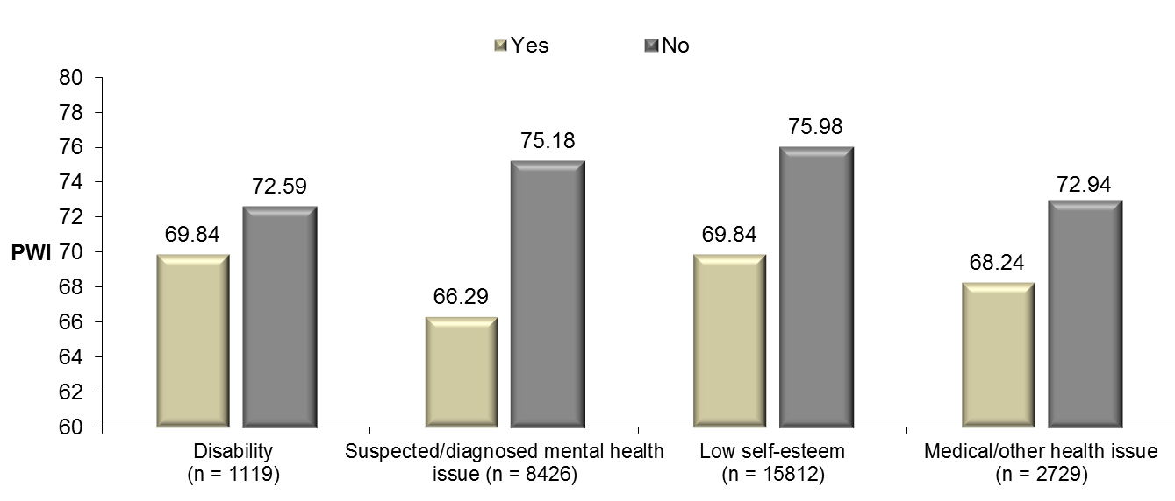

Figure 8.3: Physical and psychological health type barriers to progression and SWB

4.0% of respondents have been classified as having a disability. On average, they have lower subjective wellbeing than young people without a disability.

30.4% of respondents have a suspected or diagnosed mental health issue. As discussed in the previous chapter, their mean SWB is substantially lower than the mean for young people not classified in this way.

A substantial 57.0% of respondents have been classified as having low self-esteem. Their mean personal wellbeing is significantly lower than the mean for young people not suspected of having low self-esteem. Low self-esteem is a major issue concerning a majority of YC participants. Low self-esteem is likely to be the cause of disengagement for many young people as well as an outcome resulting from a diverse range of personal and circumstantial factors. Regardless of the cause, low self-esteem and associated negative thoughts and feelings about oneself represent a serious threat to successful participation in education settings for many young people and must be addressed.

With regards to the 9.8% of young people classified as having a medical or other health issue, their mean SWB is significantly lower than the mean for young people who were not deemed to have a medical or other health issue.

Collectively, these results indicate that Physical and psychological health type barriers to progression are risk-factors which pose major challenges to the wellbeing of many young people and addressing these barriers must remain a priority for educational and health-related government policy.

## Anti-social and behavioural type barriers to progression

Anti-social and behavioural type barriers to progression and their influence on personal wellbeing are presented in Figure 8.4. See Table H8.4 for more information.

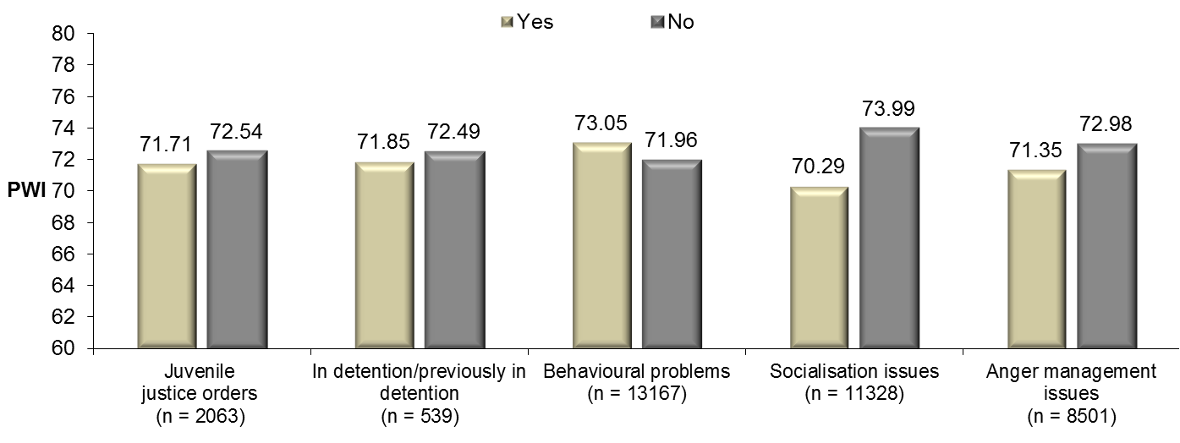

Figure 8.4: Anti-social and behavioural type barriers to progression and SWB

7.4% of respondents have current or previous juvenile justice orders. Their mean SWB score is significantly lower, but not substantially, than the mean for young people who have not had juvenile justice orders brought against them.

1.9% of respondents are in detention or have previously been in detention. There is no significant difference in mean SWB between young people classified and not classified in this way.

A substantial 47.5% of respondents have been identified as having behavioural problems. Interestingly, these young people have significantly higher SWB than young people not identified as having behavioural problems - although this difference is not substantial and likely due to large sample size.

A substantial 40.8% of respondents have been classified as having socialisation issues. They report significantly lower SWB than young people not classified as having socialisation issues.

30.6% of respondents have been classified as having anger management issues. These young people report significantly lower SWB than young people not classified as having anger management issues.

Sustained efforts must be directed toward addressing Anti-social and behavioral type barriers to progression as these have been found to have a negative impact on the personal wellbeing of many adolescents and may also impact the quality of their inter-personal relationships, successful participation in education and post-secondary training and employment.

## Substance use and misuse type barriers to progression

Substance use and misuse type barriers to progression and their influence on personal wellbeing are presented in Figure 8.5. See Table H8.5 for more information.

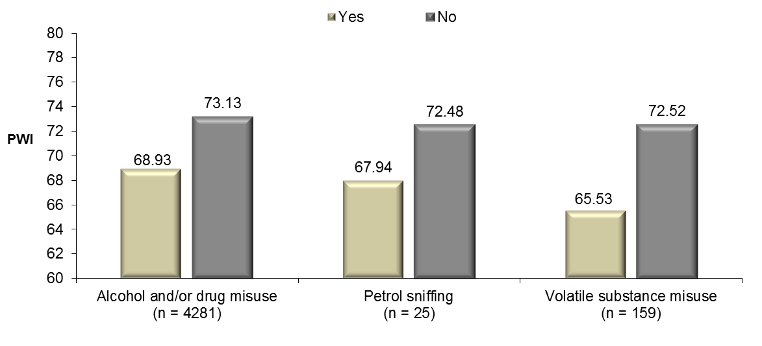

Figure 8.5: Substance use and misuse type barriers to progression and SWB

15.4% of respondents were identified as having misused alcohol and/or drugs. Their mean SWB is significantly lower than the mean for young people not identified as having misused alcohol and/or drugs.

25 respondents were identified as engaging in petrol sniffing. Their mean SWB is substantially lower than the mean for the remaining sample. However, this difference is not significant, most likely due to small sample size.

159 respondents (< 1%) were identified as having used/misused volatile substance. Their mean SWB is significantly lower than the mean for young people not identified as having used/misused volatile substance.

Collectively, the evidence gathered thus far suggests that alcohol and other harmful substances are detrimental to the psychological wellbeing of young people who abuse them and highlight the importance of providing support and education to young people on a trajectory toward misusing alcohol and/or drugs.

## Learning/academic type barriers to progression

Learning/academic type barriers to progression and their influence on personal wellbeing are presented in Figure 8.6. See Table H8.6 for more information.

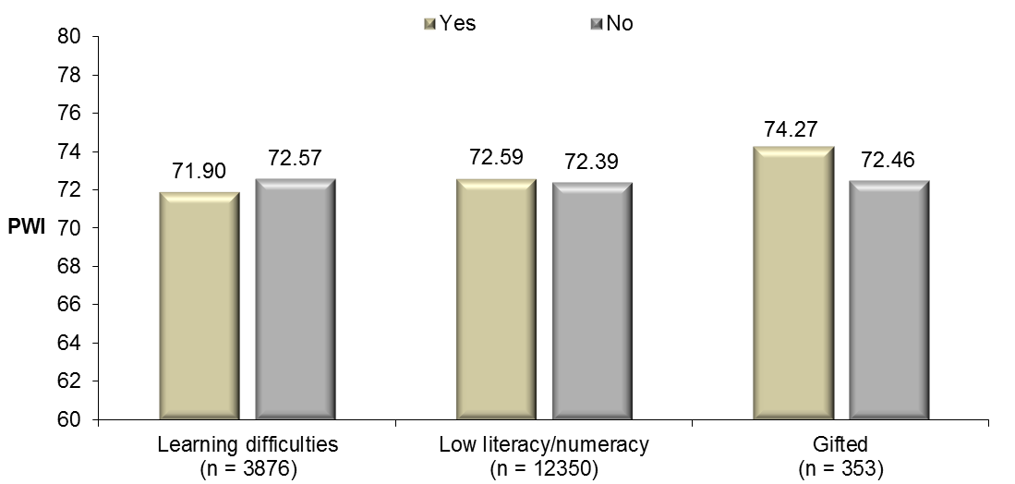

Figure 8.6: Learning/academic type barriers to progression and SWB

14.0% of respondents have a learning difficulty. Their mean SWB is significantly, but not substantially lower, than the mean for young people not classified in this way. It is essential that young people with a learning difficulty are provided with the resources and services they require to help overcome their learning deficits.

A very large proportion of respondents (44.5%) were classified as having low literacy/numeracy. Their mean SWB is no different to young people not classified in this way.

1.3% of respondents are believed to be gifted. Their mean SWB is significantly higher than the mean for young people not identified as being gifted. While this result is very encouraging, it is important that children with gifted intelligence are nurtured throughout their adolescent years to ensure that they complete their schooling, utilise their strengths and achieve their potential in life.

## Barriers to progression not otherwise classified

Barriers to progression not otherwise classified and their influence on personal wellbeing are presented in Figure 8.7. See Table H8.7 for more information.

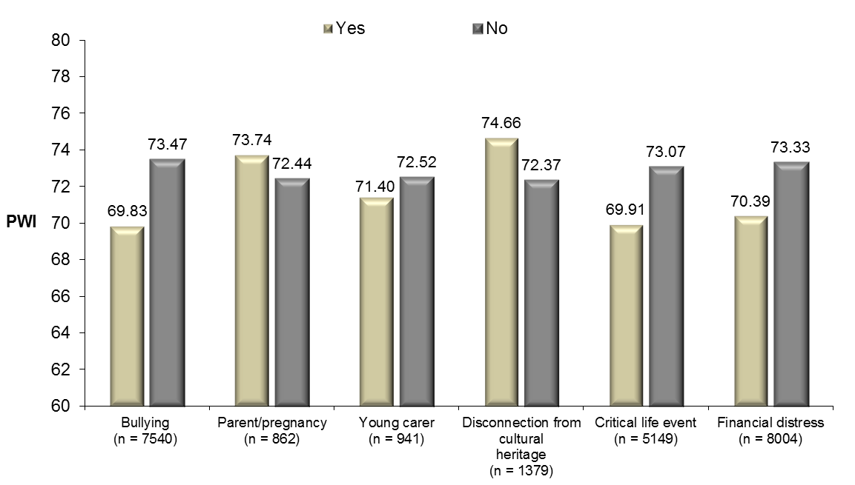

Figure 8.7: Barriers to progression not otherwise classified

A substantial 27.2% of respondents are believed to have been the victims of bullying or enact bullying behaviour themselves. Their mean SWB is significantly lower than the mean for young people not associated with bullying either as the victim or the perpetrator. The very high prevalence of bullying in this sample highlights the need to assist young people to develop social and emotional competencies and employ effective strategies to help combat/prevent bullying.

3.1% of respondents were either pregnant or already parents at the time they began their involvement with Youth Connections. Curiously, their mean SWB is significantly higher than the mean for young people who were not pregnant or already parents. Given that many young parents (particularly single parents) are a high-risk for economic and social disadvantage in adulthood, they need to be encouraged and supported to complete year 12 or equivalent to increase their employment opportunities so they can better provide for their families.

3.4% of respondents have young carer responsibilities. Their mean SWB is significantly lower than the mean for non-carers. It is well documented that Australia’s approximately two million non-formal caregivers experience amongst the lowest collective SWB of any sub-group measured to date. Unpaid caregivers are also a very high risk for physical, social and economic disadvantage that is associated with their caregiving role. In this light, adolescent caregivers must be supported by to ensure their own psychological, health-related, financial and educational needs are adequately met.

The 5.0% of respondents identified as being disconnected from their cultural heritage have significantly higher SWB than young people not categorised in this way. This result is counter-intuitive and the underlying reasons are not entirely clear.

18.6% of respondents have experienced a recent critical life event. Their mean SWB is significantly lower than the mean for young people who have not experienced a recent critical life event. Many young people who have experienced a critical life event are likely to be particularly vulnerable during the days, weeks and even months following the event in question. It is therefore imperative that they receive appropriate intervention/support and that their mental and emotional health status is monitored.

Finally, 28.9% of respondents are reported as experiencing financial distress. Their mean SWB is significantly lower than the mean for young people not classified in this way. These data support adult data collected as part of the Australian Unity Wellbeing Index, which shows that financial hardship has a pervasive and negative impact on the personal wellbeing of many Australians. Moreover, these data again highlight the need for young people to complete year 12 or equivalent to provide themselves with the best chance of finding suitable employment and achieving financial independence.

# 9 Recent activities in the past month

Young people were categorised into one of four groups based on the approximate number of days in the last month they:

* + - 1. Attended school, education or training
      2. Had contact with their family or caregiver
      3. Had contact with their friends
      4. Took part in an activity outside of their home/regular residence.

For the variable ‘Attended school, education or training’, the four groups are: ‘0-5 days’, ‘6 – 10’ days,’ 11 – 15 days’ and ‘16+ days’ in the past month respectively.

For the remaining three variables, the four groups are: ‘No days’, ‘1 – 14’ days,’ 15 – 27 days’ and ‘28 – 31’ days in the past month respectively.

## Recent attendance at school, education or training

Figure 9.1 shows mean SWB for each of the four groups based on the approximate number of days in last month the young person attended school, education or training. Data from 23,633 young people were analysed. More information is provided in Table I9.1

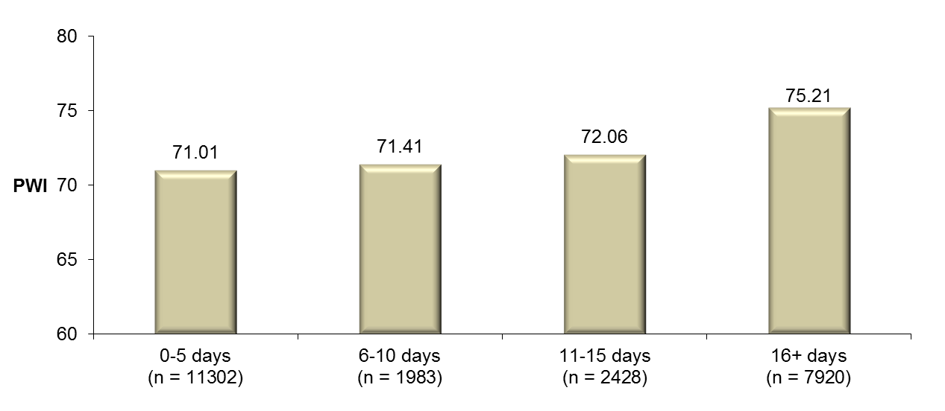

Figure 9.1: Approximate number of days in the last month the young person attended school, education or training and their SWB

Young people who attended school, education or training on 16 days or more in the previous month have, on average, significantly higher personal wellbeing than young people who attended on fewer days. While this is a positive result for young people who frequently participate in an education setting, it is concerning that only one in three young people fall into this highly engaged group.

Overall, frequent school attendance is associated with higher personal wellbeing and supports the need to create pathways that help young people to successfully connect with school, education and/or training. An important part of this will be addressing the family, social, emotional and behavioural difficulties that characterise the lives and personal circumstances of many YC participants and which may negatively impact upon their motivation and willingness to participate in education settings.

Domain happiness scores for young people in each of the four groups are presented in Figure 9.2. More information is provided in Table I9.1.

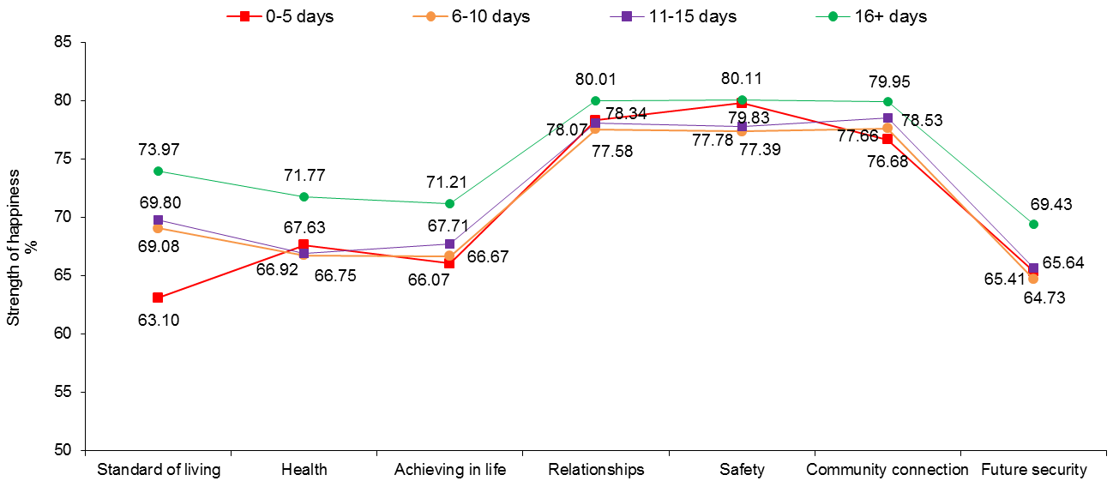

Figure 9.2: Approximate number of days in the last month the young person attended school, education or training and their domain happiness scores

Young people who attended school, education or training 16 days or more in the previous month report the highest mean happiness on all seven PWI domains.

With regard to significance, the 16+ day group scored higher than all other groups on six of the seven domains (excluding Safety). The greatest difference between the groups was observed on the domains of Standard of living and Achieving in Life.

These results suggest a potential link between the financial welfare of young people and their families and the frequency of school attendance and/or attitudes toward school and education.

Moreover, poor school attendance is associated with considerably lower perceptions of happiness with how young people feel about the things they want to be good at (Achieving in Life). Thus, young people appear to be very much aware of the fact that they are not achieving their potential in life, with poor attendance at school and associated poor performance a likely cause of these sentiments.

Overall, these are compelling findings and highlight the notion that engagement with school, education and/or training has a pervasive and positive impact on many important aspects of adolescent life. With this in mind, there is a great need to guide, encourage and support young people in their attempts to make a successful return to education and/or training.

## Recent contact with family or caregiver

Figure 9.3 shows mean SWB for each of the four groups based on the approximate number of days in last month the young person had contact with their family or caregiver. Data from 23,568 young people were analysed. More information is provided in Table I9.2.

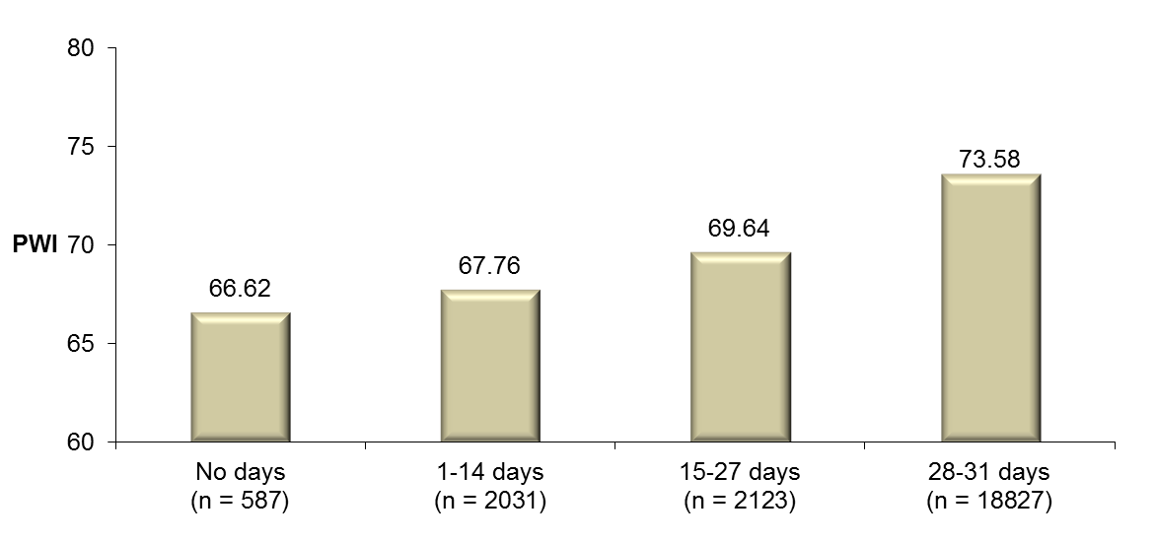

Figure 9.3: Approximate number of days in last month the young person had contact with their family or caregiver and their SWB

Mean SWB for young people who report having had contact with their family or caregiver between 28 and 31 days in the previous month is significantly higher than mean SWB for young people who reported having had fewer days of contact.

Not surprisingly, young people in the ‘No days’ group are approximately three and a half times more likely (73.9%) than young people in the 28-31 day group (20.8%) to have ‘Inadequate family support’.

It is also notable that the means for the one in five young people who report having had contact with their family or caregiver on fewer than between 28 and 31 days are below the normal 70+ range. This suggests that many young people who have less than regular contact with their family or caregivers are at a considerably higher risk for low personal wellbeing and depression. This result highlights the important role that family and adult carers play in a young person’s life – unless of course these relationships are known to be abusive/harmful.

Domain happiness scores for young people in each of the four groups are presented in Figure 9.4. More information is provided in Table I9.2.

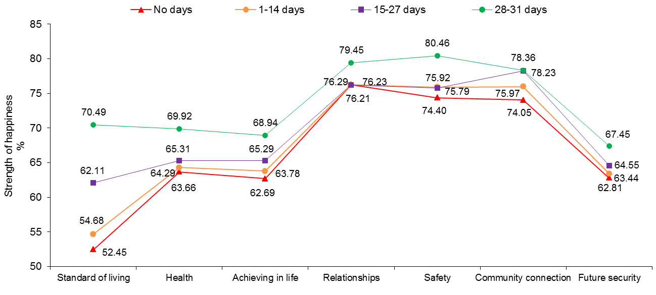

Figure 9.4: Approximate number of days in last month the young person had contact with their family or caregiver and their domain happiness scores

Young people who had contact with their family or caregiver between 28 and 31 days in the previous month have, on average, significantly higher mean happiness than all other groups on six of the seven domains (except Community Connection, which they score higher than the ‘No days’ and 11-14 day groups).

With respect to the domains, the greatest observed difference between the four groups was on Standard of Living, with the mean for young people in the 28-31 day group a substantial 18.04 points higher than the ‘No days’ group. These findings are intuitive given the crucial role that parents and families play in the provision of financial and economic resources their dependents in their care.

Substantial between group differences were also evident on the domains of Health, Achieving in Life and Safety, again highlighting the important role that a young person’s family plays in nurturing their health and wellbeing and in supporting and encouraging them to achieve personal goals.

## Recent contact with friends

Figure 9.5 shows mean SWB for each of the four groups based on the approximate number of days in the last month the young person had contact with their friends. Data from 23,598 young people were analysed. More information is provided in Table I9.3.

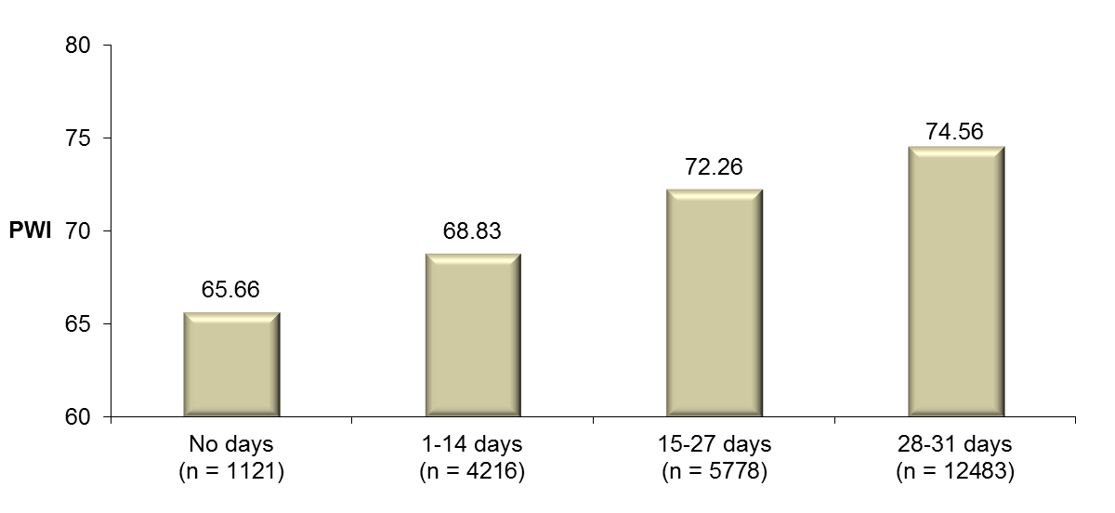

Figure 9.5: Approximate number of days in last month the young person had contact with their friends and their SWB

A clear positive relationship between the approximate number of days in the last month the young person had contact with their friends and their SWB can be observed, with the mean for young people in the 28-31 day group significantly higher than the mean for young people who reported having had fewer days of contact.

Interestingly, but not surprisingly, approximately twice as many young people in the ‘No days’ group (68.2%) compared to the 28-31 day group (34.5%) have ‘Socialisation issues’.

While data presented in Figure 9.5 is not a direct measure of the quality of interpersonal relationships, friendships that are mutually supportive are amongst the most protective factors to a person’s wellbeing identified within the literature. For example, when faced with adversity, friends and close confidants can be accessed as an important source of comfort, support, guidance, reassurance and for problem-solving. In this way, networks of peers can increase the capacity for young people (and adults) to adapt to and confront the challenges that threaten their personal wellbeing. In contrast, people low on social resources often have nobody to turn to when life becomes difficult and seems overwhelming and consequently, they are often left to face challenges alone. Unfortunately, for many young people enrolled in Youth Connections, this is the situation they find themselves in.

Domain happiness scores for young people in each of the four groups are presented in Figure 9.6. More information is provided in Table I9.3.

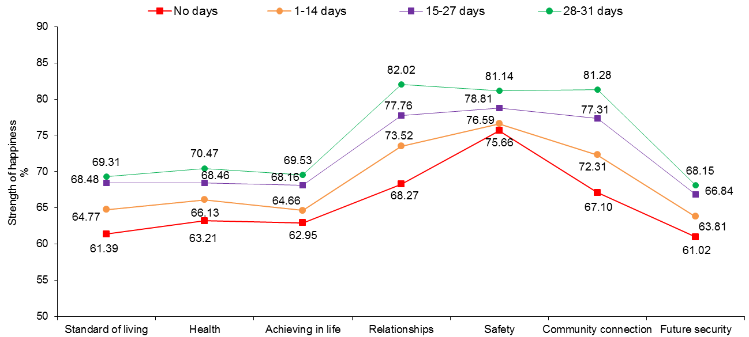

Figure 9.6: Approximate number of days in last month the young person had contact with their friends and their domain happiness scores

Young people who had contact with their friends between 28 and 31 days in the previous month are reported to have significantly higher mean happiness than all other groups on all seven PWI domains.

Not surprisingly, the most substantial differences were observed on the interpersonal domains of Community Connection and Relationships, with the means for young people in the 28-31 group 14.18 points and 13.75 points higher respectively on these domains than young people in the ‘No days’ group.

It is clear from these findings that regular contact with friends has a pervasive and positive impact on the personal wellbeing of many young people, with little/no regular contact with friends associated with very low happiness scores on multiple domains. This is concerning and it is important that all young people enrolled in Youth Connections, particularly those in less frequent contact with their friends, are encouraged to be more sociable and friendly toward their peers for the reasons described. Moreover, interventions must also address the maladaptive ways some young people interact with their peers if they are to have any chance at being successful in their future relationships and benefit from this essential resource.

## Recent participation in an activity outside of the home/regular residence

Figure 9.7 shows mean SWB for each of the four groups based on the approximate number of days in last month the young person participated in an activity outside their home/regular residence. Data from 23,621 young people were analysed. More information is provided in Table I9.4.

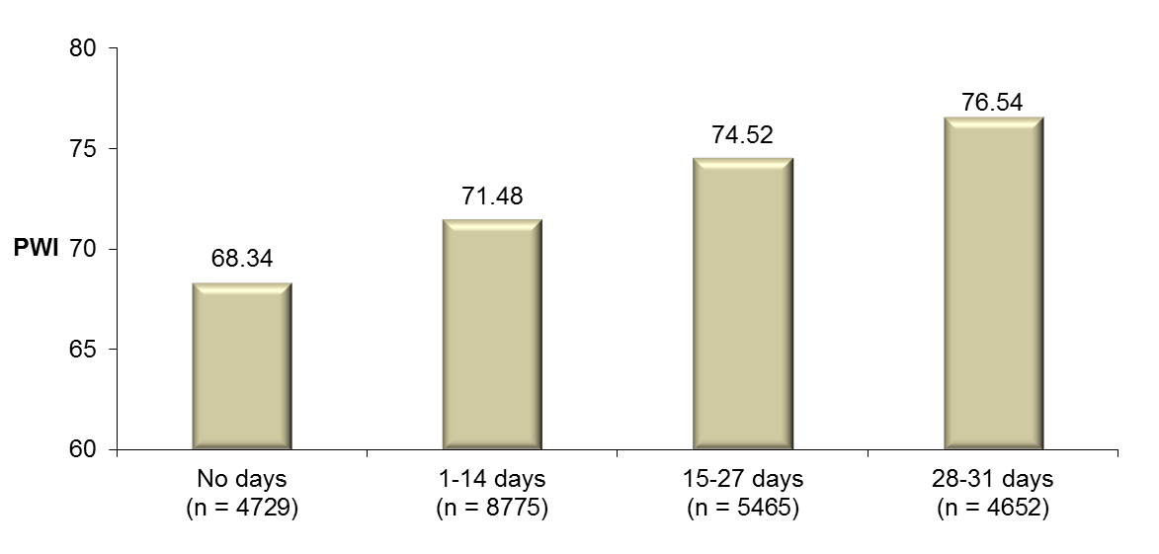

Figure 9.7: Approximate number of days in last month the young person participated in an activity outside their home/regular residence and their SWB

The benefit of regular participation in activities outside of the home/regular residence to the personal wellbeing of adolescents is clear, with the mean for young people in the 28-31 day group significantly higher than the means for young people who participated in activities on fewer days. In fact, their mean is comparative to the mainstream sample mean of 76.51 points. In this light, it is concerning that only one in five young people fall into this high activity group.

The very low mean for young people who did not participate in an activity outside their home/regular residence at all in the previous month is very worrying as these young people make up a significant proportion of YC participants who responded to this item (20.0%).

When interpreting these data, it is important to consider that a bidirectional relationship between personal wellbeing and regular participation in activities may exist, whereby a) low participation in outside activities as a consequence of fewer opportunities and greater obstacles toward participation (e.g., having a disability) contributes to low personal wellbeing; and b) passive and withdrawn type behaviour associated with depression that occurs as a result of other causes contributes to a lack of motivation and willingness to engage with various activities outside of the young person’s the home.

Domain happiness scores for young people in each of the four groups are presented in Figure 9.8. More information is provided in Table I9.4.

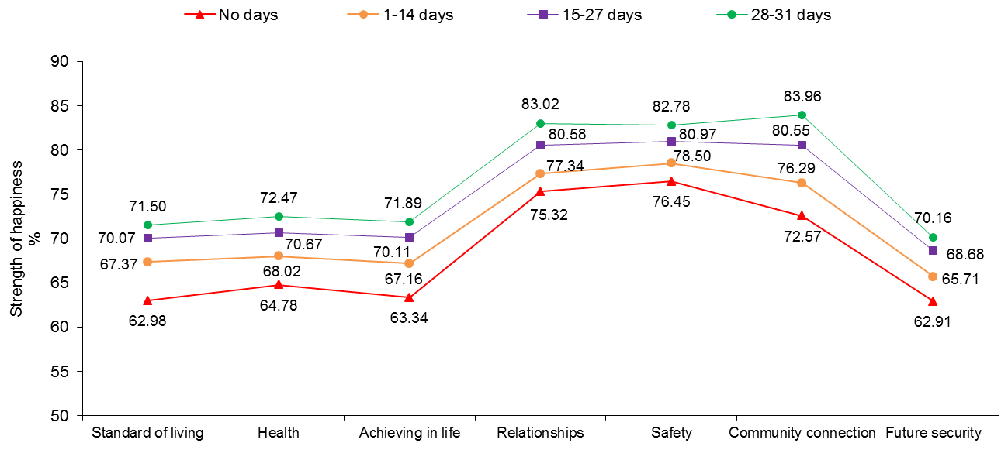

Figure 9.8: Approximate days in last month the young person participated in an activity outside their home/regular residence and their domain happiness scores

There is overwhelming evidence to support regular participation in activities outside of home/regular residence as important to the personal wellbeing of many young people – particularly the interpersonal domains of Relationships and Community Connection and Achieving in Life. In fact, the means for the 28-31 day group are significantly higher than the means for all other groups on all seven PWI domains.

It is vital that all young people are encouraged and supported to take part in regular activities outside of their home, as regular activity has direct benefits for their physical, psychological and social wellbeing.

Figure 9.9 below displays mean SWB and domain happiness scores for the 1,402 young people who were categorised into the most frequent contact/activity group for all four recent events described compared to mainstream. 58.6% were male, with 73.0% aged between 14 and 16 years and 23.5% Indigenous. Not surprisingly, only 23 (2.0%) were Connection level 2b young people, with just under two-thirds (62.6%) classified as Connection level 1. More information is provided in Figure I9.5.

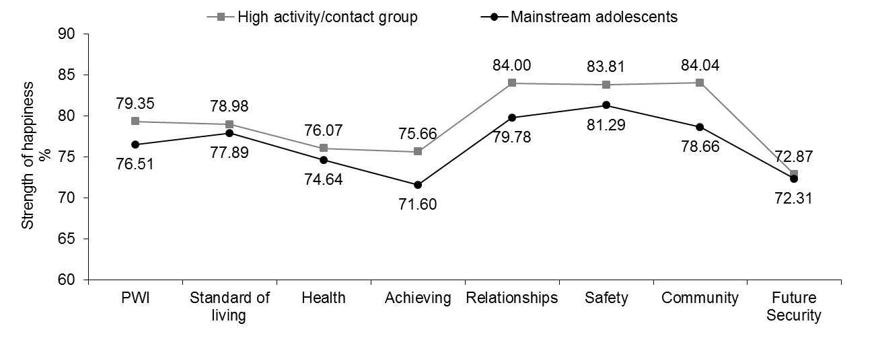

Figure 9.9: PWI and domain profile for young people categorised into the 28-31 day group for all four recent events described compared to mainstream

It is evident from Figure 9.9 that regular participation in an education setting, regular contact with family/caregivers, friends and frequent participation in activities outside of the home facilitates optimal levels of psychological wellbeing. In fact, mean SWB for this high contact/activity group is significantly higher than mainstream, with significantly higher means observed on five of the seven domains (except Standard of Living and Future Security).

These are very encouraging results and highlight the positive impact that remaining highly connected with education, family, friends and the community has on the psychological wellbeing of many adolescents. These findings also suggest that individual differences in personality characteristics (e.g., outgoing, social) and resilience (e.g., self-esteem, emotional intelligence) may enable some young people to adapt more successfully to their environment and in the face of adversity.

Figure 9.10 below displays mean SWB and domain happiness scores for the 633 young people who were categorised into the two least frequent contact/activity groups for all four recent events described compared to mainstream. 54.3% were female, with 67.0% aged between 16 and 18 years and 18.3% Indigenous. Not surprisingly, 75.7% were Connection level 2b young people, with only 4.6% classified as Connection level 1. More information is provided in Figure I9.6.

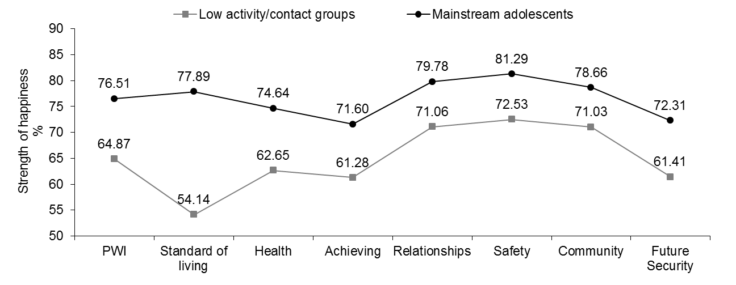

Figure 9.10: PWI and domain profile for young people categorised into the two lowest activity/contact groups for all four recent events described compared to mainstream

It is evident from Figure 9.10 that poor participation in an education setting, irregular contact with family/caregivers, friends and infrequent participation in activities outside of the home is associated with much poorer psychological wellbeing compared to mainstream. Most notable are very low scores on the domains of Standard of Living, Health and Achieving in Life.

Equally concerning are the low scores on the domains of Relationships and Safety. In many risk groups, mean scores on these domains typically remain unaffected despite lower scores on other domains. For example, although suffering from financial disadvantage or health problems, people who are unemployed or experiencing chronic illness/pain often feel safe and find comfort through social support networks which act to protect feelings of wellbeing. Thus, it appears that highly disengaged young people are at a heightened risk of low wellbeing and depression, with these key domains also affected.

# 10 Happiness with School

The eighth (optional) domain of the PWI-SC asks ‘*How happy are you with your school’?* This itemis not included in the overall calculation of the personal wellbeing composite as the school happiness construct is not relevant to all young people (e.g., those who do not attend school). However, for young people who do attend school, this item may offer useful and important insights into how happy young people feel about their school experience more generally.

Data from 11,046 young people (53.3% male) who responded to this item from March 1st, 2012 were analysed. These included only Connection level 1 and 2a young people as by definition, Connection level 2b young people have not attended school for a period of at least 3 months and so their data are considered unreliable.

Mean happiness with School for YC participants compared to 531 mainstream young people who have previously responded to this item is presented in Figure 10.1. More information is provided in Table J10.1.

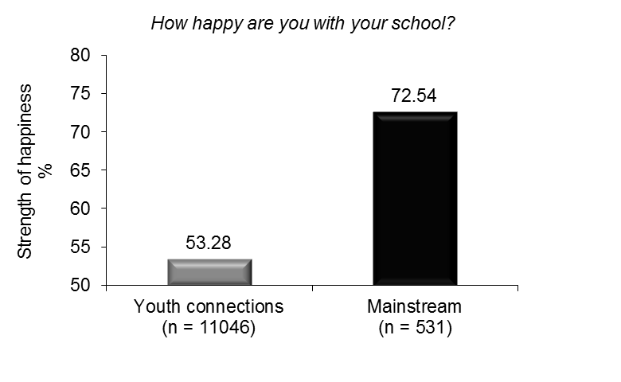

Figure 10.1: Happiness with School for Youth Connections and mainstream young people

Mean happiness with School for YC participants is substantially lower than mainstream. In fact, their mean score is only 3.28 points above the neutral point on the standardised 0 (Very Sad) to 100 (Very Happy) rating scale.

While this result is very concerning, it is not surprising given that the YC Program specifically targets young people at risk of disengaging, or who have already disengaged from school, for a variety of complex personal reasons and circumstances. These include, but not exclusively, behavioural problems, socialisation issues, disability, bullying, drug and alcohol problems and inadequate family support. Moreover, their very low mean sends a strong message that YC participants are not happy with school/aspects of school life and that a range of interventions and strategies may be required to assist young people to remain connected with their education.

On a more positive note, 4,140 young people (37.5%), rated their level of School Happiness as a seven or higher (standardised to 70%), indicating that there are a significant proportion of young people who enjoy aspects of school life and who are likely to be sufficiently motivated to do their best, despite the obstacles they face.

Mean happiness with School for males and females is presented in Figure 10.2. More information is provided in Table J10.1.

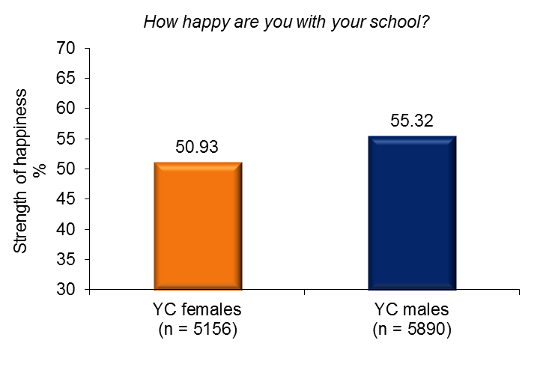

Figure 10.2: Happiness with School for females and males

Mean happiness with School for males is significantly higher than females. However, on average, both females and males are only slightly happy with School.

Mean happiness with School for young people in each age group is presented in Figure 10.3. More information is provided in Table J10.1.

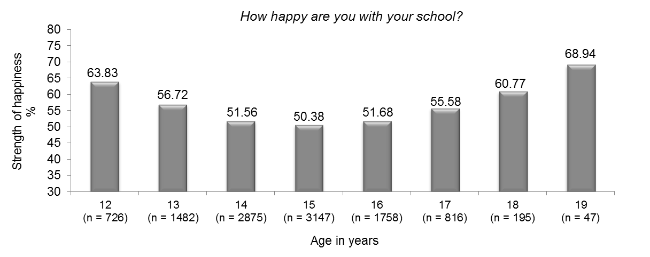

Figure 10.3: Happiness with School and age

A curvilinear relationship between age and happiness with School is evident, decreasing from 63.83 points at age 12 years to a low of 50.38 points at age 15 years; before increasing to reach a high of 68.94 points at age 19 years.

While the sample size is small, the relatively higher score for 19 year olds is positive and suggests that many older adolescents who persevere with their schooling appear to be making the most of this opportunity.

Particularly low mean scores between the ages of 14 and 16 years are very worrying as mid-adolescence is the time when many adolescents make the decision to leave school, often without a well-conceived and supported plan to engage with post-secondary training or employment.

Early adolescence is a critical period with challenges and experiences during this time posing a substantial threat to the willingness and motivation of many young people to engage successfully with their schooling. It is therefore imperative that interventions aimed at encouraging young people to persevere with their schooling target young people in their early adolescent years.

Mean happiness with School for females and males in each age group is displayed in Figure 10.4. More information is provided in Table J10.1.

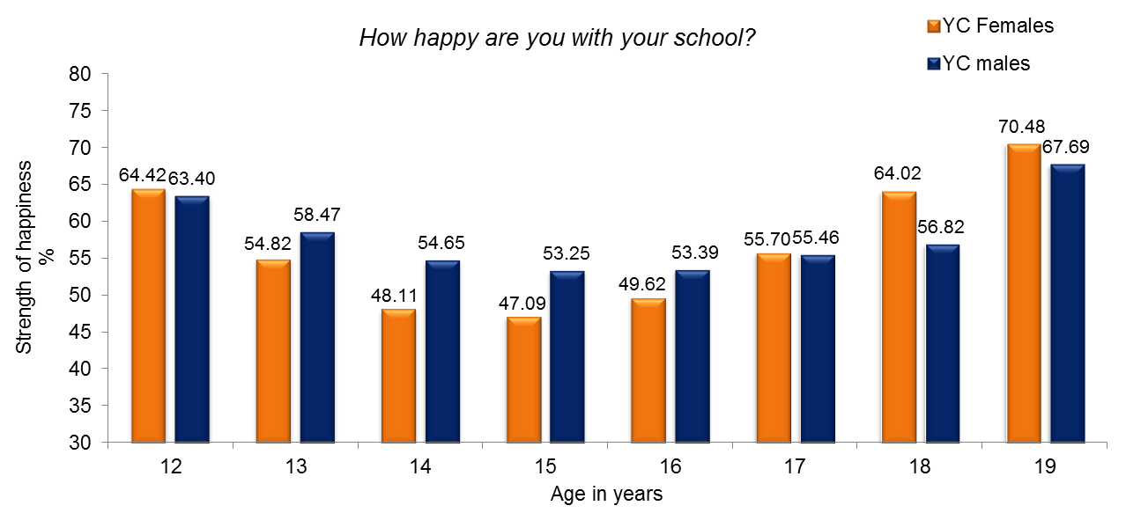

Sample Size (YC females): 12 = 303; 13 = 710; 14 =1357; 15 = 1466; 16 = 799; 17 =393; 18 = 107; 19 = 21

Sample Size (YC males): 12 = 423; 13 = 772; 14 = 1518; 15 = 1681; 16 = 959; 17 = 423; 18 = 88; 19 = 26;

Figure 10.4: Happiness with School for females and males in each age group

The decrease in school happiness from early to mid-adolescence described is generally consistent across both genders.

With respect to significance, the means for males are higher than females between the ages of 13 and 16 years.

No other significant differences were evident.

Mean happiness with School for young people according to their level of connection is presented in Figure 10.5. More information is provided in Table J10.2.

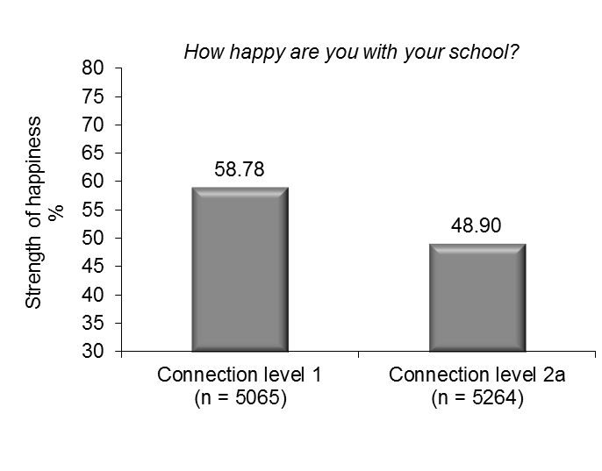

Figure 10.5: Connection level and happiness with School

Mean happiness with School for Connection level 1 young people is significantly higher than 2b.

While both mean scores are low, it is particularly concerning that the mean for 2a young people is in the ‘Sad’ range of the standardised 0 (Very Sad) to 100 (Very Happy) point rating scale as school happiness/satisfaction has been found to be an important correlate of school engagement, attendance and performance within the literature.

Happiness with School for young people living in each of the eight Australian states and territories is presented in Figure 10.6. More information is provided in Table J10.3.

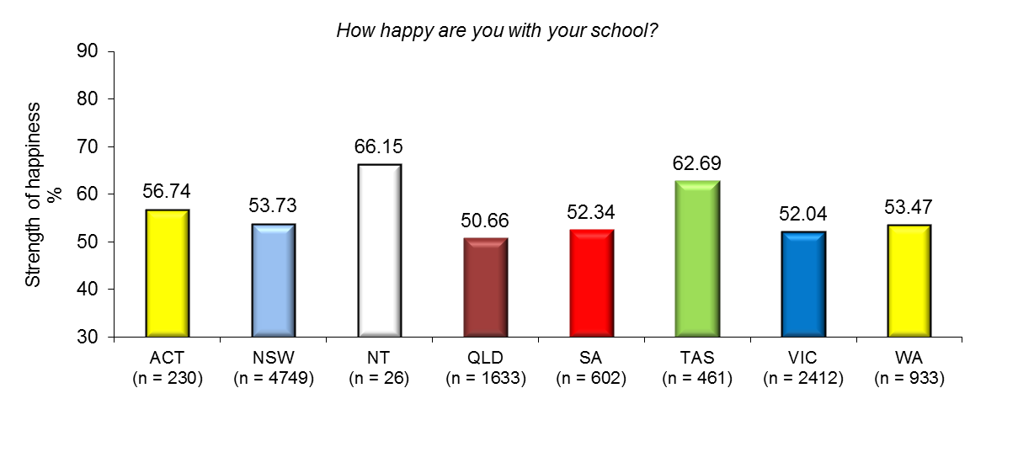

Figure 10.6: Happiness with school for young people by residency

Mean happiness with School is highest in the NT. While the sample size is small, the group mean of 66.15 points is very encouraging and suggests that the majority of young people sampled in the NT are generally happy with their school experience and find at least some aspects of school life positive.

Happiness with School is lowest in QLD, followed closely by VIC. Means of 50.66 points and 52.04 points respectively suggest that many young people in these states are not at all happy with their school experience and likely perceive a number of aspects of their school life in a negative way. However, Happiness with School is only marginally better in the other states and territories.

Changing what appears to be predominately negative attitudes toward school amongst disengaged teenagers is a national issue and represents a major challenge for parents, teachers, schools, service providers, the broader community, and state and federal governments, if young people are to remain engaged with their education and successfully complete year 12 or equivalent.

Happiness with School for young people who live in Major cities, Inner regional, Outer regional, Remote and Very remote parts of Australia classified according to the ARIA are presented in Figure 10.7. More information is provided in Table J10.4.

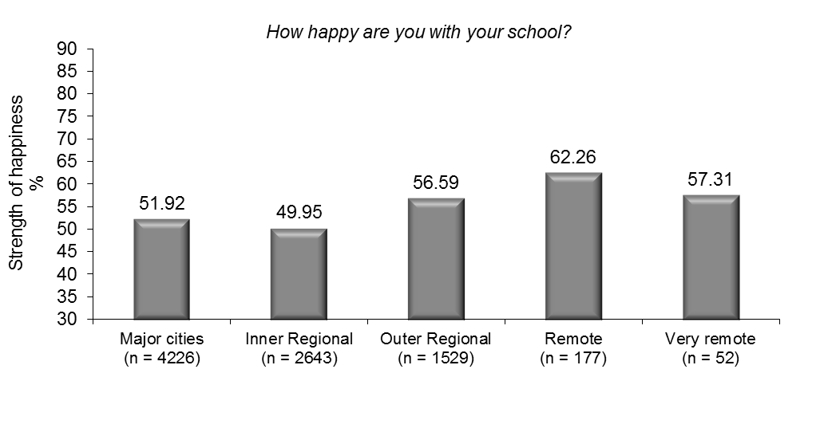

Figure 10.7: Happiness with school according to the ARIA

Young people living in more remote parts of the Australia report the highest mean Happiness with School; while young people living in Inner regional parts of the country report the lowest.

While all the means presented in Figure 10.7 are concerning, very low scores in Major cities and Inner regional parts of the country are particularly worrying given the larger number of young people who attend school in these locations.

# 11 The subjective wellbeing of young Indigenous Australians

Data from 4,779 (17.2%) Indigenous Australians aged 12 to 19 years (*M* = 15.11 years (*SD* = 1.69 years) were analysed. There were more Indigenous males (n = 2,506; 52.4%) than females (n = 2,273; 47.6%), with 37.5% were classified as Connection level 2b.

With respect to state of residence, the majority of Indigenous participants were from NSW (50.8%), QLD (23.6%) and Victoria (9.0%); with 6.1% from WA, 4.7% from SA, 2.9% from TAS, 2.6% (n = 123) from the NT and 0.3% (n = 14) from the ACT.

## Mean SWB and domain happiness scores: Comparative analyses

Figure 11.1 displays mean PWI and domain happiness scores for Indigenous and non-Indigeous YC participants. More information is provided in Table K11.2.

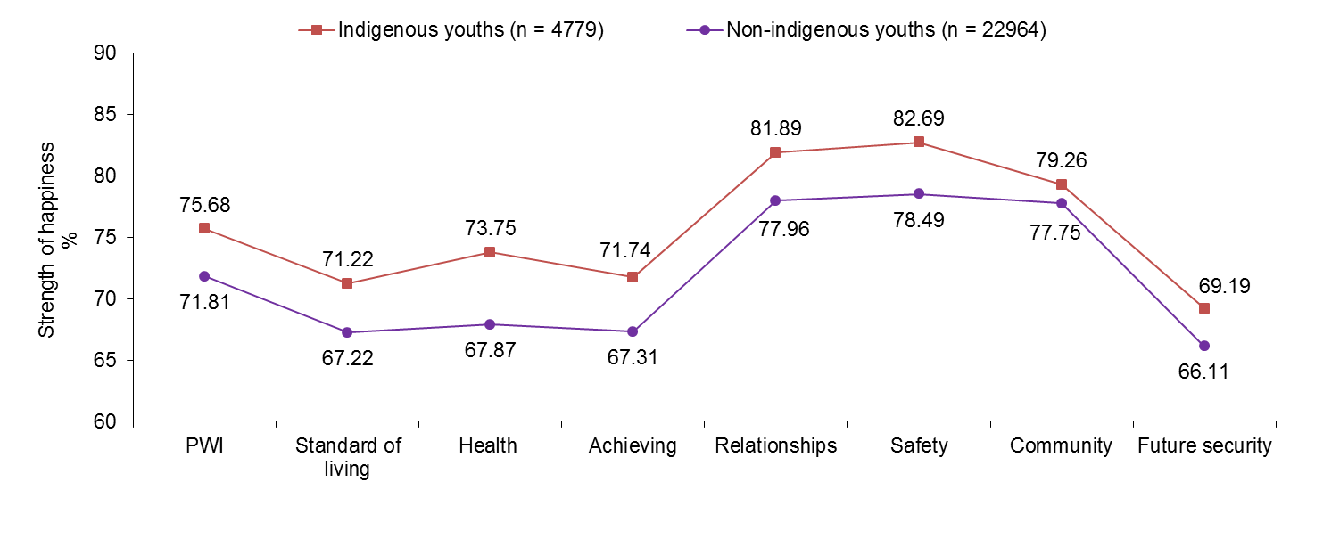

Figure 11.1: SWB and domain happiness scores for Indigenous and non-Indigenous YC participants

Indigenous young people enrolled in Youth Connections have, on average, significantly higher mean SWB (75.68 points) than non-Indigenous (71.81 points).

Indigenous young people scored significantly higher than non-Indigenous on all seven PWI-SC domains.

Interestingly, the largest difference between the two samples was on the domain of Health, with Indigenous young people scoring 5.88 points higher than non-Indigenous. This is a curious finding given that Indigenous Australians are well-documented to experience much poorer physical health outcomes compared to mainstream. One possible explanation for this finding is that in Indigenous culture, the term ‘health’ implies more than simply the prescence or absence of physical illness or injury to include spiritual, cultural, emotional and social components. In this light, mean scores on this domain may, in part, be attributed to how the item which asks *‘How happy are you with your health’?* is interpreted.

Another explanation for this finding may be found in relative comparisons young people make with others whom they are closest to. For example, it is possible that Indigenous young people may feel healthy compared to their parents, grandparents and other people in their communities with much poorer health (e.g., diabetes, heart disease, cancers, respiratory problems and arthritis) - illnesses that typically effect the health of older people.

Figure 11.2 displays the proportion of Indigenous and non-Indigenous YC participants categorised into the normal, challenged or high-risk group based on their overall PWI score. More information is provided in Table K11.3.

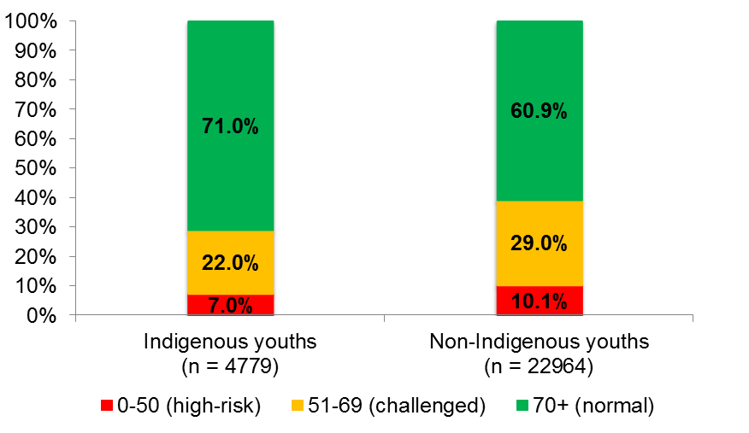

Figure 11.2: Proportion of Indigenous and non-Indigenous youths in each PWI group

Indigenous young people enrolled in Youth Connections are significantly more likely than non-Indigenous to score in the normal 70+ range (71.0% versus 60.9%).

The proportion of Indigenous young people who scored < 50 points on the PWI is 3.1% lower than non-Indigenous, however, this difference is not significant.

Indigenous young people are significantly less likely than non-Indigenous to score in the challenged range for SWB and who are likely to be experiencing a level of personal wellbeing below their normal set-point range.

Collectively, the data suggest that relative to non-Indigenous, a higher proportion of Indigenous young people have normal levels of personal wellbeing and may be adapting better to their challenging circumstances. However, the apparent sources of resilience among Indigenous young people are not yet entirely clear.

Figure 11.3 displays mean PWI and domain scores for Indigenous young people compared to mainstream. More information is provided in Table K11.4.

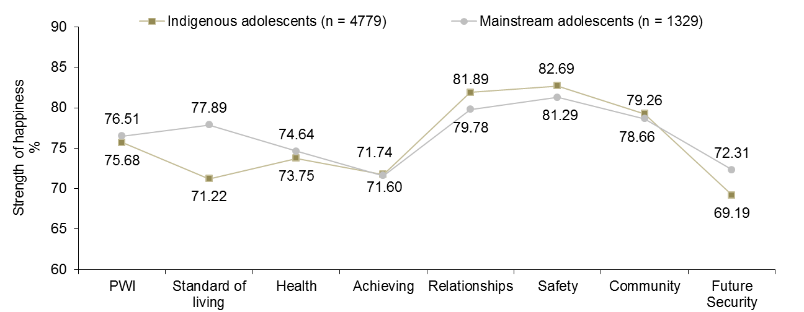

Figure 11.3: PWI and domain happiness scores for Indigenous and mainstream young people

Mean SWB of Indigenous and mainstream young people does not differ significantly.

With respect to the domains, Indigenous young people scored significantly lower than mainstream on Standard of Living (6.67 points) and Future Security (3.12 points). Lower scores on these domains may reflect the lower socio-economic status of Indigenous young people and their families and fewer opportunities to engage successfully with suitable employment and/or difficulties maintaining ongoing employment.

Interestingly, Indigenous young people scored significantly higher than mainstream on the domains of Relationships (2.11 points) and Safety (1.40 points). These are encouraging results and suggest that many Indigenous young people appear to have adequate social connections which support psychological wellbeing and feelings of safety and security.

## The SWB of male and female Indigenous young people

Figure 11.4 displays the mean PWI and domain scores for Indigenous males and females. More information is provided in Table K11.5.

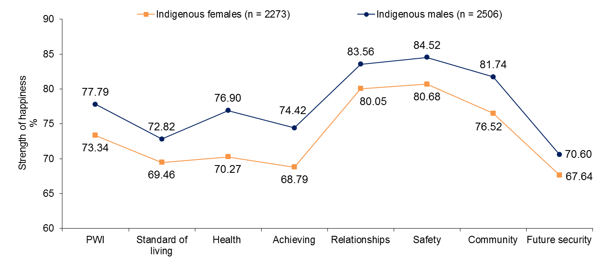

Figure 11.4: SWB and domain happiness scores for Indigenous females and males

Mean SWB for males (77.79 points) is significantly higher than for females (73.34 points).

Males scored significantly higher on all seven PWI domains, with the greatest differences on Health (6.63 points), Achieving in Life (5.63 points) and Community Connection (5.22 points).

These results appear to suggest more pervasive challenges to the SWB of young Indigenous females relative to males. Indeed, within the literature, Indigenous females have been reported as being a high-risk group for teenage pregnancy, exposure to violence, abuse and assault, and poor physical health. Also, it is reported that Indigenous females aged 15–24 are less likely than males (i.e., 28% compared with 22%) to be studying or in some form of employment (SCRGSP 2009), placing them at a significantly higher risk of social/economic disadvantage in adulthood.

Figure 11.5 displays the proportion of Indigenous females and males categorised into the normal, challenged or high-risk group based on their overall PWI score. More information is provided in Table K11.6.

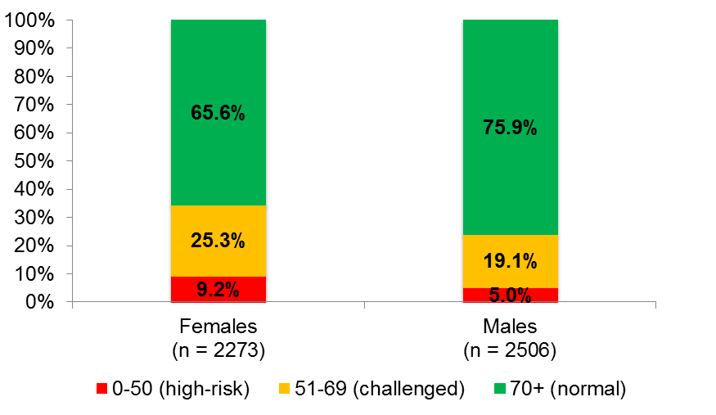

Figure 11.5: Proportion of Indigenous Australian females and males by PWI group

Three quarters of males compared to only two thirds of females scored in the normal 70+ range on the PWI-SC.

Females are almost two times more likely than males to have scored 50 or less on the PWI-SC and who are likely to be depressed or a high-risk for depression.

Approximately one third of females scored below the normal 70+ range compared to one quarter of males.

Collectively, the findings suggests that the complex needs and challenges facing Indigenous females, such as access to physical and mental health services, education, suitable employment, and awareness of the legal system and how the law can be used in matters which can directly benefit them, must be addressed as a necessary priority.

## Age and Indigenous SWB

Figure 11.6 displays mean personal wellbeing scores for Indigenous young people in each age group. More information is provided in Table K11.7.

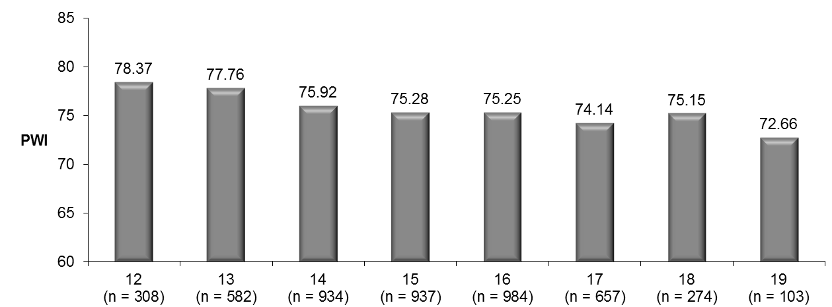

Figure 11.6: SWB amongst Indigenous young people in each age group

While the relationship between age and SWB is not entirely clear and predictable, personal wellbeing generally decreases between early and late adolescence.

With respect to significance, mean personal wellbeing for 12 and 13 years olds is higher than 15 to 19 year olds.

While Indigenous people across all age groups report a mean level of personal wellbeing within the normal 70+ range, the comparatively lower scores for young people aged 17 to 19 years suggests that a higher proportion of older Indigenous adolescents are not coping as well with the challenges they face as they approach/enter early adulthood and may be on a trajectory toward a lifetime of disadvantage/depression if their situations do not improve.

With respect to the domains, 12 to 15 year olds scored higher than 16 to 19 year olds on Standard of Living; while 12 year olds scored higher than 14 to 19 year olds on Achieving in life.

Lower scores on these two domains appear to be responsible for the general decline in SWB with age, with the greatest differences between the groups on Standard of Living and Achieving in Life. Specifically, 12 year olds scored an alarming 16.63 points higher on Standard of living than 19 year olds; while 12 year olds scored 9.99 points higher than 19 year olds on Achieving in life. These data suggest that concerns about employment, finances and future may be a contributor to lower personal wellbeing among older Indigenous teenagers/young adults. Indeed, successful participation in education settings and subsequent employment is the key to addressing these concerns.

Figure 11.7 displays the proportion of Indigenous respondents categorised into the normal, challenged or high-risk group based on their overall PWI score. More information is provided in Table K11.8.

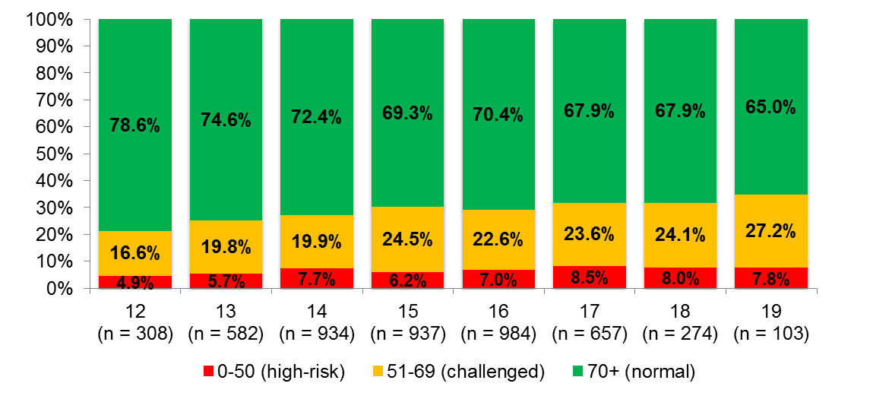

Figure 11.7: Proportion of Indigenous young people in each PWI group by age

Approximately three-quarters of 12 and 13 year olds scored in the normal 70+ range. This proportion reduces to approximately two-thirds of 17 to 19 year olds.

Following this same trend, the proportion of Indigenous adolescents who are suspected of being depressed or considered a very high-risk for depression generally increases with age, with young people aged 17 to 19 years approximately one and a half times more likely than 12 year olds to score less than or equal to 50 on the PWI.

The implication of these findings is that there may be a narrow window of opportunity in early adolescence to identify and assist many Indigenous young people ‘at-risk’, to help them engage with their education and to make sensible life choices before a history of negative thinking/poor choices are reinforced and provide additional barriers toward progress.

## Connection level and Indigenous SWB

Figure 11.8 displays mean PWI and domain scores for Indigenous respondents according to their level of connection. See Table K11.9 for more information.

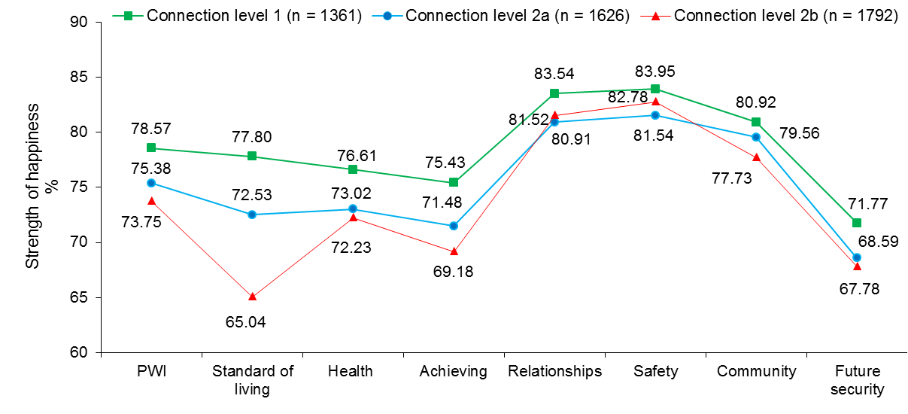

Figure 11.8: PWI, domain happiness scores and Connection level

Mean personal wellbeing for Connection level 1 young people (78.57) is significantly higher than 2a and 2b; while the mean for 2a is significantly higher than 2b.

Connection level 1 young people scored significantly higher than 2a and 2b on five of the seven PWI domains (excluding Safety and Community Connection).

The greatest observed difference between the three groups is on the domain of Standard of Living, with Connection level 1 young people scoring 12.76 points higher than 2b.

It is also notable that Connection level 1 young people scored 6.25 points higher than 2b on Achieving in Life.

Collectively, the results suggest that increasing level of disengagement/disconnection is associated with lower personal wellbeing for many Indigenous young people. This may be attributed, in part, to greater social and economic disadvantage, further highlighting the importance of programs and interventions such as Youth Connections that aim to improve educational and employment-related outcomes in this group.

Figure 11.9 displays the proportion of Connection level 1, 2a and 2b Indigenous young people categorised into the normal, challenged or high-risk group based on their overall PWI score. More information is provided in Table K11.10.

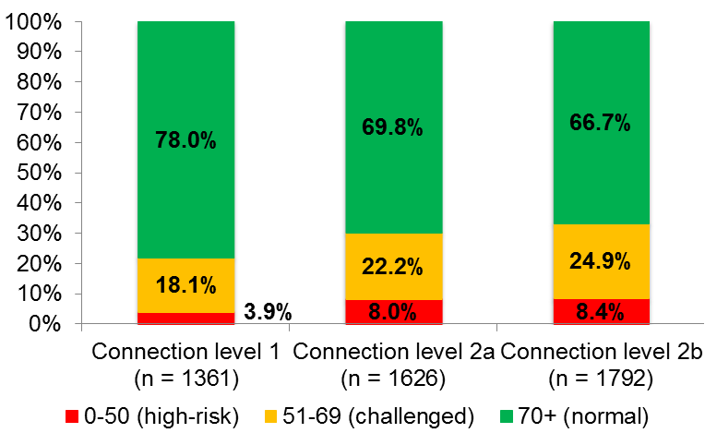

Figure 11.9: Proportion of Indigenous young people in each PWI group by Connection level

78.0% of Connection level 1 young people scored in the normal 70+ range. However, this proportion reduces to 69.8% and 66.7% of 2a and 2b respectively.

Both 2a and 2b young people are over two times more likely than Connection level 1 to score 50 or less on the PWI and who are most at-risk for depression.

These findings further highlight the detrimental impact that disengagement has on the personal wellbeing of many Indigenous adolescents, with higher levels of disengagement clearly very much associated with poorer psychological wellbeing.

## The SWB of Indigenous adolescents across Australia

Figure 11.10 displays mean SWB for Indigenous young people who live in each of the eight Australian states and territories. More information is provided in Table K11.11.

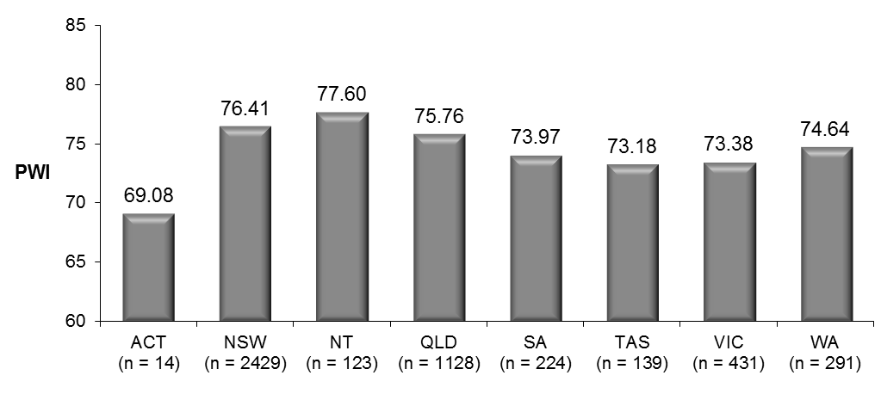

Figure 11.10: State of residence and SWB

Mean SWB is highest in the NT (77.60), followed by NSW (76.41) and QLD (75.76).

Means in all other states and territories are comparatively lower, suggesting that Indigenous adolescents residing in these locations are a higher risk for low personal wellbeing and depression (e.g., in TAS and VIC). However, no statistically significant between-group differences are evident, most likely due to the very small number of respondents in the ACT.

With regard to gender differences *within* each state, males scored significantly higher than females in TAS (7.65 points), NSW (5.53 points), QLD (3.64 points) and VIC (2.96 points). Identifying and addressing the factors that contribute to significantly poorer psychological wellbeing experienced by females compared to males in these states should be a priority.

Figure 11.11 displays mean SWB for Indigenous young people who live in Major cities, Inner regional, Outer regional, Remote and Very remote parts of Australia according to the ARIA. More information is provided in Table K11.12.

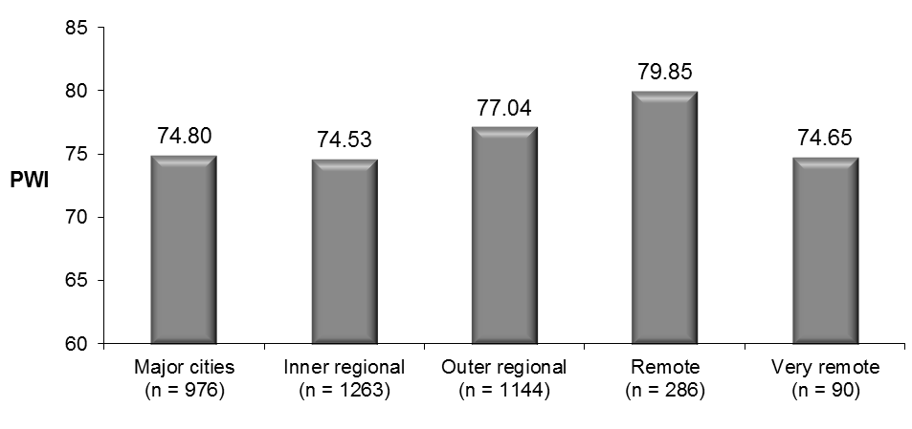

Figure 11.11: Accessibility/Remoteness Index of Australia (ARIA) and SWB

Mean SWB in the Remote group (79.85) is significantly higher than in all other locations; while the mean for the Outer regional group is significantly higher than in Major cities and Inner regional parts of the country.

Indigenous young people living in Inner regional parts of the country have the lowest collective SWB, followed closely by the Very remote group.

Notable significant between group differences concerning the domains are: Remote > Major cities and Inner regional on all domains except Community Connection and Future Security; and Outer regional > Major cities and Inner regional on Health and Relationships.

Finally, the mean for the Health domain is a significant 9.13 points higher in the Remote group compared to Major cities.

Collectively, the results presented in Figure 11.11 are very interesting and may be seen to conform with the view that Aboriginal and Torres Strait Islander concepts such as connection to land, culture, spirituality, ancestry, family and community are important ‘protective factors’ which promote resilience (Zubrick et al., 2010). Such factors may serve to mitigate the potentially harmful impact that stressful circumstances can have on social and emotional wellbeing at the individual and community level. Moreover, these factors can serve as a “unique reservoir of strength” (Kelly et al. 2009; cited in Zubrick et al., 2010), which can be accessed and may aid recovery when faced with adversity.

These views are consistent with Parker (2012) who offers a fascinating insight into the mental health of Indigenous Australian’s, suggesting that ancient connections to community, spirituality, culture and country are factors that have traditionally reinforced good mental health in this group, with historical accounts of mental illness in Indigenous history considered rare (Hunter, 2012). Earlier, Hunter (2003) suggests that this ancient society has undergone such rapid change in a historically short period of time that it is not surprising that patterns of mental health issues experienced by Indigenous Australians have changed, with people most disconnected from their homelands (e.g., Indigenous people living in Major cities) at greatest risk for experiencing a range mood and mental disorders, such as depression and anxiety. However, Very remote living appears to be associated particularly low personal wellbeing, suggesting that extreme geographic isolation from the broader community may be a risk factor for poor mental health.

## Post-program changes in Indigenous SWB

Figure 11.12 displays mean PWI and domain happiness scores for the 1,014 Indigenous young people (54.7% male; 44.5% Connection level 1) who completed the PWI-SC at the beginning of their involvement in Youth Connections (‘pre-program’) and following their exit from the program (‘post-program’). These respondents were slightly younger than the total sample, with a mean age of 14.71 years (*SD* = 1.60 years). More information is provided in Table K11.13.

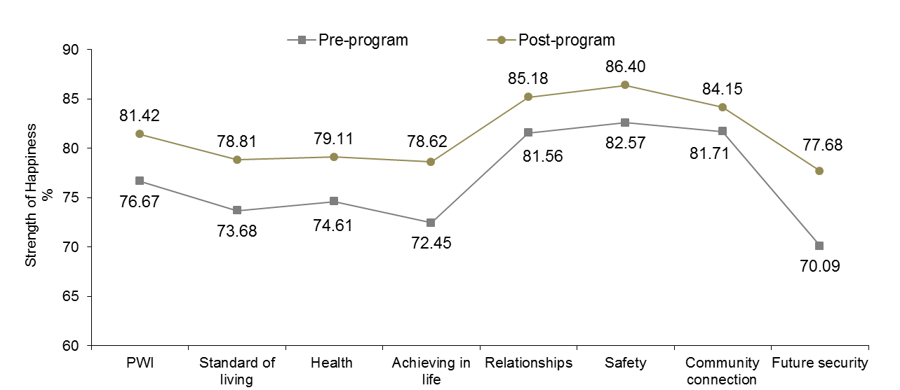

Figure 11.12: SWB and domain happiness scores at initial and at follow up interview (Indigenous youths)

A significant 4.75 percentage point increase in mean SWB is observed pre-post program (from 76.67 to 81.42 points).

Significant pre-post program improvements across all seven PWI domains are also evident, with the greatest changes observed on (7.59 points) and Achieving in Life (6.17 points).

These are very positive results and suggest that the YC Program is having a positive impact on the personal wellbeing of many Indigenous adolescents who complete the program, at least in the short term. It appears that their time with Youth Connections has resulted in a greater sense of hope and positivity about their futures and happiness with the things they want to be good at (e.g., to do well at school).

Figure 11.13 displays mean PWI and domain happiness scores for the 459 Indigenous females who completed the PWI-SC at the beginning of their involvement in Youth Connections (‘pre-program’) and following their exit from the program (‘post-program’). More information is provided in Table K11.14.

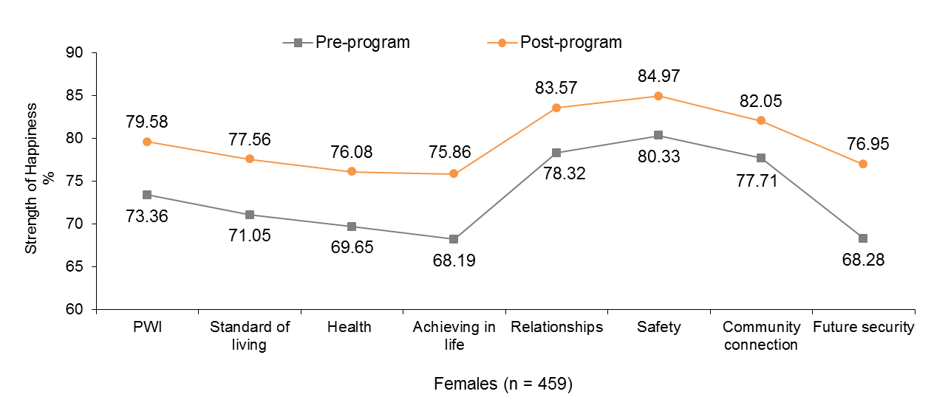

Figure 11.13: SWB and domain happiness scores at initial and at follow up interview: Indigenous females

A significant 6.22 percentage point increase in mean SWB is observed pre-post program (from 73.36 to 79.58 points).

Significant pre-post program improvements across all seven PWI domains are also evident, with the greatest changes observed on Future Security (8.67 points) and Achieving in Life (7.67 points).

It is clear that participation in the Youth Connections program is having a positive and pervasive impact on the way Indigenous females feel about themselves and the things in their lives since having completed their time in the program. These results are very encouraging, particularly given that Indigenous females have been identified as being a higher risk for low personal wellbeing and depression.

Figure 11.14 displays mean PWI and domain happiness scores for the 555 Indigenous males who completed the PWI-SC at the beginning of their involvement in Youth Connections (‘pre-program’) and following their exit from the program (‘post-program’). More information is provided in Table K11.15.

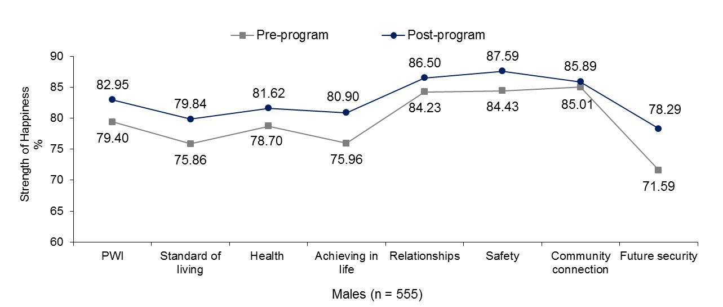

Figure 11.14: SWB and domain happiness scores at initial and at follow up interview: Indigenous males

A significant 3.55 percentage point increase in mean SWB is observed pre-post program (from 79.40 to 82.95 points).

Significant pre-post program improvements were evident across all domains except Community Connection, with the greatest changes observed on Future Security (6.70 points) and Achieving in Life (4.94 points).

It is notable that the post-program mean SWB score for males is very high, highlighting the positive experience that many young Indigenous males have had with Youth Connections. In time, however, it is expected that levels of personal wellbeing will return several points to within more normal levels.

Figure 11.15 displays pre-post program mean PWI and domain happiness scores for the 107 Indigenous young people who achieved the program outcome of ‘Re-engaged in education over the whole school term, or for 13 weeks’. More information is provided in Table N14.21.

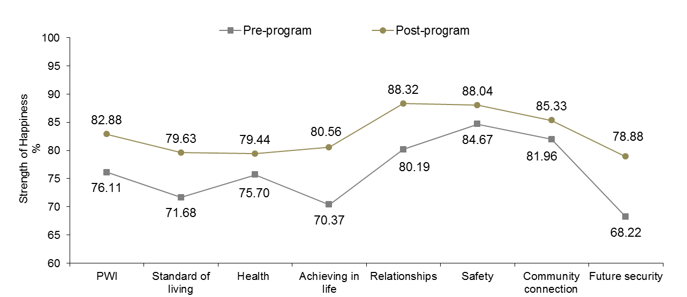

Figure 11.15: Outcome achieved: Re-engaged with education (Indigenous)

A significant 6.77 percentage point increase in mean SWB from 76.11 points to 82.88 points can be observed.

Significant pre-post program increases in happiness scores across all seven PWI domains were also evident, with the greatest positive changes on Future Security (10.66 points), Achieving in Life (10.19 points) and relationships (8.13 points).

These findings are very encouraging and support an association between recent participation in an education setting and increased feelings of personal of wellbeing among Indigenous young people. Moreover, these findings support efforts by Youth Connections to re-engage young people with their education, giving them the greatest opportunity to partake in post-secondary education, training and employment.

Figure 11.16 displays pre-post program mean PWI and domain happiness scores for the 167 Indigenous young people who achieved the program outcome “Commenced in education”. More information is provided in Table N14.24.

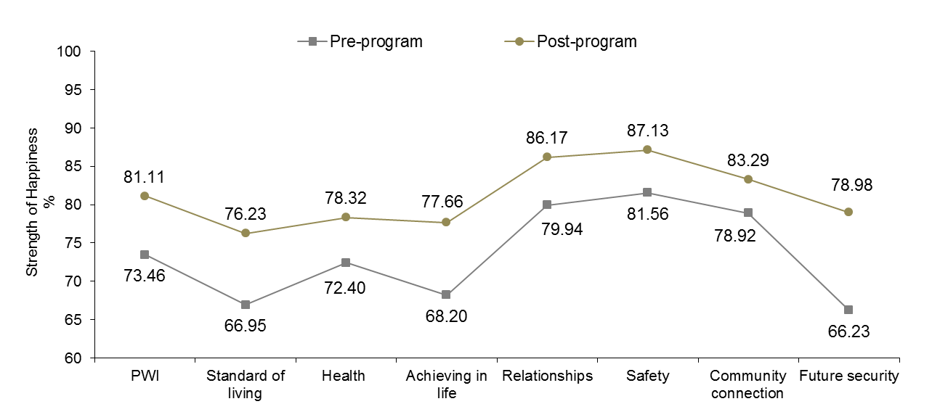

Figure 11.16: Outcome achieved: Commenced in education (Indigenous)

A significant 7.65 percentage point increase in mean SWB from 73.46 points to 81.11 points can be observed.

Significant pre-post program increases in happiness scores are evident across all seven domains, with the greatest positive changes observed on Future Security (12.75 points), Achieving in Life (9.46 points) and Standard of Living (9.28 points).

These are exceptional results and suggest that Indigenous young people who commenced in education during their time with Youth Connections have experienced a positive change in their worldview, particularly with respect to their thoughts about what will happen to them later on in their lives and their sense of personal achievement since having commenced in education.

Figure 11.17 displays pre-post program mean PWI and domain happiness scores for the 314 Indigenous young people young people who achieved the program outcome of ‘Addressed and minimised the barriers created by low literacy and/or numeracy’. More information is provided in Table N14.23.

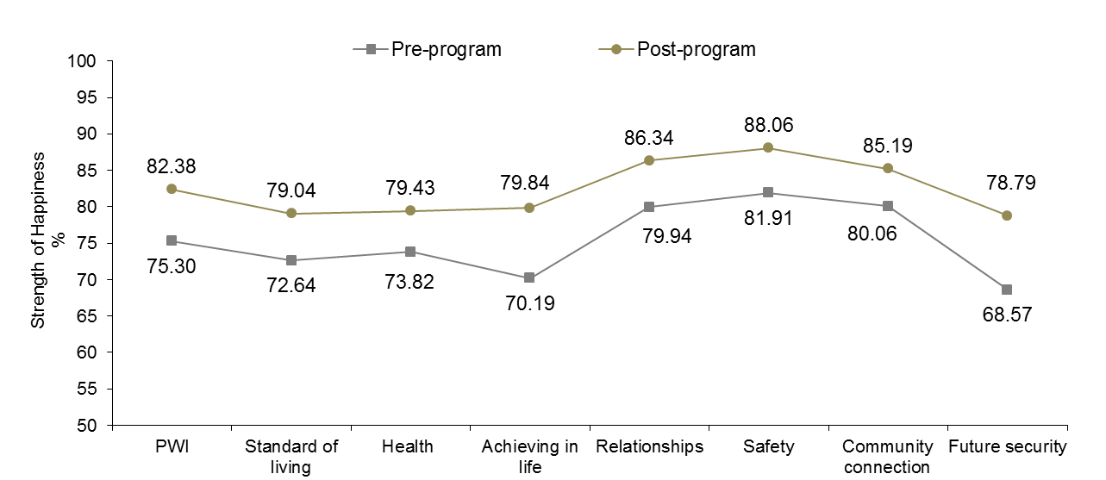

Figure 11.17: Outcome achieved: Addressed low numeracy/literacy (Indigenous)

A significant 7.08 percentage point increase in mean SWB from 75.30 points to 82.38 points can be observed.

Significant pre-post program increases in happiness scores across all seven PWI domains were also evident, with the greatest positive changes on the domains of Future Security (10.22 points), Achieving in Life (9.65 points) and Standard of Living and Relationships (both 6.40 points).

The domain profile in Figure 14.17 reflects a group of young people who appear to be more confident in their abilities and more optimistic about their futures, having completed their time in the YC Program and achieved this key outcome.

Figure 11.18 displays pre-post program mean PWI and domain happiness scores for the 102 Indigenous young people young people who achieved the program outcome of ‘Addressed family support issues’. More information is provided in Table N14.26.

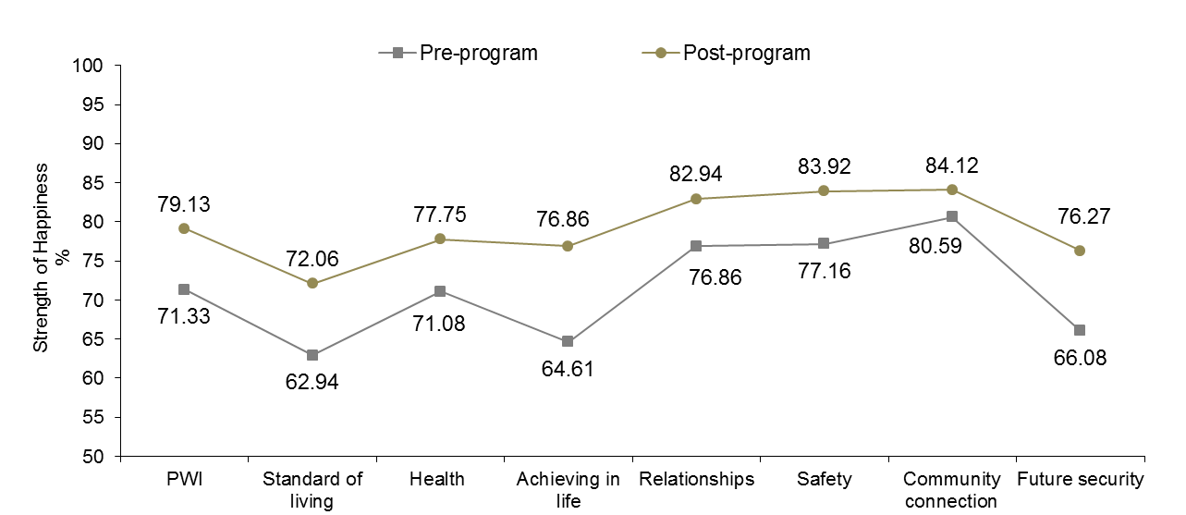

Figure 11.18: Outcome achieved: Addressed family support issues (Indigenous)

A significant 7.80 percentage point increase in mean SWB from 71.33 points to 79.13 points can be observed.

Significant pre-post program increases in happiness scores across all seven PWI domains were also evident, with the greatest positive changes on Achieving in Life (12.25 points), Future Security (10.19 points) and Standard of Living (9.12 points).

The low pre-program means highlight the detrimental impact that inadequate family support has on the psychological wellbeing of many Indigenous children. Equally as important, the post-program means support the efficacy of interventions that target Indigenous young people and their families. In this way, interventions also serve to build more stable family dynamics and increase resilience.

Figure 11.19 displays pre-post program mean PWI and domain happiness scores for the 75 Indigenous young people young people who achieved the program outcome of ‘Addressed mental health issue’. More information is provided in Table N14.27.

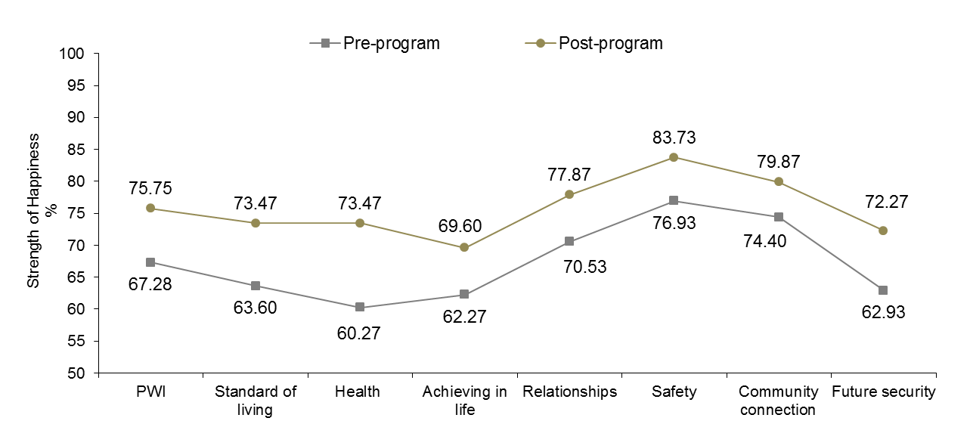

Figure 11.19: Outcome achieved: Addressed family support issues (Indigenous)

A significant 8.47 percentage point increase in mean SWB from 67.28 points to 75.75 points can be observed.

Significant pre-post program increases in happiness scores across all seven PWI domains were also evident, with the greatest positive changes on Health (13.20 points), Standard of Living (9.87 points) and Future Security (9.34 points).

The very low pre-program mean SWB score highlight the negative impact of mental health problems on subjective wellbeing. While the post-program increase in SWB is encouraging, concerted efforts must be directed toward ongoing evaluation and monitoring of the mental health status of Indigenous youths as they transition through to adulthood.

## Happiness with School

Happiness with School for Indigenous young people living in each of the eight Australian states and territories is presented in Figure 11.20. More information is provided in Table K11.16.

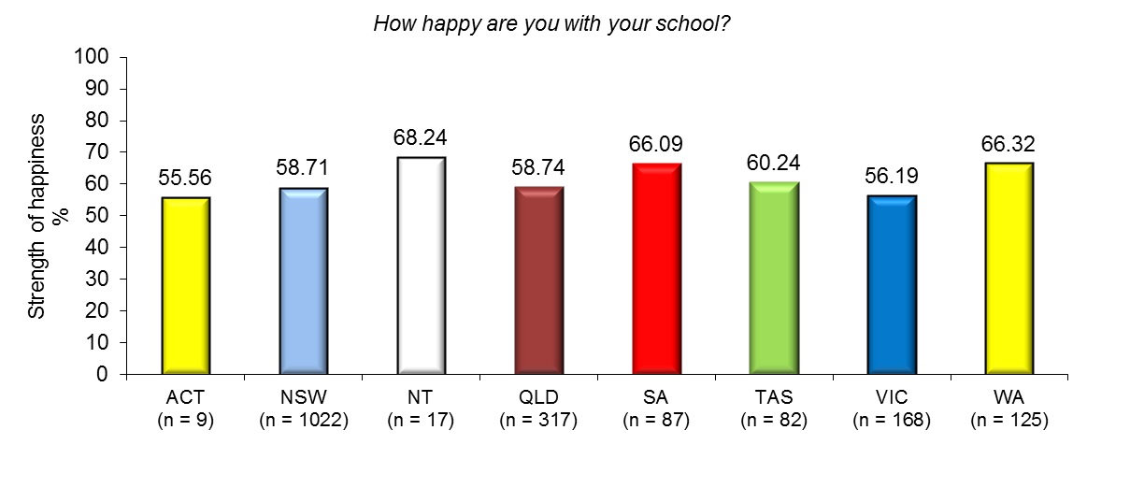

Figure 11.20: Happiness with school for young Indigenous people by residency

Concerning those states with adequate sample size for statistical comparison (n > 20), mean Happiness with School is highest in WA and lowest in VIC.

Means in SA and the NT (while sample sizes are low) are also very encouraging and suggest that the majority of Indigenous young people in these locations who persevere with their education appear to have predominately positive feelings toward school.

However, comparatively lower means in all other states and territories are worrying and must be addressed if federal and state governments are to meet their high-school completion targets regarding Australia’s Indigenous population.

Happiness with School for Indigenous young people who live in Major cities, Inner regional, Outer regional, Remote and Very remote parts of Australia classified according to the ARIA are presented in Figure 11.21. More information is provided in Table K11.17.

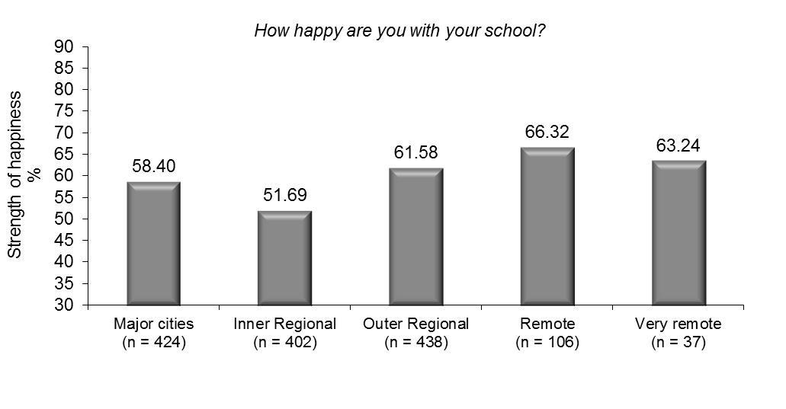

Figure 11.21: Happiness with school according to the ARIA

Mean happiness with School is highest in Remote parts of Australia and lowest in Inner regional towns and centres.

With respect to significance, the mean for the Remote group is higher than in Major cities and Inner regional parts of the country.

A major implication of these findings is that while sustained efforts should be directed at increasing school participation rates amongst Indigenous adolescents across the country, particular attention is needed in finding ways to enhance the school experience for the those young people already attending school.

Happiness with School for Indigenous young people in each age group is presented in Figure 11.22. More information is provided in Table K11.18.

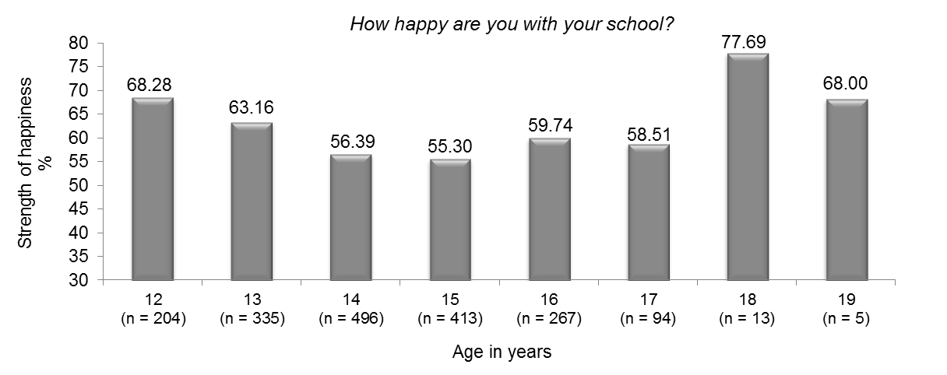

Figure 11.22: Happiness with school according to the ARIA

Mean happiness with School decreases consistently between the ages of 12 and 15 years; although does improve slightly in the years following. However, due to small sample size, interpretion of scores beyond the age of 17 years is limited.

On a more positive note, the mean for 12 year olds is encouraging and suggets that many Indigenous children appear to be enjoyng aspects of school life at this age. However, the subsequent decline in School happiness highlights the need to address the complex issues facing Indigenous young people and their successful engagement with education in early adolescence.

# 12 The subjective wellbeing of humanitarian refugees

A ‘humanitarian refugee’ in Youth Connections is defined as a permanent resident of Australia who was granted a humanitarian visa. In other words, they are young people who entered Australia seeking asylum, applied for and were granted permanent residency.

Many young refugees defined in this way may have traumatic pasts and may have been forced to leave their country or home due to war or persecution and/or after having spent time living in refugee camps. However, data on their country of origin and how long they have been living in Australian society as a permanent resident is not available.

Data from 458 humanitarian refugees were analysed in this report. Their ages ranged from 12 to 19 years with a mean age of 15.82 years (*SD* = 1.74 years). There were 209 female refugees (45.6%) and 249 male refugees (54.9%); with the majority residing in VIC (44.5%), NSW (21.4%) and WA (9.2%).

## Mean SWB and domain happiness scores: Comparative analyses with non-refugees

Figure 12.1 displays mean PWI and domain happiness scores for refugees and non-refugees enrolled in Youth Connections. More information is provided in Table L12.2.

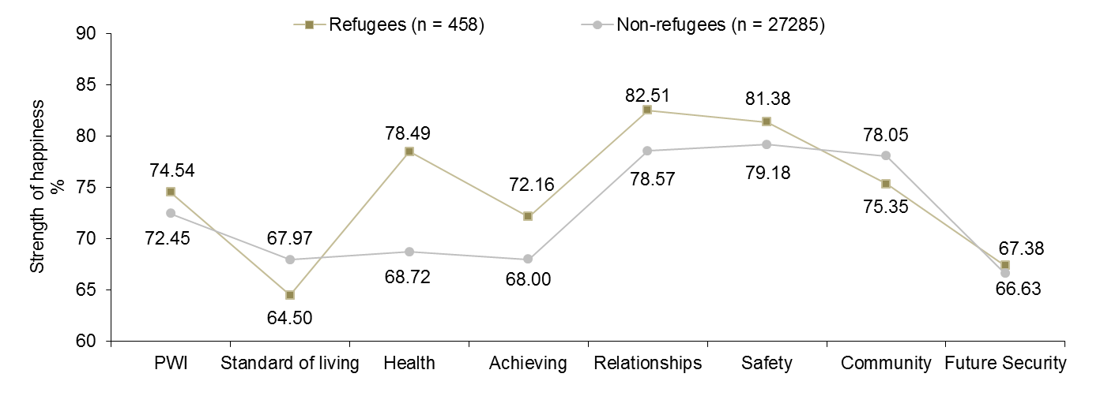

Figure 12.1: Mean PWI and domain happiness scores for refugees and non-refugees

Mean SWB for refugees is a significant 2.09 points higher than non-refugees.

With respect to the domains, refugees scored significantly higher than non-refugees on Health (9.77 points), Achieving in Life (4.16 points) and Relationships (3.94 points). These results are encouraging and may reflect a greater sense of hope, optimism and enthusiasm young refugees have for their new life in their adopted country.

On the other hand, refugees scored significantly lower than non-refugees on Standard of Living (3.47 points) and Community Connection (2.70 points). These findings are not surprising given displacement from their country of origin and potential difficulties adjusting to their new living arrangements and communities and their parents finding suitable employment.

Figure 12.2 shows the proportion of refugees and non-refugees categorised into the normal, challenged or high-risk group based on their overall PWI score. More information is provided in Table L12.3.

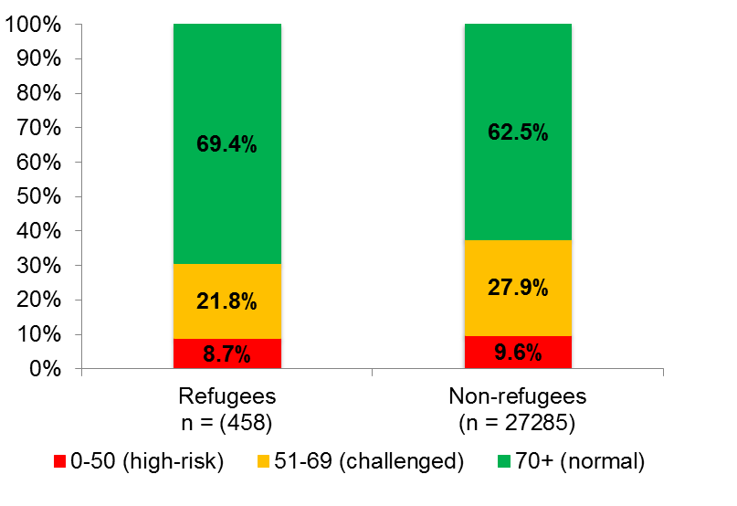

Figure 12.2: Refugees and non-refugees according to PWI groups

Despite the cultural, social and economic challenges refugees are likely to be facing in their adopted country, 69.4% scored in the normal range for personal wellbeing, compared to 62.5% of non-refugees.

8.7% of refugees scored in the high-risk range for SWB, compared to 9.6% of non-refugees.

These results highlight the challenges facing both refugees and non-refugees living in Australia and the adverse impact that disengagement/disconnection have on their personal wellbeing.

Figure 12.3 displays the mean PWI and domain scores for refugees compared to mainstream. More information is provided in Table L12.4.

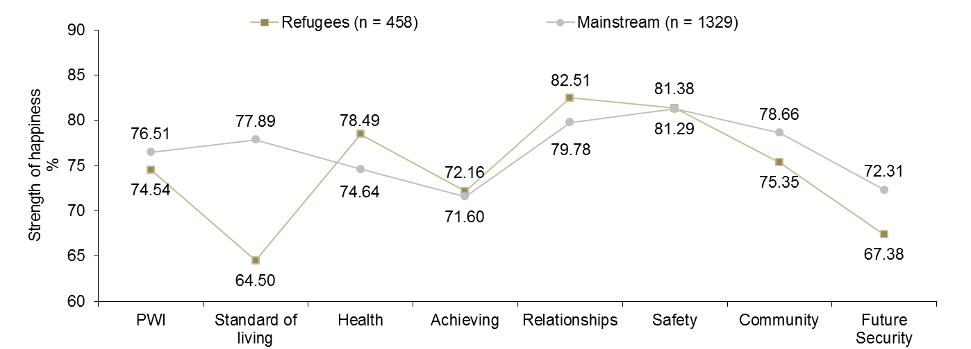

Figure 12.3: Mean PWI and domain happiness scores for refugees and mainstream

Not surprisingly, mean SWB for refugees is significantly lower than mainstream.

Refugees scored significantly lower than mainstream on the domains of Standard of Living (13.39 points), Future Security (4.93 points) and Community Connection (3.31 points).

On a more positive note, refugees scored a significant 3.85 points and 2.73 points higher respectively than mainstream on Health and Relationships.

## The SWB of male and female refugees

Figure 12.4 displays the mean PWI and domain happiness scores for female and male refugees. More information is provided in Table L12.5.

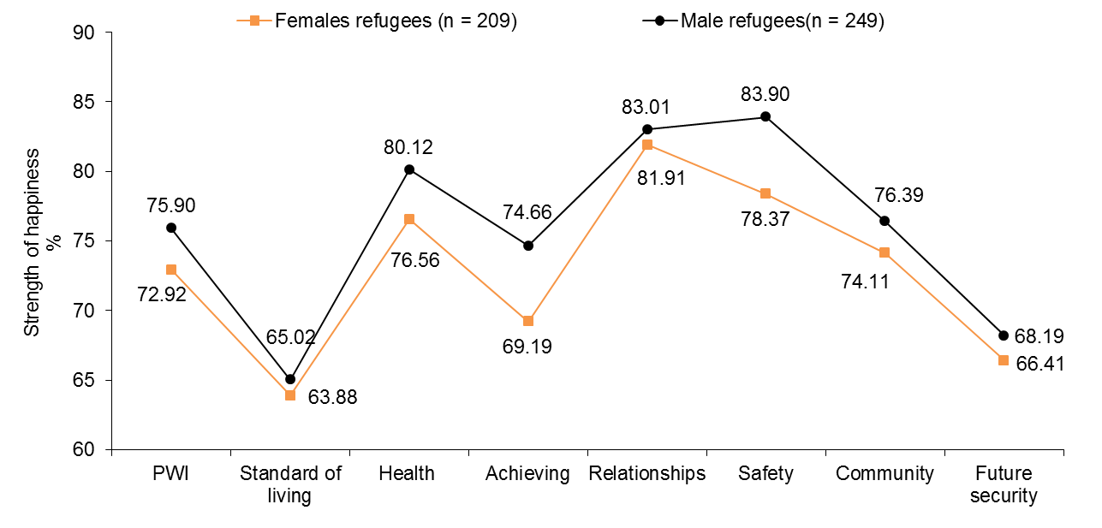

Figure 12.4: Mean PWI and domain happiness scores for male and female refugees

Mean SWB for male refugees is significantly higher than females; with males scoring significantly higher on the domains of Safety (5.53 points) and Achieving in life (5.47 points).

The results for females are concerning as feelings of safety and security are paramount to a person’s overall sense of wellbeing. Moreover, female refugees have the right to feel that they have the same opportunities as males to pursue and participate in activities (e.g., school, sport and music) that provides a sense of purpose and personal achievement. In this light, future research should be undertaken to better understand the reasons why female refugees scored lower than males on the question which asks ‘How happy are you with the things you want to be good at’?

Collectively, the results suggest that female refugees may not be to be coping as well with the challenges they are facing in their adopted country relative to males. However, these data are limited and the underlying reasons for the differences between the genders are not well understood.

Figure 12.5 shows the proportion of male and female refugees categorised into the normal, challenged or high-risk group based on their overall PWI score. More information is provided in Table L12.6.

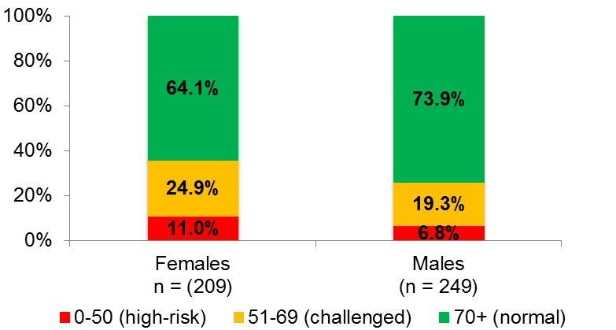

Figure 12.5: Female and male refugees in each PWI group

Male refugees are significantly more likely than females to score within the normal range for personal wellbeing (73.9% versus 64.1%).

Females are approximately one and a half times more likely to meet the criteria for very low SWB (< 50 points), placing them at considerably higher risk for depression.

Collectively, the data suggest that concerted efforts must be directed toward understanding and addressing the factors that contribute to lower levels of wellbeing experienced by female refugees.

Figure 12.6 displays mean personal wellbeing scores for refugees in each age group. More information is provided in Table L12.7.

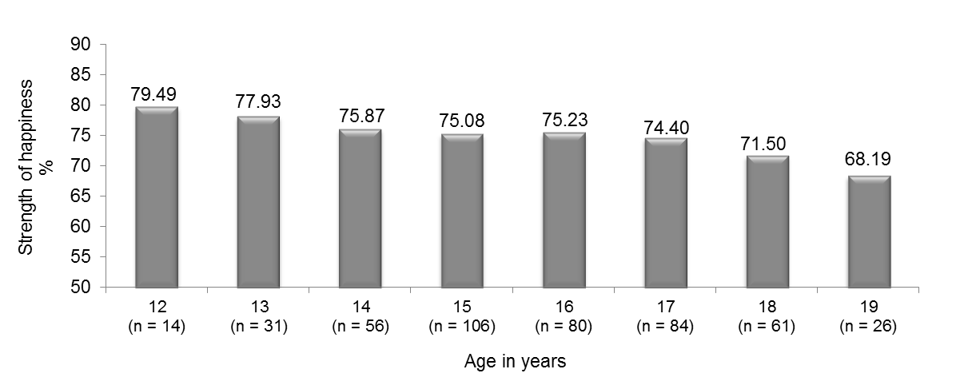

Figure 12.6: Mean SWB for refugees in each age group

While the sample sizes of some of the groups are small, SWB generally decreases with age from a high of 79.49 points at age 12 years to a low of 68.19 points at age 19 years. This is concerning and suggests that more needs to be done to assist young refugees as they attempt to complete their schooling and successfully transition to post-secondary education and employment. These data also suggest that many refugees may require counseling and other psychological services, particularly in their latter teenage years, to help them cope with the challenges they face in their adopted country.

Figure 12.7 displays mean SWB scores for young refugees living in each Australian State and territory. More information is provided in Table L12.8.

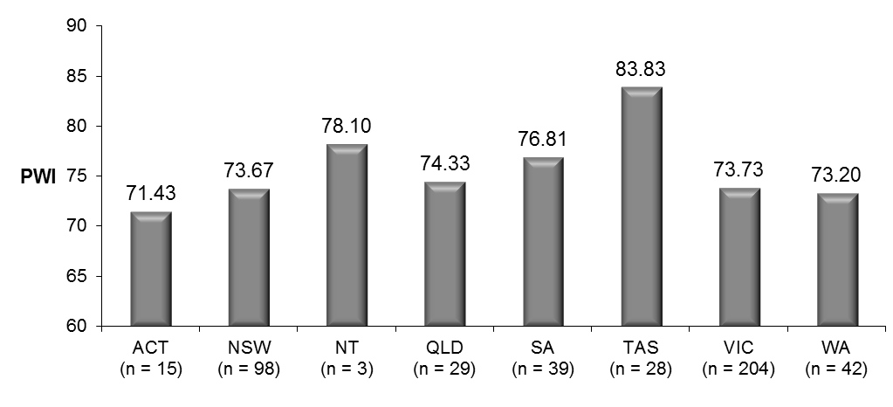

Figure 12.7: Mean SWB for refugees residing in each Australian state and territory

While the sample sizes of some of the groups are small (e.g., in the NT and ACT), the results suggest some variation in SWB experienced by refugees according to their state of residence. For example, means in TAS and SA are encouraging, suggesting that many young refugees living in these states may be adapting better to life in Australia. However, means in VIC, NSW and WA (home to the majority of young refugees), are comparatively lower, suggesting perhaps greater challenges to the personal wellbeing of young people who are resettled in these locations.

# 13 Subjective wellbeing at follow up interview

7,181 young people (25.9%) aged 12 to 19 years (*M* = 14.96 years; *SD* = 1.60 years) have so far completed the PWI-SC on two occasions – at their first meeting with their case manager and following their exit from the YC Program.

3,444 (48.0%) were female and 3,737 (52.0%) were male. 64.9% were aged 15 years or less, while 43.6% were categorised as Connection level 1, 34.7% 2a and 21.7% 2b respectively. These respondents represent groups of young people identified as a lower risk for depression (e.g., males, younger adolescents and Connection level 1) and so we would expect their pre-program mean SWB and domain scores to be slightly higher than the overall sample means.

The over-representation of Connection level 1 young people (and under-representation of 2b young people) who have completed the program further highlights the need to identify and support at-risk young people before years of disengagement and poor life choices are reinforced and create an additional barrier to progression.

The average length of time between initial and follow up surveys was 159.0 days (SD = 96.8 days) or approximately 5.1 months (SD = 3.1 months). There were no differences in average program completion times according to gender or Indigenous heritage. However, on average, 12 to 15 year olds completed the program 18.2 days sooner than 16 to 19 year olds (152.2 days versus 175.4 days); while Connection level 1 young people completed the program 41.2 days sooner than 2b (141.1 days versus 182.9 days). Finally, with respect to residency, young people living in the ACT on average completed their time in YC Program the soonest (96.7 days or 3.1 months); while young people living in SA (228.0 days or 7.4 months) took the longest – this is a considerable 131.3 day or 4.2 month difference.

## Post program change in personal wellbeing

Figure 13.1 displays mean PWI and domain happiness scores for the 7,181 young people who completed the PWI-SC at the beginning of their involvement in Youth Connections (‘pre-program’) and following their exit from the program (‘post-program’). More information is provided in Table M13.4.

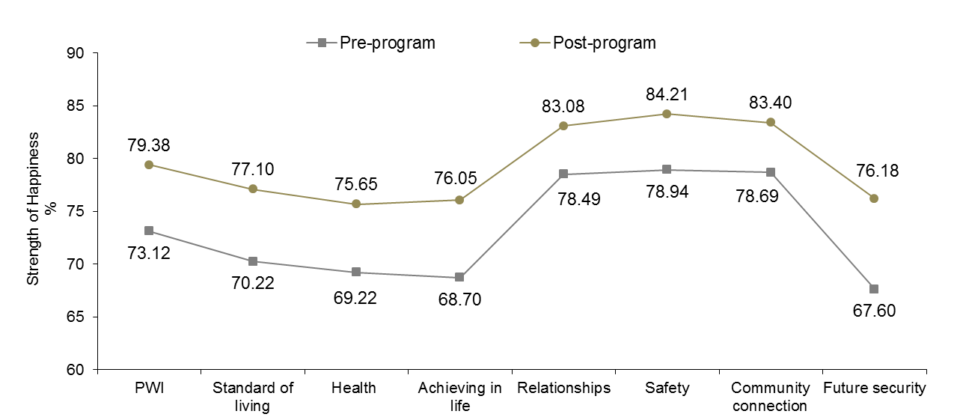

Figure 13.1: SWB and domain happiness scores at initial (pre-program) and at follow up (post-program) interviews

A significant 6.26 point increase in mean SWB is observed post-program. This is a very encouraging result and indicates that the YC Program is having a positive impact on the personal wellbeing of many young people who complete the program, at least in the short term.

Significant post-program improvements across all seven PWI domains are also evident, with the greatest changes observed on the domains of Future Security (8.58 points), Achieving in Life (7.35 points) and Standard of Living (6.88 points). These are exceptional results, particularly given that low scores on the domains of Future Security and Standard of Living consistently rank amongst those domains which contribute to very low personal wellbeing scores amongst some of the more high-risk groups of young people.

Collectively, these data suggest that many young people who complete the program are feeling more hopeful, optimistic and more positive about themselves and where their lives may be headed.

It is important to note, however, that it remains uncertain as to whether these improvements are lasting changes in positive mood, or short term fluctuations in positive emotions as a consequence of their recent experiences with Youth Connections. However, it goes without saying that for many young people, their experiences with the YC Program will be a major turning point in their lives and the first step toward a happier, more independent and fulfilling life.

Figure 13.2 shows the proportion of young people categorised into the normal, challenged or high-risk group based on their overall PWI score. More information is available in Table M13.5.

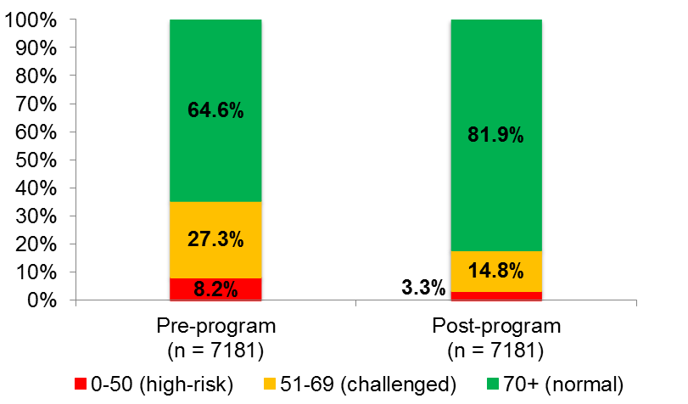

Figure 13.2: Proportion of young people in each PWI group pre-post program

The proportion of young people who scored in the 70+ normal range increased by 17.3% pre-post program.

The proportion of young people who scored in the high-risk range for personal wellbeing reduced by over half post-program - from 8.2% to 3.3%.

A 12.5% decrease in the proportion of young people scoring in the challenged range for personal wellbeing was also observed post-program.

These results suggest a considerable reduction in the proportion of young people who are likely to be depressed or at high-risk for depression and for many of these young people, restoration of their personal wellbeing back within their normal set-point range.

These data overwhelmingly support the YC Program as achieving one of its major aims – improving personal wellbeing for a significant proportion of young people who complete the program, at least in the short term.

Figure 13.3 displays the proportion of the 588 young people who initially scored in the 0-50 group (pre-program) who now score in one of the three PWI groups post-program. More information is available in Table M13.10.

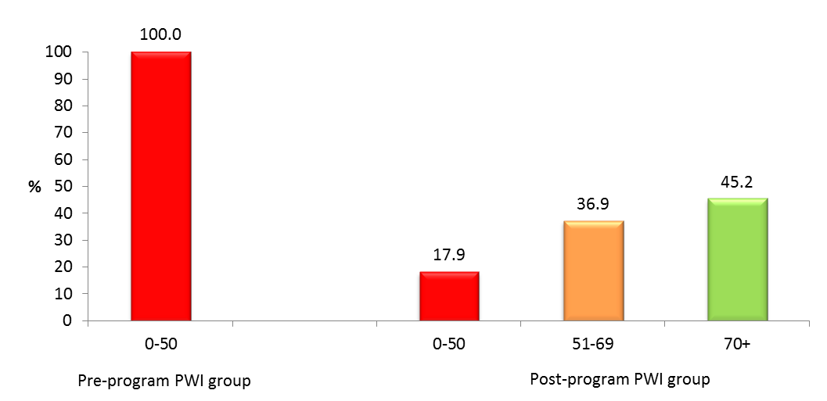

Figure 13.3: Post-program PWI groups for young people who scored between 0-50 pre-program

Only 17.9% of young people remained in the 0-50 group post-program, with 36.9% and 45.2% moving into the 51-69 and normal 70+ groups respectively.

This is an outstanding result for Youth Connections and suggests that the vast majority of young people (82.1%) are experiencing considerable improvements in their psychological wellbeing since having completed the program.

Figure 13.4 displays the proportion of the 1,957 young people who initially scored in the 51-69 group (pre-program) who now score in one of the three PWI groups post-program. More information is available in Table M13.11.

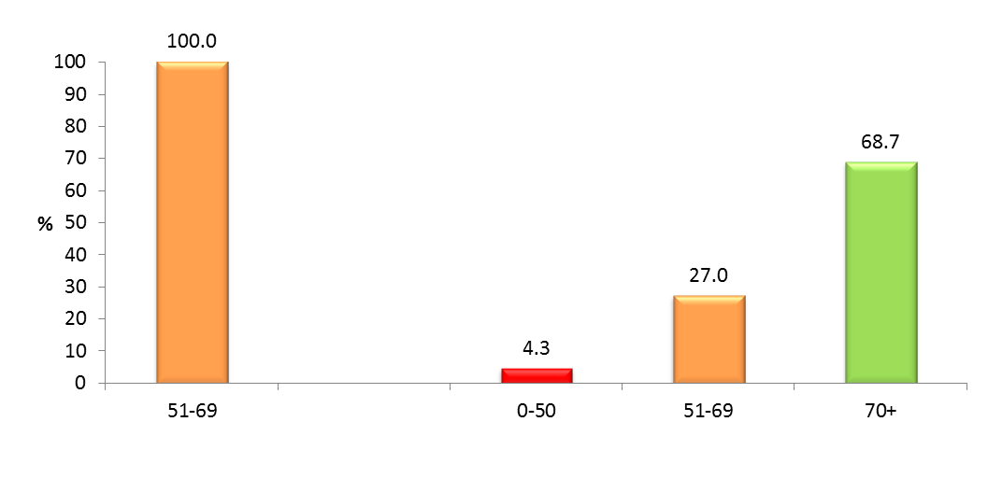

Figure 13.4: Post-program PWI groups for young people who scored between 51-69 pre-program

Only 27.0% of young people remained in the 51-69 challenged group post-program, with over two-thirds moving into the normal 70+ group.

This is a very positive result and it appears that a considerable proportion of young people who were experiencing a lower than normal level of personal wellbeing may now be functioning well within their normal range.

It is notable, however, that 84 (4.3%) young people regressed into the 0-50 high-risk group post-program, highlighting the fragility of many adolescents despite the supportive services they are receiving.

Interestingly, of the 4.3% of young people who regressed into the 0-50 group post-program, 67.9% were female, 67.9% were aged between 14 and 16 years, while 85.7% are believed to have low self-esteem.

Figure 13.5 displays the proportion of the 4,636 young people who initially scored in the normal 70+ group (pre-program) who now score in one of the three PWI groups post-program. More information is available in Table M13.12.

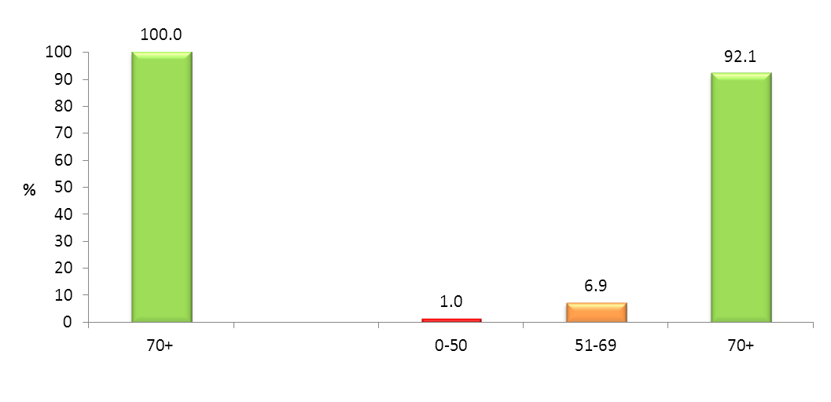

Figure 13.5: Post-program PWI groups for young people who scored in the normal 70+ group pre-program

92.1% young people remained in the 70+ group post-program. This is a positive result and suggests that Youth Connections may, at least in part, be responsible for assisting many young people to maintain a positive sense of personal wellbeing, despite their complex circumstances and current situations. For many young people, the support they are receiving from their case managers and service providers is likely to be acting as a ‘buffer’ against the negative thoughts and feelings that are directly linked to the sources of challenge they are currently facing in life. Service providers are also likely to be providing practical solutions and problem solving to help overcome adversity, which also supports the maintenance of normal levels of psychological wellbeing and which provides the motivation for making more positive life choices and behavior change.

It is important to note, however, that 6.9% and 1.0% of young people respectively regressed into the 51-69 and 0-50 groups post-program. Unfortunately, not all young people are immune to the negative impact of the challenges they are facing in their lives, even when support is offered and/or accessed.

Interestingly, of the 367 (7.9%) young people who regressed, 43.1% were Type 1. This suggests that even the least disengaged of YC participants remain a high-risk for experiencing lower wellbeing over time and following increasingly greater challenges as their personal situations deteriorate.

## Pre-post program changes in SWB for females and males

Figure 13.6 displays mean PWI and domain happiness scores for the 3,444 females who completed the PWI-SC at the beginning of their involvement with Youth Connections (‘pre-program’) and following their exit from the program (‘post-program’). More information is provided in Table M13.6.

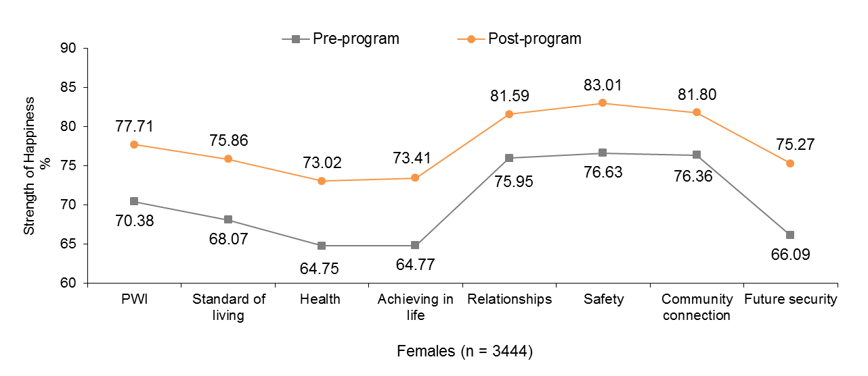

Figure 13.6: Female SWB and domain happiness scores at initial and at follow up interview

Mean SWB among female respondents increased from 70.38 points to 77.71 points. This 7.33 point increase is significant and indicates that, on average, females experience substantially higher SWB after completing their time in the YC Program.

Significant pre-post program increases in happiness scores were evident across all seven PWI domains, with the greatest positive changes on Future Security (9.18 points), Achieving in Life (8.64 points) and Health (8.27). Incidentally, females scored the lowest on these three domains pre-program.

Collectively, the results suggest that their experiences with Youth Connections appear to have had a dramatic, positive and pervasive impact on how young females feel about themselves and their lives.

Figure 13.7 displays mean PWI and domain happiness scores for the 3,737 males who completed the PWI-SC at the beginning of their involvement in Youth Connections (pre-program') and following their exit from the program (‘post-program’). More information is provided in Table M13.7.

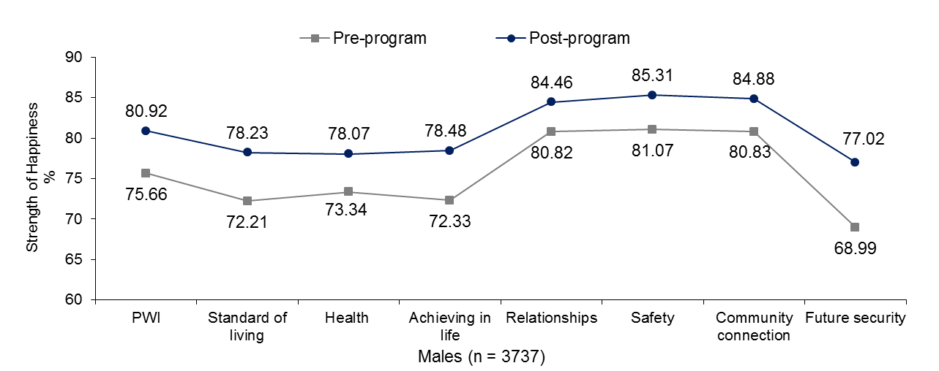

Figure 13.7: Male SWB and domain happiness scores at initial and at follow up interview

Mean SWB among male respondents increased from 75.66 points to 80.92 points. This 5.26 point increase is significant and indicates that, on average, males experience substantially higher SWB after completing their time in the YC Program.

Similarly to females, the means for all seven PWI domains were significantly higher post-program, with the greatest improvements observed on Future Security (8.03 points), Achieving in Life (6.15 points) and Standard of Living (6.02 points).

Collectively, these results indicate that participation in the YC Program has resulted in substantial improvements in how young males feel about themselves and their lives.

Post-program mean SWB for males and females compared to mainstream data is presented in Figure 13.8.

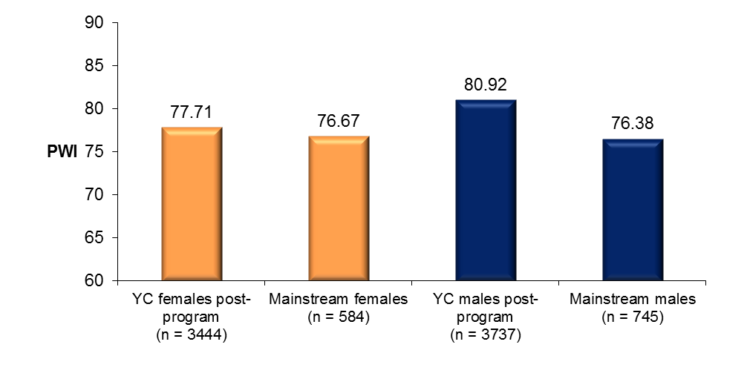

Figure 13.8: Female and male post-program PWI scores compared to mainstream

At the conclusion of their participation in the YC Program, females report a mean level of personal wellbeing comparative to that of mainstream females; while the post-program mean for males is significantly higher than mainstream.

While we cannot be certain that these improvements will be maintained over the longer term, the results nonetheless send a clear message that participation in the YC Program is associated with a substantial increase in personal wellbeing for many young people to levels seen in Victoria’s mainstream high-school population.

## Pre-post program changes in SWB for young people in each age group

Figure 13.9 displays pre-post program personal wellbeing scores for young people in each age group. More information is provided in Table M13.8.

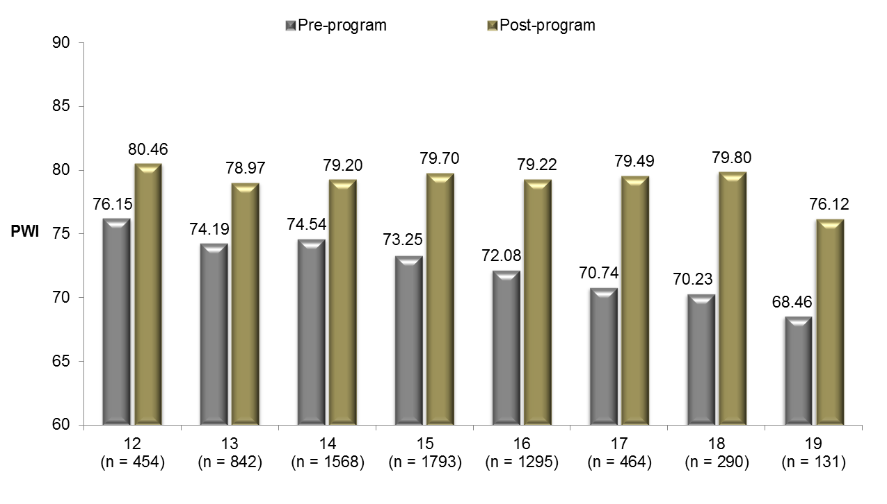

Figure 13.9: Pre and post-program mean PWI scores for young people in each age group

Significant pre-post program increases in mean personal wellbeing were evident across each age group.

Consistent with the notion that the most at-risk groups of young people should stand to benefit the most from positive intervention, the most substantial post-program increases in mean personal wellbeing were observed among young people aged between 16 and 19 years – those groups with the lowest pre-program means. Most notable is a remarkable 9.57 point increase among those aged 18 years.

## Pre-post program changes in SWB for various sub-groups of young people

Figure 13.10 displays pre-post program mean PWI scores for a number of high-risk sub-groups of young people. More information is provided in Table M13.9.

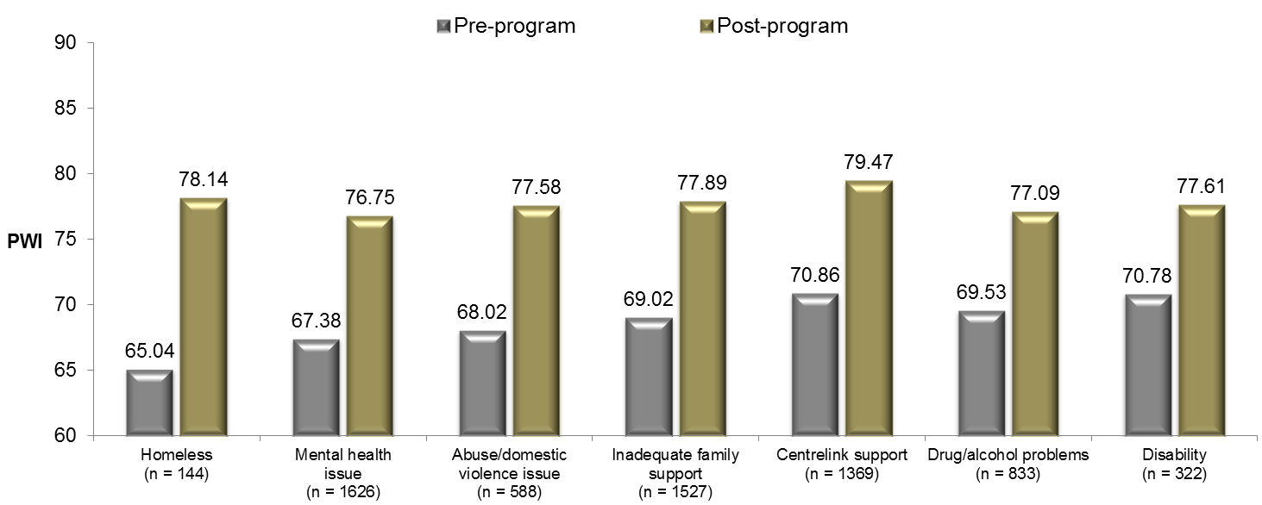

Figure 13.10: Pre and post-program PWI scores for various sub-groups of high-risk young people

Significant pre-post program increases in personal wellbeing were observed in each of the groups depicted in Figure 13.10. Moreover, substantial gains in personal wellbeing were particularly evident for those groups of young people with very low initial mean scores. For example, homeless young people (13.10 point increase); young people who have experienced abuse/domestic violence (9.56 point increase); young people with a suspected/diagnosed mental health issue (9.37 point increase); young people with inadequate family support (8.87 point increase); and young people receiving Centrelink income support (8.61 point increase). Young people with drug and alcohol problems and a disability also experienced substantial gains in personal wellbeing post-program (7.56 points and 6.83 points respectively).

Collectively, these results are very promising and suggest that the YC Program is helping to meet the needs and concerns of a diverse range of adolescents in desperate need of support and guidance.

# 14 Outcomes achieved

This chapter concerns personal wellbeing and ‘Outcomes achieved’ for the 7,181 respondents who completed the program and subsequent PWI-SC measure on both occasions. The results presented throughout this chapter offer further insights into the pre-post program changes in SWB presented in the previous Chapter 13.

The outcomes achieved over the course of participant’s time with Youth Connections to be analysed in this chapter are:

1. *‘Attendance at school or education setting improved’*: The participant’s attendance at school or education setting improved consistently over the whole school term, or for 13 weeks.
2. *‘Educational performance improved*’: The participant’s educational performance improved consistently over the whole school term, or for 13 weeks.
3. ‘*Re-engaged with education’:* The participant re-engaged in education over the whole school term, or for 13 weeks.
4. *‘Commenced education’:* The participant commenced in education.
5. *‘Engaged with employment’:* The participant started employment and has remained in that employment for 13 weeks.
6. *‘Addressed inadequate family support issues’:* Addressed and minimised the barriers created by inadequate family support.
7. *‘Addressed mental health issues’:* Addressed and minimised the barriers created by a suspected or diagnosed mental health issue.
8. ‘*Addressed self-esteem issues’:* Addressed and minimised the barriers created by low self-esteem.
9. *‘Addressed bullying issues’:* Addressed and minimised the barriers created by bullying.
10. *‘Addressed socialisation issues’:* Addressed and minimised the barriers created by the participant's socialisation issues.
11. *‘Addressed disability’:* Addressed and minimised the barriers created by the participant’s disability.
12. *‘Addressed behavioural problems’:* Addressed and minimised the barriers created by the participant's behavioural problems.
13. *‘Engagement with education strengthened’:* The participant’s engagement was strengthened and they remained engaged in education over the whole school term, or for 13 weeks.
14. *‘Addressed negative experiences with education’:* Addressed and minimised the barriers created by negative experience(s) with education and training.
15. *‘Addressed anger management issues’*: Addressed and minimised the barriers created by the participant’s anger management issues.
16. *‘Addressed low numeracy/literacy’:* Addressed and minimised the barriers created by low literacy and/or numeracy.
17. *‘Addressed alcohol and/or drug use/misuse’:* Addressed and minimised the barriers created by alcohol and/or drug use/misuse.
18. *‘Addressed financial distress issues’:* Addressed and minimised the barriers created by financial distress.
19. *‘Addressed learning difficulty’:* Addressed and minimised the barriers created by a learning difficulty.
20. *‘Addressed abuse/violence:* Addressed and minimised the barriers created by a abuse/violence.

## Outcome achieved: Attendance at school or engagement setting improved

Figure 14.1 displays pre-post program mean PWI and domain happiness scores for the 1,322 young people whose attendance at school or education setting improved consistently over the whole school term, or for 13 weeks. More information is provided in Table N14.1.

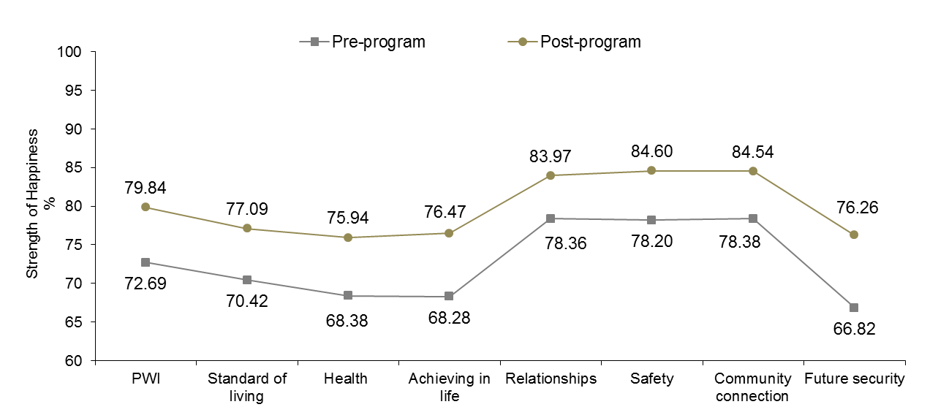

Figure 14.1: Outcome achieved: School attendance improved

A significant 7.15 percentage point increase in mean SWB from 72.69 points to 79.84 points can be observed.

Significant pre-post program increases in happiness scores across all seven PWI domains were also evident, with the greatest positive changes on Future Security (9.44 points), Achieving in Life (8.19 points) and Health (7.56 points).

These results suggest that an improvement in attendance at school or education setting appears to have a positive and pervasive impact on the personal wellbeing of YC participants who achieved this outcome over the course of their involvement in the program, at least in the short term.

It is likely that increased engagement with education is fostering a greater sense of certainty and optimism about life and that many young people have about their futures. Moreover, the satisfaction associated with persevering with their schooling likely contributes to their sense of purpose and achieving.

Collectively, the results support efforts by Youth Connections to encourage young people to re-engage with their schooling, despite the difficulties they may be facing both in and out of the classroom.

## Outcome achieved: Educational performance improved

Figure 14.2 displays pre-post program mean PWI and domain happiness scores for the 1,345 young people whose educational performance improved consistently over the whole school term, or for 13 weeks. More information is provided in Table N14.2.

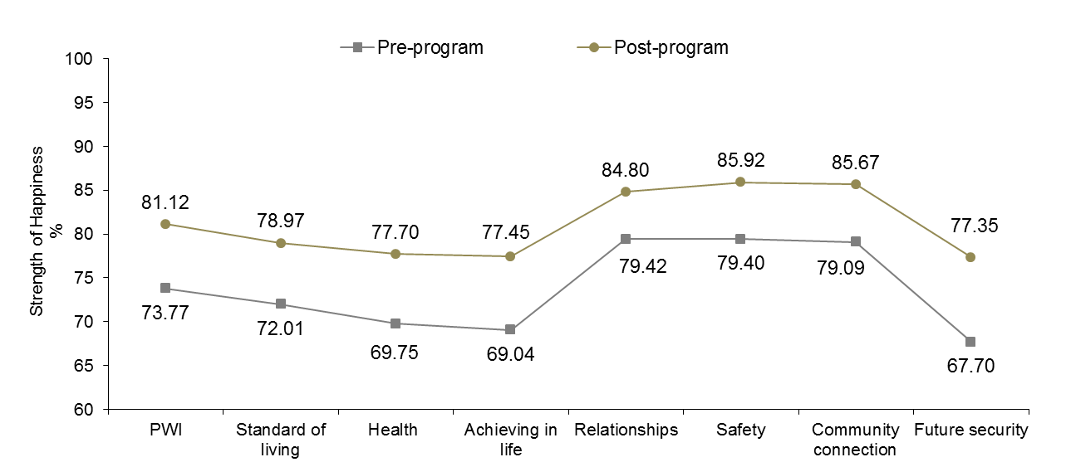

Figure 14.2: Outcome achieved: Educational performance improved

A significant 7.35 percentage point increase in mean SWB from 73.77 points to 81.12 points can be observed.

Significant pre-post program increases in happiness scores across all seven PWI domains were also evident, with the greatest positive changes on Future Security (9.65 points), Achieving in Life (8.41 points) and Health (7.95 points).

A considerable improvement on the domain of Future Security suggests that many young people feel a greater sense of hope and optimism about *‘what may happen later on in life’.* This may, in part, be attributed to an appreciation of the opportunities that they have been given to reach their academic potential and the positive consequences this will likely have on their future employment prospects, financial situations and independence.

The positive association between improved educational performance and how happy young people feel about *‘the things they want to be good at’* (Achieving in Life)is intuitive given the importance that parents, teachers and society place on education; and the sense of personal accomplishment and satisfaction that improved performance instills in young people themselves.

Collectively, these results suggest that an improvement in educational performance appears to have a positive and pervasive impact on the personal wellbeing of many respondents who achieved this outcome over the course of their involvement in the program, at least in the short term. These results validate efforts by Youth Connections to help motivate and support young people realise their educational potential.

## Outcome achieved: Re-engaged with education

Figure 14.3 displays pre-post program mean PWI and domain happiness scores for the 884 young people who re-engaged in education over the whole school term, or for 13 weeks. More information is provided in Table N14.3.

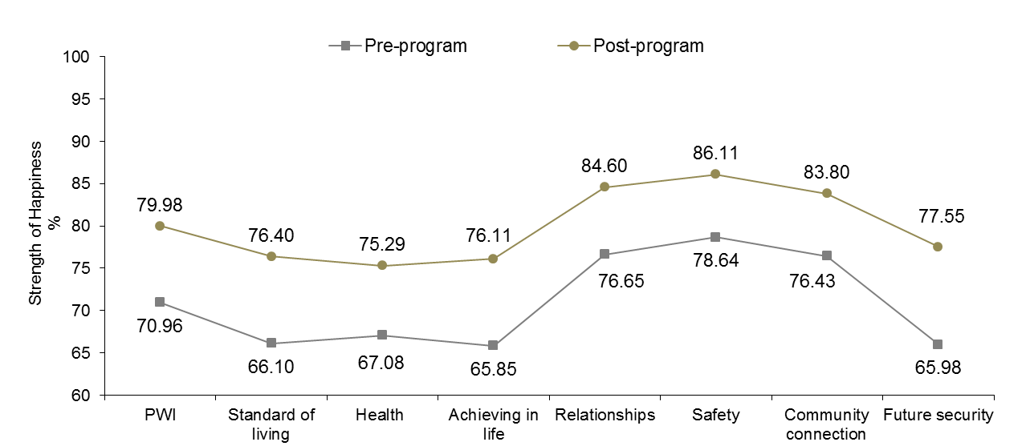

Figure 14.3: Outcome achieved: Re-engaged with education

A significant 9.02 percentage point increase in mean SWB from 70.96 points to 79.98 points can be observed.

Significant pre-post program increases in happiness scores across all seven PWI domains were also evident, with the greatest positive changes on Future Security (11.57 points), Standard of Living (10.30 points) and Achieving in Life (10.26 points).

Similarly to the previous outcome ‘Educational performance improved’, considerable increases in happiness scores on the domains of Future Security and Achieving in life indicate that many young people who have achieved this outcome have a greater sense of hope and optimism about their future trajectories now that they have re-engaged with their education. For example, with respect to employment opportunities that may now be available to them when they complete their education and/or training and the impact that this will have on their ability to live independently and enjoy an adequate standard of living that facilitates the expression of normal levels of psychological wellbeing.

It is also encouraging to report that 47.3% of respondents who achieved this outcome are Connection level 2b. For many of these young people, reconnecting with their education is a huge milestone, having potentially overcome a number of personal barriers that would have previously threatened their successful participation in an education setting.

## Outcome achieved: Commenced education

Figure 14.4 displays pre-post program mean PWI and domain happiness scores for the 1,330 young people who commenced in education. It is encouraging that 70.4% of these respondents are the most disengaged Connection level 2b and by definition, most at-risk of not completing year 12 or equivalent. More information is provided in Table N14.4.

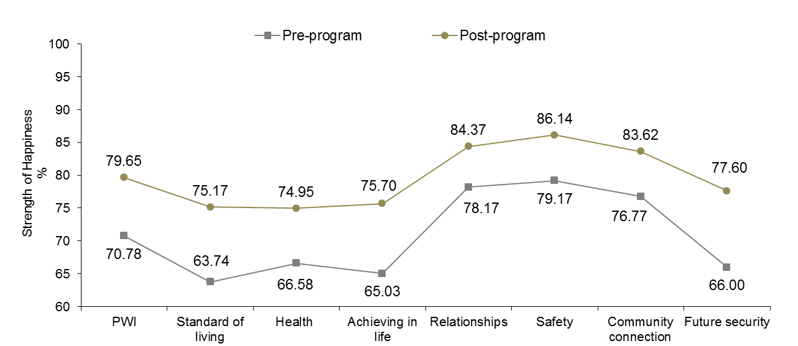

Figure 14.4: Outcome achieved: Commenced education

A significant 8.87 percentage point increase in mean SWB from 70.78 points to 79.65 points can be observed.

Significant pre-post program increases in happiness scores across all seven PWI domains are also evident, with the greatest positive changes on Future Security (11.60 points), Standard of Living (11.43), and Achieving in Life (10.67 points).

Here we see a similar post-program profile to previous outcomes concerning education, with the evidence suggesting greater hope and optimism about the future and major improvements in general outlook on life for many young people who achieved this particular outcome.

These are very positive results and justify efforts by Youth Connections to persist in their attempts to reconnect some of the country’s most disengaged young people with education.

## Outcome achieved: Engaged with employment

Figure 14.5 displays pre-post program mean PWI and domain happiness scores for the 259 young people who found work and remained in employment for at least 13 weeks. 61.8% of respondents are aged 16 and 17 years, with 62.8% classified as Connection level 2b. More information is provided in Table N14.5.

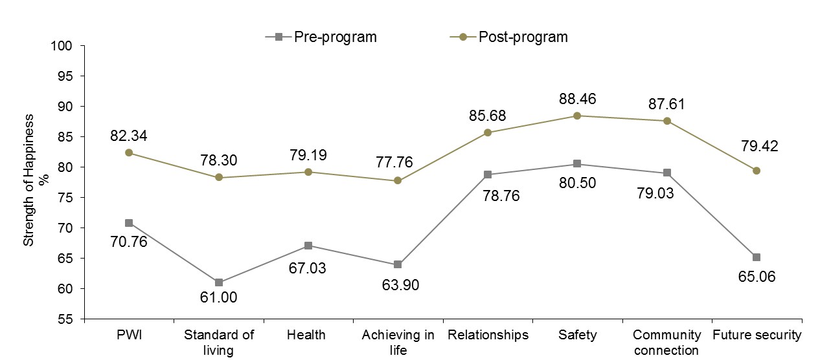

Figure 14.5: Outcome achieved: Engaged with employment

A significant 11.58 percentage point increase in mean SWB from 70.76 points to 82.34 points can be observed.

Substantial and significant pre-post program increases in happiness scores across all seven PWI domains were evident, with the greatest positive changes on Standard of Living (17.30 points), Future Security (14.36 points) and Achieving in Life (13.86 points)

The low pre-program mean SWB score is consistent with national data collected using the adult PWI which shows that, on average, unemployed Australian adults tend to have significantly lower personal wellbeing and are a higher risk for depression than people who are employed.

Pre-post intervention changes in mean SWB and domain happiness scores are remarkable and highlight the enormous impact that finding work and engaging successfully with employment has on the psychological wellbeing of many young people. Employment enhances personal wellbeing in a number of ways, most notably, from the sense of achieving and accomplishment that that is associated with having a job; and through direct financial benefits which provide the means to enjoy an adequate standard of living and independence.

## Outcome achieved: Addressed inadequate family support issues

Figure 14.6 displays pre-post program mean PWI and domain happiness scores for the 792 young people who had barriers created by inadequate family support addressed or minimised. More information is provided in Table N14.6.

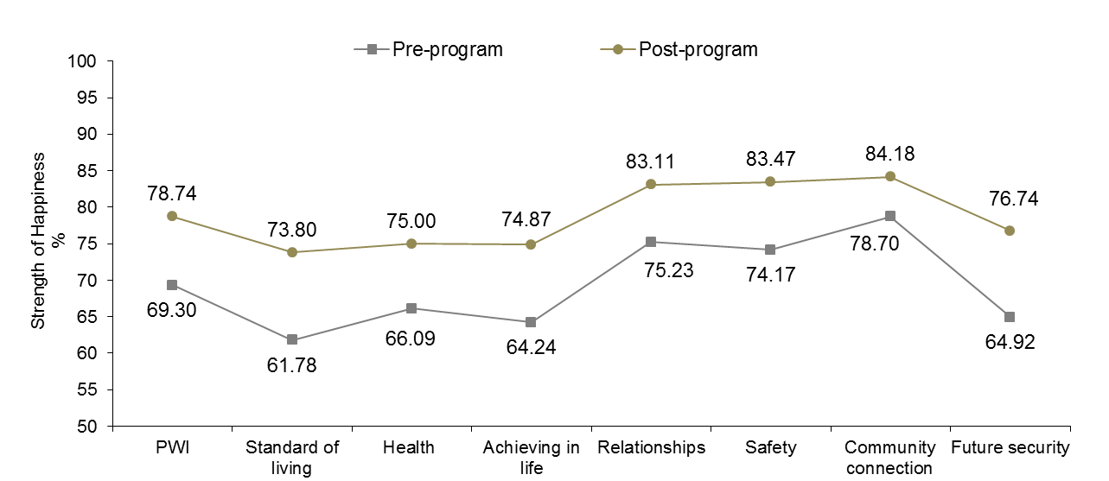

Figure 14.6: Outcome achieved: Addressed inadequate family support

A significant 9.44 percentage point increase in mean SWB from 69.30 points to 78.74 points can be observed.

Significant pre-post program increases in happiness scores across all seven PWI domains were also evident, with the greatest positive changes on Standard of Living (12.02 points), Future Security (11.82 points) and Achieving in Life (10.63 points).

Family relationships are important for adolescents as their development occurs within a social context where they are heavily reliant on key adults in their lives (Bronfenbrenner, 2005). Moreover, according to Morrow (1999), positive emotional attachments to parents and caregivers play a pivotal role in adolescents’ physical and mental health.

The very low pre-program mean personal wellbeing and domain scores in Figure 14.6, particularly for Standard of Living and Achieving in Life, highlight the negative impact that inadequate family support has on the social and emotional wellbeing of many young people that is frequently reported within the relevant scientific literature.

Collectively, post-program scores demonstrate the positive and pervasive impact that addressing inadequate family support issues have on personal wellbeing and provide a compelling argument in support of intervention strategies that target young people and their families.

## Outcome achieved: Addressed mental health issues

Figure 14.7 displays pre-post program mean PWI and domain happiness scores for the 929 young people who had barriers created by a suspected or diagnosed mental health issue addressed or minimised. Females (63.4%) and young people associated with bullying (34.8%) are over-represented in this group. More information is provided in Table N14.7.

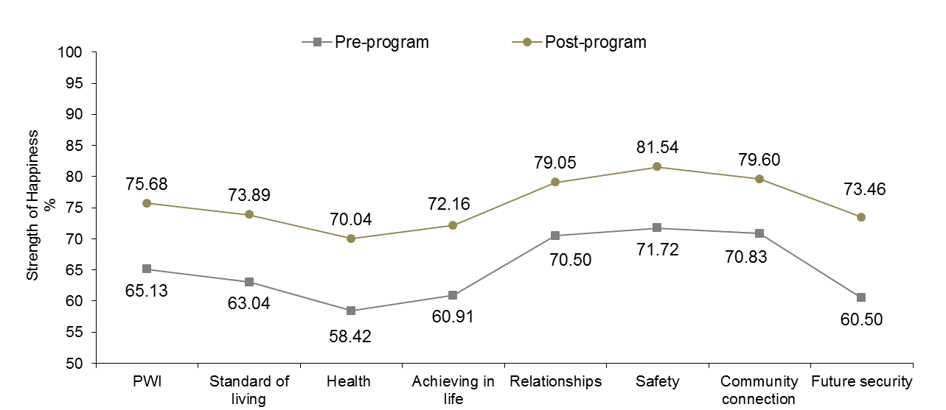

Figure 14.7: Outcome achieved: Addressed mental health issues

A significant 10.55 percentage point increase in mean SWB from 65.13 points to 75.68 points can be observed.

Significant and substantial pre-post program increases in happiness scores across all seven PWI domains were also evident, with the greatest positive changes on Future Security (12.96 points), Health (11.62 points) and Achieving in Life (11.25 points).

It is very clear from Figure 14.7 that addressing mental health issues is associated with substantial improvements in overall personal wellbeing and across all life domains. The extremely low pre-program means, particularly for Health and Future Security, suggest that physical/psychological barriers to progression and fears and concerns about the future dominate and are a substantial contributor to low SWB and potentially other mental health issues in this group (e.g., depression, low self-esteem and anxiety).

It is paramount that young people suspected or diagnosed with a mental health issue are provided the necessary support to ensure that their needs are adequately addressed and that improvements in personal wellbeing are maintained over the longer term. Moreover, the over-representation of young people associated with bullying may suggest a link between bullying and the onset of mental health problems.

## Outcome achieved: Addressed self-esteem issues

Self-esteem refers to an individual’s sense of his or her value or worth, or the extent to which a person values, approves of, appreciates, prizes, or likes themselves. A positive sense of self is as important for children as adults and is amongst the strongest correlates of subjective wellbeing. Moreover, negative self-evaluations characteristic of low self-esteem are associated with depression, anxiety and in extreme cases, suicide ideation, and can have a profound and negative impact on learning outcomes and employment participation.

In this light, addressing low self-esteem issues amongst YC participants represents an important undertaking for service providers, particularly given that 57.0% of all YC participants have been identified as suffering from low self-esteem.

Figure 14.8 displays pre-post program mean PWI and domain happiness scores for the 3,086 young people who had barriers created by low self-esteem addressed or minimised. 57.8% of respondents are female, 36.6% associated with bullying and 44.3% are Connection level 1 young people. More information is provided in Table N14.8.

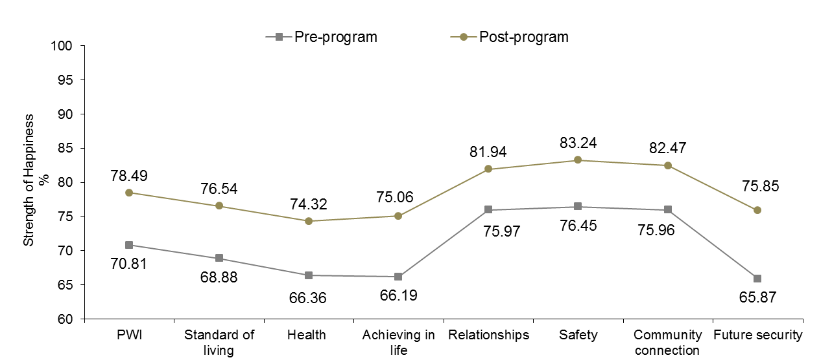

Figure 14.8: Outcome achieved: Addressed self-esteem issues

A significant 7.68 percentage point increase in mean SWB from 70.81 points to 78.49 points can be observed.

Significant pre-post program increases in happiness scores across all seven PWI domains were also evident, with the greatest positive changes on Future Security (9.98 points), Achieving in Life (8.87 points) and Health (7.96 points).

These data suggests that the needs of many young people with low self-esteem are being addressed by the supportive services they are receiving as part of their involvement in the YC Program. However, ongoing support and counseling may be required to ensure mental health improvements are maintained over the longer term.

## Outcome achieved: Addressed bullying issues

The literature supports a strong association between bullying and a range of negative social and emotional outcomes, including depression, anxiety, socialisation issues, behavioural problems and a cause of youth suicide. Bullying can also have a severe impact on learning opportunities, resulting in poor school attendance and performance.

Figure 14.9 displays pre-post program mean PWI and domain happiness scores for the 1,064 young people who had barriers created by bullying addressed or minimised. More information is provided in Table N14.9.

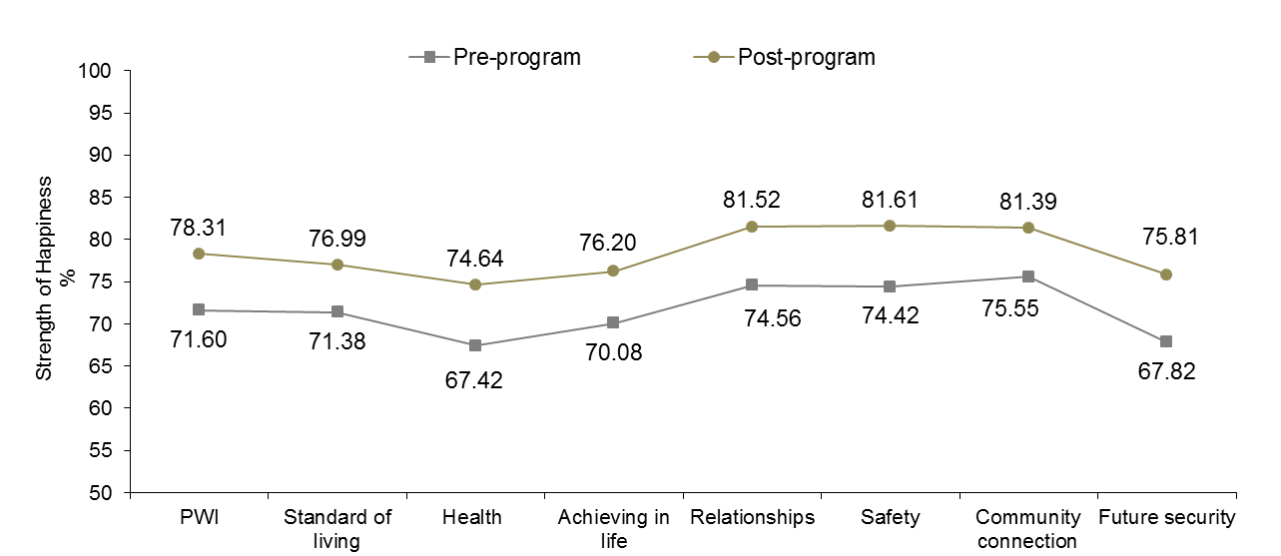

Figure 14.9: Outcome achieved: Addressed bullying issues

A significant 6.71 percentage point increase in mean SWB from 71.60 points to 78.31 points can be observed.

Significant pre-post program increases in happiness scores across all seven PWI domains were also evident, with the greatest positive changes on Future Security (7.99 points), Health (7.22 points) and Safety (7.19 points).

Data presented in Figure 14.9 support efforts by Youth Connections in providing young people who are either bullied or the perpetrators of bullying, with the support, resources and emotional and behavioural strategies they need to overcome the challenges they are facing with respect to this very important issue. The support offered appears to have culminated in a greater sense of optimism about the future, with young people feeling especially more safe and secure since having completed their time in Youth Connections.

## Outcome achieved: Addressed socialisation issues

Figure 14.10 displays pre-post program mean PWI and domain happiness scores for the 1,893 young people who had the barriers created by the participant's socialisation issues addressed or minimised. More information is provided in Table N14.10.

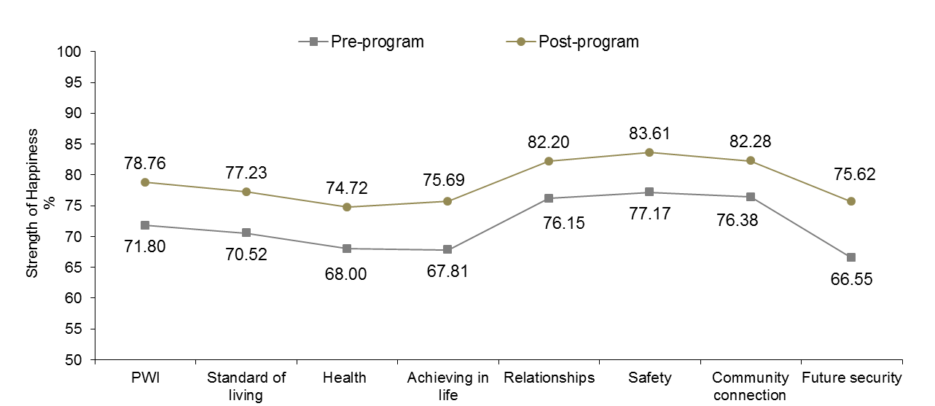

Figure 14.10: Outcome achieved: Addressed socialisation issues

A significant 6.96 percentage point increase in mean SWB from 71.80 points to 78.76 points can be observed.

Significant pre-post program increases in happiness scores across all seven PWI domains were also evident, with the greatest positive changes on Future Security (9.07 points), Achieving in Life (7.88 points) and Health (6.72 points).

Addressing participant’s socialisation issues is important as these can have a profound impact on their friendships, learning opportunities and employment prospects. Data presented in Figure 14.10 supports efforts by Youth Connections in providing young people with socialisation issues with the support and resources they need to help them learn to relate more positively with others and/or in more appropriate ways. In doing so, young people will be more successful in their interpersonal relationships, education and work and this will have flow on benefits for their mental health.

## Outcome achieved: Addressed disability

Figure 14.11 displays pre-post program mean PWI and domain happiness scores for the 114 young people who had the barriers created by their disability addressed or minimised. More information is provided in Table N14.11.

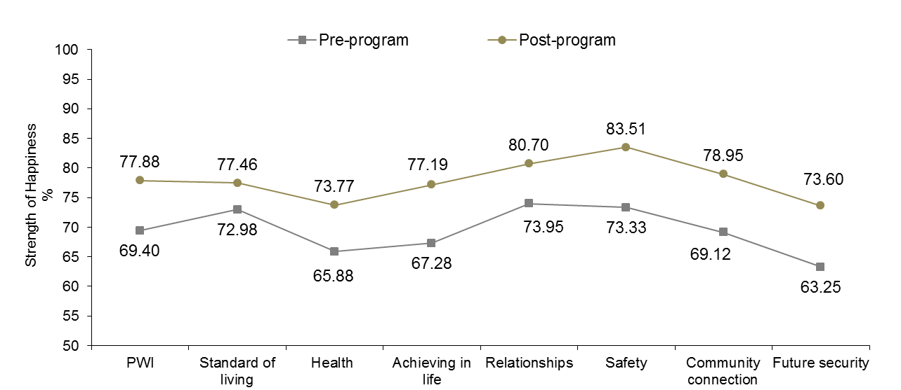

Figure 14.11: Outcome achieved: Addressed disability

A significant 8.48 percentage point increase in mean SWB from 69.40 points to 77.88 points can be observed.

Significant pre-post program increases in happiness scores across all seven PWI domains were also evident, with substantial changes on Future Security (10.35 points), Safety (10.18 points) and Achieving in Life (9.91 points).

These are very encouraging results and suggest that young people with a disability are feeling more positive about their futures, safer, more secure and perhaps more connected to people around them since having completed their time in the program.

The very low pre-program mean for Future Security, however, is notable and highlights the fears that many young people with a disability have about the future. It is essential that young people with a disability receive ongoing support from their families, the community, institutions and the government, to give them the best chance of leading fulfilling, independent and happy lives. Moreover, the over-representation of bullying in this group is concerning and highlights the need to address this issue, particularly in the classroom and in occupational settings.

## Outcome achieved: Addressed behavioural problems

Figure 14.12 displays pre-post program mean PWI and domain happiness scores for the 2,229 young people who had the barriers created by the participant's behavioural problems addressed or minimised. Interestingly, 55.5% of respondents are aged 14 and 15 years, suggesting that behavioral problems may pose a significant threat to the progression of many young people in mid-adolescence. More information is provided in Table N14.12.

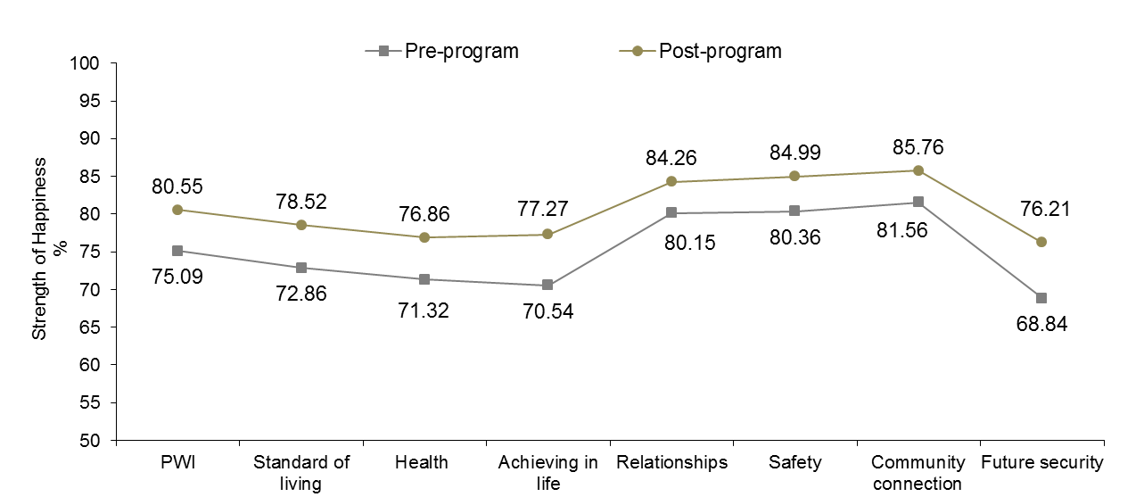

Figure 14.12: Outcome achieved: Addressed behavioural problems

A significant 5.46 percentage point increase in mean SWB from 75.09 points to 80.55 points can be observed.

Significant pre-post program increases in happiness scores across all seven PWI domains were also evident, with the greatest positive changes on Future Security (7.37 points), Achieving in Life (6.73 points) and Standard of Living (5.66 points).

It is very important that young people with behavioral problems learn more appropriate and adaptive ways of communicating with others and it appears that this supports better mental health. Moreover, overcoming behavioral problems likely plays a key role in facilitating improvements across a diverse range of personal and educational outcomes, including school attendance, concentration and performance and relationships with their parents, peers and teachers.

## Outcome achieved: Engagement with education strengthened

Figure 14.13 displays pre-post program mean PWI and domain happiness scores for the 2,171 young people whose engagement was strengthened and they remained engaged in education over the whole school term, or for 13 weeks. More information is provided in Table N14.13.

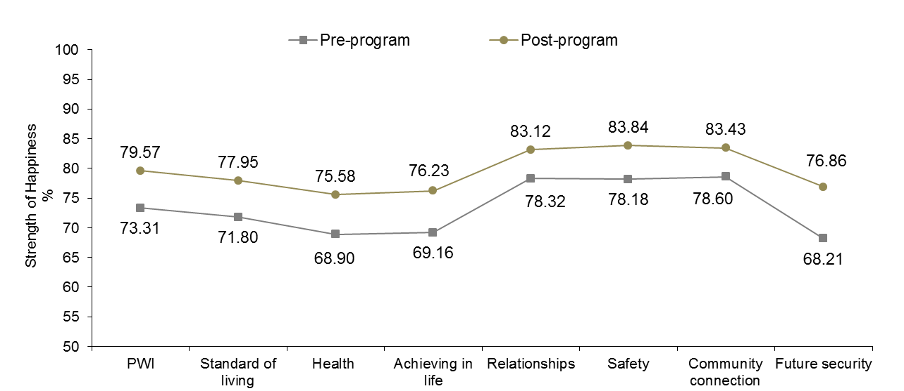

Figure 14.13: Outcome achieved: Engagement with education strengthened

A significant 6.26 percentage point increase in mean SWB from 73.31 points to 79.57 points can be observed.

Significant pre-post program increases in happiness scores across all seven PWI domains were also evident, with the greatest positive changes on Future Security (8.65 points), Achieving in Life (7.07 points) and Health (6.68 points).

These results are encouraging and suggest that many respondents, particularly younger adolescents, may be experiencing higher psychological wellbeing as a consequence of their recent and strengthened engagement with education. These results also highlight the relative success of re-engaging younger adolescents with education and the need to identify and support young people ‘at-risk’ in their early teenage years.

## Outcome achieved: Minimised negative experiences with education

Figure 14.14 displays pre-post program mean PWI and domain happiness scores for the 1,483 young people who had the barriers created by their negative experience(s) with education and training addressed and minimised. More information is provided in Table N14.14.

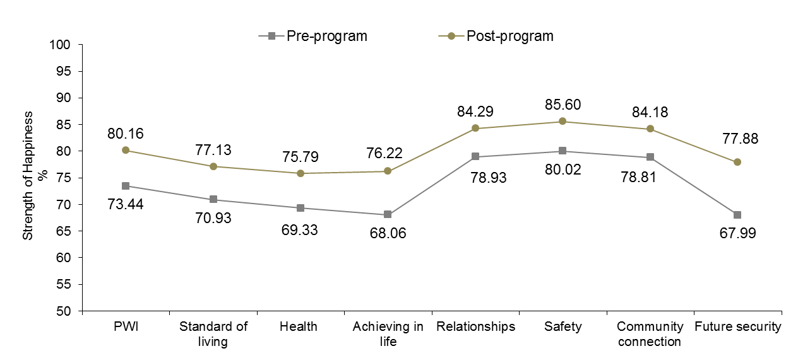

Figure 14.14: Outcome achieved: Minimised negative experiences with education

A significant 6.72 percentage point increase in mean SWB from 73.44 points to 80.16 can be observed.

Significant pre-post program increases in happiness scores across all seven PWI domains were also evident, with the greatest positive changes on Future Security (9.89 points), Achieving in Life (8.16 points) and Health (6.46 points).

These are very positive results and it appears that Youth Connections is addressing the issues that many young people have with respect to their previous and negative experiences with education, whether these concern their teachers, peers and/or learning outcomes.

It is essential that a young person’s negative experiences with education are addressed as these can have a detrimental impact on their future willingness to participate and motivation to complete year 12 or equivalent.

## Outcome achieved: Addressed anger management issues

Figure 14.15 displays pre-post program mean PWI and domain happiness scores for the 1,200 young people who had the barriers created by the participant’s anger management issues addressed and minimised. More information is provided in Table N14.15.

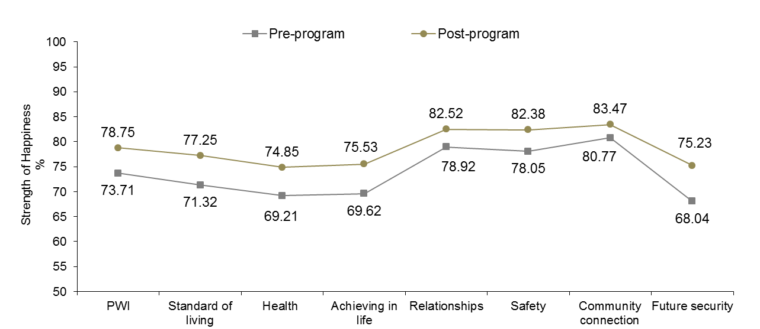

Figure 14.15: Outcome achieved: Addressed anger management issues

A significant 5.04 percentage point increase in mean SWB from 73.71 points to 78.75 points can be observed.

Significant pre-post program increases in happiness scores across all seven PWI domains were also evident, with the greatest positive changes on Future Security (7.19 points), Standard of Living (5.93 points) and Achieving in Life (5.91 points).

These results are encouraging and suggest that many young people with anger management issues may be assisted to develop strategies to help combat their inappropriate behaviour and which appears to be having a positive impact on their psychological wellbeing.

It is very important that people with anger management issues continue to work toward controlling their anger as this may be a significant barrier toward successful completion of year 12 or equivalent and may continue to threaten the health, safety and wellbeing of themselves and people around them well into adulthood.

## Outcome achieved: Addressed low numeracy/literacy

Figure 14.16 displays pre-post program mean PWI and domain happiness scores for the 1,857 young people who had the barriers created by low numeracy/literacy addressed and minimised. More information is provided in Table N14.16.

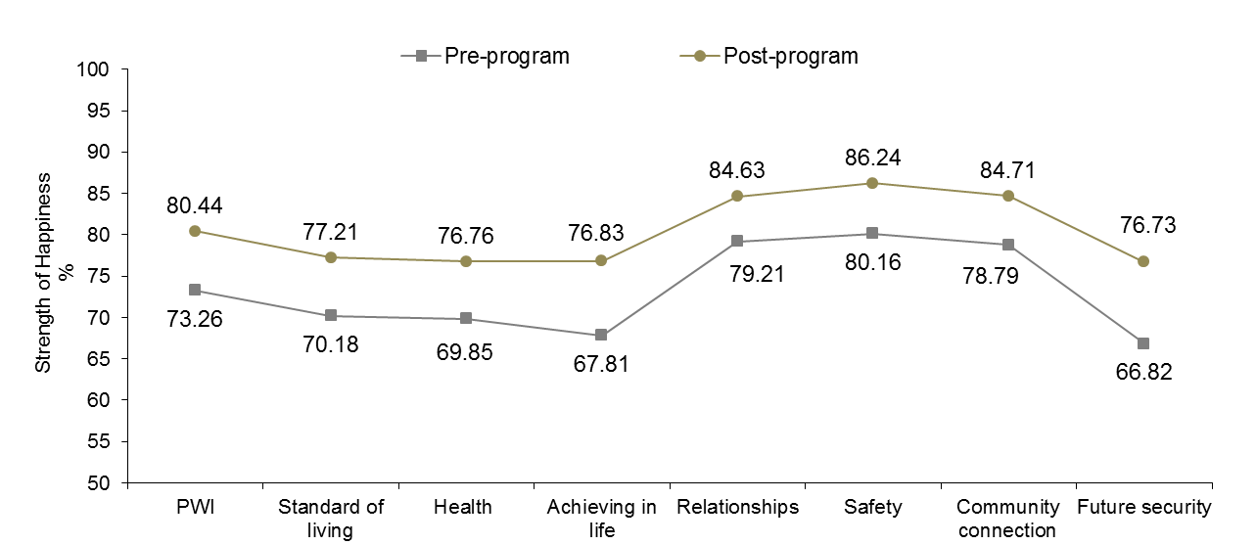

Figure 14.16: Outcome achieved: Addressed low numeracy/literacy

A significant 7.18 percentage point increase in mean SWB from 73.26 points to 80.44 points can be observed.

Significant pre-post program increases in happiness scores across all seven PWI domains were also evident, with the greatest positive changes on Future Security (9.91 points), Achieving in Life (9.02 points) and Standard of Living (7.03 points)

These results are outstanding and suggest that many young people who achieved this outcome and feeling more confident in their abilities to succeed in their education and are considerably more hopeful and optimistic about their futures.

## Outcome achieved: Addressed alcohol and/or drug use/misuse

Figure 14.17 displays pre-post program mean PWI and domain happiness scores for the 394 young people who had the barriers created by drug and/alcohol use/misuse addressed or minimised. More information is provided in Table N14.17.

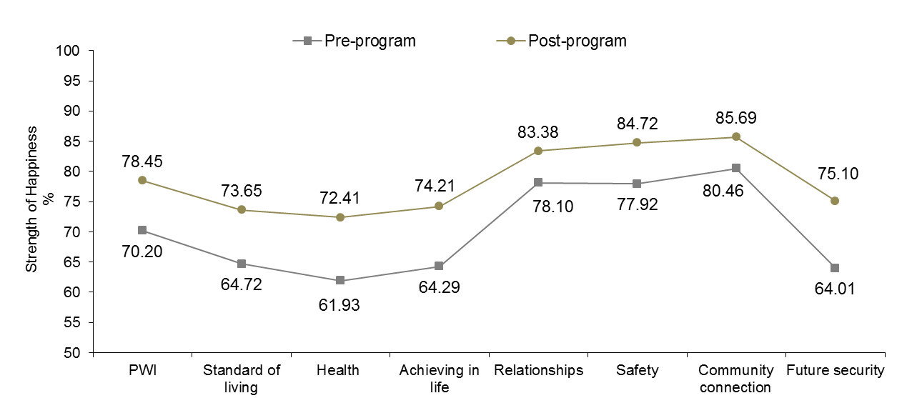

Figure 14.17: Outcome achieved: Addressed alcohol/drug use/misuse

A significant 8.25 percentage point increase in mean SWB from 70.20 points to 78.45 points can be observed.

Significant pre-post program increases in happiness scores across all seven PWI domains were also evident, with substantial changes on Future Security (11.09 points), Health (10.48 points) and Achieving in life (9.92 points).

These are exceptional results and just the domain profile we would expect from a group of young people who are likely to be making better choices with respect to their substance use. For example, respondents appear to be feeling as though their health has improved, their futures are brighter and perhaps are better off financially if indeed they are using their money in more sensible ways.

However, giving up drugs and alcohol is not easy, especially when under the influence of their peers. In this light, young people need to be encouraged and supported to make the right decisions in the future and learn how to effectively deal with peer-pressure - which is likely to be a real threat to relapse in the near future.

## Outcome achieved: Addressed barriers created by financial distress

Figure 14.18 displays pre-post program mean PWI and domain happiness scores for the 978 young people who had the barriers created by financial distress addressed and minimised. More information is provided in Table N14.18.

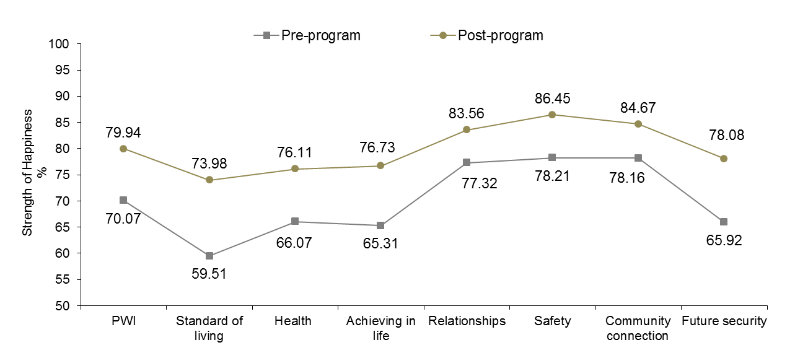

Figure 14.18: Outcome achieved: Addressed barriers created by financial distress

A significant 9.87 percentage point increase in mean SWB from 70.07 points to 79.94 points can be observed.

Significant pre-post program increases in happiness scores across all seven PWI domains were also evident, with substantial improvements observed on Standard of Living (14.47 points), Future Security (12.16 points) and Achieving in Life (11.42 points),

The very low pre-program mean of 59.51 points for Standard of Living likely reflects the socio-economic disadvantage experienced by young people and their families. Young people growing up in low-income households face additional challenges and it is encouraging to see that many respondents who achieved this outcome are feeling more positively about the things they have and about their futures.

## Outcome achieved: Addressed learning difficulty

Figure 14.19 displays pre-post program mean PWI and domain happiness scores for the 467 young people who had the barriers created by a learning difficulty addressed and minimised. More information is provided in Table N14.19.

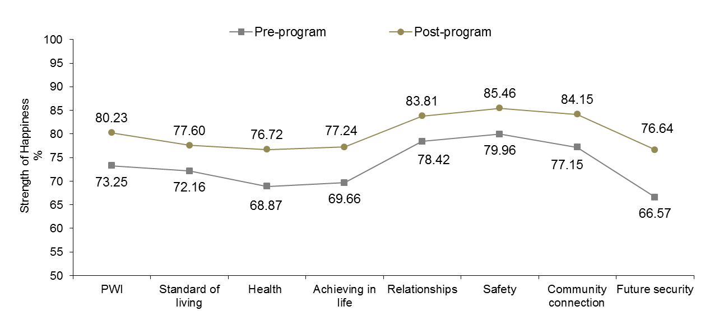

Figure 14.19: Outcome achieved: Addressed learning difficulty

A significant 6.98 percentage point increase in mean SWB from 73.25 points to 80.23 points can be observed.

Significant pre-post program increases in happiness scores across all seven PWI domains were also evident, with the greatest positive changes on Future Security (10.07 points), Health (7.85) and Achieving in Life (7.58 points).

It is important that young people with learning difficulties are provided with adequate support that addresses their specific needs, enabling them to better realise their potential. Based on these data, it appears that many young people with learning difficulties are feeling much happier about themselves and their lives after having completed the program, particularly with respect to what their futures hold for them. This is a very positive outcome and we can only hope that their experiences with Youth Connections will be the turning point they need to achieve their educational goals.

## Outcome achieved: Addressed abuse/violence

Figure 14.20 displays pre-post program mean PWI and domain happiness scores for the 167 young people who had the barriers created by abuse/domestic violence issues addressed and minimised. More information is provided in Table N14.20.

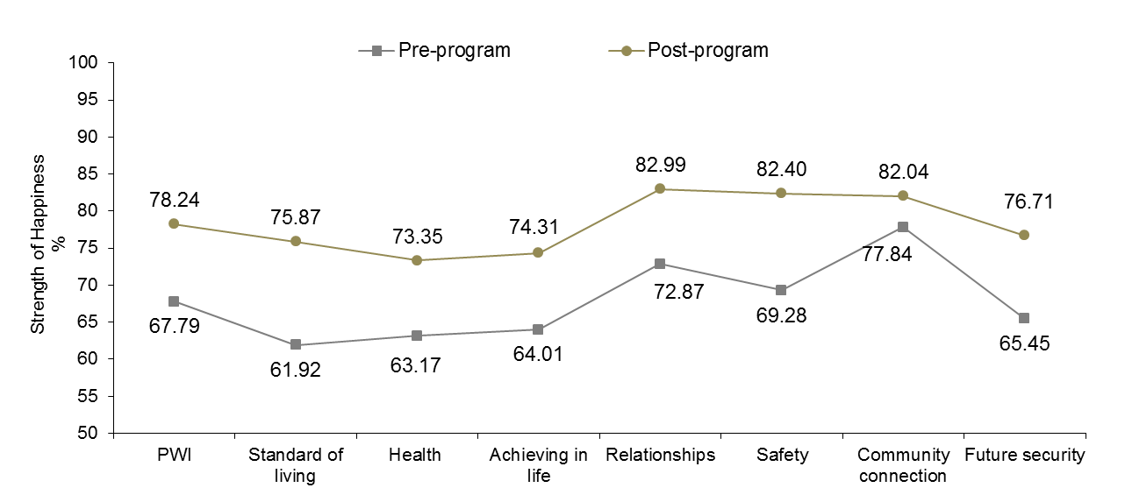

Figure 14.20: Outcome achieved: Addressed abuse/violence

A significant 10.45 percentage point increase in mean SWB from 67.79 points to 78.24 points can be observed.

Significant pre-post program increases in happiness scores across all seven PWI domains were also evident, with substantial changes on Standard of Living (13.95 points), Safety (13.12 points) and Future Security (11.26 points).

The very low pre-program mean personal wellbeing score and domain profile reflects a group of young people who are a very high-risk for experiencing emotional and physical harm – indeed, this is already a reality for many people in this group.

Collectively, these results suggest that addressing abuse and violence issues has had a substantial impact on the personal wellbeing of many young people whose safety is at-risk. It is essential that young people deemed to be at imminent risk for experiencing physical and emotional trauma are provided immediate refuge from the perpetrators of harm against them, as well as ongoing support and counseling.

Figure 14.21 displays the outcomes achieved that were associated with the greatest pre-post program increases in mean SWB. The red bar represents the overall mean increase in personal wellbeing of 6.14 points for the 7,181 young people who completed the program.

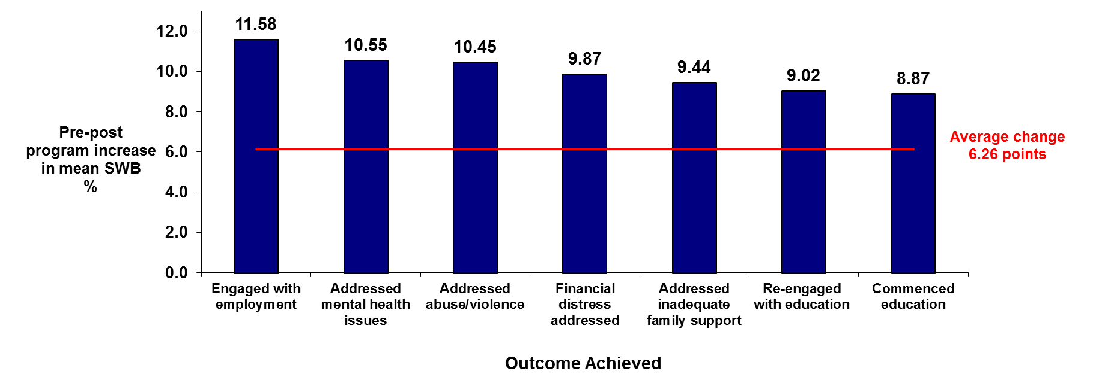

Figure 14.21: Program outcomes associated with the highest increases in mean SWB

The outcome ‘Engaged with employment’ achieved the highest post-program increase in mean SWB.

The outcome ‘Addressed mental health issues’ was also associated with a significant pre-post program improvement in mean SWB, so to was ‘Addressed abuse/violence’.

Education related outcomes were also associated with notable post-program increases in mean SWB, with the outcomes ‘Commenced education’ and ‘Re-engaged with education’ all associated with above average increases. While ‘Addressing inadequate family support’ also features on this list, highlighting once again the important role that parents play in nurturing the psychological wellbeing of their children.

Collectively, these results support the association between the attainment of key program outcomes and improved psychological wellbeing amongst young people who complete the YC Program.

# References

Bronfenbrenner, U. (2005). *Making human beings human: Bioecological perspectives on human development*. Thousand Oaks, CA: Sage Publications.

Cummins, R. A. (2000). Objective and subjective quality of life: An interactive model. *Social Indicators Research, 52,* 55-72.

Cummins, R.A. (2010). Subjective wellbeing, homeostatically protected mood and depression: A synthesis. *Journal of Happiness Studies, 11*, 1-17.

Cummins, R. A., & Lau, A. L. D. (2005). *Personal Wellbeing Index - School Children (PWI- SC) (3rd ed.).* Melbourne: Deakin University.

Dockery, A. M. (2010). Culture and wellbeing: The case of Indigenous Australians. *Social Indicators Research, 99*, 315-332.

Hunter, E.M. (2003). Mental health. In: Thomson N, editor. The health of Indigenous Australians. Melbourne: Oxford University Press, 2003.

Hunter, E.M, Gynther, B.D., Anderson, C.J., et al. (2012). Psychosis in Indigenous populations of Cape York and the Torres Strait. *Medical Journal of Australia,* 196, 133-135.

International Wellbeing Group. (2013). *Personal Wellbeing Index.* User manual. 5th ed.

Kelly, K., Dudgeon, P., Gee, G., & Glaskin, B. (2009). Living on the edge: Social and emotional wellbeing and risk and protective factors for serious psychological distress among Aboriginal and Torres Strait Islander people. Discussion Paper No. Cooperative Research Centre for Aboriginal Health, Darwin.

Morrow, V. (1999). Conceptualising social capital in relation to the well-being of children and young people: A critical review. *Sociological Review, 4*, 774-765.

Parker, M.R. (2012). Aboriginal and Torres Strait Islander mental health. *Medical Journal of Australia, 196*(2), 89-90.

SCRGSP. (2009). *Overcoming Indigenous Disadvantage: Key Indicators 2009*. Canberra: Productivity Commission.

Stewart, D., Sun, J., Patterson, C., Lemerle, K., & Hardie, M. (2004). Promoting and building resilience in primary school communities: Evidence from a comprehensive 'health promoting school' approach. *The International Journal of Mental Health Promotion, 6*, 26-33.

Thompson, S. J., Gifford, S. M., & Thorpe, L. (2000). The social and cultural context of risk and prevention: Food and physical activity in an urban Aboriginal community. *Health Education and Behavior, 27,* 725-743.

Tomyn, A. J., & Cummins, R.A. (2011). The subjective wellbeing of high-school students: Validating the Personal Wellbeing Index-School Children. *Social Indicators Research, 101,* 405-418.

**Tomyn, A.J.**, Fuller-Tyszkiewicz, M. & Cummins, R.A. (2011). The Personal Wellbeing Index: Psychometric Equivalence for Adults and School Children. Social Indicators Research. doi: 10.1007/s11205-011-9964-9

Tomyn, A.J., Fuller-Tyszkiewicz, M.D., & Norrish, J.M. (2013). The Psychometric Equivalence of the Personal Wellbeing Index School-Children for Indigenous and non-Indigenous Australian Adolescents. Journal of Happiness Studies. DOI 10.1007/s10902-013-9415-1

Zubrick, S., Dudgeon, P., Gee, G., Glaskin, B., Kelly, K., Paradies, Y., Scrine, C & Walker. R. (2010). Social Determinants of Aboriginal and Torres Strait Islander Social and Emotional Wellbeing. In Purdie, N., Dudgeon, P., & Walker, R. Working Together: Aboriginal and Torres Strait Islander Mental Health and Wellbeing Principles and Practice (pp. 75-90). Commonwealth of Australia.