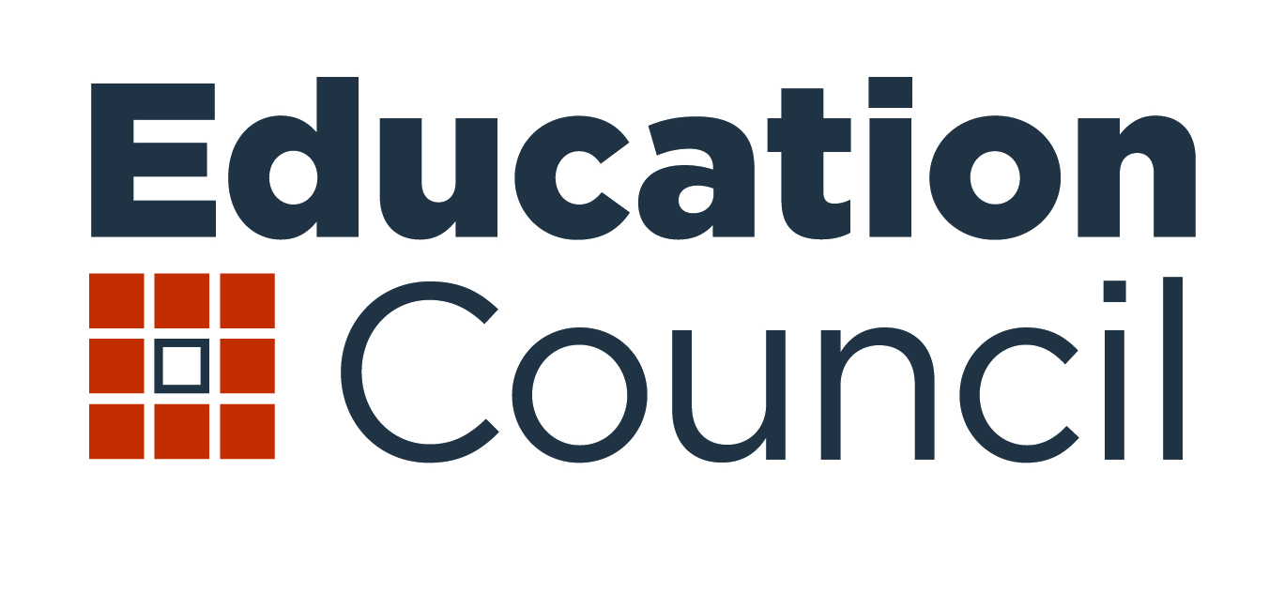

**Optimising senior secondary pathways into work, further education and training**

**Terms of Reference**

**Context**

Research shows that students who complete senior secondary education have a greater likelihood of continuing with further study, entering into the workforce, and improved living conditions. Today's students, however, face a range of challenges due to technological change, globalisation and automation. Senior secondary graduates will need a broader and different mix of skills compared to previous generations, including stronger problem solving, communication and digital skills, as well as critical and creative thinking. They will also need the skills to navigate an increasingly complex range of options and pathways into further education and training.

In recognition of the important role senior secondary education plays in preparing students for the rapidly changing world beyond school, *Through Growth to Achievement: Report of the Review to Achieve Educational Excellence in Australian Schools* recommended establishing an independent inquiry into senior secondary schooling. The recommendation has been formalised in the national school reform agreement as a national policy initiative *to review senior secondary pathways into work, further education and training* (the Review).

The Review will report to Education Council as outlined in the National School Reform Agreement 2019-2023.

Responsibility for senior secondary pathways into work, further education and training fall across levels of government, from the schooling system to vocational and higher education sectors as well as employers and industry. While the review will report to the COAG Education Council, which has responsibility for schooling, the recommendations may have broader systemic implications and will need to be considered in this policy context.

**Purpose**

The Review will provide Education Council with advice and recommendations on how senior secondary students can better understand and be enabled to choose the most appropriate pathway to support their transition into work, further education and/or training. In undertaking the review the expert panel will give consideration to the different contexts faced by disadvantaged students, including students with disability, those in regional, rural and remote areas, and Aboriginal and Torres Strait Islander students.

The expert panel will:

1. Explore the efficacy of senior secondary education in preparing young people for diverse pathways to further learning and work, including:
2. identifying from existing curriculum frameworks and relevant research, the essential knowledge, skills and values needed for diverse pathways to life long learning, work and effective participation in civic life.
3. identifying the skills and knowledge students, employers, vocational education and training (VET) providers, and higher education institutions perceive are essential for successful post school transitions.
4. clarifying the roles and responsibilities of key stakeholders, such as schools, students, parents, VET providers, higher education institutions, and employers, in supporting inclusion and preparing school leavers for life beyond school, whatever pathway they choose.
5. Investigate whether current certification and university entry requirements, including other credentials such as the International Baccalaureate, assist in allowing students to make the study choices that are right for them to develop the skills and knowledge they need to access the most appropriate pathway into work, further education and/or training.
6. Investigate barriers to students being able to equitably access all pathways, particularly for students in rural, regional and remote areas, Aboriginal and Torres Strait Islander students, students with disability, those who struggle to make transitions to work, further education and training, and potential early school leavers.
7. Identify best practice in flexible delivery options, transition and engagement support arrangements for students transitioning from Year 10 to Year 11, as well as from Year 12 to post-school destinations including:
8. career education and awareness that supports inclusion and includes information linked to labour market outcomes for all pathways, to support students to make informed decisions about their study, training and career options, as well as develop career management skills
9. the role and impact of teachers, school leaders, and different models of schooling, such as alternate education settings for disengaged students, distance education and/or home education, in successful transitions
10. vocational education and training delivered to secondary students that leads to strong transitions
11. work-based learning and industry partnerships
12. higher education
13. the role of student wellbeing on their ability to engage in different types of learning, including VET, academic and work-based learning, to facilitate completion of year 12 and transition to successful pathways.
14. Investigate what, when and how data should be collected to capture experiences, identify pathways and measure the impact of delivery options, subject choice (including academic and VET) on student outcomes and destinations, to ensure continuous improvement.

**Related Reviews**

The Review will have regard to relevant findings and recommendations of:

1. *Through Growth to Achievement: Report of the Review to Achieve Educational Excellence in Australian Schools*, 2018, chaired by Mr David Gonski
2. *National Career Education Strategy*, 2019, Department of Education and Training
3. *Optimising STEM Industry-School Partnerships,* 2018, chaired by Dr Alan Finkel, AO
4. *The Independent Review into Rural, Regional and Remote Education*, 2017, chaired by Emeritus Professor John Halsey
5. *National Aboriginal and Torres Strait Islander Education Strategy*, 2015, Education Council
6. *Australia 2030: Prosperity through Innovation*, 2017, Innovation and Science Australia
7. *Australian Qualifications Framework Review*, 2019, Department of Education and Training
8. Higher Education Standards Panel reports: *Improving the Transparency of Higher Education Admissions (2016) and Improving Retention, Completion and Success in Higher Education (2017)* and the associated Australian Government responses.
9. *Expert* *Review of Australia’s Vocational Education and Training System,* 2019, Prime Minister and Cabinet
10. *One Teaching Profession: Teacher Registration in Australia, September 2018*, the Australian Institute of Teaching and School Leadership
11. *Unique Individuals, Broad Skills, Inquiry into school to work transition,* 2018, House of Representatives Standing Committee on Employment, Education and Training
12. Curriculum reviews undertaken by states and territories, including the NSW Curriculum Review, TAS Year 9-12 Curriculum Review, SA Review of SACE Stage 2, VIC Review of Years 11-12 literacy and numeracy standards, and QLD Review of Queensland Certificate of Education.
13. Submissions by state and territory Departments of Education to the above reviews.

**Roles and responsibilities**

In order to address the terms of reference the panel will:

1. call for written submissions and undertake face to face consultations with experts and key stakeholders across Australia, including young people, parents, employers, and representatives from the schooling, vocational education and training and higher education sectors
2. ensure the review identifies and supports inclusive practices and considers the circumstances and particular needs of students with disability, those from rural, regional and remote areas, students from low socio-economic status backgrounds, Aboriginal and Torres Strait Islander students, and other students at risk of not making successful transitions from school to work or further education or training
3. commission independent research relevant to the Terms of Reference, if required, to ensure the review is underpinned by a sound evidence base
4. provide a final report to the Council of Australian Governments (COAG) Education Council in 2020.

**Membership**

The Review will be undertaken by a panel including a Chair and six members. The panel brings together expertise in one or more of the following areas: school operations; employers; vocational education and training; university entry requirements; expertise in the delivery of secondary education to disadvantaged students; and student engagement and wellbeing.

Education Council has agreed the following panel members based on their expertise to satisfy these Terms of Reference:

|  |  |
| --- | --- |
| Member | Expertise |
| Professor Peter Shergold AC (Chair)  Chancellor Western Sydney University | Public service governance and administration, higher education, vocational education and training, Aboriginal and Torres Strait Islander education, regional, rural and remote education |
| Ms Sarina Russo  Founder and Managing Director, Sarina Russo Group | Vocational education and training, particularly apprenticeships, assisting jobseekers, employment |
| Professor Tom Calma AO  Chancellor, University of Canberra | Higher education, Aboriginal and Torres Strait Islander education, regional, rural and remote education, equity and social justice |
| Ms Patrea Walton PSM  Former Deputy Director-General for State Schools, QLD | Public education, senior secondary education, school transitions, closing the gap on Year 12 attainment, equity and social justice, students with disabilities |
| Ms Jennifer Westacott AO  [Chief Executive, Business Council of Australia](http://www.bca.com.au/about-us/jennifer-westacott-chief-executive) | Employment, industry-school engagement, skills and education, labour market policy, Aboriginal and Torres Strait Islander engagement |
| Dr Don Zoellner  University Fellow, Charles Darwin University | Vocational education and training, senior secondary education, higher education, career education, Aboriginal and Torres Strait Islander education, regional, rural and remote education |
| Mr Patrick O’Reilly  Principal, Southern Cross Catholic Vocational College | Senior secondary education, vocational education and training, career education, student engagement |

**Secretariat**

Secretariat support for the Board will be provided by the Australian Government. This will include support for the Chair, organisation of meetings and consultations and analysis of written submissions.

**Timing**

The Review will report to Education Council in June 2020.