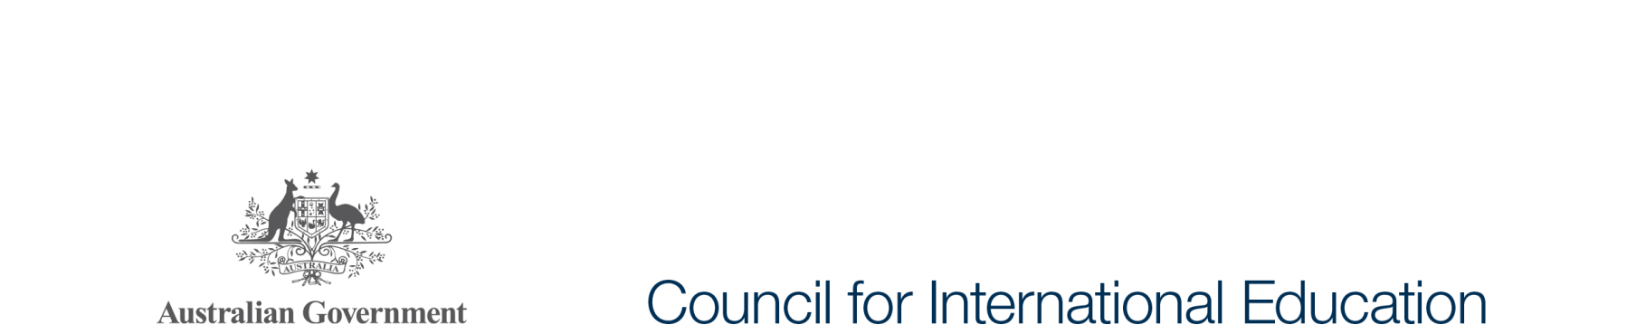

Expert Member Meeting

Meeting of the Council for International Education - Communiqué

The second meeting of the Council for International Education was held in Canberra today, Thursday 19 October. The meeting was chaired by Senator the Hon Simon Birmingham, Minister for Education and Training.

The Minister for Foreign Affairs, the Minister for Trade, Tourism and Investment, Assistant Minister for Immigration and Border Protection, Assistant Minister for Vocational Education and Skills and Assistant Minister for Industry, Innovation and Science representing the Minister for Industry, Innovation and Science attended the meeting of the Council and spoke about the interface between their relevant portfolios and international education.

Council members discussed the role of the *National Strategy for International Education 2025* in setting out the vision for sustaining and developing Australia’s role as a global leader in international education, training and research and outlined the great foundational work that had occurred across government and across the sector to build the base for future work.

Acknowledging that Australia is entering a period of extraordinary transformation for international education, Council members noted the need for the sector to continue to show strong leadership in breaking down the traditional silos and investing in new delivery modes, with government continuing to act as an enabler for the sector, providing flexible and responsive policy frameworks and regulation.

Members congratulated the Hon Phil Honeywood on his appointment as Convenor of the expert members of the Council. Mr Honeywood outlined progress of expert members on their key priorities, and presented their implementation plan for 2018. Mr Honeywood announced the formation of two short term working groups to focus on improving student service delivery and achieving nationally consistent marketing and collaboration. Working groups will be chaired by Mr David Riordan and Professor Kent Anderson respectively. Chairs will invite key personnel from the sector to participate in these working groups.

The Council will provide a progress report to the Prime Minister on implementing the National Strategy in December 2017. The report will be published on internationaleducation.gov.au early in 2018.

The next full meeting of the Council will be held in November 2018.