

# Calculation of Research Training Program allocations

This document is a practical guide on the calculation of Research Training Program funding for the 2024 to 2025 grant years



With the exception of the Commonwealth Coat of Arms, the Department’s logo, any material protected by a trade mark and where otherwise noted all material presented in this document is provided under a [Creative Commons Attribution 4.0 International](https://creativecommons.org/licenses/by/4.0/) (https://creativecommons.org/licenses/by/4.0/) licence.

The details of the relevant licence conditions are available on the Creative Commons website (accessible using the links provided) as is the full legal code for the [CC BY 4.0 International](https://creativecommons.org/licenses/by/4.0/legalcode) (https://creativecommons.org/licenses/by/4.0/legalcode)

The document must be attributed as the (Calculation of Research Training Program allocations).

Contents

Overview 4

Data used 5

Research and development income 5

Weighted HDR student completions 5

Funding pools 6

Funding drivers 6

Part 1: Calculating a HEP’s weighted HDR student completions 7

Calculation steps 7

Worked example 7

Part 2: Calculating a HEP’s percentage share of each funding driver 8

Calculation steps 8

Worked example 8

Part 3: Calculating a HEP’s RTP basic grant amount 10

Calculation steps 10

Worked example 10

Part 4: Applying rounding to calculate a HEP’s RTP grant amount 12

Calculation steps 12

Worked example 12

## Overview

For the 2024 to 2025 grant years, funding for the Research Training Program (RTP) is allocated to eligible higher education providers (HEPs) based on their relative performance in earning research and development (R&D) income and higher degree by research (HDR) student completions.

The funding formula to calculate the RTP is set by the [Commonwealth Scholarships Guidelines (Research) 2017](https://www.legislation.gov.au/F2016L01602/latest/text).

The calculation of RTP can be broken down to the following steps:

1. Calculating a HEP’s weighted HDR student completions
2. Calculating a HEP’s percentage share by funding driver
3. Calculating a HEP’s basic grant amount
4. Applying the rounding methodology.

## Data used

### Research and Development (R&D) income

R&D income is collected as part of the [Higher Education Research Data Collection](https://www.education.gov.au/research-block-grants/higher-education-research-data-collection) (HERDC) and comprises two categories for the purposes of calculating RTP:

1. **Competitive income** – R&D income classified as Category 1 in HERDC
2. **Engagement income** – R&D income classified as Categories 2, 3 and 4 in HERDC.

The two most recent years of available R&D income is summed together. For example, when calculating 2025 RTP allocations, the 2022 and 2023 data years collected through HERDC is used to calculate the competitive income and engagement income for each HEP.

A time series of [R&D income](https://www.education.gov.au/research-block-grants/resources/research-income-time-series) used to calculate RTP funding is available.

### Weighted HDR student completions

HDR student completions are collected as part of the [Higher Education Student Data Collection](https://www.education.gov.au/higher-education-statistics/student-data) (HESDC). For the purposes of calculating RTP allocations, weightings are applied to HDR student completions.

For the 2024 and 2025 grant years, HDR student completions are weighted according to the level of the HDR, the cost type of the HDR, whether the student completed an eligible research internship (Research Doctorate students only), and the student’s Indigenous or non-Indigenous status. The two most recent years of data is summed together to form the weighted HDR student completions funding driver.

Table 1: Weightings for HDR completions

| **HDR level** | **Cost type** | **Completed an eligible research internship** | **Non-Indigenous student** | **Indigenous student** |
| --- | --- | --- | --- | --- |
| Research Doctorate | High | No | 4.70 | 9.40 |
| Yes | 6.70 | 11.40 |
| Low | No | 2.00 | 4.00 |
| Yes | 4.00 | 6.00 |
| Research Masters | High | N/A | 2.35 | 4.70 |
| Low | N/A | 1.00 | 2.00 |

### Funding pools

The funding pools for the RTP from 2022 to 2025 are listed below:

2022 = $1,073,971,075

2023 = $1,111,560,062

2024 = $1,198,261,746

2025 = $1,247,390,481

### Funding drivers

A HEP’s RTP basic grant amount is based on its share of each funding driver relative to other HEPs. Each funding driver accounts for a proportion of the overall RTP funding pool.

The RTP basic grant amount is comprised of three funding drivers:

1. **Competitive income** – 25% of the funding pool
2. **Engagement income** – 25% of the funding pool
3. **Weighted HDR student completions** – 50% of the funding pool.

Figure 1: Proportion of RTP funding pool allocation by funding driver

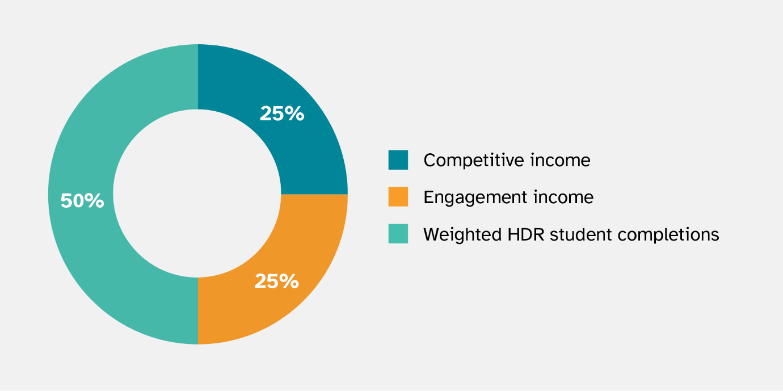

## Part 1: Calculating a HEP’s weighted HDR student completions

### Calculation steps

**Step 1** – Categorise HDR student completions by the HDR type to fill out the ‘HDR student completions’ column in the working example table below.

**Step 2** – Using the weightings for HDR student completions table in the ‘Data used’ section above, multiply the HDR completions by the weightings for each student and course type. See the ‘Weighting’ and ‘Weighted HDR student completions’ columns in the working example table below.

**Step 3** – Sum the total of weighted HDR student completions by each student and course type. In the worked example, the total weighted HDR student completions is 1,211.25.

### Worked example

Table 2: Calculating a HEP's weighted HDR student completions

| **Student classification** | **HDR course type (level – cost – eligible internship)** | **HDR student completions** | **Weighting** | **Weighted HDR student completions** |
| --- | --- | --- | --- | --- |
| Non-Indigenous | Research masters – high cost | 41 | 2.35 | 96.35 |
| Research masters – low cost | 28 | 1 | 28 |
| Research doctorate – high cost – eligible internship | 7 | 6.7 | 46.9 |
| Research doctorate – high cost – no eligible internship | 156 | 4.7 | 733.2 |
| Research doctorate – low cost – eligible internship | 2 | 4 | 8 |
| Research doctorate – low cost – no eligible internship | 130 | 2 | 260 |
| Indigenous | Research masters – high cost | 2 | 4.7 | 9.4 |
| Research masters – low cost | 3 | 2 | 6 |
| Research doctorate – high cost – eligible internship | 1 | 11.4 | 11.4 |
| Research doctorate – high cost – no eligible internship | 0 | 9.4 | 0 |
| Research doctorate – low cost – eligible internship | 2 | 6 | 12 |
| Research doctorate – low cost – no eligible internship | 0 | 4 | 0 |
| **Total** | | 372 | N/A | 1,211.25 |

## Part 2: Calculating a HEP’s percentage share of each funding driver

### **Calculation steps**

**Step 1** – For each grant year, a HEP’s share of COMPETITIVE income is calculated by the sum of that HEP’s Category 1 income for the two most recent years, divided by the sum of Category 1 income for all eligible HEPs for the two most recent years of data. For example, if the grant year is 2025, Category 1 income data from 2022 and 2023 (the two most recent years available) will be used to calculate the share.

**Step 2** – For each grant year a HEP’s share of ENGAGEMENT income is calculated by the sum of that HEP’s Category 2, 3 and 4 income for the two most recent years, divided by the sum of Category 2, 3 and 4 income for all eligible HEPs for the two most recent years of data.

**Step 3** – For each grant year a HEP’s share of WEIGHTED HDR STUDENT COMPLETIONS is calculated by the sum of that HEP’s weighted HDR student completions for the two most recent years of weighted HDR student completions divided by the sum of weighted HDR student completions for all eligible HEPs for the two most recent years.

### **Worked example**

Where the HEP has research income and weighted HDR student completions in the two most recent years comprising:

* Competitive income: $36,000,000 and $44,000,000
* Engagement income: $30,000,000 and $40,000,000
* Weighted HDR student completions: 1,600 and 2,000

And the total R&D income and weighted HDR completions for all eligible HEPs in the two most recent years is:

* Competitive income: $1,900,000,000 and $2,100,000,000
* Engagement income: $3,400,000,000 and $3,600,000,000
* Weighted HDR student completions: 55,000 and 65,000

**Step 1 – Calculate the HEP’s share of COMPETITIVE income**

COMPETITIVE share for a HEP

= $\frac{(\$36,000,000 + \$44,000,000 ) }{(\$1,900,000,000 + \$2,100,000,000)}$

= $\frac{\$80,000,000 }{\$4,000,000,000}$

= $2\% share$

**Step 2 – Calculate the HEP’s share of ENGAGEMENT income**

ENGAGEMENT share for a HEP

= $\frac{(\$30,000,000 + \$40,000,000) }{(\$3,400,000,000 + \$3,600,000,000)}$

= $\frac{\$70,000,000 }{\$7,000,000,000}$

= $1\% share$

**Step 3 – Calculate the HEP’s share of WEIGHTED HDR STUDENT COMPLETIONS**

WEIGHTED HDR STUDENT COMPLETIONS share for a HEP

= $\frac{(1,600 + 2,000) }{( 55,000 + 65,000)}$

= $\frac{3,600 }{120,000}$ = $3\% share$

## Part 3: Calculating a HEP’s RTP basic grant amount

### Calculation steps

**Step 1** – A HEP’s competitive component is calculated by multiplying 25% of the RTP funding pool by the HEP’s share of COMPETITIVE income.

**Step 2** – A HEP’s engagement component is calculated by multiplying 25% of the RTP funding pool by the HEP’s share of ENGAGEMENT income.

**Step 3** – A HEP’s weighted HDR student completions component is calculated by multiplying 50% of the RTP funding pool by the HEP’s share of WEIGHTED HDR STUDENT COMPLETIONS.

**Step 4** – These three amounts are added together to determine a HEP’s basic grant amount.

Equation 1: Calculating a HEP's RTP basic grant amount

### Worked example

**Step 1 – Calculate the HEP’s competitive component where the total RTP funding pool is $1,000,000,000**

= $25\% × \$1,000,000,000 × COMPETITIVE share$

= $25\% × \$1,000,000,000× 2\%$

= $\$250,000,000× 2\%$

= $\$5,000,000$

**Step 2 – Calculate the HEP’s engagement component where the total RTP funding pool is $1,000,000,000**

= $25\% × \$1,000,000,000× ENGAGEMENT share$

= $25\% ×\$1,000,000,000×1\%$

= $\$250,000,000×1\%$

= $\$2,500,000$

**Step 3 – Calculate the HEP’s weighted HDR student completions component where the total RTP funding pool is $1,000,000,000**

= $50\% × \$1,000,000,000 ×WEIGHTED HDR STUDENT COMPLETIONS share$

= $50\% ×\$1,000,000,000× 3\%$

= $\$500,000,000 × 3\%$

= $\$15,000,000$

**Step 4 – Calculate the HEP’s RTP basic grant amount**

= $\$5,000,000+\$2,500,000+\$15,000,000$

= $\$22,500,000$

## Part 4: Applying rounding to calculate a HEP’s RTP grant amount

### Calculation steps

**Step 1** – The RTP basic grant amount for each HEP is rounded down to the nearest dollar.

**Step 2** –The rounded down RTP basic grant amount is subtracted from the unrounded RTP basic grant amount. The difference in cents between a HEP’s rounded down and unrounded RTP basic grant amount is its remainder. The sum of all remainders is the unallocated dollars.

**Step 3** –Each HEP is ranked in descending order based on their remainder’s closeness to 100 cents.

**Step 4** –One dollar is assigned to each HEP’s rounded RTP basic grant amount in order of ranking until all unallocated dollars are exhausted. Each HEP’s RTP grant amount is equal to the rounded down RTP basic grant amount plus any whole dollars.

### Worked example

Where there are three HEPs with the following RTP basic grant amounts:

* HEP A: $8,250,000.61
* HEP B: $7,500,000.92
* HEP C: $5,750,000.47
* *Total:* $21,500,002.00

**Step 1** – Round the RTP basic grant amount for each HEP down to the nearest dollar.

* HEP A: $8,250,000.61 rounds down to $8,250,000
* HEP B: $7,500,000.92 rounds down to $7,500,000
* HEP C: $5,750,000.47 rounds down to $5,750,000
* *Rounded down total:* $21,500,000.00

**Step 2** – Subtract the rounded down RTP basic grant amount from the unrounded RTP basic grant amount. The sum of all remainders is the unallocated dollars.

* HEP A: $8,250,000.61 - $8,250,000 = 0.61
* HEP B: $7,500,000.92 - $7,500,000 = 0.92
* HEP C: $5,750,000.47 - $5,750,000 = 0.47
* *Unallocated dollars:* (0.61 + 0.92 + 0.47) = 2.00

**Step 3** – Rank HEPs in descending order based on their remainder’s closeness to 100 cents.

* HEP B: 92 cents
* HEP A: 61 cents
* HEP C: 47 cents

**Step 4** – Assign one dollar to each HEP’s rounded RTP basic grant amount in order of ranking until all unallocated dollars are exhausted. Calculate each HEP’s RTP grant amount by adding the rounded down RTP basic grant amount and any whole dollars assigned.

Assigned dollar:

* HEP B: $1
* HEP A: $1
* HEP C: $0

Final RTP grant amount:

* HEP A: $8,250,000 + $1 = $8,250,001.00
* HEP B: $7,500,000 + $1 = $7,500,001.00
* HEP C: $5,750,000 + $0 = $5,750,000.00
* *Total:* $21,500,002.00