**INCOME DIVERSITY IN SCHOOL COMMUNITIES**

Direct Measure of Income refinement working group paper

October 2020

# Income diversity in school communities

Context: The analysis in this paper is limited to family income at non-government schools in respect of data obtained through the 2019 Student Residential Address and Other Information Collection which has been matched to relevant income and other administrative data using the direct measure of income (DMI) methodology for capacity to contribute (CTC). The paper’s assumptions and conclusions regarding income distribution in schools apply to a single year only. Further, it should be noted that the analysis was undertaken in the context of reviews of CTC scores. The review process seeks to establish whether school communities’ financial circumstances are exceptional and have not necessarily been reflected in the CTC score determined for a school. As such, the paper does not consider income distribution trends across non-government schools from a more general perspective. ABS will continue to work with the Department of Education, Skills and Employment (DESE) to provide a more comprehensive understanding of how income is distributed within school communities and identify the potential implications of income distribution on CTC scores.

## About this analysis

ABS considered the range of incomes within school communities and the shape of their income distributions. The objective of this analysis was to assess the diversity of incomes within school communities, to investigate a potential scenario where the median income may not represent the capacity to contribute for a sizeable proportion of a school community. In theory, such circumstances may exist if a school community consists of two very different populations of students, for example, a disadvantaged community and a less disadvantaged community. Statistical indicators of such circumstances would include a bimodal income distribution, a wide income range and / or a large low income population in the school community.

ABS notes that in general, the median income is a more robust indicator of the ‘typical’ income of a member of a school community, than the mean, even where incomes are diverse[1]. This is because, since the median is simply the middle number in a list, each income has an equal influence on where the median is, regardless of whether it is an extreme value or not. In contrast, a single very large income can increase the mean, such that it is not representative of what most people earn. Thus, the median income is expected to be a good indicator of a typical income, even for a diverse community.

## Analysis of income diversity in school communities

ABS analysed the spread of incomes using inter-quartile ranges (IQRs) and the prevalence of low income populations within school communities. ABS also reviewed the individual income distributions of individual schools, in particular, some of those with large IQRs and / or large low income populations. Small schools with less than 10 students were excluded from this analysis.

### Definitions and considerations

* The inter-quartile range (IQR) is the difference between the third quartile (the 75th percentile) and the first quartile (the 25th percentile) of a distribution. It represents the spread of incomes across the middle 50% of a distribution. It is standard practice to use the IQR as a measure of spread around the median. In contrast, the standard deviation is a measure of spread around a mean. Means and standard deviations are more influenced by outliers than medians and IQRs; therefore, medians and IQRs are used to describe distributions which are typically skewed, such as income.
* ‘Low income’ was defined relative to the Australian population, and relative to members of non-government school communities, to enable a range of analyses to be undertaken.
* The income assignment approach used in the DMI methodology may affect the accuracy of income estimates for low income earners in school communities. This is because, where an income is not available from personal income tax or payment summary data, a person who has a low income concession card may be assigned an income of $0. This approach is not expected to influence a school community’s median income, however, it may lead to some inaccuracy of incomes at the lower end of the distribution. Therefore, caution should be taken when interpreting the analysis of schools’ first quartile of income[2].

### Summary of analysis

* In 2019, ABS found no evidence of school communities with bimodal income distributions. This is typically assessed by looking at the histogram of each income distribution.
* Non-government school communities commonly have a wide spread of incomes.
* In 2019, almost half (43%) of non-government schools had an IQR of between $75,000 and $99,999.
* For schools in all remoteness categories, IQRs were most commonly between $75,000 and $99,999. Larger IQRs mostly belonged to major city schools.
* Larger IQRs were more common for school communities with higher median incomes.
* Large low income populations within school communities were present in schools with low median incomes. All of the schools in which at least 25% of the school community had a low income, defined relative to the Australian population, also had a low DMI score in 2019.
* Some schools had a low first quartile income, defined relative to other non-government school community members in 2019. In most cases, these schools also had a low DMI score. Examination of quality metrics for some of these schools indicated they would have been examined in accordance with the existing DMI score validation process.

### Inter-Quartile Ranges (IQRs) in 2019 CTC data

Figure F1 shows the distribution of IQRs for schools in 2019 (excluding schools with less than 10 students). Like income distributions in general, this distribution is positively skewed, with a cluster of IQRs around the most common category ($75,000 - $99,999) and a long “tail” of observations extending to the right, which are much larger than the majority of schools’ IQRs.

For the majority of schools (80%), the IQR was between $50,000 and $124,999. Most commonly, IQRs were between $75,000 and $99,999, with 43% in this range. Approximately 2% of schools had an IQR of below $50,000, and approximately 18% of schools had an IQR of $125,000 and above.

Figure F1: Proportion of schools by inter-quartile range, 2019.

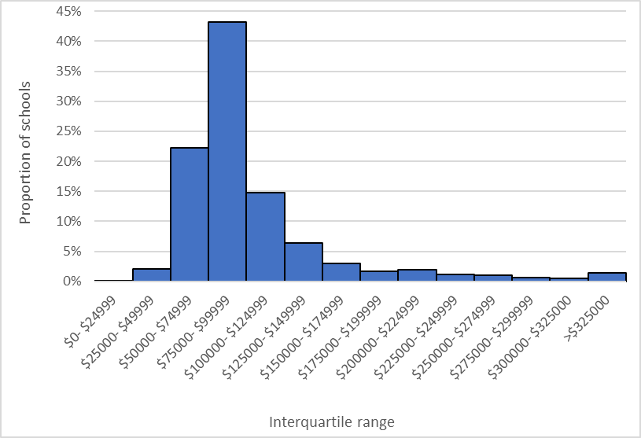

Table F2, below, shows the number of schools by inter-quartile ranges and remoteness category, in 2019. In all remoteness categories, $75,000 to $99,999 was the most common range into which IQRs fell. There were few IQRs in outer regional and remote areas over $125,000. The larger IQRs were typically in major cities, and to a small extent, inner regional areas. Most of the IQRs of $125,000 and above were found in in major city schools.

Table F2: Number of schools by Inter-quartile range and remoteness category, 2019.

|  |  |  |  |  |  |
| --- | --- | --- | --- | --- | --- |
|  | Remoteness |  |  |  | |
| Inter-quartile range | **Major Cities** | **Inner Regional** | **Outer Regional / Remote1** | | **Total2** |
| less than $75,000 | 295 | 210 | 135 | | 640 |
| $75,000 to $99,999 | 693 | 283 | 156 | | 1132 |
| $100,000 to $124,999 | 275 | 58 | 54 | | 387 |
| $125,000 to $149,999 | 146 | 13 | 7 | | 166 |
| $150,000 or more | 274 | 15 | 5 | | 294 |
| Total | 1683 | 579 | 357 | | 2619 |

1. Includes very remote.

2. Excludes small schools.

Schools with a smaller IQR also tended to have a lower DMI score, and those with a larger IQR tended to have a higher DMI score (figure F3). Almost all schools with a DMI score of 93 had an IQR of below $125,000 (99.5%), and around half (52%) had an IQR below $75,000. For schools with a DMI score from 94 to 108, IQRs were most likely to be between $75,000 and $124,999. For schools with a score between 109 and 113, 55% of schools had an IQR of between $125,000 and $174,999. For schools with a DMI score above 113, most IQRs were in the range of $175,000 and above.

Figure F3: Count of schools, by inter-quartile range and DMI score, 2019.

Column graph showing the number of schools by inter-quartile range and DMI score in 2019. 
The key points illustrated in the graph are described in the text of the report.

In summary, analysis of IQRs shows that, in 2019, it was common to have a diverse range of incomes among members of a school community. In general, there was a greater spread of incomes in school communities with a higher median income.

### Low income populations in 2019

ABS sought to identify schools with a large proportion of low income families by analysing the first quartile (Q1) of school community income distributions. ‘Low income’ was defined in two ways. The first was relative to the broader Australian population, using the definition of low income from the Survey of Income and Housing (SIH). This is a commonly used definition of low income for the Australian population. Secondly, low income was defined relative to other members of non-government school communities.

Figure F4 shows the first quartile of incomes, by DMI score in 2019. Schools with a lower DMI score also tended to have a lower first quartile income.

Figure F4: First quartile of income (Q1), by DMI score, 2019.

Stacked column graph showing the number of schools, by DMI score range and first quartile of income.
For DMI scores less than or equal to 93, most schools have a Q1 of less than $55,000. 
For DMI scores between 94-98, the majority of schools have a Q1 of between $55,000 and $79,999.
For schools with a DMI score between 99-103, the majority of schools have a DMI score between $80,000 and $104,999.
Almost all schools in the DMI score range 104-108 have a Q1 between $80,000 and $129,999.
For schools with DMI scores from 109-113, the majority of Q1s are between $105,000 and $129,999.
For schools with DMI scores from 114-123, almost all Q1s are greater than $105,000 and many are above $130,000. 
For DMI scores of 124 and above, Q1s are greater than $130,000.

### Low income, relative to the Australian population

In SIH, ‘low income’ households are defined as those with incomes from the 2nd to 20th percentiles of the income distribution[3]. In 2017-18, a low income household in Australia was defined as one with an annual income of $26,956 or less.

In 2019, 145 schools had a Q1 income of less than $26,956. That is, in these schools, at least 25% of families in the school community were classified as ‘low income’ by the SIH definition. All of these schools had a DMI score of 93.

**Low income, relative to members of non-government school communities**

The same methodology for defining low incomes can also be applied to the income distribution of members of non-government school communities. In 2019, the difference between the 2nd and 20th percentiles of the incomes of the non-government school community population was $55,123. While most schools with a Q1 income below this amount were in the lowest DMI score category, 47 schools with a DMI score above 93 had Q1 incomes less than $55,123. The majority of these schools had a DMI score of 94. Some of the schools in this category also had data quality metrics which indicated they would be flagged for further investigation, according to the quality assurance process described in ‘A data quality framework for the Australian Government’s direct measure of income for capacity to contribute.’

1. The mean income is defined as the sum of all incomes in the school community, divided by the number of incomes. The median is the value of the income in the middle of the list, if all the incomes were listed from smallest to largest.
2. For further information about the impact of income assignment on DMI quality, see *A data quality framework for the Australian Government’s direct measure of income for capacity to contribute*.
3. Survey of Income and Housing, User Guide, Australia, 2017-18 (cat. no. 6553.0). For further information, see the chapter titled ‘Income’, available at: <https://www.abs.gov.au/ausstats/abs@.nsf/mf/6553.0>. Estimates for the low income population in SIH data are labelled ‘adjusted lowest income quintile.’